

hCentive, Inc.
HIX Product Requirement Specification Document

Enhancement to Renewal Process
Version: 5.0

Copyright Information

© 2020 by hCentive, Inc. All rights reserved.

hCentive, an affiliate of Optum, is the owner of content including but not limited to any diagram, material, flowcharts, flow of events, functional requirements, solutions, and all other rights in the content developed or designed by hCentive in this document (“hCentive Material(s)”). hCentive Material is confidential, proprietary and is shall be used only as permitted under the license agreement.

Corporate Headquarters

hCentive, Inc.
12355 Sunrise Valley Drive, Suite 400
Reston, VA 20191

Contact Us

Phone: 800-984-7952
Sales: sales@hcentive.com
Support: media@hcentive.com
Partnerships: partnerships@hcentive.com

http://www.hcentive.com

Revision History

Table 1. Revision History
Draft Version | Date Submitted | Agency | Description of Changes
1.0 | 10/27/2025 | hCentive | PRSD First Submission
2.0 | 11/21/2025 | hCentive | PRSD Second Submission
3.0 | 12/9/2025 | hCentive | PRSD Third Submission
4.0 | 12/22/2025 | hCentive | PRSD Fourth Submission
5.0 | 1/15/2026 | hCentive | PRSD Fifth Submission

Copyright Information 2
Revision History 3
List of Figures 7
List of Tables 9
1: Problem Overview 10
2: Feature Overview 11
2.1. Description 11
2.2. In-Scope 12
2.3. Out-of-Scope 12
2.4. System Workflow 13
2.5. Assumptions 13
2.6. Constraints 13
2.7. Risks 14
3: Product Capabilities 15
4: Product Capabilities Detail 16
4.1 ETREN.PC01 – Provide an ability to perform RFI verification during QHP & Mixed HH renewals. 16
4.1.1: Description 16
4.1.2: Current System Behavior 16
4.1.3: Actor(s) 17
4.1.4: Trigger(s) 17
4.1.5: Precondition(s) 17
4.1.6: Postcondition(s) 17
4.1.7: Proposed Solution Specification 18
4.1.8: UI/UX 19
4.1.9: Special Design Consideration & Transaction Information 20
4.2 ETREN.PC02 – Provide an ability to perform RFI verification during Medicaid renewals. 21
4.2.1: Description 21
4.2.2: Current System Behavior 21
4.2.3: Actor(s) 21
4.2.4: Trigger(s) 21
4.2.5: Precondition(s) 21
4.2.6: Postcondition(s) 21
4.2.7: Proposed Solution Specification 21
4.2.8: UI/UX 32
4.2.9: Special Design Consideration & Transaction Information 41
4.3 ETREN.PC03 –Impact of RFI Verification over the MH renewal reinstated due to Address update (Omnibus). 42
4.3.1: Description 42
4.3.2: Current System Behavior 42
4.3.3: Actor(s) 42
4.3.4: Trigger(s) 42
4.3.5: Precondition(s) 42
4.3.6: Postcondition(s) 42
4.3.7: Description 42
4.3.8: Proposed Solution Specification 42
4.3.9: UI/UX 47
4.3.10: Special Design Consideration & Transaction Information 56
4.4 ETREN.PC04 – Enhancement to next renewal date calculation logic configurability based on the population group, and aid category 57
4.4.1: Current System Behavior 57
4.4.2: Actor(s) 57
4.4.3: Trigger(s) 57
4.4.4: Precondition(s) 57
4.4.5: Postcondition(s) 57
4.4.6: Proposed Solution Specification 58
4.4.7: UI/UX 58
4.4.8: Special Design Consideration & Transaction Information 59
4.5 ETREN.PC05 – Trigger Notice of Adverse Action XML during QHP and Mixed Household Renewals. 60
4.5.1: Description 60
4.5.2: Current System Behavior 60
4.5.3: Actor(s) 60
4.5.4: Trigger(s) 60
4.5.5: Precondition(s) 60
4.5.6: Postcondition(s) 60
4.5.7: Proposed Solution Specification 61
4.5.8: UI/UX 61
4.5.9: Special Design Consideration & Transaction Information 61
5: Appendices 62
6: Acronyms/Terms 63

List of Figures
Figure 1 Agent Portal Dashboard for scenario when auto renewal happened for qualified member post RFI verification during Medicaid renewals and there is at least one impacted or non-qualified member in the application 35
Figure 2 Agent Portal Dashboard for scenario when auto renewal happened for qualified member post RFI verification during Medicaid renewals and all the members in the application were qualified only 35
Figure 3 Agent Portal Dashboard for scenario when the application is dropped from Medicaid renewals post RFI verification. 36
Figure 4 Individual Dashboard for scenario when auto renewal happened for qualified member post RFI verification during Medicaid renewals and all the members present in the application were qualified only 37
Figure 5 Individual Dashboard for scenario when auto renewal happened for qualified member post RFI verification during Medicaid renewals and there were at least one impacted or non-qualified member present in the application. 37
Figure 6 Individual Dashboard for scenario when the application is dropped from Medicaid renewals post RFI verification. 38
Figure 7 Eligibility Application screen for scenario when there were only qualified members present in the application and auto renewal happened for qualified member post RFI verification during Medicaid renewals. 39
Figure 8 Eligibility Application screen for scenario when there were at least on impacted or non-qualified member also present in the application and auto renewal happened for qualified member post RFI verification during Medicaid renewals. 40
Figure 9 Eligibility Application screen for scenario when the application is dropped from Medicaid renewals post RFI verification 41
Figure 10 Eligibility and Processes screen for scenario when the application is dropped from Medicaid renewals post RFI verification 42
Figure 11 Eligibility and Processes screen for scenario when there is at least one non-qualified or impacted members present in the application and all the qualified members are auto renewed post RFI verification during Medicaid renewals. 42
Figure 12 Agent Portal Dashboard for scenario when auto renewal happened for qualified member post RFI verification during Medicaid renewals and there is at least one impacted or non-qualified member in the application 50
Figure 13 Agent Portal Dashboard for scenario when auto renewal happened for qualified member post RFI verification during Medicaid renewals and all the members in the application were qualified only 50
Figure 14 Agent Portal Dashboard for scenario when the application is dropped from Medicaid renewals post RFI verification. 50
Figure 15 Individual Dashboard for scenario when auto renewal happened for qualified member post RFI verification during Medicaid renewals and all the members present in the application were qualified only 52
Figure 16 Individual Dashboard for scenario when auto renewal happened for qualified member post RFI verification during Medicaid renewals and there were at least one impacted or non-qualified member present in the application. 52
Figure 17 Individual Dashboard for scenario when the application is dropped from Medicaid renewals post RFI verification. 53
Figure 18 Eligibility Application screen for scenario when there were only qualified members present in the application and auto renewal happened for qualified member post RFI verification during Medicaid renewals. 54
Figure 19 Eligibility Application screen for scenario when there were at least on impacted or non-qualified member also present in the application and auto renewal happened for qualified member post RFI verification during Medicaid renewals. 55
Figure 20 Eligibility Application screen for scenario when the application is dropped from Medicaid renewals post RFI verification 56
Figure 21 Eligibility and Processes screen for scenario when the application is dropped from Medicaid renewals post RFI verification 57
Figure 22 Eligibility and Processes screen for scenario when there is at least one non-qualified or impacted members present in the application and all the qualified members are auto renewed post RFI verification during Medicaid renewals. 57
Figure 23- Agent Portal-Account Dashboard-Informational message displayed until the initial renewal eligibility determination is not performed post RFI verification 58
Figure 24 Individual Dashboard-Informational message displayed until the initial renewal eligibility determination is not performed post RFI verification 59
Figure 25 Eligibility Application-Informational message displayed until the initial renewal eligibility determination is not performed post RFI verification 60
Figure 26 Eligibility and Processes for account-Informational message displayed until the initial renewal eligibility determination is not performed post RFI verification 61

List of Tables
Table 1. Revision History 3
Table 2. Product Capabilities 15
Table 3. ETREN.PC.01 Product Capabilities Specification 18
Table 4. ETREN.PC.03 Product Capabilities Specification 45
Table 5. ETREN.PC.05 Product Capabilities Specification 67
Table 6. ETREN.PC.05 Product Capabilities Specification 69
Table 7. ETREN.PC.06- Configuration Details 70
Table 8. ETREN.PC.07 Product Capabilities Specification 73

Problem Overview
The current HIX system presents several limitations during the Medicaid, QHP, and Mixed Household renewal processes:

- RFI Verification Restrictions:
Agent Portal users are unable to verify Requests for Information (RFI) for any household member while an application is undergoing Medicaid renewal. This results in operational delays, as RFI verification is blocked until the renewal process is completed.

Similarly, RFI verification is restricted during QHP and Mixed Household renewal processes under the following conditions:

- When the preliminary eligibility is created with PPF.
- When the preliminary eligibility is created and there is at least one Medicaid Pend member present in the current year eligibility.

- Renewal Logic for Medicaid Expanded Population
In alignment with CMS guidance under the "One Big Beautiful Bill Act" certain Medicaid-expansion populations must be renewed every six months. To support this, the system logic for setting/resetting the next renewal date will be enhanced.

- Notice Generation Gaps
During preliminary eligibility as part of QHP and Mixed HH renewal process, the system generates either:

- Preliminary Eligibility Notice XML: Includes QHP and QDP-eligible members and flags downgrades in HSN/CMSP benefits for members with QHP + Partial Medicaid.
- Non-Auto Renewal Notice XML: Includes all Medicaid-eligible members for the current year, regardless of qualification status.

However, in Mixed Households with QHP and Medicaid members, some Medicaid-eligible individuals may face benefit downgrades or terminations without receiving any notice in advance. This lack of communication leads to potential coverage and compliance gaps.

Feature Overview
  - Description
As part of this feature, The HIX system will be enhanced to include the below-mentioned changes:

- Provide a configurable ability (Allow RFI Verification) to enable/disable the user to verify the RFI in the below-mentioned circumstances when the application is being processed through Medicaid renewal process or QHP and Mixed HH renewal process:

- Updates in QHP & Mixed HH renewal process when “Allow RFI verification” is ON:

- Provide an ability to perform RFI verification during QHP & Mixed HH renewals for the circumstances below
- When preliminary eligibility is created with non-autorenewal XML with PPF.
- When the preliminary eligibility is created and there is at least one Medicaid Pend member present in the current year eligibility.

- Updates in Medicaid renewal process when the “Allow RFI Verification” is ON:

- Provide an ability to perform RFI verification when the application is being processed through any stage during Medicaid renewals without stopping the renewals.
- Provide an ability to perform RFI verification when the Medicaid renewal time clock due to reinstatement process is in progress.

- Enhancement in Next renewal date logic across all process:

- The system logic for setting/resetting the next renewal date will be enhanced for the Medicaid expanded population.
- Enhancement to next renewal date calculation logic configurability will be based on the unique combination of the input parameters defined under BR-MED-69.

- Provide an ability to Trigger Adverse Action Warning notice XML during QHP and Mixed Household renewals

Throughout this document.
- A member is considered as “eligible for renewal” if the member who satisfies the renewal (Medicaid renewal or QHP & Mixed HH renewal) selection criteria.
- A “Qualified member” is a member who is “eligible for renewal “and for whom the system will execute the renewal rules, i.e., a member who satisfies the specific renewal (Medicaid or QHP Renewal) selection criteria and does not meet the bypass criteria for that specific renewal (Medicaid or QHP & Mixed HH Renewal).
- An “Impacted member” is a member who is part of the application being processed by renewals and who is NOT “eligible for renewal” but meets the below criteria for each renewal.
  - Is present in the Disability HH and/or MAGI HH and/or Tax Household of a qualified member.
- A “non-qualified member” is a member who is part of application being processed by renewals and who is NOT “eligible for renewal” and is NOT present in the MAGI HH or Disability HH or Tax HH of the qualified member.
  - In-Scope
The following capabilities will be covered as part of the scope of this feature.
- Provide a configurable setting (Allow RFI Verification) to enable or disable the agent portal user’s ability to verify the RFI in the below-mentioned circumstances
- when the application is being processed through Medicaid renewal process or QHP and Mixed HH renewal process
- when the application is being processed through any stage during Medicaid renewals without stopping the renewals.
- when the Medicaid renewal time clock due to reinstatement process is in progress.

Note- By default, the “Allow RFI Verification” configuration will be set to OFF such that the system behavior will be as usual i.e. the agent portal user will not be allowed to verify RFI for the above-mentioned scenarios.

- Enhancement to next renewal date calculation logic to make configurability based on the input parameters defined in the requirements across all processes.
- Provide an ability to Trigger Adverse Action Warning Notice XML during QHP and Mixed Household renewals
  - Out-of-Scope
The following capability is out-of-scope for this document:

- Medicaid Downgrade assessment based on aid category tiers during non-renewal processes.
- Trigger conditions for existing eligibility related notices (including Eligibility Approval notice, Eligibility Denial Notice, Eligibility Termination Notice, Medicaid Approval notice, Medicaid Termination Notice, Medicaid Denial Notice).
- Any changes to Periodic Data Matching process.
- Following the R35 go-live, the system will support a configurable approach to setting the “Next Renewal Date” for the Medicaid expanded population and those subject to work requirements. During the Medicaid renewal process, the Next renewal date can be configured as either the current next renewal date plus X months (default: 6 months) or the renewal selection date plus X months (default: 6 months). For applications processed outside the renewal process, the next renewal date will be set as the application date plus X months (default: 6 months). Please note that any data corrections required in next renewal date for individuals whose next renewal date was already set prior to the R35 release—based on the previous logic— will be out of scope from a product standpoint.

  - System Workflow
Not Applicable
  - Assumptions
Listed below are the assumptions identified for this feature:
- There are no changes to the existing Medicaid Renewal process for areas/scenarios other than the ones mentioned in this document.
- There is no change to the existing requirements of QHP & Mixed HH Renewal and Medicaid renewals unless it is specifically mentioned in this document.
- There is no change in the factor compatibility rules to determine if a factor is compatible or not.
- There is no change in the error handling of RRV-IRS, RRV-SSA, DOR services.
- There is no change in fallback mechanism for Non-ESI MEC, APTC, and MMIS services.
- There is no change in the existing system behavior for RFI generation, and expiration process when the case is under Medicaid Renewals or QHP & Mixed HH Renewal process.
- The CoM has decided not to review the functionality that enables RFI verification during application processing for Medicaid Renewals and QHP & Mixed Renewals under certain scenarios (as outlined in PC1, PC2, and PC3). The product will deliver this functionality with a configurable option, “Allow RFI Verification,” which can be turned ON or OFF. By default, this configuration will remain OFF.
- There is no change in the trigger rule of Preliminary Eligibility Determination notice XML, Non-Auto Renewal notice XML and Auto Renewal notice XML during QHP and Mixed household renewals due to introduction of new Advance Adverse Notice XML.”
- As of now, the system does not generate any notices during preliminary eligibility determination for QHP+CMSP/HSN-unenrolled households when the member remains eligible for QHP+CMSP/HSN benefits. Additionally, when a user performs “Report a Birth” action in such cases, the system updates the preliminary eligibility accordingly but retains its preliminary status. Following the R35 go-live, this behavior will remain unchanged. Specifically, when an RFI verification is performed for such populations during preliminary eligibility, the system will continue to suppress notice generation, maintaining the current behavior.
  - Constraints
None
  - Risks
None.

Product Capabilities

Table 2. Product Capabilities
Product Capability ID | Product Capability | Proposed Release
ETREN.PC01 | Provide an ability to perform RFI verification during QHP & Mixed HH renewals when “Allow RFI Verification” configuration is ON. | R35
ETREN.PC02 | Provide an ability to perform RFI verification during Medicaid renewals when “Allow RFI Verification” configuration is ON | R35
ETREN.PC03 | Impact of RFI Verification over the MH renewal reinstated due to Address update (Omnibus) when “Allow RFI Verification” configuration is ON | R35
ETREN.PC04 | Enhancement to next renewal date calculation logic configurability based on the population group, and aid category | R35
ETREN.PC05 | Trigger Notice of Adverse Action XML during QHP and mixed household renewals. | R35
ETREN.PC06 | Provide a configurable ability to enable the agent portal user to verify the RFI during select circumstances | R35
ETREN.PC07 | Send new tags in Medicaid Non-Auto renewals notice XML | R35

Product Capabilities Detail
  - ETREN.PC01 – Provide an ability to perform RFI verification during QHP & Mixed HH renewals when “Allow RFI Verification” configuration is ON.

Description
This product capability defines the requirements to allow the agent portal user to verify any RFI for any member in below events when the “Allow RFI Verification” is ON:
- The preliminary eligibility is created with non-auto renewal Notice XML/PPF is sent for any qualified member in the application.
- The preliminary eligibility is created with/without PPF and there is at least one Medicaid Pended member in the application.

When the “Allow RFI Verification” is OFF, the system will follow the current system behavior.

Current System Behavior
Currently, the HIX system allows Agent Portal users to verify RFI only under specific conditions during QHP and Mixed Household renewal, particularly when no Non-Auto Renewal XML or Prepopulated Form (PPF) has been generated for any qualified member. The system’s behavior varies across different stages.

- During Selection/Bypass Process (No RRV Calls Initiated Yet).
  - Redetermines the current year submitted eligibility and follows the process specific rules (such as applying the manually verified data and considering the RFI status to be manually verified).
  - After determination, If the renewal period is in progress, do not create renewal eligibility, the selection/bypass process (Batch 40A and 40B) will process the application if it still qualifies the criteria.
  - After determination, If the renewal period has passed and we are in propagation period:
    - QHP only HH application: Auto propagation.
    - Mixed HH application: Auto propagation.
    - Medicaid only HH:
      - If any member is QDP eligible, then auto-propagation.
      - If not, then do not auto propagate.

Note- If RFI is verified but eligibility is not redetermined, the system still treats the data as “manually verified” for reasonable compatibility.

- RRV Calls Initiated for qualified and impacted members, but Preliminary Eligibility is not Yet created.
  - Redetermines the current year submitted eligibility and follows the process specific rules (such as applying the manually verified data and considering the RFI status to be manually verified).
  - Identifies if any member in the application still qualifies for QHP & Mixed HH renewal selection criteria and uses the latest determined eligibility (created through manual verification) for QHP & Mixed HH renewal process.
  - Discard the Old RRV request and reinitiate the data service calls (RRV-SSA, RRV-IRS, RRV-DOR) for the applicable qualified and impacted members.
Note- If RFI is verified but eligibility is not redetermined, the system still treats the data as “manually verified” for reasonable compatibility.
- Preliminary Eligibility Created Without PPF & No Medicaid Pend Members in current year’s eligibility:
  - Redetermine both current year and renewal year preliminary eligibility to apply the manually verified data and consider the RFI status to be manually verified
  - The renewal year preliminary eligibility will be finalized.

- Preliminary eligibility is created without PPF and there is at least one Medicaid Pend member in current year’s eligibility:
  - The system does not allow the agent portal user to verify any RFI for any member.

- Preliminary eligibility is created with PPF (with or without Medicaid Pend member in current year eligibility):
      - The system does not allow the agent portal user to verify any RFI for any member.

Actor(s)
- HIX System
- The agent portal user

Trigger(s)
- The agent portal user verifies any RFI for any member through document verification feature when “Allow RFI verification” configuration is ON.

Precondition(s)
      - The renewal year preliminary eligibility has been created during QHP & Mixed HH renewal process and Non-Auto Renewal notice XML /prepopulated form (PPF) has been generated for any qualified member.
      - The renewal year preliminary eligibility (with or without PPF) has been created during QHP & Mixed HH renewal process and there is at least one MH pend member in the current year eligibility

Postcondition(s)
- The system enables the agent portal capability to verify any outstanding RFI for any member when the renewal year preliminary eligibility has been created during QHP & Mixed HH renewal process and Non-Auto Renewal Notice XML /prepopulated form (PPF) has been generated for any qualified member.
- The system enables the agent portal capability to verify any outstanding RFI for any member when the renewal year preliminary eligibility has been created during QHP & Mixed HH Renewal process and there is at least one MH pend member in the current year eligibility

Proposed Solution Specification
Table 3. ETREN.PC.01 Product Capabilities Specification
Product Capability Specification ID | Product Capability Specification
ETREN.PCS.01.001 | The system shall enable Agent Portal users to verify any outstanding RFI for household members when all the conditions below are met  - The renewal year preliminary eligibility has been created during the QHP and Mixed Household renewal process,  - A Non-Auto Renewal Notice XML or Prepopulated Form (PPF) has already been generated for at least one qualified member.  - The “Allow RFI Verification” configuration is ON
ETREN.PCS.01.002 | The system shall enable Agent Portal users to verify any outstanding RFI for household members when all the conditions below are met  - The renewal year preliminary eligibility has been created during the QHP and Mixed Household renewal process.  - There is at least one Medicaid-pend member in the current year’s eligibility.  - The “Allow RFI Verification” configuration is ON
ETREN.PCS.01.003 | The system shall perform the following actions when the Agent Portal user only verifies any outstanding RFI during any of the circumstances defined in ETREN.PCS.01.001 and ETREN.PCS.01.002 and completes the determination.  Actions on Current year’s eligibility:  - Redetermine current year’s eligibility using manually verified RFI data and mark the RFI status as manually verified.  - Apply existing downstream rules, including generation of Medicaid/QHP eligibility notice XML, other applicable notices, MMIS updates, PA/PB calculations, and 834 XML creation.  Actions on Renewal year’s preliminary eligibility:  - Redetermine the renewal year preliminary eligibility using manually verified RFI data and mark the RFI status as manually verified.  - Retain the eligibility in preliminary status and shall not finalize it.  - Do not generate a new preliminary eligibility or non-auto renewal XML with PPF during this redetermination.  - Retain the original preliminary eligibility/ non-auto renewal XML (PPF notice) sent during the initial determination.  - Retain the original preliminary eligibility finalization date.  - Retain any previously applied reconsideration and review flags.  - Evaluate MH Pend and second provisional status for all members based on the updated preliminary eligibility created through verification.  Note-  - Refer to the scenario sheet for detailed examples.  - If the agent portal user is doing multiple actions (applying administrative closing reason, save and verify any of the RFI for any member) and thereafter performing the re-determination of eligibility at once, then the system will not keep the preliminary eligibility in preliminary state and finalize the preliminary eligibility.

UI/UX
Not Applicable

Special Design Consideration & Transaction Information
Not Applicable.

  - ETREN.PC02 – Provide an ability to perform RFI verification during Medicaid renewals when “Allow RFI Verification” configuration is ON.

Description
This will provide the ability to verify the outstanding RFI for any member when “Allow RFI Verification” configuration is ON, and the application is being processed as part of the Medicaid renewal process without stopping the Medicaid renewal process.

When the “Allow RFI Verification” is OFF, the system will follow the current system behavior.

Current System Behavior
Currently, the HIX system does not allow the agent portal users to verify the RFI if the application is being processed as part of the Medicaid renewal process.

Actor(s)
- HIX System
- Agent Portal User

Trigger(s)
- The agent portal user verifies any RFI for any member through document verification feature when “Allow RFI verification” configuration is ON.

Precondition(s)
- The application is being processed in any stage of the Medicaid renewal process.

Postcondition(s)
- The system enables the agent portal capability to verify any outstanding RFI for any member when the application is being processed as part of the Medicaid renewal process.

Proposed Solution Specification

Table 4. ETREN.PC.02 Product Capabilities Specification
Product Capability Specification ID | Product Capability Specification
ETREN.PCS.02.001 | The system shall enable the agent portal capability to verify any outstanding RFI for any member when “Allow RFI Verification” configuration is ON, and the application is being processed as part of the Medicaid Renewal process.
ETREN.PCS.02.002 | The system shall perform the below actions when the application is being processed through the “selection/bypass” process as part of the Medicaid Renewal and the agent portal user verifies any RFI for any member in the application and perform the determination.  - Redetermine the latest submitted eligibility to apply the manually verified data.  - Follow the existing rules for the downstream process (i.e., generate Medicaid eligibility notice XML and other applicable notices, generate the MMIS, PA/PB calculations, generation of the 834 XML).  - Identify whether any member in the application continues to meet Medicaid renewal selection criteria and, if so, utilize the most recently determined eligibility—established through manual RFI verification—for Medicaid renewal, without re-executing the selection/bypass batch process.  Note –  - Refer to the Scenario sheet for examples.  - If RFI is verified but eligibility is not redetermined, the system still treats the data as “manually verified” for Reasonable compatibility.
ETREN.PCS.02.003 | The system shall perform the below actions when the application has been processed through the “selection/bypass” process (but RRV Calls are not initiated) as part of the Medicaid renewal and the agent portal user verifies the RFI for any member in the application and perform the determination.  - Redetermine the latest submitted eligibility to apply the manually verified data.  - Follow the existing rules for the downstream process (i.e., generate Medicaid eligibility notice XML and other applicable notices, generate the MMIS, PA/PB calculations, generation of the 834 XML)  - Identify whether any member in the application continues to meet Medicaid renewal selection criteria and, if so, utilize the most recently determined eligibility—established through manual RFI verification—for Medicaid renewal, without re-executing the selection/bypass batch process.  Note –  - Refer to the Scenario sheet for examples.  - If RFI is verified but eligibility is not redetermined, the system still treats the data as “manually verified” for Reasonable compatibility.
ETREN.PCS.02.004 | The system shall perform the following actions when HUB service calls have been initiated for qualified and impacted members during Medicaid renewal, the initial renewal eligibility determination is pending or in progress, and an agent portal user subsequently verifies an RFI for any member and completes the eligibility determination.  - Redetermine the latest submitted eligibility to apply the manually verified data.  - Follow the existing rules for the downstream process (i.e., generate Medicaid eligibility notice XML and other applicable notices, generate the MMIS, PA/PB calculations, generation of the 834 XML)  - Identify whether any member in the application continues to meet Medicaid renewal selection criteria and, if so, utilize the most recently determined eligibility—established through manual RFI verification—for Medicaid renewal, without re-executing the selection/bypass batch process.  - Reinitiate the hub service calls for the applicable qualified and impacted members.  Note –  - Refer to the scenario for the details.  - If RFI is verified but eligibility is not redetermined, the system still treats the data as “manually verified” for reasonable compatibility.  - If RFI is verified post the Reasonable compatibility is already performed but eligibility is not redetermined, the system will not treat the data as “manually verified” for Reasonable compatibility.
ETREN.PCS.02.005 | The system shall perform the following actions in below order when the initial renewal eligibility is created (PPF sent for any qualified member), and an agent portal user verifies an RFI (except SSN RFI) for any member and completes the eligibility determination.  - Redetermine the latest submitted eligibility and apply the manually verified data.  - Follow the existing rules for the downstream process (i.e., generate Medicaid eligibility notice XML and other applicable notices, generate the MMIS, PA/PB calculations, generation of the 834 xml)  - Discard the original initial eligibility.  - Use the most recently determined eligibility—created through manual RFI verification in #1 above—to assess whether any member remains eligible for the Medicaid renewal process.
ETREN.PCS.02.006 | The system shall perform in below order when the member (who was previously determined as qualified prior to any RFI verification (except SSN RFI) continues to meet Medicaid renewal criteria, and no additional member is newly identified as qualified or impacted as an outcome of ETREN.PCS.02.005.  - Use the most recently determined eligibility—based on manual RFI verification—to perform reasonable compatibility checks using RRV rules to create a new initial renewal eligibility (do not rely on the regular renewal batch process for this).  - If the qualified member remains eligible for auto-renewal and none of the conditions that require generating a PPF or non-auto-renewal XML are met (including but not limited to PB increase of $X or a PA decrease of $Y), the system shall auto-renew the application, generate the auto-renewal notice, and display a UI banner as mentioned as per logic ETREN.PCS.02.007 and ETREN.PCS.02.008 to indicate that auto-renewal has occurred.  - If the same qualified member cannot be auto-renewed, or if any conditions triggering PPF or non-auto-renewal XML generation are met (including but not limited to -PB increase of $X or PA decrease of $Y), the system shall:  - Keep the Medicaid renewal time clock for the remaining duration (i.e., total 45 days minus the days already consumed during the initial renewal eligibility period).  - Suppress the non-auto-renewal notice, as it was already issued during the original initial renewal eligibility determination.  - If the qualified member (who was getting auto renewed prior to RFI verification) is now getting downgraded/terminated in this new initial renewal eligibility determination , then the system shall generate non-auto-renewal notice XML with PPF and extend the Medicaid renewal TC by Y days(default : 45).
ETREN.PCS.02.007 | The system shall display an informational message on Account dashboard, Eligibilities and processes for account- <name>,’ Individual dashboard, Eligibility Application screen at application level when all the members present in the application are qualified members only and all the members are auto renewed post RFI verification.  Note – Refer to the Release Level UISS Documentation for details.
ETREN.PCS.02.008 | The system shall display an informational message with member details<FN, LN> on Account dashboard, Eligibilities and processes for account- <name>,’ Individual dashboard, Eligibility Application screen when along with the qualified members there is at least one impacted or non-qualified member present in the application and all the qualified members are auto renewed post RFI verification.  Note – Refer to the Release Level UISS Documentation for details.
ETREN.PCS.02.009 | The system shall perform in below order when the member (who was previously determined as qualified prior to any RFI verification (except SSN)) continues to meet Medicaid renewal criteria, and another additional member is newly identified as qualified or impacted as an outcome of ETREN.PCS.02.005.  - Use the most recently determined eligibility—based on manual RFI verification— re-initiate the RRV Calls for the all the qualified and impacted members as per the existing rules, perform reasonable compatibility checks using RRV rules (follow the regular renewal batch to perform the compatibility) and create a new initial renewal eligibility.  - If all the qualified member remains eligible for auto-renewal and none of the conditions that require generating a PPF or non-auto-renewal XML are met (including but not limited to -PB increase of $X or a PA decrease of $Y), the system shall auto-renew the application, generate the auto-renewal notice, and display a UI banner as mentioned as per logic ETREN.PCS.02.007 and ETREN.PCS.02.008 to indicate that auto-renewal has occurred.  - If the same qualified member (who was identified as qualified member in original initial renewal eligibility and were downgraded/terminated) cannot be auto-renewed, or if any conditions triggering PPF or non-auto-renewal XML generation are met (including but not limited to -PB increase of $X or PA decrease of $Y), the system shall:  - Keep the Medicaid renewal time clock running for the remaining duration (i.e., total 45 days minus the days already consumed during the initial renewal eligibility period).  - Suppress the non-auto-renewal notice, as it was already issued during the original initial renewal eligibility determination.  - If the same qualified member (who was identified as qualified member in original initial renewal eligibility and were not downgraded/terminated) cannot be auto renewed, the system shall:  - Extend the Medicaid renewal time clock by Y days (default: 45 days).  - Generate the new non-auto-renewal notice, during this initial renewal eligibility determination.  - If the newly qualified member (who was not identified as qualified member in original initial renewal eligibility) cannot be auto-renewed, or if any conditions triggering PPF or non-auto-renewal XML generation are met in this determination which were not met earlier (including but not limited to -PB increase of $X or PA decrease of $Y), the system shall:  - Extend the Medicaid renewal time clock by Y days (default :45 Days).  - Trigger a new non-auto-renewal notice XML with updated qualified member/discrepancy details.  - Display the existing banner message with updated qualified member names after the initial renewal eligibility mentioned in step#1 is created.  - Do not display the “complete renewal” option across portals until the new initial renewal eligibility determination in step #1 is completed.  - Display an informational message on Account dashboard, Eligibilities and processes for account- <name>,’ Individual dashboard, Eligibility Application screen to convey that the Medicaid renewal process is being reassessed due to RFI verification until initial renewal eligibility determination in step#1 is completed.
ETREN.PCS.02.010 | The system shall perform the following actions in below order when the initial renewal eligibility is created (PPF sent for any qualified member), and an agent portal user verifies an SSN RFI for any member and completes the eligibility determination.  - Redetermine the latest submitted eligibility and apply the manually verified data.  - Follow the existing rules for the downstream process (i.e., generate Medicaid eligibility notice Xml and other applicable notices, generate the MMIS, PA/PB calculations, generation of the 834 xml)  - Discard the original initial eligibility.  - Use the most recently determined eligibility—created through manual RFI verification in #1 above—to assess whether any member remains eligible for the Medicaid renewal process.
ETREN.PCS.02.011 | The system shall perform the actions in below order when the member (who was previously determined as qualified prior to SSN RFI verification) continues to meet Medicaid renewal criteria, and no additional member is newly identified as qualified or impacted as an outcome of ETREN.PCS.02.010.  - Use the most recently determined eligibility—based on manual RFI verification—to reinitiate the hub service call for all applicable qualified and impacted members.  - Perform the reasonable compatibility checks using RRV rules to create a new initial renewal eligibility (follow the regular renewal batch to perform the compatibility).  - If the qualified member remains eligible for auto-renewal and none of the conditions that require generating a PPF or non-auto-renewal XML are met (including but not limited to -PB increase of $X or a PA decrease of $Y), the system shall auto-renew the application, generate the auto-renewal notice, and display a UI banner indicating that auto-renewal has occurred.  - If the qualified member cannot be auto-renewed, or if any conditions triggering PPF or non-auto-renewal XML generation are met (including but not limited to -PB increase of $X or PA decrease of $Y), the system shall:  - Keep the Medicaid renewal time clock running for the remaining duration (i.e., total 45 days minus the days already consumed during the initial renewal eligibility period).  - Suppress the non-auto-renewal notice, as it was already issued during the original initial renewal eligibility determination.  - If the same qualified member (who was identified as qualified member in original initial renewal eligibility and were not downgraded/terminated) cannot be auto renewed, the system shall:  - Extend the Medicaid renewal time clock by Y days (default: 45 days).  - Generate the new non-auto-renewal notice, during this initial renewal eligibility determination.  - Do not display the “complete renewal” option across portals until the new initial renewal eligibility determination in step #2 is completed.  - Display an informational message on Account dashboard, Eligibilities and processes for account- <name>,’ Individual dashboard, Eligibility Application screen to convey that the Medicaid renewal process is being reassessed due to RFI verification until initial renewal eligibility determination in step#2 is completed.
ETREN.PCS.02.012 | The system shall perform the actions below order when the member (who was previously determined as qualified prior to SSN RFI verification ) continues to meet Medicaid renewal criteria, and another additional member is newly identified as qualified or impacted as an outcome of ETREN.PCS.02.010.  - Use the most recently determined eligibility—based on manual RFI verification— re-initiate the RRV Calls for the all the qualified and impacted members as per the existing rules,  - Perform reasonable compatibility checks using RRV rules and create a new initial renewal eligibility (follow the regular renewal batch to perform the compatibility).  - If all the qualified member remains eligible for auto-renewal and none of the conditions that require generating a PPF or non-auto-renewal XML are met (including but not limited to -PB increase of $X or a PA decrease of $Y), the system shall auto-renew the application, generate the auto-renewal notice, and display a UI banner indicating that auto-renewal has occurred.  - If only the qualified member (who was identified as qualified member in original initial renewal eligibility and were downgraded/terminated) cannot be auto-renewed, or if any conditions triggering PPF or non-auto-renewal XML generation are met (including but not limited to -PB increase of $X or PA decrease of $Y), the system shall:  - Keep the Medicaid renewal time clock running for the remaining duration (i.e., total 45 days minus the days already consumed during the initial renewal eligibility period).  - Suppress the non-auto-renewal notice, as it was already issued during the original initial renewal eligibility determination.  - If the same qualified member (who was identified as qualified member in original initial renewal eligibility and were not downgraded/terminated) cannot be auto renewed, the system shall:  - Extend the Medicaid renewal time clock by Y days (default: 45 days).  - Generate the new non-auto-renewal notice, during this initial renewal eligibility determination.  - If the newly qualified member (who was not identified as qualified member in original initial renewal eligibility) cannot be auto-renewed, or if any conditions triggering PPF or non-auto-renewal XML generation are met in this determination which were not met earlier (including but not limited to -PB increase of $X or PA decrease of $Y), the system shall:  - Extend the Medicaid renewal time clock by Y days (default 45 days).  - Trigger a new non-auto-renewal notice XML with updated qualified member/discrepancy details.  - Display the existing banner message with updated qualified member names after the initial renewal eligibility mentioned in step#2 is created.  - Do not display the “complete renewal” option across portals until the new initial renewal eligibility determination in step #2 is completed.  - Display an informational message on Account dashboard, Eligibilities and processes for account- <name>,’ Individual dashboard, Eligibility Application screen to convey that the Medicaid renewal process is being reassessed due to RFI verification until initial renewal eligibility determination in step# is completed.
ETREN.PCS.02.013 | The system shall perform in below order when all the qualified members (who were previously determined as qualified prior to any RFI verification (including SSN)) do not meet Medicaid renewal criteria of qualified members, and no additional member is newly identified as qualified as an outcome of either ETREN.PCS.02.005 or ETREN.PCS.02.010.  - Drop the application from Medicaid renewal process.  - Display an informational message on Account dashboard, Eligibilities and processes for account- <name>,’ Individual dashboard, Eligibility Application screen when the application was dropped from renewal as no member is eligible for renewal post RFI verification.  Note- Refer the release level UISS for the UI related details.
ETREN.PCS.02.014 | The system shall take below actions to display the data on the “Eligibility and process for account” screen when the application is being processed under Medicaid renewal process and the agent portal user verifies any RFI and redetermine the eligibility.  - Display the latest determined eligibility id under the “Eligibility before process” in the process tab.  - Display the hub services data from the latest determined eligibility if the RRV-hub services calls were initiated as a resultant of this RFI verification. Otherwise, if non RRV-hub services are initiated then display the RRV-hub services from the eligibility available prior to the RFI verification.  - Display the renewal notice details (if generated) through renewal process post RFI verification determination under “Notices” available in process tab.  - The system will continue to display the renewal notice details (if generated) prior to RFI verification under the “Notices” available in process tab if there is no new renewal notice generated within post RFI.

UI/UX
Figure 1 Agent Portal Dashboard for scenario when auto renewal happened for qualified member post RFI verification during Medicaid renewals and there is at least one impacted or non-qualified member in the application
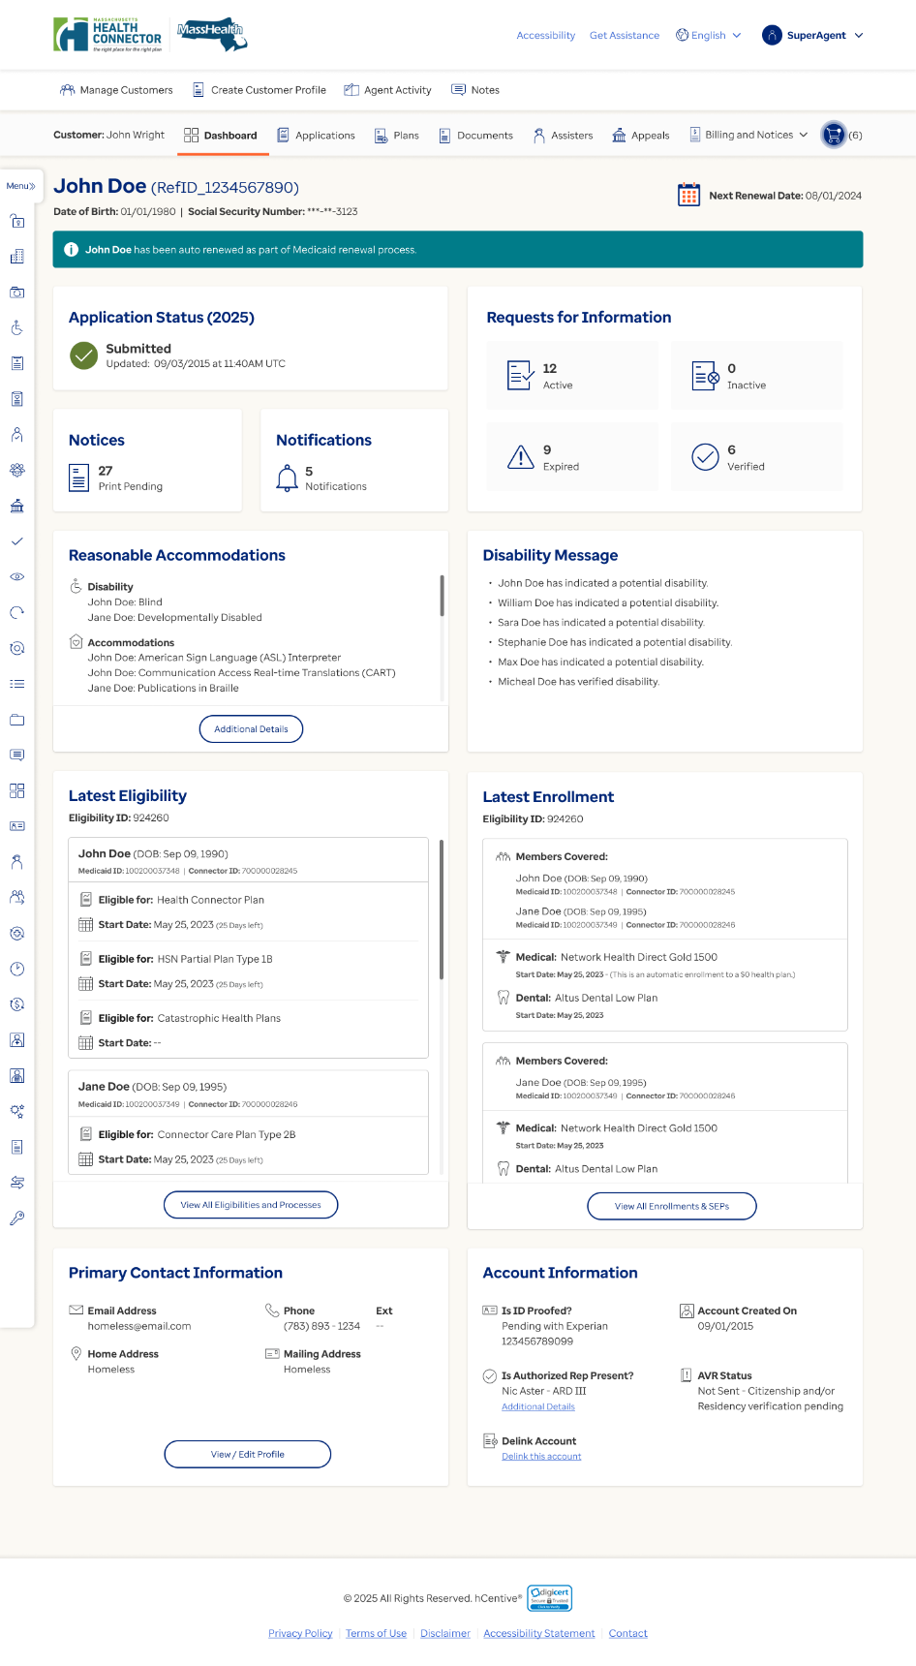

Figure 2 Agent Portal Dashboard for scenario when auto renewal happened for qualified member post RFI verification during Medicaid renewals and all the members in the application were qualified only


Figure 3 Agent Portal Dashboard for scenario when the application is dropped from Medicaid renewals post RFI verification.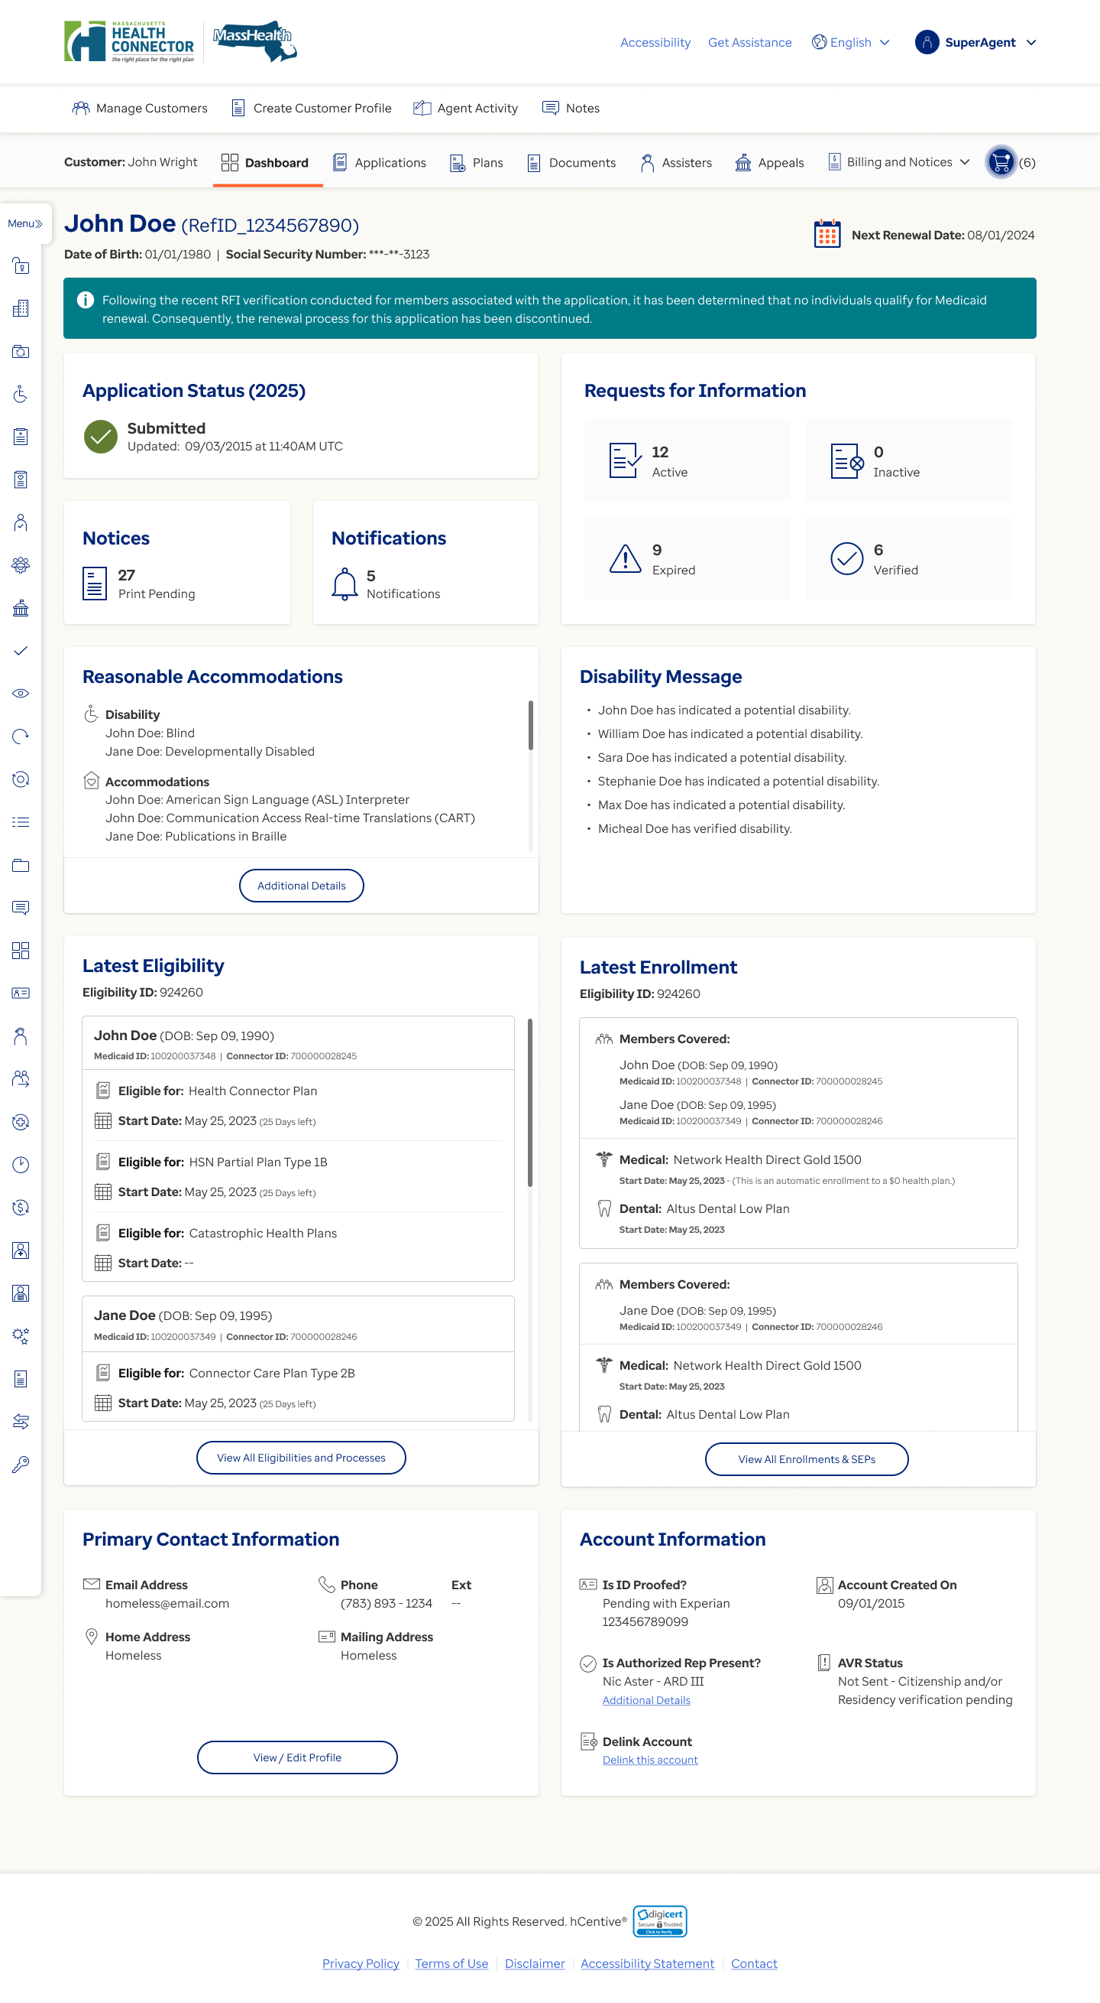

Figure 4 Individual Dashboard for scenario when auto renewal happened for qualified member post RFI verification during Medicaid renewals and all the members present in the application were qualified only
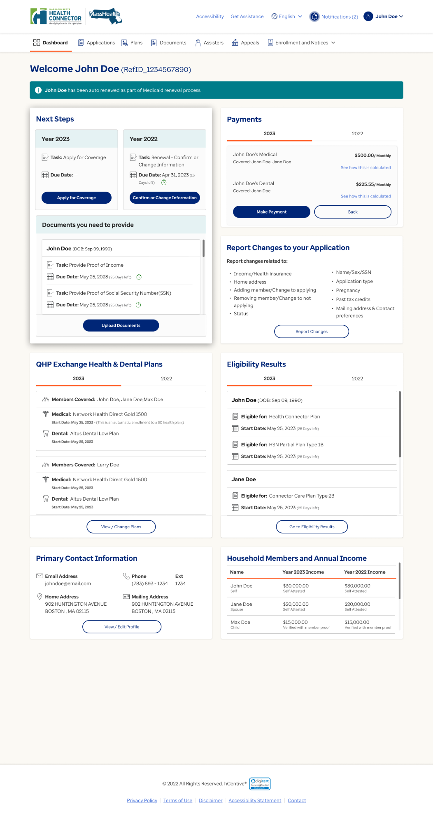

Figure 5 Individual Dashboard for scenario when auto renewal happened for qualified member post RFI verification during Medicaid renewals and there were at least one impacted or non-qualified member present in the application.


Figure 6 Individual Dashboard for scenario when the application is dropped from Medicaid renewals post RFI verification.
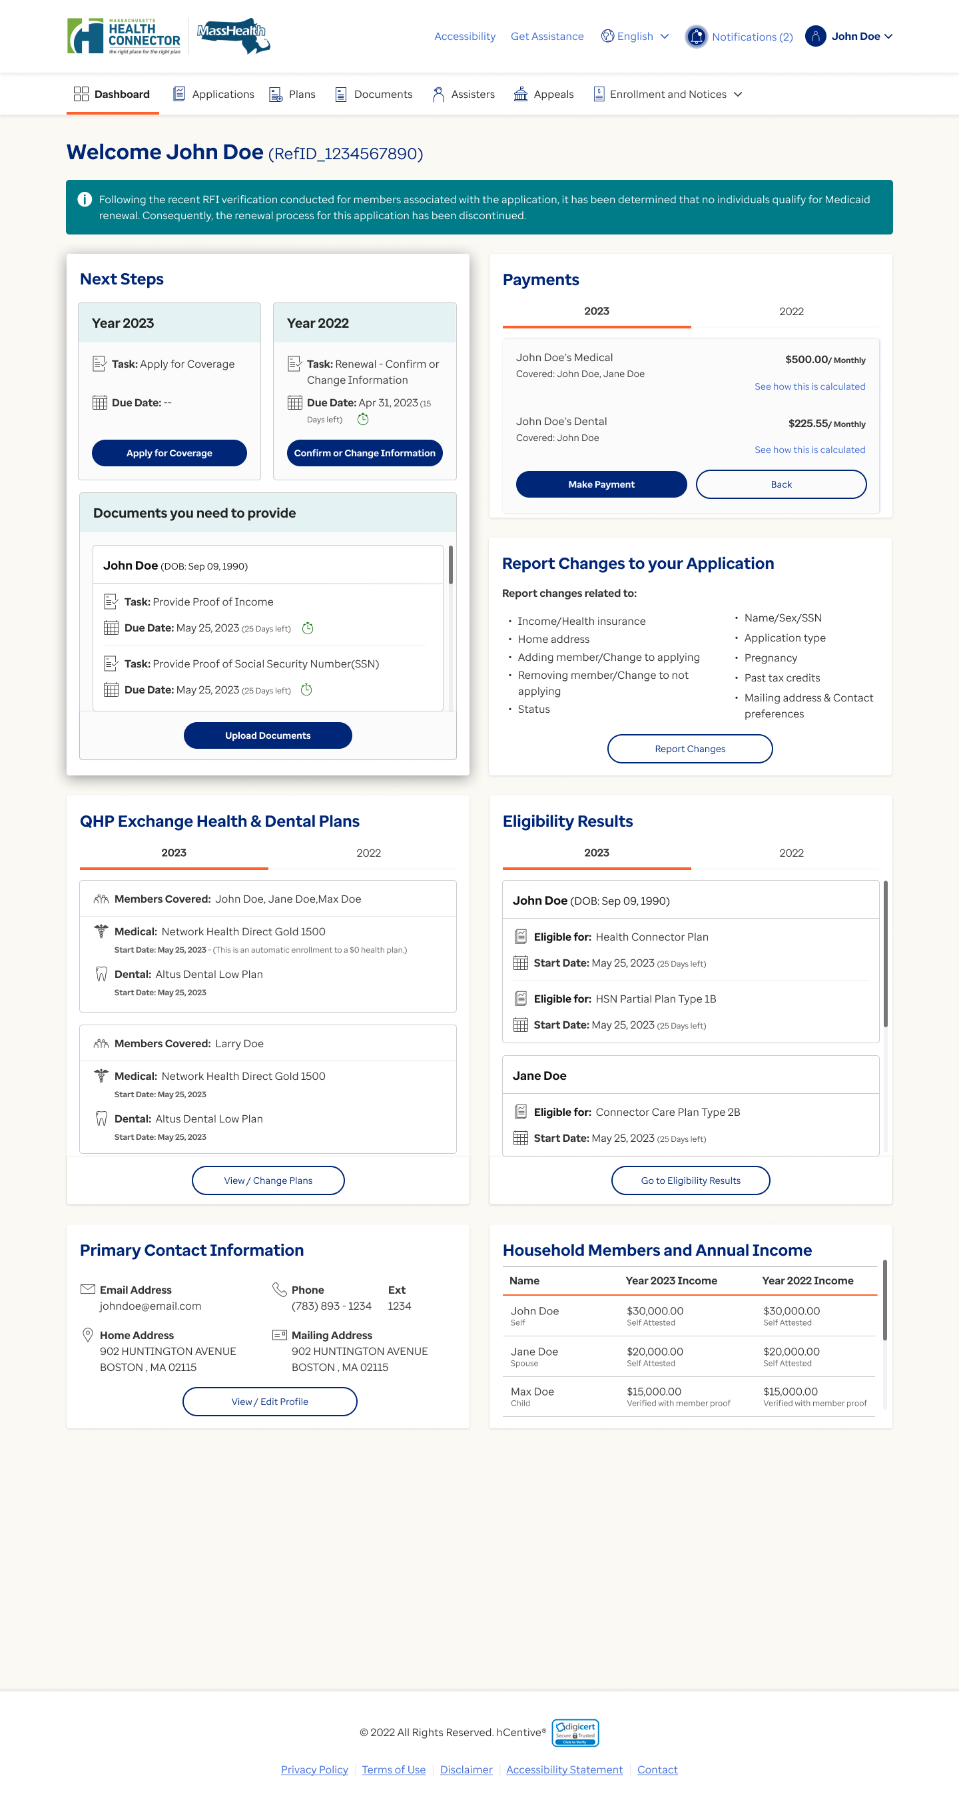

Figure 7 Eligibility Application screen for scenario when there were only qualified members present in the application and auto renewal happened for qualified member post RFI verification during Medicaid renewals.
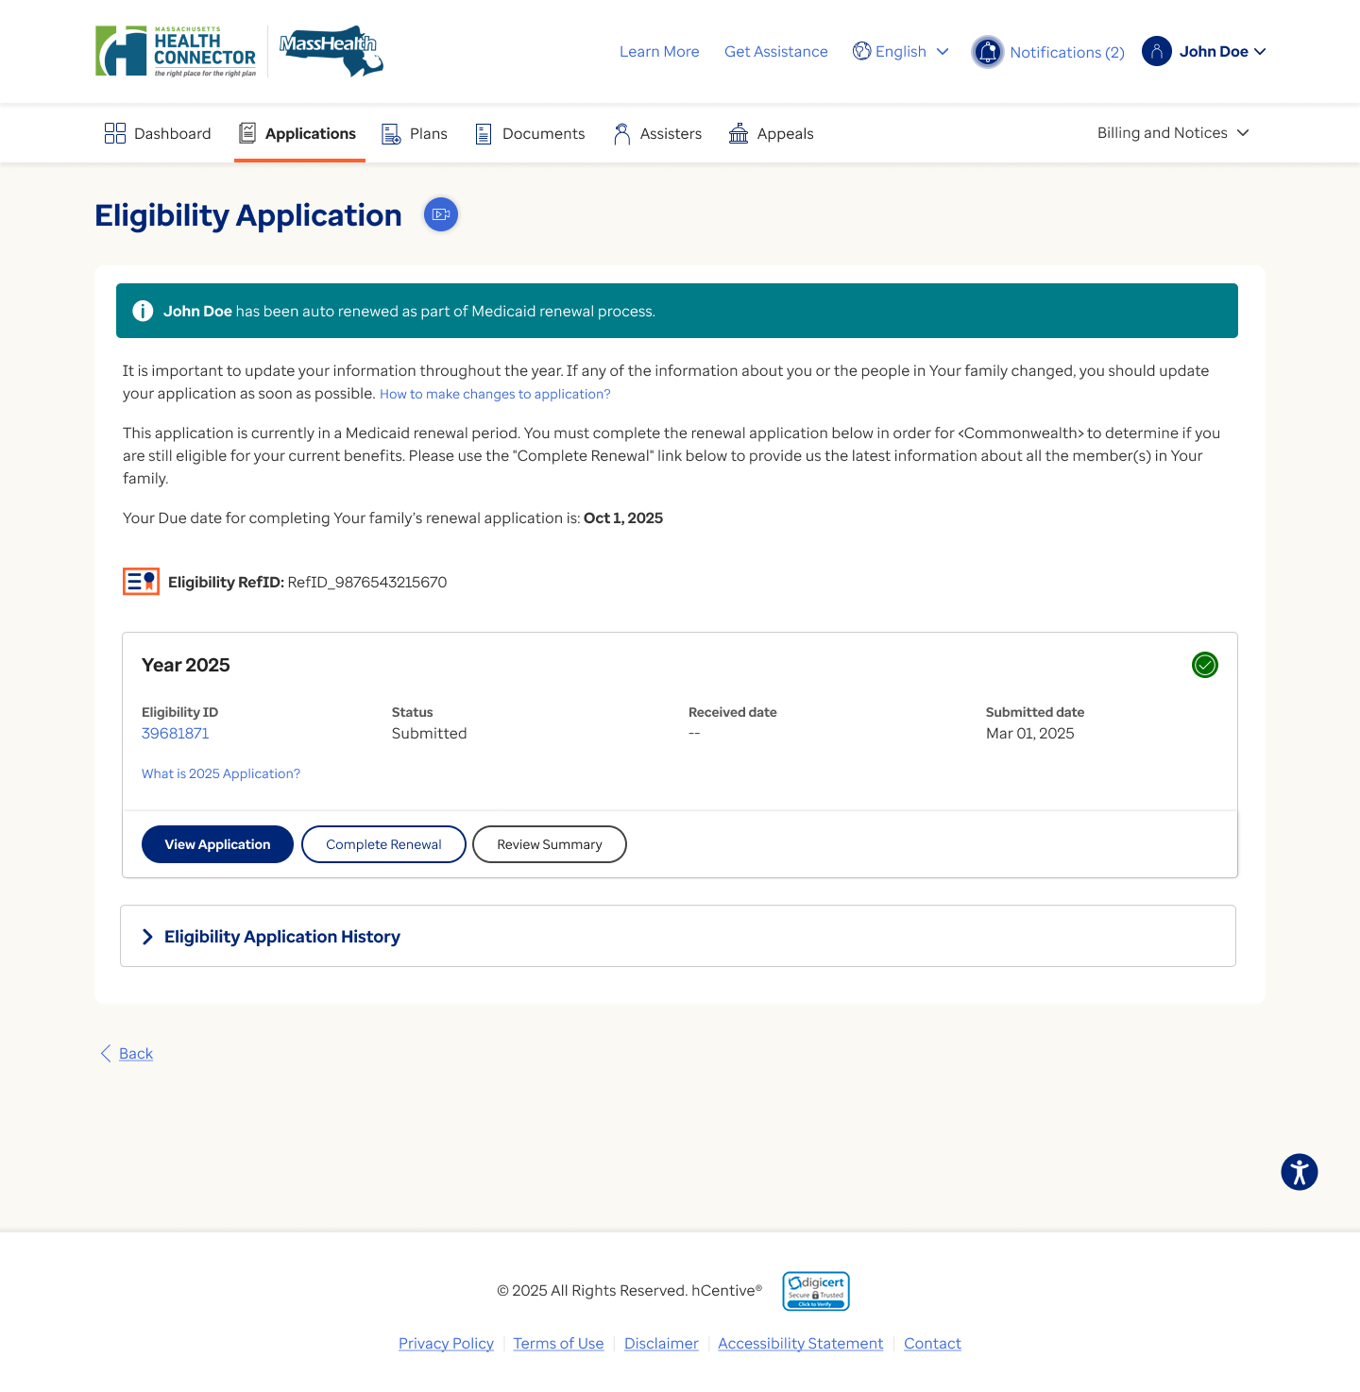

Figure 8 Eligibility Application screen for scenario when there were at least on impacted or non-qualified member also present in the application and auto renewal happened for qualified member post RFI verification during Medicaid renewals.

Figure 9 Eligibility Application screen for scenario when the application is dropped from Medicaid renewals post RFI verification
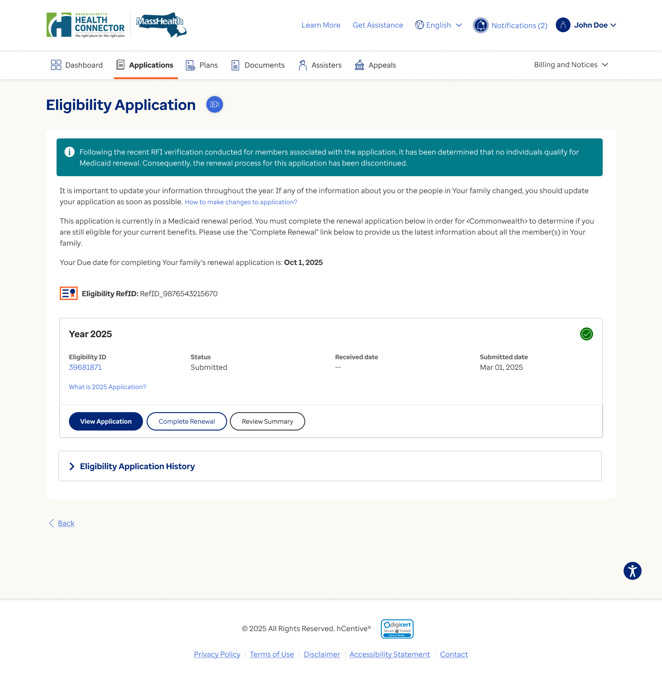

Figure 10 Eligibility and Processes screen for scenario when the application is dropped from Medicaid renewals post RFI verification
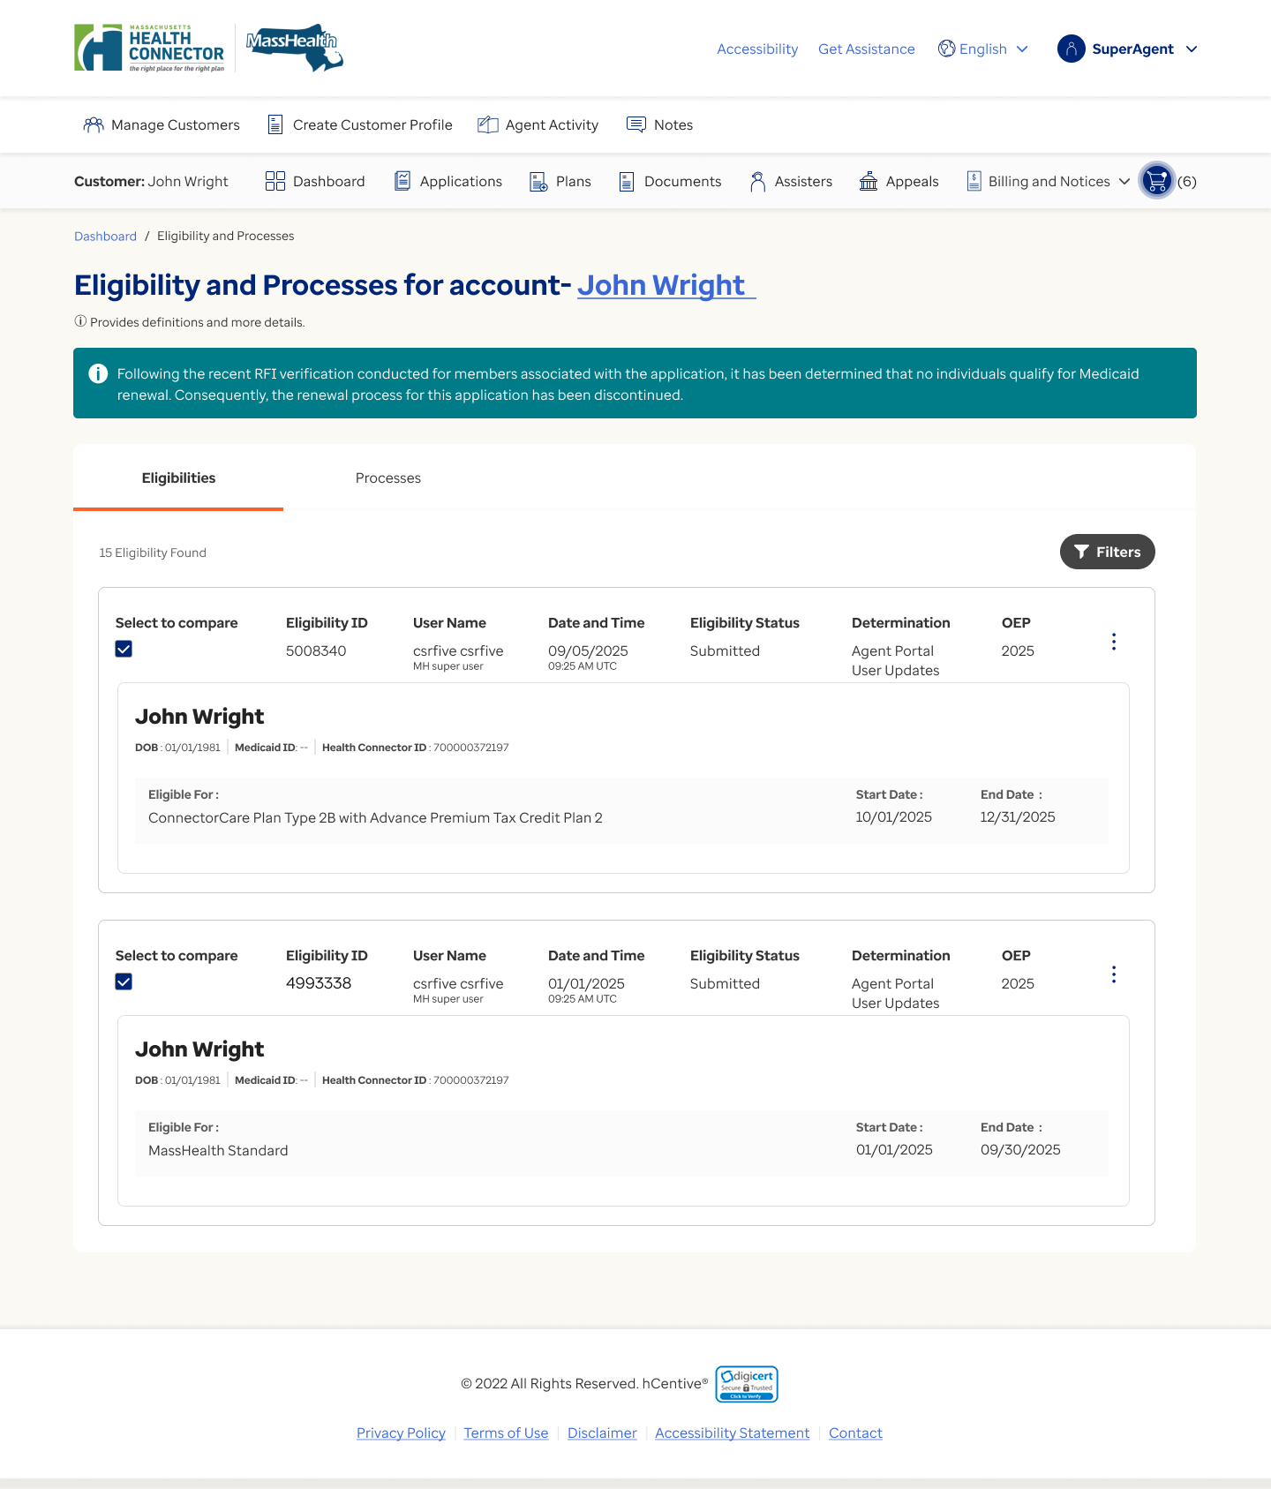

Figure 11 Eligibility and Processes screen for scenario when there is at least one non-qualified or impacted members present in the application and all the qualified members are auto renewed post RFI verification during Medicaid renewals.
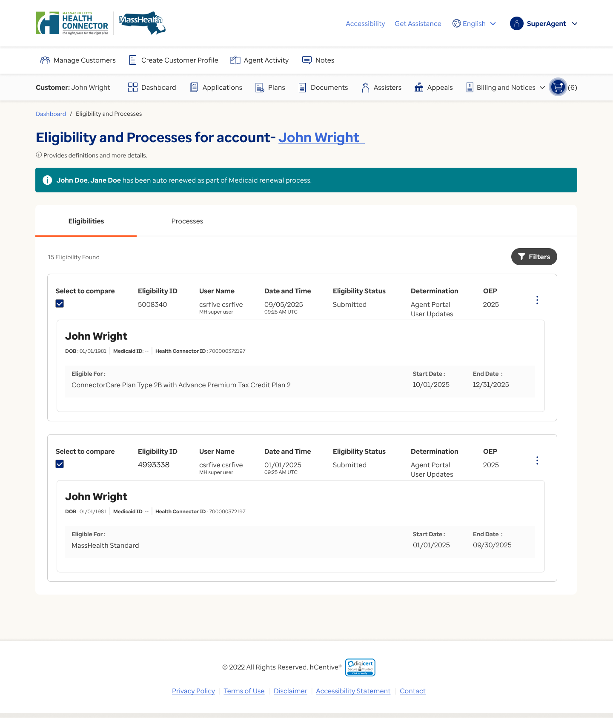

Special Design Consideration & Transaction Information
Not Applicable.

  - ETREN.PC03 –Impact of RFI Verification over the MH renewal reinstated due to Address update (Omnibus) when “Allow RFI Verification” configuration is ON.

Description
This will provide the ability to verify the outstanding RFI for any member when the application is being processed as part of the Medicaid renewal process without stopping the Medicaid renewal process.

When the “Allow RFI Verification” is OFF, the system will follow the current system behavior.

Current System Behavior
Currently, the HIX system does not allow the agent portal users to verify the RFI if the Medicaid renewal time clock is in progress due to reinstatement initiated through change address screen.

Actor(s)
- HIX System
- Agent Portal User

Trigger(s)
- The agent portal user verifies any RFI for any member through document verification feature.

Precondition(s)
- The Medicaid renewal time clock is in progress due to reinstatement (through change address screen) for an application.

Postcondition(s)
- The system enables the agent portal capability to verify any outstanding RFI for any member when Medicaid renewal time clock is in progress due to reinstatement.

Description
This product capability will provide the configurable ability to set the “Next renewal date” based on the population group and aid category following the existing rules for qualified, impacted, non-qualified when the application is processed through different process.

Proposed Solution Specification
Table 4. ETREN.PC.03 Product Capabilities Specification
Product Capability Specification ID | Product Capability Specification
ETREN.PCS.03.001 | The system shall enable the agent portal capability to verify any outstanding RFI for any member when the “Allow RFI Verification” configuration is ON, and the Medicaid renewal time clock is in progress due to reinstatement (through change address screen) for an application.
ETREN.PCS.03.002 | The system shall perform the following actions in order below when the Medicaid renewal time clock is in progress due to reinstatement, and an agent portal user verifies any RFI for any member and completes the eligibility determination.  - Redetermine the latest submitted eligibility and apply the manually verified data.  - Follow the existing rules for the downstream process (i.e., generate Medicaid eligibility notice Xml and other applicable notices, generate the MMIS, PA/PB calculations, generation of the 834 xml)  - Discard the original initial eligibility.  - Use the most recently determined eligibility—created through manual RFI verification in #1 above—to assess whether any member remains eligible for the Medicaid renewal process.
ETREN.PCS.03.003 | The system shall perform the actions in below order when the member (who was previously determined as qualified prior to RFI verification) continues to meet Medicaid renewal criteria, and no additional member is newly identified as qualified or impacted as an outcome of ETREN.PCS.03.002.  - Use the most recently determined eligibility—based on manual RFI verification—to reinitiate the hub service call for all applicable qualified and impacted members.  - Perform the reasonable compatibility checks using RRV rules to create a new initial renewal eligibility.  - If the qualified member remains eligible for auto-renewal and none of the conditions that require generating a PPF or non-auto-renewal XML are met (including but not limited to -PB increase of $X or a PA decrease of $Y), the system shall auto-renew the application, generate the auto-renewal notice, and display a UI banner as per the logic mentioned in ETREN.PCS.03.004 and ETREN.PCS.03.005 to indicate that auto-renewal has occurred.  - If the qualified member cannot be auto-renewed, or if any conditions triggering PPF or non-auto-renewal XML generation are met (including but not limited to -PB increase of $X or PA decrease of $Y), the system shall:  - Initiate the Medicaid renewal time clock for the remaining duration (i.e., total 45 days minus the days already consumed during the initial renewal eligibility period).  - Suppress the non-auto-renewal notice, as it was already issued during the original initial renewal eligibility determination.  - If the qualified member (who was getting auto renewed prior to RFI verification) is now getting downgraded/terminated in this new initial renewal eligibility determination, then the system shall generate non-auto-renewal notice XML with PPF and extend the Medicaid renewal TC by Y days (default: 45).
ETREN.PCS.03.004 | The system shall display an informational message on account dashboard, Eligibilities and processes for account- <name>,’ Individual dashboard, Eligibility Application screen at application level when all the members present in the application are qualified members only and all the members are auto renewed post RFI verification.  Note – Refer to the UISS for details.
ETREN.PCS.03.005 | The system shall display an informational message with member details<FN, LN> on account dashboard, Eligibilities and processes for account- <name>,’ Individual dashboard, Eligibility Application screen when along with the qualified members there is at least one impacted or non-qualified member present in the application and all the qualified members are auto renewed post RFI verification.  Note – Refer to the Release Level UISS Documentation for details.
ETREN.PCS.03.006 | The system shall perform the actions in below order when the member (who was previously determined as qualified prior to any RFI verification) continues to meet Medicaid renewal criteria, and another additional member is newly identified as qualified or impacted as an outcome of ETREN.PCS.03.002.  - Use the most recently determined eligibility—based on manual RFI verification— re-initiate the RRV Calls for the all the qualified and impacted members as per the existing rules,  - Perform reasonable compatibility checks using RRV rules and create a new initial renewal eligibility (follow the regular renewal batch to perform the compatibility).  - If all the qualified member remains eligible for auto-renewal and none of the conditions that require generating a PPF or non-auto-renewal XML are met (including but not limited to -PB increase of $X or a PA decrease of $Y), the system shall auto-renew the application, generate the auto-renewal notice, and display a UI banner indicating that auto-renewal has occurred.  - If only the qualified member (who was identified as qualified member in original initial renewal eligibility) cannot be auto-renewed, or if any conditions triggering PPF or non-auto-renewal XML generation are met (including but not limited to -PB increase of $X or PA decrease of $Y), the system shall:  - Keep the Medicaid renewal time clock running for the remaining duration (i.e., total 45 days minus the days already consumed during the initial renewal eligibility period).  - Suppress the non-auto-renewal notice, as it was already issued during the original initial renewal eligibility determination.  - If the same qualified member (who was identified as qualified member in original initial renewal eligibility and were not downgraded/terminated) cannot be auto renewed, the system shall:  - Extend the Medicaid renewal time clock by Y days (default: 45 days).  - Generate the new non-auto-renewal notice, during this initial renewal eligibility determination.  - If the newly qualified member (who was not identified as qualified member in original initial renewal eligibility) cannot be auto-renewed, or if any conditions triggering PPF or non-auto-renewal XML generation are met in this determination which were not met earlier (including but not limited to -PB increase of $X or PA decrease of $Y), the system shall:  - Initiate a new Medicaid renewal time clock.  - Trigger a new non-auto-renewal notice XML with updated qualified member/discrepancy details.  - Do not display the “complete renewal” option across portals until the new initial renewal eligibility determination in step #2 is completed.  - Display an informational message on Account dashboard, Eligibilities and processes for account- <name>,’ Individual dashboard, Eligibility Application screen to convey that the Medicaid renewal process is being reassessed due to RFI verification until initial renewal eligibility determination in step# is completed.
ETREN.PCS.03.007 | The system shall perform in below order when all the qualified members (who were previously determined as qualified prior to any RFI verification) do not meet Medicaid renewal criteria of qualified members, and no additional member is newly identified as qualified as an outcome of ETREN.PCS.03.002.  - Drop the application from Medicaid renewal process.  - Display an informational message on account dashboard, Eligibilities and processes for account- <name>,’ Individual dashboard, Eligibility Application screen when the application was dropped from renewal as no member is eligible for renewal post RFI verification

UI/UX
Figure 12 Agent Portal Dashboard for scenario when auto renewal happened for qualified member post RFI verification during Medicaid renewals and there is at least one impacted or non-qualified member in the application


Figure 13 Agent Portal Dashboard for scenario when auto renewal happened for qualified member post RFI verification during Medicaid renewals and all the members in the application were qualified only


Figure 14 Agent Portal Dashboard for scenario when the application is dropped from Medicaid renewals post RFI verification.

Figure 15 Individual Dashboard for scenario when auto renewal happened for qualified member post RFI verification during Medicaid renewals and all the members present in the application were qualified only


Figure 16 Individual Dashboard for scenario when auto renewal happened for qualified member post RFI verification during Medicaid renewals and there were at least one impacted or non-qualified member present in the application.


Figure 17 Individual Dashboard for scenario when the application is dropped from Medicaid renewals post RFI verification.


Figure 18 Eligibility Application screen for scenario when there were only qualified members present in the application and auto renewal happened for qualified member post RFI verification during Medicaid renewals.


Figure 19 Eligibility Application screen for scenario when there were at least on impacted or non-qualified member also present in the application and auto renewal happened for qualified member post RFI verification during Medicaid renewals.

Figure 20 Eligibility Application screen for scenario when the application is dropped from Medicaid renewals post RFI verification


Figure 21 Eligibility and Processes screen for scenario when the application is dropped from Medicaid renewals post RFI verification


Figure 22 Eligibility and Processes screen for scenario when there is at least one non-qualified or impacted members present in the application and all the qualified members are auto renewed post RFI verification during Medicaid renewals.


Figure 23- Agent Portal-Account Dashboard-Informational message displayed until the initial renewal eligibility determination is not performed post RFI verification
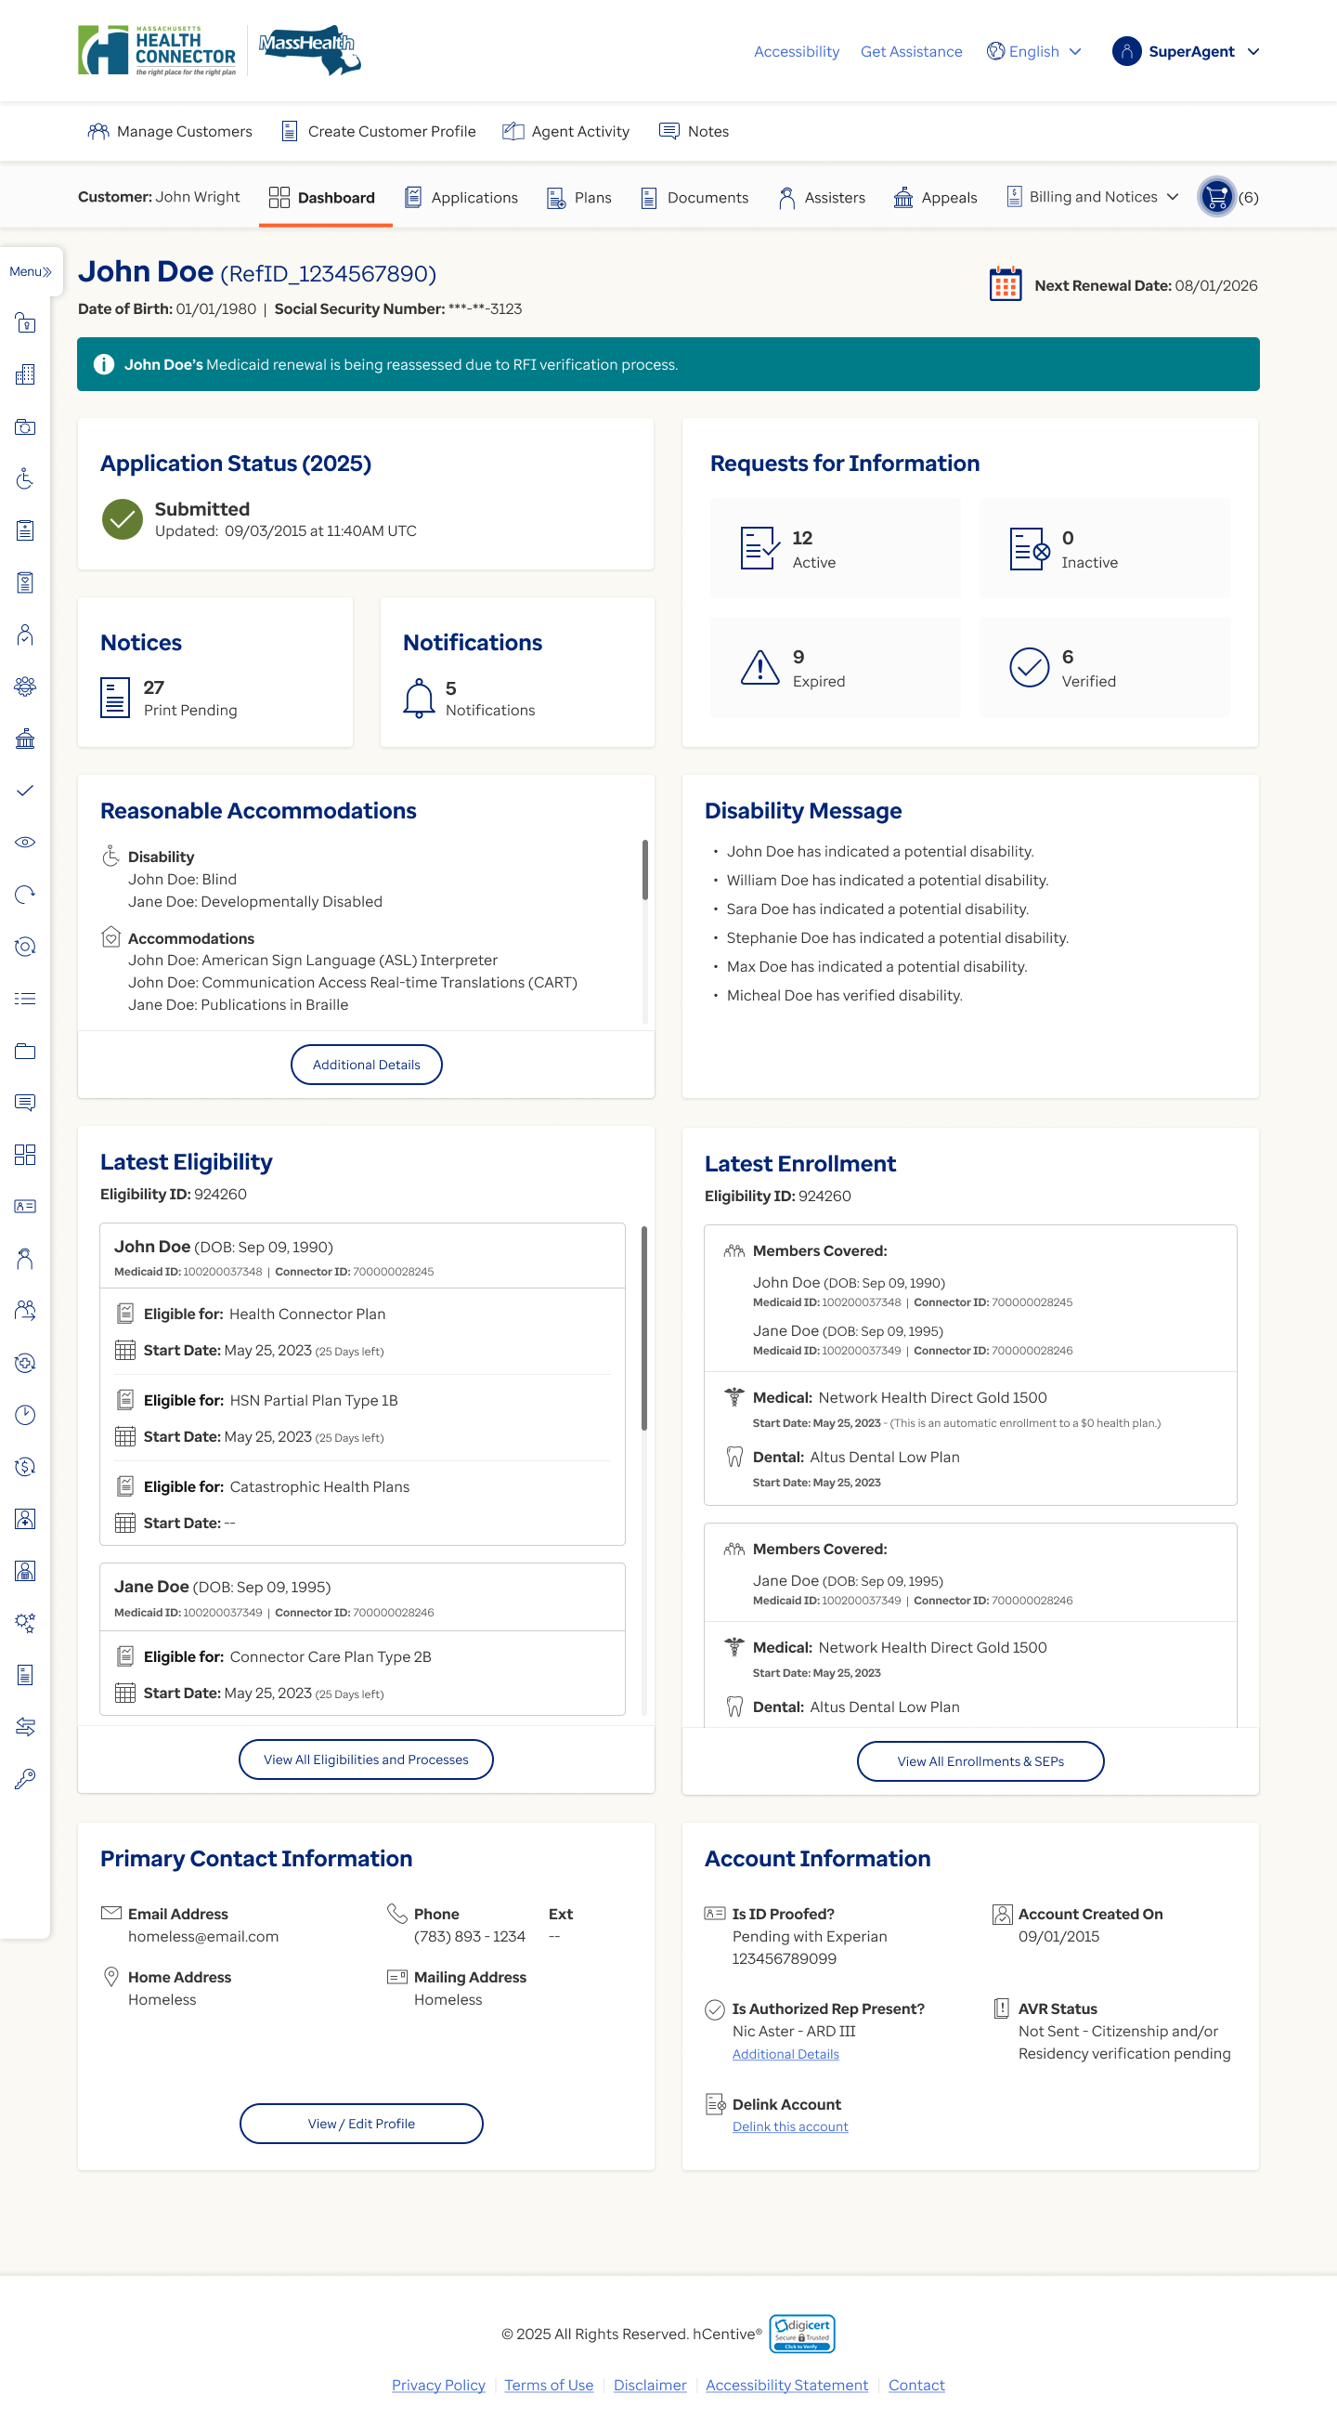

Figure 24 Individual Dashboard-Informational message displayed until the initial renewal eligibility determination is not performed post RFI verification
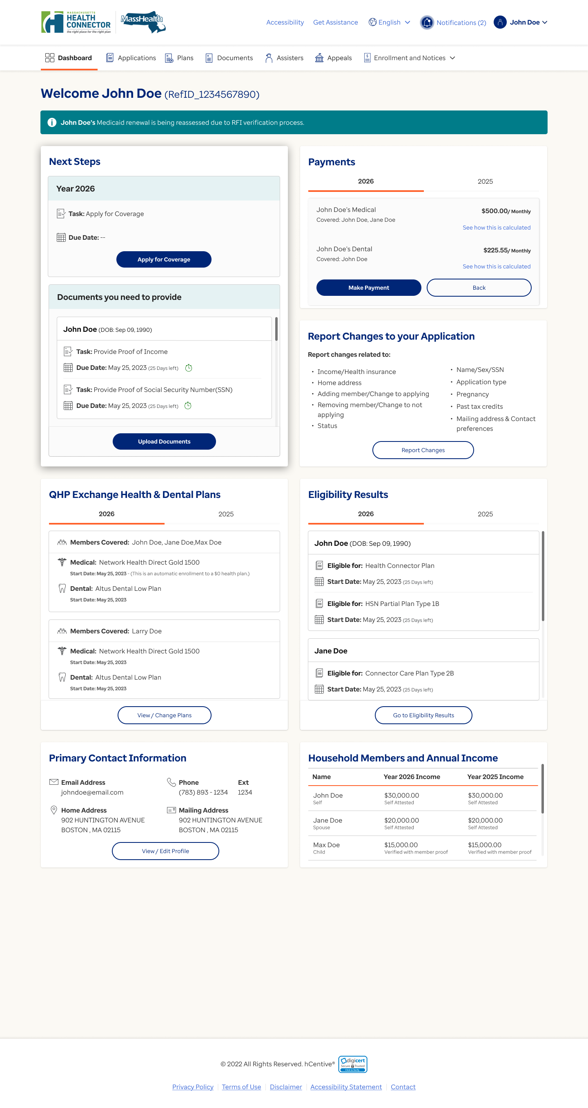

Figure 25 Eligibility Application-Informational message displayed until the initial renewal eligibility determination is not performed post RFI verification
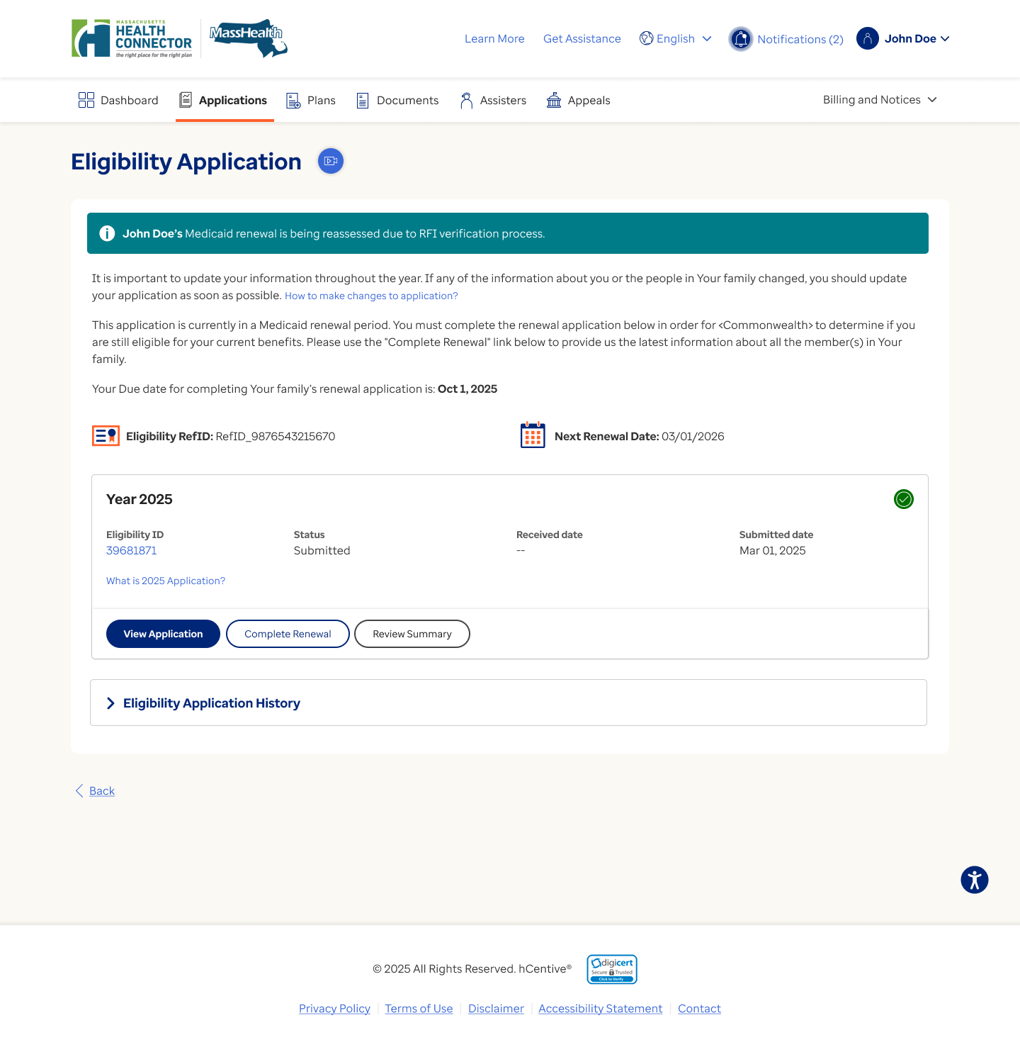

Figure 26 Eligibility and Processes for account-Informational message displayed until the initial renewal eligibility determination is not performed post RFI verification
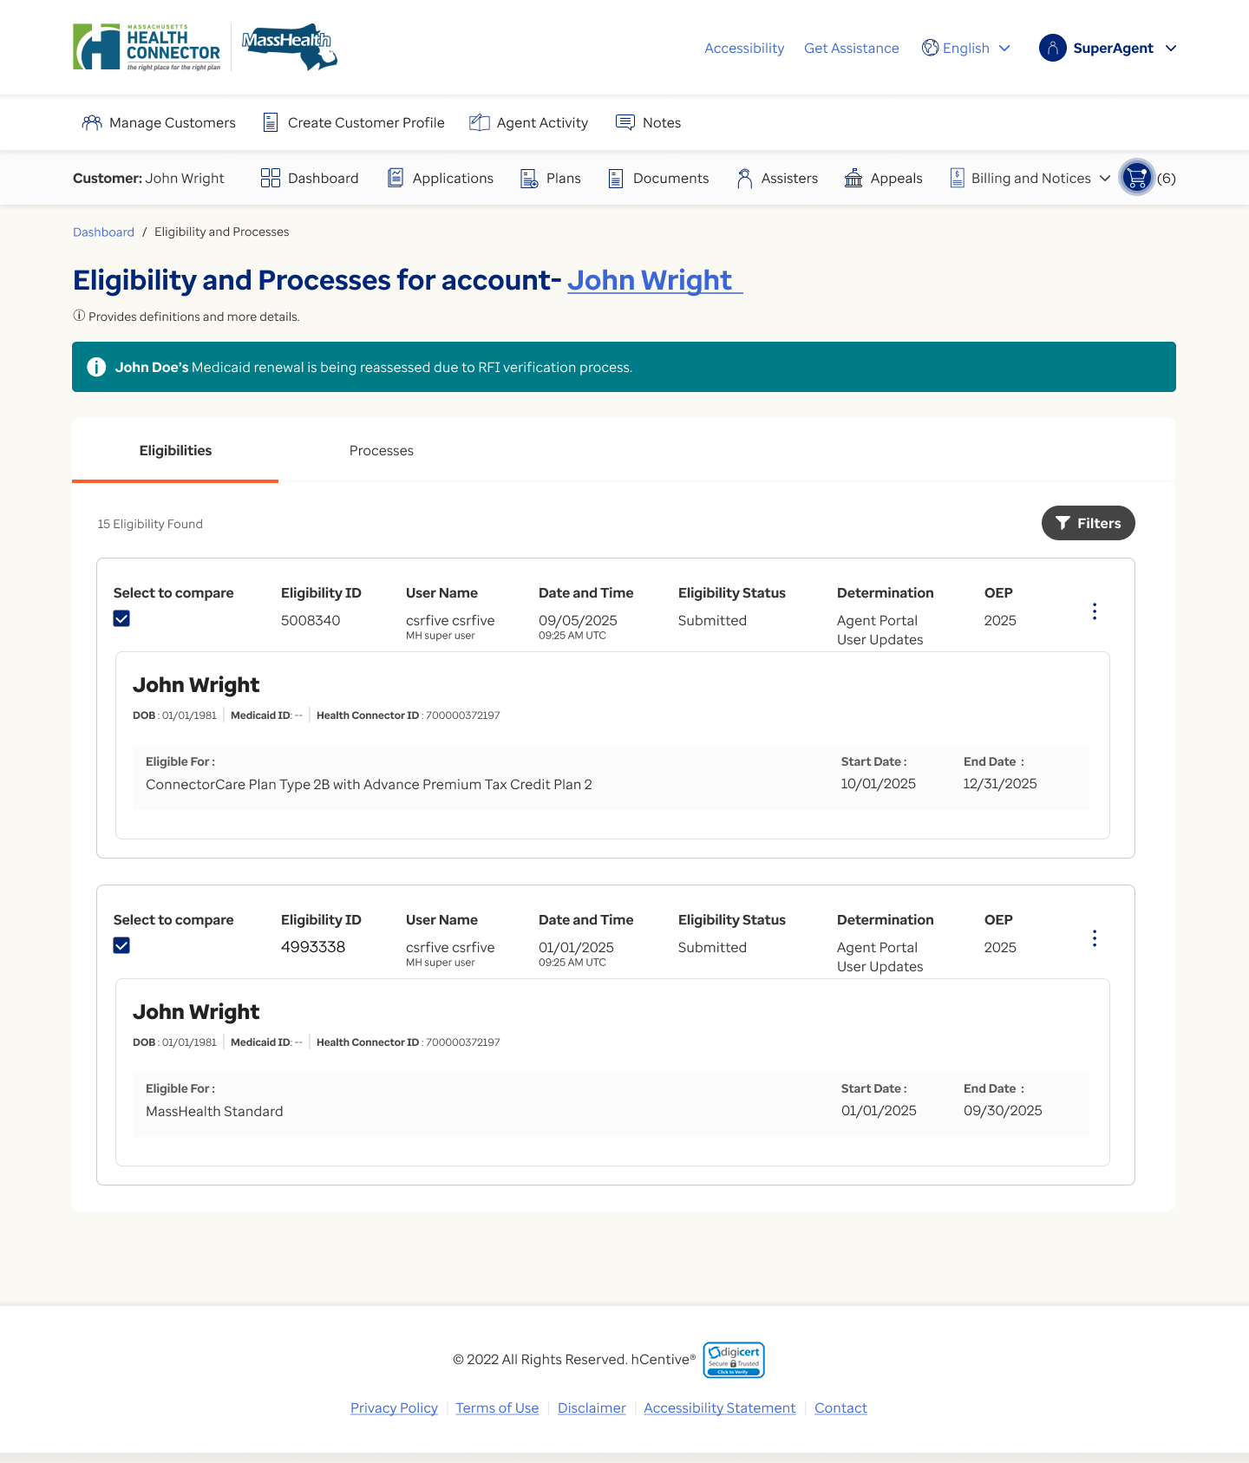

Special Design Consideration & Transaction Information
Not Applicable.

  - ETREN.PC04 – Enhancement to next renewal date calculation logic configurability based on the defined input parameters

Description
The purpose of the product capability is to define the configurable ability (based on the unique combination of input parameters defined under BR-MED-69: Calculate "Next Medicaid renewal Date, BR-MED-68: Calculate Baseline date parameter for "Next Medicaid renewal Date", and BR-MED-68a: Evaluate the variable months to be added for “Next Medicaid renewal Date ) to calculate the next Medicaid renewal date for any Medicaid (full Medicaid , Partial Medicaid , QHP + limited/CMSP/HSN) eligible members when the application is being processed through any of the user driven or systematic process (including but not limited to QHP & Mixed HH renewal process, Medicaid Renewal process, PDM process, streamline renewals)

Current System Behavior

Currently, During Medicaid renewal process the HIX system follows the below logic to reset the next renewal date for Qualified members.

- If the member is selected for renewal before the current "next renewal date," set the new "next renewal date" to current “next renewal Date + X (configurable, default- 12 months)”.
- If the member is selected after their current "next renewal date," set the new "next renewal date" to Medicaid renewal selection date + X (configurable, default- 12 months)”.

For impacted and/or non-qualified members the system does not reset the next renewal date during the Medicaid renewal time-clock expiry process. Whereas during the PPF response it does sets/resets the next renewal date for such members as “Application Submission Date + X (12) months.

Additionally, for any other process, the system reset the “next renewal date” as current “application date + X months (configurable, default 12 months)” if the application date is set/reset for these members in any other process as per the application date setting rules.

Actor(s)
- HIX System

Trigger(s)
      - The application is processed through Medicaid renewal process.
      - The application is processed through any other process which can update the application date for the member.

Precondition(s)
- An application exists in the HIX system.
- The user submits an initial application.

Postcondition(s)
- The system provides the configurable ability (based on the unique combination of input parameters defined under BR-MED-69: Calculate "Next Medicaid renewal Date, BR-MED-68: Calculate Baseline date parameter for "Next Medicaid renewal Date", and BR-MED-68a: Evaluate the variable months to be added for “Next Medicaid renewal Date) to calculate the next Medicaid renewal date for any Medicaid (full Medicaid , Partial Medicaid , QHP + limited/CMSP/HSN) eligible members when the application is being processed through any of the user driven or systematic process (including but not limited to QHP & Mixed HH renewal process, Medicaid Renewal process, PDM process, streamline renewals) .
- The system provides the configurable ability to set the next renewal date for the qualified/impacted/non-qualified member when the user responds to the PPF during Medicaid renewal process.
- The system provides the configurable ability to set the next renewal date for the qualified/impacted/non-qualified member when the user responds to the PPF during QHP & Mixed HH renewal process.

Proposed Solution Specification
Table 6. ETREN.PC.04 Product Capabilities Specification
Product Capability Specification ID | Product Capability Specification
ETREN.PCS.04.001 | The system shall reset the next renewal date based on the baseline date parameter calculated through DMN (“BR-MED-68: Calculate Baseline date parameter for "Next Medicaid renewal Date" calculation” documented in Product Medicaid Rule DMN document) for any Medicaid (full Medicaid , Partial Medicaid , QHP + limited/CMSP/HSN) eligible members when the application is being processed through any of the user driven or systematic process (including but not limited to QHP & Mixed HH renewal process, Medicaid Renewal process, PDM process, streamline renewals)  - Input Parameters for (BR-MED-68)  - Output Parameters for (BR-MED-68)  - Processing Logic for (BR-MED-68)  Note - Refer to Product Medicaid Rule DMN for detailed information of Input parameter, Output parameter, and processing logic.
ETREN.PCS.04.002 | The system shall reset the next renewal date based on (BR-MED-68a: Evaluate the variable months to be added for “Next Medicaid renewal Date" calculation and BR-MED-69: Calculate "Next Medicaid renewal Date)documented in Product Medicaid Rule DMN document))for any Medicaid (full Medicaid , Partial Medicaid, QHP + limited/HSN/CMSP) eligible members when the application is being processed through any of the user driven or systematic process (including but not limited to QHP & Mixed HH renewal process, Medicaid Renewal process, PDM process, streamline renewals)  - Input Parameters for (BR-MED-69)  - Output Parameters for (BR-MED-69)  - Processing Logic for (BR-MED-69)  - Input Parameters for (BR-MED-68a)  - Output Parameters for (BR-MED-68a)  - Processing Logic for (BR-MED-68a)  Note –  - Refer to Product Medicaid Rule DMN for detailed information of Input parameter, Output parameter, and processing logic.  - A separate work track, ‘Community Engagement Compliance,’ is being implemented as part of the OBBBA Act. This track applies to the same population set and exemptions. Consequently, this requirement also governs the renewal frequency for members subject to community engagement compliance.

UI/UX
Not Applicable

Special Design Consideration & Transaction Information
Not Applicable

  - ETREN.PC05 – Trigger Adverse Action Warning Notice XML during QHP and Mixed Household Renewals.

Description
This product capability defines the requirement for generating an Adverse Action Warning Notice XML during QHP and Mixed Household renewals. It specifically applies to members whose Medicaid benefits are not renewed during QHP and Mixed Household renewals but their Medicaid benefit is downgraded or terminated in the same process. In cases where neither a Preliminary Notice XML nor a Non-Auto Renewal Notice XML is generated, this capability ensures that the appropriate Adverse Action Warning Notice XML is sent to reflect the potential change in Medicaid benefit status for the non-renewed affected member.

Current System Behavior
Currently, the HIX system generates either a Preliminary Eligibility Notice XML or a Non-Auto Renewal Notice XML during the preliminary eligibility phase. For Non-Auto Renewal Notices, the system includes all Medicaid-eligible members for the current year—regardless of whether they are qualified, non-qualified, or impacted. For Preliminary Eligibility Notices, the system includes QHP and QDP-eligible members and flags any downgrades in HSN/CMSP benefits for QHP + Partial Medicaid (HSN/CMSP) members.
However, there are scenarios where Medicaid-eligible members (Full Medicaid with or without QDP, QHP+Partial Medicaid Limited, QDP+Partial Medicaid (HSN/CMSP) who are not eligible for renewal within a QHP and Mixed Household are experiencing benefit downgrades/termination. In certain cases, the system does not generate any notice at the time of preliminary eligibility determination to inform such members for their Medicaid benefit downgrade. To address this gap, the system must trigger a new Adverse Action Warning Notice at the time of preliminary eligibility determination of QHP and Mixed household renewals. This notice should warn the Head of Household (HoH) that a Medicaid-eligible member’s benefits have been downgraded or terminated, through the QHP or Mixed Household renewal process. Because these changes are not yet finalized, the HoH must take action to prevent potential downgrades or terminations based on federal and state data sources used in the QHP or Mixed Household renewal process

Actor(s)
- HIX System

Trigger(s)
- Notice generation process has been initiated.

Precondition(s)
- Preliminary eligibility has been created for an account during QHP and Mixed Household renewals.

Postcondition(s)
- The Adverse Action Warning Notice XML will be triggered based on rules defined in Functional Requirement ETREN.PCS.05.01.

Proposed Solution Specification
Table 5. ETREN.PC.05 Product Capabilities Specification

Product Capability Specification ID | Product Capability Specification
ETREN.PCS.05.01 | The system shall trigger the Adverse Action Warning Notice XML at the application level based on rules and trigger defined in notice template.
ETREN.PCS.05.02 | The system shall send the Adverse Action Warning Notice XML with the data elements identified in the Medicaid Data element mapping sheet.

UI/UX
Not Applicable

Special Design Consideration & Transaction Information
Not Applicable

  - ETREN.PC06 – Provide a configurable ability to enable the agent portal user to verify the RFI during select circumstances

Description
This product capability defines the requirement to provide configuration to enable the agent portal user to verify any RFI for any household member when the application is being processed through the QHP & Mixed HH renewal process or Medicaid renewal process in below circumstances.

      - When either of the conditions below satisfies during QHP & Mixed HH renewal:
- Preliminary eligibility is created with PPF.
- Preliminary eligibility is created and there is at least one Medicaid Pend member present in the current year’s eligibility.
- When the application is being processed through any stage during Medicaid renewals Process.
- When the Medicaid renewal time clock is in progress due to reinstatement process initiated through change address screen.

Current System Behavior
Currently, the HIX system does not allow the agent portal user to verify the RFI in the circumstances below:

      - When the application is being processed through QHP & Mixed HH renewal process and either of the conditions below satisfy:
- Preliminary eligibility is created with PPF.
- Preliminary eligibility is created and there is at least one Medicaid Pend member present in the current year’s eligibility.
      - When the application is being processed through any stage during Medicaid renewals Process.
      - When the Medicaid renewal time clock is in progress due to reinstatement process initiated through change address screen.

Actor(s)
- HIX System
- The agent portal user(s)

Trigger(s)
- The agent portal user verifies any RFI for any member through document verification feature

Precondition(s)
- There is an application that exists in the HIX system.

Postcondition(s)
- The system provides “Allow RFI verification” configuration to enable the agent portal user to verify the RFI when the preliminary eligibility is created with PPF during QHP & mixed HH renewal process.
- The system provides “Allow RFI verification” configuration to enable the agent portal user to verify the RFI when the preliminary eligibility is created during QHP & mixed HH renewal process and there is at least one Medicaid Pend member present in the current year’s eligibility.
- The system provides “Allow RFI verification” configuration to enable the agent portal user to verify the RFI when the application is being processed through any stage during Medicaid renewals Process.
- The system provides “Allow RFI verification” configuration to enable the agent portal user to verify the RFI when Medicaid renewal time clock is in progress due to reinstatement process initiated through change address screen.

Proposed Solution Specification
Table 6. ETREN.PC.06 Product Capabilities Specification

Product Capability Specification ID | Product Capability Specification
ETREN.PCS.06.01 | The system shall provide a configuration “Allow RFI verification” to enable the agent portal user to verify the RFI when the application is being processed through the QHP & Mixed HH renewal process or Medicaid renewal process in below circumstances.  - When either of the conditions below satisfies during QHP & Mixed HH renewal:  - Preliminary eligibility is created with PPF.  - Preliminary eligibility is created and there is at least one Medicaid Pend member present in the current year’s eligibility.  - When the application is being processed through any stage during Medicaid renewals Process.  - When the Medicaid renewal time clock is in progress due to reinstatement process initiated through change address screen.  Note- Refer to the Special Design Consideration for configuration details

UI/UX
Not Applicable

Special Design Consideration & Transaction Information

Table 7. ETREN.PC.06- Configuration Details
S.N. | Description | Configuration Required | Default
1 | “Allow RFI Verification” defines the agent portal user ability to verify the RFI when the application is being processed through Medicaid renewals or QHP & Mixed HH renewal process in select circumstances defined in ETREN.PCS.06.01 | ON/OFF  ON- Follow the rules mentioned in PC-01, PC-02, PC-03 to enable the agent portal user to verify the RFI in select circumstances defined in ETREN.PCS.06.01.  OFF- System will continue to not allow the agent portal user to verify the RFI in any of the circumstances mentioned in ETREN.PCS.06.01 | OFF

  - ETREN.PC07 – Send new tags in Medicaid Non-Auto renewals notice XML

Description
The purpose of this use case is to define the requirement to send additional tags in the Medicaid Non-Auto renewal notice XMLs to identify:
- The discrepancy reason for impacted and non-qualified member
- To indicate whether the Qualified member’s Medicaid benefit is eligible for renewal or not.

Current System Behavior
Currently, the HIX system sends a discrepancy reason for qualified member in Medicaid Non-Auto renewals notice XML.

Actor(s)
- HIX System

Trigger(s)
- Notice generation process has been initiated.

Precondition(s)
- Preliminary eligibility has been created for an account during QHP and Mixed Household renewals.
- The Medicaid renewal time clock has been initiated for an application.

Postcondition(s)
1. The system sends the following new tags in the Medicaid Non-Auto Renewal notice XML to identify:
- If the discrepancy reason for impacted and non-qualified member
- Medicaid benefit has been downgraded, terminated, or remains unchanged for members whose Medicaid benefit is not eligible for renewal.

Proposed Solution Specification
Table 7 . ETREN.PC.07 Product Capabilities Specification

Product Capability Specification ID | Product Capability Specification
ETREN.PCS.07.01 | The system shall include the following discrepancy reason(s) for impacted member in the Non-Auto Renewal Notice XML during QHP and Mixed Household renewal if the Medicaid benefit is downgraded/terminated for this member.  - Income: When Current income was determined NOT Reasonably Compatible  - Disability: If Disability factor was determined NOT Reasonably Compatible  - Loss of Medicare: If member’s Medicare enrollment was used in PD prior to Medicaid renewals and member’s Medicare enrollment is no longer used in PD during Medicaid renewals process.
ETREN.PCS.07.02 | The system shall include the following discrepancy reason(s) for Impacted member in Non-Auto renewal notice XML during Medicaid renewal if the Medicaid benefit is downgraded/terminated for this member.  - Deceased: If member was returned deceased.  - Disability: If Disability factor was determined NOT Reasonably Compatible  - Income: When Current income was determined NOT Reasonably Compatible  - Increase in Premium Bill: If PB amount for PBFG (where member is present) increased above $X.  - Decrease in Premium Assistance: If PA amount for a policy (where member is present) decreased below $X.  - Loss of Medicare: If member’s Medicare enrollment was used in PD prior to Medicaid renewals and member’s Medicare enrollment is no longer used in PD during Medicaid renewals process.
ETREN.PCS.07.03 | The system shall include following discrepancy reason(s) for Non-Qualified member in the Non-Auto renewal notice XML during a Medicaid renewal if the Medicaid benefit is downgraded/terminated for this member.  - Increase in Premium Bill: If PB amount for PBFG (where member is present) increased above $X.  - Decrease in Premium Assistance: If PA amount for a policy (where member is present) decreased below $X.  - Loss of Medicare: If member’s Medicare enrollment was used in PD prior to Medicaid renewals and member’s Medicare enrollment is no longer used in PD during Medicaid renewals process.
ETREN.PCS.07.03a | The system shall include following discrepancy reason(s) for Non-Qualified member in the Non-Auto Renewal Notice XML during QHP and Mixed Household renewal if the Medicaid benefit is downgraded/terminated for this member.  - Loss of Medicare: If member’s Medicare enrollment was used in PD prior to Medicaid renewals and member’s Medicare enrollment is no longer used in PD during Medicaid renewals process.
ETREN.PCS.07.03b | The system shall include following discrepancy reason(s) for Qualified Member (Whose Medicaid benefit is not eligible for renewals) in the Non-Auto Renewal Notice XML during QHP and Mixed Household renewal if the Medicaid benefit is downgraded/terminated for this member.  - Income: When Current income was determined NOT Reasonably Compatible  - Disability: If Disability factor was determined NOT Reasonably Compatible  - Loss of Medicare: If member’s Medicare enrollment was used in PD prior to Medicaid renewals and member’s Medicare enrollment is no longer used in PD during Medicaid renewals process.
ETREN.PCS.07.04 | The system shall send a new tag in the Non-Auto Renewal notice XML to indicate whether the Qualified member’s Medicaid benefit is eligible for renewals or not.  Note:  - This tag will be applicable for both Medicaid renewals and QHP & Mixed household renewals.  - The value for this tag will always be Yes for “Qualified” member in the Medicaid renewals.  - The value for this tag will be Yes for a Qualified Member eligible for QHP+Partial Medicaid (CMSP/HSN) during the QHP and Mixed Household renewals.  - The value for this tag will be No for a Qualified Member eligible for QHP+Partial Medicaid Limited during the QHP and Mixed Household renewals  - The value for this tag will be No for a Qualified Member eligible for QDP+Medicaid during the QHP and Mixed Household renewals

UI/UX
Not Applicable

Special Design Consideration & Transaction Information
Not Applicable

Appendices
Table 8. Appendices
Document Name | Attachment
Renewal scenario examples
Medicaid Data Element Mapping Sheet
Adverse Action Warning Notice template

Acronyms/Terms
The acronyms and terms table provides a list of all acronyms and terms included in the deliverable, along with the literal translation and definition.

Table 9. Acronym/Terms
Acronym/  Term | Definition
Account Holder | An individual who initially creates an account through the U.I. (Individual or Agent Portal)
Active QDP member | An Active QDP member is a member who is QHP/QDP eligible and is enrolled in the current year dental plan.
AGI | Adjusted Gross Income
ALM | Application Lifecycle Management
Applicant | Any individual applying for the coverage
APTC | Advance Premium Tax Credit
ARD | Authorized Representative
BED | Business Expectation Document
B.O. | Back Office (Agent Portal Access)
B.R. | Business Requirement
BRD | Business Requirements Document
CAC | Certified Application Counselor
C.E. | Closed Enrollment  Note: QHP allows enrollment if a qualifying event is submitted and documented. This does not apply to Medicaid programs.
CMS | Centers for Medicare & Medicaid Services
Complex Household | An application that contains members who are eligible for more than one type of QHP and/or has multiple tax households
CSR | Customer Service Representative (Agent Portal Access)
CSR Variant | Cost-Sharing Reduction variant
Dependent(s) | Other individuals attached to the HOH/shopping group based on the application
DOB | An individual’s date of birth
DOR | Department of Revenue
DOE | Date of Event
EOHHS | Executive Office of Health and Human Services
EDM | Electronic Document Management system
ESI | Employer-Sponsored Insurance
FMS | Financial Management System
FSD | Functional Specification Document
FPL | Federal Poverty Level Table
HOH | Head of Household
hC | hCentive
HIX | Health Insurance Exchange
ICHRA | Individual Coverage Health Reimbursement Arrangement
IES | Integrated Eligibility System
Inactive QHP Application | An application where all household members are currently QHP eligible have neither enrolled in QHP plan nor became eligible for Full Medicaid only or Partial Medicaid only at any time since the last QHP and Mixed Households redetermination.
Inactive QHP with Medicaid Partial population | The system will classify an application as an Inactive QHP Application with Partial Medicaid population if all household members are currently all QHP eligible (with at least on member being as QHP + Partial Medicaid) but have neither enrolled in QHP plan nor became eligible for Full Medicaid only or Partial Medicaid only at any time since the last QHP and Mixed Households redetermination.
JAD | Joint Application Design
JRM | Joint Requirement Meeting
MAGI | Modified Adjusted Gross Income
Member | Any individual in the application
Medicaid | Medicaid state entity
Mixed Household | Mixed H.H.s will be any application where there are two or more than two members, and one of them has a Medicaid benefit
MMIS | Medicaid Management Information Systems
Non-ESI MEC | Non-Employer Sponsored Insurance Minimal Essential Coverage
NFR | Nonfunctional Requirement
Non-FA | Non- Financial Assistance
O.E. or OEP | Open Enrollment Period (varies each year)
P.D. | Program Determination
PPF | Pre Populated form
PRD | Product Requirement Document
PPACA | Patient Protection and Affordable Care Act
QHP | Qualified Health Plan
QHP Only Household | A household will be considered a QHP only household if there are only QHP and/QDP members in the application before the renewal process starts
QDP | Qualified Dental Plan
QSEHRA | Qualified Small Employer Health Reimbursement Arrangement
RAC | Report a Change (now referred to as Life Event Change-LEC)
RRV | Renewal and Redetermination Verification
RTM | Requirements Traceability Matrix
SDLC | Software Development Life Cycle
SADP | Stand Alone Dental Plan
SEP | Special Enrollment Period
SSA | Social Security Administration
SSN | Social Security Number
SSO | Single Sign-On
TPL | Third-Party Liability
Transitional Status | Refers to the status of the enrollment which is not effectuated and has only been submitted.
TSD | Technical Specification Document
U.I. | User Interface
Void Enrollment | Refers to the enrollment that has been cancelled before it was active/effectuated which means the enrollment was not active/effectuated even for one day.

