ARCHITECTURE DIAGRAMS
Scrum Master Digital Worker
Sprint Status Agent

System | Scrum Master Digital Worker
Tech Stack | LangGraph · MCP Server · Jira · Claude Sonnet · Slack
Version | 1.0
Date | 2026-04-11

Diagram 1 — Full System Architecture
End-to-end view of all components: triggers, LangGraph agent nodes, MCP Server tool layer, Jira REST API, Claude Sonnet LLM, and Slack/Confluence delivery. Shows both Sprint Status (on-demand) and Weekly Recap (scheduled) operational modes.
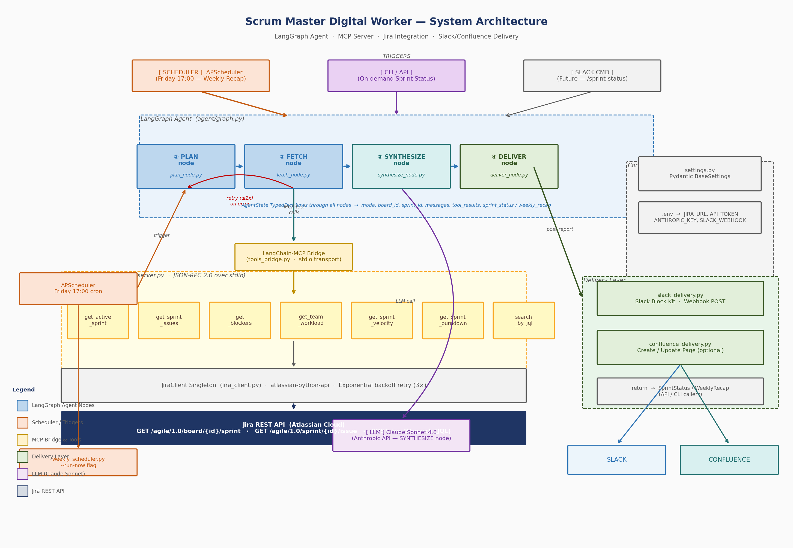

Diagram 2 — LangGraph State Machine
Four-node graph: PLAN → FETCH → SYNTHESIZE → DELIVER. Shows conditional edges: successful path to END, retry loop (FETCH → PLAN, up to 2 retries on error), and ERROR_END terminal for exhausted retries or synthesis failure. AgentState TypedDict flows through all nodes.
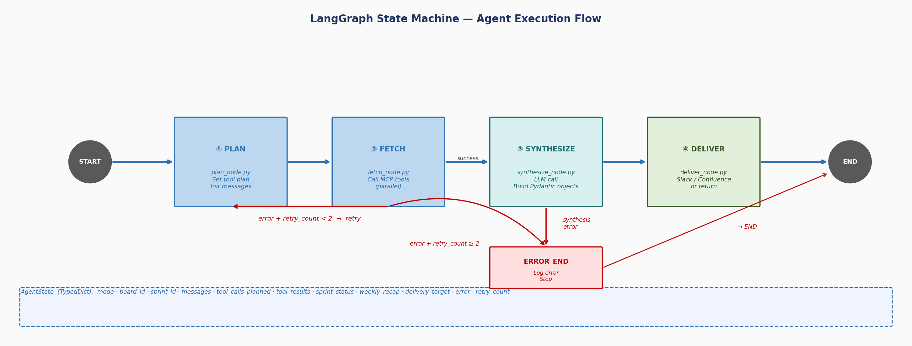

Diagram 3 — MCP Server Tool Layer
Detail view of the MCP Server: all 7 Jira tools with their input/output schemas and the Jira REST endpoints each tool calls. Shows JiraClient singleton with exponential backoff retry, and the error-handling contract (tool returns {"error":"..."} → FETCH node sets state["error"] → graph routes to retry or ERROR_END).
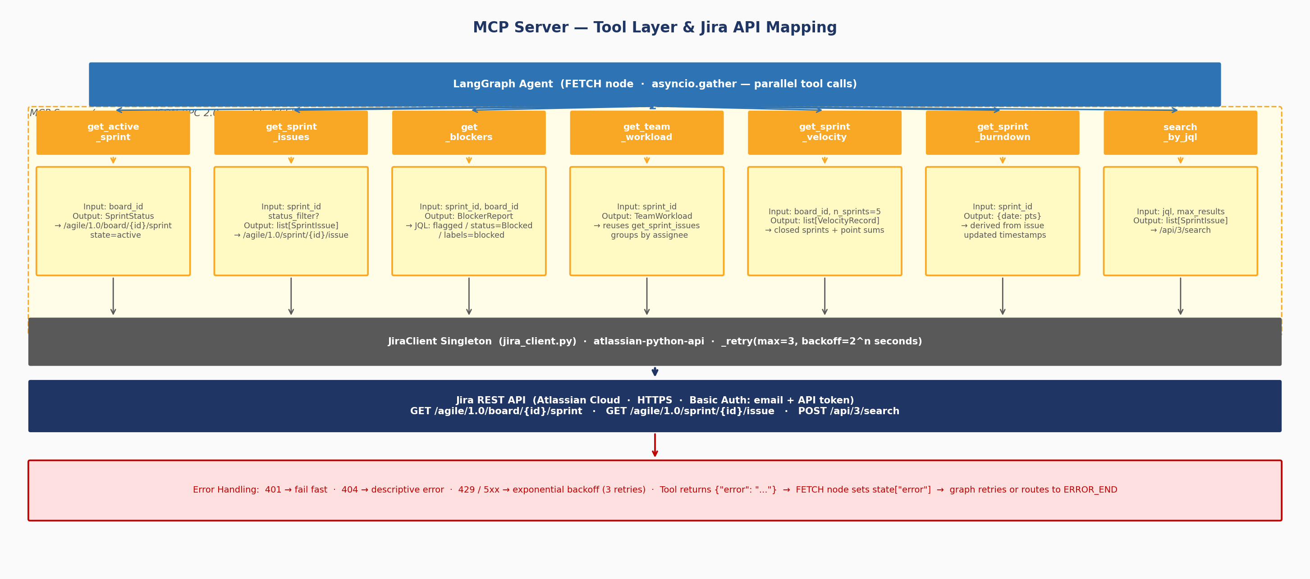

Diagram 4 — Data Flow: Sprint Status Query
Swimlane sequence diagram showing the complete on-demand Sprint Status flow: CLI trigger → PLAN → FETCH (parallel MCP tool calls) → SYNTHESIZE (Claude Sonnet) → DELIVER (Slack webhook) → return to caller. Shows exact Jira REST calls and JSON payloads at each step.
