Auth Project Overview
This is our landing page which accessible by anyone.
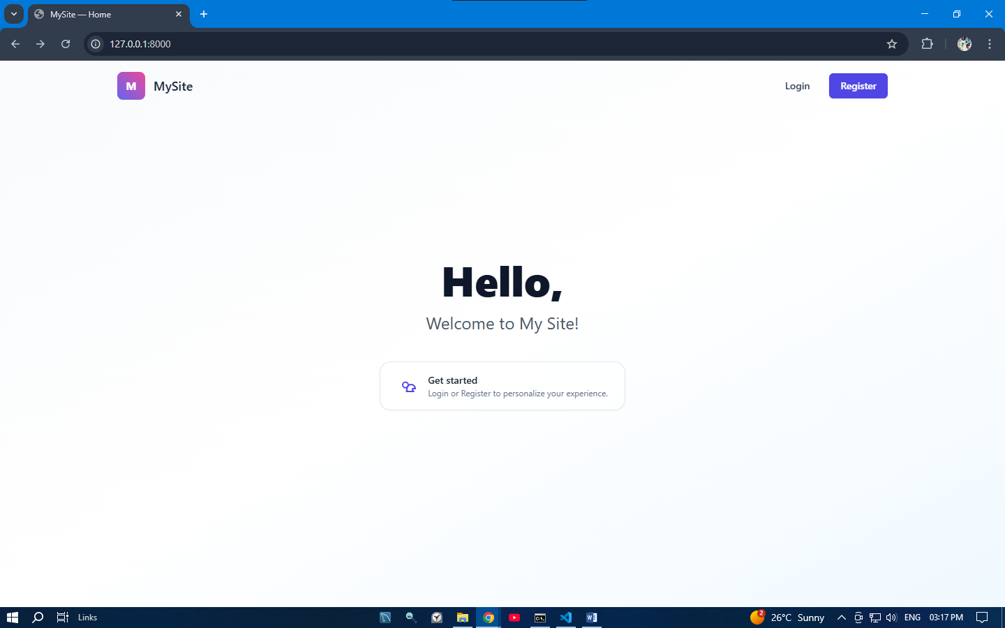
This is our registration page anyone can register one our website.
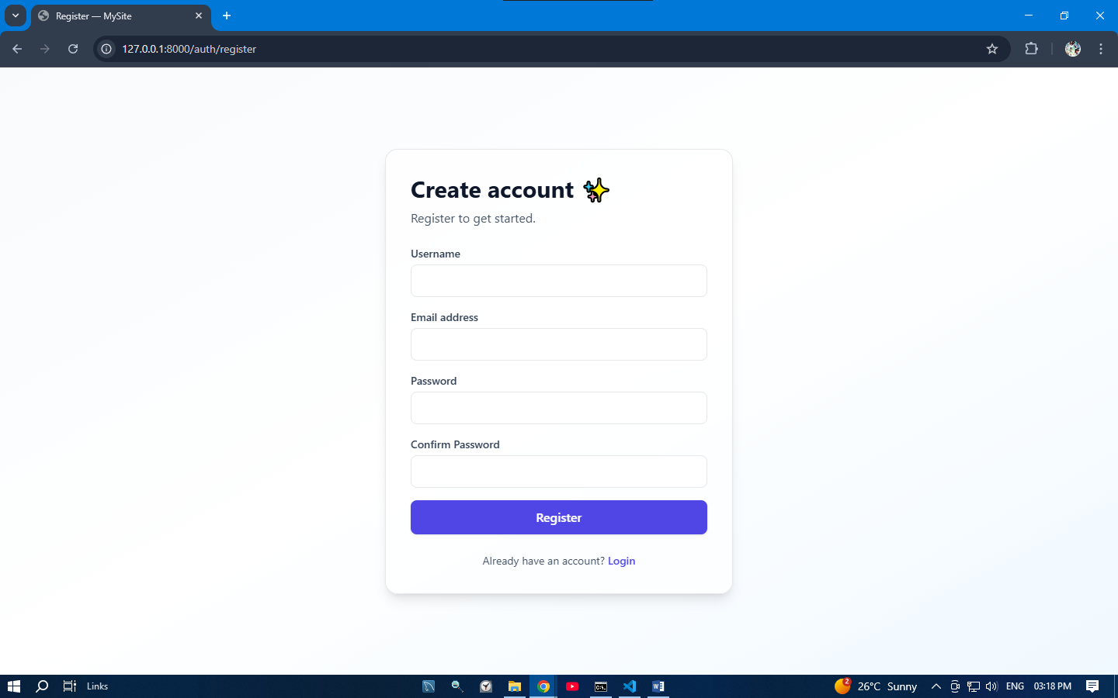
This is our login page after registration user will be redirect to login page.
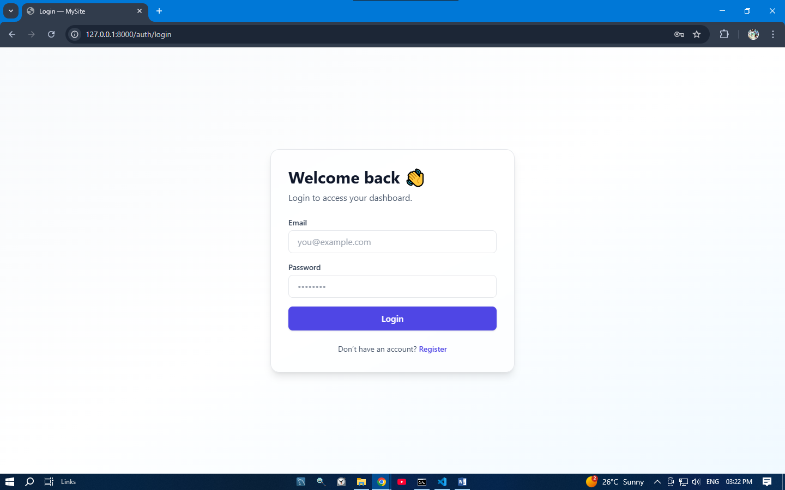This is our user dashboard when user will login they will redirect to this page.
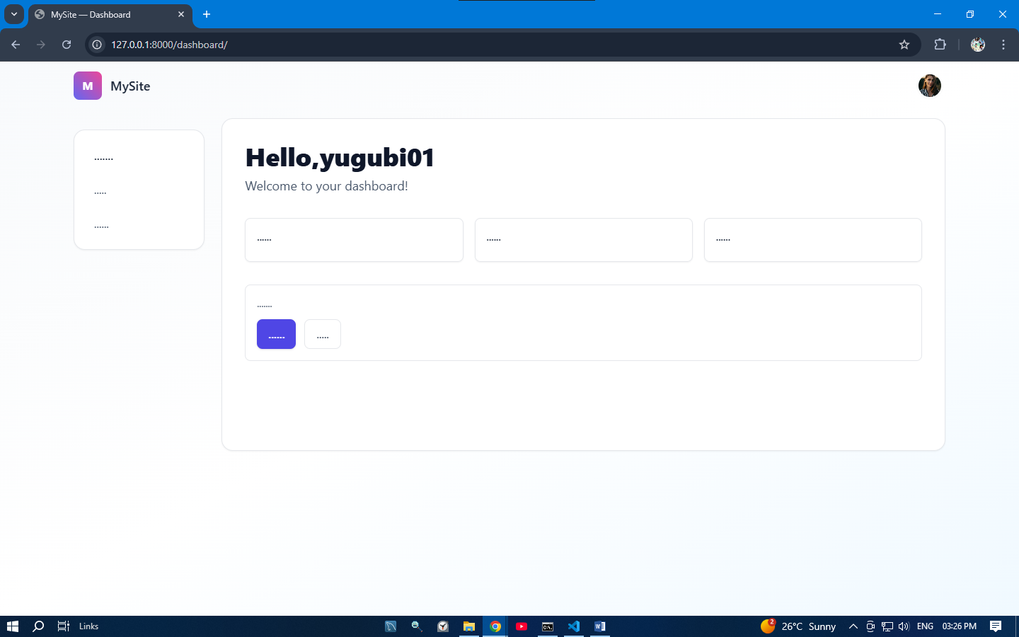
This is our profile page where user can see his profile.
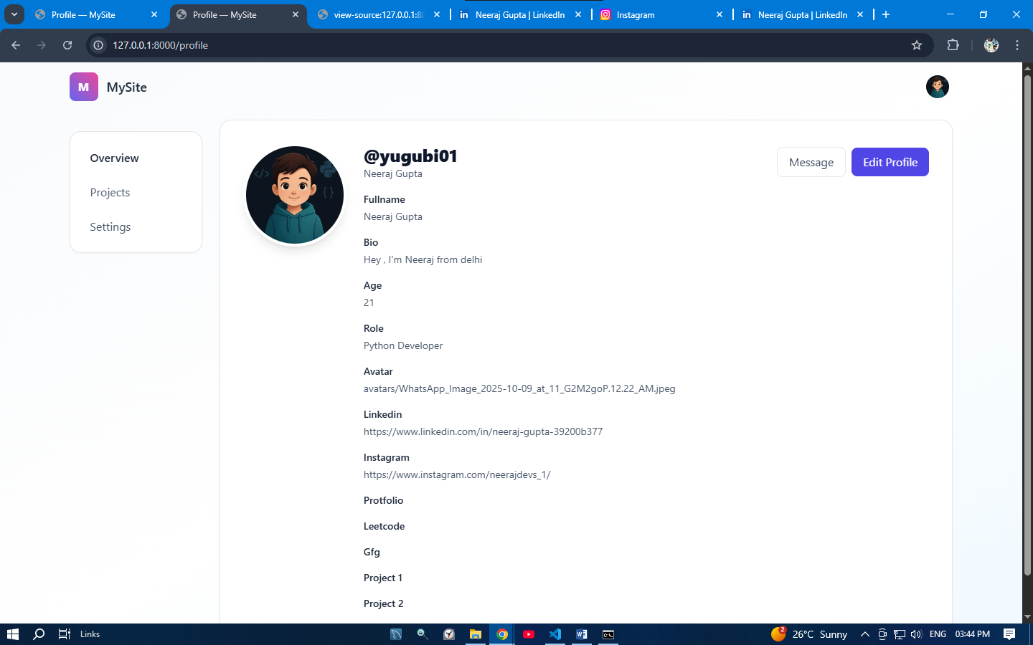
This is our edit profile page user can edit this profile also.
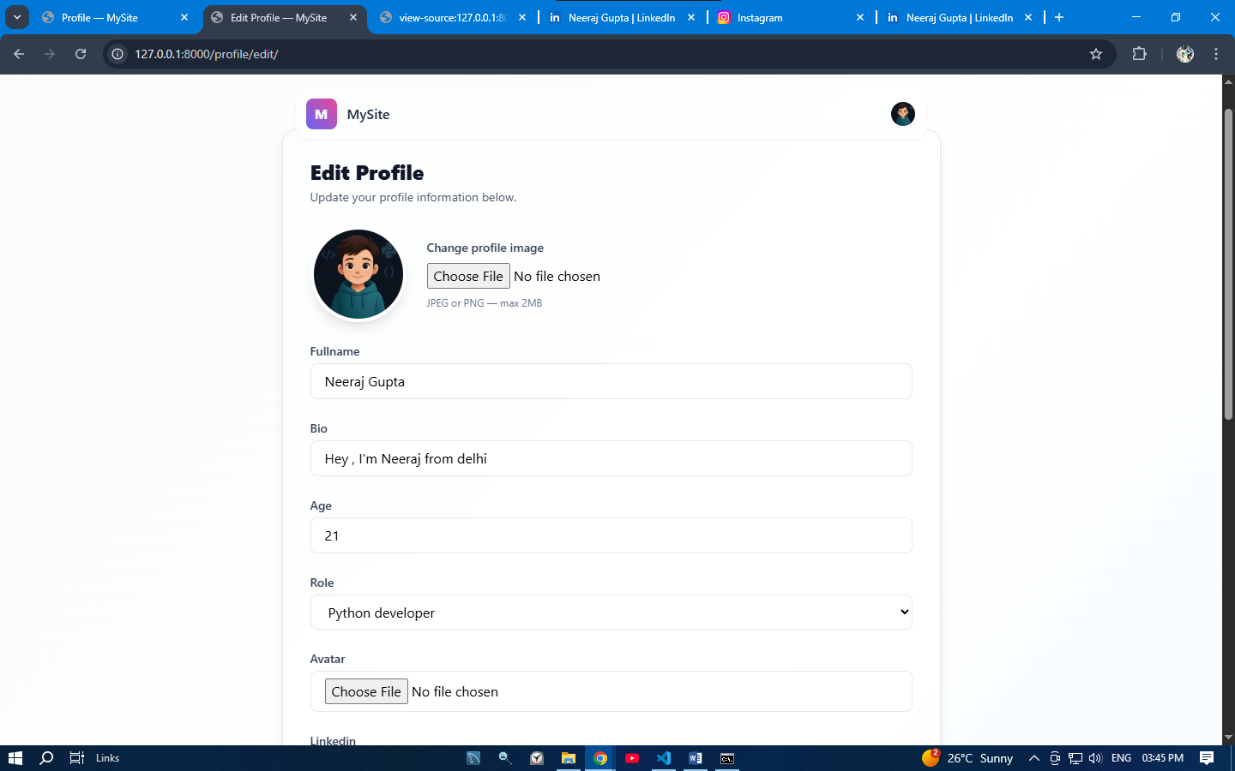
Finished, This is our basic authsystem project where user can register login see his profile update his profile.
Thank You watching this

