Hope I understand the requirement well enough however, what I understand was not looking aligned to Project design but I tried to make it as per the existing design.

First requirement was to understand the project structure and design, so for that I made the Create New Material, and update Interface, repository and service class along with controller and view work. For other product and productMaterial I used data script to insert the data.

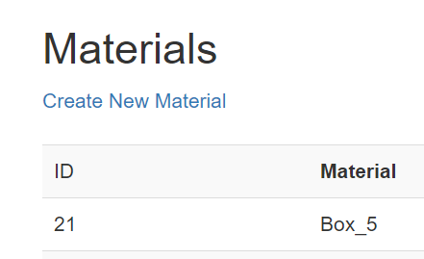

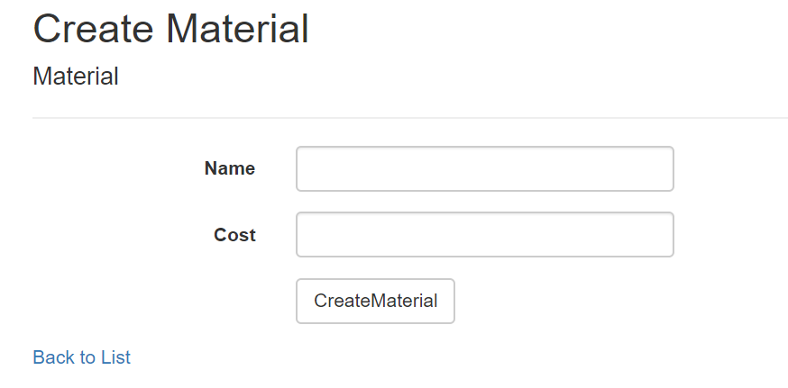

And then implemented the Merger functionality, as per my understanding it should be marked as deleted however requirement was to delete it so I did the same way, update the product Material quantity and deleted the Material , along with give did some validation when and how the Merger will be available.

Like if there is no entry in ProductMaterial table then there should be no merge available however at the same time, if more than two entry, even N entry can be handled by this merger

