RAC is sharing one database between many instances.

Oracle redefined the term "grid" to refer to the adding and removal of small rack-mounted blade servers to Oracle:

Since Oracle 10g, Oracle has added new functions XQuery and XMLTable to its arsenal of XML processing APIs.

XMLQuery lets you construct XML data and query XML and relational data using the XQuery language.

XMLTable lets you create relational tables and columns from XQuery query results.

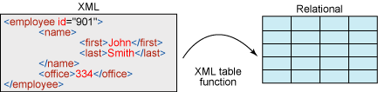

**Example:**

CREATE TABLE EMPLOYEES

(

   id     NUMBER,

   data   XMLTYPE

);

INSERT INTO EMPLOYEES

VALUES (1, xmltype ('<Employees>

<Employee emplid="1111" type="admin">

<firstname>John</firstname>

<lastname>Watson</lastname>

<age>30</age>

<email>johnwatson@sh.com</email>

</Employee>

<Employee emplid="2222" type="admin">

<firstname>Sherlock</firstname>

<lastname>Homes</lastname>

<age>32</age>

<email>sherlock@sh.com</email>

</Employee>

<Employee emplid="3333" type="user">

<firstname>Jim</firstname>

<lastname>Moriarty</lastname>

<age>52</age>

<email>jim@sh.com</email>

</Employee>

<Employee emplid="4444" type="user">

<firstname>Mycroft</firstname>

<lastname>Holmes</lastname>

<age>41</age>

<email>mycroft@sh.com</email>

</Employee>

</Employees>'));

**XMLTable Systax:**

XMLTable('<XQuery>'

PASSING <xml column>

COLUMNS <new column name> <column type> PATH <XQuery path>)

--print firstname, lastname and age of all employees

SELECT t.id, x.*

FROM employees t,

XMLTABLE ('/Employees/Employee'

PASSING t.data

COLUMNS firstname VARCHAR2(30) PATH 'firstname',

lastname VARCHAR2(30) PATH 'lastname',

age int PATh 'age') x

WHERE t.id = 1;

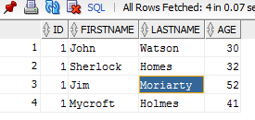

--print firstname of all employees

SELECT t.id, x.*

FROM employees t,

XMLTABLE ('/Employees/Employee/firstname'

PASSING t.data

COLUMNS firstname VARCHAR2 (30) PATH 'text()') x

WHERE t.id = 1;

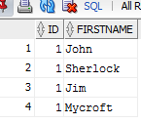

--print employee type of all employees

   SELECT emp.id, x.*

     FROM employees emp,

          XMLTABLE ('/Employees/Employee'

                    PASSING emp.data

                    COLUMNS firstname VARCHAR2(30) PATH 'firstname',

                            type VARCHAR2(30) PATH '@type') x;

**Output:**  
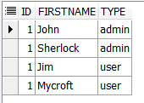

--print firstname and lastname of employee with id 2222

   SELECT t.id, x.*

     FROM employees t,

          XMLTABLE ('/Employees/Employee[@emplid=2222]'

                    PASSING t.data

                    COLUMNS firstname VARCHAR2(30) PATH 'firstname',

                            lastname VARCHAR2(30) PATH 'lastname') x

    WHERE t.id = 1;

**Output:**  
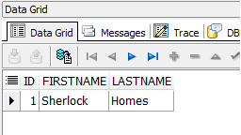

--print firstname and lastname of employees who are admins

   SELECT t.id, x.*

     FROM employees t,

          XMLTABLE ('/Employees/Employee[@type="admin"]'

                    PASSING t.data

                    COLUMNS firstname VARCHAR2(30) PATH 'firstname',

                            lastname VARCHAR2(30) PATH 'lastname') x

    WHERE t.id = 1;

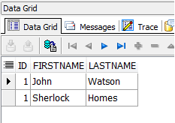

--print firstname and lastname of employees having age > 40

   SELECT t.id, x.*

     FROM employees t,

          XMLTABLE ('/Employees/Employee[age>40]'

                    PASSING t.data

                    COLUMNS firstname VARCHAR2(30) PATH 'firstname',

                            lastname VARCHAR2(30) PATH 'lastname',

                            age VARCHAR2(30) PATH 'age') x

    WHERE t.id = 1;

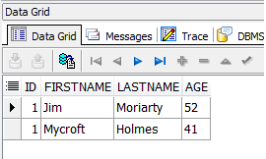

Oracle Architecture- PFiles, SPFiles, Control Files, Redo Logs and Datafiles

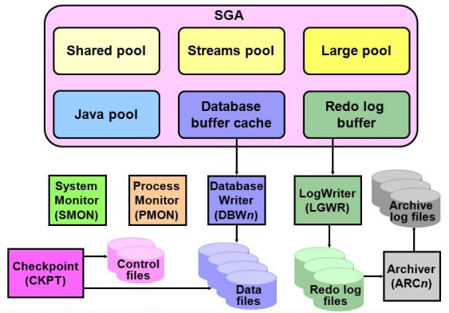

Each database instance is madeup of 1 datafile, 1 control file and 2 redo log files.

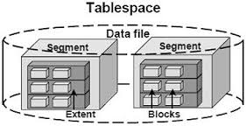

alter system set db_block_size=4096 scope=spfile;

Atomicity

Atomicity requires that each transaction is "all or nothing":

if one part of the transaction fails, the entire transaction fails, and the database state is left unchanged.

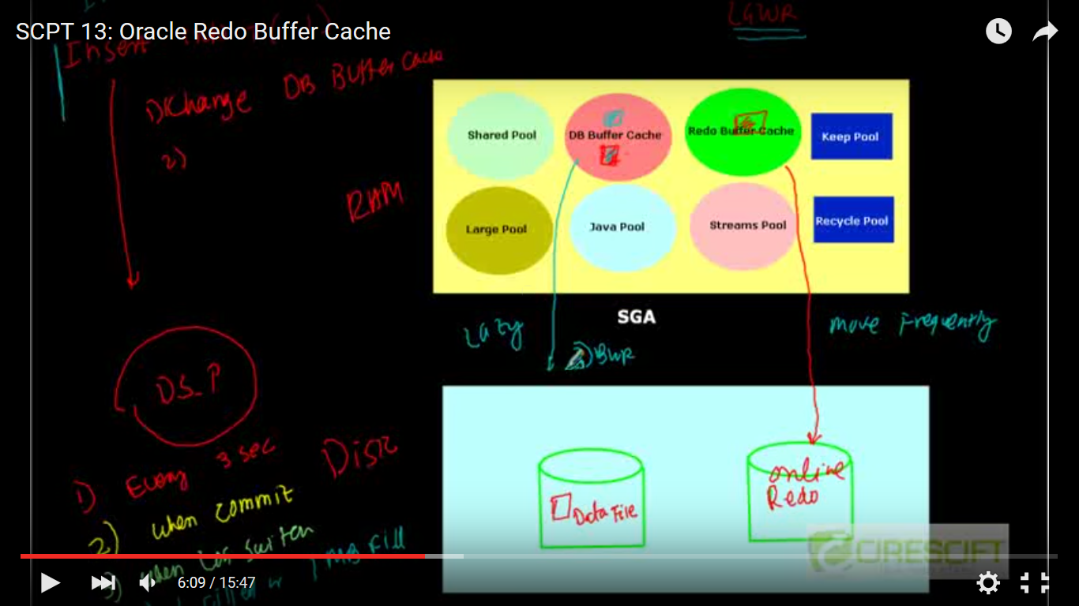

1. Every 3 sec
2. When commit
3. Log switch
4. 1 MB full

Select substr(‘ORACLE’,level,1) from dual

Connect by level <= length(‘ORACLE’);

**SQL Profile**

A **SQL profile** is a database object that contains auxiliary statistics specific to a SQL statement.