MANAV RACHNA UNIVERSITY

PYTHON LAB



NEERAJ DWIVEDI

B-TCEH CSE 4C

2K18CSUN01030

1. [Check whether a number is even or odd](https://www.programiz.com/python-programming/examples/prime-number).

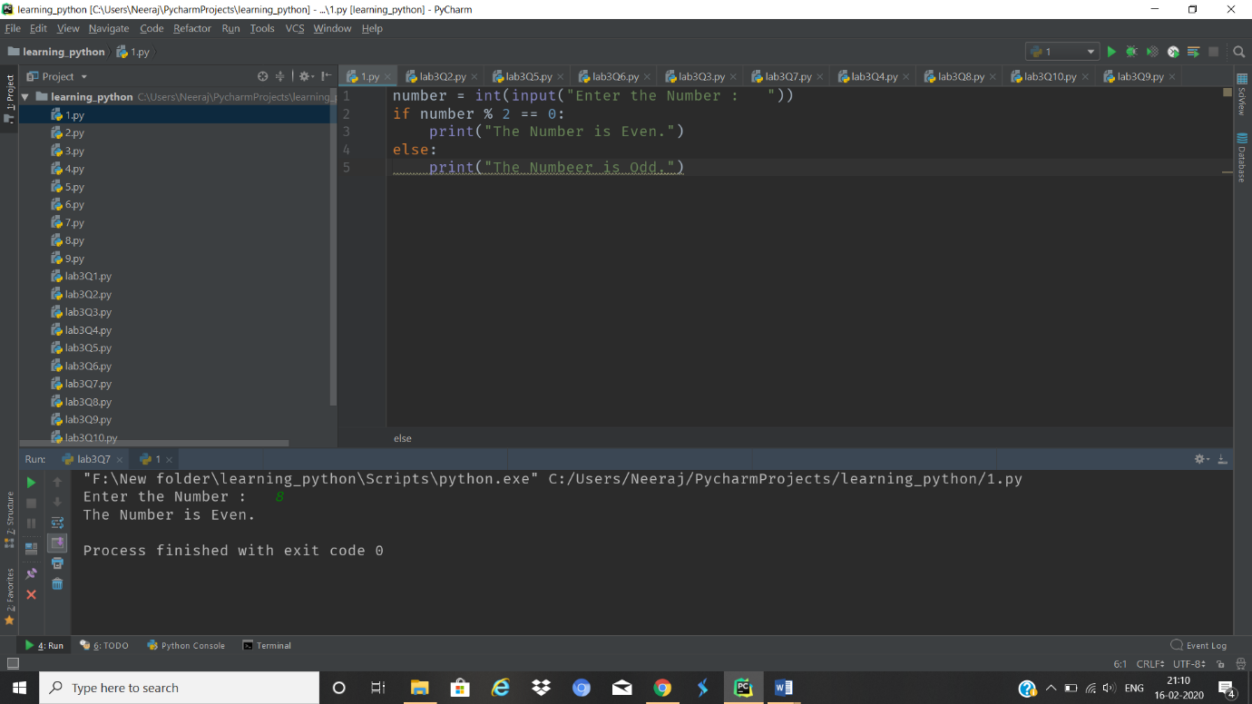

1. [Check whether an entered year is leap year or not.](https://www.programiz.com/python-programming/examples/prime-number)

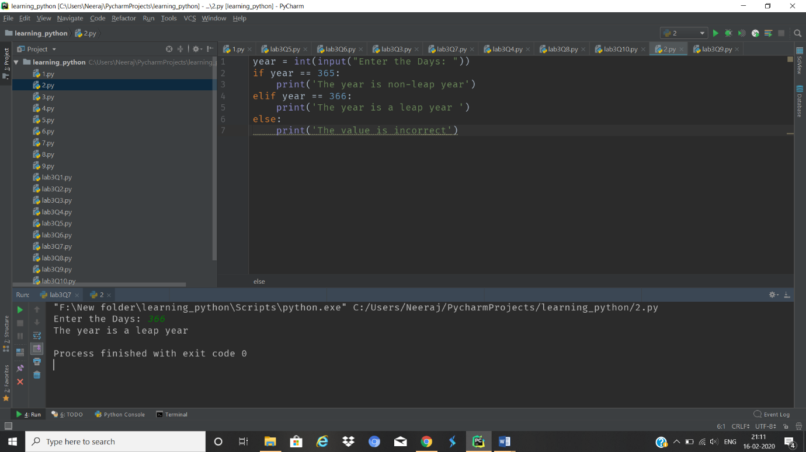

1. Write a program to check whether a character is vowel or consonants.

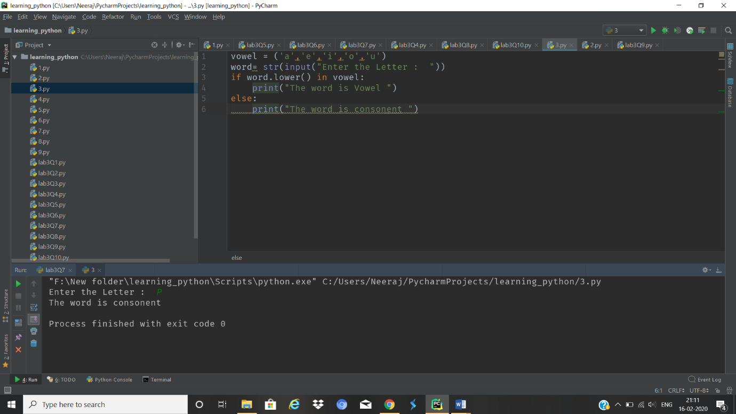

1. Write a program to find the smallest of two numbers.

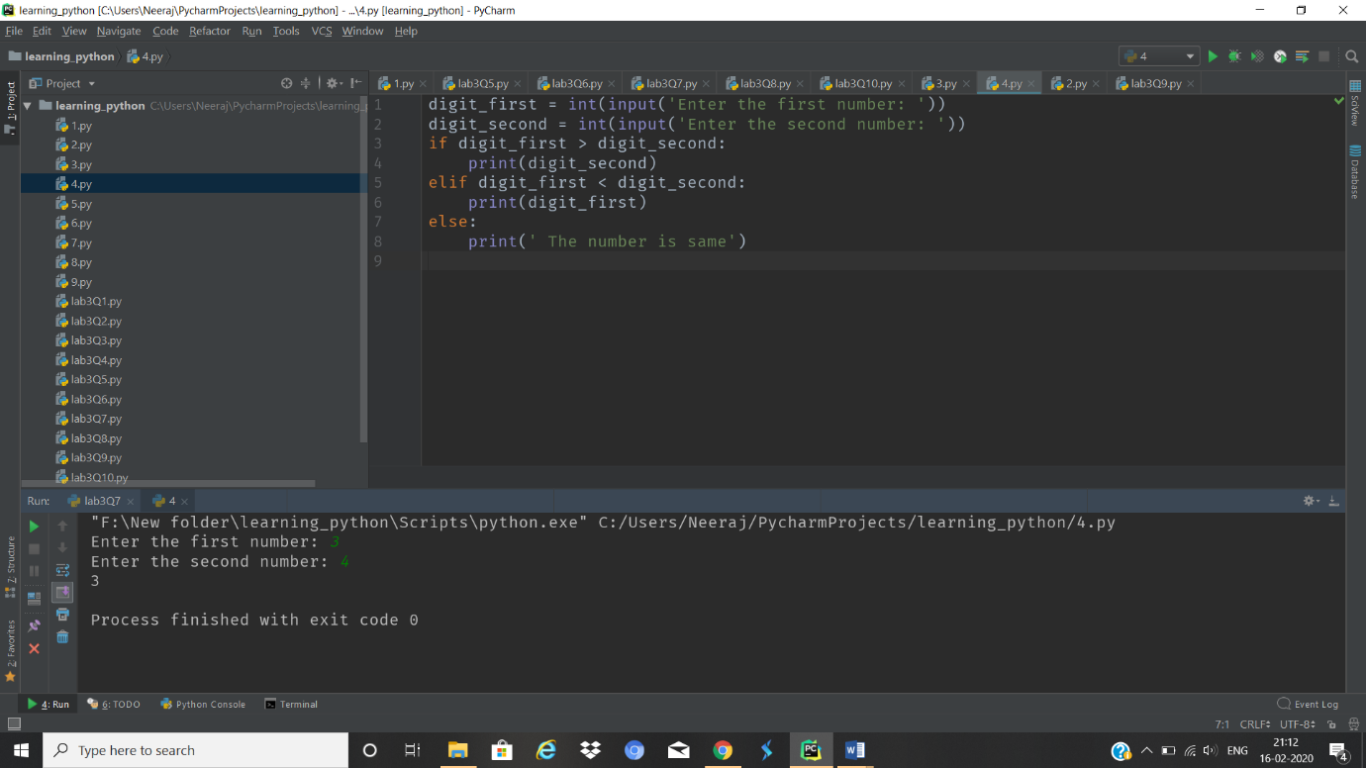

1. [Find the Factorial of a Number](https://www.programiz.com/python-programming/examples/factorial)

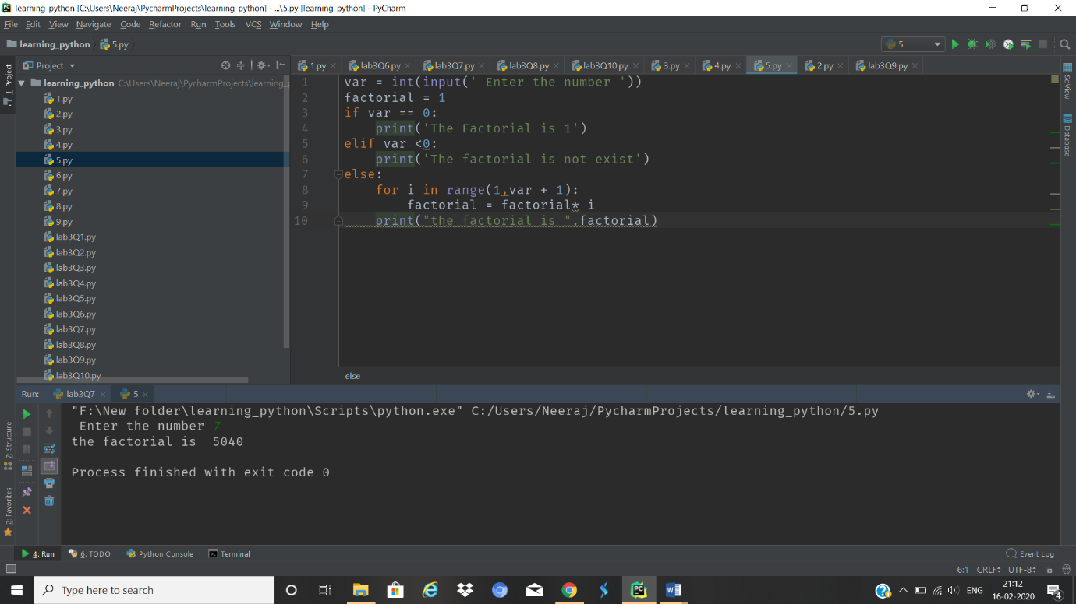

1. Write a program to print this pattern.

*

* *

* * *

* * * *

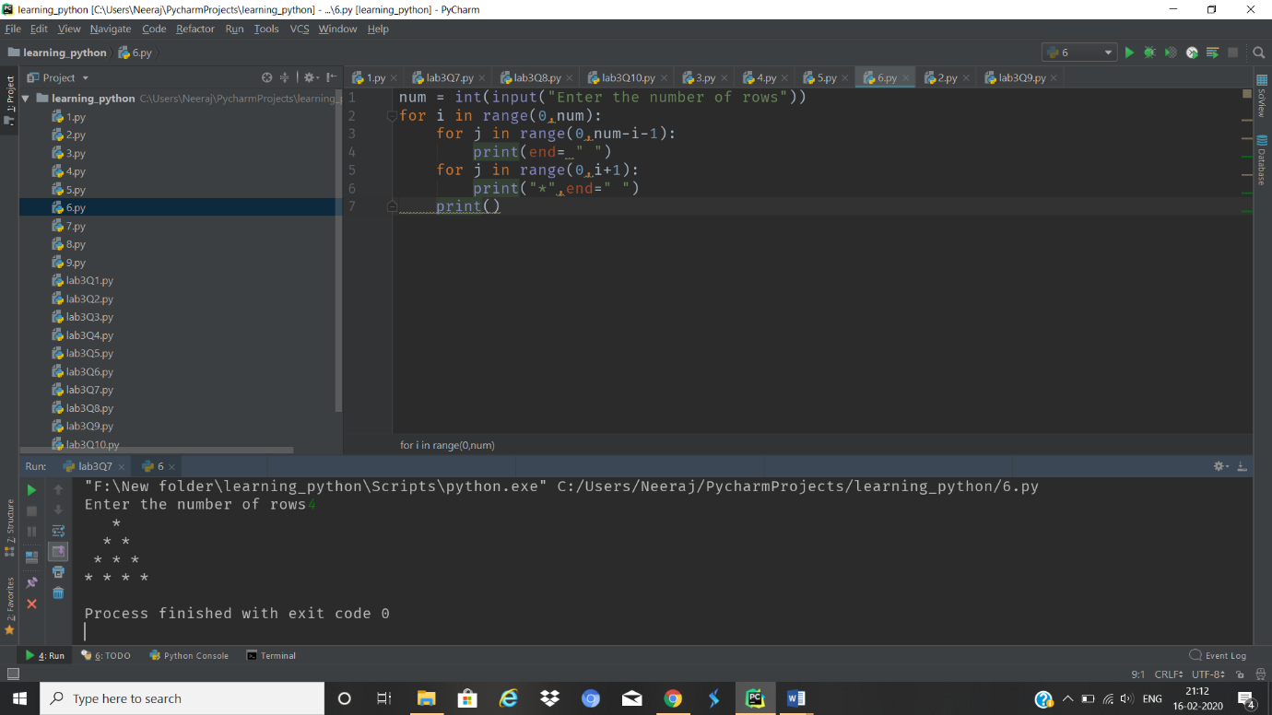

1. Write a program to print this series

1 1 2 3 5 8 13

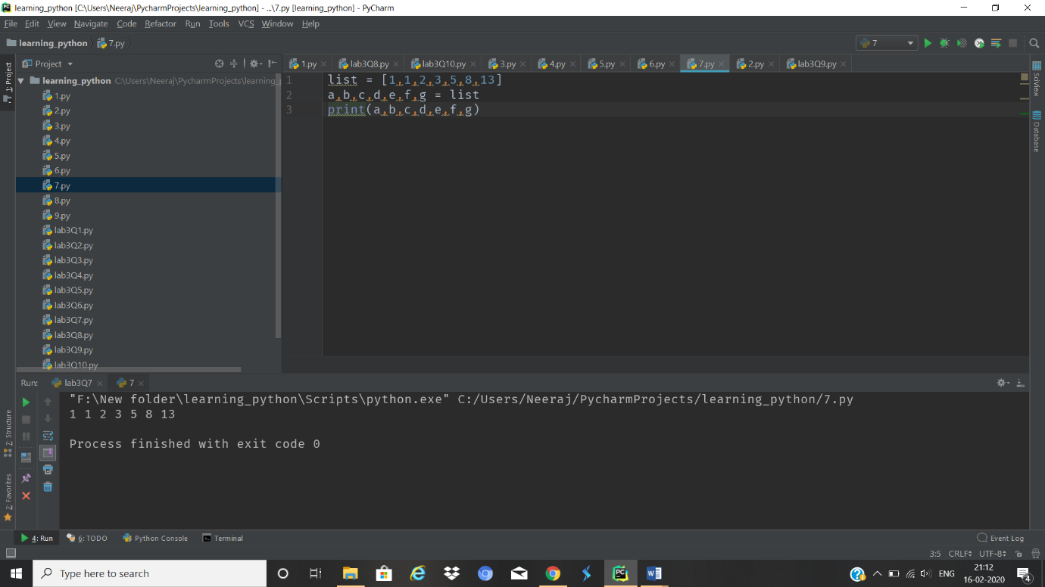

1. [Check whether a number is prime or not](https://www.programiz.com/python-programming/examples/prime-number)

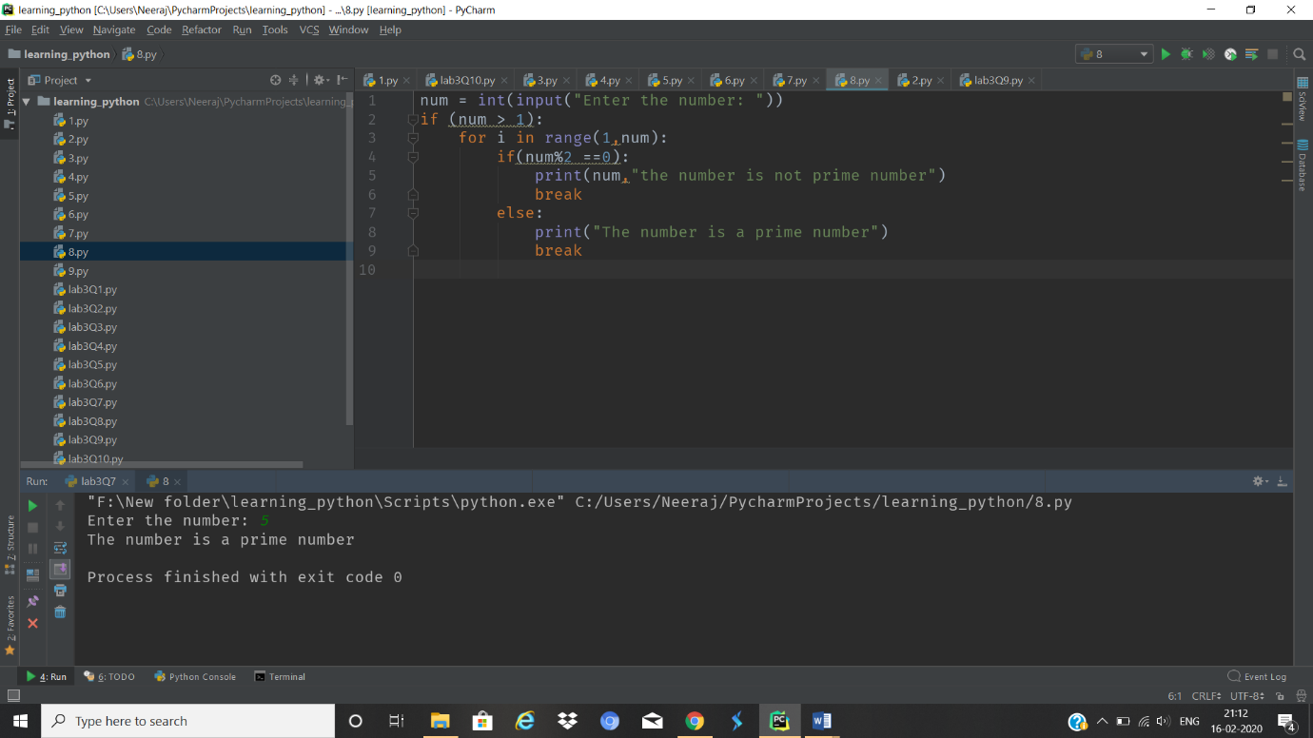

1. [Make a Simple Calculator](https://www.programiz.com/python-programming/examples/calculator).

