Design Document – Signal 2 Hypothesis
Status | Draft
Date | 2026-04-13
Tech Lead | Vijay Korapadi
DS Owner | Jean-Simon Marrocco and Rashmi Ranjan Bhuyan
PM Owner
Reviewers
Contributor | Chat Mishra, Nikhil Gopal, Manik Kosht, Andres Padilla, Antara Tewary, Karan Mudaliar and Neeraj Jhaveri
ADO
Template | DesignDocument_v1.docx

Table of Contents
2 Executive Summary 2
3 S2H Workflow Definition of Done 2
4 Milestone 3
4.1.1 Timeline | 1-Week Sprint Plan 3
5 Proposed Solution 4
5.1 Architecture 4
5.1.1 Core Concept Definition 4
5.1.2 Overview Diagram 5
5.1.3 Sequence Diagram 7
5.1.4 JSON Config Files 8
6 Annexe 10

Executive Summary
This project builds an agentic workflow within the RATIO-AI agents service that continuously processes incoming Signals (data points from Kusto clusters and other sources), maps them to predefined Symptoms (observable patterns/conditions), and maps those Symptoms to Hypotheses (likely root causes). The entire Signal → Symptom → Hypothesis pipeline is configurable via JSON files, supports many-to-many relationships at every level, and uses a ranking algorithm to surface the most probable hypothesis when multiple candidates are active.
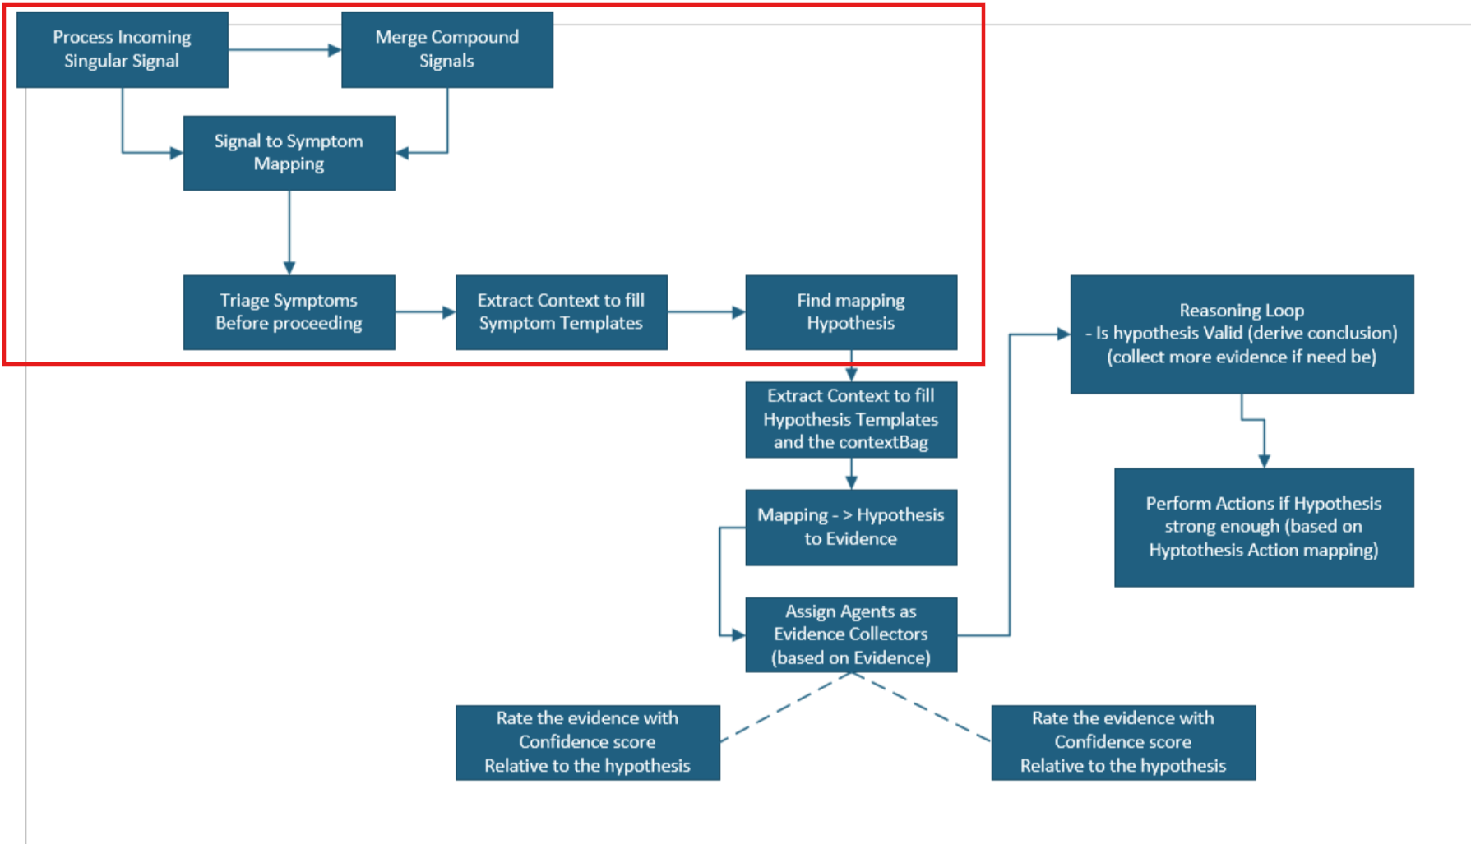

S2H Workflow Definition of Done
- End-to-end call works (via agent or api calls)
Return ranked hypotheses, each traced back through symptoms to source signals
- Configurable without code changes
Modifying the 3 JSON mapping files changes which signals produce which symptoms and which hypotheses activate, without redeploying
- Ranking is correct
Given 2+ active hypotheses, the WeightedCoverageRanker returns them ordered by score
- Many-to-many relationships work
A single signal can trigger multiple symptoms, and a single symptom can contribute to multiple hypotheses simultaneously

Milestone
Feature | Title | Effort (hrs) | Dependencies
F1 | Domain Models & Pydantic Schemas | 5 | —
F2 | JSON Configuration Loader | 6 | F1
F3 | Signal Source Abstraction & Kusto Implementation | 7 | F1
F4 | Signal-to-Symptom Mapper | 8 | F1, F2
F5 | Symptom Triage & Template Filling | 4 | F4
F6 | Symptom-to-Hypothesis Mapper & Ranker | 9 | F1, F2
F7 | Agent Tools (@tool functions) | 5 | F3, F4, F5, F6
F8 | S2H Agents (3 agents + registration) | 3 | F7
F9 | S2H Workflow Orchestration | 4 | F8
F10 | API Endpoint & Integration | 4 | F9
 | Total | 55

Timeline | 1-Week Sprint Plan
Sprint: 2026-04-21 → 2026-04-25 (5 working days) Team: Jean-Simon and Capacity: ~5.5 productive hours/day/person = ~55 person-hours total
Day | Dev 1 | Dev 2
Mon | F1 (5h) | F2 5.5h)
Tue | F3 (5.5h) | F4(5.5h, continues Wed)
Wed | F3 (1.5h) + F5(4h) | F4 (2.5h) + F6 (3h)
Thu | F7 (5h) | F6 (5.5h)
Fri | F8 (3h) + F9 (4h) | F8 + F10 (4h) + Integration testing (1.5h)
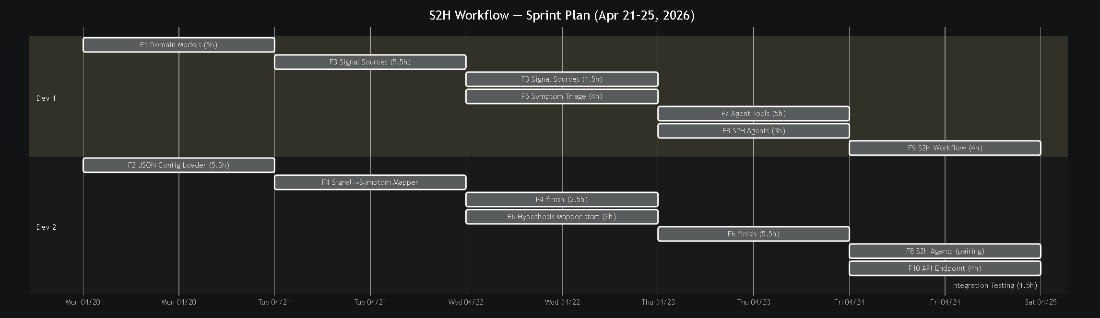

Proposed Solution

Architecture

Core Concept Definition
Object | Purpose | Design Pattern
Signal | Immutable data point from an external source. Carries payload (raw data) and metadata (source info, timestamps). | Value Object
CompoundSignal | Aggregation of related singular signals into one composite. Used when multiple raw events represent a single logical signal. | Composite
Symptom | Observable pattern/condition derived from one or more signals. Has a template string with {placeholders} filled from signal context. | Template Method
Hypothesis | A potential root cause or explanation. Activated when its required symptoms are present. Scored by a ranker. | —
SignalSource | Abstract interface for fetching signals from external systems. | Strategy / Abstract Factory
KustoSignalSource | Concrete signal source backed by a Kusto cluster. Uses Code.Shared.clients.kusto_client. | Strategy
SignalSymptomMapper | Evaluates signals against configurable rules to produce symptoms. | Strategy
SymptomHypothesisMapper | Evaluates active symptoms against hypothesis definitions. | Strategy
HypothesisRanker | Abstract ranker interface. Pluggable strategy for scoring and ordering hypotheses. | Strategy
WeightedCoverageRanker | Default ranker: scores hypotheses by (matched symptoms / required symptoms) × confidence weight. | Strategy
MappingConfig | Loads and validates JSON configuration files. | Factory Method

Overview Diagram
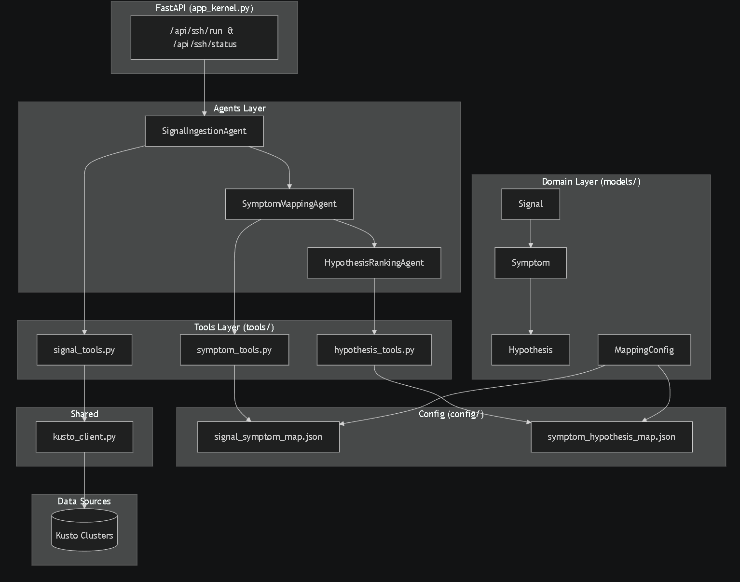
- FastAPI (app_kernel.py) : The HTTP entry point. Exposes POST /api/s2h/run to trigger the pipeline and GET /api/s2h/status to check run status. Routes requests into the agents’ layer.
- SignalIngestionAgent : First agent in the chain. Fetches raw data from external sources (Kusto clusters, etc), converts rows into Signal objects, and merges compound signals before handing off to the next agent.
- SymptomMappingAgent: Second agent. Takes incoming signals, evaluates them against configurable rules from signal_symptom_map.json, and produces Symptom objects with filled templates and confidence scores. Also triages (deduplicates and prioritizes) symptoms.
- HypothesisRankingAgent: Third and final agent. Takes active symptoms, matches them against hypothesis definitions from symptom_hypothesis_map.json, scores each hypothesis using the WeightedCoverageRanker, and returns them ranked by likelihood.
- signal_tools.py / symptom_tools.py / hypothesis_tools.py: @tool-decorated functions that each agent calls. Thin wrappers around the domain services , they accept/return JSON strings so the LLM can invoke them during agent execution.
- Signal / Symptom / Hypothesis / MappingConfig: Domain models. Signal is an immutable data point, Symptom is a pattern derived from signals, Hypothesis is a scored root-cause candidate, and MappingConfig loads/validates the JSON rule files.
- kusto_client.py: Shared Kusto client (clients). Provides query_kql() and query_kql_async() using DefaultAzureCredential with per-cluster client caching. Already exists in the codebase.
- signal_symptom_map.json / symptom_hypothesis_map.json: JSON configuration files defining the many-to-many mapping rules. Signal→Symptom rules include conditions and context extraction. Symptom→Hypothesis rules include required/anti symptoms, match conditions, and scoring weights.

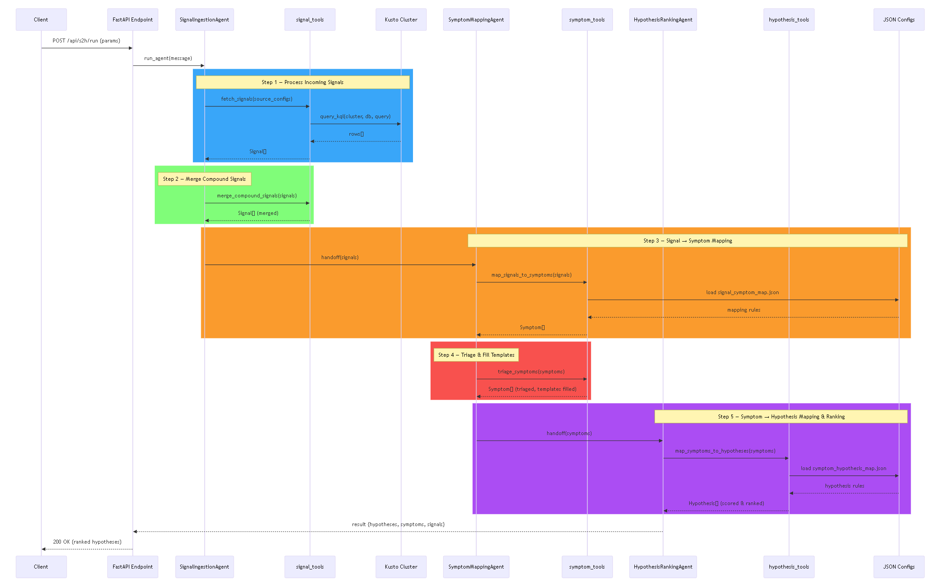
Sequence Diagram
Step 1 | Process Incoming Signals (blue)
- Client sends POST /api/s2h/run {params} to the FastAPI endpoint
- FastAPI calls run_agent(message) on the SignalIngestionAgent
- The agent invokes fetch_signals(source_configs) via signal_tools
- signal_tools calls query_kql(cluster, db, query) against the Kusto cluster
- Kusto returns raw rows[]
- signal_tools converts rows into typed Signal[] objects and returns them to the agent
Step 2 | Merge Compound Signals (green)
- SignalIngestionAgent calls merge_compound_signals(signals) via signal_tools
- Groups related singular signals by a key (e.g., same service + time window) into CompoundSignal objects
- Returns Signal[] (merged) , the deduplicated, consolidated signal set ready for mapping
Step 3 | Signal → Symptom Mapping (orange)
- SignalIngestionAgent hands off the merged signals to SymptomMappingAgent via handoff(signals)
- SymptomMappingAgent calls map_signals_to_symptoms(signals) via symptom_tools
- symptom_tools loads signal_symptom_map.json from the JSON config files
- Config returns the mapping rules (signal types, conditions, context extraction paths)
- Each signal is evaluated against all matching rules, signals that satisfy conditions produce Symptom[] objects with extracted context
Step 4 | Triage & Fill Templates (red)
- SymptomMappingAgent calls triage_symptoms(symptoms) via symptom_tools
- Deduplicates symptoms (merges source_signal_ids, keeps highest confidence)
- Fills remaining template placeholders with extracted context or defaults (e.g., "SR spike detected: 47 SRs in 5m for Compute")
- Sorts symptoms by confidence descending
- Returns Symptom[] (triaged, templates filled)
Step 5 | Symptom → Hypothesis Mapping & Ranking (purple)
- SymptomMappingAgent hands off triaged symptoms to HypothesisRankingAgent via handoff(symptoms)
- The agent calls map_symptoms_to_hypotheses(symptoms) via hypothesis_tools
- hypothesis_tools loads symptom_hypothesis_map.json from config
- Config returns hypothesis rules (required symptoms, anti-symptoms, weights, thresholds)
- Each hypothesis is scored: matched symptom weights × confidence, divided by total weights
- Anti-symptoms suppress hypotheses; match conditions (e.g., same service) are enforced
- Returns Hypothesis[] (scored & ranked by the WeightedCoverageRanker)

JSON Config Files
signal_sources.json
- Defines each data source the pipeline polls (currently Kusto clusters)
- Each source entry specifies:
  - source_id / source_type : unique name and type (e.g., "kusto")
  - signal_type: category of signal produced (e.g., "sr_volume_spike", "outage_declared")
  - cluster / database — which Kusto cluster and database to query
  - query_template: parameterized KQL query with {placeholders} (e.g., {lookback}, {bin_size})
  - parameters: default values for the query template placeholders
  - field_mappings: maps Kusto column names to standardized Signal payload fields (e.g., "service": "OwningServiceName")

signal_symptom_map.json
- Contains rules that decide when a signal produces a symptom
- Each rule specifies:
  - signal_types: which signal types this rule applies to (e.g., ["sr_volume_spike"])
  - conditions : filter the signal must pass: field, operator (>=, <=, ==, !=, in, not_in), and value (e.g., count >= 10)
  - produces_symptom: the symptom ID to create if the condition passes
  - context_extract: JSONPath-like mappings that pull values from the signal's payload into the symptom's context (e.g., "service": "$.payload.service")
- Contains symptom definitions — each symptom has a name, description, and template string with {placeholders} that get filled from the extracted context (e.g., "SR spike detected: {count} SRs in {window} for {service}")
- A single signal can match multiple rules → multiple symptoms (many-to-many)

symptom_hypothesis_map.json
- Defines each hypothesis (potential root cause) and what symptoms must be present to activate it
- Each hypothesis specifies:
  - required_symptoms: list of symptom IDs that must be active (e.g., ["sr_surge", "active_sev_outage"])
  - anti_symptoms: symptom IDs that, if present, suppress this hypothesis entirely (e.g., an "isolated SR spike" hypothesis is suppressed if an outage is active)
  - match_conditions : cross-symptom constraints (e.g., "service": "exact_match" means the service field must be the same across all matched symptoms)
  - weights: numeric weight per required symptom, controlling how much each symptom contributes to the score
  - threshold: minimum score (0.0–1.0) for the hypothesis to be considered active

Annexe

