
e-Yantra Robotics Competition 2019-20
Theme Analysis and Implementation
<4078>
Team leader name | Mayank Singhal
College | Bharati Vidyapeeth’s College of Engineering
Email
Date

Testing your knowledge (Related to Hardware)

Q1. 12.5W is the Max. Output power delivered by eYFi-Mega board [ 1 Mark ]
<Teams should refer the Hardware Manual provided>

Q2. The Line Follower Array has the default I2C address of 0x20. What changes must be done to change the address to 0x27?
Is R/W bit considered in address formation (Yes/ No)? [ 2 Marks ]
<Teams should refer the Manuals provided. You may use figures / diagrams to support your answer.
Answer format: Text, word-limit: 50 words >

Ans- To change the address to 0x26 from default value 0x20 (0100000₂) move the solder jumper to set A2, A1, A0 (Fig. 1), according to binary equivalent of 0x26 i.e. 0100110. Comparing the last three bits, move A2, A1 to the ‘1’ position and leave A0 at ‘0’.
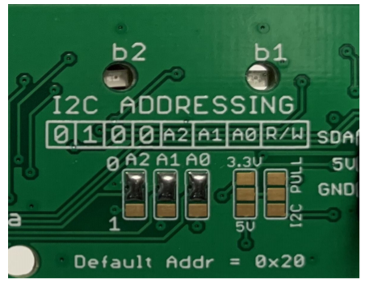
Fig. 1: I2C Addressing

Q3. Universal Asynchronous Receiver and Transmitter (UART) protocol is used for communication between ATmega2560 and ESP32 on eYFi-Mega board. [ 1 Mark ]
<Teams should refer the Hardware Manual provided>

Q4. 7.0 to 21.0V is the voltage range of External DC Power Supply for eYFi-Mega board.
2.5A is the max. current delivered by 5V when powered through External Supply.
800mA is the max. current delivered by 3.3V when powered through External Supply.
[ 3 Marks ]
<Teams should refer the Manuals provided>

Q5. Where are you planning to place the eY-LFA sensor on the robot. Justify your answer.
[ 5 Marks ]
<Answer format: Text, word-limit: 200 words>

Q6. How many VL53L0X sensors are you planning to use and where you will place them on the robot. Justify your answer. [ 6 Marks ]
<Answer format: Text, word-limit: 200 words>

Testing your knowledge (Related to Rulebook)

Q1. Consider the following scenario for all the below cases:
Total Number of Vacancies in all Hospitals (X) = 12
Digits in the maze image = [2, 4, 3, 6, 7, 1, 5, 8]
Total Time taken to complete the task (T) = 200 sec
Assume the cases mentioned below, consider the locations of digits as dummy and the shortest path is communicated to robot using which it tries to traverse all the firezones planned.

Case I : [ 4 Marks ]
  - All Digits in image = # [2, 4, 3, 6, 7, 1, 5, 8] #
  - Combination of digits for sum with their locations = # { 2: (2, 4), 3: (3, 5), 7: (3, 7) } #
  - Robot visited all planned firezones correctly

Case II : [ 4 Marks ]
  - All Digits in image = # [2, 4, 3, 6, 7, 1, 6, 8] #
  - Combination of digits for sum with their locations = # { 7: (3, 7), 4: (4, 8) } #
  - Robot only missed to visit the firezone at location (3, 7)

Case III : [ 4 Marks ]
  - All Digits in image = # [2, 4, 3, 6, 7, 1, 5, 8] #
  - Combination of digits for sum with their locations = # { 6: (4, 4), 7: (3, 7) } #
  - Robot visited all planned firezones correctly

Fill in the values of parameters of the Scoring Formula for each case.
<Teams should refer the Rulebook provided>

Parameters | Case I | Case II | Case III
VFC
VFI
NFP
NVP
NVC
NEC
NVH
B
Total

IMPORTANT:

- The document you submit should be in YOUR OWN WORDS. To avoid any copyright violations, you must NOT copy phrases directly from manuals or web.
- The team should NOT mail or upload the document anywhere else except on the portal.
- Teams failing to submit the document by the deadline will lose the marks for this task.
- e-Yantra WILL NOT entertain any request for extension of deadline for uploading the task.
- e-Yantra holds complete discretion to disqualify a team if any foul play is suspected.

