BAN 5753

**Neeraj Kankani**

**Pranjali Pingale**

**Moises Marin**

**Zach Miller**



Mini Project 2

Neeraj Kankani

Pranjali Pingale

Moises Marin

Zach Miller

Table of Contents

Background of Analysis 2

Executive Summary 2

Exploratory Data Analysis 2

Predictive Models 7

K-means Clustering 14

Prescriptive Recommendations 15

# Background of Analysis

The purpose of this project is to classify and identify clients who will subscribe for a term deposit. The bank would like our team to conduct an EDA to identify relationships and trends in the data that has been provided. Following the EDA, we have been asked to develop and save a predictive model for future classification of clients. In our modeling section, you will find that we have tested many modelling techniques and have explained our findings about each approach. Following our model completion, you will find our prescriptive recommendations.

# Executive Summary

Our exploratory data analysis provided nothing out of the ordinary but did increase our understanding of the provided dataset. Our primary findings include the identification of variable types (10 numeric and 11 categorical), cardinality of each variable (“duration” with the highest cardinality at 1544 & “Y” with the lowest cardinality at 2), no null records found, and distributions as expected for both numeric and categorical variables. Through our categorical variable distribution plots, we can say that most of our population holds jobs in administration or blue-collar, is married, and has at least a university degree with a house and no loans.

Following some data transformation, we were ready to start building predictive models to predict which clients will subscribe for a term deposit. In total, we created 5 models: Logistic Regression, Decision Tree, Random Forest, Gradient Boosted Tree, and Support Vector Classifier. After running and comparing the models, we have concluded that the Gradient Boosted Tree model performed the best and should be the model that is implemented for production. The Gradient Boosted Tree predicted with nearly 90% accuracy. Within this model “duration,” “nr_employed,” and “euribor3m” were identified as the 3 most important features for prediction.

# Exploratory Data Analysis

To begin our exploratory data analysis, the team decided to identify the numeric and categorical variables so we could begin to understand what we were dealing with. After writing the code to do so, we asked it to print a list of each. Those lists can be viewed below:

It does not appear that any variables stand out as potentially incorrectly identified. There are 10 numeric variables and 11 categorical variables.

To further our understanding of the data, we decided to seek the cardinality of all variables. To do so, we essentially counted the number of distinct values contained by each variable. The variables paired with their counts can be viewed below:

**Cardinality:**

As expected, there is a wide range of unique values from variable to variable. As you can see, the variable with the highest cardinality would be ‘duration’ with a distinct count of 1544 values, and the lowest cardinality belongs to ‘y’ with a distinct count of 2 values.

Now that we have gotten some of the gritty details out of the way, we now want to view the overall summary statistics for numeric variables before going any deeper into variable transformation. The summary statistics is quickly followed by a check of null values to ensure that we are not dealing with any amount of missing data.

**Summary Statistics:**

**Check for Nulls:**



After reviewing the summary statistics, we can say that there is nothing out of the ordinary regarding the numeric variables that would lead to a need for transformation. It also appears that we got lucky with our data as no null values have been identified that would have required removal or imputation.

A deeper dive into our data would also require a check of the distribution of the numeric and categorical variables. Most of the time, you would be hoping to see relatively normal distributions across the board, but that cannot always be expected. A plot of our numeric variable distributions can be viewed below:

In these plots, we can see a couple of relatively normal distributions such as Age, but most are heavily skewed. These may need to be transformed in the future to conduct our modeling.

A plot of our categorical variable distributions can be viewed below:

In the case of distributions of categorical variables, we are not so worried about normal distributions like we were for numerical variables. This, rather, is more of a descriptive visualization to view demographics of the population in our dataset. We can see that most of our population holds jobs in administration or blue-collar, is married, and has at least a university degree with a house and no loans.

We also found it particularly important to focus on the distribution of the target variable “Y.” You can view the distribution below:

**Bivariate Analysis of input variables:**

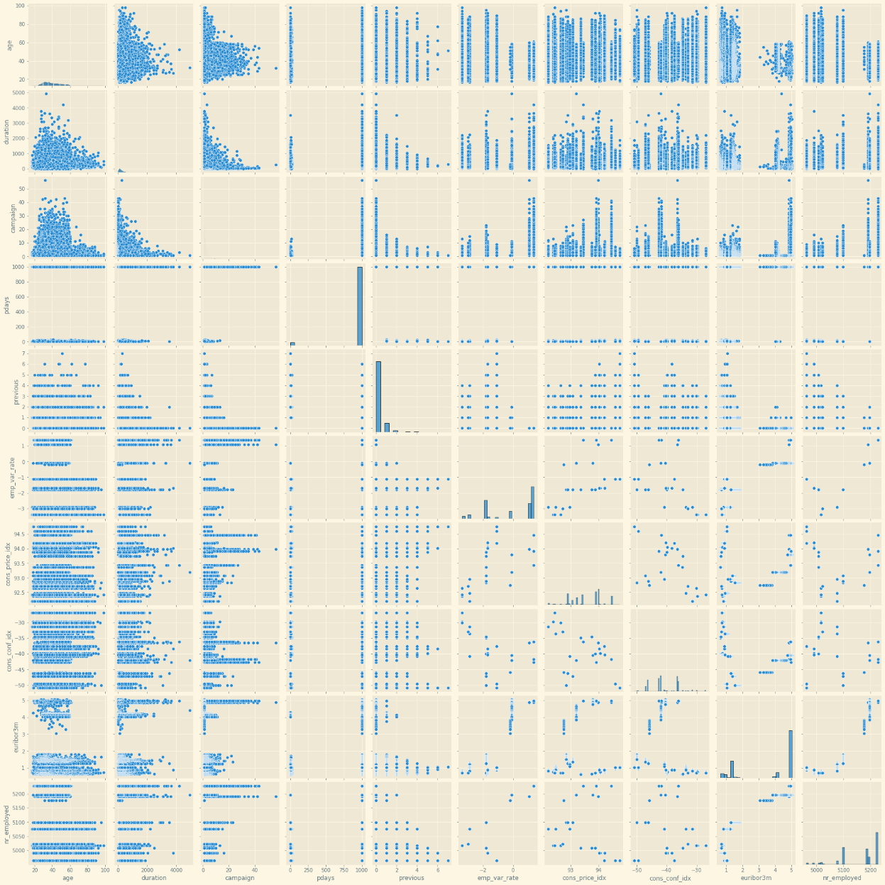

**Correlation between target and input variables:**

**Correlation Matrix:**

Correlation matrix shows the pairwise relation between input and target variables. Higher correlation means that variable can explain more variability in the target variable according to pearson correlation coefficient.

# Predictive Models

The goal of the predictive models is to identify what customers are likely to subscribe to a term deposit. We used the OneHotEncoder function with job, marital, education, default, housing, loan, contact, month, day_of_week and poutcome features to prepare them to be used in the creation of the models.

The following picture shows a sample of the columns that were encoded with the OneHotEncoder function.

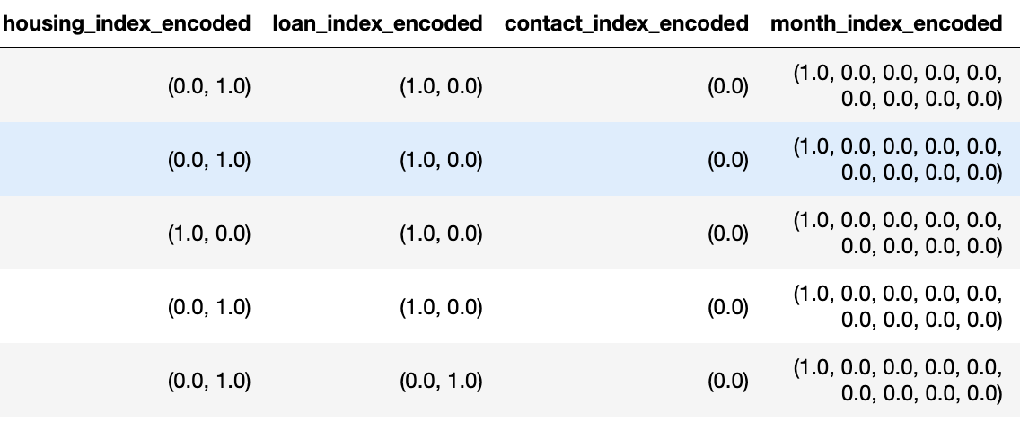

In addition to encoding some features, we also used the StandardScaler to standardize the scale of the features that were vectorized with the VectorAssembler function.

The following image shows a sample of StandardScaler function’s output.

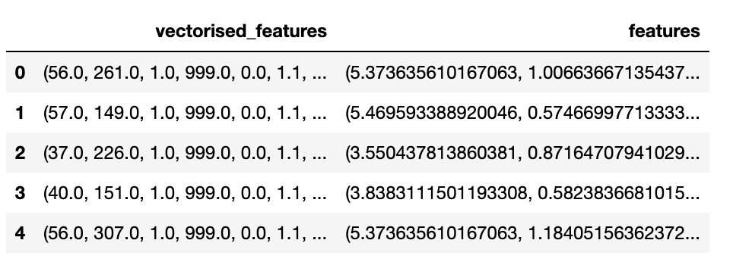

The data were split using 80% for training and 20% for testing, resulting in the following row distribution:

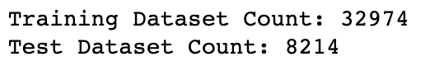

The distribution of the target variable in the two datasets (training and test) are shown in the following tables, with the training dataset on the left and the test dataset on the right:

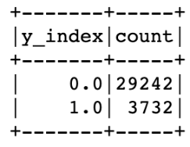 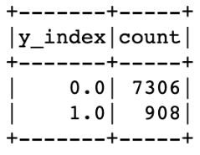

The following table summarizes the results obtained with the 5 models created for this dataset, the model with the best Accuracy was Gradient Boosted Tree.

|  |  |  |
| --- | --- | --- |
| **Model** | **Accuracy** | **Test Area Under ROC** |
| Logistic Regression | 0.9149 | 0.9359 |
| Decision Tree | 0.9159 | 0.5439 |
| Random Forest | 0.9056 | 0.9158 |
| Gradient Boosted Tree | 0.9187 | 0.9428 |
| Support Vector Classifier | 0.9024 | 0.9279 |

The first model to explore is **Logistic Regression**, the following images show the resulting confusion matrix and ROC Curve.

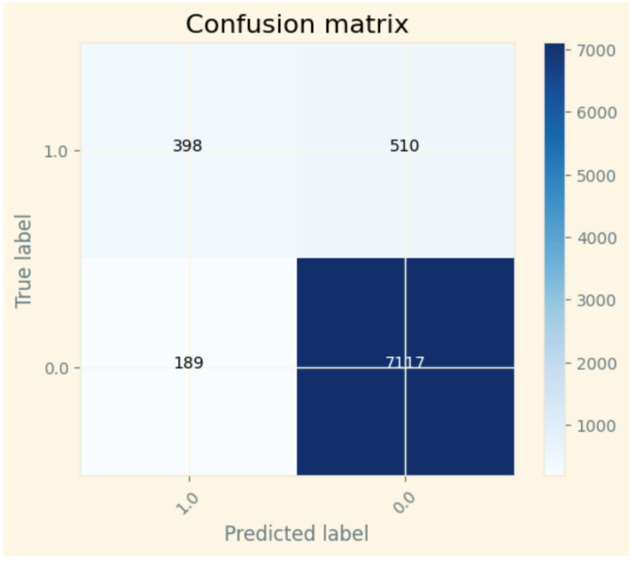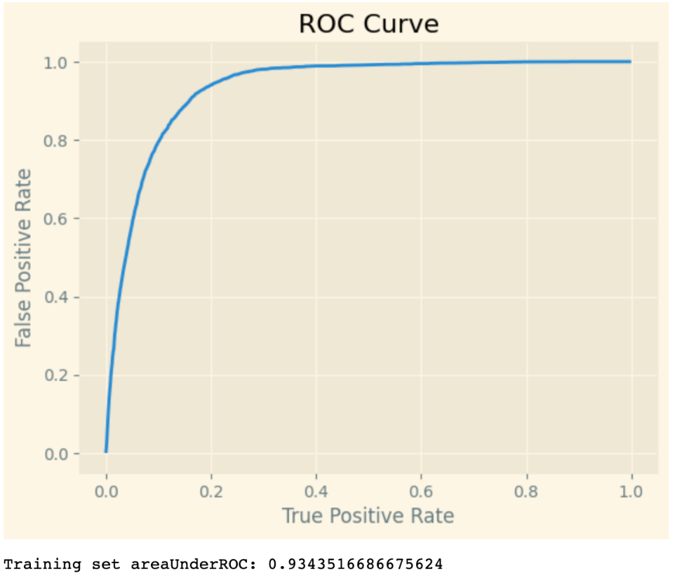

The following image shows sample predictions using the **Logistic Regression** model, in it we can see that the model predicted correctly rows 0, 1, 3 and 4, however, row 2 was predicted incorrectly as a 0 (customer doesn’t subscribe to the term deposit) when it was a 1 (customer subscribes to the term deposit):

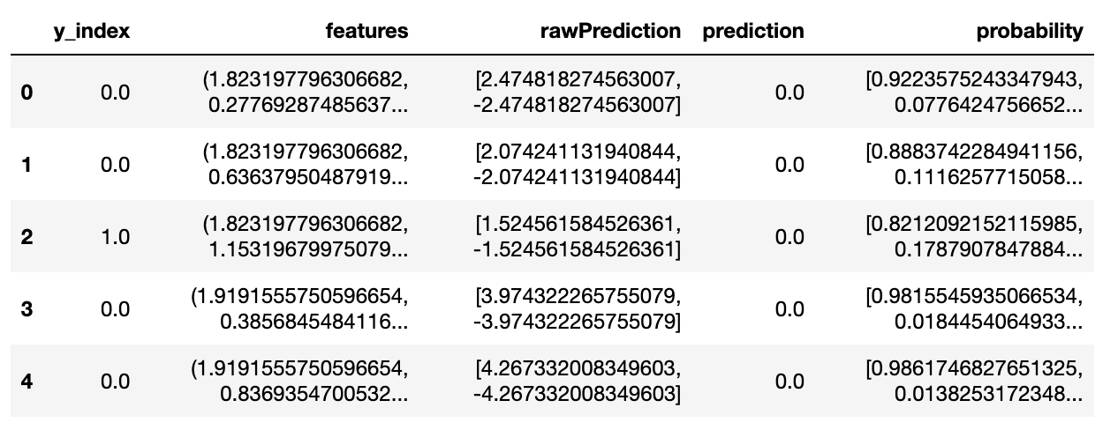

The second model used was **Decision Tree**, the following image shows the resulting confusion matrix.

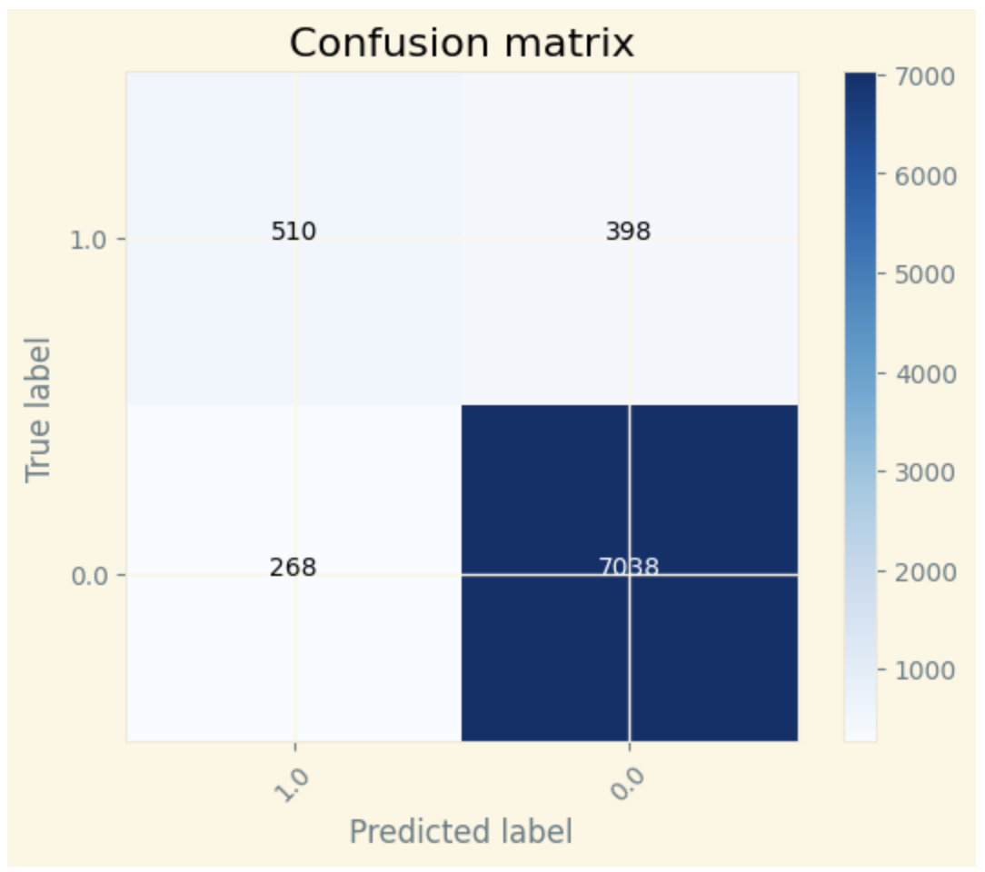

The following image shows sample predictions using the **Decision Tree** model, the predictions are like those obtained with the previous model.

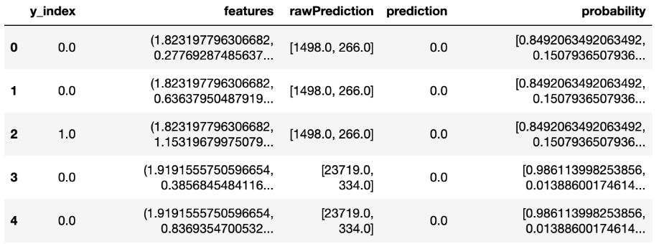

The third model we explored was **Random Forest**, the following images show the resulting confusion matrix and ROC Curve. This model has the best classification results out of the models tried up to this point.

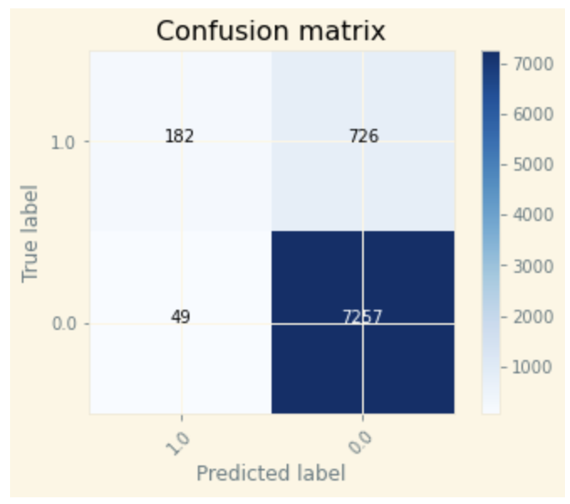

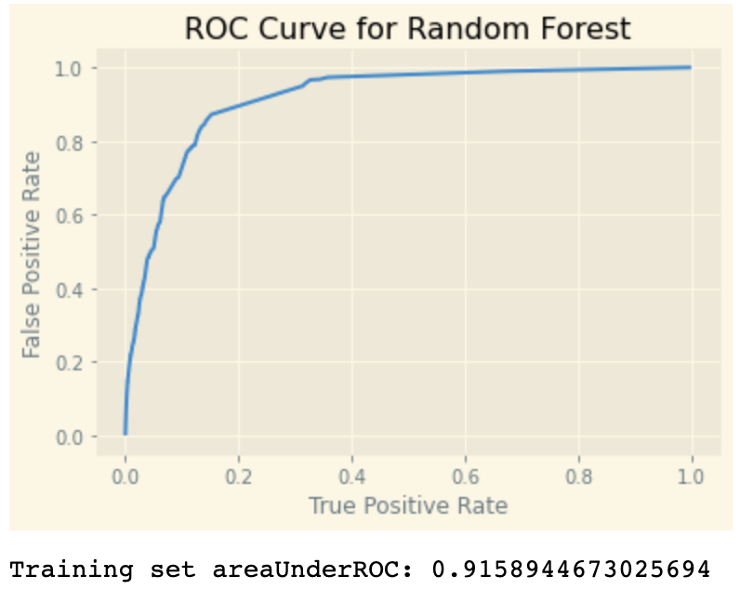

The following image shows sample predictions using the **Random Forest** model, the predictions are like the ones obtained with the previous models.

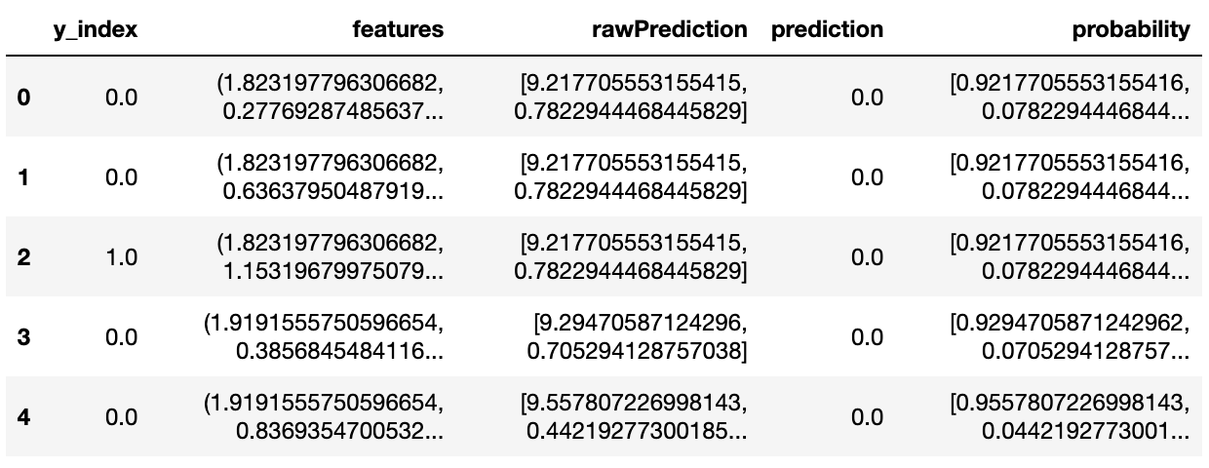

The fourth model used on our analysis was a **Gradient Boosted** **Tree**, the following image shows the resulting confusion matrix.

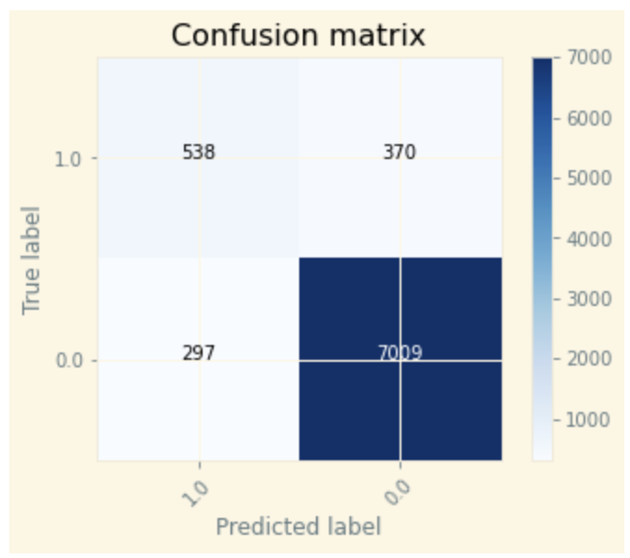

The following image shows sample predictions using the **Gradient Boosted** **Tree** model, the predictions are like those obtained with the previous models too.

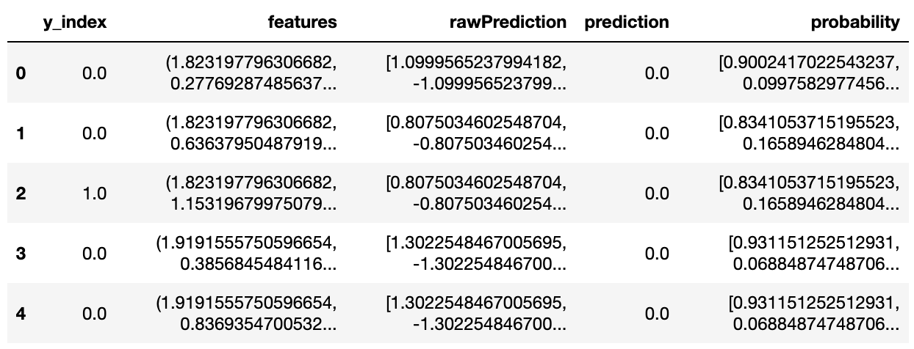

The fifth model we explored was the **Support Vector Classifier**, the following images show the resulting confusion matrix.

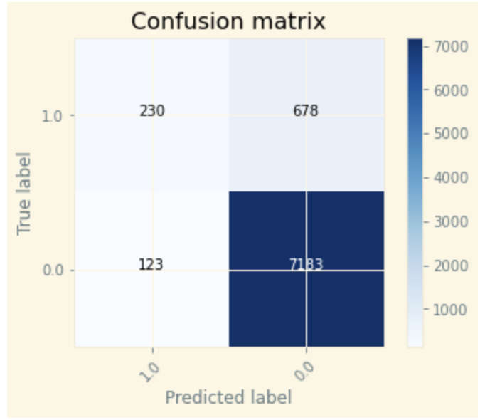

The following image shows sample predictions using the **Support Vector Classifier** model, the predictions are like the ones obtained with the previous models here as well.

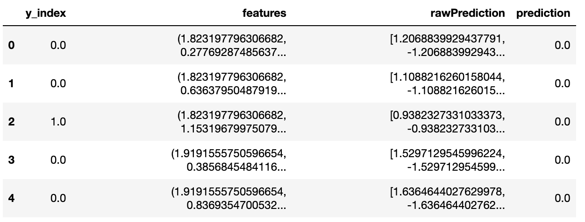

|  |  |  |
| --- | --- | --- |
| **Model** | **Accuracy** | **ROC-AUC** |
| Logistic Regression | 0.915 | 0.933 |
| Decision Tree | 0.916 | 0.544 |
| Random Forest | 0.906 | 0.915 |
| Gradient boosted trees | 0.919 | 0.943 |
| Support Vector Classifier | 0.902 | 0.928 |

Best model was found to be gradient boosted trees with highest accuracy and ROC_AUC value.

# K-means Clustering

For the KMeans analysis we set 2 clusters, this is a required parameter for this library.

# Trains a k-means model.

kmeans = KMeans().setK(2).setSeed(1)

model_km = kmeans.fit(scaler_df.select('features'))

# Make predictions

predictions_km = model_km.transform(scaler_df)

These are sample predictions obtained with the K-means clusters:

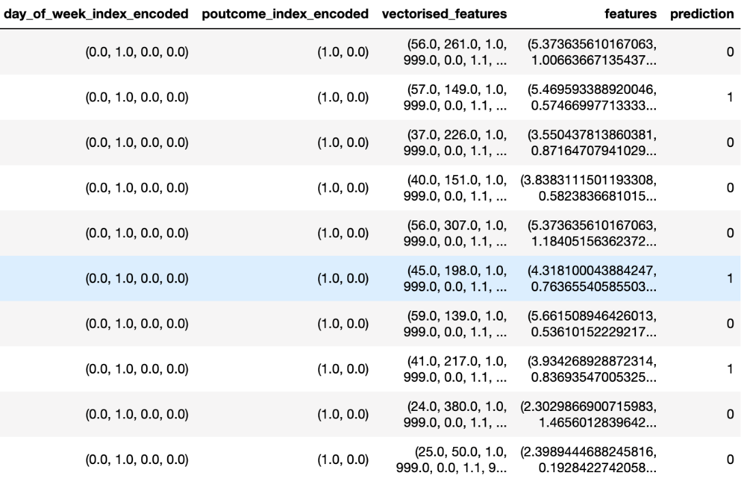

The Silhouette score for the K-means clustering model is 0.1168, this is not a great score. It indicates that the clusters are overlapping, and samples are very close to the other cluster decision boundary.

The clusters centers obtained are:

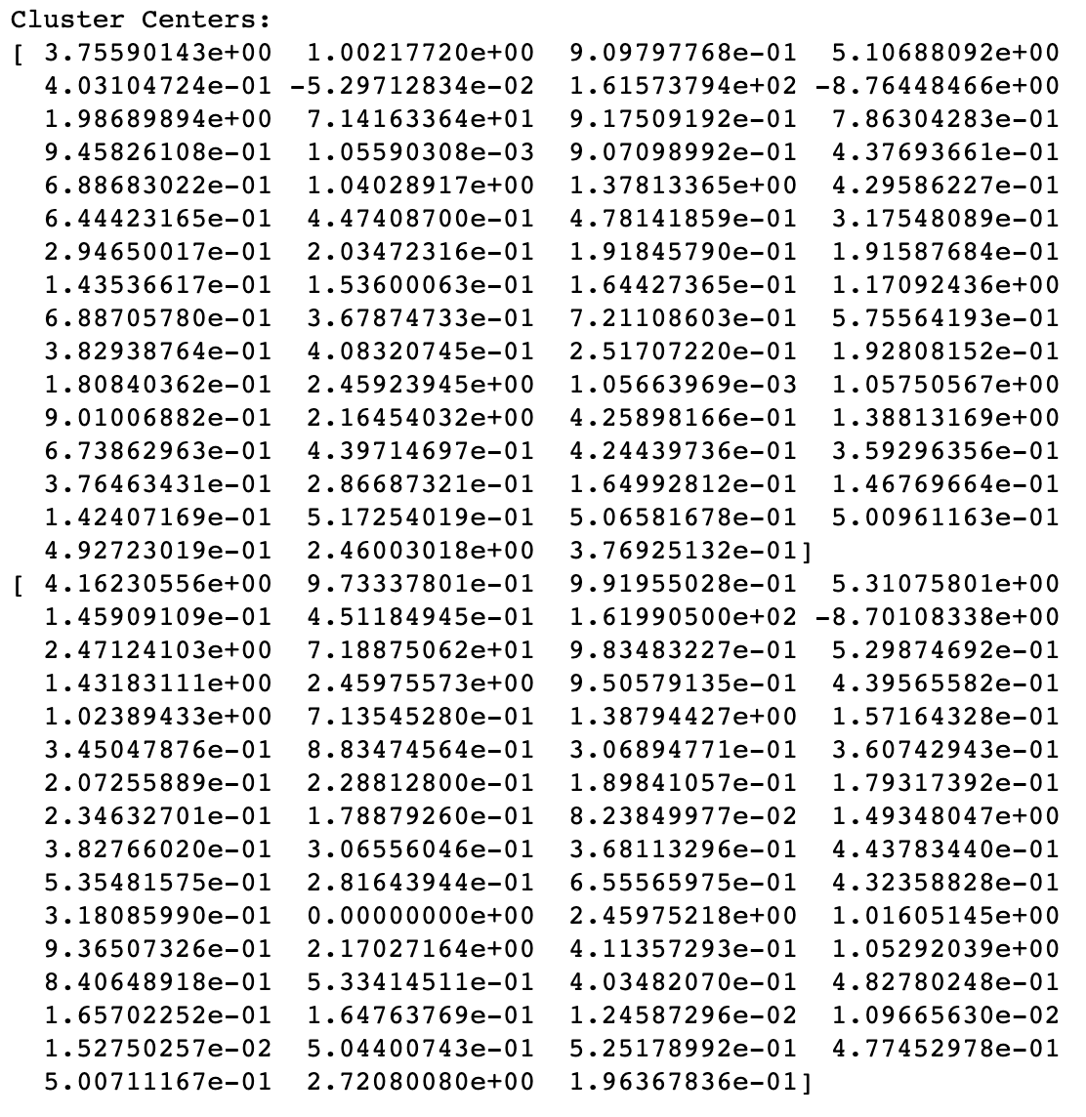

# Prescriptive Recommendations

The business problem we are trying to mitigate with this analysis is to improve the marketing expense related to bringing new clients for a term deposit to the bank. The sample dataset has a success rate of 12.70%, which means there is a large marketing expense before hitting the right customer (about 88 customers that will decline the offer before finding the first term deposit subscriber). The prescriptive part of analytics focuses on answering the question what should we do next?

In this case, based on the three most important variables in the Gradient Boost model, duration, Nr.employed and Euribor3m, the first recommendation is to define guidelines to interact with the customers. Per the model with the highest accuracy (Gradient Boost), increasing the customer interactions that have the best duration will have a direct impact in the model results.

The other two features are social and economic context attributes, the number of employees and the euribor rate (the rate of interest for lending operations in the European Union interbank market). There is little that can be done to modify them directly. It is possible however to include these social and economic context attributes in the information shared with customers in a way that can assuage their concerns, for example information of euribor trends or how banks protect from any unexpected rate change or lack of it.

In answering the question what we should do next we are trying to define the strategy that will lead to an increase in the success rate of the marketing expense.