**Task 10**

Question 1

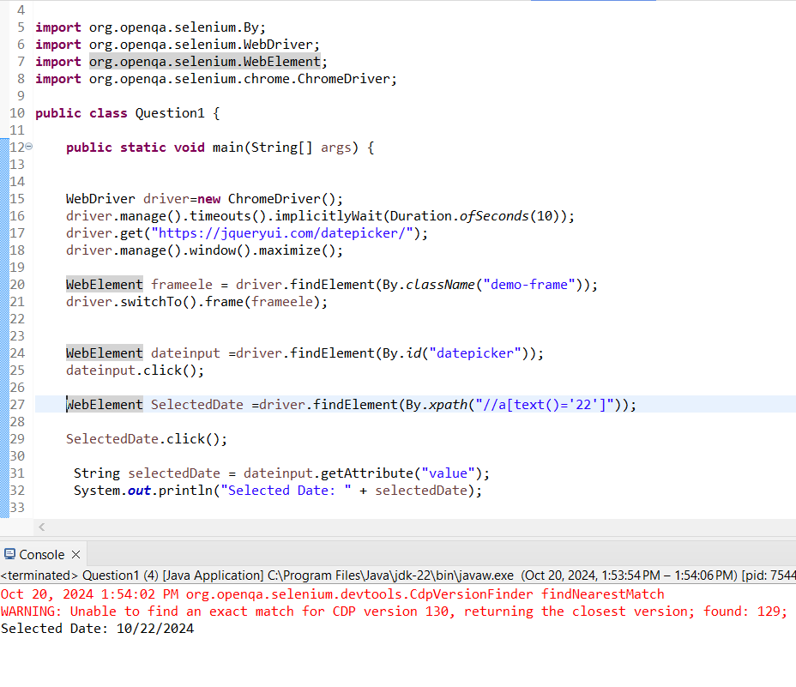

Question 2

Drag and drop succesful.

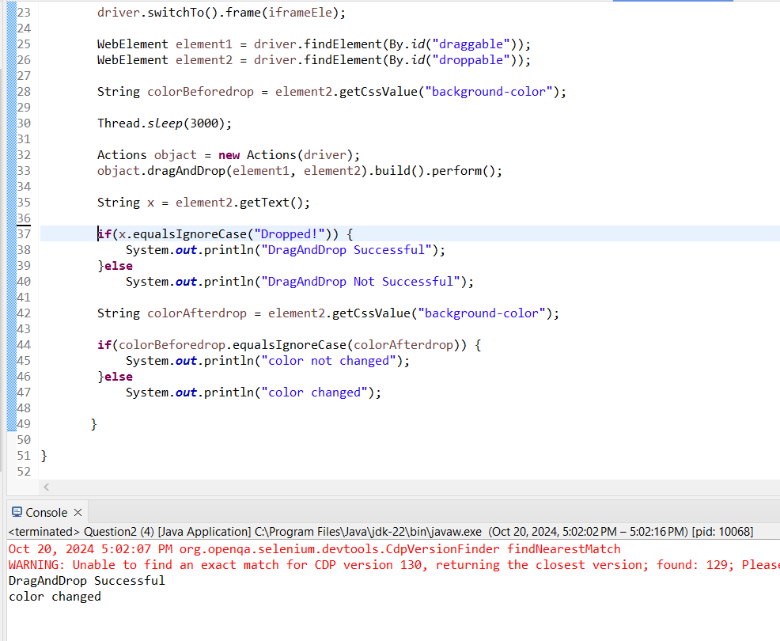

Screenshot of successful Drag and drop in the site

