**Task 12**

**Question 1**

**CODE**

create database task12;

use task12;

create table Empl(empno int, ename varchar(30), job varchar(30), mgr int, hiredate date, sal decimal(10,2), comm decimal(10,2), deptno int);

insert into Empl values (8369, 'SMITH' , 'CLERK', 8902, '1990-12-18', 800.00, NULL, 20);

insert into Empl values (8499, 'ANYA' , 'SALESMAN', 8698, '1991-02-20', 1600.00, 300.00, 30);

insert into Empl values (8521, 'SETH' , 'SALESMAN', 8698, '1991-02-22', 1250.00, 500.00, 30);

insert into Empl values (8566, 'MAHADEVAN' , 'MANAGER', 8839, '1991-04-02', 2985.00, NULL, 20);

insert into Empl values (8654, 'MOMIN' , 'SALESMAN', 8698, '1991-09-28', 1250.00, 1400.00, 30);

insert into Empl values (8698, 'BINA' , 'MANAGER', 8839, '1991-05-01', 2850.00, NULL, 30);

insert into Empl values (8882, 'SHIVANSH' , 'MANAGER', 8839, '1991-06-09', 2450.00, NULL, 10);

insert into Empl values (8888, 'SCOTT' , 'ANALYST', 8566, '1992-12-09', 3000.00, NULL, 20);

insert into Empl values (8839, 'AMIR' , 'PRESIDENT', NULL, '1991-11-18', 5000.00, NULL, 10);

insert into Empl values (8844, 'KULDEEP' , 'SALESMAN', 8698, '1991-09-08', 1500.00, 0.00, 30);

select * from Empl;

**OUTPUT**

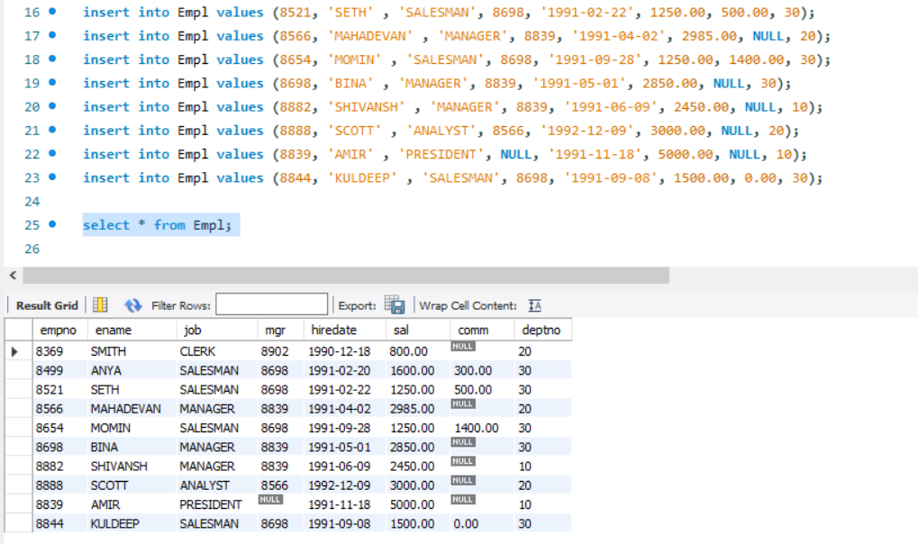

Question 1.1:

select ename,sal from empl where sal>=2200;

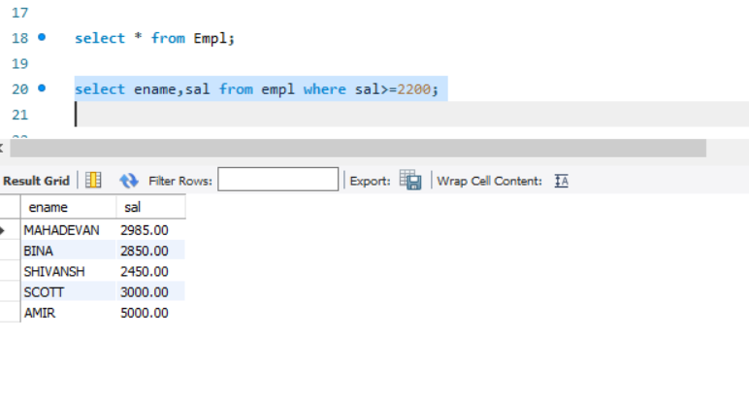

Question 1.2:

select * from empl where comm is NULL;

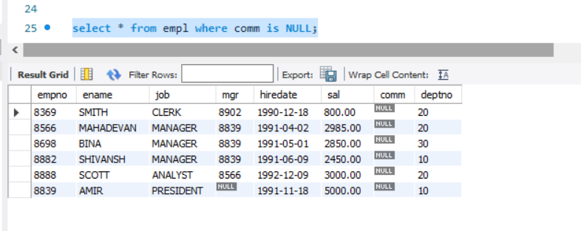

Question 1.3:

select ename,sal from empl where sal not BETWEEN 2500 AND 4000;

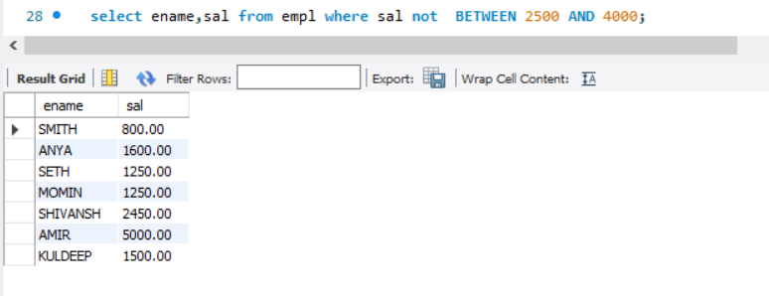

Question 1.4:

select ename,job,sal from empl where job !='Manager';

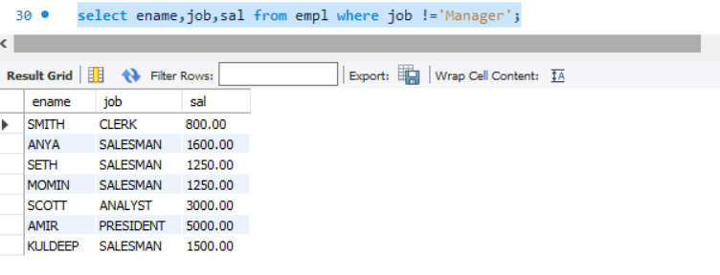

Question 1.5:

select ename from empl where SUBSTRING(ename, 3, 1) = 'A';

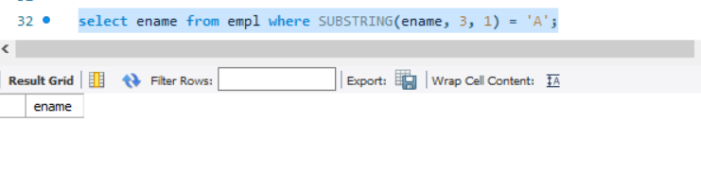

Question 1.6:

select ename from empl WHERE ename LIKE '%T';

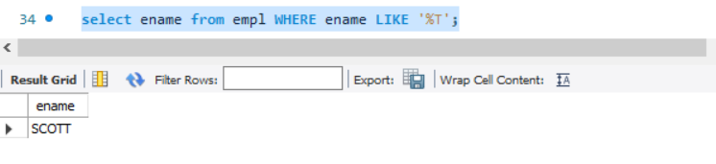

**Question 2**

Table created in MySQL

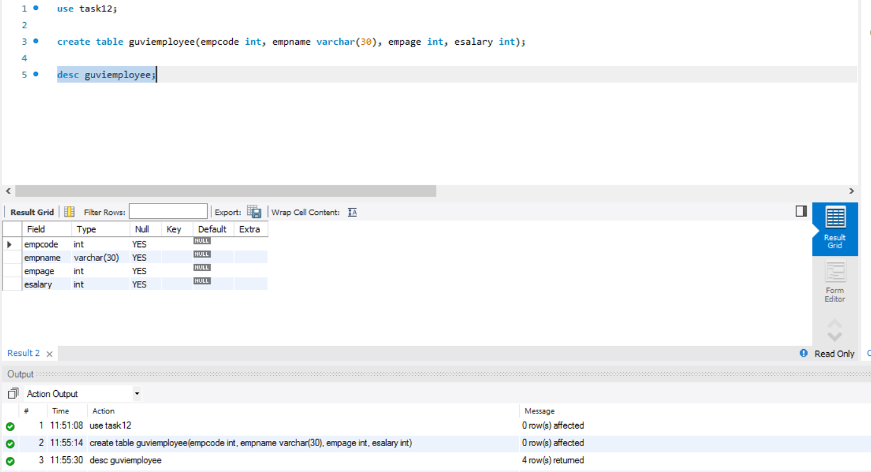

**CODE**

**package** task12;

**import** java.sql.Connection;

**import** java.sql.DriverManager;

**import** java.sql.SQLException;

**import** java.sql.Statement;

**public** **class** Question2 {

**public** **static** **void** main(String[] args) **throws** SQLException {

String URL = "jdbc:mysql://localhost:3306/task12";

String uname = "root";

String psw="Neeraj2297@";

//creating connection to database

Connection con= DriverManager.*getConnection*(URL, uname, psw);

//create statement object to create statement

Statement s= con.createStatement();

String query = "Insert into guviemployee(empcode, empname, empage, esalary) values" +

"(101, 'Jenny', 25, 10000)," +

"(102, 'Jacky', 30, 20000),"+

"(103, 'Joe', 20, 40000),"+

"(104, 'John', 40, 80000),"+

"(105, 'Shameer', 25, 90000)";

s.executeUpdate(query);

System.***out***.println("Successful");

}

}

**Output**

