**Task 8**

The empty excel file created

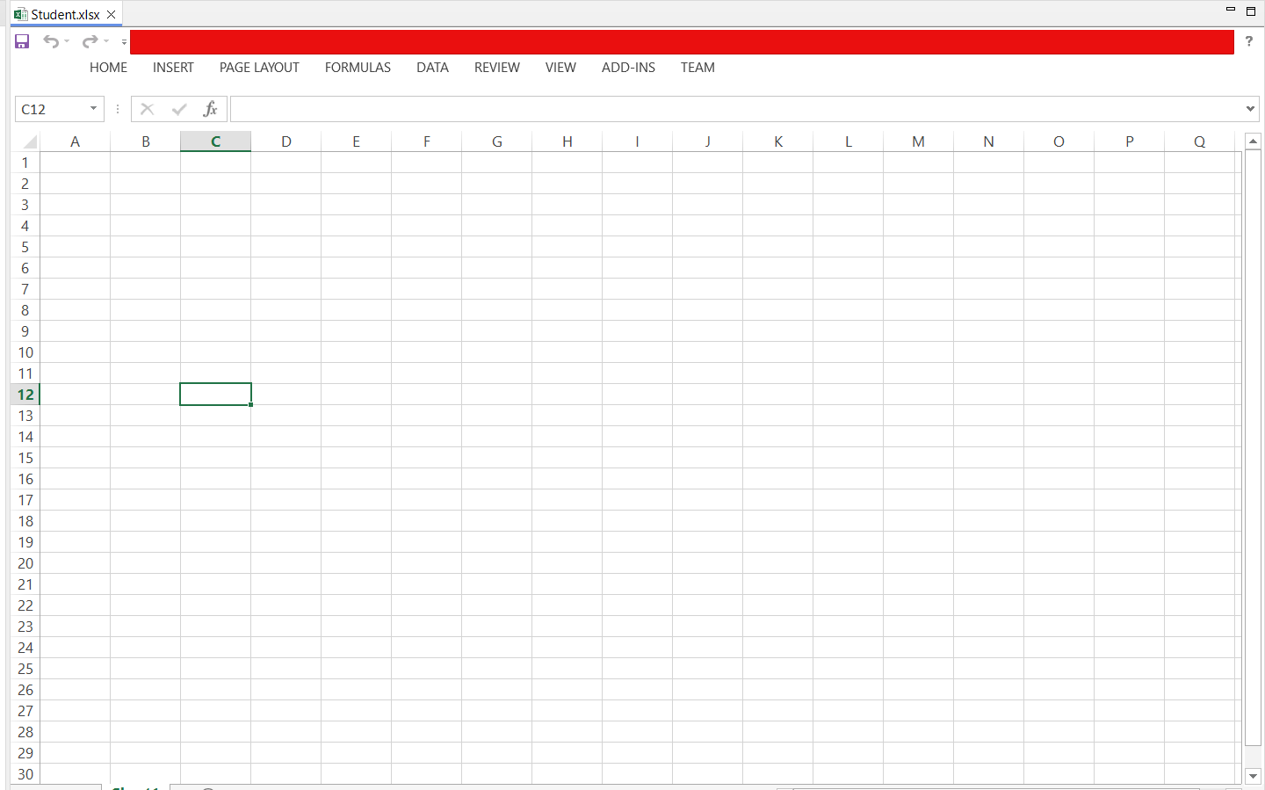

**CODE**

package task8;

import org.apache.poi.ss.usermodel.*;

import org.apache.poi.xssf.usermodel.XSSFWorkbook;

import practice.WriteExcel;

import java.io.FileInputStream;

import java.io.FileOutputStream;

import java.io.IOException;

public class Task8 {

private static final String FILE_PATH = "Utils//Student.xlsx";

public static void main(String[] args) {

WriteExcel x= new WriteExcel();

x.writeToExcel("Sheet1", 0, 0, "Name");

x.writeToExcel("Sheet1", 1, 0, "John Doe");

x.writeToExcel("Sheet1", 2, 0, "Jane Doe");

x.writeToExcel("Sheet1", 3, 0, "Bob Smith");

x.writeToExcel("Sheet1", 4, 0, "Swapnil");

x.writeToExcel("Sheet1", 0, 1, "Age");

x.writeToExcel("Sheet1", 1, 1, "30");

x.writeToExcel("Sheet1", 2, 1, "28");

x.writeToExcel("Sheet1", 3, 1, "35");

x.writeToExcel("Sheet1", 4, 1, "37");

x.writeToExcel("Sheet1", 0, 2, "Email");

x.writeToExcel("Sheet1", 1, 2, "john@test.com");

x.writeToExcel("Sheet1", 2, 2, "jahn@test.com");

x.writeToExcel("Sheet1", 3, 2, "jacky@example.com");

x.writeToExcel("Sheet1", 4, 2, "swapnil@example.com");

// Read and print the data from the Excel file

readDataFromExcel();

}

// Method to write data into an empty Excel file

public static void writeDataToExcel(String data) {

Workbook workbook = new XSSFWorkbook(); // Create a new workbook (for .xlsx files)

Sheet sheet = workbook.createSheet("Sheet1"); // Create a sheet

// Create a row

Row row = sheet.createRow(0); // Row 0 (first row)

// Create a cell

Cell cell = row.createCell(0); // Column 0 (first column)

cell.setCellValue(data); // Set the retrieved data into the cell

// Write the workbook into an Excel file

try (FileOutputStream fileOut = new FileOutputStream(FILE_PATH)) {

workbook.write(fileOut); // Write the workbook data to the Excel file

System.out.println("Data written successfully to Excel file!");

} catch (IOException e) {

e.printStackTrace();

} finally {

try {

workbook.close(); // Close the workbook resource

} catch (IOException e) {

e.printStackTrace();

}

}

}

// Method to read data from the Excel file and print the values

public static void readDataFromExcel() {

try (FileInputStream fileInputStream = new FileInputStream(FILE_PATH)) {

Workbook workbook = new XSSFWorkbook(fileInputStream); // Open the workbook

Sheet sheet = workbook.getSheetAt(0); // Get the first sheet

// Loop through each row and cell to print data

for (Row row : sheet) {

for (Cell cell : row) {

// Print the cell value

switch (cell.getCellType()) {

case STRING:

System.out.print(cell.getStringCellValue()+" ");

break;

case NUMERIC:

System.out.print(+ cell.getNumericCellValue()+" ");

break;

case BOOLEAN:

System.out.print(cell.getBooleanCellValue()+" ");

break;

default:

System.out.print("Unknown Cell Type");

}

}

System.out.println("");

}

workbook.close(); // Close the workbook

} catch (IOException e) {

e.printStackTrace();

}

}

}

**Output**

The console output of the values inserted

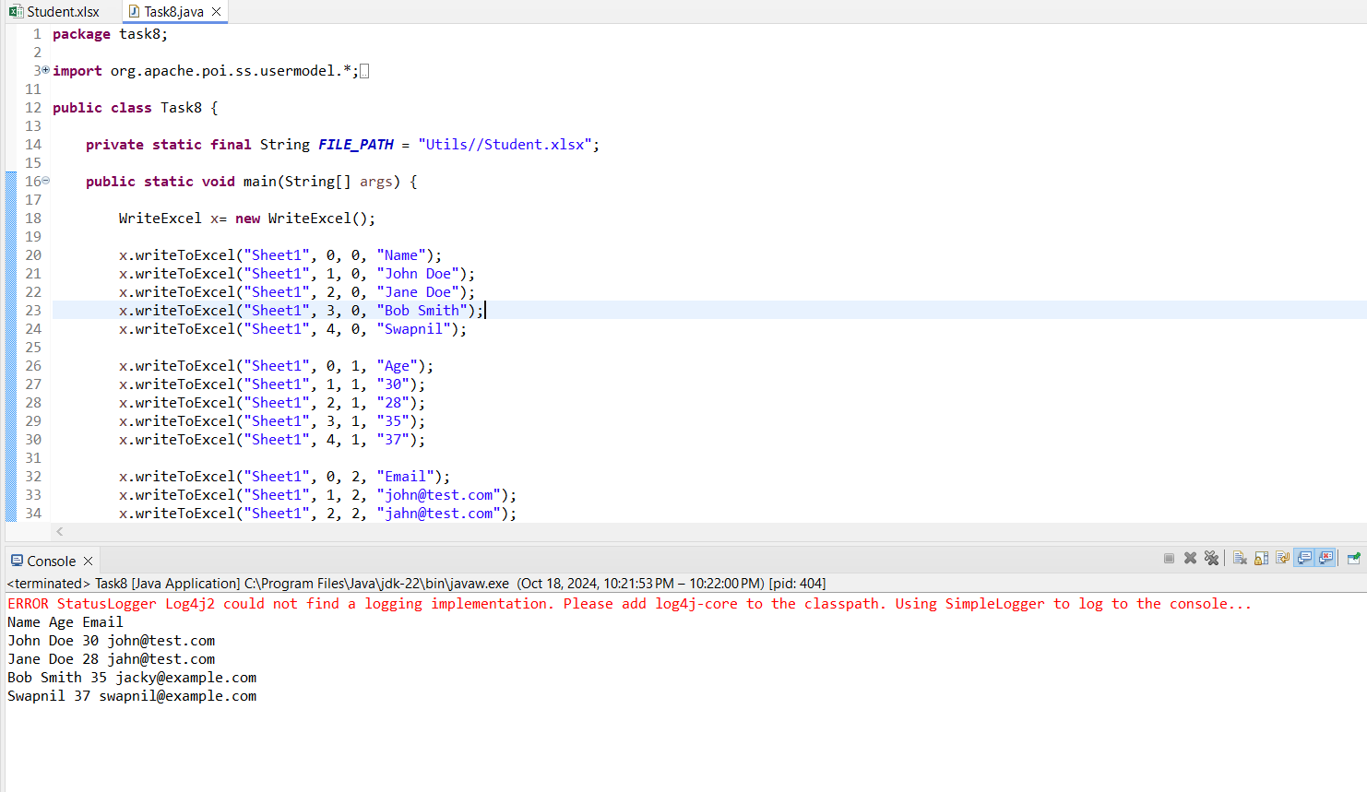

The values being inserted to Student.xlsx excel file

