Code Coverage Testing Report

Submitted By – Neeraj Kumar Kannoujiya (MSE2024003)

# 1. Objective

The goal of this project is to demonstrate code coverage testing using a simple Login and Signup system written in Python. We test the functionality using unittest and evaluate how much of our code is actually tested using coverage.py.

# 2. What is Code Coverage?

Code Coverage is a metric used in software testing that describes the degree to which the source code of a program is executed during testing. It helps identify untested parts of a codebase and ensures the reliability of the system.

* Types of Code Coverage:
* Statement Coverage – Are all statements executed?
* Branch Coverage – Are all if/else branches executed?
* Function Coverage – Are all functions invoked during testing?
* Line Coverage – Are all lines of code touched by tests?

# 3. Tools Used

|  |  |
| --- | --- |
| Tool | Purpose |
| Python | Core programming language |
| unittest | Python built-in unit testing tool |
| coverage | To measure code coverage |
| Bash Script | Automate test and coverage report |

# 4. Project Structure

login_signup_project/  
├── app/  
│ ├── auth.py # Login/Signup logic  
│ └── __init__.py  
├── tests/  
│ ├── test_auth.py # Unit tests  
│ └── __init__.py  
├── run_coverage.sh # Bash script to run coverage  
└── requirements.txt

# 5. Coverage Script – run_coverage.sh

#!/bin/bash  
echo "Running coverage tests..."  
coverage run -m unittest discover tests  
coverage report -m  
coverage html  
echo "HTML report generated at htmlcov/index.html"

# 6. Coverage Report Output

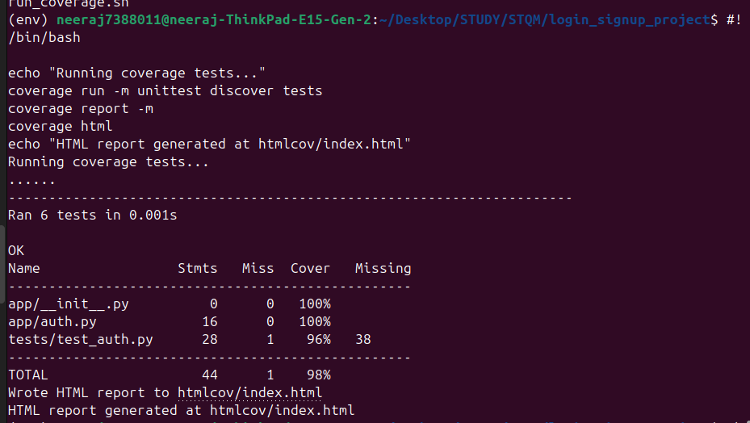

# 7. Generate HTML Report Output

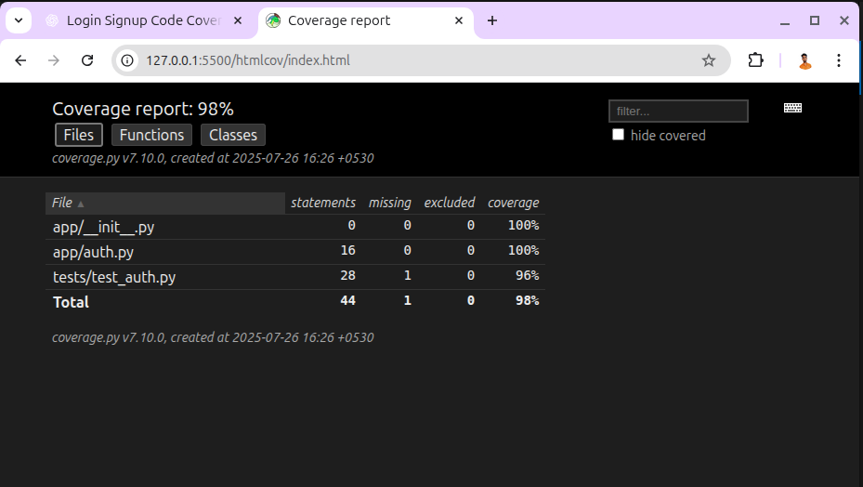

# 8. Conclusion

This mini project successfully demonstrates how to:  
- Write a login/signup system  
- Test it using Python’s unittest  
- Measure and report code coverage using coverage.py  
  
Benefits of Code Coverage:  
- Helps ensure all logic paths are tested  
- Reduces the risk of bugs in production  
- Increases developer confidence in changes