Revision History
DOCUMENT NAME | Auth Lambda AID  TDG_RezAir
VERSION NO. | 1.0
RELEASE DATE | 12-Oct-25
CLASSIFICATION | Internal

This document of Cybage Software Pvt. Ltd. is for restricted circulation. No part of this publication may be reproduced, stored in a retrieval system, or transmitted in any form or by any means – recording, photocopying, electronic and mechanical, without prior written permission of Cybage Software Pvt. Ltd.

Version No. | Authored / Modified by, Date | Reviewed by, Date | Approved by, Date | Remarks / Change History
1.0 | Nilophar S / Dwarkesh Modi |  | 12-10-25 | V1

Table of Contents

Contents
1. Introduction 5
1.1 Purpose of the AID Document 5
1.2 Objective of AID Document 5
1.3 Scope of AID Document 5
1.4 Out of Scope for AID 5
1.5 Acronyms and Definitions 5
1.6 References 6
2. AID Goals and Capacity 6
2.1 AID Goal Representation (audience-wise): 6
2.2 AID Capacity Details (FR/NFR): 6
3. Physical Design 7
3.1 Middleware Diagram 7
3.1.1 Primary Presentation: 7
3.1.2 Elements Catalog: 7
3.2 Hardware Requirements 7
3.3 Software Requirements 8
3.4 Network Diagram 8
3.5 Sub-systems Diagram 8
3.5.1 Design Rational: 9
3.5.2 Variability Guide: 10
4. Sequence View 10
4.1 Sequence Outline 10
5. Test Guidelines 10
5.1 Elements Catalog 10
5.1.1 Testing Guidelines: 10
6. Constraints 11
6.1 Assumptions 11
6.2 Dependencies on another Subsystem 11
6.3 Limitations & Constraints 11
7. Lambda Strategies 11
7.1 Tools to be used 11
7.2 Exception Handling 11
7.3 Logging and Auditing Strategy 11

Introduction
This application information document (AID) will be used for understanding the AD-based lambda function created for authenticating the incoming agent from react UI of RezAir project. The lambda function is based on the POC performed by TDG team and borrows the foundational idea from it. The POC documents are attached below –

Purpose of the AID Document
The purpose of this document is to:
- Document AD based requirements and choices being opted for the Auth Lambda.
- Highlighting the thought process behind the auth lambda design.
- Infra and Technology opted for the auth lambda.
- Assumptions and limitations.
- TDG POC details.

Objective of AID Document
The objectives of AID Doc are:
- Ideation and Purpose
- Infra and Technology
- Testability and Maintainability

Scope of AID Document
The scope of AID Doc is:
- RezAir System (POS agents only)

Out of Scope for AID
The out of scope of AID Doc is:
- Any usage of auth lambda other than for authenticating the POS agents

Acronyms and Definitions
This sub-section includes the definitions of all acronyms required to interpret the AD properly.
Sr. No. | Acronyms | Definitions
 | AD | Architectural Document
 | AID | Application Information Document
 | DB/DBMS | Database/Database Management System
 | JSON | JavaScript Object Notation
 | POS | Point of Sale

References
This sub-section provides a complete list of all details/documents referenced elsewhere in the AID with the details of the sources from which the references can be obtained.
- TDG Wireframes / POC
- Requirement specification captured in Jira stories

AID Goals and Capacity

AID Goal Representation (audience-wise):
Sr. No. | Goal Name | Audience | Concerns Addressed
 | Physical Design | Infra/DevOps Admins | Layered Architecture, Hardware/Network requirements
 | Sequence View | Infra/DevOps Admins, Programmers, BAs | Auth Progression and Visualization w.r.t to Infra Resources
 | Test Guidelines | QAs | Test Guidelines Outlining Various QA Activities

AID Capacity Details (FR/NFR):
A. Scalability: As suggested, the baseline will be minimum and will grow gradually, since this is a new business line.
- Supports concurrent user interactions.
B. Availability
- To avoid DB failures for lambda, instead of single-node RDS, Multi-AZ RDS or Aurora can be used for high availability.
C. Security
- Authorized POS agency users will have access only.
D. Maintainability
  - Simple java spring based single responsibility function.
  - Easy to maintain and update for dev/test/stag/prod environments.

Physical Design
This section describes the physical architecture of the system where system type, sequence along with hardware and software requirements are visualized. The Infra/DevOps teams are the major stake holders of this section.

Middleware Diagram

Primary Presentation:
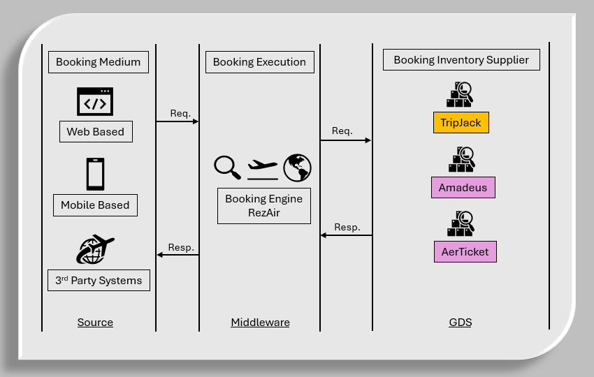
Fig #3.1.1 Middleware Diagram

Elements Catalog:
Booking Medium: Web (POS / XML) and Mobile are the two primary booking mediums.
Booking Execution: RezAir is going to be the middleware booking engine.
Booking Inventory Supplier: GDS like TripJack, Amadeus, AerTicket, etc are inventory suppliers.

Hardware Requirements
- AWS API Gateway
- AWS Lambda
- AWS RDS - MySql

Software Requirements
1. Java OpenJDK 21
2. Maven 3.9
3. MySQL 8.4
Note – Kindly refer RezAir confluence page for more details

Network Diagram
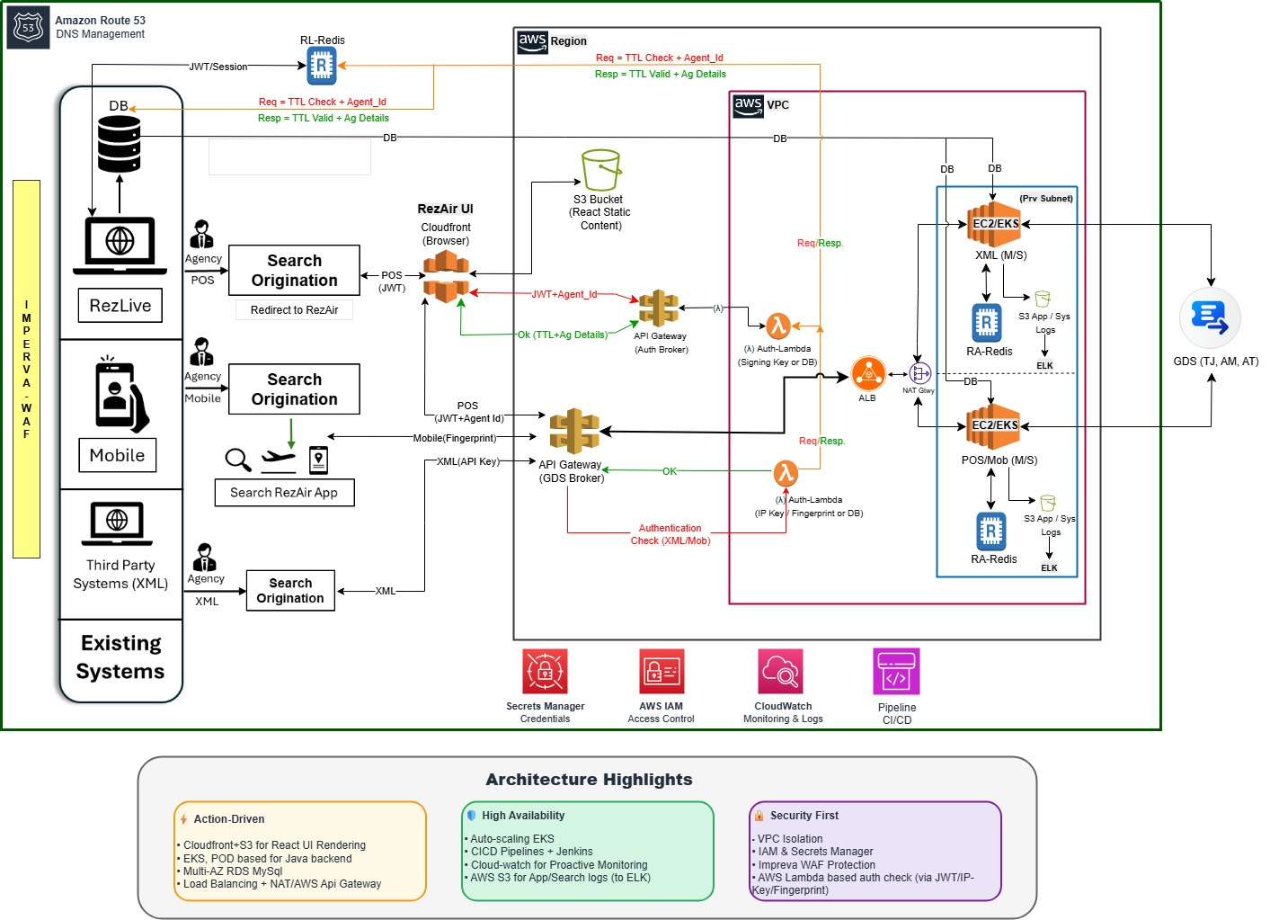
Fig#3.4 Auth Lambda API Gateway – 1

Sub-systems Diagram
1. Fig#3.5 highlighted in green the subsystem diagram for auth lambda
2. RezLive to RezAir UI (React) to Api gateway-1 -> Auth Lambda -> MySQL (ra_agent_tokens table)

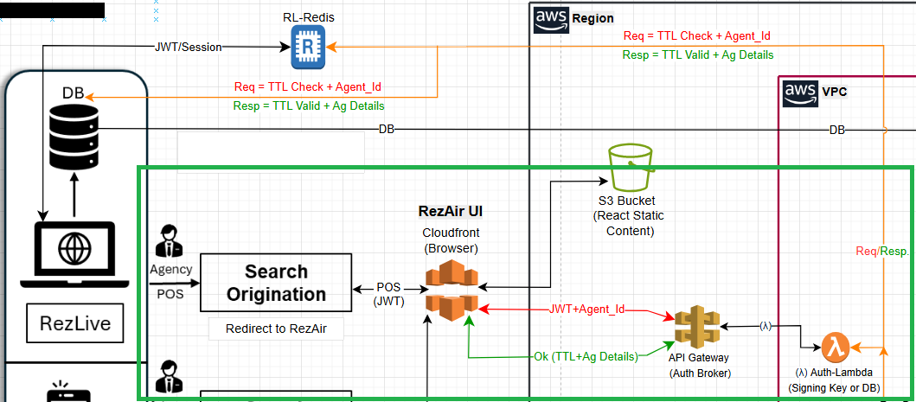
Fig#3.5 Auth Lambda Subsystem Diagram (Green Border)

Design Rational:
1. Agent when redirects from RL -> RA, by clicking on Air/Flight tab, passes the agent id and jwt
2. React UI then passes the incoming agent id and jwt to the Auth Broker (AWS API Gateway-1)
3. The Auth Broker then calls the Auth Lambda internally (Serverless Authentication Check)
4. The Auth Lambda gets the agent id and jwt and performs a lookup in the DB
5. If the Auth Lambda finds the entry for the incoming agent id and jwt, then it return ok-200 ‘Authorized‘ along with the details list containing the authId, ipaddress, created_at, expires_at, etc fields
6. If the Auth Lambda did not finds the entry for the incoming agent id and jwt, then it return 401 ‘Unauthorized: no matching JWT for agentId‘
7. The logic also checks for JWT format and validate it before hitting the DB
8. AuthId – The agent id, gets converted into ‘long’ anad returned from lambda using the CRC algorithm, please check below –
// CRC creation for agent id, returns long data type value (Cyclic Redundancy Check)
private static long getCrcLongOfAgentId(String agentId) {
CRC32 crc = new CRC32();
crc.update(agentId.getBytes(StandardCharsets.UTF_8));
return crc.getValue();
}
9. The crc value of the agent id gets passed to the backend, where the crc gets regenerated and matched against the incoming authId, if the match passed, the booking process continues, if it fails, the auth failed error is returned. The crc check will not happen for each request but rather for 1st request from the agentid, making it more optimal

Variability Guide:
This section documents variation points to achieve variability for adapting to change:
1. As the traction on the RezAir system is increased, the output of the lambda needs to be increased as well and for that, additional computational processing must be integrated
2. Once integration with DB is seamless, as a next step, team(s) would do the JWT read/write in Redis and the lookup will happen from there, this require change in PHP (To Post the Agent details in Redis) and in RezAir (To Get the agent details from Redis). However, this will depend if there is a need to optimize the performance
3. As of now, the expire_at column of the ra_agent_tokens table is having the session validity details and the same will be utilized in RezAir, post the integration with Redis TTL can be used for the same
4. No secret or signing key will be shared by PHP to RezAir for doing any local authorization check and instead DB to be used for the same. If need be, the approach to use a key to decrypt the JWT can be opted saving the db call

Sequence View

Sequence Outline
The cloud-based setup is already in place and with API Gateway, Lambda Java 21 JVM, MySQL DB and React, etc.:
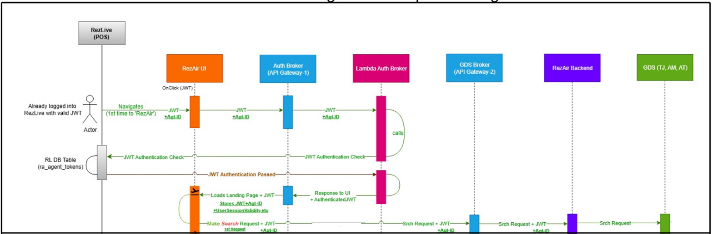
Fig #5.1.1 Sequence diagram for auth lambda with booking process

Test Guidelines

Elements Catalog

Testing Guidelines:
1. Objective of Testing:
- Its purpose is to ensure that the system meets the functional requirements from lambda function.
2. Testing Strategy: By creating a test in the aws console:
  - Pass Agent id
  - Pass Token
  - The lambda will validate and return success response

Constraints

Assumptions
1. User signup/login is not in a scope, users with valid credentials will access to the RezLive portal, all authentication and login validations will be already checked at existing RezLive platform.
2. Existing DB and ra_agent_tokens table will be utilized for lookup.

Dependencies on another Subsystem
1. RezLive System

Limitations & Constraints
1. AWS API Gateway is a powerful managed service, but it has some limitations:
- REST API: Max payload size is 10 MB & HTTP API: Max payload size is 2 MB.
- Max timeout for integration responses is ~29 seconds.
- Default soft limit: 10,000 RPS (requests per second) per region for REST APIs.
2. AWS Lambda limitation:
- Max duration: 15 minutes per invocation.
- Max uncompressed size: 250 MB.
- Memory: 128 MB – 10 GB.

Lambda Strategies

Tools to be used
This section will describe any tools to be used in the application for e.g.
- Code generators: IDE Eclipse
- Review Tools: JIRA

Exception Handling
1. Standard exception handling at the component level.
2. Fallback mechanism for handling DB failures.

Logging and Auditing Strategy
1. Log4j based logging will be enabled for logging at all levels.

*********

