Revision History
DOCUMENT NAME | Data Storage & Purging AID  TDG_RezAir
VERSION NO. | 1.0
RELEASE DATE | 12-Oct-25
CLASSIFICATION | Internal

This document of Cybage Software Pvt. Ltd. is for restricted circulation. No part of this publication may be reproduced, stored in a retrieval system, or transmitted in any form or by any means – recording, photocopying, electronic and mechanical, without prior written permission of Cybage Software Pvt. Ltd.

Version No. | Authored / Modified by, Date | Reviewed by, Date | Approved by, Date | Remarks / Change History
1.0 | Nilophar S / Dwarkesh M |  | 12-10-25 | V1

Table of Contents

Contents
1. Introduction 4
1.1 Purpose of the AID Document 4
1.2 Objective of AID Document 4
1.3 Scope of AID Document 4
1.4 Out of Scope for AID 4
1.5 Acronyms and Definitions 4
1.6 References 5
2. AID Goals and Capacity 5
2.1 AID Goal Representation (audience-wise): 5
3. Physical Design 6
3.1 Middleware Diagram 6
3.1.1 Primary Presentation: 6
3.1.2 Elements Catalog: 6
3.2 Software Requirements 6
3.3 Search Data Flow 7
3.3.1 Design Rational: 7
3.3.2 Variability Guide: 8
3.4 Booking Data Flow 9
3.4.1 Design Rational: 10
3.4.2 Variability Guide: 10
4. Constraints 10
4.1 Assumptions 10
4.2 Dependencies on another Subsystem 10
4.3 Exception Handling 10
4.4 Logging and Auditing Strategy 10

Introduction
This application information document (AID) will be used for understanding the AD-based data storage & purging strategy proposed for RezAir project.

Purpose of the AID Document
The purpose of this document is to:
- Document AD based requirements and choices being opted for the storage & purge strategy.
- Highlighting the thought process behind the approach.
- Infra and Technology opted for achieving the objective.
- Assumptions and limitations.

Objective of AID Document
The objectives of AID Doc are:
- Ideation and Purpose
- Infra and Technology

Scope of AID Document
The scope of AID Doc is:
- RezAir System (POS)

Out of Scope for AID
The out of scope of AID Doc is:
- RezAir System (XML & Mobile), although some of the strategy components can be reused

Acronyms and Definitions
This sub-section includes the definitions of all acronyms required to interpret the AD properly.
Sr. No. | Acronyms | Definitions
1. | AID | Application Information Document
2. | DB/DBMS | Database/Database Management System
3. | JSON | JavaScript Object Notation
4. | POS | Point of Sale
5. | PURGE | The process of permanently deleting obsolete, inactive, or unnecessary data
6. | STORAGE | The process of storing the accumulated app data in DB, Disks, Journals, Cloud, etc

References
This sub-section provides a complete list of all details/documents referenced elsewhere in the AID with the details of the sources from which the references can be obtained.
- TDG Wireframes
- Requirement specification captured in Jira stories

AID Goals and Capacity

AID Goal Representation (audience-wise):
Sr. No. | Goal Name | Audience | Concerns Addressed
 | Physical Design | Infra/DevOps Admins | Layered Architecture, Hardware/Network requirements
 | Flow Diagram | Infra/DevOps Admins, Programmers, BAs | Search Data Progression and Visualization w.r.t to Infra Resources

Physical Design
This section describes the physical architecture of the system where system type, sequence along with hardware and software requirements are visualized. The Infra/DevOps teams are the major stake holders of this section.

Middleware Diagram

Primary Presentation:
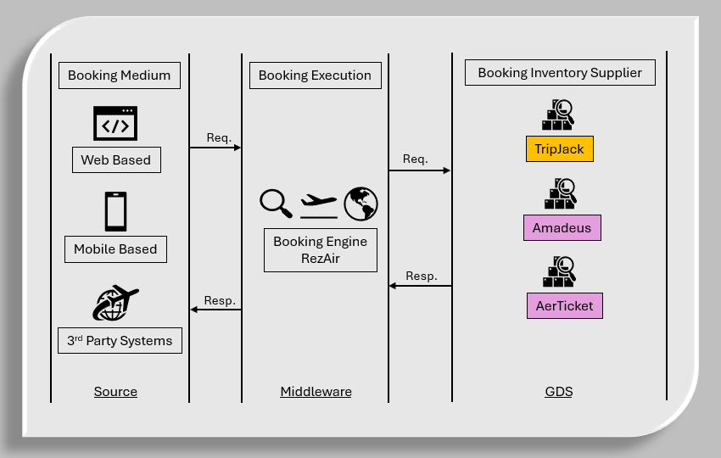
Fig #3.1.1 Middleware Diagram

Elements Catalog:
Booking Medium: Web (POS / XML) and Mobile are the two primary booking mediums.
Booking Execution: RezAir is going to be the middleware booking engine.
Booking Inventory Supplier: GDS like TripJack, Amadeus, AerTicket, etc are inventory suppliers.

Software Requirements
1. Java OpenJDK 21
2. Maven 3.9
3. MySQL 8.4
Note – Kindly refer RezAir confluence page for more details

Search Data Flow
1. Fig#3.3 highlighted the search data flow diagram for storage

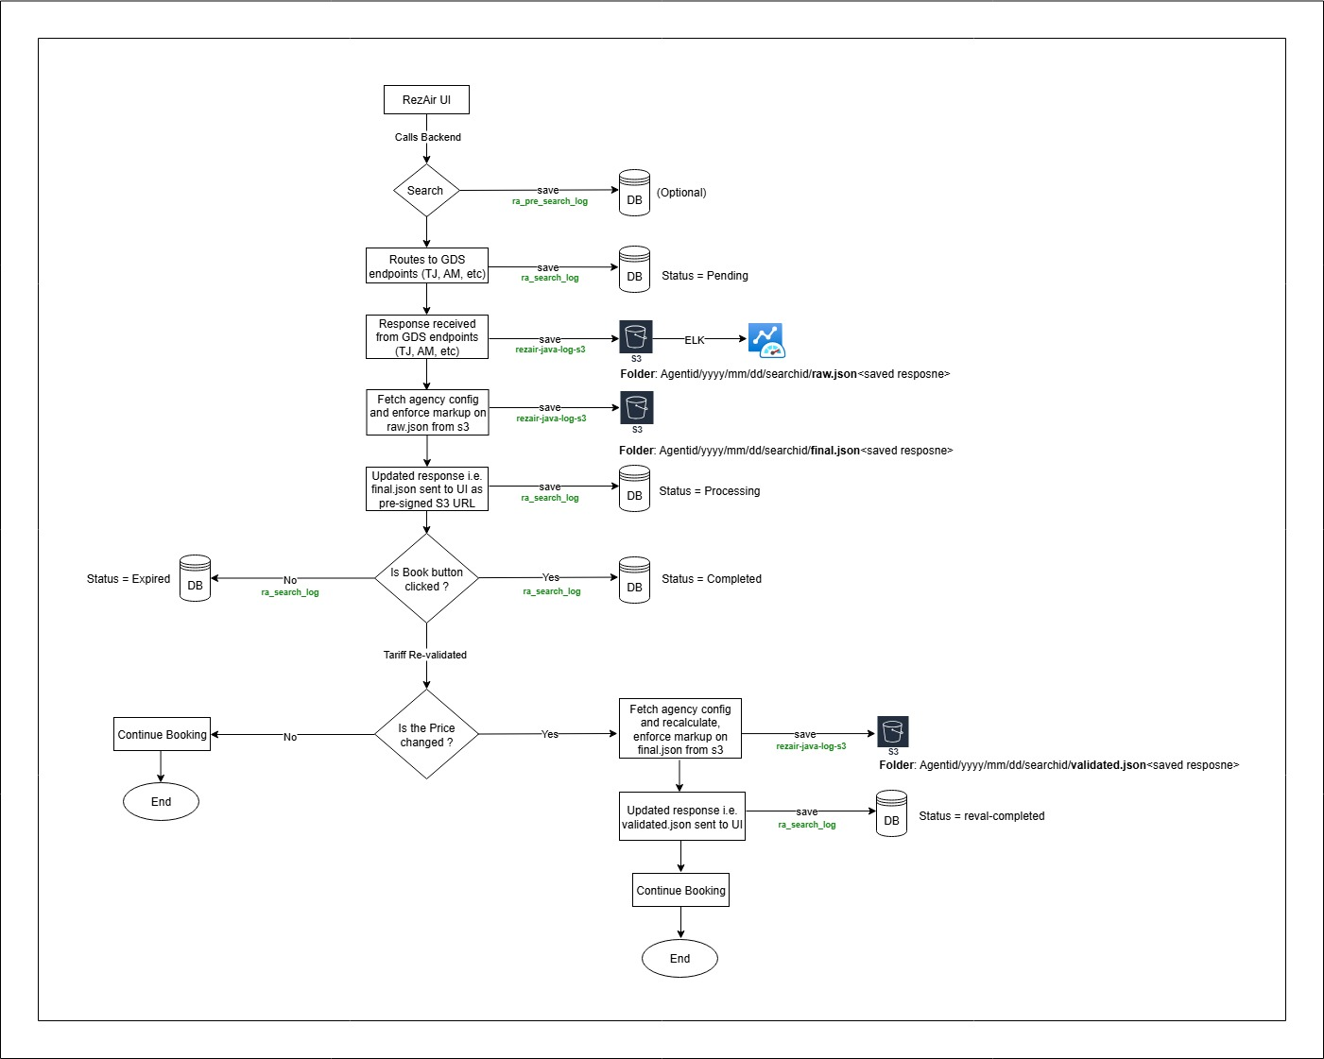
Fig#3.3 Search Data Flow Diagram w.r.t POS

Design Rational:
1. Search event is triggered from React UI
2. Search data gets accumulated into the database and in the S3 bucket first, Supplierwise, then agentwise
Folder: Agentid/yyyy/mm/dd/searchid/response.json<saved response>
3. The purge activity has to purge and move the data from database as well as from S3
4. In the database, we have is_softdelete column added in all of the tables, which will be used for purging
5. Java-based scheduler will be used for the storage and purging activity
6. In phase-1 archival, The scheduler-1 runs every 6 hour, the logic checks if timeNow > search_timestamp + 48 Hrs on ra_search_log table and set is_softdelete column to inactive (0) i.e. marking the said record as no more active (1)
7. The scheduler-2 runs after every 48 Hr interval to identify the search records based on the is_softdelete column value (0) and copy all such search response entries (by searchids) from S3 to archival DB and delete those entries from S3 (1000 entries can be deleted in one go on S3)
8. The same scheduler-2 after successful archival will delete the entries by searchids from ra_search_log table that had is_softdelete column set to inactive (0), keeping the ra_search_log table lightweight from search response load
9. The said search response entries will remain in archival DB. The time to keep the records in archival DB will be 24 months at any given point of time
10. Post 24 months, the decision can be taken to permanently move the records to phase-2 archival instance / data-warehouse or delete them forever
11. EC2/RDS/Glacier instances can be used for phase-1 / phase-2 archival processing and holding the data
12. The accumulated records are very useful and can help to generate insights using data analytics like demand forecast, markup optimization, trend identification, load prediction, infra streamlining, etc
13. Automated AI based analytics are available on AWS to generate insights using data analytics tools
14. The ra_trx_joblog table will be used to track the scheduler job for when it started and ended, to know the current state of purging process and if there is any stuck job
15. The entire process is time based and requires minimal watch, with added email triggers as well
React UI
↓
RA_Search_Log DB + S3 (json)
↓ (after 48 hrs)
[Scheduler-1] → mark is_softdelete=0
↓ (after 48 hrs + interval)
[Scheduler-2]
→ Copy S3 to Archival DB table
→ Delete from S3
→ Delete from RA_Search_Log (if is_softdelete=0)
↓
[Archival DB]
↓ (after 24 months)
Move to Long Term Archive / Glacier (Data-warehouse) / Delete permanently (Phase-2)

Variability Guide:
This section documents variation points to achieve variability for adapting to change:
1. As the traction on the RezAir system is increased, the capacity to purge and archival also needs to be enhanced by adding horizontal scaling (xl->2xl)
2. ln case, a scheduled job failed than graceful handling of the failures needs to be enhanced considering the load

Booking Data Flow
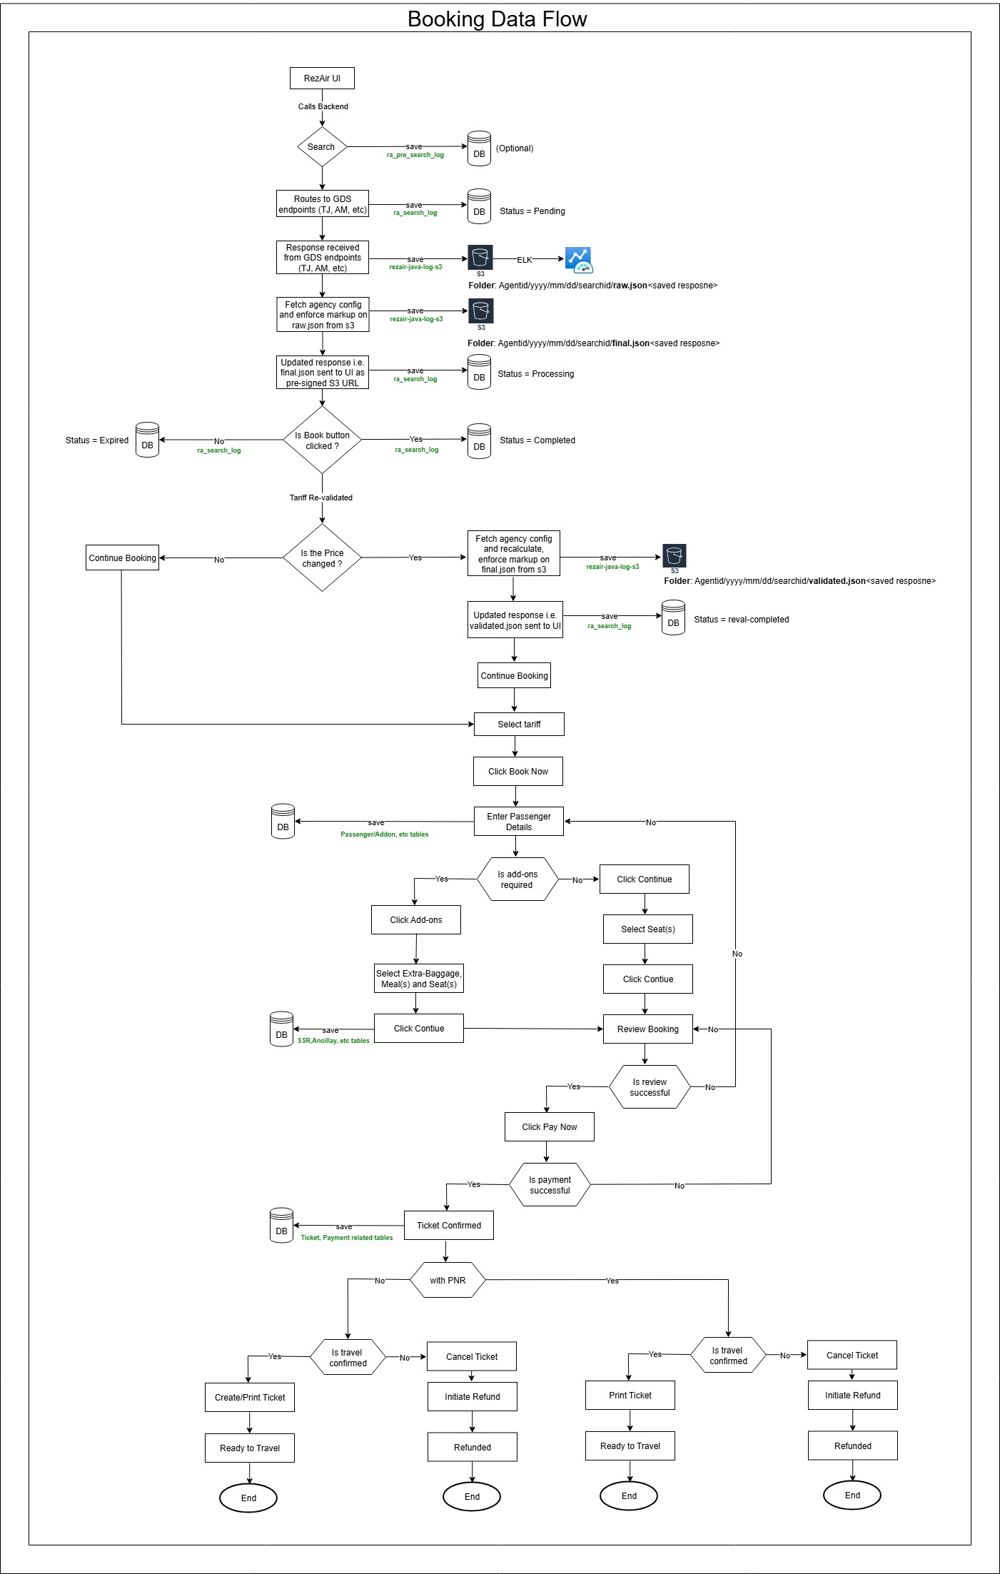
Fig#3.4 Booking Data Flow Diagram w.r.t POS

Design Rational:
1. Search event is triggered from React UI
2. Search data gets accumulated into the database and in the S3 bucket agentwise
Folder: Agentid/yyyy/mm/dd/searchid/response.json<saved response>
3. Booking data is accumulated into the database only
4. To get the booking logs agentwise or supplierwise, the DB tables related to Supplier, Booking, Tickets, Passengers, etc can be queried as needed
5. As RezAir gets more traction, the proposal is to create a scheduler based approach similar to ‘search response’ for moving the booking data into archival db or data-warehouse or to delete permanently, but unlike Search, the booking and other related tables are owned by RezLive hence no direct archival strategy or purge option can be implemented. Hence, assuming existing RezLive’s archival/purge setup will be used as the tables are the same

Variability Guide:
This section documents variation points to achieve variability for adapting to change / maintain booking data:
1. Java-based scheduler can be used for the storage and purging activity
2. EC2/RDS/Glacier instances can be used for phase-1 / phase-2 archival processing and holding the data
3. The accumulated records are very useful and can help to generate insights using data analytics like regional booking forecast, trend identification, upcoming volume prediction, infra streamlining, etc
4. Automated AI based analytics are available on AWS to generate insights using data analytics tools
5. As the traction on the RezAir system is increased, the capacity to purge and archival also needs to be enhanced by adding horizontal scaling (xl->2xl)

Constraints

Assumptions
1. Existing DB and tables will be utilized for lookup. Additional capacity can be added as needed

Dependencies on another Subsystem
1. RezLive System

Exception Handling
1. Standard exception handling at the component level.
2. Fallback mechanism for handling scheduler job failures.

Logging and Auditing Strategy
1. Log4j based logging will be enabled for logging at all levels.

*********

