APPLICATION UNDER THE RIGHT TO INFORMATION ACT 2005
To: The State / Central Public Information Officer -- Maharashtra Sales Tax Department and GST Authority
RM-RTI-04 -- VAT / GST Registration and Turnover Records -- Rashmi Metasteel Private Limited -- CIN: U27310MH2011PTC213595
DUAL AUTHORITY NOTE: This application is filed “SIMULTANEOUSLY” with TWO authorities -- (1) Maharashtra Sales Tax Department for pre-GST VAT records 2011 to 2017 -- and (2) GST Authority for post-July 2017 GST records. Each authority is requested to respond for its respective period. If any authority does not hold records for its period -- please provide written confirmation and transfer under Section 6(3) RTI Act if appropriate.
ONLINE FILING: (1) Maharashtra VAT – to be filed physically by Speedpost - Department: Finance -- Maharashtra Sales Tax Department. (2) GST Central Taxes -- filed online at rtionline.gov.in -- Ministry: Finance -- CBIC.

To -- (1) Pre-GST VAT Records:
The State Public Information Officer
Maharashtra Sales Tax Department
Mazgaon -- Mumbai 400010

To -- (2) GST Records:
The Central Public Information Officer
Central Board of Indirect Taxes and Customs (CBIC)
GST Commissionerate -- Mumbai | cbic.gov.in

Copy To -- Appellate Authorities:
(1) The Commissioner of Sales Tax -- Maharashtra
(2) The Additional Commissioner -- GST Mumbai
First Appeal under Section 19(1) RTI Act 2005 will be filed on day 31 if no response received.

Date: 16th May 2026 Place: Mumbai

SUBJECT: RTI Application under the Right to Information Act 2005 -- seeking VAT registration -- TIN -- GST registration -- GSTIN -- annual turnover declarations -- returns filed -- commodity-wise sales -- input tax credit claimed -- and scrutiny records -- for Rashmi Metasteel Private Limited -- CIN U27310MH2011PTC213595 -- for the entire period of its existence from 2011 to its strike off -- for use as primary evidence in proceedings before DRT II Mumbai and EOW/CBI Mumbai.

PART 1 -- APPLICANT DETAILS

Field | Detail
Name | Neeraj Singh Mohnia
Address | A-503 Marathon Eminence Dadasaheb Gaikwad Marg Mulund West Mumbai 400080
Mobile | 9323722122
Email | adarshimpexent@gmail.com
Capacity | Decree Holder -- Civil Suit 1351/2017 -- City Civil Court Mumbai -- Intervener IA 884/2026 in OA 122/2022 DRT II Mumbai -- Complainant EOW Mumbai
Fee | Rs 10 paid to each authority respectively-- total Rs 20 paid

PART 2 -- WHY TAX RECORDS ARE THE FINAL CONCLUSIVE TEST

THE FINAL CONCLUSIVE TEST: Tax registration and return records are the ultimate proof of whether any business activity -- whether manufacturing or trading -- was ever conducted. A company that manufactures metals must pay VAT or GST on sales. A company that trades in metals must pay VAT or GST. A company acting as agent earns commissions subject to Service Tax. If Rashmi Metasteel was never registered under VAT or GST -- or if registered but declared zero turnover -- this closes the argument entirely. No manufacturing. No trading. No agency. No business of any kind.

The certified balance sheet for FY 2012-13 already establishes the following facts:

Certified Balance Sheet Finding | What Tax Records Will Confirm
Trade receivables Rs 5,480 only -- near-zero sales | VAT returns showing same near-zero sales confirms no trading or manufacturing revenue
Zero trade payables -- no purchases | VAT returns showing zero purchases confirms no raw material procurement -- manufacturing impossible
Zero inventories | Consistent with zero VAT on goods held -- neither manufacturer nor trader
Rs 2.38 crore from related parties -- Rs 2.08 crore lent out | Circular fund flows are not taxable supplies -- confirms only financial pass-through activity
MOA permits both manufacturing and trading | VAT/GST HSN codes in returns will conclusively identify what activity if any was actually declared

Under the Maharashtra Value Added Tax Act 2002 -- every dealer with annual turnover exceeding Rs 10 lakh must register for VAT. Under GST from July 2017 -- every supplier of goods with turnover above Rs 20 lakh must register. A genuine manufacturer or trader of metals with any meaningful activity would mandatorily be registered. If Rashmi Metasteel was never registered -- or declared negligible turnover -- this raises questions the investigating authorities are invited to examine.

PART 3 -- SPECIFIC INFORMATION SOUGHT

Items 1 through 5 are directed to the Maharashtra Sales Tax Department for the VAT period 2011 to June 2017. Items 6 through 9 are directed to the GST authority for July 2017 onwards. The applicant requests individual and complete answers to each item.

SECTION A -- MAHARASHTRA VAT RECORDS (2011 to June 2017) -- To Maharashtra Sales Tax Department

ITEM 1 -- VAT Registration

• 1-A. Whether Rashmi Metasteel Private Limited -- CIN U27310MH2011PTC213595 -- was ever registered as a dealer under the Maharashtra Value Added Tax Act 2002 -- and if yes -- the TIN allotted.
• 1-B. The date of VAT registration -- the registered address declared -- and the category of registration -- manufacturer -- importer -- retailer -- or other.
• 1-C. The commodity classification declared -- specifically whether aluminium -- steel -- ferrous or non-ferrous metals -- or scrap and waste metals were covered.
• 1-D. Whether also registered under the Central Sales Tax Act 1956 -- and if yes -- the CST registration number.
• 1-E. If never registered under MVAT -- written confirmation on department letterhead -- as this means the company never conducted any taxable sale of goods in Maharashtra.

ITEM 2 -- Annual VAT Returns -- Year by Year Turnover

The applicant seeks year-by-year sales turnover as declared in VAT returns for each year of the company existence from 2011-12 to 2016-17.

Year | Significance
2011-12 | First year -- February 2011 incorporation -- was any sales activity declared
2012-13 | Year of available balance sheet -- only Rs 5,480 trade receivables -- does VAT return confirm same
2013-14 | Third year -- was company active in any trade
2014-15 | Fourth year -- continuing activity or dormant
2015-16 | Final year -- what was declared before strike off
2016-17 (April to June 2017) | Last VAT year before GST transition

• 2-A. Total gross turnover -- total taxable turnover -- and total tax payable as declared in MVAT returns for each year.
• 2-B. Turnover breakdown by commodity -- specifically what proportion was attributed to aluminium -- steel -- ferrous metals -- non-ferrous metals -- or scrap.
• 2-C. Whether any purchases of raw materials were declared -- and if yes -- total purchase turnover and commodity classification.
• 2-D. Whether any Input Tax Credit was claimed -- and if yes -- total ITC per year.

ITEM 3 -- Assessment and Audit History

• 3-A. Whether any assessment was ever conducted under Section 23 of the MVAT Act 2002.
• 3-B. Whether any audit was conducted under Section 22 of the MVAT Act 2002.
• 3-C. Whether any notice was issued for non-filing of returns -- and if yes -- details and outcome.
• 3-D. Whether any demand was raised for unpaid VAT -- and if yes -- the amount and recovery status.

ITEM 4 -- Service Tax Registration

• 4-A. Whether Rashmi Metasteel Private Limited was ever registered under the Finance Act 1994 for Service Tax -- given that the MOA permits agency and brokerage activities.
• 4-B. If registered -- the Service Tax Registration Number -- category of taxable services -- and total service tax paid per year.
• 4-C. If never registered for service tax -- written confirmation of that fact.

ITEM 5 -- Cancellation of VAT Registration

• 5-A. Whether VAT registration was ever cancelled -- and if yes -- date and reason.
• 5-B. Whether the company applied voluntarily for cancellation citing business closure -- and if yes -- the date claimed for closure.
• 5-C. The last return period for which any VAT return was filed.

SECTION B -- GST RECORDS (July 2017 Onwards) -- To GST Commissionerate Mumbai

ITEM 6 -- GST Registration

• 6-A. Whether Rashmi Metasteel Private Limited -- CIN U27310MH2011PTC213595 -- was ever registered under CGST Act 2017 and MGST Act 2017 -- and if yes -- the GSTIN allotted.
• 6-B. If registered -- the date of registration -- registered address -- and business activity declared.
• 6-C. The HSN codes declared -- specifically whether codes for metals -- aluminium products -- steel products -- or scrap were declared.
• 6-D. If never registered under GST -- written confirmation -- noting the company was struck off in or around 2016 and may have been defunct before GST commenced in July 2017.

ITEM 7 -- GST Returns and Turnover

• 7-A. If registered -- total outward supplies declared in GSTR-1 and total tax liability in GSTR-3B for each month of GST registration.
• 7-B. HSN-wise summary of outward supplies -- to identify whether goods were actually supplied and their nature.
• 7-C. Total Input Tax Credit claimed in GSTR-3B and the nature of inputs.

ITEM 8 -- GST Scrutiny or Audit

• 8-A. Whether any scrutiny notice was issued under Section 61 CGST Act 2017.
• 8-B. Whether any audit was conducted under Section 65 CGST Act 2017.
• 8-C. Whether any demand was raised for non-payment or short payment of GST.

ITEM 9 -- GST Registration Cancellation

• 9-A. Whether GST registration was ever cancelled -- and if yes -- whether suo motu by the department or on the company application.
• 9-B. The date of GST cancellation if applicable.

PART 4 -- SIGNIFICANCE OF EACH POSSIBLE RESPONSE

Tax Authority Response | What It Conclusively Establishes
Never registered under MVAT and never registered under GST | Company conducted no taxable sale of any goods in Maharashtra -- neither manufacturing nor trading -- conclusive
Registered under MVAT but zero turnover in all returns | Registered but no sales declared -- consistent with shell company status -- no genuine business activity
VAT registration but very low turnover -- below Rs 1 lakh per year | Inconsistent with any genuine metal manufacturing or trading operation
MVAT returns show purchases but no corresponding sales | Possible fraudulent ITC claim without output -- warrants examination
No Service Tax registration | No agency or brokerage income was ever declared -- all three revenue streams were absent
GST not applicable -- company struck off before July 2017 | Confirms company was inactive before GST regime -- corroborates MPCB and EPFO findings of zero activity

PART 5 -- LEGAL BASIS

Provision | Application
RTI Act 2005 -- Section 2(f) | VAT and GST registration and compliance records constitute information within RTI Act -- both Maharashtra Sales Tax Dept and CBIC are public authorities
RTI Act 2005 -- Section 6(1) and 7(1) | Absolute right -- 30-day mandatory response -- First Appeal on day 31
RTI Act 2005 -- Section 8(2) | Public interest override -- Rs 51.29 crore fraud -- DRT II Mumbai -- EOW Mumbai -- CBI BSFC
RTI Act 2005 -- Section 6(3) | Mandatory transfer within 5 days if records not with addressed CPIO
RTI Act 2005 -- Section 10 | Severability -- all non-exempt items must be provided
MVAT Act 2002 -- Section 80 | Tax records maintained under MVAT are public records subject to RTI
CGST Act 2017 -- Section 168 | GST records are government records subject to RTI in public interest

PART 6 -- PRE-EMPTION OF DENIAL GROUNDS

Likely Denial Ground | Legal Pre-emption
Tax records are confidential -- Section 8(1)(j) | Tax registration status and aggregate turnover figures of a company are not personal financial information. CIC has consistently held that registration status and aggregate compliance data of companies are not exempt. The applicant seeks registration status and aggregate turnover -- not individual transaction details or customer identities.
Never registered -- no records | Written confirmation on department letterhead that Rashmi Metasteel was never registered under MVAT or GST is the most important response sought -- please provide it signed by the competent officer.
Section 138 Income Tax Act confidentiality | This RTI is to VAT and GST departments -- Section 138 of the Income Tax Act applies only to income tax information -- not VAT or GST records.
Commercially sensitive -- Section 8(1)(d) | Tax data of a struck-off company with pending fraud proceedings is not commercially sensitive. The company is defunct. Section 8(1)(d) does not apply.
Sub-judice | RTI Act Section 8 has no sub-judice exemption. Tax compliance records are statutory administrative records independent of any court proceedings.
GSTN portal has this information | GSTN portal shows only basic registration details -- aggregate return data and commodity-wise turnover are not publicly available -- a specific RTI response is required.
Records not available beyond a certain period | MVAT Act requires permanent retention of assessment records. Non-availability must be stated specifically item by item with reasons.
Transfer to another commissionerate | Transfer under Section 6(3) within 5 days -- do not ask applicant to file fresh RTI.

PART 7 -- PRAYER

• Maharashtra Sales Tax Department: Provide complete answers to Items 1 through 5 -- including written confirmation if Rashmi Metasteel was never registered under MVAT -- and year-by-year turnover data if registered.
• GST Commissionerate Mumbai: Provide complete answers to Items 6 through 9 -- including written confirmation if Rashmi Metasteel was never registered under GST.
• Both authorities: Provide certified copies of all registration certificates -- returns -- assessment orders -- and cancellation orders.
• Both authorities: If the company was never registered -- provide written confirmation on department letterhead signed by the competent officer.
• Both authorities: If any item is claimed exempt -- cite specific sub-section of Section 8 RTI Act 2005 and provide all non-exempt items under Section 10.
• Both authorities: If records not with addressed CPIO -- transfer under Section 6(3) within 5 days.

VERIFICATION

I -- Neeraj Singh Mohnia -- declare that I am a citizen of India -- not an officer of any intelligence or security organisation -- and that the information sought is for genuine legal proceedings before DRT II Mumbai -- EOW Mumbai -- and CBI Banking Securities and Fraud Cell. RTI fee of Rs 10(Court Revenue Stamp affixed) has been paid to each of the two authorities online -- total Rs 20.

Verified at Mumbai on 16th May 2026.

___________________________
Neeraj Singh Mohnia
Decree Holder -- Civil Suit 1351/2017 -- City Civil Court Mumbai
Intervener -- IA 884/2026 in OA 122/2022 -- DRT II Mumbai
Mobile: 9323722122 | Email: adarshimpexent@gmail.com

Date: 16th May 2026 Place: Mumbai

Registration Number: CCEM1/R/E/26/00115
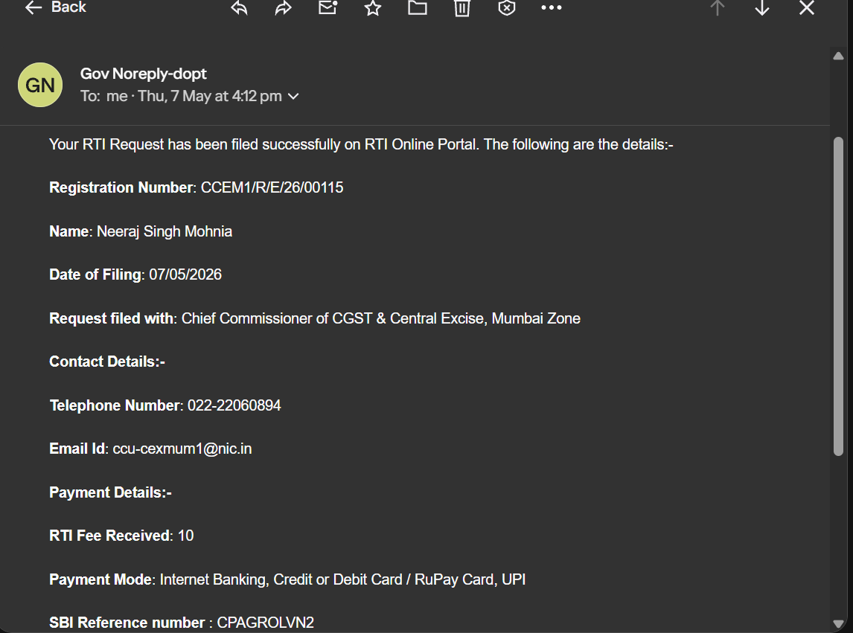

Status as on 8th May 2026
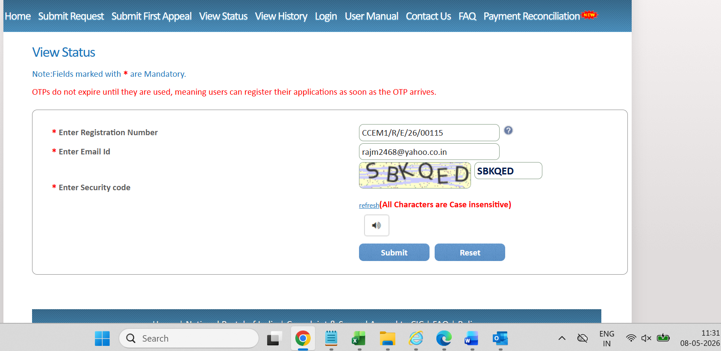
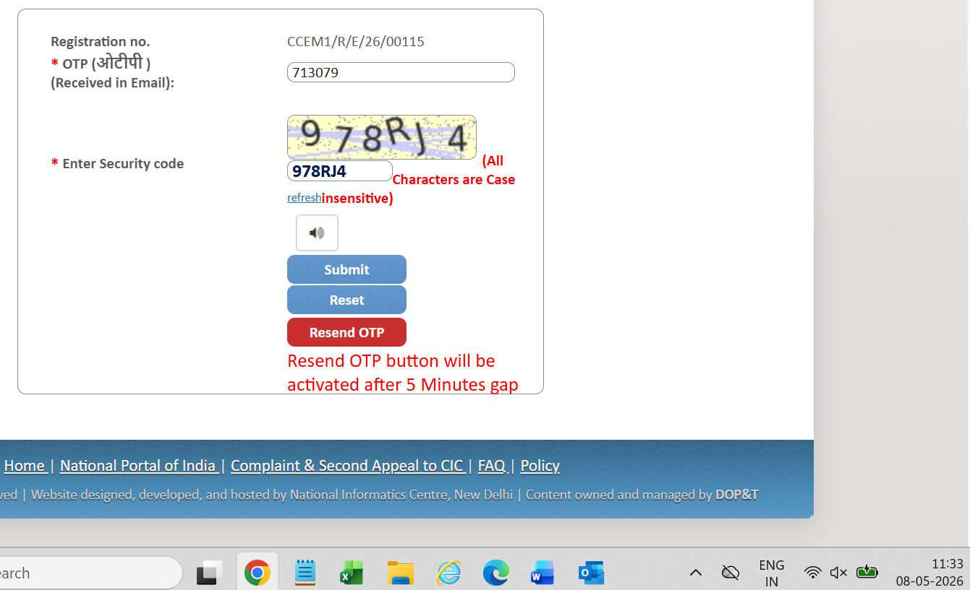
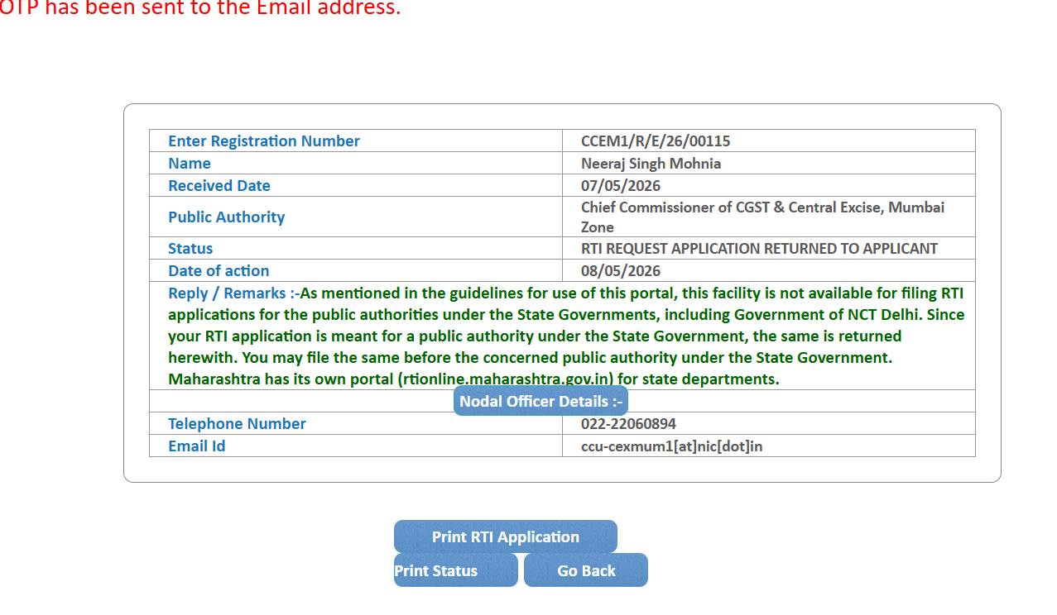

Mistake in the "Textarea text" rectified and filed a new one.

