RIGHT TO INFORMATION ACT 2005
APPLICATION UNDER SECTION 6(1)
CBIC — Chief Commissioner Central Excise — Ahmedabad Zone
GST & Pre-GST VAT Compliance | Three Bohra Network Companies | Gujarat GSTIN | Shell Company Investigation
ADDRESSEE
To: The Central Public Information Officer
Chief Commissioner, Central Excise, Ahmedabad Zone
Central Board of Indirect Taxes and Customs
Via: rtionline.gov.in

APPLICANT
Neeraj Singh Mohnia
A-503 Marathon Eminence, Dadasaheb Gaikwad Marg, Mulund West, Mumbai — 400 080
Mobile: 9323722122 Email: adarshimpexent@gmail.com
Capacity: Decree Holder — Execution Petition EXE S/2026 Filing No. 9/2026 — 6-27th Addl. Sr. Civil Judge & A.C.J.M. Vadodara. Active Intervener — IA 884/2026 in OA 122/2022 — DRT-II Mumbai. Complainant — CBI Mumbai — EOW Transfer Ref. 993/VPNI/AJUVI/Unit 7(Shares)/2026 dated 08/05/2026.
Date: 26th May 2026 Place: Mumbai

PART 1 — LEGAL BASIS AND SCOPE
This application is filed under Section 6(1) of the Right to Information Act 2005. GST and pre-GST VAT registration and compliance records are government records not shielded by any confidentiality provision. The applicant expressly invokes Section 8(2) public interest override.
All subject entities are at the centre of an active multi-crore bank fraud investigation before CBI Mumbai — EOW Transfer Ref. 993/VPNI/AJUVI/Unit 7(Shares)/2026 dated 08/05/2026. Active proceedings before DRT-II Mumbai (IA 884/2026 in OA 122/2022) and Vadodara Civil Court (EXE S/2026) are pending. All three companies are confirmed as having zero MCA annual return filings across all years of existence.

Binding Supreme Court Authority
Girish Ramchandra Deshpande v. CIC (2013) 1 SCC 212 — Official conduct and statutory compliance obligations are not personal information under Section 8(1)(j).

CBSE v. Aditya Bandopadhyay (2011) 8 SCC 497 — Exemptions construed narrowly — disclosure is the default — burden on public authority to establish exemption.

RBI v. Jayantilal N. Mistry (2016) 3 SCC 525 — Public institutions cannot shield deployment of public funds — public interest override mandatory.

Namit Sharma v. Union of India (2013) 1 SCC 745 — RTI Act must be construed liberally in favour of applicant.

Bhagat Singh v. CIC (2013) SCC OnLine Del 1941 — No sub-judice exemption in RTI Act — court proceedings not a ground for refusal.

Thalappalam Service Co-op Bank v. Kerala (2013) 16 SCC 82 — Public authorities substantially financed by Government — full RTI obligations apply.

SP Gupta v. President of India AIR 1982 SC 149 — Disclosure is the rule — secrecy is the exception.

PART 2 — ENTITIES IN RESPECT OF WHICH INFORMATION IS SOUGHT

Section A — Individual GSTIN:

# | Name | GSTIN | State | Reg. | Cancelled
1 | Babulal Ganeshmal Bohra | 24AAGPB8496B1ZW | Gujarat (24) | 01/07/2017 | 31/03/2021

Note: Principal place of business under GSTIN 24AAGPB8496B1ZW is Survey No 152/1 Kural Village Vadodara — the same village as Survey No 124 Kural Village Padra — the subject property in active DRT-II Mumbai and Vadodara Civil Court proceedings.

Section B — Three Bohra Network Companies:

# | Company Name | CIN | Role
2 | M/s Light and Glaze Profile Pvt. Ltd. | U27203GJ2011PTC065583 | IOB borrower — CERSAI 200003766496 — struck off
3 | M/s Shri Maintainance Contract Pvt. Ltd. | U99999GJ1992PTC017724 | Owns Survey 124 Kural — Section 68 GLRC — struck off
4 | M/s S.G. Preservatives Pvt. Ltd. | U15130GJ2015PTC083769 | BOB borrower — Survey 885/886 — struck off

PART 3 — INFORMATION SOUGHT
ITEM A — GUJARAT GSTIN 24AAGPB8496B1ZW — BABULAL GANESHMAL BOHRA
(a) Confirm legal name, PAN, HSN/SAC codes declared at registration — whether migrated from pre-GST VAT regime — prior TIN/VAT number if any.
(b) Whether GSTR-1 and GSTR-3B filed for each period from 01/07/2017 to 31/03/2021 — total periods filed — aggregate outward supplies declared — number of NIL periods.
(c) HSN codes declared — specifically whether Chapter 76 aluminium — Chapter 72 steel — or scrap codes declared.
(d) Total ITC claimed — whether any ITC reversal notice issued.
(e) Whether cancellation was suo motu by department or on taxpayer application — specific reason — pending dues if any.
(f) Whether any SCN under Section 73 or 74 CGST Act — scrutiny under Section 61 — or audit under Section 65 was conducted.

ITEM B — THREE BOHRA NETWORK COMPANIES — GST REGISTRATION STATUS
(g) Whether each of the three companies in Section B of Part 2 was ever registered under CGST Act 2017 and Gujarat GST Act 2017 — GSTIN if any. If never registered — written confirmation on department letterhead.
(h) HSN codes declared at registration if registered — whether codes for metals, aluminium, steel, or scrap were declared.

ITEM C — THREE COMPANIES — PRE-GST GUJARAT VAT REGISTRATION
(i) Whether each company was ever registered under Gujarat Value Added Tax Act 2003 — TIN if any. If never registered — written confirmation on department letterhead.
(j) Whether each company was registered under Central Sales Tax Act 1956 — CST number if any.

ITEM D — THREE COMPANIES — RETURN FILING AND TURNOVER
(k) Whether GST returns (GSTR-1 and GSTR-3B) were filed for any period — total periods filed per company.
(l) Total aggregate outward taxable supplies declared under GST across all periods — aggregate per company only.
(m) Whether Gujarat VAT returns were filed for any year — year-wise aggregate turnover declared.
(n) Total ITC claimed under GST — aggregate per company only.

ITEM E — THREE COMPANIES — SCNs, DEMANDS, CANCELLATION
(o) Whether any SCN issued under Section 73 or 74 CGST Act or under Gujarat VAT Act — grounds, amount, status.
(p) Whether GST or VAT registration was cancelled — suo motu or on application — date and reason.
(q) Whether GST/VAT authorities were notified of RoC strike-off of each company — and whether any action was taken.

Tax Authority Response | What It Conclusively Establishes
Never registered under GST or Gujarat VAT | Zero business activity — conclusive shell company status
Registered but zero turnover declared | No genuine business activity — shell company confirmed
Cancellation suo motu by department | Regulatory non-compliance confirmed independently
ITC claimed without output | Possible fraudulent ITC — separate GST offence

CRITICAL NOTE: If any company was never registered under GST or Gujarat VAT — written confirmation on department letterhead is the most important response sought — zero registrations confirm zero business activity.

PART 4 — PRE-EMPTION OF ANTICIPATED OBJECTIONS
Objection 1 — Records Are Confidential
Tax registration status, aggregate return data, and compliance history of businesses are not personal financial information. CIC has consistently held that aggregate compliance data of businesses is not exempt under Section 8(1)(j).

Objection 2 — Section 8(1)(j) Personal Information
The Supreme Court in Girish Ramchandra Deshpande v. CIC (2013) 1 SCC 212 held that statutory compliance in an official/business capacity is not personal information. Business tax compliance is conduct in the marketplace — not private personal affairs.

Objection 3 — Commercially Sensitive — Section 8(1)(d)
All subject entities are either cancelled, struck-off, or under active CBI and judicial scrutiny. Defunct entities have no commercial interests to protect. Section 8(1)(d) does not apply.

Objection 4 — Sub-Judice
Section 8 RTI Act contains no sub-judice exemption. The Delhi High Court in Bhagat Singh v. CIC (2013) SCC OnLine Del 1941 held that pendency of court proceedings is not a ground for refusing RTI disclosure. Section 22 RTI Act overrides any inconsistent provision.

Objection 5 — Section 8(2) Public Interest Override Mandates Disclosure
Even if any exemption technically applies — Section 8(2) mandates disclosure where public interest outweighs harm. Active CBI investigation, pending DRT-II Mumbai proceedings, and active Execution Petition Vadodara establish overwhelming public interest.

SEVERABILITY NOTICE: Even if any item is claimed exempt — Section 10 RTI Act requires mandatory provision of all non-exempt items. Item-wise reasoning must be provided for any exemption claimed.

PART 5 — MANDATORY RESPONSE TIMELINE
Response mandatory within 30 days under Section 7(1) RTI Act 2005. First Appeal before FAA on day 31 if no response received. Second Appeal before CIC will follow.
If any item falls outside jurisdiction of addressed CPIO — mandatory transfer under Section 6(3) RTI Act within 5 days — applicant must not be asked to file fresh application.
Applicant willing to pay all prescribed fees on intimation to adarshimpexent@gmail.com.

DECLARATION AND VERIFICATION
I, Neeraj Singh Mohnia, hereby declare that I am a citizen of India. All facts stated are true and correct to the best of my knowledge and belief. This application is filed in complete good faith under Section 6(1) of the Right to Information Act 2005. RTI fee of Rs 10 has been paid via the online portal.

Verified at Mumbai
Date: 26th May 2026
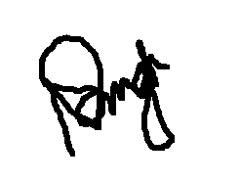
Neeraj Singh Mohnia
Decree Holder — EXE S/2026 | Intervener — IA 884/2026 OA 122/2022 DRT-II Mumbai
Complainant — CBI Mumbai — EOW Transfer Ref. 993 dated 08/05/2026
Mobile: 9323722122 | Email: adarshimpexent@gmail.com

Registration Number: CCEAB/R/E/26/00184

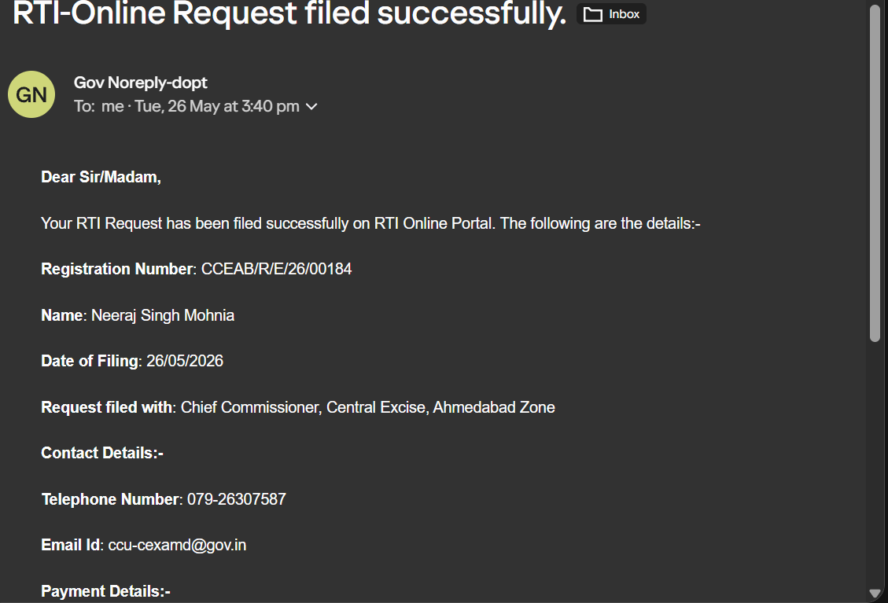

Status as on 30th May: Transferred
Registration #: CCEVD/R/T/26/00086
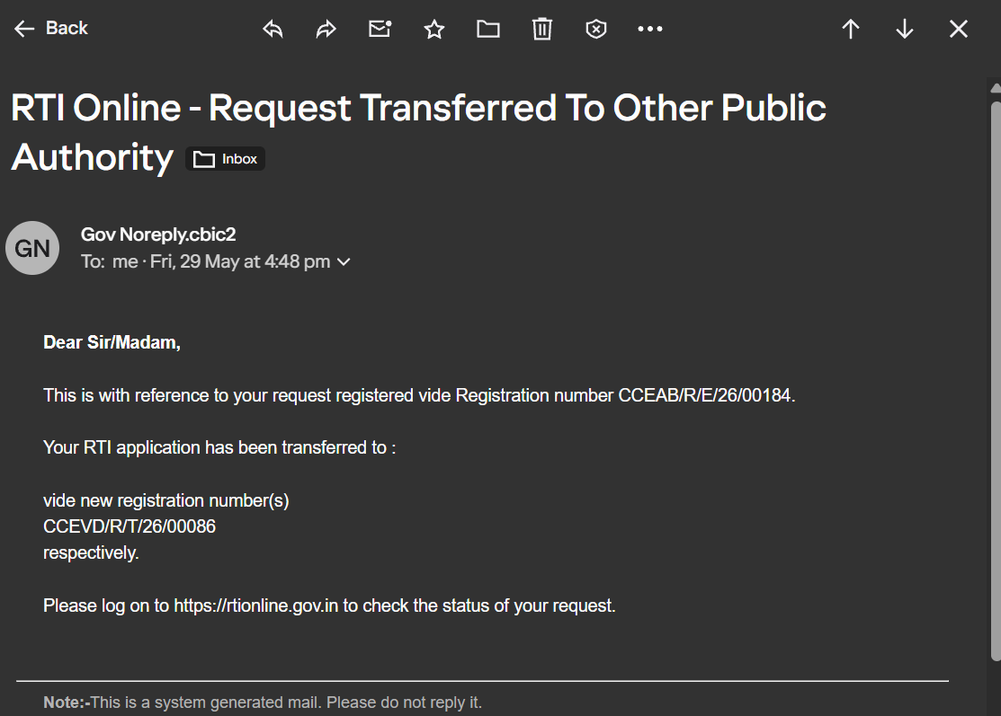

Status as on 1st June 2026: Gave a new Authority to be addressed
