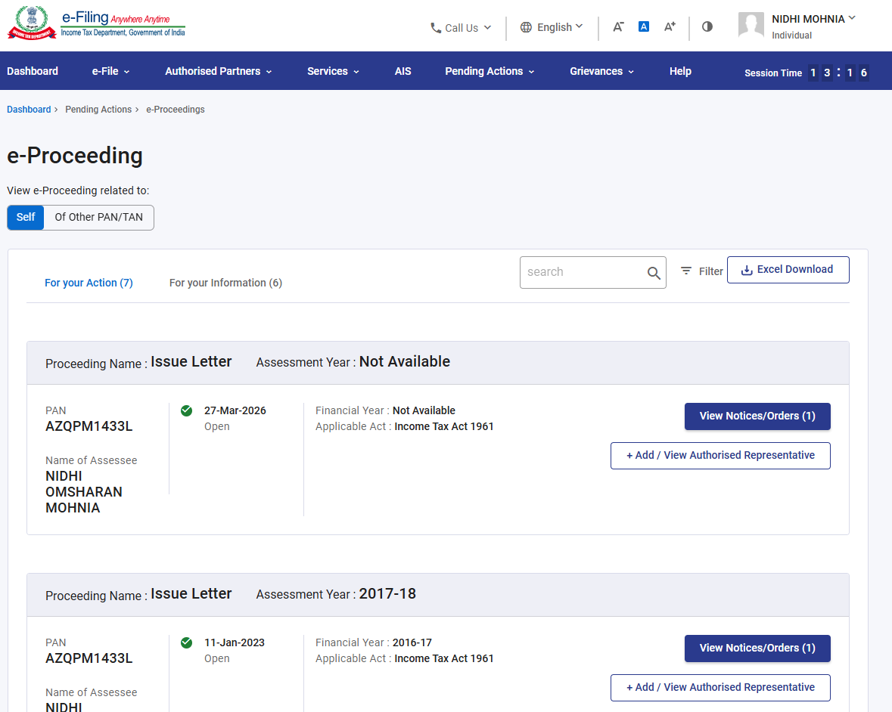
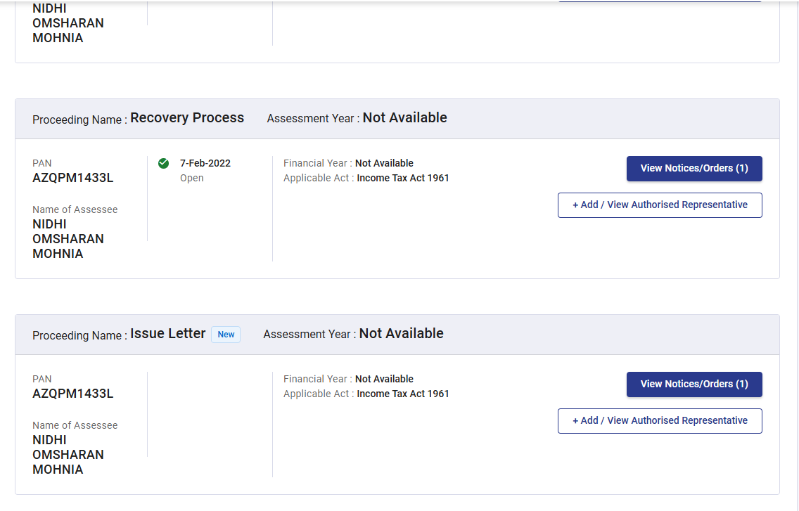
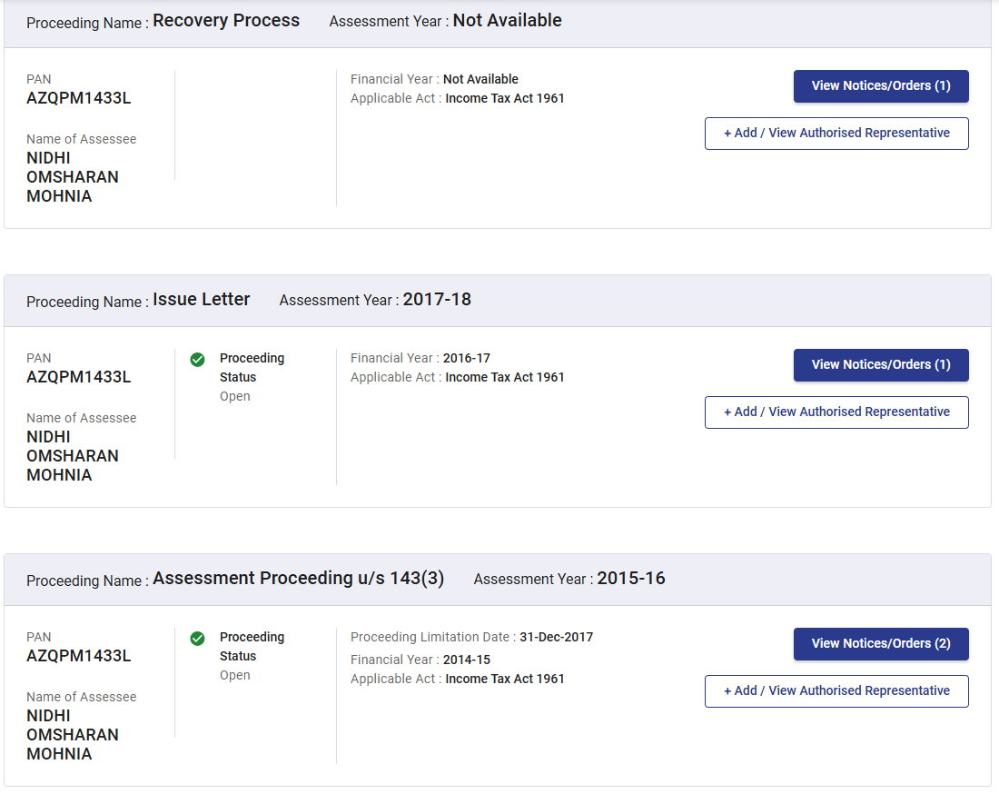

//---------------
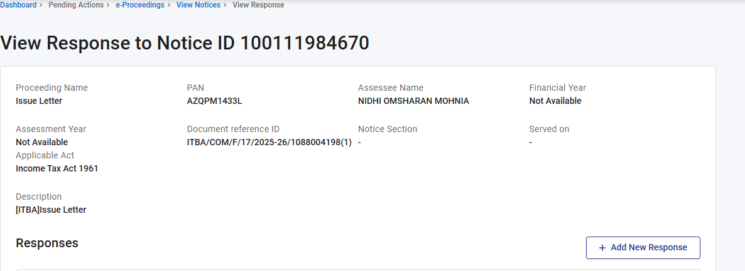
Textual copy pasted of the response by NOM:
This response is filed in connection with the above proceeding. The outstanding demand for AY 2017-18 and the bank attachment under Section 226(3) on ICICI Bank Account No. 001101082404 Andheri Lokhandwala Branch Mumbai are void and without legal basis. The Income Tax Appellate Tribunal, B Bench, Mumbai has passed an Order dated 29th December 2023 in ITA No. 3281/Mum/2022 entirely in favour of the Assessee directing deletion of the entire addition of Rs 89,58,000 for AY 2017-18. This order is available in your departments own ITBA system and is directly accessible to your office. The Assessee is not required to furnish the order of your own Tribunal to the very department whose Tribunal issued it. The duty to give effect under Rule 34 5 of the ITAT Rules 1963 was triggered by the receipt of the order by the Principal Commissioner not by any action of the Assessee. The 90 day deadline expired on 29th March 2024 over 14 months ago. The demand notice dated 27/03/2026 bearing DIN ITBA/COM/F/17/2025-26/1088004198(1) is additionally void on two independent grounds: (a) it references wrong PAN ACFPM3533R instead of the Assessees PAN AZQPM1433L; and (b) it bears an unverified digital signature. The Assessee demands immediate: (i) Order Giving Effect to ITAT Order ITA 3281/Mum/2022 (ii) Zeroing of all AY 2017-18 demands on the e-filing portal (iii) Withdrawal of Section 226(3) attachment on ICICI Bank Account 001101082404 A detailed legal protest letter (Legal_Protest_AY_2017-18_PAN_AZQPM1433L_pdf )dated 1st June 2026 has been sent to the Assessing Officer separately.
This response is filed in connection with the above proceeding. The outstanding demand for AY 2017-18 and the bank attachment under Section 226(3) on ICICI Bank Account No. 001101082404 Andheri Lokhandwala Branch Mumbai are void and without legal basis. The Income Tax Appellate Tribunal, B Bench, Mumbai has passed an Order dated 29th December 2023 in ITA No. 3281/Mum/2022 entirely in favour of the Assessee directing deletion of the entire addition of Rs 89,58,000 for AY 2017-18. This order is available in your departments own ITBA system and is directly accessible to your office. The Assessee is not required to furnish the order of your own Tribunal to the very department whose Tribunal issued it. The duty to give effect under Rule 34 5 of the ITAT Rules 1963 was triggered by the receipt of the order by the Principal Commissioner not by any action of the Assessee. The 90 day deadline expired on 29th March 2024 over 14 months ago. The demand notice dated 27/03/2026 bearing DIN ITBA/COM/F/17/2025-26/1088004198(1) is additionally void on two independent grounds: (a) it references wrong PAN ACFPM3533R instead of the Assessees PAN AZQPM1433L; and (b) it bears an unverified digital signature. The Assessee demands immediate: (i) Order Giving Effect to ITAT Order ITA 3281/Mum/2022 (ii) Zeroing of all AY 2017-18 demands on the e-filing portal (iii) Withdrawal of Section 226(3) attachment on ICICI Bank Account 001101082404 A detailed legal protest letter (Legal_Protest_AY_2017-18_PAN_AZQPM1433L_pdf )dated 1st June 2026 has been sent to the Assessing Officer separately.
This response is filed in connection with the above proceeding. The outstanding demand for AY 2017-18 and the bank attachment under Section 226(3) on ICICI Bank Account No. 001101082404 Andheri Lokhandwala Branch Mumbai are void and without legal basis. The Income Tax Appellate Tribunal, B Bench, Mumbai has passed an Order dated 29th December 2023 in ITA No. 3281/Mum/2022 entirely in favour of the Assessee directing deletion of the entire addition of Rs 89,58,000 for AY 2017-18. This order is available in your departments own ITBA system and is directly accessible to your office. The Assessee is not required to furnish the order of your own Tribunal to the very department whose Tribunal issued it. The duty to give effect under Rule 34 5 of the ITAT Rules 1963 was triggered by the receipt of the order by the Principal Commissioner not by any action of the Assessee. The 90 day deadline expired on 29th March 2024 over 14 months ago. The demand notice dated 27/03/2026 bearing DIN ITBA/COM/F/17/2025-26/1088004198(1) is additionally void on two independent grounds: (a) it references wrong PAN ACFPM3533R instead of the Assessees PAN AZQPM1433L; and (b) it bears an unverified digital signature. The Assessee demands immediate: (i) Order Giving Effect to ITAT Order ITA 3281/Mum/2022 (ii) Zeroing of all AY 2017-18 demands on the e-filing portal (iii) Withdrawal of Section 226(3) attachment on ICICI Bank Account 001101082404 A detailed legal protest letter (Legal_Protest_AY_2017-18_PAN_AZQPM1433L_pdf )dated 1st June 2026 has been sent to the Assessing Officer separately.
Response Submitted On
04-Jun-2026
Response Type
Full
Response Filed By
Self
//----------------------------------
9th September 2026: Response to Outstanding Demands:
