Implement API Gateway Usage Plan & Throttling Endpoint (Java)
1. User Story
A dedicated Java-based API endpoint to manage API Usage Plans is to be developed, so that per-user rate limiting (throttling) and cooling periods can be enforced to protect our system resources and monetize different tiers of access for RezAir users.
2. Business Context & Background
RezLive requires a mechanism to prevent system abuse and ensure fair usage. Currently, in SILv2, we manage this for Hotels via a .NET service. We need to migrate/replicate this logic into our Java/Spring Boot ecosystem for RezAir.
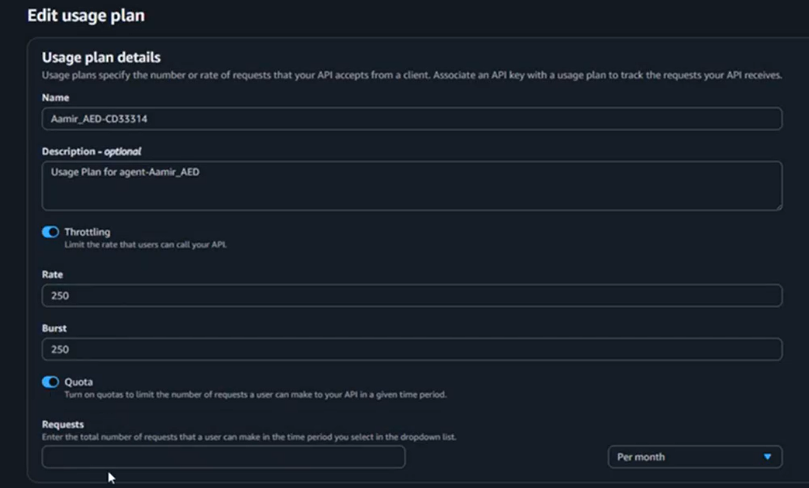
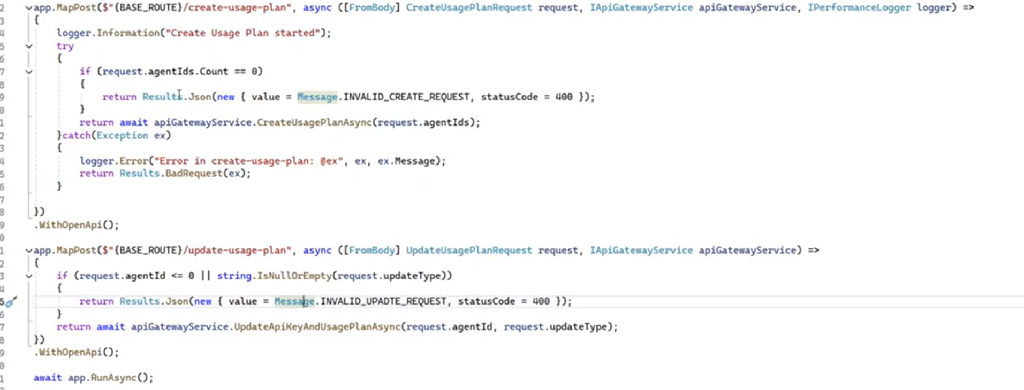
- Throttling: Restricting users to specific limits (e.g., 100 vs. 200 requests/sec).
- Cool-down Period: A "circuit breaker" behavior similar to AWS CloudWatch where requests are paused once the quota is exceeded.
- API Key Management: Each user/agent is identified by an API Key which maps to a specific "Usage Plan" (Staging vs. Production).
3. High-Level Technical Overview
- Tech Stack: Java 17/21, Spring Boot, AWS SDK for Java (v2).
- Integration: This endpoint will be consumed by PHP-based front-end systems.
- AWS Service: Amazon API Gateway (Usage Plans, API Keys, and Throttling).
4. Functional Requirements
- Endpoint Creation: Develop a REST endpoint (e.g., POST /v1/usage-plan/sync) that handles both the creation and update of usage plans.
- Agent Mapping: The service must fetch the Agent ID, API Key, and Plan Configuration from the database to configure the AWS Usage Plan.
- SDK Integration: Utilize the AWS SDK to programmatically:
  - Create/Update Usage Plan names and descriptions.
  - Set Burst and Rate limits.
  - Associate API Keys with the Usage Plan.
- Environment Awareness: Logic must distinguish between Staging and Production AWS ARN configurations.
5. Technical Acceptance Criteria (AC)
- A single Java endpoint is available that can idempotently "Create or Update" a Usage Plan.
- The endpoint correctly interfaces with the AWS SDK and successfully modifies settings in the AWS Console.
- Proper error handling is implemented for AWS throttling or invalid API keys (returning appropriate HTTP status codes).
- Security: The endpoint must only be accessible by authorized internal services (PHP backend).
- Performance: Execution time for the AWS SDK call must be logged to monitor latency.
6. Non-Functional Requirements
- Parity: The logic must match the existing .NET (SILv2) implementation to ensure consistent behavior across Hotels and Air segments.
- Observability: Integrated with CloudWatch logs for tracking plan assignments per Agent ID.

7. Technical Roadmap:
Review the "Significant Java Code" document provided in the technical attachment. Note that we are opting for a Single API approach (Create + Update) to reduce complexity for the PHP integration team.
"Security (Least Privilege): The Spring Boot service must use an IAM Role with a Tag-Based Condition Policy. This ensures the service can only perform apigateway:* actions (including Create and Update) on resources where the Environment tag matches the deployment environment (e.g., PROD, STAGING).".
To begin with, to implement, we will use the AWS SDK for Java 2.x. In the AWS ecosystem, "usage rights" are enforced by linking an API Key (which represents your user) to a Usage Plan (which defines the limits). The overall logic follows three main steps:
- Create Usage Plans: Define the "Gold" and "Silver" tiers (e.g., AgentY vs. AgentX).
- Create API Keys: Generate unique identifiers for each user.
- Link them: Associate the Key with the Plan.

- Configurations like, add the API Gateway dependency to your pom.xml:
<dependency>
<groupId>software.amazon.awssdk</groupId>
<artifactId>apigateway</artifactId>
<version>2.20.0</version>
</dependency>
- Setup for AgentX vs. AgentY
To differentiate between AgentX and AgentY, you don't necessarily need to create a “new plan” every time. Instead, create static plans and move users between them:
User | Plan Tier | Rate Limit (req/sec) | Quota (req/month)
AgentX | Silver | 5 | 10,000
AgentY | Gold | 100 | 1,000,000

- Operational points
API Key Source: Ensure your API Gateway settings have the "API Key Source" set to HEADER. The client must then pass the key in the x-api-key header.
Method Requirement: You must explicitly enable "API Key Required" on the specific Resource/Method in the API Gateway console (or via SDK) for these plans to actually trigger.

- Throttling: Controls the speed (e.g., AgentX can only do 5 hits per second).
- Quota: Controls the volume (e.g., AgentX can only do 1,000 hits per day).

- The Architectural Workflow
- Identity: Each AgentID is mapped to a unique API Key.
- Logic: Java code checks if an API Key for that AgentID exists.
- Association: If the Agent needs specific limits (Rate/Burst), the code either creates a custom Usage Plan or updates an existing one and links the API Key to it.

- Code sample, to understand the workflow
import software.amazon.awssdk.services.apigateway.ApiGatewayClient;
import software.amazon.awssdk.services.apigateway.model.*;
import java.util.Optional;

public class AgentUsagePlanManager {

private final ApiGatewayClient apiGateway = ApiGatewayClient.create();

/**
* Configures a specific usage plan for an Agent.
* @param agentId Unique ID of the Agent
* @param rateLimit Requests per second
* @param burstLimit Maximum concurrent request bucket
*/
public void provisionAgentAccess(String agentId, Double rateLimit, Integer burstLimit) {

String apiKeyId = getOrCreateApiKey(agentId); // 1. Create or Get API Key for the Agent
String usagePlanId = createUsagePlan(agentId, rateLimit, burstLimit);// 2. Create a specific Usage Plan for this Agent's limits
linkKeyToPlan(usagePlanId, apiKeyId); // 3. Link the API Key to the Usage Plan
log.info("Provisioning Complete for Agent: " + agentId);
}

private String getOrCreateApiKey(String agentId) {
String keyName = "Key_Agent_" + agentId;

// Check if key already exists
GetApiKeysResponse keys = apiGateway.getApiKeys(r -> r.nameQuery(keyName));
Optional<ApiKey> existingKey = keys.items().stream().findFirst();

if (existingKey.isPresent()) {
return existingKey.get().id();
}

// Create new key if not found
CreateApiKeyResponse response = apiGateway.createApiKey(r -> r
.name(keyName)
.enabled(true)
.description("API Key for Agent " + agentId));
return response.id();
}

private String createUsagePlan(String agentId, Double rateLimit, Integer burstLimit) {
CreateUsagePlanResponse response = apiGateway.createUsagePlan(r -> r
.name("Plan_Agent_" + agentId)
.throttle(ThrottleSettings.builder()
.rateLimit(rateLimit)
.burstLimit(burstLimit)
.build())
// Optional: add quota (e.g., 5000 requests per month)
.quota(QuotaSettings.builder().limit(5000).period(QuotaPeriodType.MONTH).build())
.build());

return response.id();
}

private void linkKeyToPlan(String usagePlanId, String apiKeyId) {
try {
apiGateway.createUsagePlanKey(r -> r
.usagePlanId(usagePlanId)
.keyId(apiKeyId)
.keyType("API_KEY"));
} catch (ConflictException e) {
// Key might already be linked to a plan
System.out.println("Key already associated with a plan.");
}
}
}

- Cloud(AWS) specifics : Configure the Gateway to look for the key.
Gateway Console: Go to your API -> Settings.
- API Key Source: Ensure this is set to HEADER.
- Method Request: On every API Resource/Method (e.g., GET /data), set API Key Required to true.
- Deployment: Deploy the API to a Stage (e.g., prod) and then add that Stage to the Usage Plan created in the Java code.

Limitations to Watch For
- Account Limits: AWS has a default limit of 500 Usage Plans per region. If RezAir has hundreds of Agents, do not create one plan per agent. Instead, create "Tiered Plans" (Bronze, Silver, Gold) and just link the Agent's API Key to the pre-existing tier.
- Propagation Delay: When the Java code creates a plan, it can take a few seconds (usually < 30s) to propagate across all AWS edge locations.
- Pseudo code sample with focus on Asynchronous code/ important libraries inclusion
1. RezAir Maven Configuration (pom.xml)

<project xmlns="http://maven.apache.org/POM/4.0.0"
xmlns:xsi="http://www.w3.org/2001/XMLSchema-instance"
xsi:schemaLocation="http://maven.apache.org/POM/4.0.0 http://maven.apache.org/xsd/maven-4.0.0.xsd">
<modelVersion>4.0.0</modelVersion>
<groupId>com.rezair</groupId>
<artifactId>rezair-provisioning</artifactId>
<version>1.0-SNAPSHOT</version>

<properties>
<maven.compiler.source>21</maven.compiler.source>
<maven.compiler.target>21</maven.compiler.target>
<aws.sdk.version>2.29.0</aws.sdk.version>
<resilience4j.version>2.2.0</resilience4j.version> <!-- To be or not to be used will be explained later !>
<log4j.version>2.23.1</log4j.version>
</properties>

<dependencyManagement>
<dependencies>
<dependency>
<groupId>software.amazon.awssdk</groupId>
<artifactId>bom</artifactId>
<version>${aws.sdk.version}</version>
<type>pom</type>
<scope>import</scope>
</dependency>
</dependencies>
</dependencyManagement>

<dependencies>
<dependency>
<groupId>software.amazon.awssdk</groupId>
<artifactId>apigateway</artifactId>
</dependency>
<dependency>
<groupId>software.amazon.awssdk</groupId>
<artifactId>url-connection-client</artifactId>
</dependency>

<dependency>
<groupId>io.github.resilience4j</groupId>
<artifactId>resilience4j-bulkhead</artifactId>
<version>${resilience4j.version}</version>
</dependency>
<dependency>
<groupId>io.github.resilience4j</groupId>
<artifactId>resilience4j-retry</artifactId>
<version>${resilience4j.version}</version>
</dependency>
<dependency>
<groupId>io.github.resilience4j</groupId>
<artifactId>resilience4j-micrometer</artifactId>
<version>${resilience4j.version}</version>
</dependency>

<dependency>
<groupId>org.apache.logging.log4j</groupId>
<artifactId>log4j-api</artifactId>
<version>${log4j.version}</version>
</dependency>
<dependency>
<groupId>org.apache.logging.log4j</groupId>
<artifactId>log4j-core</artifactId>
<version>${log4j.version}</version>
</dependency>
</dependencies>
</project>

2. RezAir Constants
package com.rezair.config;

import java.time.Duration;

public final class RezAirConstants {
private RezAirConstants() {} // Prevent instantiation

// Resource Naming Patterns
public static final String KEY_NAME_FORMAT = "RezAir-Key-%s-%d";
public static final String PLAN_NAME_FORMAT = "RezAir-Plan-%d";
public static final String API_STAGE_PROD = "prod";

// Resilience Settings
public static final int MAX_CONCURRENT_AWS_CALLS = 5;
public static final Duration BULKHEAD_MAX_WAIT = Duration.ofSeconds(10);
public static final int MAX_RETRY_ATTEMPTS = 3;
public static final Duration RETRY_WAIT_DURATION = Duration.ofSeconds(2);

// Default "Low Limit" Usage Plan Values ensure in case of throttling challenges, we want RezAir system to be very slow but operational
public static final Double DEFAULT_RATE_LIMIT = 1.0;
public static final Integer DEFAULT_BURST_LIMIT = 1;

// Propagation
public static final Duration PROPAGATION_DELAY = Duration.ofSeconds(30);
}

3. The RezAir Provisioning Service

package com.rezair.service;

import com.rezair.config.RezAirConstants;
import io.github.resilience4j.bulkhead.Bulkhead;
import io.github.resilience4j.bulkhead.BulkheadConfig;
import io.github.resilience4j.retry.Retry;
import io.github.resilience4j.retry.RetryConfig;
import org.apache.logging.log4j.LogManager;
import org.apache.logging.log4j.Logger;
import software.amazon.awssdk.http.urlconnection.UrlConnectionHttpClient;
import software.amazon.awssdk.services.apigateway.ApiGatewayClient;
import software.amazon.awssdk.services.apigateway.model.*;

import java.util.concurrent.ExecutorService;
import java.util.concurrent.Executors;
import java.util.function.Supplier;

/** Entry point. Spawns the Virtual Thread and manages the Redisson Semaphore lifecycle.
Uses Distributed Bulkheads to manage cluster-wide AWS API limits.
*/
public class RezAirProvisioningService {
private static final Logger logger = LogManager.getLogger(RezAirProvisioningService.class);

private final ApiGatewayClient apiClient;
private final ExecutorService virtualExecutor;
private final Bulkhead bulkhead;
private final Retry retry;

public RezAirProvisioningService() {
// Prevent pinning with UrlConnectionHttpClient
this.apiClient = ApiGatewayClient.builder()
.httpClientBuilder(UrlConnectionHttpClient.builder())
.build();

// One Virtual Thread per Task
this.virtualExecutor = Executors.newVirtualThreadPerTaskExecutor();

// Bulkhead: Limit in-flight AWS calls to protect quotas
this.bulkhead = Bulkhead.of("rezair-aws-bulkhead", BulkheadConfig.custom()
.maxConcurrentCalls(RezAirConstants.MAX_CONCURRENT_AWS_CALLS)
.maxWaitDuration(RezAirConstants.BULKHEAD_MAX_WAIT)
.build()
);

// Retry: Exponential backoff for AWS limits
this.retry = Retry.of("rezair-aws-retry", RetryConfig.custom()
.maxAttempts(RezAirConstants.MAX_RETRY_ATTEMPTS)
.waitDuration(RezAirConstants.RETRY_WAIT_DURATION)
.retryExceptions(TooManyRequestsException.class, ServiceUnavailableException.class)
.build()
);
}

/* Manages the thread lifecycle,
*/
public void provisionAgent(int agentId, String username) {
virtualExecutor.submit(() -> {
try {
logger.info("RezAir: Initiating lifecycle for Agent ID: {}", agentId);
// Combined Resilience logic
Supplier<String> call = () -> executeAwsWorkflow(agentId, username);
String planId = Bulkhead.decorateSupplier(bulkhead,
Retry.decorateSupplier(retry, call)
)
.get();

handlePropagationDelay(agentId, planId);

} catch (Exception e) {
logGranularException(e, agentId);
applyEmergencyDefaultPlan(agentId);
}
}
);
}

/* Actual AWS- SDK calls
*/
private String executeAwsWorkflow(int agentId, String username) {
String keyName = String.format(RezAirConstants.KEY_NAME_FORMAT, username, agentId);
String planName = String.format(RezAirConstants.PLAN_NAME_FORMAT, agentId);

logger.debug("RezAir: Creating API Key [{}] and Plan [{}]", keyName, planName);

// 1. Identity Creation
CreateApiKeyResponse keyRes = apiClient.createApiKey(r -> r.name(keyName).enabled(true));

// 2. Policy Creation
CreateUsagePlanResponse planRes = apiClient.createUsagePlan(r -> r
.name(planName)
.throttle(t -> t
.rateLimit(RezAirConstants.DEFAULT_RATE_LIMIT)
.burstLimit(RezAirConstants.DEFAULT_BURST_LIMIT))
.build());

// 3. Association
apiClient.createUsagePlanKey(r -> r.usagePlanId(planRes.id())
.keyId(keyRes.id())
.keyType("API_KEY"));

return planRes.id();
}

private void handlePropagationDelay(int agentId, String planId) {
try {
logger.info("RezAir: Entering propagation sleep for Agent {}", agentId);
Thread.sleep(RezAirConstants.PROPAGATION_DELAY); // Virtual threads make this sleep "free" - it doesn't block the OS
logger.info("RezAir: SUCCESS - Agent {} is LIVE on Plan {}", agentId, planId);
} catch (InterruptedException e) {
Thread.currentThread().interrupt();
}
}

private void logGranularException(Exception e, int agentId) {

switch (e) { // Pattern matching switch - cleaner, safer, and faster
case TooManyRequestsException -> logger.error("RezAir-MONITOR: AWS Throttling triggered for Agent {}",
agentId);
case ApiGatewayException awsEx -> logger.error("RezAir-MONITOR: AWS Service Error [{}] for Agent {}",
awsEx.awsErrorDetails().errorCode(), agentId);
case null -> logger.error("RezAir-MONITOR: Received null exception for Agent {}", agentId);
default -> logger.error("RezAir-MONITOR: Unexpected system error for Agent {}: {}", agentId,
e.getMessage());
}
}

private void applyEmergencyDefaultPlan(int agentId) {
logger.warn("RezAir-FALLBACK: Applying static Default Usage Plan for Agent {}", agentId);
// Direct assignment to pre-existing safety plan ID
}
}

- Advanced AWS Cluster specifics
Deploying RezAir to an EC2 Cluster requires moving from local execution to an orchestrated AWS infrastructure. Since RezAir will use a cluster (likely managed via an Auto Scaling Group), the security and configuration must be more refined.
- Identity: IAM Instance Profiles (Cluster-Level): Use a separate Instance Profile for each environment (RezAir-Dev-Profile, RezAir-Prod-Profile) to ensure that a compromise in DEV cannot affect PROD
- Networking: Security Groups & VPC Endpoints: EC2 cluster nodes sit in a private subnet. To reach the AWS API Gateway service, they need a route out. Private API: Create an Interface VPC Endpoint for API Gateway.
- Multi-Environment Variable Injection: Use EC2 User Data or Systems Manager (SSM) Parameter Store.
- Security: Restricted Resource Policies:
Ensure PROD role can only touch PROD resources:
{
"Version": "2012-10-17",
"Statement": [
{
"Effect": "Allow",
"Action": "apigateway:*",
"Resource": "arn:aws:apigateway:us-east-1::/usageplans",
"Condition": {
"StringLike": {
"aws:RequestTag/Environment": "${environment_variable}"
}
}
}
]
}

- Advanced Java code
If we want that the request limit is shared across all nodes, then we can use implement a Distributed Bulkhead (using Redis)
pom.xml Configuration: Add the Redisson dependency to your pom.xml.(No dependency on Resilience library)
<dependency>
<groupId>org.redisson</groupId>
<artifactId>redisson</artifactId>
<version>3.25.0</version>
</dependency>

package com.rezair.config;

import org.redisson.Redisson;
import org.redisson.api.RedissonClient;
import org.redisson.config.Config;
import org.springframework.context.annotation.Bean;
import org.springframework.context.annotation.Configuration;
import software.amazon.awssdk.http.urlconnection.UrlConnectionHttpClient;
import software.amazon.awssdk.services.apigateway.ApiGatewayClient;

@Configuration
public class RezAirSpringConfig{

@Bean
public ApiGatewayClient apiGatewayClient() {
// Shared singleton client using the V-Thread friendly HTTP client
return ApiGatewayClient.builder()
.httpClientBuilder(UrlConnectionHttpClient.builder())
.build();
}

@Bean(destroyMethod = "shutdown")
public RedissonClient redissonClient() {
Config config = new Config();
String redisUrl = System.getenv().getOrDefault("REDIS_URL", "redis://127.0.0.1:6379");

config.useSingleServer()
.setAddress(redisUrl)
.setConnectionPoolSize(64);

return Redisson.create(config);
}
}

// ------------ Class RezAirDistributedProvisioningService
package com.rezair.service;

import com.rezair.config.RezAirConstants;
import org.redisson.api.RSemaphore;
import org.redisson.api.RedissonClient;
import org.apache.logging.log4j.LogManager;
import org.apache.logging.log4j.Logger;
import software.amazon.awssdk.services.apigateway.ApiGatewayClient;
import software.amazon.awssdk.services.apigateway.model.*;

import java.util.concurrent.TimeUnit;

public class RezAirDistributedProvisioningService {
private static final Logger logger = LogManager.getLogger(RezAirDistributedProvisioningService.class);

private final ApiGatewayClient apiClient;
private final RedissonClient redisson;
private final String REDIS_BULKHEAD_KEY = "rezair:bulkhead:aws-api";

public RezAirDistributedProvisioningService(ApiGatewayClient apiClient, RedissonClient redisson) {
this.apiClient = apiClient;
this.redisson = redisson;

// Initialize the global limit once (shared across the cluster)
RSemaphore semaphore = redisson.getSemaphore(REDIS_BULKHEAD_KEY);
semaphore.trySetPermits(RezAirConstants.MAX_CONCURRENT_AWS_CALLS);
}

public void provisionAgent(int agentId, String username) {
// Spawn a Virtual Thread for every request
Thread.ofVirtual().name("RezAir-Worker-" + agentId).start(() -> {
RSemaphore semaphore = redisson.getSemaphore(REDIS_BULKHEAD_KEY);
boolean acquired = false;

try {
// Wait for a global permit from Redis
/* We could have technically used a method acquire(), instead of tryAcquire which indefinitely waits!
semaphore.acquire() // The thread will stay "parked" until the permit is free.
*/
acquired = semaphore.tryAcquire(
RezAirConstants.BULKHEAD_MAX_WAIT.toSeconds(),
TimeUnit.SECONDS
);

if (acquired) {
executeAwsWorkflow(agentId, username);
} else {
logger.error("RezAir-CLUSTER: Global Bulkhead full. Rejecting Agent {}", agentId);
applyEmergencyDefaultPlan(agentId);
}
} catch (InterruptedException e) {
Thread.currentThread().interrupt();
logger.error("RezAir-SYSTEM: Provisioning interrupted for Agent {}", agentId);
} catch (Exception e) {
// Pattern matching for granular logging
logGranularException(e, agentId);
applyEmergencyDefaultPlan(agentId);
} finally {
if (acquired) {
semaphore.release(); // Return permit to the cluster pool
}
}
});
}

/**
* Orchestrates the 3-step AWS API Gateway workflow.
*/
private void executeAwsWorkflow(int agentId, String username) {
logger.info("RezAir-AWS: Starting workflow for Agent {}", agentId);

// 1. Create API Key
CreateApiKeyResponse keyResponse = apiClient.createApiKey(r -> r
.name("Key-" + username + "-" + agentId)
.enabled(true)
.generateDistinctId(true));

// 2. Create Usage Plan
CreateUsagePlanResponse planResponse = apiClient.createUsagePlan(r -> r
.name("Plan-Agent-" + agentId)
.description("Automated plan for " + username)
.throttle(t -> t.rateLimit(10.0).burstLimit(20)));

// 3. Link Key to Plan
apiClient.createUsagePlanKey(r -> r
.usagePlanId(planResponse.id())
.keyId(keyResponse.id())
.keyType("API_KEY"));

logger.info("RezAir-AWS: Successfully provisioned Plan {} for Agent {}", planResponse.id(), agentId);

// Wait for AWS eventual consistency (Non-blocking for Virtual Threads)
handlePropagationDelay(agentId);
}

/**
* Helper to simulate/wait for AWS infrastructure propagation.
*/
private void handlePropagationDelay(int agentId) {
try {
// This unmounts the virtual thread from the carrier thread
Thread.sleep(RezAirConstants.PROPAGATION_DELAY);
logger.info("RezAir-MONITOR: Agent {} infrastructure is now live.", agentId);
} catch (InterruptedException e) {
Thread.currentThread().interrupt();
}
}

/**
* Pattern Matching Switch for efficient exception handling.
*/
private void logGranularException(Exception e, int agentId) {
switch (e) {
case TooManyRequestsException _ ->
logger.error("RezAir-MONITOR: AWS Throttling triggered for Agent {}", agentId);

case ApiGatewayException awsEx ->
logger.error("RezAir-MONITOR: AWS Service Error [{}] for Agent {}",
awsEx.awsErrorDetails().errorCode(), agentId);

default ->
logger.error("RezAir-MONITOR: Unexpected system error for Agent {}: {}",
agentId, e.getMessage());
}
}

/**
* Fallback logic when the system is under too much pressure.
* Instead of a custom plan, we link the agent to a pre-existing "Safety Plan".
*/
private void applyEmergencyDefaultPlan(int agentId) {
logger.warn("RezAir-FALLBACK: Initiating Emergency Plan for Agent {}", agentId);

try {
// 1. We still need a unique API Key for the agent to track them
CreateApiKeyResponse keyResponse = apiClient.createApiKey(r -> r
.name("Emergency-Key-Agent-" + agentId)
.enabled(true));

// 2. Link this new key to your PRE-EXISTING global safety plan
// This plan ID should be stored in your RezAirConstants
apiClient.createUsagePlanKey(r -> r
.usagePlanId(RezAirConstants.GLOBAL_SAFETY_PLAN_ID) // e.g., "p371pt"
.keyId(keyResponse.id())
.keyType("API_KEY"));

logger.info("RezAir-FALLBACK: Agent {} successfully mapped to Global Safety Plan.", agentId);

} catch (Exception e) { // If even the fallback fails (e.g., AWS is completely down),
// we must trigger a manual alert for the Ops team.
logger.fatal("RezAir-CRITICAL: Emergency fallback failed for Agent {}. Manual intervention required!", agentId);
triggerInternalAlertSystem(agentId, e.getMessage());
}
}

/**
* Helper to notify your monitoring system (email/etc..) of a total failure.
*/
private void triggerInternalAlertSystem(int agentId, String error) {
// Integration with CloudWatch Metrics or SNS would go here
logger.error("RezAir-ALERT: Provisioning Death-End for Agent {}. Error: {}", agentId, error);
}
}

