https://tutorialsdojo.com/aws-global-infrastructure/
AWS Global Infrastructure Cheat Sheet
Amazon Web Services provides the most extensive global footprint compared to any other cloud provider in the market, and it opens up new regions faster than others.
AWS Global Cloud Infrastructure
AWS provides the most extensive global footprint compared to any other cloud providers in the market, and it opens up new regions faster than others. AWS maintains numerous geographic regions around the globe, from North America, South America, Europe, Asia Pacific, and the Middle East. AWS serves over a million active customers in more than 190 countries.
AWS is able to support this massive workload thanks to its Global Cloud Infrastructure, which consists of the following:
- Availability Zones
- Regions
- Edge Networks
The AWS Global Cloud Infrastructure is the most secure, extensive, and reliable cloud platform in the industry today, which offers a wide range of cloud service offerings. AWS is the top choice of small and medium enterprises for deploying their application workloads across the globe and for distributing content closer to their end-users with low latency. It provides you with a highly available and fault-tolerant cloud infrastructure where and when you need it.
AWS owns and operates thousands of servers and networking devices that are running in various data centers scattered around the globe. A data center is a physical facility that houses hundreds of computer systems, network devices, and storage appliances. You can run your applications in two or more data centers to achieve high availability, so if there is an outage in one of the data centers, you still have other servers running in another data center. A data center can also deliver cached content to your global end-users to improve response times.
At its core, the AWS Global Infrastructure utilizes multiple data centers and groups them into Availability Zones, Regions, and Edge Locations. Let’s discuss these components one by one:
AWS Availability Zone and AWS Region
An Availability Zone consists of one or more data centers, each with redundant power, networking, and connectivity. The data centers of a single Availability Zone, or “AZ” for short, are typically within 100 kilometers or 60 miles of each other. Think of it as a cluster of interconnected data centers in a specific geographic zone, that can help your applications become highly available – hence the name, Availability Zone.
An AWS Region consists of multiple Availability Zones. AWS has various regions available in North America, South America, Europe, Asia, and other parts of the globe. Since a single AZ consists of multiple data centers, your system can achieve a higher level of fault-tolerance by running it in two or more AZs. This enables companies to build highly available, fault-tolerant, and scalable cloud architecture instead of running their applications on a single datacenter.
Remember that a single AZ consists of one or more data centers. Since you can deploy your application or your database to multiple AZs in a single region, your systems will still be running even if three or more data centers experienced an outage simultaneously.
To improve the durability of your data, you can also replicate it in two or more regions. This is helpful for disaster recovery and backups.
The Availability Zones of a single AWS Region are typically within hundreds of kilometers or miles of each other. However, these AZs are still within a specific country to comply with the data sovereignty requirement. This is particularly useful if you have sensitive data that must only be stored in a certain location or country for data privacy compliance.
AWS Edge Networks
The other component of the AWS Global Cloud Infrastructure is the edge networks of Point-of-Presence or PoP. It consists of Edge Locations and Regional Edge Caches, which enables you to distribute your content with low-latency (pronounce: Laaay-tancy) to your global users. Basically, a PoP serves as an access point that allows two different networks to communicate with each other.
By using these global edge networks, a user request doesn’t need to travel far back to your origin just to fetch data. The cached contents can quickly be retrieved from regional edge caches that are closer to your end-users. This is also referred to as a Content Delivery Network or CDN.
So for example, you have high-resolution images stored in a server in California. You can cache these media files to an edge location in the Philippines, India, or Singapore to allow your customers in Asia to retrieve these photos faster. The images will be loaded quickly because it is fetched to an edge server near your users, instead of retrieving it from its origin server in California.
As mentioned above, the AWS Global infrastructure is built around Regions and Availability Zones (AZs):
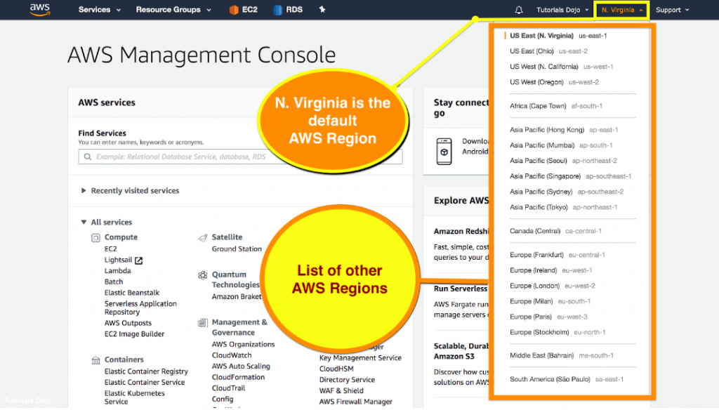

Regions provide multiple, physically separated, and isolated Availability Zones which are connected with low latency, high throughput, and highly redundant networking. Availability Zones offer highly availability, fault tolerance, and scalability. It consists of one or more discrete data centers, each with redundant power, networking, and connectivity, housed in separate facilities. An Availability Zone is represented by a region code followed by a letter identifier; for example, us-east-1a.
You can visualize the hierarchy of the Availability Zone and AWS Region in this diagram:
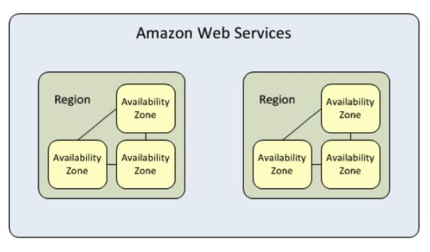

An AWS Local Region is a single datacenter designed to complement an existing AWS Region. An AWS Local Zone places AWS compute, storage, database, and other select services closer to large population, industry, and IT centers where no AWS Region exists today. To deliver low-latency content to users around the globe, AWS has placed Points of Presence, which are either edge locations or edge caches. These points are used by Cloudfront and Lambda@edge services. Edge locations are locations that CloudFront uses to cache copies of your content for faster delivery to users at any location.
View the Interactive AWS Global Infrastructure Map here.
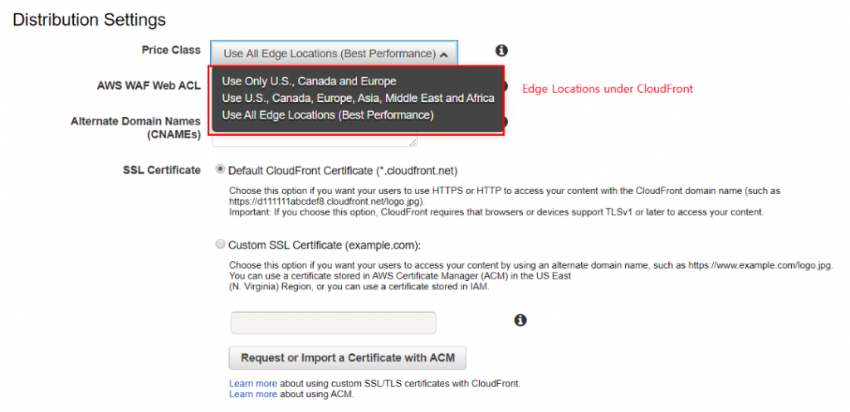

AWS Global Infrastructure Cheat Sheet Sources:
https://aws.amazon.com/about-aws/global-infrastructure/
https://docs.aws.amazon.com/aws-technical-content/latest/aws-overview/global-infrastructure.html
https://www.infrastructure.aws/
----------------------------------------------------------------------------------------

https://tutorialsdojo.com/comparison-of-aws-services/
In this section, we will compare seemingly similar services and concepts, and highlight their main differences to help you gain a better understanding of these topics. The AWS certification exams are now composed of very tricky and complex scenario questions and going through this section can help you tackle these confusing questions with more confidence. Do note that not every cheat sheet here will be applicable to each AWS certification exam so it’s best to also refer to our study guides when reviewing.
We also recommend that you answer as many AWS practice test questions as you can to further increase your chances of passing the exam. And if you want to access only the relevant cheat sheets for the specific AWS exams that you are preparing for then check out the Tutorials Dojo Study Guide and Cheat Sheets eBooks.
All the best!
Comparison of AWS Services Cheat Sheets:
- Amazon Aurora vs Amazon RDS
- Amazon Cognito User Pools vs Identity Pools
- Amazon EKS vs Amazon ECS
- Amazon EFS vs Amazon FSx for Windows vs Amazon FSx for Lustre
- Amazon Kinesis Data Streams vs Data Firehose vs Data Analytics vs Video Streams
- Amazon RDS vs DynamoDB
- Amazon S3 vs EBS vs EFS
- Amazon S3 vs Glacier
- Amazon SWF vs AWS Step Function vs Amazon SQS
- Application Load Balancer vs Network Load Balancer vs Classic Load Balancer
- AWS CloudTrail vs Amazon CloudWatch
- AWS DataSync vs Storage Gateway
- AWS Global Accelerator vs Amazon CloudFront
- AWS Secrets Manager vs Systems Manager Parameter Store
- Backup and Restore vs Pilot Light vs Warm Standby vs Multi – site
- CloudWatch Agent vs SSM Agent vs Custom Daemon Scripts
- EBS-SSD vs HDD
- EC2 Container Services ECS vs Lambda
- EC2 Instance Health Check vs ELB Health Check vs Auto Scaling and Custom Health Check
- Elastic Beanstalk vs CloudFormation vs OpsWorks vs CodeDeploy
- ELB Health Checks vs Route 53 Health Checks For Target Health Monitoring
- Global Secondary Index vs Local Secondary Index
- Interface Endpoint vs Gateway Endpoint vs Gateway Load Balancer Endpoint
- Latency Routing vs Geoproximity Routing vs Geolocation Routing
- Redis Append – Only files vs Redis Replication
- Redis Cluster Mode Enabled vs Disabled vs Memcached
- S3 Pre-Signed URLS vs CloudFront Signed URLS vs Origin Access Identity
- S3 Standard vs S3 Standard-IA vs S3OneZone-IA
- S3 Transfer Acceleration vs Direct Connect vs VPN vs Snowball vs Snowmobile
- Security Group vs NACL
- Service Control Policies vs IAM Policies
- SNI Custom SSL vs Dedicated IP Custom SSL
- Step Scaling vs Simple Scaling Policies in Amazon EC2
- VPC Interface Endpoint vs. Gateway Endpoint in AWS
AWS vs Microsoft Azure
- AWS Certified Cloud Practitioner vs AZ-900 Microsoft Azure Fundamentals
- AWS vs Azure Services Comparison
Once again, if you want to access only the relevant cheat sheets for the specific AWS exams that you are preparing for then do check out the Tutorials Dojo Study Guide and Cheat Sheets eBooks.
----------------------------------------------------------------------------------------------------
https://tutorialsdojo.com/amazon-aurora-vs-amazon-rds/
 | Aurora | RDS
Type of database | Relational database
Features | - • MySQL and PostgreSQL compatible.  - • 5x faster than standard MySQL databases and 3x faster than standard PostgreSQL databases.  - • Use Parallel Query to run transactional and analytical workloads in the same Aurora database, while maintaining high performance.  - • You can distribute and load balance your unique workloads across different sets of Aurora DB instances using custom endpoints.  - • Aurora Serverless allows for on-demand, autoscaling of your Aurora DB instance capacity. | - • Has several database instance types for different kinds of workloads and support five database engines – MySQL, PostgreSQL, MariaDB, Oracle, and SQL Server.  - • Can use either General Purpose Storage and Provisioned IOPS storage to deliver a consistent IOPS performance
Maximum storage capacity | 128 TB | 64 TB for MySQL, MariaDB, Oracle, and PostgreSQL engines  16 TB for SQL Server engine
DB instance classes | - • Memory Optimized classes – for workloads that need to process large data sets in memory.  - • Burstable classes – provides the instance the ability to burst to a higher level of CPU performance when required by the workload. | - • Standard classes – for a wide range of workloads, you can use general purpose instance. It offers a balance of compute, memory, and networking resources.  - • Memory Optimized classes – for workloads that need to process large data sets in memory.  - • Burstable classes – provides the instance the ability to burst to a higher level of CPU performance when required by the workload.
Availability and durability | - • Amazon Aurora uses RDS Multi-AZ technology to automate failover to one of up to 15 Amazon Aurora Replicas across three Availability Zones  - • Amazon Aurora Global Database uses storage-based replication to replicate a database across multiple AWS Regions, with typical latency of less than 1 second.  - • Self-healing: data blocks and disks are continuously scanned for errors and replaced automatically. | - • Amazon RDS Multi-AZ deployments synchronously replicates your data to a standby instance in a different Availability Zone.  - • Amazon RDS will automatically replace the compute instance powering your deployment in the event of a hardware failure.
Backups | - • Point-in-time recovery to restore your database to any second during your retention period, up to the last five minutes.  - • Automatic backup retention period up to thirty-five days.  - • Backtrack to the original database state without needing to restore data from a backup. | - • The automated backup feature enables point-in-time recovery for your database instance.  - • Database snapshots are user-initiated backups of your instance stored in Amazon S3 that are kept until you explicitly delete them.
Scalability | - • Aurora automatically increases the size of your volumes as your database grows larger (increments of 10 GB).  - • Aurora also supports replica auto-scaling, where it automatically adds and removes DB replicas in response to changes in performance metrics.  - • Cross-region replicas provide fast local reads to your users, and each region can have an additional 15 Aurora replicas to further scale local reads. | - • The MySQL, MariaDB, SQL Server, Oracle, and PostgreSQL engines scale your storage automatically as your database workload grows with zero downtime.  - • Read replicas are available for Amazon RDS for MySQL, MariaDB, PostgreSQL, Oracle, and SQL Server. Amazon RDS creates a second DB instance using a snapshot of the source DB instance and uses the engines’ native asynchronous replication to update the read replica whenever there is a change to the source.  - • Can scale compute and memory resources (vertically) of up to a maximum of 32 vCPUs and 244 GiB of RAM.
Security | - • Isolate the database in your own virtual network via VPC.  - • Connect to your on-premises IT infrastructure using encrypted IPsec VPNs or Direct Connect and VPC Endpoints.  - • Configure security group firewall and network access rules to your database instances.  - • Integrates with IAM.
Encryption | - • Encrypt your databases using keys you manage through AWS KMS. With Amazon Aurora encryption, data stored at rest is encrypted, as are its automated backups, snapshots, and replicas in the same cluster.  - • Supports the use of SSL (AES-256) to secure data in transit. | - • Encrypt your databases using keys you manage through AWS KMS. With Amazon RDS encryption, data stored at rest is encrypted, as are its automated backups, read replicas, and snapshots.  - • Supports Transparent Data Encryption in SQL Server and Oracle.  - • Supports the use of SSL to secure data in transit
DB Authentication | - • Password authentication  - • Password and IAM database authentication | - • Password authentication  - • Password and IAM database authentication  - • Password and Kerberos authentication
Maintenance | - • Amazon Aurora automatically updates the database with the latest patches.  - • Amazon Aurora Serverless enables you to run your database in the cloud without managing/maintaining any database infrastructure. | - • Amazon RDS will update databases with the latest major and minor patches on scheduled maintenance windows. You can exert optional control over when and if your database instance is patched.
Monitoring | - • Use Enhanced Monitoring to collect metrics from the operating system instance.  - • Use Performance Insights to detect database performance problems and take corrective action.  - • Uses Amazon SNS to receive a notification on database events.
Pricing | - • A monthly charge for each database instance that you launch if you use on-demand. This includes both the instance compute capacity and the amount of storage being used.  - • Option to reserve a DB instance for a one or three-year term (reserve instances) and receive discounts in pricing.
Use Cases | - • Enterprise applications – a great option for any enterprise application that uses relational database since it handles provisioning, patching, backup, recovery, failure detection, and repair.  - • SaaS applications – without worrying about the underlying database that powers the application, you can concentrate on building high-quality applications.  - • Web and mobile gaming – since games need a database with high throughput, storage scalability, and must be highly available. Aurora suits the variable use pattern of these apps perfectly. | - • Web and mobile applications – since the application needs a database with high throughput, storage scalability, and must be highly available. RDS also fulfills the needs of such highly demanding apps.  - • E-commerce applications – a managed database service that offers PCI compliance. You can just focus on building high-quality customer experiences without thinking of the underlying database.  - • Mobile and online games – game developers don’t need to worry about provisioning, scaling, and monitoring of database servers since RDS manages the database infrastructure.

---------------------------------------------------------------------------------------------------
https://tutorialsdojo.com/amazon-cognito-user-pools-vs-identity-pools/
With the proliferation of smartphones in our connected world, more and more developers are quickly deploying their applications on the cloud. One of the first challenges in developing applications is allowing users to log in and authenticate on your applications. There are multiple stages involved in user verification and most of these are not visible from the end-user. AWS provides an easy solution for this situation.
User Identity verification is at the core of Amazon Cognito. It provides solutions for three key areas of user identification:
- Authentication – provides users sign-up and sign-in options. Enables support for federation with Enterprise Identities (Microsoft AD), or Social Identities (Amazon, Facebook, Google, etc.)
- Authorization – sets of permission or operations allowed for a user. It provides fine-grained access control to resources.
- User Management – allows management of user lifecycles, such as importing users, onboarding users, disabling users, and storing and managing user profiles.

In this post, we’ll talk about Cognito User Pools and Identity Pools, including an overview of how they are used to provide authentication and authorization functionalities that can be integrated on your mobile app.
Amazon Cognito User Pools
Amazon Cognito User Pools are used for authentication. To verify your user’s identity, you will want to have a way for them to login using username/passwords or federated login using Identity Providers such as Amazon, Facebook, Google, or a SAML supported authentication such as Microsoft Active Directory. You can configure these Identity Providers on Cognito, and it will handle the interactions with these providers so you only have to worry about handling the Authentication tokens on your app.
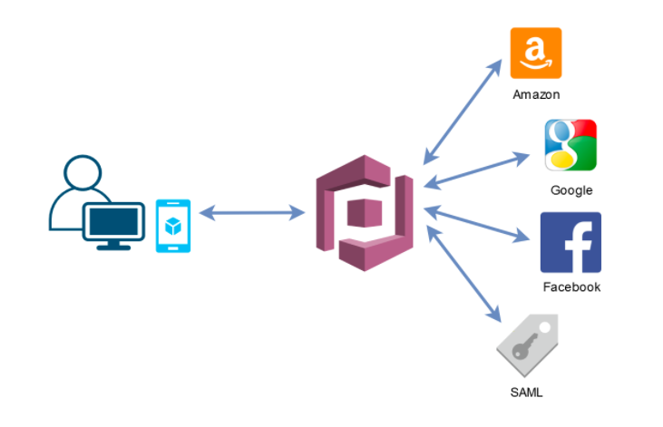
With Cognito User Pools, you can provide sign-up and sign-in functionality for your mobile or web app users. You don’t have to build or maintain any server infrastructure on which users will authenticate.
This diagram shows how authentication is handled with Cognito User Pools:
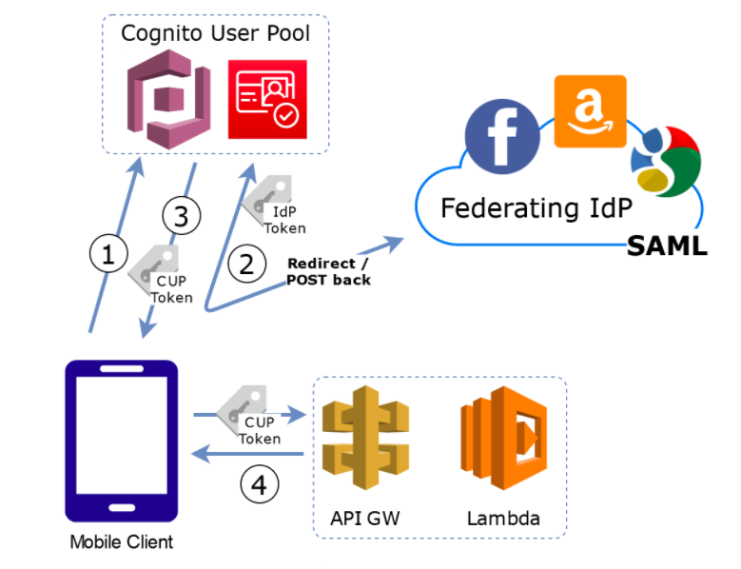
- Users send authentication requests to Cognito User Pools.
- The Cognito user pool verifies the identity of the user or sends the request to Identity Providers such as Facebook, Google, Amazon, or SAML authentication (with Microsoft AD).
- The Cognito User Pool Token is sent back to the user.
- The person can then use this token to access your backend APIs hosted on your EC2 clusters or in API Gateway and Lambda.
If you want a quick login page, you can even use the pre-built login UI provided by Amazon Cognito which you just have to integrate on your application.

On the Amazon Cognito User Pool page, you can also manage users if you need to. You can reset the password, disable/enable users, and enroll/delete users or other actions needed for User Management.
Amazon Cognito Identity Pools
Cognito Identity Pools (Federated Identities) provides different functionality compared to User Pools. Identity Pools are used for User Auth orization. You can create unique identities for your users and federate them with your identity providers. Using identity pools, users can obtain temporary AWS credentials to access other AWS services.
Identity Pools can be thought of as the actual mechanism authorizing access to AWS resources. When you create Identity Pools, think of it as defining who is allowed to get AWS credentials and use those credentials to access AWS resources.
This diagram shows how authorization is handled with Cognito Identity Pools:
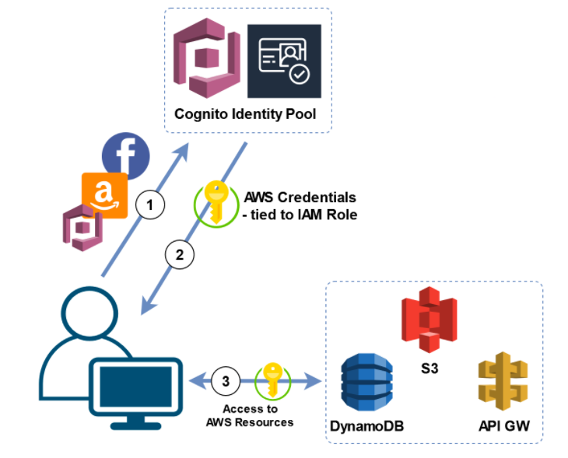
- The web app or mobile app sends its authentication token to Cognito Identity Pools. The token can come from a valid Identity Provider, like Cognito User Pools, Amazon, or Facebook.
- Cognito Identity Pool exchanges the user authentication token for temporary AWS credentials to access resources such as S3 or DynamoDB. AWS credentials are sent back to the user.
- The temporary AWS credentials will be used to access AWS resources.
You can define rules in Cognito Identity Pools for mapping users to different IAM roles to provide fine-grain permissions.
Here’s a table summary describing Cognito User Pool and Identity Pool:
Cognito User Pools | Cognito Identity Pools
Handles the IdP interactions for you | Provides AWS credentials for accessing resources on behalf of users
Provides profiles to manage users | Supports rules to map users to different IAM roles
Provides OpenID Connect and OAuth standard tokens | Free
Priced per monthly active user
Note: If you are studying for the AWS Certified Security Specialty exam, we highly recommend that you take our AWS Certified Security – Specialty Practice Exams and read our Security Specialty exam study guide.
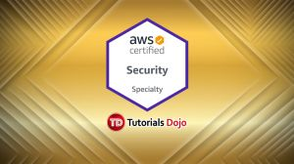
Amazon Cognito User Pools vs Identity Pools References:
https://aws.amazon.com/premiumsupport/knowledge-center/cognito-user-pools-identity-pools/
https://docs.aws.amazon.com/cognito/latest/developerguide/cognito-user-identity-pools.html
https://docs.aws.amazon.com/cognito/latest/developerguide/cognito-identity.html
https://docs.aws.amazon.com/cognito/latest/developerguide/authentication.html
https://docs.aws.amazon.com/cognito/latest/developerguide/switching-identities.html
This article is authored by: Kenneth Samonte, our resident AWS whiz/contributor.
Written by: Kenneth Samonte

Kenneth is an AWS Architect & Linux System Administrator. He's a Red Hat Certified System Administrator, AWS Certified Solutions Architect Professional, and a VMware Certified Professional. He's also a registered Electronics Engineer and Cisco Certified Network Associate (CCNA). He enjoys exploring cloud platforms and administering Linux systems. When he's not busy, you’ll find him online playing League of Legends.

https://tutorialsdojo.com/amazon-efs-vs-amazon-fsx-for-windows-vs-amazon-fsx-for-lustre/
Amazon EFS | Amazon FSx for Windows File Server | Amazon FSx for Lustre
- • Amazon EFS is a serverless, scalable, high-performance, POSIX-compliant file system in the cloud.  - • EFS file systems can be accessed by Amazon EC2 Linux instances, Amazon ECS, Amazon EKS, AWS Fargate, and AWS Lambda functions via a file system interface such as NFS protocol.  - • Amazon EFS supports file system access semantics such as strong consistency and file locking.  - • EFS file systems can automatically scale in storage to handle petabytes of data. With Bursting mode, the throughput available to a file system scales as a file system grows. Provisioned Throughput mode allows you to provision a constant file system throughput independent of the amount of data stored.  - • POSIX-compliant (Portable Operating System Interface)  - • EFS file systems can be concurrently accessed by thousands of compute services without sacrificing performance.  - • Common use cases for EFS file systems include big data and analytics workloads, media processing workflows, content management, web serving, and home directories.  - • Amazon EFS has four storage classes: Standard, Standard Infrequent Access, One Zone, and One Zone Infrequent Access  - • You can create lifecycle management rules to move your data from standard storage classes to infrequent access storage classes.  - • Every EFS file system object of Standard storage is redundantly stored across multiple AZs.  - • EFS offers the ability to encrypt data at rest and in transit. Data encrypted at rest using AWS KMS for encryption keys. Data encryption in transit uses TLS 1.2  - • To access EFS file systems from on-premises, you must have an AWS Direct Connect or AWS VPN connection between your on-premises datacenter and your Amazon VPC. | • Amazon FSx for Windows File Server is a fully managed, scalable file storage that is accessible over SMB protocol.  - • Since it is built on Windows Server, it natively supports administrative features such as user quotas, end-user file restore, and Microsoft Active Directory integration.  • FSx for WFS is accessible from Windows, Linux, and MacOS compute instances and devices. Thousands of compute instances and devices can access a file system concurrently.  • FSx for WFS can connect your file system to Amazon EC2, Amazon ECS, VMware Cloud on AWS, Amazon WorkSpaces, and Amazon AppStream 2.0 instances.  - • Every file system comes with a default Windows file share, named “share”.  • Common use cases for FSx for WFS include CRM, ERP, custom or .NET applications, home directories, data analytics, media and entertainment workflows, software build environments, and Microsoft SQL Server.  • You can access FSx file systems from your on-premises environment using an AWS Direct Connect or AWS VPN connection between your on-premises datacenter and your Amazon VPC.  - • You can choose the storage type for your file system: SSD storage for latency-sensitive workloads or workloads requiring the highest levels of IOPS/throughput. HDD storage for throughput-focused workloads that aren’t latency-sensitive.  • Every FSx for WFS ﬁle system has a throughput capacity that you conﬁgure when the ﬁle system is created and that you can change at any time.  - • Each Windows File Server file system can store up to 64 TB of data. You can only manually increase the storage capacity.  - • Your file system can be deployed in multiple AZs or a single AZ only. Multi-AZ file systems provide automatic failover.  • FSx for Windows File Server always encrypts your file system data and your backups at-rest using keys you manage through AWS KMS. Data-in-transit encryption uses SMB Kerberos session keys. | • Amazon FSx for Lustre is a serverless, POSIX-compliant file system that runs on Lustre ー an open-source, high-performance file system.  • The Lustre file system is designed for applications that require fast storage. FSx for Lustre file systems can scale to hundreds of GB/s of throughput and millions of IOPS. FSx for Lustre also supports concurrent access to the same file or directory from thousands of compute instances.  • Unlike EFS, storage capacity needs to be manually increased, and only every six hours can you do so.  • Amazon FSx for Lustre also integrates with Amazon S3, which lets you process cloud data sets with the Lustre high-performance file system.  • Common use cases for Lustre include machine learning, high-performance computing (HPC), video processing, financial modeling, genome sequencing, and electronic design automation (EDA).  • POSIX-compliant (Portable Operating System Interface)  • FSx for Lustre can only be used by Linux-based instances. To access your file system, you first install the open-source Lustre client on that instance. Then you mount your file system using standard Linux commands. Lustre file systems can also be used with Amazon EKS and AWS Batch.  • FSx for Lustre provides two deployment options:  Scratch file systems are for temporary storage and shorter-term processing of data. Data is not replicated and does not persist if a file server fails.  Persistent file systems are for longer-term storage and workloads. The file servers are highly available, and data is automatically replicated within the AZ that is associated with the file system.  • You can choose the storage type for your file system: SSD storage for latency-sensitive workloads or workloads requiring the highest levels of IOPS/throughput. HDD storage for throughput-focused workloads that aren’t latency-sensitive.  • FSx for Lustre always encrypts your file system data and your backups at-rest using keys you manage through AWS KMS. FSx encrypts data-in-transit when accessed from supported EC2 instances.

https://tutorialsdojo.com/amazon-eks-vs-amazon-ecs/
 | Elastic Container Service (ECS) | Elastic Kubernetes Service (EKS)
Overview | - AWS’s fully managed container orchestration service for Docker containers.  - Designed for simplicity and ease of use.  - Seamless integration with AWS services and minimal management overhead.  - Tightly coupled with AWS, making it a cloud-native service. | - AWS’s managed Kubernetes service.  - Offers Kubernetes flexibility with AWS’s management and scaling.  - Ideal for teams needing Kubernetes features and ecosystem.  - Kubernetes is cloud-agnostic and has a loosely coupled architecture, allowing it to run across various cloud providers like Google Cloud, Azure, and others.
Features | - Simplifies container management without the need for control plane management.  - Deeply integrates with AWS services such as EC2, ECR, and IAM.  - Extends capabilities to on-premises environments.  - Offers serverless container management, eliminating the need to manage servers or clusters. | - Provides a fully managed Kubernetes control plane, handling upgrades and patching.  - Works seamlessly with AWS services like IAM, VPC, and Load Balancer.  - Supports on-premises Kubernetes clusters using VMware or AWS Outposts.  - Offers serverless Kubernetes pods, combining Kubernetes flexibility with serverless management.
Complexity & Control | - Ideal for straightforward applications with minimal management overhead.  - Lower learning curve, best for teams familiar with AWS. | - Suited for complex, microservices-oriented applications requiring detailed control and customization.  - Requires Kubernetes expertise, with a steeper learning curve but offers more granular control.
Cost | - Generally lower cost, especially with Fargate and EC2 Spot Instances. No separate control plane charge. | - Includes charges for the managed Kubernetes control plane in addition to compute and storage resources. Costs can be mitigated with Fargate and effective use of autoscaling features.
Portability | - Less portable; best suited for environments primarily within AWS. | - Ideal for multi-cloud or hybrid environments due to Kubernetes’ open standards.
Use Cases | - Simple, AWS-integrated applications.  - Quick deployments with minimal setup.  - Applications using AWS services extensively. | - Complex, microservices-based architectures.  - Multi-cloud or hybrid deployments.  - Environments requiring Kubernetes-native tools and integrations.
Security | - Provides robust security with IAM roles, VPC integration, and security groups. | - Offers detailed access control with Kubernetes Role-Based Access Control, enhanced by AWS IAM integration.
References:
Amazon ECS vs Amazon EKS: making sense of AWS container services | Amazon Web Services
AWS EKS Vs. ECS: The Ultimate Guide | nOps
-------------------------------------------------------------------------- --------------------------------------------------
Amazon EBS Cheat Sheet
- Block level storage volumes for use with EC2 instances.
- Well-suited for use as the primary storage for file systems, databases, or for any applications that require fine granular updates and access to raw, unformatted, block-level storage.
- Well-suited to both database-style applications (random reads and writes), and to throughput-intensive applications (long, continuous reads and writes).
- New EBS volumes receive their maximum performance the moment that they are available and do not require initialization (formerly known as pre-warming). However, storage blocks on volumes that were restored from snapshots must be initialized (pulled down from Amazon S3 and written to the volume) before you can access the block.
- Termination protection is turned off by default and must be manually enabled (keeps the volume/data when the instance is terminated)
- You can have up to 5,000 EBS volumes by default
- You can have up to 10,000 snapshots by default

Features
- Different types of storage options: General Purpose SSD (gp2, gp3), Provisioned IOPS SSD (io1,io2), Throughput Optimized HDD (st1), and Cold HDD (sc1) volumes up to 16 TiB in size or 64TiB for io2 Block Express.
- You can mount multiple volumes on the same instance, and you can mount a Provisioned IOPS volume to multiple instances at a time using Amazon EBS Multi-Attach.
- Enable Multi-Attach on EBS Provisioned IOPS io1 volumes to allow a single volume to be concurrently attached to up to sixteen AWS Nitro System-based Amazon EC2 instances within the same AZ.
- You can create a file system on top of these volumes, or use them in any other way you would use a block device (like a hard drive).
- You can use encrypted EBS volumes to meet data-at-rest encryption requirements for regulated/audited data and applications.
- You can create point-in-time snapshots of EBS volumes, which are persisted to Amazon S3. Similar to AMIs. Snapshots can be copied across AWS regions.
- Volumes are created in a specific AZ, and can then be attached to any instances in that same AZ. To make a volume available outside of the AZ, you can create a snapshot and restore that snapshot to a new volume anywhere in that region.
- You can copy snapshots to other regions and then restore them to new volumes there, making it easier to leverage multiple AWS regions for geographical expansion, data center migration, and disaster recovery.
- Performance metrics, such as bandwidth, throughput, latency, and average queue length, provided by Amazon CloudWatch, allow you to monitor the performance of your volumes to make sure that you are providing enough performance for your applications without paying for resources you don’t need.
- You can detach an EBS volume from an instance explicitly or by terminating the instance. However, if the instance is running, you must first unmount the volume from the instance.
- If an EBS volume is the root device of an instance, you must stop the instance before you can detach the volume.
- You can use AWS Backup, an automated and centralized backup service, to protect EBS volumes and your other AWS resources. AWS Backup is integrated with Amazon DynamoDB, Amazon EBS, Amazon RDS, Amazon EFS, and AWS Storage Gateway to give you a fully managed AWS backup solution.
- With AWS Backup, you can configure backups for EBS volumes, automate backup scheduling, set retention policies, and monitor backup and restore activity.
- EBS fast snapshot restore allows you to create a volume from a snapshot that is fully initialized. This removes the latency of I/O operations on the block when accessed for the first time.
- Elastic Volumes allow you to increase the volume size, adjust performance, or change the volume type while the volume is in use. If your instance supports Elastic Volumes, you can do so without detaching the volume or restarting the instance.
  - This feature is available for all current-generation EBS volumes attached to current-generation EC2 instances.
  - You can continue to use your application while the changes take effect.
Types of EBS Volumes
- General Purpose SSD (gp3)
- Delivers a consistent baseline rate of 3,000 IOPS and 125 MiB/s. You can provision additional IOPS (up to 16,000) and throughput (up to 1,000 MiB/s) for an additional cost.
- The maximum ratio of provisioned IOPS to provisioned volume size is 500 IOPS per GiB. The maximum ratio of provisioned throughput to provisioned IOPS is .25 MiB/s per IOPS.
- General Purpose SSD (gp2)
- Base performance of 3 IOPS/GiB, with the ability to burst to 3,000 IOPS for extended periods of time.
- Support up to 16,000 IOPS and 250 MB/s of throughput.
- The burst duration of a volume is dependent on the size of the volume, the burst IOPS required, and the credit balance when the burst begins. Burst IO duration is computed using the following formula:
Burst duration = (Credit balance) [(Burst IOPS) – 3 (Volume size in GiB)]

  - If your gp2 volume uses all of its I/O credit balance, the maximum IOPS performance of the volume remains at the baseline IOPS performance level and the volume’s maximum throughput is reduced to the baseline IOPS multiplied by the maximum I/O size.
  - Throughput for a gp2 volume can be calculated using the following formula, up to the throughput limit of 160 MiB/s:
Throughput in MiB/s = (Volume size in GiB) (IOPS per GiB) × (I/O size in KiB)
- Provisioned IOPS SSD (io1/io2)
  - Designed for I/O-intensive workloads, particularly database workloads, which are sensitive to storage performance and consistency.
  - Allows you to specify a consistent IOPS rate when you create the volume
  - EBS Provisioned IOPS io2 features higher durability of 99.999%, and supports provisioning 500 IOPS for every provisioned GB. EBS io2 has 100x better volume durability and a 10x higher IOPS to storage ratio than io1, for the same price as io1.
- Throughput Optimized HDD (st1)
  - Low-cost magnetic storage that focuses on throughput rather than IOPS.
  - Throughput of up to 500 MiB/s.
  - Subject to throughput and throughput-credit caps, the available throughput of an st1 volume is expressed by the following formula:
(Volume size)(Credit accumulation rate per TiB) = Throughput
- Cold HDD (sc1)
  - Low-cost magnetic storage that focuses on throughput rather than IOPS.
  - Throughput of up to 250 MiB/s.
Volume Name | General Purpose SSD |  | Provisioned IOPS SSD
Volume type | gp3 | gp2 | io2 | io1
Description | General Purpose SSD volume that balances price performance for a wide variety of transactional workloads | General Purpose SSD volume that balances price performance for a wide variety of transactional workloads | High performance SSD volume designed for business-critical latency-sensitive applications | High performance SSD volume designed for latency-sensitive transactional workloads
Use Cases | virtual desktops, medium sized single instance databases such as MSFT SQL Server and Oracle DB, low-latency interactive apps, dev & test, boot volumes | Boot volumes, low-latency interactive apps, dev & test | Workloads that require sub-millisecond latency, and sustained IOPS performance or more than 64,000 IOPS or 1,000 MiB/s of throughput | Workloads that require sustained IOPS performance or more than 16,000 IOPS and I/O-intensive database workloads
Volume Size | 1 GB – 16 TB | 1 GB – 16 TB | 4 GB – 16 TB  / 64 TB for io2 block express | 4 GB – 16 TB
Durability | 99.8% – 99.9% durability | 99.8% – 99.9% durability | 99.999% | 99.8% – 99.9%
Max IOPS / Volume | 16,000 | 16,000 | 64,000  / 256,000 for io2 block express | 64,000
Max Throughput / Volume | 1000 MB/s | 250 MB/s | 1,000 MB/s  / 4,000 MiB/s for io2 block express | 1,000 MB/s
Max IOPS / Instance | 260,000 | 260,000 | 160,000  / 260,000 MiB/s for io2 block express | 260,000
Max IOPS / GB | N/A | N/A | 500 IOPS/GB  / 1,000 IOPS/GB for io2 block express | 50 IOPS/GB
Max Throughput / Instance | 7,500 MB/s | 7,500 MB/s | 4,750 MB/s  / 7,500 MB/s for io2 block express | 7,500 MB/s
Latency | single digit millisecond | single digit millisecond | single digit millisecond | single digit millisecond
Multi-Attach | No | No | Yes | Yes

Volume Name | Throughput Optimized HDD | Cold HDD
Volume type | st1 | sc1
Description | Low cost HDD volume designed for frequently accessed, throughput-intensive workloads | Throughput-oriented storage for data that is infrequently accessed.  Scenarios where the lowest storage cost is important.
Use Cases | Big data, data warehouses, log processing | Colder data requiring fewer scans per day
Volume Size | 125 GB – 16 TB | 125 GB – 16 TB
Durability | 99.8% – 99.9% durability | 99.8% – 99.9% durability
Max IOPS / Volume | 500 | 250
Max Throughput / Volume | 500 MB/s | 250 MB/s
Max IOPS / Instance | 260,000 | 260,000
Max IOPS / GB | N/A | N/A
Max Throughput / Instance | 7,500 MB/s | 7,500 MB/s
Multi-Attach | No | No

Encryption
- Data stored at rest on an encrypted volume, disk I/O, and snapshots created from it are all encrypted.
- Also provides encryption for data in-transit from EC2 to EBS since encryption occurs on the servers that hosts EC2 instances.
- The following types of data are encrypted:
  - Data at rest inside the volume
  - All data moving between the volume and the instance
  - All snapshots created from the volume
  - All volumes created from those snapshots
- Uses AWS Key Management Service (AWS KMS) master keys when creating encrypted volumes and any snapshots created from your encrypted volumes.
- Volumes restored from encrypted snapshots are automatically encrypted.
- EBS encryption is only available on certain instance types.
- There is no direct way to encrypt an existing unencrypted volume, or to remove encryption from an encrypted volume. However, you can migrate data between encrypted and unencrypted volumes.
- You can now enable Amazon Elastic Block Store (EBS) Encryption by Default, ensuring that all new EBS volumes created in your account are encrypted.
Amazon EBS Monitoring
- Cloudwatch Monitoring two types: Basic and Detailed monitoring
- Volume status checks provide you the information that you need to determine whether your EBS volumes are impaired, and help you control how a potentially inconsistent volume is handled. List of statuses include:
  - Ok – normal volume
  - Warning – degraded volume
  - Impaired – stalled volume
  - Insufficient-data – insufficient data
- Volume events include a start time that indicates the time at which an event occurred, and a duration that indicates how long I/O for the volume was disabled. The end time is added to the event when I/O for the volume is enabled.
- Volume events are:
  - Awaiting Action: Enable IO
  - IO Enabled
  - IO Auto-Enabled
  - Normal
  - Degraded
  - Severely Degraded
  - Stalled
Modifying the Size, IOPS, or Type of an EBS Volume on Linux
- If your current-generation EBS volume is attached to a current-generation EC2 instance type, you can increase its size, change its volume type, or (for an io1 volume) adjust its IOPS performance, all without detaching it.
- EBS currently supports a maximum volume size of 16 TiB.
- Two partitioning schemes commonly used on Linux and Windows systems: master boot record (MBR) and GUID partition table (GPT).
- An EBS volume being modified goes through a sequence of states. The volume enters first the Modifying state, then the Optimizing state, and finally the Complete state.
- You can expand a partition to a new size. Expand by using parted or gdisk.
- Use a file system–specific command to resize the file system to the larger size of the new volume. These commands work even if the volume to extend is the root volume. For ext2, ext3, and ext4 file systems, this command is resize2fs. For XFS file systems, this command is xfs_growfs.
- Decreasing the size of an EBS volume is not supported.
EBS Snapshots
- Back up the data on your EBS volumes to S3 by taking point-in-time snapshots.
- Snapshots are incremental backups, which means that only the blocks on the device that have changed after your most recent snapshot are saved. This minimizes the time required to create the snapshot and saves on storage costs by not duplicating data.
- When you delete a snapshot, only the data unique to that snapshot is removed.
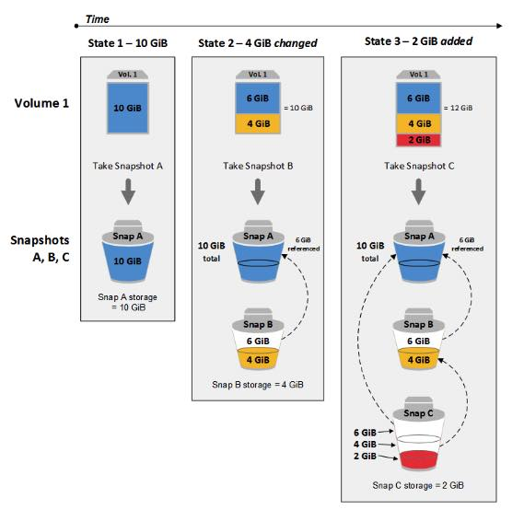
- You can share a snapshot across AWS accounts by modifying its access permissions.
- You can make copies of your own snapshots as well as snapshots that have been shared with you.
- A snapshot is constrained to the Region where it was created.
- EBS snapshots broadly support EBS encryption.
- You can’t delete a snapshot of the root device of an EBS volume used by a registered AMI. You must first deregister the AMI before you can delete the snapshot.
- Each account can have up to 5 concurrent snapshot copy requests to a single destination Region.
- User-defined tags are not copied from the source snapshot to the new snapshot.
- Snapshots are constrained to the Region in which they were created. To share a snapshot with another Region, copy the snapshot to that Region.
- Snapshots that you intend to share must instead be encrypted with a custom CMK.
Amazon EBS–Optimized Instances
- Provides the best performance for your EBS volumes by minimizing contention between EBS I/O and other traffic from your instance.
- EBS–optimized instances deliver dedicated bandwidth between 500 Mbps and 60,000 Mbps to EBS.
- For instance types that are EBS–optimized by default, there is no need to enable EBS optimization and no effect if you disable EBS optimization.
Amazon EBS Pricing
- You are charged by the amount you provision in GB per month until you release the storage.
- Provisioned storage for gp2 volumes, provisioned storage and provisioned IOPS for io1 volumes, provisioned storage for st1 and sc1 volumes will be billed in per-second increments, with a 60 second minimum.
- With Provisioned IOPS SSD (io1) volumes, you are also charged by the amount you provision in IOPS per month.
- After you detach a volume, you are still charged for volume storage as long as the storage amount exceeds the limit of the AWS Free Tier. You must delete a volume to avoid incurring further charges.
- Snapshot storage is based on the amount of space your data consumes in Amazon S3.
- Copying a snapshot to a new Region does incur new storage costs.
- When you enable EBS optimization for an instance that is not EBS-optimized by default, you pay an additional low, hourly fee for the dedicated capacity.
Improving Performance
- Use EBS-Optimized Instances
- Understand How Performance is Calculated
- Understand Your Workload
- Be Aware of the Performance Penalty When Initializing Volumes from Snapshots
- Factors That Can Degrade HDD Performance
- Increase Read-Ahead for High-Throughput, Read-Heavy Workloads on st1 and sc1
- Use a Modern Linux Kernel
- Use RAID 0 (Redundant Array of Independent Disks) to Maximize Utilization of Instance Resources
- Track Performance Using Amazon CloudWatch

Free Amazon EBS Tutorials on YouTube:

https://www.youtube.com/user/AmazonWebServices/search?query=ebs
Other Amazon EBS-related Cheat Sheets:
- EBS – SSD vs HDD
- Amazon S3 vs EBS vs EFS

Validate Your Knowledge
Question 1
An organization needs to provision a new Amazon EC2 instance with a persistent block storage volume to migrate data from its on-premises network to AWS. The required maximum performance for the storage volume is 64,000 IOPS.
In this scenario, which of the following can be used to fulfill this requirement?
- Directly attach multiple Instance Store volumes in an EC2 instance to deliver maximum IOPS performance.
- Launch a Nitro-based EC2 instance and attach a Provisioned IOPS SSD EBS volume (io1) with 64,000 IOPS.
- Launch an Amazon EFS file system and mount it to a Nitro-based Amazon EC2 instance and set the performance mode to Max I/O.
- Launch any type of Amazon EC2 instance and attach a Provisioned IOPS SSD EBS volume (io1) with 64,000 IOPS.
Show me the answer!
- IOPS SSD EBS volume (io1) with 64,000 IOPS.
Show me the answer!
Correct Answer: 2
An Amazon EBS volume is a durable, block-level storage device that you can attach to your instances. After you attach a volume to an instance, you can use it as you would use a physical hard drive. EBS volumes are flexible.
The AWS Nitro System is the underlying platform for the latest generation of EC2 instances that enables AWS to innovate faster, further reduce the cost of the customers, and deliver added benefits like increased security and new instance types.
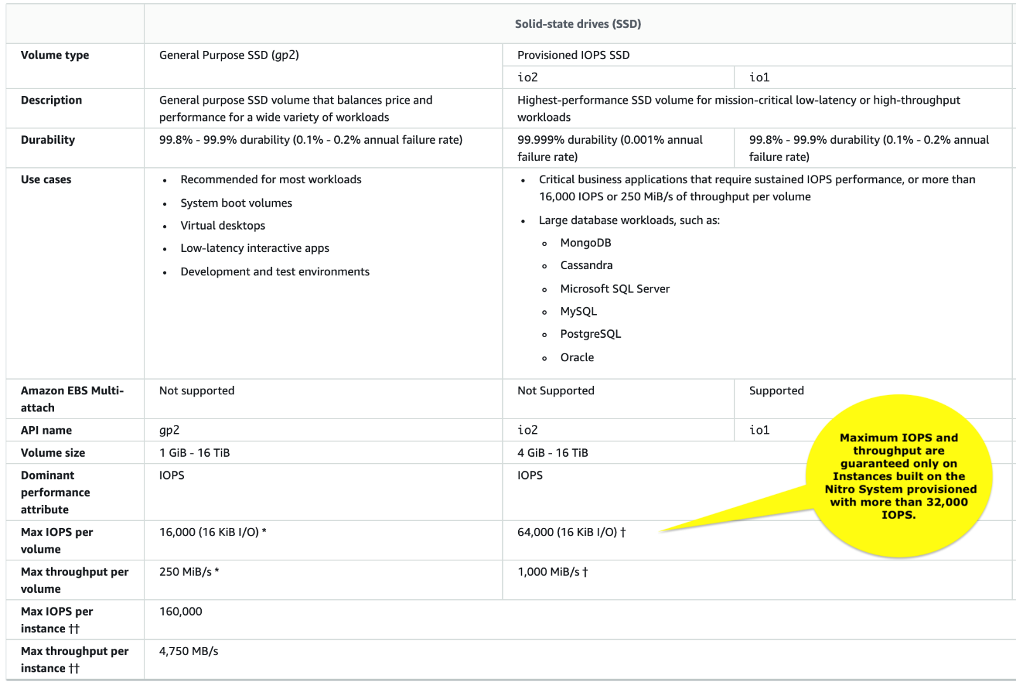
Amazon EBS is a persistent block storage volume. It can persist independently from the life of an instance. Since the scenario requires you to have an EBS volume with up to 64,000 IOPS, you have to launch a Nitro-based EC2 instance.
Hence, the correct answer in this scenario is: Launch a Nitro-based EC2 instance and attach a Provisioned IOPS SSD EBS volume (io1) with 64,000 IOPS.
The option that says: Directly attach multiple Instance Store volumes in an EC2 instance to deliver maximum IOPS performance is incorrect. Although an Instance Store is a block storage volume, it is not persistent and the data will be gone if the instance is restarted from the stopped state (note that this is different from the OS-level reboot. In OS-level reboot, data still persists in the instance store). An instance store only provides temporary block-level storage for your instance. It means that the data in the instance store can be lost if the underlying disk drive fails, if the instance stops, and if the instance terminates.
The option that says: Launch an Amazon EFS file system and mount it to a Nitro-based Amazon EC2 instance and set the performance mode to Max I/O is incorrect. Although Amazon EFS can provide over 64,000 IOPS, this solution uses a file system and not a block storage volume which is what is asked in the scenario.
The option that says: Launch an EC2 instance and attach an io1 EBS volume with 64,000 IOPS is incorrect. In order to achieve the 64,000 IOPS for a provisioned IOPS SSD, you must provision a Nitro-based EC2 instance. The maximum IOPS and throughput are guaranteed only on Instances built on the Nitro System provisioned with more than 32,000 IOPS. Other instances guarantee up to 32,000 IOPS only.
References:
https://docs.aws.amazon.com/AWSEC2/latest/UserGuide/ebs-volume-types.html#EBSVolumeTypes_piops
https://aws.amazon.com/s3/storage-classes/
https://docs.aws.amazon.com/AWSEC2/latest/UserGuide/instance-types.html
Cheat Sheet:
https://tutorialsdojo.com/amazon-s3-vs-ebs-vs-efs/
Note: This question was extracted from our AWS Certified Solutions Architect Associate Practice Exams.
Question 2
A Database Specialist manages an EBS-Optimized Amazon RDS for MySQL DB instance with Provisioned IOPS storage. The users recently raised a database IO latency issue during peak hours when it was always under a heavy workload. Upon review, the Specialist noticed that the RDS DB instance was barely using the maximum IOPS configured but was fully utilizing the maximum bandwidth for the required throughput. CloudWatch metrics showed that CPU and Memory utilization were at optimum levels.
Which action should the Database Specialist take to fix the performance issue?
- Change the underlying EBS storage type of the instance to General Purpose (SSD).
- Modify the DB instance to an EBS-Optimized instance class with higher maximum bandwidth.
- Disable EBS optimization on the MySQL DB instance to allow higher maximum bandwidth.
- Modify the DB instance to increase the size and corresponding Provisioned IOPS allocated to the storage.
Show me the answer!
Correct Answer: 2
Amazon RDS volumes are built using Amazon EBS volumes, except for Amazon Aurora, which uses an SSD-backed virtualized storage layer purpose-built for database workloads. RDS currently supports both magnetic and SSD-based storage volume types. There are two supported Amazon EBS SSD-based storage types, Provisioned IOPS (called io1) and General Purpose (called gp2).
Provisioned IOPS storage is a storage type that delivers predictable performance and consistently low latency. If your workload is I/O constrained, using Provisioned IOPS SSD storage can increase the number of I/O requests that the system can process concurrently.
Provisioned IOPS SSD storage provides a way to reserve I/O capacity by specifying IOPS. However, as with any other system capacity attribute, its maximum throughput under load is constrained by the resource that is consumed first. That resource might be network bandwidth, CPU, memory, or database internal resources.
EBS–optimized instances deliver dedicated bandwidth to Amazon EBS. When attached to an EBS–optimized instance, Provisioned IOPS SSD (io1) volumes are designed to achieve their provisioned performance, 99.9% of the time. Choose an EBS–optimized instance that provides more dedicated Amazon EBS throughput than your application needs; otherwise, the connection between Amazon EBS and Amazon EC2 can become a performance bottleneck.
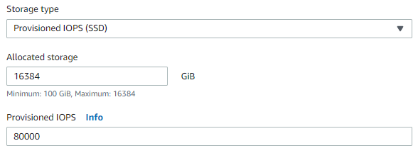
Therefore, the correct answer is: Modify the DB instance to an EBS-Optimized instance class with higher maximum bandwidth.
The option that says: Change the underlying EBS storage type of the instance to General Purpose (SSD) is incorrect. Using a gp2 storage type can potentially degrade the performance since its maximum throughput is lower than an io1 storage type.
The option that says: Disable EBS optimization on the MySQL DB instance to allow higher maximum bandwidth is incorrect. EBS optimization is necessary to deliver dedicated bandwidth to the EBS volumes.
The option that says: Modify the DB instance to increase the size and corresponding Provisioned IOPS allocated to the storage is incorrect. Expanding the storage will not increase the bandwidth for the required throughput.
References:
https://docs.aws.amazon.com/AWSEC2/latest/UserGuide/ebs-optimized.html
https://docs.aws.amazon.com/AmazonRDS/latest/UserGuide/CHAP_Storage.html
Note: This question was extracted from our AWS Certified Database Specialty Practice Exams.
------------------------------------------ -------------------------------------------- ------------------------------------------
https://tutorialsdojo.com/amazon-efs/
Amazon EFS Cheat Sheet
- A fully-managed file storage service that makes it easy to set up and scale file storage in the Amazon Cloud.
Features
- The service manages all the file storage infrastructure for you, avoiding the complexity of deploying, patching, and maintaining complex file system configurations.
- EFS supports the Network File System version 4 protocol.
- You can mount EFS filesystems onto EC2 instances running Linux or MacOS Big Sur. Windows is not supported.
- Aside from EC2 instances, you can also mount EFS filesystems on ECS tasks, EKS pods, and Lambda functions.
- Multiple Amazon EC2 instances can access an EFS file system at the same time, providing a common data source for workloads and applications running on more than one instance or server.
- EFS file systems store data and metadata across multiple Availability Zones in an AWS Region.
- EFS file systems can grow to petabyte scale, drive high levels of throughput, and allow massively parallel access from EC2 instances to your data.

- EFS provides file system access semantics, such as strong data consistency and file locking.
- EFS enables you to control access to your file systems through Portable Operating System Interface (POSIX) permissions.
- Moving your EFS file data can be managed simply with AWS DataSync – a managed data transfer service that makes it faster and simpler to move data between on-premises storage and Amazon EFS.
- You can schedule automatic incremental backups of your EFS file system using the EFS-to-EFS Backup solution.
- Amazon EFS Infrequent Access (EFS IA) is a new storage class for Amazon EFS that is cost-optimized for files that are accessed less frequently. Customers can use EFS IA by creating a new file system and enabling Lifecycle Management. With Lifecycle Management enabled, EFS automatically will move files that have not been accessed for 30 days from the Standard storage class to the Infrequent Access storage class. To further lower your costs in exchange for durability, you can use the EFS IA-One Zone storage class.
Performance Modes
- General purpose performance mode (default)
  - Ideal for latency-sensitive use cases.
- Max I/O mode
  - Can scale to higher levels of aggregate throughput and operations per second with a tradeoff of slightly higher latencies for file operations.
Throughput Modes
- Bursting Throughput mode (default)
  - Throughput scales as your file system grows.
- Provisioned Throughput mode
  - You specify the throughput of your file system independent of the amount of data stored.
Mount Targets
- To access your EFS file system in a VPC, you create one or more mount targets in the VPC. A mount target provides an IP address for an NFSv4 endpoint.
- You can create one mount target in each Availability Zone in a region.
- You mount your file system using its DNS name, which will resolve to the IP address of the EFS mount target. Format of DNS is
File-system-id.efs.aws-region.amazonaws.com
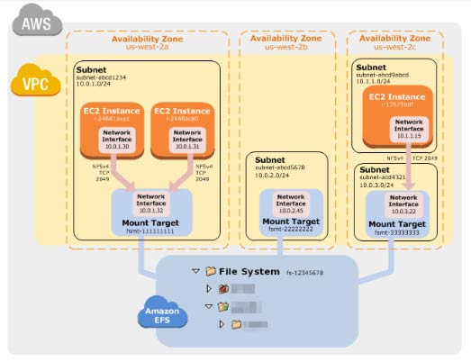
- When using Amazon EFS with an on-premises server, your on-premises server must have a Linux based operating system.
Access Points
- EFS Access Points simplify how applications are provided access to shared data sets in an EFS file system.
- EFS Access Points work together with AWS IAM and enforce an operating system user and group, and a directory for every file system request made through the access point.
Components of a File System
- ID
- creation token
- creation time
- file system size in bytes
- number of mount targets created for the file system
- file system state
- mount target
Data Consistency in EFS
- EFS provides the open-after-close consistency semantics that applications expect from NFS.
- Write operations will be durably stored across Availability Zones.
- Applications that perform synchronous data access and perform non-appending writes will have read-after-write consistency for data access.
Managing File Systems
- You can create encrypted file systems. EFS supports encryption in transit and encryption at rest.
- Managing file system network accessibility refers to managing the mount targets:
  - Creating and deleting mount targets in a VPC
  - Updating the mount target configuration
- You can create new tags, update values of existing tags, or delete tags associated with a file system.
- The following list explains the metered data size for different types of file system objects.
  - Regular files – the metered data size of a regular file is the logical size of the file rounded to the next 4-KiB increment, except that it may be less for sparse files.
    - A sparse file is a file to which data is not written to all positions of the file before its logical size is reached. For a sparse file, if the actual storage used is less than the logical size rounded to the next 4-KiB increment, Amazon EFS reports actual storage used as the metered data size.
  - Directories – the metered data size of a directory is the actual storage used for the directory entries and the data structure that holds them, rounded to the next 4 KiB increment. The metered data size doesn’t include the actual storage used by the file data.
  - Symbolic links and special files – the metered data size for these objects is always 4 KiB.
- File system deletion is a destructive action that you can’t undo. You lose the file system and any data you have in it, and you can’t restore the data. You should always unmount a file system before you delete it.
- You can use AWS DataSync to automatically, efficiently, and securely copy files between two Amazon EFS resources, including file systems in different AWS Regions and ones owned by different AWS accounts. Using DataSync to copy data between EFS file systems, you can perform one-time migrations, periodic ingest for distributed workloads, or automate replication for data protection and recovery.
- File systems created using the Amazon EFS console are automatically backed up daily through AWS Backup with a retention of 35 days. You can also disable automatic backups for your file systems at any time.
- Amazon Cloudwatch Metrics can monitor your EFS file system storage usage, including the size in each of the EFS storage classes.
Mounting File Systems
- To mount your EFS file system on your EC2 instance, use the mount helper in the amazon-efs-utils package.
- You can mount your EFS file systems on your on-premises data center servers when connected to your Amazon VPC with AWS Direct Connect or VPN.
- You can use fstab to automatically mount your file system using the mount helper whenever the EC2 instance is mounted on reboots.
Lifecycle Management
- You can choose from five EFS Lifecycle Management policies (7, 14, 30, 60, or 90 days) to automatically move files into the EFS Infrequent Access (EFS IA) storage class and save up to 85% in cost.
Monitoring File Systems
- Amazon CloudWatch Alarms
- Amazon CloudWatch Logs
- Amazon CloudWatch Events
- AWS CloudTrail Log Monitoring
- Log files on your file system
Amazon EFS Security
- You must have valid credentials to make EFS API requests, such as create a file system.
- You must also have permissions to create or access resources.
- When you first create the file system, there is only one root directory at /. By default, only the root user (UID 0) has read-write-execute permissions.
- Specify EC2 security groups for your EC2 instances and security groups for the EFS mount targets associated with the file system.
- You can use AWS IAM to manage Network File System (NFS) access for Amazon EFS. You can use IAM roles to identify NFS clients with cryptographic security and use IAM policies to manage client-specific permissions.
Amazon EFS Pricing
- You pay only for the storage used by your file system.
- Costs related to Provisioned Throughput are determined by the throughput values you specify.
EFS vs EBS vs S3
- Performance Comparison
 | Amazon EFS | Amazon EBS Provisioned IOPS
Per-operation latency | Low, consistent latency. | Lowest, consistent latency.
Throughput scale | Multiple GBs per second | Single GB per second
- Performance Comparison
 | Amazon EFS | Amazon S3
Per-operation latency | Low, consistent latency. | Low, for mixed request types, and integration with CloudFront.
Throughput scale | Multiple GBs per second | Multiple GBs per second
- Storage Comparison
 | Amazon EFS | Amazon EBS Provisioned IOPS
Availability and durability | Data are stored redundantly across multiple AZs. | Data are stored redundantly in a single AZ.
Access | Up to thousands of EC2 instances from multiple AZs can connect concurrently to a file system. | A single EC2 instance in a single AZ can connect to a file system.
Use cases | Big data and analytics, media processing workflows, content management, web serving, and home directories. | Boot volumes, transactional and NoSQL databases, data warehousing, and ETL.

 | Amazon EFS | Amazon S3
Availability and durability | Data are stored redundantly across multiple AZs. | Stored redundantly across multiple AZs.
Access | Up to thousands of EC2 instances from multiple AZs can connect concurrently to a file system. | One to millions of connections over the web.
Use cases | Big data and analytics, media processing workflows, content management, web serving, and home directories. | Web serving and content management, media and entertainment, backups, big data analytics, data lake.

Free Amazon EFS Tutorials on YouTube:
https://www.youtube.com/user/AmazonWebServices/search?query=EFS
Other Amazon EFS-related Cheat Sheets:

- Amazon S3 vs EBS vs EFS

Validate Your Knowledge
Question 1
A multinational company has been building its new data analytics platform with high-performance computing workloads (HPC) which requires a scalable, POSIX-compliant storage service. The data need to be stored redundantly across multiple AZs and allows concurrent connections from thousands of EC2 instances hosted on multiple Availability Zones.
Which of the following AWS storage service is the most suitable one to use in this scenario?
- Amazon EBS Volumes
- Amazon Elastic File System
- Amazon S3
- ElastiCache
Show me the answer!
Correct Answer: 2
In this question, you should take note of this phrase: “allows concurrent connections from multiple EC2 instances”. There are various AWS storage options that you can choose but whenever these criteria show up, always consider using EFS instead of using EBS Volumes which is mainly used as a “block” storage and can only have one connection to one EC2 instance at a time.
Amazon EFS is a fully-managed service that makes it easy to set up and scale file storage in the Amazon Cloud. With a few clicks in the AWS Management Console, you can create file systems that are accessible to Amazon EC2 instances via a file system interface (using standard operating system file I/O APIs) and supports full file system access semantics (such as strong consistency and file locking).
Amazon EFS file systems can automatically scale from gigabytes to petabytes of data without needing to provision storage. Tens, hundreds, or even thousands of Amazon EC2 instances can access an Amazon EFS file system at the same time, and Amazon EFS provides consistent performance to each Amazon EC2 instance. Amazon EFS is designed to be highly durable and highly available.
References:
https://docs.aws.amazon.com/efs/latest/ug/performance.html
https://aws.amazon.com/efs/faq/
Note: This question was extracted from our AWS Certified Solutions Architect Associate Practice Exams.
Question 2
A company has an online stock exchange application with a daily batch job that aggregates all intraday data and stores the result to an existing Amazon EFS. Currently, the batch processing is handled by several On-Demand EC2 instances and takes less than 3 hours to complete to generate a report that will only be used internally in the company. The batch job can be easily and safely re-run in the event that there is a problem in the processing since the data being processed are not mission-critical. To further reduce its operating costs, the company is looking for ways to optimize its current architecture.
As the SysOps Administrator, which is the MOST cost-effective and secure solution that you should implement?
- Request for a Spot Fleet to process the batch execution. Create a new EFS file system with encryption at rest enabled then copy all data from the current file system. After the data is copied over, delete the unencrypted file system. Use the new EFS file system when storing the results processed by the Spot instances.
- Use Regional Reserved EC2 Instances to process the batch execution and register the instances to AWS Compute Optimizer to lower the costs further. Enable encryption at rest in the existing EFS file system.
- Use Dedicated EBS-backed Amazon EC2 Instances to process the batch execution. Enable the Fast Snapshot Restore (FSR) feature on all EBS volumes to lower the storage cost. Create a new EFS file system with encryption at rest enabled then copy all data from the current file system. Use the new EFS file system when storing the results processed by the On-Demand instances.
- Generate a custom AMI using the EC2 Image Builder service. Request for several Spot EC2 instances and launch your compute capacity using the AMI. Enable encryption at rest in the existing EFS file system. Create a rule in AWS Control Tower to automatically stop the EC2 instances after the batch processing.
Show me the answer!
Correct Answer: 1
Spot Instances are a cost-effective choice if you can be flexible about when your applications run and if your applications can be interrupted. For example, Spot Instances are well-suited for data analysis, batch jobs, background processing, and optional tasks.
Amazon EFS supports two forms of encryption for file systems, encryption of data in transit and encryption at rest. You can only enable encryption of data at rest when creating an Amazon EFS file system. You can enable encryption of data in transit when you mount the file system.
Your organization might require the encryption of all data that meets a specific classification or is associated with a particular application, workload, or environment. You can enforce data encryption policies for Amazon EFS file systems by using detective controls that detect the creation of a file system and verify that encryption is enabled. If an unencrypted file system is detected, you can respond in a number of ways, ranging from deleting the file system and mount targets to notifying an administrator.
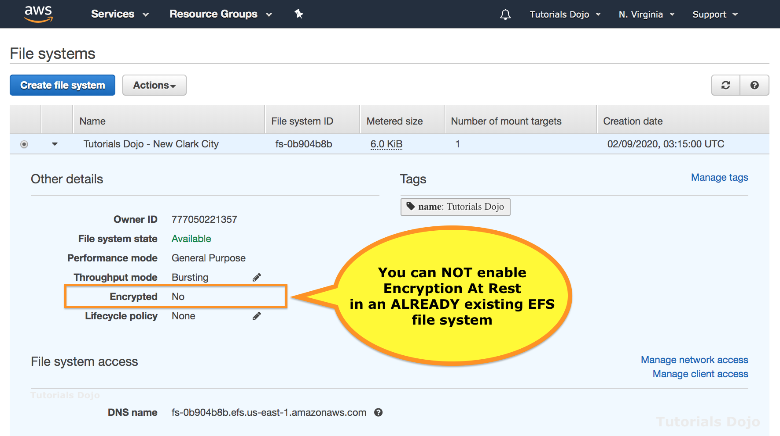
Be aware that if you want to delete the unencrypted file system but want to retain the data, you should first create a new encrypted file system. Next, you should copy the data over to the new encrypted file system. After the data is copied over, you can delete the unencrypted file system.
Hence, the correct answer is: Request for a Spot Fleet to process the batch execution. Create a new EFS file system with encryption at rest enabled then copy all data from the current file system. After the data is copied over, delete the unencrypted file system. Use the new EFS file system when storing the results processed by the Spot instances.
The option that says: Use Regional Reserved EC2 Instances to process the batch execution and register the instances to AWS Compute Optimizer to lower the costs further. Enable encryption at rest in the existing EFS file system is incorrect. Although Regional Reserved instances are cheaper than On-Demand instances, it still costs higher than Spot Instances; hence, this is not the most cost-effective solution. Moreover, you cannot directly enable encryption at rest in an already existing EFS file system. Keep in mind that the AWS Compute Optimizer only provides recommendations for your Amazon EC2 instances to help you improve performance and lower your costs. You don’t need to register instances for this particular service.
The option that says: Use Dedicated EBS-backed Amazon EC2 Instances to process the batch execution. Enable the Fast Snapshot Restore (FSR) feature on all EBS volumes to lower the storage cost. Create a new EFS file system with encryption at rest enabled then copy all data from the current file system. Use the new EFS file system when storing the results processed by the On-Demand instances is incorrect. Although the process of enabling encryption at rest in EFS is right, the choice of EC2 Instance Purchasing option is incorrect. Dedicated Instances are just regular Amazon EC2 instances that run in a VPC on hardware that’s dedicated to a single customer and cost more than Reserved, On-Demand, and Spot Instances. Enabling the Fast Snapshot Restore (FSR) feature will actually increase your EBS bill instead of lowering it down. This is actually the most expensive one among the rest of the options.
The option that says: Generate a custom AMI using the EC2 Image Builder service. Request for several Spot EC2 instances and launch your compute capacity using the AMI. Enable encryption at rest in the existing EFS file system. Create a rule in AWS Control Tower to automatically stop the EC2 instances after the batch processing is incorrect. Although you will gain a substantial amount of savings by using Spot Instances, you still cannot directly enable encryption at rest in an existing EFS file system. Moreover, the AWS Control Tower service is primarily used for managing your AWS accounts and not for controlling your EC2 instances.
References:
https://aws.amazon.com/premiumsupport/knowledge-center/encrypt-data-efs/
https://d1.awsstatic.com/whitepapers/amazon-efs-encrypted-filesystems.pdf
https://docs.aws.amazon.com/AWSEC2/latest/UserGuide/spot-requests.html
Note: This question was extracted from our AWS Certified SysOps Administrator Associate Practice Exams.
For more AWS practice exam questions with detailed explanations, visit the Tutorials Dojo Portal: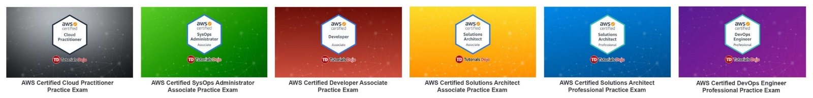
Amazon EFS Cheat Sheet References:
https://docs.aws.amazon.com/efs/latest/ug/
https://aws.amazon.com/efs/pricing/
https://aws.amazon.com/efs/faq/
https://aws.amazon.com/efs/features/
https://aws.amazon.com/efs/when-to-choose-efs/
------------------------------------- ------------------------------------- ------------------------------------------
https://tutorialsdojo.com/amazon-fsx/
Amazon FSx Cheat Sheet
- Amazon FSx is a fully managed third-party file system solution. It uses SSD storage to provide fast performance with low latency.
- There are four available FSx solutions available in AWS:

  - Amazon FSx for Windows File Server

    - A fully managed native Microsoft Windows file system with full support for the SMB protocol, Windows NTFS, and Microsoft Active Directory (AD) integration.
    - How It Works
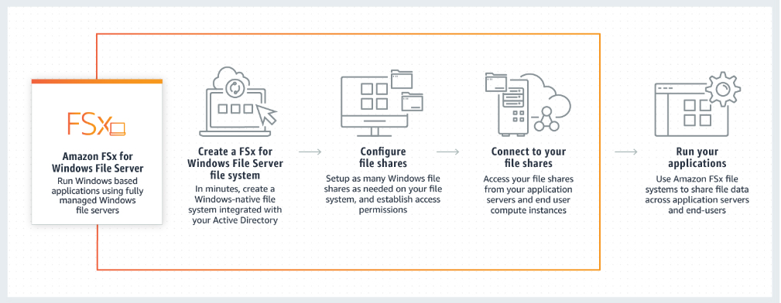
Common Use Cases

      - File systems that is accessible by multiple users, and can establish permissions at the file or folder level.
      - Application workloads that require shared file storage provided by Windows-based file systems (NTFS) and that use the SMB protocol.
      - Media workflows like media transcoding, processing, and streaming.
      - Data-intensive analytics workloads.
      - Content management and web serving applications such as IIS

    - Works with the following compute services:
      - Amazon EC2
      - Amazon Workspaces instances
      - Amazon AppStream 2.0 instances
      - VMs running in VMWare Cloud on AWS Environments

    - Works with Microsoft Active Directory (AD) to integrate your file system with your existing Windows environments.
    - Supports the use of AWS Direct Connect or AWS VPN to access your file systems from your on-premises compute instances.
    - Microsoft Windows File Share
      - A Microsoft Windows file share is a specific folder in your file system, including that folder’s subfolders, which you make accessible to your compute instances with the Server Message Block (SMB) protocol.
      - Your file system comes with a default Windows file share, named share. You can create and manage as many other Windows file shares as you want by using the Windows graphical user interface (GUI) tool called Shared Folders.
      - To access your file shares, you use the Windows Map Network Drive functionality to map a drive letter on your compute instance to your Amazon FSx file share.
Storage

      - You can configure user storage quotas on your file systems to limit how much data storage that users can consume. After you set quotas, you can track quota status to monitor usage and see when users surpass their quotas.
      - You can use DFS (Distributed File System) Namespaces to group file shares on multiple file systems into one common folder structure (a namespace) that you use to access the entire file dataset.
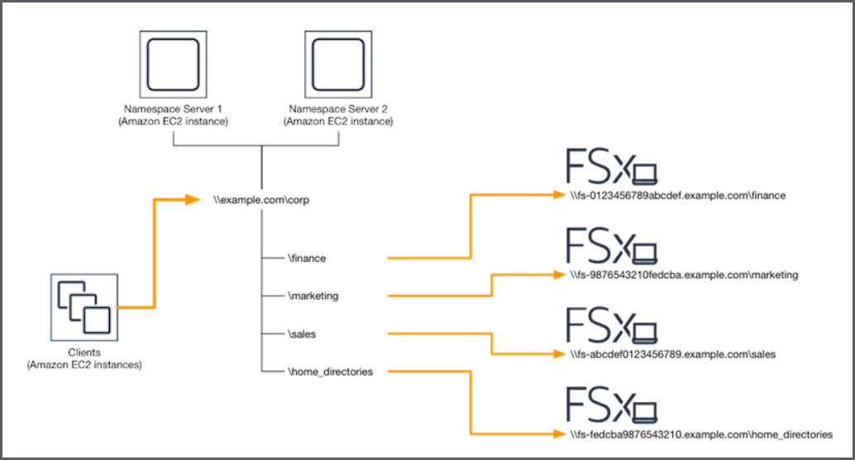

    - You can reduce your data storage costs by turning on data deduplication for your file system. Data deduplication reduces or eliminates redundant data by storing duplicated portions of the dataset only once.
    - Performance Metrics
      - Amazon FSx uses SSD storage, provides storage of up to 64 TB per file system, and throughput of up to 2GB/s per file system.
      - You can use DFS Namespaces to create shared common namespaces spanning multiple Amazon FSx file systems to scale-out storage and throughput. Each common namespace is capable of scaling out storage to hundreds of petabytes of data, and performance to tens of GB/s of throughput, and millions of IOPS.
Amazon FSx Migration
To migrate your existing file data into Amazon FSx, use Windows’s Robust File Copy (RoboCopy) to copy your files (both the data and the full set of metadata like ownership and Access Control Lists) directly to Amazon FSx.
Amazon FSx Limits
Resource | Default Limit | Can be increased Up To
Number of file systems | 100 | Thousands
Total storage for all file systems | 512 TiB | Multiple PiBs
Total throughput capacity for all file systems | 10 GBps | Hundreds of GBps
Total number of user-initiated backups for all file system | 500 | Thousands

  - Amazon FSx for Lustre
    - A high-performance file system optimized for fast processing of workloads. Lustre is a popular open-source parallel file system.
    - You can choose between SSD storage options and HDD storage options, each offering different levels of performance. The HDD options reduce storage costs by up to 80% for throughput-intensive workloads that don’t require the sub-millisecond latencies of SSD storage.
    - Since this is a high-performance parallel file system, you can use Amazon FSx as “hot” storage for your highly accessed files, and Amazon S3 as “cold” storage for rarely accessed files.
    - When linked to an S3 bucket, an FSx for Lustre file system transparently presents S3 objects as files and allows you to write results back to S3.
    - The Lustre file system provides a POSIX-compliant file system interface.
    - Also supports concurrent access to the same file or directory from thousands of compute instances
    - How It Works
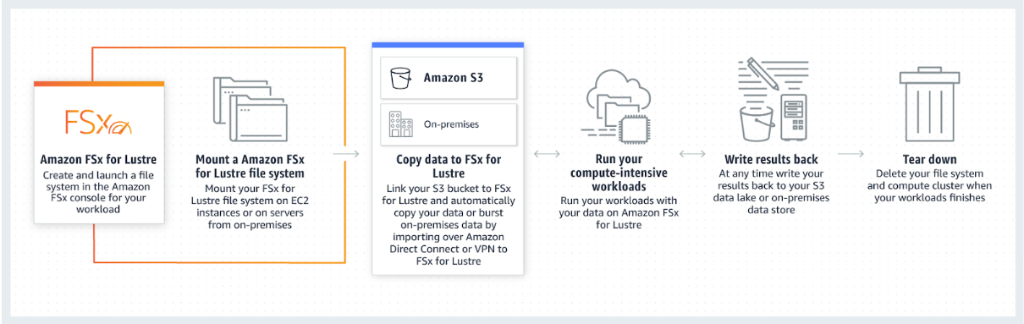

    - You can mount your Amazon FSx for Lustre file system from an on-premises client over AWS Direct Connect or VPN, and then use parallel copy tools to import your data to your Amazon FSx for Lustre file system.
    - You can export files and their associated metadata that you have written or modified in your file system to your durable data repository on Amazon S3
    - Performance Metrics
      - Provides sub-millisecond access to your data
      - Allows you to read and write data at speeds of up to hundreds of gigabytes per second of throughput and millions of IOPS.
      - FSx for Lustre provides 200MBps of baseline throughput per TB of storage provisioned. As your file systems scales, your throughput can scale up to hundreds of GB/s.

    - Limits

  - Amazon FSx for NetApp ONTAP
    - A shared file storage solution that provides high-performance SSD storage with submillisecond latency and is widely accessible from Linux, Windows, and macOS compute instances running on AWS or on-premises.
    - FSx for ONTAP file system is composed of the following:
      - Storage Virtual Machines (SVMs)
      - Volumes
    - Supports multi-protocol access to data using NFS, SMB, and iSCSI.
    - Each file system has the following endpoints to access NetApp applications:
      - Management – access NetApp ONTAP CLI over SSH or to use NetApp ONTAP REST API.
Intercluster – set up replication using NetApp SnapMirror or caching with NetApp FlexCache.
    - Automatically transitions data to a between storage tiers based on your access patterns.
      - Data that is accessed infrequently is automatically moved to the capacity pool tier.
      - Auto – moves cold user data blocks from active file system and snapshot copies to the capacity pool tier.
      - Snapshot-only – moves user data blocks that are not associated with active file system to capacity pool tier.
      - All – moves all user data blocks from active file system and snapshot copies to the capacity pool tier.
      - None – keeps volume data in primary storage tier.

  - Amazon FSx for OpenZFS
    - A file storage service that delivers up to 1 million IOPS with latencies of hundreds of microseconds.
    - Enables you to move data from on-premises ZFS without modifying application code.
    - OpenZFS file system is powered by the AWS Graviton family of processors
    - With NFS protocol, OpenZFS file system is accessible from Linux, Windows, and macOS compute instances and containers.
    - data management capabilities:
      - Z-Standard compression
      - Instant point-in-time snapshots
      - Data cloning
    - File system backups are stored on S3, with cross-region backup copies.
    - Support for multiple volumes per file system, thin provisioning, and user and group quotas.
- Amazon FSx Windows File Servers vs. Amazon EFS vs. Amazon FSx for Lustre: https://tutorialsdojo.com/amazon-efs-vs-amazon-fsx-for-windows-vs-amazon-fsx-for-lustre/

- High Availability and Durability
  - Automatically replicates your data within an Availability Zone (AZ) it resides in (which you specify during creation).
  - Offers single AZ and multi-AZ deployment options for your Windows file-based workloads.
  - Uses the Volume Shadow Copy Service (VSS) to automatically takes highly durable, file-system consistent daily backups to S3
  - Supports restoring individual files and folders to previous versions using Windows shadow copies.
  - The default backup retention period is 7 days.
Amazon FSx Security

  - Supports identity-based authentication over the Server Message Block (SMB) protocol through Microsoft Active Directory.
  - Amazon FSx automatically encrypts your data at-rest using AWS KMS and in-transit using SMB Kerberos session keys.
  - Amazon FSx is ISO, PCI-DSS, and SOC compliant, and is HIPAA eligible.
  - Integrated with AWS CloudTrail that monitors and logs your API calls.
Amazon FSx Pricing

  - You are billed hourly for your Amazon FSx file systems, based on your configured storage capacity (priced per GB-month) and throughput capacity (priced per MBps-month).
  - You are billed hourly for your backup storage (priced per GB-month). You can enable data deduplication to automatically reduce costs associated with redundant data by storing duplicated portions of your dataset only once.
Amazon FSx Cheat Sheet References:
https://aws.amazon.com/fsx/windows/?nc=sn&loc=2
https://docs.aws.amazon.com/fsx/latest/WindowsGuide/what-is.html
https://aws.amazon.com/fsx/windows/faqs/?nc=sn&loc=7
https://aws.amazon.com/fsx/lustre/?nc=sn&loc=3
https://docs.aws.amazon.com/fsx/latest/LustreGuide/what-is.html
https://aws.amazon.com/fsx/lustre/faqs/?nc=sn&loc=5

------------------------------------ ------------------------------------- ------------------------------------------
https://tutorialsdojo.com/amazon-s3/
Amazon S3 Cheat Sheet
- S3 stores data as objects within buckets.
- An object consists of a file and optionally any metadata that describes that file.
- A key is a unique identifier for an object within a bucket.
- Storage capacity is virtually unlimited.
Buckets
- For each bucket, you can:
  - Control access to it (create, delete, and list objects in the bucket)
  - View access logs for it and its objects
  - Choose the geographical region where to store the bucket and its contents.
- Bucket name must be a unique DNS-compliant name.
  - The name must be unique across all existing bucket names in Amazon S3.
  - After you create the bucket you cannot change the name.
  - The bucket name is visible in the URL that points to the objects that you’re going to put in your bucket.
- By default, you can create up to 100 buckets in each of your AWS accounts.
- You can’t change its Region after creation.
- You can host static websites by configuring your bucket for website hosting.
- You can’t delete an S3 bucket using the Amazon S3 console if the bucket contains 100,000 or more objects. You can’t delete an S3 bucket using the AWS CLI if versioning is enabled.
Data Consistency Model
- read-after-write consistency for PUTS of new objects in your S3 bucket in all regions
- strong consistency for read-after-write HEAD or GET requests
- strong consistency for overwrite PUTS and DELETES in all regions
- strong read-after-write consistency for any storage request
- eventual consistency for listing all buckets after deleting a bucket (deleted bucket might still show up)
- eventual consistency on propagation of enabling versioning on a bucket for the first time.

Storage Classes
- Storage Classes for Frequently Accessed Objects
  - S3 STANDARD for general-purpose storage of frequently accessed data.
  - S3 EXPRESS ONE ZONE is a high-performance, single AZ storage class designed to deliver consistent single-digit millisecond data access for frequently accessed data and latency-sensitive applications. It can improve data access speeds by 10x and reduce request costs by 50% compared to S3 Standard and scales to process millions of requests per minute.
- Storage Classes for Infrequently Accessed Objects
  - S3 STANDARD_IA for long-lived, but less frequently accessed data. It stores the object data redundantly across multiple geographically separated AZs.
  - S3 ONEZONE_IA stores the object data in only one AZ. Less expensive than STANDARD_IA, but data is not resilient to the physical loss of the AZ.
  - These two storage classes are suitable for objects larger than 128 KB that you plan to store for at least 30 days. If an object is less than 128 KB, Amazon S3 charges you for 128 KB. If you delete an object before the 30-day minimum, you are charged for 30 days.
- Amazon S3 Intelligent Tiering
  - S3 Intelligent-Tiering is a storage class designed for customers who want to optimize storage costs automatically when data access patterns change, without performance impact or operational overhead.
  - S3 Intelligent-Tiering is the first cloud object storage class that delivers automatic cost savings by moving data between two access tiers — frequent access and infrequent access — when access patterns change, and is ideal for data with unknown or changing access patterns.
  - S3 Intelligent-Tiering monitors access patterns and moves objects that have not been accessed for 30 consecutive days to the infrequent access tier. If an object in the infrequent access tier is accessed later, it is automatically moved back to the frequent access tier.
  - S3 Intelligent-Tiering supports the archive access tier. If the objects haven’t been accessed for 90 consecutive days, it will be moved to the archive access tier. After 180 consecutive days of no access, it is automatically moved to the deep archive access tier.
  - There are no retrieval fees in S3 Intelligent-Tiering.
- S3 GLACIER
  - For long-term archive
  - S3 Glacier provides the following storage classes: S3 Glacier Instant Retrieval, S3 Glacier Flexible Retrieval, and S3 Glacier Deep Archive.
  - Archived objects are not available for real-time access. You must first restore the objects before you can access them.
  - You cannot specify GLACIER as the storage class at the time that you create an object.
  - Glacier objects are visible through S3 only.
  - Retrieval Options
    - Expedited – allows you to quickly access your data when occasional urgent requests for a subset of archives are required. For all but the largest archived objects, data accessed are typically made available within 1–5 minutes. There are two types of Expedited retrievals: On-Demand requests are similar to EC2 On-Demand instances and are available most of the time. Provisioned requests are guaranteed to be available when you need them.
    - Standard – allows you to access any of your archived objects within several hours. Standard retrievals typically complete within 3–5 hours. This is the default option for retrieval requests that do not specify the retrieval option.
    - Bulk – Glacier’s lowest-cost retrieval option, enabling you to retrieve large amounts, even petabytes, of data inexpensively in a day. Bulk retrievals typically complete within 5–12 hours.
  - For S3 Standard, S3 Standard-IA, and Glacier storage classes, your objects are automatically stored across multiple devices spanning a minimum of three Availability Zones.
 | S3 Standard | S3 Express One Zone** | S3 intelligent-Tiering *
Designed for durability | 99.999999999%  (11 9’ s)
Designed for availability | 99.99% | 99.95% | 99.99%
Availability SLA | 99.9% | 99.9% | 99%
Availability Zones | >=3 | 1 | >=3
Minimum capacity charge per object | N/A | 512 KB | N/A
Minimum storage duration charge | N/A | 1 hour | 30 days
Retrieval fee | N/A | N/A | N/A
First byte latency | milliseconds | single-digit milliseconds | milliseconds
Storage type | Object | Object | Object
Lifecycle transitions | Yes | No | Yes
 | S3 Standard-IA | S3 One Zone-IA ** | S3 Glacier Instant Retrieval
Designed for durability | 99.999999999%  (11 9’ s)
Designed for availability | 99.99% | 99.5% | 99.9%
Availability SLA | 99% | 99% | 99%
Availability Zones | >=3 | 1 | >=3
Minimum capacity charge per object | 128KB | 128KB | 128KB
Minimum storage duration charge | 30 days | 30 days | 90 days
Retrieval fee | per GB retrieved | per GB retrieved | per GB retrieved
First byte latency | milliseconds | milliseconds | milliseconds
Storage type | Object | Object | Object
Lifecycle transitions | Yes | Yes | Yes
 | S3 Glacier Flexible Retrieval | S3 Glacier Deep Archive
Designed for durability | 99.999999999%  (11 9’ s)
Designed for availability | 99.99% | 99.99%
Availability SLA | 99% | 99.9%
Availability Zones | >=3 | >=3
Minimum capacity charge per object | 40KB | 40 KB
Minimum storage duration charge | 90 days | 180 days
Retrieval fee | per GB retrieved | per GB retrieved
First byte latency | minutes or hours | hours
Storage type | Object | Object
Lifecycle transitions | Yes | Yes
- Amazon S3 Glacier Instant Retrieval
  - A storage class for long-lived data that are rarely accessed and must be retrieved in milliseconds.
  - When your data is accessed only once every quarter, you can save costs on storage compared to using S3 Standard-IA.
  - The data stored in S3 Glacier Instant Retrieval storage class is resilient in the event of the destruction of one entire Availability Zone.
- Amazon S3 Glacier Flexible Retrieval
  - A storage class for storing archive data that is accessed once or twice per year.
  - S3 Glacier Flexible Retrieval provides the most cost-effective retrieval options, with access times ranging from minutes to hours and free bulk retrievals.
- Amazon S3 Glacier Deep Archive
  - An Amazon S3 storage class that provides secure and durable object storage for long-term retention of data that is accessed rarely in a year.
  - S3 Glacier Deep Archive offers the lowest cost storage in the cloud, at prices lower than storing and maintaining data in on-premises magnetic tape libraries or archiving data offsite.
  - All objects stored in the S3 Glacier Deep Archive storage class are replicated and stored across at least three geographically-dispersed Availability Zones, protected by 99.999999999% durability, and can be restored within 12 hours or less.
  - S3 Glacier Deep Archive also offers a bulk retrieval option, where you can retrieve petabytes of data within 48 hours.
- Amazon S3 on Outposts
  - Amazon S3 on Outposts uses S3 APIs to deliver object storage to an on-premises AWS Outposts environment.
  - The data is encrypted with SSE-C and SSE-S3 and redundantly stored across Outposts servers.
  - With AWS DataSync, you can automate data transfer between Outposts and AWS Regions.
  - You can use access points to access any object in an Outposts bucket.
  - Supports S3 lifecycle rules.
S3 API
- REST – use standard HTTP requests to create, fetch, and delete buckets and objects. You can use S3 virtual hosting to address a bucket in a REST API call by using the HTTP Host header.
- SOAP – support for SOAP over HTTP is deprecated, but it is still available over HTTPS. However, new Amazon S3 features will not be supported for SOAP. AWS recommends using either the REST API or the AWS SDKs.
Bucket Configurations
Subresource | Description
location | Specify the AWS Region where you want S3 to create the bucket.
policy and ACL  (access control list) | All your resources are private by default. Use bucket policy and ACL options to grant and manage bucket-level permissions.
cors  (cross-origin resource sharing) | You can configure your bucket to allow cross-origin requests. CORS defines a way for client web applications that are loaded in one domain to interact with resources in a different domain.
website | You can configure your bucket for static website hosting.
logging | Logging enables you to track requests for access to your bucket. Each access log record provides details about a single access request, such as the requester, bucket name, request time, request action, response status, and error code, if any.
event notification | You can enable your bucket to send you notifications of specified bucket events.
versioning | AWS recommends VERSIONING AS A BEST PRACTICE to recover objects from being deleted or overwritten by mistake.
lifecycle | You can define lifecycle rules for objects in your bucket that have a well-defined lifecycle.
cross-region replication | Cross-region replication is the automatic, asynchronous copying of objects across buckets in different AWS Regions.
tagging | S3 provides the tagging subresource to store and manage tags on a bucket. AWS generates a cost allocation report with usage and costs aggregated by your tags.
requestPayment | By default, the AWS account that creates the bucket (the bucket owner) pays for downloads from the bucket. The bucket owner can specify that the person requesting the download will be charged for the download.
transfer acceleration | Transfer Acceleration enables fast, easy, and secure transfers of files over long distances between your client and an S3 bucket. It takes advantage of Amazon CloudFront’s globally distributed edge locations.
Amazon S3 Objects
- Are private by default. Grant permissions to other users.
- Each S3 object has data, a key, and metadata.
- You cannot modify object metadata after object is uploaded.
- Two kinds of metadata
  - System metadata
Name | Description | Can User Modify the Value?
Date | Current date and time. | No
Content-Length | Object size in bytes. | No
Last-Modified | Object creation date or the last modified date, whichever is the latest. | No
Content-MD5 | The base64-encoded 128-bit MD5 digest of the object. | No
x-amz-server-side-encryption | Indicates whether server-side encryption is enabled for the object, and whether that encryption is from the AWS Key Management Service (SSE-KMS) or from AWS managed encryption (SSE-S3). | Yes
x-amz-version-id | Object version. When you enable versioning on a bucket, Amazon S3 assigns a version number to objects added to the bucket. | No
x-amz-delete-marker | In a bucket that has versioning enabled, this Boolean marker indicates whether the object is a delete marker. | No
x-amz-storage-class | Storage class used for storing the object. | Yes
x-amz-website-redirect-location | Redirects requests for the associated object to another object in the same bucket or an external URL. | Yes
x-amz-server-side-encryption-aws-kms-key-id | If x-amz-server-side-encryption is present and has the value of aws:kms, this indicates the ID of the AWS Key Management Service (AWS KMS) master encryption key that was used for the object. | Yes
x-amz-server-side-encryption-customer-algorithm | Indicates whether server-side encryption with customer-provided encryption keys (SSE-C) is enabled. | Yes

  - User-defined metadata – key-value pair that you provide.
- You can upload and copy objects of up to 5 GB in size in a single operation. For objects greater than 5 GB up to 5 TB, you must use the multipart upload API.
- S3 Object Lambda supports the HeadObject, ListObjects, and ListObjectsV2 operations.
- Tagging
  - You can associate up to 10 tags with an object. Tags associated with an object must have unique tag keys.
  - A tag key can be up to 128 Unicode characters in length and tag values can be up to 256 Unicode characters in length.
  - Key and values are case sensitive.
- Object Delete
  - Deleting Objects from a Version-Enabled Bucket
    - Specify a non-versioned delete request – specify only the object’s key, and not the version ID.
    - Specify a versioned delete request – specify both the key and also a version ID.
  - Deleting Objects from an MFA-Enabled Bucket
    - If you provide an invalid MFA token, the request always fails.
    - If you are not deleting a versioned object, and you don’t provide an MFA token, the delete succeeds.
- Object Lock
  - Prevents objects from being deleted or overwritten for a fixed amount of time or indefinitely.
  - Objection retention options:
    - Retention period – object remains locked until the retention period expires.
    - Legal hold – object remains locked until you explicitly remove it.
  - Object Lock works only in versioned buckets and only applies to individual versions of objects.
- Object Ownership
  - With the bucket-owner-full-control ACL, you can automatically assume ownership of objects that are uploaded to your buckets.
- S3 Select
  - S3 Select is an Amazon S3 capability designed to pull out only the data you need from an object, which can dramatically improve the performance and reduce the cost of applications that need to access data in S3.
  - Amazon S3 Select works on objects stored in CSV and JSON format, Apache Parquet format, JSON Arrays, and BZIP2 compression for CSV and JSON objects.
  - CloudWatch Metrics for S3 Select lets you monitor S3 Select usage for your applications. These metrics are available at 1-minute intervals and lets you quickly identify and act on operational issues.
- Lifecycle Management
  - A lifecycle configuration is a set of rules that define actions that is applied to a group of objects.
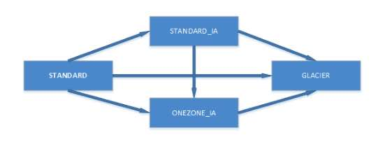

    - Transition actions—Define when objects transition to another storage class. For S3-IA and S3-One-Zone, the objects must be stored at least 30 days in the current storage class before you can transition them to another class.

    - Expiration actions—Define when objects expire. S3 deletes expired objects on your behalf.
Default Data Integrity Protections
- S3 verifies data integrity during uploads using cyclic redundancy check (CRC) based checksums stored in metadata. This ensures that transmitted data is unaltered and maintains consistency.
- Checksums are available for integrity verification during future access or downloads.
- It automatically detects and repairs any data corruption that may occur during upload, storage, or retrieval.
- Customers can access reports detailing the verification process to monitor the health and status of their stored data.
- This feature applies to all Amazon S3 storage classes, including S3 Standard, S3 Intelligent-Tiering, S3 One Zone-IA, and others.
- The data integrity protection is included at no extra cost to customers.
Amazon S3 Metadata (Preview)
- It allows customers to access and manage additional metadata information associated with objects. This preview gives users a deeper understanding of their stored data, enabling more precise management.
- Introduces automated, queryable metadata updated in near real-time to streamline data discovery and AI/ML application workflows.
- Allows users to tag, search, and organize objects based on metadata attributes.
- Provides APIs for metadata queries, enabling integration with analytics and monitoring tools.
- Improve their lifecycle management processes.
- Automatically captures and stores metadata for objects in general-purpose S3 buckets in read-only, fully managed Apache Iceberg tables, enabling efficient data discovery and querying. These read-only tables are called metadata tables.
- Types of Metadata:
  - System-defined – Object’s creation time, storage class, etc.
  - Custom – Tags and user-defined metadata added during object upload.
  - Event – Metadata about updates, deletions, and AWS account actions.
- Metadata tables are stored in S3 table buckets optimized for tabular data. These tables can be queried using Amazon Athena, Amazon EMR, Amazon Redshift, Apache Spark, Apache Trino, or any tool supporting Apache Iceberg.
- Metadata tables can be integrated with AWS Glue Data Catalog for seamless querying and dashboard creation in Amazon QuickSight.
Amazon S3 Tables
- S3 Tables are designed to store tabular data, including daily purchase transactions, streaming sensor data, and ad impressions.
- S3 Tables are stored in a new bucket named table bucket that stores tables as subresources.
- Table buckets support storing tables in the Apache Iceberg format, optimized for analytics workloads with increased transactions and query throughput.
- Reduces the complexity of managing large data lakes by integrating directly with analytics frameworks.
- Improves data querying efficiency for machine learning and analytics applications
Features of S3 Tables
- Purpose-built storage for tables
  - S3 Table buckets are designed specifically for tables, offering higher transactions per second (TPS) and better query throughput compared to general-purpose S3 buckets, while maintaining durability, availability, and scalability.
- Built-in support for Apache Iceberg
  - Tables are stored in Apache Iceberg format, which supports querying via standard SQL and optimizes query performance with features like schema evolution, partition evolution, and transaction support for data consistency and reliability.
- Automated table optimization
  - S3 automatically performs maintenance operations like compaction, snapshot management, and unreferenced file removal, improving query performance and reducing storage costs. Customizable maintenance configurations are available for tables and buckets.
- Access management and security
  - Access control for table buckets and individual tables is managed through AWS Identity and Access Management (IAM) and Service Control Policies. S3 Tables uses a distinct s3tables namespace, allowing for tailored policies. Public access settings are always enabled and cannot be disabled.
- Integration with AWS analytics services
  - Table buckets can be automatically integrated with AWS analytics services (e.g., Amazon Athena, Amazon Redshift, Amazon QuickSight) via the S3 console. Integration with the AWS Glue Data Catalog enables seamless analytics.
Note: This integration is currently in preview and subject to change.
Storage Browser for Amazon S3
- An open-source component for integrating a graphical interface into web applications, enabling end users to interact with Amazon S3 data. It allows authorized users to browse, upload, download, copy, and delete data directly from the application.
- Includes LIST, GET, PUT, COPY, UPLOAD, and DELETE for file management in S3.
- Ensures high throughput data transfer, faster load times, and maintains data integrity during uploads via checksum validation. Only authorized data is displayed to users.
- Storage Browser can be tailored to match the design and branding of your existing application.
- Designed for web and intranet applications built on the React framework.
- Supports all S3 storage classes except for S3 Glacier Flexible Retrieval, S3 Glacier Deep Archive, and certain Intelligent-Tiering tiers.
Amazon S3 Pricing
- S3 charges you only for what you actually use, with no hidden fees and no overage charges
- No charge for creating a bucket, but only for storing objects in the bucket and for transferring objects in and out of the bucket.
Charge | Comments
Storage | You pay for storing objects in your S3 buckets. The rate you’re charged depends on your objects’ size, how long you stored the objects during the month, and the storage class.
Requests | You pay for requests, for example, GET requests, made against your S3 buckets and objects. This includes lifecycle requests. The rates for requests depend on what kind of request you’re making.
Retrievals | You pay for retrieving objects that are stored in STANDARD_IA, ONEZONE_IA, and GLACIER storage.
Early Deletes | If you delete an object stored in STANDARD_IA, ONEZONE_IA, or GLACIER storage before the minimum storage commitment has passed, you pay an early deletion fee for that object.
Storage Management | You pay for the storage management features that are enabled on your account’s buckets.
Bandwidth | You pay for all bandwidth into and out of S3, except for the following:  - Data transferred in from the internet  - Data transferred out to an Amazon EC2 instance, when the instance is in the same AWS Region as the S3 bucket  - Data transferred out to Amazon CloudFront  You also pay a fee for any data transferred using Amazon S3 Transfer Acceleration.
Amazon S3 Networking
- Hosted-style access
  - Amazon S3 routes any virtual hosted–style requests to the US East (N. Virginia) region by default if you use the endpoint s3.amazonaws.com, instead of the region-specific endpoint.
  - Format:
    - http://bucket.s3.amazonaws.com
    - http://bucket.s3-aws-region.amazonaws.com
- Path-style access
  - In a path-style URL, the endpoint you use must match the Region in which the bucket resides.
  - Format:
    - US East (N. Virginia) Region endpoint, http://s3.amazonaws.com/bucket
    - Region-specific endpoint, http://s3-aws-region.amazonaws.com/bucket
- Customize S3 URLs with CNAMEs – the bucket name must be the same as the CNAME.
- Amazon S3 Transfer Acceleration enables fast, easy, and secure transfers of files over long distances between your client and an S3 bucket. It takes advantage of Amazon CloudFront’s globally distributed edge locations.
- Transfer Acceleration cannot be disabled, and can only be suspended.
- Transfer Acceleration URL is: bucket.s3-accelerate.amazonaws.com
Amazon S3 Security
- Policies contain the following:
  - Resources – buckets and objects
  - Actions – set of operations
  - Effect – can be either allow or deny. Need to explicitly grant allow to a resource.
  - Principal – the account, service or user who is allowed access to the actions and resources in the statement.
- Resource Based Policies
  - Bucket Policies
    - Provides centralized access control to buckets and objects based on a variety of conditions, including S3 operations, requesters, resources, and aspects of the request (e.g., IP address).
    - Can either add or deny permissions across all (or a subset) of objects within a bucket.
    - IAM users need additional permissions from root account to perform bucket operations.
    - Bucket policies are limited to 20 KB in size.
  - Access Control Lists
    - A list of grants identifying grantee and permission granted.
    - ACLs use an S3–specific XML schema.
    - You can grant permissions only to other AWS accounts, not to users in your account.
    - You cannot grant conditional permissions, nor explicitly deny permissions.
    - Object ACLs are limited to 100 granted permissions per ACL.
    - The only recommended use case for the bucket ACL is to grant write permissions to the S3 Log Delivery group.
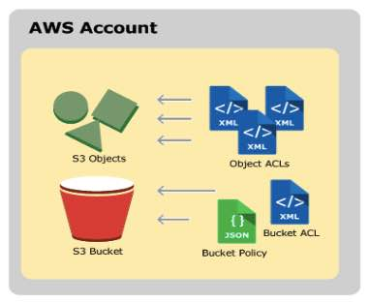
- User Policies
  - AWS IAM (see AWS Security and Identity Services)
    - IAM User Access Keys
    - Temporary Security Credentials
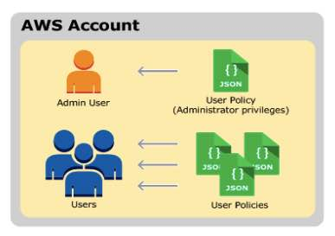
- Versioning
  - Use versioning to keep multiple versions of an object in one bucket.
  - Versioning protects you from the consequences of unintended overwrites and deletions.
  - You can also use versioning to archive objects so you have access to previous versions.
  - Since versioning is disabled by default, need to EXPLICITLY enable.
  - When you PUT an object in a versioning-enabled bucket, the non-current version is not overwritten.
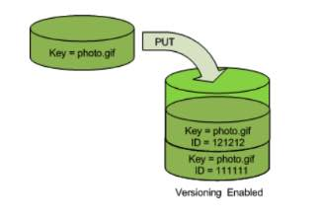

  - When you DELETE an object, all versions remain in the bucket and Amazon S3 inserts a delete marker.
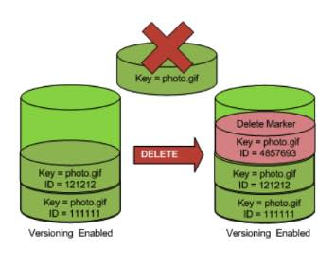

  - Performing a simple GET Object request when the current version is a delete marker returns a 404 Not Found error. You can, however, GET a non-current version of an object by specifying its version ID.
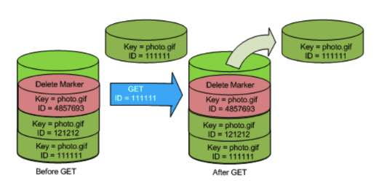

  - You can permanently delete an object by specifying the version you want to delete. Only the owner of an Amazon S3 bucket can permanently delete a version.
  - Amazon S3 on Outposts buckets has three versioning states: Unversioned, Enabled and Suspended.
  - When you enable S3 Versioning for an S3 on the Outposts bucket, it can never be set to unversioned, but you can set the state to suspend versioning.
- Backup

    - You can use AWS Backup to define a central backup policy to protect your Amazon S3 data.
      - Continuous backups and Periodic backups
      - Automated backup scheduling and retention
      - Restore backups
Encryption

  - Server-side Encryption using
    - Amazon S3-Managed Keys (SSE-S3)
    - AWS KMS-Managed Keys (SSE-KMS)
    - Customer-Provided Keys (SSE-C)
  - Client-side Encryption using
    - AWS KMS customer-managed key
    - client-side master key

- MFA Delete
  - MFA delete grants additional authentication for either of the following operations:
    - Change the versioning state of your bucket
    - Permanently delete an object version
  - MFA Delete requires two forms of authentication together:
    - Your security credentials
    - The concatenation of a valid serial number, a space, and the six-digit code displayed on an approved authentication device
- Cross-Account Access
  - You can provide another AWS account access to an object that is stored in an Amazon Simple Storage Service (Amazon S3) bucket. These are the methods on how to grant cross-account access to objects that are stored in your own Amazon S3 bucket:
    - Resource-based policies and AWS Identity and Access Management (IAM) policies for programmatic-only access to S3 bucket objects
    - Resource-based Access Control List (ACL) and IAM policies for programmatic-only access to S3 bucket objects
    - Cross-account IAM roles for programmatic and console access to S3 bucket objects
  - You can create cross-account access points using the S3 console or the AWS CLI.
  - Supports failover controls for S3 Multi-Region access points.
- Requester Pays Buckets
  - Bucket owners pay for all of the Amazon S3 storage and data transfer costs associated with their bucket. To save on costs, you can enable the Requester Pays feature so the requester will pay the cost of the request and the data download from the bucket instead of the bucket owner. Take note that the bucket owner always pays the cost of storing data.
Amazon S3 Monitoring

  - Automated monitoring tools to watch S3:
    - Amazon CloudWatch Alarms – Watch a single metric over a time period that you specify, and perform one or more actions based on the value of the metric relative to a given threshold over a number of time periods.
    - AWS CloudTrail Log Monitoring – Share log files between accounts, monitor CloudTrail log files in real time by sending them to CloudWatch Logs, write log processing applications in Java, and validate that your log files have not changed after delivery by CloudTrail.
  - Monitoring with CloudWatch
    - Daily Storage Metrics for Buckets ‐ You can monitor bucket storage using CloudWatch, which collects and processes storage data from S3 into readable, daily metrics.
    - Request metrics ‐ You can choose to monitor S3 requests to quickly identify and act on operational issues. The metrics are available at 1 minute intervals after some latency to process.
  - You can have a maximum of 1000 metrics configurations per bucket.
  - Supported event activities that occur in S3 are recorded in a CloudTrail event along with other AWS service events in Event history.
- Website Hosting

  - Enable website hosting in your bucket Properties.
  - Your static website is available via the region-specific website endpoint.
  - You must make the objects that you want to serve publicly readable by writing a bucket policy that grants everyone s3:GetObject permission.
Key Difference | REST API Endpoint | Website Endpoint
Access control | Supports both public and private content. | Supports only publicly readable content.
Error message handling | Returns an XML-formatted error response. | Returns an HTML document.
Redirection support | Not applicable | Supports both object-level and bucket-level redirects.
Requests supported | Supports all bucket and object operations | Supports only GET and HEAD requests on objects.
Responses to GET and HEAD requests at the root of a bucket | Returns a list of the object keys in the bucket. | Returns the index document that is specified in the website configuration.
Secure Sockets Layer (SSL) support | Supports SSL connections. | Does not support SSL connections.
S3 Events Notification

  - To enable notifications, add a notification configuration identifying the events to be published, and the destinations where to send the event notifications.
  - Can publish following events:
    - A new object created event
    - An object removal event
    - A Reduced Redundancy Storage (RRS) object lost event
  - Supports the following destinations for your events:
    - Amazon Simple Notification Service (Amazon SNS) topic
    - Amazon Simple Queue Service (Amazon SQS) queue
    - AWS Lambda
- Cross Region Replication
  - Enables automatic, asynchronous copying of objects across buckets in different AWS Regions.
  - When to use:
    - Comply with compliance requirements
    - Minimize latency
    - Increase operational efficiency
    - Maintain object copies under different ownership

  - Requirements of CRR:
    - Both source and destination buckets must have versioning enabled.
    - The source and destination buckets must be in different AWS Regions.
    - S3 must have permissions to replicate objects from the source bucket to the destination bucket on your behalf.
    - If the owner of the source bucket doesn’t own the object in the bucket, the object owner must grant the bucket owner READ and READ_ACP permissions with the object ACL.
  - Only the following are replicated:
    - Objects created after you add a replication configuration.
    - Both unencrypted objects and objects encrypted using Amazon S3 managed keys (SSE-S3) or AWS KMS managed keys (SSE-KMS), although you must explicitly enable the option to replicate objects encrypted using KMS keys. The replicated copy of the object is encrypted using the same type of server-side encryption that was used for the source object.
    - Object metadata.
    - Only objects in the source bucket for which the bucket owner has permissions to read objects and access control lists.
    - Object ACL updates, unless you direct S3 to change the replica ownership when source and destination buckets aren’t owned by the same accounts.
    - Object tags.
    - Objects encrypted using SSE-C.
  - What isn’t replicated
    - Objects that existed before you added the replication configuration to the bucket.
    - Objects created with server-side encryption using customer-provided (SSE-C) encryption keys.
    - Objects in the source bucket that the bucket owner doesn’t have permissions for.
    - Updates to bucket-level subresources.
    - Actions performed by lifecycle configuration.
    - Objects in the source bucket that are replicas created by another cross-region replication. You can replicate objects from a source bucket to only one destination bucket.
  - CRR delete operations
    - If you make a DELETE request without specifying an object version ID, S3 adds a delete marker.
    - If you specify an object version ID to delete in a DELETE request, S3 deletes that object version in the source bucket, but it doesn’t replicate the deletion in the destination bucket. This protects data from malicious deletions.
- S3 Batch Operations is a new feature that makes it simple to manage billions of objects stored in Amazon S3. Customers can make changes to object properties and metadata, and perform other storage management tasks – such as copying objects between buckets, replacing tag sets, modifying access controls, and restoring archived objects from Amazon S3 Glacier – for any number of S3 objects in minutes.
- S3 Storage Lens is a cloud-storage analytics feature to visualize insights and trends, flag outliers, and receive recommendations.

Amazon S3 Best Practices from AWS re:Invent
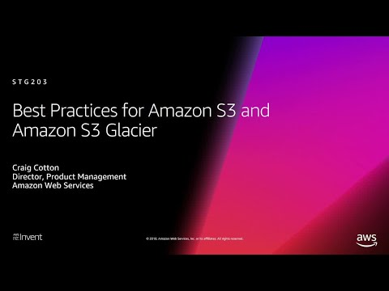
Amazon S3-related Cheat Sheets:
- Amazon S3 vs EBS vs EFS
- Amazon S3 vs Glacier
- S3 Standard vs S3 Standard-IA vs S3 One Zone-IA
- S3 Pre-signed URLs vs CloudFront Signed URLs vs Origin Access Identity (OAI)
- S3 Transfer Acceleration vs Direct Connect vs VPN vs Snowball vs Snowmobile

Validate Your Knowledge
Question 1
A graphics design startup is using multiple Amazon S3 buckets to store high-resolution media files for their various digital artworks. After securing a partnership deal with a leading media company, the two parties shall be sharing digital resources with one another as part of the contract. The media company frequently performs multiple object retrievals from the S3 buckets every day, which increased the startup’s data transfer costs.
As the Solutions Architect, what should you do to help the startup lower their operational costs?
- Advise the media company to create their own S3 bucket. Then run the aws s3 sync s3://sourcebucket s3://destinationbucket command to copy the objects from their S3 bucket to the other party’s S3 bucket. In this way, future retrievals can be made on the media company’s S3 bucket instead.
- Enable the Requester Pays feature in all of the startup’s S3 buckets to make the media company pay the cost of the data transfer from the buckets.
- Create a new billing account for the social media company by using AWS Organizations. Apply SCPs on the organization to ensure that each account has access only to its own resources and each other’s S3 buckets.
- Provide cross-account access for the media company, which has permissions to access contents in the S3 bucket. Cross-account retrieval of S3 objects is charged to the account that made the request.
Show me the answer!
Correct Answer: 2
In general, bucket owners pay for all Amazon S3 storage and data transfer costs associated with their bucket. A bucket owner, however, can configure a bucket to be a Requester Pays bucket. With Requester Pays buckets, the requester instead of the bucket owner pays the cost of the request and the data download from the bucket. The bucket owner always pays the cost of storing data.
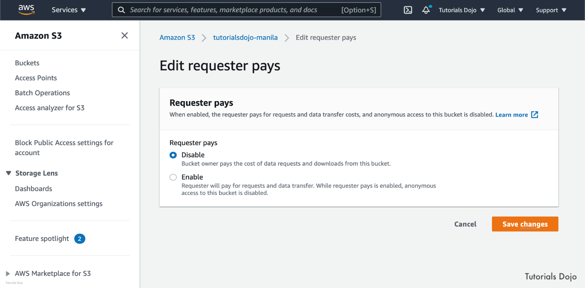
You must authenticate all requests involving Requester Pays buckets. The request authentication enables Amazon S3 to identify and charge the requester for their use of the Requester Pays bucket. After you configure a bucket to be a Requester Pays bucket, requesters must include x-amz-request-payer in their requests either in the header, for POST, GET and HEAD requests, or as a parameter in a REST request to show that they understand that they will be charged for the request and the data download.
Hence, the correct answer is to enable the Requester Pays feature in all of the startup’s S3 buckets to make the media company pay the cost of the data transfer from the buckets.
The option that says: Advise the media company to create their own S3 bucket. Then run the aws s3 sync s3://sourcebucket s3://destinationbucket command to copy the objects from their S3 bucket to the other party’s S3 bucket. In this way, future retrievals can be made on the media company’s S3 bucket instead is incorrect because sharing all the assets of the startup to the media entails a lot of costs considering that you will be charged for the data transfer charges made during the sync process.
Creating a new billing account for the social media company by using AWS Organizations, then applying SCPs on the organization to ensure that each account has access only to its own resources and each other’s S3 buckets is incorrect because AWS Organizations does not create a separate billing account for every account under it. Instead, what AWS Organizations has is consolidated billing. You can use the consolidated billing feature in AWS Organizations to consolidate billing and payment for multiple AWS accounts. Every organization in AWS Organizations has a master account that pays the charges of all the member accounts.
The option that says: Provide cross-account access for the media company, which has permissions to access contents in the S3 bucket. Cross-account retrieval of S3 objects is charged to the account that made the request is incorrect because cross-account access does not shoulder the charges that are made during S3 object requests. Unless Requester Pays is enabled on the bucket, the bucket owner is still the one that is charged.
Reference:
https://docs.aws.amazon.com/AmazonS3/latest/dev/RequesterPaysBuckets.html
Note: This question was extracted from our AWS Certified Solutions Architect Professional Practice Exams.
Question 2
A government agency recently decided to modernize its network infrastructure using AWS. They are developing a solution to store confidential files containing Personally Identifiable Information (PII) and other sensitive financial records of its citizens. All data in the storage solution must be encrypted both at rest and in transit. In addition, all of its data must also be replicated in two locations that are at least 450 miles apart from each other.
As a DevOps Engineer, what solution should you implement to meet these requirements?
- Set up primary and secondary S3 buckets in two separate Availability Zones that are at least 450 miles apart. Create a bucket policy to enforce access to the buckets only through HTTPS and enforce S3 SSE-C encryption on all objects uploaded to the bucket. Enable cross-region replication (CRR) between the two buckets.
- Set up primary and secondary S3 buckets in two separate AWS Regions that are at least 450 miles apart. Create a bucket policy to enforce access to the buckets only through HTTPS and enforce S3-Managed Keys (SSE-S3) encryption on all objects uploaded to the bucket. Enable cross-region replication (CRR) between the two buckets.
- Set up primary and secondary Amazon S3 buckets in two separate AWS Regions that are at least 450 miles apart. Create an IAM role to enforce access to the buckets only through HTTPS. Set up a bucket policy to enforce Amazon S3-Managed Keys (SSE-S3) encryption on all objects uploaded to the bucket. Enable cross-region replication (CRR) between the two buckets.
- Set up primary and secondary S3 buckets in two separate Availability Zones that are at least 450 miles apart. Create a bucket policy to enforce access to the buckets only through HTTPS and enforce AWS KMS encryption on all objects uploaded to the bucket. Enable Transfer Acceleration between the two buckets. Set up a KMS Key in the primary region for encrypting objects.
Show me the answer!
Correct Answer: 2
Availability Zones give customers the ability to operate production applications and databases that are more highly available, fault-tolerant, and scalable than would be possible from a single data center. AWS maintains multiple AZs around the world and more zones are added at a fast pace. Each AZ can be multiple data centers (typically 3), and at full scale can be hundreds of thousands of servers. They are fully isolated partitions of the AWS Global Infrastructure. With their own power infrastructure, the AZs are physically separated by a meaningful distance, many kilometers, from any other AZ, although all are within 100 km (60 miles of each other).
All AZs are interconnected with high-bandwidth, low-latency networking, over fully redundant, dedicated metro fiber providing high-throughput, low-latency networking between AZs. The network performance is sufficient to accomplish synchronous replication between AZs. AWS Availability Zones are also powerful tools for helping build highly available applications. AZs make partitioning applications about as easy as it can be. If an application is partitioned across AZs, companies are better isolated and protected from issues such as lightning strikes, tornadoes, earthquakes and more.
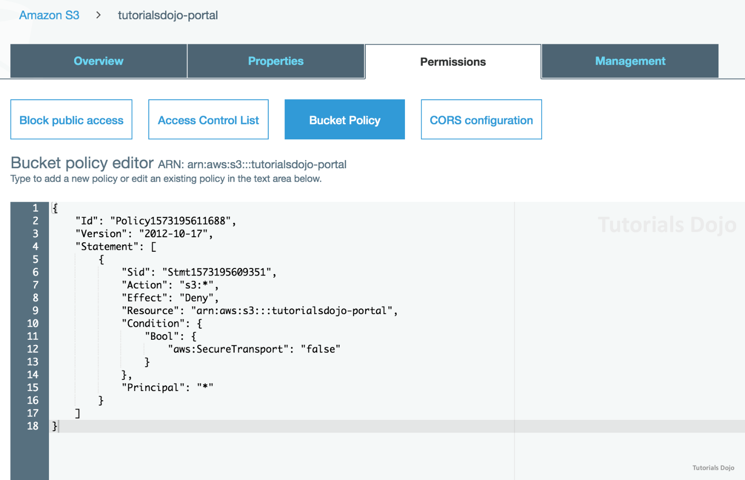
By default, Amazon S3 allows both HTTP and HTTPS requests. To comply with the s3-bucket-ssl-requests-only rule, confirm that your bucket policies explicitly deny access to HTTP requests. Bucket policies that allow HTTPS requests without explicitly denying HTTP requests might not comply with the rule.
To determine HTTP or HTTPS requests in a bucket policy, use a condition that checks for the key “aws:SecureTransport”. When this key is true, this means that the request is sent through HTTPS. To be sure to comply with the s3-bucket-ssl-requests-only rule, create a bucket policy that explicitly denies access when the request meets the condition “aws:SecureTransport”: “false”. This policy explicitly denies access to HTTP requests.
In this scenario, you should use AWS Regions since AZs are physically separated by only 100 km (60 miles) from each other. Within each AWS Region, S3 operates in a minimum of three AZs, each separated by miles to protect against local events like fires, floods et cetera. Take note that you can’t launch an AZ-based S3 bucket.
Hence, the correct answer is: Set up primary and secondary S3 buckets in two separate AWS Regions that are at least 450 miles apart. Create a bucket policy to enforce access to the buckets only through HTTPS and enforce S3-Managed Keys (SSE-S3) encryption on all objects uploaded to the bucket. Enable cross-region replication (CRR) between the two buckets.
The option that says: Set up primary and secondary S3 buckets in two separate Availability Zones that are at least 450 miles apart. Create a bucket policy to enforce access to the buckets only through HTTPS and enforce S3 SSE-C encryption on all objects uploaded to the bucket. Enable cross-region replication (CRR) between the two buckets is incorrect. You can’t create Amazon S3 buckets in two separate Availability Zones since this is a regional service.
The option that says: Set up primary and secondary Amazon S3 buckets in two separate AWS Regions that are at least 450 miles apart. Create an IAM role to enforce access to the buckets only through HTTPS. Set up a bucket policy to enforce Amazon S3-Managed Keys (SSE-S3) encryption on all objects uploaded to the bucket. Enable cross-region replication (CRR) between the two buckets is incorrect. You have to use the bucket policy to enforce access to the bucket using HTTPS only and not an IAM role.
The option that says: Set up primary and secondary S3 buckets in two separate Availability Zones that are at least 450 miles apart. Create a bucket policy to enforce access to the buckets only through HTTPS and enforce AWS KMS encryption on all objects uploaded to the bucket. Enable Transfer Acceleration between the two buckets. Set up a KMS Key in the primary region for encrypting objects is incorrect. You have to enable Cross-Region replication and not Transfer Acceleration. This feature simply enables fast, easy, and secure transfers of files over long distances between your client and an S3 bucket but not data replication.
References:
https://docs.aws.amazon.com/config/latest/developerguide/s3-bucket-ssl-requests-only.html
https://aws.amazon.com/premiumsupport/knowledge-center/s3-bucket-policy-for-config-rule/ https://aws.amazon.com/about-aws/global-infrastructure/regions_az/
Note: This question was extracted from our AWS Certified DevOps Engineer Professional Practice Exams.

For more AWS practice exam questions with detailed explanations, visit the Tutorials Dojo Portal:
Additional Training Materials: Amazon S3 Video Courses on Udemy
- Amazon S3 Mastery – THE How-To’ Guides For Amazon S3
Amazon S3 Cheat Sheet References:
https://aws.amazon.com/blogs/aws/introducing-default-data-integrity-protections-for-new-objects-in-amazon-s3/
https://aws.amazon.com/about-aws/whats-new/2024/12/amazon-s3-metadata-preview/
https://docs.aws.amazon.com/AmazonS3/latest/userguide/metadata-tables-overview.html
https://docs.aws.amazon.com/AmazonS3/latest/userguide/storage-browser.html
https://docs.aws.amazon.com/AmazonS3/latest/dev/Welcome.html
https://aws.amazon.com/s3/faqs/
------------------------------------ ------------------------------------- ------------------------------------------
https://tutorialsdojo.com/amazon-glacier/
Amazon S3 Glacier Cheat Sheet
- Long-term archival solution optimized for infrequently used data, or “cold data.”
- Glacier is a REST-based web service.
- You can store an unlimited number of archives and an unlimited amount of data.
- You cannot specify Glacier as the storage class at the time you create an object.
- It is designed to provide an average annual durability of 99.999999999% for an archive. Glacier synchronously stores your data across multiple AZs before confirming a successful upload.
- To prevent corruption of data packets over the wire, Glacier uploads the checksum of the data during data upload. It compares the received checksum with the checksum of the received data and validates data authenticity with checksums during data retrieval.
- Glacier works together with Amazon S3 lifecycle rules to help you automate archiving of S3 data and reduce your overall storage costs. Requested archival data is copied to S3 One Zone-IA
Data Model
- Vault
  - A container for storing archives.
  - Each vault resource has a unique address with form:
https://region-specific endpoint/account-id/vaults/vaultname
  - You can store an unlimited number of archives in a vault.
  - Vault operations are Region specific.
- Archive
  - Can be any data such as a photo, video, or document and is a base unit of storage in Glacier.
  - Each archive has a unique address with form:
https://region-specific-endpoint/account-id/vaults/vault-name/archives/archive-id
- Job
  - You can perform a select query on an archive, retrieve an archive, or get an inventory of a vault. Glacier Select runs the query in place and writes the output results to Amazon S3.
  - Select, archive retrieval, and vault inventory jobs are associated with a vault. A vault can have multiple jobs in progress at any point in time.
- Notification Configuration
  - Because jobs take time to complete, Glacier supports a notification mechanism to notify you when a job is complete.

Glacier Operations
- Retrieving an archive (asynchronous operation)
- Retrieving a vault inventory (list of archives) (asynchronous operation)
- Create and delete vaults
- Get the vault description for a specific vault or for all vaults in a region
- Set, retrieve, and delete a notification configuration on the vault
- Upload and delete archives. You cannot update an existing archive.
- Glacier jobs — select, archive-retrieval, inventory-retrieval
Vaults
- Vault operations are region specific.
- Vault names must be unique within an account and the region in which the vault is being created.
- You can delete a vault only if there are no archives in the vault as of the last inventory that Glacier computed and there have been no writes to the vault since the last inventory.
- You can retrieve vault information such as the vault creation date, number of archives in the vault, and the total size of all the archives in the vault.
- Glacier maintains an inventory of all archives in each of your vaults for disaster recovery or occasional reconciliation. A vault inventory refers to the list of archives in a vault. Glacier updates the vault inventory approximately once a day. Downloading a vault inventory is an asynchronous operation.
- You can assign your own metadata to Glacier vaults in the form of tags. A tag is a key-value pair that you define for a vault.
- Glacier Vault Lock allows you to easily deploy and enforce compliance controls for individual Glacier vaults with a vault lock policy. You can specify controls such as “write once read many” (WORM) in a vault lock policy and lock the policy from future edits. Once locked, the policy can no longer be changed.
Archives
- Glacier supports the following basic archive operations: upload, download, and delete. Downloading an archive is an asynchronous operation.
- You can upload an archive in a single operation or upload it in parts.
- Using the multipart upload API, you can upload large archives, up to about 10,000 x 4 GB.
- You cannot upload archives to Glacier by using the management console. Use the AWS CLI or write code to make requests, by using either the REST API directly or by using the AWS SDKs.
- You cannot delete an archive using the Amazon S3 Glacier (Glacier) management console. Glacier provides an API call that you can use to delete one archive at a time.
- After you upload an archive, you cannot update its content or its description. The only way you can update the archive content or its description is by deleting the archive and uploading another archive.
- Glacier does not support any additional metadata for the archives.
Glacier Select
- You can perform filtering operations using simple SQL statements directly on your data in Glacier.
- You can run queries and custom analytics on your data that is stored in Glacier, without having to restore your data to a hotter tier like S3.
- When you perform select queries, Glacier provides three data access tiers:
  - Expedited – data accessed is typically made available within 1–5 minutes.
  - Standard – data accessed is typically made available within 3–5 hours.
  - Bulk – data accessed is typically made available within 5–12 hours.
Glacier Data Retrieval Policies
- Set data retrieval limits and manage the data retrieval activities across your AWS account in each region.
- Three types of policies:
  - Free Tier Only – you can keep your retrievals within your daily free tier allowance and not incur any data retrieval cost.
  - Max Retrieval Rate – ensures that the peak retrieval rate from all retrieval jobs across your account in a region does not exceed the bytes-per-hour limit you set.
  - No Retrieval Limit
Amazon S3 Glacier Security
- Glacier encrypts your data at rest by default and supports secure data transit with SSL.
- Data stored in Amazon Glacier is immutable, meaning that after an archive is created it cannot be updated.
- Access to Glacier requires credentials that AWS can use to authenticate your requests. Those credentials must have permissions to access Glacier vaults or S3 buckets.
- Glacier requires all requests to be signed for authentication protection. To sign a request, you calculate a digital signature using a cryptographic hash function that returns a hash value that you include in the request as your signature.
- Glacier supports policies only at the vault level.
- You can attach identity-based policies to IAM identities.
- A Glacier vault is the primary resource and resource-based policies are referred to as vault policies.
- When activity occurs in Glacier, that activity is recorded in a CloudTrail event along with other AWS service events in Event History.
Amazon S3 Glacier Pricing
- You are charged per GB per month of storage
- You are charged for retrieval operations such as retrieve requests and amount of data retrieved depending on the data access tier – Expedited, Standard, or Bulk
- Upload requests are charged.
- You are charged for data transferred out of Glacier.
- Pricing for Glacier Select is based upon the total amount of data scanned, the amount of data returned, and the number of requests initiated.
- There is a charge if you delete data within 90 days.
Amazon S3 Glacier Limits
- Under a single AWS account, you can have up to 1000 vaults.
Free Amazon Glacier Tutorials on YouTube:
https://www.youtube.com/user/AmazonWebServices/search?query=Glacier


Other Amazon Glacier-related Cheat Sheets:
- Amazon S3 vs Glacier

Validate Your Knowledge
Question 1
A SysOps Administrator plans to set up a disaster and recovery plan in AWS. The requirement is to establish a durable, highly available backup and archiving strategy for the company-owned financial documents, which should be accessible immediately for 6 months. It is expected that there would be a compliance audit every 3 years. The Administrator needs to ensure that the files are still available during that period.
Which service should the Administrator use to fulfill these requirements in the most cost-effective manner?
- Set up a storage gateway to upload data in an Amazon S3 bucket. Configure lifecycle policies to archive the data to a Cold HDD Amazon EBS volume.
- Set up a Direct Connect connection to upload data to an Amazon S3 bucket. For archiving purposes, use IAM policies to move the data into Amazon Glacier.
- Use AWS DataSync to transfer the data to an Amazon S3 bucket for storage. Schedule periodic transfers to ensure backups are synchronized for compliance audits.
- Upload data to an Amazon S3 bucket. Use lifecycle policies to move the data to Amazon Glacier for archiving.
Show me the answer!
Correct Answer: 4
To manage your objects so that they are stored cost-effectively throughout their lifecycle, configure their Amazon S3 Lifecycle. An S3 Lifecycle configuration is a set of rules that define actions that Amazon S3 applies to a group of objects.
You can use lifecycle policies to define actions that you want Amazon S3 to take during an object’s lifetime (for example, transition objects to another storage class, archive them, or delete them after a specified period of time).
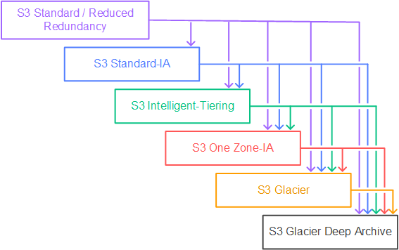
You can add rules in a lifecycle configuration to tell Amazon S3 to transition objects to another Amazon S3 storage class. For example:
– When you know objects are infrequently accessed, you might transition them to the STANDARD_IA storage class.
– You might want to archive objects that you don’t need to access in real-time to the GLACIER storage class.
Hence, the correct answer is: Upload data to an Amazon S3 bucket. Use lifecycle policies to move the data to Amazon Glacier for archiving.
The option that says: Set up a storage gateway to upload data in an Amazon S3 bucket. Configure lifecycle policies to archive the data to a Cold HDD Amazon EBS volume is incorrect. It’s not possible to transition data from Amazon S3 to Amazon EBS via lifecycle policies.
The option that says: Set up a Direct Connect connection to upload data to an Amazon S3 bucket. For archiving purposes, use IAM policies to move the data into Amazon Glacier is incorrect. Direct Connect is not required to transfer data to Amazon S3 unless a private connection between an on-premises data center and AWS is specified. Also, IAM policies only set the permissions needed to carry out an action in AWS. S3 lifecycle policy is the correct answer.
The option that says: Use AWS DataSync to transfer the data to an Amazon S3 bucket for storage. Schedule periodic transfers to ensure backups are synchronized for compliance audits is incorrect because DataSync is primarily used for large-scale data migration and synchronization rather than archival management. It does not automate lifecycle transitions to archival storage like Glacier. It is not ideal for a long-term and cost-effective solution.
References:
https://docs.aws.amazon.com/AmazonS3/latest/userguide/object-lifecycle-mgmt.html
https://docs.aws.amazon.com/AmazonS3/latest/dev/lifecycle-transition-general-considerations.html
Note: This question was extracted from our AWS Certified SysOps Administrator Associate Practice Exams.

Question 2
An organization is currently using a tape backup solution to store its application data on-premises. They plan to use a cloud storage service to preserve the backup data for up to 10 years that may be accessed about once or twice a year.
Which of the following is the most cost-effective option to implement this solution?
- Use AWS Storage Gateway to backup the data directly to Amazon S3 Glacier.
- Order an AWS Snowball Edge appliance to import the backup directly to Amazon S3 Glacier.
- Use AWS Storage Gateway to backup the data and transition it to Amazon S3 Glacier Deep Archive.
- Use Amazon S3 to store the backup data and add a lifecycle rule to transition the current version to Amazon S3 Glacier.
Show me the answer!
Correct Answer: 3
Tape Gateway enables you to replace physical tapes on-premises with virtual tapes in AWS without changing existing backup workflows. Tape Gateway supports all leading backup applications and caches virtual tapes on-premises for low-latency data access. Tape Gateway encrypts data between the gateway and AWS for secure data transfer and compresses data and transitions virtual tapes between Amazon S3 and Amazon S3 Glacier, or Amazon S3 Glacier Deep Archive, to minimize storage costs.
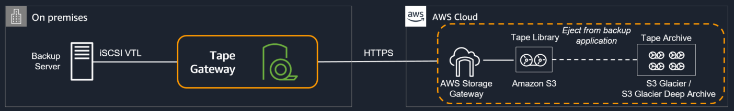
The scenario requires you to back up your application data to a cloud storage service for long-term retention of data that will be retained for 10 years. Given that the organization uses a tape backup solution, an option that uses AWS Storage Gateway must be the possible answer. Tape Gateway can transition virtual tapes archived in Amazon S3 Glacier or Amazon S3 Glacier Deep Archive storage class, enabling you to further reduce the monthly cost to store long-term data in the cloud by up to 75%.
Hence, the correct answer is: Use AWS Storage Gateway to backup the data and transition it to Amazon S3 Glacier Deep Archive.
The option that says: Use AWS Storage Gateway to backup the data directly to Amazon S3 Glacier is incorrect. Although this is a valid solution, moving to S3 Glacier is more expensive than directly backing it up to Glacier Deep Archive.
The option that says: Order an AWS Snowball Edge appliance to import the backup directly to Amazon S3 Glacier is incorrect because Snowball Edge can’t directly integrate backups to S3 Glacier. Moreover, you have to use the Amazon S3 Glacier Deep Archive storage class as it is more cost-effective than the regular Glacier class.
The option that says: Use Amazon S3 to store the backup data and add a lifecycle rule to transition the current version to Amazon S3 Glacier is incorrect. Although this is a possible solution, it is difficult to directly integrate a tape backup solution to S3 without using Storage Gateway.
References:
https://aws.amazon.com/storagegateway/faqs/
https://aws.amazon.com/s3/storage-classes/
Check out this AWS Storage Gateway Cheat Sheet:
https://tutorialsdojo.com/aws-storage-gateway/
Note: This question was extracted from our AWS Certified Solutions Architect Associate Practice Exams.
------------------------------------ ------------------------------------- ------------------------------------------
https://tutorialsdojo.com/aws-snowball-edge/
AWS Snowball Edge Cheat Sheet
- A type of Snowball device with on-board storage and compute power for select AWS capabilities. It can undertake local processing and edge-computing workloads in addition to transferring data between your local environment and the AWS Cloud.
- Has on-board S3-compatible storage and compute to support running Lambda functions and EC2 instances.
- Options for device configurations
  - Storage optimized – this option has the most storage capacity at up to 80 TB of useable storage space, 24 vCPUs, and 32 GiB of memory for compute functionality. You can transfer up to 100 TB with a single Snowball Edge Storage Optimized device.
  - Compute optimized – this option has the most compute functionality with 52 vCPUs, 208 GiB of memory, and 7.68 TB of dedicated NVMe SSD storage for instances. This option also comes with 42 TB of additional storage space.
  - Compute Optimized with GPU – identical to the compute optimized option, save for an installed GPU, equivalent to the one available in the P3 Amazon EC2 instance type.

Features
- Network adapters with transfer speeds of up to 100 GB/second.
- Encryption is enforced, protecting your data at rest and in physical transit.
- You can import or export data between your local environments and S3.
- Snowball Edge devices come with an on-board LCD display that can be used to manage network connections and get service status information.
- You can cluster Snowball Edge devices for local storage and compute jobs to achieve 99.999 percent data durability across 5–10 devices, and to locally grow and shrink storage on demand.
- You can use the file interface to read and write data to a Snowball Edge device through a file share or Network File System (NFS) mount point.
- You can write Python-language Lambda functions and associate them with S3 buckets when you create a Snowball Edge device job. Each function triggers whenever there’s a local S3 PUT object action executed on the associated bucket on the appliance.
- Snowball Edge devices have S3 and EC2 compatible endpoints available, enabling programmatic use cases.
- Customers who need to run Amazon EC2 workloads on AWS Snowball Edge devices can attach multiple persistent block storage volumes to their Amazon EC2 instances.
- For latency-sensitive applications such as machine learning, you can deploy a performance-optimized SSD volume (sbp1). Performance optimized volumes on the Snowball Edge Compute Optimized device use NVMe SSD, and on the Snowball Edge Storage Optimized device, they use SATA SSD. Alternatively, you can use capacity-optimized HDD volumes (sbg1) on any Snowball Edge.
Snowball vs Snowball Edge
- (View AWS Migration CheatSheet: Snowball: Snowball vs Snowball Edge section)
Job Types
- Import To S3 – transfer of 80 TB or less of your local data copied onto a single device, and then moved into S3.
  - Snowball Edge devices and jobs have a one-to-one relationship. Each job has exactly one device associated with it. If you need to import more data, you can create new import jobs or clone existing ones.
- Export From S3 – transfer of any amount of data located in S3, copied onto any number of Snowball Edge devices, and then move one Snowball Edge device at a time into your on-premises data destination.
  - When you create an export job, it’s split into job parts. Each job part is no more than 100 TB in size, and each job part has exactly one Snowball Edge device associated with it.
- Local Compute and Storage Only – these jobs involve one Snowball Edge device, or multiple devices used in a cluster. This job type is only for local use.
  - A cluster job is for those workloads that require increased data durability and storage capacity. Clusters have anywhere from 5 to 10 Snowball Edge devices, called nodes.
  - A cluster offers increased durability and increased storage over a standalone Snowball Edge for local storage and compute.
Recommendations
- Files should be in a static state while being written to the device.
- The Job created status is the only status in which you can cancel a job. When a job changes to a different status, it can’t be canceled.
- All files transferred to a Snowball be no smaller than 1 MB in size.
- Perform multiple write operations at one time by running each command from multiple terminal windows on a computer with a network connection to a single Snowball Edge device.
- Transfer small files in batches.
AWS Snowball Edge Security
- All data transferred to a device is protected by SSL encryption over the network.
- To protect data at rest, Snowball Edge uses server side-encryption.
- Access to Snowball Edge requires credentials that AWS can use to authenticate your requests. Those credentials must have permissions to access AWS resources, such an Amazon S3 bucket or an AWS Lambda function.
AWS Snowball Edge Pricing
- You are charged depending on the type of Snowball Edge machine you choose (storage optimized or compute optimized).
- You are charged based on what you select for your term of use: On demand, a 1-year commitment, or a 3-year commitment.
- For on-demand use, you pay a service fee per data transfer job, which includes 10 days of on-site Snowball Edge device usage. Shipping days, including the day the device is received and the day it is shipped back to AWS, are not counted toward the 10 days. If the device is kept for more than 10 days, you will incur an additional fee for each day beyond 10 days.

- There is a one-time setup fee per job ordered through the console.
AWS Snowball Edge Limits
- Each data transferred must have a maximum size of 5 terabytes.
- Jobs must be completed within 120 days of the Snowball Edge device being prepared.
- The default service limit for the number of AWS Snowball Edge devices you can have at one time is 1.
- If you allocate the minimum recommendation of 128 MB of memory for each of your functions, you can have up to seven Lambda functions in a single job. (Limited because of physical limits)
AWS Snowball Edge Cheat Sheet References:
https://aws.amazon.com/snowball-edge/features/
https://aws.amazon.com/snowball-edge/pricing/
https://aws.amazon.com/snowball-edge/faqs/
------------------------------------ ------------------------------------- ------------------------------------------
https://tutorialsdojo.com/amazon-aurora/
Amazon Aurora Cheat Sheet
- A fully managed relational database engine that’s compatible with MySQL and PostgreSQL.
- With some workloads, Aurora can deliver up to five times the throughput of MySQL and up to three times the throughput of PostgreSQL.
- Aurora includes a high-performance storage subsystem. The underlying storage grows automatically as needed, up to 128 terabytes. The minimum storage is 10GB.
- Aurora will keep your database up-to-date with the latest patches.
- Aurora supports quick, efficient cloning operations.
  - You can share your Amazon Aurora DB clusters with other AWS accounts for quick and efficient database cloning.
- Aurora is fault-tolerant and self-healing.

DB Clusters

  - An Aurora DB cluster consists of one or more DB instances and a cluster volume that manages the data for those DB instances.
  - An Aurora cluster volume is a virtual database storage volume that spans multiple AZs, with each AZ having a copy of the DB cluster data.
  - Cluster Types:
    - Primary DB instance – Supports read and write operations, and performs all of the data modifications to the cluster volume. Each Aurora DB cluster has one primary DB instance.
    - Aurora Replica – Connects to the same storage volume as the primary DB instance and supports only read operations. Each Aurora DB cluster can have up to 15 Aurora Replicas in addition to the primary DB instance. Aurora automatically fails over to an Aurora Replica in case the primary DB instance becomes unavailable. You can specify the failover priority for Aurora Replicas. Aurora Replicas can also offload read workloads from the primary DB instance.
Aurora Endpoints
- Cluster endpoint – connects to the current primary DB instance for a DB cluster. This endpoint is the only one that can perform write operations. Each Aurora DB cluster has one cluster endpoint and one primary DB instance.
- Reader endpoint – connects to one of the available Aurora Replicas for that DB cluster. Each Aurora DB cluster has one reader endpoint. The reader endpoint provides load-balancing support for read-only connections to the DB cluster. Use the reader endpoint for read operations, such as queries. You can’t use the reader endpoint for write operations.
- Custom endpoint – represents a set of DB instances that you choose. When you connect to the endpoint, Aurora performs load balancing and chooses one of the instances in the group to handle the connection. You define which instances this endpoint refers to, and you decide what purpose the endpoint serves.
- Instance endpoint – connects to a specific DB instance within an Aurora cluster. The instance endpoint provides direct control over connections to the DB cluster. The main way that you use instance endpoints is to diagnose capacity or performance issues that affect one specific instance in an Aurora cluster.

  - When you connect to an Aurora cluster, the host name and port that you specify point to an intermediate handler called an endpoint.
  - Types of Endpoints
Storage and Reliability

  - Aurora data is stored in the cluster volume, which is designed for reliability. A cluster volume consists of copies of the data across multiple Availability Zones in a single AWS Region.
  - Aurora automatically detects failures in the disk volumes that make up the cluster volume. When a segment of a disk volume fails, Aurora immediately repairs the segment. When Aurora repairs the disk segment, it uses the data in the other volumes that make up the cluster volume to ensure that the data in the repaired segment is current.
  - Aurora preloads the buffer pool with the pages for known common queries that are stored in an in-memory page cache when a database starts up after it has been shut down or restarted after a failure.
  - Aurora is designed to recover from a crash almost instantaneously and continue to serve your application data without the binary log. Aurora performs crash recovery asynchronously on parallel threads, so that your database is open and available immediately after a crash.
  - Amazon Aurora Auto Scaling works with Amazon CloudWatch to automatically add and remove Aurora Replicas in response to changes in performance metrics that you specify. This feature is available in the PostgreSQL-compatible edition of Aurora. There is no additional cost to use Aurora Auto Scaling beyond what you already pay for Aurora and CloudWatch alarms.
  - Dynamic resizing automatically decreases the allocated storage space from your Aurora database cluster when you delete data.
High Availability and Fault Tolerance

  - When you create Aurora Replicas across Availability Zones, RDS automatically provisions and maintains them synchronously. The primary DB instance is synchronously replicated across Availability Zones to Aurora Replicas to provide data redundancy, eliminate I/O freezes, and minimize latency spikes during system backups.
  - An Aurora DB cluster is fault tolerant by design. If the primary instance in a DB cluster fails, Aurora automatically fails over to a new primary instance in one of two ways:
    - By promoting an existing Aurora Replica to the new primary instance
    - By creating a new primary instance
  - Aurora storage is also self-healing. Data blocks and disks are continuously scanned for errors and repaired automatically.
  - Aurora backs up your cluster volume automatically and retains restore data for the length of the backup retention period, from 1 to 35 days.
  - Aurora automatically maintains 6 copies of your data across 3 Availability Zones and will automatically attempt to recover your database in a healthy AZ with no data loss.
  - Aurora has a Backtrack feature that rewinds or restores the DB cluster to the time you specify. However, take note that the Amazon Aurora Backtrack feature is not a total replacement for fully backing up your DB cluster since the limit for a backtrack window is only 72 hours.
  - With Aurora MySQL, you can set up cross-region Aurora Replicas using either logical or physical replication. Aurora PostgreSQL does not currently support cross-region replicas.
Aurora Global Database

  - An Aurora global database spans multiple AWS Regions, enabling low latency global reads and disaster recovery from region-wide outages.
  - Consists of one primary AWS Region where your data is mastered, and one read-only, secondary AWS Region.
  - Aurora global databases use dedicated infrastructure to replicate your data.
  - Aurora global databases introduce a higher level of failover capability than a default Aurora cluster.
  - An Aurora cluster can recover in less than 1 minute even in the event of a complete regional outage. This provides your application with an effective Recovery Point Objective (RPO) of 5 seconds and a Recovery Time Objective (RTO) of less than 1 minute.
  - Has managed planned failover capability, which lets you change which AWS Region hosts the primary cluster while preserving the physical topology of your global database and avoiding unnecessary application changes.
DB Cluster Configurations

  - Aurora supports two types of instance classes
    - Memory Optimized
    - Burstable Performance
  - Aurora Serverless is an on-demand, autoscaling configuration for Amazon Aurora (supports both MySQL and PostgreSQL). An Aurora Serverless DB cluster automatically starts up, shuts down, and scales up or down capacity based on your application’s needs.
    - A non-Serverless DB cluster for Aurora is called a provisioned DB cluster.
    - Instead of provisioning and managing database servers, you specify Aurora Capacity Units (ACUs). Each ACU is a combination of processing and memory capacity.
    - You can choose to pause your Aurora Serverless DB cluster after a given amount of time with no activity. The DB cluster automatically resumes and services the connection requests after receiving requests.
    - Aurora Serverless does not support fast failover, but it supports automatic multi-AZ failover.
    - The cluster volume for an Aurora Serverless cluster is always encrypted. You can choose the encryption key, but not turn off encryption.
    - You can set the following specific values:
      - Minimum Aurora capacity unit – Aurora Serverless can reduce capacity down to this capacity unit.
      - Maximum Aurora capacity unit – Aurora Serverless can increase capacity up to this capacity unit.
      - Pause after inactivity – The amount of time with no database traffic to scale to zero processing capacity.
    - You pay by the second and only when the database is in use.
    - You can share snapshots of Aurora Serverless DB clusters with other AWS accounts or publicly. You also have the ability to copy Aurora Serverless DB cluster snapshots across AWS regions.

  - Limitations of Aurora Serverless
    - Aurora Serverless supports specific MySQL and PostgreSQL versions only.
    - The port number for connections must be:
      - 3306 for Aurora MySQL
      - 5432 for Aurora PostgreSQL
    - You can’t give an Aurora Serverless DB cluster a public IP address. You can access an Aurora Serverless DB cluster only from within a virtual private cloud (VPC) based on the Amazon VPC service.
    - Each Aurora Serverless DB cluster requires two AWS PrivateLink endpoints. If you reach the limit for PrivateLink endpoints within your VPC, you can’t create any more Aurora Serverless clusters in that VPC.
    - A DB subnet group used by Aurora Serverless can’t have more than one subnet in the same Availability Zone.
    - Changes to a subnet group used by an Aurora Serverless DB cluster are not applied to the cluster.
    - Aurora Serverless doesn’t support the following features:
      - Loading data from an Amazon S3 bucket
      - Saving data to an Amazon S3 bucket
      - Invoking an AWS Lambda function with an Aurora MySQL native function
      - Aurora Replicas
      - Backtrack
      - Multi-master clusters
      - Database cloning
      - IAM database authentication
      - Restoring a snapshot from a MySQL DB instance
      - Amazon RDS Performance Insights

  - When you reboot the primary instance of an Aurora DB cluster, RDS also automatically restarts all of the Aurora Replicas in that DB cluster. When you reboot the primary instance of an Aurora DB cluster, no failover occurs. When you reboot an Aurora Replica, no failover occurs.
  - Deletion protection is enabled by default when you create a production DB cluster using the AWS Management Console. However, deletion protection is disabled by default if you create a cluster using the AWS CLI or API.
    - For Aurora MySQL, you can’t delete a DB instance in a DB cluster if both of the following conditions are true:
      - The DB cluster is a Read Replica of another Aurora DB cluster.
      - The DB instance is the only instance in the DB cluster.
- Aurora Multi Master

  - The feature is available on Aurora MySQL 5.6
  - Allows you to create multiple read-write instances of your Aurora database across multiple Availability Zones, which enables uptime-sensitive applications to achieve continuous write availability through instance failure.
  - In the event of instance or Availability Zone failures, Aurora Multi-Master enables the Aurora database to maintain read and write availability with zero application downtime. There is no need for database failovers to resume write operations.
Tags

  - You can use Amazon RDS tags to add metadata to your RDS resources.
  - Tags can be used with IAM policies to manage access and to control what actions can be applied to the RDS resources.
  - Tags can be used to track costs by grouping expenses for similarly tagged resources.
Amazon Aurora Monitoring

  - Subscribe to Amazon RDS events to be notified when changes occur with a DB instance, DB cluster, DB cluster snapshot, DB parameter group, or DB security group.
  - Database log files
  - RDS Enhanced Monitoring — Look at metrics in real time for the operating system.
  - RDS Performance Insights monitors your Amazon RDS DB instance load so that you can analyze and troubleshoot your database performance.
  - Use CloudWatch Metrics, Alarms and Logs
Amazon Aurora Security

  - Use IAM to control access.
  - To control which devices and EC2 instances can open connections to the endpoint and port of the DB instance for Aurora DB clusters in a VPC, you use a VPC security group.
  - You can make endpoint and port connections using Transport Layer Security (TLS) / Secure Sockets Layer (SSL). In addition, firewall rules can control whether devices running at your company can open connections to a DB instance.
  - Use RDS encryption to secure your RDS instances and snapshots at rest.
  - You can authenticate to your DB cluster using AWS IAM database authentication. IAM database authentication works with Aurora MySQL and Aurora PostgreSQL. With this authentication method, you don’t need to use a password when you connect to a DB cluster. Instead, you use an authentication token, which is a unique string of characters that Amazon Aurora generates on request.
- Aurora for MySQL
  - Performance Enhancements
    - Push-Button Compute Scaling
    - Storage Auto-Scaling
    - Low-Latency Read Replicas
    - Serverless Configuration
    - Custom Database Endpoints
    - Fast insert accelerates parallel inserts sorted by primary key.
    - Aurora MySQL parallel query is an optimization that parallelizes some of the I/O and computation involved in processing data-intensive queries.
    - You can use the high-performance Advanced Auditing feature in Aurora MySQL to audit database activity. To do so, you enable the collection of audit logs by setting several DB cluster parameters.
  - Scaling
    - Instance scaling – scale your Aurora DB cluster by modifying the DB instance class for each DB instance in the DB cluster.
    - Read scaling – as your read traffic increases, you can create additional Aurora Replicas and connect to them directly to distribute the read load for your DB cluster.
Feature | Amazon Aurora Replicas | MySQL Replicas
Number of Replicas | Up to 15 | Up to 5
Replication type | Asynchronous  (milliseconds) | Asynchronous  (seconds)
Performance impact on primary | Low | High
Act as failover target | Yes (no data loss) | Yes  (potentially minutes of data loss)
Automated failover | Yes | No
Support for user-defined replication delay | No | Yes
Support for different data or schema vs. primary | No | Yes
- Aurora for PostgreSQL
  - Performance Enhancements
    - Push-button Compute Scaling
    - Storage Auto-Scaling
    - Low-Latency Read Replicas
    - Custom Database Endpoints
  - Scaling
    - Instance scaling
    - Read scaling
  - Amazon Aurora PostgreSQL now supports logical replication. With logical replication, you can replicate data changes from your Aurora PostgreSQL database to other databases using native PostgreSQL replication slots, or data replication tools such as the AWS Database Migration Service.
  - Rebooting the primary instance of an Amazon Aurora DB cluster also automatically reboots the Aurora Replicas for that DB cluster, in order to re-establish an entry point that guarantees read/write consistency across the DB cluster.
  - You can import data (supported by the PostgreSQL COPY command) stored in an Amazon S3 bucket into a PostgreSQL table.
Amazon Aurora Pricing

  - You are charged for DB instance hours, I/O requests, Backup storage and Data transfer.
  - You can purchase On-Demand Instances and pay by the hour for the DB instance hours that you use, or Reserved Instances to reserve a DB instance for a one-year or three-year term and receive a significant discount compared to the on-demand DB instance pricing.
  - Aurora PostgreSQL support for Kerberos and Microsoft Active Directory provides the benefits of single sign-on and centralized authentication of Aurora PostgreSQL database users. In addition to password-based and IAM-based authentication methods, you can also authenticate using AWS Managed Microsoft AD Service
Deep Dive on Amazon Aurora:

Note: If you are studying for the AWS Certified Data Engineer Associate exam, we highly recommend that you take our AWS Certified Data Engineer Associate Practice Exams and read our Data Engineer Associate exam study guide.

Validate Your Knowledge
Question 1
An online shopping platform is hosted on an Auto Scaling group of Amazon EC2 Spot instances and utilizes Amazon Aurora PostgreSQL as its database. It is required to optimize database workloads in the cluster by directing the production traffic to high-capacity instances and routing the reporting queries from the internal staff to the low-capacity instances.
Which is the most suitable configuration for the application as well as the Aurora database cluster to achieve this requirement?
- Configure your application to use the reader endpoint for both production traffic and reporting queries, which will enable your Aurora database to automatically perform load-balancing among all the Aurora Replicas.
- In your application, use the instance endpoint of your Aurora database to handle the incoming production traffic and use the cluster endpoint to handle reporting queries.
- Create a custom endpoint in Aurora based on the specified criteria for the production traffic and another custom endpoint to handle the reporting queries.
- Do nothing since by default, Aurora will automatically direct the production traffic to your high-capacity instances and the reporting queries to your low-capacity instances.
Show me the answer!
Correct Answer: 3
Amazon Aurora typically involves a cluster of DB instances instead of a single instance. Each connection is handled by a specific DB instance. When you connect to an Aurora cluster, the host name and port that you specify point to an intermediate handler called an endpoint. Aurora uses the endpoint mechanism to abstract these connections. Thus, you don’t have to hardcode all the hostnames or write your own logic for load-balancing and rerouting connections when some DB instances aren’t available.
For certain Aurora tasks, different instances or groups of instances perform different roles. For example, the primary instance handles all data definition language (DDL) and data manipulation language (DML) statements. Up to 15 Aurora Replicas handle read-only query traffic.

Using endpoints, you can map each connection to the appropriate instance or group of instances based on your use case. For example, to perform DDL statements you can connect to whichever instance is the primary instance. To perform queries, you can connect to the reader endpoint, with Aurora automatically performing load-balancing among all the Aurora Replicas. For clusters with DB instances of different capacities or configurations, you can connect to custom endpoints associated with different subsets of DB instances. For diagnosis or tuning, you can connect to a specific instance endpoint to examine details about a specific DB instance.
The custom endpoint provides load-balanced database connections based on criteria other than the read-only or read-write capability of the DB instances. For example, you might define a custom endpoint to connect to instances that use a particular AWS instance class or a particular DB parameter group. Then you might tell particular groups of users about this custom endpoint. For example, you might direct internal users to low-capacity instances for report generation or ad hoc (one-time) querying, and direct production traffic to high-capacity instances.
Hence, the correct answer is: Create a custom endpoint in Aurora based on the specified criteria for the production traffic and another custom endpoint to handle the reporting queries.
The option that says: Configuring your application to use the reader endpoint for both production traffic and reporting queries, which will enable your Aurora database to automatically perform load-balancing among all the Aurora Replicas is incorrect. Although it is true that a reader endpoint enables your Aurora database to automatically perform load-balancing among all the Aurora Replicas, it is quite limited to doing read operations only. You still need to use a custom endpoint to load-balance the database connections based on the specified criteria.
The option that says: In your application, use the instance endpoint of your Aurora database to handle the incoming production traffic and use the cluster endpoint to handle reporting queries is incorrect because a cluster endpoint (also known as a writer endpoint) for an Aurora DB cluster simply connects to the current primary DB instance for that DB cluster. This endpoint can perform write operations in the database such as DDL statements, which is perfect for handling production traffic but not suitable for handling queries for reporting since there will be no write database operations that will be sent. Moreover, the endpoint does not point to lower-capacity or high-capacity instances as per the requirement. A better solution for this is to use a custom endpoint.
The option that says: Do nothing since by default, Aurora will automatically direct the production traffic to your high-capacity instances and the reporting queries to your low-capacity instances is incorrect because Aurora does not do this by default. You have to create custom endpoints in order to accomplish this requirement.

References:
https://docs.aws.amazon.com/AmazonRDS/latest/AuroraUserGuide/Aurora.Overview.Endpoints.html
https://docs.aws.amazon.com/AmazonRDS/latest/AuroraUserGuide/Aurora.Endpoints.Custom.html
Note: This question was extracted from our AWS Certified Solutions Architect Associate Practice Exams.

Question 2
A Database Specialist is adding new indexes and altering large tables of an Amazon Aurora PostgreSQL database that uses a medium instance type with a default configuration. The application suddenly crashes with the following error message when loading a large dataset:
ERROR: could not write block 18980612 of temporary file: No space left on device
Which of the following can the Database Specialist do to resolve this issue? (Select TWO.)
- Modify the Aurora database to use a DB instance class with more local SSD storage.
- Enable local storage scaling on the Amazon Aurora database, which is disabled by default.
- Add an Auto Scaling policy to the Aurora database which will automatically increase the local storage.
- Wait for a few minutes until Amazon Aurora automatically scales out the cluster volume storage and then reload the datasets once again.
- Lessen the database workload to reduce the amount of temporary storage required.
Show me the answer!
Correct Answers: 1, 5
Each DB instance in an Amazon Aurora DB cluster uses local solid-state drive (SSD) storage to store temporary tables for a session. This local storage for temporary tables doesn’t automatically grow like the Aurora cluster volume. Instead, the amount of local storage is limited. The limit is based on the DB instance class for DB instances in your DB cluster.
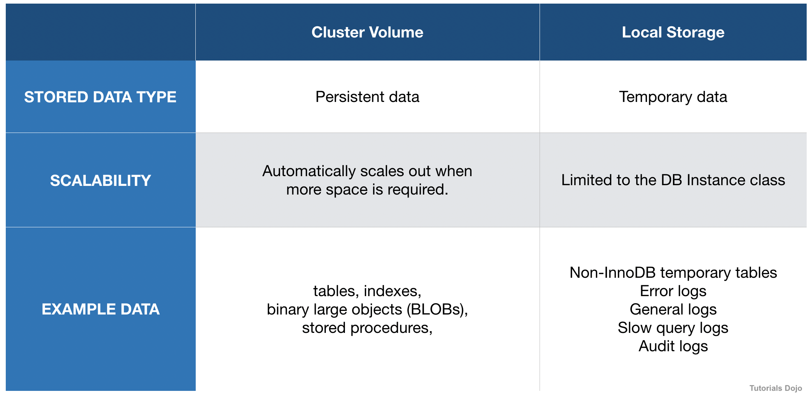
Instances in Aurora clusters have two types of storage:
– Storage for persistent data (called the cluster volume). This storage type increases automatically when more space is required.
– Local storage for each Aurora instance in the cluster, based on the instance class. This storage type and size is bound to the instance class, and can be changed only by moving to a larger DB instance class. Aurora for MySQL uses local storage for storing error logs, general logs, slow query logs, audit logs, and non-InnoDB temporary tables.
To show the amount of storage available for temporary tables and logs, you can use the CloudWatch metric FreeLocalStorage. This metric is for per-instance temporary volumes, not the cluster volume. In some cases, you can’t modify your workload to reduce the amount of temporary storage required. If so, you have to modify your DB instances to use a DB instance class that has more local SSD storage.
Hence, the correct answers are:
– Modify the Aurora database to use a DB instance class with more local SSD storage.
– Lessen the database workload to reduce the amount of temporary storage required.
The option that says: Enable local storage scaling on the Amazon Aurora database, which is disabled by default is incorrect because the amount of local storage is limited and can’t be automatically scaled. Amazon Aurora also does not have a feature that you can enable to scale the local storage automatically.
The option that says: Add an Auto Scaling policy to the Aurora database, which will automatically increase the local storage is incorrect because the root cause of this issue is the lack of free local storage of the Aurora database and not the lack of an Auto Scaling policy. By default, the Amazon Aurora storage automatically scales with the data in your cluster volume, which is why it doesn’t need to have a new Auto Scaling policy. What it needs is a larger instance type to increase its local SSD storage.
The option that says: Wait for a few minutes until Amazon Aurora automatically scales out the cluster volume storage and then reload the datasets once again is incorrect because the error message pertains to the lack of available disk space in the local storage and not on the cluster volume. The cluster volume is a type of storage that increases automatically when more space is required.
References:
https://aws.amazon.com/premiumsupport/knowledge-center/postgresql-aurora-storage-issue/
https://docs.aws.amazon.com/AmazonRDS/latest/AuroraUserGuide/CHAP_Troubleshooting.html#CHAP_Troubleshooting.Aurora.NoSpaceLeft
https://docs.amazonaws.cn/en_us/AmazonRDS/latest/AuroraUserGuide/AuroraPostgreSQL.BestPractices.html#AuroraPostgreSQL.BestPractices.TroubleshootingStorage
Note: This question was extracted from our AWS Certified Database Specialty Practice Exams.
For more AWS practice exam questions with detailed explanations, check out the Tutorials Dojo Portal:
Amazon Aurora Cheat Sheet References:
https://docs.aws.amazon.com/AmazonRDS/latest/AuroraUserGuide/
https://aws.amazon.com/rds/aurora/details/mysql-details/
https://aws.amazon.com/rds/aurora/details/postgresql-details/
https://aws.amazon.com/rds/aurora/global-database/
https://aws.amazon.com/rds/aurora/parallel-query/
https://aws.amazon.com/rds/aurora/serverless/
https://aws.amazon.com/rds/aurora/pricing/
https://aws.amazon.com/rds/aurora/faqs/
------------------------------------ ------------------------------------- ------------------------------------------
https://tutorialsdojo.com/amazon-documentdb/
Amazon DocumentDB Cheat Sheet
- Fully managed document database service designed to be fast, scalable, and highly available.
- Data is stored in JSON-like documents.
- Compatible with MongoDb.
- Flexible schema and indexing.
- Commonly used for content management, user profiles, and real-time big data.

How it Works
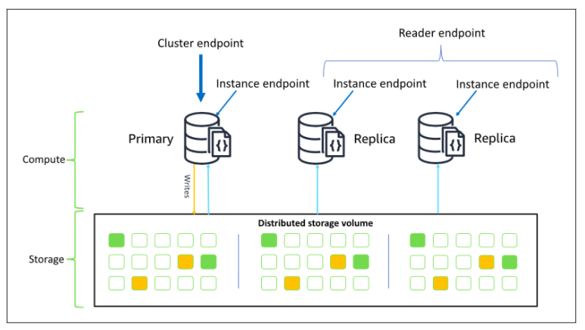

- An Amazon DocumentDB cluster decouples storage and compute.
- A cluster consists of Cluster volume and Instances
  - Cluster volume refers to the storage layer that spans multiple Availability Zones. Each Availability Zone has a copy of the cluster data.
  - Instances refers to the compute layer. It provides the processing power needed for the database to write data to, and read data from, the cluster volume.
- Amazon DocumentDB Endpoints
  - Cluster endpoint
    - Connects to cluster’s current primary instance.
    - Can be used for both read and write operations.

  - Reader endpoint
    - Connects to one of the available replicas of the cluster.
    - Use for read operations only.
    - If the cluster has more than one replica, the reader endpoint will direct each request to DocumentDB replicas.

  - Instance endpoint
    - Connects to a specific instance in the cluster.
    - Use for specialized workloads that will only affect specific replica instances.

Performance
- Provides millions of requests per second with millisecond latency and has twice the throughput of MongoDb.
Amazon DocumentDB Scaling
- The minimum storage is 10GB. The Amazon DocumentDB storage will automatically scale up to 64 TB in 10 GB increments without affecting performance.
- The Amazon DocumentDB cluster can be scaled by modifying the instance class for each instance in the cluster.
- You can create up to 15 Amazon DocumentDB replicas in the cluster.
- The replication lag is usually less than 100 milliseconds after the primary instance has written an update.
Amazon DocumentDB Reliability
- The cluster volume provides durability by maintaining six copies of all data across three Availability Zones.
- Amazon DocumentDB uses asynchronous replication to update the changes made to the primary instance to all of DocumentDB’s read replicas.
- In most cases, the DocumentDB’s restart time is less than a minute after a database crash.
- DocumentDB replicas can act as a failover target with no data loss.
- Supports automatic failover.
- Supports promotion priority within a cluster. Amazon DocumentDB will promote the replica with the highest priority tier to primary when the primary instance fails.
- To increase the cluster’s availability, create replicas in multiple Availability Zones. The Amazon DocumentDB will automatically include the replicas when selecting for a failover target in the event of an instance failure.
Backup And Restore
 | Cluster Volume | Local Storage
STORED DATA TYPE | Persistent data | Temporary data
SCALABILITY | Automatically scales out when more space is required | Limited to the DB Instance class
- Automated backups are always enabled.
- Supports Point-In-Time restoration, which can be up to 5 minutes in the past.
- You can restore from a cluster snapshot.
- Supports sharing of encrypted manual snapshots.
- Supports cross-region snapshot copying.
Amazon DocumentDB Security
- You can authenticate a connection to a DocumentDB database through standard MongoDb tools with Salted Challenge Response Authentication Mechanism (SCRAM).
- You can authenticate and authorize the use of DocumentDB management APIs through the use of IAM users, roles, and policies.
- Data in transit is encrypted using Transport Layer Security (TLS).
- Data at rest is encrypted using keys you manage through AWS KMS.
- Amazon DocumentDB supports role based access control ( RBAC ) with built-in roles to enforce the principle of least privileged access.
Amazon DocumentDB Pricing
- You are billed based on four categories
  - On-demand instances
    - Pricing per second with a 10-minute minimum
  - Database I/O
    - Pricing per million I/Os
  - Database Storage
    - Pricing per GB/month
  - Backup Storage
    - Pricing per GB/month
Amazon DocumentDB Limitations
- Amazon DocumentDB supports the Global Clusters feature which allows you to launch up to five read-only replicas.
- Encryption of an existing DocumentDB instance is not supported.
- Sharing of automatic DB snapshots to other accounts is not allowed. A workaround for this is to manually copy the snapshot from the automatic snapshot, then, copy the manual snapshot to another account.
Note: If you are studying for the AWS Certified Data Engineer Associate exam, we highly recommend that you take our AWS Certified Data Engineer Associate Practice Exams and read our Data Engineer Associate exam study guide.
------------------------------------ ------------------------------------- ------------------------------------------
https://tutorialsdojo.com/amazon-dynamodb/
Amazon DynamoDB Cheat Sheet
- NoSQL database service that provides fast and predictable performance with seamless scalability.
- Offers encryption at rest.
- You can create database tables that can store and retrieve any amount of data, and serve any level of request traffic.
- You can scale up or scale down your tables’ throughput capacity without downtime or performance degradation, and use the AWS Management Console to monitor resource utilization and performance metrics.
- Provides on-demand backup capability as well as enable point-in-time recovery for your DynamoDB tables. With point-in-time recovery, you can restore that table to any point in time during the last 35 days.
- All of your data is stored in partitions, backed by solid state disks (SSDs) and automatically replicated across multiple AZs in an AWS region, providing built-in high availability and data durability.
- You can create tables that are automatically replicated across two or more AWS Regions, with full support for multi-master writes.
- AWS now specifies the IP address ranges for Amazon DynamoDB endpoints. You can use these IP address ranges in your routing and firewall policies to control outbound application traffic. You can also use these ranges to control outbound traffic for applications in your Amazon Virtual Private Cloud, behind AWS Virtual Private Network or AWS Direct Connect.

Core Components
- Tables – a collection of items
  - DynamoDB stores data in a table, which is a collection of data.
  - Are schemaless.
  - There is an initial limit of 256 tables per region.
- Items – a collection of attributes
  - DynamoDB uses primary keys to uniquely identify each item in a table and secondary indexes to provide more querying flexibility.
  - Each table contains zero or more items.
- Attributes – a fundamental data element
  - DynamoDB supports nested attributes up to 32 levels deep.
- Primary Key – uniquely identifies each item in the table, so that no two items can have the same key. Must be scalar.
  - Partition key – a simple primary key, composed of one attribute.
  - Partition key and sort key (composite primary key) – composed of two attributes.
  - DynamoDB uses the partition key value as input to an internal hash function. The output from the hash function determines the partition in which the item will be stored. All items with the same partition key are stored together, in sorted order by sort key value. If no sort key is used, no two items can have the same partition key value.
- Secondary Indexes – lets you query the data in the table using an alternate key, in addition to queries against the primary key.
  - You can create one or more secondary indexes on a table.
  - Two kinds of indexes:
    - Global secondary index – An index with a partition key and sort key that can be different from those on the table.
    - Local secondary index – An index that has the same partition key as the table, but a different sort key.
  - You can define up to 20 global secondary indexes and 5 local secondary indexes per table.
- DynamoDB Streams – an optional feature that captures data modification events in DynamoDB tables.
  - The naming convention for DynamoDB Streams endpoints is streams.dynamodb..amazonaws.com
  - Each event is represented by a stream record, and captures the following events:
    - A new item is added to the table: captures an image of the entire item, including all of its attributes.
    - An item is updated: captures the “before” and “after” image of any attributes that were modified in the item.
    - An item is deleted from the table: captures an image of the entire item before it was deleted.
  - Each stream record also contains the name of the table, the event timestamp, and other metadata.
  - Stream records are organized into groups, or shards. Each shard acts as a container for multiple stream records, and contains information required for accessing and iterating through these records.
  - Stream records have a lifetime of 24 hours; after that, they are automatically removed from the stream.
  - You can use DynamoDB Streams together with AWS Lambda to create a trigger, which is a code that executes automatically whenever an event of interest appears in a stream.
  - DynamoDB Streams enables powerful solutions such as data replication within and across Regions, materialized views of data in DynamoDB tables, data analysis using Kinesis materialized views, and much more.
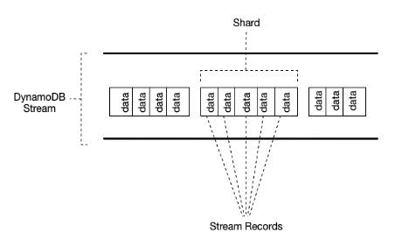
Data Types for Attributes
- Scalar Types – A scalar type can represent exactly one value. The scalar types are number, string, binary, Boolean, and null. Primary keys should be scalar types.
- Document Types – A document type can represent a complex structure with nested attributes—such as you would find in a JSON document. The document types are list and map.

- Set Types – A set type can represent multiple scalar values. The set types are string set, number set, and binary set.
Other Notes:
- When you read data from a DynamoDB table, the response might not reflect the results of a recently completed write operation. The response might include some stale data, but you should eventually have consistent reads.
- When you request a strongly consistent read, DynamoDB returns a response with the most up-to-date data, reflecting the updates from all prior write operations that were successful. A strongly consistent read might not be available if there is a network delay or outage.
- DynamoDB does not support strongly consistent reads across AWS regions
- When you create a table or index in DynamoDB, you must specify your throughput capacity requirements for read and write activity in terms of:
  - One read capacity unit represents one strongly consistent read per second, or two eventually consistent reads per second, for an item up to 4 KB in size. If you need to read an item that is larger than 4 KB, DynamoDB will need to consume additional read capacity units.
  - One write capacity unit represents one write per second for an item up to 1 KB in size. If you need to write an item that is larger than 1 KB, DynamoDB will need to consume additional write capacity units.
- Throttling prevents your application from consuming too many capacity units. DynamoDB can throttle read or write requests that exceed the throughput settings for a table, and can also throttle read requests exceeds for an index.
- When a request is throttled, it fails with an HTTP 400 code (Bad Request) and a ProvisionedThroughputExceededException.
Throughput Management
- Provisioned throughput – manually defined maximum amount of capacity that an application can consume from a table or index. If your application exceeds your provisioned throughput settings, it is subject to request throttling. Free tier eligible.
  - DynamoDB auto scaling
    - Define a range (upper and lower limits) for read and write capacity units, and define a target utilization percentage within that range.
    - A table or a global secondary index can increase its provisioned read and write capacity to handle sudden increases in traffic, without request throttling.
    - DynamoDB auto scaling can decrease the throughput when the workload decreases so that you don’t pay for unused provisioned capacity.
  - Reserved capacity – with reserved capacity, you pay a one-time upfront fee and commit to a minimum usage level over a period of time, for cost-saving solutions.
- Amazon DynamoDB on-demand is a flexible capacity mode for DynamoDB capable of serving thousands of requests per second without capacity planning. When you choose on-demand capacity mode, DynamoDB instantly accommodates your workloads as they ramp up or down to any previously reached traffic level. If a workload’s traffic level hits a new peak, DynamoDB adapts rapidly to accommodate the workload. DynamoDB on-demand offers simple pay-per-request pricing for read and write requests so that you only pay for what you use, making it easy to balance costs and performance.
Capacity Unit Consumption
- CUC for Reads – strongly consistent read request consumes one read capacity unit, while an eventually consistent read request consumes 0.5 of a read capacity unit.
  - GetItem – reads a single item from a table.
  - BatchGetItem – reads up to 100 items, from one or more tables.
  - Query – reads multiple items that have the same partition key value.
  - Scan – reads all of the items in a table
- CUC for Writes
  - PutItem – writes a single item to a table.
  - UpdateItem – modifies a single item in the table.
  - DeleteItem – removes a single item from a table.
  - BatchWriteItem – writes up to 25 items to one or more tables.
  - Calculating the Required Read and Write Capacity Unit for Your DynamoDB table: https://tutorialsdojo.com/calculating-the-required-read-and-write-capacity-unit-for-your-dynamodb-table/
DynamoDB Auto Scaling
- When you use the AWS Management Console to create a new table, DynamoDB auto scaling is enabled for that table by default.
- Uses the AWS Application Auto Scaling service to dynamically adjust provisioned throughput capacity on your behalf, in response to actual traffic patterns.
- You create a scaling policy for a table or a global secondary index. The scaling policy specifies whether you want to scale read capacity or write capacity (or both), and the minimum and maximum provisioned capacity unit settings for the table or index. The scaling policy also contains a target utilization, which is the percentage of consumed provisioned throughput at a point in time.
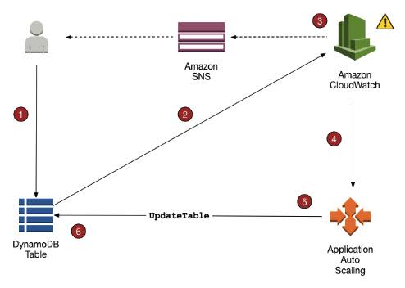

- DynamoDB auto scaling doesn’t prevent you from manually modifying provisioned throughput settings.
- If you enable DynamoDB auto scaling for a table that has one or more global secondary indexes, AWS highly recommends that you also apply auto scaling uniformly to those indexes.
Tagging
- Tags can help you:
  - Quickly identify a resource based on the tags you’ve assigned to it.
  - See AWS bills broken down by tags.
- Each DynamoDB table can have only one tag with the same key. If you try to add an existing tag (same key), the existing tag value will be updated to the new value.
- Maximum number of tags per resource: 50
DynamoDB Items
- You can use the UpdateItem operation to implement an atomic counter – a numeric attribute that is incremented, unconditionally, without interfering with other write requests.
- DynamoDB optionally supports conditional writes for these operations: PutItem, UpdateItem, DeleteItem. A conditional write will succeed only if the item attributes meet one or more expected conditions.
- Conditional writes can be idempotent if the conditional check is on the same attribute that is being updated. DynamoDB performs a given write request only if certain attribute values in the item match what you expect them to be at the time of the request.
- Expressions
  - To get only a few attributes of an item, use a projection expression.
  - An expression attribute name is a placeholder that you use in an expression, as an alternative to an actual attribute name. An expression attribute name must begin with a #, and be followed by one or more alphanumeric characters.
  - Expression attribute values are substitutes for the actual values that you want to compare — values that you might not know until runtime. An expression attribute value must begin with a :, and be followed by one or more alphanumeric characters.
  - For PutItem, UpdateItem and DeleteItem operations, you can specify a condition expression to determine which items should be modified. If the condition expression evaluates to true, the operation succeeds; otherwise, the operation fails.
  - An update expression specifies how UpdateItem will modify the attributes of an item—for example, setting a scalar value, or removing elements from a list or a map.
Time To Live (TTL)
- Allows you to define when items in a table expire so that they can be automatically deleted from the database.
DynamoDB Queries
- The Query operation finds items based on primary key values. You can query any table or secondary index that has a composite primary key (a partition key and a sort key).
- A key condition expression is a search criteria that determines the items to be read from the table or index.
- You must specify the partition key name and value as an equality condition.
- You can optionally provide a second condition for the sort key. The sort key condition must use one of the following comparison operators: =, <, <=, >, >=, BETWEEN, AND
- A single Query operation can retrieve a maximum of 1 MB of data.
- For further refining of Query results, you can optionally provide a filter expression, to determine which items within the Query results should be returned to you. All of the other results are discarded.
- The Query operation allows you to limit the number of items that it returns in the result by setting the Limit parameter to the maximum number of items that you want.
- DynamoDB paginates the results from Query operations, where Query results are divided into “pages” of data that are 1 MB in size (or less).
- ScannedCount is the number of items that matched the key condition expression, before a filter expression (if present) was applied.
- Count is the number of items that remain, after a filter expression (if present) was applied.
DynamoDB Scans
- A Scan operation reads every item in a table or a secondary index. By default, a Scan operation returns all of the data attributes for every item in the table or index.
- Scan always returns a result set. If no matching items are found, the result set will be empty.
- A single Scan request can retrieve a maximum of 1 MB of data.
- You can optionally provide a filter expression.
- You can limit the number of items that is returned in the result.
- DynamoDB paginates the results from Scan operations.
- ScannedCount is the number of items evaluated, before any ScanFilter is applied.
- Count is the number of items that remain, after a filter expression (if present) was applied.
- A Scan operation performs eventually consistent reads, by default.
- By default, the Scan operation processes data sequentially.
On-Demand Backup and Restore
- You can use IAM to restrict DynamoDB backup and restore actions for some resources.
- All backup and restore actions are captured and recorded in AWS CloudTrail.
- Backups
  - Each time you create an on-demand backup, the entire table data is backed up.
  - All backups and restores in DynamoDB work without consuming any provisioned throughput on the table.
  - DynamoDB backups do not guarantee causal consistency across items; however, the skew between updates in a backup is usually much less than a second.
  - You can restore backups as new DynamoDB tables in other regions.
  - Included in the backup are:
    - Database data
    - Global secondary indexes
    - Local secondary indexes
    - Streams
    - Provisioned read and write capacity
  - While a backup is in progress, you can’t do the following:
    - Pause or cancel the backup operation.
    - Delete the source table of the backup.
    - Disable backups on a table if a backup for that table is in progress.
- Restore
  - You cannot overwrite an existing table during a restore operation.
  - You restore backups to a new table.
  - For tables with even data distribution across your primary keys, the restore time is proportional to the largest single partition by item count and not the overall table size.
  - If your source table contains data with significant skew, the time to restore may increase.
DynamoDB Transactions
- Amazon DynamoDB transactions simplify the developer experience of making coordinated, all-or-nothing changes to multiple items both within and across tables.
- Transactions provide atomicity, consistency, isolation, and durability (ACID) in DynamoDB, helping you to maintain data correctness in your applications.
- You can group multiple Put, Update, Delete, and ConditionCheck actions. You can then submit the actions as a single TransactWriteItems operation that either succeeds or fails as a unit.
- You can group and submit multiple Get actions as a single TransactGetItems operation.
- Amazon DynamoDB supports up to 25 unique items and 4 MB of data per transactional request.
Global Tables
- Global tables provide a solution for deploying a multi-region, multi-master database, without having to build and maintain your own replication solution.
- You specify the AWS regions where you want the table to be available. DynamoDB performs all tasks to create identical tables in these regions, and propagate ongoing data changes to all of them.
- Replica Table (Replica, for short)
  - A single DynamoDB table that functions as a part of a global table.
  - Each replica stores the same set of data items.
  - Any given global table can only have one replica table per region.
  - You can add new or delete replicas from global tables.
- To ensure eventual consistency, DynamoDB global tables use a “last writer wins” reconciliation between concurrent updates, where DynamoDB makes a best effort to determine the last writer.
- If a single AWS region becomes isolated or degraded, your application can redirect to a different region and perform reads and writes against a different replica table. DynamoDB also keeps track of any writes that have been performed, but have not yet been propagated to all of the replica tables.
- Requirements for adding a new replica table
  - The table must have the same partition key as all of the other replicas.
  - The table must have the same write capacity management settings specified.
  - The table must have the same name as all of the other replicas.
  - The table must have DynamoDB Streams enabled, with the stream containing both the new and the old images of the item.
  - None of the replica tables in the global table can contain any data.
- If global secondary indexes are specified, then the following conditions must also be met:
  - The global secondary indexes must have the same name.
  - The global secondary indexes must have the same partition key and sort key (if present).
Amazon DynamoDB Security
- Encryption
  - Encrypts your data at rest using an AWS Key Management Service (AWS KMS) managed encryption key for DynamoDB.
  - Encryption at rest can be enabled only when you are creating a new DynamoDB table.
  - After encryption at rest is enabled, it can’t be disabled.
  - Uses AES-256 encryption.
  - The following are encrypted:
    - DynamoDB base tables
    - Local secondary indexes
    - Global secondary indexes
  - Authentication and Access Control
    - Access to DynamoDB requires credentials.
    - Aside from valid credentials, you also need to have permissions to create or access DynamoDB resources.
    - Types of Identities
      - AWS account root user
      - IAM user
      - IAM role
  - You can create indexes and streams only in the context of an existing DynamoDB table, referred to as subresources.
  - Resources and subresources have unique Amazon Resource Names (ARNs) associated with them.
  - A permissions policy describes who has access to what.
    - Identity-based Policies
      - Attach a permissions policy to a user or a group in your account
      - Attach a permissions policy to a role (grant cross-account permissions)

    - Policy Elements
      - Resource – use an ARN to identify the resource that the policy applies to.
      - Action – use action keywords to identify resource operations that you want to allow or deny.
      - Effect – specify the effect, either allow or deny, when the user requests the specific action.
      - Principal – the user that the policy is attached to is the implicit principal.

  - Web Identity Federation – Customers can sign in to an identity provider and then obtain temporary security credentials from AWS Security Token Service (AWS STS).
Amazon DynamoDB Monitoring
- Automated tools:
  - Amazon CloudWatch Alarms – Watch a single metric over a time period that you specify, and perform one or more actions based on the value of the metric relative to a given threshold over a number of time periods.
  - Amazon CloudWatch Logs – Monitor, store, and access your log files from AWS CloudTrail or other sources.
  - Amazon CloudWatch Events – Match events and route them to one or more target functions or streams to make changes, capture state information, and take corrective action.
  - AWS CloudTrail Log Monitoring – Share log files between accounts, monitor CloudTrail log files in real time by sending them to CloudWatch Logs, write log processing applications in Java, and validate that your log files have not changed after delivery by CloudTrail.
- Using the information collected by CloudTrail, you can determine the request that was made to DynamoDB, the IP address from which the request was made, who made the request, when it was made, and additional details.
DynamoDB Accelerator (DAX)
- DAX is a fully managed, highly available, in-memory cache for DynamoDB.
- DynamoDB Accelerator (DAX) delivers microsecond response times for accessing eventually consistent data.
- It requires only minimal functional changes to use DAX with an existing application since it is API-compatible with DynamoDB.
- For read-heavy or bursty workloads, DAX provides increased throughput and potential cost savings by reducing the need to overprovision read capacity units.
- DAX lets you scale on-demand.
- DAX is fully managed. You no longer need to do hardware or software provisioning, setup and configuration, software patching, operating a reliable, distributed cache cluster, or replicating data over multiple instances as you scale.
- DAX is not recommended if you need strongly consistent reads.
- DAX is useful for read-intensive workloads, but not write-intensive ones.
- DAX supports server-side encryption as well as encryption in transit.
- Use Cases
  - Applications that require the fastest possible response time for reads.
  - Applications that read a small number of items more frequently than others. For example, limited-time on-sale items in an ecommerce store.
  - Applications that are read-intensive, but are also cost-sensitive. Offload read activity to a DAX cluster and reduce the number of read capacity units that you need to purchase for your DynamoDB tables.
  - Applications that require repeated reads against a large set of data. This will avoid eating up all your DynamoDB resources which are needed by other applications.
- To achieve high availability for your application, provision your DAX cluster with at least three nodes, then place the nodes in multiple Availability Zones within a Region.
- There are two options available for scaling a DAX cluster:
  - Horizontal scaling, where you add read replicas to the cluster. A single DAX cluster supports up to 10 read replicas, and you can add or remove replicas while the cluster is running.
  - Vertical scaling, where you select different node types. Larger nodes enable the cluster to store more data in memory, reducing cache misses and improving overall application performance. You can’t modify the node types on a running DAX cluster. Instead, you must create a new cluster with the desired node type.
Best Practices
- Know the Differences Between Relational Data Design and NoSQL
Relational database systems (RDBMS) | NoSQL database
In RDBMS, data can be queried flexibly, but queries are relatively expensive and don’t scale well in high-traffic situations. | In a NoSQL database such as DynamoDB, data can be queried efficiently in a limited number of ways, outside of which queries can be expensive and slow.
In RDBMS, you design for flexibility without worrying about implementation details or performance. Query optimization generally doesn’t affect schema design, but normalization is very important. | In DynamoDB, you design your schema specifically to make the most common and important queries as fast and as inexpensive as possible. Your data structures are tailored to the specific requirements of your business use cases.
For an RDBMS, you can go ahead and create a normalized data model without thinking about access patterns. You can then extend it later when new questions and query requirements arise. You can organize each type of data into its own table. | For DynamoDB, by contrast, you shouldn’t start designing your schema until you know the questions it will need to answer. Understanding the business problems and the application use cases up front is essential.  You should maintain as few tables as possible in a DynamoDB application. Most well designed applications require only one table.
It is important to understand three fundamental properties of your application’s access patterns:
- Data size: Knowing how much data will be stored and requested at one time will help determine the most effective way to partition the data.
- Data shape: Instead of reshaping data when a query is processed, a NoSQL database organizes data so that its shape in the database corresponds with what will be queried.
- Data velocity: DynamoDB scales by increasing the number of physical partitions that are available to process queries, and by efficiently distributing data across those partitions. Knowing in advance what the peak query loads might be helps determine how to partition data to best use I/O capacity.

- Design and Use Partition Keys Effectively
  - DynamoDB provides some flexibility in your per-partition throughput provisioning by providing burst capacity.
  - To better accommodate uneven access patterns, DynamoDB adaptive capacity enables your application to continue reading and writing to ‘hot’ partitions without being throttled, by automatically increasing throughput capacity for partitions that receive more traffic.
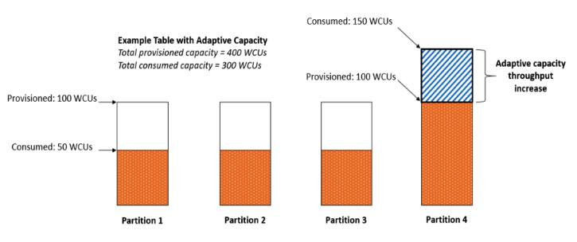


  - Amazon DynamoDB now applies adaptive capacity in real time in response to changing application traffic patterns, which helps you maintain uninterrupted performance indefinitely, even for imbalanced workloads. In addition, instant adaptive capacity helps you provision read and write throughput more efficiently instead of overprovisioning to accommodate uneven data access patterns. Instant adaptive capacity is on by default at no additional cost for all DynamoDB tables and global secondary indexes.
  - The optimal usage of a table’s provisioned throughput depends not only on the workload patterns of individual items, but also on the partition-key design. In general, you will use your provisioned throughput more efficiently as the ratio of partition key values accessed to the total number of partition key values increases.
  - Structure the primary key elements to avoid one heavily requested partition key value that slows overall performance.
  - Distribute loads more evenly across a partition key space by adding a random number to the end of the partition key values. Then you randomize the writes across the larger space.
  - A randomizing strategy can greatly improve write throughput, but it’s difficult to read a specific item because you don’t know which suffix value was used when writing the item. Instead of using a random number to distribute the items among partitions, use a number that you can calculate based upon something that you want to query on.
  - Distribute write activity efficiently during data upload by using the sort key to load items from each partition key value, keeping more DynamoDB servers busy simultaneously and improving your throughput performance.
- Use Sort Keys to Organize Data
  - Well-designed sort keys gather related information together in one place where it can be queried efficiently.
  - Composite sort keys let you define hierarchical (one-to-many) relationships in your data that you can query at any level of the hierarchy.
- Use indexes efficiently by keeping the number of indexes to a minimum and avoid indexing tables that experience heavy write activity.
- Choose Projections Carefully.
- Optimize Frequent Queries to Avoid Fetches.
- Be Aware of Item-Collection Size Limits When Creating Local Secondary Indexes.
- For Querying and Scanning Data
  - Performance considerations for scans
  - Avoiding sudden spikes in read activity
  - Taking advantage of parallel scans
Amazon DynamoDB Pricing
- DynamoDB charges per GB of disk space that your table consumes. The first 25 GB consumed per month is free.
- DynamoDB charges for Provisioned Throughput —- WCU and RCU, Reserved Capacity and Data Transfer Out.
- You should round up to the nearest KB when estimating how many capacity units to provision.
- There are additional charges for DAX, Global Tables, On-demand Backups (per GB), Continuous backups and point-in-time recovery (per GB), Table Restorations (per GB), and Streams (read request units).
AWS re:Invent – Amazon DynamoDB Deep Dive

Other Amazon DynamoDB-related Cheat Sheets:
- Amazon RDS vs DynamoDB
- DynamoDB Scan vs Query
- AWS Lambda Integration with Amazon DynamoDB Streams
- Calculating the Required Read and Write Capacity Unit for your DynamoDB Table
Note: If you are studying for the AWS Certified Data Engineer Associate exam, we highly recommend that you take our AWS Certified Data Engineer Associate Practice Exams and read our Data Engineer Associate exam study guide.

------------------------------------ ------------------------------------- ------------------------------------------

