- 1. Question
A company launched a website that accepts high-quality photos and turns the photos into a downloadable video montage. The website offers both a free and a premium account, with the premium account guaranteeing faster processing. All requests by both free and premium members go through a single Amazon SQS queue and are then processed by a group of Amazon EC2 instances that generate the videos. The company needs to ensure that premium users, who paid for the service, have higher priority than free members.
How should the company re-design its architecture to address this requirement?
  - For the requests made by premium members, set a higher priority in the SQS queue so it will be processed first compared to the requests made by free members.
  - Create an SQS queue for free members and another one for premium members. Configure your EC2 instances to consume messages from the premium queue first and if it is empty, poll from the free members' SQS queue.
  - Use Amazon Kinesis to process the photos and generate the video montage in real-time.
  - Use Amazon S3 to store and process the photos and then generate the video montage afterward.
Correct
Amazon Simple Queue Service (SQS) is a fully managed message queuing service that enables you to decouple and scale microservices, distributed systems, and serverless applications. SQS eliminates the complexity and overhead associated with managing and operating message-oriented middleware and empowers developers to focus on differentiating work. Using SQS, you can send, store, and receive messages between software components at any volume without losing messages or requiring other services to be available.
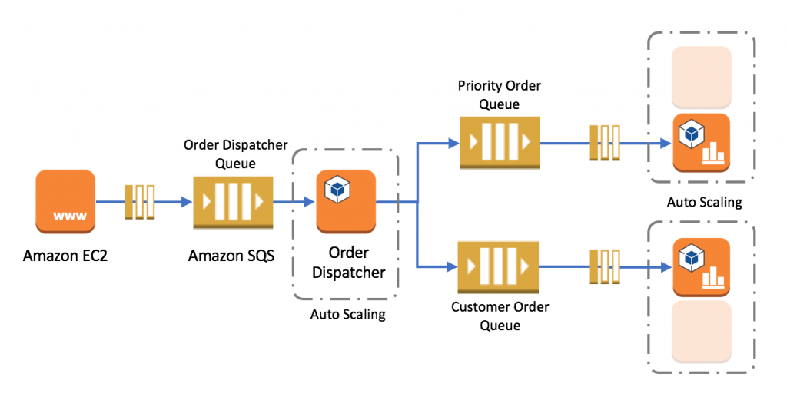
In this scenario, it is best to create 2 separate SQS queues for each type of member. The SQS queues for the premium members can be polled first by the EC2 Instances and once completed, the messages from the free members can be processed next.
Hence, the correct answer is: Create an SQS queue for free members and another one for premium members. Configure your EC2 instances to consume messages from the premium queue first and if it is empty, poll from the free members’ SQS queue.
The option that says: For the requests made by premium members, set a higher priority in the SQS queue so it will be processed first compared to the requests made by free members is incorrect because you cannot only set a priority to individual items in the SQS queue.
The option that says: Using Amazon Kinesis to process the photos and generate the video montage in real time is incorrect because Amazon Kinesis is just used to process streaming data and it is not applicable in this scenario.
The option that says: Using Amazon S3 to store and process the photos and then generating the video montage afterward is incorrect because Amazon S3 is used for durable storage and not for processing data.

References:
https://aws.amazon.com/sqs/
https://docs.aws.amazon.com/AWSSimpleQueueService/latest/SQSDeveloperGuide/sqs-best-practices.html

Check out this Amazon SQS Cheat Sheet:
https://tutorialsdojo.com/amazon-sqs/
- 2. Question A company is running a multi-tier web application farm in a virtual private cloud (VPC) that is not connected to their corporate network. They are connecting to the VPC over the Internet to manage the fleet of Amazon EC2 instances running in both the public and private subnets. The Solutions Architect has added a bastion host with Microsoft Remote Desktop Protocol (RDP) access to the application instance security groups, but the company wants to further limit administrative access to all of the instances in the VPC.
Which of the following bastion host deployment options will meet this requirement?
  - Deploy a Windows Bastion host on the corporate network that has RDP access to all EC2 instances in the VPC.
  - Deploy a Windows Bastion host with an Elastic IP address in the private subnet, and restrict RDP access to the bastion from only the corporate public IP addresses.
  - Deploy a Windows Bastion host with an Elastic IP address in the public subnet and allow SSH access to the bastion from anywhere.
  - Deploy a Windows Bastion host with an Elastic IP address in the public subnet and allow RDP access to bastion only from the corporate IP addresses.
Incorrect
The correct answer is to deploy a Windows Bastion host with an Elastic IP address in the public subnet and allow RDP access to Bastion only from the corporate IP addresses.
A bastion host is a special purpose computer on a network specifically designed and configured to withstand attacks. If you have a bastion host in AWS, it is basically just an EC2 instance. It should be in a public subnet with either a public or Elastic IP address with sufficient RDP or SSH access defined in the security group. Users log on to the bastion host via SSH or RDP and then use that session to manage other hosts in the private subnets.
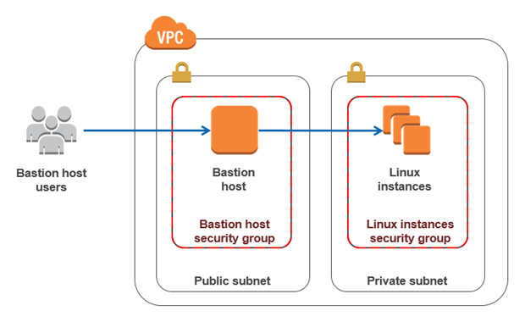
Deploying a Windows Bastion host on the corporate network that has RDP access to all EC2 instances in the VPC is incorrect since you do not deploy the Bastion host to your corporate network. It should be in the public subnet of a VPC.
Deploying a Windows Bastion host with an Elastic IP address in the private subnet and restricting RDP access to the bastion from only the corporate public IP addresses is incorrect since it should be deployed in a public subnet, not a private subnet.
Deploying a Windows Bastion host with an Elastic IP address in the public subnet and allowing SSH access to the bastion from anywhere is incorrect. Since it is a Windows bastion, you should allow RDP access and not SSH as this is mainly used for Linux-based systems.

Reference:
https://docs.aws.amazon.com/quickstart/latest/linux-bastion/architecture.html

Check out this Amazon VPC Cheat Sheet:
https://tutorialsdojo.com/amazon-vpc/
- 3. Question
A company is building an automation tool for generating custom reports on its AWS usage. The company must be able to programmatically access and forecast usage costs on specific services.
Which of the following would meet the requirements with the LEAST amount of operational overhead?
  - Generate AWS Budgets reports for usage cost data and deliver them via Amazon Simple Queue Service (SQS).
  - Configure AWS Budgets to send usage cost data to the company via Amazon SNS.
  - Utilize the downloadable AWS Cost Explorer report .csv files to access the cost-related data. Predict usage costs using AWS Budgets.
  - Use the AWS Cost Explorer API with pagination to programmatically retrieve the usage cost-related data.
Correct
AWS Cost Explorer is a service provided by Amazon Web Services (AWS) that helps you visualize, understand, and analyze your AWS costs and usage. It provides a comprehensive set of tools and features to help you monitor and manage your AWS spending.
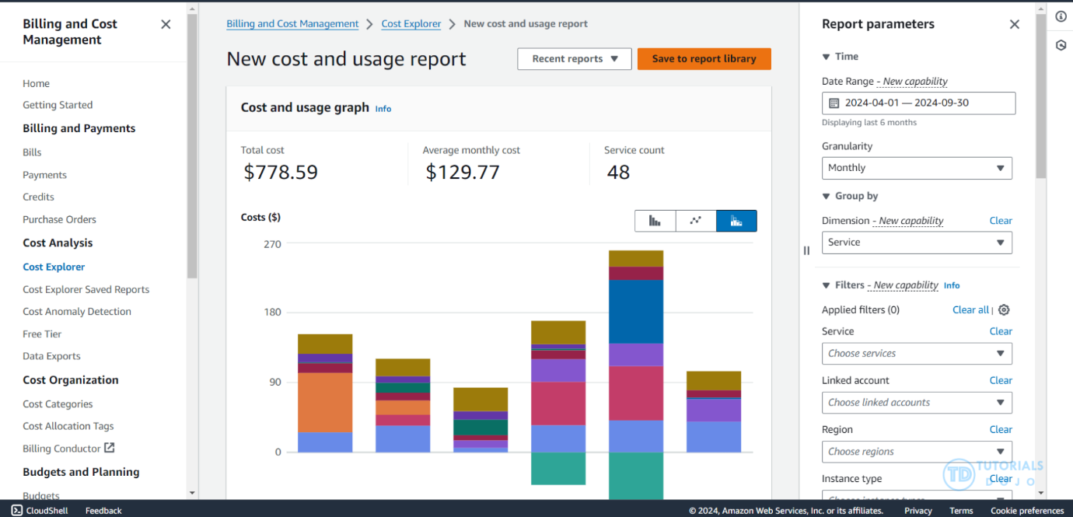
The primary purpose of AWS Cost Explorer is to help you gain insights into your AWS costs and usage patterns over time. It lets you view and analyze your historical spending data, forecast future costs, and identify cost-saving opportunities.
You can programmatically query your cost and usage data via the Cost Explorer API. You can query for aggregated data such as total monthly costs or total daily usage. You can also query for granular data, such as the number of daily write operations for DynamoDB database tables in your production environment.
By using the AWS Cost Explorer API, the company can programmatically access the usage cost-related data they need on specific services. The pagination feature allows for the efficient retrieval of large datasets.
Hence the correct answer is: Use the AWS Cost Explorer API with pagination to programmatically retrieve the usage cost-related data.
The option that says: Utilize the downloadable AWS Cost Explorer report .csv files to access the cost-related data. Predict usage costs using AWS Budgets is incorrect. This option involves the process of manually downloading .csv files, which adds significant operational overhead compared to directly accessing data through the AWS Cost Explorer API. This method simply lacks the ability to programmatically and dynamically retrieve usage data, making it a less efficient solution.
The option that says: Configure AWS Budgets to send usage cost data to the company via Amazon SNS is incorrect because this simply helps you get notified on budget thresholds; it does not provide access to the usage of cost-related data.
The option that says: Generate AWS Budgets reports for usage cost data and deliver them via Amazon Simple Queue Service (SQS) is incorrect. AWS Budgets just allows you to set custom cost and usage budgets that alert you when your budget thresholds are exceeded. It won’t give you detailed information on AWS usage and cost.

References:
https://docs.aws.amazon.com/cost-management/latest/userguide/ce-what-is.html
https://docs.aws.amazon.com/cost-management/latest/userguide/ce-api.html

Check out this AWS Billing and Cost Management Cheat Sheet:
https://tutorialsdojo.com/aws-billing-and-cost-management/
- 4. Question
A company plans to use Route 53 instead of an ELB to load balance the incoming request to the web application. The system is deployed to two EC2 instances to which the traffic needs to be distributed. You want to set a specific percentage of traffic to go to each instance.
Which routing policy would you use?
  - Geolocation
  - Latency
  - Failover
  - Weighted
Correct
Weighted routing lets you associate multiple resources with a single domain name (tutorialsdojo.com) or subdomain name (portal.tutorialsdojo.com) and choose how much traffic is routed to each resource. This can be useful for a variety of purposes including load balancing and testing new versions of software. You can set a specific percentage of how much traffic will be allocated to the resource by specifying the weights.
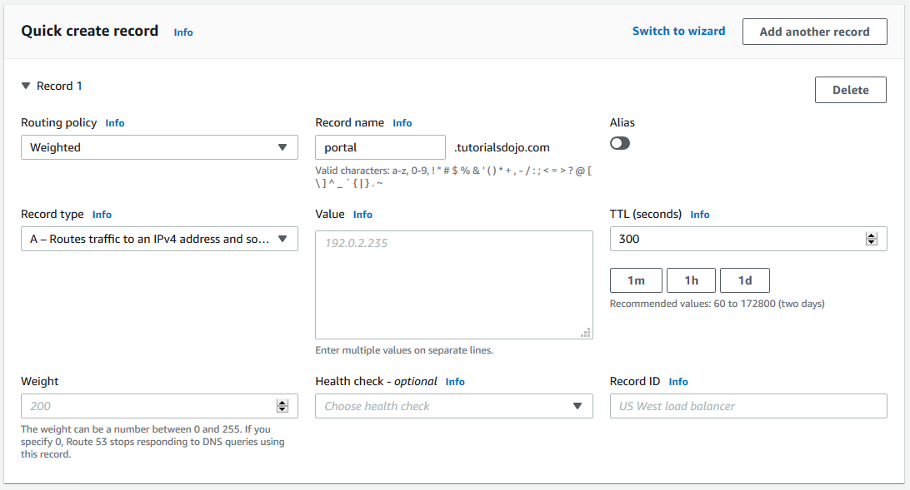
For example, if you want to send a tiny portion of your traffic to one resource and the rest to another resource, you might specify weights of 1 and 255. The resource with a weight of 1 gets 1/256th of the traffic (1/1+255), and the other resource gets 255/256ths (255/1+255).
You can gradually change the balance by changing the weights. If you want to stop sending traffic to a resource, you can change the weight for that record to 0.
Hence, the correct answer is Weighted.
Latency is incorrect because you cannot set a specific percentage of traffic for the 2 EC2 instances with this routing policy. Latency routing policy is primarily used when you have resources in multiple AWS Regions and if you need to automatically route traffic to a specific AWS Region that provides the best latency with less round-trip time.
Failover is incorrect because this type is commonly used if you want to set up an active-passive failover configuration for your web application.
Geolocation is incorrect because this is more suitable for routing traffic based on the location of your users, and not for distributing a specific percentage of traffic to two AWS resources.

Reference:
http://docs.aws.amazon.com/Route53/latest/DeveloperGuide/routing-policy.html
Check out this Amazon Route 53 Cheat Sheet:
https://tutorialsdojo.com/amazon-route-53/
- 5. Question
An online stock trading application stores financial data in an Amazon S3 bucket, with a lifecycle policy that moves older data to Glacier every month. A strict compliance requirement mandates that a surprise audit can occur at any time, and the required data must be retrievable in under 15 minutes under all circumstances. The manager has instructed that retrieval capacity be available when needed and should support up to 150 MB/s of retrieval throughput.
Which of the following will meet the given requirement? (Select TWO.)
  - Use Bulk Retrieval to access the financial data.
  - Use Standard Retrieval for accessing the financial data.
  - Use Expedited Retrieval to access the financial data.
  - Specify a range, or portion, of the financial data archive to retrieve.
  - Purchase provisioned retrieval capacity.
Correct
Expedited retrievals allow you to quickly access your data when occasional urgent requests for a subset of archives are required. For all but the largest archives (250 MB+), data accessed using Expedited retrievals are typically made available within 1–5 minutes. Provisioned Capacity ensures that retrieval capacity for Expedited retrievals is available when you need it.
To make an Expedited, Standard, or Bulk retrieval, set the Tier parameter in the Initiate Job (POST jobs) REST API request to the option you want, or the equivalent in the AWS CLI or AWS SDKs. If you have purchased provisioned capacity, then all expedited retrievals are automatically served through your provisioned capacity.
Provisioned capacity ensures that your retrieval capacity for expedited retrievals is available when you need it. Each unit of capacity provides that at least three expedited retrievals can be performed every five minutes and provides up to 150 MB/s of retrieval throughput. You should purchase provisioned retrieval capacity if your workload requires highly reliable and predictable access to a subset of your data in minutes. Without provisioned capacity Expedited retrievals are accepted, except for rare situations of unusually high demand. However, if you require access to Expedited retrievals under all circumstances, you must purchase provisioned retrieval capacity.
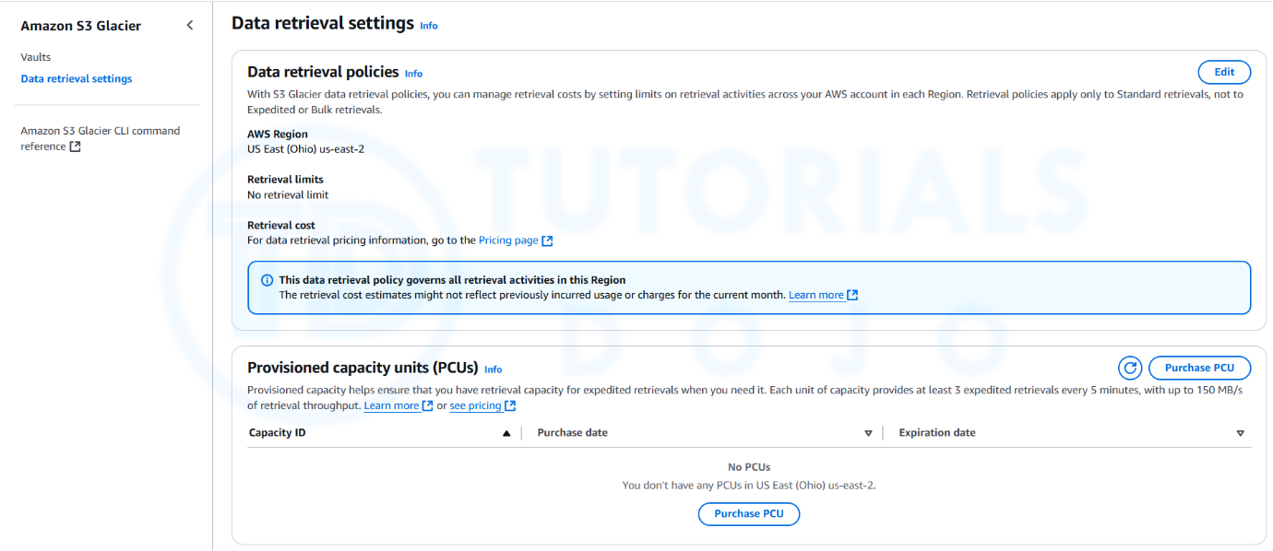
Hence, the correct answers are:
– Use Expedited Retrieval to access the financial data.
– Purchase provisioned retrieval capacity.
The option that says: Use Standard Retrieval for accessing the financial data is incorrect because Standard Retrieval typically takes 3–5 hours, which does not meet the audit’s rapid retrieval time requirement.
The option that says: Use Bulk Retrieval to access the financial data is incorrect because Bulk Retrieval typically complete within 5–12 hours hence, this does not satisfy the requirement of retrieving the data within 15 minutes. The provisioned capacity option is also not compatible with Bulk Retrieval.
The option that says: Specify a range, or portion, of the financial data archive to retrieve is incorrect because using ranged archive retrievals is not enough to meet the requirement of retrieving the whole archive in the given timeframe. In addition, it does not primarily provide additional retrieval capacity which is what the provisioned capacity option can offer.

References:
https://docs.aws.amazon.com/amazonglacier/latest/dev/downloading-an-archive-two-steps.html
https://docs.aws.amazon.com/AmazonS3/latest/userguide/restoring-objects-retrieval-options.html

Check out this Amazon S3 Glacier Cheat Sheet:
https://tutorialsdojo.com/amazon-glacier/
- 6. Question
A medical records company is planning to store sensitive clinical trial data in an Amazon S3 repository with the object-level versioning feature enabled. The Solutions Architect is tasked with ensuring that no object can be overwritten or deleted by any user in a period of one year only. To meet the strict compliance requirements, the root user of the company’s AWS account must also be restricted from making any changes to an object in the S3 bucket.
Which of the following is the most secure way of storing the data in S3?
  - Enable S3 Object Lock in governance mode with a retention period of one year.
  - Enable S3 Object Lock in compliance mode with a retention period of one year.
  - Enable S3 Object Lock in governance mode with a legal hold of one year.
  - Enable S3 Object Lock in compliance mode with a legal hold of one year.
Incorrect
With S3 Object Lock, you can store objects using a write-once-read-many (WORM) model. Object Lock can help prevent objects from being deleted or overwritten for a fixed amount of time or indefinitely. You can use Object Lock to help meet regulatory requirements that require WORM storage or to simply add another layer of protection against object changes and deletion.
Before you lock any objects, you have to enable a bucket to use S3 Object Lock. You enable Object Lock when you create a bucket. After you enable Object Lock on a bucket, you can lock objects in that bucket. When you create a bucket with Object Lock enabled, you can’t disable Object Lock or suspend versioning for that bucket.
S3 Object Lock provides two retention modes:
-Governance mode
-Compliance mode
These retention modes apply different levels of protection to your objects. You can apply either retention mode to any object version that is protected by Object Lock.
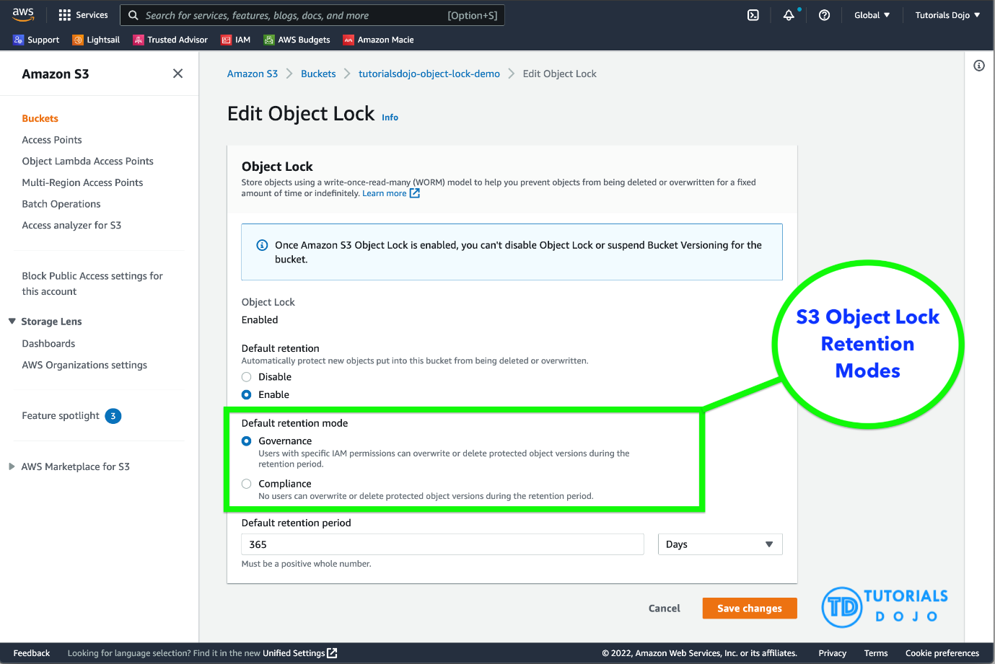
In governance mode, users can’t overwrite or delete an object version or alter its lock settings unless they have special permissions. With governance mode, you protect objects against being deleted by most users, but you can still grant some users permission to alter the retention settings or delete the object if necessary. You can also use governance mode to test retention-period settings before creating a compliance-mode retention period.
In compliance mode, a protected object version can’t be overwritten or deleted by any user, including the root user in your AWS account. When an object is locked in compliance mode, its retention mode can’t be changed, and its retention period can’t be shortened. Compliance mode helps ensure that an object version can’t be overwritten or deleted for the duration of the retention period.
To override or remove governance-mode retention settings, a user must have the s3:BypassGovernanceRetention permission and must explicitly include x-amz-bypass-governance-retention:true as a request header with any request that requires overriding governance mode.
Legal Hold vs. Retention Period
With Object Lock, you can also place a Legal Hold on an object version. Like a retention period, a Legal Hold prevents an object version from being overwritten or deleted. However, a Legal Hold DOESN’T have an associated retention period and remains in effect until removed. Legal Hold can be freely placed and removed by any user who has the s3:PutObjectLegalHold permission.
Legal holds are independent from retention periods. As long as the bucket that contains the object has Object Lock enabled, you can place and remove legal holds regardless of whether the specified object version has a retention period set. Placing a legal hold on an object version doesn’t affect the retention mode or retention period for that object version.
For example, suppose that you place a legal hold on an object version while the object version is also protected by a retention period. If the retention period expires, the object doesn’t lose its WORM protection. Rather, the legal hold continues to protect the object until an authorized user explicitly removes it. Similarly, if you remove a legal hold while an object version has a retention period in effect, the object version remains protected until the retention period expires.
Hence, the correct answer is: Enable S3 Object Lock in compliance mode with a retention period of one year.
The option that says: Enable S3 Object Lock in governance mode with a retention period of one year is incorrect because in the governance mode, users typically can’t overwrite or delete an object version or alter its lock settings unless they have special permissions or if a user has access to the root AWS user account. A better option to choose here is to use the compliance mode.
The option that says: Enable S3 Object Lock in governance mode with a legal hold of one year is incorrect. You cannot set a time period for a legal hold. You can only do this using the “retention period” option. Take note that a legal hold will still restrict users from changing the S3 objects even after the one-year retention period has elapsed. In addition, a governance mode will allow the root user to modify your S3 objects and override any existing settings.
The option that says: Enable S3 Object Lock in compliance mode with a legal hold of one year is incorrect. Although the choice of using the compliance mode is right, you still cannot set a one-year time period for the legal hold option. Keep in mind that the legal hold is independent of the retention period.

References:
https://docs.aws.amazon.com/AmazonS3/latest/userguide/object-lock.html
https://docs.aws.amazon.com/AmazonS3/latest/userguide/object-lock-overview.html

Check out this Amazon S3 Cheat Sheet:
https://tutorialsdojo.com/amazon-s3/
- 7. Question
A company plans to launch an application that tracks the GPS coordinates of delivery trucks in the country. The coordinates are transmitted from each delivery truck every five seconds. The must be able to process coordinates from multiple consumers in real-time. The aggregated data will be analyzed in a separate reporting application.
Which AWS service should you use for this scenario?
  - Amazon Simple Queue Service
  - Amazon AppStream
  - Amazon Elastic MapReduce (EMR)
  - Amazon Kinesis
Correct
Amazon Kinesis makes it easy to collect, process, and analyse real-time, streaming data so you can get timely insights and react quickly to new information. It offers key capabilities to cost-effectively process streaming data at any scale, along with the flexibility to choose the tools that best suit the requirements of your application.
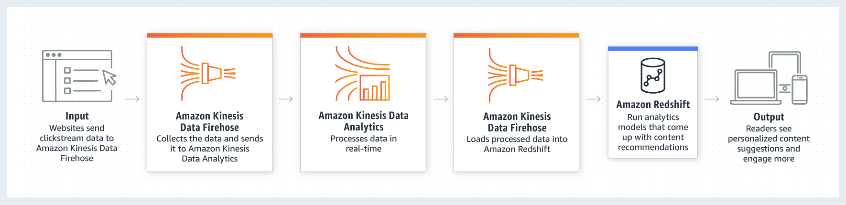
With Amazon Kinesis, you can ingest real-time data such as video, audio, application logs, website clickstreams, and IoT telemetry data for machine learning, analytics, and other applications. Amazon Kinesis enables you to process and analyze data as it arrives and responds instantly instead of having to wait until all your data are collected before the processing can begin.
Hence, the correct answer is: Amazon Kinesis.
The option that says: Amazon Elastic MapReduce (EMR) is incorrect because EMR is primarily used for big data processing, often in batch mode, using frameworks like Hadoop and Spark. It’s great for processing vast amounts of data, but it’s not optimized for real-time streaming data.
The option that says: Amazon AppStream is incorrect because this service is typically used for streaming desktop applications to end users. It’s not designed for handling and processing streams of data.
The option that says: Amazon Simple Queue Service (SQS) is incorrect because SQS is a message queuing service that ensures message delivery between distributed components, but it’s NOT optimized for real-time processing of high-velocity data streams. It’s better suited for tasks that can handle a bit of latency.

References:
https://aws.amazon.com/kinesis/
https://docs.aws.amazon.com/kinesis/

Check out this Amazon Kinesis Cheat Sheet:
https://tutorialsdojo.com/amazon-kinesis/
- 8. Question
A company is building an internal application that serves as a repository for images uploaded by a couple of users. Whenever a user uploads an image, it would be sent to Kinesis Data Streams for processing before it is stored in an S3 bucket. If the upload was successful, the application will return a prompt informing the user that the operation was successful. The entire processing typically takes about 5 minutes to finish.
Which of the following options will allow you to asynchronously process the request to the application from upload request to Kinesis, S3, and return a reply in the most cost-effective manner?
  - Use a combination of Lambda and Step Functions to orchestrate service components and asynchronously process the requests.
  - Use a combination of SNS to buffer the requests and then asynchronously process them using On-Demand EC2 Instances.
  - Use a combination of SQS to queue the requests and then asynchronously process them using On-Demand EC2 Instances.
  - Replace the Kinesis Data Streams with an Amazon SQS queue. Create a Lambda function that will asynchronously process the requests.
Incorrect
AWS Lambda supports the synchronous and asynchronous invocation of a Lambda function. You can control the invocation type only when you invoke a Lambda function. When you use an AWS service as a trigger, the invocation type is predetermined for each service. You have no control over the invocation type that these event sources use when they invoke your Lambda function. Since processing only takes 5 minutes, Lambda is also a cost-effective choice.
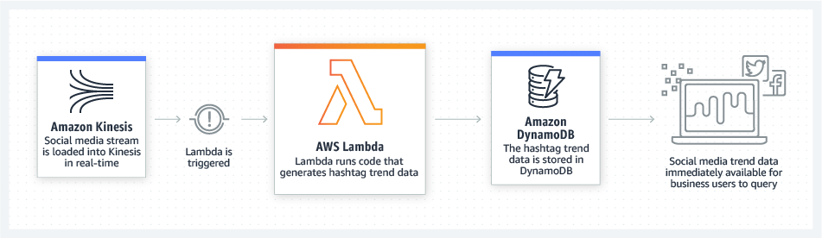
You can use an AWS Lambda function to process messages in an Amazon Simple Queue Service (Amazon SQS) queue. Lambda event source mappings support standard queues and first-in, first-out (FIFO) queues. With Amazon SQS, you can offload tasks from one component of your application by sending them to a queue and processing them asynchronously.
Kinesis Data Streams is a real-time data streaming service that requires the provisioning of shards. Amazon SQS is a cheaper option because you only pay for what you use. Since there is no requirement for real-time processing in the scenario given, replacing Kinesis Data Streams with Amazon SQS would save more costs.
Hence, the correct answer is: Replace the Kinesis stream with an Amazon SQS queue. Create a Lambda function that will asynchronously process the requests.
Using a combination of Lambda and Step Functions to orchestrate service components and asynchronously process the requests is incorrect. The AWS Step Functions service lets you coordinate multiple AWS services into serverless workflows so you can build and update apps quickly. Although this can be a valid solution, it is not cost-effective since the application does not have a lot of components to orchestrate. Lambda functions can effectively meet the requirements in this scenario without using Step Functions. This service is not as cost-effective as Lambda.
Using a combination of SQS to queue the requests and then asynchronously processing them using On-Demand EC2 Instances and Using a combination of SNS to buffer the requests and then asynchronously processing them using On-Demand EC2 Instances are both incorrect as using On-Demand EC2 instances is not cost-effective. It is better to use a Lambda function instead.

References:
https://docs.aws.amazon.com/lambda/latest/dg/welcome.html
https://docs.aws.amazon.com/lambda/latest/dg/lambda-invocation.html
https://aws.amazon.com/blogs/compute/new-aws-lambda-controls-for-stream-processing-and-asynchronous-invocations/

Tutorials Dojo’s AWS Certified Solutions Architect Associate Exam Study Guide:
https://tutorialsdojo.com/aws-certified-solutions-architect-associate/
- 9. Question A merchandising company is planning to enhance its storage capabilities for Amazon EC2 instances by using Amazon FSx for Windows File Server. The company’s EC2 instance in the us-east-2 region has a Server Message Block (SMB) file share mounted as a volume. The company has set a Recovery Time Objective (RTO) of 10 minutes to mitigate the risks associated with disruptions.
Moreover, the company aims to have a backup copy of this file system in the us-west-1 region and must ensure that users cannot delete or alter the data for 5 years to meet compliance and governance standards.
Which of the solutions will fulfil these requirements? (Select TWO.)
  - Configure an AWS FSx for Windows File Server file system in us-east-2 with a Multi-AZ deployment type. Utilize AWS Backup to establish a daily backup plan with a rule replicating the backup to us-west-1.
  - Establish an AWS FSx for Windows File Server file system in us-east-2, and opt for a Multi-AZ deployment type. Configure a Lambda function that sets a daily backup and includes a rule to replicate the backup to us-west-1.
  - Set up AWS Backup Vault Lock in governance mode for a target vault in us-east-2 and configure the minimum retention duration of 5 years.
  - Launch an AWS FSx for Windows File Server file system in us-east-2 with a Single-AZ 2 deployment type. Use AWS Backup to establish a daily backup plan, including a backup rule to copy the backup to us-west-1.
  - Enable Vault Lock in compliance mode for a designated vault in the us-east-2 region on AWS Backup. Configure the data retention period to be a minimum of 5 years.
Incorrect
AWS FSx for Windows File Server is a fully managed service that offers highly reliable and scalable file storage accessible over the industry-standard Server Message Block (SMB) protocol. It is built on Windows Server and has rich features, including Multi-AZ deployments for high availability, automated backups, and integration with other AWS services. Multi-AZ deployments enhance resilience by automatically copying data across multiple-AZ within a region, which helps achieve higher uptime and data durability. However, while this service excels in availability and integration within the AWS ecosystem, it requires complementary solutions to meet stringent RPO objectives and cross-region disaster recovery requirements.
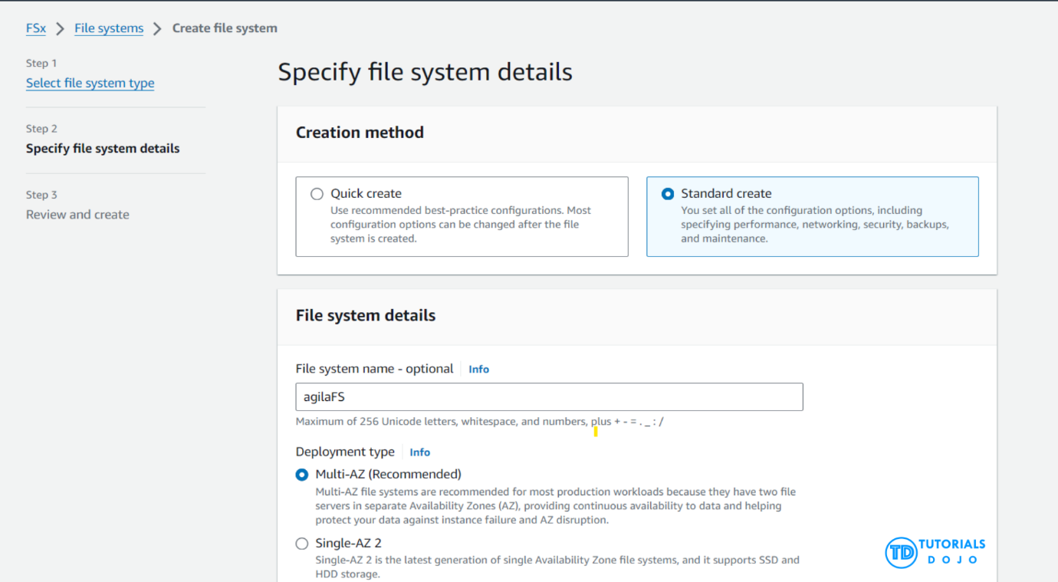
AWS Backup provides a centralized solution for automating and managing backups across AWS services. It simplifies the creation, migration, restoration, and deletion of backups, ensuring that data across various AWS services is consistently protected according to user-defined policies. Within AWS Backup, Vault Lock is a feature that allows users to enforce compliance and governance by locking down backup vaults. This prevents the deletion of backups for a specified period, which can be set up for decades. When configured in compliance mode, Vault Lock provides an immutable policy that ensures backups cannot be altered or deleted, meeting stringent regulatory requirements for data retention. This feature is crucial for organizations that must adhere to compliance standards mandating specific retention periods for their data.
Hence, the correct answers are:
– Configure an AWS FSx for Windows File Server file system in us-east-2 with a Multi-AZ deployment type. Utilize AWS Backup to establish a daily backup plan with a rule replicating the backup to us-west-1.
– Enable Vault Lock in compliance mode for a designated vault in the us-east-2 region on AWS Backup. Configure the data retention period to be a minimum of 5 years.
The option that says: Set up AWS Backup Vault Lock in governance mode for a target vault in us-east-2 and configure the minimum retention duration of 5 years is incorrect. While it can meet the retention policy, governance mode allows privileged users to potentially modify or remove backups after setting them up, provided they have the necessary permissions, which could pose a risk if data immutability is a regulatory or compliance requirement.
The option that says: Launch an AWS FSx for Windows File Server file system in us-east-2 with a Single-AZ 2 deployment type. Use AWS Backup to establish a daily backup plan, including a backup rule to copy the backup to us-west-1 is incorrect. Single-AZ deployment does not offer the same level of fault tolerance or availability as a Multi-AZ deployment. Thus, it can potentially compromise data accessibility in the event of failure. Furthermore, a daily backup schedule does not meet the strict RPO of 10 minutes, risking significant data loss between backup intervals in case of a disaster.
The option that says: Establish an AWS FSx for Windows File Server file system in us-east-2, and opt for a Multi-AZ deployment type. Configure a Lambda function that sets a daily backup and includes a rule to replicate the backup to us-west-1 is incorrect. Using AWS Lambda to automate backups introduces extra complexity and only complicates the setup compared to using standard tools like AWS Backup that is recommended backup and restore solution for EFS file systems.
References:
https://docs.aws.amazon.com/aws-backup/latest/devguide/vault-lock.html
https://docs.aws.amazon.com/fsx/latest/WindowsGuide/using-backups.html
Check out these Amazon FSx and AWS Backup Cheat Sheets:
https://tutorialsdojo.com/amazon-fsx/
https://tutorialsdojo.com/aws-backup/
- 10. Question A company has moved its suite of internal tools to AWS. For audit compliance, several CloudTrail trails are made to record all API calls. Each log file is also protected with server-side encryption with AWS KMS keys (SSE-KMS). Despite this, the company wants to ensure it can identify whether a log file has been tampered with.
Which security measure should the solutions architect employ?
  - Enable the CloudTrail Log File Validation feature on all trails.
  - Enable CloudTrail Insights events.
  - Use the CloudTrail Processing Library when doing audit compliance.
  - Configure CloudWatch Logs to monitor all trails and use Amazon SNS to send notifications when a log file has been tampered with.
Incorrect
To determine whether a log file was modified, deleted, or unchanged after CloudTrail delivered it, you can use CloudTrail log file integrity validation. This feature is built using industry-standard algorithms: SHA-256 for hashing and SHA-256 with RSA for digital signing. This makes it computationally infeasible to modify, delete or forge CloudTrail log files without detection. You can use the AWS CLI to validate the files in the location where CloudTrail delivered them.
Validated log files are invaluable in security and forensic investigations. For example, a validated log file enables you to assert positively that the log file itself has not changed, or that particular user credentials performed specific API activity. The CloudTrail log file integrity validation process also lets you know if a log file has been deleted or changed, or assert positively that no log files were delivered to your account during a given period of time.
When you enable log file integrity validation, CloudTrail creates a hash for every log file that it delivers. Every hour, CloudTrail also creates and delivers a file that references the log files for the last hour and contains a hash of each. This file is called a digest file. CloudTrail signs each digest file using the private key of a public and private key pair. After delivery, you can use the public key to validate the digest file. CloudTrail uses different key pairs for each AWS region.
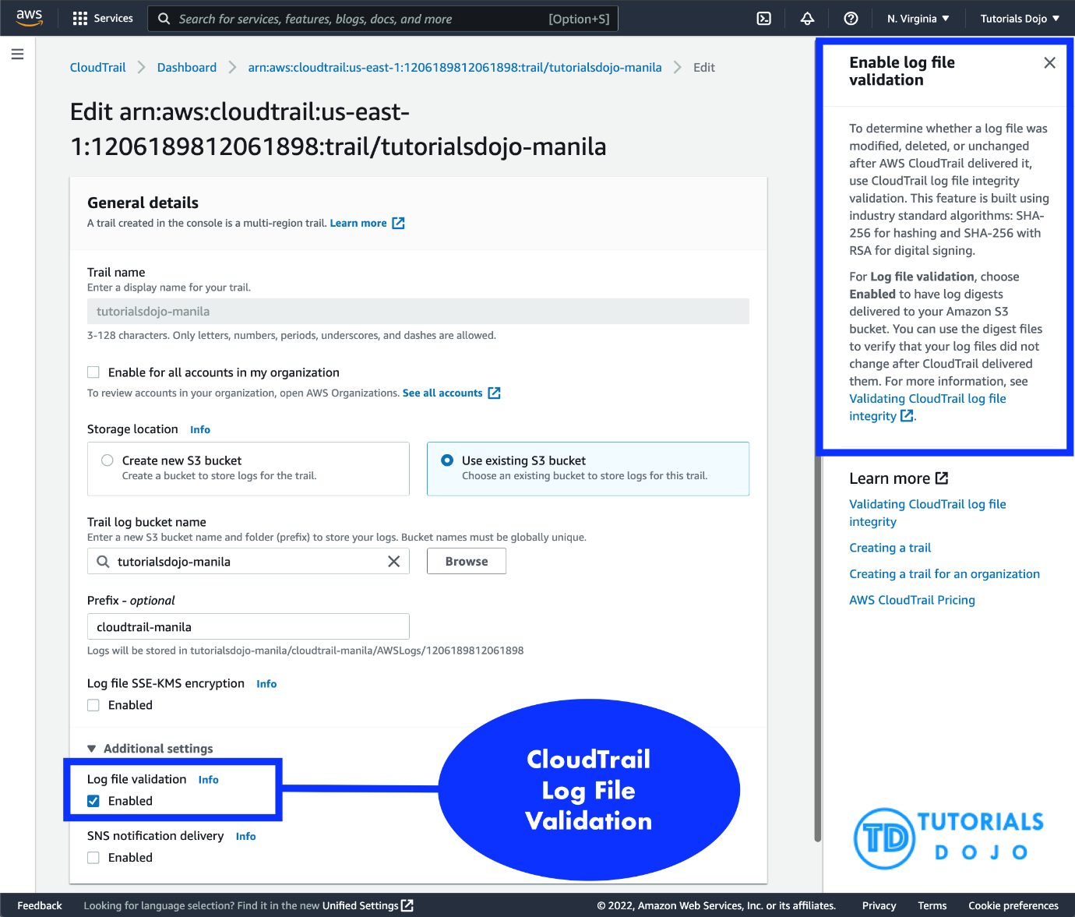
The digest files are delivered to the same Amazon S3 bucket associated with your trail as your CloudTrail log files. If your log files are delivered from all regions or from multiple accounts into a single Amazon S3 bucket, CloudTrail will deliver the digest files from those regions and accounts into the same bucket.
The digest files are put into a folder separate from the log files. This separation of digest files and log files enables you to enforce granular security policies and permits existing log processing solutions to continue to operate without modification. Each digest file also contains the digital signature of the previous digest file if one exists. The signature for the current digest file is in the metadata properties of the digest file Amazon S3 object.
Hence, the correct answer is: Enable the CloudTrail Log File Validation feature on all trails.
The option that says: Use the CloudTrail Processing Library when doing audit compliance is incorrect. The CloudTrail Processing Library is just a Java library that simplifies the processing of CloudTrail logs. It’s not capable of detecting log tampering.
The option that says: Configure CloudWatch Logs to monitor all trails and use Amazon SNS to send notifications when a log file has been tampered with is incorrect. Enabling CloudWatch Logs will simply record the same event data as the logs that CloudTrail sends on Amazon S3. It cannot identify whether a log has been tampered with.
The option that says: Enable CloudTrail Insights events is incorrect. CloudTrail Insights Events is just an optional feature that allows you to detect unusual write API activities in your account.

References:
https://docs.aws.amazon.com/awscloudtrail/latest/userguide/cloudtrail-log-file-validation-intro.html
https://aws.amazon.com/blogs/aws/aws-cloudtrail-update-sse-kms-encryption-log-file-integrity-verification/

Check out this AWS CloudTrail Cheat Sheet:
https://tutorialsdojo.com/aws-cloudtrail/
- 11. Question A manufacturing company has EC2 instances running in AWS. The EC2 instances are configured with Auto Scaling. There are a lot of requests being lost because of too much load on the servers. The Auto Scaling is launching new EC2 instances to take the load accordingly yet, there are still some requests that are being lost.
Which of the following is the MOST suitable solution that you should implement to avoid losing recently submitted requests?
  - Use an Amazon SQS queue to decouple the application components and scale-out the EC2 instances based upon the ApproximateNumberOfMessages metric in Amazon CloudWatch.
  - Use larger instances for your application with an attached Elastic Fabric Adapter (EFA).
  - Replace the Auto Scaling group with a cluster placement group to achieve a low-latency network performance necessary for tightly-coupled node-to-node communication.
  - Set up Amazon Aurora Serverless for on-demand, auto-scaling configuration of your EC2 Instances and also enable Amazon Aurora Parallel Query feature for faster analytical queries over your current data.
Incorrect
Amazon Simple Queue Service (SQS) is a fully managed message queuing service that makes it easy to decouple and scale microservices, distributed systems, and serverless applications. Building applications from individual components that each perform a discrete function improves scalability and reliability and is best practice design for modern applications. SQS makes it simple and cost-effective to decouple and coordinate the components of a cloud application. Using SQS, you can send, store, and receive messages between software components at any volume without losing messages or requiring other services to be always available.
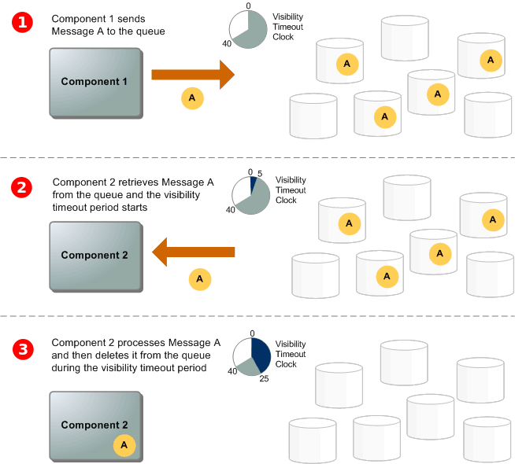
The number of messages in your Amazon SQS queue does not solely define the number of instances needed. In fact, the number of instances in the fleet can be driven by multiple factors, including how long it takes to process a message and the acceptable amount of latency (queue delay).
The solution is to use a backlog per instance metric with the target value being the acceptable backlog per instance to maintain. You can calculate these numbers as follows:
Backlog per instance: To determine your backlog per instance, start with the Amazon SQS metric ApproximateNumberOfMessages to determine the length of the SQS queue (number of messages available for retrieval from the queue). Divide that number by the fleet’s running capacity, which for an Auto Scaling group is the number of instances in the InService state, to get the backlog per instance.
Acceptable backlog per instance: To determine your target value, first calculate what your application can accept in terms of latency. Then, take the acceptable latency value and divide it by the average time that an EC2 instance takes to process a message.
To illustrate with an example, let’s say that the current ApproximateNumberOfMessages is 1500 and the fleet’s running capacity is 10. If the average processing time is 0.1 seconds for each message and the longest acceptable latency is 10 seconds then the acceptable backlog per instance is 10 / 0.1, which equals 100. This means that 100 is the target value for your target tracking policy. Because the backlog per instance is currently at 150 (1500 / 10), your fleet scales out by five instances to maintain proportion to the target value.
Hence, the correct answer is: Use an Amazon SQS queue to decouple the application components and scale-out the EC2 instances based upon the ApproximateNumberOfMessages metric in Amazon CloudWatch.
Replacing the Auto Scaling group with a cluster placement group to achieve a low-latency network performance necessary for tightly-coupled node-to-node communication is incorrect. Although it is true that a cluster placement group allows you to achieve a low-latency network performance, you still need to use Auto Scaling for your architecture to add more EC2 instances.
Using larger instances for your application with an attached Elastic Fabric Adapter (EFA) is incorrect because using a larger EC2 instance would not prevent data from being lost in case of a larger spike. You can take advantage of the durability and elasticity of SQS to keep the messages available for consumption by your instances. Elastic Fabric Adapter (EFA) is simply a network interface for Amazon EC2 instances that enables customers to run applications requiring high levels of inter-node communications at scale on AWS.
Setting up Amazon Aurora Serverless for on-demand, auto-scaling configuration of your EC2 Instances and also enabling Amazon Aurora Parallel Query feature for faster analytical queries over your current data is incorrect. Although the Amazon Aurora Parallel Query feature provides faster analytical queries over your current data, Amazon Aurora Serverless is an on-demand, auto-scaling configuration for your database, and NOT for your EC2 instances. This is actually an auto-scaling configuration for your Amazon Aurora database and not for your compute services.
References:
https://aws.amazon.com/sqs/
https://docs.aws.amazon.com/AWSSimpleQueueService/latest/SQSDeveloperGuide/welcome.html
https://docs.aws.amazon.com/autoscaling/ec2/userguide/as-using-sqs-queue.html

Check out this Amazon SQS Cheat Sheet:
https://tutorialsdojo.com/amazon-sqs/
Explanation: Let's break down this scenario and find the most suitable solution.
Analysis of the Situation: The core problem is that despite Auto Scaling launching new EC2 instances, requests are still being lost due to high server load. This indicates that the new instances are not becoming available fast enough to handle the sudden spikes in traffic. The application is likely synchronous, meaning it processes each request in real time, and when the load is too high, it simply can't keep up.

Explanation of Options
a) Use an Amazon SQS queue to decouple the application components and scale-out the EC2 instances based upon the ApproximateNumberOfMessages metric in Amazon CloudWatch.
- Correctness: This is a highly suitable solution.
- Suitability: By introducing an Amazon SQS (Simple Queue Service) queue, you can decouple the request reception from the request processing. When a request comes in, it's immediately placed in the queue instead of being processed directly by the EC2 instances. This ensures that no requests are lost, as they are safely stored in the queue. The Auto Scaling group can then be configured to monitor the ApproximateNumberOfMessages metric in Amazon CloudWatch. This metric will indicate how many messages are waiting in the queue. When the number of messages exceeds a certain threshold, Auto Scaling can proactively launch new EC2 instances to process them. This provides a buffer against sudden traffic spikes and allows the application to scale out gracefully.
b) Use larger instances for your application with an attached Elastic Fabric Adapter (EFA).
- Incorrectness: This is an incorrect solution.
- Suitability: Using larger instances might temporarily handle a higher load, but it doesn't solve the core issue of scaling. If a traffic spike exceeds the capacity of the larger instances, you will still lose requests. An Elastic Fabric Adapter (EFA) is designed for high-performance computing (HPC) and machine learning applications that require low-latency, tightly-coupled node-to-node communication. This is not the use case described in the problem and would be an unnecessary and costly solution for handling web requests.
c) Replace the Auto Scaling group with a cluster placement group to achieve a low-latency network performance necessary for tightly-coupled node-to-node communication.
- Incorrectness: This is an incorrect solution.
- Suitability: A cluster placement group is designed to ensure that EC2 instances are launched in a single Availability Zone and are physically close to each other for extremely low-latency network performance. Like the EFA, this is intended for HPC applications. It does not address the problem of lost requests due to high load, nor does it provide a mechanism for scaling in and out based on demand. In fact, replacing an Auto Scaling group with a placement group would remove the key functionality needed to handle traffic spikes.
d) Set up Amazon Aurora Serverless for on-demand, auto-scaling configuration of your EC2 Instances and also enable Amazon Aurora Parallel Query feature for faster analytical queries over your current data.
- Incorrectness: This is an incorrect solution.
- Suitability: Amazon Aurora Serverless is a database service, not a compute service for EC2 instances. While it does provide auto-scaling for the database, it has no direct control over your EC2 instances. The Parallel Query feature is used for running fast analytical queries on data, which is unrelated to the problem of a web application losing recently submitted requests. This option fundamentally misunderstands the services involved and their purposes.

Based on the analysis, the most suitable solution is a) Use an Amazon SQS queue to decouple the application components and scale-out the EC2 instances based upon the ApproximateNumberOfMessages metric in Amazon CloudWatch. This is the standard, cloud-native pattern for handling unpredictable traffic loads without losing data.
- 12. Question A company is deploying a Microsoft SharePoint Server environment on AWS using CloudFormation. The Solutions Architect needs to install and configure the architecture that is composed of Microsoft Active Directory (AD) domain controllers, Microsoft SQL Server 2012, multiple Amazon EC2 instances to host the Microsoft SharePoint Server and many other dependencies. The Architect needs to ensure that the required components are properly running before the stack creation proceeds.
Which of the following should the Architect do to meet this requirement?
  - Configure a UpdatePolicy attribute to the instance in the CloudFormation template. Send a success signal after the applications are installed and configured using the cfn-signal helper script.
  - Configure the UpdateReplacePolicy attribute in the CloudFormation template. Send a success signal after the applications are installed and configured using the cfn-signal helper script.
  - Configure a CreationPolicy attribute to the instance in the CloudFormation template. Send a success signal after the applications are installed and configured using the cfn-signal helper script.
  - Configure the DependsOn attribute in the CloudFormation template. Send a success signal after the applications are installed and configured using the cfn-init helper script.
You can associate the CreationPolicy attribute with a resource to prevent its status from reaching create complete until AWS CloudFormation receives a specified number of success signals or the timeout period is exceeded. To signal a resource, you can use the cfn-signal helper script or SignalResource API. AWS CloudFormation publishes valid signals to the stack events so that you track the number of signals sent.
The CreationPolicy is invoked only when AWS CloudFormation creates the associated resource. Currently, the only AWS CloudFormation resources that support creation policies are AWS::AutoScaling::AutoScalingGroup, AWS::EC2::Instance, and AWS::CloudFormation::WaitCondition.
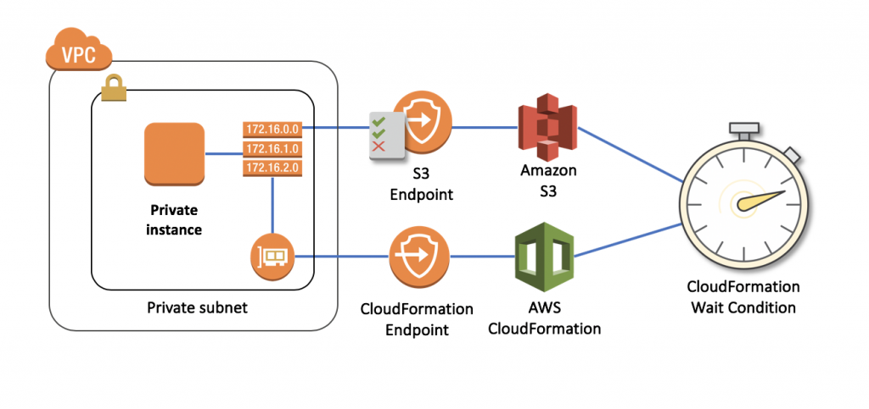
Use the CreationPolicy attribute when you want to wait on resource configuration actions before stack creation proceeds. For example, if you install and configure software applications on an EC2 instance, you might want those applications to be running before proceeding. In such cases, you can add a CreationPolicy attribute to the instance and then send a success signal to the instance after the applications are installed and configured.
Hence, the option that says: Configure a CreationPolicy attribute to the instance in the CloudFormation template. Send a success signal after the applications are installed and configured using the cfn-signal helper script is correct.
The option that says: Configure the DependsOn attribute in the CloudFormation template. Send a success signal after the applications are installed and configured using the cfn-init helper script is incorrect because the cfn-init helper script is not suitable to be used to signal another resource. You have to use cfn-signal instead. And although you can use the DependsOn attribute to ensure the creation of a specific resource follows another, it is still better to use the CreationPolicy attribute instead as it ensures that the applications are properly running before the stack creation proceeds.
The option that says: Configure a UpdatePolicy attribute to the instance in the CloudFormation template. Send a success signal after the applications are installed and configured using the cfn-signal helper script is incorrect because the UpdatePolicy attribute is primarily used for updating resources and for stack update rollback operations.
The option that says: Configure the UpdateReplacePolicy attribute in the CloudFormation template. Send a success signal after the applications are installed and configured using the cfn-signal helper script is incorrect because the UpdateReplacePolicy attribute is primarily used to retain or in some cases, back up the existing physical instance of a resource when it is replaced during a stack update operation.

References:
https://docs.aws.amazon.com/AWSCloudFormation/latest/UserGuide/aws-attribute-creationpolicy.html
https://docs.aws.amazon.com/AWSCloudFormation/latest/UserGuide/deploying.applications.html#deployment-walkthrough-cfn-signal
https://aws.amazon.com/blogs/devops/use-a-creationpolicy-to-wait-for-on-instance-configurations/

Check out this AWS CloudFormation Cheat Sheet:
https://tutorialsdojo.com/aws-cloudformation/
- 13. Question A company is using AWS IAM to manage access to AWS services. The Solutions Architect of the company created the following IAM policy for AWS Lambda:
{
"Version": "2012-10-17",
"Statement": [
{
"Effect": "Allow",
"Action": [
"lambda:CreateFunction",
"lambda:DeleteFunction"
],
"Resource": "*"
},
{
"Effect": "Deny",
"Action": [
"lambda:CreateFunction",
"lambda:DeleteFunction",
"lambda:InvokeFunction",
"lambda:TagResource"
],
"Resource": "*",
"Condition": {
"IpAddress": {
"aws:SourceIp": "187.5.104.11/32"
}
}
}
]
}
Which of the following options is allowed by this policy?
  - Create an AWS Lambda function using the 100.220.0.11/32 address.
  - Delete an AWS Lambda function using the 187.5.104.11/32 address.
  - Delete an AWS Lambda function from any network address.
  - Create an AWS Lambda function using the 187.5.104.11/32 address.
Correct
You manage access in AWS by creating policies and attaching them to IAM identities (users, groups of users, or roles) or AWS resources. A policy is an object in AWS that, when associated with an identity or resource, defines their permissions. AWS evaluates these policies when an IAM principal (user or role) makes a request. Permissions in the policies determine whether the request is allowed or denied. Most policies are stored in AWS as JSON documents.
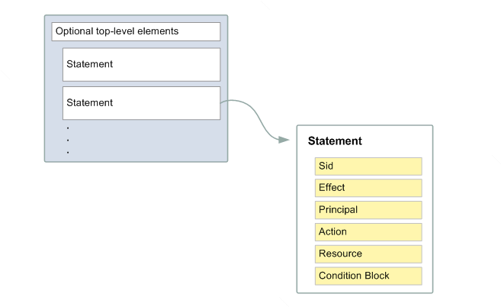
You can use AWS Identity and Access Management (IAM) to manage access to the Lambda API and resources like functions and layers. Based on the given IAM policy, you can create and delete a Lambda function from any network address except for the IP address 187.5.104.11/32. Since the IP address 100.220.0.11/32 is not denied in the policy, you can use this address to create a Lambda function.
Hence, the correct answer is: Create an AWS Lambda function using the 100.220.0.11/32 address.
The option that says: Delete an AWS Lambda function using the 187.5.104.11/32 address is incorrect because the source IP used in this option is denied by the IAM policy.
The option that says: Delete an AWS Lambda function from any network address is incorrect. You can’t delete a Lambda function from any network address because the address 187.5.104.11/32 is denied by the policy.
The option that says: Create an AWS Lambda function using the 187.5.104.11/32 address is incorrect. Just like the option above, the IAM policy denied the IP address 187.5.104.11/32.

References:
https://docs.aws.amazon.com/IAM/latest/UserGuide/access_policies.html
https://docs.aws.amazon.com/lambda/latest/dg/lambda-permissions.html

Check out this AWS IAM Cheat Sheet:
https://tutorialsdojo.com/aws-identity-and-access-management-iam/
- 14. Question A Solutions Architect is working for a large global media company with multiple office locations all around the world. The Architect is instructed to build a system to distribute training videos to all employees.
Using Amazon CloudFront, what method would be used to serve content that is stored in Amazon S3 but not publicly accessible from S3 directly?
  - Create an S3 bucket policy that lists the CloudFront distribution ID as the principal and the target bucket as the Amazon Resource Name (ARN).
  - Create an Origin Access Control (OAC) for CloudFront and grant access to the objects in your S3 bucket to that OAC.
  - Create a web ACL in AWS WAF to block any public S3 access and attach it to the CloudFront distribution.
  - Create an Identity and Access Management (IAM) user for CloudFront and grant access to the objects in your S3 bucket to that IAM user.
When you create or update a distribution in CloudFront, you can add an origin access Control (OAC) and automatically update the bucket policy to give the origin access control permission to access your bucket. Alternatively, you can choose to manually change the bucket policy or change ACLs, which control permissions on individual objects in your bucket.
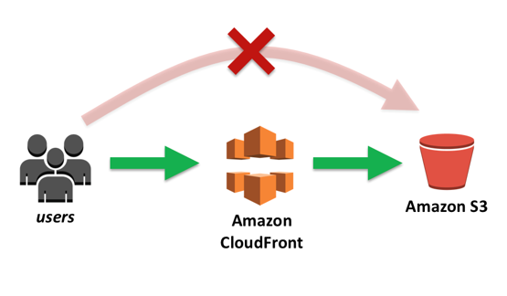
You can update the Amazon S3 bucket policy using either the AWS Management Console or the Amazon S3 API:
– Grant the CloudFront origin access control the applicable permissions on the bucket.
– Deny access to anyone that you don’t want to have access using Amazon S3 URLs.
Hence, the correct answer is: Create an Origin Access Control (OAC) for CloudFront and grant access to the objects in your S3 bucket to that OAC.
The option that says: Create an Identity and Access Management (IAM) user for CloudFront and grant access to the objects in your S3 bucket to that IAM user is incorrect because you CANNOT directly create an IAM User for a specific Amazon CloudFront distribution. You have to use an origin access control (OAC) instead.
The option that says: Create an S3 bucket policy that lists the CloudFront distribution ID as the principal and the target bucket as the Amazon Resource Name (ARN) is incorrect. While you can typically specify AWS accounts, IAM users, and IAM roles as principals in an S3 bucket policy, you CANNOT directly use a CloudFront distribution ID as a principal in an S3 bucket policy. Instead, you MUST define the CloudFront service as the principal and restrict access to your CF distribution using the Condition policy. Therefore, this is not the correct method for the given scenario.
The option that says: Create a web ACL in AWS WAF to block any public S3 access and attach it to the CloudFront distribution is incorrect because AWS WAF is primarily used to protect your applications from common web vulnerabilities and not to ensure exclusive access to CloudFront.

References:
https://docs.aws.amazon.com/AmazonCloudFront/latest/DeveloperGuide/private-content-restricting-access-to-s3.html
https://docs.aws.amazon.com/AmazonCloudFront/latest/DeveloperGuide/SecurityAndPrivateContent.html

Check out this Amazon CloudFront Cheat Sheet:
https://tutorialsdojo.com/amazon-cloudfront/

Comparison of AWS Services Cheat Sheets:
https://tutorialsdojo.com/comparison-of-aws-services/
- 15. Question A company hosts its web application on a set of Amazon EC2 instances in an Auto Scaling group behind an Application Load Balancer (ALB). The application has an embedded NoSQL database. As the application receives more traffic, the application becomes overloaded mainly due to database requests. The management wants to ensure that the database is eventually consistent and highly available.
Which of the following options can meet the company requirements with the least operational overhead?
  - Configure the Auto Scaling group to spread the Amazon EC2 instances across three Availability Zones. Use the AWS Database Migration Service (DMS) with a replication server and an ongoing replication task to migrate the embedded NoSQL database to Amazon DynamoDB
  - Change the ALB with a Network Load Balancer (NLB) to handle more traffic. Use the AWS Migration Service (DMS) to migrate the embedded NoSQL database to Amazon DynamoDB.
  - Configure the Auto Scaling group to spread the Amazon EC2 instances across three Availability Zones. Configure replication of the NoSQL database on the set of Amazon EC2 instances to spread the database load.
  - Change the ALB with a Network Load Balancer (NLB) to handle more traffic and integrate AWS Global Accelerator to ensure high availability. Configure replication of the NoSQL database on the set of Amazon EC2 instances to spread the database load.
Incorrect
AWS Database Migration Service (AWS DMS) is a cloud service that makes it easy to migrate relational databases, data warehouses, NoSQL databases, and other types of data stores. You can use AWS DMS to migrate your data into the AWS Cloud or between combinations of cloud and on-premises setups.
With AWS DMS, you can perform one-time migrations, and you can replicate ongoing changes to keep sources and targets in sync. If you want to migrate to a different database engine, you can use the AWS Schema Conversion Tool (AWS SCT) to translate your database schema to the new platform. You then use AWS DMS to migrate the data. Because AWS DMS is a part of the AWS Cloud, you get the cost efficiency, speed to market, security, and flexibility that AWS services offer.
You can use AWS DMS to migrate data to an Amazon DynamoDB table. Amazon DynamoDB is a fully managed NoSQL database service that provides fast and predictable performance with seamless scalability. AWS DMS supports using a relational database or MongoDB as a source.
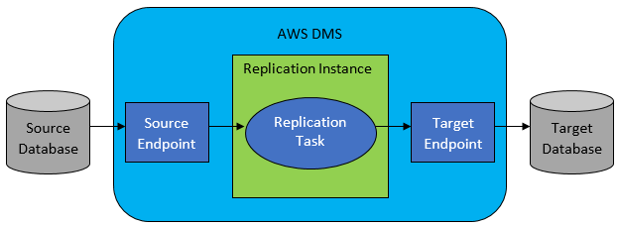
Therefore, the correct answer is: Configure the Auto Scaling group to spread the Amazon EC2 instances across three Availability Zones. Use the AWS Database Migration Service (DMS) with a replication server and an ongoing replication task to to Amazon DynamoDB. Using an Auto Scaling group of EC2 instances and migrating the embedded database to Amazon DynamoDB will ensure that both the application and database are highly available with low operational overhead.
The option that says: Change the ALB with a Network Load Balancer (NLB) to handle more traffic and integrate AWS Global Accelerator to ensure high availability. Configure replication of the NoSQL database on the set of Amazon EC2 instances to spread the database load is incorrect. It is not recommended to run a production system with an embedded database on EC2 instances. A better option is to migrate the database to a managed AWS service such as Amazon DynamoDB, so you won’t have to manually maintain, patch, provision and scale your database yourself. In addition, using an AWS Global Accelerator is not warranted since the architecture is only hosted in a single AWS region and not in multiple regions.
The option that says: Change the ALB with a Network Load Balancer (NLB) to handle more traffic. Use the AWS Migration Service (DMS) to migrate the embedded NoSQL database to Amazon DynamoDB is incorrect. The scenario did not require handling millions of requests per second or very low latency to justify the use of NLB. The ALB should be able to able to scale and handle scaling traffic.
The option that says: Configure the Auto Scaling group to spread the Amazon EC2 instances across three Availability Zones. Configure replication of the NoSQL database on the set of Amazon EC2 instances to spread the database load is incorrect. This may be possible, but it entails an operational overhead of manually configuring the embedded database to replicate and scale with the EC2 instances. It would be better to migrate the database to a managed AWS database service such as Amazon DynamoDB.

References:
https://docs.aws.amazon.com/dms/latest/userguide/CHAP_Target.DynamoDB.html
https://docs.aws.amazon.com/dms/latest/userguide/Welcome.html
https://docs.aws.amazon.com/autoscaling/ec2/userguide/as-add-availability-zone.html

Check out these Amazon DynamoDB and AWS DMS Cheat Sheets:
https://tutorialsdojo.com/amazon-dynamodb/
https://tutorialsdojo.com/aws-database-migration-service/
- 16. Question A food company bought 50 licenses of Windows Server to be used by the developers when launching Amazon EC2 instances to deploy and test applications. The developers are free to provision EC2 instances as long as there is a license available. The licenses are tied to the total CPU count of each virtual machine. The company wants to ensure that developers won’t be able to launch new instances once the licenses are exhausted. The company wants to receive notifications when all licenses are in use.
Which of the following options is the recommended solution to meet the company’s requirements?
  - Define licensing rules on AWS License Manager to track and control license usage. Enable the option to “Enforce license limit” to prevent going over the number of allocated licenses. Add an Amazon SNS topic to send notifications and alerts.
  - Define license configuration rules on AWS Certificate Manager to track and control license usage. Enable the option to “Enforce certificate limit” to prevent going over the number of allocated licenses. Add an Amazon SQS queue with ChangeVisibility Timeout configured to send notifications and alerts.
  - Upload the licenses on AWS Systems Manager Fleet Manager to be encrypted and distributed to Amazon EC2 instances. Attach an IAM role on the EC2 instances to request a license from the Fleet Manager. Set up an Amazon SNS to send notifications and alerts once all licenses are used
  - Configure AWS Resource Access Manager (AWS RAM) to track and control the licenses used by AWS resources. Configure AWS RAM to provide available licenses for Amazon EC2 instances. Set up an Amazon SNS to send notifications and alerts once all licenses are used.
Correct
AWS License Manager is a service that makes it easier for you to manage your software licenses from software vendors (for example, Microsoft, SAP, Oracle, and IBM) centrally across AWS and your on-premises environments. This provides control and visibility into the usage of your licenses, enabling you to limit licensing overages and reduce the risk of non-compliance and misreporting.
As you build out your cloud infrastructure on AWS, you can save costs by using Bring Your Own License model (BYOL) opportunities. That is, you can re-purpose your existing license inventory for use with your cloud resources.
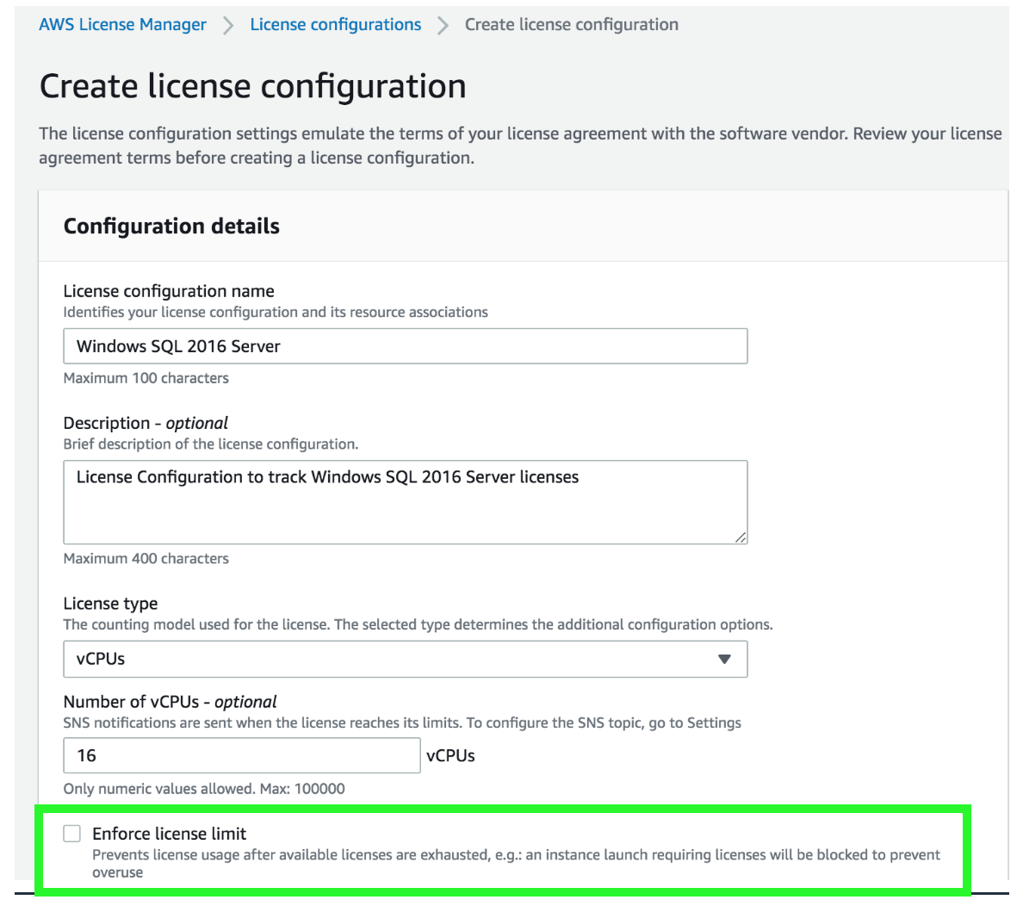
If you are responsible for managing licenses in your organization, you can use License Manager to set up licensing rules, attach them to your launches, and keep track of usage. The users in your organization can then add and remove license-consuming resources without additional work.
License Manager reduces the risk of licensing overages and penalties with inventory tracking that is tied directly into AWS services. License Manager’s built-in dashboards provide ongoing visibility into license usage and assistance with vendor audits.
You can prevent license usage when the available licenses are exhausted by selecting the “Enforce license limit” option in license configuration. When this limit exceeds, the instance launch is blocked to control overages.
Therefore, the correct answer is: Define licensing rules on AWS License Manager to track and control license usage. Enable the option to “Enforce license limit” to prevent going over the number of allocated licenses. Add an Amazon SNS topic to send notifications and alerts. You can use AWS License Manager to set up licensing rules, attach them to your EC2 launches, and keep track of usage.
The option that says: Define license configuration rules on AWS Certificate Manager to track and control license usage. Enable the option to “Enforce certificate limit” to prevent going over the number of allocated licenses. Add an Amazon SQS queue with ChangeVisibility Timeout configured to send notifications and alerts is incorrect. AWS Certificate Manager is used to provision, manage and deploy SSL certificates, NOT software licenses. In addition, you should use Amazon SNS for notification and not an Amazon SQS queue.
The option that says: Upload the licenses on AWS Systems Manager Fleet Manager to be encrypted and distributed to Amazon EC2 instances. Attach an IAM role on the EC2 instances to request a license from the Fleet Manager. Set up an Amazon SNS to send notifications and alerts once all licenses are used is incorrect. The Fleet Manager is just one of the many capabilities of the AWS Systems Manager that provides a unified user interface (UI) experience in remotely managing your nodes/EC2 instances running on AWS or on-premises. This service is not capable of managing the software licenses of your EC2 instances.
The option that says: Configure AWS Resource Access Manager (AWS RAM) to track and control the licenses used by AWS resources. Configure AWS RAM to provide available licenses for Amazon EC2 instances. Set up an Amazon SNS to send notifications and alerts once all licenses are used is incorrect. AWS RAM is used securely share your resources across AWS accounts in your AWS organization and NOT for tracking or controlling software licenses.

References:
https://docs.aws.amazon.com/license-manager/latest/userguide/license-manager.html
https://docs.aws.amazon.com/license-manager/latest/userguide/license-manager-overview.html
https://aws.amazon.com/blogs/mt/mechanisms-to-govern-license-usage-with-aws-license-manager/

Check out this AWS License Manager Cheat Sheet:
https://tutorialsdojo.com/aws-license-manager/
- 17. Question A company has a requirement to move an 80 TB data warehouse to the cloud. It would take 2 months to transfer the data based on the current bandwidth allocation.
Which option is the most cost-effective for quick data upload to AWS?
  - AWS DataSync
  - AWS Direct Connect
  - Amazon S3 Multipart Upload
  - AWS Snowball Edge
Correct
AWS Snowball Edge is a type of Snowball device with on-board storage and compute power for select AWS capabilities. Snowball Edge can undertake local processing and edge-computing workloads in addition to transferring data between your local environment and the AWS Cloud.
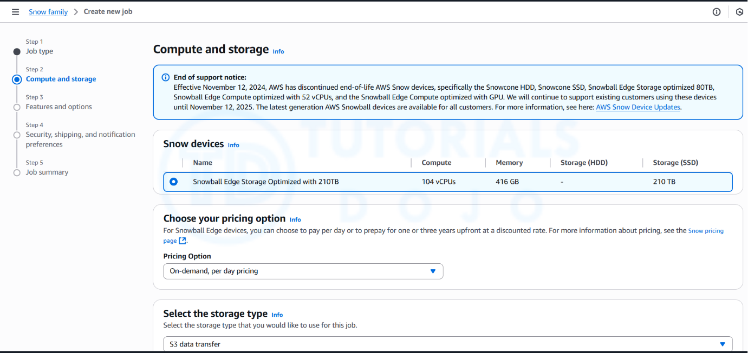
Each Snowball Edge device can transport data at speeds faster than the internet. This transport is done by shipping the data in the appliances through a regional carrier. The appliances are rugged shipping containers, complete with E Ink shipping labels. The AWS Snowball Edge device differs from the standard Snowball because it can bring the power of the AWS Cloud to your on-premises location, with local storage and compute functionality.
Hence, the correct answer is: AWS Snowball Edge.
AWS DataSync is incorrect because it still relies on network bandwidth, which is the limiting factor in this scenario. Since the company’s current bandwidth would take two months to transfer 80 TB, DataSync does not significantly improve the speed of transfer.
AWS Direct Connect is incorrect because it is primarily used to establish a dedicated network connection from your premises network to AWS. This is not suitable for one-time data transfer tasks, like what is depicted in the scenario.
Amazon S3 Multipart Upload is incorrect because this feature simply enables you to upload large objects in multiple parts. It still uses the same Internet connection of the company, which means that the transfer will still take time due to its current bandwidth allocation.

References:
https://docs.aws.amazon.com/snowball/latest/ug/whatissnowball.html
https://docs.aws.amazon.com/snowball/latest/ug/device-differences.html

Check out this AWS Snowball Edge Cheat Sheet:
https://tutorialsdojo.com/aws-snowball-edge/
- 18. Question A company has a web-based ticketing service that utilizes Amazon SQS and a fleet of EC2 instances. The EC2 instances that consume messages from the SQS queue are configured to poll the queue as often as possible to keep end-to-end throughput as high as possible. The Solutions Architect noticed that polling the queue in tight loops is using unnecessary CPU cycles, resulting in increased operational costs due to empty responses.
In this scenario, what should the Solutions Architect do to make the system more cost-effective?
  - Configure Amazon SQS to use short polling by setting the ReceiveMessageWaitTimeSeconds to zero.
  - Configure Amazon SQS to use short polling by setting the ReceiveMessageWaitTimeSeconds to a number greater than zero.
  - Configure Amazon SQS to use long polling by setting the ReceiveMessageWaitTimeSeconds to a number greater than zero.
  - Configure Amazon SQS to use long polling by setting the ReceiveMessageWaitTimeSeconds to zero.
Incorrect
In this scenario, the application is deployed in a fleet of EC2 instances that are polling messages from a single SQS queue. Amazon SQS uses short polling by default, querying only a subset of the servers (based on a weighted random distribution) to determine whether any messages are available for inclusion in the response. Short polling works for scenarios that require higher throughput. However, you can also configure the queue to use Long polling instead, to reduce cost.
The ReceiveMessageWaitTimeSeconds is the queue attribute that determines whether you are using Short or Long polling. By default, its value is zero which means it is using Short polling. If it is set to a value greater than zero, then it is Long polling.
Hence, configuring Amazon SQS to use long polling by setting the ReceiveMessageWaitTimeSeconds to a number greater than zero is the correct answer.
Quick facts about SQS Long Polling:
– Long polling helps reduce your cost of using Amazon SQS by reducing the number of empty responses when there are no messages available to return in reply to a ReceiveMessage request sent to an Amazon SQS queue and eliminating false empty responses when messages are available in the queue but aren’t included in the response.
– Long polling reduces the number of empty responses by allowing Amazon SQS to wait until a message is available in the queue before sending a response. Unless the connection times out, the response to the ReceiveMessage request contains at least one of the available messages, up to the maximum number of messages specified in the ReceiveMessage action.
– Long polling eliminates false empty responses by querying all (rather than a limited number) of the servers. Long polling returns messages as soon any message becomes available.

Reference:
https://docs.aws.amazon.com/AWSSimpleQueueService/latest/SQSDeveloperGuide/sqs-long-polling.html

Check out this Amazon SQS Cheat Sheet:
https://tutorialsdojo.com/amazon-sqs/
- 19. Question A government entity is conducting a population and housing census in the city. Each household information uploaded on their online portal is stored in encrypted files in Amazon S3. The government assigned its Solutions Architect to set compliance policies that verify data containing personally identifiable information (PII) in a manner that meets their compliance standards. They should also be alerted if there are potential policy violations with the privacy of their S3 buckets.
Which of the following should the Architect implement to satisfy this requirement?
  - Set up and configure Amazon Macie to monitor their Amazon S3 data.
  - Set up and configure Amazon Fraud Detector to send out alert notifications whenever a security violation is detected on their Amazon S3 data.
  - Set up and configure Amazon Kendra to monitor malicious activity on their Amazon S3 data
  - Set up and configure Amazon Polly to scan for usage patterns on Amazon S3 data
Correct
Amazon Macie is an ML-powered security service that helps you prevent data loss by automatically discovering, classifying, and protecting sensitive data stored in Amazon S3. Amazon Macie uses machine learning to recognize sensitive data such as personally identifiable information (PII) or intellectual property, assigns a business value, and provides visibility into where this data is stored and how it is being used in your organization.
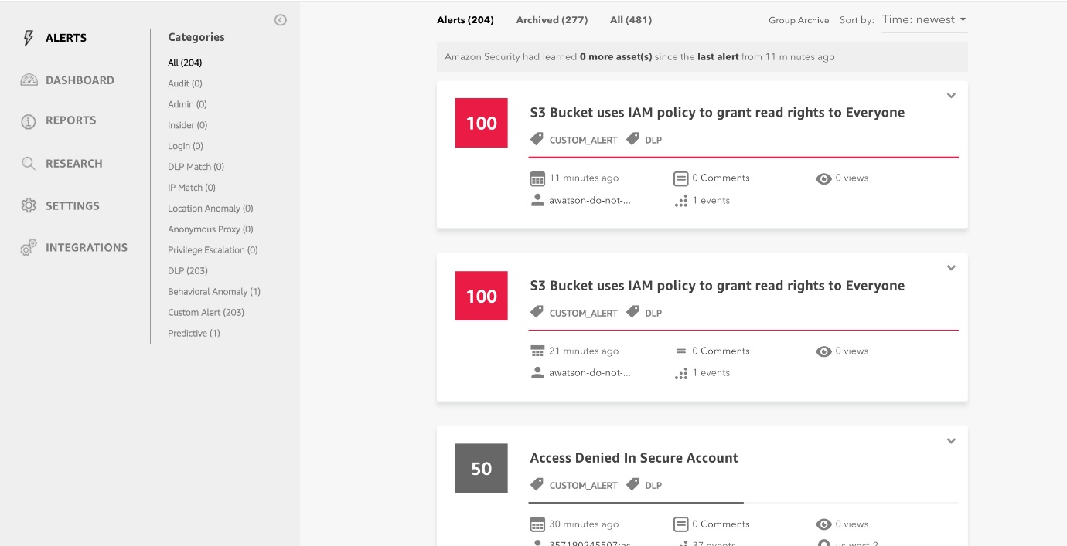
Amazon Macie generates two categories of findings: policy findings and sensitive data findings. A policy finding is a detailed report of a potential policy violation or issue with the security or privacy of an Amazon S3 bucket. Macie generates these findings as part of its ongoing monitoring activities for your Amazon S3 data. A sensitive data finding is a detailed report of sensitive data in an S3 object. Macie generates these findings when it discovers sensitive data in S3 objects that you configure a sensitive data discovery job to analyze.
Hence, the correct answer is: Set up and configure Amazon Macie to monitor their Amazon S3 data.
The option that says: Set up and configure Amazon Polly to scan for usage patterns on Amazon S3 data is incorrect because Amazon Polly is simply a service that turns text into lifelike speech, allowing you to create applications that talk, and build entirely new categories of speech-enabled products. Polly can’t be used to scan usage patterns on your S3 data.
The option that says: Set up and configure Amazon Kendra to monitor malicious activity on their Amazon S3 data is incorrect Amazon Kendra is just an enterprise search service that allows developers to add search capabilities to their applications. This enables their end users to discover information stored within the vast amount of content spread across their company, but not monitor malcious activity on their S3 buckets.
The option that says: Set up and configure Amazon Fraud Detector to send out alert notifications whenever a security violation is detected on their Amazon S3 data is incorrect because the Amazon Fraud Detector is only a fully managed service for identifying potentially fraudulent activities and for catching more online fraud faster. It does not check any S3 data containing personally identifiable information (PII), unlike Amazon Macie.

References:
https://docs.aws.amazon.com/macie/latest/userguide/what-is-macie.html
https://aws.amazon.com/macie/faq/
https://docs.aws.amazon.com/macie/index.html

Check out this Amazon Macie Cheat Sheet:
https://tutorialsdojo.com/amazon-macie/
- 20. Question A manufacturing company is building an IoT-based system to detect faults in its production process in real-time. The system will feed sensor data to an Amazon API Gateway REST API, where the data will be analyzed for any anomalies or faults.
The result of the data processing will then determine the necessary remedial action to be taken. It’s critical that the data is processed in the sequence in which it was sent.
Which of the following is the most operationally efficient solution?
  - Store incoming data in Amazon S3 and trigger an AWS Lambda function to process the data via S3 Event Notification
  - Utilize an API Gateway integration to send incoming data to an Amazon Kinesis Data Stream. Attach an AWS Lambda function to the Kinesis stream to process the data.
  - Store incoming data in a standard Amazon SQS queue and configure an AWS Lambda function to process the data as it arrives in the queue.
  - Implement an API Gateway authorizer to ensure that the data stream is processed in real-time and in order of arrival.
Incorrect
Amazon API Gateway is an AWS service for creating, publishing, maintaining, monitoring, and securing REST, HTTP, and WebSocket APIs at any scale. API developers can create APIs that access AWS or other web services, as well as data stored in the AWS Cloud.
You can use an AWS Lambda function to process records in an Amazon Kinesis data stream. A Kinesis data stream is a set of shards. Each shard contains a sequence of data records. A consumer is an application that processes the data from a Kinesis data stream. You can map a Lambda function to a shared-throughput consumer (standard iterator), or to a dedicated-throughput consumer with enhanced fan-out.
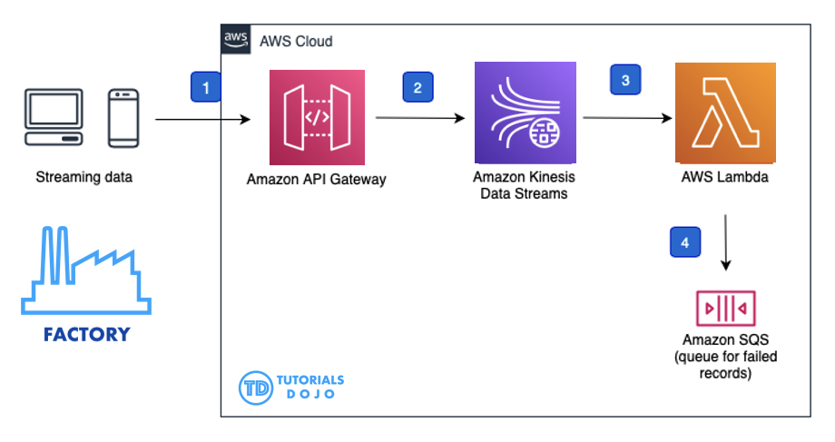
In this scenario, three services are required to implement this solution. First, an API Gateway integration is needed to send incoming data to an Amazon Kinesis Data Stream. This data stream serves as a durable and scalable storage solution for streaming data, preserving its exact sequence of arrival. An AWS Lambda function is used to read and process data from the Kinesis data stream.
Hence, the correct answer in this scenario is: Utilize an API Gateway integration to send incoming data to an Amazon Kinesis Data Stream. Attach an AWS Lambda function to the Kinesis stream to process the data.
The option that says: Implement an API Gateway authorizer to ensure that the data stream is processed in real-time and in order of arrival is incorrect because an API Gateway authorizer is NOT designed to ensure that data is processed in real-time nor in a specific order. Its primary function is to control access to an API by validating incoming requests.
The option that says: Store incoming data in Amazon S3 and trigger an AWS Lambda function to process the data via S3 Event Notification is incorrect because the order of data stored in Amazon S3 is not guaranteed. This can lead to inconsistent processing of data, which can negatively impact the manufacturing process. In addition, the use of Amazon S3 event notification is not a real-time solution. You have to use the Amazon Kinesis data stream instead for this particular scenario.
The option that says: Store incoming data in a standard Amazon SQS queue and configure an AWS Lambda function to process the data as it arrives in the queue is incorrect because a standard SQS queue will not guarantee the order in which the data is processed. Additionally, the use of an SQS queue may introduce delays in processing incoming data, which could be problematic for a real-time monitoring system.

References:
https://docs.aws.amazon.com/apigateway/latest/developerguide/integrating-api-with-aws-services-kinesis.html#api-gateway-create-api-as-kinesis-proxy
https://docs.aws.amazon.com/lambda/latest/dg/with-kinesis.html#services-kinesis-configure

Check out this Amazon API Gateway Cheat Sheet:
https://tutorialsdojo.com/amazon-api-gateway/
- 21. Question A company receives semi-structured and structured data from different sources, which are eventually stored in their Amazon S3 data lake. The Solutions Architect plans to use big data processing frameworks to analyze these data and access it using various business intelligence tools and standard SQL queries.
Which of the following provides the MOST high-performing solution that fulfils this requirement?
  - Create an Amazon EMR cluster and store the processed data in Amazon Redshift.
  - Create an Amazon EC2 instance and store the processed data in Amazon EBS.
  - Use AWS Glue and store the processed data in Amazon S3.
  - Use Amazon Managed Service for Apache Flink Studio and store the processed data in Amazon DynamoDB.
Correct
Amazon EMR is a managed cluster platform that simplifies running big data frameworks, such as Apache Hadoop and Apache Spark, on AWS to process and analyze vast amounts of data. By using these frameworks and related open-source projects, such as Apache Hive and Apache Pig, you can process data for analytics purposes and business intelligence workloads. Additionally, you can use Amazon EMR to transform and move large amounts of data into and out of other AWS data stores and databases.
Amazon Redshift is the most widely used cloud data warehouse. It makes it fast, simple, and cost-effective to analyze all your data using standard SQL and your existing Business Intelligence (BI) tools. It allows you to run complex analytic queries against terabytes to petabytes of structured and semi-structured data, using sophisticated query optimization, columnar storage on high-performance storage, and massively parallel query execution.
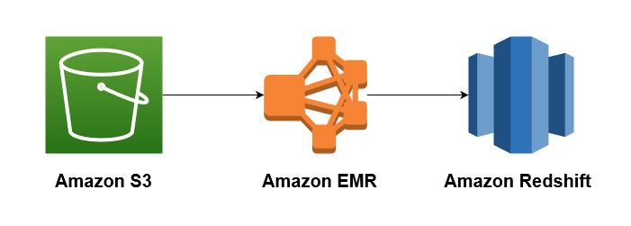
The key phrases in the scenario are “big data processing frameworks” and “various business intelligence tools and standard SQL queries” to analyze the data. To leverage big data processing frameworks, you need to use Amazon EMR. The cluster will perform data transformations (ETL) and load the processed data into Amazon Redshift for analytic and business intelligence applications.
Hence, the correct answer is: Create an Amazon EMR cluster and store the processed data in Amazon Redshift.
The option that says: Use AWS Glue and store the processed data in Amazon S3 is incorrect. While Glue can transform and load data into S3, it lacks the speed and SQL querying power of Amazon Redshift, making it less ideal for large-scale analytical queries and BI integrations. Redshift, in contrast, is purpose-built for fast SQL analytics and complex queries, especially for data lakes.
The option that says: Use Amazon Managed Service for Apache Flink Studio and store the processed data in Amazon DynamoDB is incorrect because Amazon Managed Service for Apache Flink Studio is more suitable for processing streaming data. Additionally, Amazon DynamoDB doesn’t fully support the use of standard SQL and Business Intelligence (BI) tools, unlike Amazon Redshift. It also doesn’t allow you to run complex analytic queries against terabytes to petabytes of structured and semi-structured data.
The option that says: Create an Amazon EC2 instance and store the processed data in Amazon EBS is incorrect because a single EBS-backed EC2 instance is quite limited in its computing capability. Moreover, it also entails an administrative overhead since you have to manually install and maintain the big data frameworks for the EC2 instance yourself. The most suitable solution to leverage big data frameworks is to use EMR clusters.

References:
https://docs.aws.amazon.com/emr/latest/ManagementGuide/emr-what-is-emr.html
https://docs.aws.amazon.com/redshift/latest/dg/loading-data-from-emr.html

Check out this Amazon EMR Cheat Sheet:
https://tutorialsdojo.com/amazon-emr/
- 22. Question A company operates a data lake on Amazon S3, integrating data in Apache Parquet format from various sources. To enhance the data for analysis, the company employs multiple transformation steps. These include filtering anomalies, standardizing date and time formats, and generating analytical aggregates. The transformed data is stored in S3 buckets for access by data analysts.
The company seeks a pre-built, non-coding solution for these data transformations. This solution must include data lineage and profiling features. Additionally, the data transformation steps must be transparent and shareable across the entire organization.
What is the most suitable AWS solution to fulfil these specific needs?
  - Query data using Amazon Athena to execute the data transformation using SQL queries. Facilitate the sharing of these Athena SQL queries among employees.
  - Utilize AWS Glue DataBrew for the data transformation tasks. Make the transformation steps available to employees through the use of DataBrew recipes.
  - Set up Amazon EMR to manage data transformation. Document and share the transformation steps with employees through EMR Studio notebooks.
  - Leverage AWS Glue Studio's visual interface for data transformation. Distribute the transformation process across the organization by utilizing AWS Glue jobs.
Incorrect
AWS Glue DataBrew is essentially a no-code tool that streamlines the process of preparing data for analysis and machine learning. It’s especially valuable for data professionals looking to clean, normalize, and transform their data more efficiently. One of the standout features of DataBrew is its ability to cut down data preparation time by up to 80% compared to traditional manual methods. This efficiency boost not only accelerates the data preparation process but also allows data analysts and scientists to focus more on extracting insights rather than getting stuck in the initial stages of data processing.
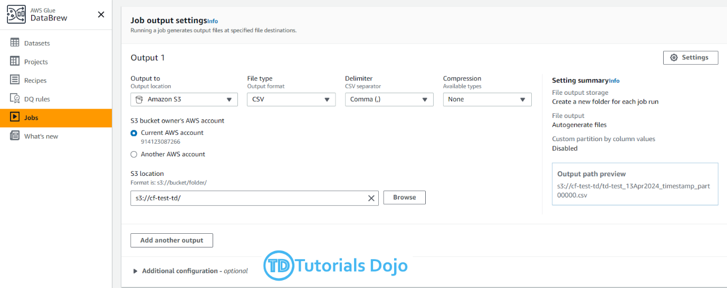
Hence, the correct answer is: Utilize AWS Glue DataBrew for the data transformation tasks. Make the transformation steps available to employees through the use of DataBrew recipes.
The option that says: Leverage AWS Glue Studio’s visual interface for data transformation. Distribute the transformation process across the organization by utilizing AWS Glue jobs is incorrect because it only suggests using AWS Glue Studio’s visual interface for data transformations, which supports non-coding transformations and could be shared via AWS Glue jobs. However, it doesn’t specifically address the requirements for data profiling or data lineage as directly as DataBrew does.
The option that says: Query data using Amazon Athena to execute the data transformation using SQL queries. Facilitate the sharing of these Athena SQL queries among employees is incorrect because Amazon Athena primarily serves as an interactive query service and lacks the built-in, visual data transformation, data lineage, and profiling capabilities that DataBrew offers. Sharing Athena SQL queries does not provide the same level of collaboration or ease of use for non-technical users as DataBrew recipes.
The option that says: Set up Amazon EMR to manage data transformation. Document and share the transformation steps with employees through EMR Studio notebooks is incorrect because this option simply requires technical expertise, which contradicts the scenario’s requirement for a non-coding solution. Additionally, EMR DOES NOT offer built-in data profiling and lineage tracking, which is essential for easy management and transparency, making it less suitable compared to AWS Glue DataBrew, which meets these needs directly.
References:
https://docs.aws.amazon.com/databrew/latest/dg/what-is.html
https://docs.aws.amazon.com/prescriptive-guidance/latest/serverless-etl-aws-glue/databrew.html
Check out this AWS Glue Cheat Sheet:
https://tutorialsdojo.com/aws-glue/#glue-databrew
- 23. Question A company runs a messaging application in the ap-northeast-1 and ap-southeast-2 region. A Solutions Architect needs to create a routing policy wherein a larger portion of traffic from the Philippines and North India will be routed to the resource in the ap-northeast-1 region.
Which Route 53 routing policy should the Solutions Architect use?
  - Geolocation Routing
  - Weighted Routing
  - Geoproximity Routing
  - Latency Routing
Incorrect
Amazon Route 53 is a highly available and scalable Domain Name System (DNS) web service. You can use Route 53 to perform three main functions in any combination: domain registration, DNS routing, and health checking. After you create a hosted zone for your domain, such as example.com, you create records to tell the Domain Name System (DNS) how you want traffic to be routed for that domain.
For example, you might create records that cause DNS to do the following:
– Route Internet traffic for example.com to the IP address of a host in your data center.
– Route email for that domain (jose.rizal@tutorialsdojo.com) to a mail server (mail.tutorialsdojo.com).
– Route traffic for a subdomain called operations.manila.tutorialsdojo.com to the IP address of a different host.
Each record includes the name of a domain or a subdomain, a record type (for example, a record with a type of MX routes email), and other information applicable to the record type (for MX records, the hostname of one or more mail servers and a priority for each server).
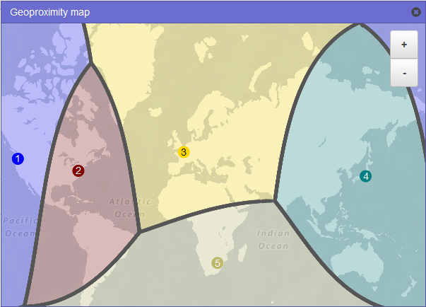
Route 53 has different routing policies that you can choose from. Below are some of the policies:
Latency Routing lets Amazon Route 53 serve user requests from the AWS Region that provides the lowest latency. It does not, however, guarantee that users in the same geographic region will be served from the same location.
Geoproximity Routing lets Amazon Route 53 route traffic to your resources based on the geographic location of your users and your resources. You can also optionally choose to route more traffic or less to a given resource by specifying a value, known as a bias. A bias expands or shrinks the size of the geographic region from which traffic is routed to a resource.
Geolocation Routing lets you choose the resources that serve your traffic based on the geographic location of your users, meaning the location that DNS queries originate from.
Weighted Routing lets you associate multiple resources with a single domain name (tutorialsdojo.com) or subdomain name (subdomain.tutorialsdojo.com) and choose how much traffic is routed to each resource.
In this scenario, the problem requires a routing policy that will let Route 53 route traffic to the resource in the Tokyo region from a larger portion of the Philippines and North India.
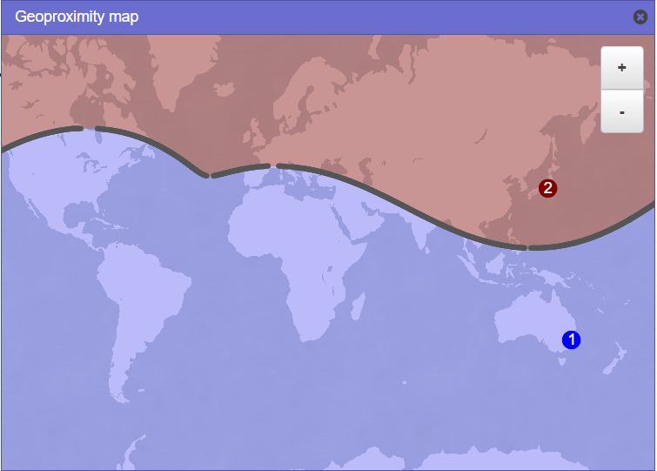
You need to use Geoproximity Routing and specify a bias to control the size of the geographic region from which traffic is routed to your resource. The sample image above uses a bias of -40 in the Tokyo region and a bias of 1 in the Sydney Region. Setting up the bias configuration in this manner would cause Route 53 to route traffic coming from the middle and northern part of the Philippines, as well as the northern part of India to the resource in the Tokyo Region.
Hence, the correct answer is Geoproximity Routing.
Geolocation Routing is incorrect because you cannot control the coverage size from which traffic is routed to your instance in Geolocation Routing. It just lets you choose the instances that will serve traffic based on the location of your users.
Latency Routing is incorrect because it is mainly used for improving performance by letting Route 53 serve user requests from the AWS Region that provides the lowest latency.
Weighted Routing is incorrect because it is used for routing traffic to multiple resources in proportions that you specify. This can be useful for load balancing and testing new versions of software.

References:
https://docs.aws.amazon.com/Route53/latest/DeveloperGuide/routing-policy.html#routing-policy-geoproximity
https://docs.aws.amazon.com/Route53/latest/DeveloperGuide/rrsets-working-with.html

Latency Routing vs. Geoproximity Routing vs. Geolocation Routing:
https://tutorialsdojo.com/latency-routing-vs-geoproximity-routing-vs-geolocation-routing/
- 24. Question A Solutions Architect is designing a highly available relational database solution to mitigate the risk of a multi-region failure. The database must meet a Recovery Point Objective (RPO) of 1 second and a Recovery Time Objective (RTO) of less than 1 minute. The architect needs a disaster recovery plan that enables automatic cross-region replication with minimal data loss and rapid recovery in the event of a failure.
Which AWS feature best fulfils this requirement?
  - Amazon Aurora Global Database
  - Amazon RDS for PostgreSQL with cross-region read replicas
  - Amazon DynamoDB Global table
  - Amazon Timestream for Analytics
Correct
Amazon Aurora Global Database is designed for globally distributed applications, allowing a single Amazon Aurora database to span multiple AWS regions. It replicates your data with no impact on database performance, enables fast local reads with low latency in each region, and provides disaster recovery from region-wide outages.
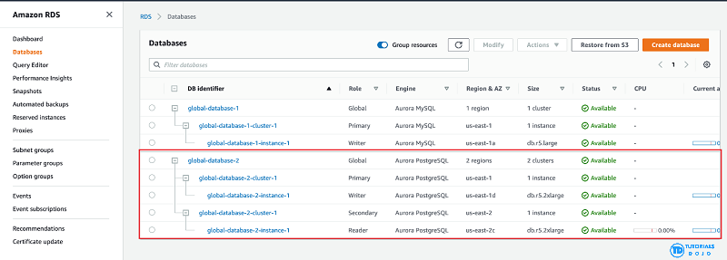
Aurora Global Database supports storage-based replication that has a latency of less than 1 second. If there is an unplanned outage, one of the secondary regions you assigned can be promoted to read and write capabilities in less than 1 minute. This feature is called Cross-Region Disaster Recovery. An RPO of 1 second and an RTO of less than 1 minute provide you a strong foundation for a global business continuity plan.
Hence, the correct answer is: Amazon Aurora Global Database.
The option that says: Amazon DynamoDB Global table is incorrect because while this supports multi-region, fully replicated tables with low latency, it’s more suitable for NoSQL workloads, not relational databases.
The option that says: Amazon RDS for PostgreSQL with cross-region read replicas is incorrect. While this option can help with disaster recovery, it simply doesn’t meet the specified RPO and RTO requirements in the scenario. Replication lag in cross-region read replicas can take several minutes to complete, which could prevent the company from meeting the RPO of 1 second.
The option that says: Amazon Timestream for Analytics is incorrect because it is primarily a serverless time series database service that is commonly used for IoT and operational applications. The most suitable solution for this scenario is to use the Amazon Aurora Global Database since it can provide the required RPO and RTO.

References:
https://aws.amazon.com/rds/aurora/global-database/
https://docs.aws.amazon.com/AmazonRDS/latest/AuroraUserGuide/aurora-global-database.html

Check out this Amazon Aurora Cheat Sheet:
https://tutorialsdojo.com/amazon-aurora/
- 25. Question
A large telecommunications company needs to run analytics against all combined log files from the Application Load Balancer as part of the regulatory requirements.
Which AWS services can be used together to collect logs and then easily perform log analysis?
  - Amazon S3 for storing the ELB log files and an EC2 instance for analyzing the log files using a custom-built application.
  - Amazon S3 for storing ELB log files and Amazon Athena for analyzing the log files.
  - Amazon EC2 with EBS volumes for storing and analyzing the log files.
  - Amazon DynamoDB for storing and EC2 for analyzing the logs.
Correct
Access logging is an optional feature of Elastic Load Balancing that is disabled by default. After you enable access logging for your load balancer, Elastic Load Balancing captures the logs and stores them in the Amazon S3 bucket that you specify as compressed files. You can disable access logging at any time.
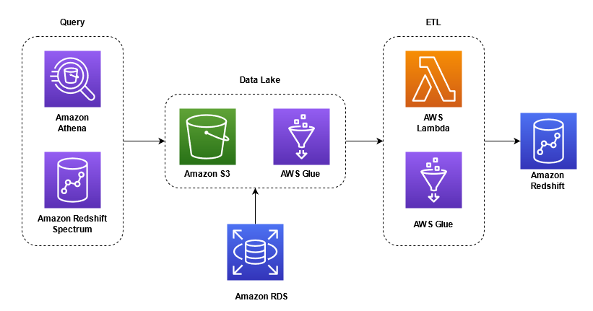
Amazon Athena is an interactive query service that makes it easy to analyze data directly from Amazon S3 using standard SQL. Athena is serverless, so there is no infrastructure to set up or manage and you can start analyzing your data immediately. You don’t even need to load your data into Athena, or have complex ETL processes. Athena works directly with data stored in S3.
In this scenario, it is best to use a combination of Amazon S3 and Amazon Athena: Amazon S3 for storing ELB log files and Amazon Athena for analyzing the log files. Access logging in the ELB is stored in Amazon S3, which means that the following are valid options:
– Amazon S3 for storing the ELB log files and an EC2 instance for analyzing the log files using a custom-built application.
– Amazon S3 for storing ELB log files and Amazon Athena for analyzing the log files.
However, log analysis can be automatically provided by Amazon Athena, which is more economical than building a custom-built log analysis application and hosting it in EC2. Hence, the option that says: Amazon S3 for storing ELB log files and Amazon Athena for analyzing the log files is the best answer between the two.
The option that says: Amazon DynamoDB for storing and EC2 for analyzing the logs is incorrect because DynamoDB is a noSQL database solution of AWS. It would be inefficient to store logs in DynamoDB while using EC2 to analyze them.
The option that says: Amazon EC2 with EBS volumes for storing and analyzing the log files is incorrect because using EC2 with EBS would be costly, and EBS might not provide the most durable storage for your logs, unlike S3.
The option that says: Amazon S3 for storing the ELB log files and an EC2 instance for analyzing the log files using a custom-built application is incorrect because using EC2 to analyze logs would be inefficient and expensive since you will have to program the analyzer yourself.

References:
https://aws.amazon.com/blogs/big-data/analyzing-data-in-s3-using-amazon-athena/
https://docs.aws.amazon.com/athena/latest/ug/application-load-balancer-logs.html
https://docs.aws.amazon.com/elasticloadbalancing/latest/application/load-balancer-access-logs.html

Check out this Amazon Athena Cheat Sheet:
https://tutorialsdojo.com/amazon-athena/

Check out this AWS Elastic Load Balancing (ELB) Cheat Sheet:
https://tutorialsdojo.com/aws-elastic-load-balancing-elb/
- 26. Question A company faces performance degradation due to intermittent traffic spikes in its application. The application is deployed across multiple EC2 instances within an Auto Scaling group and is fronted by a Network Load Balancer (NLB). The operations team found out that HTTP errors are not being detected by the NLB. As a result, clients are continuously routed to unhealthy targets and are never replaced, which impacts the availability of the application.
Which solution could resolve the issue with the least amount of development overhead?
  - Configure the NLB to perform HTTP health checks on the critical paths of the application.
  - Configure CloudFront as a content delivery network (CDN) in front of the NLB to reduce the load on the instances and improve performance.
  - Increase the NLB's idle timeout to allow more time for requests to be processed, reducing the occurrence of intermittent HTTP/s errors.
  - Use an Application Load Balancer (ALB) in place of the NLB. Enable HTTP health checks using the application's path.
Incorrect
Network Load Balancer (NLB) is a highly scalable load-balancing service that AWS provides. It is designed to handle substantial traffic volumes and distribution of incoming connections across healthy targets within one or more target groups, including Amazon EC2 instances, containers, IP addresses, or Lambda functions. NLB operates at the transport layer (Layer 4) and handles TCP, UDP, and TLS traffic.
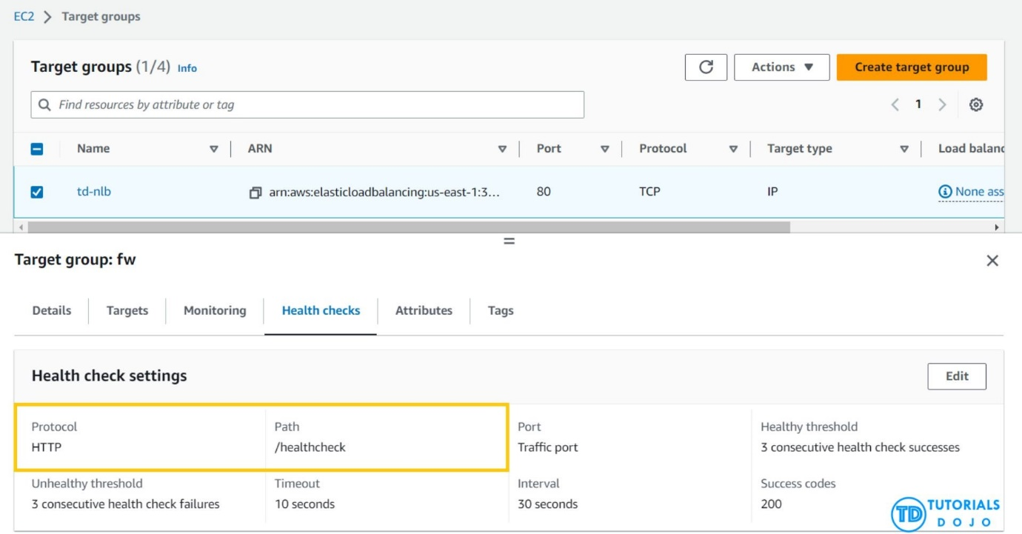
NLBs utilize active and passive health checks to assess a target’s capability to handle requests. These health checks are essential for the NLB component within an Amazon VPC as they regularly confirm the availability and responsiveness of registered targets. Through TCP, UDP, or TLS protocol requests, the health check guarantees that only healthy targets receive traffic. Failing targets are temporarily removed from rotation to maintain optimal performance and availability. Furthermore, NLBs are capable of managing millions of requests per second with ultra-low latencies, effectively handling sudden and volatile traffic patterns for applications with high traffic demands.
Hence, the correct answer is: Configure the NLB by enabling HTTP health checks on critical paths of the application.
The option that says: Use an Application Load Balancer (ALB) in place of the NLB. Enable HTTP health checks using the application’s path is incorrect. Switching from NLB to ALB involves a significant architectural change and could potentially require updating the application code to work with ALB.
The option that says: Increase the NLB’s idle timeout to allow more time for requests to be processed, reducing the occurrence of intermittent HTTP/s errors is incorrect. Increasing the idle timeout can help when long-running requests are being terminated. However, it does not address the issue of automatically detecting and error handling. It may reduce intermittent errors but does not provide a proactive solution to ensure high availability.
The option that says: Configure CloudFront as a content delivery network (CDN) in front of the NLB to reduce the load on the instances and improve performance is incorrect. While it’s true that CloudFront can help reduce the load on instances by caching static content, it does not directly affect the actual processing carried out by the instances. Moreover, simply using CloudFront as a CDN does not actively provide a mechanism for detecting and handling HTTP errors.

References:
https://docs.aws.amazon.com/elasticloadbalancing/latest/network/introduction.html
https://docs.aws.amazon.com/elasticloadbalancing/latest/network/target-group-health-checks.html

Check out this AWS Elastic Load Balancing (ELB) Cheat Sheet:
https://tutorialsdojo.com/aws-cheat-sheet-aws-elastic-load-balancing-elb/
Explanation: This is an interesting problem that a lot of companies face. Let's break down the requirements and the potential solutions to see which one works best.
Key Requirements
Before we get to the solution, let's enlist the key requirements based on the problem description:
- Detect HTTP Errors: The primary issue is that the current setup is not detecting application-level errors (like HTTP 5xx).
- Route Traffic Away from Unhealthy Instances: The system needs to automatically stop routing traffic to instances that are returning HTTP errors.
- Replace Unhealthy Instances: The Auto Scaling group needs to be notified to replace instances that are no longer healthy.
- Minimal Development Overhead: The solution should no t require significant changes to the application code or a complex new deployment process.
- Maintain High Availability: The ultimate goal is to improve the application's availability, especially during traffic spikes.

Solution Analysis
Let's evaluate each of the proposed solutions against these requirements.
- Option A: Configure the NLB to perform HTTP health checks on the critical paths of the application.
  - Explanation: The Network Load Balancer (NLB) operates at layer 4 (the transport layer) of the OSI model. It uses TCP or TLS health checks. It DOES NOT have the capability to inspect the content of a request or response, meaning it CANNOT understand application-level protocols like HTTP. While you can configure an NLB to check if a port is open, it CANNOT check for HTTP status codes (like 500 errors).
- Option B: Configure CloudFront as a content delivery network (CDN) in front of the NLB to reduce the load on the instances and improve performance.
  - Explanation: CloudFront can certainly help improve performance and reduce load by caching content. However, it's a content delivery network, not a load balancer. It won't solve the fundamental problem of routing traffic away from unhealthy application instances that are returning errors. While it might mitigate some issues by reducing the number of requests that hit your EC2 instances, it doesn't address the root cause of the health check failure.
- Option C: Increase the NLB's idle timeout to allow more time for requests to be processed, reducing the occurrence of intermittent HTTP/s errors.
  - Explanation: Increasing the idle timeout would only affect the duration a connection is kept open. It does not address the core issue of a failing application. The problem isn't that the requests are timing out; it's that the application itself is returning errors, and the load balancer is failing to detect this.
- Option D: Use an Application Load Balancer (ALB) in place of the NLB. Enable HTTP health checks using the application's path.
Explanation: The Application Load Balancer (ALB) operates at layer 7 (the application layer) of the OSI model. This means it can inspect the contents of HTTP/S traffic, including HTTP headers and status codes. An ALB is specifically designed to perform these kinds of application-level health checks. By configuring an ALB, you can set a health check to a specific endpoint (e.g., /health) on your application that returns a success code (HTTP 200) when the instance is healthy and an error code (HTTP 5xx) when it's not. This allows the load balancer to correctly identify and de-register unhealthy instances. When an instance is de-registered, the Auto Scaling group will see it as unhealthy and automatically replace it.

- Conclusion Based on our analysis, the best solution is Option D: Use an Application Load Balancer (ALB) in place of the NLB. Enable HTTP health checks using the application's path.
This is because the root of the problem is the inability to perform application-level health checks. The ALB is specifically built for this purpose and will accurately detect when an instance is returning errors. Since the application is already built to handle traffic and simply needs a proper health check mechanism, this solution requires a simple configuration change to the infrastructure (swapping the load balancer) rather than significant application code changes. This resolves the issue with the least amount of development overhead and correctly integrates with the Auto Scaling group to maintain high availability.

- 27. Question A company plans to use a durable storage service to store on-premises database backups to the AWS cloud. To move their backup data, they need to use a service that can store and retrieve objects through standard file storage protocols for quick recovery.
Which of the following options will meet this requirement?
  - Use the AWS Storage Gateway volume gateway to store the backup data and directly access it using Amazon S3 API actions.
  - Use Amazon EBS volumes to store all the backup data and attach it to an Amazon EC2 instance.
  - Use AWS Snowball Edge to directly backup the data in Amazon S3 Glacier.
  - Use the AWS Storage Gateway file gateway to store all the backup data in Amazon S3.
Incorrect
File Gateway presents a file-based interface to Amazon S3, which appears as a network file share. It enables you to store and retrieve Amazon S3 objects through standard file storage protocols. File Gateway allows your existing file-based applications or devices to use secure and durable cloud storage without needing to be modified. With File Gateway, your configured S3 buckets will be available as Network File System (NFS) mount points or Server Message Block (SMB) file shares.
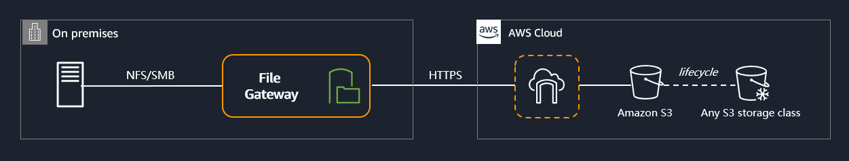
To store the backup data from on-premises to a durable cloud storage service, you can use File Gateway to store and retrieve objects through standard file storage protocols (SMB or NFS). File Gateway enables your existing file-based applications, devices, and workflows to use Amazon S3, without modification. File Gateway securely and durably stores both file contents and metadata as objects while providing your on-premises applications low-latency access to cached data.
Hence, the correct answer is: Use the AWS Storage Gateway file gateway to store all the backup data in Amazon S3.
The option that says: Use the AWS Storage Gateway volume gateway to store the backup data and directly access it using Amazon S3 API actions is incorrect. Although this is a possible solution, you cannot directly access the volume gateway using Amazon S3 APIs. You should use File Gateway to access your data in Amazon S3.
The option that says: Use Amazon EBS volumes to store all the backup data and attached it to an Amazon EC2 instance is incorrect. Take note that in the scenario, you are required to store the backup data in a durable storage service. An Amazon EBS volume is not highly durable like Amazon S3. Also, file storage protocols such as NFS or SMB, are not directly supported by EBS.
The option that says: Use AWS Snowball Edge to directly backup the data in Amazon S3 Glacier is incorrect because AWS Snowball Edge cannot store and retrieve objects through standard file storage protocols. Also, Snowball Edge can’t directly integrate backups to S3 Glacier.

References:
https://aws.amazon.com/storagegateway/faqs/
https://aws.amazon.com/s3/storage-classes/

Check out this AWS Storage Gateway Cheat Sheet:
https://tutorialsdojo.com/aws-storage-gateway/
Storage Gateways:
Hybrid storage on AWS allows you to bridge the gap between your on-premises infrastructure and the AWS Cloud. This is particularly useful for organizations that need to keep some data locally for low-latency access or compliance reasons while still leveraging the scalability, durability, and cost-effectiveness of cloud storage.
Here's an explanation of the three services you mentioned:
AWS Storage Gateway
This service acts as a bridge between your on-premises environment and AWS cloud storage. You install a virtual appliance (or a hardware appliance) in your data center that connects to AWS storage services like Amazon S3, Amazon EBS, and Amazon S3 Glacier. This allows your local applications to access cloud storage seamlessly.
There are three main types of Storage Gateway, each designed for a different use case:
- File Gateway: Provides a file-based interface (NFS and SMB) that allows your local applications to store files in Amazon S3. It uses a local cache for frequently accessed files, ensuring low latency.
- Volume Gateway: Provides block storage (iSCSI protocol) that can be used for on-premises applications. It operates in two modes:
    - Cached volumes: The entire dataset is stored in Amazon S3, with the most frequently accessed data cached locally. This is great for applications that need low-latency access to a small portion of a large dataset.
    - Stored volumes: The entire dataset is stored locally, with a point-in-time backup asynchronously uploaded to Amazon S3 as an Amazon EBS snapshot. This is ideal for disaster recovery.
- Tape Gateway: A virtual tape library (VTL) that can be used to replace physical tape backups. It integrates with your existing backup software and stores your virtual tapes in Amazon S3 Glacier for long-term, low-cost archiving.

AWS DataSync

This is a data transfer service that simplifies, automates, and accelerates moving large amounts of data between your on-premises storage and various AWS storage services, and even between different AWS services. DataSync handles the complexities of data transfer, including scripting copy jobs, scheduling, and monitoring.
Key features of DataSync include:
- Accelerated transfer: It uses a purpose-built protocol to speed up data movement over the internet or AWS Direct Connect.
- Security: Data is encrypted in transit and in the cloud.
- Automation: You can schedule data transfers and use filtering to copy only what you need.
- Validation: It automatically verifies data integrity after the transfer.
You would use DataSync for one-time data migrations, regularly scheduled data replication for backup or disaster recovery, or transferring data to the cloud for in-cloud processing.

AWS TRANSFER FAMILY
This service provides fully managed support for file transfers into and out of Amazon S3 using common protocols like SFTP, FTPS, and FTP. It allows you to seamlessly migrate your file transfer workflows to AWS without changing your existing applications or user authentication.
Unlike DataSync, which is a bulk data migration tool, AWS Transfer Family is designed for business-to-business (B2B) file exchange workflows. For example, if you have partners or customers who need to upload files to your business, you can set up a secure SFTP endpoint that directly connects to an S3 bucket.
Essentially, it's a serverless, scalable, and highly available service for managing file transfers that would traditionally be handled by an on-premises server.
Do you have any questions about a specific service or would you like to explore a particular use case for hybrid storage?
- 28. Question The DevOps Team at Agila Corporation aims to enforce an IAM policy that grants them exclusive permissions to start, stop, and terminate EC2 instances in the us-west-1 region. To maintain strict security measures, any requests originating outside the company’s network range (192.158.1.0/24) should be denied.
Which of the following IAM policies would satisfy these requirements?
{
"Version": "2012-10-17",
"Statement": [
{
"Effect": "Allow",
"Action": [
"ec2:TerminateInstances",
"ec2:StartInstances",
"ec2:StopInstances"
],
"Resource": "*",
"Condition": {
"StringNotEquals": {
"aws:RequestedRegion": "us-west-1"
}
}
},
{
"Effect": "Deny",
"Action": "ec2:*",
"Resource": "*",
"Condition": {
"IpAddress": {
"aws:SourceIp": "192.158.1.0/24"
}
}
}
]
}

{
"Version": "2012-10-17",
"Statement": [
{
"Effect": "Allow",
"Action": [
"ec2:StartInstances",
"ec2:StopInstances",
"ec2:TerminateInstances"
],
"Resource": "*"
}
]
}

{
"Version": "2012-10-17",
"Statement": [
{
"Effect": "Allow",
"Action": [
"ec2:StartInstances",
"ec2:StopInstances",
"ec2:TerminateInstances"
],
"Resource": "*",
"Condition": {
"IpAddress": {
"aws:SourceIp": "192.158.1.0/24"
}
}
},
{
"Effect": "Deny",
"Action": [
"ec2:StartInstances",
"ec2:StopInstances",
"ec2:TerminateInstances"
],
"Resource": "*"
}
]
}

{
"Version": "2012-10-17",
"Statement": [
{
"Effect": "Allow",
"Action": [
"ec2:TerminateInstances",
"ec2:StartInstances",
"ec2:StopInstances"
],
"Resource": "*",
"Condition": {
"StringEquals": {
"aws:RequestedRegion": "us-west-1"
}
}
},
{
"Effect": "Deny",
"Action": "ec2:*",
"Resource": "*",
"Condition": {
"NotIpAddress": {
"aws:SourceIp": "192.158.1.0/24"
}
}
}
]
}
Correct
IAM Policies are essential for controlling access to AWS resources. IAM policies enable you to set fine-grained permissions for AWS account users, groups, or roles. By creating IAM policies, you can control who can access your resources and what actions they can perform. These policies are written in a JSON format and consist of one or more statements. Each statement represents an access control rule that defines the conditions under which specific actions are permitted or denied.
An IAM policy statement includes several key elements:
- -Effect: This element determines whether the statement allows or denies access. The effect can be set to “Allow” or “Deny”, to permit, or prohibit, actions explicitly.
- -Action: The action specifies the specific AWS service actions allowed or denied. Actions are represented by unique names, such as ec2:RunInstances for launching EC2 instances or s3:GetObject for retrieving objects from S3 buckets.
- -Resource: The resource element identifies the AWS resources the actions apply. It uses Amazon Resource Names (ARNs) to specify the specific resources or resource types, such as arn:aws:s3:::my-bucket/* for all objects in an S3 bucket.
- -Condition (optional): Conditions provide additional constraints on when the policy’s effect applies. For example, you can define conditions based on time, IP address, or request parameters to further control access.
IAM policies offer great flexibility in defining access controls. You can create policies granting broad access to AWS services or narrowly restrict access to specific resources. Policies can be attached to individual users, groups, or roles, allowing you to manage permissions at a granular level and follow the principle of least privilege.
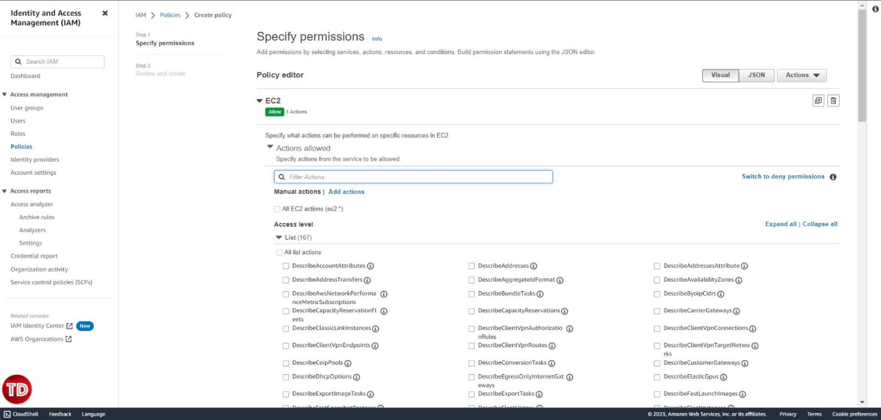
The correct answer is the following IAM Policy. The first statement allows the specified actions on any resource. It includes a condition that checks if the requested region is equal to us-west-1. This ensures that the DevOps team can start, stop, and terminate EC2 instances that are in the us-west-1. region only.
The second statement uses Deny to block all EC2 actions on any resource. It combines this with the NotIpAddress condition, which checks if the source IP address is not within the specified range (192.158.1.0/24). This effectively denies access to requests originating from IP addresses outside the company’s network range.
{
"Version": "2012-10-17",
"Statement": [
{
"Effect": "Allow",
"Action": [
"ec2:TerminateInstances",
"ec2:StartInstances",
"ec2:StopInstances"
],
"Resource": "*",
"Condition": {
"StringEquals": {
"aws:RequestedRegion": "us-west-1"
}
}
},
{
"Effect": "Deny",
"Action": "ec2:*",
"Resource": "*",
"Condition": {
"NotIpAddress": {
"aws:SourceIp": "192.158.1.0/24"
}
}
}
]
}

The IAM Policy below is incorrect. The second statement denies all actions unconditionally without factoring in the source IP address. This leads to all requests being denied, regardless of where they originate, superseding any permissions given in the first statement. This occurs due to the IAM policy’s evaluation order, where Deny statements take precedence over Allow statements.
{
"Version": "2012-10-17",
"Statement": [{
"Effect": "Allow",
"Action": [
"ec2:StartInstances",
"ec2:StopInstances",
"ec2:TerminateInstances"],
"Resource": "*",
"Condition": {
"IpAddress": {
"aws:SourceIp": "192.158.1.0/24"
}
}
}, {
"Effect": "Deny",
"Action": [
"ec2:StartInstances",
"ec2:StopInstances",
"ec2:TerminateInstances"
],
"Resource": "*"
}]
}

The IAM policy below is incorrect because it lacks the necessary restrictions on access based on the source IP address and the requested region. Without these, anyone with appropriate IAM permissions would be able to start, stop, and terminate EC2 instances regardless of their location or network range.
{
"Version": "2012-10-17",
"Statement": [
{
"Effect": "Allow",
"Action": [
"ec2:StartInstances",
"ec2:StopInstances",
"ec2:TerminateInstances"
],
"Resource": "*"
}
]
}
The IAM policy below is incorrect. The first statement uses StringNotEquals condition to check if the requested region is not equal to us-west-1. However, the requirement states that the DevOps team should be able to start, stop, and terminate EC2 instances in the us-west-1 region. Therefore, the condition should be StringEquals to enforce this requirement. Moreover, the second statement explicitly denies requests originating from the company’s network, which is opposite to what the scenario requires.
{
"Version": "2012-10-17",
"Statement": [{
"Effect": "Allow",
"Action": ["ec2:TerminateInstances", "ec2:StartInstances", "ec2:StopInstances"],
"Resource": "*",
"Condition": {
"StringNotEquals": {
"aws:RequestedRegion": "us-west-1"
}
}
}, {
"Effect": "Deny",
"Action": "ec2:",
"Resource": "*",
"Condition": {
"IpAddress": {
"aws:SourceIp": "192.158.1.0/24"
}
}
}]
}

References:
https://docs.aws.amazon.com/IAM/latest/UserGuide/access_policies.html
https://docs.aws.amazon.com/IAM/latest/UserGuide/best-practices.html
https://docs.aws.amazon.com/IAM/latest/UserGuide/reference_policies_elements.html

Check out this AWS IAM Cheat Sheet:
https://tutorialsdojo.com/aws-identity-and-access-management-iam/

- 29. Question An Intelligence Agency developed a missile tracking application that is hosted on both development and production AWS accounts. The Intelligence agency’s junior developer only has access to the development account. The developer has received security clearance to access the agency’s production account but the access is only temporary and only write access to Amazon EC2 and Amazon S3 is allowed.
Which of the following allows the developer to issue short-lived access tokens that act as temporary security credentials to allow access to AWS resources?
  - Use AWS Security Token Service (STS)
  - Use Amazon Cognito to issue JSON Web Tokens (JWT)
  - All of the given options are correct.
  - Use AWS IAM Identity Center
Correct
AWS Security Token Service (STS) is the service that you can use to create and provide trusted users with temporary security credentials that can control access to your AWS resources. Temporary security credentials work almost identically to the long-term access key credentials that your IAM users can use.
In this diagram, IAM user Alice in the Dev account (the role-assuming account) needs to access the Prod account (the role-owning account). Here’s how it works:
    - Alice in the Dev account assumes an IAM role (WriteAccess) in the Prod account by calling AssumeRole.
    - STS returns a set of temporary security credentials.
    - Alice uses the temporary security credentials to access services and resources in the Prod account. Alice could, for example, make calls to Amazon S3 and Amazon EC2, which are granted by the WriteAccess role.
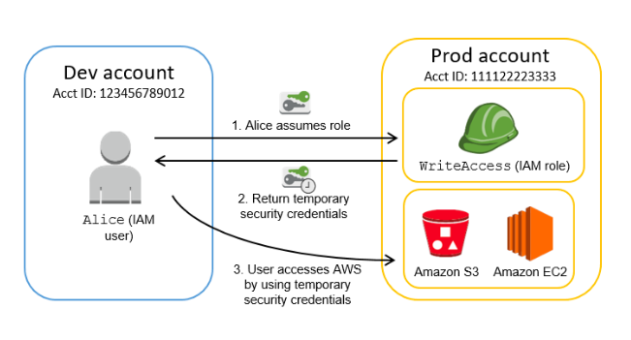
Hence, the correct answer is: Use AWS Security Token Service (STS).
Using Amazon Cognito to issue JSON Web Tokens (JWT) is incorrect because the Amazon Cognito service is primarily used for user authentication and not for providing access to your AWS resources. A JSON Web Token (JWT) is meant to be used for user authentication and session management.
Using AWS: AWS IAM Identity Center is incorrect because this simply helps you securely create or connect your workforce identities and manage their access centrally across AWS accounts and applications. IAM Identity Center is the recommended approach for workforce authentication and authorization on AWS for organizations of any size and type, but not for generating tokens.
The option that says All of the above is incorrect as only STS has the ability to provide temporary security credentials.

References:
https://docs.aws.amazon.com/IAM/latest/UserGuide/id_credentials_temp.html
https://docs.aws.amazon.com/IAM/latest/UserGuide/id_credentials_temp_request.html

Check out this AWS IAM Cheat Sheet:
https://tutorialsdojo.com/aws-identity-and-access-management-iam/

Tutorials Dojo’s AWS Certified Solutions Architect Associate Exam Study Guide:
https://tutorialsdojo.com/aws-certified-solutions-architect-associate/

- 30. Question A large consulting firm is in the process of conducting an internal security audit of its cloud infrastructure. The goal is to ensure that the information in its Amazon S3 bucket, which is associated with the firm’s AWS Lake Formation data lake, doesn’t include confidential data related to its customers or staff.
The firm aims to uncover financial or personally identifiable information (PII), such as passport, credit card numbers, and taxpayer identification numbers, in its S3 bucket. This will prevent any sensitive data from being ingested into a data lake.
What solution would be the most operationally effective solution in meeting these particular requirements?
  - Set up AWS Glue DataBrew to identify and cleanse sensitive data in the S3 bucket.
  - Utilize Amazon Macie to perform a comprehensive data discovery operation using managed identifiers to detect various data types.
  - Set up Amazon S3 Inventory for the S3 bucket and then configure Amazon Athena to conduct queries on the generated inventory.
  - Implement AWS Audit Manager within the AWS account and opt for auditing based on the Payment Card Industry Data Security Standards (PCI DSS).
Incorrect
Amazon Macie is a powerful security service that automatically discovers, classifies, and protects sensitive data on Amazon Web Services. It is designed to help organizations maintain compliance with regulations and protect sensitive data from unauthorized access. With Amazon Macie, users can quickly identify and categorize sensitive data, such as personally identifiable information (PII), financial information, and intellectual property. It also provides real-time alerts on potential data breaches, allowing users to take immediate action to protect the data.
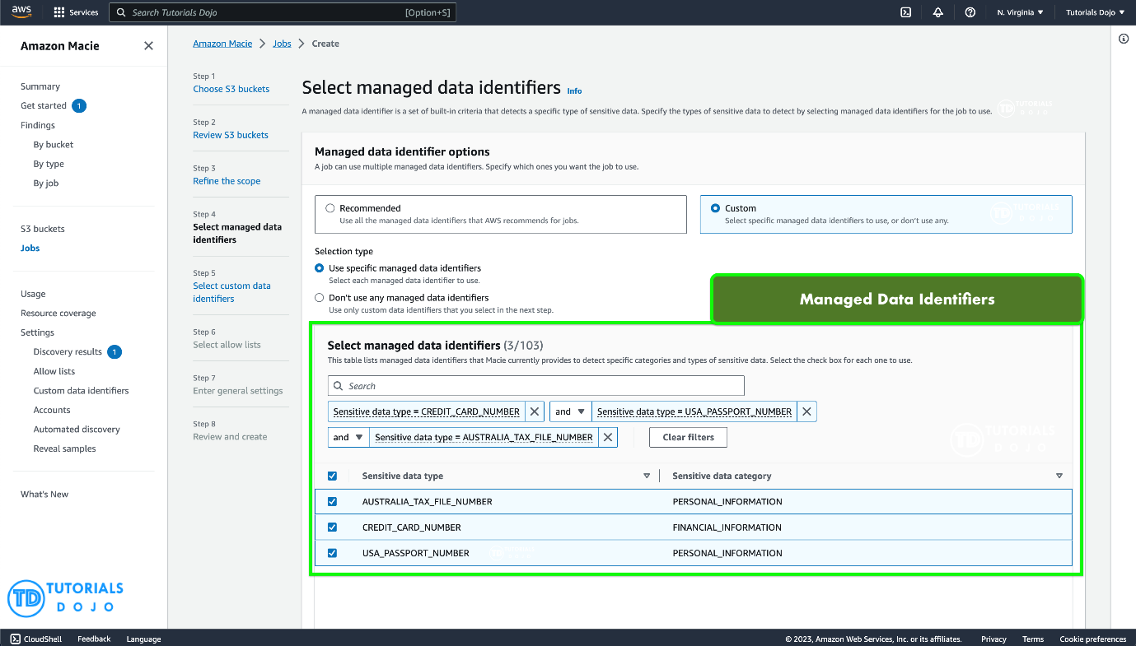
One of the key features of Amazon Macie is its ability to provide users with a comprehensive view of their data security posture. It uses machine learning algorithms to identify sensitive data and then applies various techniques to analyze and classify it. This allows users to quickly and easily identify areas where they need to improve their security posture and take action to address any vulnerabilities. Overall, Amazon Macie is an essential tool for any organization that wants to ensure the security and compliance of its AWS environment.
Amazon Macie uses a combination of criteria and techniques, including machine learning and pattern matching, to detect sensitive data in Amazon Simple Storage Service (Amazon S3) objects. These criteria and techniques, collectively referred to as managed data identifiers, can detect a large and growing list of sensitive data types for many countries and regions, including multiple types of credentials data, financial information, personal health information (PHI), and personally identifiable information (PII). Each managed data identifier is designed to detect a specific type of sensitive data—for example, AWS secret access keys, credit card numbers, or passport numbers for a particular country or region.
Hence, the correct answer is: Utilize Amazon Macie to perform a comprehensive data discovery operation using managed identifiers to detect various data types.
The option that says: Implement AWS Audit Manager within the AWS account and opt for auditing based on the Payment Card Industry Data Security Standards (PCI DSS) is incorrect. AWS Audit Manager is simply a service used for managing audits and compliance assessments. While it’s valuable for auditing against specific compliance standards like PCI DSS, the AWS Audit Manager is more focused on evaluating and managing compliance rather than actively discovering sensitive data within S3 buckets. This service might help ensure proper security controls, but it WON’T directly address the goal of identifying sensitive data stored in the S3 bucket.
The option that says: Set up Amazon S3 Inventory for the S3 bucket and then configure Amazon Athena to conduct queries on the generated inventory is incorrect. Amazon S3 Inventory just helps you manage your storage by creating lists of the objects in an S3 bucket. It doesn’t have the specialized capability to identify sensitive data types like PII. Additionally, utilizing Amazon Athena to query inventory data necessitates manual query construction and pattern identification, resulting in a less accurate approach compared to the specialized data identification capabilities of Amazon Macie.
The option that says: Set up AWS Glue DataBrew to identify and cleanse sensitive data in the S3 bucket is incorrect. AWS Glue DataBrew is typically used for data preparation and cleansing but DOES NOT specialize in automatic sensitive data discovery like Amazon Macie. While DataBrew could be used to prepare or mask data, it lacks the comprehensive detection capabilities needed for this scenario.

References:
https://docs.aws.amazon.com/macie/latest/user/what-is-macie.html
https://docs.aws.amazon.com/macie/latest/user/managed-data-identifiers.html

Check out this Amazon Macie Cheat Sheet:
https://tutorialsdojo.com/amazon-macie/
- 31. Question An On-Demand EC2 instance is launched into a VPC subnet with the Network ACL configured to allow all inbound traffic and deny all outbound traffic. The instance’s security group has an inbound rule to allow SSH from any IP address and does not have any outbound rules.
In this scenario, what are the changes needed to allow SSH connection to the instance?
  - The outbound security group needs to be modified to allow outbound traffic.
  - The outbound network ACL needs to be modified to allow outbound traffic.
  - No action needed. It can already be accessed from any IP address using SSH.
  - Both the outbound security group and outbound network ACL need to be modified to allow outbound traffic.
Correct
In order for you to establish an SSH connection from your home computer to your EC2 instance, you need to do the following:
– On the Security Group, add an Inbound Rule to allow SSH traffic to your EC2 instance.
– On the NACL, add both an Inbound and Outbound Rule to allow SSH traffic to your EC2 instance.
The reason why you have to add both Inbound and Outbound SSH rule is due to the fact that Network ACLs are stateless which means that responses to allow inbound traffic are subject to the rules for outbound traffic (and vice versa). In other words, if you only enabled an Inbound rule in NACL, the traffic can only go in but the SSH response will not go out since there is no Outbound rule.
Security groups are stateful which means that if an incoming request is granted, then the outgoing traffic will be automatically granted as well, regardless of the outbound rules.
Explanation: That's an excellent question that highlights the important differences between Security Groups and Network ACLs.
The Role of Security Groups and Network ACLs
- Security Groups (SGs): These act as a virtual firewall for your instance. They are stateful, meaning that if you allow inbound traffic (like SSH), the response traffic (outbound) is automatically allowed.
- Network ACLs (NACLs): These are stateless firewalls for your subnet. You must explicitly allow both inbound and outbound traffic. If you allow inbound SSH, you must also create a separate rule to allow the outbound response.
Analyzing the Scenario: In this scenario, we have two issues:
- Security Group: The security group is configured to allow inbound SSH but denies all outbound traffic. However, because security groups are stateful, the outbound response to the inbound SSH connection is automatically allowed. Therefore, the security group's outbound rule does not block SSH access.
- Network ACL: The network ACL for the subnet allows all inbound traffic but denies all outbound traffic. Since NACLs are stateless, the inbound SSH request is allowed, but the response from the instance is blocked by the outbound deny rule. This prevents the connection from being established.
Solution
To allow SSH access, both the security group and the network ACL must allow the necessary traffic.
- The outbound security group does not need to be changed for SSH to work, because its stateful nature allows the return traffic.
- The outbound network ACL must be modified to allow the outbound traffic from the instance. Specifically, you need to add a rule to allow outbound traffic on the ephemeral port range (1024-65535), which is where the return SSH traffic will originate.
Therefore, you must modify the outbound network ACL. The security group, while configured to deny outbound traffic, will not be the source of the problem for the SSH connection itself due to its stateful nature.
Based on this analysis, the most accurate answer from the options you provided would be a combination of a and b, but since d combines them, that is the most complete answer:
- d) Both the outbound security group and outbound network ACL need to be modified to allow outbound traffic.
This is the most comprehensive answer because while the security group's outbound rule won't block the initial SSH response (due to it being stateful), it's best practice to allow outbound traffic on the security group for other general use. In a practical, real-world scenario, you would need to adjust both for a fully functional instance. The Network ACL is the direct cause of the failed SSH connection, so it's a mandatory change.
This is a classic question that tests a deep understanding of how security groups and network ACLs interact.
References:
https://docs.aws.amazon.com/AmazonVPC/latest/UserGuide/VPC_ACLs.html
https://docs.aws.amazon.com/AWSEC2/latest/UserGuide/authorizing-access-to-an-instance.html
- 32. Question
A company is hosting EC2 instances that are on non-production environment and processing non-priority batch loads, which can be interrupted at any time.
What is the best instance purchasing option which can be applied to your EC2 instances in this case?
  - Spot Instances
  - On-Demand Capacity Reservations
  - On-Demand Instances
  - Reserved Instances
Correct
Amazon EC2 Spot instances are spare compute capacity in the AWS cloud available to you at steep discounts compared to On-Demand prices. It can be interrupted by AWS EC2 with two minutes of notification when the EC2 needs the capacity back.
To use Spot Instances, you create a Spot Instance request that includes the number of instances, the instance type, the Availability Zone, and the maximum price that you are willing to pay per instance hour. If your maximum price exceeds the current Spot price, Amazon EC2 fulfils your request immediately if capacity is available. Otherwise, Amazon EC2 waits until your request can be fulfilled or until you cancel the request.
Reserved Instances and On-Demand Capacity Reservations are better suited for workloads with steady, predictable usage, while On-Demand Instances may not be the most cost-efficient option for workloads that are flexible and non-urgent.
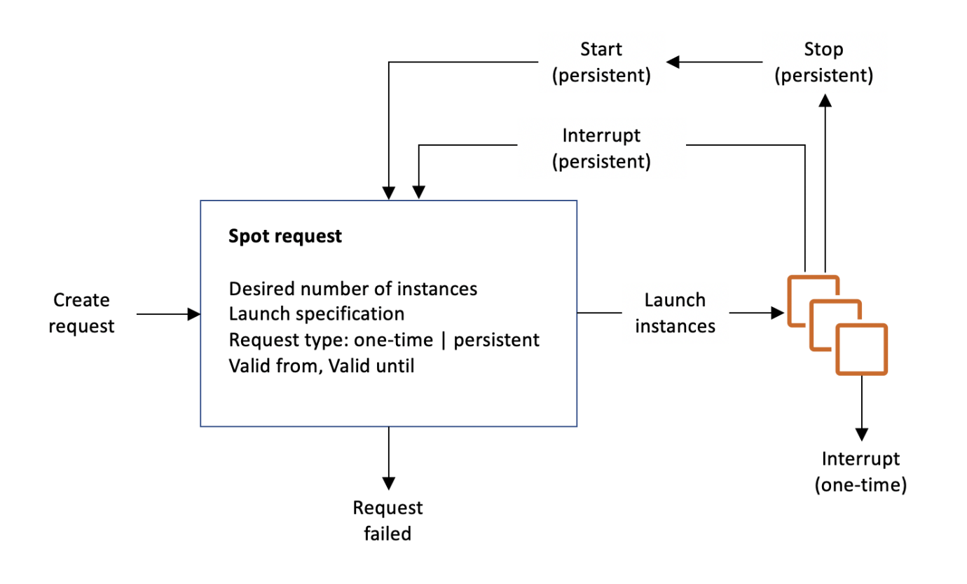

References:
http://docs.aws.amazon.com/AWSEC2/latest/UserGuide/using-spot-instances.html
https://aws.amazon.com/ec2/spot/

Check out this Amazon EC2 Cheat Sheet:
https://tutorialsdojo.com/amazon-elastic-compute-cloud-amazon-ec2/
- 33. Question : A car dealership website hosted in Amazon EC2 stores car listings in an Amazon Aurora database managed by Amazon RDS. Once a vehicle has been sold, its data must be removed from the current listings and forwarded to a distributed processing system. Which of the following options can satisfy the given requirement?
- Create a native function or a stored procedure that invokes an AWS Lambda function. Configure the Lambda function to send event notifications to an Amazon SQS queue for the processing system to consume.
- Create an RDS event subscription and send the notifications to Amazon SNS. Configure the SNS topic to fan out the event notifications to multiple Amazon SQS queues. Process the data using AWS Lambda functions.
- Create an RDS event subscription and send the notifications to AWS Lambda. Configure the Lambda function to fanout the event notifications to multiple Amazon SQS queues to update the target groups.
- Create an RDS event subscription and send the notifications to Amazon SQS. Configure the SQS queues to fan out the event notifications to multiple Amazon SNS topics. Process the data using AWS Lambda functions.
Incorrect
You can invoke an AWS Lambda function from an Amazon Aurora MySQL-Compatible Edition DB cluster with a native function or a stored procedure. This approach can be useful when you want to integrate your database running on Aurora MySQL with other AWS services. For example, you might want to capture data changes whenever a row in a table is modified in your database.
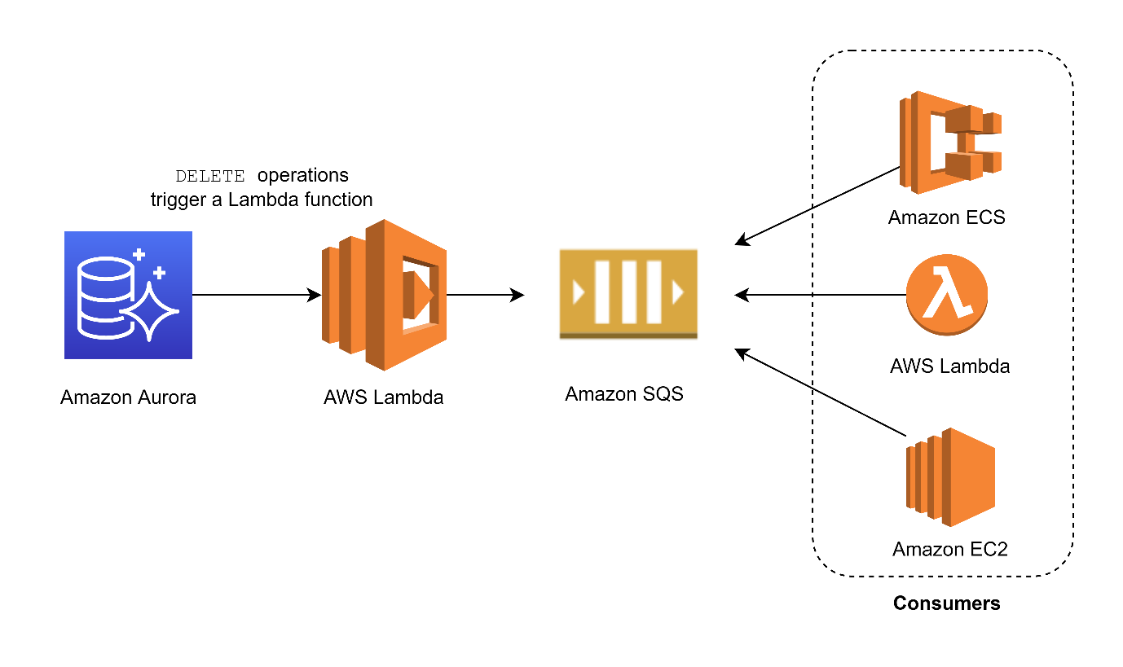
In the scenario, you can trigger a Lambda function whenever a listing is deleted from the database. You can then write the logic of the function to send the listing data to an SQS queue and have different processes consume it.
Hence, the correct answer is Option A.: Create a native function or a stored procedure that invokes an AWS Lambda function. Configure the Lambda function to send event notifications to an Amazon SQS queue for the processing system to consume.
The option that says: Create an RDS event subscription and send the notifications to Amazon SQS. Configure the SQS queues to fan out the event notifications to multiple Amazon SNS topics. Process the data using AWS Lambda functions is incorrect because RDS event subscriptions typically notify about operational changes rather than data modifications. This method does not capture database modifications like INSERT, DELETE, or UPDATE.
The option that says: Create an RDS event subscription and send the notifications to AWS Lambda. Configure the Lambda function to fan out the event notifications to multiple Amazon SQS queues to update the processing system is incorrect because RDS event subscriptions primarily focus on operational-level changes rather than capturing direct data modifications.
The option that says: Create an RDS event subscription and send the notifications to Amazon SNS. Configure the SNS topic to fan out the event notifications to multiple Amazon SQS queues. Process the data using AWS Lambda functions is incorrect because RDS event subscriptions only track infrastructure-related events and not actual database changes.

References:
https://docs.aws.amazon.com/AmazonRDS/latest/AuroraUserGuide/AuroraMySQL.Integrating.Lambda.html
https://aws.amazon.com/blogs/database/capturing-data-changes-in-amazon-aurora-using-aws-lambda/

Check out this Amazon Aurora Cheat Sheet:
https://tutorialsdojo.com/amazon-aurora/
Explanation: Key Requirements
- Trigger on Data Deletion: The distributed processing system must be triggered when a vehicle's data is removed from the car listings.
- Move Data from RDS: The solution needs to get the data from the Amazon Aurora database to an external processing system.
- Use a Distributed System: The target for the data is a separate, distributed processing system.
- Automate the Workflow: The entire process of data transfer and notification should be automated.

Solution Analysis
Let's evaluate each option against these requirements, keeping in mind the technical capabilities of the AWS services mentioned.
- Option A: Create a native function or a stored procedure that invokes an AWS Lambda function. Configure the Lambda function to send event notifications to an Amazon SQS queue for the processing system to consume.
  - Explanation: This option describes an approach where a database-level action (the deletion of a row) triggers an external process. A stored procedure is a block of SQL code that executes directly on the database. In theory, this is the correct place to handle an event that occurs within the database itself. While a stored procedure in Amazon Aurora CANNOT directly invoke an AWS Lambda function, this option represents the most logical and direct architectural pattern for what the question is asking. The Lambda-SQS part of the solution is a standard, robust pattern for decoupling systems. Therefore, despite a minor technical inaccuracy in the direct invocation part, this is the conceptually correct solution.
- Option B: Create an RDS Event Subscriptions and send the notifications to Amazon SNS. Configure the SNS topic to fan out the event notifications to multiple Amazon SQS queues. Process the data using AWS Lambda functions.
  - Explanation: RDS Event Subscriptions are designed to notify you about events related to the database instance itself, such as a reboot, failover, or maintenance. They DO NOT provide events for data manipulation language (DML) operations like DELETE, INSERT, or UPDATE. This option fails at the first step as it cannot be used to detect when a car listing is removed.
- Option C: Create an RDS event subscription and send the notifications to AWS Lambda. Configure the Lambda function to fanout the event notifications to multiple Amazon SQS queues to update the target groups.
  - Explanation: Similar to Option B, this solution relies on a non-existent capability of RDS Event Subscriptions. You cannot use them to trigger an action based on data changes within a table. Furthermore, the goal is to send data to a processing system, not to update "target groups," which are a concept related to load balancers. This option is incorrect on multiple levels.
- Option D: Create an RDS event subscription and send the notifications to Amazon SQS. Configure the SQS queues to fan out the event notifications to multiple Amazon SNS topics. Process the data using AWS Lambda functions.
  - Explanation: This option is also based on the flawed premise that RDS Event Subscriptions can track data changes. Additionally, the fan-out model described is inverted—Amazon SNS is used to fan out to multiple queues, not the other way around. This option is architecturally incorrect and technically unfeasible.

The correct answer is Option A: Create a native function or a stored procedure that invokes an AWS Lambda function. Configure the Lambda function to send event notifications to an Amazon SQS queue for the processing system to consume.
Although Amazon Aurora does not natively allow a stored procedure to directly invoke a Lambda function, this option correctly identifies the use of a database trigger (a stored procedure) as the mechanism to initiate the workflow. The remainder of the description—using Lambda, SQS, and a fan-out model—is a standard, scalable, and correct architectural pattern for connecting a database to a distributed processing system. It is the only option that addresses the root of the problem: detecting a data-level event within the database.

- 34. Question An e-commerce company is redesigning the architecture of its application. The new architecture needs a more robust application layer and an online transactional processing (OLTP) relational database that can handle spiky traffic loads. The company also wants to ensure the application is always available while minimizing computing costs during idle periods.
As the company’s solution architect, which solution would be the MOST cost-effective to meet these requirements?
  - Utilize Amazon EC2 instances with a burstable instance type to operate the application and adopt Amazon Redshift as the database.
  - Use Amazon ECS on AWS Fargate to run the application in containers and opt for Amazon Aurora Serverless to host the database.
  - Utilize AWS Elastic Beanstalk to deploy the application, use a MySQL database on Amazon RDS, then configure Auto Scaling to scale down the number of EC2 instances during idle periods.
  - Use Amazon EC2 instances in an Auto Scaling group behind an Application Load Balancer. Implement Amazon RDS for MySQL for the database.
Incorrect
Amazon ECS on AWS Fargate is a container orchestration solution that allows the company to execute containerized apps without handling the underlying infrastructure. It handles infrastructure scaling, patching, and provisioning, giving the company more time to focus on creating and deploying applications. This service enables companies to run containerized apps in a serverless environment, where they pay for the resources consumed, making it a cost-effective solution for applications with fluctuating workloads. With ECS on AWS Fargate, you can launch containers on demand, respond quickly to necessary changes, and have the flexibility to scale up or down as needed.
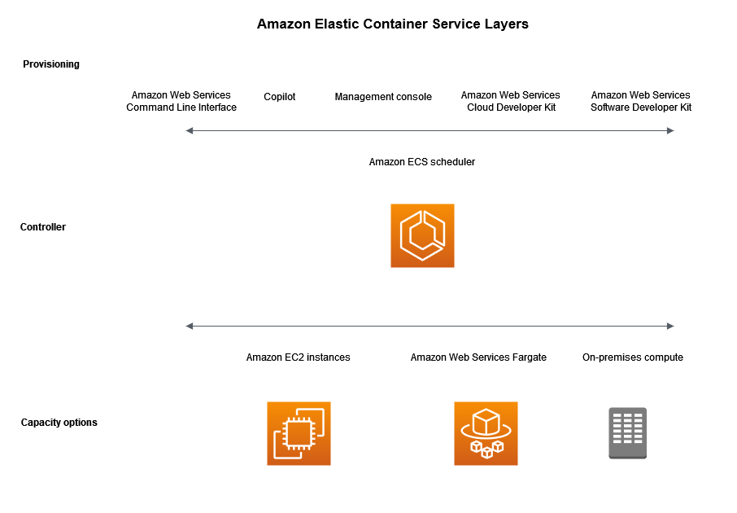
Amazon Aurora Serverless, on the other hand, is a fully managed, auto-scaling relational database engine that eliminates the need to manage infrastructure, providing the company with cost savings and scalability. It offers an excellent option for hosting databases for applications with unpredictable workloads or low usage patterns. Furthermore, Aurora Serverless scales the database up or down based on the workload, which helps to minimize costs during idle periods. With Aurora Serverless, companies can also achieve high availability, as the database automatically replicates data across multiple Availability Zones. Overall, the combination of Amazon ECS on AWS Fargate and Amazon Aurora Serverless provides companies with a cost-effective, scalable, and reliable infrastructure to run their applications and databases.
Hence the correct answer is: Use Amazon ECS on AWS Fargate to run the application in containers and opt for Amazon Aurora Serverless to host the database.
The option that says: Utilize Amazon EC2 instances with a burstable instance type to operate the application and adopt Amazon Redshift as the database is incorrect because Amazon Redshift is designed primarily for Online Analytical Processing (OLAP) workloads, which are optimized for querying large datasets and generating complex reports. While burstable instance types can provide a cost-effective approach, they may NOT be able to sustain prolonged periods of high traffic when their credit balance reaches 0.
The option that says: Utilize AWS Elastic Beanstalk to deploy the application, use a MySQL database on Amazon RDS, then configure Auto Scaling to scale down the number of EC2 instances during idle periods is incorrect. AWS Elastic Beanstalk can deploy and run applications, but it might NOT be as cost-efficient as Fargate in handling sporadic loads because you’re still dealing with full EC2 instances, which might not fully utilize their resources. Auto Scaling does help reduce costs during idle times, but it isn’t as flexible and instantaneous as the on-demand scaling provided by serverless options. While Amazon RDS with MySQL could handle OLTP workloads, it doesn’t provide the same automatic scaling features as Aurora Serverless.
The option that says: Use Amazon EC2 instances in an Auto Scaling group behind an Application Load Balancer. Implement Amazon RDS for MySQL for the database is incorrect. When you implement Amazon RDS for MySQL for the database, you pay for the computing and storage resources whether or not you are actively using them. This means you would be charged even during idle periods, which would not be as cost-effective as using Amazon Aurora Serverless.

References:
https://docs.aws.amazon.com/AmazonECS/latest/developerguide/AWS_Fargate.html
https://aws.amazon.com/rds/aurora/serverless/

Check out these Cheat Sheets on Amazon Elastic Container Service, AWS Fargate, and Amazon Aurora Serverless:
https://tutorialsdojo.com/amazon-elastic-container-service-amazon-ecs/
https://tutorialsdojo.com/aws-fargate/
https://tutorialsdojo.com/amazon-aurora/
- 35. Question
A Solutions Architect is migrating several Windows-based applications to AWS that require a scalable file system storage for high-performance computing (HPC). The storage service must have full support for the SMB protocol and Windows NTFS, Active Directory (AD) integration, and Distributed File System (DFS).
Which of the following is the MOST suitable storage service that the Architect should use to fulfil this scenario?
  - Amazon FSx for Lustre
  - AWS DataSync
  - Amazon FSx for Windows File Server
  - Amazon S3 Glacier Deep Archive
Correct
Amazon FSx provides fully managed third-party file systems. Amazon FSx provides you with the native compatibility of third-party file systems with feature sets for workloads such as Windows-based storage, high-performance computing (HPC), machine learning, and electronic design automation (EDA). You don’t have to worry about managing file servers and storage, as Amazon FSx automates time-consuming administration tasks such as hardware provisioning, software configuration, patching, and backups. Amazon FSx integrates the file systems with cloud-native AWS services, making them even more useful for a broader set of workloads.
Amazon FSx provides you with two file systems to choose from: Amazon FSx for Windows File Server for Windows-based applications and Amazon FSx for Lustre for compute-intensive workloads.
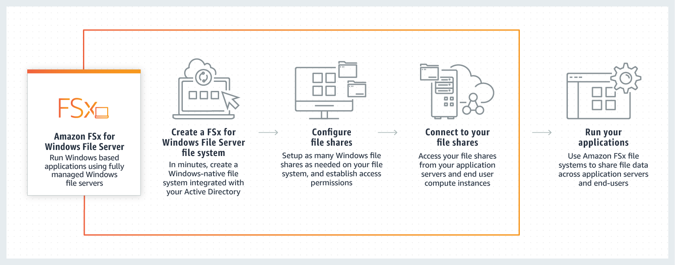
For Windows-based applications, Amazon FSx provides fully managed Windows file servers with features and performance optimized for “lift-and-shift” business-critical application workloads including home directories (user shares), media workflows, and ERP applications. It is accessible from Windows and Linux instances via the SMB protocol. If you have Linux-based applications, Amazon EFS is a cloud-native fully managed file system that provides simple, scalable, elastic file storage accessible from Linux instances via the NFS protocol.
For compute-intensive and fast processing workloads, like high-performance computing (HPC), machine learning, EDA, and media processing, Amazon FSx for Lustre, provides a file system that’s optimized for performance, with input and output stored on Amazon S3.
Hence, the correct answer is: Amazon FSx for Windows File Server.
Amazon S3 Glacier Deep Archive is incorrect because this service is primarily used as a secure, durable, and extremely low-cost cloud storage for data archiving and long-term backup.
AWS DataSync is incorrect because this service simply provides a fast way to move large amounts of data online between on-premises storage and Amazon S3 or Amazon Elastic File System (Amazon EFS).
Amazon FSx for Lustre is incorrect because this service doesn’t support Windows-based applications as well as Windows servers.

References:
https://aws.amazon.com/fsx/
https://aws.amazon.com/getting-started/use-cases/hpc/3/

Check out this Amazon FSx Cheat Sheet:
https://tutorialsdojo.com/amazon-fsx/
- 36. Question A company runs its multitier online shopping platform on AWS. Every new sale transaction is published as a message in an open-source RabbitMQ queue that runs on an Amazon EC2 instance. There is a consumer application is hosted on a separate EC2 instance that consumes the incoming messages, which then stores the transaction in a self-hosted PostgreSQL database on another EC2 instance.
All of the EC2 instances used are in the same Availability Zone in the eu-central-1 Region. A solutions architect needs to redesign its cloud architecture to provide the highest availability with the least amount of operational overhead.
What should a solutions architect do to meet the company’s requirements above?
  - Migrate the RabbitMQ queue to Amazon MQ to a cluster broker deployment setup. Launch a Multi-AZ Auto Scaling group for the Amazon EC2 instances that host the consumer application. Migrate the existing database to Amazon RDS for PostgreSQL in a Multi-AZ Deployment configuration.
  - Migrate the RabbitMQ queue to Amazon Simple Queue Service (SQS). Rehost the consumer application to an Amazon OpenSearch Service (Amazon Elasticsearch) cluster. Migrate the PostgreSQL database to an Amazon Aurora Serverless cluster
  - Migrate the RabbitMQ queue to a redundant pair (active/standby) of Amazon MQ brokers in AWS. Launch a Multi-AZ Auto Scaling group for the Amazon EC2 instances that host the consumer application. Migrate the PostgreSQL database to Amazon RDS for PostgreSQL with cross-Region read replicas
  - Migrate the RabbitMQ queue to an Auto Scaling group of EC2 instances. Rehost the consumer application to an Amazon ECS cluster with AWS Fargate. Migrate the PostgreSQL database to Amazon Aurora PostgreSQL using the Aurora cloning feature.
Incorrect
Amazon MQ is a managed message broker service that makes it easy to migrate to a message broker in the cloud. A message broker allows software applications and components to communicate using various programming languages, operating systems, and formal messaging protocols. Amazon MQ supports Apache ActiveMQ, RabbitMQ, and other message broker engine types.
A cluster deployment is a logical grouping of three RabbitMQ broker nodes behind a Network Load Balancer, each sharing users, queues, and a distributed state across multiple Availability Zones (AZ). In a cluster deployment, Amazon MQ automatically manages broker policies to enable classic mirroring across all nodes, ensuring high availability (HA). Each mirrored queue consists of one main node and one or more mirrors. Each queue has its own main node. All operations for a given queue are first applied on the queue’s main node and then propagated to mirrors. Amazon MQ creates a default system policy that sets the HA-mode to all and HA-sync-mode to automatic. This ensures that data is replicated to all nodes in the cluster across different Availability Zones for better durability.
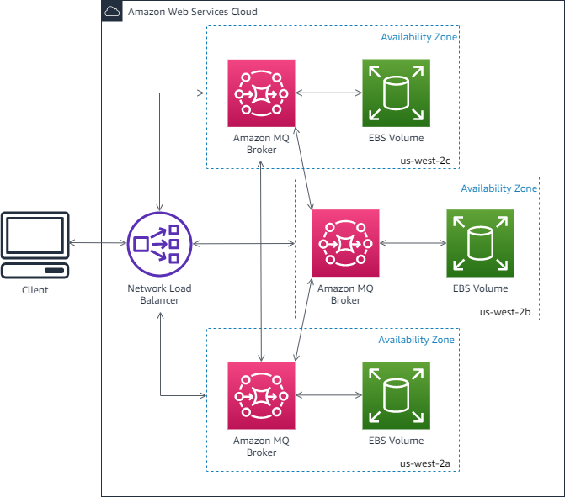
The default policy should not be deleted. If you do delete this policy, Amazon MQ will automatically recreate it. Amazon MQ will also ensure that HA properties are applied to all other policies that you create on a clustered broker. If you add a policy without the HA properties, Amazon MQ will add them for you. If you add a policy with different high-availability properties, Amazon MQ will replace them.
Hence, the correct answer is: Migrate the RabbitMQ queue to Amazon MQ to a cluster broker deployment setup. Launch a Multi-AZ Auto Scaling group for the Amazon EC2 instances that host the consumer application. Migrate the existing database to Amazon RDS for PostgreSQL in a Multi-AZ Deployment configuration.
The option that says: Migrate the RabbitMQ queue to Amazon Simple Queue Service (SQS). Rehost the consumer application to an Amazon OpenSearch Service (Amazon Elasticsearch) cluster. Migrate the PostgreSQL database to an Amazon Aurora Serverless cluster is incorrect because you cannot directly migrate RabbitMQ to Amazon SQS. A more suitable course of action is to migrate the RabbitMQ queue to Amazon MQ as this service supports a wide variety of functions that RabbitMQ already has.
The option that says: Migrate the RabbitMQ queue to an Auto Scaling group of EC2 instances. Rehost the consumer application to an Amazon ECS cluster with AWS Fargate. Migrate the PostgreSQL database to Amazon Aurora PostgreSQL using the Aurora cloning feature is incorrect. A queueing service isn’t usually deployed to an Auto Scaling group of EC2 instances but to a set number of brokers/servers. Take note that the scenario didn’t mention any high load in the incoming messages. The use of the Aurora cloning feature is also incorrect. This feature simply allows you to create a new cluster that uses the same Aurora cluster volume and has the same data as the original Aurora DB, and not from a self-hosted PostgreSQL database.
The option that says: Migrate the RabbitMQ queue to a redundant pair (active/standby) of Amazon MQ brokers in AWS. Launch a Multi-AZ Auto Scaling group for the Amazon EC2 instances that host the consumer application. Migrate the PostgreSQL database to Amazon RDS for PostgreSQL with cross-Region read replicas is incorrect. Although an active/standby Amazon MQ setup provides better availability than a single-instance deployment, it still takes a short time to take the inactive instance out of service and replace it with the standby instance. In Amazon MQ for RabbitMQ, a cluster broker deployment setup is recommended to ensure high availability. The active/standby architecture is commonly used for Amazon MQ for the ActiveMQ variant. In a database standpoint, it’s better to launch an Amazon RDS in a Multi-AZ Deployment configuration as it provides high availability and faster failover than a Read Replica. Keep in mind that the primary use case for a Read Replica is usually for scaling your database with a high number of read/select SQL operations (e.g., data reporting).

References:
https://docs.aws.amazon.com/amazon-mq/latest/developer-guide/rabbitmq-broker-architecture-cluster.html
https://docs.aws.amazon.com/amazon-mq/latest/developer-guide/rabbitmq-basic-elements-broker.html

Check out the Amazon MQ Cheat Sheets:
https://tutorialsdojo.com/amazon-mq/
https://tutorialsdojo.com/amazon-relational-database-service-amazon-rds/
- 37. Question
A company has an infrastructure that allows EC2 instances from a private subnet to fetch objects from Amazon S3 via a NAT Instance. The company’s Solutions Architect was instructed to lower down the cost incurred by the current solution.
How should the Solutions Architect redesign the architecture in the most cost-efficient manner?
  - Remove the NAT instance and create an S3 interface endpoint to access S3 objects.
  - Use a smaller instance type for the NAT instance.
  - Remove the NAT instance and create an S3 gateway endpoint to access S3 objects.
  - Replace the NAT instance with NAT Gateway to access S3 objects.
Incorrect
A VPC endpoint enables you to privately connect your VPC to supported AWS services and VPC endpoint services powered by PrivateLink without requiring an Internet gateway, NAT device, VPN connection, or AWS Direct Connect connection. Instances in your VPC do not require public IP addresses to communicate with resources in the service. Traffic between your VPC and the other services does not leave the Amazon network.
Endpoints are virtual devices. They are horizontally scaled, redundant, and highly available VPC components that allow communication between instances in your VPC and services without imposing availability risks or bandwidth constraints on your network traffic.
There are two types of VPC endpoints: interface endpoints and gateway endpoints. You should create the type of VPC endpoint required by the supported service. As a rule of thumb, most AWS services use VPC Interface Endpoint except for S3 and DynamoDB, which use VPC Gateway Endpoint.
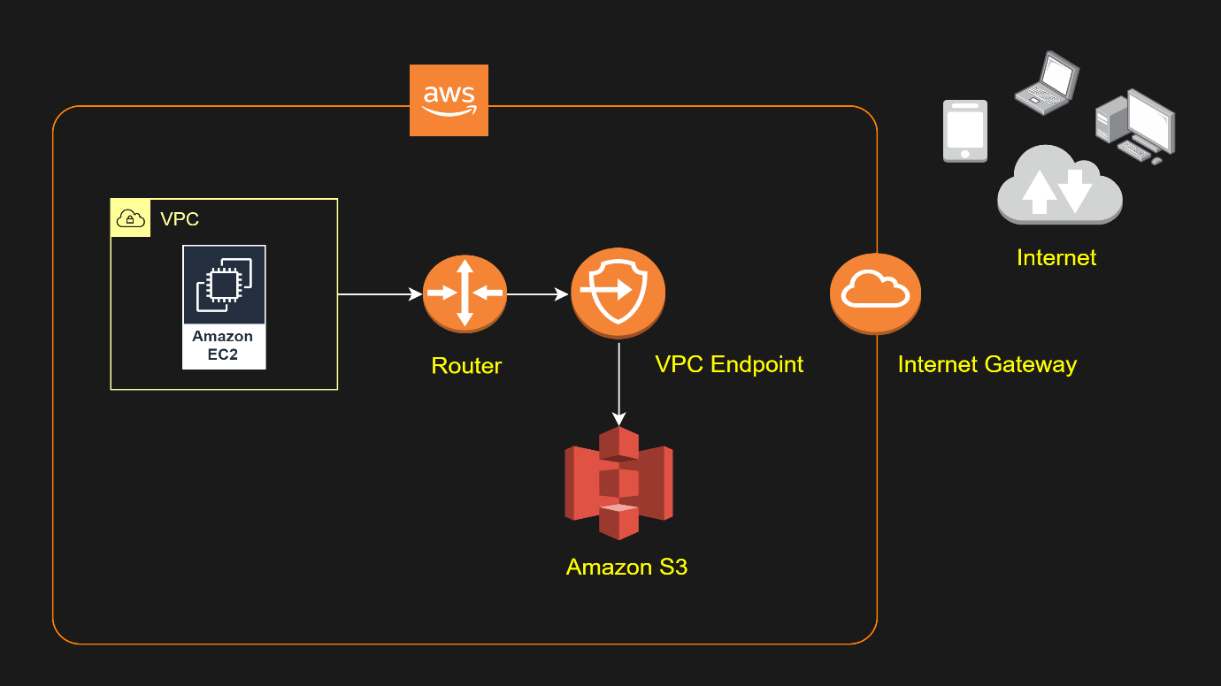
There is no additional charge for using gateway endpoints. However, standard charges for data transfer and resource usage still apply.
Let’s assume you created a NAT gateway, and you have an EC2 instance routing to the Internet through the NAT gateway. Your EC2 instance behind the NAT gateway sends a 1 GB file to one of your S3 buckets. The EC2 instance, NAT gateway, and S3 Bucket are in the same region US East (Ohio), and the NAT gateway and EC2 instance are in the same availability zone.
Your cost will be calculated as follows:
– NAT Gateway Hourly Charge: NAT Gateway is charged on an hourly basis. For example, the rate is $0.045 per hour in this region.
– NAT Gateway Data Processing Charge: 1 GB data went through NAT gateway. The NAT Gateway Data Processing charge is applied and will result in a charge of $0.045.
– Data Transfer Charge: This is the standard EC2 Data Transfer charge. 1 GB data was transferred from the EC2 instance to S3 via the NAT gateway. There was no charge for the data transfer from the EC2 instance to S3 as it is Data Transfer Out to Amazon EC2 to S3 in the same region. There was also no charge for the data transfer between the NAT Gateway and the EC2 instance since the traffic stays in the same availability zone using private IP addresses. There will be a data transfer charge between your NAT Gateway and EC2 instance if they are in the different availability zone.
In summary, your charge will be $0.045 for 1 GB of data processed by the NAT gateway and a charge of $0.045 per hour will always apply once the NAT gateway is provisioned and available. The data transfer has no charge in this example. However, if you send the file to a non-AWS Internet location instead, there will be a data transfer charge as it is data transfer out from Amazon EC2 to the Internet.
To avoid the NAT Gateway Data Processing charge in this example, you could set up a Gateway Type VPC endpoint and route the traffic to/from S3 through the VPC endpoint instead of going through the NAT Gateway.
There is no data processing or hourly charges for using Gateway Type VPC endpoints.
Hence, the correct answer is the option that says: Remove the NAT instance and create an S3 gateway endpoint to access S3 objects.
The option that says: Replace the NAT instance with NAT Gateway to access S3 objects is incorrect. A NAT Gateway is just a NAT instance that is managed for you by AWS. It provides less operational management and you pay for the hour that your NAT Gateway is running. This is not the most effective solution since you will still pay for the idle time.
The option that says: Use a smaller instance type for the NAT instance is incorrect. Although this might reduce the cost, it still is not the most cost-efficient solution. An S3 Gateway endpoint is still the best solution because it comes with no additional charge.
The option that says: Remove the NAT instance and create an S3 interface endpoint to access S3 objects is incorrect. An interface endpoint is an elastic network interface with a private IP address from the IP address range of your subnet. Unlike a gateway endpoints, you still get billed for the time your interface endpoint is running and the GB data it has processed. From a cost standpoint, using the S3 gateway endpoints is the most favorable solution.

References:
https://docs.aws.amazon.com/vpc/latest/privatelink/vpce-gateway.html
https://aws.amazon.com/blogs/architecture/reduce-cost-and-increase-security-with-amazon-vpc-endpoints/
https://aws.amazon.com/vpc/pricing/

Check out this Amazon S3 Cheat Sheet:
https://tutorialsdojo.com/amazon-s3/
- 38. Question
A Solutions Architect created a new Standard-class Amazon S3 bucket to store financial reports that are not frequently accessed but should immediately be available when an auditor requests the reports. To save costs, the Architect changed the storage class of the S3 bucket from Standard to Infrequent Access storage class.
In S3 Standard – Infrequent Access storage class, which of the following statements are true? (Select TWO.)
  - Ideal to use for data archiving.
  - It provides high latency and low throughput performance.
  - It is designed for data that requires rapid access when needed.
  - It automatically moves data to the most cost-effective access tier without any operational overhead.
  - It is designed for data that is accessed less frequently.
Incorrect
Amazon S3 Standard – Infrequent Access (Standard – IA) is an Amazon S3 storage class for data that is accessed less frequently, but requires rapid access when needed. Standard – IA offers the high durability, throughput, and low latency of Amazon S3 Standard, with a low per GB storage price and per GB retrieval fee.
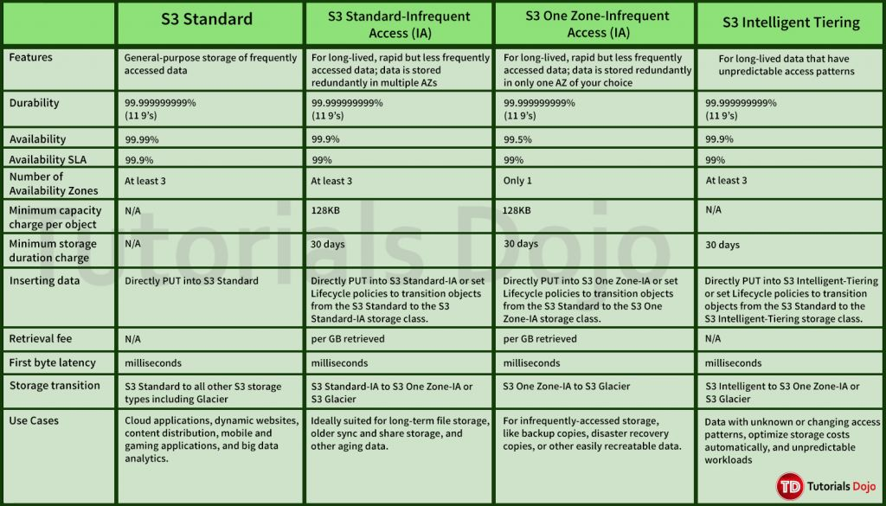
This combination of low cost and high performance make Standard – IA ideal for long-term storage, backups, and as a data store for disaster recovery. The Standard – IA storage class is set at the object level and can exist in the same bucket as Standard, allowing you to use lifecycle policies to automatically transition objects between storage classes without any application changes.
Key Features:
– Same low latency and high throughput performance of Standard
– Designed for durability of 99.999999999% of objects
– Designed for 99.9% availability over a given year
– Backed with the Amazon S3 Service Level Agreement for availability
– Supports SSL encryption of data in transit and at rest
– Lifecycle management for automatic migration of objects
Hence, the correct answers are:
– It is designed for data that is accessed less frequently.
– It is designed for data that requires rapid access when needed.
The option that says: It automatically moves data to the most cost-effective access tier without any operational overhead is incorrect because it, actually, refers to Amazon S3 – Intelligent Tiering, which is the only cloud storage class that delivers automatic cost savings by moving objects between different access tiers when access patterns change.
The option that says: It provides high latency and low throughput performance is incorrect because it should just be “low latency” and “high throughput” instead. S3 automatically scales performance to meet user demands.
The option that says: Ideal to use for data archiving is incorrect because this statement refers to Amazon S3 Glacier. Glacier is a secure, durable, and extremely low-cost cloud storage service for data archiving and long-term backup.

References:
https://aws.amazon.com/s3/storage-classes/
https://aws.amazon.com/s3/faqs

Check out this Amazon S3 Cheat Sheet:
https://tutorialsdojo.com/amazon-s3/
- 39. Question A solutions architect is writing an AWS Lambda function that will process encrypted documents from an Amazon FSx for NetApp ONTAP file system. The documents are protected by an AWS KMS customer key. After processing the documents, the Lambda function will store the results in an S3 bucket with an Amazon S3 Glacier Flexible Retrieval storage class. The solutions architect must ensure that the files can be decrypted by the Lambda function.
Which action accomplishes the requirement?
  - Attach the kms:decrypt permission to the Lambda function’s execution role. Add a statement to the AWS KMS key’s policy that grants the function’s ARN the kms:decrypt permission.
  - Attach the kms:decrypt permission to the Lambda function’s execution role. Add a statement to the AWS KMS key’s policy that grants the function’s execution role the kms:decrypt permission.
  - Attach the kms:decrypt permission to the Lambda function’s resource policy. Add a statement to the AWS KMS key’s policy that grants the function’s resource policy ARN the kms:decrypt permission.
  - Attach the kms:decrypt permission to the Lambda function’s resource policy. Add a statement to the AWS KMS key’s policy that grants the function’s execution role the kms:decrypt permission.
Incorrect
A key policy is a resource policy for an AWS KMS key. Key policies are the primary way to control access to KMS keys. Every KMS key must have exactly one key policy. The statements in the key policy determine who has permission to use the KMS key and how they can use it. You can also use IAM policies and grants to control access to the KMS key, but every KMS key must have a key policy.
Unless the key policy explicitly allows it, you cannot use IAM policies to allow access to a KMS key. Without permission from the key policy, IAM policies that allow permissions have no effect. (You can use an IAM policy to deny permission to a KMS key without permission from a key policy.) The default key policy enables IAM policies. To enable IAM policies in your key policy, add the policy statement described here.
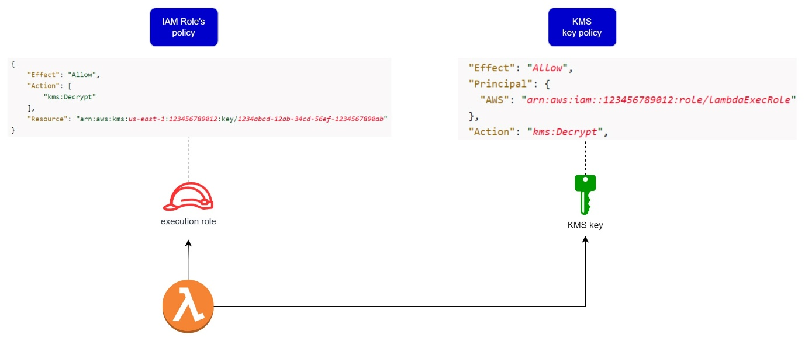
All Amazon FSx for NetApp ONTAP file systems is encrypted at rest with keys managed using AWS Key Management Service (AWS KMS). Data is automatically encrypted before being written to the file system and automatically decrypted as it is read. These processes are handled transparently by Amazon FSx, so you don’t have to modify your applications. Amazon FSx uses an industry-standard AES-256 encryption algorithm to encrypt Amazon FSx data and metadata at rest.
Hence, the correct answer is: Attach the kms:decrypt permission to the Lambda function’s execution role. Add a statement to the AWS KMS key’s policy that grants the function’s execution role the kms:decrypt permission.
The option that says: Attach the kms:decrypt permission to the Lambda function’s resource policy. Add a statement to the AWS KMS key’s policy that grants the function’s resource policy ARN the kms:decrypt permission is incorrect. The resource policy specifies who can invoke the Lambda function, NOT which AWS operations it can use.
The option that says: Attach the kms:decrypt permission to the Lambda function’s execution role. Add a statement to the AWS KMS key’s policy that grants the function’s ARN the kms:decrypt permission is incorrect. You MUST use the ARN of the function’s execution role as the principal instead of the actual ARN of the function. The reason for this is that AWS Lambda interacts with other AWS services using the permissions associated with an execution role.
The option that says: Attach the kms:decrypt permission to the Lambda function’s resource policy. Add a statement to the AWS KMS key’s policy that grants the function’s execution role the kms:decrypt permission is incorrect. Like the other incorrect option, the decrypt permission must be added to the function’s execution role and NOT on its resource policy.
References:
https://docs.aws.amazon.com/kms/latest/developerguide/key-policies.html#key-policy-default-allow-root-enable-iam
https://docs.aws.amazon.com/kms/latest/developerguide/iam-policies.html
https://docs.aws.amazon.com/fsx/latest/ONTAPGuide/encryption-at-rest.html

Check out this AWS KMS Cheat sheet:
https://tutorialsdojo.com/aws-key-management-service-aws-kms/
Explanation: Based on your requirements, here is a detailed breakdown of each option.
Option A: Attach the kms:decrypt permission to the Lambda function’s execution role. Add a statement to the AWS KMS key’s policy that grants the function’s ARN the kms:decrypt permission.
Correctness: This option is technically correct and will accomplish the requirement.
Suitability: It correctly identifies the need to attach the kms:decrypt permission to the Lambda function’s execution role (an identity-based policy) and to the AWS KMS key policy (a resource-based policy). Granting the permission to the specific Lambda function's ARN is a valid but less common practice than granting it to the execution role ARN.
Option B: Attach the kms:decrypt permission to the Lambda function’s execution role. Add a statement to the AWS KMS key’s policy that grants the function’s execution role, the kms:decrypt permission.
Correctness: This option is correct.
Suitability: This is the most suitable and recommended approach. An AWS Lambda function assumes an execution role to interact with other AWS services. The permissions needed by the function must be attached to this role. The AWS KMS key policy must then explicitly permit the role to perform the kms:decrypt action. This two-part policy configuration is a core tenet of AWS security best practices.
Option C: Attach the kms:decrypt permission to the Lambda function’s resource policy. Add a statement to the AWS KMS key’s policy that grants the function’s resource policy ARN the kms:decrypt permission.
Correctness: This option is incorrect.
Suitability: A Lambda function's resource policy is used to control which principals can invoke the function (lambda:InvokeFunction). It is not used to grant the function permissions to access other services like KMS. The kms:decrypt permission must be attached to the Lambda function's execution role.
Option D: Attach the kms:decrypt permission to the Lambda function’s resource policy. Add a statement to the AWS KMS key’s policy that grants the function’s execution role the kms:decrypt permission.
Correctness: This option is incorrect.
Suitability: As with Option C, this choice incorrectly attempts to use the Lambda resource policy for permissions to a different service. While the second part of the statement correctly identifies the need to grant the permission to the function's execution role within the KMS key policy, the overall approach is flawed.
The correct action is Option B. This approach correctly applies the necessary permissions to both the identity (the Lambda execution role) and the resource (the KMS key).
For further learning, you can explore tutorials on AWS IAM roles and policies on sites like youtube.com.

- 40. Question A financial analytics application that collects, processes, and analyzes stock data in real-time uses Amazon Kinesis Data Streams. The producers continually push data to Kinesis Data Streams while the consumers process the data in real time.
In Kinesis, where can the consumers store the results? (Select TWO.)
  - AWS Glue
  - Amazon S3
  - Amazon EMR
  - Amazon Athena
  - Amazon Redshift
Incorrect
In Amazon Kinesis, the producers continually push data to Kinesis Data Streams and the consumers process the data in real-time. Consumers (such as a custom application running on Amazon EC2, or an Amazon Data Firehose stream) can store their results using an AWS service such as Amazon DynamoDB, Amazon Redshift, or Amazon S3.
The following diagram illustrates the high-level architecture of Kinesis Data Streams:
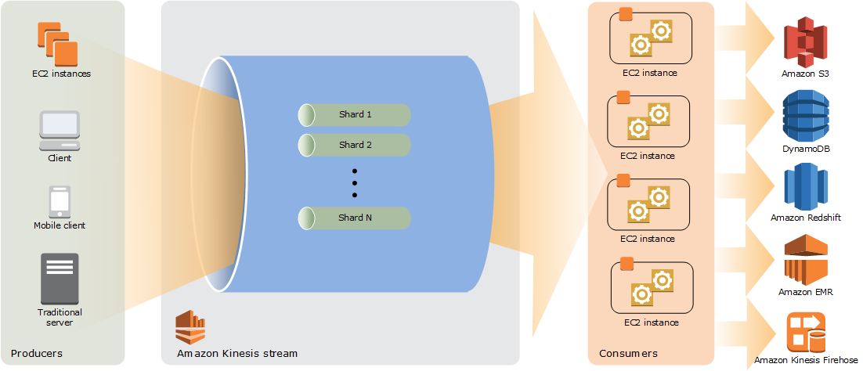
Hence, the correct answers are:
– Amazon S3
– Amazon Redshift
Amazon EMR is incorrect because it is primarily used for big data processing with frameworks like Apache Spark and Hadoop. While it can process data from Kinesis, it is not a direct storage solution for consumer results.
AWS Glue is incorrect because this is not a storage service. It is a fully managed extract, transform, and load (ETL) service that makes it easy for customers to prepare and load their data for analytics.
Amazon Athena is incorrect because this is just an interactive query service that makes it easy to analyze data in Amazon S3 using standard SQL. It is not a storage service where you can store the results processed by the consumers.
References:
http://docs.aws.amazon.com/streams/latest/dev/key-concepts.html
https://docs.aws.amazon.com/streams/latest/dev/using-other-services-redshift.html
https://aws.amazon.com/blogs/big-data/streaming-data-from-amazon-s3-to-amazon-kinesis-data-streams-using-aws-dms/

Amazon Redshift Overview:
Check out this Amazon Kinesis Cheat Sheet:
https://tutorialsdojo.com/amazon-kinesis/
- 41. Question
A company is running an on-premises application backed by a 1TB MySQL 8.0 database. A couple of times each month, the production data is fully copied to a staging database at the request of the analytics team. The team can’t work on the staging database until the copy is finished, which takes hours.
Throughout this period, the application experiences intermittent downtimes as well. To expedite the process for the analytics team, a solutions architect must redesign the application’s architecture in AWS. The application must also be highly resilient to disruptions.
Which combination of actions best satisfies the given set of requirements while being the most cost-effective? (Select TWO)
  - Replicate the production database to a staging database using the mysqldump client utility
  - Use an Amazon RDS database in a Multi-AZ Deployments configuration
  - Take a manual snapshot and restore it to a database in the staging environment.
  - Use an Amazon Aurora database with Multi-AZ Replicas.
  - Clone the production database in the staging environment using Aurora cloning.
Incorrect
The resiliency of an application pertains to its ability to recover from infrastructure or service disruptions. Both Amazon Aurora and Amazon RDS can give you a highly resilient infrastructure by deploying replicas in multiple availability zones. Both database services can perform an automatic failover to a standby instance in the event of failure. However, only Amazon Aurora has the ability to replicate a database in a fast and efficient manner without impacting performance, thanks to its underlying storage system. By using Aurora cloning, you can create a new cluster that uses the same Aurora cluster volume and has the same data as the original. The process is designed to be fast and cost-effective. The new cluster with its associated data volume is called a clone.
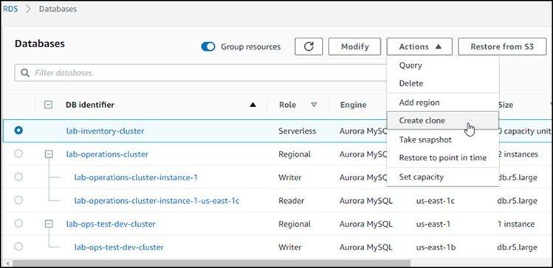
Creating a clone is faster and more space-efficient than physically copying the data using other techniques, such as restoring from a snapshot like you would in Amazon RDS or using the native mysqldump utility.
Therefore, the correct answers are:
- Use an Amazon Aurora database with Multi-AZ Replicas.
- Clone the production database in the staging environment using Aurora cloning.
The option that says: Use an Amazon RDS database in a Multi-AZ Deployments configuration is incorrect. While Amazon RDS is a valid option, Amazon Aurora best fits what’s described in the scenario due to its cloning feature.
The option that says: Take a manual snapshot and restore it to a database in the staging environment is incorrect. Using Aurora Cloning is a faster and more cost-effective method than restoring from a snapshot.
The option that says: Replicate the production database to a staging database using the mysqldump client utility is incorrect as this is a slow process and will impact the performance of the source database.

References:
https://docs.aws.amazon.com/AmazonRDS/latest/AuroraUserGuide/Aurora.Managing.Clone.html
https://aws.amazon.com/blogs/aws/amazon-aurora-fast-database-cloning/

Check out this Amazon Aurora Cheat Sheet:
https://tutorialsdojo.com/amazon-aurora/
- 42. Question
A company plans to host a web application in an Auto Scaling group of Amazon EC2 instances. The application will be used globally by users to upload and store several types of files. Based on user trends, files that are older than 2 years must be stored in a different storage class. The Solutions Architect of the company needs to create a cost-effective and scalable solution to store the old files yet still provide durability and high availability.
Which of the following approach can be used to fulfill this requirement? (Select TWO.)
  - Use a RAID 0 storage configuration that stripes multiple Amazon EBS volumes together to store the files. Configure the Amazon Data Lifecycle Manager (DLM) to schedule snapshots of the volumes after 2 years.
  - Use Amazon EBS volumes to store the files. Configure the Amazon Data Lifecycle Manager (DLM) to schedule snapshots of the volumes after 2 years.
  - Use Amazon S3 and create a lifecycle policy that will move the objects to S3 Standard-IA after 2 years.
  - Use Amazon EFS and create a lifecycle policy that will move the objects to EFS-IA after 2 years.
  - Use Amazon S3 and create a lifecycle policy that will move the objects to S3 Glacier after 2 years.
Correct
Amazon S3 stores data as objects within buckets. An object is a file and any optional metadata that describes the file. To store a file in Amazon S3, you upload it to a bucket. When you upload a file as an object, you can set permissions on the object and any metadata. Buckets are containers for objects. You can have one or more buckets. You can control access for each bucket, deciding who can create, delete, and list objects in it. You can also choose the geographical region where Amazon S3 will store the bucket and its contents and view access logs for the bucket and its objects.
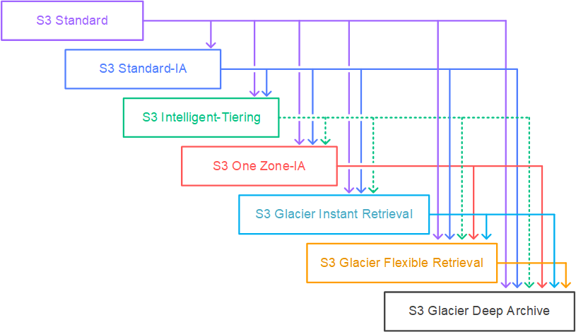
To move a file to a different storage class, you can use Amazon S3 or Amazon EFS. Both services have lifecycle configurations. Take note that Amazon EFS can only transition a file to the IA storage class after 90 days. Since you need to move the files that are older than 2 years to a more cost-effective and scalable solution, you should use the Amazon S3 lifecycle configuration. With S3 lifecycle rules, you can transition files to S3 Standard IA or S3 Glacier. Using S3 Glacier expedited retrieval, you can quickly access your files within 1-5 minutes.
Hence, the correct answers are:
– Use Amazon S3 and create a lifecycle policy that will move the objects to S3 Glacier after 2 years.
– Use Amazon S3 and create a lifecycle policy that will move the objects to S3 Standard-IA after 2 years.
The option that says: Use Amazon EFS and create a lifecycle policy that will move the objects to EFS-IA after 2 years is incorrect because the maximum days of EFS lifecycle policies is only up to 365 days. Therefore, it still does not meet the requirement of moving files older than 2 years or 730 days.
The option that says: Use Amazon EBS volumes to store the files. Configure the Amazon Data Lifecycle Manager (DLM) to schedule snapshots of the volumes after 2 years is incorrect simply because the Amazon EBS costs more and is not as scalable as Amazon S3. It has some limitations when accessed by multiple EC2 instances. There are also huge costs involved in using the multi-attach feature on a Provisioned IOPS EBS volume to allow multiple EC2 instances to access the volume.
The option that says: Use a RAID 0 storage configuration that stripes multiple Amazon EBS volumes together to store the files. Configure the Amazon Data Lifecycle Manager (DLM) to schedule snapshots of the volumes after 2 years is incorrect because RAID (Redundant Array of Independent Disks) is just a data storage virtualization technology that combines multiple storage devices to achieve higher performance or data durability. RAID 0 can stripe multiple volumes together for greater I/O performance than you can achieve with a single volume. On the other hand, RAID 1 can mirror two volumes together to achieve on-instance redundancy.

References:
https://docs.aws.amazon.com/AmazonS3/latest/dev/object-lifecycle-mgmt.html
https://docs.aws.amazon.com/efs/latest/ug/lifecycle-management-efs.html
https://docs.aws.amazon.com/efs/latest/ug/API_LifecyclePolicy.html
https://aws.amazon.com/s3/faqs/

Check out this Amazon S3 Cheat Sheet:
https://tutorialsdojo.com/amazon-s3/
- 43. Question
A company launched a cryptocurrency mining server on a Reserved EC2 instance in the us-east-1 region’s private subnet that uses IPv6. Due to the financial data that the server contains, the system should be secured to prevent any unauthorized access and to meet regulatory compliance requirements.
In this scenario, which VPC feature will allow the EC2 instance to communicate to the Internet but prevents inbound IPv6 traffic?
  - Egress-only Internet gateway
  - NAT Gateway
  - NAT instances
  - Internet Gateway
Correct
An egress-only Internet gateway is a horizontally scaled, redundant, and highly available VPC component that allows outbound communication over IPv6 from instances in your VPC to the Internet, and prevents the Internet from initiating an IPv6 connection with your instances.
Take note that an egress-only Internet gateway is for use with IPv6 traffic only. To enable outbound-only Internet communication over IPv4, use a NAT gateway instead.
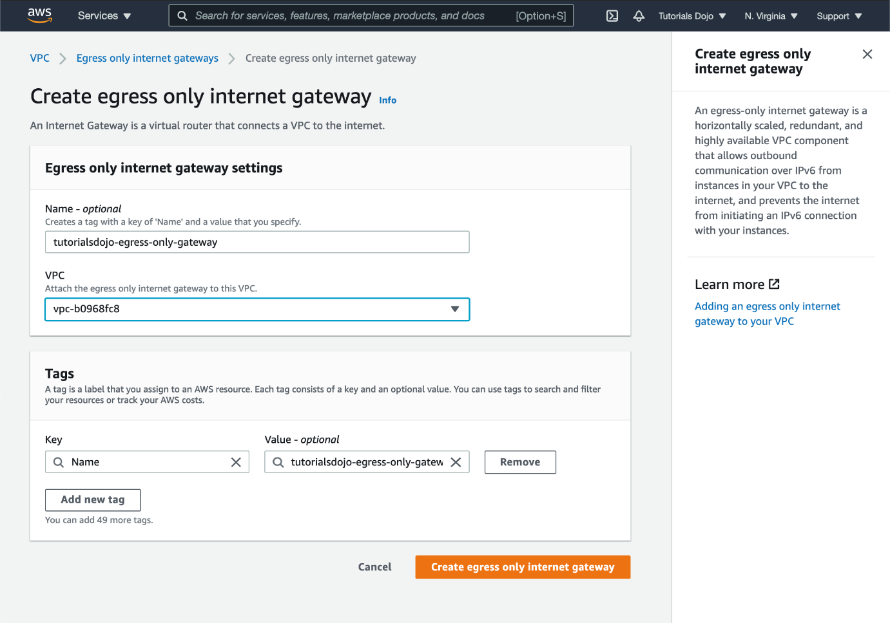
Hence, the correct answer is: Egress-only Internet gateway.
NAT Gateway and NAT instances are incorrect. Although NAT64, a feature that enables the communication between IPv6 and IPv4 hosts, may be supported by these components, they are unable to block inbound IPv6 traffic. Both NAT 64 and egress-only gateways can be used to enable outbound Internet connectivity, for instances in a VPC, but they differ in their support for inbound traffic and their handling of IPv4 and IPv6 addresses. The most suitable VPC component to use is the scenario is the egress-only Internet gateway.
Internet Gateway is incorrect because this is primarily used to provide Internet access to your instances in the public subnet of your VPC and NOT for private subnets. However, with an Internet gateway, traffic originating from the public Internet will also be able to reach your instances. The scenario is asking you to prevent inbound access, so this is not the correct answer.

Reference:
https://docs.aws.amazon.com/vpc/latest/userguide/egress-only-internet-gateway.html

Check out this Amazon VPC Cheat Sheet:
https://tutorialsdojo.com/amazon-vpc/
- 44. Question
A GraphQL API is hosted in an Amazon EKS cluster with AWS Fargate launch type and deployed using AWS SAM. The API is connected to an Amazon DynamoDB table with DynamoDB Accelerator (DAX) as its data store. Both resources are hosted in the us-east-1 region.
The AWS IAM authenticator for Kubernetes is integrated into the EKS cluster for role-based access control (RBAC) and cluster authentication. A solutions architect must improve network security by preventing database calls from traversing the public internet. An automated cross-account backup for the DynamoDB table is also required for long-term retention.
Which of the following should the solutions architect implement to meet the requirement?
  - Create a DynamoDB interface endpoint. Associate the endpoint to the appropriate route table. Enable Point-in-Time Recovery (PITR) to restore the DynamoDB table to a particular point in time on the same or a different AWS account.
  - Create a DynamoDB interface endpoint. Set up a stateless rule using AWS Network Firewall to control all outbound traffic to only use the dynamodb.us-east-1.amazonaws.com endpoint. Integrate the DynamoDB table with Amazon Timestream to allow point-in-time recovery from a different AWS account.
  - Create a DynamoDB gateway endpoint. Associate the endpoint to the appropriate route table. Use AWS Backup to automatically copy the on-demand DynamoDB backups to another AWS account for disaster recovery.
  - Create a DynamoDB gateway endpoint. Set up a Network Access Control List (NACL) rule that allows outbound traffic to the dynamodb.us-east-1.amazonaws.com gateway endpoint. Use the built-in on-demand DynamoDB backups for cross-account backup and recovery.
Correct
Since DynamoDB tables are public resources, applications within a VPC rely on an Internet Gateway to route traffic to/from Amazon DynamoDB. You can use a Gateway endpoint if you want to keep the traffic between your VPC and Amazon DynamoDB within the Amazon network. This way, resources residing in your VPC can use their private IP addresses to access DynamoDB with no exposure to the public internet.
When you create a DynamoDB Gateway endpoint, you specify the VPC where it will be deployed as well as the route table that will be associated with the endpoint. The route table will be updated with an Amazon DynamoDB prefix list (list of CIDR blocks) as the destination and the endpoint’s ID as the target.
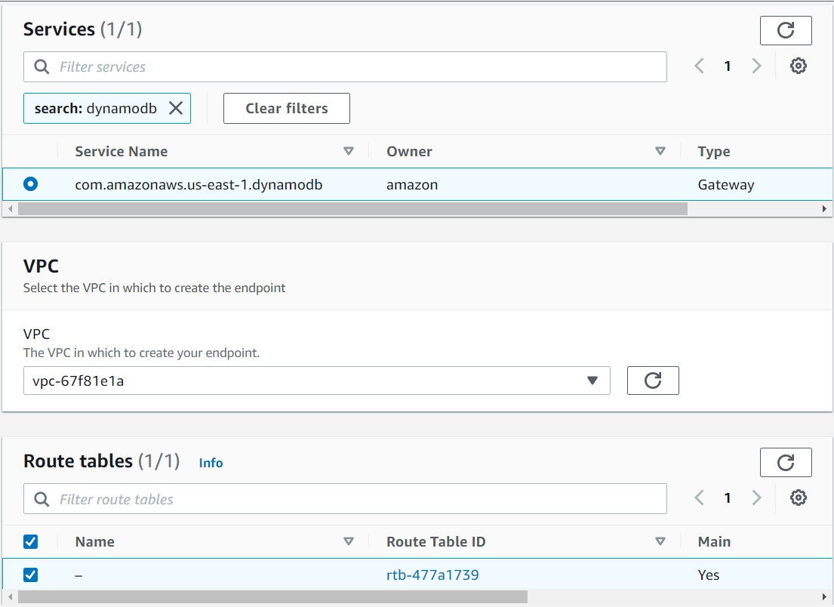
DynamoDB on-demand backups are available at no additional cost beyond the normal pricing that’s associated with backup storage size. DynamoDB on-demand backups cannot be copied to a different account or Region. To create backup copies across AWS accounts and Regions and for other advanced features, you should use AWS Backup.
With AWS Backup, you can configure backup policies and monitor activity for your AWS resources and on-premises workloads in one place. Using DynamoDB with AWS Backup, you can copy your on-demand backups across AWS accounts and Regions, add cost allocation tags to on-demand backups, and transition on-demand backups to cold storage for lower costs. To use these advanced features, you must opt into AWS Backup. Opt-in choices apply to the specific account and AWS Region, so you might have to opt into multiple Regions using the same account.
Hence, the correct answer is: Create a DynamoDB gateway endpoint. Associate the endpoint to the appropriate route table. Use AWS Backup to automatically copy the on-demand DynamoDB backups to another AWS account for disaster recovery.
The option that says: Create a DynamoDB interface endpoint. Associate the endpoint to the appropriate route table. Enable Point-in-Time Recovery (PITR) to restore the DynamoDB table to a particular point in time on the same or a different AWS account is incorrect. While this option addresses the network security requirement, Point-in-Time Recovery (PITR) is only used for restoring a DynamoDB table to a specific point in time within the same AWS account and region. It does not support cross-account backups or long-term retention. If this functionality is needed, you have to use the AWS Backup service instead.
The option that says: Create a DynamoDB gateway endpoint. Set up a Network Access Control List (NACL) rule that allows outbound traffic to the dynamodb.us-east-1.amazonaws.com gateway endpoint. Use the built-in on-demand DynamoDB backups for cross-account backup and recovery is incorrect because using a Network Access Control List alone is not enough to prevent traffic traversing to the public Internet. Moreover, you cannot copy DynamoDB on-demand backups to a different account or Region.
The option that says: Create a DynamoDB interface endpoint. Set up a stateless rule using AWS Network Firewall to control all outbound traffic to only use the dynamodb.us-east-1.amazonaws.com endpoint. Integrate the DynamoDB table with Amazon Timestream to allow point-in-time recovery from a different AWS account is incorrect. Keep in mind that the dynamodb.us-east-1.amazonaws.com is a public service endpoint for Amazon DynamoDB. Since the application is able to communicate with Amazon DynamoDB prior to the required architectural change, it’s implied that no firewalls (security group, NACL, etc.) are blocking traffic to/from Amazon DynamoDB, hence, adding an NACL rule to allow outbound traffic to DynamoDB is unnecessary. Furthermore, the use of the AWS Network Firewall in this solution is simply incorrect as you have to integrate this with your Amazon VPC. The use of Amazon Timestream is also wrong since this is a time series database service in AWS for IoT and operational applications. You cannot directly integrate DynamoDB and Amazon Timestream for the purpose of point-in-time data recovery.

References:
https://docs.aws.amazon.com/amazondynamodb/latest/developerguide/vpc-endpoints-dynamodb.html
https://aws.amazon.com/blogs/database/how-to-configure-a-private-network-environment-for-amazon-dynamodb-using-vpc-endpoints/
https://docs.aws.amazon.com/amazondynamodb/latest/developerguide/BackupRestore.html

Check out this Amazon DynamoDB Cheat sheet:
https://tutorialsdojo.com/amazon-dynamodb
- 45. Question
A solutions architect is instructed to host a website that consists of HTML, CSS, and some Javascript files. The web pages will display several high-resolution images. The website should have optimal loading times and be able to respond to high request rates.
Which of the following architectures can provide the most cost-effective and fastest loading experience?
  - Host the website in an AWS Elastic Beanstalk environment. Upload the images in an S3 bucket. Use CloudFront as a CDN to deliver the images closer to your end-users.
  - Launch an Auto Scaling Group using an AMI that has a pre-configured Apache web server, then configure the scaling policy accordingly. Store the images in an Elastic Block Store. Then, point your instance’s endpoint to AWS Global Accelerator.
  - Host the website using an Nginx server in an EC2 instance. Upload the images in an S3 bucket. Use CloudFront as a CDN to deliver the images closer to end-users.
  - Upload the HTML, CSS, Javascript, and the images in a single bucket. Then enable website hosting. Create a CloudFront distribution and point the domain on the S3 website endpoint.
Correct
Amazon S3 is an object storage service that offers industry-leading scalability, data availability, security, and performance. Additionally, You can use Amazon S3 to host a static website. On a static website, individual webpages include static content. Amazon S3 is highly scalable, and you only pay for what you use, you can start small and grow your application as you wish, with no compromise on performance or reliability.
Amazon CloudFront is a fast content delivery network (CDN) service that securely delivers data, videos, applications, and APIs to customers globally with low latency, high transfer speeds. CloudFront can be integrated with Amazon S3 for fast delivery of data originating from an S3 bucket to your end-users. By design, delivering data out of CloudFront can be more cost-effective than delivering it from S3 directly to your users.
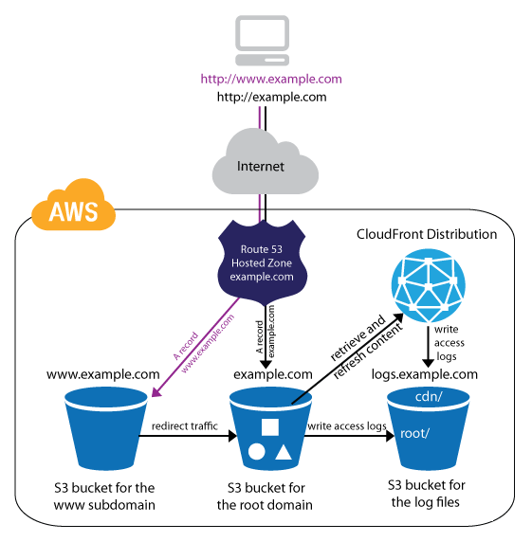
In the scenario, Since we are only dealing with static content, we can leverage the web hosting feature of S3. Then we can improve the architecture further by integrating it with CloudFront. This way, users will be able to load both the web pages and images faster than if we hosted them on a webserver that we built from scratch.
Hence, the correct answer is: Upload the HTML, CSS, Javascript, and the images in a single bucket. Then enable website hosting. Create a CloudFront distribution and point the domain on the S3 website endpoint.
The option that says: Host the website using an Nginx server in an EC2 instance. Upload the images in an S3 bucket. Use CloudFront as a CDN to deliver the images closer to end-users is incorrect. Creating your own web server to host a static website in AWS is a costly solution. Web Servers on an EC2 instance are usually used for hosting applications that require server-side processing (connecting to a database, data validation, etc.). Since static websites contain web pages with fixed content, we should use S3 website hosting instead.
The option that says: Launch an Auto Scaling Group using an AMI that has a pre-configured Apache web server, then configure the scaling policy accordingly. Store the images in an Elastic Block Store. Then, point your instance’s endpoint to AWS Global Accelerator is incorrect. This is how we serve static websites in the old days. Now, with the help of S3 website hosting, we can host our static contents from a durable, high-availability, and highly scalable environment without managing any servers. Hosting static websites in S3 is cheaper than hosting it in an EC2 instance. In addition, Using ASG for scaling instances that host a static website is an over-engineered solution that carries unnecessary costs. S3 automatically scales to high requests and you only pay for what you use.
The option that says: Host the website in an AWS Elastic Beanstalk environment. Upload the images in an S3 bucket. Use CloudFront as a CDN to deliver the images closer to your end-users is incorrect. AWS Elastic Beanstalk simply sets up the infrastructure (EC2 instance, load balancer, auto-scaling group) for your application. It’s a more expensive and a bit of an overkill solution for hosting a bunch of client-side files.

References:
https://docs.aws.amazon.com/AmazonS3/latest/dev/WebsiteHosting.html
https://aws.amazon.com/blogs/networking-and-content-delivery/amazon-s3-amazon-cloudfront-a-match-made-in-the-cloud/

Check out these Amazon S3 and CloudFront Cheat Sheets:
https://tutorialsdojo.com/amazon-s3/
https://tutorialsdojo.com/amazon-cloudfront/
- 46. Question
A Solutions Architect is working for an online hotel booking firm with terabytes of customer data coming from the websites and applications. There is an annual corporate meeting where the Architect needs to present the booking behaviour and acquire new insights from the customers’ data. The Architect is looking for a service to perform super-fast analytics on massive data sets in near real-time.
Which of the following services gives the Architect the ability to store huge amounts of data and perform quick and flexible queries on it?
  - Amazon ElastiCache
  - Amazon DynamoDB
  - Amazon RDS
  - Amazon Redshift
Correct
Amazon Redshift is a fast, scalable data warehouse that makes it simple and cost-effective to analyze all your data across your data warehouse and data lake. Redshift delivers ten times faster performance than other data warehouses by using machine learning, massively parallel query execution, and columnar storage on a high-performance disk.
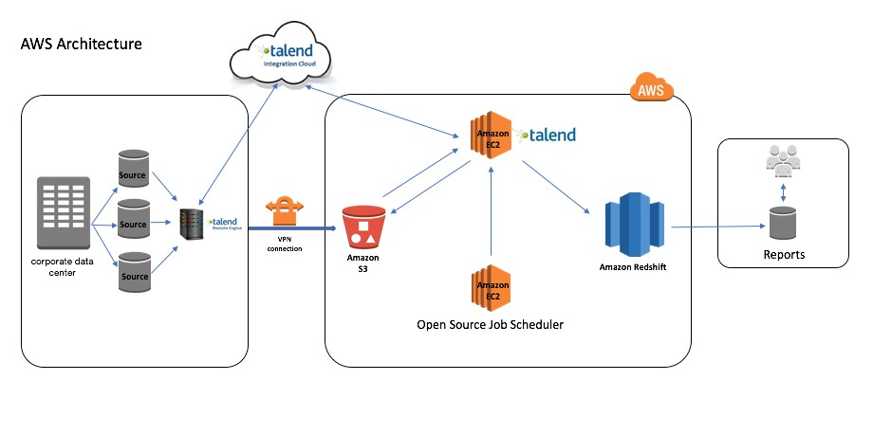
You can use Redshift to analyze all your data using standard SQL and your existing Business Intelligence (BI) tools. It also allows you to run complex analytic queries against terabytes to petabytes of structured and semi-structured data, using sophisticated query optimization, columnar storage on high-performance storage, and massively parallel query execution.
Hence, the correct answer is Amazon Redshift.
Amazon DynamoDB is incorrect because DynamoDB is a NoSQL database that is based on key-value pairs used for fast processing of small data that dynamically grows and changes. But if you need to scan large amounts of data (i.e., a lot of keys all in one query), the performance will not be optimal.
Amazon ElastiCache is incorrect because this is used to increase the performance, speed, and redundancy with which applications can retrieve data by providing an in-memory database caching system, and not for database analytical processes.
Amazon RDS is incorrect because this is mainly used for On-Line Transaction Processing (OLTP) applications and not for Online Analytics Processing (OLAP).

References:
https://docs.aws.amazon.com/redshift/latest/mgmt/welcome.html
https://docs.aws.amazon.com/redshift/latest/gsg/getting-started.html

Amazon Redshift Overview:
Check out this Amazon Redshift Cheat Sheet:
https://tutorialsdojo.com/amazon-redshift/
- 47. Question
A company plans to migrate all of their applications to AWS. The Solutions Architect suggested to store all the data to EBS volumes. The Chief Technical Officer is worried that EBS volumes are not appropriate for the existing workloads due to compliance requirements, downtime scenarios, and IOPS performance.
Which of the following are valid points in proving that EBS is the best service to use for migration? (Select TWO.)
  - EBS volumes support live configuration changes while in production which means that you can modify the volume type, volume size, and IOPS capacity without service interruptions.
  - EBS volumes can be attached to any EC2 Instance in any Availability Zone.
  - When you create an EBS volume in an Availability Zone, it is automatically replicated on a separate AWS region to prevent data loss due to a failure of any single hardware component.
  - An EBS volume is off-instance storage that can persist independently from the life of an instance.
  - Amazon EBS provides the ability to create snapshots (backups) of any EBS volume and write a copy of the data in the volume to Amazon RDS, where it is stored redundantly in multiple Availability Zones
Incorrect
An Amazon EBS volume is a durable, block-level storage device that you can attach to a single EC2 instance. You can use EBS volumes as primary storage for data that requires frequent updates, such as the system drive for an instance or storage for a database application. You can also use them for throughput-intensive applications that perform continuous disk scans. EBS volumes persist independently from the running life of an EC2 instance.
Here is a list of important information about EBS Volumes:
– When you create an EBS volume in an Availability Zone, it is automatically replicated within that zone to prevent data loss due to a failure of any single hardware component.
– After you create a volume, you can attach it to any EC2 instance in the same Availability Zone
– Amazon EBS Multi-Attach enables you to attach a single Provisioned IOPS SSD (io1) volume to multiple Nitro-based instances that are in the same Availability Zone. However, other EBS types are not supported.
– An EBS volume is off-instance storage that can persist independently from the life of an instance. You can specify not to terminate the EBS volume when you terminate the EC2 instance during instance creation.
– EBS volumes support live configuration changes while in production which means that you can modify the volume type, volume size, and IOPS capacity without service interruptions.
– Amazon EBS encryption uses 256-bit Advanced Encryption Standard algorithms (AES-256)
– EBS Volumes offer 99.999% SLA.
The option that says: When you create an EBS volume in an Availability Zone, it is automatically replicated on a separate AWS region to prevent data loss due to a failure of any single hardware component is incorrect because when you create an EBS volume in an Availability Zone, it is automatically replicated within that zone only, and not on a separate AWS region, to prevent data loss due to a failure of any single hardware component.
The option that says: EBS volumes can be attached to any EC2 Instance in any Availability Zone is incorrect as EBS volumes can only be attached to an EC2 instance in the same Availability Zone.
The option that says: Amazon EBS provides the ability to create snapshots (backups) of any EBS volume and write a copy of the data in the volume to Amazon RDS, where it is stored redundantly in multiple Availability Zones is almost correct. But instead of storing the volume to Amazon RDS, the EBS Volume snapshots are actually sent to Amazon S3.

References:
http://docs.aws.amazon.com/AWSEC2/latest/UserGuide/EBSVolumes.html
https://aws.amazon.com/ebs/features/

Check out this Amazon EBS Cheat Sheet:
https://tutorialsdojo.com/aws-cheat-sheet-amazon-ebs/

Here is a short video tutorial on EBS:
- 48. Question
A company has a High Performance Computing (HPC) cluster that is composed of EC2 Instances with Provisioned IOPS (io1) volume to process transaction-intensive, low-latency workloads. The Solutions Architect must maintain high IOPS while keeping the latency down by setting the optimal queue length for the volume. The size of each volume is 10 GiB.
Which of the following is the MOST suitable configuration that the Architect should set up?
  - Set the IOPS to 600 then maintain a high queue length.
  - Set the IOPS to 500 then maintain a low queue length.
  - Set the IOPS to 400 then maintain a low queue length.
  - Set the IOPS to 800 then maintain a low queue length.
Incorrect
Provisioned IOPS SSD (io1) volumes are designed to meet the needs of I/O-intensive workloads, particularly database workloads, that are sensitive to storage performance and consistency. Unlike gp2, which uses a bucket and credit model to calculate performance, an io1 volume allows you to specify a consistent IOPS rate when you create the volume, and Amazon EBS delivers within 10 percent of the provisioned IOPS performance 99.9 percent of the time over a given year.
An io1 volume can range in size from 4 GiB to 16 TiB. You can provision from 100 IOPS up to 64,000 IOPS per volume on Nitro system instance families and up to 32,000 on other instance families. The maximum ratio of provisioned IOPS to the requested volume size (in GiB) is 50:1.
For example, a 100 GiB volume can be provisioned with up to 5,000 IOPS. On a supported instance type, any volume 1,280 GiB in size or greater allows provisioning up to the 64,000 IOPS maximum (50 × 1,280 GiB = 64,000).
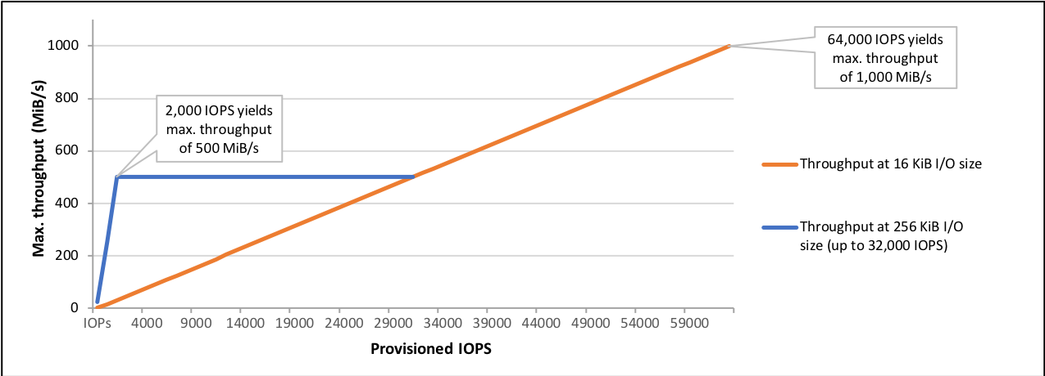
An io1 volume provisioned with up to 32,000 IOPS supports a maximum I/O size of 256 KiB and yields as much as 500 MiB/s of throughput. With the I/O size at the maximum, peak throughput is reached at 2,000 IOPS. A volume provisioned with more than 32,000 IOPS (up to the cap of 64,000 IOPS) supports a maximum I/O size of 16 KiB and yields as much as 1,000 MiB/s of throughput.
The volume queue length is the number of pending I/O requests for a device. Latency is the true end-to-end client time of an I/O operation, in other words, the time elapsed between sending an I/O to EBS and receiving an acknowledgment from EBS that the I/O read or write is complete. Queue length must be correctly calibrated with I/O size and latency to avoid creating bottlenecks either on the guest operating system or on the network link to EBS.
Optimal queue length varies for each workload, depending on your particular application’s sensitivity to IOPS and latency. If your workload is not delivering enough I/O requests to fully use the performance available to your EBS volume, then your volume might not deliver the IOPS or throughput that you have provisioned.
Transaction-intensive applications are sensitive to increased I/O latency and are well-suited for SSD-backed io1 and gp2 volumes. You can maintain high IOPS while keeping latency down by maintaining a low queue length and a high number of IOPS available to the volume. Consistently driving more IOPS to a volume than it has available can cause increased I/O latency.
Throughput-intensive applications are less sensitive to increased I/O latency and are well-suited for HDD-backed st1 and sc1 volumes. You can maintain high throughput to HDD-backed volumes by maintaining a high queue length when performing large, sequential I/O.
Therefore, for instance, a 10 GiB volume can be provisioned with up to 500 IOPS. Any volume 640 GiB in size or greater allows provisioning up to a maximum of 32,000 IOPS (50 × 640 GiB = 32,000). Hence, the correct answer is to set the IOPS to 500 then maintain a low queue length.
Setting the IOPS to 400 then maintaining a low queue length is incorrect. Although a value of 400 is an acceptable value, it is not the maximum value for the IOPS. You will not fully utilize the available IOPS that the volume can offer if you just set it to 400.
The options that say: Set the IOPS to 600 then maintain a high queue length and Set the IOPS to 800 then maintain a low queue length are both incorrect because the maximum IOPS for the 10 GiB volume is only 500. Therefore, any value greater than the maximum amount, such as 600 or 800, is wrong. Moreover, you should keep the latency down by maintaining a low queue length, and not higher.

References:
http://docs.aws.amazon.com/AWSEC2/latest/UserGuide/EBSVolumeTypes.html
https://docs.aws.amazon.com/AWSEC2/latest/UserGuide/ebs-io-characteristics.html

Check out this Amazon EBS Cheat Sheet:
https://tutorialsdojo.com/amazon-ebs/
- 49. Question
A company has an application hosted in an Amazon ECS Cluster behind an Application Load Balancer. The Solutions Architect is building a sophisticated web filtering solution that allows or blocks web requests based on the country that the requests originate from. However, the solution should still allow specific IP addresses from that country.
Which combination of steps should the Architect implement to satisfy this requirement? (Select TWO.)
  - In the Application Load Balancer, create a listener rule that explicitly allows requests from approved IP addresses.
  - Using AWS WAF, create a web ACL with a rule that explicitly allows requests from approved IP addresses declared in an IP Set.
  - Add another rule in the AWS WAF web ACL with a geo match condition that blocks requests that originate from a specific country.
  - Place a Transit Gateway in front of the VPC where the application is hosted and set up Network ACLs that block requests that originate from a specific country.
  - Set up a geo match condition in the Application Load Balancer that blocks requests from a specific country.
Incorrect
If you want to allow or block web requests based on the country that the requests originate from, create one or more geo-match conditions. A geo match condition lists countries that your requests originate from. Later in the process, when you create a web ACL, you specify whether to allow or block requests from those countries.
You can use geo-match conditions with other AWS WAF Classic conditions or rules to build sophisticated filtering. For example, if you want to block certain countries but still allow specific IP addresses from that country, you could create a rule containing a geo match condition and an IP match condition. Configure the rule to block requests that originate from that country and do not match the approved IP addresses. As another example, if you want to prioritize resources for users in a particular country, you could include a geo-match condition in two different rate-based rules. Set a higher rate limit for users in the preferred country and set a lower rate limit for all other users.
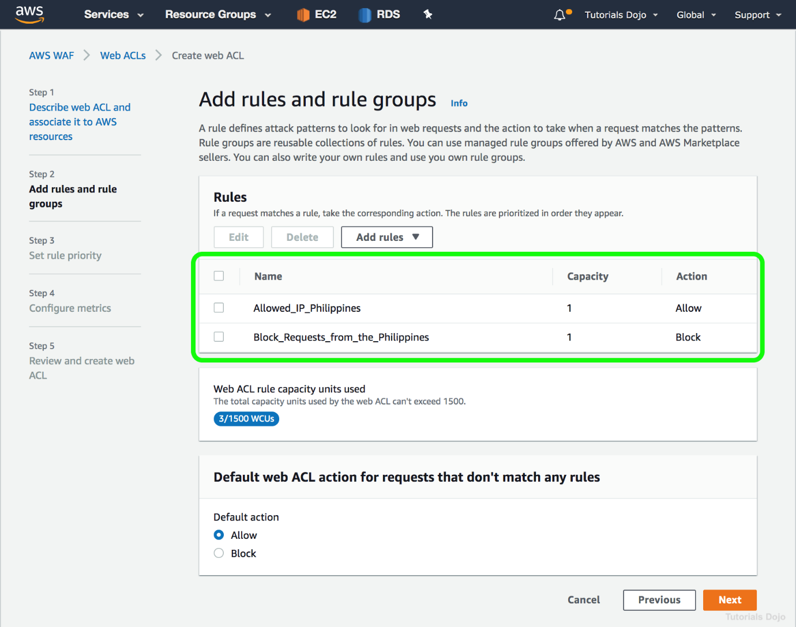
If you are using the CloudFront geo restriction feature to block a country from accessing your content, any request from that country is blocked and is not forwarded to AWS WAF Classic. So if you want to allow or block requests based on geography plus other AWS WAF Classic conditions, you should not use the CloudFront geo restriction feature. Instead, you should use an AWS WAF Classic geo match condition.
Hence, the correct answers are:
– Using AWS WAF, create a web ACL with a rule that explicitly allows requests from approved IP addresses declared in an IP Set.
– Add another rule in the AWS WAF web ACL with a geo match condition that blocks requests that originate from a specific country.
The option that says: In the Application Load Balancer, create a listener rule that explicitly allows requests from approved IP addresses is incorrect because a listener rule just checks for connection requests using the protocol and port that you configure. It only determines how the load balancer routes the requests to its registered targets.
The option that says: Set up a geo match condition in the Application Load Balancer that block requests that originate from a specific country is incorrect because you can’t configure a geo match condition in an Application Load Balancer. You have to use AWS WAF instead.
The option that says: Place a Transit Gateway in front of the VPC where the application is hosted and set up Network ACLs that block requests that originate from a specific country is incorrect because AWS Transit Gateway is simply a service that enables customers to connect their Amazon Virtual Private Clouds (VPCs) and their on-premises networks to a single gateway. Using this type of gateway is not warranted in this scenario. Moreover, Network ACLs are not suitable for blocking requests from a specific country. You have to use AWS WAF instead.

References:
https://docs.aws.amazon.com/waf/latest/developerguide/classic-web-acl-geo-conditions.html
https://docs.aws.amazon.com/waf/latest/developerguide/how-aws-waf-works.html

Check out this AWS WAF Cheat Sheet:
https://tutorialsdojo.com/aws-waf/
- 50. Question
A company needs to use Amazon Aurora as the Amazon RDS database engine of their web application. The Solutions Architect has been instructed to implement a 90-day backup retention policy.
Which of the following options can satisfy the given requirement?
  - Configure RDS to export the automated snapshot automatically to Amazon S3 and create a lifecycle policy to delete the object after 90 days.
  - Create an AWS Backup plan to take daily snapshots with a retention period of 90 days.
  - Create a daily scheduled event using CloudWatch Events and AWS Lambda to directly download the RDS automated snapshot to an S3 bucket. Archive snapshots older than 90 days to Glacier.
  - Configure an automated backup and set the backup retention period to 90 days.
Incorrect
AWS Backup is a centralized backup service that makes it easy and cost-effective for you to backup your application data across AWS services in the AWS Cloud, helping you meet your business and regulatory backup compliance requirements. AWS Backup makes protecting your AWS storage volumes, databases, and file systems simple by providing a central place where you can configure and audit the AWS resources you want to backup, automate backup scheduling, set retention policies, and monitor all recent backup and restore activity.
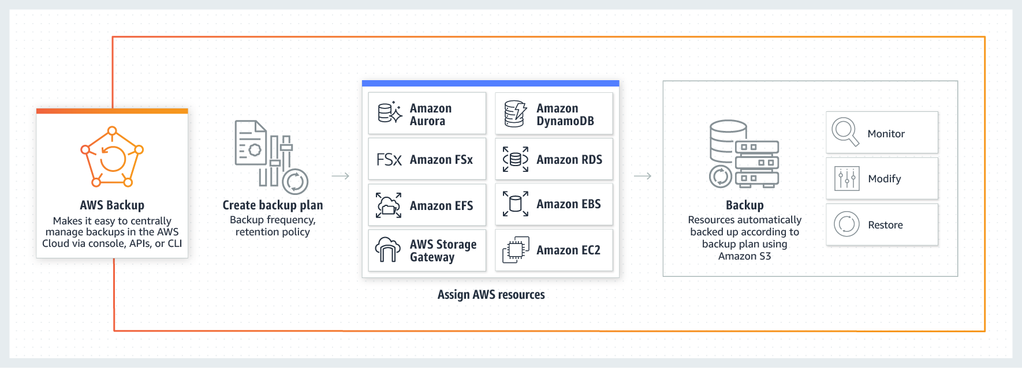
In this scenario, you can use AWS Backup to create a backup plan with a retention period of 90 days. A backup plan is a policy expression that defines when and how you want to back up your AWS resources. You assign resources to backup plans, and AWS Backup then automatically backs up and retains backups for those resources according to the backup plan.
Hence, the correct answer is: Create an AWS Backup plan to take daily snapshots with a retention period of 90 days.
The option that says: Configure an automated backup and set the backup retention period to 90 days is incorrect because the maximum backup retention period for automated backup is only 35 days.
The option that says: Configure RDS to export the automated snapshot automatically to Amazon S3 and create a lifecycle policy to delete the object after 90 days is incorrect because you can’t export an automated snapshot automatically to Amazon S3. You must export the snapshot manually.
The option that says: Create a daily scheduled event using CloudWatch Events and AWS Lambda to directly download the RDS automated snapshot to an S3 bucket. Archive snapshots older than 90 days to Glacier is incorrect because you cannot directly download or export an automated snapshot in RDS to Amazon S3. You have to copy the automated snapshot first for it to become a manual snapshot, which you can move to an Amazon S3 bucket. A better solution for this scenario is to simply use AWS Backup.

References:
https://docs.aws.amazon.com/aws-backup/latest/devguide/create-a-scheduled-backup.html
https://aws.amazon.com/backup/faqs/

Check out these AWS Cheat Sheets:
https://tutorialsdojo.com/links-to-all-aws-cheat-sheets/
- 51. Question
A company is experiencing repeated outages in the Availability Zone where its Amazon RDS database instance is deployed, resulting in a complete loss of access to the database during each incident.
Which solution should be implemented to prevent losing database access if this occurs again?
  - Make a snapshot of the database
  - Increase the database instance size
  - Create a read replica
  - Enable Multi-AZ failover
Correct
Amazon RDS Multi-AZ deployments are designed to enhance the availability and durability of database instances, making them well-suited for production workloads. When you enable Multi-AZ failover, Amazon RDS automatically creates a standby replica in a different Availability Zone (AZ) and synchronously replicates data from the primary instance. This ensures high data consistency and protection against infrastructure-related disruptions. Each AZ operates on physically distinct infrastructure, which adds fault isolation and resilience.
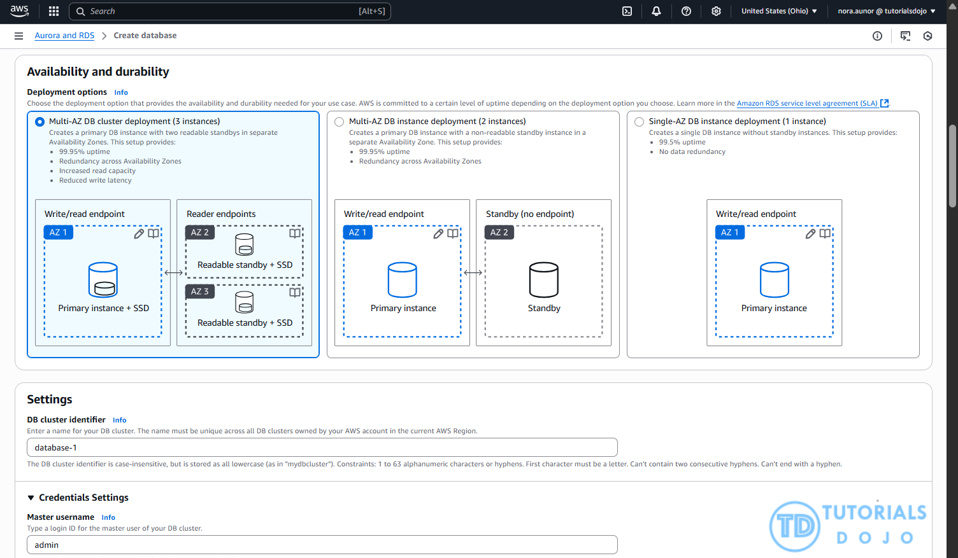
In the event of planned maintenance or an unexpected failure such as an Availability Zone outage or hardware issue, Amazon RDS automatically performs a failover to the standby instance. This process is fully managed by Amazon RDS and does not require manual intervention, helping to minimize downtime and maintain business continuity. For Amazon Aurora, the failover involves promoting a replica to become the new writer instance.
Hence, the correct answer is: Enable Multi-AZ failover.
The option that says: Make a snapshot of the database is incorrect because snapshots are typically used for backup and disaster recovery, not for maintaining high availability. A snapshot allows you to restore a database to a specific point in time, but it does not prevent downtime or provide continuous access during an Availability Zone outage.
The option that says: Increase the database instance size is incorrect because this action just improves the instance’s compute and memory capacity, which may help performance but does not address Availability Zone-level failures. The database would still be a single point of failure within the same zone, leaving it vulnerable to the same type of outage described in the question.
The option that says: Create a read replica is incorrect because read replicas are primarily intended to handle read-heavy workloads and do not automatically take over in the event of a failure. Promoting a read replica to a standalone instance requires manual intervention, which simply does not meet the goal of preventing loss of access during unplanned outages.

References:
https://aws.amazon.com/rds/features/multi-az/
https://docs.aws.amazon.com/AmazonRDS/latest/UserGuide/Concepts.MultiAZ.html

Check out this Amazon RDS Cheat Sheet:
https://tutorialsdojo.com/amazon-relational-database-service-amazon-rds/

Tutorials Dojo’s AWS Certified Solutions Architect Associate Exam Study Guide:
https://tutorialsdojo.com/aws-certified-solutions-architect-associate-saa-c03/
- 52. Question
A large multinational investment bank has a web application that requires a minimum of 4 EC2 instances to run to ensure that it can cater to its users across the globe. You are instructed to ensure fault tolerance of this system.
Which of the following is the best option?
  - Deploy an Auto Scaling group with 2 instances in each of 2 Availability Zones behind an Application Load Balancer.
  - Deploy an Auto Scaling group with 2 instances in each of 3 Availability Zones behind an Application Load Balancer.
  - Deploy an Auto Scaling group with 1 instance in each of 4 Availability Zones behind an Application Load Balancer.
  - Deploy an Auto Scaling group with 4 instances in one Availability Zone behind an Application Load Balancer.
Incorrect
Fault Tolerance is the ability of a system to remain in operation even if some of the components used to build the system fail. In AWS, this means that in the event of server fault or system failures, the number of running EC2 instances should not fall below the minimum number of instances required by the system for it to work properly. So if the application requires a minimum of 4 instances, there should be at least 4 instances running in case there is an outage in one of the Availability Zones or if there are server issues.
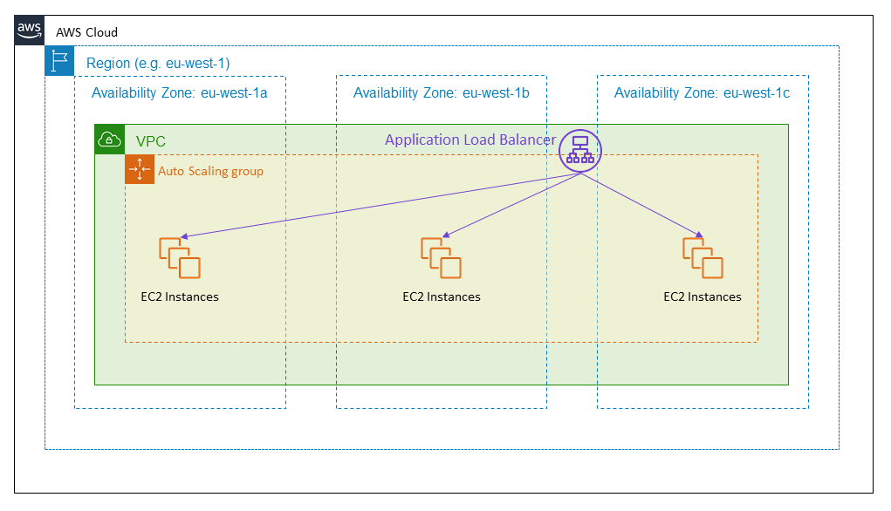
One of the differences between Fault Tolerance and High Availability is that the former refers to the minimum number of running instances. For example, you have a system that requires a minimum of 4 running instances and currently has 6 running instances deployed in two Availability Zones. There was a component failure in one of the Availability Zones which knocks out 3 instances. In this case, the system can still be regarded as Highly Available since there are still instances running that can accommodate the requests. However, it is not Fault-Tolerant since the required minimum of four instances has not been met.
Hence, the correct answer is: Deploy an Auto Scaling group with 2 instances in each of 3 Availability Zones behind an Application Load Balancer.
The option that says: Deploy an Auto Scaling group with 2 instances in each of 2 Availability Zones behind an Application Load Balancer is incorrect because if one Availability Zone went out, there will only be 2 running instances available out of the required 4 minimum instances. Although the Auto Scaling group can spin up another 2 instances, the fault tolerance of the web application has already been compromised.
The option that says: Deploy an Auto Scaling group with 4 instances in one Availability Zone behind an Application Load Balancer is incorrect because if the Availability Zone went out, there will be no running instance available to accommodate the request.
The option that says: Deploy an Auto Scaling group with 1 instance in each of 4 Availability Zones behind an Application Load Balancer is incorrect because if one Availability Zone went out, there will only be 3 instances available to accommodate the request.

References:
https://media.amazonwebservices.com/AWS_Building_Fault_Tolerant_Applications.pdf
https://d1.awsstatic.com/whitepapers/aws-building-fault-tolerant-applications.pdf

AWS Overview Cheat Sheets:
https://tutorialsdojo.com/aws-cheat-sheets-overview/

Tutorials Dojo’s AWS Certified Solutions Architect Associate Exam Study Guide:
https://tutorialsdojo.com/aws-certified-solutions-architect-associate/
- 53. Question
A company has several microservices that send messages to an Amazon SQS queue and a backend application that poll the queue to process the messages. The company also has a Service Level Agreement (SLA) which defines the acceptable amount of time that can elapse from the point when the messages are received until a response is sent. The backend operations are I/O-intensive as the number of messages is constantly growing, causing the company to miss its SLA. The Solutions Architect must implement a new architecture that improves the application’s processing time and load management.
Which of the following is the MOST effective solution that can satisfy the given requirement?
  - Create an AMI of the backend application's EC2 instance and launch it to a cluster placement group.
  - Create an AMI of the backend application’s EC2 instance. Use the image to set up an Auto Scaling group and configure a target tracking scaling policy based on the CPUUtilization metric with a target value of 80%.
  - Create an AMI of the backend application’s EC2 instance. Use the image to set up an Auto Scaling group and configure a target tracking scaling policy based on the ApproximateAgeOfOldestMessage metric.
  - Create an AMI of the backend application's EC2 instance and replace it with a larger instance size.
Incorrect
Amazon Simple Queue Service (SQS) is a fully managed message queuing service that enables you to decouple and scale microservices, distributed systems, and serverless applications. SQS eliminates the complexity and overhead associated with managing and operating message-oriented middleware and empowers developers to focus on differentiating work. Using SQS, you can send, store, and receive messages between software components at any volume, without losing messages or requiring other services to be available.
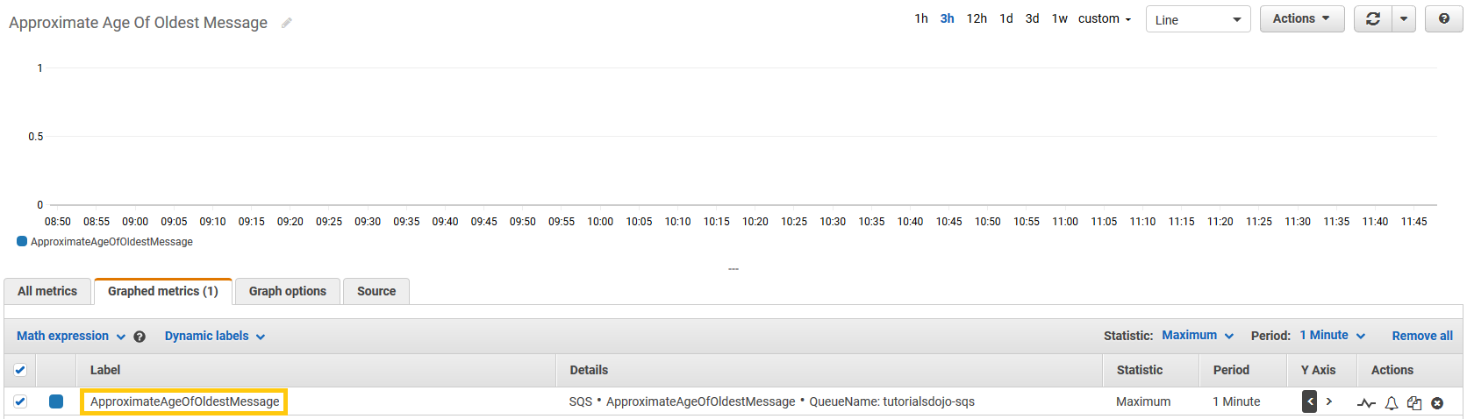
The ApproximateAgeOfOldestMessage metric is useful when applications have time-sensitive messages and you need to ensure that messages are processed within a specific time period. You can use this metric to set Amazon CloudWatch alarms that issue alerts when messages remain in the queue for extended periods of time. You can also use alerts to take action, such as increasing the number of consumers to process messages more quickly.
With a target tracking scaling policy, you can scale (increase or decrease capacity) a resource based on a target value for a specific CloudWatch metric. To create a custom metric for this policy, you need to use AWS CLI or AWS SDKs. Take note that you need to create an AMI from the instance first before you can create an Auto Scaling group to scale the instances based on the ApproximateAgeOfOldestMessage metric.
Hence, the correct answer is: Create an AMI of the backend application’s EC2 instance. Use the image to set up an Auto Scaling Group and configure a target tracking scaling policy based on the ApproximateAgeOfOldestMessage metric.
The option that says: Create an AMI of the backend application’s EC2 instance. Use the image to set up an Auto Scaling Group and configure a target tracking scaling policy based on the CPUUtilization metric with a target value of 80% is incorrect. Although this will improve the backend processing, the scaling policy based on the CPUUtilization metric is not meant for time-sensitive messages where you need to ensure that the messages are processed within a specific time period. It will only trigger the scale-out activities based on the CPU Utilization of the current instances, and not based on the age of the message, which is a crucial factor in meeting the SLA. To satisfy the requirement in the scenario, you should use the ApproximateAgeOfOldestMessage metric.
The option that says: Create an AMI of the backend application’s EC2 instance and replace it with a larger instance size is incorrect because replacing the instance with a large size won’t be enough to dynamically handle workloads at any level. You need to implement an Auto Scaling group to automatically adjust the capacity of your computing resources.
The option that says: Create an AMI of the backend application’s EC2 instance and launch it to a cluster placement group is incorrect because a cluster placement group is just a logical grouping of EC2 instances. Instead of launching the instance in a placement group, you must set up an Auto Scaling group for your EC2 instances and configure a target tracking scaling policy based on the ApproximateAgeOfOldestMessage metric.

References:
https://aws.amazon.com/about-aws/whats-new/2016/08/new-amazon-cloudwatch-metric-for-amazon-sqs-monitors-the-age-of-the-oldest-message/
https://docs.aws.amazon.com/AWSSimpleQueueService/latest/SQSDeveloperGuide/sqs-available-cloudwatch-metrics.html
https://docs.aws.amazon.com/autoscaling/ec2/userguide/as-using-sqs-queue.html

Check out this Amazon SQS Cheat Sheet:
https://tutorialsdojo.com/amazon-sqs/
- 54. Question
A company has a cryptocurrency exchange portal that is hosted in an Auto Scaling group of EC2 instances behind an Application Load Balancer and is deployed across multiple AWS regions. The users can be found all around the globe, but the majority are from Japan and Sweden. Because of the compliance requirements in these two locations, you want the Japanese users to connect to the servers in the ap-northeast-1 Asia Pacific (Tokyo) region, while the Swedish users should be connected to the servers in the eu-west-1 EU (Ireland) region.
Which of the following services would allow you to easily fulfill this requirement?
  - Set up a new CloudFront web distribution with the geo-restriction feature enabled.
  - Use Route 53 Weighted Routing policy.
  - Use Route 53 Geolocation Routing policy.
  - Set up an Application Load Balancers that will automatically route the traffic to the proper AWS region.
Correct
Geolocation routing lets you choose the resources that serve your traffic based on the geographic location of your users, meaning the location that DNS queries originate from. For example, you might want all queries from Europe to be routed to an ELB load balancer in the Frankfurt region.
When you use geolocation routing, you can localize your content and present some or all of your website in the language of your users. You can also use geolocation routing to restrict the distribution of content to only the locations in which you have distribution rights. Another possible use is for balancing load across endpoints in a predictable, easy-to-manage way so that each user location is consistently routed to the same endpoint.
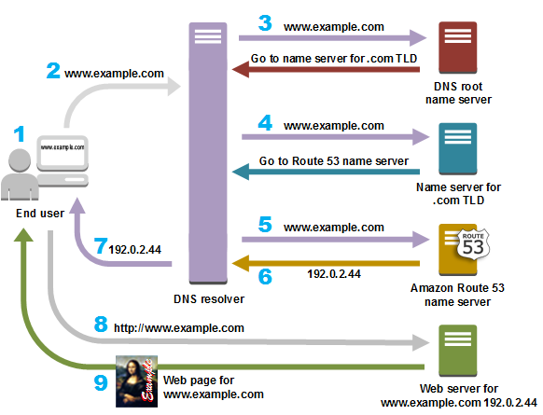
Setting up an Application Load Balancers that will automatically route the traffic to the proper AWS region is incorrect because Elastic Load Balancers distribute traffic among EC2 instances across multiple Availability Zones but not across AWS regions.
Setting up a new CloudFront web distribution with the geo-restriction feature enabled is incorrect because the CloudFront geo-restriction feature is primarily used to prevent users in specific geographic locations from accessing content that you’re distributing through a CloudFront web distribution. It does not let you choose the resources that serve your traffic based on the geographic location of your users, unlike the Geolocation routing policy in Route 53.
Using Route 53 Weighted Routing policy is incorrect because this is not a suitable solution to meet the requirements of this scenario. It just lets you associate multiple resources with a single domain name (tutorialsdojo.com) or subdomain name (forums.tutorialsdojo.com) and choose how much traffic is routed to each resource. You have to use a Geolocation routing policy instead.

References:
https://docs.aws.amazon.com/Route53/latest/DeveloperGuide/routing-policy.html
https://aws.amazon.com/premiumsupport/knowledge-center/geolocation-routing-policy

Check out this Amazon Route 53 Cheat Sheet:
https://tutorialsdojo.com/amazon-route-53/

Latency Routing vs. Geoproximity Routing vs. Geolocation Routing:
https://tutorialsdojo.com/latency-routing-vs-geoproximity-routing-vs-geolocation-routing/

Comparison of AWS Services Cheat Sheets:
https://tutorialsdojo.com/comparison-of-aws-services/
- 55. Question
A company has two On-Demand EC2 instances inside the Virtual Private Cloud in the same Availability Zone but are deployed to different subnets. One EC2 instance is running a database and the other EC2 instance a web application that connects with the database. You need to ensure that these two instances can communicate with each other for the system to work properly.
What are the things you have to check so that these EC2 instances can communicate inside the VPC? (Select TWO.)
  - Check the Network ACL if it allows communication between the two subnets.
  - Check if both instances are the same instance class.
  - Check if the default route is set to a NAT instance or Internet Gateway (IGW) for them to communicate.
  - Check if all security groups are set to allow the application host to communicate to the database on the right port and protocol.
  - Ensure that the EC2 instances are in the same Placement Group.
Incorrect
First, the Network ACL should be properly set to allow communication between the two subnets. The security group should also be properly configured so that your web server can communicate with the database server.
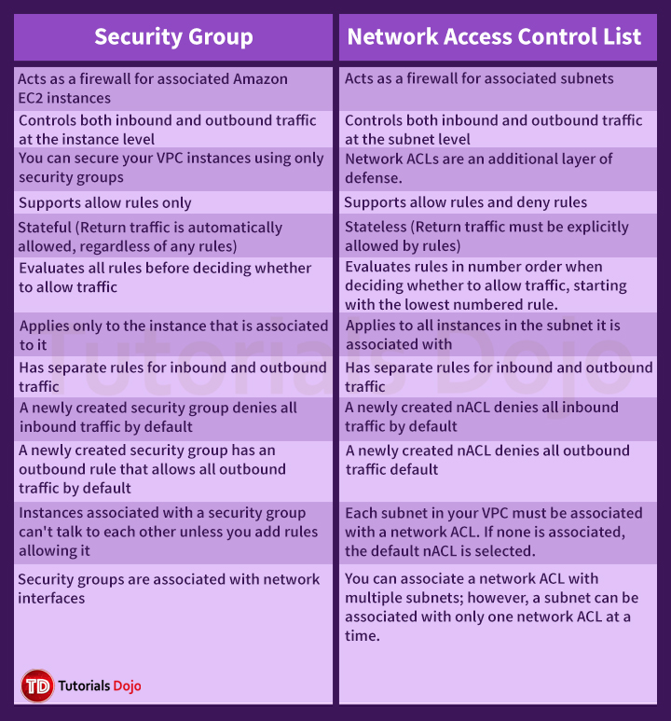
Hence, these are the correct answers:
  - Check if all security groups are set to allow the application host to communicate to the database on the right port and protocol.
  - Check the Network ACL if it allows communication between the two subnets.
The option that says: Check if both instances are the same instance class is incorrect because the EC2 instances do not need to be of the same class in order to communicate with each other.
The option that says: Check if the default route is set to a NAT instance or Internet Gateway (IGW) for them to communicate is incorrect because an Internet gateway is primarily used to communicate to the Internet.
The option that says: Ensure that the EC2 instances are in the same Placement Group is incorrect because Placement Group is mainly used to provide low-latency network performance necessary for tightly-coupled node-to-node communication.
Reference:
http://docs.aws.amazon.com/AmazonVPC/latest/UserGuide/VPC_Subnets.html
Check out this Amazon VPC Cheat Sheet:
https://tutorialsdojo.com/amazon-vpc/
Tutorials Dojo’s AWS Certified Solutions Architect Associate Exam Study Guide:
https://tutorialsdojo.com/aws-certified-solutions-architect-associate/
Explanation: The two things you have to check to ensure that the two EC2 instances can communicate with each other are:
- Check the Network ACL if it allows communication between the two subnets.
- Check if all security groups are set to allow the application host to communicate to the database on the right port and protocol.
Here's a detailed explanation of why these two are the correct answers:
1. Network ACLs (NACLs)
Network Access Control Lists (NACLs) act as a firewall for a subnet, controlling traffic in and out. Since the two EC2 instances are in different subnets, the NACL for each subnet must explicitly allow the necessary communication.
- NACLs are stateless, meaning that you must create separate rules for both inbound and outbound traffic.
- The web application's subnet's NACL must have an outbound rule allowing traffic to the database subnet on the correct port and protocol.
- Conversely, the database's subnet's NACL must have an inbound rule allowing traffic from the web application's subnet on the same port and protocol.
2. Security Groups
Security Groups act as a virtual firewall for an individual EC2 instance. They are stateful, meaning that a single rule (e.g., an inbound rule allowing traffic) automatically allows the return traffic. You must ensure the following:
- The database instance's security group must have an inbound rule that allows traffic on the database port (e.g., port 3306 for MySQL, 5432 for PostgreSQL) from the web application's security group.
- The web application's security group must have an outbound rule that allows traffic to the database instance on its specific port. While Security Groups are stateful and this outbound rule may not be explicitly required, it's a best practice to configure it for clarity and to avoid any potential issues.
Why the Other Options Are Not Correct
- Check if both instances are the same instance class. The instance class (e.g., t2.micro, m5.large) only relates to the instance's computing power and memory. It has no bearing on network connectivity within a VPC.
- Check if the default route is set to a NAT instance or Internet Gateway (IGW) for them to communicate. A NAT instance or Internet Gateway is only necessary for communication outside the VPC (to the internet). Communication between instances within the same VPC is handled by the VPC's internal routing, so a route to an IGW or NAT is not needed.
- Ensure that the EC2 instances are in the same Placement Group. Placement Groups are used for controlling the physical location of instances to optimize for high throughput and low latency, typically for tightly coupled applications like high-performance computing (HPC) clusters. They are not a requirement for standard communication between instances within the same Availability Zone.

- 56. Question A company is using an Amazon RDS for MySQL 5.6 with Multi-AZ deployment enabled and several web servers across two AWS Regions. The database is currently experiencing highly dynamic reads due to the growth of the company’s website. The Solutions Architect tried to test the read performance from the secondary AWS Region and noticed a notable slowdown on the SQL queries.
Which of the following options would provide a read replication latency of less than 1 second?
  - Migrate the existing database to Amazon Aurora and create a cross-region read replica.
  - Upgrade the MySQL database engine.
  - Use Amazon ElastiCache to improve database performance.
  - Create an Amazon RDS for MySQL read replica in the secondary AWS Region.
Correct
Amazon Aurora is a MySQL and PostgreSQL-compatible relational database built for the cloud, that combines the performance and availability of traditional enterprise databases with the simplicity and cost-effectiveness of open source databases. Amazon Aurora is up to five times faster than standard MySQL databases and three times faster than standard PostgreSQL databases.
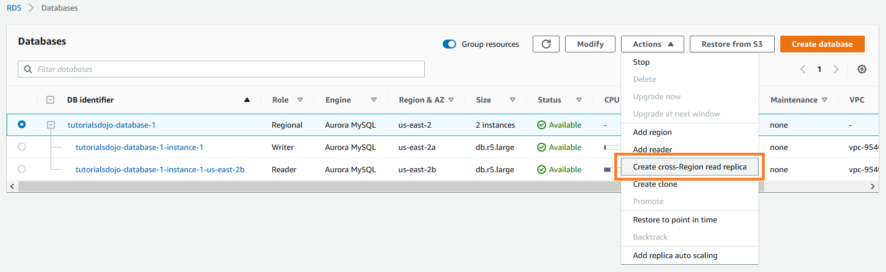
It provides the security, availability, and reliability of commercial databases at 1/10th the cost. Amazon Aurora is fully managed by Amazon RDS, which automates time-consuming administration tasks like hardware provisioning, database setup, patching, and backups.
Based on the given scenario, there is a significant slowdown after testing the read performance from the secondary AWS Region. Since the existing setup is an Amazon RDS for MySQL, you should migrate the database to Amazon Aurora and create a cross-region read replica.
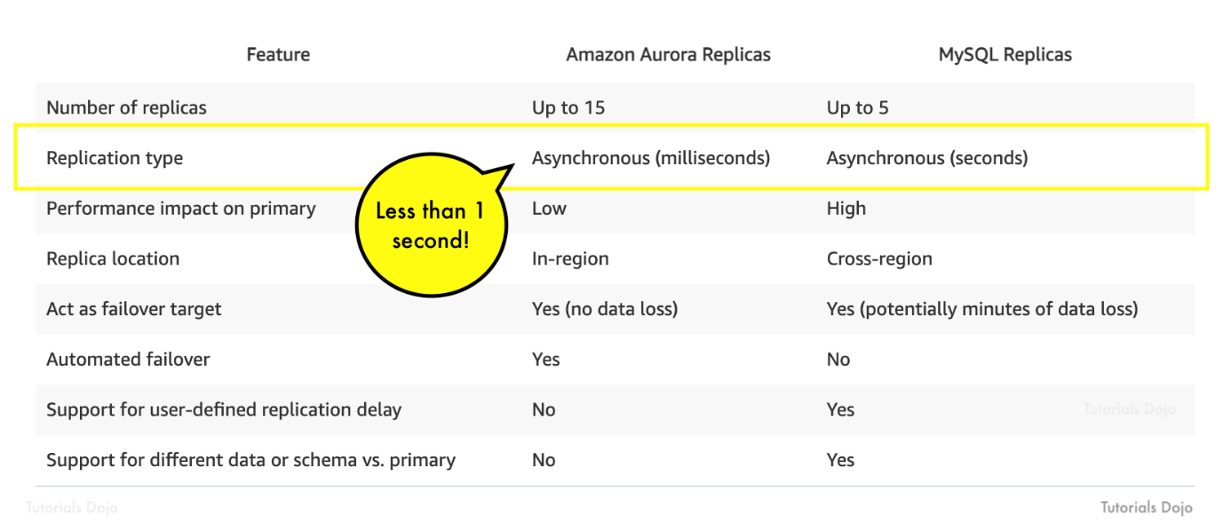
The read replication latency of less than 1 second is only possible if you would use Amazon Aurora replicas. Aurora replicas are independent endpoints in an Aurora DB cluster, best used for scaling read operations and increasing availability. You can create up to 15 replicas within an AWS Region.
Hence, the correct answer is: Migrate the existing database to Amazon Aurora and create a cross-region read replica.
The option that says: Upgrade the MySQL database engine is incorrect because upgrading the database engine wouldn’t improve the read replication latency to milliseconds. To achieve the read replication latency of less than 1-second requirement, you need to use Amazon Aurora replicas.
The option that says: Use Amazon ElastiCache to improve database performance is incorrect. Amazon ElastiCache won’t be able to improve the database performance because it is experiencing highly dynamic reads. This option would be helpful if the database frequently receives the same queries.
The option that says: Create an Amazon RDS for MySQL read replica in the secondary AWS Region is incorrect because MySQL replicas won’t provide you a read replication latency of less than 1 second. RDS Read Replicas can only provide asynchronous replication in seconds and not in milliseconds. You have to use Amazon Aurora replicas in this scenario.
References:
https://aws.amazon.com/rds/aurora/faqs/
https://docs.aws.amazon.com/AmazonRDS/latest/AuroraUserGuide/AuroraMySQL.Replication.CrossRegion.html

Check out this Amazon Aurora Cheat Sheet:
https://tutorialsdojo.com/amazon-aurora/
Explanation: This is a great question that gets to the heart of how to optimize database performance for a globally distributed application.
The best option to provide a read replication latency of less than 1 second is:
Migrate the existing database to Amazon Aurora and create a cross-region read replica.
Here is a breakdown of why this is the optimal solution and why the other options are not.
Amazon Aurora and Cross-Region Read Replicas
Amazon Aurora is a cloud-native relational database service that is designed for high performance and high availability. It is fully compatible with MySQL, making the migration seamless. Aurora's architecture is a game-changer for this specific problem.
- High-Performance Architecture: Unlike standard MySQL where replication is based on binary logs, Aurora uses a distributed, shared-storage architecture. This means that data is replicated at the storage layer, not the database instance layer. When you create an Aurora read replica, it is simply a new compute node that attaches to the same storage volume.
- Low Replication Latency: Because the data is already replicated at the storage level, creating a cross-region read replica in Aurora is incredibly fast. The data is transferred across regions efficiently, resulting in typical replication latency of less than 100 milliseconds, which is well under the 1-second requirement.
Why the Other Options Are Not Correct
- Upgrade the MySQL database engine.
Upgrading the MySQL engine might bring some performance improvements, but it does not fundamentally change the replication mechanism. The replication will still be based on binary logs, which can suffer from high latency, especially over long distances between regions.
- Use Amazon ElastiCache to improve database performance.
Amazon ElastiCache is an excellent solution for caching frequently accessed data and offloading read traffic from the database. It would certainly improve the performance of your web application, but it does not solve the root cause of the problem, which is the high latency in the cross-region replication. You would still have a slow replica.
- Create an Amazon RDS for MySQL read replica in the secondary AWS Region.
This seems like a straightforward solution, but it has a significant drawback: replication latency. When you create a cross-region read replica for standard Amazon RDS for MySQL, the data is replicated using MySQL's native binary log (binlog) replication. The latency is directly proportional to the network distance and the volume of writes to the primary database. A highly dynamic database with a high number of write operations will cause the binlog to get backed up, leading to a high replication lag, often exceeding the 1-second mark. This is the exact problem you are trying to solve.

- 57. Question
A company has established a dedicated network connection from its on-premises data center to AWS Cloud using AWS Direct Connect (DX). The core network services, such as the Domain Name System (DNS) service and Active Directory services, are all hosted on-premises. The company has new AWS accounts that will also require consistent and dedicated access to these network services.
Which of the following can satisfy this requirement with the LEAST amount of operational overhead and in a cost-effective manner?
  - Create a new AWS VPN CloudHub. Set up a Virtual Private Network (VPN) connection for additional AWS accounts.
  - Set up a new Direct Connect gateway and integrate it with the existing Direct Connect connection. Configure a VPC peering connection between AWS accounts and associate it with Direct Connect gateway.
  - Create a new Direct Connect gateway and integrate it with the existing Direct Connect connection. Set up a Transit Gateway between AWS accounts and associate it with the Direct Connect gateway.
  - Set up another Direct Connect connection for each and every new AWS account that will be added.
Incorrect
AWS Transit Gateway provides a hub and spoke design for connecting VPCs and on-premises networks. You can attach all your hybrid connectivity (VPN and Direct Connect connections) to a single Transit Gateway consolidating and controlling your organization’s entire AWS routing configuration in one place. It also controls how traffic is routed among all the connected spoke networks using route tables. This hub and spoke model simplifies management and reduces operational costs because VPCs only connect to the Transit Gateway to gain access to the connected networks.
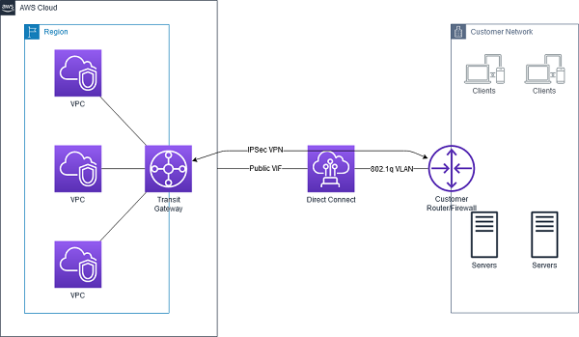
By attaching a transit gateway to a Direct Connect gateway using a transit virtual interface, you can manage a single connection for multiple VPCs or VPNs that are in the same AWS Region. You can also advertise prefixes from on-premises to AWS and from AWS to on-premises.
The AWS Transit Gateway and AWS Direct Connect solution simplify the management of connections between an Amazon VPC and your networks over a private connection. It can also minimize network costs, improve bandwidth throughput, and provide a more reliable network experience than Internet-based connections.
Hence, the correct answer is: Create a new Direct Connect gateway and integrate it with the existing Direct Connect connection. Set up a Transit Gateway between AWS accounts and associate it with the Direct Connect gateway.
The option that says: Set up another Direct Connect connection for each and every new AWS account that will be added is incorrect because this solution entails a significant amount of additional cost. Setting up a single DX connection requires a substantial budget and takes a lot of time to establish. It also has high management overhead since you will need to manage all of the Direct Connect connections for all AWS accounts.
The option that says: Create a new AWS VPN CloudHub. Set up a Virtual Private Network (VPN) connection for additional AWS accounts is incorrect because a VPN connection is not capable of providing consistent and dedicated access to the on-premises network services. Take note that a VPN connection traverses the public Internet and doesn’t use a dedicated connection.
The option that says: Set up a new Direct Connect gateway and integrate it with the existing Direct Connect connection. Configure a VPC peering connection between AWS accounts and associate it with Direct Connect gateway is incorrect because VPC peering is not supported in a Direct Connect connection. VPC peering does not support transitive peering relationships.

References:
https://docs.aws.amazon.com/directconnect/latest/UserGuide/direct-connect-transit-gateways.html
https://docs.aws.amazon.com/whitepapers/latest/aws-vpc-connectivity-options/aws-direct-connect-aws-transit-gateway.html
https://aws.amazon.com/blogs/networking-and-content-delivery/integrating-sub-1-gbps-hosted-connections-with-aws-transit-gateway/

Check out this AWS Transit Gateway Cheat Sheet:
https://tutorialsdojo.com/aws-transit-gateway/
Explanation: The best solution to satisfy this requirement with the least amount of operational overhead and in a cost-effective manner is:
Create a new Direct Connect gateway and integrate it with the existing Direct Connect connection. Set up a Transit Gateway between AWS accounts and associate it with the Direct Connect gateway.
Here is a breakdown of why this approach is the most effective:
AWS Direct Connect Gateway
A Direct Connect gateway is a key component that allows you to connect your on-premises network to multiple Amazon Virtual Private Clouds (VPCs) across different AWS accounts and AWS Regions using a single Direct Connect connection. This is a significant improvement over the older model, which required a separate virtual interface for each VPC connection.
By creating a Direct Connect gateway and associating your existing Direct Connect connection with it, you establish a centralized point of entry from your on-premises network into the AWS Cloud.
AWS Transit Gateway
A Transit Gateway is a network hub that centralizes and simplifies connectivity between your VPCs and your on-premises networks. It eliminates the need for complex VPC peering connections and simplifies your network architecture as you scale.
By setting up a Transit Gateway and associating the Direct Connect gateway with it, you create a central hub where all new AWS accounts (and their VPCs) can connect. The Transit Gateway then routes all traffic from these VPCs to the on-premises network via the single Direct Connect gateway.
Why the Other Options Are Not Correct
- Create a new AWS VPN CloudHub. Set up a Virtual Private Network (VPN) connection for additional AWS accounts.
This is a less-than-ideal solution. While a VPN CloudHub could work, it is not a high-performance or low-latency solution like Direct Connect. It would also increase complexity by forcing you to manage both a Direct Connect and a separate VPN solution for different accounts, which is not cost-effective.
- Set up a new Direct Connect gateway and integrate it with the existing Direct Connect connection. Configure a VPC peering connection between AWS accounts and associate it with Direct Connect gateway.
VPC peering connections are point-to-point connections. As you add more AWS accounts, you would have to manage a complex web of peering connections. This would dramatically increase operational overhead and is not a scalable solution. Transit Gateway was specifically designed to solve this "spaghetti" architecture.
- Set up another Direct Connect connection for each and every new AWS account that will be added.
This would be the most expensive and operationally complex solution. Each Direct Connect connection has a significant cost for the physical port and a separate setup process. This is the opposite of a cost-effective and low-overhead solution.

- 58. Question
In Amazon EC2, you can manage your instances from the moment you launch them up to their termination. You can flexibly control your computing costs by changing the EC2 instance state.
Which of the following statements is true regarding EC2 billing? (Select TWO.)
  - You will be billed when your Reserved instance is in terminated state.
  - You will be billed when your On-Demand instance is preparing to hibernate with a stopping state.
  - You will be billed when your Spot instance is preparing to stop with a stopping state.
  - You will not be billed for any instance usage while an instance is not in the running state.
  - You will be billed when your On-Demand instance is in pending state.
Incorrect
By working with Amazon EC2 to manage your instances from the moment you launch them through their termination, you ensure that your customers have the best possible experience with the applications or sites that you host on your instances. The following illustration represents the transitions between instance states. Notice that you can’t stop and start an instance store-backed instance:
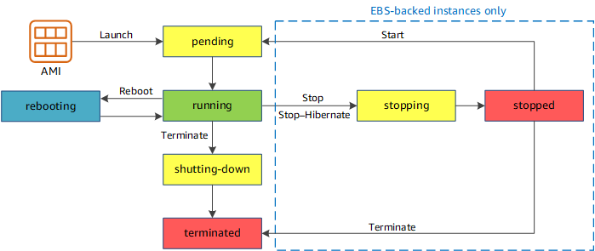
Below are the valid EC2 lifecycle instance states:
pending – The instance is preparing to enter the running state. An instance enters the pending state when it launches for the first time, or when it is restarted after being in the stopped state.
running – The instance is running and ready for use.
stopping – The instance is preparing to be stopped. Take note that you will not billed if it is preparing to stop however, you will still be billed if it is just preparing to hibernate.
stopped – The instance is shut down and cannot be used. The instance can be restarted at any time.
shutting-down – The instance is preparing to be terminated.
terminated – The instance has been permanently deleted and cannot be restarted. Take note that Reserved Instances that applied to terminated instances are still billed until the end of their term according to their payment option.
The option that says: You will be billed when your On-Demand instance is preparing to hibernate with a stopping state is correct because when the instance state is stopping, you will not be billed if it is preparing to stop however, you will still be billed if it is just preparing to hibernate.
The option that says: You will be billed when your Reserved instance is in terminated state is correct because Reserved Instances that applied to terminated instances are still billed until the end of their term according to their payment option. I actually raised a pull-request to Amazon team about the billing conditions for Reserved Instances, which has been approved and reflected on your official AWS Documentation: https://github.com/awsdocs/amazon-ec2-user-guide/pull/45
The option that says: You will be billed when your On-Demand instance is in pending state is incorrect because you will not be billed if your instance is in pending state.
The option that says: You will be billed when your Spot instance is preparing to stop with a stopping state is incorrect because you will not be billed if your instance is preparing to stop with a stopping state.
The option that says: You will not be billed for any instance usage while an instance is not in the running state is incorrect because the statement is not entirely true. You can still be billed if your instance is preparing to hibernate with a stopping state.

References:
https://github.com/awsdocs/amazon-ec2-user-guide/pull/45
http://docs.aws.amazon.com/AWSEC2/latest/UserGuide/ec2-instance-lifecycle.html

Check out this Amazon EC2 Cheat Sheet:
https://tutorialsdojo.com/amazon-elastic-compute-cloud-amazon-ec2/
Explanation: The correct statements regarding EC2 billing are:
- You will be billed when your On-Demand instance is in pending state.
- You will be billed when your Reserved instance is in terminated state.
Here is a breakdown of why these two statements are correct and the others are not:
Correct Statements
- You will be billed when your On-Demand instance is in pending state.
When you launch an EC2 instance, it goes through a pending state as AWS provisions the underlying resources. Billing starts as soon as the instance transitions to pending because the resources have been allocated and are being prepared for your use.
- You will be billed when your Reserved instance is in terminated state.
Reserved Instances are a billing commitment, not a physical server. When you purchase a Reserved Instance, you are essentially buying a discount for a specific instance type for a one- or three-year term. The upfront cost is a commitment regardless of whether the instance is running or not. You are billed for the full term even if you terminate the associated EC2 instance.
Incorrect Statements
- You will be billed when your On-Demand instance is preparing to hibernate with a stopping state.
When an On-Demand instance is in a stopped state, you are not billed for the compute time. You are only billed for the storage of the associated EBS volumes. This holds true for the stopping state as well; you are not billed for compute during this transition.
- You will be billed when your Spot instance is preparing to stop with a stopping state.
You are billed for Spot Instances only for the period they are running. The billing is per second, with a one-minute minimum. If a Spot Instance is interrupted by AWS, you are not billed for the current hour if the instance is terminated within the first minute. You are never billed for compute when a Spot instance is stopping or stopped.
- You will not be billed for any instance usage while an instance is not in the running state.
This is incorrect because, as mentioned, you are billed for an On-Demand instance during its pending state. You are also billed for the upfront cost of a Reserved Instance regardless of its state. Additionally, you are always billed for any associated storage (EBS volumes), regardless of whether the instance is running or not.

- 59. Question
A company has a top priority requirement to monitor certain database metrics and send email notifications to the Operations team if any issues occur.
Which combination of AWS services can accomplish this requirement? (Select TWO.)
  - Amazon CloudWatch
  - Amazon Simple Email Service
  - Amazon Simple Notification Service (SNS)
  - Amazon Simple Queue Service (SQS)
  - Amazon EC2 Instance with a running Berkeley Internet Name Domain (BIND) Server.
Correct
Amazon CloudWatch and Amazon Simple Notification Service (SNS) are correct. In this requirement, you can use Amazon CloudWatch to monitor the database and then Amazon SNS to send the emails to the Operations team. Take note that you should use SNS instead of SES (Simple Email Service) when you want to monitor your EC2 instances.
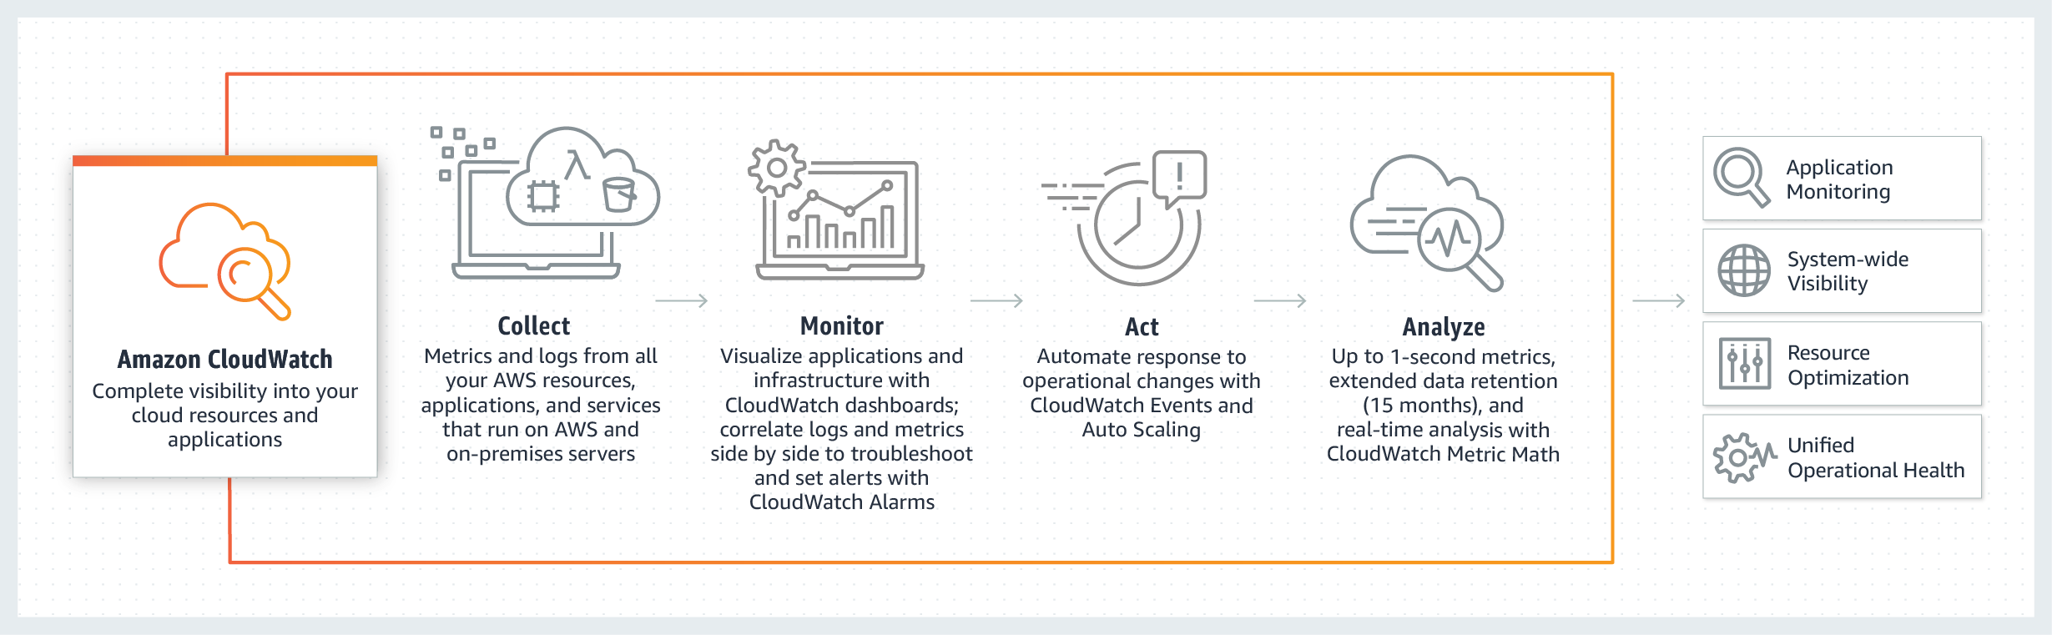
CloudWatch collects monitoring and operational data in the form of logs, metrics, and events, providing you with a unified view of AWS resources, applications, and services that run on AWS, and on-premises servers.
SNS is a highly available, durable, secure, fully managed pub/sub messaging service that enables you to decouple microservices, distributed systems, and serverless applications.
Amazon Simple Email Service is incorrect. SES is primarily designed for sending bulk emails, transactional emails, and marketing communications, rather than system notifications.
Amazon Simple Queue Service (SQS) is incorrect. SQS is a fully-managed message queuing service. It does not monitor applications nor send email notifications, unlike SES.
Amazon EC2 Instance with a running Berkeley Internet Name Domain (BIND) Server is incorrect because BIND is primarily used as a Domain Name System (DNS) web service. This is only applicable if you have a private hosted zone in your AWS account. It does not monitor applications nor send email notifications.
References:
https://aws.amazon.com/cloudwatch/
https://aws.amazon.com/sns/
Check out this Amazon CloudWatch Cheat Sheet:
https://tutorialsdojo.com/amazon-cloudwatch/
- 60. Question
A financial services organization is developing a cloud-native application on AWS to process and analyze customer transaction data. The application utilizes Amazon Aurora for the database, Amazon EFS for file storage, and Amazon EventBridge to trigger AWS Step Functions for workflow orchestration.
The organization has implemented AWS IAM Identity Center for user authentication. The data science, engineering, and compliance teams require secure access to Amazon Aurora and Amazon EFS while maintaining strict data privacy standards. The solution must adhere to the principle of least privilege and minimize administrative overhead.
Which approach best satisfies these requirements?
  - Set up AWS Control Tower to manage multi-account access. Use Service Control Policies (SCPs) to restrict access to Aurora and EFS at the organizational level. Create IAM roles in each account with specific permissions.
  - Enable the IAM Identity Center with an Identity Center directory and create permission sets for granular access for Amazon Aurora and Amazon EFS. Assign teams to groups linked to specific permission sets based on their roles.
  - Use Amazon Cognito User Pools for authentication and use Cognito Identity Pools to provide temporary AWS credentials. Create fine-grained IAM roles for Aurora and EFS access in each team.
  - Create separate AWS accounts for each team using AWS Organizations. Set up cross-account IAM roles with least privilege and assign specific Aurora and EFS permissions based on team roles.
Incorrect
AWS IAM Identity Center centralizes access management for various AWS accounts and applications. It provides single sign-on (SSO) access, enabling users to manage all their assigned accounts from a single location. Users can synchronize with an existing identity provider or create new users and groups directly within the service.
IAM Identity Center utilizes permission sets—collections of IAM policies—to manage user access across AWS Organizations. It includes a user-friendly AWS Access Portal for easy access to applications and supports deployment for both organization and account instances. Designed for high availability across multiple availability zones, the service ensures secure access through AWS Identity and Access Management (IAM) roles and policies.
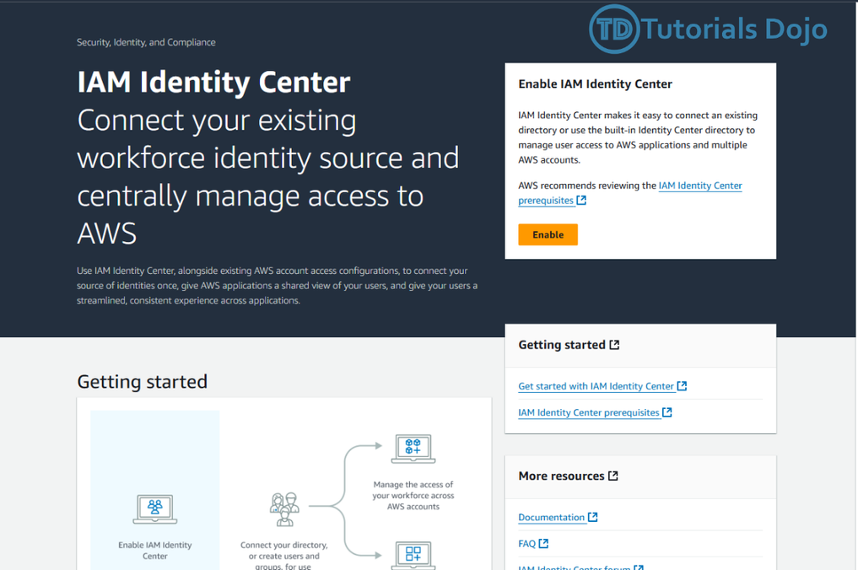
Hence, the correct answer is: Enable the IAM Identity Center with an Identity Center directory and create permission sets for granular access for Amazon Aurora and Amazon EFS. Assign teams to groups linked to specific permission sets based on their roles. This approach provides centralized user management and granular access control and integrates well with the existing IAM Identity Center setup. This approach allows for easy assignment of permissions based on team roles and adheres to the principle of least privilege.
The option that says: Set up AWS Control Tower to manage multi-account access. Use Service Control Policies (SCPs) to restrict access to Aurora and EFS at the organizational level. Create IAM roles in each account with specific permissions is incorrect. AWS Control Tower is typically used for multi-account governance and high-level policy enforcement using Service Control Policies (SCPs). While SCPs can restrict access, they operate at the account or organizational level and cannot provide the fine-grained access required for individual resources like Amazon Aurora or Amazon EFS. This approach increases administrative complexity and does not minimize overhead.
The option that says: Use Amazon Cognito User Pools for authentication and use Cognito Identity Pools to provide temporary AWS credentials. Create fine-grained IAM roles for Aurora and EFS access in each team is incorrect. Amazon Cognito typically provides user authentication and access to AWS resources through temporary credentials. However, Cognito is not inherently integrated with the IAM Identity Center, which the organization is already using. This approach introduces additional complexity and does not align with the organization’s current authentication strategy.
The option that says: Create separate AWS accounts for each team using AWS Organizations. Set up cross-account IAM roles with least privilege and assign specific Aurora and EFS permissions based on team roles is incorrect. Using separate AWS accounts and cross-account roles can enforce strict access boundaries, but it adds significant administrative overhead. Managing multiple accounts for each team is unnecessary for this scenario and does not align with the requirement to minimize complexity.

References:
https://aws.amazon.com/about-aws/whats-new/2023/05/amazon-sagemaker-data-wrangler-image-data-preparation/https://docs.aws.amazon.com/singlesignon/latest/userguide/get-set-up-for-idc.html
https://docs.aws.amazon.com/singlesignon/latest/userguide/what-is.html

Check out this AWS Identity and Access Management Cheat Sheet:
https://tutorialsdojo.com/aws-identity-and-access-management-iam/
- 61. Question
A new company policy requires IAM users to change their passwords’ minimum length to 12 characters. After a random inspection, you found out that there are still employees who do not follow the policy.
How can you automatically check and evaluate whether the current password policy for an account complies with the company password policy?
  - Create a rule in the Amazon CloudWatch event. Build an event pattern to match events on IAM. Set the event name to “ChangePassword” in the event pattern. Configure SNS to send notifications to you whenever a user has made changes to his password.
  - Create a Scheduled Lambda Function that will run a custom script to check compliance against changes made to the passwords periodically.
  - Configure AWS Config to trigger an evaluation that will check the compliance for a user’s password periodically.
  - Create a CloudTrail trail. Filter the result by setting the attribute to “Event Name” and lookup value to “ChangePassword”. This easily gives you the list of users who have made changes to their passwords.
Incorrect
AWS Config is a service that enables you to assess, audit, and evaluate the configurations of your AWS resources. Config continuously monitors and records your AWS resource configurations and allows you to automate the evaluation of recorded configurations against desired configurations.
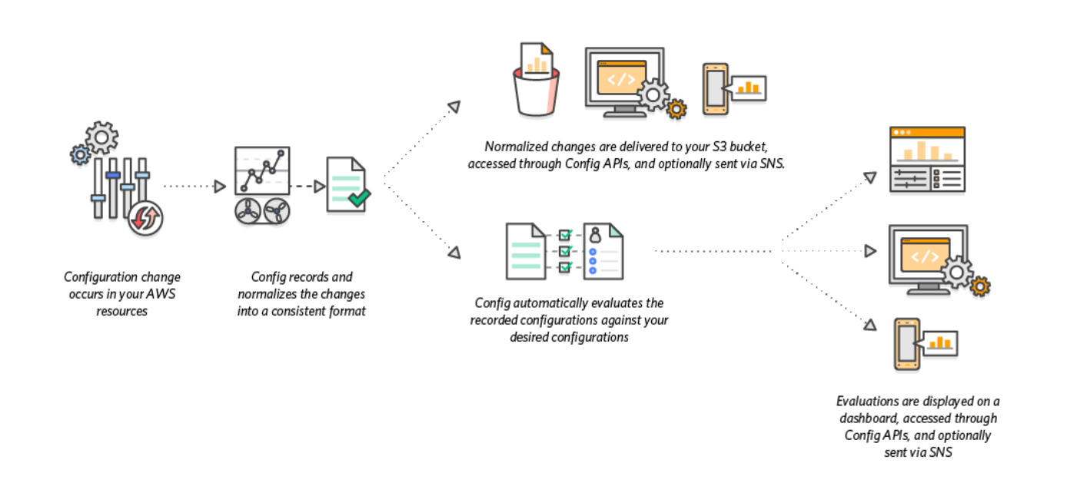
In the scenario given, we can utilize AWS Config to check for compliance on the password policy by configuring the Config rule to check the IAM_PASSWORD_POLICY on an account. Additionally, because Config integrates with AWS Organizations, we can improve the setup to aggregate compliance information across accounts to a central dashboard.
Hence, the correct answer is: Configure AWS Config to trigger an evaluation that will check the compliance for a user’s password periodically.
Create a CloudTrail trail. Filter the result by setting the attribute to “Event Name” and lookup value to “ChangePassword”. This easily gives you the list of users who have made changes to their passwords is incorrect because this setup will just give you the name of the users who have made changes to their respective passwords. It will not give you the ability to check whether their passwords have met the required minimum length.
Create a Scheduled Lambda function that will run a custom script to check compliance against changes made to the passwords periodically is a valid solution but still incorrect. AWS Config is already integrated with AWS Lambda. You don’t have to create and manage your own Lambda function. You just have to define a Config rule where you will check compliance, and Lambda will process the evaluation. Moreover, you can’t directly create a scheduled function by using Lambda itself. You have to create a rule in AWS CloudWatch Events to run the Lambda functions on the schedule that you define.
Create a rule in the Amazon CloudWatch event. Build an event pattern to match events on IAM. Set the event name to “ChangePassword” in the event pattern. Configure SNS to send notifications to you whenever a user has made changes to his password is incorrect because this setup will just alert you whenever a user changes his password. Sure, you’ll have information about who made changes, but that is not enough to check whether it complies with the required minimum password length. This can be easily done in AWS Config.

References:
https://docs.aws.amazon.com/config/latest/developerguide/evaluate-config-rules.html
https://aws.amazon.com/config/

Check out this AWS Config Cheat Sheet:
https://tutorialsdojo.com/aws-config/
- 62. Question
A startup company is developing a new application in AWS. The architecture is a web application with an Amazon Elastic Container Service (Amazon ECS) cluster, an Amazon S3 bucket where the application assets are stored, and a managed Amazon RDS for MySQL Database. The database layer of the web application contains personally identifiable information (PII) data. As part of compliance requirements, data in both the RDS for MySQL database, and the S3 bucket should be securely accessed only by the ECS cluster.
How should the system be designed to satisfy this requirement?
  - Create and configure an Amazon RDS Proxy for the RDS for MySQL database to use the appropriate database endpoint and port for the RDS for MySQL database. Define an Identity Access Management (IAM) role that grants permission to the ECS task execution role to access the RDS Proxy. Update the ECS task definition to assume this role. Define an IAM policy that allows S3 actions to the IAM role in the S3 bucket. Attach the IAM policy to the IAM role.
  - Provision a new AWS Key Management Service (AWS KMS) customer-managed key to encrypt both the S3 bucket and the RDS for MySQL database. Ensure that the KMS key policy includes encrypt and decrypt permissions for the ECS task execution role. Then, configure an S3 bucket policy to specify the ECS task execution role as a user, allowing access to the encrypted data.
  - Configure two VPC endpoints for RDS for MySQL database and Amazon S3. Add an allow rule for the RDS for MySQL security group to grant access from subnets that the ECS cluster will generate tasks in. Add an S3 bucket policy to deny access to the resources that matches StringNotEquals of aws:SourceVpce list with the VPC endpoint id.
  - Configure a VPC endpoint to establish a private connection between the VPC and the RDS for MySQL database. Update the RDS for MySQL security group to only allow access from subnets of the ECS cluster. Add an S3 bucket policy to restrict access to the ECS task execution role, with an exception allowing public internet access to the S3 bucket.
Incorrect
You can establish a private connection between your VPC and Amazon RDS API endpoints by creating an interface VPC endpoint. Interface endpoints are powered by AWS PrivateLink. VPC security groups control the access that traffic has in and out of a DB instance. Rules in the security group can be an IP address range, port, or security group.
For S3 buckets, access from specific endpoints, VPCs, IP address ranges, and AWS accounts can be restricted by making use of bucket policies. Depending on condition keys in the bucket policy, you can restrict access to a specific endpoint, a specific VPC, a specific IP address range, or a specific AWS account.
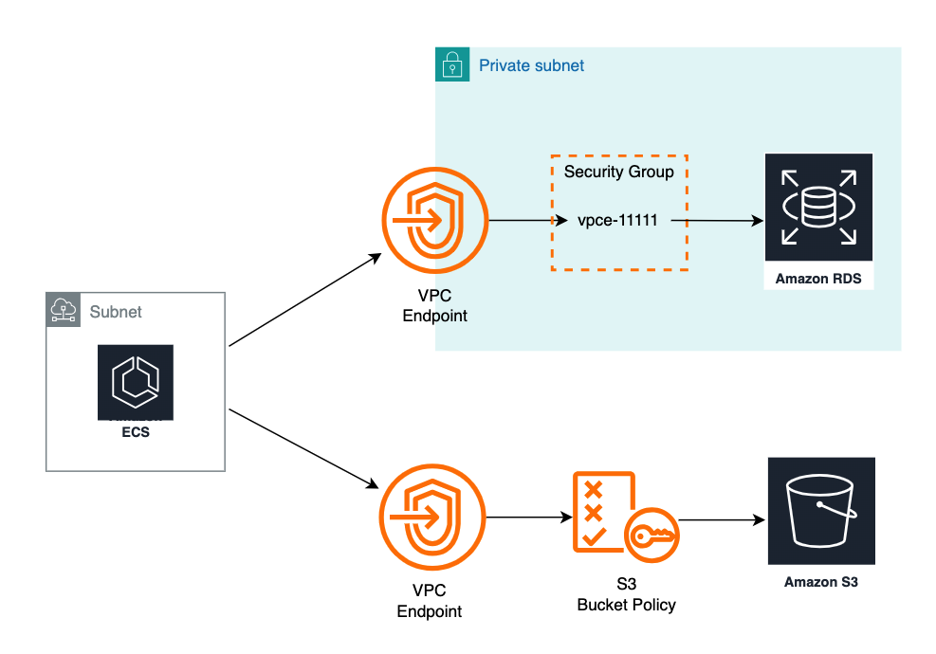
It is important to secure access to data by applying the Principle of Least Privilege Access. Since both the Amazon RDS for MySQL database and Amazon S3 bucket contain Personal Identifiable Information (PII) data, it is best practice to only grant access to these resources and limit specific actions on the resources under specific conditions. The web application in ECS can be granted access to both the RDS database and the Amazon S3 bucket by making use of VPC endpoints, ensuring only the application can access the restricted data.
Therefore, the correct answer is: Configure two VPC endpoints for RDS for MySQL database and Amazon S3. Add an allow rule for the RDS for MySQL security group to grant access from subnets that the ECS cluster will generate tasks in. Add an S3 bucket policy to deny access to the resources that matches StringNotEquals of aws:SourceVpce list with the VPC endpoint id.
The option that says: Configure a VPC endpoint to establish a private connection between the VPC and the RDS for MySQL database. Update the RDS for MySQL security group to only allow access from subnets of the ECS cluster. Add an S3 bucket policy to restrict access to the ECS task execution role, with an exception allowing public internet access to the S3 bucket is incorrect. Even though the S3 bucket policy restricts access to the ECS task execution role, having an exception of allowing public internet access to the S3 bucket does not satisfy the requirement for secure access to the data.
The option that says: Create and configure an Amazon RDS Proxy for the RDS for MySQL database to use the appropriate database endpoint and port for the RDS for MySQL database. Define an Identity Access Management (IAM) role that grants permission to the ECS task execution role to access the RDS proxy. Update the ECS task definition to assume this role. Define an IAM policy that allows S3 actions to the IAM role in the S3 bucket. Attach the IAM policy to the IAM role is incorrect since it does not ensure that only the ECS cluster can access the RDS for MySQL database; other resources or entities with appropriate permissions can still access the RDS proxy. Furthermore, IAM roles is not a secure way to limit access to S3 buckets. If another service or entity or service is associated to the same IAM role, it can then access the data in the S3 bucket.
The option that says: Provision a new AWS Key Management Service (AWS KMS) customer-managed key to encrypt both the S3 bucket and the RDS for MySQL database. Ensure that the KMS key policy includes encrypt and decrypt permissions for the ECS task execution role. Then, configure an S3 bucket policy to specify the ECS task execution role as a user, allowing access to the encrypted data is incorrect. Even though AWS Key Management Service (AWS KMS) adds an additional layer of security by encrypting data, it does not restrict access to the ECS cluster as required.
References:
https://docs.aws.amazon.com/AmazonRDS/latest/UserGuide/vpc-interface-endpoints.html
https://docs.aws.amazon.com/AmazonRDS/latest/UserGuide/Overview.RDSSecurityGroups.html
https://docs.aws.amazon.com/vpc/latest/privatelink/vpc-endpoints-s3.html
https://docs.aws.amazon.com/wellarchitected/latest/framework/sec_permissions_least_privileges.html
Check out this article on Amazon S3 Bucket Policies for VPC Endpoints:
https://tutorialsdojo.com/amazon-s3-bucket-policies-for-vpc-endpoints/
- 63. Question
A company has several EC2 Reserved Instances in their account that need to be decommissioned and shut down since they are no longer used by the development team. However, the data is still required by the audit team for compliance purposes.
Which of the following steps can be taken in this scenario? (Select TWO.)
  - Convert the EC2 instances to Spot instances with a persistent Spot request type.
  - Take snapshots of the EBS volumes and terminate the EC2 instances.
  - You can opt to sell these EC2 instances on the AWS Reserved Instance Marketplace
  - Stop all the running EC2 instances.
  - Convert the EC2 instance to On-Demand instances
Incorrect
Amazon Elastic Compute Cloud (Amazon EC2) is a web service that provides secure, resizable compute capacity in the cloud. It is designed to make web-scale cloud computing easier for developers. Amazon EC2’s simple web service interface allows you to obtain and configure capacity with minimal friction. It provides you with complete control of your computing resources and lets you run on Amazon’s proven computing environment.
The first requirement as per the scenario is to decommission and shut down several EC2 Reserved Instances. However, it is also mentioned that the audit team still requires the data for compliance purposes. To fulfill the given requirements, you can first create a snapshot of the instance to save its data and then sell the instance to the Reserved Instance Marketplace.
The Reserved Instance Marketplace is a platform that supports the sale of third-party and AWS customers’ unused Standard Reserved Instances, which vary in terms of length and pricing options. For example, you may want to sell Reserved Instances after moving instances to a new AWS region, changing to a new instance type, ending projects before the term expiration, when your business needs change, or if you have unneeded capacity.
Hence, the correct answers are:
– You can opt to sell these EC2 instances on the AWS Reserved Instance Marketplace.
– Take snapshots of the EBS volumes and terminate the EC2 instances.
The option that says: Convert the EC2 instance to On-Demand instances is incorrect because it’s stated in the scenario that the development team no longer needs several EC2 Reserved Instances. By converting it to On-Demand instances, the company will still have instances running in their infrastructure and this will result in additional costs.
The option that says: Convert the EC2 instances to Spot instances with a persistent Spot request type is incorrect because the requirement in the scenario is to terminate or shut down several EC2 Reserved Instances. Converting the existing instances to Spot instances will not satisfy the given requirement.
The option that says: Stop all the running EC2 instances is incorrect because doing so will still incur storage cost. Take note that the requirement in the scenario is to decommission and shut down several EC2 Reserved Instances. Therefore, this approach won’t fulfill the given requirement.

References:
https://docs.aws.amazon.com/AWSEC2/latest/UserGuide/ri-market-general.html
https://docs.aws.amazon.com/AWSEC2/latest/UserGuide/ebs-creating-snapshot.html

Check out this Amazon EC2 Cheat Sheet:
https://tutorialsdojo.com/amazon-elastic-compute-cloud-amazon-ec2/
- 64. Question
A company developed a financial analytics web application hosted in a Docker container using MEAN (MongoDB, Express.js, AngularJS, and Node.js) stack. You want to easily port that web application to AWS Cloud which can automatically handle all the tasks such as balancing load, auto-scaling, monitoring, and placing your containers across your cluster.
Which of the following services can be used to fulfill this requirement?
  - AWS Elastic Beanstalk
  - Amazon Elastic Container Service (Amazon ECS)
  - AWS CloudFormation
  - AWS Compute Optimizer
Incorrect
AWS Elastic Beanstalk supports the deployment of web applications from Docker containers. With Docker containers, you can define your own runtime environment. You can choose your own platform, programming language, and any application dependencies (such as package managers or tools), that aren’t supported by other platforms. Docker containers are self-contained and include all the configuration information and software your web application requires to run.
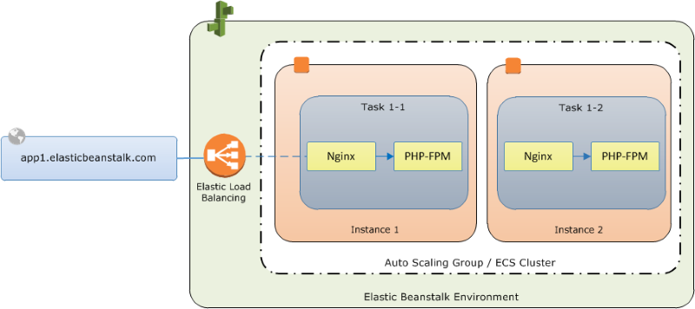
By using Docker with Elastic Beanstalk, you have an infrastructure that automatically handles the details of capacity provisioning, load balancing, scaling, and application health monitoring. You can manage your web application in an environment that supports the range of services that are integrated with Elastic Beanstalk, including but not limited to VPC, RDS, and IAM.
Hence, the correct answer is: AWS Elastic Beanstalk.
Amazon Elastic Container Service (Amazon ECS) is incorrect. Although it also provides Service Auto Scaling, Service Load Balancing, and Monitoring with CloudWatch, these features are not automatically enabled by default unlike with Elastic Beanstalk. Take note that the scenario requires a service that will automatically handle all the tasks such as balancing load, auto-scaling, monitoring, and placing your containers across your cluster. You will have to manually configure these things if you wish to use ECS. With Elastic Beanstalk, you can manage your web application in an environment that supports the range of services easier.
AWS CloudFormation is incorrect. While you can deploy the infrastructure for your application thru CloudFormation templates, you will be the one responsible for connecting the AWS resources needed to build your application environment. With ElasticBeanstalk, all you have to do is upload your code; ElasticBeanstalk will automatically set up the environment for your application.
AWS Compute Optimizer is incorrect. Compute Optimizer simply analyzes your workload and recommends the optimal AWS resources needed to improve performance and reduce costs.

Reference:
https://docs.aws.amazon.com/elasticbeanstalk/latest/dg/create_deploy_docker.html

Check out this AWS Elastic Beanstalk Cheat Sheet:
https://tutorialsdojo.com/aws-elastic-beanstalk/

Elastic Beanstalk vs CloudFormation vs OpsWorks vs CodeDeploy:
https://tutorialsdojo.com/elastic-beanstalk-vs-cloudformation-vs-opsworks-vs-codedeploy/

Comparison of AWS Services Cheat Sheets:
https://tutorialsdojo.com/comparison-of-aws-services/
- 65. Question
An application is loading hundreds of JSON documents into an Amazon S3 bucket every hour which is registered in AWS Lake Formation as a data catalog. The Data Analytics team uses Amazon Athena to run analyses on these data, but due to the volume, most queries take a long time to complete.
What change should be made to improve the query performance while ensuring data security?
  - Compress the data into GZIP format before storing it in the S3 bucket. Apply an IAM policy with aws:SourceArn and aws:SourceAccount global condition context keys in Lake Formation that prevents cross-service confused deputy problems and other security issues.
  - Apply minification on the data and implement the Lake Formation tag-based access control (LF-TBAC) authorization strategy to ensure security.
  - Transform the JSON data into Apache Parquet format. Ensure that the user has an lakeformation:GetDataAccess IAM permission for underlying data access control.
  - Convert the JSON documents into CSV format. Provide fine-grained named resource access control to specific databases or tables in AWS Lake Formation.
Incorrect
Amazon Athena supports a wide variety of data formats like CSV, TSV, JSON, or Textfiles and also supports open-source columnar formats such as Apache ORC and Apache Parquet. Athena also supports compressed data in Snappy, Zlib, LZO, and GZIP formats. By compressing, partitioning, and using columnar formats you can improve performance and reduce your costs.
Parquet and ORC file formats both support predicate pushdown (also called predicate filtering). Parquet and ORC both have blocks of data that represent column values. Each block holds statistics for the block, such as max/min values. When a query is being executed, these statistics determine whether the block should be read or skipped.
Athena charges you by the amount of data scanned per query. You can save on costs and get better performance if you partition the data, compress data, or convert it to columnar formats such as Apache Parquet.
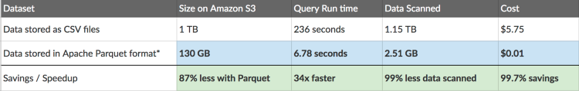
Apache Parquet is an open-source columnar storage format that is 2x faster to unload and takes up 6x less storage in Amazon S3 as compared to other text formats. One can COPY Apache Parquet and Apache ORC file formats from Amazon S3 to your Amazon Redshift cluster. Using AWS Glue, one can configure and run a job to transform CSV data to Parquet. Parquet is a columnar format that is well suited for AWS analytics services like Amazon Athena and Amazon Redshift Spectrum.
When an integrated AWS service requests access to data in an Amazon S3 location that is access-controlled by AWS Lake Formation, Lake Formation supplies temporary credentials to access the data. To enable Lake Formation to control access to underlying data at an Amazon S3 location, you register that location with Lake Formation.
To enable Lake Formation principals to read and write underlying data with access controlled by Lake Formation permissions:
– The Amazon S3 locations that contain the data must be registered with Lake Formation.
– Principals who create Data Catalog tables that point to underlying data locations must have data location permissions.
– Principals who read and write underlying data must have Lake Formation data access permissions on the Data Catalog tables that point to the underlying data locations.
– Principals who read and write underlying data must have the lakeformation:GetDataAccess IAM permission.
Thus, the correct answer is: Transform the JSON data into Apache Parquet format. Ensure that the user has an lakeformation:GetDataAccess IAM permission for underlying data access control.
The option that says: Convert the JSON documents into CSV format. Provide fine-grained named resource access control to specific databases or tables in AWS Lake Formation is incorrect because Athena queries performed against row-based formats like CSV are slower than columnar file formats like Apache Parquet.
The option that says:Apply minification on the data and implement the Lake Formation tag-based access control (LF-TBAC) authorization strategy using IAM Tags to ensure security is incorrect. Although minifying the JSON file might reduce its overall file size, there won’t be a significant difference in terms of querying performance. LF-TBAC is a type of an attribute-based access control (ABAC) that defines permissions based on certain attributes, such as tags in AWS. LF-TBAC uses LF-Tags to grant Lake Formation permissions and not regular IAM Tags.
The option that says: Compress the data into GZIP format before storing in the S3 bucket. Apply an IAM policy with aws:SourceArn and aws:SourceAccount global condition context keys in Lake Formation that prevents cross-service confused deputy problems and other security issues. is incorrect. Compressing the files prior to storing them in Amazon S3 will only save storage costs. As for query performance, it won’t have much improvement. In addition, using an IAM Policy to prevent cross-service confused deputy issues is not warranted in this scenario. Having an lakeformation:GetDataAccess IAM permission for underlying data access control should suffice.

References:
https://aws.amazon.com/blogs/big-data/top-10-performance-tuning-tips-for-amazon-athena/
https://docs.aws.amazon.com/lake-formation/latest/dg/access-control-underlying-data.html
https://docs.aws.amazon.com/lake-formation/latest/dg/TBAC-overview.html

Check out this Amazon Athena Cheat Sheet:
https://tutorialsdojo.com/amazon-athena/

AWS_TestQuizDojo02

66. Question A startup is building IoT devices and monitoring applications. They are using IoT sensors to monitor the traffic in real-time by using an Amazon Kinesis Stream that is configured with default settings. It then sends the data to an Amazon S3 bucket every 3 days. When you checked the data in S3 on the 3rd day, only the data for the last day is present and no data is present from 2 days ago.
Which of the following is the MOST likely cause of this issue?
- Amazon S3 bucket has encountered a data loss.
- By default, data records in Kinesis are only accessible for 24 hours from the time they are added to a stream.
- The access of the Kinesis stream to the S3 bucket is insufficient.
- Someone has manually deleted the record in Amazon S3

67. Question A company plans to migrate all of their applications to AWS. The Solutions Architect suggested to store all the data to EBS volumes. The Chief Technical Officer is worried that EBS volumes are not appropriate for the existing workloads due to compliance requirements, downtime scenarios, and IOPS performance.
Which of the following are valid points in proving that EBS is the best service to use for migration? (Select TWO.)
- An EBS volume is off-instance storage that can persist independently from the life of an instance.
- EBS volumes can be attached to any EC2 Instance in any Availability Zone.
- When you create an EBS volume in an Availability Zone, it is automatically replicated on a separate AWS region to prevent data loss due to a failure of any single hardware component.
- Amazon EBS provides the ability to create snapshots (backups) of any EBS volume and write a copy of the data in the volume to Amazon RDS, where it is stored redundantly in multiple Availability Zones
- EBS volumes support live configuration changes while in production which means that you can modify the volume type, volume size, and IOPS capacity without service interruptions.
68 3. Question A data analytics company is setting up an innovative checkout-free grocery store. The Solutions Architect developed a real-time monitoring application that uses smart sensors to collect the items that the customers are getting from the grocery’s refrigerators and shelves, then automatically deduct those items from customer accounts. The company wants to analyze the items that are frequently being bought and store the results in Amazon S3 for durable storage to determine the purchase behavior of its customers.
Which of the following must be used to easily capture, transform, and load streaming data into S3, Amazon OpenSearch Service, and Splunk?
- Amazon SQS
- Amazon Data Firehose
- Amazon DynamoDB Streams
- Amazon Redshift
69 4. Question A company is using a combination of API Gateway and AWS Lambda for the web services of an online web portal that is accessed by hundreds of thousands of clients each day. The company will be announcing a new revolutionary product, and it is expected that the web portal will receive a massive number of visitors from all around the globe.
How can the back-end systems and applications be protected from traffic spikes?
- API Gateway will automatically scale and handle massive traffic spikes so you do not have to do anything.
- Deploy Multi-AZ in API Gateway with Read Replica
- Manually upgrade the Amazon EC2 instances being used by API Gateway
- Use throttling limits in API Gateway

70 5. Question A company has a web-based ticketing service that utilizes Amazon SQS and a fleet of EC2 instances. The EC2 instances that consume messages from the SQS queue are configured to poll the queue as often as possible to keep end-to-end throughput as high as possible. The Solutions Architect noticed that polling the queue in tight loops is using unnecessary CPU cycles, resulting in increased operational costs due to empty responses.
In this scenario, what should the Solutions Architect do to make the system more cost-effective?
- Configure Amazon SQS to use short polling by setting the ReceiveMessageWaitTimeSeconds to a number greater than zero.
- Configure Amazon SQS to use long polling by setting the ReceiveMessageWaitTimeSeconds to a number greater than zero.
- Configure Amazon SQS to use short polling by setting the ReceiveMessageWaitTimeSeconds to zero.
- Configure Amazon SQS to use long polling by setting the ReceiveMessageWaitTimeSeconds to zero.

71 6. Question A healthcare company stores sensitive patient health records in their on-premises storage systems. These records must be kept indefinitely and protected from any type of modifications once they are stored. Compliance regulations mandate that the records must have granular access control and each data access must be audited at all levels. Currently, there are millions of obsolete records that are not accessed by their web application, and their on-premises storage is quickly running out of space. The Solutions Architect must design a solution to immediately move existing records to AWS and support the ever-growing number of new health records.
Which of the following is the most suitable solution that the Solutions Architect should implement to meet the above requirements?
- Set up AWS DataSync to move the existing health records from the on-premises network to the AWS Cloud. Launch a new Amazon S3 bucket to store existing and new records. Enable AWS CloudTrail with Data Events and Amazon S3 Object Lock in the bucket.
- Set up AWS Storage Gateway to move the existing health records from the on-premises network to the AWS Cloud. Launch a new Amazon S3 bucket to store existing and new records. Enable AWS CloudTrail with Management Events and Amazon S3 Object Lock in the bucket.
- Set up AWS DataSync to move the existing health records from the on-premises network to the AWS Cloud. Launch a new Amazon S3 bucket to store existing and new records. Enable AWS CloudTrail with Management Events and Amazon S3 Object Lock in the bucket.
- Set up AWS Storage Gateway to move the existing health records from the on-premises network to the AWS Cloud. Launch an Amazon EBS-backed EC2 instance to store both the existing and new records. Enable Amazon S3 server access logging and S3 Object Lock in the bucket.

72 7. Question A newly hired Solutions Architect is checking all of the security groups and network access control list rules of the company’s AWS resources. For security purposes, the MS SQL connection via port 1433 of the database tier should be secured. Below is the security group configuration of their Microsoft SQL Server database:
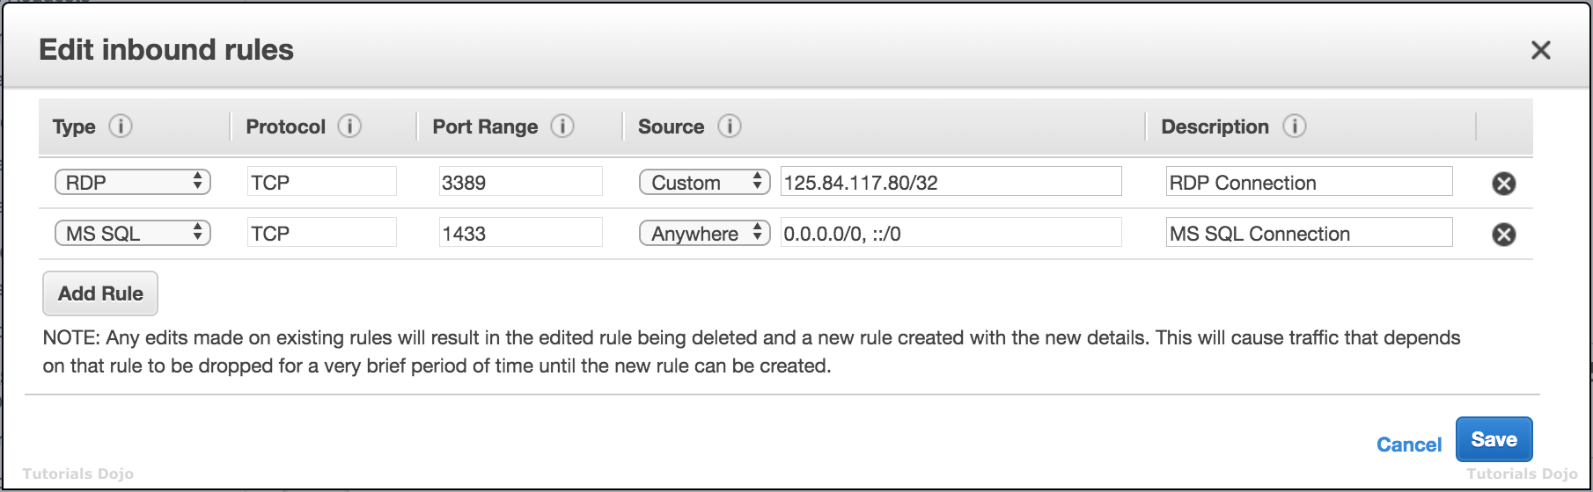
The application tier hosted in an Auto Scaling group of EC2 instances is the only identified resource that needs to connect to the database. The Architect should ensure that the architecture complies with the best practice of granting least privilege.
Which of the following changes should be made to the security group configuration?
- For the MS SQL rule, change the Source to the EC2 instance IDs of the underlying instances of the Auto Scaling group.
- For the MS SQL rule, change the Source to the security group ID attached to the application tier.
- For the MS SQL rule, change the Source to the static AnyCast IP address attached to the application tier.
- For the MS SQL rule, change the Source to the Network ACL ID attached to the application tier.

73 8. Question A large consulting firm is in the process of conducting an internal security audit of its cloud infrastructure. The goal is to ensure that the information in its Amazon S3 bucket, which is associated with the firm’s AWS Lake Formation data lake, doesn’t include confidential data related to its customers or staff.
The firm aims to uncover financial or personally identifiable information (PII), such as passport, credit card numbers, and taxpayer identification numbers, in its S3 bucket. This will prevent any sensitive data from being ingested into a data lake.
What solution would be the most operationally effective solution in meeting these particular requirements?
- Implement AWS Audit Manager within the AWS account and opt for auditing based on the Payment Card Industry Data Security Standards (PCI DSS).
- Set up AWS Glue DataBrew to identify and cleanse sensitive data in the S3 bucket.
- Utilize Amazon Macie to perform a comprehensive data discovery operation using managed identifiers to detect various data types.
- Set up Amazon S3 Inventory for the S3 bucket and then configure Amazon Athena to conduct queries on the generated inventory.

74 9. Question A company has an enterprise web application hosted on Amazon ECS Docker containers that use an Amazon FSx for Lustre filesystem for its high-performance computing workloads. A warm standby environment is running in another AWS region for disaster recovery. A Solutions Architect was assigned to design a system that will automatically route the live traffic to the disaster recovery (DR) environment only in the event that the primary application stack experiences an outage.
What should the Architect do to satisfy this requirement?
- Set up a failover routing policy configuration in Route 53 by adding a health check on the primary service endpoint. Configure Route 53 to direct the DNS queries to the secondary record when the primary resource is unhealthy. Configure the network access control list and the route table to allow Route 53 to send requests to the endpoints specified in the health checks. Enable the Evaluate Target Health option by setting it to Yes.
- Set up a Weighted routing policy configuration in Route 53 by adding health checks on both the primary stack and the DR environment. Configure the network access control list and the route table to allow Route 53 to send requests to the endpoints specified in the health checks. Enable the Evaluate Target Health option by setting it to Yes.
- Set up an ​Amazon EventBridge rule to monitor the primary Route 53 DNS endpoint and create a custom AWS Lambda function. Execute the ChangeResourceRecordSets API call using the function to initiate the failover to the secondary DNS record.
- Set up an Amazon CloudWatch Alarm to monitor the primary Route 53 DNS endpoint and create a custom AWS Lambda function. Execute the ChangeResourceRecordSets API call using the function to initiate the failover to the secondary DNS record.

75 10. Question An insurance company plans to implement a message filtering feature in its web application. To implement this solution, it needs to create separate Amazon SQS queues for each type of quote request. The entire message processing should not exceed 24 hours.
As the Solutions Architect for the company, which of the following solutions should be implemented to meet the above requirement?
- Create multiple Amazon SNS topics and configure the SQS queues to subscribe to the SNS topics. Publish the message to the designated SQS queue based on the quote request type.
- Create a data stream in Amazon Kinesis Data Streams. Use the Kinesis Client Library to deliver all the records to the designated SQS queues based on the quote request type.
- Create one Amazon SNS topic and configure the SQS queues to subscribe to the SNS topic. Set the filter policies in the SNS subscriptions to publish the message to the designated SQS queue based on its quote request type.
- Create one Amazon SNS topic and configure the SQS queues to subscribe to the SNS topic. Publish the same messages to all SQS queues. Filter the messages in each queue based on the quote request type.

76 11. Question A company plans to implement a hybrid architecture. A dedicated connection needs to be created from the Amazon Virtual Private Cloud (VPC) to the on-premises network. This connection must provide high bandwidth throughput and a more consistent network experience than Internet-based solutions.
Which of the following can be used to create a private connection between the VPC and the company’s on-premises network?
- Transit Gateway with equal-cost multipath routing (ECMP)
- AWS Direct Connect
- Transit VPC
- AWS Site-to-Site VPN

77 12. Question A company has a global news website hosted in a fleet of EC2 Instances. Lately, the load on the website has increased which resulted in slower response time for the site visitors. This issue impacts the revenue of the company as some readers tend to leave the site if it does not load after 10 seconds. The goal is to address the issue in a cost-effective manner.”
Which of the below services in AWS can be used to solve this problem? (Select TWO.)
- Use Amazon CloudFront with website as the custom origin.
- Use Amazon ElastiCache for the website's in-memory data store or cache.
- Use Amazon RDS Multi-AZ deployments for database read scalability.
- For better read throughput, use AWS Storage Gateway to distribute the content across multiple regions.
- Deploy the website to all regions in different VPCs for faster processing.

78 13. Question A company has a highly available architecture consisting of an Elastic Load Balancer and multiple Amazon EC2 instances configured with Auto Scaling across three Availability Zones. The company needs to monitor EC2 instances based on a specific metric that is not readily available in Amazon CloudWatch.
Which of the following is a custom metric in CloudWatch that requires manual setup?
- CPU Utilization of an EC2 instance
- Disk Read activity of an EC2 instance
- Memory Utilization of an EC2 instance
- Network packets out of an EC2 instance

79 14. Question A Solutions Architect is hosting a website in an Amazon S3 bucket named tutorialsdojo. The users load the website using the following URL: http://tutorialsdojo.s3-website-us-east-1.amazonaws.com. A new requirement has been introduced to add JavaScript on the webpages to make authenticated HTTP GET requests against the same bucket using the S3 API endpoint (tutorialsdojo.s3.amazonaws.com). However, upon testing, the web browser blocks JavaScript from allowing those requests.
Which of the following options is the MOST suitable solution to implement for this scenario?
- Enable Cross-Zone Load Balancing.
- Enable cross-account access.
- Enable Cross-Region Replication (CRR).
- Enable Cross-origin resource sharing (CORS) configuration in the bucket.

80 15. Question A company is in the process of migrating their applications to AWS. One of their systems requires a database that can scale globally and handle frequent schema changes. The application should not have any downtime or performance issues whenever there is a schema change in the database. It should also provide a low latency response to high-traffic queries.
Which is the most suitable database solution to use to achieve this requirement?
- An Amazon RDS instance in Multi-AZ Deployments configuration
- An Amazon Aurora database with Read Replicas
- Redshift
- Amazon DynamoDB

81 16. Question A multinational corporate and investment bank regularly processes steady workloads of accruals, loan interests, and other critical financial calculations every night from 10 PM to 3 AM on their on-premises data center for their corporate clients. Once the process is done, the results are then uploaded to the Oracle General Ledger which means that the processing should not be delayed or interrupted. The CTO has decided to move its IT infrastructure to AWS to save costs. The company needs to reserve compute capacity in a specific Availability Zone to properly run their workloads.
As the Senior Solutions Architect, how can you implement a cost-effective architecture in AWS for their financial system?
- Use On-Demand EC2 instances which allows you to pay for the instances that you launch and use by the second. Reserve compute capacity in a specific Availability Zone to avoid any interruption.
- Use Regional Reserved Instances to reserve capacity on a specific Availability Zone and lower the operating cost through its billing discounts.
- Use Dedicated Hosts, which provide a physical host that is fully dedicated to running your instances, and bring your existing per-socket, per-core, or per-VM software licenses to reduce costs.
- Use On-Demand Capacity Reservations, which provide compute capacity that is always available on the specified recurring schedule.

82 17. Question An e-commerce company is redesigning the architecture of its application. The new architecture needs a more robust application layer and an online transactional processing (OLTP) relational database that can handle spiky traffic loads. The company also wants to ensure the application is always available while minimizing computing costs during idle periods.
As the company’s solution architect, which solution would be the most cost-effective to meet these requirements?
- Utilize AWS Elastic Beanstalk to deploy the application, use a MySQL database on Amazon RDS, then configure Auto Scaling to scale down the number of EC2 instances during idle periods.
- Utilize Amazon EC2 instances with a burstable instance type to operate the application and adopt Amazon Redshift as the database.
- Use Amazon EC2 instances in an Auto Scaling group behind an Application Load Balancer. Implement Amazon RDS for MySQL for the database.
- Use Amazon ECS on AWS Fargate to run the application in containers and opt for Amazon Aurora Serverless to host the database.

83 18. Question A company has multiple AWS Site-to-Site VPN connections placed between their VPCs and their remote network. During peak hours, many employees are experiencing slow connectivity issues, which limits their productivity. The company has asked a solutions architect to scale the throughput of the VPN connections. Which solution should the architect carry out?
- Associate the VPCs to an Equal Cost Multipath Routing (ECMR)-enabled transit gateway and attach additional VPN tunnels.
- Re-route some of the VPN connections to a secondary customer gateway device on the remote network’s end.
- Modify the VPN configuration by increasing the number of tunnels to scale the throughput.
- Add more virtual private gateways to a VPC and enable Equal Cost Multipath Routing (ECMR) to get higher VPN bandwidth.

84 19. Question A Docker application, which is running on an Amazon ECS cluster behind a load balancer, is heavily using Amazon DynamoDB. The application requires improved database performance by distributing the workload evenly and utilizing the provisioned throughput efficiently.
Which of the following should be implemented for the DynamoDB table?
- Reduce the number of partition keys in the DynamoDB table.
- Use partition keys with low-cardinality attributes, which have a few number of distinct values for each item.
- Avoid using a composite primary key, which is composed of a partition key and a sort key.
- Use partition keys with high-cardinality attributes, which have a large number of distinct values for each item.

85 20. A global IT company with offices around the world has multiple AWS accounts. To improve efficiency and drive costs down, the Chief Information Officer (CIO) wants to set up a solution that centrally manages their AWS resources. This will allow them to procure AWS resources centrally and share resources such as AWS Transit Gateways, AWS License Manager configurations, or Amazon Route 53 Resolver rules across their various accounts.
As the Solutions Architect, which combination of options should you implement in this scenario? (Select TWO.)
- Use the AWS Identity and Access Management service to set up cross-account access that will easily and securely share your resources with your AWS accounts.
- Use AWS Control Tower to easily and securely share your resources with your AWS accounts.
- Consolidate all of the company's accounts using AWS ParallelCluster.
- Consolidate all of the company's accounts using AWS Organizations.
- Use the AWS Resource Access Manager (RAM) service to easily and securely share your resources with your AWS accounts.

86 21. Question A startup company is developing a new application in AWS. The architecture is a web application with an Amazon Elastic Container Service (Amazon ECS) cluster, an Amazon S3 bucket where the application assets are stored, and a managed Amazon RDS for MySQL Database. The database layer of the web application contains personally identifiable information (PII) data. As part of compliance requirements, data in both the RDS for MySQL database, and the S3 bucket should be securely accessed only by the ECS cluster.
How should the system be designed to satisfy this requirement?
- Configure a VPC endpoint to establish a private connection between the VPC and the RDS for MySQL database. Update the RDS for MySQL security group to only allow access from subnets of the ECS cluster. Add an S3 bucket policy to restrict access to the ECS task execution role, with an exception allowing public internet access to the S3 bucket.
- Provision a new AWS Key Management Service (AWS KMS) customer-managed key to encrypt both the S3 bucket and the RDS for MySQL database. Ensure that the KMS key policy includes encrypt and decrypt permissions for the ECS task execution role. Then, configure an S3 bucket policy to specify the ECS task execution role as a user, allowing access to the encrypted data.
- Configure two VPC endpoints for RDS for MySQL database and Amazon S3. Add an allow rule for the RDS for MySQL security group to grant access from subnets that the ECS cluster will generate tasks in. Add an S3 bucket policy to deny access to the resources that matches StringNotEquals of aws:SourceVpce list with the VPC endpoint id.
- Create and configure an Amazon RDS Proxy for the RDS for MySQL database to use the appropriate database endpoint and port for the RDS for MySQL database. Define an Identity Access Management (IAM) role that grants permission to the ECS task execution role to access the RDS Proxy. Update the ECS task definition to assume this role. Define an IAM policy that allows S3 actions to the IAM role in the S3 bucket. Attach the IAM policy to the IAM role.

87 22. Question A company discovered that a significant portion of their monthly bill in the AWS Cloud was due to unused Amazon Elastic Block Store (EBS) volumes and snapshots. Having checked AWS Cost Explorer, the company expects this monthly cost to increase. The company wants to mitigate and optimize these EBS costs.
Which solution will meet these requirements with the LEAST operational overhead?
- Check the logs through Amazon Cloudwatch Logs to monitor the storage used by Amazon EBS. Then, utilize Amazon EBS Elastic Volumes to reduce the size of the EBS volumes.
- Create a custom script that deploys an AWS CDK application that monitors the disk space usage of EBS volumes and utilizes Amazon EBS Elastic Volumes to reduce the size of the EBS volumes.
- Delete all expired and unused snapshots. Then, utilize the Amazon Data Lifecycle Manager to manage new snapshots.
- Delete all expired and unused snapshots using the AWS CLI.

88 23. Question A Solutions Architect is building a cloud infrastructure where Amazon EC2 instances require access to various AWS services, such as Amazon S3 and Amazon Redshift. The Architect will also need to provide access to system administrators so that the system administrators can deploy and test changes.
Which configuration should be used to ensure that access to the resources is secured and not compromised? (Select TWO.)
- Assign an IAM role to the EC2 instance.
- Enable Multi-Factor Authentication.
- Store the AWS Access Keys in ACM.
- Assign an IAM user for each EC2 Instance.
- Store the AWS Access Keys in the EC2 instance.

89 24. Question A company has several websites and hosts its infrastructure on the AWS Cloud. The mission-critical web applications are hosted on fleets of Amazon EC2 instances behind Application Load Balancers. The company uses AWS Certificate Manager (ACM) provided certificate on the ALBs to enable HTTPS access on its websites. The security team wants to get notified 30 days before the expiration of the SSL certificates.
Which of the following can the Solutions Architect implement to meet this request? (Select TWO.)
- Utilize AWS Trusted Advisor to check for the ACM certificates that will expire in 30 days. Using this metric, create an Amazon CloudWatch alarm that will send an alert to an AWS Systems Manager OpsItem.
- Create an Amazon EventBridge (Amazon CloudWatch Events) rule that will check AWS Health or ACM expiration events related to ACM certificates. Send an alert notification to an Amazon Simple Notification Service (Amazon SNS) topic when a certificate is going to expire in 30 days.
- Create an Amazon EventBridge (Amazon CloudWatch Events) rule and schedule it to run every day to identify the expiring ACM certificates. Configure to rule to check the DaysToExpiry metric of all ACM certificates in Amazon CloudWatch. Send an alert notification to an Amazon Simple Notification Service (Amazon SNS) topic when a certificate is going to expire in 30 days.
- Modify all certificates to use the AWS Certificate Manager Private Certificate Authority. Create an Amazon EventBridge (Amazon CloudWatch Events) rule that will check for ACM events that shows certificates expiring within 30 days. Set the target to invoke an AWS Lambda function to send a message to an Amazon SNS topic.
- Use AWS Config to manually create a rule that checks for certificate expiry on ACM. Create an Amazon EventBridge (Amazon CloudWatch Events) rule to send an alert to an Amazon Simple Notification Service (Amazon SNS) topic when AWS Config flags a resource.

90 25. Question An e-commerce company’s Chief Information Security Officer (CISO) has taken necessary measures to ensure that sensitive customer data is secure in the cloud. However, the company recently discovered that some customer Personally Identifiable Information (PII) was mistakenly uploaded to an S3 bucket.
The company aims to rectify this mistake and prevent any similar incidents from happening again in the future. Additionally, the company would like to be notified if this error occurs again.
As the Solutions Architect, which combination of options should you implement in this scenario? (Select TWO.)
- Identify sensitive data using Amazon Macie and create an Amazon EventBridge (Amazon CloudWatch Events) rule to capture the SensitiveData event type.
- Set up an AWS IoT Message Broker as the target for an Amazon EventBridge (Amazon CloudWatch Events) rule that sends notifications when the SensitiveData:S3Object/Personal event occurs again.
- Identify sensitive data using Amazon GuardDuty by creating an Amazon EventBridge (Amazon CloudWatch Events) rule to include the CRITICAL event types from GuardDuty findings.
- Set up an Amazon SNS topic as the target for an Amazon EventBridge (Amazon CloudWatch Events) rule that sends notifications when the error occurs again.
- Set up an Amazon SQS as the target for an Amazon EventBridge (Amazon CloudWatch Events) rule that sends notifications when the error occurs again.

91 26. Question A company requires that all AWS resources be tagged with a standard naming convention for better access control. The company’s solutions architect must implement a solution that checks for untagged AWS resources.
Which solution requires the least amount of effort to implement?
- Use an AWS Config rule to detect non-compliant tags.
- Use tag policies in AWS Organizations to standardize the naming of tags. Store all the tags in an Amazon S3 bucket with the S3 Object Lock feature enabled.
- Create a Lambda function that runs compliance checks on tagged resources. Schedule the function using Amazon EventBridge (Amazon CloudWatch Events).
- Use service control policies (SCP) to detect resources that are not tagged properly.

92 27. Question A company has an application hosted in an Amazon ECS Cluster behind an Application Load Balancer. The Solutions Architect is building a sophisticated web filtering solution that allows or blocks web requests based on the country that the requests originate from. However, the solution should still allow specific IP addresses from that country.
Which combination of steps should the Architect implement to satisfy this requirement? (Select TWO.)
- Set up a geo match condition in the Application Load Balancer that blocks requests from a specific country.
- Add another rule in the AWS WAF web ACL with a geo match condition that blocks requests that originate from a specific country.
- Place a Transit Gateway in front of the VPC where the application is hosted and set up Network ACLs that block requests that originate from a specific country.
- Using AWS WAF, create a web ACL with a rule that explicitly allows requests from approved IP addresses declared in an IP Set.
- In the Application Load Balancer, create a listener rule that explicitly allows requests from approved IP addresses.

93 28. Question A retail company is exploring AWS services to enhance its customer experience by understanding the intricate relationships between customer interactions, product preferences, and purchasing patterns. The goal is to implement a solution that not only efficiently stores and manages this complex, relationship-rich data but also dynamically tracks changes in the database.
This capability is crucial for developing a sophisticated recommendation engine that tailors product suggestions to individual user behaviours and preferences.
Which option would best meet these requirements with the least operational overhead?
- Configure Amazon Neptune to manage the data and integrate with Amazon Kinesis Data Streams for tracking and processing database changes.
- Use Amazon Keyspaces (for Apache Cassandra) for data storage and connect it with Neptune Streams for effective change monitoring and analysis.
- Store transactional data in Amazon Aurora PostgreSQL and use Amazon Kinesis Data Streams for managing and analyzing changes.
- Set up Amazon Neptune to store the data and utilize Neptune Streams to monitor and analyze database changes in real time.

94 29. Question An e-commerce company plans to optimize its disaster recovery configuration using AWS Cloud to minimize operational disruptions during outages or major system maintenance for its on-premises Microsoft SQL Server-based application. The objective is to achieve a recovery point objective (RPO) of 60 seconds or less and a recovery time objective (RTO) of 1 hour.
Which of the following is the MOST cost-effective solution for this scenario?
- Back up SQL Server to AWS Storage Gateway for hybrid storage and fast disaster recovery. Enable fast snapshot restore in Amazon Elastic Block Store (Amazon EBS).
- Set up a pilot light strategy using AWS Elastic Disaster Recovery (AWS DRS) to replicate the changes of the on-premises application to AWS
- Use Microsoft SQL Server Enterprise with Always On availability groups and set up a multi-site active/active setup between the corporate on-premises application and AWS.
- On AWS, implement a warm standby using Amazon RDS for SQL Server database and configure AWS Database Migration Service (AWS DMS) with change data capture (CDC) to sync the data from the on-premises application.

95 30. Question A food company bought 50 licenses of Windows Server to be used by the developers when launching Amazon EC2 instances to deploy and test applications. The developers are free to provision EC2 instances as long as there is a license available. The licenses are tied to the total CPU count of each virtual machine. The company wants to ensure that developers won’t be able to launch new instances once the licenses are exhausted. The company wants to receive notifications when all licenses are in use.
Which of the following options is the recommended solution to meet the company’s requirements?
- Upload the licenses on AWS Systems Manager Fleet Manager to be encrypted and distributed to Amazon EC2 instances. Attach an IAM role on the EC2 instances to request a license from the Fleet Manager. Set up an Amazon SNS to send notifications and alerts once all licenses are used
- Define license configuration rules on AWS Certificate Manager to track and control license usage. Enable the option to “Enforce certificate limit” to prevent going over the number of allocated licenses. Add an Amazon SQS queue with ChangeVisibility Timeout configured to send notifications and alerts.
- Define licensing rules on AWS License Manager to track and control license usage. Enable the option to “Enforce license limit” to prevent going over the number of allocated licenses. Add an Amazon SNS topic to send notifications and alerts.
- Configure AWS Resource Access Manager (AWS RAM) to track and control the licenses used by AWS resources. Configure AWS RAM to provide available licenses for Amazon EC2 instances. Set up an Amazon SNS to send notifications and alerts once all licenses are used.

96 31. Question A company plans to design an application that can handle batch processing of large amounts of financial data. The Solutions Architect is tasked to create two Amazon S3 buckets to store the input and output data. The application will transfer the data between multiple EC2 instances over the network to complete the data processing.
Which of the following options would reduce the data transfer costs?
- Deploy the Amazon EC2 instances in private subnets in different Availability Zones.
- Deploy the Amazon EC2 instances behind an Application Load Balancer.
- Deploy the Amazon EC2 instances in the same Availability Zone.
- Deploy the Amazon EC2 instances in the same AWS Region.

97 32. Question A company has a web application that uses Amazon CloudFront to distribute its images, videos, and other static content stored in its Amazon S3 bucket to users around the world. The company has recently introduced a new member-only access feature for some of its high-quality media files. There is a requirement to provide access to multiple private media files only to paying subscribers without having to change the current URLs.
Which of the following is the most suitable solution to implement to satisfy this requirement?
- Configure your CloudFront distribution to use Field-Level Encryption to protect your private data and only allow access to members.
- Configure your CloudFront distribution to use Match Viewer as its Origin Protocol Policy which will automatically match the user request. This will allow access to the private content if the request is a paying member and deny it if it is not a member.
- Use Signed Cookies to control who can access the private files in your CloudFront distribution by modifying your application to determine whether a user should have access to your content. For members, send the required Set-Cookie headers to the viewer which will unlock the content only to them.
- Create a Signed URL with a custom policy which only allows the members to see the private files.

98 33. Question A Solutions Architect is working for a weather station in Asia with a weather monitoring system that needs to be migrated to AWS. Since the monitoring system requires a low network latency and high network throughput, the Architect decided to launch the EC2 instances to a new cluster placement group. The system was working fine for a couple of weeks, however, when they try to add new instances to the placement group that already has running EC2 instances, they receive an ‘insufficient capacity error’.
How will the Architect fix this issue?
- Create another Placement Group and launch the new instances in the new group.
- Stop and restart the instances in the Placement Group and then try the launch again.
- Submit a capacity increase request to AWS as you are initially limited to only 12 instances per Placement Group.
- Verify all running instances are of the same size and type and then try the launch again.

99 34. Question A logistics company manages a fleet of delivery trucks equipped with GPS devices that periodically upload location data to an Amazon S3 bucket. Historically, the company used an Amazon EC2 Spot Fleet to process the GPS data in batches every night.
The processing typically takes 3 minutes to complete and requires at least 64 MB of memory. The company’s solutions architect is tasked with modifying the application to process GPS data as it is uploaded to the S3 bucket.
Which modification will achieve this objective in the MOST cost-effective manner?
- Enable S3 Event Notifications to automatically forward the details of the GPS data file to an Amazon SNS topic. Set up an application in AWS Elastic Beanstalk wherein it processes the data files as they are uploaded after subscribing to the topic.
- Set S3 Event Notifications to transmit GPS data files to an Amazon Kinesis Data Stream. Create a Lambda Function to periodically pull and process the data from the stream.
- Configure S3 Event Notifications to populate an Amazon SQS queue with details of uploaded GPS data files. Assign an AWS Lambda function to process the data by retrieving the queue's messages.
- Configure S3 Event Notifications to send GPS data files to an Amazon SNS topic. Establish an Amazon ECS service that processes data by subscribing to the topic.

100 35. Question A solutions architect is designing a plan to recover from accidental writes and deletes on an Amazon DynamoDB table. The solution must be capable of recovering data up to an hour prior to the occurrence of an incident.
Which approach should be taken to meet these criteria?
- Enable DynamoDB Streams to record all changes made to the table. Use a Lambda function to restore the table in case of an incident.
- Create a DynamoDB global table. In case of an incident, direct the application’s requests to the global table’s endpoint.
- Enable Point-In-Time Recovery (PITR) in DynamoDB. Restore the table in case of an incident.
- Export DynamoDB data to S3 Glacier daily for disaster recovery

101 36. Question A company is running a batch job on an EC2 instance inside a private subnet. The instance gathers input data from an S3 bucket in the same region through a NAT Gateway. The company is looking for a solution that will reduce costs without imposing risks on redundancy or availability.
Which solution will accomplish this?
- Deploy a Transit Gateway to peer connection between the instance and the S3 bucket.
- Re-assign the NAT Gateway to a lower EC2 instance type.
- Replace the NAT Gateway with a NAT instance hosted on a burstable instance type.
- Remove the NAT Gateway and use a Gateway VPC endpoint to access the S3 bucket from the instance.

102 37. Question There is a technical requirement by a financial firm that does online credit card processing to have a secure application environment on AWS. They are trying to decide on whether to use KMS or CloudHSM.
Which of the following statements is right when it comes to CloudHSM and KMS?
- You should consider using AWS CloudHSM over AWS KMS if you require your keys stored in dedicated, third-party validated hardware security modules under your exclusive control.
- AWS CloudHSM should always be used for any payment transactions.
- If you want a managed service for creating and controlling your encryption keys but don't want or need to operate your own HSM, consider using AWS CloudHSM.
- No major difference. They both do the same thing.

103 38. Question A company needs to collect gigabytes of data per second from websites and social media feeds to gain insights on its product offerings and continuously improve the user experience. To meet this design requirement, you have developed an application hosted on an Auto Scaling group of Spot EC2 instances which processes the data and stores the results to DynamoDB and Redshift. The solution should have a built-in enhanced fan-out feature.
Which fully-managed AWS service can you use to collect and process large streams of data records in real-time with the LEAST amount of administrative overhead?
- Amazon Managed Streaming for Apache Kafka (Amazon MSK)
- Amazon S3 Access Points
- Amazon Kinesis Data Streams
- AWS Data Exchange

104 39. Question Every week, an e-commerce company announces a sales promotion, causing its application hosted on an Auto Scaling group to experience intermittent downtime. Because of long initialization times, the application only becomes operational minutes before a new EC2 instance turns into RUNNING state. A solutions architect must devise a solution that launches capacity in advance based on a forecasted load in order to scale faster.
Which solution meets the requirements with the least amount of effort?
- Configure the Auto Scaling group to use predictive scaling.
- Create a Scheduled Amazon EventBridge (Amazon CloudWatch Events) Rule that runs a scaling job on a Lambda function every midnight.
- Use Amazon SageMaker Clarify to analyze and predict the workload pattern of the application. Create a scheduled scaling policy based on the prediction results.
- Create a dynamic scaling policy based on the historical average CPU load of the application.

105 40. Question A startup plans to develop a multiplayer game that uses UDP as the protocol for communication between clients and game servers. The data of the users will be stored in a key-value store. As the Solutions Architect, you need to implement a solution that will distribute the traffic across a number of servers.
Which of the following could help you achieve this requirement?
- Distribute the traffic using Application Load Balancer and store the data in Amazon DynamoDB.
- Distribute the traffic using Network Load Balancer and store the data in Amazon Aurora.
- Distribute the traffic using Network Load Balancer and store the data in Amazon DynamoDB.
- Distribute the traffic using Application Load Balancer and store the data in Amazon RDS.

106 41. Question A data analytics company keeps a massive volume of data that they store in their on-premises data center. To scale their storage systems, they are looking for cloud-backed storage volumes that they can mount using Internet Small Computer System Interface (iSCSI) devices from their on-premises application servers. They have an on-site data analytics application that frequently accesses the latest data subsets locally while the older data are rarely accessed. You are required to minimize the need to scale the on-premises storage infrastructure while still providing their web application with low-latency access to the data.
Which type of AWS Storage Gateway service will you use to meet the above requirements?
- Tape Gateway
- Volume Gateway in cached mode
- File Gateway
- Volume Gateway in stored mode

107 42. Question A startup launched a new FTP server using an On-Demand EC2 instance in a newly created VPC with default settings. The server should not be accessible publicly but only through the IP address 175.45.116.100 and nowhere else.
Which of the following is the most suitable way to implement this requirement?
- Create a new Network ACL inbound rule in the subnet of the EC2 instance with the following details:
Protocol: UDP
Port Range: 20 – 21
Source: 175.45.116.100/0
Allow/Deny: ALLOW
- Create a new inbound rule in the security group of the EC2 instance with the following details:
Protocol: UDP
Port Range: 20 – 21
Source: 175.45.116.100/32
- Create a new inbound rule in the security group of the EC2 instance with the following details:
Protocol: TCP
Port Range: 20 – 21
Source: 175.45.116.100/32
- Create a new Network ACL inbound rule in the subnet of the EC2 instance with the following details:
Protocol: TCP
Port Range: 20 – 21
Source: 175.45.116.100/0
Allow/Deny: ALLOW

108 43. Question A technology company is building a new cryptocurrency trading platform that allows the buying and selling of Bitcoin, Ethereum, Ripple, Tether, and many others. A Cloud Engineer was hired to build the infrastructure required for this platform. During the first week, the engineer began creating CloudFormation YAML scripts to define all of the AWS resources needed for the application. The manager was shocked that the engineer hadn’t set up the EC2 instances, S3 buckets, and other AWS resources immediately. He doesn’t understand the purpose of the text-based scripts the engineer has written and has asked for clarification.
In this scenario, what are the benefits of using Amazon CloudFormation that the manager should know to address his concerns? (Select TWO.)
- Allows you to model your entire infrastructure in a text file
- A storage location for the code of your application
- Enables modeling, provisioning, and version-controlling of your entire AWS infrastructure
- Using CloudFormation itself is free, including the AWS resources that have been created.
- Provides highly durable and scalable data storage

109 44. Question An organization wants to use Amazon Managed Grafana for data visualization tasks. Their primary data source is an Amazon RDS database. The requirement is to ensure the visualization process is secure and the data is not exposed over the internet.
Which approach should the business take to meet these requirements?
- Establish an Amazon Managed Grafana workspace externally to a VPC. Implement a public endpoint for Amazon RDS, and, assign this endpoint as the data connection within the Grafana workspace.
- Configure the Amazon Managed Grafana workspace in a VPC but link it to the RDS database using a public endpoint as the data connection within Amazon Managed Grafana.
- Set up an Amazon Managed Grafana workspace with a public endpoint. Configure an AWS PrivateLink endpoint to facilitate a secure connection to Amazon RDS, and integrate Amazon RDS as the data connection in the Grafana workspace.
- Establish an Amazon Managed Grafana workspace within a Virtual Private Cloud, establish a private endpoint for Amazon RDS, and subsequently connect this endpoint as the data connection within the Grafana workspace.
Explanation: Amazon Managed Grafana is a fully managed service that provides powerful data visualization tools. To integrate with an Amazon RDS database securely, ensuring that no data is exposed to the public internet, certain configurations are necessary. Amazon Managed Grafana can operate either within a Virtual Private Cloud (VPC) or with public internet access. However, for secure, private connections, especially when handling sensitive data, deploying within a VPC is advisable.
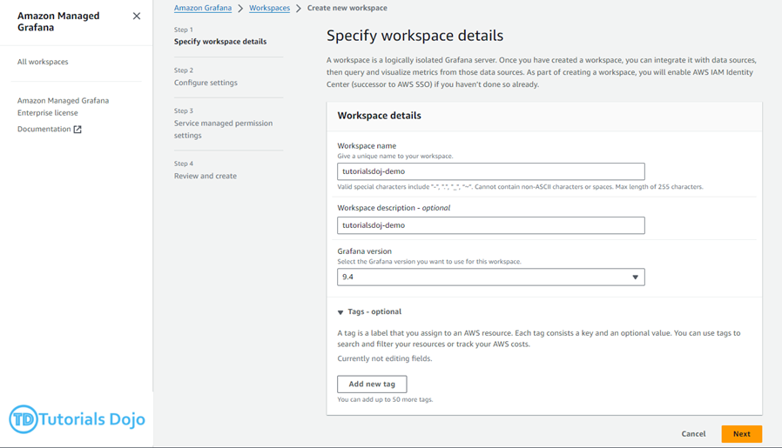

When setting up Amazon Managed Grafana, it’s highly recommended that the workspace be deployed within a Virtual Private Cloud(VPC). This approach offers several benefits. Firstly, it ensures secure connectivity to other AWS services, such as Amazon RDS, by using private endpoints that are inaccessible via the public internet. This approach enhances data security as it prevents exposure to external threats. Secondly, operating within a VPC facilitates a more controlled and secure environment by using AWS networking features like VPC endpoints or PrivateLink. You can establish a private network pathway that further secures data transmission between AWS. This approach is particularly advantageous when handling sensitive data, as it adheres to stringent security protocols.
Hence, the correct is: Establish an Amazon Managed Grafana workspace within a Virtual Private Cloud, establish a private endpoint for Amazon RDS, and subsequently connect this endpoint as the data connection within the Grafana workspace.
The option that says: Establish an Amazon Managed Grafana workspace externally to a VPC. Implement a public endpoint for Amazon RDS, and assign this endpoint as the data connection within the Grafana workspace is incorrect because this would not only expose the RDS database to the public internet but also potentially compromise the security of the data, increasing the risk of unauthorized access and breaches, which directly contradicts the aim of maintaining strict privacy and security protocols.
The option that says: Set up an Amazon Managed Grafana workspace with a public endpoint. Configure an AWS PrivateLink endpoint to facilitate a secure connection to Amazon RDS, and integrate Amazon RDS as the data connection in the Grafana workspace is incorrect. Although AWS PrivateLink provides a private connection, deploying Grafana outside a VPC and relying solely on PrivateLink does not align with the best practices for maximizing security and compliance with the scenario’s requirements.
The option that says: Configure the Amazon Managed Grafana workspace in a VPC but link it to the RDS database using a public endpoint as the data connection within Amazon Managed Grafana is incorrect because linking the RDS database to a public endpoint simply opens a doorway that anyone on the internet could potentially find and attempt to access. This setup significantly increases the risk of security breaches and data leaks, directly conflicting with the intended goal of a secure, private data handling environment provided by the VPC setup.

References:
https://docs.aws.amazon.com/grafana/latest/userguide/what-is-Amazon-Managed-Service-Grafana.html
https://docs.aws.amazon.com/vpc/latest/userguide/what-is-amazon-vpc.html

Check out these Amazon Managed Grafana and Amazon VPC Cheat Sheets:
https://tutorialsdojo.com/amazon-managed-grafana/
https://tutorialsdojo.com/amazon-vpc/

110 45. Question An online medical system hosted in AWS stores sensitive Personally Identifiable Information (PII) of the users in an Amazon S3 bucket. Both the master keys and the unencrypted data should NEVER be sent to AWS to comply with the strict compliance and regulatory requirements of the company.
Which S3 encryption technique should the Architect use?
- Use S3 client-side encryption with an AWS KMS key.
- Use S3 server-side encryption with customer provided key.
- Use S3 client-side encryption with a client-side master key.
- Use S3 server-side encryption with an AWS KMS key.

Client-side encryption is the act of encrypting data before sending it to Amazon S3. To enable client-side encryption, you have the following options:
– Use an AWS KMS key.
– Use a client-side master key.
When using an AWS KMS key to enable client-side data encryption, you provide an AWS KMS key identifier (KeyId) to AWS. On the other hand, when you use client-side master key for client-side data encryption, your client-side master keys and your unencrypted data are never sent to AWS. It’s important that you safely manage your encryption keys because if you lose them, you can’t decrypt your data.
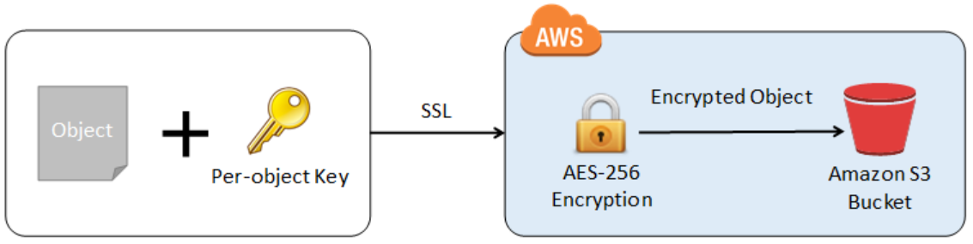

This is how client-side encryption using a client-side master key works:
When uploading an object – You provide a client-side master key to the Amazon S3 encryption client. The client uses the master key only to encrypt the data encryption key that it generates randomly. The process works like this:
1. The Amazon S3 encryption client generates a one-time-use symmetric key (also known as a data encryption key or data key) locally. It uses the data key to encrypt the data of a single Amazon S3 object. The client generates a separate data key for each object.
2. The client encrypts the data encryption key using the master key that you provide. The client uploads the encrypted data key and its material description as part of the object metadata. The client uses the material description to determine which client-side master key to use for decryption.
3. The client uploads the encrypted data to Amazon S3 and saves the encrypted data key as object metadata (x-amz-meta-x-amz-key) in Amazon S3.
When downloading an object – The client downloads the encrypted object from Amazon S3. Using the material description from the object’s metadata, the client determines which master key to use to decrypt the data key. The client uses that master key to decrypt the data key and then uses the data key to decrypt the object.
Hence, the correct answer is: Use S3 client-side encryption with a client-side master key.
The option that says: Use S3 client-side encryption with an AWS KMS key is incorrect because, in client-side encryption with a KMS key, you provide an AWS KMS key identifier (KeyId) to AWS. The scenario clearly indicates that both the master keys and the unencrypted data should never be sent to AWS.
The option that says: Use S3 server-side encryption with an AWS KMS key is incorrect because the scenario mentioned that the unencrypted data should never be sent to AWS, which means that you have to use client-side encryption in order to encrypt the data first before sending to AWS. In this way, you can only ensure that there is no unencrypted data being uploaded to AWS. In addition, the master key used by Server-Side Encryption with AWS KMS Key (SSE-KMS) is uploaded and managed by AWS, which directly violates the requirement of not uploading the master key.
The option that says: Use S3 server-side encryption with customer provided key is incorrect because, just as mentioned above, you have to use client-side encryption in this scenario instead of server-side encryption. For the S3 server-side encryption with a customer-provided key (SSE-C), you actually provide the encryption key as part of your request to upload the object to S3. Using this key, Amazon S3 manages both the encryption (as it writes to disks) and decryption (when you access your objects).

References:
https://docs.aws.amazon.com/AmazonS3/latest/dev/UsingEncryption.html
https://docs.aws.amazon.com/AmazonS3/latest/dev/UsingClientSideEncryption.html

Check out this Amazon S3 Cheat Sheet:
https://tutorialsdojo.com/amazon-s3/

111 46. Question A company plans to conduct a network security audit. The web application is hosted on an Auto Scaling group of EC2 Instances with an Application Load Balancer in front to evenly distribute the incoming traffic. A Solutions Architect has been tasked to enhance the security posture of the company’s cloud infrastructure and minimize the impact of DDoS attacks on its resources.
Which of the following is the most effective solution that should be implemented?
- Configure Amazon CloudFront distribution and set an Application Load Balancer as the origin. Create a security group rule and deny all the suspicious addresses. Use Amazon SNS for notification.
- Configure Amazon CloudFront distribution and set a Network Load Balancer as the origin. Use VPC Flow Logs to monitor abnormal traffic patterns. Set up a custom AWS Lambda function that processes the flow logs and invokes Amazon SNS for notification.
- Configure Amazon CloudFront distribution and set Application Load Balancer as the origin. Create a rate-based web ACL rule using AWS WAF and associate it with Amazon CloudFront.
- Configure Amazon CloudFront distribution and set a Network Load Balancer as the origin. Use Amazon GuardDuty to block suspicious hosts based on its security findings. Set up a custom AWS Lambda function that processes the security logs and invokes Amazon SNS for notification.
Incorrect
AWS WAF is a web application firewall that helps protect your web applications or APIs against common web exploits that may affect availability, compromise security, or consume excessive resources. AWS WAF gives you control over how traffic reaches your applications by enabling you to create security rules that block common attack patterns, such as SQL injection or cross-site scripting, and rules that filter out specific traffic patterns you define. You can deploy AWS WAF on Amazon CloudFront as part of your CDN solution, the Application Load Balancer that fronts your web servers or origin servers running on EC2, or Amazon API Gateway for your APIs.
To detect and mitigate DDoS attacks, you can use AWS WAF in addition to AWS Shield. AWS WAF is a web application firewall that helps detect and mitigate web application layer DDoS attacks by inspecting traffic inline. Application layer DDoS attacks use well-formed but malicious requests to evade mitigation and consume application resources. You can define custom security rules that contain a set of conditions, rules, and actions to block attacking traffic. After you define web ACLs, you can apply them to CloudFront distributions, and web ACLs are evaluated in the priority order you specified when you configured them.
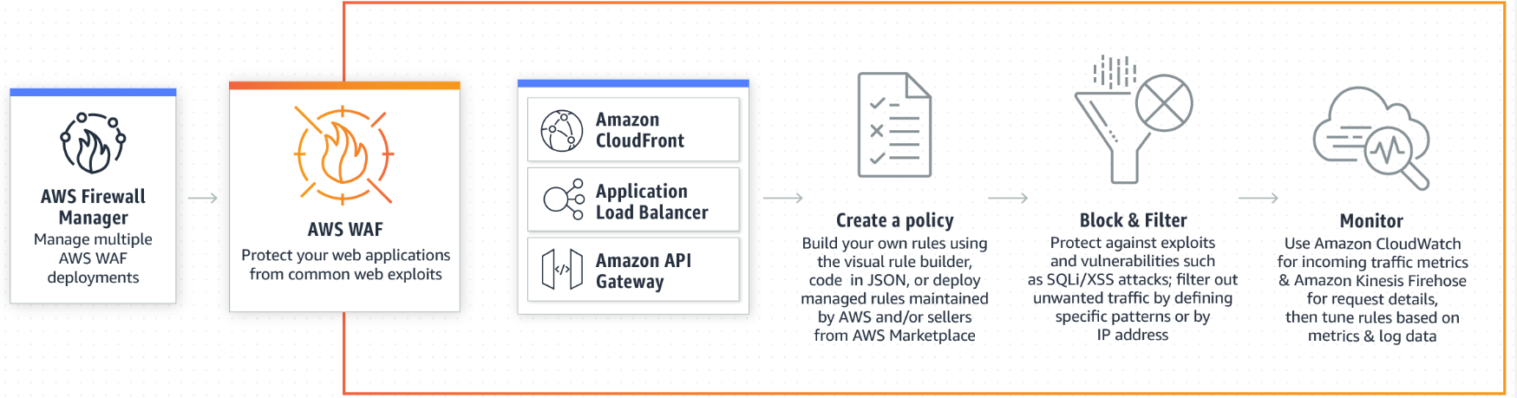
By using AWS WAF, you can configure web access control lists (Web ACLs) on your CloudFront distributions or Application Load Balancers to filter and block requests based on request signatures. Each Web ACL consists of rules that you can configure to string match or regex match one or more request attributes, such as the URI, query-string, HTTP method, or header key. In addition, by using AWS WAF’s rate-based rules, you can automatically block the IP addresses of bad actors when requests matching a rule exceed a threshold that you define. Requests from offending client IP addresses will receive 403 Forbidden error responses and will remain blocked until request rates drop below the threshold. This is useful for mitigating HTTP flood attacks that are disguised as regular web traffic.
It is recommended that you add web ACLs with rate-based rules as part of your AWS Shield Advanced protection. These rules can alert you to sudden spikes in traffic that might indicate a potential DDoS event. A rate-based rule counts the requests that arrive from any individual address in any five-minute period. If the number of requests exceeds the limit that you define, the rule can trigger an action such as sending you a notification.

Hence, the correct answer is: Configure Amazon CloudFront distribution and set Application Load Balancer as the origin. Create a rate-based web ACL rule using AWS WAF and associate it with Amazon CloudFront.

The option that says: Configure Amazon CloudFront distribution and set a Network Load Balancer as the origin. Use VPC Flow Logs to monitor abnormal traffic patterns. Set up a custom AWS Lambda function that processes the flow logs and invokes Amazon SNS for notification is incorrect because this option only allows you to monitor the traffic that is reaching your instance. You can’t use VPC Flow Logs to mitigate DDoS attacks.
The option that says: Configure Amazon CloudFront distribution and set an Application Load Balancer as the origin. Create a security group rule and deny all the suspicious addresses. Use Amazon SNS for notification is incorrect. To deny suspicious addresses, you must manually insert the IP addresses of these hosts. This is a manual task which is not a sustainable solution. Take note that attackers generate large volumes of packets or requests to overwhelm the target system. Using a security group in this scenario won’t help you mitigate DDoS attacks.
The option that says: Configure Amazon CloudFront distribution and set a Network Load Balancer as the origin. Use Amazon GuardDuty to block suspicious hosts based on its security findings. Set up a custom AWS Lambda function that processes the security logs and invokes Amazon SNS for notification is incorrect because Amazon GuardDuty is just a threat detection service. You should use AWS WAF and create your own AWS WAF rate-based rules for mitigating HTTP flood attacks that are disguised as regular web traffic.

_{References:}
https://docs.aws.amazon.com/waf/latest/developerguide/ddos-overview.html
https://docs.aws.amazon.com/waf/latest/developerguide/ddos-get-started-rate-based-rules.html
https://d0.awsstatic.com/whitepapers/Security/DDoS_White_Paper.pdf

Check out this AWS WAF Cheat Sheet:
https://tutorialsdojo.com/aws-waf/

112 47. Question A news company is planning to use a Hardware Security Module (CloudHSM) in AWS for secure key storage of their web applications. You have launched the CloudHSM cluster but after just a few hours, a support staff mistakenly attempted to log in as the administrator three times using an invalid password in the Hardware Security Module. This has caused the HSM to be zeroized, which means that the encryption keys on it have been wiped. Unfortunately, you did not have a copy of the keys stored anywhere else.
How can you obtain a new copy of the keys that you have stored on Hardware Security Module?
- Contact AWS Support and they will provide you a copy of the keys.
- The keys are lost permanently if you did not have a copy.
- Use the Amazon CLI to get a copy of the keys.
- Restore a snapshot of the Hardware Security Module.
Attempting to log in as the administrator more than twice with the wrong password zeroizes your HSM appliance. When an HSM is zeroized, all keys, certificates, and other data on the HSM is destroyed. You can use your cluster’s security group to prevent an unauthenticated user from zeroizing your HSM.
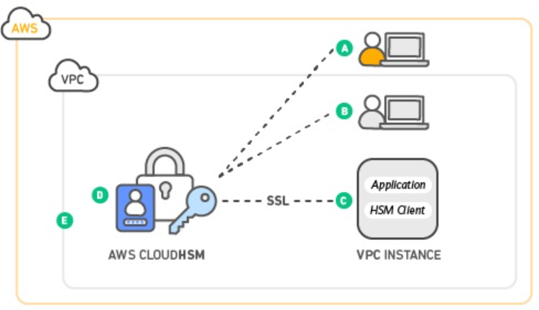
Amazon does not have access to your keys nor to the credentials of your Hardware Security Module (HSM) and therefore has no way to recover your keys if you lose your credentials. Amazon strongly recommends that you use two or more HSMs in separate Availability Zones in any production CloudHSM Cluster to avoid loss of cryptographic keys.
Refer to the CloudHSM FAQs for reference:
Q: Could I lose my keys if a single HSM instance fails?
Yes. It is possible to lose keys that were created since the most recent daily backup if the CloudHSM cluster that you are using fails and you are not using two or more HSMs. Amazon strongly recommends that you use two or more HSMs, in separate Availability Zones, in any production CloudHSM Cluster to avoid loss of cryptographic keys.
Q: Can Amazon recover my keys if I lose my credentials to my HSM?
No. Amazon does not have access to your keys or credentials and therefore has no way to recover your keys if you lose your credentials.

References:
https://aws.amazon.com/premiumsupport/knowledge-center/stop-cloudhsm/
https://aws.amazon.com/cloudhsm/faqs/
https://d1.awsstatic.com/whitepapers/Security/security-of-aws-cloudhsm-backups.pdf

113 48. Question An e-commerce company utilizes a regional Amazon API Gateway to host its public REST APIs. The API Gateway endpoint is accessed through a custom domain name set up with an Amazon Route 53 alias record. To support continuous improvement, the company intends to launch a new version of its APIs with enhanced features and performance optimizations.
How can the company reduce customer disruption and ensure MINIMAL data loss during the update process in the MOST cost-effective way?
- Implement a canary release deployment strategy for the API Gateway. Deploy the latest version of the APIs to a canary stage and direct a portion of the user traffic to this stage. Verify the new APIs. Gradually increase the traffic percentage, monitor for any issues, and, if successful, promote the canary stage to production.
- Create a new API Gateway with the updated version of the APIs in OpenAPI JSON or YAML file format, but keep the same custom domain name for the new API Gateway.
- Implement a blue-green deployment strategy for the API Gateway, deploying the latest version of the APIs to the green environment. Route some user traffic to it, validate the new APIs, and once thoroughly validated, promote the green environment to production.
- Modify the existing API Gateway with the updated version of the APIs, but keep the same custom domain name for the new API Gateway by using the import-to-update operation in either overwrite or merge mode.
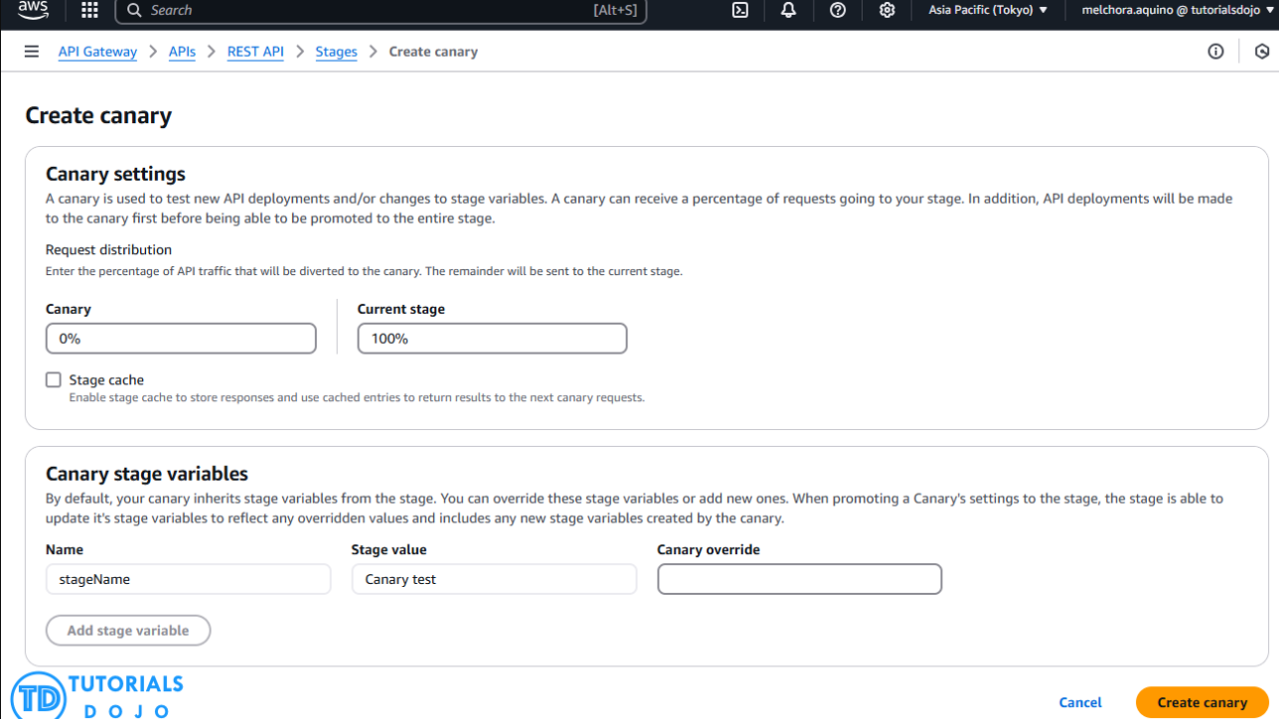

Implementing a canary release deployment strategy for the API Gateway is a great way to ensure your APIs remain stable and reliable. This strategy involves releasing a new version of your API to a small subset of users, allowing you to test the latest version in a controlled environment.
If the new version performs well, you can gradually roll out the update to the rest of your users. This approach lets you catch any issues before they affect your entire user base, minimizing the impact on your customers. By using Amazon API Gateway, you can quickly implement a canary release deployment strategy, ensuring that your APIs are always up-to-date and performing at their best.

Hence, the correct answer is: Implement a canary release deployment strategy for the API Gateway. Deploy the latest version of the APIs to a canary stage and direct a portion of the user traffic to this stage. Verify the new APIs. Gradually increase the traffic percentage, monitor for any issues, and, if successful, promote the canary stage to production.
The option that says: Create a new API Gateway with the updated version of the APIs in OpenAPI JSON or YAML file format, but keep the same custom domain name for the new API Gateway is incorrect. Upgrading to a new API Gateway using an updated version of the APIs in OpenAPI JSON or YAML file format while keeping the same custom domain name can typically result in downtime and confusion during the switch. This is because of DNS propagation delays, which can negatively affect users and even lead to data loss.
The option that says: Modify the existing API Gateway with the updated version of the APIs, but keep the same custom domain name for the new API Gateway by using the import-to-update operation in either overwrite or merge mode is incorrect. Using the import-to-update operation in either overwrite or merge mode may not provide enough isolation and control testing for the new version of the APIs. If something goes wrong during the update process, it could just lead to data loss on the existing API Gateway, potentially affecting all customers simultaneously.
The option that says: Implement a blue-green deployment strategy for the API Gateway, deploying the latest version of the APIs to the green environment. Route some user traffic to it, validate the new APIs, and once thoroughly validated, promote the green environment to production is incorrect. In a blue-green deployment, the blue (existing) and green (updated) environments must be provisioned and maintained. This adds complexity and cost to the update process, which breaks the cost requirement that’s explicitly mentioned in the scenario. Additionally, directing some user traffic to the green environment may only lead to issues for those users, especially if there are undiscovered bugs or performance problems in the updated APIs.
References:
https://docs.aws.amazon.com/apigateway/latest/developerguide/welcome.html
https://docs.aws.amazon.com/apigateway/latest/developerguide/canary-release.html
https://docs.aws.amazon.com/apigateway/latest/developerguide/api-gateway-import-api-update.html

Check out this Amazon API Gateway Cheat Sheet:
https://tutorialsdojo.com/amazon-api-gateway/

114 49. Question A company uses multiple Amazon Elastic Block Store (Amazon EBS) volumes of the Provisioned IOPS SSD (io2) type, which are attached to Amazon EC2 instances in its production environment. Based on AWS Cost Explorer reports, the company noticed a significant increase in monthly storage costs. To address this, the company wants to optimize EBS costs by analyzing usage metrics and making necessary volume adjustments without causing any application downtime.
What actions can help the company achieve this goal? (Select TWO.)
- Monitor performance metrics such as IOPS and throughput for the EBS volumes using Amazon CloudWatch GetMetricData.
- Modify instance attributes to lower EBS performance using Amazon EC2 ModifyInstanceAttribute.
- Adjust the size or performance settings of the EBS volumes with Amazon EC2 ModifyVolume.
- Apply an Amazon S3 lifecycle policy to archive infrequently accessed backup data to Amazon S3 Glacier automatically.
- Set an Amazon CloudWatch Billing Alarm to receive notifications about increased EBS storage costs.
Amazon EBS provides scalable, high-performance storage for Amazon EC2 instances. Cost optimization strategies for EBS include monitoring performance metrics to ensure the volumes are appropriately sized and modifying volume settings to avoid paying for unnecessary capacity or performance.
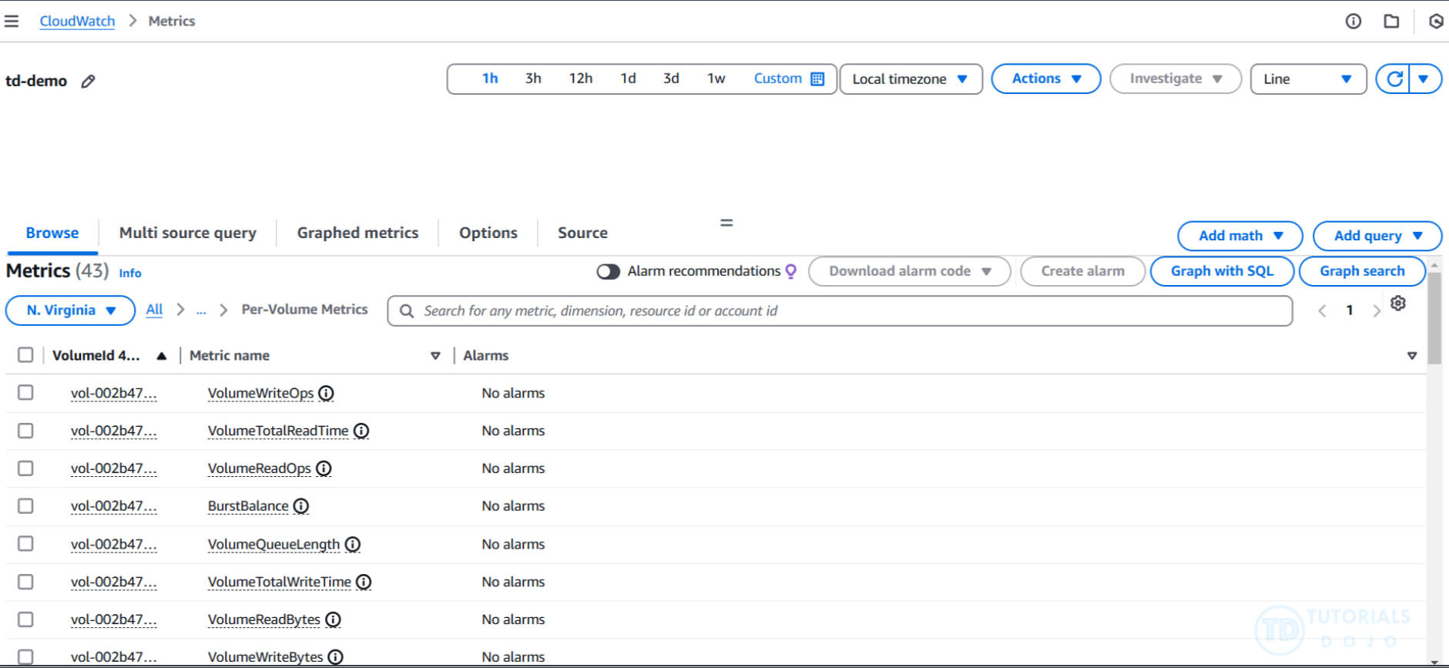
Amazon CloudWatch GetMetricData allows the company to monitor key performance metrics such as IOPS and throughput for EBS volumes. This helps identify underutilized or overprovisioned volumes, which can then be adjusted to reduce costs.
Amazon EC2 ModifyVolume enables users to change the size, performance, or volume type of EBS volumes without stopping the instance. This action helps optimize costs while maintaining application availability.
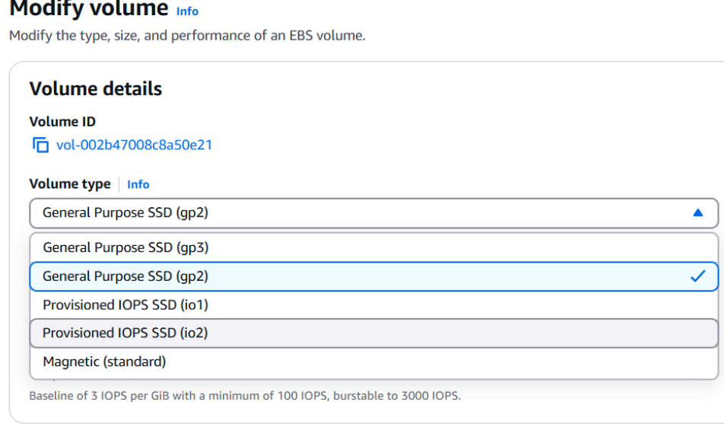

Hence, the correct answers are:
– Monitor performance metrics such as IOPS and throughput for the EBS volumes using Amazon CloudWatch GetMetricData.
– Adjust the size or performance settings of the EBS volumes with Amazon EC2 ModifyVolume.
The option that says: Apply an Amazon S3 lifecycle policy to archive infrequently accessed backup data to Amazon S3 Glacier automatically is incorrect because this only applies to Amazon S3 storage and does not help optimize Amazon EBS storage costs.
The option that says: Modify instance attributes to lower EBS performance using Amazon EC2 ModifyInstanceAttribute is incorrect because instance attributes do not primarily control EBS volume performance. This option is unrelated to the task of optimizing EBS costs.
The option that says: Set an Amazon CloudWatch Billing Alarm to receive notifications about increased EBS storage costs is incorrect. Although it can alert the company to increased costs, it does not provide detailed performance metrics or allow for direct volume optimization actions.
References:
https://docs.aws.amazon.com/AmazonCloudWatch/latest/APIReference/API_GetMetricData.html
https://docs.aws.amazon.com/AWSEC2/latest/APIReference/API_ModifyVolume.html

Check out these Amazon EBS and Amazon CloudWatch Cheat Sheets:
https://tutorialsdojo.com/amazon-ebs/

115 50. Question A solutions architect is tasked with designing a scalable infrastructure solution for a business that runs uses Amazon Elastic Kubernetes Service (Amazon EKS) to execute container applications. Since the company’s workload varies throughout the day, they want to make sure that its underlying infrastructure automatically scales in and out in response to demand.
Which of the following would meet the requirements with the LEAST amount of operational overhead?
- Set up CloudWatch alarms for CPU utilization or request count to monitor the relevant metrics of the container applications running on Amazon EKS.
- Integrate an edge-optimized API endpoint in Amazon API Gateway with Amazon EKS to manage and expose APIs for the containerized applications running on EKS.
- Use a combination of Kubernetes Metrics and Kubernetes Cluster Autoscaler to manage the number of nodes.
- Use Amazon EC2 Auto Scaling Groups with custom scaling policies to manage the scaling of EKS worker nodes.

Autoscaling is a function that automatically scales your resources up or down to meet changing demands. This is a major Kubernetes function that would otherwise require extensive human resources to perform manually.
Amazon EKS supports two autoscaling solutions:
Karpenter is a flexible, high-performance Kubernetes cluster autoscaler that launches appropriately sized compute resources, like Amazon EC2 instances, in response to changing application load. It integrates with AWS to provision compute resources that precisely match workload requirements.
Cluster Autoscaler, on the other hand, automatically adjusts the number of nodes in a cluster based on pod failures or rescheduling. It utilizes Auto Scaling groups for managing the cluster’s node capacity.
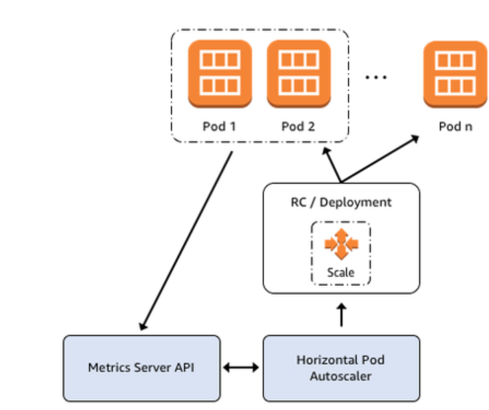
The Kubernetes Horizontal Pod Autoscaler (HPA) automatically scales the number of Pods based on CPU utilization, allowing applications to scale in or out to meet demand. It is a standard API resource in Kubernetes that requires a metrics source like the Kubernetes metrics server to be installed on the Amazon EKS cluster. The HPA does not need additional deployment or installation on the cluster to start scaling applications.
Hence, the correct answer is: Use a combination of Kubernetes Metrics and Kubernetes Cluster Autoscaler to manage the number of nodes.
The option that says: Integrate an edge-optimized API endpoint in Amazon API Gateway with Amazon EKS to manage and expose APIs for the containerized applications running on EKS is incorrect because the question specifically asks for a solution that enables automatic scaling in response to demand. An edge-optimized API endpoint in Amazon API Gateway is primarily used for geographically distributed clients wherein the API requests are routed to the nearest CloudFront Point of Presence (POP). It doesn’t specifically address the need for scaling.

The option that says: Use Amazon EC2 Auto Scaling Groups with custom scaling policies to manage the scaling of EKS worker nodes is incorrect. While Amazon EC2 Auto Scaling Groups can be used to manage EKS worker nodes, this approach requires more configuration and management of scaling policies. It does not offer the same level of seamless integration and automation as Kubernetes Cluster Autoscaler, which is more optimized for Kubernetes workloads.
The option that says: Set up CloudWatch alarms for CPU utilization or request count to monitor the relevant metrics of the container applications running on Amazon EKS is incorrect. While Amazon CloudWatch alarms can monitor the metrics of the Amazon EKS cluster, this approach alone does not enable automatic scaling of the EKS cluster in response to demand.

References:
https://docs.aws.amazon.com/eks/latest/userguide/autoscaling.html
https://docs.aws.amazon.com/eks/latest/userguide/horizontal-pod-autoscaler.html

Check out this Amazon EKS Cheat Sheet:
https://tutorialsdojo.com/amazon-elastic-kubernetes-service-eks/

- 116 51. Question A logistics company plans to automate its order management application. The company wants to use SFTP file transfer for uploading business-critical documents. Since the files are confidential, encryption at rest is required, and high availability must be ensured. Additionally, each file must be automatically deleted one month after creation.
Which of the following options should be implemented to meet the company’s requirements with the least operational overhead?
  - Create an Amazon Elastic File System (Amazon EFS) and enable encryption. Configure AWS Transfer for SFTP to securely upload files to the EFS file system. Apply an EFS lifecycle policy to delete files after 30 days.
  - Create an Amazon S3 bucket with encryption enabled. Launch an AWS Transfer for SFTP endpoint to securely upload files to the S3 bucket. Configure an S3 lifecycle rule to delete files after a month.
  - Create an Amazon S3 bucket with encryption enabled. Configure AWS Transfer for SFTP to securely upload files to the S3 bucket. Configure the retention policy on the SFTP server to delete files after a month.
  - Provision an Amazon EC2 instance and install the SFTP service. Mount an encrypted Amazon EFS file system on the EC2 instance to store the uploaded files. Add a cron job to delete the files older than a month.

AWS Transfer for SFTP enables you to easily move your file transfer workloads that use the Secure Shell File Transfer Protocol (SFTP) to AWS without needing to modify your applications or manage any SFTP servers.
To get started with AWS Transfer for SFTP (AWS SFTP) you create an SFTP server and map your domain to the server endpoint, select authentication for your SFTP clients using service-managed identities, or integrate your own identity provider, and select your Amazon S3 buckets to store the transferred data. Your existing users can continue to operate with their existing SFTP clients or applications. Data uploaded or downloaded using SFTP is available in your Amazon S3 bucket, and can be used for archiving or processing in AWS.
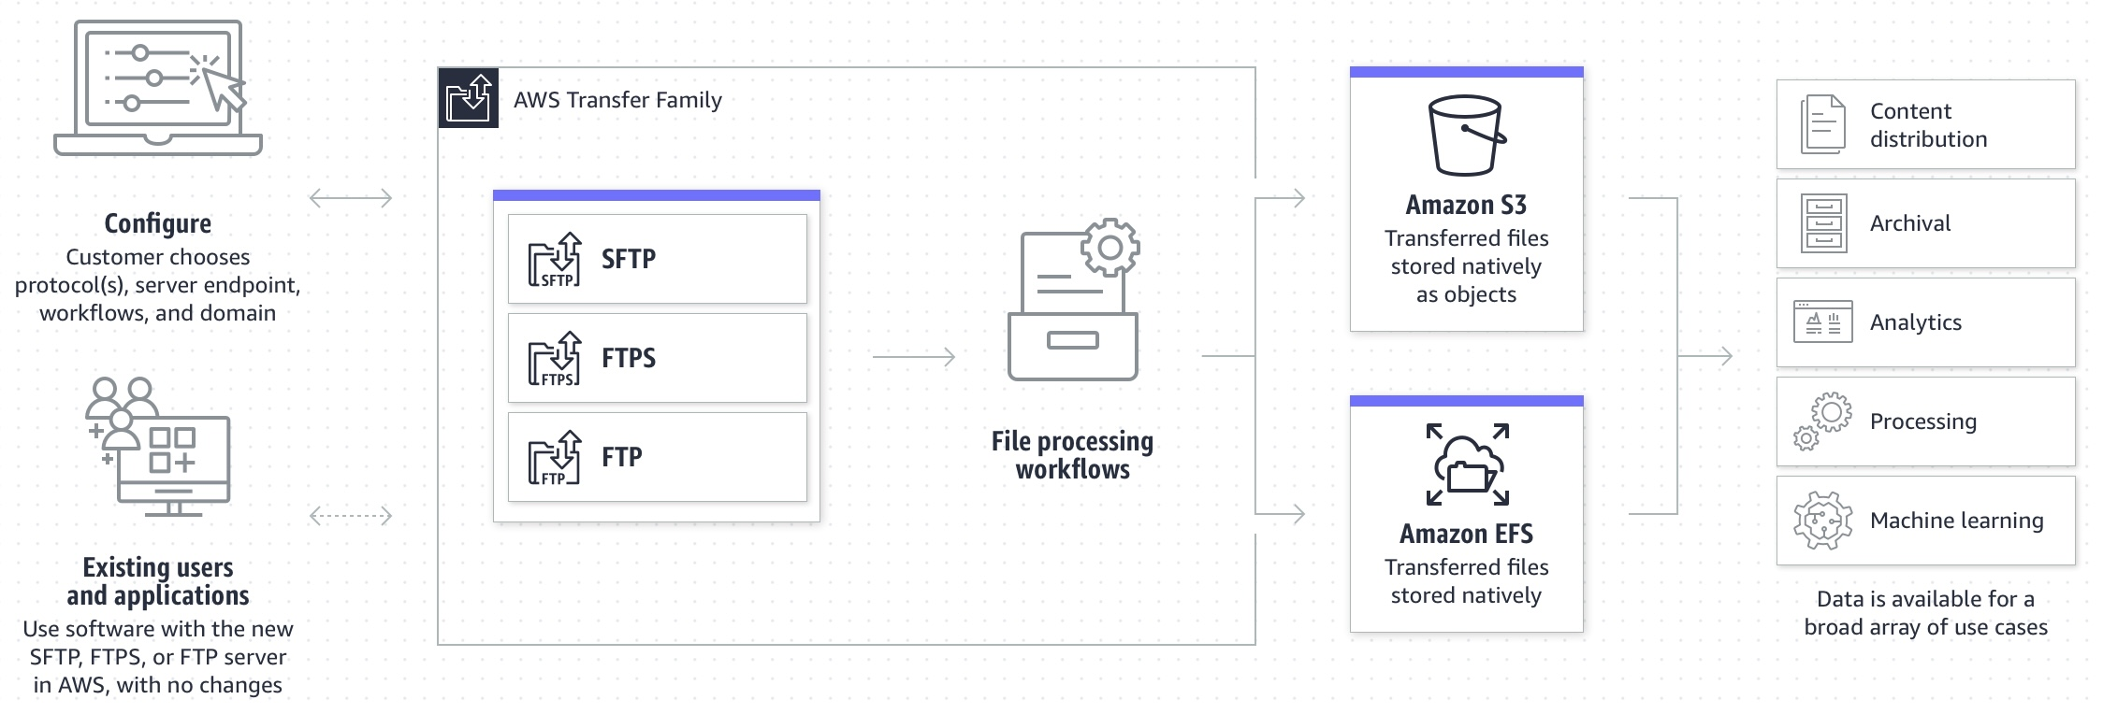
An Amazon S3 Lifecycle configuration is a set of rules that define actions that Amazon S3 applies to a group of objects. There are two types of actions:
Transition actions – These actions define when objects transition to another storage class. For example, you might choose to transition objects to the S3 Standard-IA storage class 30 days after creating them.
Expiration actions – These actions define when objects expire. Amazon S3 deletes expired objects on your behalf.
Therefore, the correct answer is: Create an Amazon S3 bucket with encryption enabled. Launch an AWS Transfer for SFTP endpoint to securely upload files to the S3 bucket. Configure an S3 lifecycle rule to delete files after a month. You can use S3 as the storage service for your AWS Transfer SFTP-enabled server.

The option that says: Create an Amazon S3 bucket with encryption enabled. Configure AWS Transfer for SFTP to securely upload files to the S3 bucket. Configure the retention policy on the SFTP server to delete files after a month is incorrect. The 30-day retention policy must be primarily configured on the Amazon S3 bucket. There is no retention policy option on AWS Transfer for SFTP.
The option that says: Create an Amazon Elastic File System (Amazon EFS) and enable encryption. Configure AWS Transfer for SFTP to securely upload files to the EFS file system. Apply an EFS lifecycle policy to delete files after 30 days is incorrect. This may be possible, however, the EFS lifecycle management doesn’t delete objects. It can only transition files in and out of the “Infrequent Access” tier.
The option that says: Provision an Amazon EC2 instance and install the SFTP service. Mount an encrypted Amazon EFS file system on the EC2 instance to store the uploaded files. Add a cron job to delete the files older than a month is incorrect. This option is possible, however, it entails greater operational overhead since you need to manage the EC2 instance and SFTP service.

References:
https://aws.amazon.com/aws-transfer-family/
https://docs.aws.amazon.com/transfer/latest/userguide/create-server-sftp.html
https://docs.aws.amazon.com/AmazonS3/latest/userguide/object-lifecycle-mgmt.html

Check out these AWS Transfer Family and Amazon S3 Cheat Sheets:
https://tutorialsdojo.com/amazon-s3/
https://tutorialsdojo.com/aws-transfer-family/

117 52. Question A company runs a messaging application in the ap-northeast-1 and ap-southeast-2 region. A Solutions Architect needs to create a routing policy wherein a larger portion of traffic from the Philippines and North India will be routed to the resource in the ap-northeast-1 region.
Which Route 53 routing policy should the Solutions Architect use?
- Latency Routing
- Weighted Routing
- Geoproximity Routing
- Geolocation Routing
Amazon Route 53 is a highly available and scalable Domain Name System (DNS) web service. You can use Route 53 to perform three main functions in any combination: domain registration, DNS routing, and health checking. After you create a hosted zone for your domain, such as example.com, you create records to tell the Domain Name System (DNS) how you want traffic to be routed for that domain.
For example, you might create records that cause DNS to do the following:
– Route Internet traffic for example.com to the IP address of a host in your data center.
– Route email for that domain (jose.rizal@tutorialsdojo.com) to a mail server (mail.tutorialsdojo.com).
– Route traffic for a subdomain called operations.manila.tutorialsdojo.com to the IP address of a different host.
Each record includes the name of a domain or a subdomain, a record type (for example, a record with a type of MX routes email), and other information applicable to the record type (for MX records, the hostname of one or more mail servers and a priority for each server).
.

Route 53 has different routing policies that you can choose from. Below are some of the policies:
Latency Routing lets Amazon Route 53 serve user requests from the AWS Region that provides the lowest latency. It does not, however, guarantee that users in the same geographic region will be served from the same location.
Geoproximity Routing lets Amazon Route 53 route traffic to your resources based on the geographic location of your users and your resources. You can also optionally choose to route more traffic or less to a given resource by specifying a value, known as a bias. A bias expands or shrinks the size of the geographic region from which traffic is routed to a resource.
Geolocation Routing lets you choose the resources that serve your traffic based on the geographic location of your users, meaning the location that DNS queries originate from.
Weighted Routing lets you associate multiple resources with a single domain name (tutorialsdojo.com) or subdomain name (subdomain.tutorialsdojo.com) and choose how much traffic is routed to each resource.
In this scenario, the problem requires a routing policy that will let Route 53 route traffic to the resource in the Tokyo region from a larger portion of the Philippines and North India.

You need to use Geoproximity Routing and specify a bias to control the size of the geographic region from which traffic is routed to your resource. The sample image above uses a bias of -40 in the Tokyo region and a bias of 1 in the Sydney Region. Setting up the bias configuration in this manner would cause Route 53 to route traffic coming from the middle and northern part of the Philippines, as well as the northern part of India to the resource in the Tokyo Region.
Hence, the correct answer is Geoproximity Routing.
Geolocation Routing is incorrect because you cannot control the coverage size from which traffic is routed to your instance in Geolocation Routing. It just lets you choose the instances that will serve traffic based on the location of your users.
Latency Routing is incorrect because it is mainly used for improving performance by letting Route 53 serve user requests from the AWS Region that provides the lowest latency.
Weighted Routing is incorrect because it is used for routing traffic to multiple resources in proportions that you specify. This can be useful for load balancing and testing new versions of software.

References:
https://docs.aws.amazon.com/Route53/latest/DeveloperGuide/routing-policy.html#routing-policy-geoproximity
https://docs.aws.amazon.com/Route53/latest/DeveloperGuide/rrsets-working-with.html

Latency Routing vs. Geoproximity Routing vs. Geolocation Routing:
https://tutorialsdojo.com/latency-routing-vs-geoproximity-routing-vs-geolocation-routing/

118 3. Question A new DevOps engineer has created a CloudFormation template for a web application and she raised a pull request in GIT for you to check and review. After checking the template, you immediately told her that the template will not work. Which of the following is the reason why this CloudFormation template will fail to deploy the stack?
"AWSTemplateFormatVersion":"2010-09-09",
"Parameters":{
"VPCId":{
"Type":"String",
"Description":"manila"
},
"SubnetId":{
"Type":"String",
"Description":"subnet-b46032ec"
}
},
"Outputs":{
"InstanceId":{
"Value":{
"Ref":"manilaInstance"
},
"Description":"Instance Id"
}
}
}
- An invalid section named Parameters is present. This will cause the CloudFormation stack to fail.
- The value of the AWSTemplateFormatVersion is incorrect. It should be 2017-06-06.
- The Conditions section is missing.
- The Resources section is missing.
In CloudFormation, a template is a JSON or a YAML-formatted text file that describes your AWS infrastructure. Templates include several major sections. The Resources section is the only required section. Some sections in a template can be in any order. However, as you build your template, it might be helpful to use the logical ordering of the following list, as values in one section might refer to values from a previous section. Take note that all of the sections here are optional, except for Resources, which is the only one required.
- Format Version
- Description
- Metadata
- Parameters
- Mappings
- Conditions
- Transform
- Resources (required)
- Outputs
Reference:
http://docs.aws.amazon.com/AWSCloudFormation/latest/UserGuide/template-anatomy.html

Check out this AWS CloudFormation Cheat Sheet:
https://tutorialsdojo.com/aws-cloudformation/

119 54. Question A Solutions Architect is designing a highly available environment for an application. She plans to host the application on EC2 instances within an Auto Scaling Group. One of the conditions requires data stored on root EBS volumes to be preserved if an instance terminates.
What should be done to satisfy the requirement?
  - Set the value of DeleteOnTermination attribute of the EBS volumes to False.
  - Configure ASG to suspend the health check process for each EC2 instance.
  - Use AWS DataSync to replicate root volume data to Amazon S3.
  - Enable the Termination Protection option for all EC2 instances.
By default, Amazon EBS root device volumes are automatically deleted when the instance terminates. However, by default, any additional EBS volumes that you attach at launch, or any EBS volumes that you attach to an existing instance persist even after the instance terminates. This behavior is controlled by the volume’s DeleteOnTermination attribute, which you can modify.
To preserve the root volume when an instance terminates, change the DeleteOnTermination attribute for the root volume to False.

This EBS attribute can be changed through the AWS Console upon launching the instance or through CLI/API command.
Hence, the correct answer is the option that says: Set the value of DeleteOnTermination attribute of the EBS volumes to False.
The option that says: Use AWS DataSync to replicate root volume data to Amazon S3 is incorrect because AWS DataSync does not work with Amazon EBS volumes. DataSync can copy data between Network File System (NFS) shares, Server Message Block (SMB) shares, self-managed object storage, AWS Snowcone, Amazon Simple Storage Service (Amazon S3) buckets, Amazon Elastic File System (Amazon EFS) file systems, and Amazon FSx for Windows File Server file systems.
The option that says: Configure ASG to suspend the health check process for each EC2 instance is incorrect because suspending the health check process will prevent the ASG from replacing unhealthy EC2 instances. This can cause availability issues to the application.
The option that says: Enable the Termination Protection option for all EC2 instances is incorrect. Termination Protection will just prevent your instance from being accidentally terminated using the Amazon EC2 console.

References:
https://aws.amazon.com/premiumsupport/knowledge-center/deleteontermination-ebs/
https://docs.aws.amazon.com/AWSEC2/latest/UserGuide/terminating-instances.html

Check out this Amazon EBS Cheat Sheet:
https://tutorialsdojo.com/amazon-ebs/

120 55. Question A firm has a containerized application that runs on a self-managed Kubernetes cluster. The cluster writes data in an on-premises MongoDB database. A solutions architect is requested to move the service to AWS in order to minimize operational overhead. The firm prohibits any changes to the code.
Which action meets these objectives?
  - Migrate the cluster to an Amazon Elastic Container Service (ECS) cluster using Amazon ECS Anywhere and the database to an Amazon Aurora Serverless database.
  - Migrate the cluster to an Amazon Elastic Kubernetes Service (EKS) cluster using Amazon EKS Anywhere and the database to an Amazon DynamoDB table.
  - Migrate the cluster to an Amazon Elastic Kubernetes Service (EKS) cluster and the database to an Amazon DocumentDB (with MongoDB compatibility) database.
  - Migrate the cluster to an Amazon Elastic Container Service (ECS) cluster with the images stored in the Amazon Elastic Container Registry (Amazon ECR). Move the database to an Amazon Neptune database
Amazon DocumentDB (with MongoDB compatibility) is a fast, scalable, highly available, and fully managed document database service that supports MongoDB workloads. The Amazon DocumentDB Migration Guide outlines three primary approaches for migrating from MongoDB to Amazon DocumentDB: offline, online, and hybrid.
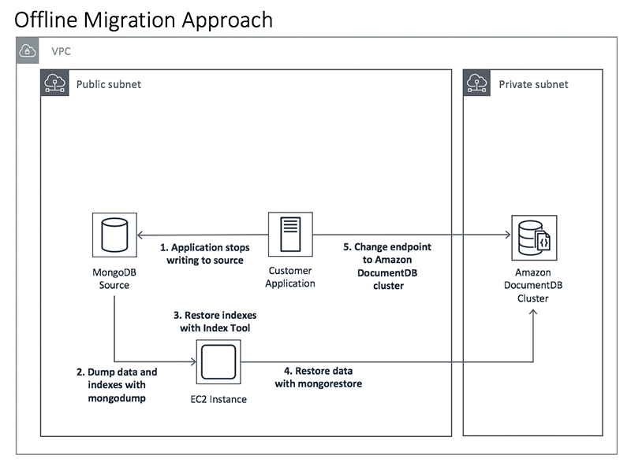
The image above illustrates an offline migration approach, which is the fastest and simplest of the three but incurs the longest period of downtime. This approach is a good choice for proofs of concepts, development and test workloads, and production workloads for which downtime is not of primary concern. For online approach, you may use AWS DMS to minimize downtime. AWS DMS continually reads from the source MongoDB oplog and applies those changes in near-real time on the source Amazon DocumentDB cluster.
Hence, the correct answer is: Migrate the cluster to an Amazon Elastic Kubernetes Service (EKS) cluster and the database to an Amazon DocumentDB (with MongoDB compatibility) database.
The option that says: Migrate the cluster to an Amazon Elastic Container Service (ECS) cluster using Amazon ECS Anywhere and the database to an Amazon Aurora Serverless database is incorrect. You can’t directly migrate to Amazon Aurora because MongoDB is a non-relational database. Amazon Elastic Container Service (ECS) Anywhere is simply a feature of Amazon ECS that enables you to easily run and manage container workloads on customer-managed infrastructure.
The option that says: Migrate the cluster to an Amazon Elastic Kubernetes Service (EKS) cluster using Amazon EKS Anywhere and the database to an Amazon DynamoDB table is incorrect. Although DynamoDB supports JSON-like documents, migrating from MongoDB to a DynamoDB table would involve code changes since the operations for accessing DynamoDB tables are different. DynamoDB has a different set of APIs for creating, reading, updating, and deleting items than MongoDB. The use of Amazon EKS Anywhere is not warranted as well. This is only a new deployment option for Amazon EKS that allows customers to create and operate Kubernetes clusters on customer-managed infrastructure.
The option that says: Migrate the cluster to an Amazon Elastic Container Service (ECS) cluster with the images stored in the Amazon Elastic Container Registry (Amazon ECR). Move the database to an Amazon Neptune database is incorrect. Amazon Neptune is not suitable for the use case described in the scenario. Amazon Neptune is a fully managed graph database service that makes it easy to build and run applications that work with highly connected datasets.

References:
https://docs.aws.amazon.com/documentdb/latest/developerguide/docdb-migration.html#docdb-migration-approaches
https://aws.amazon.com/eks/

Check out this Amazon DocumentDB Cheat Sheet:
https://tutorialsdojo.com/amazon-documentdb/

- 121 56. Question An organization operates a high-traffic static website hosted on Amazon S3, which is distributed via Amazon CloudFront. The current CloudFront distribution has a default Time-to-Live (TTL) of 10 seconds, leading to no caching. The company aims to implement caching to enhance website performance while ensuring that outdated content is not served for more than a few minutes post-deployment.
Which caching strategies should a solutions architect apply to achieve these objectives?
    - Apply a default TTL of 4 minutes on the S3 bucket.
    - Deploy an AWS Lambda@Edge function to insert an Expires header into HTTP responses. Set this function to trigger on viewer response.
    - Set up Amazon S3 lifecycle policies to automatically delete objects older than 7 days, ensuring that CloudFront edge caches are regularly purged of stale content.
    - Set the CloudFront default TTL to 4 minutes and implement a Cache-Control private directive on objects stored within Amazon S3.

Amazon CloudFront is a global content delivery network (CDN) service provided by AWS, designed to accelerate the delivery of static and dynamic web content to users worldwide with low latency and high transfer speeds. It works by caching content at edge locations distributed globally, reducing the distance between users and content, which in turn improves the overall performance and responsiveness of websites and applications. CloudFront integrates seamlessly with other AWS services like Amazon S3, enabling organizations to deliver content more efficiently while reducing the load on their origin servers.
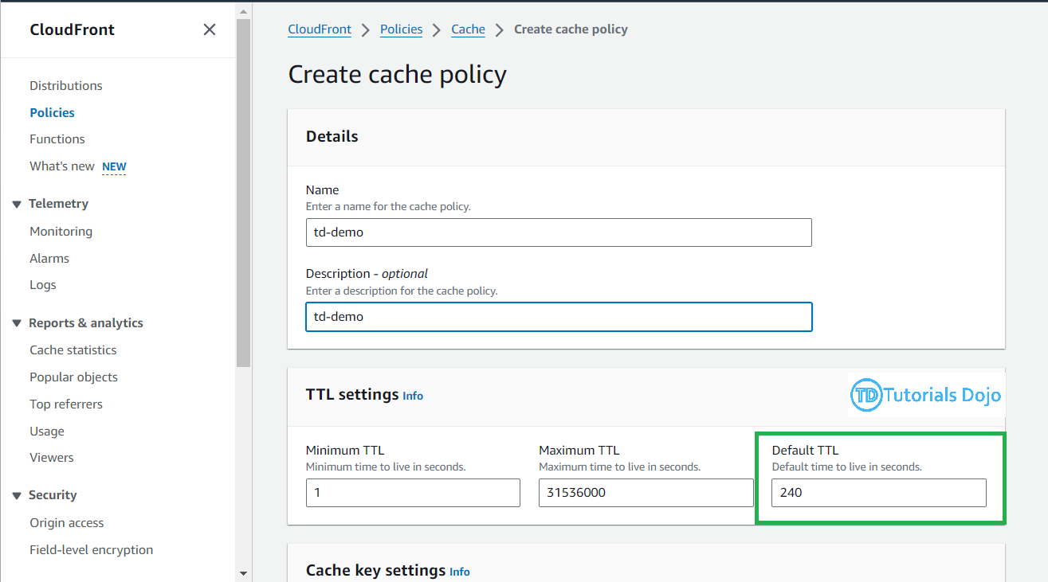
Setting the CloudFront default TTL (Time-to-Live) to 4 minutes and implementing a Cache-Control private directive on objects stored within Amazon S3 leverages CloudFront’s caching capabilities to enhance website performance. With the TTL set to 4 minutes, CloudFront caches content at edge locations for up to 4 minutes before checking the origin (S3) for updates. This reduces latency for subsequent requests from users accessing the same content within the caching period. Additionally, implementing the Cache-Control private directive on S3 objects ensures that content is cached by CloudFront and individual user browsers but not by shared caches, thereby maintaining control over content freshness. As a result, these measures optimize the delivery of static content while ensuring that updated content is quickly served to users, enhancing both the performance and reliability of the website or application globally.

Hence, the correct answer is: Set the CloudFront default TTL to 4 minutes and implement a Cache-Control private directive on objects stored within Amazon S3.
The option that says: Apply a default TTL of 4 minutes on the S3 bucket is incorrect because S3 does not support setting a default TTL directly on the bucket. Moreover, TTL settings are managed via headers that CloudFront uses.
The option that says: Deploy an AWS Lambda@Edge function to insert an Expires header into HTTP responses. Set this function to trigger on viewer response is incorrect because this approach primarily allows customization of caching behavior through Lambda@Edge and also introduces additional complexity. While functional, this option may be overly complex for the given requirements.
The option that says: Set up Amazon S3 lifecycle policies to automatically delete objects older than 7 days, ensuring that CloudFront edge caches are regularly purged of stale content is incorrect because CloudFront only manages its own cache independently of S3 lifecycle policies. In addition, S3 lifecycle policies do not directly manage CloudFront’s cache duration.

References:
https://docs.aws.amazon.com/AmazonCloudFront/latest/DeveloperGuide/Expiration.html
https://docs.aws.amazon.com/whitepapers/latest/amazon-cloudfront-media/cloudfront-configuration-best-practices.html

Check out this Amazon CloudFront Cheat Sheet:
https://tutorialsdojo.com/amazon-cloudfront/

122 57. Question
A company plans to deploy a Docker-based batch application in AWS. The application will be used to process both mission-critical data as well as non-essential batch jobs.
Which of the following is the most cost-effective option to use in implementing this architecture?
- Use ECS as the container management service then set up a combination of Reserved and Spot EC2 Instances for processing mission-critical and non-essential batch jobs respectively.
- Use ECS as the container management service then set up On-Demand EC2 Instances for processing both mission-critical and non-essential batch jobs.
- Use ECS as the container management service then set up Spot EC2 Instances for processing both mission-critical and non-essential batch jobs.
- Use ECS as the container management service then set up Reserved EC2 Instances for processing both mission-critical and non-essential batch jobs.
Amazon ECS lets you run batch workloads with managed or custom schedulers on Amazon EC2 On-Demand Instances, Reserved Instances, or Spot Instances. You can launch a combination of EC2 instances to set up a cost-effective architecture depending on your workload. You can launch Reserved EC2 instances to process the mission-critical data and Spot EC2 instances for processing non-essential batch jobs.
There are two different charge models for Amazon Elastic Container Service (ECS): Fargate Launch Type Model and EC2 Launch Type Model. With Fargate, you pay for the amount of vCPU and memory resources that your containerized application requests while for EC2 launch type model, there is no additional charge. You pay for AWS resources (e.g., EC2 instances or EBS volumes) you create to store and run your application. You only pay for what you use, as you use it; there are no minimum fees and no upfront commitments.
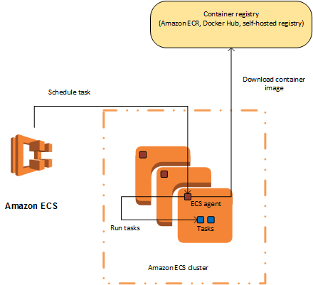
- In this scenario, the most cost-effective solution is to use ECS as the container management service then set up a combination of Reserved and Spot EC2 Instances for processing mission-critical and non-essential batch jobs respectively. You can use Scheduled Reserved Instances (Scheduled Instances) which enables you to purchase capacity reservations that recur on a daily, weekly, or monthly basis, with a specified start time and duration, for a one-year term. This will ensure that you have an uninterrupted compute capacity to process your mission-critical batch jobs.
- Hence, the correct answer is the option that says: Use ECS as the container management service then set up a combination of Reserved and Spot EC2 Instances for processing mission-critical and non-essential batch jobs respectively.
- Using ECS as the container management service then setting up Reserved EC2 Instances for processing both mission-critical and non-essential batch jobs is incorrect because processing the non-essential batch jobs can be handled much cheaper by using Spot EC2 instances instead of Reserved Instances.
- Using ECS as the container management service then setting up On-Demand EC2 Instances for processing both mission-critical and non-essential batch jobs is incorrect because an On-Demand instance costs more compared to Reserved and Spot EC2 instances. Processing the non-essential batch jobs can be handled much cheaper by using Spot EC2 instances instead of On-Demand instances.
- Using ECS as the container management service then setting up Spot EC2 Instances for processing both mission-critical and non-essential batch jobs is incorrect. Although this setup provides the cheapest solution among other options, it will not be able to meet the required workload. Using Spot instances to process mission-critical workloads is not suitable since these types of instances can be terminated by AWS at any time, which can affect critical processing.

References:
https://docs.aws.amazon.com/AmazonECS/latest/developerguide/Welcome.html
https://aws.amazon.com/ec2/spot/containers-for-less/get-started/

Check out this Amazon ECS Cheat Sheet:
https://tutorialsdojo.com/amazon-elastic-container-service-amazon-ecs/

123 58. Question An insurance company utilizes SAP HANA for its day-to-day ERP operations. Since they can’t migrate this database due to customer preferences, they need to integrate it with the current AWS workload in the VPC in which they are required to establish a site-to-site VPN connection.
What needs to be configured outside of the VPC for them to have a successful site-to-site VPN connection?
  - An Internet-routable IP address (static) of the customer gateway's external interface for the on-premises network
  - An EIP to the Virtual Private Gateway
  - The main route table in your VPC to route traffic through a NAT instance
  - A dedicated NAT instance in a public subnet
By default, instances that you launch into a virtual private cloud (VPC) CAN’T communicate with your own network. You can enable access to your network from your VPC by attaching a virtual private gateway to the VPC, creating a custom route table, updating your security group rules, and creating an AWS managed VPN connection.
Although the term VPN connection is a general term, in the Amazon VPC documentation, a VPN connection refers to the connection between your VPC and your own network. AWS supports Internet Protocol security (IPsec) VPN connections.
A customer gateway is a physical device or software application on your side of the VPN connection. To create a VPN connection, you must create a customer gateway resource in AWS, which provides information to AWS about your customer gateway device. Next, you have to set up an Internet-routable IP address (static) of the customer gateway’s external interface.

The following diagram illustrates Single VPN connections. The VPC has an attached virtual private gateway, and your remote network includes a customer gateway, which you must configure to enable the VPN connection. You set up the routing so that any traffic from the VPC bound for your network is routed to the virtual private gateway.
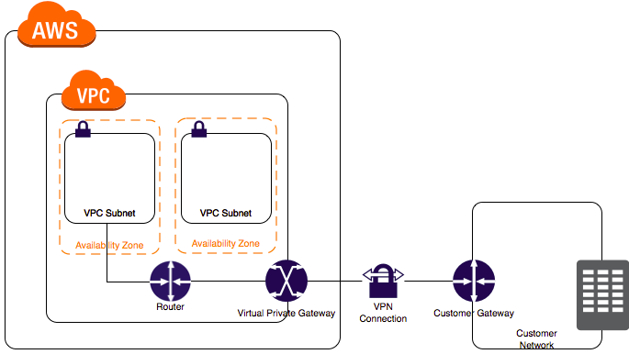
The options that say: A dedicated NAT instance in a public subnet and the main route table in your VPC to route traffic through a NAT instance are incorrect since you don’t need a NAT instance for you to be able to create a VPN connection. An EIP to the Virtual Private Gateway is incorrect since you do not attach an EIP to a VPG.

References:
https://docs.aws.amazon.com/AmazonVPC/latest/UserGuide/VPC_VPN.html
https://docs.aws.amazon.com/vpc/latest/userguide/SetUpVPNConnections.html

Check out this Amazon VPC Cheat Sheet:
https://tutorialsdojo.com/amazon-vpc/

124 9. Question A company plans to use a durable storage service to store on-premises database backups to the AWS cloud. To move their backup data, they need to use a service that can store and retrieve objects through standard file storage protocols for quick recovery.
Which of the following options will meet this requirement?
- Use AWS Snowball Edge to directly backup the data in Amazon S3 Glacier.
- Use Amazon EBS volumes to store all the backup data and attach it to an Amazon EC2 instance.
- Use the AWS Storage Gateway file gateway to store all the backup data in Amazon S3.
- Use the AWS Storage Gateway volume gateway to store the backup data and directly access it using Amazon S3 API actions.

File Gateway presents a file-based interface to Amazon S3, which appears as a network file share. It enables you to store and retrieve Amazon S3 objects through standard file storage protocols. File Gateway allows your existing file-based applications or devices to use secure and durable cloud storage without needing to be modified. With File Gateway, your configured S3 buckets will be available as Network File System (NFS) mount points or Server Message Block (SMB) file shares.

To store the backup data from on-premises to a durable cloud storage service, you can use File Gateway to store and retrieve objects through standard file storage protocols (SMB or NFS). File Gateway enables your existing file-based applications, devices, and workflows to use Amazon S3, without modification. File Gateway securely and durably stores both file contents and metadata as objects while providing your on-premises applications low-latency access to cached data.
Hence, the correct answer is: Use the AWS Storage Gateway file gateway to store all the backup data in Amazon S3.
The option that says: Use the AWS Storage Gateway volume gateway to store the backup data and directly access it using Amazon S3 API actions is incorrect. Although this is a possible solution, you cannot directly access the volume gateway using Amazon S3 APIs. You should use File Gateway to access your data in Amazon S3.
The option that says: Use Amazon EBS volumes to store all the backup data and attached it to an Amazon EC2 instance is incorrect. Take note that in the scenario, you are required to store the backup data in a durable storage service. An Amazon EBS volume is not highly durable like Amazon S3. Also, file storage protocols such as NFS or SMB, are not directly supported by EBS.
The option that says: Use AWS Snowball Edge to directly backup the data in Amazon S3 Glacier is incorrect because AWS Snowball Edge cannot store and retrieve objects through standard file storage protocols. Also, Snowball Edge can’t directly integrate backups to S3 Glacier.

References:
https://aws.amazon.com/storagegateway/faqs/
https://aws.amazon.com/s3/storage-classes/

Check out this AWS Storage Gateway Cheat Sheet:
https://tutorialsdojo.com/aws-storage-gateway/

125 60. Question A company has several EC2 Reserved Instances in their account that need to be decommissioned and shut down since they are no longer used by the development team. However, the data is still required by the audit team for compliance purposes.
Which of the following steps can be taken in this scenario? (Select TWO.)
    - Stop all the running EC2 instances.
    - You can opt to sell these EC2 instances on the AWS Reserved Instance Marketplace
    - Convert the EC2 instances to Spot instances with a persistent Spot request type.
    - Convert the EC2 instance to On-Demand instances
    - Take snapshots of the EBS volumes and terminate the EC2 instances.
Amazon Elastic Compute Cloud (Amazon EC2) is a web service that provides secure, resizable compute capacity in the cloud. It is designed to make web-scale cloud computing easier for developers. Amazon EC2’s simple web service interface allows you to obtain and configure capacity with minimal friction. It provides you with complete control of your computing resources and lets you run on Amazon’s proven computing environment.
The first requirement as per the scenario is to decommission and shut down several EC2 Reserved Instances. However, it is also mentioned that the audit team still requires the data for compliance purposes. To fulfil the given requirements, you can first create a snapshot of the instance to save its data and then sell the instance to the Reserved Instance Marketplace.
The Reserved Instance Marketplace is a platform that supports the sale of third-party and AWS customers’ unused Standard Reserved Instances, which vary in terms of length and pricing options. For example, you may want to sell Reserved Instances after moving instances to a new AWS region, changing to a new instance type, ending projects before the term expiration, when your business needs change, or if you have unneeded capacity.
Hence, the correct answers are:
– You can opt to sell these EC2 instances on the AWS Reserved Instance Marketplace.
– Take snapshots of the EBS volumes and terminate the EC2 instances.
The option that says: Convert the EC2 instance to On-Demand instances is incorrect because it’s stated in the scenario that the development team no longer needs several EC2 Reserved Instances. By converting it to On-Demand instances, the company will still have instances running in their infrastructure and this will result in additional costs.
The option that says: Convert the EC2 instances to Spot instances with a persistent Spot request type is incorrect because the requirement in the scenario is to terminate or shut down several EC2 Reserved Instances. Converting the existing instances to Spot instances will not satisfy the given requirement.
The option that says: Stop all the running EC2 instances is incorrect because doing so will still incur storage cost. Take note that the requirement in the scenario is to decommission and shut down several EC2 Reserved Instances. Therefore, this approach won’t fulfil the given requirement.

References:
https://docs.aws.amazon.com/AWSEC2/latest/UserGuide/ri-market-general.html
https://docs.aws.amazon.com/AWSEC2/latest/UserGuide/ebs-creating-snapshot.html

Check out this Amazon EC2 Cheat Sheet:
https://tutorialsdojo.com/amazon-elastic-compute-cloud-amazon-ec2/

126 61. Question An application is loading hundreds of JSON documents into an Amazon S3 bucket every hour which is registered in AWS Lake Formation as a data catalog. The Data Analytics team uses Amazon Athena to run analyses on these data, but due to the volume, most queries take a long time to complete.
What change should be made to improve the query performance while ensuring data security?
  - Convert the JSON documents into CSV format. Provide fine-grained named resource access control to specific databases or tables in AWS Lake Formation.
  - Transform the JSON data into Apache Parquet format. Ensure that the user has an lakeformation:GetDataAccess IAM permission for underlying data access control.
  - Apply minification on the data and implement the Lake Formation tag-based access control (LF-TBAC) authorization strategy to ensure security.
  - Compress the data into GZIP format before storing it in the S3 bucket. Apply an IAM policy with aws:SourceArn and aws:SourceAccount global condition context keys in Lake Formation that prevents cross-service confused deputy problems and other security issues.
Amazon Athena supports a wide variety of data formats like CSV, TSV, JSON, or Textfiles and also supports open-source columnar formats such as Apache ORC and Apache Parquet. Athena also supports compressed data in Snappy, Zlib, LZO, and GZIP formats. By compressing, partitioning, and using columnar formats you can improve performance and reduce your costs.
Parquet and ORC file formats both support predicate pushdown (also called predicate filtering). Parquet and ORC both have blocks of data that represent column values. Each block holds statistics for the block, such as max/min values. When a query is being executed, these statistics determine whether the block should be read or skipped.
Athena charges you by the amount of data scanned per query. You can save on costs and get better performance if you partition the data, compress data, or convert it to columnar formats such as Apache Parquet.

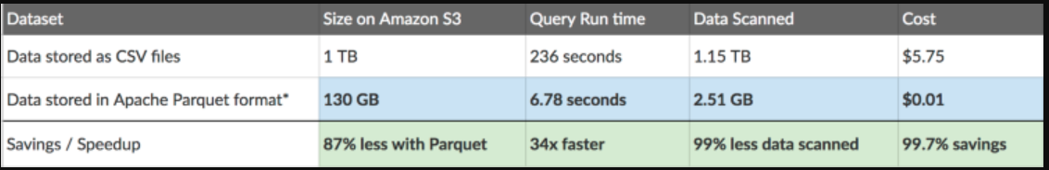
Apache Parquet is an open-source columnar storage format that is 2x faster to unload and takes up 6x less storage in Amazon S3 as compared to other text formats. One can COPY Apache Parquet and Apache ORC file formats from Amazon S3 to your Amazon Redshift cluster. Using AWS Glue, one can configure and run a job to transform CSV data to Parquet. Parquet is a columnar format that is well suited for AWS analytics services like Amazon Athena and Amazon Redshift Spectrum.
When an integrated AWS service requests access to data in an Amazon S3 location that is access-controlled by AWS Lake Formation, Lake Formation supplies temporary credentials to access the data. To enable Lake Formation to control access to underlying data at an Amazon S3 location, you register that location with Lake Formation.
To enable Lake Formation principals to read and write underlying data with access controlled by Lake Formation permissions:
– The Amazon S3 locations that contain the data must be registered with Lake Formation.
– Principals who create Data Catalog tables that point to underlying data locations must have data location permissions.
– Principals who read and write underlying data must have Lake Formation data access permissions on the Data Catalog tables that point to the underlying data locations.
– Principals who read and write underlying data must have the lakeformation:GetDataAccess IAM permission.
Thus, the correct answer is: Transform the JSON data into Apache Parquet format. Ensure that the user has an lakeformation:GetDataAccess IAM permission for underlying data access control.
The option that says: Convert the JSON documents into CSV format. Provide fine-grained named resource access control to specific databases or tables in AWS Lake Formation is incorrect because Athena queries performed against row-based formats like CSV are slower than columnar file formats like Apache Parquet.
The option that says:Apply minification on the data and implement the Lake Formation tag-based access control (LF-TBAC) authorization strategy using IAM Tags to ensure security is incorrect. Although minifying the JSON file might reduce its overall file size, there won’t be a significant difference in terms of querying performance. LF-TBAC is a type of an attribute-based access control (ABAC) that defines permissions based on certain attributes, such as tags in AWS. LF-TBAC uses LF-Tags to grant Lake Formation permissions and not regular IAM Tags.
The option that says: Compress the data into GZIP format before storing in the S3 bucket. Apply an IAM policy with aws:SourceArn and aws:SourceAccount global condition context keys in Lake Formation that prevents cross-service confused deputy problems and other security issues. is incorrect. Compressing the files prior to storing them in Amazon S3 will only save storage costs. As for query performance, it won’t have much improvement. In addition, using an IAM Policy to prevent cross-service confused deputy issues is not warranted in this scenario. Having an lakeformation:GetDataAccess IAM permission for underlying data access control should suffice.

References:
https://aws.amazon.com/blogs/big-data/top-10-performance-tuning-tips-for-amazon-athena/
https://docs.aws.amazon.com/lake-formation/latest/dg/access-control-underlying-data.html
https://docs.aws.amazon.com/lake-formation/latest/dg/TBAC-overview.html

Check out this Amazon Athena Cheat Sheet:
https://tutorialsdojo.com/amazon-athena/

- 127 62. Question
A commercial bank has designed its next-generation online banking platform to use a distributed system architecture. As their Software Architect, you have to ensure that their architecture is highly scalable, yet still cost-effective.
Which of the following will provide the most suitable solution for this scenario?
  - Launch multiple EC2 instances behind an Application Load Balancer to host your application services and SNS which will act as a highly-scalable buffer that stores messages as they travel between distributed applications.
  - Launch an Auto-Scaling group of EC2 instances to host your application services and an SQS queue. Include an Auto Scaling trigger to watch the SQS queue size which will either scale in or scale out the number of EC2 instances based on the queue.
  - Launch multiple On-Demand EC2 instances to host your application services and an SQS queue which will act as a highly-scalable buffer that stores messages as they travel between distributed applications.
  - Launch multiple EC2 instances behind an Application Load Balancer to host your application services, and Step Functions which will act as a highly-scalable buffer that stores messages as they travel between distributed applications.

An Auto Scaling group allows you to maintain the health and availability of your application by scaling the number of EC2 instances up or down based on demand. This is particularly useful in a banking platform where traffic can be highly variable. The group can scale out (add more instances) during high-demand periods and scale in (remove instances) during low demand periods, ensuring optimal resource utilization and cost-effectiveness.
To improve the scalability of your distributed system, you can add an Auto Scaling group to your EC2 instances.
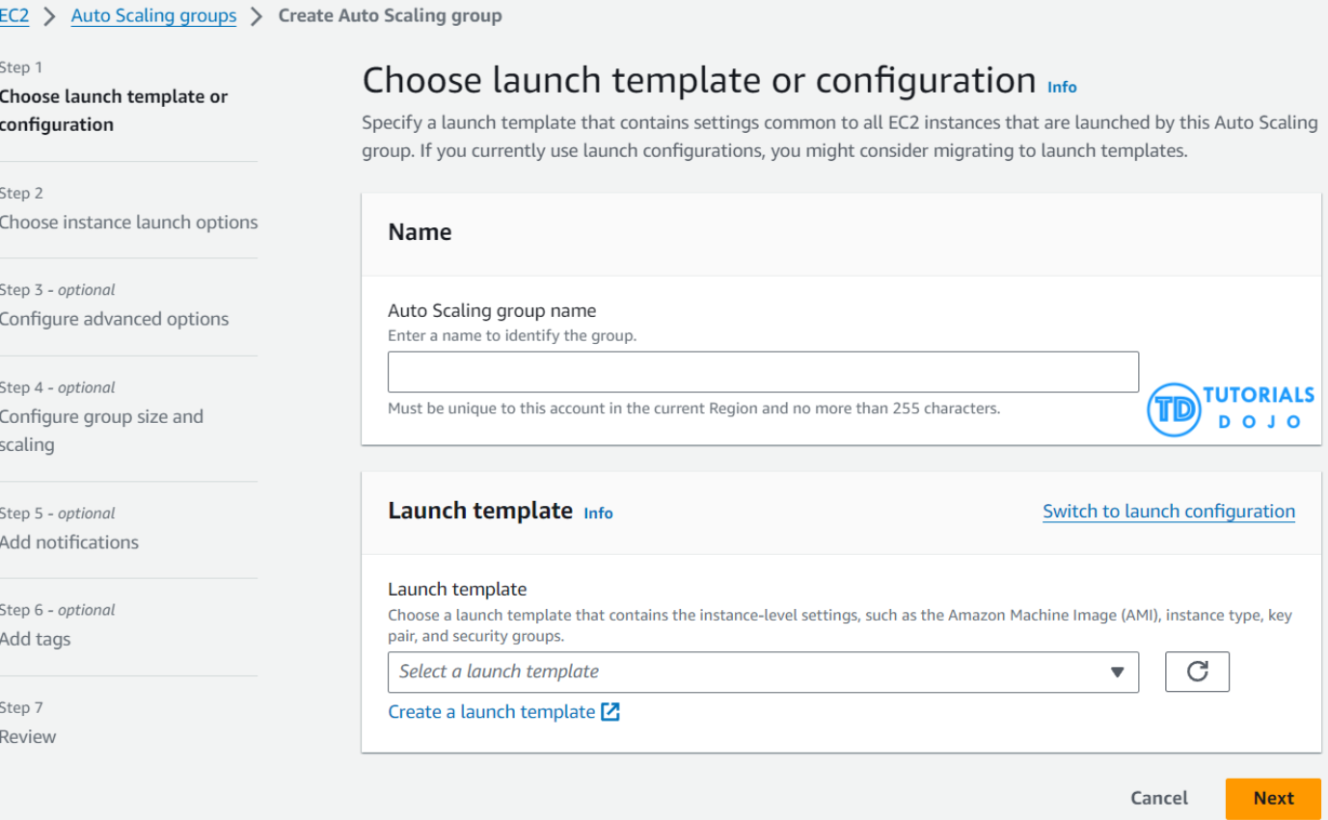
Amazon Simple Queue Service (SQS) is a fully managed message queuing service that enables you to decouple and scale microservices, distributed systems, and serverless applications. In the context of a banking platform, SQS can act as a buffer for messages as they travel between distributed applications, ensuring that no message is lost and that the order of transactions is maintained.
There are three main parts in a distributed messaging system: the components of your distributed system, which can be hosted on EC2 instance; your queue (distributed on Amazon SQS servers); and the messages in the queue.

Hence, the correct answer is: Launch an Auto-Scaling group of EC2 instances to host your application services and an SQS queue. Include an Auto Scaling trigger to watch the SQS queue size which will either scale in or scale out the number of EC2 instances based on the queue.
The option that says: Launch multiple EC2 instances behind an Application Load Balancer to host your application services and SNS which will act as a highly-scalable buffer that stores messages as they travel between distributed applications is incorrect because Amazon SNS is designed for pub-sub (publish-subscribe) messaging and mobile notifications. It is not the best choice for a banking platform where transactions and data consistency are critical.
The option that says: Launch multiple EC2 instances behind an Application Load Balancer to host your application services, and Step Functions which will act as a highly-scalable buffer that stores messages as they travel between distributed applications is incorrect because Step Functions is primarily designed for orchestrating complex workflows and business processes, rather than acting as a buffer for messages. For a banking platform, a more suitable service might be one that provides reliable message queuing and delivery, such as Amazon SQS.
The option that says: Launch multiple On-Demand EC2 instances to host your application services and an SQS queue which will act as a highly-scalable buffer that stores messages as they travel between distributed applications is incorrect because On-Demand EC2 instances are expensive and might not be the most cost-effective solution for a banking platform that needs to be highly scalable. SQS (Simple Queue Service) is a good choice for buffering messages between distributed applications, but the cost of running multiple On-Demand EC2 instances might outweigh the benefits.
References:
https://docs.aws.amazon.com/autoscaling/ec2/userguide/as-using-sqs-queue.html
https://docs.aws.amazon.com/AWSSimpleQueueService/latest/SQSDeveloperGuide/sqs-basic-architecture.html
Check out this AWS Auto Scaling Cheat Sheet:
https://tutorialsdojo.com/aws-auto-scaling/

128 63. Question There is a new compliance rule in your company that audits every Windows and Linux EC2 instances each month to view any performance issues. They have more than a hundred EC2 instances running in production, and each must have a logging function that collects various system details regarding that instance. The SysOps team will periodically review these logs and analyze their contents using AWS Analytics tools, and the result will need to be retained in an S3 bucket.
In this scenario, what is the most efficient way to collect and analyze logs from the instances with minimal effort?
  - Install the unified CloudWatch Logs agent in each instance which will automatically collect and push data to CloudWatch Logs. Analyze the log data with CloudWatch Logs Insights.
  - Install the AWS Systems Manager Agent (SSM Agent) in each instance which will automatically collect and push data to CloudWatch Logs. Analyze the log data with CloudWatch Logs Insights.
  - Install AWS Inspector Agent in each instance which will collect and push data to CloudWatch Logs periodically. Set up a CloudWatch dashboard to properly analyze the log data of all instances.
  - Install AWS SDK in each instance and create a custom daemon script that would collect and push data to CloudWatch Logs periodically. Enable CloudWatch detailed monitoring and use CloudWatch Logs Insights to analyze the log data of all instances.

To collect logs from your Amazon EC2 instances and on-premises servers into CloudWatch Logs, AWS offers both a new unified CloudWatch agent, and an older CloudWatch Logs agent. It is recommended to use the unified CloudWatch agent which has the following advantages:
- You can collect both logs and advanced metrics with the installation and configuration of just one agent.
- The unified agent enables the collection of logs from servers running Windows Server.
- If you are using the agent to collect CloudWatch metrics, the unified agent also enables the collection of additional system metrics, for in-guest visibility.
- The unified agent provides better performance.
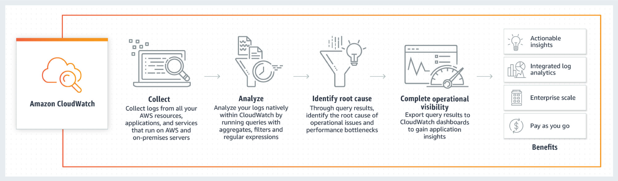
CloudWatch Logs Insights enables you to interactively search and analyze your log data in Amazon CloudWatch Logs. You can perform queries to help you quickly and effectively respond to operational issues. If an issue occurs, you can use CloudWatch Logs Insights to identify potential causes and validate deployed fixes.
CloudWatch Logs Insights includes a purpose-built query language with a few simple but powerful commands. CloudWatch Logs Insights provides sample queries, command descriptions, query autocompletion, and log field discovery to help you get started quickly. Sample queries are included for several types of AWS service logs.
The option that says: Install AWS SDK in each instance and create a custom daemon script that would collect and push data to CloudWatch Logs periodically. Enable CloudWatch detailed monitoring and use CloudWatch Logs Insights to analyze the log data of all instances is incorrect. Although this is a valid solution, this entails a lot of effort to implement as you have to allocate time to install the AWS SDK to each instance and develop a custom monitoring solution. Remember that the question is specifically looking for a solution that can be implemented with minimal effort. In addition, it is unnecessary and not cost-efficient to enable detailed monitoring in CloudWatch in order to meet the requirements of this scenario since this can be done using CloudWatch Logs.
The option that says: Install the AWS Systems Manager Agent (SSM Agent) in each instance which will automatically collect and push data to CloudWatch Logs. Analyze the log data with CloudWatch Logs Insights is incorrect. Although this is also a valid solution, it is more efficient to use CloudWatch agent than an SSM agent. Manually connecting to an instance to view log files and troubleshoot an issue with SSM Agent is time-consuming hence, for more efficient instance monitoring, you can use the CloudWatch Agent instead to send the log data to Amazon CloudWatch Logs.
The option that says: Install AWS Inspector Agent in each instance which will collect and push data to CloudWatch Logs periodically. Set up a CloudWatch dashboard to properly analyze the log data of all instances is incorrect because AWS Inspector is simply a security assessments service which only helps you in checking for unintended network accessibility of your EC2 instances and for vulnerabilities on those EC2 instances. Furthermore, setting up an Amazon CloudWatch dashboard is not suitable since its primarily used for scenarios where you have to monitor your resources in a single view, even those resources that are spread across different AWS Regions. It is better to use CloudWatch Logs Insights instead since it enables you to interactively search and analyze your log data.

References:
https://docs.aws.amazon.com/AmazonCloudWatch/latest/logs/WhatIsCloudWatchLogs.html
https://docs.aws.amazon.com/systems-manager/latest/userguide/monitoring-ssm-agent.html
https://docs.aws.amazon.com/AmazonCloudWatch/latest/logs/AnalyzingLogData.html

Amazon CloudWatch Overview:
Check out this Amazon CloudWatch Cheat Sheet:
https://tutorialsdojo.com/amazon-cloudwatch/

CloudWatch Agent vs SSM Agent vs Custom Daemon Scripts:
https://tutorialsdojo.com/cloudwatch-agent-vs-ssm-agent-vs-custom-daemon-scripts/

129 64. Question A company faces performance degradation due to intermittent traffic spikes in its application. The application is deployed across multiple EC2 instances within an Auto Scaling group and is fronted by a Network Load Balancer (NLB). The operations team found out that HTTP errors are not being detected by the NLB. As a result, clients are continuously routed to unhealthy targets and are never replaced, which impacts the availability of the application.
Which solution could resolve the issue with the least amount of development overhead?
  - Increase the NLB's idle timeout to allow more time for requests to be processed, reducing the occurrence of intermittent HTTP/s errors.
  - Configure the NLB to perform HTTP health checks on the critical paths of the application.
  - Use an Application Load Balancer (ALB) in place of the NLB. Enable HTTP health checks using the application's path.
  - Configure CloudFront as a content delivery network (CDN) in front of the NLB to reduce the load on the instances and improve performance.

Network Load Balancer (NLB) is a highly scalable load-balancing service that AWS provides. It is designed to handle substantial traffic volumes and distribution of incoming connections across healthy targets within one or more target groups, including Amazon EC2 instances, containers, IP addresses, or Lambda functions. NLB operates at the transport layer (Layer 4) and handles TCP, UDP, and TLS traffic.
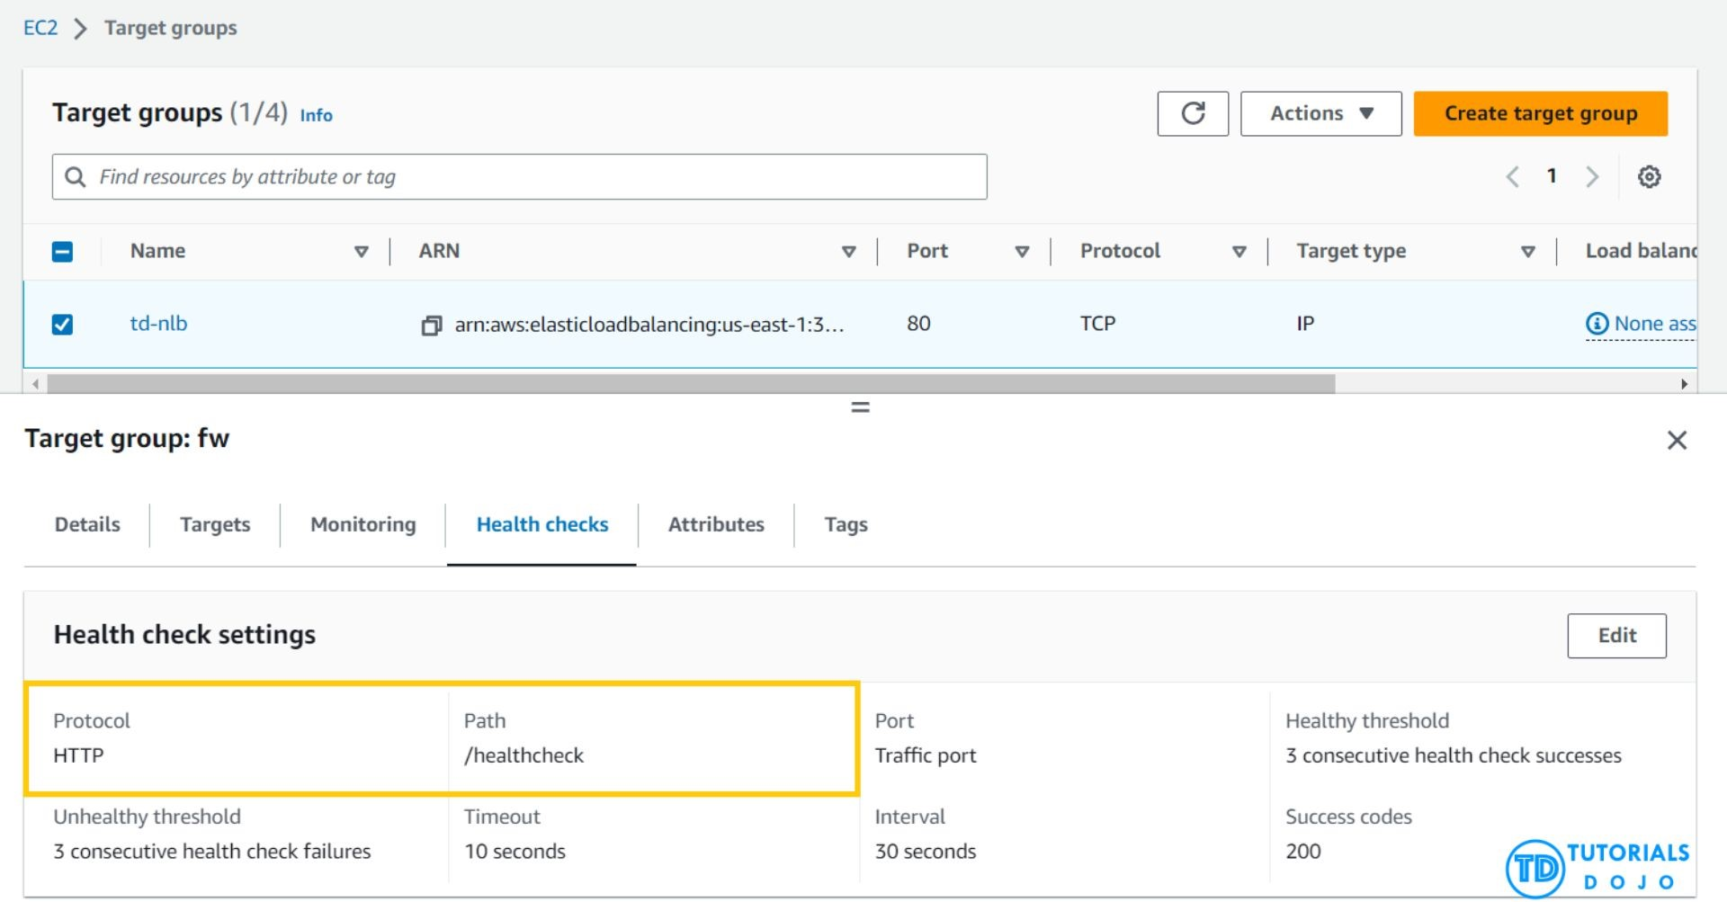
NLBs utilize active and passive health checks to assess a target’s capability to handle requests. These health checks are essential for the NLB component within an Amazon VPC as they regularly confirm the availability and responsiveness of registered targets. Through TCP, UDP, or TLS protocol requests, the health check guarantees that only healthy targets receive traffic. Failing targets are temporarily removed from rotation to maintain optimal performance and availability. Furthermore, NLBs are capable of managing millions of requests per second with ultra-low latencies, effectively handling sudden and volatile traffic patterns for applications with high traffic demands.
Hence, the correct answer is: Configure the NLB by enabling HTTP health checks on critical paths of the application.
The option that says: Use an Application Load Balancer (ALB) in place of the NLB. Enable HTTP health checks using the application’s path is incorrect. Switching from NLB to ALB involves a significant architectural change and could potentially require updating the application code to work with ALB.
The option that says: Increase the NLB’s idle timeout to allow more time for requests to be processed, reducing the occurrence of intermittent HTTP/s errors is incorrect. Increasing the idle timeout can help when long-running requests are being terminated. However, it does not address the issue of automatically detecting and error handling. It may reduce intermittent errors but does not provide a proactive solution to ensure high availability.
The option that says: Configure CloudFront as a content delivery network (CDN) in front of the NLB to reduce the load on the instances and improve performance is incorrect. While it’s true that CloudFront can help reduce the load on instances by caching static content, it does not directly affect the actual processing carried out by the instances. Moreover, simply using CloudFront as a CDN does not actively provide a mechanism for detecting and handling HTTP errors.

References:
https://docs.aws.amazon.com/elasticloadbalancing/latest/network/introduction.html
https://docs.aws.amazon.com/elasticloadbalancing/latest/network/target-group-health-checks.html

Check out this AWS Elastic Load Balancing (ELB) Cheat Sheet:
https://tutorialsdojo.com/aws-cheat-sheet-aws-elastic-load-balancing-elb/

130 65. Question
An accounting application uses an Amazon RDS database configured with Multi-AZ deployments to improve availability. What would happen to RDS if the primary database instance fails?
  - The primary database instance will reboot.
  - A new database instance is created in the standby Availability Zone.
  - The IP address of the primary DB instance is switched to the standby DB instance.
  - The canonical name record (CNAME) is switched from the primary to standby instance.
Incorrect
In Amazon RDS, failover is automatically handled so that you can resume database operations as quickly as possible without administrative intervention in the event that your primary database instance goes down. When failing over, Amazon RDS simply flips the canonical name record (CNAME) for your DB instance to point at the standby, which is in turn promoted to become the new primary.
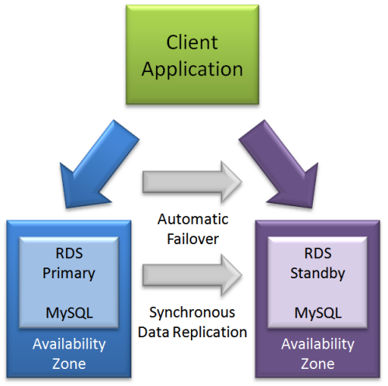
Hence, the correct answer is: The canonical name record (CNAME) is switched from the primary to standby instance.
The option that says: The IP address of the primary DB instance is switched to the standby DB instance is incorrect because IP addresses are per subnet, and subnets simply cannot span multiple AZs.
The option that says: The primary database instance will reboot is incorrect because, in the event of a failure, there is typically no database to reboot with.
The option that says: A new database instance is created in the standby Availability Zone is incorrect because with multi-AZ enabled, you already have a standby database in another AZ.

References:
https://aws.amazon.com/rds/details/multi-az/
https://aws.amazon.com/rds/faqs/
Check out this Amazon RDS Cheat Sheet:
https://tutorialsdojo.com/amazon-relational-database-service-amazon-rds/

131 1. Question
A cryptocurrency trading platform is using an API built in AWS Lambda and API Gateway. Due to the recent news and rumors about the upcoming price surge of Bitcoin, Ethereum and other cryptocurrencies, it is expected that the trading platform would have a significant increase in site visitors and new users in the coming days ahead.
In this scenario, how can you protect the backend systems of the platform from traffic spikes?
- Enable throttling limits and result caching in API Gateway.
- Switch from using AWS Lambda and API Gateway to a more scalable and highly available architecture using EC2 instances, ELB, and Auto Scaling.
- Use CloudFront in front of the API Gateway to act as a cache.
- Move the Lambda function in a VPC.
- Incorrect
- Amazon API Gateway provides throttling at multiple levels including global and by service call. Throttling limits can be set for standard rates and bursts. For example, API owners can set a rate limit of 1,000 requests per second for a specific method in their REST APIs, and also configure Amazon API Gateway to handle a burst of 2,000 requests per second for a few seconds. Amazon API Gateway tracks the number of requests per second. Any request over the limit will receive a 429 HTTP response. The client SDKs generated by Amazon API Gateway retry calls automatically when met with this response. Hence, enabling throttling limits and result caching in API Gateway is the correct answer.
- You can add caching to API calls by provisioning an Amazon API Gateway cache and specifying its size in gigabytes. The cache is provisioned for a specific stage of your APIs. This improves performance and reduces the traffic sent to your back end. Cache settings allow you to control the way the cache key is built and the time-to-live (TTL) of the data stored for each method. Amazon API Gateway also exposes management APIs that help you invalidate the cache for each stage.
- 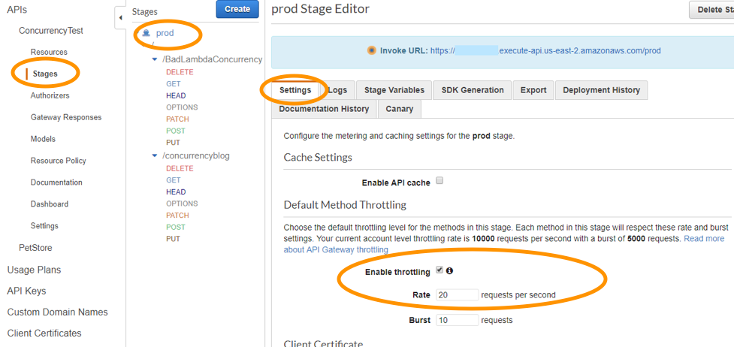
- The option that says: Switch from using AWS Lambda and API Gateway to a more scalable and highly available architecture using EC2 instances, ELB, and Auto Scaling is incorrect since there is no need to transfer your applications to other services.
- Using CloudFront in front of the API Gateway to act as a cache is incorrect because CloudFront only speeds up content delivery which provides a better latency experience for your users. It does not help much for the backend.
- Moving the Lambda function in a VPC is incorrect because this answer is irrelevant to what is being asked. A VPC is your own virtual private cloud where you can launch AWS services.

Reference:
https://aws.amazon.com/api-gateway/faqs/

Check out this Amazon API Gateway Cheat Sheet:
https://tutorialsdojo.com/amazon-api-gateway/
Here is an in-depth tutorial on Amazon API Gateway:
- 132 2. Question
A retail company receives raw .csv data files into its Amazon S3 bucket from multiple sources on an hourly basis, with an average file size of 2 GB.
An automated process must be implemented to convert these .csv files into the more efficient Apache Parquet format and store the converted files in another S3 bucket. Additionally, the conversion process must be automatically initiated each time a new file is uploaded into the S3 bucket.
Which of the following options must be implemented to meet these requirements with the LEAST operational overhead?
  - Use an AWS Lambda function triggered by an S3 PUT event to convert the .csv files to Parquet format. Use the AWS Transfer Family with SFTP service to move the output files to the target S3 bucket.
  - Utilize an AWS Glue extract, transform, and load (ETL) job to process and convert the .csv files to Apache Parquet format and then store the output files into the target S3 bucket. Set up an S3 Event Notification to track every S3 PUT event and invoke the ETL job in Glue through Amazon SQS.
  - Create an ETL (Extract, Transform, Load) job and a Data Catalog table in AWS Glue. Configure the Glue crawler to run on a schedule to check for new files in the S3 bucket every hour and convert them to Parquet format.
  - Set up an Apache Spark job running in an Amazon EC2 instance and create an Amazon EventBridge (Amazon CloudWatch Events) rule to monitor S3 PUT events in the S3 bucket. Configure AWS Lambda to invoke the Spark job for every new .csv file added via a Function URL.
Correct
AWS Glue is a powerful ETL service that easily moves data between different data stores. By using AWS Glue, you can easily create and manage ETL jobs to transfer data from various sources, such as Amazon S3, Amazon RDS, and Amazon Redshift. Additionally, AWS Glue enables you to transform your data as needed to fit your specific needs. One of the key advantages of AWS Glue is its automatic schema discovery and mapping, which allows you to easily map data from different sources with different schemas.
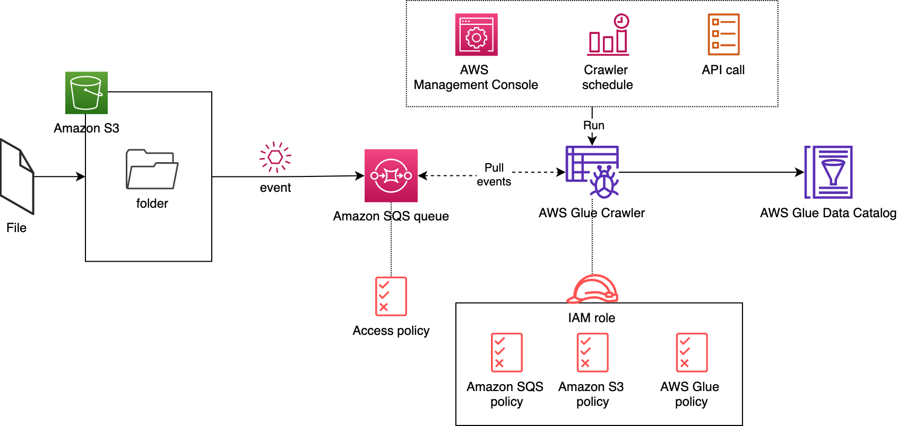
When working with big data processing, it is often necessary to convert data from one format to another to optimize processing efficiency. Apache Parquet is a columnar storage format that is designed to provide higher efficiency and performance for big data processing. By storing and processing large amounts of data with high compression rates and faster query times, Parquet can offer significant benefits to the company. Fortunately, Parquet is compatible with many data processing frameworks such as Spark, Hive, and Hadoop, making it a versatile format for big data processing. By using AWS Glue and other AWS services, you can easily convert their .csv files to the more efficient Apache Parquet format and store the output files in an S3 bucket, making it easy to access and process large amounts of data.
Hence the correct answer is: Utilize an AWS Glue extract, transform, and load (ETL) job to process and convert the .csv files to Apache Parquet format and then store the output files into the target S3 bucket. Set up an S3 Event Notification to track every S3 PUT event and invoke the ETL job in Glue through Amazon SQS.
The option that says: Use an AWS Lambda function triggered by an S3 PUT event to convert the .csv files to Parquet format. Use the AWS Transfer Family with SFTP service to move the output files to the target S3 bucket is incorrect. The conversion of the CSV files to Parquet format by using a combination of a Lambda function and S3 event notification would work; however, this is not the most efficient solution when primarily handling large amounts of data. The Lambda function has a maximum execution time limit which means that converting large files may result in timeout issues. Using the AWS Transfer Family with SFTP service to move the output files to the target S3 bucket is unnecessary too. Moreover, reading the records has to be delivered via a data stream since a Lambda function has a memory limit. This entails additional effort compared with using AWS Glue.
The option that says: Set up an Apache Spark job running in an Amazon EC2 instance and create an Amazon EventBridge (Amazon CloudWatch Events) rule to monitor S3 PUT events in the S3 bucket. Configure AWS Lambda to invoke the Spark job for every new .csv file added via a Function URL is incorrect. Running Spark on EC2 instances requires manual provisioning, monitoring, and maintenance, leading to time and additional costs. Additionally, using Amazon EventBridge (Amazon CloudWatch Events) to trigger the Spark job through a Function URL adds complexity and potential points of failure. Thus, this option just introduces unnecessary complexity and operational overhead.
The option that says: Create an ETL (Extract, Transform, Load) job and a Data Catalog table in AWS Glue. Configure the Glue crawler to run on a schedule to check for new files in the S3 bucket every hour and convert them to Parquet format is incorrect. Although it is right to create an ETL job using AWS Glue, simply triggering the job on a scheduled basis rather than being triggered automatically by a new file upload is not ideal. It is not as efficient as using an S3 event trigger to initiate the conversion process immediately upon file upload.

References:
https://aws.amazon.com/blogs/big-data/run-aws-glue-crawlers-using-amazon-s3-event-notifications/
https://docs.aws.amazon.com/glue/latest/dg/aws-glue-programming-etl-format-parquet-home.html
https://docs.aws.amazon.com/athena/latest/ug/glue-athena.html

Check out this AWS Glue Cheat Sheet:
https://tutorialsdojo.com/aws-glue/

