133 3. Question
A company is using Amazon S3 to store frequently accessed data. When an object is created or deleted, the S3 bucket will send an event notification to the Amazon SQS queue. A solutions architect needs to create a solution that will notify the development and operations team about the created or deleted objects.
Which of the following would satisfy this requirement?
  - Set up another SQS queue for the other team. Grant S3 permission to send a notification to the second SQS queue.
  - Create a new Amazon SNS FIFO topic for the other team. Grant S3 permission to send the notification to the second SNS topic.
  - Create an Amazon SNS topic and configure two SQS queues to subscribe to the topic. Grant S3 permission to send notifications to SNS and update the bucket to use the new SNS topic.
  - Set up an Amazon SNS topic and configure two SQS queues to poll the SNS topic. Grant S3 permission to send notifications to SNS and update the bucket to use the new SNS topic.
Correct
The Amazon S3 notification feature enables you to receive notifications when certain events happen in your bucket. To enable notifications, you must first add a notification configuration that identifies the events you want Amazon S3 to publish and the destinations where you want Amazon S3 to send the notifications. You store this configuration in the notification sub-resource that is associated with a bucket.
Amazon S3 supports the following destinations where it can publish events:
- Amazon Simple Notification Service (Amazon SNS) topic
- Amazon Simple Queue Service (Amazon SQS) queue
- AWS Lambda
In Amazon SNS, the fanout scenario is when a message published to an SNS topic is replicated and pushed to multiple endpoints, such as Amazon SQS queues, HTTP(S) endpoints, and Lambda functions. This allows for parallel asynchronous processing.
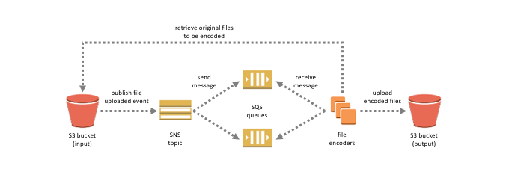
For example, you can develop an application that publishes a message to an SNS topic whenever an order is placed for a product. Then, SQS queues that are subscribed to the SNS topic receive identical notifications for the new order. An Amazon Elastic Compute Cloud (Amazon EC2) server instance attached to one of the SQS queues can handle the processing or fulfilment of the order. And you can attach another Amazon EC2 server instance to a data warehouse for analysis of all orders received.
Based on the given scenario, the existing setup sends the event notification to an SQS queue. Since you need to send the notification to the development and operations team, you can use a combination of Amazon SNS and SQS. By using the message fanout pattern, you can create a topic and use two Amazon SQS queues to subscribe to the topic. If Amazon SNS receives an event notification, it will publish the message to both subscribers.
Take note that Amazon S3 event notifications are designed to be delivered at least once and to one destination only. You cannot attach two or more SNS topics or SQS queues for S3 event notification. Therefore, you must send the event notification to Amazon SNS.
Hence, the correct answer is: Create an Amazon SNS topic and configure two SQS queues to subscribe to the topic. Grant S3 permission to send notifications to SNS and update the bucket to use the new SNS topic.
The option that says: Set up another SQS queue for the other team. Grant S3 permission to send a notification to the second SQS queue is incorrect because you can only add 1 SQS or SNS at a time for Amazon S3 events notification. If you need to send the events to multiple subscribers, you should implement a message fanout pattern with Amazon SNS and Amazon SQS.
The option that says: Create a new Amazon SNS FIFO topic for the other team. Grant S3 permission to send the notification to the second SNS topic is incorrect. Just as mentioned in the previous option, you can only add 1 SQS or SNS at a time for Amazon S3 events notification. In addition, neither Amazon SNS FIFO topic nor Amazon SQS FIFO queue is warranted in this scenario. Both of them can be used together to provide strict message ordering and message deduplication. The FIFO capabilities of each of these services work together to act as a fully managed service to integrate distributed applications that require data consistency in near-real-time.
The option that says: Set up an Amazon SNS topic and configure two SQS queues to poll the SNS topic. Grant S3 permission to send notifications to SNS and update the bucket to use the new SNS topic is incorrect because you can’t poll Amazon SNS. Instead of configuring queues to poll Amazon SNS, you should configure each Amazon SQS queue to subscribe to the SNS topic.

References:
https://docs.aws.amazon.com/AmazonS3/latest/dev/ways-to-add-notification-config-to-bucket.html
https://docs.aws.amazon.com/AmazonS3/latest/dev/NotificationHowTo.html#notification-how-to-overview
https://docs.aws.amazon.com/sns/latest/dg/welcome.html

Check out this Amazon S3 Cheat Sheet:
https://tutorialsdojo.com/amazon-s3/

134 4. Question
A pharmaceutical company has resources hosted on both its on-premises network and in the AWS cloud. The company requires all Software Architects to access resources in both environments using on-premises credentials, which are stored in Active Directory.
In this scenario, which of the following can be used to fulfill this requirement?
  - Set up SAML 2.0-Based Federation by using a Microsoft Active Directory Federation Service.
  - Set up SAML 2.0-Based Federation by using a Web Identity Federation.
  - Use IAM users
  - Use Amazon VPC
Correct
Since the company is using Microsoft Active Directory which implements Security Assertion Markup Language (SAML), you can set up a SAML-Based Federation for API Access to your AWS cloud. In this way, you can easily connect to AWS using the login credentials of your on-premises network.
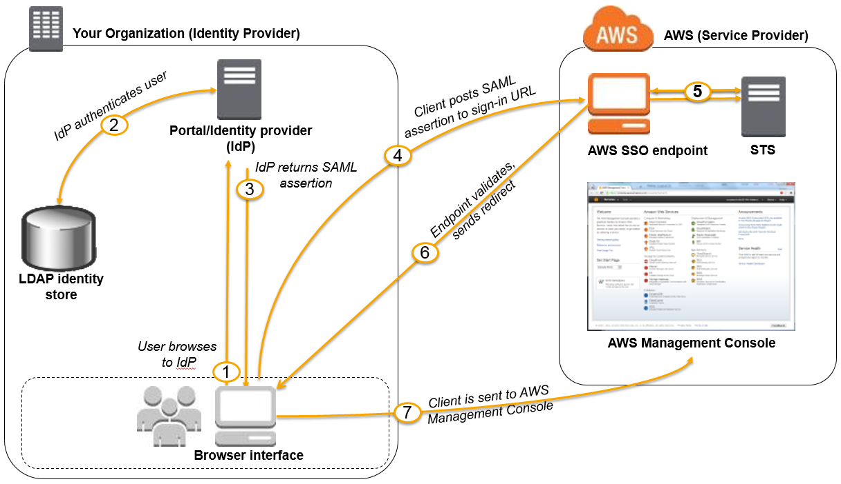
AWS supports identity federation with SAML 2.0, an open standard that many identity providers (IdPs) use. This feature enables federated single sign-on (SSO), so users can log into the AWS Management Console or call the AWS APIs without you having to create an IAM user for everyone in your organization. By using SAML, you can simplify the process of configuring federation with AWS, because you can use the IdP’s service instead of writing custom identity proxy code.
Before you can use SAML 2.0-based federation as described in the preceding scenario and diagram, you must configure your organization’s IdP and your AWS account to trust each other. The general process for configuring this trust is described in the following steps. Inside your organization, you must have an IdP that supports SAML 2.0, like Microsoft Active Directory Federation Service (AD FS, part of Windows Server), Shibboleth, or another compatible SAML 2.0 provider.
Hence, the correct answer is: Set up SAML 2.0-Based Federation by using a Microsoft Active Directory Federation Service.
The option that says: Setting up SAML 2.0-Based Federation by using a Web Identity Federation is incorrect because this is primarily used to let users sign in via a well-known external identity provider (IdP), such as Login with Amazon, Facebook, Google. It does not utilize Active Directory.
The option that says: Using IAM users is incorrect because the situation requires you to use the existing credentials stored in their Active Directory, and not user accounts that will be generated by IAM.
The option that says: Using Amazon VPC is incorrect because this only lets you provision a logically isolated section of the AWS Cloud where you can launch AWS resources in a virtual network that you define. This has nothing to do with user authentication or Active Directory.

References:
http://docs.aws.amazon.com/IAM/latest/UserGuide/id_roles_providers_saml.html
https://docs.aws.amazon.com/IAM/latest/UserGuide/id_roles_providers.html

Check out this AWS IAM Cheat Sheet:
https://tutorialsdojo.com/aws-identity-and-access-management-iam/

135 5. Question
There was an incident in a production environment where user data stored in an Amazon S3 bucket was accidentally deleted by a Junior DevOps Engineer. The issue was escalated to management, and after a few days, an instruction was given to improve the security and protection of AWS resources.
What combination of the following options will protect the S3 objects in the bucket from both accidental deletion and overwriting? (Select TWO.)
  - Disallow S3 Delete using an IAM bucket policy
  - Enable Versioning
  - Enable S3 Intelligent-Tiering
  - Provide access to S3 data strictly through pre-signed URL only
  - Enable Multi-Factor Authentication Delete
Incorrect
By using Versioning and enabling MFA (Multi-Factor Authentication) Delete, you can secure and recover your S3 objects from accidental deletion or overwrite.
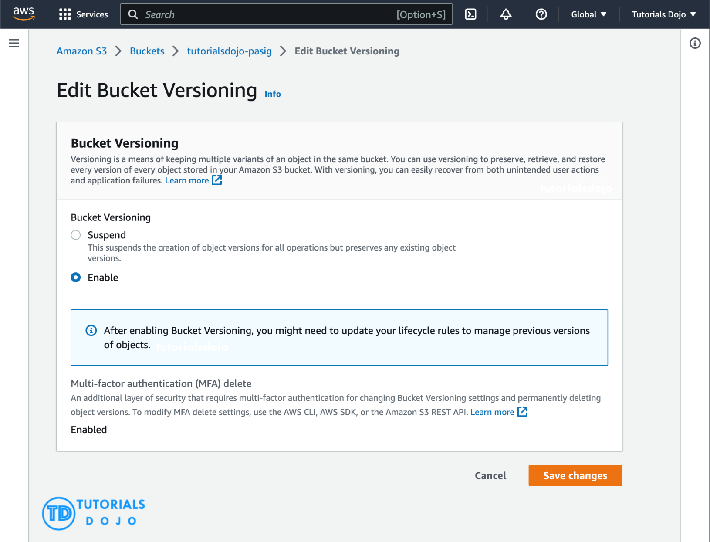
Versioning is a means of keeping multiple variants of an object in the same bucket. Versioning-enabled buckets enable you to recover objects from accidental deletion or overwrite. You can use versioning to preserve, retrieve, and restore every version of every object stored in your Amazon S3 bucket. With versioning, you can easily recover from both unintended user actions and application failures.
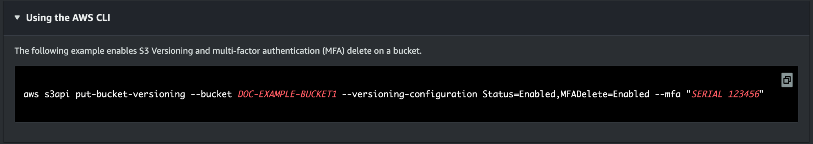
You can also optionally add another layer of security by configuring a bucket to enable MFA (Multi-Factor Authentication) Delete, which requires additional authentication for either of the following operations:
– Change the versioning state of your bucket
– Permanently delete an object version
MFA Delete requires two forms of authentication together:
– Your security credentials
– The concatenation of a valid serial number, a space, and the six-digit code displayed on an approved authentication device.

Hence, the correct answers are:
– Enable Versioning
– Enable Multi-Factor Authentication Delete
The option that says: Providing access to S3 data strictly through pre-signed URL only is incorrect since a pre-signed URL gives access to the object identified in the URL. Pre-signed URLs are useful when customers perform an object upload to your S3 bucket, but does not help in preventing accidental deletes.
The option that says: Disallowing S3 Delete using an IAM bucket policy is incorrect since you still want users to be able to delete objects in the bucket, and you just want to prevent accidental deletions. Disallowing S3 Delete using an IAM bucket policy will restrict all delete operations to your bucket.
The option that says: Enabling S3 Intelligent-Tiering is incorrect since S3 intelligent tiering does not help in this situation.

References:
https://docs.aws.amazon.com/AmazonS3/latest/dev/Versioning.html
https://docs.aws.amazon.com/AmazonS3/latest/userguide/Welcome.html

Check out this Amazon S3 Cheat Sheet:
https://tutorialsdojo.com/amazon-s3/

136 5. Question
There was an incident in a production environment where user data stored in an Amazon S3 bucket was accidentally deleted by a Junior DevOps Engineer. The issue was escalated to management, and after a few days, an instruction was given to improve the security and protection of AWS resources.
What combination of the following options will protect the S3 objects in the bucket from both accidental deletion and overwriting? (Select TWO.)
  - Disallow S3 Delete using an IAM bucket policy
  - Enable Versioning
  - Enable S3 Intelligent-Tiering
  - Provide access to S3 data strictly through pre-signed URL only
  - Enable Multi-Factor Authentication Delete
Incorrect
By using Versioning and enabling MFA (Multi-Factor Authentication) Delete, you can secure and recover your S3 objects from accidental deletion or overwrite.
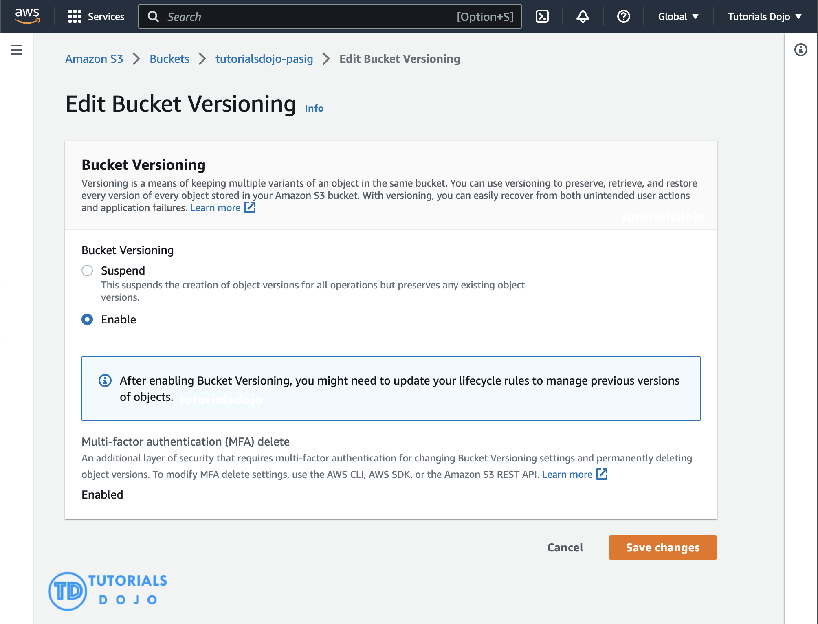
Versioning is a means of keeping multiple variants of an object in the same bucket. Versioning-enabled buckets enable you to recover objects from accidental deletion or overwrite. You can use versioning to preserve, retrieve, and restore every version of every object stored in your Amazon S3 bucket. With versioning, you can easily recover from both unintended user actions and application failures.

You can also optionally add another layer of security by configuring a bucket to enable MFA (Multi-Factor Authentication) Delete, which requires additional authentication for either of the following operations:
– Change the versioning state of your bucket
– Permanently delete an object version
MFA Delete requires two forms of authentication together:
– Your security credentials
– The concatenation of a valid serial number, a space, and the six-digit code displayed on an approved authentication device.

Hence, the correct answers are:
– Enable Versioning
– Enable Multi-Factor Authentication Delete
The option that says: Providing access to S3 data strictly through pre-signed URL only is incorrect since a pre-signed URL gives access to the object identified in the URL. Pre-signed URLs are useful when customers perform an object upload to your S3 bucket, but does not help in preventing accidental deletes.
The option that says: Disallowing S3 Delete using an IAM bucket policy is incorrect since you still want users to be able to delete objects in the bucket, and you just want to prevent accidental deletions. Disallowing S3 Delete using an IAM bucket policy will restrict all delete operations to your bucket.
The option that says: Enabling S3 Intelligent-Tiering is incorrect since S3 intelligent tiering does not help in this situation.

References:
https://docs.aws.amazon.com/AmazonS3/latest/dev/Versioning.html
https://docs.aws.amazon.com/AmazonS3/latest/userguide/Welcome.html

Check out this Amazon S3 Cheat Sheet:
https://tutorialsdojo.com/amazon-s3/

137 6. Question
An application consists of multiple Amazon EC2 instances in private subnets in different availability zones. The application uses a single NAT Gateway for downloading software patches from the Internet to the instances. There is a requirement to protect the application from a single point of failure when the NAT Gateway encounters a failure or if its availability zone goes down.
How should the Solutions Architect redesign the architecture to be more highly available and cost-effective?
  - Create a NAT Gateway in each availability zone. Configure the route table in each public subnet to ensure that instances use the NAT Gateway in the same availability zone.
  - Create two NAT Gateways in each availability zone. Configure the route table in each public subnet to ensure that instances use the NAT Gateway in the same availability zone.
  - Create three NAT Gateways in each availability zone. Configure the route table in each private subnet to ensure that instances use the NAT Gateway in the same availability zone.
  - Create a NAT Gateway in each availability zone. Configure the route table in each private subnet to ensure that instances use the NAT Gateway in the same availability zone
Correct
A NAT Gateway is a highly available, managed Network Address Translation (NAT) service for your resources in a private subnet to access the Internet. NAT gateway is created in a specific Availability Zone and implemented with redundancy in that zone.
You must create a NAT gateway on a public subnet to enable instances in a private subnet to connect to the Internet or other AWS services, but prevent the Internet from initiating a connection with those instances.
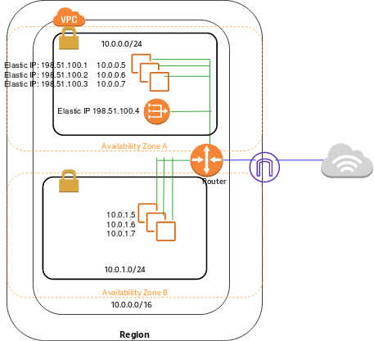
If you have resources in multiple Availability Zones and they share one NAT gateway, and if the NAT gateway’s Availability Zone is down, resources in the other Availability Zones lose Internet access. To create an Availability Zone-independent architecture, create a NAT gateway in each Availability Zone and configure your routing to ensure that resources use the NAT gateway in the same Availability Zone.
Hence, the correct answer is: Create a NAT Gateway in each availability zone. Configure the route table in each private subnet to ensure that instances use the NAT Gateway in the same availability zone.
The option that says: Create a NAT Gateway in each availability zone. Configure the route table in each public subnet to ensure that instances use the NAT Gateway in the same availability zone is incorrect because you should configure the route table in the private subnet and not the public subnet to associate the right instances in the private subnet.
The options that say: Create two NAT Gateways in each availability zone. Configure the route table in each public subnet to ensure that instances use the NAT Gateway in the same availability zone is incorrect because you are primarily required to set up the NAT Gateway in the private subnet to allow outbound internet access for private instances.
The options that say: Create three NAT Gateways in each availability zone. Configure the route table in each private subnet to ensure that instances use the NAT Gateway in the same availability zone is incorrect because the only necessity here is ensuring outbound traffic for private instances, and adding multiple NAT Gateways does not align with cost optimization unless explicitly required for high availability.

References:
https://docs.aws.amazon.com/vpc/latest/userguide/vpc-nat-gateway.html
https://docs.aws.amazon.com/vpc/latest/userguide/vpc-nat-comparison.html

Check out this Amazon VPC Cheat Sheet:
https://tutorialsdojo.com/amazon-vpc/

138 7. Question
A Forex trading platform, which frequently processes and stores global financial data every minute, is hosted in an on-premises data center and uses an Oracle database. Due to a recent cooling problem in its data center, the company urgently needs to migrate its infrastructure to AWS to improve the performance of its applications. As the Solutions Architect, the responsibility is to ensure that the database is properly migrated and remains available in case of database server failure in the future.
Which combination of actions would meet the requirement? (Select TWO.)
  - Create an Oracle database in Amazon RDS with Multi-AZ deployments.
  - Launch an Oracle database instance in Amazon RDS with Recovery Manager (RMAN) enabled.
  - Migrate the Oracle database to a non-cluster Amazon Aurora with a single instance.
  - Convert the database schema using the AWS Schema Conversion Tool.
  - Migrate the Oracle database to AWS using the AWS Database Migration Service
Incorrect
Amazon RDS Multi-AZ deployments provide enhanced availability and durability for Database (DB) Instances, making them a natural fit for production database workloads. When you provision a Multi-AZ DB Instance, Amazon RDS automatically creates a primary DB Instance and synchronously replicates the data to a standby instance in a different Availability Zone (AZ). Each AZ runs on its own physically distinct, independent infrastructure, and is engineered to be highly reliable.
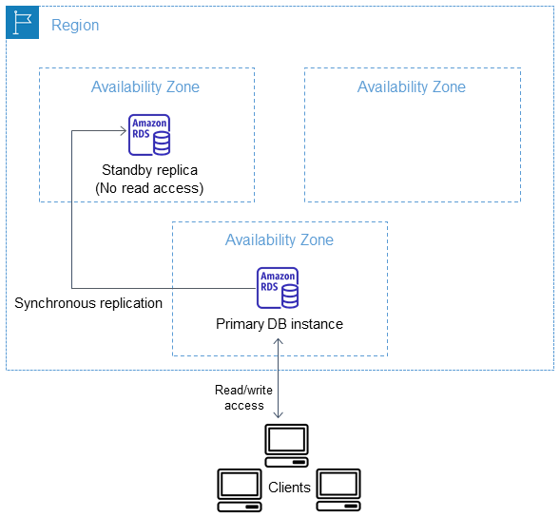
In case of an infrastructure failure, Amazon RDS performs an automatic failover to the standby (or to a read replica in the case of Amazon Aurora) so that you can resume database operations as soon as the failover is complete. Since the endpoint for your DB Instance remains the same after a failover, your application can resume database operation without the need for manual administrative intervention.
In this scenario, the best RDS configuration to use is an Oracle database in RDS with Multi-AZ deployments to ensure high availability even if the primary database instance goes down. You can use AWS DMS to move the on-premises database to AWS with minimal downtime and zero data loss. It supports over 20 engines, including Oracle to Aurora MySQL, MySQL to RDS for MySQL, SQL Server to Aurora PostgreSQL, MongoDB to DocumentDB, Oracle to Redshift, and S3.
Hence, the correct answers are:
– Create an Oracle database in Amazon RDS with Multi-AZ deployments.
– Migrate the Oracle database to AWS using the AWS Database Migration Service.
The option that says: Launch an Oracle database instance in Amazon RDS with Recovery Manager (RMAN) enabled is incorrect because Oracle RMAN is not supported in RDS.
The option that says: Convert the database schema using the AWS Schema Conversion Tool is incorrect. AWS Schema Conversion Tool is typically used for heterogeneous migrations where you’re moving from one type of database to another (e.g., Oracle to PostgreSQL). In the scenario, the migration is homogenous, meaning it’s an Oracle-to-Oracle migration. As a result, there’s no need to convert the schema since you’re staying within the same database type.
The option that says: Migrate the Oracle database to a non-cluster Amazon Aurora with a single instance is incorrect. While a single-instance Aurora can be a feasible solution for non-critical applications or environments like development or testing, it is typically not suitable for applications that demand high availability.

References:
https://aws.amazon.com/rds/details/multi-az/
https://aws.amazon.com/dms/
https://docs.aws.amazon.com/AmazonRDS/latest/UserGuide/Concepts.MultiAZ.html

Check out this Amazon RDS Cheat Sheet:
https://tutorialsdojo.com/amazon-relational-database-service-amazon-rds/

139 8. Question
An e-commerce company utilizes a regional Amazon API Gateway to host its public REST APIs. The API Gateway endpoint is accessed through a custom domain name set up with an Amazon Route 53 alias record. To support continuous improvement, the company intends to launch a new version of its APIs with enhanced features and performance optimizations.
How can the company reduce customer disruption and ensure MINIMAL data loss during the update process in the MOST cost-effective way?
  - Implement a canary release deployment strategy for the API Gateway. Deploy the latest version of the APIs to a canary stage and direct a portion of the user traffic to this stage. Verify the new APIs. Gradually increase the traffic percentage, monitor for any issues, and, if successful, promote the canary stage to production.
  - Create a new API Gateway with the updated version of the APIs in OpenAPI JSON or YAML file format, but keep the same custom domain name for the new API Gateway.
  - Modify the existing API Gateway with the updated version of the APIs, but keep the same custom domain name for the new API Gateway by using the import-to-update operation in either overwrite or merge mode.
  - Implement a blue-green deployment strategy for the API Gateway, deploying the latest version of the APIs to the green environment. Route some user traffic to it, validate the new APIs, and once thoroughly validated, promote the green environment to production.
Incorrect
Amazon API Gateway is a fully managed service that makes it easy for developers to create, publish, maintain, monitor, and secure APIs at any scale. It is a front door for your APIs, enabling you to design and implement scalable, highly available, and secure APIs. With Amazon API Gateway, you can create RESTful APIs that any HTTP client, such as web browsers and mobile devices, can consume.
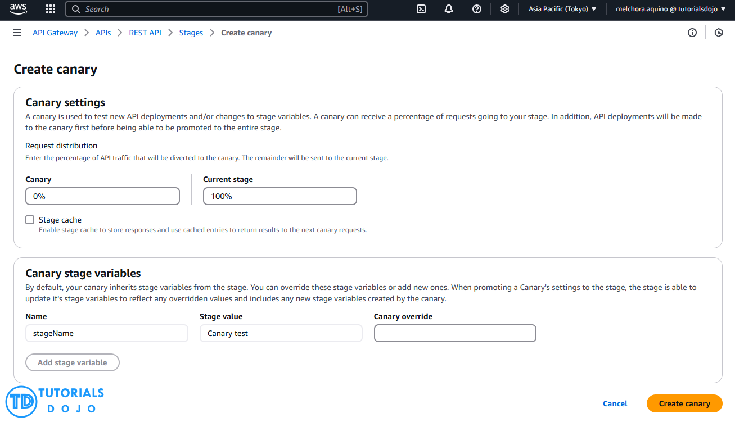
Implementing a canary release deployment strategy for the API Gateway is a great way to ensure your APIs remain stable and reliable. This strategy involves releasing a new version of your API to a small subset of users, allowing you to test the latest version in a controlled environment.
If the new version performs well, you can gradually roll out the update to the rest of your users. This approach lets you catch any issues before they affect your entire user base, minimizing the impact on your customers. By using Amazon API Gateway, you can quickly implement a canary release deployment strategy, ensuring that your APIs are always up-to-date and performing at their best.
Hence, the correct answer is: Implement a canary release deployment strategy for the API Gateway. Deploy the latest version of the APIs to a canary stage and direct a portion of the user traffic to this stage. Verify the new APIs. Gradually increase the traffic percentage, monitor for any issues, and, if successful, promote the canary stage to production.
The option that says: Create a new API Gateway with the updated version of the APIs in OpenAPI JSON or YAML file format, but keep the same custom domain name for the new API Gateway is incorrect. Upgrading to a new API Gateway using an updated version of the APIs in OpenAPI JSON or YAML file format while keeping the same custom domain name can typically result in downtime and confusion during the switch. This is because of DNS propagation delays, which can negatively affect users and even lead to data loss.
The option that says: Modify the existing API Gateway with the updated version of the APIs, but keep the same custom domain name for the new API Gateway by using the import-to-update operation in either overwrite or merge mode is incorrect. Using the import-to-update operation in either overwrite or merge mode may not provide enough isolation and control testing for the new version of the APIs. If something goes wrong during the update process, it could just lead to data loss on the existing API Gateway, potentially affecting all customers simultaneously.
The option that says: Implement a blue-green deployment strategy for the API Gateway, deploying the latest version of the APIs to the green environment. Route some user traffic to it, validate the new APIs, and once thoroughly validated, promote the green environment to production is incorrect. In a blue-green deployment, the blue (existing) and green (updated) environments must be provisioned and maintained. This adds complexity and cost to the update process, which breaks the cost requirement that’s explicitly mentioned in the scenario. Additionally, directing some user traffic to the green environment may only lead to issues for those users, especially if there are undiscovered bugs or performance problems in the updated APIs.

References:
https://docs.aws.amazon.com/apigateway/latest/developerguide/welcome.html
https://docs.aws.amazon.com/apigateway/latest/developerguide/canary-release.html
https://docs.aws.amazon.com/apigateway/latest/developerguide/api-gateway-import-api-update.html

Check out this Amazon API Gateway Cheat Sheet:
https://tutorialsdojo.com/amazon-api-gateway/

140 9. Question
A tech company that you are working for has undertaken a Total Cost Of Ownership (TCO) analysis evaluating the use of Amazon S3 versus acquiring more storage hardware. The result was that all 1200 employees would be granted access to use Amazon S3 for the storage of their personal documents.
Which of the following will you need to consider so you can set up a solution that incorporates a single sign-on feature from your corporate AD or LDAP directory and also restricts access for each individual user to a designated user folder in an S3 bucket? (Select TWO.)
  - Set up a matching IAM user for each of the 1200 users in your corporate directory that needs access to a folder in the S3 bucket.
  - Use 3rd party Single Sign-On solutions such as Atlassian Crowd, OKTA, OneLogin and many others.
  - Set up a Federation proxy or an Identity provider, and use AWS Security Token Service to generate temporary tokens.
  - Configure an IAM role and an IAM Policy to access the bucket.
  - Map each individual user to a designated user folder in S3 using Amazon WorkDocs to access their personal documents.
Incorrect
The question refers to one of the common scenarios for temporary credentials in AWS. Temporary credentials are useful in scenarios that involve identity federation, delegation, cross-account access, and IAM roles. In this example, it is called enterprise identity federation, considering that you also need to set up a single sign-on (SSO) capability.
The correct answers are:
– Setup a Federation proxy or an Identity provider, and use AWS Security Token Service to generate temporary tokens
– Configure an IAM role and an IAM Policy to access the bucket.
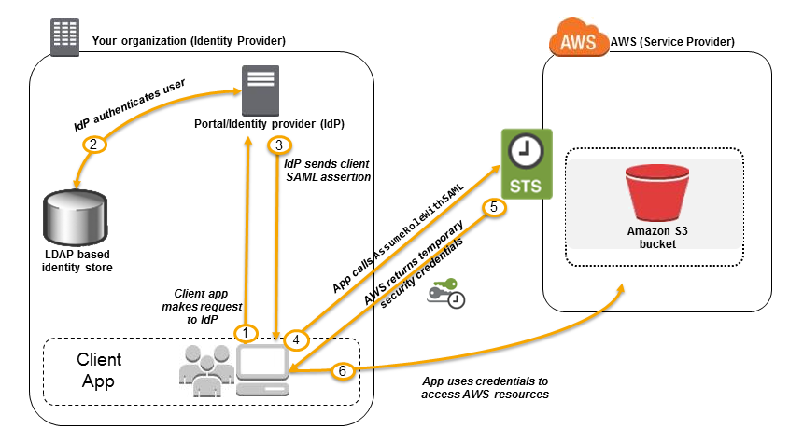In an enterprise identity federation, you can authenticate users in your organization’s network, and then provide those users access to AWS without creating new AWS identities for them and requiring them to sign in with a separate user name and password. This is known as the single sign-on (SSO) approach to temporary access. AWS STS supports open standards like Security Assertion Markup Language (SAML) 2.0, with which you can use Microsoft AD FS to leverage your Microsoft Active Directory. You can also use SAML 2.0 to manage your own solution for federating user identities.
Using 3rd party Single Sign-On solutions such as Atlassian Crowd, OKTA, OneLogin and many others is incorrect since you don’t have to use 3rd party solutions to provide the access. AWS already provides the necessary tools that you can use in this situation.
Mapping each individual user to a designated user folder in S3 using Amazon WorkDocs to access their personal documents is incorrect as there is no direct way of integrating Amazon S3 with Amazon WorkDocs for this particular scenario. Amazon WorkDocs is simply a fully managed, secure content creation, storage, and collaboration service. With Amazon WorkDocs, you can easily create, edit, and share content. And because it’s stored centrally on AWS, you can access it from anywhere on any device.
Setting up a matching IAM user for each of the 1200 users in your corporate directory that needs access to a folder in the S3 bucket is incorrect since creating that many IAM users would be unnecessary. Also, you want the account to integrate with your AD or LDAP directory, hence, IAM Users does not fit these criteria.

References:
https://docs.aws.amazon.com/IAM/latest/UserGuide/id_roles_providers_saml.html
https://docs.aws.amazon.com/IAM/latest/UserGuide/id_roles_providers_oidc.html
https://aws.amazon.com/premiumsupport/knowledge-center/iam-s3-user-specific-folder/

Check out this AWS IAM Cheat Sheet:
https://tutorialsdojo.com/aws-identity-and-access-management-iam/

141 10. Question
A Solutions Architect is designing a highly available relational database solution to mitigate the risk of a multi-region failure. The database must meet a Recovery Point Objective (RPO) of 1 second and a Recovery Time Objective (RTO) of less than 1 minute. The architect needs a disaster recovery plan that enables automatic cross-region replication with minimal data loss and rapid recovery in the event of a failure.
Which AWS feature best fulfills this requirement?
  - Amazon Timestream for Analytics
  - Amazon RDS for PostgreSQL with cross-region read replicas
  - Amazon Aurora Global Database
  - Amazon DynamoDB Global table
Correct
Amazon Aurora Global Database is designed for globally distributed applications, allowing a single Amazon Aurora database to span multiple AWS regions. It replicates your data with no impact on database performance, enables fast local reads with low latency in each region, and provides disaster recovery from region-wide outages.
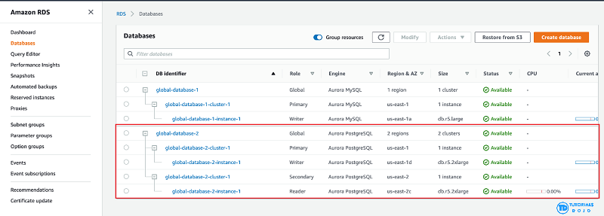
Aurora Global Database supports storage-based replication that has a latency of less than 1 second. If there is an unplanned outage, one of the secondary regions you assigned can be promoted to read and write capabilities in less than 1 minute. This feature is called Cross-Region Disaster Recovery. An RPO of 1 second and an RTO of less than 1 minute provide you a strong foundation for a global business continuity plan.
Hence, the correct answer is: Amazon Aurora Global Database.
The option that says: Amazon DynamoDB Global table is incorrect because while this supports multi-region, fully replicated tables with low latency, it’s more suitable for NoSQL workloads, not relational databases.
The option that says: Amazon RDS for PostgreSQL with cross-region read replicas is incorrect. While this option can help with disaster recovery, it simply doesn’t meet the specified RPO and RTO requirements in the scenario. Replication lag in cross-region read replicas can take several minutes to complete, which could prevent the company from meeting the RPO of 1 second.
The option that says: Amazon Timestream for Analytics is incorrect because it is primarily a serverless time series database service that is commonly used for IoT and operational applications. The most suitable solution for this scenario is to use the Amazon Aurora Global Database since it can provide the required RPO and RTO.

References:
https://aws.amazon.com/rds/aurora/global-database/
https://docs.aws.amazon.com/AmazonRDS/latest/AuroraUserGuide/aurora-global-database.html

Check out this Amazon Aurora Cheat Sheet:
https://tutorialsdojo.com/amazon-aurora/

142 11 Question
An online shopping platform is hosted on an Auto Scaling group of Amazon EC2 Spot instances and utilizes Amazon Aurora PostgreSQL as its database. It is required to optimize database workloads in the cluster by directing the production traffic to high-capacity instances and routing the reporting queries from the internal staff to the low-capacity instances.
Which is the most suitable configuration for the application as well as the Aurora database cluster to achieve this requirement?
- Do nothing since by default, Aurora will automatically direct the production traffic to your high-capacity instances and the reporting queries to your low-capacity instances.
- In your application, use the instance endpoint of your Aurora database to handle the incoming production traffic and use the cluster endpoint to handle reporting queries.
- Configure your application to use the reader endpoint for both production traffic and reporting queries, which will enable your Aurora database to automatically perform load-balancing among all the Aurora Replicas.
- Create a custom endpoint in Aurora based on the specified criteria for the production traffic and another custom endpoint to handle the reporting queries.
Incorrect
Amazon Aurora typically involves a cluster of DB instances instead of a single instance. Each connection is handled by a specific DB instance. When you connect to an Aurora cluster, the host name and port that you specify point to an intermediate handler called an endpoint. Aurora uses the endpoint mechanism to abstract these connections. Thus, you don’t have to hardcode all the hostnames or write your own logic for load-balancing and rerouting connections when some DB instances aren’t available.
For certain Aurora tasks, different instances or groups of instances perform different roles. For example, the primary instance handles all data definition language (DDL) and data manipulation language (DML) statements. Up to 15 Aurora Replicas handle read-only query traffic.

Using endpoints, you can map each connection to the appropriate instance or group of instances based on your use case. For example, to perform DDL statements you can connect to whichever instance is the primary instance. To perform queries, you can connect to the reader endpoint, with Aurora automatically performing load-balancing among all the Aurora Replicas. For clusters with DB instances of different capacities or configurations, you can connect to custom endpoints associated with different subsets of DB instances. For diagnosis or tuning, you can connect to a specific instance endpoint to examine details about a specific DB instance.
The custom endpoint provides load-balanced database connections based on criteria other than the read-only or read-write capability of the DB instances. For example, you might define a custom endpoint to connect to instances that use a particular AWS instance class or a particular DB parameter group. Then you might tell particular groups of users about this custom endpoint. For example, you might direct internal users to low-capacity instances for report generation or ad hoc (one-time) querying, and direct production traffic to high-capacity instances.
Hence, the correct answer is: Create a custom endpoint in Aurora based on the specified criteria for the production traffic and another custom endpoint to handle the reporting queries.
The option that says: Configuring your application to use the reader endpoint for both production traffic and reporting queries, which will enable your Aurora database to automatically perform load-balancing among all the Aurora Replicas is incorrect. Although it is true that a reader endpoint enables your Aurora database to automatically perform load-balancing among all the Aurora Replicas, it is quite limited to doing read operations only. You still need to use a custom endpoint to load-balance the database connections based on the specified criteria.
The option that says: In your application, use the instance endpoint of your Aurora database to handle the incoming production traffic and use the cluster endpoint to handle reporting queries is incorrect because a cluster endpoint (also known as a writer endpoint) for an Aurora DB cluster simply connects to the current primary DB instance for that DB cluster. This endpoint can perform write operations in the database such as DDL statements, which is perfect for handling production traffic but not suitable for handling queries for reporting since there will be no write database operations that will be sent. Moreover, the endpoint does not point to lower-capacity or high-capacity instances as per the requirement. A better solution for this is to use a custom endpoint.
The option that says: Do nothing since by default, Aurora will automatically direct the production traffic to your high-capacity instances and the reporting queries to your low-capacity instances is incorrect because Aurora does not do this by default. You have to create custom endpoints in order to accomplish this requirement.

References:
https://docs.aws.amazon.com/AmazonRDS/latest/AuroraUserGuide/Aurora.Overview.Endpoints.html
https://docs.aws.amazon.com/AmazonRDS/latest/AuroraUserGuide/Aurora.Endpoints.Custom.html

Check out this Amazon Aurora Cheat Sheet:
https://tutorialsdojo.com/amazon-aurora/

143 12 Question
A healthcare organization wants to build a system that can predict drug prescription abuse. The organization will gather real-time data from multiple sources, which include Personally Identifiable Information (PII). It’s crucial that this sensitive information is anonymized prior to landing in a NoSQL database for further processing.
Which solution would meet the requirements?
  - Stream the data in an Amazon DynamoDB table. Enable DynamoDB Streams, and configure a function that performs anonymization on newly written items.
  - Create a data lake in Amazon S3 and use it as the primary storage for patient health data. Use an S3 trigger to run an AWS Lambda function that performs anonymization. Send the anonymized data to Amazon DynamoDB.
  - Deploy an Amazon Data Firehose stream to capture and transform the streaming data. Deliver the anonymized data to Amazon Redshift for analysis.
  - Ingest real-time data using Amazon Kinesis Data Stream. Use an AWS Lambda function to anonymize the PII, then store it in Amazon DynamoDB.
Incorrect
Amazon Kinesis Data Streams (KDS) is a massively scalable and durable real-time data streaming service. KDS can continuously capture gigabytes of data per second from hundreds of thousands of sources.
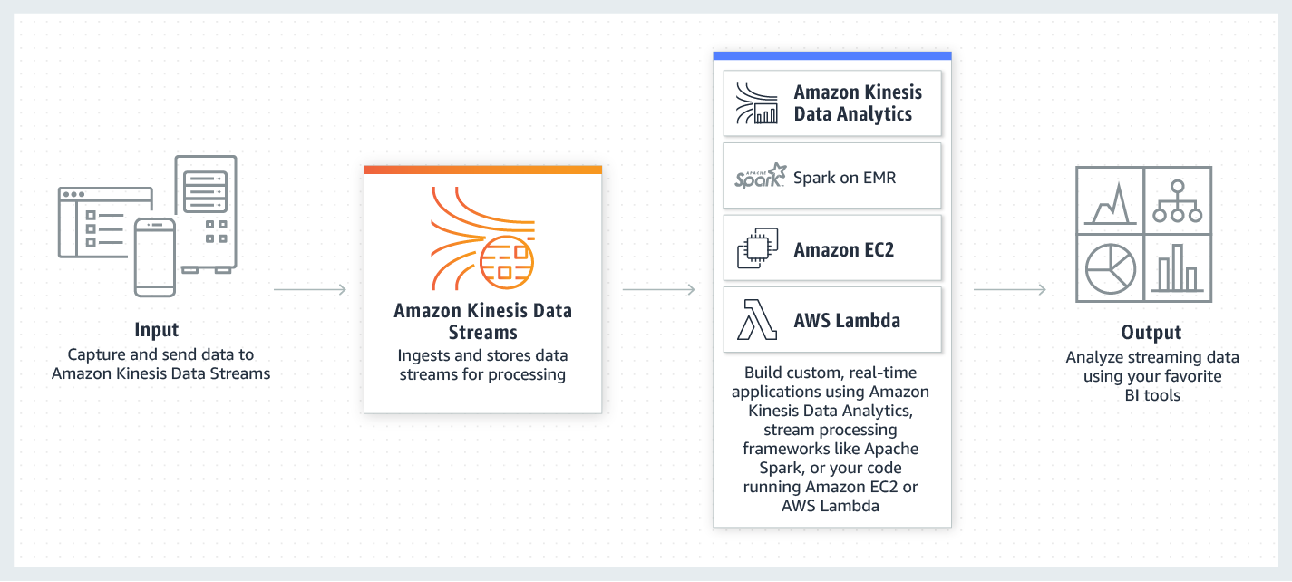
Kinesis Data Streams integrates seamlessly with AWS Lambda, which can be utilized to transform and anonymize the Personally Identifiable Information (PII) in transit prior to storage. This ensures that sensitive information is appropriately anonymized at the earliest opportunity, significantly reducing the risk of any data breaches or privacy violations. Finally, the anonymized data is stored in Amazon DynamoDB, a NoSQL database suitable for handling the processed data.
Hence, the correct answer is: Ingest real-time data using Amazon Kinesis Data Stream. Use an AWS Lambda function to anonymize the PII, then store it in Amazon DynamoDB.
The option that says: Create a data lake in Amazon S3 and use it as the primary storage for patient health data. Use an S3 trigger to run an AWS Lambda function that performs anonymization. Send the anonymized data to Amazon DynamoDB is incorrect. This approach only doesn’t guarantee the anonymization of data before it lands on DynamoDB. The data will first be stored in S3 and then anonymized, potentially exposing sensitive information. This violates the principle of ensuring PII is anonymized prior to storage.
The option that says: Stream the data in an Amazon DynamoDB table. Enable DynamoDB Streams, and configure a function that performs anonymization on newly written items is incorrect. DynamoDB streams typically operate on changes to data that has already been written to the database. Therefore, the PII will be stored in DynamoDB before the anonymization function is triggered, which is a potential privacy concern.
The option that says: Deploy an Amazon Data Firehose stream to capture and transform the streaming data. Deliver the anonymized data to Amazon Redshift for analysis is incorrect. The requirement was to store the data in a NoSQL database. Amazon Redshift is primarily a data warehousing solution built on a relational database model, not a NoSQL model, which makes this option unsuitable to meet the given requirements.

References:
https://aws.amazon.com/kinesis/data-streams/
https://docs.aws.amazon.com/lambda/latest/dg/with-kinesis.html

Check out this Amazon Kinesis Cheat Sheet:
https://tutorialsdojo.com/amazon-kinesis/
144 13. Question
A newly hired Solutions Architect is assigned to manage a set of CloudFormation templates that are used in the company’s cloud architecture in AWS. The Architect accessed the templates and tried to analyze the configured IAM policy for an S3 bucket.
{
"Version": "2012-10-17",
"Statement": [
{
"Effect": "Allow",
"Action": [
"s3:Get*",
"s3:List*"
],
"Resource": "*"
},
{
"Effect": "Allow",
"Action": "s3:PutObject",
"Resource": "arn:aws:s3:::boracay/*"
}
]
}
What does the above IAM policy allow? (Select THREE.)
  - An IAM user with this IAM policy is allowed to change access rights for the boracay S3 bucket.
  - An IAM user with this IAM policy is allowed to read objects from all S3 buckets owned by the account.
  - An IAM user with this IAM policy is allowed to write objects into the boracay S3 bucket.
  - An IAM user with this IAM policy is allowed to read and delete objects from the boracay S3 bucket.
  - An IAM user with this IAM policy is allowed to read objects from the boracay S3 bucket.
  - An IAM user with this IAM policy is allowed to read objects in the boracay S3 bucket but not allowed to list the objects in the bucket.
Correct
You manage access in AWS by creating policies and attaching them to IAM identities (users, groups of users, or roles) or AWS resources. A policy is an object in AWS that, when associated with an identity or resource, defines their permissions. AWS evaluates these policies when an IAM principal (user or role) makes a request. Permissions in the policies determine whether the request is allowed or denied. Most policies are stored in AWS as JSON documents. AWS supports six types of policies: identity-based policies, resource-based policies, permissions boundaries, AWS Organizations SCPs, ACLs, and session policies.
IAM policies define permissions for action regardless of the method that you use to perform the operation. For example, if a policy allows the GetUser action, then a user with that policy can get user information from the AWS Management Console, the AWS CLI, or the AWS API. When you create an IAM user, you can choose to allow console or programmatic access. If console access is allowed, the IAM user can sign in to the console using a user name and password. Or if programmatic access is allowed, the user can use access keys to work with the CLI or API.
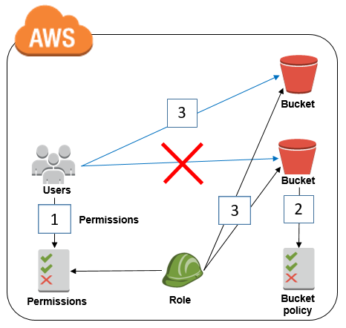
Based on the provided IAM policy, the user is only allowed to get, write, and list all of the objects for the boracay s3 bucket. The s3:PutObject basically means that you can submit a PUT object request to the S3 bucket to store data.
Hence, the correct answers are:
– An IAM user with this IAM policy is allowed to read objects from all S3 buckets owned by the account.
– An IAM user with this IAM policy is allowed to write objects into the boracay S3 bucket.
– An IAM user with this IAM policy is allowed to read objects from the boracay S3 bucket.
The option that says: An IAM user with this IAM policy is allowed to change access rights for the boracay S3 bucket is incorrect because the template does not have any statements which allow the user to change access rights in the bucket.
The option that says: An IAM user with this IAM policy is allowed to read objects in the boracay S3 bucket but not allowed to list the objects in the bucket is incorrect because it can clearly be seen in the template that there is a s3:List* which permits the user to list objects.
The option that says: An IAM user with this IAM policy is allowed to read and delete objects from the boracay S3 bucket is incorrect. Although you can read objects from the bucket, you cannot delete any objects.

References:
https://docs.aws.amazon.com/AmazonS3/latest/API/RESTObjectOps.html
https://docs.aws.amazon.com/IAM/latest/UserGuide/access_policies.html

Check out this Amazon S3 Cheat Sheet:
https://tutorialsdojo.com/amazon-s3/

145 14 Question
An online cryptocurrency exchange platform is hosted in AWS, utilizing an Amazon ECS Cluster and Amazon RDS in a Multi-AZ Deployments configuration. The application heavily uses the RDS instance to process complex read and write database operations. To maintain reliability, availability, and performance, it is necessary to closely monitor how the different processes or threads on a DB instance use the CPU, including the percentage of CPU bandwidth and total memory consumed by each process. Which of the following is the most suitable solution to monitor the database properly?

- Check the CPU% and MEM% metrics which are readily available in the RDS console that shows the percentage of the CPU bandwidth and total memory consumed by each database process of your RDS instance.
- Enable Enhanced Monitoring in RDS.
- Use Amazon CloudWatch to monitor the CPU Utilization of your database.
- Create a script that collects and publishes custom metrics to Amazon CloudWatch, which tracks the real-time CPU Utilization of the RDS instance, and then set up a custom CloudWatch dashboard to view the metrics.
Incorrect
Amazon RDS offers a powerful feature known as Enhanced Monitoring, which provides detailed metrics in real-time about the operating system (OS) underlying your database instances. This feature allows users to monitor performance at a granular level through the AWS Management Console or by accessing the Enhanced Monitoring JSON output via CloudWatch Logs. By default, these metrics are retained in CloudWatch Logs for 30 days, but this retention period can be adjusted by modifying the retention settings for the RDSOSMetrics log group in CloudWatch.
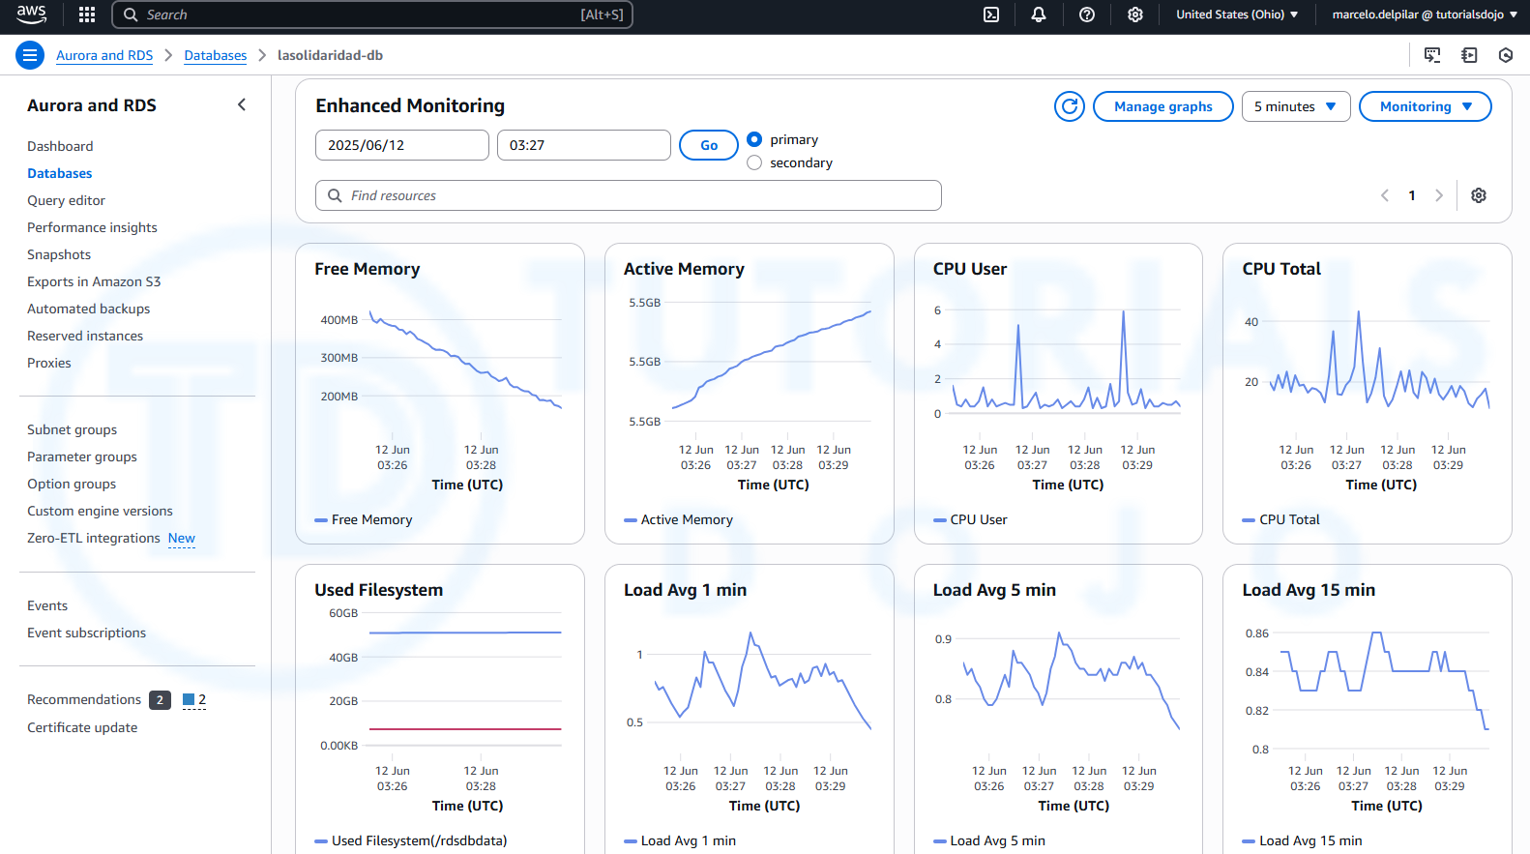
Enhanced Monitoring differs from standard CloudWatch metrics in that it gathers data directly from an agent installed on the instance, rather than from the hypervisor, which is used by CloudWatch. This distinction can lead to slight variations between the two sets of metrics. For instance, CloudWatch provides CPU utilization metrics based on the hypervisor’s view, while Enhanced Monitoring captures detailed insights from the instance itself, offering a more accurate representation of resource usage at the OS level.
This feature is particularly beneficial for users who need in-depth visibility into how individual processes or threads on a DB instance utilize CPU resources. The differences in metric data may become more pronounced when using smaller instance classes, as multiple virtual machines are often managed by the same hypervisor, affecting the accuracy of hypervisor-based metrics.
Hence, the correct answer is: B. Enable Enhanced Monitoring in RDS.
The option that says: C. Using Amazon CloudWatch to monitor the CPU Utilization of your database is incorrect. Although you can use this to monitor the CPU Utilization of your database instance, it does not provide the percentage of the CPU bandwidth and total memory consumed by each database process in your RDS instance. Take note that CloudWatch primarily gathers metrics about CPU utilization from the hypervisor for a DB instance while RDS Enhanced Monitoring gathers its metrics from an agent on the instance.
The option that says: D. Create a script that collects and publishes custom metrics to Amazon CloudWatch, which tracks the real-time CPU Utilization of the RDS instance, and then set up a custom CloudWatch dashboard to view the metrics is incorrect. Although you can use Amazon CloudWatch Logs and CloudWatch dashboard to monitor the CPU Utilization of the database instance, using CloudWatch alone is just NOT enough to get the specific percentage of the CPU bandwidth and total memory consumed by each database processes. The data provided by CloudWatch is not as detailed as compared with the Enhanced Monitoring feature in RDS. Take note as well that you do not have direct access to the instances/servers of your RDS database instance, unlike with your EC2 instances where you can install a CloudWatch agent or a custom script to get CPU and memory utilization of your instance.
The option that says: A. Check the CPU% and MEM% metrics which are readily available in the RDS console that shows the percentage of the CPU bandwidth and total memory consumed by each database process of your RDS instance is incorrect because the CPU% and MEM% metrics are NOT readily available in the Amazon RDS console, which is contrary to what is being stated in this option.

References:
https://docs.aws.amazon.com/AmazonRDS/latest/UserGuide/USER_Monitoring.OS.html#USER_Monitoring.OS.CloudWatchLogs
https://docs.aws.amazon.com/AmazonRDS/latest/UserGuide/MonitoringOverview.html#monitoring-cloudwatch

Check out these Amazon CloudWatch and Amazon RDS Cheat Sheets:
https://tutorialsdojo.com/amazon-cloudwatch/
https://tutorialsdojo.com/amazon-relational-database-service-amazon-rds/

146 15 Question
An application that records weather data every minute is deployed in a fleet of Amazon EC2 Spot instances and uses a MySQL RDS database instance. Currently, there is only one Amazon RDS instance running in one Availability Zone. The database needs to be improved to ensure high availability by enabling synchronous data replication to another RDS instance.
Which of the following performs synchronous data replication in RDS?
- Amazon DynamoDB Read Replica
- Amazon CloudFront running as a Multi-AZ deployment
- RDS Read Replica
- RDS DB instance running as a Multi-AZ deployment
Correct
When you create or modify your DB instance to run as a Multi-AZ deployment, Amazon RDS automatically provisions and maintains a synchronous standby replica in a different Availability Zone. Updates to your DB Instance are synchronously replicated across Availability Zones to the standby in order to keep both in sync and protect your latest database updates against DB instance failure.
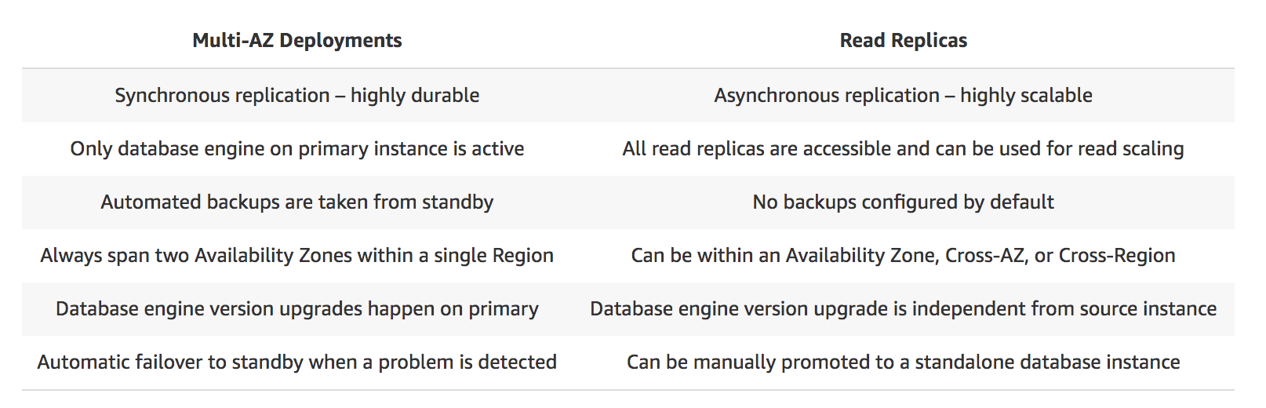
Therefore, the correct answer is: RDS DB instance running as a Multi-AZ deployment
RDS Read Replica is incorrect as a Read Replica primarily provides an asynchronous replication instead of synchronous.
Amazon DynamoDB Read Replica is incorrect since it does not offer a Read Replica feature. It typically uses global tables to replicate data across multiple AWS Regions.
Amazon CloudFront running as a Multi-AZ deployment is incorrect as it also does not have a Read Replica feature. It simply caches content at edge locations rather than replicating data in the database.

References:
https://aws.amazon.com/rds/details/multi-az/
https://aws.amazon.com/rds/features/multi-az/

Check out this Amazon RDS Cheat Sheet:
https://tutorialsdojo.com/amazon-relational-database-service-amazon-rds/

147 16 Question
A company collects atmospheric data such as temperature, air pressure, and humidity from different countries. Each site location is equipped with various weather instruments and a high-speed Internet connection. The average collected data in each location is around 500 GB and will be analyzed by a weather forecasting application hosted in Northern Virginia. The Solutions Architect must determine the fastest way to aggregate all the data.
Which of the following options can satisfy the given requirement?
- Use AWS Snowball Edge to transfer large amounts of data.
- Set up a Site-to-Site VPN connection.
- Enable Transfer Acceleration in the destination bucket and upload the collected data using Multipart Upload.
- Upload the data to the closest Amazon S3 bucket. Set up a cross-region replication and copy the objects to the destination bucket.
Incorrect
Amazon S3 is object storage built to store and retrieve any amount of data from anywhere on the Internet. It’s a simple storage service that offers industry-leading durability, availability, performance, security, and virtually unlimited scalability at very low costs. Amazon S3 is also designed to be highly flexible. Store any type and amount of data that you want; read the same piece of data a million times or only for emergency disaster recovery; build a simple FTP application or a sophisticated web application.
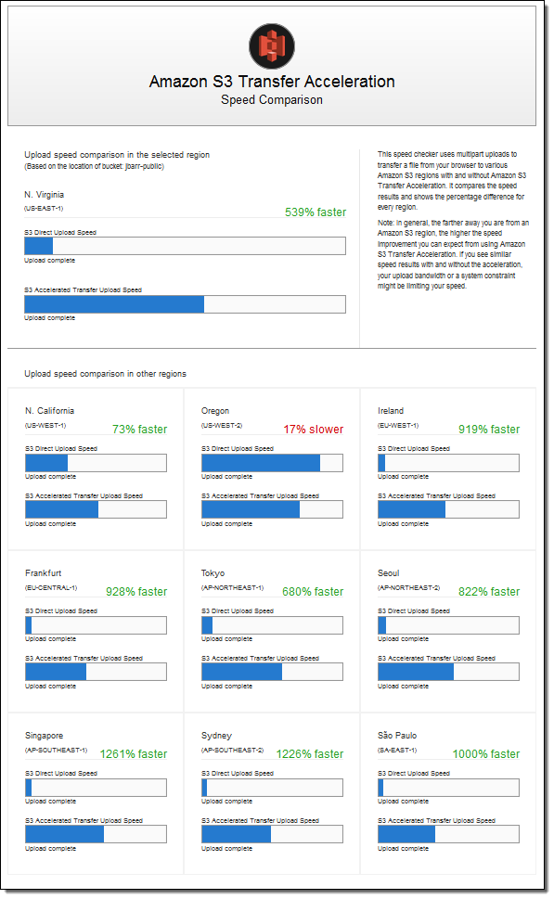
Since the weather forecasting application is located in N.Virginia, you need to transfer all the data in the same AWS Region. With Amazon S3 Transfer Acceleration, you can speed up content transfers to and from Amazon S3 by as much as 50-500% for long-distance transfer of larger objects. Multipart upload allows you to upload a single object as a set of parts. After all the parts of your object are uploaded, Amazon S3 then presents the data as a single object. This approach is the fastest way to aggregate all the data.
Hence, the correct answer is: Enable Transfer Acceleration in the destination bucket and upload the collected data using Multipart Upload.
The option that says: Upload the data to the closest Amazon S3 bucket. Set up a cross-region replication and copy the objects to the destination bucket is incorrect because replicating the objects to the destination bucket typically takes about 15 minutes. Take note that the requirement in the scenario is to aggregate the data in the fastest way.
The option that says: Use AWS Snowball Edge to transfer large amounts of data is incorrect because the end-to-end time to transfer up to 80 TB of data into AWS Snowball Edge is only approximately one week.
The option that says: Set up a Site-to-Site VPN connection is incorrect because setting up a VPN connection is not needed in this scenario. Site-to-Site VPN is just used for establishing secure connections between an on-premises network and Amazon VPC. Also, this approach is not the fastest way to transfer your data. You must use Amazon S3 Transfer Acceleration.

References:
https://docs.aws.amazon.com/AmazonS3/latest/dev/replication.html
https://docs.aws.amazon.com/AmazonS3/latest/dev/transfer-acceleration.html

Check out this Amazon S3 Cheat Sheet:
https://tutorialsdojo.com/amazon-s3/

148 17 Question
A content management system (CMS) is hosted on a fleet of auto-scaled, On-Demand Amazon EC2 instances that use Amazon Aurora as its database. Currently, the system stores the file documents that users upload in one of the attached Amazon EBS volumes. The system’s performance has been observed to be slow, and the manager has instructed the team to improve the architecture.
In this scenario, which solution should be implemented to achieve a scalable, highly available, POSIX-compliant shared file system?
- Create an Amazon S3 bucket and use this as the storage for the CMS
- Leverage Amazon ElastiCache to cache frequently accessed data and reduce latency
- Use Amazon EFS to provide a shared file system for concurrent access to data
- Upgrade your existing EBS volumes to Provisioned IOPS SSD volumes
Correct
Amazon Elastic File System (Amazon EFS) provides simple, scalable, elastic file storage for use with AWS Cloud services and on-premises resources. When mounted on Amazon EC2 instances, an Amazon EFS file system provides a standard file system interface and file system access semantics, allowing you to seamlessly integrate Amazon EFS with your existing applications and tools. Multiple Amazon EC2 instances can access an Amazon EFS file system at the same time, allowing Amazon EFS to provide a common data source for workloads and applications running on more than one Amazon EC2 instance.
This particular scenario tests your understanding of EBS, EFS, and S3. In this scenario, there is a fleet of On-Demand EC2 instances that store file documents from the users to one of the attached EBS Volumes. The system performance is quite slow because the architecture doesn’t provide the EC2 instances parallel shared access to the file documents.

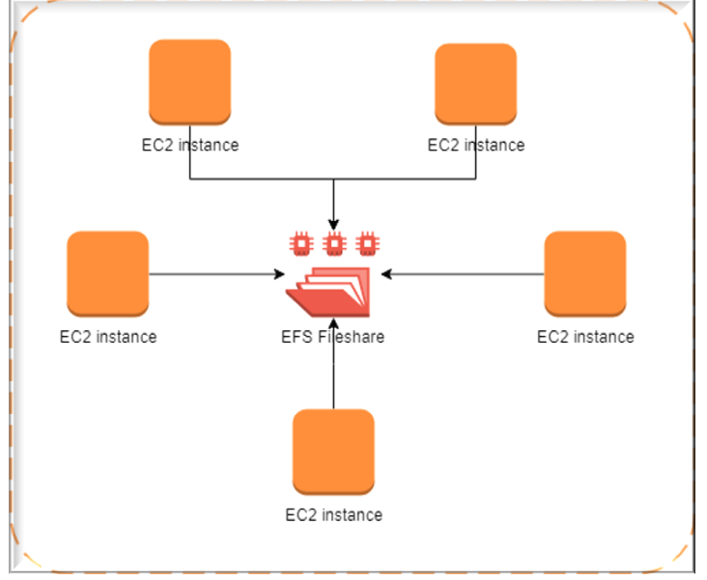
Although an EBS Volume can be attached to multiple EC2 instances, you can only do so on instances within an availability zone. What we need is highly available storage that can span multiple availability zones. Take note as well that the type of storage needed here is file storage, which means that S3 is not the best service to use because it is primarily used for object storage.
Hence, the correct answer is: Use Amazon EFS to provide a shared file system for concurrent access to data.
The option that says: Create an Amazon S3 bucket and use this as the storage for the CMS is incorrect because Amazon S3 is just an object storage service, which does not provide the required file system interface and file locking needed by a CMS.
The option that says: Upgrade your existing EBS volumes to Provisioned IOPS SSD volumes is incorrect because simply upgrading EBS does not address the requirement for a shared, POSIX-compliant file system. EBS volumes are block storage devices attached to a single instance, making them unsuitable for shared storage.
The option that says: Leverage Amazon ElastiCache to cache frequently accessed data and reduce latency is incorrect because this is an in-memory data store that improves the performance of your applications, which is not what you need since it is not a file storage.

References:
https://aws.amazon.com/efs/
https://docs.aws.amazon.com/efs/latest/ug/whatisefs.html
https://docs.aws.amazon.com/efs/latest/ug/mount-multiple-ec2-instances.html

Check out this Amazon EFS Cheat Sheet:
https://tutorialsdojo.com/amazon-efs/

Check out this Amazon S3 vs EBS vs EFS Cheat Sheet:
https://tutorialsdojo.com/amazon-s3-vs-ebs-vs-efs/

149 18 Question
A company is experiencing repeated outages in the Availability Zone where its Amazon RDS database instance is deployed, resulting in a complete loss of access to the database during each incident.
Which solution should be implemented to prevent losing database access if this occurs again?
- Make a snapshot of the database
- Create a read replica
- Enable Multi-AZ failover
- Increase the database instance size
Correct
Amazon RDS Multi-AZ deployments are designed to enhance the availability and durability of database instances, making them well-suited for production workloads. When you enable Multi-AZ failover, Amazon RDS automatically creates a standby replica in a different Availability Zone (AZ) and synchronously replicates data from the primary instance. This ensures high data consistency and protection against infrastructure-related disruptions. Each AZ operates on physically distinct infrastructure, which adds fault isolation and resilience.
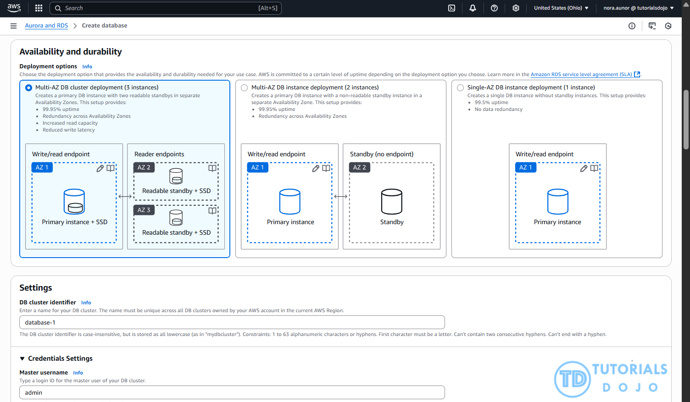
In the event of planned maintenance or an unexpected failure such as an Availability Zone outage or hardware issue, Amazon RDS automatically performs a failover to the standby instance. This process is fully managed by Amazon RDS and does not require manual intervention, helping to minimize downtime and maintain business continuity. For Amazon Aurora, the failover involves promoting a replica to become the new writer instance.
Hence, the correct answer is: Enable Multi-AZ failover.
The option that says: Make a snapshot of the database is incorrect because snapshots are typically used for backup and disaster recovery, not for maintaining high availability. A snapshot allows you to restore a database to a specific point in time, but it does not prevent downtime or provide continuous access during an Availability Zone outage.
The option that says: Increase the database instance size is incorrect because this action just improves the instance’s compute and memory capacity, which may help performance but does not address Availability Zone-level failures. The database would still be a single point of failure within the same zone, leaving it vulnerable to the same type of outage described in the question.
The option that says: Create a read replica is incorrect because read replicas are primarily intended to handle read-heavy workloads and do not automatically take over in the event of a failure. Promoting a read replica to a standalone instance requires manual intervention, which simply does not meet the goal of preventing loss of access during unplanned outages.

References:
https://aws.amazon.com/rds/features/multi-az/
https://docs.aws.amazon.com/AmazonRDS/latest/UserGuide/Concepts.MultiAZ.html

Check out this Amazon RDS Cheat Sheet:
https://tutorialsdojo.com/amazon-relational-database-service-amazon-rds/

Tutorials Dojo’s AWS Certified Solutions Architect Associate Exam Study Guide:
https://tutorialsdojo.com/aws-certified-solutions-architect-associate-saa-c03/

150 19 Question
A company requires all the data stored in the cloud to be encrypted at rest. To easily integrate this with other AWS services, they must have full control over the encryption of the created keys and also the ability to immediately remove the key material from AWS KMS. The solution should also be able to audit the key usage independently of AWS CloudTrail.
Which of the following options will meet this requirement?
- Use AWS Key Management Service to create AWS managed keys and store the non-extractable key material in AWS CloudHSM.
- Use AWS Key Management Service to create a KMS key in a custom key store and store the non-extractable key material in AWS CloudHSM.
- Use AWS Key Management Service to create AWS owned Keys and store the non-extractable key material in AWS CloudHSM.
- Use AWS Key Management Service to create a KMS key in a custom key store and store the non-extractable key material in Amazon S3.
Correct
The AWS Key Management Service (KMS) custom key store feature combines the controls provided by AWS CloudHSM with the integration and ease of use of AWS KMS. You can configure your own CloudHSM cluster and authorize AWS KMS to use it as a dedicated key store for your keys rather than the default AWS KMS key store. When you create keys in AWS KMS you can choose to generate the key material in your CloudHSM cluster. KMS Keys that are generated in your custom key store never leave the HSMs in the CloudHSM cluster in plaintext and all AWS KMS operations that use those KMS keys are only performed on your HSMs.

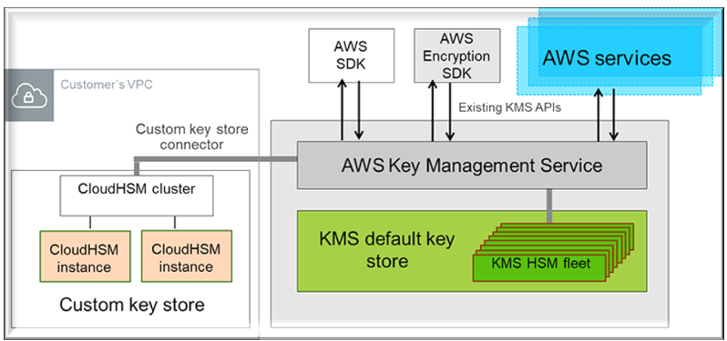
AWS KMS can help you integrate with other AWS services to encrypt the data that you store in these services and control access to the keys that decrypt it. To immediately remove the key material from AWS KMS, you can use a custom key store. Take note that each custom key store is associated with an AWS CloudHSM cluster in your AWS account. Therefore, when you create an AWS KMS Key in a custom key store, AWS KMS generates and stores the non-extractable key material for the KMS key in an AWS CloudHSM cluster that you own and manage. This is also suitable if you want to be able to audit the usage of all your keys independently of AWS KMS or AWS CloudTrail.
Since you control your AWS CloudHSM cluster, you have the option to manage the lifecycle of your KMS keys independently of AWS KMS. Here are the criteria why you might find a custom key store useful:
- You have encryption keys that must be safeguarded within a dedicated hardware security module (HSM) under your direct control, adhering to strict single-tenancy requirements.
- You require the capability to promptly and independently revoke and remove key material from AWS KMS, exercising complete control over the key lifecycle.
- Your compliance obligations mandate independent auditing and monitoring of all key usage activities, beyond the logging provided by AWS KMS and AWS CloudTrail.
Hence, the correct answer in this scenario is: Use AWS Key Management Service to create a KMS key in a custom key store and store the non-extractable key material in AWS CloudHSM.
The option that says: Use AWS Key Management Service to create a KMS key in a custom key store and store the non-extractable key material in Amazon S3 is incorrect. Amazon S3 is primarily for general storage purposes and does not provide the required level of security and control needed for cryptographic key management. You have to use AWS CloudHSM instead.
The options that says: Use AWS Key Management Service to create AWS owned Keys and store the non-extractable key material in AWS CloudHSM and Use AWS Key Management Service to create AWS managed Keys and store the non-extractable key material in AWS CloudHSM are both incorrect because the scenario primarily requires you to have full control over the encryption of the created key. AWS owned Keys, and AWS managed Keys are managed by AWS. Moreover, these options do not allow you to audit the key usage independently of AWS CloudTrail.

References:
https://docs.aws.amazon.com/kms/latest/developerguide/custom-key-store-overview.html
https://docs.aws.amazon.com/kms/latest/developerguide/keystore-cloudhsm.html
https://aws.amazon.com/blogs/security/are-kms-custom-key-stores-right-for-you/

Check out this AWS KMS Cheat Sheet:
https://tutorialsdojo.com/aws-key-management-service-aws-kms/

151 20 Question
A company plans to host a web application in an Auto Scaling group of Amazon EC2 instances. The application will be used globally by users to upload and store several types of files. Based on user trends, files that are older than 2 years must be stored in a different storage class. The Solutions Architect of the company needs to create a cost-effective and scalable solution to store the old files yet still provide durability and high availability.
Which of the following approach can be used to fulfill this requirement? (Select TWO.)
- Use Amazon S3 and create a lifecycle policy that will move the objects to S3 Standard-IA after 2 years.
- Use Amazon EFS and create a lifecycle policy that will move the objects to EFS-IA after 2 years.
- Use Amazon S3 and create a lifecycle policy that will move the objects to S3 Glacier after 2 years.
- Use Amazon EBS volumes to store the files. Configure the Amazon Data Lifecycle Manager (DLM) to schedule snapshots of the volumes after 2 years.
- Use a RAID 0 storage configuration that stripes multiple Amazon EBS volumes together to store the files. Configure the Amazon Data Lifecycle Manager (DLM) to schedule snapshots of the volumes after 2 years.
Correct
Amazon S3 stores data as objects within buckets. An object is a file and any optional metadata that describes the file. To store a file in Amazon S3, you upload it to a bucket. When you upload a file as an object, you can set permissions on the object and any metadata. Buckets are containers for objects. You can have one or more buckets. You can control access for each bucket, deciding who can create, delete, and list objects in it. You can also choose the geographical region where Amazon S3 will store the bucket and its contents and view access logs for the bucket and its objects.

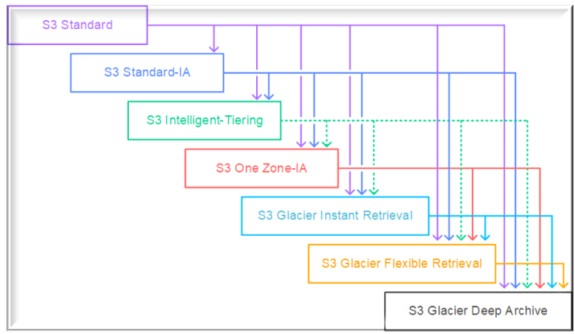
To move a file to a different storage class, you can use Amazon S3 or Amazon EFS. Both services have lifecycle configurations. Take note that Amazon EFS can only transition a file to the IA storage class after 90 days. Since you need to move the files that are older than 2 years to a more cost-effective and scalable solution, you should use the Amazon S3 lifecycle configuration. With S3 lifecycle rules, you can transition files to S3 Standard IA or S3 Glacier. Using S3 Glacier expedited retrieval, you can quickly access your files within 1-5 minutes.
Hence, the correct answers are:
– Use Amazon S3 and create a lifecycle policy that will move the objects to S3 Glacier after 2 years.
– Use Amazon S3 and create a lifecycle policy that will move the objects to S3 Standard-IA after 2 years.
The option that says: Use Amazon EFS and create a lifecycle policy that will move the objects to EFS-IA after 2 years is incorrect because the maximum days of EFS lifecycle policies is only up to 365 days. Therefore, it still does not meet the requirement of moving files older than 2 years or 730 days.
The option that says: Use Amazon EBS volumes to store the files. Configure the Amazon Data Lifecycle Manager (DLM) to schedule snapshots of the volumes after 2 years is incorrect because the Amazon EBS simply costs more and is not as scalable as Amazon S3. It has some limitations when accessed by multiple EC2 instances. There are also huge costs involved in using the multi-attach feature on a Provisioned IOPS EBS volume to allow multiple EC2 instances to access the volume.
The option that says: Use a RAID 0 storage configuration that stripes multiple Amazon EBS volumes together to store the files. Configure the Amazon Data Lifecycle Manager (DLM) to schedule snapshots of the volumes after 2 years is incorrect because RAID (Redundant Array of Independent Disks) is just a data storage virtualization technology that combines multiple storage devices to achieve higher performance or data durability. RAID 0 can stripe multiple volumes together for greater I/O performance than you can achieve with a single volume. On the other hand, RAID 1 can mirror two volumes together to achieve on-instance redundancy.

References:
https://docs.aws.amazon.com/AmazonS3/latest/dev/object-lifecycle-mgmt.html
https://docs.aws.amazon.com/efs/latest/ug/lifecycle-management-efs.html
https://docs.aws.amazon.com/efs/latest/ug/API_LifecyclePolicy.html
https://aws.amazon.com/s3/faqs/

Check out this Amazon S3 Cheat Sheet:
https://tutorialsdojo.com/amazon-s3/

152 21 Question
An online learning company hosts its Microsoft .NET e-Learning application on a Windows Server in its on-premises data center. The application uses an Oracle Database Standard Edition as its backend database.
The company wants a high-performing solution to migrate this workload to the AWS cloud to take advantage of the cloud’s high availability. The migration process should minimize development changes, and the environment should be easier to manage.
Which of the following options should be implemented to meet the company requirements? (Select TWO.)
- Refactor the application to .NET Core and run it as a serverless container service using Amazon Elastic Kubernetes Service (Amazon EKS) with AWS Fargate.
- Migrate the Oracle database to Amazon RDS for Oracle in a Multi-AZ deployment by using AWS Database Migration Service (AWS DMS).
- Provision and re-platform the application to Amazon Elastic Container Service (Amazon ECS) with Amazon EC2 worker nodes. Use the Windows Server Amazon Machine Image (AMI) and deploy the .NET application using to the ECS cluster via the ECS Anywhere service.
- Use AWS Application Migration Service (AWS MGN) to migrate the on-premises Oracle database server to a new Amazon EC2 instance.
- Rehost the on-premises .NET application to an AWS Elastic Beanstalk Multi-AZ environment which runs in multiple Availability Zones.
Incorrect
AWS Database Migration Service (AWS DMS) is a cloud service that makes it easy to migrate relational databases, data warehouses, NoSQL databases, and other types of data stores. You can use AWS DMS to migrate your data into the AWS Cloud or between combinations of cloud and on-premises setups.
With AWS DMS, you can perform one-time migrations, and you can replicate ongoing changes to keep sources and targets in sync. If you want to migrate to a different database engine, you can use the AWS Schema Conversion Tool (AWS SCT) to translate your database schema to the new platform. You then use AWS DMS to migrate the data.
AWS Elastic Beanstalk reduces management complexity without restricting choice or control. You simply upload your application, and Elastic Beanstalk automatically handles the details of capacity provisioning, load balancing, scaling, and application health monitoring. Elastic Beanstalk supports applications developed in Go, Java, .NET, Node.js, PHP, Python, and Ruby. When you deploy your application, Elastic Beanstalk builds the selected supported platform version and provisions one or more AWS resources, such as Amazon EC2 instances, to run your application.

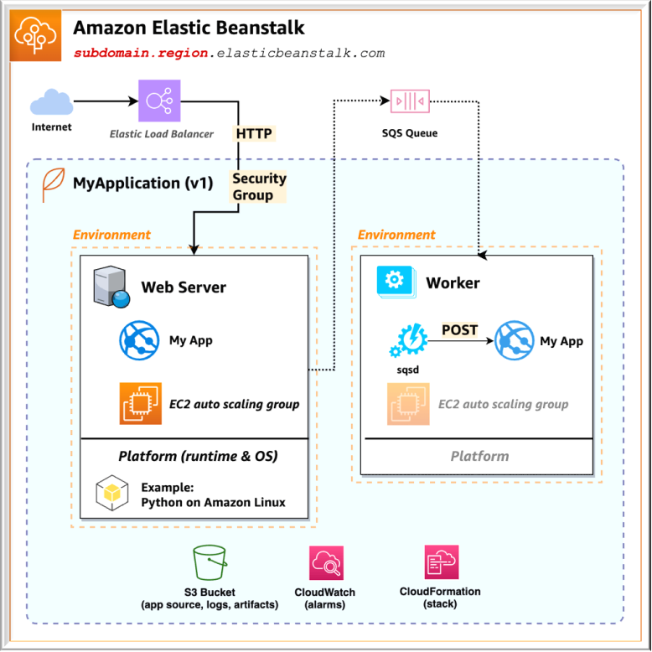
AWS Elastic Beanstalk for .NET makes it easier to deploy, manage, and scale your ASP.NET web applications that use Amazon Web Services. Elastic Beanstalk for .NET is available to anyone who is developing or hosting a web application that uses IIS.
Hence, the correct answers are:
– Migrate the Oracle database to Amazon RDS for Oracle in a Multi-AZ deployment by using AWS Database Migration Service (AWS DMS)
– Rehost the on-premises .NET application to an AWS Elastic Beanstalk Multi-AZ environment which runs in multiple Availability Zones.
The option that says: Refactor the application to .NET Core and run it as a serverless container service using Amazon Elastic Kubernetes Service (Amazon EKS) with AWS Fargate is incorrect. This will take significant changes to the application as you will refactor, or do a code change to, the codebase in order for it to become a serverless container application. Remember that the scenario explicitly mentioned that the migration process should minimize development changes. A better solution is to simply rehost the on-premises .NET application to an AWS Elastic Beanstalk Multi-AZ environment, which doesn’t require any code changes.
The option that says: Use AWS Application Migration Service (AWS MGN) to migrate the on-premises Oracle database server to a new Amazon EC2 instance is incorrect. Amazon RDS primarily supports standard Oracle databases so it would be better to use AWS DMS for the database migration, not AWS MGN.
The option that says: Provision and replatform the application to Amazon Elastic Container Service (Amazon ECS) with Amazon EC2 worker nodes. Use the Windows Server Amazon Machine Image (AMI) and deploy the .NET application using to the ECS cluster via the ECS Anywhere service is incorrect. This may be possible but not recommended for this scenario because you will have to manage the underlying EC2 instances of your Amazon ECS cluster that will run the application. It would be better just to use Elastic Beanstalk to take care of provisioning the resources for your .NET application. Keep in mind that doing a re-platform-type migration like this one entails significant development changes, which is not suitable with the requirements given in the scenario.

References:
https://docs.aws.amazon.com/dms/latest/userguide/Welcome.html
https://docs.aws.amazon.com/elasticbeanstalk/latest/dg/create_deploy_NET.html
https://docs.aws.amazon.com/elasticbeanstalk/latest/dg/Welcome.html

Check out these AWS DMS and AWS Beanstalk Cheat Sheets:
https://tutorialsdojo.com/aws-database-migration-service/
https://tutorialsdojo.com/aws-elastic-beanstalk/

153 22 Question
A company has a web application that uses Amazon CloudFront to distribute its images, videos, and other static content stored in its Amazon S3 bucket to users around the world. The company has recently introduced a new member-only access feature for some of its high-quality media files. There is a requirement to provide access to multiple private media files only to paying subscribers without having to change the current URLs.
Which of the following is the most suitable solution to implement to satisfy this requirement?
- Use Signed Cookies to control who can access the private files in your CloudFront distribution by modifying your application to determine whether a user should have access to your content. For members, send the required Set-Cookie headers to the viewer which will unlock the content only to them.
- Create a Signed URL with a custom policy which only allows the members to see the private files.
- Configure your CloudFront distribution to use Field-Level Encryption to protect your private data and only allow access to members.
- Configure your CloudFront distribution to use Match Viewer as its Origin Protocol Policy which will automatically match the user request. This will allow access to the private content if the request is a paying member and deny it if it is not a member.
Incorrect
Many companies that distribute content over the internet want to restrict access to documents, business data, media streams, or content that is intended for selected users, for example, users who have paid a fee. To securely serve this private content by using CloudFront, you can do the following:
– Require that your users access your private content by using special CloudFront signed URLs or signed cookies.
– Require that your users access your content by using CloudFront URLs, not URLs that access content directly on the origin server (for example, Amazon S3 or a private HTTP server). Requiring CloudFront URLs isn’t necessary, but we recommend it to prevent users from bypassing the restrictions that you specify in signed URLs or signed cookies.
CloudFront signed URLs and signed cookies provide the same basic functionality: they allow you to control who can access your content.

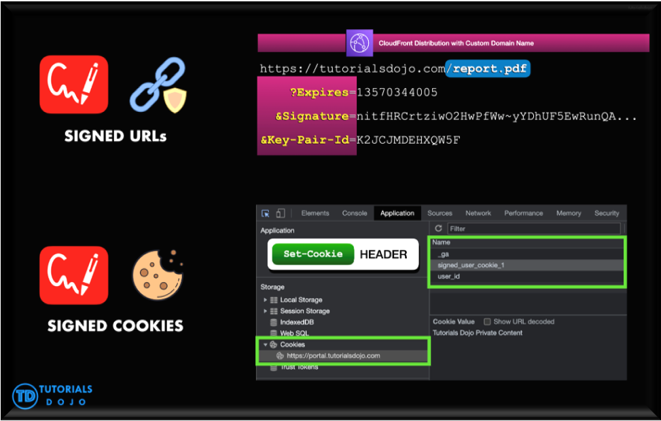
If you want to serve private content through CloudFront and you’re trying to decide whether to use signed URLs or signed cookies, consider the following:
Use signed URLs for the following cases:
– You want to use an RTMP distribution. Signed cookies aren’t supported for RTMP distributions.
– You want to restrict access to individual files, for example, an installation download for your application.
– Your users are using a client (for example, a custom HTTP client) that doesn’t support cookies.
Use signed cookies for the following cases:
– You want to provide access to multiple restricted files, for example, all of the files for a video in HLS format or all of the files in the subscribers’ area of a website.
– You don’t want to change your current URLs.
Hence, the correct answer is: Use Signed Cookies to control who can access the private files in your CloudFront distribution by modifying your application to determine whether a user should have access to your content. For members, send the required Set-Cookie headers to the viewer which will unlock the content only to them.
The option that says: Configure your CloudFront distribution to use Match Viewer as its Origin Protocol Policy which will automatically match the user request. This will allow access to the private content if the request is a paying member and deny it if it is not a member is incorrect because a Match Viewer is an Origin Protocol Policy that configures CloudFront to communicate with your origin using HTTP or HTTPS, depending on the protocol of the viewer request. CloudFront caches the object only once even if viewers make requests using both HTTP and HTTPS protocols.
The option that says: Create a Signed URL with a custom policy which only allows the members to see the private files is incorrect because Signed URLs are primarily used for providing access to individual files, as shown in the above explanation. In addition, the scenario explicitly says that they don’t want to change their current URLs which is why implementing Signed Cookies is more suitable than Signed URLs.
The option that says: Configure your CloudFront distribution to use Field-Level Encryption to protect your private data and only allow access to members is incorrect because Field-Level Encryption only allows you to securely upload user-submitted sensitive information to your web servers. It does not provide access to download multiple private files.

References:
https://docs.aws.amazon.com/AmazonCloudFront/latest/DeveloperGuide/private-content-choosing-signed-urls-cookies.html
https://docs.aws.amazon.com/AmazonCloudFront/latest/DeveloperGuide/private-content-signed-cookies.html

Check out this Amazon CloudFront Cheat Sheet:
https://tutorialsdojo.com/amazon-cloudfront/

154 23 Question
A software development company is using serverless computing with AWS Lambda to build and run applications without having to set up or manage servers. The company has a Lambda function that connects to a MongoDB Atlas, which is a popular Database as a Service (DBaaS) platform, and also uses a third-party API to fetch certain data for its application. One of the developers was instructed to create the environment variables for the MongoDB database hostname, username, and password, as well as the API credentials that will be used by the Lambda function for DEV, SIT, UAT, and PROD environments.
Considering that the Lambda function is storing sensitive database and API credentials, how can this information be secured to prevent other developers on the team, or anyone, from seeing these credentials in plain text? Select the best option that provides maximum security.
- There is no need to do anything because, by default, Lambda already encrypts the environment variables using the AWS Key Management Service.
- Create a new AWS KMS key and use it to enable encryption helpers that leverage on AWS Key Management Service to store and encrypt the sensitive information.
- Enable SSL encryption that leverages on AWS CloudHSM to store and encrypt the sensitive information.
- Lambda does not provide encryption for the environment variables. Deploy your code to an Amazon EC2 instance instead.
Incorrect
When you create or update Lambda functions that use environment variables, AWS Lambda encrypts them using the AWS Key Management Service. When your Lambda function is invoked, those values are decrypted and made available to the Lambda code.
The first time you create or update Lambda functions that use environment variables in a region, a default service key is created for you automatically within AWS KMS. This key is used to encrypt environment variables. However, if you wish to use encryption helpers and use KMS to encrypt environment variables after your Lambda function is created, you must create your own AWS KMS key and choose it instead of the default key. The default key will give errors when chosen. Creating your own key gives you more flexibility, including the ability to create, rotate, disable, and define access controls, and to audit the encryption keys used to protect your data.

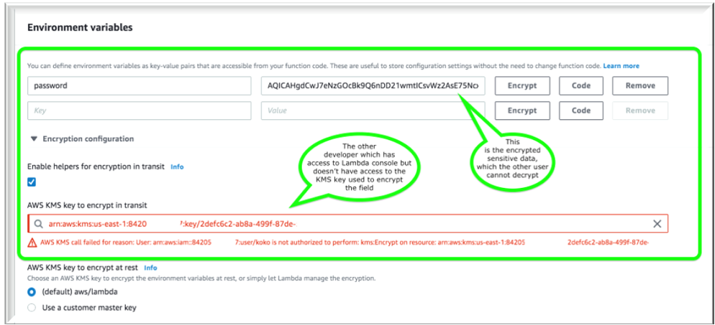
Hence, the correct answer is: Create a new AWS KMS key and use it to enable encryption helpers that leverage on AWS Key Management Service to store and encrypt the sensitive information.
The option that says: There is no need to do anything because, by default, Lambda already encrypts the environment variables using the AWS Key Management Service is incorrect. Although Lambda encrypts the environment variables in your function by default, the sensitive information would still be visible to other users who have access to the Lambda console. This is because Lambda uses a default KMS key to encrypt the variables, which is usually accessible by other users. The best option in this scenario is to use encryption helpers to secure your environment variables.
The option that says: Enable SSL encryption that leverages on AWS CloudHSM to store and encrypt the sensitive information is also incorrect since enabling SSL would encrypt data only when in-transit. Your other teams would still be able to view the plaintext at-rest. Typically, AWS KMS is the recommended choice for encrypting sensitive data at rest.
The option that says: Lambda does not provide encryption for the environment variables. Deploy your code to an Amazon EC2 instance instead is incorrect since, as mentioned, Lambda does provide encryption functionality of environment variables.

References:
https://docs.aws.amazon.com/lambda/latest/dg/env_variables.html#env_encrypt
https://docs.aws.amazon.com/lambda/latest/dg/tutorial-env_console.html

Check out this AWS Lambda Cheat Sheet:
https://tutorialsdojo.com/aws-lambda/

155 24 Question
A Solutions Architect identified a series of DDoS attacks while monitoring the Amazon VPC. The Architect needs to fortify the current cloud infrastructure to protect the data of the clients.
Which of the following is the most suitable solution to mitigate these kinds of attacks?
- A combination of Security Groups and Network Access Control Lists to only allow authorized traffic to access your VPC.
- Using the AWS Firewall Manager, set up a security layer that will prevent SYN floods, UDP reflection attacks, and other DDoS attacks.
- Use AWS Shield Advanced to detect and mitigate DDoS attacks.
- Set up a web application firewall using AWS WAF to filter, monitor, and block HTTP traffic.
Correct
For higher levels of protection against attacks targeting your applications running on Amazon Elastic Compute Cloud (EC2), Elastic Load Balancing(ELB), Amazon CloudFront, and Amazon Route 53 resources, you can subscribe to AWS Shield Advanced. In addition to the network and transport layer protections that come with Standard, AWS Shield Advanced provides additional detection and mitigation against large and sophisticated DDoS attacks, near real-time visibility into attacks, and integration with AWS WAF, a web application firewall.
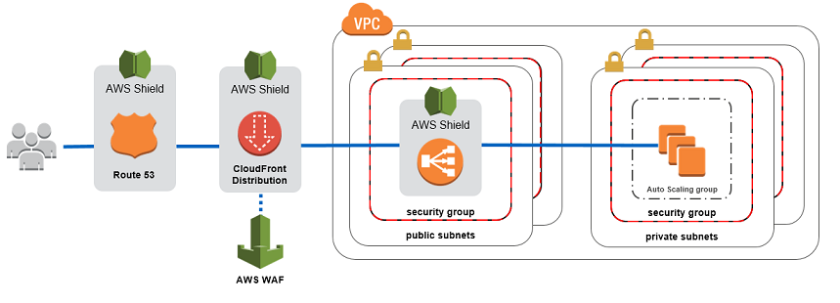
AWS Shield Advanced also gives you 24×7 access to the AWS DDoS Response Team (DRT) and protection against DDoS related spikes in your Amazon Elastic Compute Cloud (EC2), Elastic Load Balancing(ELB), Amazon CloudFront, and Amazon Route 53 charges.
Hence, the correct answer is: Use AWS Shield Advanced to detect and mitigate DDoS attacks.
The option that says: Using the AWS Firewall Manager, set up a security layer that will prevent SYN floods, UDP reflection attacks and other DDoS attacks is incorrect because AWS Firewall Manager is mainly used to simplify your AWS WAF administration and maintenance tasks across multiple accounts and resources. It does not protect your VPC against DDoS attacks.
The option that says: Set up a web application firewall using AWS WAF to filter, monitor, and block HTTP traffic is incorrect. Even though AWS WAF can help you block common attack patterns to your VPC such as SQL injection or cross-site scripting, this is still not enough to withstand DDoS attacks. It is just better to use AWS Shield in this scenario.
The option that says: A combination of Security Groups and Network Access Control Lists to only allow authorized traffic to access your VPC is incorrect. Although using a combination of Security Groups and NACLs are valid to provide security to your VPC, this is not enough to mitigate a DDoS attack. You should use AWS Shield for better security protection.

References:
https://d1.awsstatic.com/whitepapers/Security/DDoS_White_Paper.pdf
https://aws.amazon.com/shield/

Check out this AWS Shield Cheat Sheet:
https://tutorialsdojo.com/aws-shield/

156 25 Question
A tech company has a CRM application hosted on an Auto Scaling group of On-Demand EC2 instances with different instance types and sizes. The application is extensively used during office hours from 9 in the morning to 5 in the afternoon. Their users are complaining that the performance of the application is slow during the start of the day but then works normally after a couple of hours.
Which of the following is the MOST operationally efficient solution to implement to ensure the application works properly at the beginning of the day?
- Configure a Dynamic scaling policy for the Auto Scaling group to launch new instances based on the CPU utilization.
- Configure a Dynamic scaling policy for the Auto Scaling group to launch new instances based on the Memory utilization.
- Configure a Predictive scaling policy for the Auto Scaling group to automatically adjust the number of Amazon EC2 instances
- Configure a Scheduled scaling policy for the Auto Scaling group to launch new instances before the start of the day.
Incorrect
Scaling based on a schedule allows you to scale your application in response to predictable load changes. For example, every week the traffic to your web application starts to increase on Wednesday, remains high on Thursday, and starts to decrease on Friday. You can plan your scaling activities based on the predictable traffic patterns of your web application.
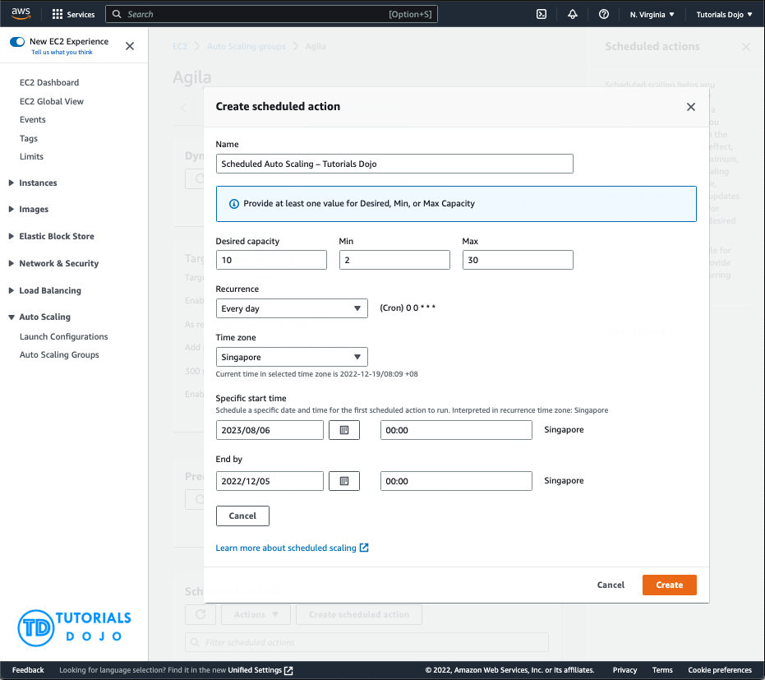
To configure your Auto Scaling group to scale based on a schedule, you create a scheduled action. The scheduled action tells Amazon EC2 Auto Scaling to perform a scaling action at specified times. To create a scheduled scaling action, you specify the start time when the scaling action should take effect and the new minimum, maximum, and desired sizes for the scaling action. At the specified time, Amazon EC2 Auto Scaling updates the group with the values for minimum, maximum, and desired size specified by the scaling action. You can create scheduled actions for scaling one time only or for scaling on a recurring schedule.
Hence, configuring a Scheduled scaling policy for the Auto Scaling group to launch new instances before the start of the day is the correct answer. You need to configure a Scheduled scaling policy. This will ensure that the instances are already scaled up and ready before the start of the day since this is when the application is used the most.
The following options are both incorrect. Although these are valid solutions, it is still better to configure a Scheduled scaling policy as you already know the exact peak hours of your application. By the time either the CPU or Memory hits a peak, the application already has performance issues, so you need to ensure the scaling is done beforehand using a Scheduled scaling policy:
-Configure a Dynamic scaling policy for the Auto Scaling group to launch new instances based on the CPU utilization
-Configure a Dynamic scaling policy for the Auto Scaling group to launch new instances based on the Memory utilization
The option that says: Configure a Predictive scaling policy for the Auto Scaling group to automatically adjust the number of Amazon EC2 instances is incorrect. Although this type of scaling policy can be used in this scenario, it is not the most operationally efficient option. Take note that the scenario mentioned that the Auto Scaling group consists of Amazon EC2 instances with different instance types and sizes. Predictive scaling assumes that your Auto Scaling group is homogenous, which means that all EC2 instances are of equal capacity. The forecasted capacity can be inaccurate if you are using a variety of EC2 instance sizes and types on your Auto Scaling group.

References:
https://docs.aws.amazon.com/autoscaling/ec2/userguide/schedule_time.html
https://docs.aws.amazon.com/autoscaling/ec2/userguide/ec2-auto-scaling-scheduled-scaling.html
https://docs.aws.amazon.com/autoscaling/ec2/userguide/ec2-auto-scaling-predictive-scaling.html#predictive-scaling-limitations

Check out this AWS Auto Scaling Cheat Sheet:
https://tutorialsdojo.com/aws-auto-scaling/

157 26 Question
A company uses an Application Load Balancer (ALB) for its public-facing multi-tier web applications. The security team has recently reported that there has been a surge of SQL injection attacks lately, which causes critical data discrepancy issues. The same issue is also encountered by its other web applications in other AWS accounts that are behind an ALB. An immediate solution is required to prevent the remote injection of unauthorized SQL queries and protect their applications hosted across multiple accounts.
As a Solutions Architect, what solution would you recommend?
- Use AWS WAF and set up a managed rule to block request patterns associated with the exploitation of SQL databases, like SQL injection attacks. Associate it with the Application Load Balancer. Integrate AWS WAF with AWS Firewall Manager to reuse the rules across all the AWS accounts.
- Use Amazon GuardDuty and set up a managed rule to block request patterns associated with the exploitation of SQL databases, like SQL injection attacks. Associate it with the Application Load Balancer and utilize the AWS Security Hub service to reuse the managed rules across all the AWS accounts
- Use Amazon Macie to scan for vulnerabilities and unintended network exposure. Refactor the web application to be less susceptible to SQL injection attacks based on the security assessment. Utilize the AWS Audit Manager to reuse the security assessment across all AWS accounts.
- Use AWS Network Firewall to filter web vulnerabilities and brute force attacks using stateful rule groups across all Application Load Balancers on all AWS accounts. Refactor the web application to be less susceptible to SQL injection attacks based on the security assessment.
Correct
AWS WAF is a web application firewall that lets you monitor the HTTP(S) requests that are forwarded to an Amazon CloudFront distribution, an Amazon API Gateway REST API, an Application Load Balancer, or an AWS AppSync GraphQL API.
-Web ACLs – You use a web access control list (ACL) to protect a set of AWS resources. You create a web ACL and define its protection strategy by adding rules. Rules define criteria for inspecting web requests and specify how to handle requests that match the criteria. You set a default action for the web ACL that indicates whether to block or allow through those requests that pass the rules inspections.
-Rules – Each rule contains a statement that defines the inspection criteria and an action to take if a web request meets the criteria. When a web request meets the criteria, that’s a match. You can configure rules to block matching requests, allow them through, count them, or run CAPTCHA controls against them.
-Rules groups – You can use rules individually or in reusable rule groups. AWS Managed Rules and AWS Marketplace sellers provide managed rule groups for your use. You can also define your own rule groups.
AWSManagedRulesSQLiRuleSet – The SQL database rule group contains rules to block request patterns associated with the exploitation of SQL databases, like SQL injection attacks. This can help prevent remote injection of unauthorized queries. Evaluate this rule group for use if your application interfaces with an SQL database.

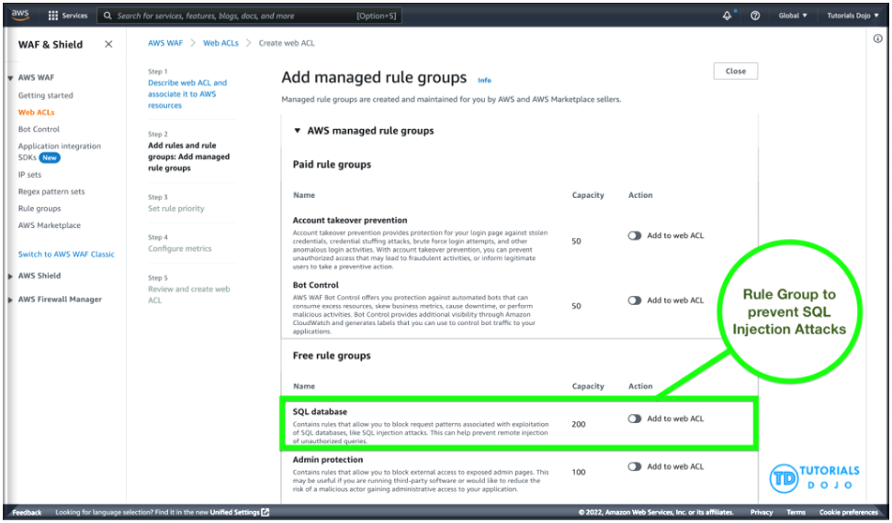
AWS WAF is easy to deploy and protect applications deployed on either Amazon CloudFront as part of your CDN solution, the Application Load Balancer that fronts all your origin servers, Amazon API Gateway for your REST APIs, or AWS AppSync for your GraphQL APIs. There is no additional software to deploy, DNS configuration, SSL/TLS certificate to manage, or need for a reverse proxy setup.
With AWS Firewall Manager integration, you can centrally define and manage your rules and reuse them across all the web applications that you need to protect.
Therefore, the correct answer is: Use AWS WAF and set up a managed rule to block request patterns associated with the exploitation of SQL databases, like SQL injection attacks. Associate it with the Application Load Balancer. Integrate AWS WAF with AWS Firewall Manager to reuse the rules across all the AWS accounts.
The option that says: Use Amazon GuardDuty and set up a managed rule to block request patterns associated with the exploitation of SQL databases, like SQL injection attacks. Associate it with the Application Load Balancer and utilize the AWS Security Hub service to reuse the managed rules across all the AWS accountsis incorrect because Amazon GuardDuty is only a threat detection service and cannot directly be integrated with the Application Load Balancer.
The options that says: Use AWS Network Firewall to filter web vulnerabilities and brute force attacks using stateful rule groups across all Application Load Balancers on all AWS accounts. Refactor the web application to be less susceptible to SQL injection attacks based on the security assessment is incorrect because AWS Network Firewall is a managed service that is primarily used to deploy essential network protections for all of your Amazon Virtual Private Clouds (VPCs) and not particularly to your Application Load Balancers. Take note that the AWS Network Firewall is account-specific by default and needs to be integrated with the AWS Firewall Manager to easily share the firewall across your other AWS accounts. In addition, refactoring the web application will require an immense amount of time.
The options that says: Use Amazon Macie to scan for vulnerabilities and unintended network exposure. Refactor the web application to be less susceptible to SQL injection attacks based on the security assessment. Utilize the AWS Audit Manager to reuse the security assessment across all AWS accounts is incorrect because Amazon Macie is only used for data security and data privacy service that uses machine learning and pattern matching to discover and protect your sensitive data. Just like before, refactoring the web application will require an immense amount of time. The use of the AWS Audit Manager is not relevant as well. The AWS Audit Manager simply helps you continually audit your AWS usage to simplify how you manage risk and compliance with regulations and industry standards.

References:
https://docs.aws.amazon.com/waf/latest/developerguide/how-aws-waf-works.html
https://docs.aws.amazon.com/waf/latest/developerguide/fms-chapter.html
https://docs.aws.amazon.com/waf/latest/developerguide/aws-managed-rule-groups-use-case.html#aws-managed-rule-groups-use-case-sql-db

Check out this AWS Web Application Firewall Cheat Sheet:
https://tutorialsdojo.com/aws-waf

158 27 Question
A government agency plans to store confidential tax documents on AWS. Due to the sensitive information in the files, the Solutions Architect must restrict the data access requests made to the storage solution to a specific Amazon VPC only. The solution should also prevent the files from being deleted or overwritten to meet the regulatory requirement of having a write-once-read-many (WORM) storage model.
Which combination of the following options should the Architect implement? (Select TWO.)
- Configure an Amazon S3 Access Point for the S3 bucket to restrict data access to a particular VPC only.
- Store the tax documents in the Amazon S3 Glacier Instant Retrieval storage class. Use the PutBucketPolicy API to apply a bucket policy that restricts access requests to a specific VPC.
- Enable Object Lock but disable Object Versioning on the new Amazon S3 bucket to comply with the write-once-read-many (WORM) storage model requirement.
- Set up a new Amazon S3 bucket to store the tax documents and integrate it with AWS Network Firewall. Configure the Network Firewall to only accept data access requests from a specific VPC.
- Create a new Amazon S3 bucket with the S3 Object Lock feature enabled. Store the documents in the bucket and set the Legal Hold option for object retention.
Incorrect
Amazon S3 access points simplify data access for any AWS service or customer application that stores data in S3. Access points are named network endpoints that are attached to buckets that you can use to perform S3 object operations, such as GetObject and PutObject.
Each access point has distinct permissions and network controls that S3 applies for any request that is made through that access point. Each access point enforces a customized access point policy that works in conjunction with the bucket policy that is attached to the underlying bucket. You can configure any access point to accept requests only from a virtual private cloud (VPC) to restrict Amazon S3 data access to a private network. You can also configure custom block public access settings for each access point.
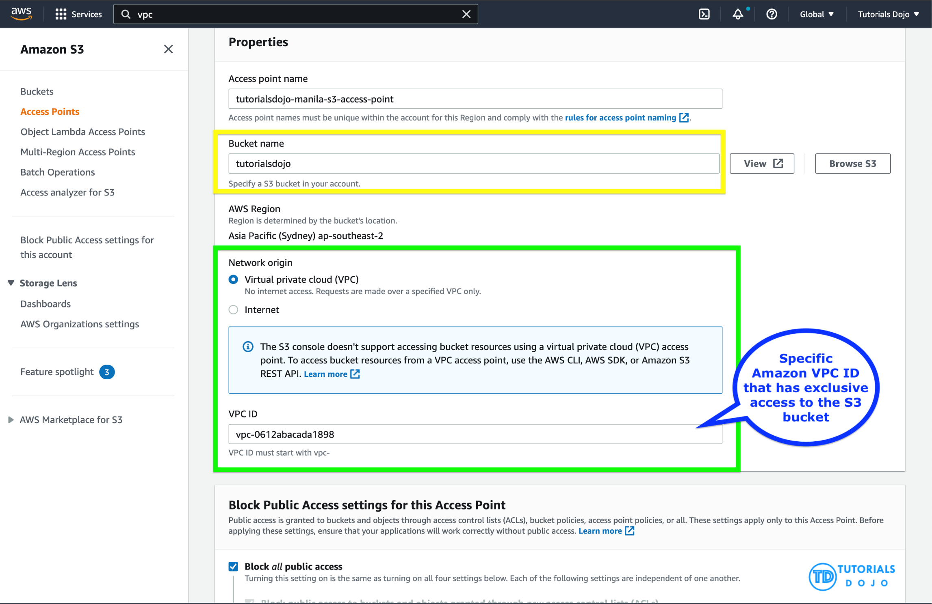
You can also use Amazon S3 Multi-Region Access Points to provide a global endpoint that applications can use to fulfill requests from S3 buckets located in multiple AWS Regions. You can use Multi-Region Access Points to build multi-Region applications with the same simple architecture used in a single Region, and then run those applications anywhere in the world. Instead of sending requests over the congested public internet, Multi-Region Access Points provide built-in network resilience with acceleration of internet-based requests to Amazon S3. Application requests made to a Multi-Region Access Point global endpoint use AWS Global Accelerator to automatically route over the AWS global network to the S3 bucket with the lowest network latency.
With S3 Object Lock, you can store objects using a write-once-read-many (WORM) model. Object Lock can help prevent objects from being deleted or overwritten for a fixed amount of time or indefinitely. You can use Object Lock to help meet regulatory requirements that require WORM storage, or to simply add another layer of protection against object changes and deletion.
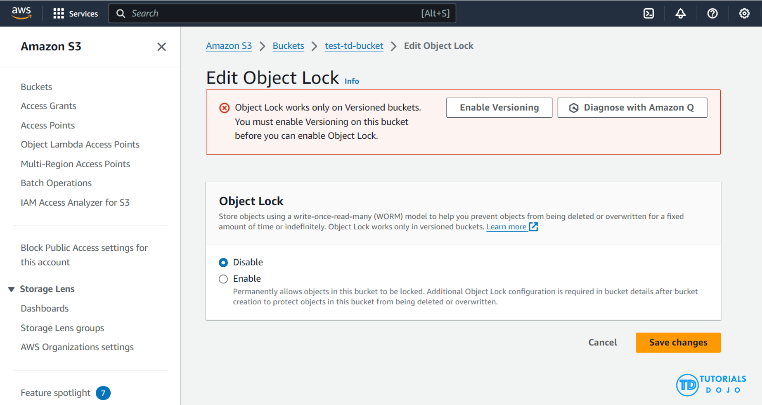
Before locking any objects, it is essential to enable S3 Object Lock on a bucket. Previously, Object Lock could only be enabled at the time of bucket creation, but now, Amazon S3 allows you to enable S3 Object Lock for existing buckets with just a few clicks. Once S3 Object Lock is enabled on a bucket, it allows you to lock objects within that bucket to prevent them from being deleted or overwritten for a fixed amount of time or indefinitely. While Object Lock can now be enabled on existing buckets, it is important to note that once enabled, Object Lock itself cannot be disabled. However, you can still manage and configure object lock settings, including retention periods and legal holds, but the core feature of Object Lock remains active and irreversible. Also, versioning, which is required for Object Lock, cannot be suspended or disabled once Object Lock is enabled on the bucket.
Hence, the correct answers are:
– Configure an Amazon S3 Access Point for the S3 bucket to restrict data access to a particular VPC only.
– Create a new Amazon S3 bucket with the S3 Object Lock feature enabled. Store the documents in the bucket and set the Legal Hold option for object retention.
The option that says: Set up a new Amazon S3 bucket to store the tax documents and integrate it with AWS Network Firewall. Configure the Network Firewall to only accept data access requests from a specific VPC is incorrect because you cannot directly use an AWS Network Firewall to restrict S3 bucket data access requests to a specific Amazon VPC only. You have to use an Amazon S3 Access Point instead for this particular use case. An AWS Network Firewall is commonly integrated to your Amazon VPC and not to an S3 bucket.
The option that says: Store the tax documents in the Amazon S3 Glacier Instant Retrieval storage class. Use the PutBucketPolicy API to apply a bucket policy that restricts access requests to a specific VPC is incorrect because Amazon S3 Glacier Instant Retrieval is just an archive storage class that delivers the lowest-cost storage for long-lived data that is rarely accessed and requires retrieval in milliseconds. Additionally, using a bucket policy to restrict access from a VPC is less efficient compared to using an S3 Access Point.
The option that says: Enable Object Lock but disable Object Versioning on the new Amazon S3 bucket to comply with the write-once-read-many (WORM) storage model requirement is incorrect. Although the Object Lock feature does provide write-once-read-many (WORM) storage, the Object Versioning feature must also be enabled in order for this to work. In fact, you cannot manually disable the Object Versioning feature if you have already selected the Object Lock option.

References:
https://docs.aws.amazon.com/AmazonS3/latest/userguide/access-points.html
https://docs.aws.amazon.com/AmazonS3/latest/userguide/object-lock.html

Check out this Amazon S3 Cheat Sheet:
https://tutorialsdojo.com/amazon-s3/

159 28 Question
A medical records company is planning to store sensitive clinical trial data in an Amazon S3 repository with the object-level versioning feature enabled. The Solutions Architect is tasked with ensuring that no object can be overwritten or deleted by any user in a period of one year only. To meet the strict compliance requirements, the root user of the company’s AWS account must also be restricted from making any changes to an object in the S3 bucket.
Which of the following is the most secure way of storing the data in S3?
- Enable S3 Object Lock in compliance mode with a retention period of one year.
- Enable S3 Object Lock in compliance mode with a legal hold of one year.
- Enable S3 Object Lock in governance mode with a retention period of one year.
- Enable S3 Object Lock in governance mode with a legal hold of one year.
Incorrect
With S3 Object Lock, you can store objects using a write-once-read-many (WORM) model. Object Lock can help prevent objects from being deleted or overwritten for a fixed amount of time or indefinitely. You can use Object Lock to help meet regulatory requirements that require WORM storage or to simply add another layer of protection against object changes and deletion.
Before you lock any objects, you have to enable a bucket to use S3 Object Lock. You enable Object Lock when you create a bucket. After you enable Object Lock on a bucket, you can lock objects in that bucket. When you create a bucket with Object Lock enabled, you can’t disable Object Lock or suspend versioning for that bucket.
S3 Object Lock provides two retention modes:
-Governance mode
-Compliance mode
These retention modes apply different levels of protection to your objects. You can apply either retention mode to any object version that is protected by Object Lock.
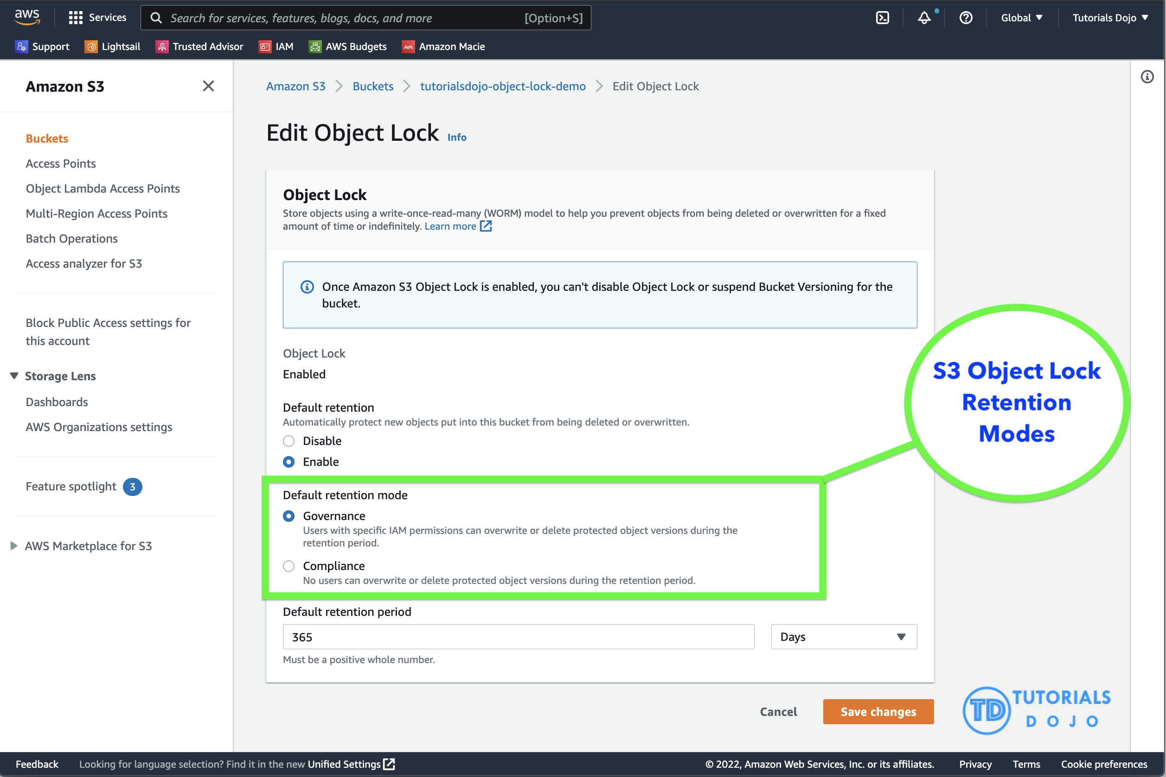
In governance mode, users can’t overwrite or delete an object version or alter its lock settings unless they have special permissions. With governance mode, you protect objects against being deleted by most users, but you can still grant some users permission to alter the retention settings or delete the object if necessary. You can also use governance mode to test retention-period settings before creating a compliance-mode retention period.
In compliance mode, a protected object version can’t be overwritten or deleted by any user, including the root user in your AWS account. When an object is locked in compliance mode, its retention mode can’t be changed, and its retention period can’t be shortened. Compliance mode helps ensure that an object version can’t be overwritten or deleted for the duration of the retention period.
To override or remove governance-mode retention settings, a user must have the s3:BypassGovernanceRetention permission and must explicitly include x-amz-bypass-governance-retention:true as a request header with any request that requires overriding governance mode.
Legal Hold vs. Retention Period
With Object Lock, you can also place a legal hold on an object version. Like a retention period, a legal hold prevents an object version from being overwritten or deleted. However, a legal hold doesn’t have an associated retention period and remains in effect until removed. Legal holds can be freely placed and removed by any user who has the s3:PutObjectLegalHold permission.
Legal holds are independent from retention periods. As long as the bucket that contains the object has Object Lock enabled, you can place and remove legal holds regardless of whether the specified object version has a retention period set. Placing a legal hold on an object version doesn’t affect the retention mode or retention period for that object version.
For example, suppose that you place a legal hold on an object version while the object version is also protected by a retention period. If the retention period expires, the object doesn’t lose its WORM protection. Rather, the legal hold continues to protect the object until an authorized user explicitly removes it. Similarly, if you remove a legal hold while an object version has a retention period in effect, the object version remains protected until the retention period expires.
Hence, the correct answer is: Enable S3 Object Lock in compliance mode with a retention period of one year.
The option that says: Enable S3 Object Lock in governance mode with a retention period of one year is incorrect because in the governance mode, users typically can’t overwrite or delete an object version or alter its lock settings unless they have special permissions or if a user has access to the root AWS user account. A better option to choose here is to use the compliance mode.
The option that says: Enable S3 Object Lock in governance mode with a legal hold of one year is incorrect. You CANNOT set a time period FOR A legal hold. You can only do this using the “retention period” option. Take note that a legal hold will still restrict users from changing the S3 objects even after the one-year retention period has elapsed. In addition, a governance mode will allow the root user to modify your S3 objects and override any existing settings.
The option that says: Enable S3 Object Lock in compliance mode with a legal hold of one year is incorrect. Although the choice of using the compliance mode is right, you still cannot set a one-year time period for the legal hold option. Keep in mind that the legal hold is independent of the retention period.

References:
https://docs.aws.amazon.com/AmazonS3/latest/userguide/object-lock.html
https://docs.aws.amazon.com/AmazonS3/latest/userguide/object-lock-overview.html

Check out this Amazon S3 Cheat Sheet:
https://tutorialsdojo.com/amazon-s3/

160 29 Question
An e-commerce company runs a highly scalable web application that depends on an Amazon Aurora database. As the number of users increases, the read replica faces difficulties keeping up with the increasing read traffic, causing performance bottlenecks during peak periods.
Which of the following will resolve the issue with the most cost-effective solution?
- Increase the size of the Aurora DB cluster.
- Set up a read replica that can operate across different regions.
- Use automatic scaling for the Aurora read replica using Aurora Auto Scaling.
- Implement read scaling with Aurora Global Database.
Correct
Amazon Aurora is a cloud-based relational database service that provides better performance and reliability for database workloads. It is highly available and scalable, making it a great choice for businesses of any size. One of the key features of Amazon Aurora is Aurora Auto Scaling, which automatically adjusts the capacity of your Aurora database cluster based on the workload. This means that you don’t have to worry about manually adjusting the ability of your database cluster to handle changes in demand. With Aurora Auto Scaling, you can be sure that your database cluster will always have the appropriate capacity to handle your workload while minimizing costs.
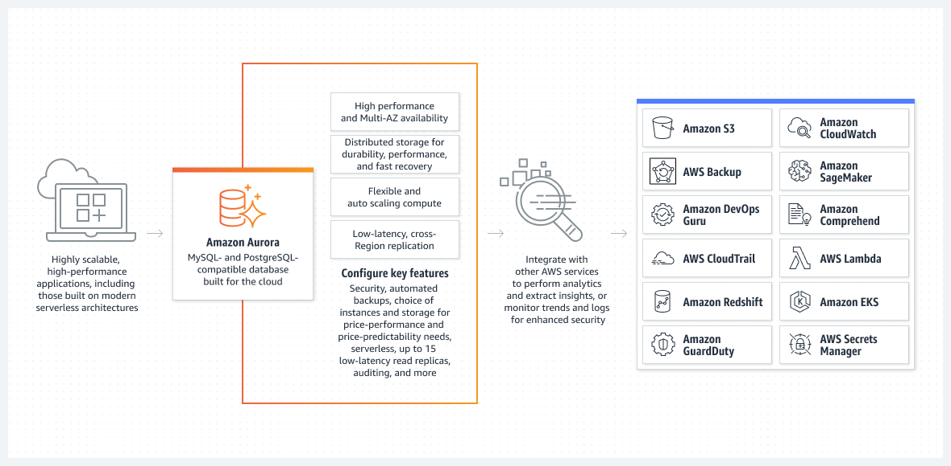
Aurora Auto Scaling is particularly useful for businesses that have fluctuating workloads. It ensures that your database cluster scales up or down as needed without manual intervention. This feature saves time and resources, allowing businesses to focus on other aspects of their operations. Aurora Auto Scaling is also cost-effective, as it helps minimize unnecessary expenses associated with overprovisioning or underprovisioning database resources.
In this scenario, the company can benefit from using Aurora Auto Scaling. This solution allows the system to dynamically manage resources, effectively addressing the surge in read traffic during peak periods. This dynamic management of resources ensures that the company pays only for the extra resources when they are genuinely required.
Hence, the correct answer is: Use automatic scaling for the Aurora read replica using Aurora Auto Scaling.
The option that says: Increase the size of the Aurora DB cluster is incorrect because it’s not economical to upsize the cluster just to alleviate the bottleneck during peak periods. A static increase in the DB cluster size results in constant costs, regardless of whether your database’s resources are being fully utilized during off-peak periods or not.
The option that says: Implement read scaling with Aurora Global Database is incorrect. Amazon Aurora Global Database is primarily designed for globally distributed applications, allowing a single Amazon Aurora database to span multiple AWS Regions. While this can provide global availability, it introduces additional complexity and can be more expensive due to infrastructure and data transfer costs.
The option that says: Set up a read replica that can operate across different regions is incorrect. Setting up a read replica that operates across different regions can provide read scalability and load-balancing benefits by typically distributing the read traffic across regions. However, it is not the most cost-effective solution in this scenario since it incurs additional costs associated with inter-region data replication. Moreover, the issue is not related to cross-region availability but rather the read replica’s performance within the current region.

References:
https://docs.aws.amazon.com/AmazonRDS/latest/AuroraUserGuide/Aurora.Integrating.AutoScaling.html
https://docs.aws.amazon.com/AmazonRDS/latest/AuroraUserGuide/CHAP_AuroraOverview.html

Check out this Amazon Aurora Cheat Sheet:
https://tutorialsdojo.com/amazon-aurora/

161 30 Question
A logistics company plans to automate its order management application. The company wants to use SFTP file transfer for uploading business-critical documents. Since the files are confidential, encryption at rest is required, and high availability must be ensured. Additionally, each file must be automatically deleted one month after creation.
Which of the following options should be implemented to meet the company’s requirements with the least operational overhead?
- Create an Amazon S3 bucket with encryption enabled. Launch an AWS Transfer for SFTP endpoint to securely upload files to the S3 bucket. Configure an S3 lifecycle rule to delete files after a month.
- Create an Amazon Elastic File System (Amazon EFS) and enable encryption. Configure AWS Transfer for SFTP to securely upload files to the EFS file system. Apply an EFS lifecycle policy to delete files after 30 days.
- Provision an Amazon EC2 instance and install the SFTP service. Mount an encrypted Amazon EFS file system on the EC2 instance to store the uploaded files. Add a cron job to delete the files older than a month.
- Create an Amazon S3 bucket with encryption enabled. Configure AWS Transfer for SFTP to securely upload files to the S3 bucket. Configure the retention policy on the SFTP server to delete files after a month.
Correct
AWS Transfer for SFTP enables you to easily move your file transfer workloads that use the Secure Shell File Transfer Protocol (SFTP) to AWS without needing to modify your applications or manage any SFTP servers.
To get started with AWS Transfer for SFTP (AWS SFTP) you create an SFTP server and map your domain to the server endpoint, select authentication for your SFTP clients using service-managed identities, or integrate your own identity provider, and select your Amazon S3 buckets to store the transferred data. Your existing users can continue to operate with their existing SFTP clients or applications. Data uploaded or downloaded using SFTP is available in your Amazon S3 bucket, and can be used for archiving or processing in AWS.
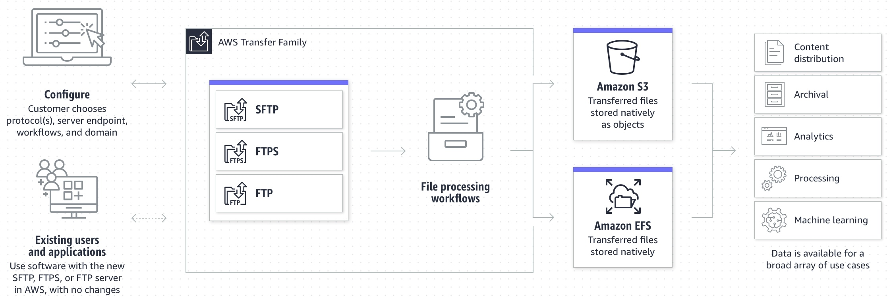
An Amazon S3 Lifecycle configuration is a set of rules that define actions that Amazon S3 applies to a group of objects. There are two types of actions:
Transition actions – These actions define when objects transition to another storage class. For example, you might choose to transition objects to the S3 Standard-IA storage class 30 days after creating them.
Expiration actions – These actions define when objects expire. Amazon S3 deletes expired objects on your behalf.
Therefore, the correct answer is: Create an Amazon S3 bucket with encryption enabled. Launch an AWS Transfer for SFTP endpoint to securely upload files to the S3 bucket. Configure an S3 lifecycle rule to delete files after a month. You can use S3 as the storage service for your AWS Transfer SFTP-enabled server.
The option that says: Create an Amazon S3 bucket with encryption enabled. Configure AWS Transfer for SFTP to securely upload files to the S3 bucket. Configure the retention policy on the SFTP server to delete files after a month is incorrect. The 30-day retention policy must be primarily configured on the Amazon S3 bucket. There is no retention policy option on AWS Transfer for SFTP.
The option that says: Create an Amazon Elastic File System (Amazon EFS) and enable encryption. Configure AWS Transfer for SFTP to securely upload files to the EFS file system. Apply an EFS lifecycle policy to delete files after 30 days is incorrect. This may be possible, however, the EFS lifecycle management doesn’t delete objects. It can only transition files in and out of the “Infrequent Access” tier.
The option that says: Provision an Amazon EC2 instance and install the SFTP service. Mount an encrypted Amazon EFS file system on the EC2 instance to store the uploaded files. Add a cron job to delete the files older than a month is incorrect. This option is possible, however, it entails greater operational overhead since you need to manage the EC2 instance and SFTP service.

References:
https://aws.amazon.com/aws-transfer-family/
https://docs.aws.amazon.com/transfer/latest/userguide/create-server-sftp.html
https://docs.aws.amazon.com/AmazonS3/latest/userguide/object-lifecycle-mgmt.html

Check out these AWS Transfer Family and Amazon S3 Cheat Sheets:
https://tutorialsdojo.com/amazon-s3/
https://tutorialsdojo.com/aws-transfer-family/

162 31 Question
A suite of web applications is hosted in an Auto Scaling group of Amazon EC2 instances across three Availability Zones and is configured with default settings. There is an Application Load Balancer that forwards the request to the respective target group on the URL path. The scale-in policy has been triggered due to the low number of incoming traffic to the application.
Which EC2 instance will be the first one to be terminated by the Auto Scaling group?
- The instance will be randomly selected by the Auto Scaling group
- The EC2 instance which has the least number of user sessions
- The EC2 instance which has been running for the longest time
- The EC2 instance launched from the oldest launch template.
Incorrect
The default termination policy is designed to help ensure that your network architecture spans Availability Zones evenly. With the default termination policy, the behavior of the Auto Scaling group is as follows:
1. If there are instances in multiple Availability Zones, choose the Availability Zone with the most instances and at least one instance that is not protected from scale in. If there is more than one Availability Zone with this number of instances, choose the Availability Zone with the instances that use the oldest launch template.
2. Determine which unprotected instances in the selected Availability Zone use the oldest launch template. If there is one such instance, terminate it.
3. If there are multiple instances to terminate based on the above criteria, determine which unprotected instances are closest to the next billing hour. (This helps you maximize the use of your EC2 instances and manage your Amazon EC2 usage costs.) If there is one such instance, terminate it.
4. If there is more than one unprotected instance closest to the next billing hour, choose one of these instances at random.
The following flow diagram illustrates how the default termination policy works:
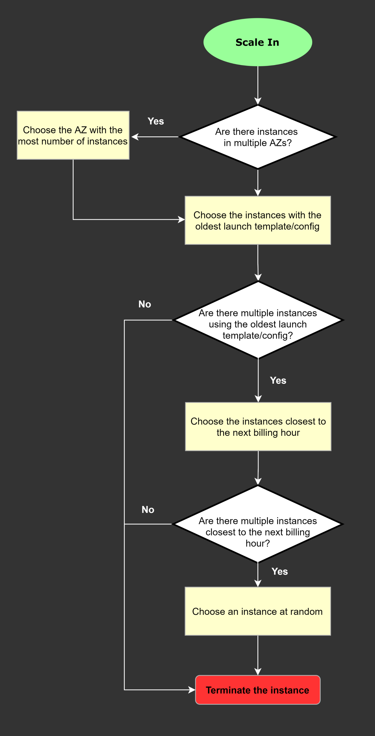
Hence, the correct answer is: The EC2 instance launched from the oldest launch template.
The option that says: The EC2 instance which has the least number of user sessions is incorrect because the number of user sessions is not typically a factor considered by Amazon EC2 Auto Scaling groups when deciding which instances to terminate during a scale-in event.
The option that says: The EC2 instance which has been running for the longest time is incorrect because the duration for which an EC2 instance has been running is not primarily a factor considered by Amazon EC2 Auto Scaling groups when deciding which instances to terminate during a scale-in event.
The option that says: The instance will be randomly selected by the Auto Scaling group is incorrect because Amazon EC2 Auto Scaling groups do not randomly select instances for termination during a scale-in event.

References:
https://docs.aws.amazon.com/autoscaling/ec2/userguide/as-instance-termination.html#default-termination-policy
https://docs.aws.amazon.com/autoscaling/ec2/userguide/as-instance-termination.html

Check out this AWS Auto Scaling Cheat Sheet:
https://tutorialsdojo.com/aws-auto-scaling/

163 32 Question
An online medical system hosted in AWS stores sensitive Personally Identifiable Information (PII) of the users in an Amazon S3 bucket. Both the master keys and the unencrypted data should never be sent to AWS to comply with the strict compliance and regulatory requirements of the company.
Which S3 encryption technique should the Architect use?
- Use S3 server-side encryption with an AWS KMS key.
- Use S3 server-side encryption with customer provided key.
- Use S3 client-side encryption with an AWS KMS key.
- Use S3 client-side encryption with a client-side master key.
Incorrect
Client-side encryption is the act of encrypting data before sending it to Amazon S3. To enable client-side encryption, you have the following options:
– Use an AWS KMS key.
– Use a client-side master key.
When using an AWS KMS key to enable client-side data encryption, you provide an AWS KMS key identifier (KeyId) to AWS. On the other hand, when you use client-side master key for client-side data encryption, your client-side master keys and your unencrypted data are never sent to AWS. It’s important that you safely manage your encryption keys because if you lose them, you can’t decrypt your data.
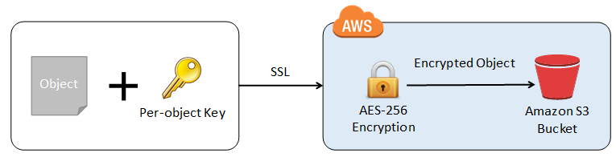
This is how client-side encryption using a client-side master key works:
When uploading an object – You provide a client-side master key to the Amazon S3 encryption client. The client uses the master key only to encrypt the data encryption key that it generates randomly. The process works like this:
1. The Amazon S3 encryption client generates a one-time-use symmetric key (also known as a data encryption key or data key) locally. It uses the data key to encrypt the data of a single Amazon S3 object. The client generates a separate data key for each object.
2. The client encrypts the data encryption key using the master key that you provide. The client uploads the encrypted data key and its material description as part of the object metadata. The client uses the material description to determine which client-side master key to use for decryption.
3. The client uploads the encrypted data to Amazon S3 and saves the encrypted data key as object metadata (x-amz-meta-x-amz-key) in Amazon S3.
When downloading an object – The client downloads the encrypted object from Amazon S3. Using the material description from the object’s metadata, the client determines which master key to use to decrypt the data key. The client uses that master key to decrypt the data key and then uses the data key to decrypt the object.
Hence, the correct answer is: Use S3 client-side encryption with a client-side master key.
The option that says: Use S3 client-side encryption with an AWS KMS key is incorrect because, in client-side encryption with a KMS key, you provide an AWS KMS key identifier (KeyId) to AWS. The scenario clearly indicates that both the master keys and the unencrypted data should never be sent to AWS.
The option that says: Use S3 server-side encryption with an AWS KMS key is incorrect because the scenario mentioned that the unencrypted data should never be sent to AWS, which means that you have to use client-side encryption in order to encrypt the data first before sending to AWS. In this way, you can only ensure that there is no unencrypted data being uploaded to AWS. In addition, the master key used by Server-Side Encryption with AWS KMS Key (SSE-KMS) is uploaded and managed by AWS, which directly violates the requirement of not uploading the master key.
The option that says: Use S3 server-side encryption with customer provided key is incorrect because, just as mentioned above, you have to use client-side encryption in this scenario instead of server-side encryption. For the S3 server-side encryption with a customer-provided key (SSE-C), you actually provide the encryption key as part of your request to upload the object to S3. Using this key, Amazon S3 manages both the encryption (as it writes to disks) and decryption (when you access your objects).

References:
https://docs.aws.amazon.com/AmazonS3/latest/dev/UsingEncryption.html
https://docs.aws.amazon.com/AmazonS3/latest/dev/UsingClientSideEncryption.html

Check out this Amazon S3 Cheat Sheet:
https://tutorialsdojo.com/amazon-s3/

164 33 Question
A company needs to deploy at least two Amazon EC2 instances to support the normal workloads of its application and automatically scale up to six EC2 instances to handle the peak load. The architecture must be highly available and fault-tolerant as it is processing mission-critical workloads.
As a Solutions Architect, what should be done to meet this requirement?
- Create an Auto Scaling group of EC2 instances and set the minimum capacity to 2 and the maximum capacity to 6. Use 2 Availability Zones and deploy 1 instance for each AZ.
- Create an Auto Scaling group of EC2 instances and set the minimum capacity to 2 and the maximum capacity to 4. Deploy 2 instances in Availability Zone A and 2 instances in Availability Zone B.
- Create an Auto Scaling group of EC2 instances and set the minimum capacity to 2 and the maximum capacity to 6. Deploy 4 instances in Availability Zone A.
- Create an Auto Scaling group of EC2 instances and set the minimum capacity to 4 and the maximum capacity to 6. Deploy 2 instances in Availability Zone A and another 2 instances in Availability Zone B.
Incorrect
Amazon EC2 Auto Scaling helps ensure that you have the correct number of Amazon EC2 instances available to handle the load for your application. You create collections of EC2 instances, called Auto Scaling groups. You can specify the minimum number of instances in each Auto Scaling group, and Amazon EC2 Auto Scaling ensures that your group never goes below this size. You can also specify the maximum number of instances in each Auto Scaling group, and Amazon EC2 Auto Scaling ensures that your group never goes above this size.

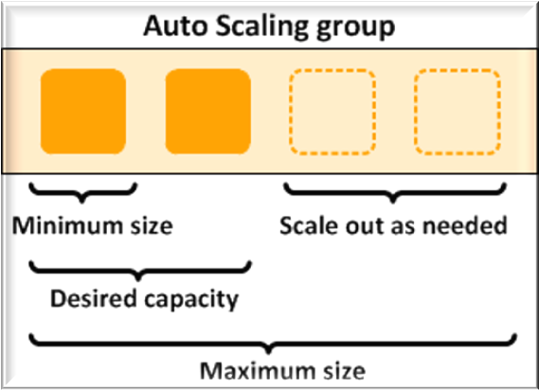
To achieve highly available and fault-tolerant architecture for your applications, you must deploy all your instances in different Availability Zones. This will help you isolate your resources if an outage occurs. Take note that to achieve fault tolerance, you need to have redundant resources in place to avoid any system degradation in the event of a server fault or an Availability Zone outage. Having a fault-tolerant architecture entails an extra cost in running additional resources than what is usually needed. This is to ensure that the mission-critical workloads are processed.
Since the scenario requires at least 2 instances to handle regular traffic, you should have 2 instances running all the time even if an AZ outage occurred. You can use an Auto Scaling Group to automatically scale your compute resources across two or more Availability Zones. You have to specify the minimum capacity to 4 instances and the maximum capacity to 6 instances. If each AZ has 2 instances running, even if an AZ fails, your system will still run a minimum of 2 instances.
Hence, the correct answer is: Create an Auto Scaling group of EC2 instances and set the minimum capacity to 4 and the maximum capacity to 6. Deploy 2 instances in Availability Zone A and another 2 instances in Availability Zone B.
The option that says: Create an Auto Scaling group of EC2 instances and set the minimum capacity to 2 and the maximum capacity to 6. Deploy 4 instances in Availability Zone A is incorrect because the instances are only deployed in a single Availability Zone. It cannot protect your applications and data from datacenter or AZ failures.
The option that says: Create an Auto Scaling group of EC2 instances and set the minimum capacity to 2 and the maximum capacity to 6. Use 2 Availability Zones and deploy 1 instance for each AZ is incorrect. It is required to have 2 instances running all the time. If an AZ outage happened, ASG will launch a new instance on the unaffected AZ. This provisioning does not happen instantly, which means that for a certain period of time, there will only be 1 running instance left.
The option that says: Create an Auto Scaling group of EC2 instances and set the minimum capacity to 2 and the maximum capacity to 4. Deploy 2 instances in Availability Zone A and 2 instances in Availability Zone B is incorrect. Although this fulfills the requirement of at least 2 EC2 instances and high availability, the maximum capacity setting is wrong. It should be set to 6 to properly handle the peak load. If an AZ outage occurs and the system is at its peak load, the number of running instances in this setup will only be 4 instead of 6 and this will affect the performance of your application.

References:
https://docs.aws.amazon.com/autoscaling/ec2/userguide/what-is-amazon-ec2-auto-scaling.html
https://docs.aws.amazon.com/documentdb/latest/developerguide/regions-and-azs.html

Check out this AWS Auto Scaling Cheat Sheet:
https://tutorialsdojo.com/aws-auto-scaling/

165 34 Question
A company has recently migrated its microservices-based application to Amazon Elastic Kubernetes Service (Amazon EKS). As part of the migration, the company must ensure that all sensitive configuration data and credentials, such as database passwords and API keys, are stored securely and encrypted within the Amazon EKS cluster’s etcd key-value store.
What is the most suitable solution to meet the company’s requirements?
- Use Amazon EKS default options and the Amazon Elastic Block Store (Amazon EBS) Container Storage Interface (CSI) driver as an add-on to securely store sensitive data within the Amazon EKS cluster.
- Enable default Amazon EBS volume encryption for the account with a new AWS KMS key to ensure encryption of sensitive data within the Amazon EKS cluster.
- Enable secret encryption with a new AWS KMS key on an existing Amazon EKS cluster to encrypt sensitive data stored in the EKS cluster's etcd key-value store.
- Use AWS Secrets Manager with a new AWS KMS key to securely manage and store sensitive data within the EKS cluster's etcd key-value store.
Incorrect
Enabling secret encryption with a new AWS Key Management Service (KMS) key in an existing Amazon Elastic Kubernetes Service (EKS) cluster is critical to securing sensitive data stored in the cluster’s etcd key-value store. Amazon EKS is a service for running and managing containerized applications, storing configuration data and secrets, etc., and is a distributed data store. By default, these secrets are not encrypted, posing potential security risks. Integrating AWS KMS with Amazon EKS allows for the encryption of these secrets, leveraging AWS KMS’s capabilities to manage cryptographic keys and control their use across AWS services and applications.

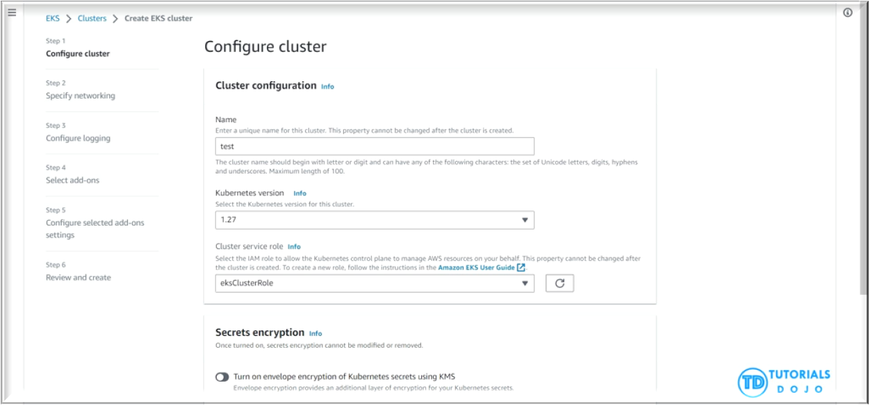
The process involves creating an AWS KMS key specifically for the EKS cluster and configuring the cluster to encrypt secrets before they are saved in etcd. This setup ensures that all sensitive information within the etcd database is encrypted at rest, enhancing data security. By adopting this approach, organizations can significantly improve their security posture, ensuring that sensitive data and credentials are protected according to industry standards and compliance requirements, thus maintaining data confidentiality and integrity within their Kubernetes environments.
Hence, the correct answer is: Enable secret encryption with a new AWS KMS key on an existing Amazon EKS cluster to encrypt sensitive data stored in the EKS cluster’s etcd key-value store.
The option that says: Use AWS Secrets Manager with a new AWS KMS key to securely manage and store sensitive data within the EKS cluster’s etcd key-value store is incorrect. AWS Secrets Manager is a powerful tool for managing secrets but it doesn’t directly address encrypting data within the etcd key-value store of an EKS cluster. Secrets Manager is more about managing and retrieving secrets rather than encrypting data within etcd.
The option that says: Enable default Amazon EBS volume encryption for the account with a new AWS KMS key to ensure encryption of sensitive data within the Amazon EKS cluster is incorrect. Enabling default Amazon EBS volume encryption is a way to ensure that data at rest in EBS volumes is encrypted. However, the EBS volumes are primarily used for persistent storage of the worker nodes. They are not directly related to the storage of sensitive configuration data and credentials within the EKS cluster’s etcd key-value store.
The option that says: Use Amazon EKS default options and the Amazon Elastic Block Store (Amazon EBS) Container Storage Interface (CSI) driver as an add-on to securely store sensitive data within the Amazon EKS cluster is incorrect. Amazon EBS CSI driver enables Amazon Elastic Block Store (EBS) volumes as persistent storage for Kubernetes applications running on the Amazon EKS. While this can provide secure persistent storage for your microservices, it does not address the specific requirement of securely storing sensitive data within the EKS cluster’s etcd key-value store.

References:
https://docs.aws.amazon.com/eks/latest/userguide/what-is-eks.html
https://kubernetes.io/docs/tasks/administer-cluster/encrypt-data/
https://docs.aws.amazon.com/eks/latest/userguide/enable-kms.html

Check out this Amazon Elastic Kubernetes Service Cheat Sheet:
https://tutorialsdojo.com/amazon-elastic-kubernetes-service-eks/

166 35 Question
A Docker application, which is running on an Amazon ECS cluster behind a load balancer, is heavily using Amazon DynamoDB. The application requires improved database performance by distributing the workload evenly and utilizing the provisioned throughput efficiently.
Which of the following should be implemented for the DynamoDB table?
- Use partition keys with low-cardinality attributes, which have a few number of distinct values for each item.
- Avoid using a composite primary key, which is composed of a partition key and a sort key.
- Use partition keys with high-cardinality attributes, which have a large number of distinct values for each item.
- Reduce the number of partition keys in the DynamoDB table.
Correct
The partition key portion of a table’s primary key determines the logical partitions in which a table’s data is stored. This in turn affects the underlying physical partitions. Provisioned I/O capacity for the table is divided evenly among these physical partitions. Therefore a partition key design that doesn’t distribute I/O requests evenly can create “hot” partitions that result in throttling and use your provisioned I/O capacity inefficiently.
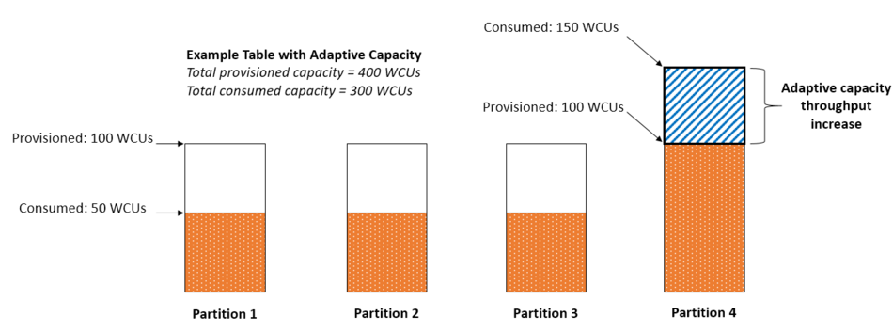
The optimal usage of a table’s provisioned throughput depends not only on the workload patterns of individual items, but also on the partition-key design. This doesn’t mean that you must access all partition key values to achieve an efficient throughput level, or even that the percentage of accessed partition key values must be high. It does mean that the more distinct partition key values that your workload accesses, the more those requests will be spread across the partitioned space. In general, you will use your provisioned throughput more efficiently as the ratio of partition key values accessed to the total number of partition key values increases.
Hence, the correct answer is: Use partition keys with high-cardinality attributes, which have a large number of distinct values for each item.
The option that says: Reducing the number of partition keys in the DynamoDB table is incorrect. Instead of doing this, you should actually add more to improve its performance to distribute the I/O requests evenly and not simply avoid “hot” partitions.
The option that says: Using partition keys with low-cardinality attributes, which have a few number of distinct values for each item is incorrect because this is only the exact opposite of the correct answer. Remember that the more distinct partition key values your workload accesses, the more those requests will be spread across the partitioned space. Conversely, the less distinct partition key values, the less evenly spread it would be across the partitioned space, which effectively slows the performance.
The option that says: Avoid using a composite primary key, which is composed of a partition key and a sort key is incorrect because as mentioned, a composite primary key will provide more partition for the table and in turn, improves the performance. Hence, it should be used and not avoided.

References:
https://docs.aws.amazon.com/amazondynamodb/latest/developerguide/bp-partition-key-uniform-load.html
https://aws.amazon.com/blogs/database/choosing-the-right-dynamodb-partition-key/

Check out this Amazon DynamoDB Cheat Sheet:
https://tutorialsdojo.com/amazon-dynamodb/

Amazon DynamoDB Overview:

167 36 Question
A company hosted an e-commerce website on an Auto Scaling group of Amazon EC2 instances behind an Application Load Balancer. The Solutions Architect noticed that the website is receiving a high number of illegitimate external requests from multiple systems with frequently changing IP addresses. To address the performance issues, the Solutions Architect must implement a solution that would block these requests while having minimal impact on legitimate traffic.
Which of the following options fulfills this requirement?
- Create a rate-based rule in AWS WAF and associate the web ACL to an Application Load Balancer.
- Create a custom rule in the security group of the Application Load Balancer to block the offending requests.
- Create a regular rule in AWS WAF and associate the web ACL to an Application Load Balancer.
- Create a custom network ACL and associate it with the subnet of the Application Load Balancer to block the offending requests.
Incorrect
AWS WAF is tightly integrated with Amazon CloudFront, the Application Load Balancer (ALB), Amazon API Gateway, and AWS AppSync – services that AWS customers commonly use to deliver content for their websites and applications. When you use AWS WAF on Amazon CloudFront, your rules run in all AWS Edge Locations, located around the world close to your end-users. This means security doesn’t come at the expense of performance. Blocked requests are stopped before they reach your web servers. When you use AWS WAF on regional services, such as Application Load Balancer, Amazon API Gateway, and AWS AppSync, your rules run in the region and can be used to protect Internet-facing resources as well as internal resources.
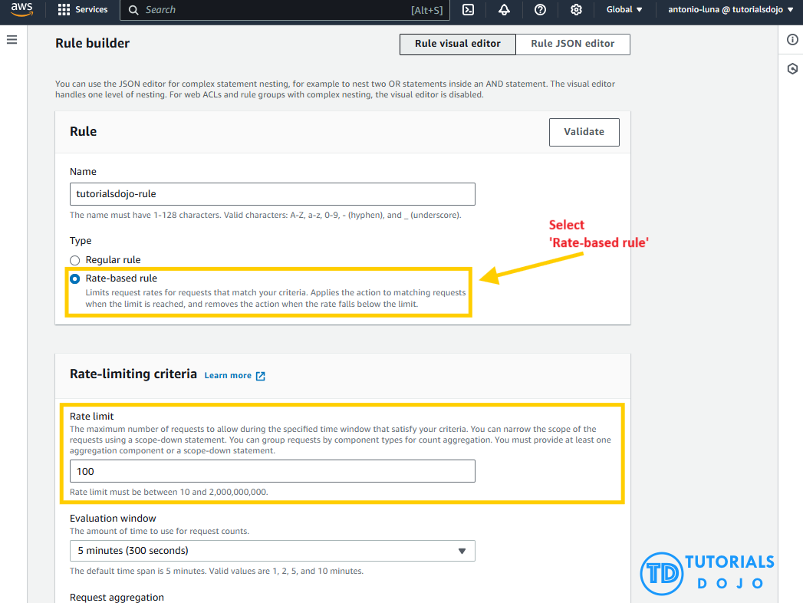
A rate-based rule tracks the rate of requests for each originating IP address and triggers the rule action on IPs with rates that go over a limit. You set the limit as the number of requests per 5-minute time span. You can use this type of rule to put a temporary block on requests from an IP address that’s sending excessive requests.
Based on the given scenario, the requirement is to limit the number of requests from the illegitimate requests without affecting the genuine requests. To accomplish this requirement, you can use AWS WAF web ACL. There are two types of rules in creating your own web ACL rule: regular and rate-based rules. You need to select the latter to add a rate limit to your web ACL. After creating the web ACL, you can associate it with ALB. When the rule action triggers, AWS WAF applies the action to additional requests from the IP address until the request rate falls below the limit.
Hence, the correct answer is: Create a rate-based rule in AWS WAF and associate the web ACL to an Application Load Balancer.
The option that says: Create a regular rule in AWS WAF and associate the web ACL to an Application Load Balancer is incorrect because a regular rule typically matches the statement defined in the rule. If you need to add a rate limit to your rule, you should create a rate-based rule.
The option that says: Create a custom network ACL and associate it with the subnet of the Application Load Balancer to block the offending requests is incorrect. Although NACLs can help you block incoming traffic, this option wouldn’t be able to limit the number of requests from a single IP address that is dynamically changing.
The option that says: Create a custom rule in the security group of the Application Load Balancer to block the offending requests is incorrect because the security group can only allow incoming traffic. Remember that you can’t deny traffic using security groups. In addition, it is not capable of limiting the rate of traffic to your application unlike AWS WAF.

References:
https://docs.aws.amazon.com/waf/latest/developerguide/waf-rule-statement-type-rate-based.html
https://aws.amazon.com/waf/faqs/

Check out this AWS WAF Cheat Sheet:
https://tutorialsdojo.com/aws-waf/

168 37 Question
A global IT company with offices around the world has multiple AWS accounts. To improve efficiency and drive costs down, the Chief Information Officer (CIO) wants to set up a solution that centrally manages their AWS resources. This will allow them to procure AWS resources centrally and share resources such as AWS Transit Gateways, AWS License Manager configurations, or Amazon Route 53 Resolver rules across their various accounts.
As the Solutions Architect, which combination of options should you implement in this scenario? (Select TWO.)
- Use AWS Control Tower to easily and securely share your resources with your AWS accounts.
- Consolidate all of the company's accounts using AWS Organizations.
- Use the AWS Identity and Access Management service to set up cross-account access that will easily and securely share your resources with your AWS accounts.
- Use the AWS Resource Access Manager (RAM) service to easily and securely share your resources with your AWS accounts.
- Consolidate all of the company's accounts using AWS ParallelCluster.
Incorrect
AWS Resource Access Manager (RAM) is a service that enables you to easily and securely share AWS resources with any AWS account or within your AWS Organization. You can share AWS Transit Gateways, Subnets, AWS License Manager configurations, and Amazon Route 53 Resolver rules resources with RAM.
Many organizations use multiple accounts to create administrative or billing isolation, and limit the impact of errors. RAM eliminates the need to create duplicate resources in multiple accounts, reducing the operational overhead of managing those resources in every single account you own. You can create resources centrally in a multi-account environment, and use RAM to share those resources across accounts in three simple steps: create a Resource Share, specify resources, and specify accounts. RAM is available to you at no additional charge.
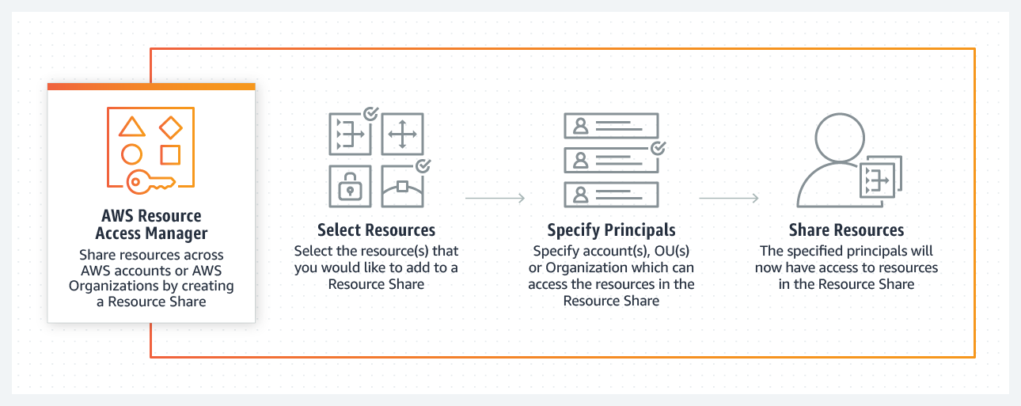
You can procure AWS resources centrally, and use RAM to share resources such as subnets or License Manager configurations with other accounts. This eliminates the need to provision duplicate resources in every account in a multi-account environment, reducing the operational overhead of managing those resources in every account.
AWS Organizations is an account management service that lets you consolidate multiple AWS accounts into an organization that you create and centrally manage. With Organizations, you can create member accounts and invite existing accounts to join your organization. You can organize those accounts into groups and attach policy-based controls.
Hence, the correct combination of options in this scenario is:
– Consolidate all of the company’s accounts using AWS Organizations.
– Use the AWS Resource Access Manager (RAM) service to easily and securely share your resources with your AWS accounts.
The option that says: Use the AWS Identity and Access Management service to set up cross-account access that will easily and securely share your resources with your AWS accounts is incorrect. Although you can delegate access to resources that are in different AWS accounts using IAM, this process is extremely tedious and entails a lot of operational overhead since you have to manually set up cross-account access to each and every AWS account of the company. A better solution is to use AWS Resources Access Manager instead.
The option that says: Use AWS Control Tower to easily and securely share your resources with your AWS accounts is incorrect because AWS Control Tower simply offers the easiest way to set up and govern a new, secure, multi-account AWS environment. This is not the most suitable service to use to securely share your resources across AWS accounts or within your Organization. You have to use AWS Resources Access Manager (RAM) instead.
The option that says: Consolidate all of the company’s accounts using AWS ParallelCluster is incorrect because AWS ParallelCluster is simply an AWS-supported open-source cluster management tool that makes it easy for you to deploy and manage High-Performance Computing (HPC) clusters on AWS. In this particular scenario, it is more appropriate to use AWS Organizations to consolidate all of your AWS accounts.

References:
https://aws.amazon.com/ram/
https://docs.aws.amazon.com/ram/latest/userguide/shareable.html

169 38 Question
A company is using AWS Fargate to run a batch job whenever an object is uploaded to an Amazon S3 bucket. The minimum ECS task count is initially set to 1 to save on costs and should only be increased based on new objects uploaded to the S3 bucket.
Which is the most suitable option to implement with the LEAST amount of effort?
- Set up an Amazon EventBridge (Amazon CloudWatch Events) rule to detect S3 object PUT operations and set the target to the ECS cluster to run a new ECS task.
- Set up an alarm in CloudWatch to monitor S3 object-level operations recorded on CloudTrail. Set two alarm actions to update the ECS task count to scale-out/scale-in depending on the S3 event.
- Set up an Amazon EventBridge (Amazon CloudWatch Events) rule to detect S3 object PUT operations and set the target to a Lambda function that will run the StartTask API command.
- Set up an alarm in Amazon CloudWatch to monitor S3 object-level operations that are recorded on CloudTrail. Create an Amazon EventBridge (Amazon CloudWatch Events) rule that triggers the ECS cluster when new CloudTrail events are detected.
Correct
Amazon EventBridge (Amazon CloudWatch Events) is a serverless event bus that makes it easy to connect applications together. It uses data from your own applications, integrated software as a service (SaaS) applications, and AWS services. This simplifies the process of building event-driven architectures by decoupling event producers from event consumers. This allows producers and consumers to be scaled, updated, and deployed independently. Loose coupling improves developer agility in addition to application resiliency.
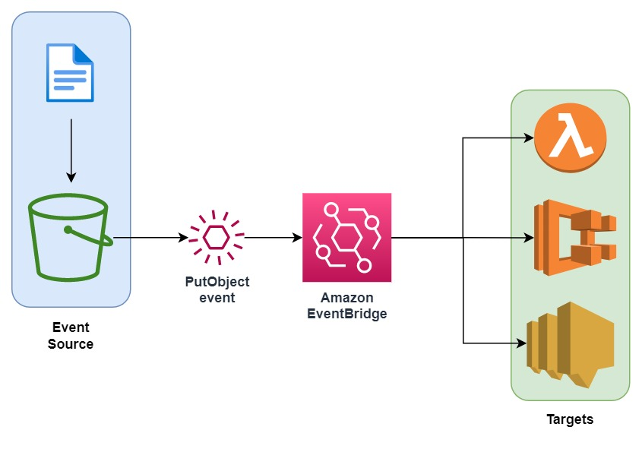
You can use Amazon EventBridge (Amazon CloudWatch Events) to run Amazon ECS tasks when certain AWS events occur. You can set up an EventBridge rule that runs an Amazon ECS task whenever a file is uploaded to a certain Amazon S3 bucket using the Amazon S3 PUT operation.
Hence, the correct answer is: Set up an Amazon EventBridge (Amazon CloudWatch Events) rule to detect S3 object PUT operations and set the target to the ECS cluster to run a new ECS task.
The option that says: Set up an Amazon EventBridge (Amazon CloudWatch Events) rule to detect S3 object PUT operations and set the target to a Lambda function that will run the StartTask API command is incorrect. Although this solution meets the requirement, creating your own Lambda function for this scenario is not really necessary. It is much simpler to control ECS tasks directly as targets for the CloudWatch Event rule. Take note that the scenario asks for a solution that is the easiest to implement.
The option that says: Set up an alarm in Amazon CloudWatch to monitor S3 object-level operations that are recorded on CloudTrail. Create an Amazon EventBridge (Amazon CloudWatch Events) rule that triggers the ECS cluster when new CloudTrail events are detected is incorrect because using CloudTrail and CloudWatch Alarm creates an unnecessary complexity to what you want to achieve. Amazon EventBridge (Amazon CloudWatch Events) can directly target an ECS task on the Targets section when you create a new rule.
The option that says: Set up an alarm in CloudWatch to monitor CloudTrail since this S3 object-level operations are recorded on CloudTrail. Set two alarm actions to update ECS task count to scale-out/scale-in depending on the S3 event is incorrect because you can’t directly set CloudWatch Alarms to update the ECS task count.

References:
https://docs.aws.amazon.com/AmazonCloudWatch/latest/events/CloudWatch-Events-tutorial-ECS.html
https://docs.aws.amazon.com/AmazonCloudWatch/latest/events/Create-CloudWatch-Events-Rule.html

Check out this Amazon CloudWatch Cheat Sheet:
https://tutorialsdojo.com/amazon-cloudwatch/

170 39 Question
A popular social media website uses a Amazon CloudFront web distribution to serve static content to millions of users around the globe. Recently, the website has received a number of complaints about long login times. Additionally, there are instances where users encounter HTTP 504 errors. The manager has instructed the team to significantly reduce login time and further optimize the system.
Which of the following options should be used together to set up a cost-effective solution that improves the application’s performance? (Select TWO.)
- Deploy your application to multiple AWS regions to accommodate your users around the world. Set up a Route 53 record with latency routing policy to route incoming traffic to the region that provides the best latency to the user.
- Establish multiple Amazon VPCs in different AWS regions and configure a transit VPC to interconnect all of your resources. To handle the requests faster, set up AWS Lambda functions in each region with the AWS Serverless Application Model (SAM) service.
- Customize the content that the CloudFront web distribution delivers to your users using Lambda@Edge, which allows your AWS Lambda functions to execute the authentication process in AWS locations closer to the users.
- Implement an origin failover by creating an origin group that includes two origins. Assign one as the primary origin and the other as secondary, which enables CloudFront to automatically switch to if the primary origin encounters specific HTTP status code failure responses.
- Configure your origin to add a Cache-Control max-age directive to your objects, and specify the longest practical value for max-age to increase the cache hit ratio of your CloudFront distribution.
Incorrect
Lambda@Edge lets you run Lambda functions to customize the content that CloudFront delivers, executing the functions in AWS locations closer to the viewer. The functions run in response to CloudFront events, without provisioning or managing servers. You can use Lambda functions to change CloudFront requests and responses at the following points:
– After CloudFront receives a request from a viewer (viewer request)
– Before CloudFront forwards the request to the origin (origin request)
– After CloudFront receives the response from the origin (origin response)
– Before CloudFront forwards the response to the viewer (viewer response)
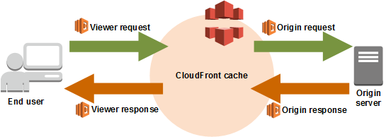
In the given scenario, you can use Lambda@Edge to allow your Lambda functions to customize the content that CloudFront delivers and to execute the authentication process in AWS locations closer to the users. In addition, you can set up an origin failover by creating an origin group with two origins with one as the primary origin and the other as the second origin which CloudFront automatically switches to when the primary origin fails. This will alleviate the occasional HTTP 504 errors that users are experiencing.
Therefore, the correct answers are:
– Customize the content that the CloudFront web distribution delivers to your users using Lambda@Edge, which allows your AWS Lambda functions to execute the authentication process in AWS locations closer to the users.
– Implement an origin failover by creating an origin group that includes two origins. Assign one as the primary origin and the other as secondary, which enables CloudFront to automatically switch to if the primary origin encounters specific HTTP status code failure responses.
The option that says: Establish multiple Amazon VPCs in different AWS regions and configure a transit VPC to interconnect all of your resources. To handle the requests faster, set up AWS Lambda functions in each region with the AWS Serverless Application Model (SAM) service is incorrect because of the same reason provided above. Although setting up multiple VPCs across various regions which are just connected with a transit VPC is valid, this solution still entails higher setup and maintenance costs. A more cost-effective option would be to use Lambda@Edge instead.
The option that says: Configure your origin to add a Cache-Control max-age directive to your objects, and specify the longest practical value for max-age to increase the cache hit ratio of your CloudFront distribution is incorrect because improving the cache hit ratio for the CloudFront distribution is irrelevant in this scenario. You can only improve your cache performance by increasing the proportion of your viewer requests that are served from CloudFront edge caches instead of going to your origin servers for content. However, take note that the problem in the scenario is the sluggish authentication process of your global users and not just the caching of the static objects.
The option that says: Deploy your application to multiple AWS regions to accommodate your users around the world. Set up a Route 53 record with latency routing policy to route incoming traffic to the region that provides the best latency to the user is incorrect. Although this may resolve the performance issue, this solution entails a significant implementation cost since you have to deploy your application to multiple AWS regions. Remember that the scenario asks for a solution that will improve the performance of the application with minimal cost.

References:
https://docs.aws.amazon.com/AmazonCloudFront/latest/DeveloperGuide/high_availability_origin_failover.html
https://docs.aws.amazon.com/lambda/latest/dg/lambda-edge.html

Check out these Amazon CloudFront and AWS Lambda Cheat Sheets:
https://tutorialsdojo.com/amazon-cloudfront/
https://tutorialsdojo.com/aws-lambda/

171 40 Question
A government entity is conducting a population and housing census in the city. Each household information uploaded on their online portal is stored in encrypted files in Amazon S3. The government assigned its Solutions Architect to set compliance policies that verify data containing personally identifiable information (PII) in a manner that meets their compliance standards. They should also be alerted if there are potential policy violations with the privacy of their S3 buckets.
Which of the following should the Architect implement to satisfy this requirement?
- Set up and configure Amazon Kendra to monitor malicious activity on their Amazon S3 data
- Set up and configure Amazon Macie to monitor their Amazon S3 data.
- Set up and configure Amazon Fraud Detector to send out alert notifications whenever a security violation is detected on their Amazon S3 data.
- Set up and configure Amazon Polly to scan for usage patterns on Amazon S3 data
Correct
Amazon Macie is an ML-powered security service that helps you prevent data loss by automatically discovering, classifying, and protecting sensitive data stored in Amazon S3. Amazon Macie uses machine learning to recognize sensitive data such as personally identifiable information (PII) or intellectual property, assigns a business value, and provides visibility into where this data is stored and how it is being used in your organization.
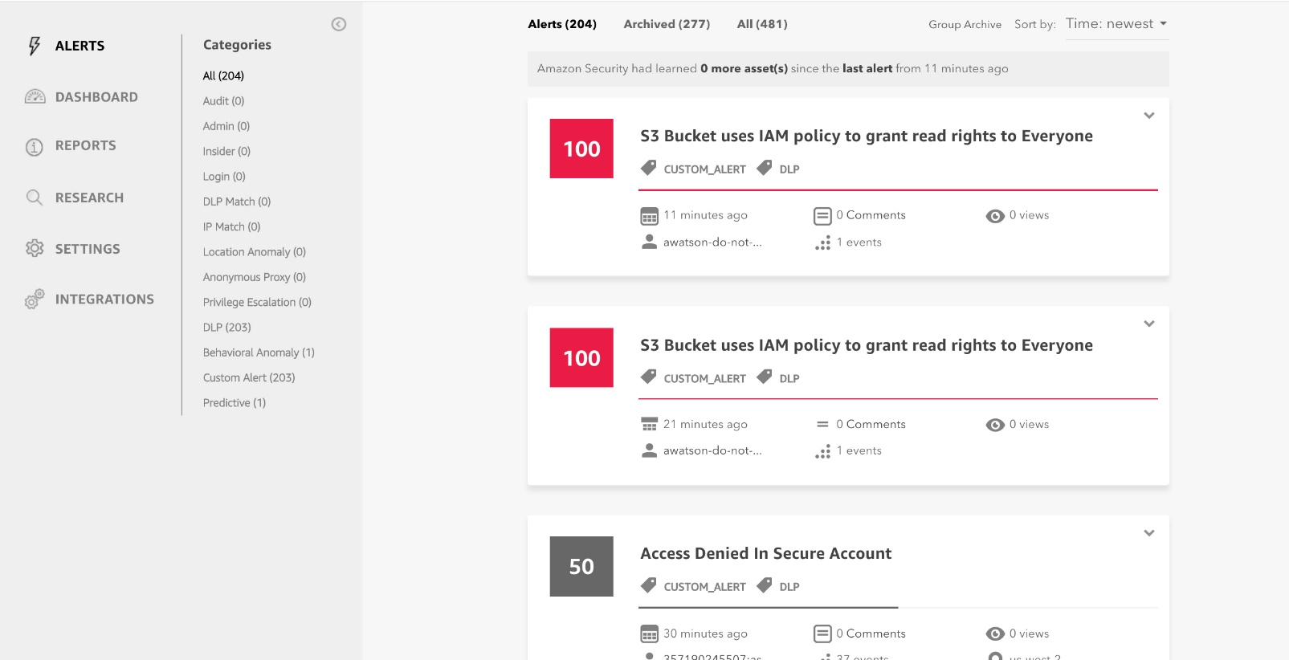
Amazon Macie generates two categories of findings: policy findings and sensitive data findings. A policy finding is a detailed report of a potential policy violation or issue with the security or privacy of an Amazon S3 bucket. Macie generates these findings as part of its ongoing monitoring activities for your Amazon S3 data. A sensitive data finding is a detailed report of sensitive data in an S3 object. Macie generates these findings when it discovers sensitive data in S3 objects that you configure a sensitive data discovery job to analyze.
Hence, the correct answer is: Set up and configure Amazon Macie to monitor their Amazon S3 data.
The option that says: Set up and configure Amazon Polly to scan for usage patterns on Amazon S3 data is incorrect because Amazon Polly is simply a service that turns text into lifelike speech, allowing you to create applications that talk, and build entirely new categories of speech-enabled products. Polly can’t be used to scane usage patterns on your S3 data.
The option that says: Set up and configure Amazon Kendra to monitor malicious activity on their Amazon S3 data is incorrect Amazon Kendra is just an enterprise search service that allows developers to add search capabilities to their applications. This enables their end users to discover information stored within the vast amount of content spread across their company, but not monitor malcious activity on their S3 buckets.
The option that says: Set up and configure Amazon Fraud Detector to send out alert notifications whenever a security violation is detected on their Amazon S3 data is incorrect because the Amazon Fraud Detector is only a fully managed service for identifying potentially fraudulent activities and for catching more online fraud faster. It does not check any S3 data containing personally identifiable information (PII), unlike Amazon Macie.

References:
https://docs.aws.amazon.com/macie/latest/userguide/what-is-macie.html
https://aws.amazon.com/macie/faq/
https://docs.aws.amazon.com/macie/index.html

Check out this Amazon Macie Cheat Sheet:
https://tutorialsdojo.com/amazon-macie/

172 41 Question
A Solutions Architect needs to make sure that the On-Demand Amazon EC2 instance can only be accessed from this IP address (110.238.98.71) via an SSH connection.
Which configuration below will satisfy this requirement?
- Security Group Inbound Rule: Protocol – TCP, Port Range – 22, Source 110.238.98.71/32
- Security Group Inbound Rule: Protocol – UDP, Port Range – 22, Source 110.238.98.71/32
- Security Group Outbound Rule: Protocol – TCP, Port Range – 22, Destination 110.238.98.71/32
- Security Group Outbound Rule: Protocol – UDP, Port Range – 22, Destination 0.0.0.0/0
Correct
A security group acts as a virtual firewall for your instance to control inbound and outbound traffic. When you launch an instance in a VPC, you can assign up to five security groups to the instance. Security groups act at the instance level, not the subnet level. Therefore, each instance in a subnet in your VPC can be assigned to a different set of security groups.

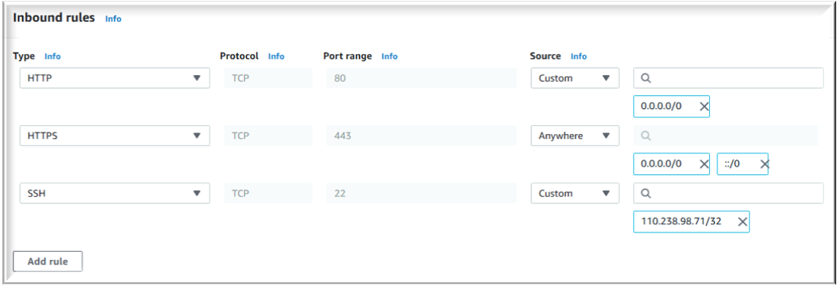
The requirement is to only allow the individual IP of the client and not the entire network. The /32 CIDR notation denotes a single IP address. Take note that the SSH protocol uses TCP, not UDP, and runs on port 22 (default). In the scenario, we can create a security group with an inbound rule allowing incoming traffic from the specified IP address on port 22.
Security groups are stateful, meaning they automatically allow return traffic associated with the client who initiated the connection to the instance. Therefore, any return traffic from the specified IP address on port 22 will be allowed to pass through the security group, regardless of whether or not there is an explicit outbound rule allowing it.
Hence, the correct answer is: Security Group Inbound Rule: Protocol – TCP, Port Range – 22, Source 110.238.98.71/32
The option that says: Security Group Inbound Rule: Protocol – UDP, Port Range – 22, Source 110.238.98.71/32 is incorrect because it typically uses UDP instead of TCP. SSH runs over the TCP protocol, so specifying UDP would not allow the desired access.
The option that says: Security Group Outbound Rule: Protocol – TCP, Port Range – 22, Destination 110.238.98.71/32 is incorrect because it’s an outbound rule, not an inbound rule. Outbound rules control traffic leaving the instance. In the scenario, we need to limit inbound traffic coming from a specific address.
The option that says: Security Group Outbound Rule: Protocol – UDP, Port Range – 22, Destination 0.0.0.0/0 is incorrect because it is an outbound rule rather than an inbound rule. Moreover, SSH connections only require TCP.

References:
https://docs.aws.amazon.com/AWSEC2/latest/UserGuide/using-network-security.html#security-group-rules
https://docs.aws.amazon.com/vpc/

Tutorials Dojo’s AWS Certified Solutions Architect Associate Exam Study Guide:
https://tutorialsdojo.com/aws-certified-solutions-architect-associate/

Check out this Amazon EC2 Cheat Sheet:
https://tutorialsdojo.com/amazon-elastic-compute-cloud-amazon-ec2/

173 42 Question
A company has a highly available architecture consisting of an Elastic Load Balancer and multiple Amazon EC2 instances configured with Auto Scaling across three Availability Zones. The company needs to monitor EC2 instances based on a specific metric that is not readily available in Amazon CloudWatch.
Which of the following is a custom metric in CloudWatch that requires manual setup?
- Network packets out of an EC2 instance
- Disk Read activity of an EC2 instance
- CPU Utilization of an EC2 instance
- Memory Utilization of an EC2 instance
Incorrect
Amazon CloudWatch has Amazon EC2 Metrics available for monitoring. CPU Utilization identifies the processing power required to run an application upon a selected instance. Network Utilization identifies the volume of incoming and outgoing network traffic to a single instance. The Disk Read metric is used to determine the volume of data the application reads from the hard disk of the instance. This can be used to determine the speed of the application. However, there are certain metrics that are not readily available in CloudWatch which can be collected by setting up a custom metric.
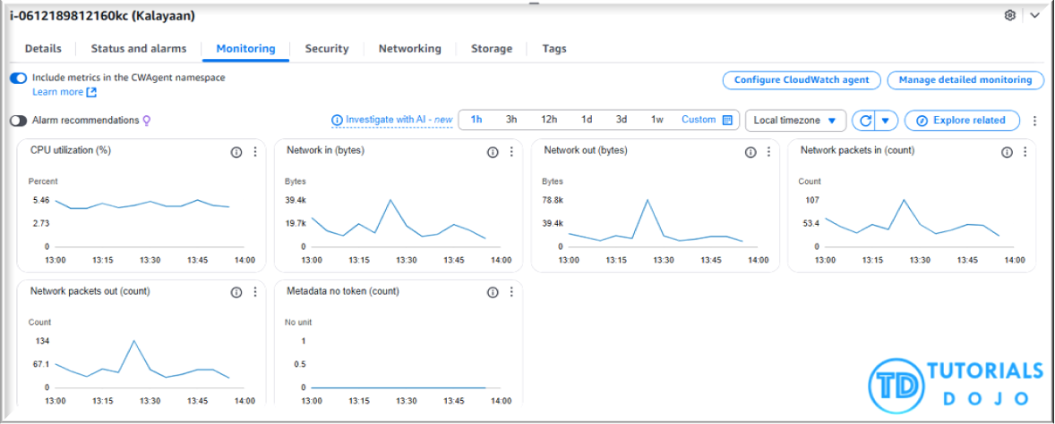

You need to prepare a custom metric using CloudWatch Monitoring Scripts which is written in Perl. You can also install CloudWatch Agent to collect more system-level metrics from Amazon EC2 instances. Here’s the list of some of the custom metrics that you can set up:
– Memory utilization
– Disk swap utilization
– Disk space utilization
– Page file utilization
– Log collection
Hence, the correct answer is: Memory Utilization of an EC2 instance.
The option that says: CPU Utilization of an EC2 instance is incorrect because this metric is typically available by default in CloudWatch and does not require a custom metric setup.
The option that says: Disk Read activity of an EC2 instance is incorrect because only certain storage-related metrics, such as disk space utilization, require custom monitoring. Whereas disk read activity is already included in CloudWatch.
The option that says: Network packets out of an EC2 instance is incorrect because this metric is typically included in CloudWatch’s default network utilization monitoring, so there is no need to configure a custom metric.

References:
https://docs.aws.amazon.com/AWSEC2/latest/UserGuide/monitoring_ec2.html
https://docs.aws.amazon.com/AWSEC2/latest/UserGuide/mon-scripts.html#using_put_script

Check out these Amazon EC2 and Amazon CloudWatch Cheat Sheets:
https://tutorialsdojo.com/amazon-elastic-compute-cloud-amazon-ec2/
https://tutorialsdojo.com/amazon-cloudwatch/

174 43 Question
A company is designing a banking portal that uses Amazon ElastiCache for Redis as its distributed session management component. To secure session data and ensure that Cloud Engineers must authenticate before executing Redis commands, specifically MULTI EXEC commands, the system should enforce strong authentication by requiring users to enter a password. Additionally, access should be managed with long-lived credentials while supporting robust security practices.
Which of the following actions should be taken to meet the above requirement?
- Set up a Redis replication group and enable the AtRestEncryptionEnabled parameter.
- Authenticate the users using Redis AUTH by creating a new Redis Cluster with both the --transit-encryption-enabled and --auth-token parameters enabled.
- Generate an IAM authentication token using AWS credentials and provide this token as a password.
- Enable the in-transit encryption for Redis replication groups.
Incorrect
Using Redis AUTH command can improve data security by requiring the user to enter a password before they are granted permission to execute Redis commands on a password-protected Redis server.
Hence, the correct answer is: Authenticate the users using Redis AUTH by creating a new Redis Cluster with both the --transit-encryption-enabled and --auth-token parameters enabled.
To require that users enter a password on a password-protected Redis server, include the parameter --auth-token with the correct password when you create your replication group or cluster and on all subsequent commands to the replication group or cluster.
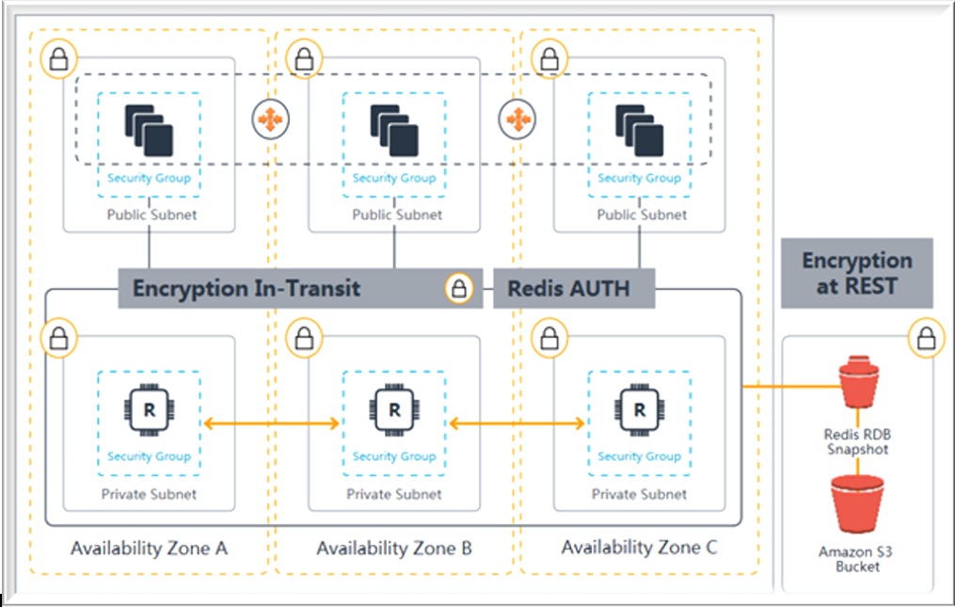
The option that says: Generate an IAM authentication token using AWS credentials and provide this token as a password is incorrect. IAM authentication is simply not supported for executing Redis commands like MULTI EXEC, and IAM tokens expire every 12 hours, which does not align with the need for long-lived credentials.
The option that says: Set up a Redis replication group and enable the AtRestEncryptionEnabled parameter is incorrect because the Redis At-Rest Encryption feature only secures the data inside the in-memory data store. You have to use Redis AUTH option instead.
The option that says: Enable the in-transit encryption for Redis replication groups is incorrect. Although in-transit encryption is part of the solution, it is missing the most important thing which is the Redis AUTH option.

References:
https://docs.aws.amazon.com/AmazonElastiCache/latest/red-ug/auth.html
https://docs.aws.amazon.com/AmazonElastiCache/latest/red-ug/encryption.html

Check out this Amazon Elasticache Cheat Sheet:
https://tutorialsdojo.com/amazon-elasticache/

Redis (cluster mode enabled vs disabled) vs Memcached:
https://tutorialsdojo.com/redis-cluster-mode-enabled-vs-disabled-vs-memcached/

175 44 Question
A financial services company plans to migrate its trading application from on-premises Microsoft Windows Server to Amazon Web Services (AWS).
The solution must ensure high availability across multiple Availability Zones and offer low-latency access to block storage.
Which of the following solutions will fulfill these requirements?
- Configure the trading application on Amazon EC2 Windows Server instances across two Availability Zones. Use Amazon FSx for NetApp ONTAP to create a Multi-AZ file system and access the data via iSCSI protocol.
- Deploy the trading application on Amazon EC2 Windows Server instances across two Availability Zones. Use Amazon FSx for Windows File Server for shared storage.
- Configure the trading application on Amazon EC2 Windows instances across two Availability Zones. Use Amazon Simple Storage Service (Amazon S3) for storage and configure cross-region replication to sync data between S3 buckets in each Availability Zone.
- Deploy the trading application on Amazon EC2 Windows Server instances across two Availability Zones. Use Amazon Elastic File System (Amazon EFS) to provide shared storage between the instances. Configure Amazon EFS with cross-region replication to sync data across Availability Zones.
Incorrect
Amazon FSx for NetApp ONTAP is a fully managed AWS service that provides high-performance, scalable file storage based on NetApp’s ONTAP file system. It offers versatile storage options, supporting both file (NFS, SMB) and block (iSCSI) protocols, making it compatible with Windows, Linux, and macOS environments.

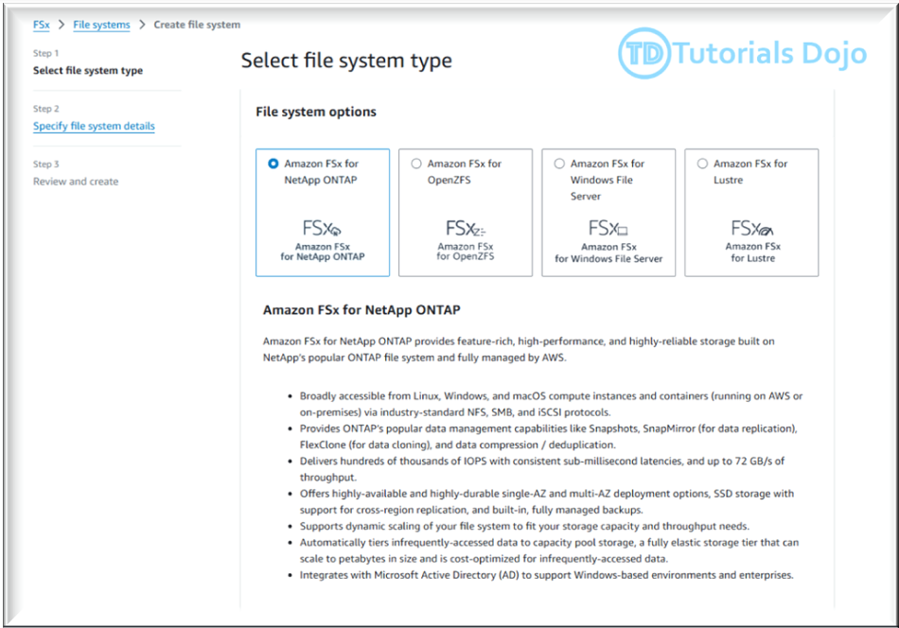
The Amazon FSx for NetApp ONTAP features Multi-AZ file systems designed to ensure continuous availability across AWS Availability Zones, providing high availability for your Windows Server workloads. It offers consistent sub-millisecond file operation latencies with SSD storage, essential for block storage workloads in Windows environments. FSx for NetApp ONTAP fully supports block storage protocols like iSCSI, commonly used in Windows Server settings, and it works seamlessly with the SMB protocol, ensuring compatibility with Windows Server and related applications.
Moreover, FSx for NetApp ONTAP simplifies migrating from on-premises NetApp systems to AWS for users currently utilizing NetApp storage. It can scale to accommodate petabyte-scale datasets, making it suitable for large Windows Server environments.
Hence, the correct answer is: Configure the trading application on Amazon EC2 Windows Server instances across two Availability Zones. Use Amazon FSx for NetApp ONTAP to create a Multi-AZ file system and access the data via iSCSI protocol.
The option that says: Deploy the trading application on Amazon EC2 Windows Server instances across two Availability Zones. Use Amazon FSx for Windows File Server for shared storage is incorrect. Amazon FSx for Windows File Server only provides shared, low-latency file storage for Windows environments. It doesn’t support low-latency access to shared block storage.
The option that says: Deploy the trading application on Amazon EC2 Windows Server instances across two Availability Zones. Use Amazon Elastic File System (Amazon EFS) to provide shared storage between the instances. Configure Amazon EFS with cross-region replication to sync data across Availability Zones is incorrect. While this option provides high availability across AZs, Amazon EFS is not optimized for Windows workloads and doesn’t offer low-latency block storage.
The option that says: Configure the trading application on Amazon EC2 Windows instances across two Availability Zones. Use Amazon Simple Storage Service (Amazon S3) for storage and configure cross-region replication to sync data between S3 buckets in each Availability Zone is incorrect. While this option provides high availability across AZs, Amazon S3 is primarily an object storage, not block storage. It doesn’t offer the low-latency access required for a trading application.

References:
https://docs.aws.amazon.com/fsx/latest/ONTAPGuide/what-is-fsx-ontap.html
https://docs.aws.amazon.com/fsx/latest/ONTAPGuide/high-availability-AZ.html

Check out this Amazon FSx Cheat Sheet:
https://tutorialsdojo.com/amazon-fsx/

176 45 Question
A payment processing company plans to migrate its on-premises application to an Amazon EC2 instance. An IPv6 CIDR block is attached to the company’s Amazon VPC. Strict security policy mandates that the production VPC must only allow outbound communication over IPv6 between the instance and the internet but should prevent the internet from initiating an inbound IPv6 connection. The new architecture should also allow traffic flow inspection and traffic filtering.
What should a solutions architect do to meet these requirements?
- Launch the EC2 instance to a private subnet and attach AWS PrivateLink interface endpoint to the VPC to control outbound IPv6 communication to the internet. Use Amazon GuardDuty to set up the required rules for traffic inspection and traffic filtering.
- Launch the EC2 instance to a private subnet and attach an Egress-Only Internet Gateway to the VPC to allow outbound IPv6 communication to the internet. Use AWS Network Firewall to set up the required rules for traffic inspection and traffic filtering.
- Launch the EC2 instance to a public subnet and attach an Internet Gateway to the VPC to allow outbound IPv6 communication to the internet. Use Traffic Mirroring to set up the required rules for traffic inspection and traffic filtering.
- Launch the EC2 instance to a private subnet and attach a NAT Gateway to the VPC to allow outbound IPv6 communication to the internet. Use AWS Firewall Manager to set up the required rules for traffic inspection and traffic filtering.
Correct
An egress-only internet gateway is a horizontally scaled, redundant, and highly available VPC component that allows outbound communication over IPv6 from instances in your VPC to the internet and prevents it from initiating an IPv6 connection with your instances.

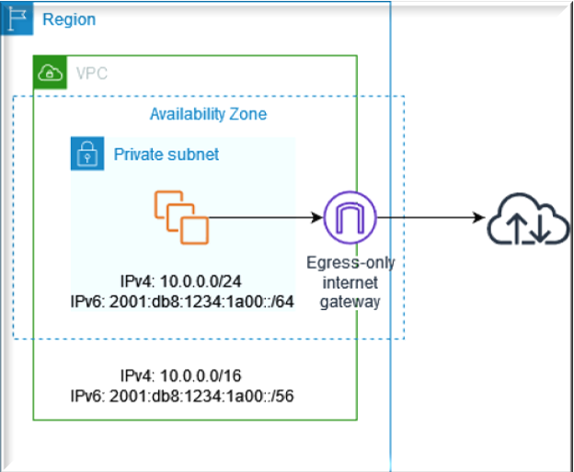
IPv6 addresses are globally unique and are therefore public by default. If you want your instance to be able to access the internet, but you want to prevent resources on the internet from initiating communication with your instance, you can use an egress-only internet gateway.
A subnet is a range of IP addresses in your VPC. You can launch AWS resources into a specified subnet. Use a public subnet for resources that must be connected to the internet and a private subnet for resources that won’t be connected to the internet.
AWS Network Firewall is a managed service that makes it easy to deploy essential network protections for all of your Amazon Virtual Private Clouds (VPCs). The service can be set up with just a few clicks and scales automatically with your network traffic, so you don’t have to worry about deploying and managing any infrastructure. AWS Network Firewall includes features that provide protection from common network threats.

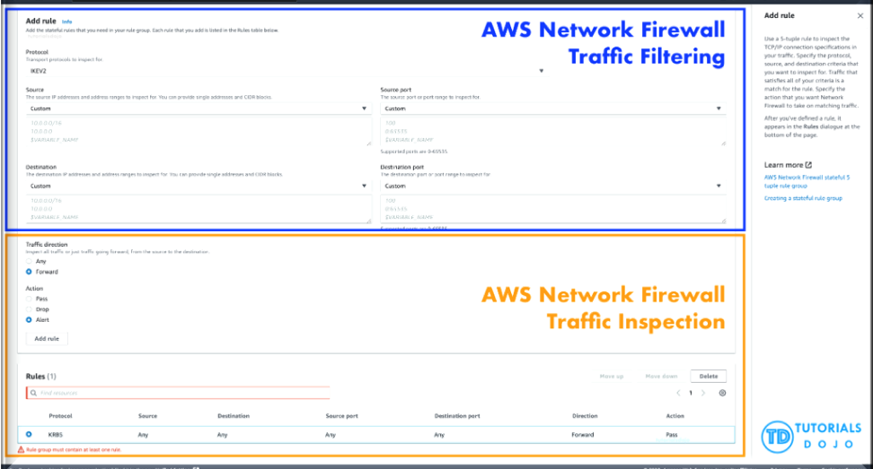
AWS Network Firewall’s stateful firewall can incorporate context from traffic flows, like tracking connections and protocol identification, to enforce policies such as preventing your VPCs from accessing domains using an unauthorized protocol. AWS Network Firewall’s intrusion prevention system (IPS) provides active traffic flow inspection so you can identify and block vulnerability exploits using signature-based detection. AWS Network Firewall also offers web filtering that can stop traffic to known bad URLs and monitor fully qualified domain names.
In this scenario, you can use an egress-only internet gateway to allow outbound IPv6 communication to the internet and then use the AWS Network Firewall to set up the required rules for traffic inspection and traffic filtering.
Hence, the correct answer is: Launch the EC2 instance to a private subnet and attach an Egress-Only Internet Gateway to the VPC to allow outbound IPv6 communication to the internet. Use AWS Network Firewall to set up the required rules for traffic inspection and traffic filtering.
The option that says: Launch the EC2 instance to a private subnet and attach AWS PrivateLink interface endpoint to the VPC to control outbound IPv6 communication to the internet. Use Amazon GuardDuty to set up the required rules for traffic inspection and traffic filtering is incorrect because the AWS PrivateLink (which is also known as VPC Endpoint) is just a highly available, scalable technology that enables you to privately connect your VPC to the AWS services as if they were in your VPC. This service is not capable of controlling outbound IPv6 communication to the Internet. Furthermore, the Amazon GuardDuty service doesn’t have the features to do traffic inspection or filtering.
The option that says: Launch the EC2 instance to a public subnet and attach an Internet Gateway to the VPC to allow outbound IPv6 communication to the internet. Use Traffic Mirroring to set up the required rules for traffic inspection and traffic filtering is incorrect because an Internet Gateway does not limit or control any outgoing IPv6 connection. Take note that the requirement is to prevent the Internet from initiating an inbound IPv6 connection to your instance. This solution allows all kinds of traffic to initiate a connection to your EC2 instance hence, this option is wrong. In addition, the use of Traffic Mirroring is not appropriate as well. This is just an Amazon VPC feature that you can use to copy network traffic from an elastic network interface of type interface, not to filter or inspect the incoming/outgoing traffic.
The option that says: Launch the EC2 instance to a private subnet and attach a NAT Gateway to the VPC to allow outbound IPv6 communication to the internet. Use AWS Firewall Manager to set up the required rules for traffic inspection and traffic filtering is incorrect. While NAT Gateway has a NAT64 feature that translates an IPv6 address to IPv4, it will not prevent inbound IPv6 traffic from reaching the EC2 instance. You have to use the egress-only Internet Gateway instead. Moreover, the AWS Firewall Manager is neither capable of doing traffic inspection nor traffic filtering.

References:
https://docs.aws.amazon.com/vpc/latest/userguide/egress-only-internet-gateway.html
https://docs.aws.amazon.com/vpc/latest/userguide/configure-subnets.html
https://docs.aws.amazon.com/vpc/latest/userguide/VPC_Internet_Gateway.html

Check out this Amazon VPC Cheat Sheet:
https://tutorialsdojo.com/amazon-vpc/

178 46 Question
A company hosted a web application in an Auto Scaling group of EC2 instances. The IT manager is concerned about the over-provisioning of the resources that can cause higher operating costs. A Solutions Architect has been instructed to create a cost-effective solution without affecting the performance of the application.
Which dynamic scaling policy should be used to satisfy this requirement?
- Use simple scaling.
- Use scheduled scaling.
- Use suspend and resume scaling.
- Use target tracking scaling.
Incorrect
An Auto Scaling group contains a collection of Amazon EC2 instances that are treated as a logical grouping for the purposes of automatic scaling and management. An Auto Scaling group also enables you to use Amazon EC2 Auto Scaling features such as health check replacements and scaling policies. Both maintaining the number of instances in an Auto Scaling group and automatic scaling are the core functionality of the Amazon EC2 Auto Scaling service. The size of an Auto Scaling group depends on the number of instances that you set as the desired capacity. You can adjust its size to meet demand, either manually or by using automatic scaling.
Step scaling policies and simple scaling policies are two of the dynamic scaling options available for you to use. Both require you to create CloudWatch alarms for the scaling policies. Both require you to specify the high and low thresholds for the alarms. Both require you to define whether to add or remove instances, and how many, or set the group to an exact size. The main difference between the policy types is the step adjustments that you get with step scaling policies. When step adjustments are applied, and they increase or decrease the current capacity of your Auto Scaling group, the adjustments vary based on the size of the alarm breach.
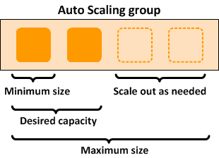
The primary issue with simple scaling is that after a scaling activity is started, the policy must wait for the scaling activity or health check replacement to complete and the cooldown period to expire before responding to additional alarms. Cooldown periods help to prevent the initiation of additional scaling activities before the effects of previous activities are visible.
With a target tracking scaling policy, you can increase or decrease the current capacity of the group based on a target value for a specific metric. This policy will help resolve the over-provisioning of your resources. The scaling policy adds or removes capacity as required to keep the metric at, or close to, the specified target value. In addition to keeping the metric close to the target value, a target tracking scaling policy also adjusts to changes in the metric due to a changing load pattern.
Hence, the correct answer is: Use target tracking scaling.
The option that says: Use simple scaling is incorrect because you need to wait for the cooldown period to complete before initiating additional scaling activities. Target tracking or step scaling policies can trigger a scaling activity immediately without waiting for the cooldown period to expire.
The option that says: Use scheduled scaling is incorrect because this policy is mainly used for predictable traffic patterns. You need to use the target tracking scaling policy to optimize the cost of your infrastructure without affecting the performance.
The option that says: Use suspend and resume scaling is incorrect because this type is used to temporarily pause scaling activities triggered by your scaling policies and scheduled actions.

References:
https://docs.aws.amazon.com/autoscaling/ec2/userguide/as-scaling-target-tracking.html
https://docs.aws.amazon.com/autoscaling/ec2/userguide/AutoScalingGroup.html

Check out this AWS Auto Scaling Cheat Sheet:
https://tutorialsdojo.com/aws-auto-scaling/

179 47 Question
A company is using a combination of API Gateway and AWS Lambda for the web services of an online web portal that is accessed by hundreds of thousands of clients each day. The company will be announcing a new revolutionary product, and it is expected that the web portal will receive a massive number of visitors from all around the globe.
How can the back-end systems and applications be protected from traffic spikes?
- API Gateway will automatically scale and handle massive traffic spikes so you do not have to do anything.
- Use throttling limits in API Gateway
- Manually upgrade the Amazon EC2 instances being used by API Gateway
- Deploy Multi-AZ in API Gateway with Read Replica
Incorrect
Amazon API Gateway provides throttling at multiple levels including global and by a service call. Throttling limits can be set for standard rates and bursts. For example, API owners can set a rate limit of 1,000 requests per second for a specific method in their REST APIs, and also configure Amazon API Gateway to handle a burst of 2,000 requests per second for a few seconds.
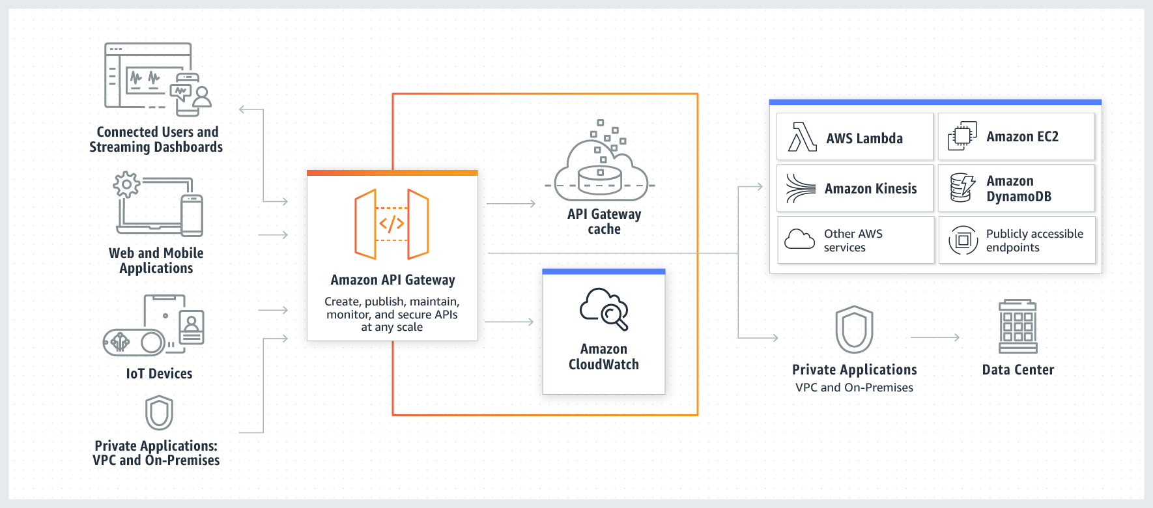
Amazon API Gateway tracks the number of requests per second. Any requests over the limit will receive a 429 HTTP response. The client SDKs generated by Amazon API Gateway retry calls automatically when met with this response.
Hence, the correct answer is: Use throttling limits in API Gateway.
The option that says: API Gateway will automatically scale and handle massive traffic spikes so you do not have to do anything is incorrect. Although it can scale using AWS Edge locations, you still need to configure the throttling, typically to further manage the bursts of your APIs.
The option that says: Manually upgrade the Amazon EC2 instances being used by API Gateway is incorrect because API Gateway is a fully managed service and hence, you do not have access to its underlying resources.
The option that says: Deploying Multi-AZ in API Gateway with Read Replica is incorrect because only RDS has Multi-AZ and Read Replica capabilities, and not API Gateway.

References:
https://aws.amazon.com/api-gateway/faqs/#Throttling_and_Caching
https://docs.aws.amazon.com/apigateway/

Check out this Amazon API Gateway Cheat Sheet:
https://tutorialsdojo.com/amazon-api-gateway/

180 48 Question
A company has 3 DevOps engineers that are handling its software development and infrastructure management processes. One of the engineers accidentally deleted a file hosted in Amazon S3 which has caused disruption of service.
What can the DevOps engineers do to prevent this from happening again?
- Enable S3 Versioning and Multi-Factor Authentication Delete on the bucket.
- Create an IAM bucket policy that disables delete operation.
- Use S3 Infrequently Accessed storage to store the data.
- Set up a signed URL for all users.
Correct
To enhance data protection and meet best practices for securing stored objects, AWS recommends implementing safeguards against accidental deletions. To avoid accidental deletion in an Amazon S3 bucket, you can:
– Enable Versioning
– Enable MFA (Multi-Factor Authentication) Delete
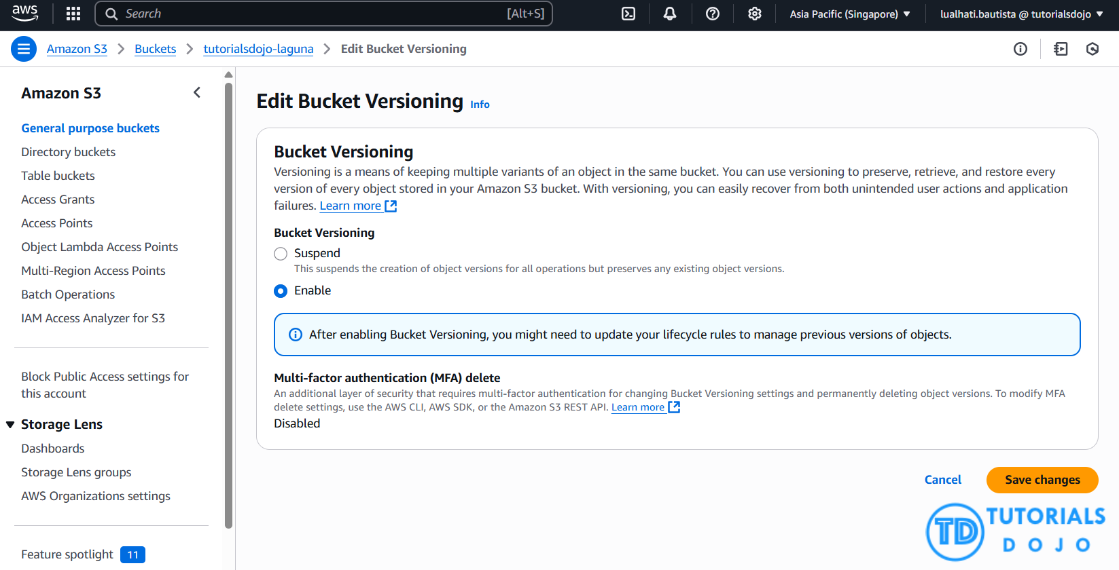
Versioning is a means of keeping multiple variants of an object in the same bucket. You can use versioning to preserve, retrieve, and restore every version of every object stored in your Amazon S3 bucket. With versioning, you can easily recover from both unintended user actions and application failures.
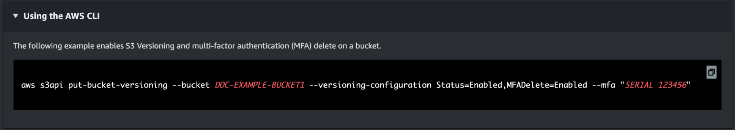
If the MFA (Multi-Factor Authentication) Delete is enabled, it requires additional authentication for either of the following operations:
– Change the versioning state of your bucket
– Permanently delete an object version
Hence, the correct answer is: Enable S3 Versioning and Multi-Factor Authentication Delete on the bucket.
Using S3 Infrequently Accessed storage to store the data is incorrect. Switching your storage class to S3 Infrequent Access won’t help mitigate accidental deletions.
Setting up a signed URL for all users is incorrect. Signed URLs give you more control over access to your content, so this feature primarily deals more with accessing rather than deletion.
Creating an IAM bucket policy that disables delete operation is incorrect. If you create a bucket policy preventing deletion, other users won’t be able to delete objects that should be deleted. You only want to prevent accidental deletion, not disable the action itself.

References:
http://docs.aws.amazon.com/AmazonS3/latest/dev/Versioning.html
https://docs.aws.amazon.com/AmazonS3/latest/userguide/MultiFactorAuthenticationDelete.html

Check out this Amazon S3 Cheat Sheet:
https://tutorialsdojo.com/amazon-s3/

181 49 Question
A financial application consists of an Auto Scaling group of Amazon EC2 instances, an Application Load Balancer, and a MySQL RDS instance set up in a Multi-AZ Deployment configuration. To protect customers’ confidential data, it must be ensured that the Amazon RDS database is only accessible using an authentication token specific to the profile credentials of EC2 instances.
Which of the following actions should be taken to meet this requirement?
- Use a combination of IAM and STS to enforce restricted access to your RDS instance using a temporary authentication token.
- Configure SSL in your application to encrypt the database connection to RDS.
- Create an IAM Role and assign it to your EC2 instances which will grant exclusive access to your RDS instance.
- Enable the IAM DB Authentication.
Incorrect
You can authenticate to your DB instance using AWS Identity and Access Management (IAM) database authentication. IAM database authentication works with MySQL and PostgreSQL. With this authentication method, you don’t need to use a password when you connect to a DB instance. Instead, you use an authentication token.
An authentication token is a unique string of characters that Amazon RDS generates on request. Authentication tokens are generated using AWS Signature Version 4. Each token has a lifetime of 15 minutes. You don’t need to store user credentials in the database, because authentication is managed externally using IAM. You can also still use standard database authentication.
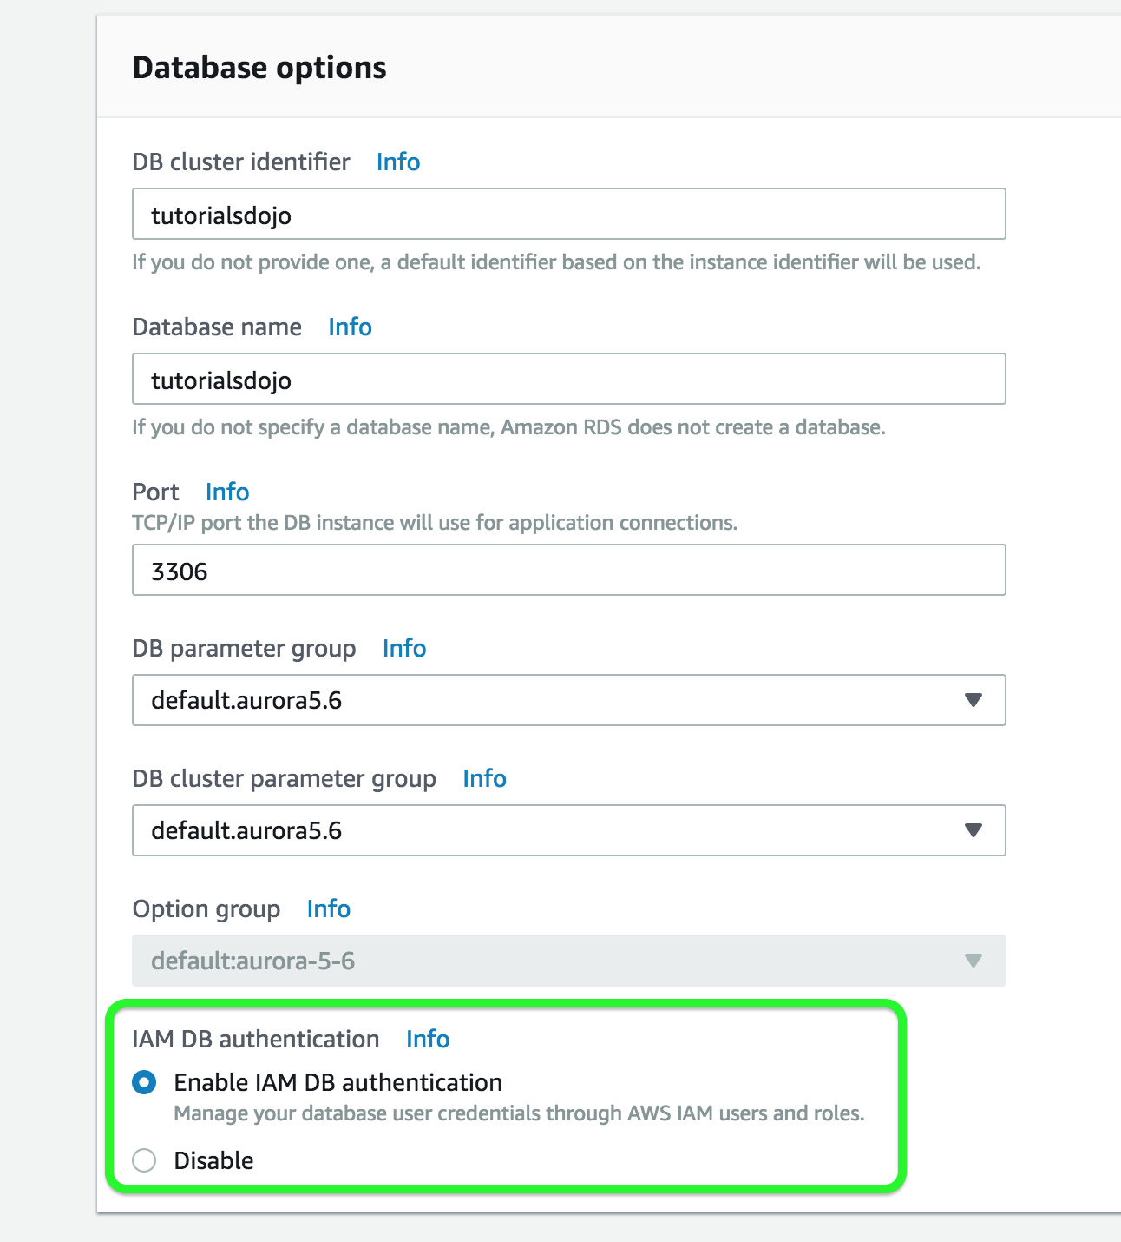
IAM database authentication provides the following benefits:
- Network traffic to and from the database is encrypted using Secure Sockets Layer (SSL).
- You can use IAM to centrally manage access to your database resources, instead of managing access individually on each DB instance.
- For applications running on Amazon EC2, you can use profile credentials specific to your EC2 instance to access your database instead of a password, for greater security
Hence, the correct answer is: Enable the IAM DB Authentication.
The option that says: Configuring SSL in your application to encrypt the database connection to RDS is incorrect because an SSL connection is not just using an authentication token from IAM. Although configuring SSL to your application can improve the security of your data in flight, it is still not a suitable option to use in this scenario.
The option that says: Creating an IAM Role and assigning it to your EC2 instances which will grant exclusive access to your RDS instance is incorrect because although you can create and assign an IAM Role to your EC2 instances, you still need to configure your RDS to use IAM DB Authentication.
The option that says: Use a combination of IAM and STS to enforce restricted access to your RDS instance using a temporary authentication token is incorrect because you have to use IAM DB Authentication for this scenario, and not simply a combination of an IAM and STS. Although STS is used to send temporary tokens for authentication, this is not a compatible use case for RDS.

References:
https://docs.aws.amazon.com/AmazonRDS/latest/UserGuide/UsingWithRDS.IAMDBAuth.html
https://aws.amazon.com/rds/

Check out this Amazon RDS cheat sheet:
https://tutorialsdojo.com/amazon-relational-database-service-amazon-rds/

182 50 Question
A popular social network is hosted in AWS and is using a Amazon DynamoDB table as its database. There is a requirement to implement a ‘follow’ feature where users can subscribe to certain updates made by a particular user and be notified via email.
Which of the following is the most suitable solution to implement to meet the requirement?
- Using the Amazon Kinesis Client Library (KCL), write an application that leverages on DynamoDB Streams Kinesis Adapter that will fetch data from the DynamoDB Streams endpoint. When there are updates made by a particular user, notify the subscribers via email using Amazon SNS.
- Enable DynamoDB Stream and create an AWS Lambda trigger, as well as the IAM role which contains all of the permissions that the Lambda function will need at runtime. The data from the stream record will be processed by the Lambda function which will then publish a message to Amazon SNS Topic that will notify the subscribers via email.
- Create an AWS Lambda function that uses DynamoDB Streams Amazon Kinesis Adapter which will fetch data from the DynamoDB Streams endpoint. Set up an Amazon SNS Topic that will notify the subscribers via email when there is an update made by a particular user.
- Set up a DAX cluster to access the source DynamoDB table. Create a new DynamoDB trigger and an AWS Lambda function. For every update made in the user data, the trigger will send data to the Lambda function which will then notify the subscribers via email using Amazon SNS.
Incorrect
A DynamoDB stream is an ordered flow of information about changes to items in an Amazon DynamoDB table. When you enable a stream on a table, DynamoDB captures information about every modification to data items in the table.
Whenever an application creates, updates, or deletes items in the table, DynamoDB Streams writes a stream record with the primary key attribute(s) of the items that were modified. A stream record contains information about a data modification to a single item in a DynamoDB table. You can configure the stream so that the stream records capture additional information, such as the “before” and “after” images of modified items.
Amazon DynamoDB is integrated with AWS Lambda so that you can create triggers—pieces of code that automatically respond to events in DynamoDB Streams. With triggers, you can build applications that react to data modifications in DynamoDB tables.
If you enable DynamoDB Streams on a table, you can associate the stream ARN with a Lambda function that you write. Immediately after an item in the table is modified, a new record appears in the table’s stream. AWS Lambda polls the stream and invokes your Lambda function synchronously when it detects new stream records. The Lambda function can perform any actions you specify, such as sending a notification or initiating a workflow.

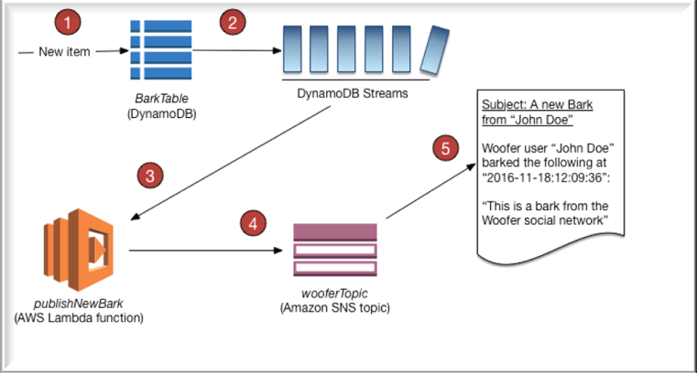
Hence, the correct answer is: Enable DynamoDB Stream and create an AWS Lambda trigger, as well as the IAM role which contains all of the permissions that the Lambda function will need at runtime. The data from the stream record will be processed by the Lambda function which will then publish a message to Amazon SNS Topic that will notify the subscribers via email.
The option that says: Using the Amazon Kinesis Client Library (KCL), write an application that leverages on DynamoDB Streams Kinesis Adapter that will fetch data from the DynamoDB Streams endpoint. When there are updates made by a particular user, notify the subscribers via email using Amazon SNS is incorrect. Although this is a valid solution, it is missing a vital step which is to enable DynamoDB Streams. With the DynamoDB Streams Kinesis Adapter in place, you can begin developing applications via the KCL interface, with the API calls seamlessly directed at the DynamoDB Streams endpoint. Remember that the DynamoDB Stream feature is not enabled by default.
The option that says: Create an AWS Lambda function that uses DynamoDB Streams Amazon Kinesis Adapter which will fetch data from the DynamoDB Streams endpoint. Set up an Amazon SNS Topic that will notify the subscribers via email when there is an update made by a particular user is incorrect because just like in the above, you have to manually enable DynamoDB Streams first before you can use its endpoint.
The option that says: Set up a DAX cluster to access the source DynamoDB table. Create a new DynamoDB trigger and an AWS Lambda function. For every update made in the user data, the trigger will send data to the Lambda function which will then notify the subscribers via email using Amazon SNS is incorrect because the DynamoDB Accelerator (DAX) feature is primarily used to significantly improve the in-memory read performance of your database, and not to capture the time-ordered sequence of item-level modifications. You should use DynamoDB Streams in this scenario instead.

References:
https://docs.aws.amazon.com/amazondynamodb/latest/developerguide/Streams.html
https://docs.aws.amazon.com/amazondynamodb/latest/developerguide/Streams.Lambda.Tutorial.html

Check out this Amazon DynamoDB Cheat Sheet:
https://tutorialsdojo.com/amazon-dynamodb/

183 51 Question 2
A company has an application that heavily uses AWS KMS to encrypt financial data. A Security Engineer has been instructed to ensure that communications between the company’s VPC and AWS KMS do not pass through the public Internet.
Which combination of steps is the MOST suitable solution in this scenario? (Select TWO.)
- Modify the AWS KMS key policy to include the aws:sourceVpc condition and reference the VPC endpoint ID.
- Replace the Internet Gateway of the VPC with an AWS Transit Gateway.
- Set up a new VPC endpoint for AWS KMS with private DNS enabled.
- Establish a Direct Connect connection between the VPC and AWS KMS.
- In the AWS KMS key policy, add a new aws:sourceVpc condition and reference the VPC endpoint ID.
Show me the answer!
Correct Answers: 1,3
You can connect directly to AWS KMS through a private endpoint in your VPC instead of connecting over the internet. When you use a VPC endpoint, communication between your VPC and AWS KMS is conducted entirely within the AWS network. AWS KMS supports Amazon Virtual Private Cloud (Amazon VPC) interface endpoints that are powered by AWS PrivateLink.
Each VPC endpoint is represented by one or more Elastic Network Interfaces (ENIs) with private IP addresses in your VPC subnets. The VPC interface endpoint connects your VPC directly to AWS KMS without an internet gateway, NAT device, VPN connection, or AWS Direct Connect connection. The instances in your VPC do not need public IP addresses to communicate with AWS KMS.
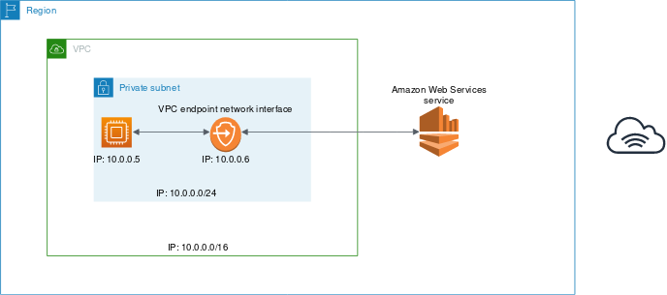
If you use the default domain name servers (AmazonProvidedDNS) and enable private DNS hostnames for your VPC endpoint, you do not need to specify the endpoint URL. AWS populates your VPC name server with private zone data, so the public KMS endpoint (https://kms.<region>.amazonaws.com) resolves to your private VPC endpoint. To enable this feature when using your own name servers, forward requests for the KMS domain to the VPC name server.
You can also use AWS CloudTrail logs to audit your use of KMS keys through the VPC endpoint. And you can use the conditions in IAM and key policies to deny access to any request that does not come from a specified VPC or VPC endpoint.
Hence, the correct answers are:
– Modify the AWS KMS key policy to include the aws:sourceVpce condition and reference the VPC endpoint ID.
– Set up a new VPC endpoint for AWS KMS with private DNS enabled.
The option that says: Replace the Internet Gateway of the VPC with an AWS Transit Gateway is incorrect because AWS Transit Gateway is simply a service that enables customers to connect their Amazon Virtual Private Clouds (VPCs) and their on-premises networks to a single gateway.
The option that says: Establish a Direct Connect connection between the VPC and AWS KMS is incorrect because Direct Connect is primarily used to connect your on-premises data center and your VPC. This service is not suitable for integrating AWS KMS and your VPC.
The option that says: In the AWS KMS key policy, add a new aws:sourceVpc condition and reference the VPC endpoint ID is incorrect because the aws:sourceVpc condition is more suitable if you already have multiple VPC endpoints configured in the same VPC. This means that you still have to use VPC Endpoints in order for you to use this condition. Moreover, if you use the aws:sourceVpc condition, you have to specify the VPC ID and not the VPC endpoint ID.
References:
https://docs.aws.amazon.com/kms/latest/developerguide/kms-vpc-endpoint.html
https://docs.aws.amazon.com/vpc/latest/userguide/vpce-interface.html
Note: This question was extracted from our AWS Certified Security Specialty Practice Exams.
Explanation:

184 52 Question 2
A company has an application that heavily uses AWS KMS to encrypt financial data. A Security Engineer has been instructed to ensure that communications between the company’s VPC and AWS KMS do not pass through the public Internet.
Which combination of steps is the MOST suitable solution in this scenario? (Select TWO.)
- Modify the AWS KMS key policy to include the aws:sourceVpce condition and reference the VPC endpoint ID.
- Replace the Internet Gateway of the VPC with an AWS Transit Gateway.
- Set up a new VPC endpoint for AWS KMS with private DNS enabled.
- Establish a Direct Connect connection between the VPC and AWS KMS.
- In the AWS KMS key policy, add a new aws:sourceVpc condition and reference the VPC endpoint ID.
Show me the answer!
Correct Answers: 1,3
You can connect directly to AWS KMS through a private endpoint in your VPC instead of connecting over the internet. When you use a VPC endpoint, communication between your VPC and AWS KMS is conducted entirely within the AWS network. AWS KMS supports Amazon Virtual Private Cloud (Amazon VPC) interface endpoints that are powered by AWS PrivateLink.
Each VPC endpoint is represented by one or more Elastic Network Interfaces (ENIs) with private IP addresses in your VPC subnets. The VPC interface endpoint connects your VPC directly to AWS KMS without an internet gateway, NAT device, VPN connection, or AWS Direct Connect connection. The instances in your VPC do not need public IP addresses to communicate with AWS KMS.

If you use the default domain name servers (AmazonProvidedDNS) and enable private DNS hostnames for your VPC endpoint, you do not need to specify the endpoint URL. AWS populates your VPC name server with private zone data, so the public KMS endpoint (https://kms.<region>.amazonaws.com) resolves to your private VPC endpoint. To enable this feature when using your own name servers, forward requests for the KMS domain to the VPC name server.
You can also use AWS CloudTrail logs to audit your use of KMS keys through the VPC endpoint. And you can use the conditions in IAM and key policies to deny access to any request that does not come from a specified VPC or VPC endpoint.
Hence, the correct answers are:
– Modify the AWS KMS key policy to include the aws:sourceVpce condition and reference the VPC endpoint ID.
– Set up a new VPC endpoint for AWS KMS with private DNS enabled.
The option that says: Replace the Internet Gateway of the VPC with an AWS Transit Gateway is incorrect because AWS Transit Gateway is simply a service that enables customers to connect their Amazon Virtual Private Clouds (VPCs) and their on-premises networks to a single gateway.
The option that says: Establish a Direct Connect connection between the VPC and AWS KMS is incorrect because Direct Connect is primarily used to connect your on-premises data center and your VPC. This service is not suitable for integrating AWS KMS and your VPC.
The option that says: In the AWS KMS key policy, add a new aws:sourceVpc condition and reference the VPC endpoint ID is incorrect because the aws:sourceVpc condition is more suitable if you already have multiple VPC endpoints configured in the same VPC. This means that you still have to use VPC Endpoints in order for you to use this condition. Moreover, if you use the aws:sourceVpc condition, you have to specify the VPC ID and not the VPC endpoint ID.
References:
https://docs.aws.amazon.com/kms/latest/developerguide/kms-vpc-endpoint.html
https://docs.aws.amazon.com/vpc/latest/userguide/vpce-interface.html

185
186
187
188
189
190
191
192
193
194
195
196
197
198
199
200
201

