Step 01: https://portal.tutorialsdojo.com/
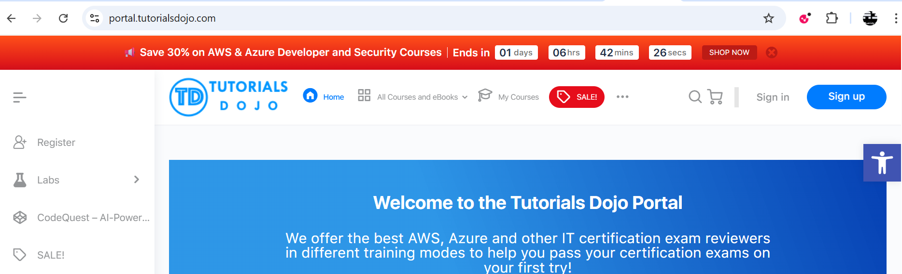
Step 02:
Step 03:
Step 04:
Step 05:
Step 06:
Step 07:
Step 08:
Step 09:
Step 10:

