https://tutorialsdojo.com/amazon-elasticache/
Amazon ElastiCache Cheat Sheet
- ElastiCache is a distributed in-memory cache environment in the AWS Cloud.
- ElastiCache works with both the Redis and Memcached engines.
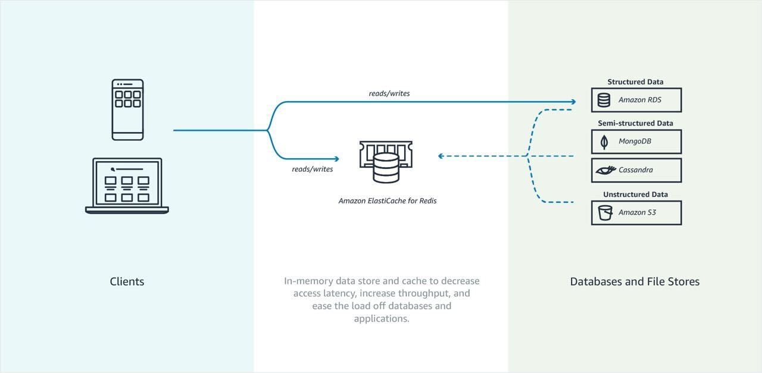
Components
- ElastiCache Nodes
  - A node is a fixed-size chunk of secure, network-attached RAM. A node can exist in isolation from or in some relationship to other nodes.
  - Every node within a cluster is the same instance type and runs the same cache engine. Each cache node has its own Domain Name Service (DNS) name and port.
- If a maintenance event is scheduled for a given week, it will be initiated and completed at some point during the 60 minute maintenance window you specify.
- Elasticache can be used for storing session state.
- ElastiCache Redis
  - Existing applications that use Redis can use ElastiCache with almost no modification.
  - Features
    - Automatic detection and recovery from cache node failures.
    - Multi-AZ with automatic failover of a failed primary cluster to a read replica in Redis clusters that support replication.
    - Redis (cluster mode enabled) supports partitioning your data across up to 250 shards.
    - The node or shard limit can be increased to a maximum of 500 per cluster if the Redis engine version is 5.0.6 or higher.
    - Redis supports in-transit and at-rest encryption with authentication so you can build HIPAA-compliant applications.
    - Flexible Availability Zone placement of nodes and clusters for increased fault tolerance.
    - Data is persistent.
    - Can be used as a datastore.
    - Not multi-threaded.
    - Amazon ElastiCache for Redis supports self-service updates, which allows you to apply service updates at the time of your choosing and track the progress in real-time.
  - Cache data if:
    - It is slow or expensive to acquire when compared to cache retrieval.
    - It is accessed with sufficient frequency.
    - It is relatively static, or if rapidly changing, staleness is not a significant issue.
  - Redis sorted sets guarantee both uniqueness and element ordering. Each time a new element is added to the sorted set it’s reranked in real time. It’s then added to the set in its appropriate numeric position.
  - In the Redis publish/subscribe paradigm, you send a message to a specific channel not knowing who, if anyone, receives it. Recipients of the message are those who are subscribed to the channel.
  - Redis hashes are hashes that map string names to string values.
  - Components
    - Redis Shard – a grouping of one to six related nodes. A Redis (cluster mode disabled) cluster always has one shard. A Redis (cluster mode enabled) cluster can have 1–90 shards.
      - A multiple node shard implements replication by have one read/write primary node and 1–5 replica nodes.
      - If there is more than one node in a shard, the shard supports replication with one node being the read/write primary node and the others read-only replica nodes.
    - Redis Cluster – a logical grouping of one or more ElastiCache for Redis Shards. Data is partitioned across the shards in a Redis (cluster mode enabled) cluster.
  - For improved fault tolerance, have at least two nodes in a Redis cluster and enabling Multi-AZ with automatic failover.
  - Replica nodes use asynchronous replication mechanisms to keep synchronized with the primary node.
  - If any primary has no replicas and the primary fails, you lose all that primary’s data.
  - You can use backup and restore to migrate to Redis (cluster mode enabled) and resize your Redis (cluster mode enabled).
  - Redis (cluster mode disabled) vs Redis (cluster mode enabled)

 | Redis  (cluster mode disabled) | Redis  (cluster mode enabled)
Shards (node groups) | 1 | 1-90
Replicas for each shard  (node group) | 0-5 | 0-5
Data partitioning | No | Yes
Add/Delete replicas | Yes | Yes
Add/Delete node groups | No | No
Supports scale up | Yes | No
Supports engine upgrades | Yes | Yes
Promote replica to primary | Yes | No
Multi-AZ with automatic failover | Yes, with at least a replica.  Optional. On by default. | Required
Backup / Restore | Yes | Yes

  - You can vertically scale up or scale down your sharded Redis Cluster on demand. Amazon ElastiCache resizes your cluster by changing the node type, while the cluster continues to stay online and serve incoming requests.
  - You can set up automatic snapshots or initiate manual backups, and then seed new ElastiCache for Redis clusters. You can also export your snapshots to an S3 bucket of your choice for disaster recovery, analysis or cross-region backup and restore.
  - Endpoints
    - Single Node Redis (cluster mode disabled) Endpoints – used to connect to the cluster for both reads and writes.
    - Multi-Node Redis (cluster mode disabled) Endpoints – use the primary endpoint for all writes to the cluster. The read endpoint points to your read replicas.
    - Redis (cluster mode enabled) Endpoints – has a single configuration endpoint. By connecting to the configuration endpoint, your application is able to discover the primary and read endpoints for each shard in the cluster.
  - Parameter Groups
    - Cache parameter group is a named collection of engine-specific parameters that you can apply to a cluster.
    - Parameters are used to control memory usage, eviction policies, item sizes, and more.
  - Redis Security
    - ElastiCache for Redis node access is restricted to applications running on whitelisted EC2 instances. You can control access of your cluster by using subnet groups or security groups. By default, network access to your clusters is turned off.
    - By default, all new ElastiCache for Redis clusters are launched in a VPC environment. Use subnet groups to grant cluster access from Amazon EC2 instances running on specific subnets.
    - ElastiCache for Redis supports TLS and in-place encryption for nodes running specified versions of the ElastiCache for Redis engine.
    - You can use your own customer managed customer master keys (CMKs) in AWS Key Management Service to encrypt data at rest in ElastiCache for Redis.
  - Redis Backups
    - A point-in-time copy of a Redis cluster.
    - Backups consist of all the data in a cluster plus some metadata.
  - Global Datastore
    - A new feature that provides fully managed, secure cross-region replication. You can now write to your ElastiCache for Redis cluster in one region and have the data available for reading in two other cross-region replica clusters.
    - In the unlikely event of regional degradation, one of the healthy cross-region replica clusters can be promoted to become the primary cluster with full read/write capabilities.
ElastiCache Memcached
- Features
  - Automatic detection and recovery from cache node failures.
  - Automatic discovery of nodes within a cluster enabled for automatic discovery, so that no changes need to be made to your application when you add or remove nodes.
  - Flexible Availability Zone placement of nodes and clusters.
  - ElastiCache Auto Discovery feature for Memcached lets your applications identify all of the nodes in a cache cluster and connect to them.
  - ElastiCache node access is restricted to applications running on whitelisted EC2 instances. You can control the instances that can access your cluster by using subnet groups or security groups.
  - It is not persistent.
  - Supports large nodes with multiple cores or threads.
  - Does not support multi-AZ failover or replication
  - Does not support snapshots
- Components
  - Memcached cluster – a logical grouping of one or more ElastiCache Nodes. Data is partitioned across the nodes in a Memcached cluster.
    - Memcached supports up to 100 nodes per customer for each Region with each cluster having 1–20 nodes.
    - When you partition your data, use consistent hashing.
  - Endpoint – the unique address your application uses to connect to an ElastiCache node or cluster.
    - Each node in a Memcached cluster has its own endpoint.
    - The cluster also has an endpoint called the configuration endpoint.
  - ElastiCache parameter group – a named collection of engine-specific parameters that you can apply to a cluster. Parameters are used to control memory usage, eviction policies, item sizes, and more.
  - ElastiCache allows you to control access to your clusters using security groups. By default, network access to your clusters is turned off.
  - A subnet group is a collection of subnets that you can designate for your clusters running in a VPC environment. If you create a cluster in a VPC, then you must specify a cache subnet group. ElastiCache uses that cache subnet group to choose a subnet and IP addresses within that subnet to associate with your cache nodes.
- Mitigating Failures
  - Node Failures
    - Spread your cached data over more nodes. Because Memcached does not support replication, a node failure will always result in some data loss from your cluster.
  - Availability Zone Failure
    - Locate your nodes in as many Availability Zones as possible. In the unlikely event of an AZ failure, you will lose the data cached in that AZ, not the data cached in the other AZs.
- ElastiCache uses DNS entries to allow client applications to locate servers (nodes). The DNS name for a node remains constant, but the IP address of a node can change over time.
Caching Strategies
- Lazy Loading – a caching strategy that loads data into the cache only when necessary.
  - Only requested data is cached.
  - Node failures are not fatal.
  - There is a cache miss penalty.
  - Stale data.
- Write Through – adds data or updates data in the cache whenever data is written to the database.
  - Data in the cache is never stale.
  - Write penalty vs. Read penalty. Every write involves two trips: A write to the cache and a write to the database.
  - Missing data.
  - Cache churn.
- By adding a time to live (TTL) value to each write, we are able to enjoy the advantages of each strategy and largely avoid cluttering up the cache with superfluous data.
Scaling ElastiCache for Memcached Clusters
- Scaling Memcached Horizontally
  - The Memcached engine supports partitioning your data across multiple nodes. Because of this, Memcached clusters scale horizontally easily. A Memcached cluster can have 1 to 20 nodes. To horizontally scale your Memcached cluster, just add or remove nodes.
- Scaling Memcached Vertically
  - When you scale your Memcached cluster up or down, you must create a new cluster. Memcached clusters always start out empty unless your application populates it.
Amazon ElastiCache Monitoring
- The service continuously monitors the health of your instances. In case a node experiences failure or a prolonged degradation in performance, ElastiCache will automatically restart the node and associated processes.
- ElastiCache provides both host-level metrics and metrics that are specific to the cache engine software. These metrics are measured and published for each Cache node in 60-second intervals.
- Monitor events with ElastiCache Events. When significant events happen on a cache cluster, including failure to add a node, success in adding a node, the modification of a security group, and others, ElastiCache sends a notification to a specific SNS topic.
- Monitor costs with tags.
Redis VS Memcached
- Memcached is designed for simplicity while Redis offers a rich set of features that make it effective for a wide range of use cases.
 | Redis (cluster mode enabled) | Redis (cluster mode disabled) | Memcached
Data Types | string, sets, sorted sets, lists, hashes, bitmaps, hyperloglog, geospatial indexes | string, sets, sorted sets, lists, hashes, bitmaps, hyperloglog, geospatial indexes | string, objects, (like databases)
Data Partitioning (distribute your data among multiple nodes) | Supported | Unsupported | Supported
Modifiable cluster | Only versions 3.2.10 and later | Yes
Online resharding | Only versions 3.2.10 and later | No
Encryption | 3.2.6,4.0.10 and later |  | Unsupported
Sub-millisecond latency | Yes
FedRAMP, PCI DSS and HIPAA compliant | 3.2.6,4.0.10 and later |  | No
Multi-threaded (make use of multiple processing cores) | No |  | Yes
Node type upgrading | No | Yes | No
Engine upgrading | Yes
Cluster replication (create multiple copies of a primary cluster) | Supported |  | Unsupported
Multi-AZ for automatic failover | Required | Optional | Unsupported
Transaction (execute a group of commands as an isolated and automatic operation) | Supported |  | Unsupported
Pub/Sub capability | Yes |  | No
Backup and restore (keep your data on disk with a point in time snapshot) | Supported |  | Unsupported
Lua Scripting (execute transactional Lua scripts) | Supported |  | Unsupported
Use Case | - You need to partition your data across two to 90 node groups (clustered mode only).  - You need geospatial indexing (clustered mode or non-clustered mode).  - You don’t need to support multiple databases  - Plus features of non-clustered mode | - You need complex data types, such as string, hashes, lists, sets, sorted sets, and bitmaps.  - You need to sort or rank in-memory datasets.  - You need persistence of your key store.  - You need to replicate your data from the primary to one or more read replicas for read intensive applications.  - You need automatic failover if your primary node fails.  - You need pub/sub capabilities.  - You need backup and restore capabilities.  - You need to support multiple databases. | - You need the simplest model possible.  - You need to run large nodes with multiple cores or threads.  - You need the ability to scale out and in, adding and removing nodes as demand on your system increases and decreases.  - You need to cache objects, such as a databases.  - Need Auto Discovery to simplify the way an application connects to a cluster.
Amazon ElastiCache Pricing
- With on-demand nodes you pay only for the resources you consume by the hour without any long-term commitments.
- With Reserved Nodes, you can make a low, one-time, up-front payment for each node you wish to reserve for a 1 or 3 year term. In return, you receive a significant discount off the ongoing hourly usage rate for the Node(s) you reserve.
- ElastiCache provides storage space for one snapshot free of charge for each active ElastiCache for Redis cluster. Additional backup storage is charged.
- EC2 Regional Data Transfer charges apply when transferring data between an EC2 instance and an ElastiCache Node in different Availability Zones of the same Region.
Free Amazon ElastiCache Tutorials on YouTube:
https://www.youtube.com/user/AmazonWebServices/search?query=elasticache
Amazon ElastiCache-related Cheat Sheets:
- Redis (cluster mode enabled vs disabled) vs Memcached
- Redis Append-Only Files vs Redis Replication
Note: If you are studying for the AWS Certified Data Engineer Associate exam, we highly recommend that you take our AWS Certified Data Engineer Associate Practice Exams and read our Data Engineer Associate exam study guide.

Validate Your Knowledge
Question 1
A startup is developing a distributed cache for session management using Amazon ElastiCache for Redis with cluster mode enabled. The cache layer will be used by various applications running in AWS. The cluster shall use the default port for Redis connection.
Which combination of steps should the Database Specialist do to protect the ElastiCache cluster from unauthorized access? (Select TWO.)
- Enable Transparent Data Encryption (TDE) in the ElastiCache cluster.
- Set the associated security group to allow inbound traffic on TCP port 6379 from trusted clients only.
- Enable encryption in-transit and encryption at-rest on the ElastiCache cluster including Redis AUTH. Configure the clients to use the auth-token parameter when connecting to the Redis cluster.
- Ensure that the associated security group allows inbound traffic on TCP port 11211 from trusted clients only.
- Integrate AWS Web Application Firewall (WAF) with the ElastiCache Redis cluster.
Show me the answer!
Correct Answers: 2,3
To help keep your data secure, Amazon ElastiCache and Amazon EC2 provide mechanisms to guard against unauthorized access of your data on the server.
Amazon ElastiCache for Redis also provides optional encryption features for data on clusters running Redis versions 3.2.6, 4.0.10 or later:
– In-transit encryption encrypts your data whenever it is moving from one place to another, such as between nodes in your cluster or between your cluster and your application.
– At-rest encryption encrypts your on-disk data during sync and backup operations.
If you want to enable in-transit or at-rest encryption, you must meet the following conditions:
– Your cluster or replication group must be running Redis 3.2.6, 4.0.10 or later.
– Your cluster or replication group must be created in a VPC based on Amazon VPC.
– Optionally, you can also use AUTH and the AUTH token (password) needed to perform operations on this cluster or replication group.
Amazon ElastiCache in-transit encryption is an optional feature that allows you to increase the security of your data at its most vulnerable points—when it is in transit from one location to another. Because there is some processing needed to encrypt and decrypt the data at the endpoints, enabling in-transit encryption can have some performance impact. You should benchmark your data with and without in-transit encryption to determine the performance impact for your use cases.
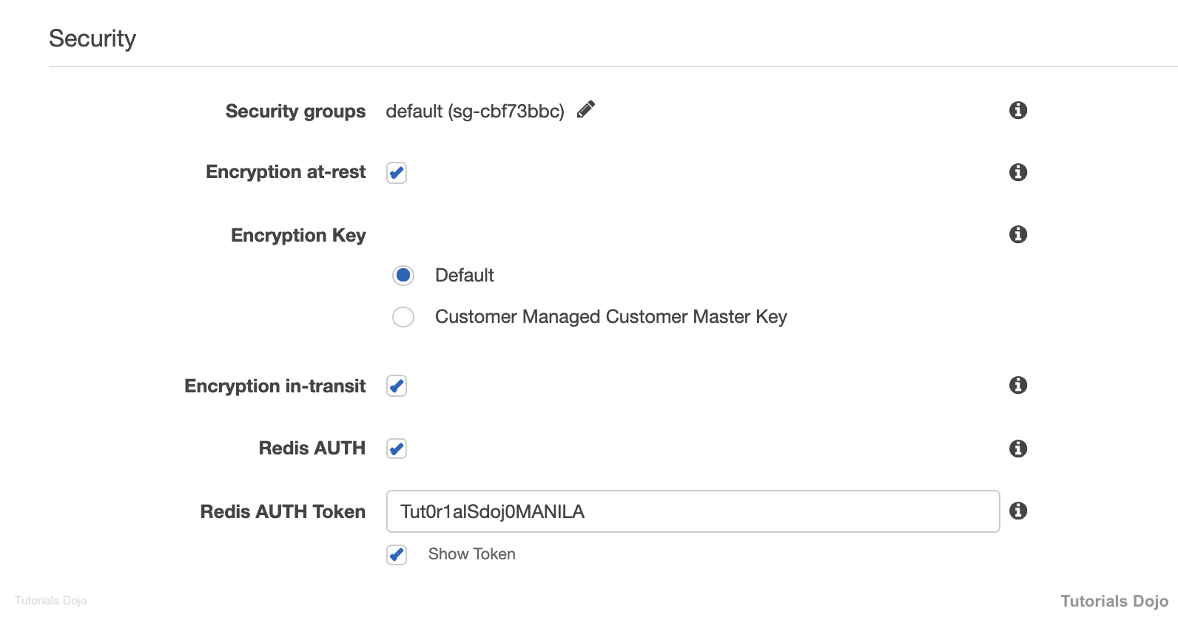
At-rest encryption can be enabled on a replication group only when it is created. Because there is some processing needed to encrypt and decrypt the data, enabling at-rest encryption can have a performance impact during these operations. You should benchmark your data with and without at-rest encryption to determine the performance impact for your use cases.
Redis authentication tokens enable Redis to require a token (password) before allowing clients to run commands, thereby improving data security. When you use Redis AUTH with your ElastiCache for Redis cluster, you should follow a strict token policy to enhance the security of your ElastiCache cluster. To connect to your cluster, you have to include the parameter --auth-token (API: AuthToken) with the correct token when you create your replication group or cluster. You must also include the token in all subsequent commands to the replication group or cluster.
The default TCP port for Redis is 6379. This port must be allowed in the associated security group of the cluster. For Memcached, the default port is 11211.
Hence, the correct answers are:
- Set the associated security group to allow inbound traffic on TCP port 6379 from trusted clients only.
- Enable encryption in-transit and encryption at-rest on the ElastiCache cluster including Redit AUTH. Configure the clients to use the auth-token parameter when connecting to the Redis cluster.
The option that says: Enable Transparent Data Encryption (TDE) in the ElastiCache cluster is incorrect because TDE is not an available encryption feature in ElastiCache. This is only applicable to the Microsoft SQL Server.
The option that says: Ensure that the associated security group allows inbound traffic on TCP port 11211 from trusted clients only is incorrect because this the default port for Memcached, and not for Redis.
The option that says: Integrate AWS Web Application Firewall (WAF) with the ElastiCache Redis cluster is incorrect because you can’t directly integrate AWS WAF with ElastiCache. It is more appropriate to integrate AWS WAF to your CloudFront web distribution, Application Load Balancers, or Amazon API Gateway for your APIs.
References:
https://docs.aws.amazon.com/AmazonElastiCache/latest/red-ug/in-transit-encryption.html
https://docs.aws.amazon.com/AmazonElastiCache/latest/red-ug/at-rest-encryption.html
https://docs.aws.amazon.com/AmazonElastiCache/latest/red-ug/auth.html
Note: This question was extracted from our AWS Certified Database Specialty Practice Exams.

Question 2
A developer is moving a legacy web application from their on-premises data center to AWS. The application is used simultaneously by thousands of users, and their session states are stored in memory. The on-premises server usually reaches 100% CPU Utilization every time there is a surge in the number of people accessing the application.
Which of the following is the best way to re-factor the performance and availability of the application’s session management once it is migrated to AWS?
- Use an ElastiCache for Redis cluster to store the user session state of the application.
- Store the user session state of the application using CloudFront.
- Use an ElastiCache for Memcached cluster to store the user session state of the application.
- Use Sticky Sessions with Local Session Caching.
Show me the answer!
Correct Answer: 1
Amazon ElastiCache for Redis is a blazing fast in-memory data store that provides sub-millisecond latency to power internet-scale real-time applications. Built on open-source Redis and compatible with the Redis APIs, ElastiCache for Redis works with your Redis clients and uses the open Redis data format to store your data. Your self-managed Redis applications can work seamlessly with ElastiCache for Redis without any code changes. ElastiCache for Redis combines the speed, simplicity, and versatility of open-source Redis with manageability, security, and scalability from Amazon to power the most demanding real-time applications in Gaming, Ad-Tech, E-Commerce, Healthcare, Financial Services, and IoT.
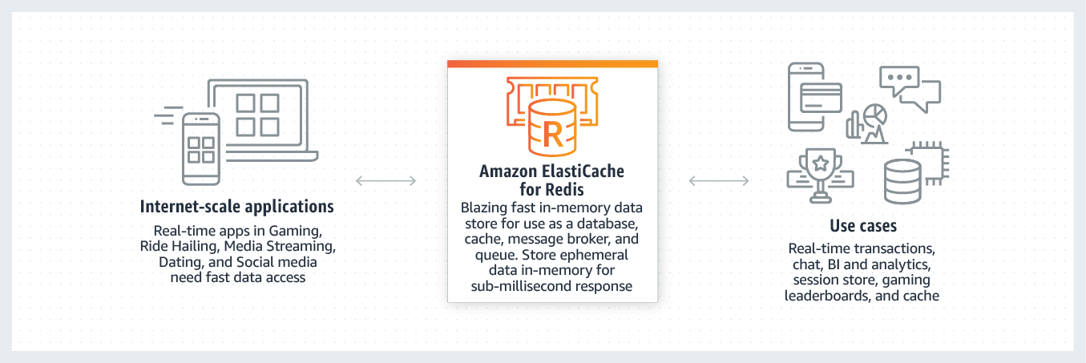
In order to address scalability and provide a shared data storage for sessions that can be accessible from any individual web server, you can abstract the HTTP sessions from the web servers themselves. A common solution to for this is to leverage an In-Memory Key/Value store such as Redis and Memcached. While Key/Value data stores are known to be extremely fast and provide sub-millisecond latency, the added network latency and added cost are the drawbacks. An added benefit of leveraging Key/Value stores is that they can also be utilized to cache any data, not just HTTP sessions, which can help boost the overall performance of your applications.
With Redis, you can keep your data on disk with a point in time snapshot which can be used for archiving or recovery. Redis also lets you create multiple replicas of a Redis primary. This allows you to scale database reads and to have highly available clusters. Hence, the correct answer for this scenario is to use an ElastiCache for Redis cluster to store the user session state of the application.
The option that says: Store the user session state of the application using CloudFront is incorrect because CloudFront is not suitable for storing user session data. It is primarily used as a content delivery network.
The option that says: Use an ElastiCache for Memcached cluster to store the user session state of the application is incorrect. Although using ElastiCache is a viable answer, Memcached is not as highly available as Redis.
The option that says: Use Sticky Sessions with Local Session Caching is incorrect. Although this is also a viable solution, it doesn’t offer durability and high availability compared to a distributed session management solution. The best solution for this scenario is to use an ElastiCache for Redis cluster.
References:
https://aws.amazon.com/caching/session-management
https://aws.amazon.com/elasticache/redis-vs-memcached/
https://aws.amazon.com/elasticache/redis/
Note: This question was extracted from our AWS Certified Developer Associate Practice Exams.
For more AWS practice exam questions with detailed explanations, visit the Tutorials Dojo Portal:
Amazon ElastiCache References:
https://docs.aws.amazon.com/AmazonElastiCache/latest/red-ug/
https://aws.amazon.com/elasticache/redis-details/
https://docs.aws.amazon.com/AmazonElastiCache/latest/mem-ug/
https://aws.amazon.com/elasticache/redis-vs-memcached/
https://aws.amazon.com/elasticache/features/
https://aws.amazon.com/elasticache/pricing/

-------------------------------- ----------------------------------- --------------------------------------------
https://tutorialsdojo.com/amazon-memorydb-for-redis/
Amazon MemoryDB for Redis Cheat Sheet
- An in-memory database service for microservices-based applications.
- MemoryDB stores all of your data in memory, allowing you to achieve microsecond read and single-digit millisecond write latency and high throughput.
- It also uses a Multi-AZ transactional log to store data across multiple AZs in order to enable fast failover, database recovery, and node restarts.

Features
- Primary nodes have strong consistency, and replica nodes have guaranteed eventual consistency.
- Scale horizontally by adding and removing nodes or vertically by changing node types.

    - Write throughput – can be increased by adding shards.
    - Read throughput – can be increased by adding replicas.
- With Amazon S3, you can store snapshots with a retention period of up to 35 days.
- Automatic software patching and cluster upgrades.
- Supports both encryption in-transit / at-rest and authentication of users via ACLs.
Concepts
- Clusters

    - A collection of one or more nodes serving a single dataset.
    - A dataset is partitioned into shards, and each shard has a primary node and up to 5 optional replica nodes.
      - Primary node – serves both read and write requests.
      - Replica node – only serves read requests.
    - A cluster’s nodes are all designed to be the same node type, with the same parameter and security group settings.
    - When a primary node fails over to a replica node, that replica becomes the new primary node for that shard.
    - Each MemoryDB cluster has its own Redis engine version.
    - Each cluster endpoint has an address and a port that clients can use to discover the specific roles, IP addresses, and slots for each node in the cluster.
    - Supports data tiering using a node type from the r6gd family.
    - When you create or modify a cluster without specifying a preferred maintenance window, MemoryDB assigns a 60-minute maintenance window within your region’s maintenance window on a randomly selected day of the week.
    - Data is automatically backed up to a Multi-AZ transactional log, but you can choose to create point-in-time snapshots of a cluster either periodically or on-demand.
- Nodes

    - The smallest component of a MemoryDB deployment that runs on an Amazon EC2 instance.
    - A node is part of a shard, which is part of a cluster.
    - Each node runs an instance of the engine at the version you specified when you set up your cluster.
    - Every node has its own DNS name and port number.
    - Multiple types of nodes are supported, each with different amounts of memory and processing power.
    - When MemoryDB for Redis replaces a node, the new node may have a different IP address. You must update your application configuration to use the new IP address.
- Shards

    - A hierarchical arrangement of nodes, each wrapped in a cluster.
    - A grouping of one to six nodes, with one serving as the primary write node and the other five as read replicas.
    - A cluster should always have at least one shard.
    - Supports both replication and multiple shards within a cluster.
- Parameter groups are named set of engine-specific settings that can be applied to a cluster so that all nodes in the cluster are configured identically.
- Subnet Groups are a set of subnets that you can assign to your clusters in an Amazon VPC environment.
- Access Control Lists (ACLs) are a collection of one or more users.
- Snapshots

    - Supports automatic snapshots.
    - The snapshot window has a minimum length of 60 minutes.
    - You can set the retention limit of your snapshots in Amazon S3. The snapshot is automatically deleted when the retention period expires.
Security
- To control who has access to clusters, you can create users with specific permissions and add them to ACLs.
- Configure TLS encryption in transit and encryption at rest using AWS KMS keys.
- Use a VPC security group to allow inbound traffic on the node’s endpoint and port to control which devices and Amazon EC2 instances can connect to MemoryDB clusters in a VPC.
Networking
- An Amazon EC2 instance in the same Amazon VPC can connect to your MemoryDB node. Alternatively, you can use VPC peering to connect to your MemoryDB node from another Amazon VPC.
- Your application uses the endpoint to connect to your cluster.
- The endpoint is a unique address that identifies your cluster.
Pricing
- You can choose between two types of nodes:

    - You are charged per hour for on-demand nodes.
    - By reserving nodes in 1-year or 3-year terms, you get discounts on the ongoing hourly usage rate. You can pay using any of the following methods:
      - No Upfront – low hourly rate.
      - Partial Upfront – lower hourly rate.
      - All Upfront – lowest hourly rate.
- You are charged based on the amount of data (in GB) written to the MemoryDB cluster.
- You are charged for the additional snapshot storage.

Amazon MemoryDB for Redis Cheat Sheet References:
https://docs.aws.amazon.com/memorydb/latest/devguide/what-is-memorydb-for-redis.html
https://aws.amazon.com/memorydb/
-------------------------------- ----------------------------------- --------------------------------------------
https://tutorialsdojo.com/amazon-relational-database-service-amazon-rds/
Amazon RDS Cheat Sheet
- Industry-standard relational database
- RDS manages backups, software patching, automatic failure detection, and recovery.
- You can have automated backups performed when you need them, or manually create your own backup snapshot. You can use these backups to restore a database.
- Supports Aurora, MySQL, MariaDB, PostgreSQL, Oracle, Microsoft SQL Server.
- You can get high availability with a primary instance and a synchronous secondary instance that you can fail over to when problems occur. You can also use MySQL, MariaDB, or PostgreSQL Read Replicas to increase read scaling.
- Basic building block of RDS is the DB instance, which is an isolated database environment in the cloud.
- You can have up to 40 Amazon RDS DB instances.
- Each DB instance runs a DB engine.
- You can select the computation and memory capacity of a DB instance, determined by its DB instance class. If your needs change over time, you can change DB instances.
- Each DB instance has minimum and maximum storage requirements depending on the storage type and the database engine it supports.
- You can run your DB instance in several AZs, an option called a Multi-AZ deployment. Amazon automatically provisions and maintains a secondary standby DB instance in a different AZ. Your primary DB instance is synchronously replicated across AZs to the secondary instance to provide data redundancy, failover support, eliminate I/O freezes, and minimize latency spikes during system backups.
DB Engines
- MySQL DB instance:
  - You’re limited to 10,000 tables if you are either using Provisioned IOPS or General Purpose storage and the DB instance is 200 GiB or larger in size.
  - You’re limited to 1000 tables if you are either using Standard or General Purpose storage and the DB instance is less than 200 GiB in size.
  - MySQL database instances can be launched with up to 64 TiB of storage and provisioned I/O performance of up to 80,000 IOPS.
  - The Point-In-Time Restore and snapshot restore features of Amazon RDS for MySQL require a crash-recoverable storage engine and are supported for the InnoDB storage engine only.
  - InnoDB is the recommended and supported storage engine for MySQL DB instances on Amazon RDS.
  - The database name is the name of a database hosted in your DB instance. Databases hosted by the same DB instance must have a unique name within that instance.
  - You can now enforce password policies in your Amazon RDS for MySQL databases using the MySQL validate_password plugin. This improves the security of your databases by defining minimum password length, required characters, and other rules.
- MariaDB instance:
  - The point-in-time restore and snapshot restore features of Amazon RDS for MariaDB require a crash-recoverable storage engine.
  - MariaDB database instances can be launched with up to 64 TiB of storage and provisioned I/O performance of up to 80,000 IOPS.
  - The database name is the name of a database hosted in your DB instance. Databases hosted by the same DB instance must have a unique name within that instance.
- PostgreSQL instance:
  - You can improve performance with PostgreSQL on Amazon RDS when loading data into a DB instance and when using the PostgreSQL autovacuum feature.
  - PostgreSQL database instances can be launched with up to 64 TiB of storage and provisioned I/O performance of up to 80,000 IOPS.
  - The database name is the unique name of a database hosted in your DB instance, and is not required when creating a DB instance.
- Microsoft SQL Server instance:
  - Up to 10 can be SQL Server DB instances under the “License Included” model. You can have 40 DB instances for SQL Server under the “BYOL” licensing model.
  - The maximum number of databases supported on a DB instance depends on the instance class type and the availability mode—Single-AZ, Multi-AZ Database Mirroring (DBM), or Multi-AZ Availability Groups (AGs). The Microsoft SQL Server system databases don’t count toward this limit.
Instance Class Type | Single-AZ | Multi-AZ with DBM | Multi-AZ with Always On AGs
db.*.micro to db.*.medium | 30 | N/A | N/A
db.*.large | 30 | 30 | 30
db.*.xlarge to db.*.16xlarge | 100 | 50 | 75
db.*.24xlarge | 100 | 50 | 100

  - For Multi-AZ enabled instances:
    - Use Amazon RDS DB events to monitor failovers.
    - If your application caches DNS values, set time to live (TTL) to less than 30 seconds.
    - AWS recommends to NOT enable Simple Recover, Offline, or Read-only modes because they turn off transaction logging, which is required for Multi-AZ.
    - Test to determine how long it takes for your DB instance to failover.
    - Deploy your applications in all Availability Zones.
  - Database name is not a supported parameter.

- Oracle instance:
  - Up to 10 can be Oracle instances under the “License Included” model. You can have 40 DB instances for Oracle under the “BYOL” licensing model.
  - Database name is used to set the value of ORACLE_SID, which must be supplied when connecting to the Oracle RDS instance.
  - You can now create Amazon RDS for Oracle database instances with up to 64 TiB of storage (32 TiB originally) and provisioned I/O performance of up to 80,000 IOPS.
DB Instance
- Class Types
  - Standard
  - Memory Optimized
  - Burstable Performance
- You can change the CPU and memory available to a DB instance by changing its DB instance class. Specify the following processor features to optimize your DB instance for specific workloads or business needs:
  - Number of CPU cores
  - Threads per core
- Endpoint: rds.<region>.amazonaws.com
- Storage
  - Amazon RDS for MySQL, MariaDB, PostgreSQL, Oracle, and Microsoft SQL Server use Amazon EBS volumes for database and log storage.
  - Storage types :

        - General Purpose SSD (gp2)
          - MySQL, MariaDB, Oracle, and PostgreSQL DB instances: 20 GiB–64 TiB storage size
          - SQL Server for Enterprise, Standard, Web, and Express editions: 20 GiB–16 TiB storage size
        - Provisioned IOPS SSD (io1)
Database Engine | Range of Provisioned IOPS | Range of Storage
MariaDB | 1,000–80,000 | 100 GiB–64 TiB
SQL Server, Enterprise and Standard editions | 1000–32,000 or 64,000 for Nitro-based m5 instance types | 20 GiB–16 TiB
SQL Server, Web and Express editions | 1000–32,000 or 64,000 for Nitro-based m5 instance types | 100 GiB–16 TiB
MySQL | 1,000–80,000 | 100 GiB–64 TiB
Oracle | 1,000–80,000 | 100 GiB–64 TiB
PostgreSQL | 1,000–80,000 | 100 GiB–64 TiB

      - For production OLTP use cases, use Multi-AZ deployments for enhanced fault tolerance with Provisioned IOPS storage for fast and predictable performance.
        - You can use PIOPS storage with Read Replicas for MySQL, MariaDB or PostgreSQL.
      - Magnetic
        - Doesn’t allow you to scale storage when using the SQL Server database engine.
        - Doesn’t support elastic volumes.
        - Limited to a maximum size of 3 TiB.
        - Limited to a maximum of 1,000 IOPS.
- Instance Lifecycle – includes creating, modifying, maintaining and upgrading, performing backups and restores, rebooting, and deleting the instance.
  - You can’t stop an Amazon RDS for SQL Server DB instance in a Multi-AZ configuration.
  - You can stop a DB instance for up to seven days. If you do not manually start your DB instance after seven days, your DB instance is automatically started.
  - You can’t stop a DB instance that has a Read Replica, or that is a Read Replica.
  - You can’t modify a stopped DB instance.
  - To delete a DB instance, you must specify the name of the instance and whether to take a final DB snapshot of the instance.
  - You can enable deletion protection so that users can’t delete a database. Deletion protection is disabled by default.
RDS Storage Auto Scaling
- RDS Storage Auto Scaling automatically scales storage capacity in response to growing database workloads, with zero downtime.
- Amazon RDS for MariaDB, Amazon RDS for MySQL, Amazon RDS for PostgreSQL, Amazon RDS for SQL Server and Amazon RDS for Oracle support RDS Storage Auto Scaling.
- RDS Storage Auto Scaling continuously monitors actual storage consumption, and scales capacity up automatically when actual utilization approaches provisioned storage capacity.
- Auto Scaling works with new and existing database instances.
Amazon Relational Database Service Security
- Security Groups
  - DB Security Groups – controls access to a DB instance that is not in a VPC. By default, network access is turned off to a DB instance. This SG is for the EC2-Classic platform.
  - VPC Security Groups – controls access to a DB instance inside a VPC. This SG is for the EC2-VPC platform.
  - EC2 Security Groups – controls access to an EC2 instance and can be used with a DB instance.
- Practices
  - Assign an individual IAM account to each person who manages RDS resources. Do not use AWS root credentials to manage RDS resources.
  - Grant each user the minimum set of permissions required to perform his or her duties.
  - Use IAM groups to effectively manage permissions for multiple users.
  - Rotate your IAM credentials regularly.
  - Use security groups to control what IP addresses or Amazon EC2 instances can connect to your databases on a DB instance.
  - Run your DB instance in an Amazon Virtual Private Cloud (VPC) for the greatest possible network access control.
  - Use Secure Socket Layer (SSL) connections with DB instances running the MySQL, MariaDB, PostgreSQL, Oracle, or Microsoft SQL Server database engines.
  - Use RDS encryption to secure your RDS instances and snapshots at rest.
  - Use the security features of your DB engine to control who can log in to the databases on a DB instance.
- A resource owner is the AWS account that created a resource. That is, the resource owner is the AWS account of the principal entity (the root account, an IAM user, or an IAM role) that authenticates the request that creates the resource.
- A permissions policy describes who has access to what. Policies attached to an IAM identity are identity-based policies (IAM policies) and policies attached to a resource are resource-based policies. Amazon RDS supports only identity-based policies (IAM policies).
- MySQL and PostgreSQL both support IAM database authentication.
- Encryption
  - At rest and in-transit.
  - Manage keys used for encrypted DB instances using the AWS KMS. KMS encryption keys are specific to the region that they are created in.
  - RDS encryption is currently available for all database engines and storage types. RDS encryption is available for most DB instance classes.
  - You can’t have an encrypted Read Replica of an unencrypted DB instance or an unencrypted Read Replica of an encrypted DB instance.
  - You can’t restore an unencrypted backup or snapshot to an encrypted DB instance.
  - You can use SSL from your application to encrypt a connection to a DB instance running MySQL, MariaDB, SQL Server, Oracle, or PostgreSQL.
- Amazon RDS supports the following scenarios for accessing a DB instance in a VPC:
DB Instance | Accessed By
In a VPC | An EC2 Instance in the Same VPC
 | An EC2 Instance in a Different VPC
 | An EC2 Instance Not in a VPC
 | A Client Application Through the Internet
Not in a VPC | An EC2 Instance in a VPC
 | An EC2 Instance Not in a VPC
 | A Client Application Through the Internet

- Working with a DB Instance in a VPC
  - Your VPC must have at least two subnets. These subnets must be in two different Availability Zones in the region where you want to deploy your DB instance.
  - If you want your DB instance in the VPC to be publicly accessible, you must enable the VPC attributes DNS hostnames and DNS resolution.
  - Your VPC must have a DB subnet group that you create.
  - Your VPC must have a VPC security group that allows access to the DB instance.
  - The CIDR blocks in each of your subnets must be large enough to accommodate spare IP addresses for Amazon RDS to use during maintenance activities, including failover and compute scaling.
  - When an option group is assigned to a DB instance, it is linked to the supported platform the DB instance is on, either VPC or EC2-Classic.
  - If you restore a DB instance into a different VPC or onto a different platform, you must either assign the default option group to the DB instance, assign an option group that is linked to that VPC or platform, or create a new option group and assign it to the DB instance.
Tagging
- An RDS tag is a name-value pair that you define and associate with an RDS resource. The name is referred to as the key. Supplying a value for the key is optional.
- All Amazon RDS resources can be tagged.
- Use tags to organize your AWS bill to reflect your own cost structure.
- A tag set can contain as many as 50 tags, or it can be empty.
High Availability using Multi-AZ
- Multi-AZ deployments for Oracle, PostgreSQL, MySQL, and MariaDB DB instances use Amazon’s failover technology. SQL Server DB instances use SQL Server Mirroring.
- Amazon RDS for SQL Server offers Always On Availability Groups for the Multi-AZ configuration in all AWS Regions. This is available for both Standard and Enterprise editions.
- You can modify a DB instance in a Single-AZ deployment to a Multi-AZ deployment.
- The primary DB instance switches over automatically to the standby replica if any of the following conditions occur:
  - An Availability Zone outage
  - The primary DB instance fails
  - The DB instance’s server type is changed
  - The operating system of the DB instance is undergoing software patching
  - A manual failover of the DB instance was initiated using Reboot with failover
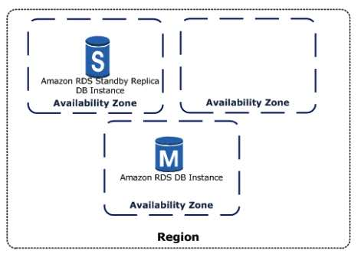
Read Replicas
- Updates made to the source DB instance are asynchronously copied to the Read Replica.
- You can reduce the load on your source DB instance by routing read queries from your applications to the Read Replica.
- You can elastically scale out beyond the capacity constraints of a single DB instance for read-heavy database workloads.
- You can create a Read Replica that has a different storage type from the source DB instance.
- A source DB instance can have cross-region Read Replicas in multiple regions. Due to the limit on the number of access control list (ACL) entries for a VPC, cannot have more than five cross-region Read Replica instances.
- PostgreSQL does physical replication. MySQL and MariaDB do logical replication.
- You can create a manual snapshot of a PostgreSQL Read Replica, but you can’t enable automatic backups. You can enable automatic backups on a MySQL or MariaDB Read Replica.
- When creating a Read Replica, there are a few things to consider.
  - Enable automatic backups on the source DB instance by setting the backup retention period to a value other than 0.
  - Automatic backups are supported only for Read Replicas running MySQL 5.6 and later.
- Oracle supports Read Replicas with Active Data Guard for customers who are using the Bring Your Own License model with Oracle Database Enterprise Edition and have licensed the Active Data Guard Option. This feature allows RDS Oracle customers to offload their read workload from the primary DB Instance, and also supports the scalability of read workloads over a farm of up to five read replicas.
- You can promote a Read Replica to become a standalone DB instance.
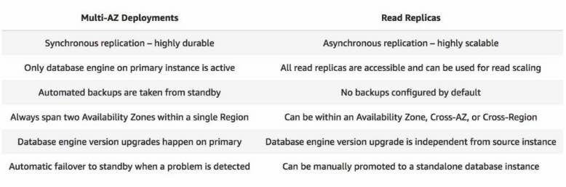
Backups and Restores
- Your DB instance must be in the ACTIVE state for automated backups to occur. Automated backups and automated snapshots don’t occur while a copy is executing in the same region for the same DB instance.
- The first snapshot of a DB instance contains the data for the full DB instance. Subsequent snapshots of the same DB instance are incremental.
- The default backup retention period is one day if you create the DB instance using the RDS API or the AWS CLI, or seven days if you used the AWS Console.
- Manual snapshot limits are limited to 100 per region.
- You can copy a snapshot within the same AWS Region, you can copy a snapshot across AWS Regions, and you can copy a snapshot across AWS accounts.
- When you restore a DB instance to a point in time, the default DB parameter and default DB security group is applied to the new DB instance.
- When you restore an Oracle DB instance to a point in time, you can specify a different Oracle DB engine, license model, and DBName to be used.
- You can restore SQL Server native backups onto SQL Server DB instances that have read replicas configured.
- When you restore a SQL Server DB instance to a point in time, each database within that instance is restored to a point in time within 1 second of each other database within the instance.
- You can retain Amazon RDS automated backups (system snapshots and transaction logs) when you delete a database instance.
- You can export Amazon RDS or Amazon Aurora snapshots to Amazon S3 as Apache Parquet.
Amazon Relational Database Service Monitoring
- Amazon CloudWatch
- RDS Events
  - An Amazon RDS event is created when the reboot is completed.
  - Be notified when changes occur with a DB instance, DB snapshot, DB parameter group, or DB security group.
  - Uses the Amazon Simple Notification Service (SNS) to provide notification when an Amazon RDS event occurs.
- Database log files
- Using enhanced monitoring to identify operating system issues for the following:
  - MariaDB
  - Microsoft SQL Server
  - MySQL version 5.5 or later
  - Oracle
  - PostgreSQL
- Enhanced monitoring is available for all DB instance classes except for db.m1.small.
- Enhance monitoring metrics include:
  - IOPS – the number of I/O operations completed each second.
  - Latency – the elapsed time between the submission of an I/O request and its completion.
  - Throughput – the number of bytes each second that are transferred to or from disk.
  - Queue Depth – the number of I/O requests in the queue waiting to be serviced.
- CloudWatch gathers metrics about CPU utilization from the hypervisor for a DB instance, and Enhanced Monitoring gathers its metrics from an agent on the instance.
- Instance Status – indicates the health of the instance. Here are some statuses:
DB Instance Status | Billed | Description
available | Billed | The instance is healthy and available.
backing-up | Billed | The instance is currently being backed up.
creating | Not billed | The instance is being created. The instance is inaccessible while it is being created.
deleting | Not billed | The instance is being deleted.
failed | Not billed | The instance has failed and Amazon RDS can’t recover it. Perform a point-in-time restore to the latest restorable time of the instance to recover the data.
maintenance | Billed | Amazon RDS is applying a maintenance update to the DB instance. This status is used for instance-level maintenance that RDS schedules well in advance.
rebooting | Billed | The instance is being rebooted because of a customer request or an Amazon RDS process that requires the rebooting of the instance.
starting | Billed for storage | The DB instance is starting.
stopped | Billed for storage | The DB instance is stopped.
stopping | Billed for storage | The DB instance is being stopped.
storage-full | Billed | The instance has reached its storage capacity allocation. This is a critical status, and we recommend that you fix this issue immediately. To do so, scale up your storage by modifying the DB instance. To avoid this situation, set Amazon CloudWatch alarms to warn you when storage space is getting low.

- RDS Performance Insights monitors your DB instance load so that you can analyze and troubleshoot your database performance. You can visualize the database load and filter the load by waits, SQL statements, hosts, or users.
- CloudTrail captures all API calls for RDS as events.
RDS Proxy
- Amazon RDS Proxy is a fully managed, highly available database proxy for RDS that makes applications more scalable, more resilient to database failures, and more secure.
- RDS Proxy allows applications to pool and share connections established with the database so you won’t have to use up your database memory and compute resources just for database connections.
- RDS Proxy lets you create multiple endpoints with their own VPC settings, enabling access to your Aurora or RDS databases from applications in a different VPC.
- It also lets you create a read-only endpoint to connect your applications to Amazon Aurora Replicas.
Amazon Relational Database Service Pricing
- With Amazon RDS, you pay only for the RDS instances that are active.
- The data transferred for cross-region replication incurs RDS data transfer charges.
- Instances are billed for DB instance hours (per second), Storage (per GiB per month), I/O requests (per 1 million requests per month), Provisioned IOPS (per IOPS per month), Backup storage (per GiB per month), and Data transfer (per GB).
  - Amazon RDS is billed in one-second increments for database instances and attached storage. Pricing is still listed on a per-hour basis, but bills are now calculated down to the second and show usage in decimal form. There is a 10 minute minimum charge when an instance is created, restored or started.
- RDS purchasing options:
  - On-Demand Instances – Pay by the hour for the DB instance hours that you use.
  - Reserved Instances – Reserve a DB instance for a one-year or three-year term and receive a significant discount compared to the on-demand DB instance pricing.
- You are charged for using Enhanced Monitoring.
- Amazon RDS is now billed in one-second increments for database instances and attached storage. Pricing is still listed on a per-hour basis, but bills are now calculated down to the second and show usage in decimal form. There is a 10 minute minimum charge when an instance is created, restored or started.
Best Practices

- Monitor your memory, CPU, and storage usage.
- Scale up your DB instance when you are approaching storage capacity limits.
- Enable automatic backups and set the backup window to occur during the daily low in write IOPS.
- If your database workload requires more I/O than you have provisioned, recovery after a failover or database failure will be slow. Increase the I/O capacity of a DB instance by:
  - Migrate to a DB instance class with High I/O capacity.
  - Convert from standard storage to either General Purpose or Provisioned IOPS storage, depending on how much of an increase you need.
  - If you convert to Provisioned IOPS storage, make sure you also use a DB instance class that is optimized for Provisioned IOPS..
  - If you are already using Provisioned IOPS storage, provision additional throughput capacity.
- If your client application is caching the Domain Name Service (DNS) data of your DB instances, set a time-to-live (TTL) value of less than 30 seconds.
- Test failover for your DB instance.
Amazon RDS Tutorial on YouTube:
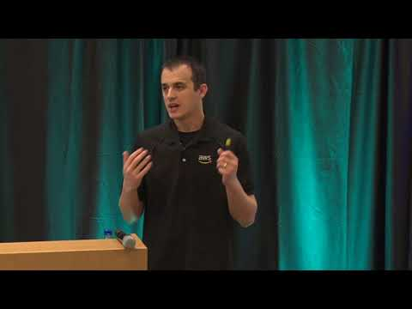
Amazon RDS-related Cheat Sheets:
- Amazon RDS vs DynamoDB
Note: If you are studying for the AWS Certified Data Engineer Associate exam, we highly recommend that you take our AWS Certified Data Engineer Associate Practice Exams and read our Data Engineer Associate exam study guide.

Validate Your Knowledge
Question 1
A customer has a popular website that has millions of viewers from all over the world and has read-heavy database workloads. Which of the following is the best option to use to increase the read throughput on their database?
- Enable Multi-AZ deployments
- Enable Amazon RDS Standby Replicas
- Enable Amazon RDS Read Replicas
- Use Amazon SQS to queue up the requests
Show me the answer!
Correct Answer: 3
Amazon RDS Read Replicas provide enhanced performance and durability for database (DB) instances. This feature makes it easy to elastically scale out beyond the capacity constraints of a single DB instance for read-heavy database workloads.
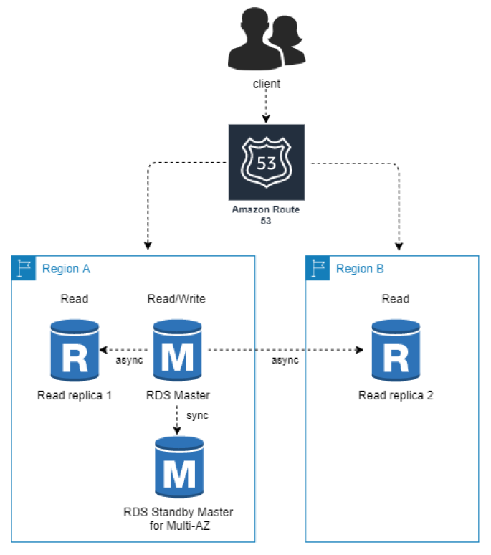
You can create one or more replicas of a given source DB Instance and serve high-volume application read traffic from multiple copies of your data, thereby increasing aggregate read throughput. Read replicas can also be promoted when needed to become standalone DB instances. Read replicas are available in Amazon RDS for MySQL, MariaDB, Oracle, and PostgreSQL as well as Amazon Aurora.
Hence, the correct answer is: Enable Amazon RDS Read Replicas.
The option that says: Enable Multi-AZ deployments is incorrect because the Multi-AZ deployments feature is mainly used to achieve high availability and failover support for your database.
The option that says: Enable Amazon RDS Standby Replicas is incorrect because a Standby replica is used in Multi-AZ deployments and hence, it is not a solution to reduce read-heavy database workloads.
The option that says: Use Amazon SQS to queue up the requests is incorrect. Although an SQS queue can effectively manage the requests, it won’t be able to entirely improve the read-throughput of the database by itself.
References:
https://aws.amazon.com/rds/details/read-replicas/
https://aws.amazon.com/premiumsupport/knowledge-center/create-read-replica-rds/
Note: This question was extracted from our AWS Certified Cloud Practitioner Practice Exams.
Question 2
A Database Specialist manages an Amazon RDS for MySQL 5.6 Multi-AZ DB instance and wants to offload read-only queries by creating an RDS read replica. After running the AWS CLI command, create-db-instance-read-replica, an error occurs, and the read replica was not successfully created.
What is most likely causing the issue?
- The proper AWS CLI command to create a read replica for RDS is CreateDBInstance.
- The backup retention period of the RDS DB instance is 0.
- The source DB instance used in the create-db-instance-read-replica command is another read replica.
- The source DB instance has to be converted to Single-AZ first to create a read replica from it.
Show me the answer!
Correct Answer: 2
When you create a read replica, you first specify an existing DB instance as the source. Then Amazon RDS takes a snapshot of the source instance and creates a read-only instance from the snapshot. Amazon RDS then uses the asynchronous replication method for the DB engine to update the read replica whenever there is a change to the primary DB instance. The read replica operates as a DB instance that allows only read-only connections. Applications connect to a read replica the same way they do to any DB instance. Amazon RDS replicates all databases in the source DB instance.
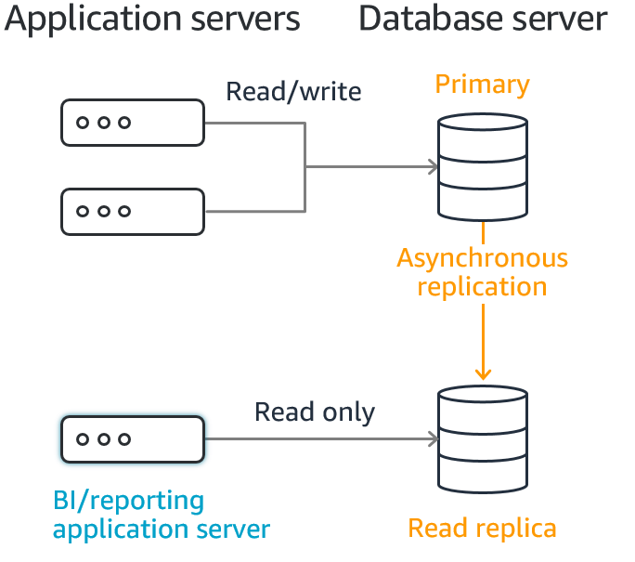
When creating a read replica, there are a few things to consider. First, you must enable automatic backups on the source DB instance by setting the backup retention period to a value other than 0. This requirement also applies to a read replica that is the source DB instance for another read replica. For MySQL DB instances, automatic backups are supported only for read replicas running MySQL 5.6 and later, but not for MySQL versions 5.5. To enable automatic backups on an Amazon RDS MySQL version 5.6 and later read replica, first create the read replica, then modify the read replica to enable automatic backups.
Hence, the correct answer is: The backup retention period of the RDS DB instance is 0.
The option that says: The proper AWS CLI command to create a read replica for RDS is CreateDBInstance is incorrect. This choice is correct if used to create an instance for an Amazon Aurora DB Cluster (applicable to Aurora read replicas).
The option that says: The source DB instance used in the create-db-instance-read-replica command is another read replica is incorrect as explained above.
The option that says: The source DB instance has to be converted to Single-AZ first to create a read replica from it is incorrect. You can create a read replica from either single-AZ or Multi-AZ DB instance deployments.
References:
https://docs.aws.amazon.com/AmazonRDS/latest/UserGuide/USER_ReadRepl.html
https://docs.aws.amazon.com/AmazonRDS/latest/UserGuide/USER_MySQL.Replication.ReadReplicas.html
Note: This question was extracted from our AWS Certified Database Specialty Practice Exams.
For more AWS practice exam questions with detailed explanations, visit the Tutorials Dojo Portal:

Additional Training Materials: Amazon RDS Video Courses on Udemy
- AWS Data Architect Bootcamp – 43 Services 500 FAQs 20+ Tools
- Oracle Database on AWS: Exploring EC2 & RDS from scratch
Amazon RDS Cheat Sheet References:
https://docs.aws.amazon.com/AmazonRDS/latest/UserGuide/
https://aws.amazon.com/rds/features/
https://aws.amazon.com/rds/pricing/
https://aws.amazon.com/rds/faqs/
-------------------------------- ----------------------------------- --------------------------------------------
https://tutorialsdojo.com/amazon-redshift/
Amazon Redshift Cheat Sheet
- A fully managed, petabyte-scale data warehouse service.
- Redshift extends data warehouse queries to your data lake. You can run analytic queries against petabytes of data stored locally in Redshift, and directly against exabytes of data stored in S3.
- RedShift is an OLAP type of DB.

- Currently, Redshift only supports Single-AZ deployments.
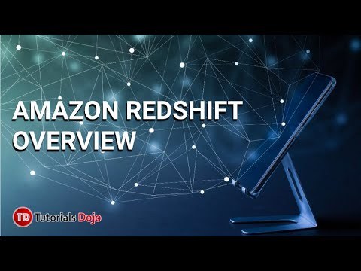
- Features
  - Redshift uses columnar storage, data compression, and zone maps to reduce the amount of I/O needed to perform queries.
  - It uses a massively parallel processing data warehouse architecture to parallelize and distribute SQL operations.
  - Redshift uses machine learning to deliver high throughput based on your workloads.
  - Redshift uses result caching to deliver sub-second response times for repeat queries.
  - Redshift automatically and continuously backs up your data to S3. It can asynchronously replicate your snapshots to S3 in another region for disaster recovery.
Components

  - Cluster – a set of nodes, which consists of a leader node and one or more compute nodes.
    - Redshift creates one database when you provision a cluster. This is the database you use to load data and run queries on your data.
    - You can scale the cluster in or out by adding or removing nodes. Additionally, you can scale the cluster up or down by specifying a different node type.
    - Redshift assigns a 30-minute maintenance window at random from an 8-hour block of time per region, occurring on a random day of the week. During these maintenance windows, your cluster is not available for normal operations.
    - Redshift supports both the EC2–VPC and EC2-Classic platforms to launch a cluster. You create a cluster subnet group if you are provisioning your cluster in your VPC, which allows you to specify a set of subnets in your VPC.
  - Redshift Nodes
    - The leader node receives queries from client applications, parses the queries, and develops query execution plans. It then coordinates the parallel execution of these plans with the compute nodes and aggregates the intermediate results from these nodes. Finally, it returns the results back to the client applications.
    - Compute nodes execute the query execution plans and transmit data among themselves to serve these queries. The intermediate results are sent to the leader node for aggregation before being sent back to the client applications.
    - Node Type
      - Dense storage (DS) node type – for large data workloads and use hard disk drive (HDD) storage.
      - Dense compute (DC) node types – optimized for performance-intensive workloads. Uses SSD storage.
  - Parameter Groups – a group of parameters that apply to all of the databases that you create in the cluster. The default parameter group has preset values for each of its parameters, and it cannot be modified.
- Database Querying Options
  - Connect to your cluster and run queries on the AWS Management Console with the Query Editor.
  - You can use the Query editor with Redshift clusters enabled and with enhanced VPC routing. Leverage AWS Secrets Manager to store your cluster credentials and use that with the Query Editor.
  - Connect to your cluster through a SQL client tool using standard ODBC and JDBC connections.
- Enhanced VPC Routing
  - By using Enhanced VPC Routing, you can use VPC features to manage the flow of data between your cluster and other resources.
  - You can also use VPC flow logs to monitor COPY and UNLOAD traffic.
- RedShift Spectrum
  - Enables you to run queries against exabytes of data in S3 without having to load or transform any data.
  - Redshift Spectrum supports Enhanced VPC Routing.
  - If you store data in a columnar format, Redshift Spectrum scans only the columns needed by your query, rather than processing entire rows.
  - If you compress your data using one of Redshift Spectrum’s supported compression algorithms, less data is scanned.
- RedShift Streaming Ingestion
  - Allows you to consume and process data directly from a streaming source to a Redshift cluster using SQL.
  - Streaming ingestion eliminates the need for staging data in Amazon S3, which gives you a low-latency, high-speed ingestion.
  - Valid data source:

      - Amazon Kinesis Data Streams
      - Amazon Managed Streaming for Apache Kafka (MSK)
- Redshift ML
  - Allows you to train and deploy machine learning models using the data stored in your Amazon Redshift cluster through a simple CREATE MODEL SQL statement.
  - You can make in-database local inferences using SQL, eliminating the need to move data between Redshift and other storage services like Amazon S3.
  - Redshift ML uses Amazon SageMaker Autopilot behind the scenes to find the best model based on your input data.
- Redshift Data Sharing
  - Redshift Data Sharing is a secure way to share live data across Redshift clusters within an AWS account, without the need to copy or move data.
  - Data Sharing provides live access to the data so that your users always see the most up-to-date and consistent information as it is updated in the data warehouse.
  - Can be used on Redshift RA3 clusters at no additional cost.
- Redshift Cross-Database Query
  - Redshift Cross-database queries provide the ability to query across databases in a Redshift cluster, regardless of which database you are connected to.
  - Available on Redshift RA3 node types at no additional cost.
- Cluster Snapshots
  - Point-in-time backups of a cluster. There are two types of snapshots: automated and manual. Snapshots are stored in S3 using SSL.
  - Redshift periodically takes incremental snapshots of your data every 8 hours or 5 GB per node of data change.
  - Redshift provides free storage for snapshots that is equal to the storage capacity of your cluster until you delete the cluster. After you reach the free snapshot storage limit, you are charged for any additional storage at the normal rate.
  - Automated snapshots are enabled by default when you create a cluster. These snapshots are deleted at the end of a retention period, which is one day, but you can modify it. You cannot delete an automated snapshot manually.
  - By default, manual snapshots are retained indefinitely, even after you delete your cluster.
  - You can share an existing manual snapshot with other AWS accounts by authorizing access to the snapshot.
  - You can configure Amazon Redshift to automatically copy snapshots (automated or manual) for a cluster to another AWS Region. For automated snapshots, you can also specify the retention period to keep them in the destination AWS Region. The default retention period for copied snapshots is seven days.
  - If you store a copy of your snapshots in another AWS Region, you can restore your cluster from recent data if anything affects the primary AWS Region. You can configure your cluster to copy snapshots to only one destination AWS Region at a time.

Amazon Redshift Monitoring

  - Use the database audit logging feature to track information about authentication attempts, connections, disconnections, changes to database user definitions, and queries run in the database. The logs are stored in S3 buckets.
  - Redshift tracks events and retains information about them for a period of several weeks in your AWS account.
  - Redshift provides performance metrics and data so that you can track the health and performance of your clusters and databases. It uses CloudWatch metrics to monitor the physical aspects of the cluster, such as CPU utilization, latency, and throughput.
  - Query/Load performance data helps you monitor database activity and performance.
  - When you create a cluster, you can optionally configure a CloudWatch alarm to monitor the average percentage of disk space that is used across all of the nodes in your cluster, referred to as the default disk space alarm.
Amazon Redshift Security

  - By default, an Amazon Redshift cluster is only accessible to the AWS account that creates the cluster.
  - Use IAM to create user accounts and manage permissions for those accounts to control cluster operations.
  - If you are using the EC2-Classic platform for your Redshift cluster, you must use Redshift security groups.
  - If you are using the EC2-VPC platform for your Redshift cluster, you must use VPC security groups.
  - When you provision the cluster, you can optionally choose to encrypt the cluster for additional security. Encryption is an immutable property of the cluster.
  - Snapshots created from the encrypted cluster are also encrypted.
Amazon Redshift Pricing

  - You pay a per-second billing rate based on the type and number of nodes in your cluster.
  - You pay for the number of bytes scanned by RedShift Spectrum
  - You can reserve instances by committing to using Redshift for a 1 or 3-year term and save costs.
Deep Dive and Best Practices for Amazon Redshift:
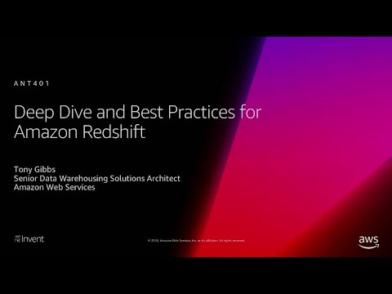
Validate Your Knowledge
Question 1
A financial services company based in Australia uses Amazon Redshift for its data-warehousing solutions. They have expanded recently in Singapore and is designing a solution that would integrate queries between data from an Amazon RDS for PostgreSQL database in Singapore with data from the Redshift cluster in Sydney.
Which solution will best simplify the integration between these data sources?
- Configure cross-regional snapshots with Redshift cluster and restore a new cluster with the latest snapshot in Singapore. Export the PostgreSQL tables to an S3 bucket and load it to the new Amazon Redshift cluster.
- Configure cross-regional snapshots with Redshift cluster and restore a new cluster with the latest snapshot in Singapore. Export the PostgreSQL tables to an S3 bucket. Create an external schema and external tables from the S3 files and use Redshift Spectrum to query from S3 and the new Redshift cluster.
- Set up connectivity from your Amazon Redshift cluster to your Amazon RDS PostgreSQL cluster. Create an external schema from the PostgreSQL database and use federated queries to access both sources.
- Export the RDS PostgreSQL tables to an S3 bucket. Create an external schema and external tables from the S3 files and use Redshift Spectrum to query from S3 and the new Redshift cluster.
Show me the answer!
Correct Answer: 3
Previously, you need to extract data from your PostgreSQL database to Amazon Simple Storage Service (Amazon S3) and load it to Amazon Redshift using COPY, or query it from Amazon S3 with Amazon Redshift Spectrum. Now, Amazon Redshift Federated Query enables you to use the analytic power of Amazon Redshift to directly query data stored in Amazon Aurora PostgreSQL and Amazon RDS for PostgreSQL databases.
With Federated queries, you can query and analyze data across operational databases, data warehouses, and data lakes. This feature can integrate queries from Amazon Redshift on live data in external databases with queries across your Amazon Redshift and Amazon S3 environments.
In some cases, you might access an Amazon RDS or Aurora database in a different AWS region than Amazon Redshift. In these cases, you typically incur network latency and billing charges for transferring data across AWS regions. However, the scenario asks for a solution that simplifies the integration between the two sources.
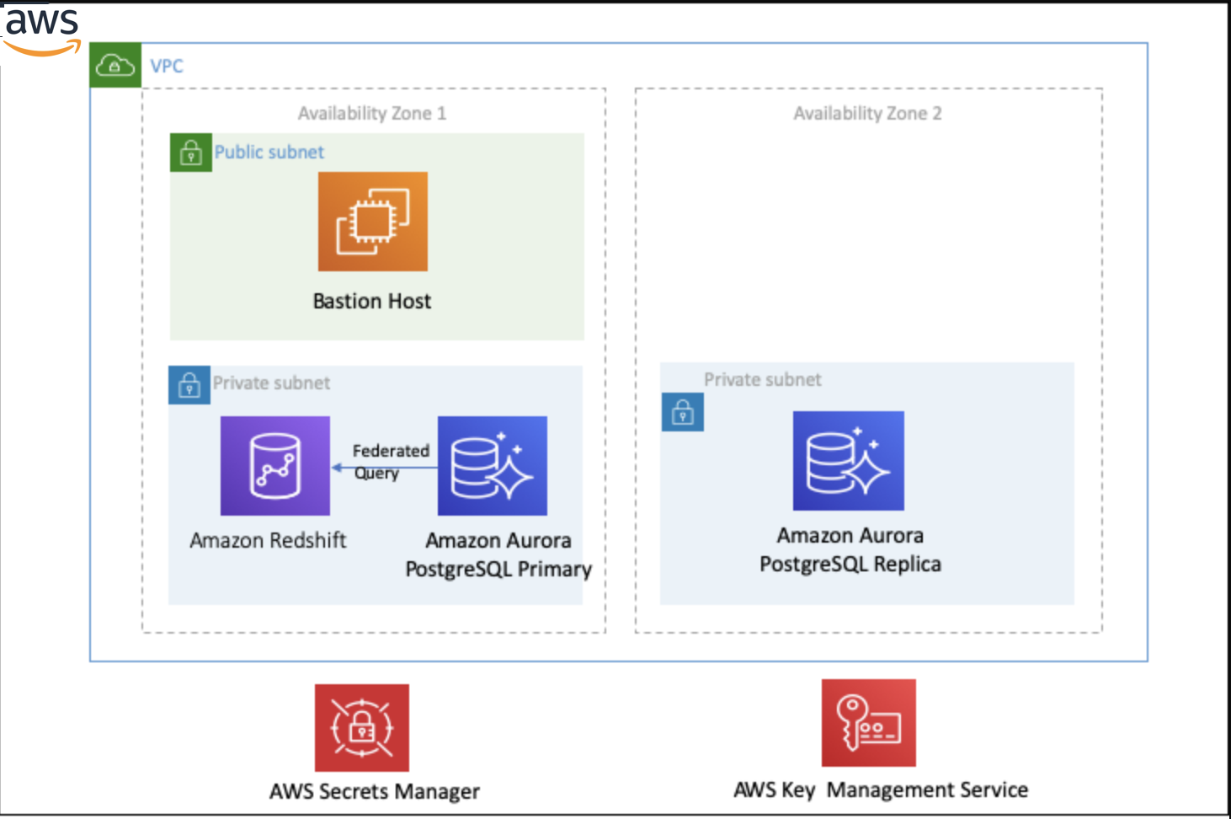
Therefore, the correct answer is: Set up connectivity from your Amazon Redshift cluster to your Amazon RDS PostgreSQL cluster. Create an external schema from the PostgreSQL database and use federated queries to access both sources.
The three other options are all incorrect:
– Configure cross-regional snapshots with Redshift cluster and restore a new cluster with the latest snapshot in Singapore. Export the PostgreSQL tables to an S3 bucket and load it to the new Amazon Redshift cluster
– Configure cross-regional snapshots with Redshift cluster and restore a new cluster with the latest snapshot in Singapore. Export the PostgreSQL tables to an S3 bucket. Create an external schema and external tables from the S3 files and use Redshift Spectrum to query from S3 and the new Redshift cluster.
– Export the RDS PostgreSQL tables to an S3 bucket. Create an external schema and external tables from the S3 files and use Redshift Spectrum to query from S3 and the new Redshift cluster.
Although they are working solutions, using Federated Queries is the most simplified solution among the choices.
References:
https://docs.aws.amazon.com/redshift/latest/dg/federated-overview.html
https://aws.amazon.com/blogs/big-data/amazon-redshift-federated-query-best-practices-and-performance-considerations/
Note: This question was extracted from our AWS Certified Database Specialty Practice Exams.
Question 2
A Database Specialist manages an Amazon Redshift cluster for the company’s data warehousing solution. Keeping track of the maintenance tasks that run on the cluster, the Database Manager wants to receive e-mail notifications as soon as the cluster goes into and outside of maintenance mode and is advised if the maintenance was customer-initiated.
How should the Database Specialist meet this requirement with the least operational effort?
- Using the Redshift console, create an event subscription that sends a notification for Management events.
- Work with Amazon Redshift’s performance data metrics and create an alarm whenever the Maintenance Mode unit value is 1. Use Amazon SNS to send an e-mail.
- Write an AWS Lambda function to trigger on AWS CloudTrail API calls. Filter on specific Redshift API calls and create an Amazon SNS topic to send the notifications.

- Create an Amazon EventBridge rule with the operations that need to be tracked on the Redshift Cluster. Create an AWS Lambda function to act on these rules and use Amazon SNS to send an e-mail.
Show me the answer!
Correct Answer: 1
Amazon Redshift uses the Amazon Simple Notification Service (Amazon SNS) to communicate notifications of Amazon Redshift events. You enable notifications by creating an Amazon Redshift event subscription. In the Amazon Redshift subscription, you specify a set of filters for Amazon Redshift events and an Amazon SNS topic.
Whenever an event occurs that matches the filter criteria, Amazon Redshift publishes a notification message to the Amazon SNS topic. Amazon SNS then transmits the message to an Amazon SNS consumer with an Amazon SNS subscription to the topic. Amazon SNS can support the messages sent to the Amazon SNS consumers for an AWS Region, such as an e-mail, a text message, or a call to an HTTP endpoint.
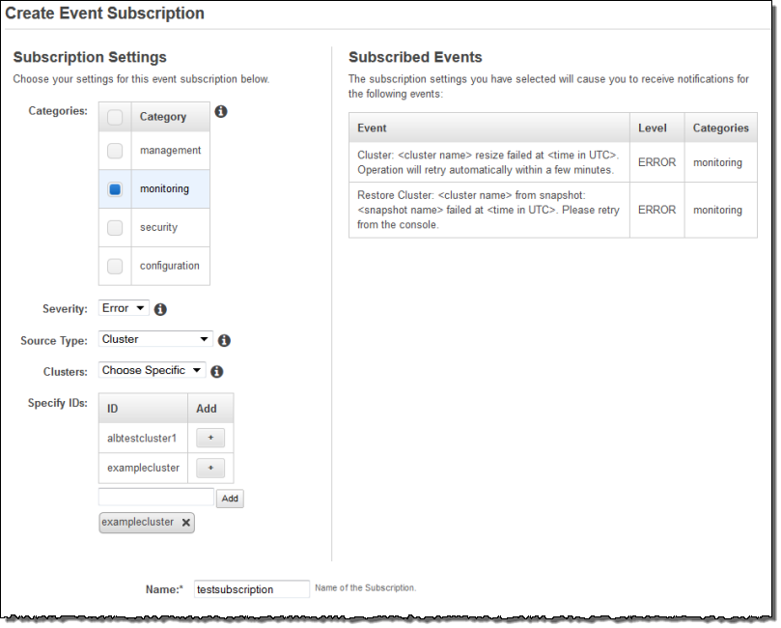
When you create an event notification subscription, you specify one or more event filters. Amazon Redshift sends notifications through the subscription at any time an event matches all of the filter criteria.
You can set up event notifications for Amazon Redshift clusters to receive notifications regarding on-going or completed maintenance. After you create the proper event subscription, you receive notifications with the following event codes:
– REDSHIFT-EVENT-2003 for Amazon Redshift maintenance in progress.
– REDSHIFT-EVENT-2004 for Amazon Redshift maintenance that is complete.
Note: Amazon Redshift scheduled maintenance doesn’t trigger an event.
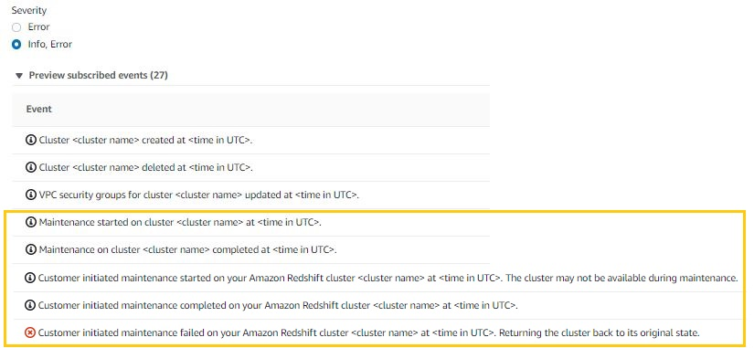
All choices can help notify the Manager whenever the cluster is in maintenance mode. However, the solution that addresses the requirement with the least operational effort is the option that says: Using the Redshift console, create an event subscription that sends a notification for Management events.
The option that says: Create an Amazon EventBridge rule with the operations that need to be tracked on the Redshift Cluster. Create an AWS Lambda function to act on these rules and use Amazon SNS to send an e-mail is incorrect. Although this is a possible solution, it requires more effort to implement the solution.
The option that says: Work with Amazon Redshift’s performance data metrics and create an alarm whenever the Maintenance Mode unit value is 1. Use Amazon SNS to send an e-mail is incorrect. Although the solution will work and does not need too much effort to implement, CloudWatch Alarms cannot identify if the maintenance mode was customer-initiated.
The option that says: Write an AWS Lambda function to trigger on AWS CloudTrail API calls. Filter on specific Redshift API calls and create an Amazon SNS topic to send the notifications is incorrect. Although this is a possible solution, it requires more effort to implement the solution.
Reference:
https://docs.aws.amazon.com/redshift/latest/mgmt/working-with-event-notifications.html
https://aws.amazon.com/premiumsupport/knowledge-center/notification-maintenance-rds-redshift/
https://docs.aws.amazon.com/redshift/latest/mgmt/performance-metrics-perf.html
https://docs.aws.amazon.com/redshift/latest/mgmt/performance-metrics-alarms.html
Note: This question was extracted from our AWS Certified Database Specialty Practice Exams.
For more AWS practice exam questions with detailed explanations, check out the Tutorials Dojo Portal:

Additional Training Materials: Amazon Redshift Video Courses on Udemy
- Mastering Amazon Redshift – Development and Administration
- Hands-on with Amazon Redshift
- AWS Serverless Analytics: Glue, Redshift, Athena, QuickSight
Amazon Redshift Cheat Sheet References:
https://docs.aws.amazon.com/redshift/latest/mgmt/
https://aws.amazon.com/redshift/features/
https://aws.amazon.com/redshift/pricing/
https://aws.amazon.com/redshift/faqs/
-------------------------------- ------------------------------------ ------------------------------------------
https://tutorialsdojo.com/aws-database-migration-service/
AWS Database Migration Service Cheat Sheet
- AWS Database Migration Service supports homogeneous migrations such as Oracle to Oracle, as well as heterogeneous migrations between different database platforms, such as Oracle or Microsoft SQL Server to Amazon Aurora.
- You can use Database Migration Service for one-time data migration into RDS and EC2-based databases.

- You can also continuously replicate your data with high availability (enable multi-AZ) and consolidate databases into a petabyte-scale data warehouse by streaming data to Amazon Redshift and Amazon S3.
- Continuous replication can be done from your data center to the databases in AWS or the reverse.
- Replication between on-premises to on-premises databases is not supported.
- The service provides an end-to-end view of the data replication process, including diagnostic and performance data for each point in the replication pipeline.
- Supports transaction commit date partitioning in CDC Mode when you select Amazon S3 as a target. You can write data from a single source table to a time-hierarchy folder structure in Amazon S3.
Supported Sources | Supported targets
- Oracle  - Microsoft SQL Server non-Web and Express editions  - MySQL  - MariaDB  - PostgreSQL  - MongoDB  - SAP Adaptive Server Enterprise (ASE)  - IBM Db2 for Linux, UNIX, and Windows  - Azure SQL Database  - Amazon DocumentDB  - Amazon S3 | - Oracle  - Microsoft SQL Server non-Web and Express editions  - MySQL  - MariaDB  - PostgreSQL  - SAP Adaptive Server Enterprise (ASE)  - Amazon Aurora with MySQL or PostgreSQL compatibility  - Amazon Aurora Serverless  - Amazon Redshift  - Amazon S3  - Amazon DynamoDB  - Amazon Elasticsearch Service  - Amazon Kinesis Data Streams  - Amazon DocumentDB (with MongoDB compatibility)  - Amazon Neptune  - Apache Kafka
AWS Schema Conversion Tool (SCT)

  - The AWS Schema Conversion Tool makes heterogeneous database migrations predictable by automatically converting the source database schema and a majority of the database code objects, including views, stored procedures, and functions, to a format compatible with the target database.
  - SCT can also scan your application source code for embedded SQL statements and convert them as part of a database schema conversion project.
  - Supported migrations
Source Database | Target Database
Microsoft SQL Server | Amazon Aurora with MySQL or PostgreSQL, MariaDB, Microsoft SQL Server, MySQL, PostgreSQL
MySQL | Aurora PostgreSQL, MySQL, PostgreSQL  You can migrate schema and data from MySQL to an Aurora MySQL DB cluster without using AWS SCT.
Oracle Database | Aurora MySQL or PostgreSQL, MariaDB, MySQL, Oracle, PostgreSQL
PostgreSQL | Aurora MySQL, MySQL, PostgreSQL, Aurora PostgreSQL
IBM Db2 LUW | Aurora MySQL, MariaDB, MySQL, PostgreSQL, Aurora PostgreSQL
Sybase ASE | Aurora MySQL, Aurora PostgreSQL, MySQL, PostgreSQL
Oracle Data Warehouse, Microsoft SQL Server, Teradata, IBM Netezza, Greenplum, HPE Vertica | Amazon Redshift
Apache Cassandra | Amazon DynamoDB

Basic Schema Copy

  - To quickly migrate a database schema to your target instance you can rely on the Basic Schema Copy feature of AWS Database Migration Service.
  - Basic Schema Copy will automatically create tables and primary keys in the target instance if the target does not already contain tables with the same names.
  - It will not migrate secondary indexes, foreign keys or stored procedures. When you need to use a more customizable schema migration process, use AWS SCT.
AWS Database Migration Service Pricing

  - You only pay for the compute resources used during the migration process and any additional log storage. Each database migration instance includes storage sufficient for swap space, replication logs, and data cache for most replications and inbound data transfer is free.
Note: If you are studying for the AWS Certified Data Engineer Associate exam, we highly recommend that you take our AWS Certified Data Engineer Associate Practice Exams and read our Data Engineer Associate exam study guide.
-------------------------------- ------------------------------------ ------------------------------------------
https://tutorialsdojo.com/aws-datasync/

AWS DataSync Cheat Sheet
- An online data transfer service that simplifies, automates, and accelerates copying large amounts of data to and from AWS storage services over the internet or AWS Direct Connect.
- DataSync can copy data between:
  - Network File System (NFS) or Server Message Block (SMB) file servers,
  - Amazon Simple Storage Service (Amazon S3) buckets,
  - Amazon Elastic File System (Amazon EFS) file systems,
  - Amazon FSx for Windows File Server file systems
How It Works
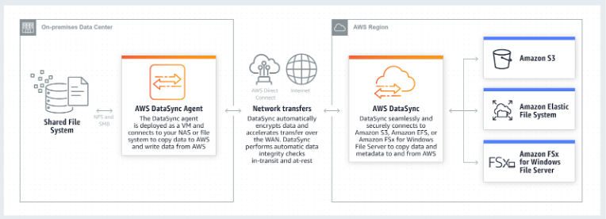

  - Deploy an agent – Deploy a DataSync agent and associate it to your AWS account via the Management Console or API. The agent will be used to access your NFS server or SMB file share to read data from it or write data to it.
  - Create a data transfer task – Create a task by specifying the location of your data source and destination, and any options you want to use to configure the transfer, such as the desired task schedule.
  - Start the transfer – Start the task and monitor data movement in the console or with Amazon CloudWatch.
Concepts

  - Agent – A virtual machine used to read data from or write data to an on-premises location.
  - Location – Any source or destination location used in the data transfer.
  - Task – A task includes two locations (source and destination), and also the configuration of how to transfer the data from one location to the other. Configuration settings can include options such as how to treat metadata, deleted files, and copy permission.
  - Task execution – An individual run of a task, which includes options such as start time, end time, bytes written, and status. A task execution has five transition phases and two terminal statuses, as shown in the following diagram. If the VerifyMode option is not enabled, a terminal status occurs after the TRANSFERRING phase. Otherwise, it occurs after the VERIFYING phase.
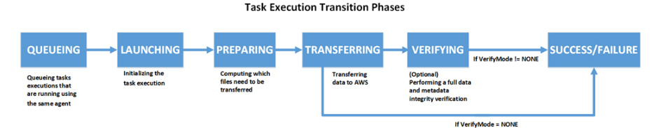
Features

  - The service employs an AWS-designed transfer protocol—decoupled from storage protocol—to speed data movement. The protocol performs optimizations on how, when, and what data is sent over the network.
  - A single DataSync agent is capable of saturating a 10 Gbps network link.
  - DataSync auto-scales cloud resources to support higher-volume transfers, and makes it easy to add agents on-premises.
  - All of your data is encrypted in transit with TLS. DataSync supports using default encryption for S3 buckets using Amazon S3-Managed Encryption Keys (SSE-S3), and Amazon EFS file system encryption of data at rest.
  - DataSync supports storing data directly into S3 Standard, S3 Intelligent-Tiering, S3 Standard-Infrequent Access (S3 Standard-IA), S3 One Zone-Infrequent Access (S3 One Zone-IA), Amazon S3 Glacier, and S3 Glacier Deep Archive.
  - You can use AWS DataSync to copy files into EFS and configure EFS Lifecycle Management to migrate files that have not been accessed for a set period of time to the Infrequent Access (IA) storage class.
  - DataSync ensures that your data arrives intact by performing integrity checks both in transit and at rest.
  - You can specify an exclude filter, an include filter, or both, to limit which files, folders, or objects get transferred each time a task runs.
  - Task scheduling enables you to configure periodically executing a task, to detect and copy changes from your source storage system to the destination.
  - DataSync supports VPC endpoints (powered by AWS PrivateLink) in order to move files directly into your Amazon VPC.
Use Cases

  - Data migration to Amazon S3, Amazon EFS, or Amazon FSx for Windows File Server.
  - Data processing for hybrid workloads. If you have on-premises systems generating or using data that needs to move into or out of AWS for processing, you can use DataSync to accelerate and schedule the transfers.
  - If you have large amounts of cold data stored in expensive on-premises storage systems, you can move this data directly to durable and secure long-term storage such as Amazon S3 Glacier or Amazon S3 Glacier Deep Archive.
  - If you have large Network Attached Storage (NAS) systems with important files that need to be protected, you can replicate them into S3 using DataSync.
- DataSync Agent
  - Agents need to be activated first using an activation key entered in the AWS console, before you can start using them. You must activate your agent in the same region where your S3 or EFS source/destination resides.
  - You run DataSync on-premises as a virtual machine (VM).
  - DataSync provides an Amazon Machine Image (AMI) that contains the DataSync VM image when running in an EC2 instance.
  - The agent VM requires access to some endpoints to communicate with AWS. You must configure your firewall settings to allow these connections.
  - You can have more than one DataSync Agent running.
- AWS DataSync vs AWS CLI tools
  - AWS DataSync fully automates and accelerates moving large active datasets to AWS, up to 10 times faster than command line tools.
  - DataSync uses a purpose-built network protocol and scale-out architecture to transfer data.
  - DataSync fully automates the data transfer. It comes with retry and network resiliency mechanisms, network optimizations, built-in task scheduling, and CloudWatch monitoring that provides granular visibility into the transfer process.
  - DataSync performs data integrity verification both during the transfer and at the end of the transfer.
  - DataSync provides end to end security, and integrates directly with AWS storage services.
- AWS DataSync vs Snowball/Snowball Edge
  - AWS DataSync is ideal for online data transfers. AWS Snowball/ Snowball Edge is suitable for offline data transfers, for customers who are bandwidth constrained, or transferring data from remote, disconnected, or austere environments.
- AWS DataSync vs AWS Storage Gateway File Gateway
  - Use AWS DataSync to migrate existing data to Amazon S3, and then use the File Gateway to retain access to the migrated data and for ongoing updates from your on-premises file-based applications.
- AWS DataSync vs Amazon S3 Transfer Acceleration
  - If your applications are already integrated with the Amazon S3 API, and you want higher throughput for transferring large files to S3, you can use S3 Transfer Acceleration. If not, you may use AWS DataSync.
- AWS DataSync vs AWS Transfer for SFTP
  - If you currently use SFTP to exchange data with third parties, you may use AWS Transfer for SFTP to transfer directly these data.
  - If you want an accelerated and automated data transfer between NFS servers, SMB file shares, Amazon S3, Amazon EFS, and Amazon FSx for Windows File Server, you can use AWS DataSync.
AWS DataSync Pricing

  - You pay for the amount of data that you copy. Your costs are based on a flat per-gigabyte fee for the use of network acceleration technology, managed cloud infrastructure, data validation, and automation capabilities in DataSync.
  - You are charged standard request, storage, and data transfer rates to read to and write from AWS services, such as Amazon S3, Amazon EFS, Amazon FSx for Windows File Server, and AWS Key Management Service (KMS).
  - When copying data from AWS to an on-premises storage system, you pay for AWS Data Transfer at your standard rate. You are also charged standard rates for Amazon CloudWatch Logs, Amazon CloudWatch Events, and Amazon CloudWatch Metrics.
  - You will be billed by AWS PrivateLink for interface VPC endpoints that you create to manage and control the traffic between your agent(s) and the DataSync service over AWS PrivateLink.
AWS DataSync Limits
Resource | Quota
Maximum number of tasks you can create in account per AWS Region | 100
Maximum number of files per task | 50 million  For tasks that transfer more than 20 million files, make sure that you allocate a minimum of 64 GB of RAM to the VM
Maximum throughput per task | 10 Gbps
AWS DataSync References:
https://aws.amazon.com/datasync/
https://docs.aws.amazon.com/datasync/latest/userguide/what-is-datasync.html
https://aws.amazon.com/datasync/faqs/

-------------------------------- ------------------------------------ ------------------------------------------

