https://tutorialsdojo.com/amazon-api-gateway/

Amazon API Gateway Cheat Sheet
- Enables developers to create, publish, maintain, monitor, and secure APIs at any scale.
- This is a HIPAA eligible service.
- Allows creating, deploying, and managing a RESTful API to expose backend HTTP endpoints, Lambda functions, or other AWS services.
- Together with Lambda, API Gateway forms the app-facing part of the AWS serverless infrastructure.

Concepts

  - API deployment – a point-in-time snapshot of your API Gateway API resources and methods. To be available for clients to use, the deployment must be associated with one or more API stages.
  - API endpoints – host names APIs in API Gateway, which are deployed to a specific region and of the format: rest-api-id.execute-api.region.amazonaws.com
  - API key – An alphanumeric string that API Gateway uses to identify an app developer who uses your API.
  - API stage – A logical reference to a lifecycle state of your API. API stages are identified by API ID and stage name.
  - Model – Data schema specifying the data structure of a request or response payload.
  - Private API – An API that is exposed through interface VPC endpoints and isolated from the public internet
  - Private integration – An API Gateway integration type for a client to access resources inside a customer’s VPC through a private API endpoint without exposing the resources to the public internet.
  - Proxy integration – You can set up a proxy integration as an HTTP proxy integration type or a Lambda proxy integration type.
    - For the HTTP proxy integration, API Gateway passes the entire request and response between the frontend and an HTTP backend.
    - For the Lambda proxy integration, API Gateway sends the entire request as an input to a backend Lambda function.
  - Usage plan – Provides selected API clients with access to one or more deployed APIs. You can use a usage plan to configure throttling and quota limits, which are enforced on individual client API keys.
API Endpoint Types

  - Edge-optimized API endpoint: The default host name of an API Gateway API that is deployed to the specified region while using a CloudFront distribution to facilitate client access typically from across AWS regions. API requests are routed to the nearest CloudFront Point of Presence.
  - Regional API endpoint: The host name of an API that is deployed to the specified region and intended to serve clients, such as EC2 instances, in the same AWS region. API requests are targeted directly to the region-specific API Gateway without going through any CloudFront distribution.
    - You can apply latency-based routing on regional endpoints to deploy an API to multiple regions using the same regional API endpoint configuration, set the same custom domain name for each deployed API, and configure latency-based DNS records in Route 53 to route client requests to the region that has the lowest latency.
  - Private API endpoint: Allows a client to securely access private API resources inside a VPC. Private APIs are isolated from the public Internet, and they can only be accessed using VPC endpoints for API Gateway that have been granted access.
Features

  - API Gateway can execute Lambda code in your account, start Step Functions state machines, or make calls to Elastic Beanstalk, EC2, or web services outside of AWS with publicly accessible HTTP endpoints.
  - API Gateway helps you define plans that meter and restrict third-party developer access to your APIs.
  - API Gateway helps you manage traffic to your backend systems by allowing you to set throttling rules based on the number of requests per second for each HTTP method in your APIs.
  - You can set up a cache with customizable keys and time-to-live in seconds for your API data to avoid hitting your backend services for each request.
  - API Gateway lets you run multiple versions of the same API simultaneously with API Lifecycle.
  - After you build, test, and deploy your APIs, you can package them in an API Gateway usage plan and sell the plan as a Software as a Service (SaaS) product through AWS Marketplace.
  - API Gateway offers the ability to create, update, and delete documentation associated with each portion of your API, such as methods and resources.
  - Amazon API Gateway offers general availability of HTTP APIs, which gives you the ability to route requests to private ELBs AWS AppConfig, Amazon EventBridge, Amazon Kinesis Data Streams, Amazon SQS, AWS Step Functions and IP-based services registered in AWS CloudMap such as ECS tasks. Previously, HTTP APIs enabled customers to only build APIs for their serverless applications or to proxy requests to HTTP endpoints.
  - You can create data mapping definitions from an HTTP API’s method request data (e.g. path parameters, query string, and headers) to the corresponding integration request parameters and from the integration response data (e.g. headers) to the HTTP API method response parameters.
  - Use wildcard custom domain names (*.example.com) to create multiple URLs that route to one API Gateway HTTP API.
  - You can configure your custom domain name to route requests to different APIs. Using multi-level base path mappings, you can implement path-based API versioning and migrate API traffic between APIs according to request paths with many segments.
- All of the APIs created expose HTTPS endpoints only. API Gateway does not support unencrypted (HTTP) endpoints.
Amazon API Gateway Monitoring

  - API Gateway console is integrated with CloudWatch, so you get backend performance metrics such as API calls, latency, and error rates.
  - You can set up custom alarms on API Gateway APIs.
  - API Gateway can also log API execution errors to CloudWatch Logs.
Amazon API Gateway Security

  - To authorize and verify API requests to AWS services, API Gateway can help you leverage signature version 4. Using signature version 4 authentication, you can use IAM and access policies to authorize access to your APIs and all your other AWS resources.
  - You can enable AWS WAF for your APIs in Amazon API Gateway, making it easier to protect your APIs against common web exploits such as SQL injection and Cross-Site Scripting (XSS).
  - For API Gateway HTTP APIs, in addition to the previously supported OIDC/OAuth2 authorization option, you can also secure them using Lambda authorizers and IAM authorizers.
Amazon API Gateway Pricing

  - You pay only for the API calls you receive and the amount of data transferred out.
  - API Gateway also provides optional data caching charged at an hourly rate that varies based on the cache size you select.
Building APIs with Amazon API Gateway:

Amazon API Gateway-related Cheat Sheets:
- How to invalidate API Gateway Cache
Note: If you are studying for the AWS Certified Advanced Networking Specialty exam, we highly recommend that you take our AWS Certified Advanced Networking – Specialty Practice Exams and read our Advanced Networking Specialty exam study guide.

Validate Your Knowledge
Question 1
A startup is using Amazon RDS to store data from a web application. Most of the time, the application has low user activity but it receives bursts of traffic within seconds whenever there is a new product announcement. The Solutions Architect needs to create a solution that will allow users around the globe to access the data using an API.
What should the Solutions Architect do meet the above requirement?
- Create an API using Amazon API Gateway and use the Amazon ECS cluster with Service Auto Scaling to handle the bursts of traffic in seconds.
- Create an API using Amazon API Gateway and use Amazon Elastic Beanstalk with Auto Scaling to handle the bursts of traffic in seconds.
- Create an API using Amazon API Gateway and use AWS Lambda to handle the bursts of traffic in seconds.
- Create an API using Amazon API Gateway and use an Auto Scaling group of Amazon EC2 instances to handle the bursts of traffic in seconds.
Show me the answer!
Correct Answer: 3
AWS Lambda lets you run code without provisioning or managing servers. You pay only for the compute time you consume. With Lambda, you can run code for virtually any type of application or backend service – all with zero administration. Just upload your code, and Lambda takes care of everything required to run and scale your code with high availability. You can set up your code to automatically trigger from other AWS services or call it directly from any web or mobile app.
The first time you invoke your function, AWS Lambda creates an instance of the function and runs its handler method to process the event. When the function returns a response, it stays active and waits to process additional events. If you invoke the function again while the first event is being processed, Lambda initializes another instance, and the function processes the two events concurrently. As more events come in, Lambda routes them to available instances and creates new instances as needed. When the number of requests decreases, Lambda stops unused instances to free up the scaling capacity for other functions.
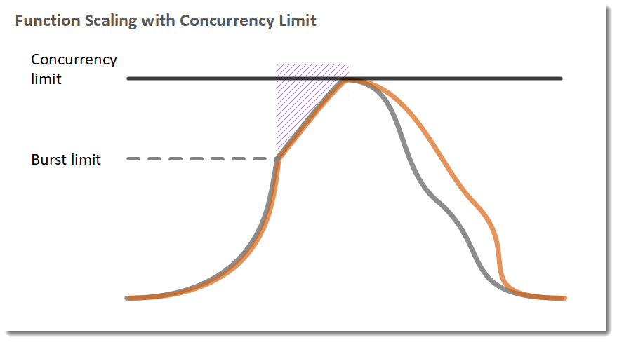
Your functions’ concurrency is the number of instances that serve requests at a given time. For an initial burst of traffic, your functions’ cumulative concurrency in a Region can reach an initial level of between 500 and 3000, which varies per Region.
Based on the given scenario, you need to create a solution that will satisfy the two requirements. The first requirement is to create a solution that will allow the users to access the data using an API. To implement this solution, you can use Amazon API Gateway. The second requirement is to handle the burst of traffic within seconds. You should use AWS Lambda in this scenario because Lambda functions can absorb reasonable bursts of traffic for approximately 15-30 minutes.
Lambda can scale faster than the regular Auto Scaling feature of Amazon EC2, Amazon Elastic Beanstalk, or Amazon ECS. This is because AWS Lambda is more lightweight than other computing services. Under the hood, Lambda can run your code to thousands of available AWS-managed EC2 instances (that could already be running) within seconds to accommodate traffic. This is faster than the Auto Scaling process of launching new EC2 instances that could take a few minutes or so. An alternative is to overprovision your compute capacity but that will incur significant costs. The best option to implement given the requirements is a combination of AWS Lambda and Amazon API Gateway.
Hence, the correct answer is: Create an API using Amazon API Gateway and use AWS Lambda to handle the bursts of traffic.
The option that says: Create an API using Amazon API Gateway and use the Amazon ECS cluster with Service Auto Scaling to handle the bursts of traffic in seconds is incorrect. AWS Lambda is a better option than Amazon ECS since it can handle a sudden burst of traffic within seconds and not minutes.
The option that says: Create an API using Amazon API Gateway and use Amazon Elastic Beanstalk with Auto Scaling to handle the bursts of traffic in seconds is incorrect because just like the previous option, the use of Auto Scaling has a delay of a few minutes as it launches new EC2 instances that will be used by Amazon Elastic Beanstalk.
The option that says: Create an API using Amazon API Gateway and use an Auto Scaling group of Amazon EC2 instances to handle the bursts of traffic in seconds is incorrect because the processing time of Amazon EC2 Auto Scaling to provision new resources takes minutes. Take note that in the scenario, a burst of traffic within seconds is expected to happen.
References:
https://aws.amazon.com/blogs/startups/from-0-to-100-k-in-seconds-instant-scale-with-aws-lambda/
https://docs.aws.amazon.com/lambda/latest/dg/invocation-scaling.html
Note: This question was extracted from our AWS Certified Solutions Architect Associate Practice Exams.
Question 2
A developer configured an Amazon API Gateway proxy integration named MyAPI to work with a Lambda function. However, when the API is being called, the developer receives a 502 Bad Gateway error. She tried invoking the underlying function, but it properly returned the result in XML format.
What is the MOST likely root cause of this issue?
- The API name of the Amazon API Gateway proxy is invalid.
- There has been an occasional out-of-order invocation due to heavy loads.
- The endpoint request timed-out.

- There is an incompatible output returned from a Lambda proxy integration backend.
Show me the answer!
Correct Answer: 4
Amazon API Gateway Lambda proxy integration is a simple, powerful, and nimble mechanism to build an API with a setup of a single API method. The Lambda proxy integration allows the client to call a single Lambda function in the backend. The function accesses many resources or features of other AWS services, including calling other Lambda functions
In Lambda proxy integration, when a client submits an API request, API Gateway passes the raw request as-is to the integrated Lambda function, except that the order of the request parameters is not preserved. This request data includes the request headers, query string parameters, URL path variables, payload, and API configuration data. The configuration data can include current deployment stage name, stage variables, user identity, or authorization context (if any). The backend Lambda function parses the incoming request data to determine the response that it returns.
For API Gateway to pass the Lambda output as the API response to the client, the Lambda function must return the result in the following JSON format:
{
"isBase64Encoded": true|false,
"statusCode": httpStatusCode,
"headers": { "headerName": "headerValue", ... },
"body": "..."
}
Since the Lambda function returns the result in XML format, it will cause the 502 errors in the API Gateway. Hence, the correct answer is that there is an incompatible output returned from a Lambda proxy integration backend.
The option that says: The API name of the Amazon API Gateway proxy is invalid is incorrect because there is nothing wrong with its MyAPI name.
The option that says: There has been an occasional out-of-order invocation due to heavy loads is incorrect. Although this is a valid cause of a 502 error, the issue is most likely caused by the Lambda function’s XML response instead of JSON.
The option that says: The endpoint request timed-out is incorrect because this will likely result in 504 errors and not 502’s.
References:
https://aws.amazon.com/premiumsupport/knowledge-center/malformed-502-api-gateway/
https://docs.aws.amazon.com/apigateway/latest/developerguide/set-up-lambda-proxy-integrations.html#api-gateway-simple-proxy-for-lambda-output-format
https://docs.aws.amazon.com/apigateway/api-reference/handling-errors/
Note: This question was extracted from our AWS Certified Developer Associate Practice Exams.
For more AWS practice exam questions with detailed explanations, visit the Tutorials Dojo Portal:

Additional Training Materials: Amazon API Gateway Video Courses on Udemy
- AWS Serverless APIs & Apps – A Complete Introduction by Maximilian Schwarzmüller
- AWS Lambda & Serverless Architecture Bootcamp (Build 5 Apps) by Riyaz Sayyad
- Serverless Architecture on Amazon Web Services by Mahmoud Matouk
Amazon API Gateway References:
https://docs.aws.amazon.com/apigateway/latest/developerguide/
https://aws.amazon.com/api-gateway/features/
https://aws.amazon.com/api-gateway/pricing/
https://aws.amazon.com/api-gateway/faqs/
------------------------------ ---------------------------------- ---------------------------------
https://tutorialsdojo.com/amazon-cloudfront/
Amazon CloudFront Cheat Sheet
A web service that speeds up distribution of your static and dynamic web content to your users. A Content Delivery Network (CDN) service.
- It delivers your content through a worldwide network of data centers called edge locations. When a user requests content that you’re serving with CloudFront, the user is routed to the edge location that provides the lowest latency, so that content is delivered with the best possible performance.
  - If the content is already in the edge location with the lowest latency, CloudFront delivers it immediately.
  - If the content is not in that edge location, CloudFront retrieves it from an origin that you’ve defined
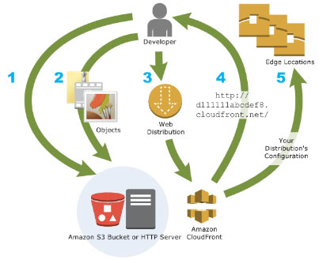
How CloudFront Delivers Content

  - You specify origin servers, like an S3 bucket or your own HTTP server, from which CloudFront gets your files which will then be distributed from CloudFront edge locations all over the world.
  - Upload your files to your origin servers. Your files, also known as objects.
  - Create a CloudFront distribution, which tells CloudFront which origin servers to get your files from when users request the files through your web site or application. At the same time, you specify details such as whether you want CloudFront to log all requests and whether you want the distribution to be enabled as soon as it’s created.
  - CloudFront assigns a domain name to your new distribution that you can see in the CloudFront console.
  - CloudFront sends your distribution’s configuration (but not your content) to all of its edge locations—collections of servers in geographically dispersed data centers where CloudFront caches copies of your objects.
- CloudFront supports the WebSocket protocol as well as the HTTP protocol with the following HTTP methods:
  - GET
  - HEAD
  - POST
  - PUT
  - DELETE
  - OPTIONS
  - PATCH.
- Using Lambda@Edge with CloudFront enables a variety of ways to customize the content that CloudFront delivers. It can help you configure your CloudFront distribution to serve private content from your own custom origin, as an option to using signed URLs or signed cookies.(See AWS Compute Services Lambda Lambda@Edge)

- CloudFront also has regional edge caches that bring more of your content closer to your viewers, even when the content is not popular enough to stay at a CloudFront edge location, to help improve performance for that content.
- You can use a zone apex name on CloudFront
- CloudFront supports wildcard CNAME
- Different CloudFront Origins
  - Using S3 buckets for your origin – you place any objects that you want CloudFront to deliver in an S3 bucket.
  - Using S3 buckets configured as website endpoints for your origin
  - Using a mediastore container or a media package channel for your origin – you can set up an S3 bucket that is configured as a MediaStore container, or create a channel and endpoints with MediaPackage. Then you create and configure a distribution in CloudFront to stream the video.
  - Using an Application Load Balancer – if your origin is more than one HTTP server, you can use an ALB to distribute traffic to the web servers.
  - Using a Lambda function URL – you don’t need to use an API Gateway or ALB since the Lambda web application can be called directly from the function URL.
  - Using EC2 or other custom origins – A custom origin is an HTTP server, for example, a web server.
  - Using CloudFront Origin Groups for origin failover – use origin failover to designate a primary origin for CloudFront plus a second origin that CloudFront automatically switches to when the primary origin returns specific HTTP status code failure responses.
- Objects are cached for 24 hours by default. You can invalidate files in CloudFront edge caches even before they expire.
- You can configure CloudFront to automatically compress files of certain types and serve the compressed files when viewer requests include Accept-Encoding: gzip in the request header.
- CloudFront can cache different versions of your content based on the values of query string parameters.
- CloudFront Distributions
  - You create a CloudFront distribution to tell CloudFront where you want content to be delivered from, and the details about how to track and manage content delivery.
  - You create a distribution and choose the configuration settings you want:
    - Your content origin—that is, the Amazon S3 bucket, MediaPackage channel, MediaStore container, ELB load balancer, or HTTP server from which CloudFront gets the files to distribute. You can specify any combination of up to 25 origins for a single distribution.
    - Access—whether you want the files to be available to everyone or restrict access to some users.
    - Security—whether you want CloudFront to require users to use HTTPS to access your content.
    - Cache key— uniquely identifies each file in the cache for a given distribution.
    - Origin request settings—whether you want CloudFront to forward cookies or query strings to your origin.
    - Geographic restrictions—whether you want CloudFront to prevent users in selected countries from accessing your content.
    - Logs—whether you want CloudFront to create access logs that show viewer activity, which is recorded in real-time.
  - You can use distributions to serve the following content over HTTP or HTTPS:
    - Static and dynamic download content.
    - Video on demand in different formats, such as Apple HTTP Live Streaming (HLS) and Microsoft Smooth Streaming.
    - A live event, such as a meeting, conference, or concert, in real time.
  - Values that you specify when you create or update a distribution
    - Origin Settings – information about one or more locations where you store the original versions of your web content.
    - Cache Behavior Settings – lets you configure a variety of CloudFront functionality for a given URL path pattern for files on your website.
    - Distribution Settings
    - Custom Error Pages and Error Caching
    - Restrictions – if you need to prevent users in selected countries from accessing your content, you can configure your CloudFront distribution either to allow users in a whitelist of specified countries to access your content or to not allow users in a blacklist of specified countries to access your content.
  - With CloudFront continuous deployment, you can safely deploy changes to your CDN configuration by testing first with a subset of production traffic.
Cache Behavior Settings

  - The functionality that you can configure for each cache behavior includes:
    - The path pattern.
    - If you have configured multiple origins for your CloudFront distribution, which origin you want CloudFront to forward your requests to.
    - Whether to forward query strings to your origin.
    - Whether accessing the specified files requires signed URLs.
    - Whether to require users to use HTTPS to access those files.
    - The minimum amount of time that those files stay in the CloudFront cache regardless of the value of any Cache-Control headers that your origin adds to the files.
  - CloudFront also offers a new method of cache configuration called policies. You may use the policies premade by AWS or you can create your own. These policies define how you’d like the cache to behave, such as cache TTL Settings, Cache Key Contents, and Compression settings.
  - After creating your CloudFront distribution, you can invalidate its cached items by creating an invalidation request.
Price Class

  - Choose the price class that corresponds with the maximum price that you want to pay for CloudFront service. By default, CloudFront serves your objects from edge locations in all CloudFront regions.
Performance and Availability

  - CloudFront also allows you to set up multiple origins to enable redundancy with Origin Failover. To set up origin failover, you must have a distribution with at least two origins. Next, you create an origin group for your distribution that includes the two origins, setting one as the primary. Finally, you define a cache behavior in which you specify the origin group as your origin.
    - The two origins in the origin group can be any combination of the following: AWS origins, like Amazon S3 buckets or Amazon EC2 instances, or custom origins, like your own HTTP web server.
    - When you create the origin group, you configure CloudFront to failover to the second origin for GET, HEAD, and OPTIONS HTTP methods when the primary origin returns specific status codes that you configure.
  - CloudFront is optimized for both dynamic and static content, providing extensive flexibility for optimizing cache behavior, coupled with network-layer optimizations for latency and throughput.
Using HTTPS with CloudFront

  - You can choose HTTPS settings both for communication between viewers and CloudFront, and between CloudFront and your origin.
  - If you want your viewers to use HTTPS and to use alternate domain names for your files, you need to choose one of the following options for how CloudFront serves HTTPS requests:
    - Use a dedicated IP address in each edge location
    - Use Server Name Indication (SNI)
Amazon CloudFront Monitoring

  - The billing report is a high-level view of all of the activity for the AWS services that you’re using, including CloudFront.
  - The usage report is a summary of activity for a service such as CloudFront, aggregated by hour, day, or month. It also includes usage charts that provide a graphical representation of your CloudFront usage.
  - CloudFront console includes a variety of reports based on the data in CloudFront access logs:
    - CloudFront Cache Statistics Reports
    - CloudFront Popular Objects Report
    - CloudFront Top Referrers Report
    - CloudFront Usage Reports
    - CloudFront Viewers Reports
  - You can use AWS Config to record configuration changes for CloudFront distribution settings changes.
  - CloudFront integrates with Amazon CloudWatch metrics so that you can monitor your website or application.
  - Capture API requests with AWS CloudTrail. CloudFront is a global service. To view CloudFront requests in CloudTrail logs, you must update an existing trail to include global services.
  - You can view metrics about CloudFront’s behavior and performance by enabling the Server-Timing header in HTTP responses sent from CloudFront.
  - With Amazon CloudWatch, you can monitor how many times a CloudFront Function was throttled in a given time period.
  - The CloudFront-Viewer-TLS header contains information about the TLS/SSL version and the cipher used to connect the viewer and CloudFront.
  - Supports various wildcard configurations in CORS access-control headers.
  - You can also specify header order and header count to identify the viewer based on the headers it sends.
Amazon CloudFront Security

  - CloudFront, AWS Shield, AWS WAF, and Route 53 work seamlessly together to create a flexible, layered security perimeter against multiple types of attacks including network and application layer DDoS attacks.
  - You can deliver your content, APIs or applications via SSL/TLS, and advanced SSL features are enabled automatically.
  - Through geo-restriction capability, you can prevent users in specific geographic locations from accessing content that you’re distributing through CloudFront.
  - You can restrict access to ALBs by configuring a custom HTTP header to the CloudFront request.
  - With Origin Access Control (OAC) feature, you can restrict access to an S3 bucket to only be accessible from CloudFront distributions.
  - Field-Level Encryption is a feature of CloudFront that allows you to securely upload user-submitted data such as credit card numbers to your origin servers.
  - You can use An AWS-managed prefix list to restrict inbound HTTP and HTTPS traffic to your origins to IP addresses assigned to CloudFront’s origin-facing servers.
  - To remove headers that CloudFront received in the origin response, you can use a CloudFront response headers policy. The specified headers are not included in the response sent to viewers by CloudFront.
Amazon CloudFront Pricing

  - Charge for storage in an S3 bucket.
  - Charge for serving objects from edge locations.
    - Data Transfer Out
  - Charge for submitting data to your origin.
    - Data Transfer Out
    - HTTP/HTTPS Requests
    - Invalidation Requests,
    - Dedicated IP Custom SSL certificates associated with a CloudFront distribution.
  - You also incur a surcharge for HTTPS requests, and an additional surcharge for requests that also have field-level encryption enabled.
- Compliance
  - CloudFront has been validated as being compliant with Payment Card Industry (PCI) Data Security Standard (DSS).
  - CloudFront is a HIPAA eligible service.
  - CloudFront is compliant with SOC measures.
Free Amazon CloudFront Tutorials on YouTube:
https://www.youtube.com/user/AmazonWebServices/search?query=CloudFront
Amazon CloudFront-related Cheat Sheets:
- S3 Pre-signed URLs vs CloudFront Signed URLs vs Origin Access Identity (OAI)
- SNI Custom SSL vs Dedicated IP Custom SSL
Note: If you are studying for the AWS Certified Advanced Networking Specialty exam, we highly recommend that you take our AWS Certified Advanced Networking – Specialty Practice Exams and read our Advanced Networking Specialty exam study guide.

Validate Your Knowledge
Question 1
An online customer portal is hosted in an Amazon ECS cluster behind an Application Load Balancer. The portal is set as the origin of a CloudFront Web distribution to deliver the dynamic and static content to users in low-latency. A Cloud Engineer was assigned to configure CloudFront to communicate with your origin using HTTP or HTTPS, based on the protocol of the viewer request.
What should the Engineer implement to complete this task?
- Set the Origin Protocol policy of the CloudFront distribution to Match Viewer.
- Set the Origin Protocol policy of the CloudFront distribution to HTTP and HTTPS.
- Set the Viewer Protocol policy of the CloudFront distribution to HTTP and HTTPS.
- Set the Viewer Protocol policy of the CloudFront distribution to Match Viewer.
Show me the answer!
Correct Answer: 1
For web distributions, you can configure CloudFront to require that viewers use HTTPS to request your objects so that connections are encrypted when CloudFront communicates with viewers. You also can configure CloudFront to use HTTPS to get objects from your origin so that connections are encrypted when CloudFront communicates with your origin.
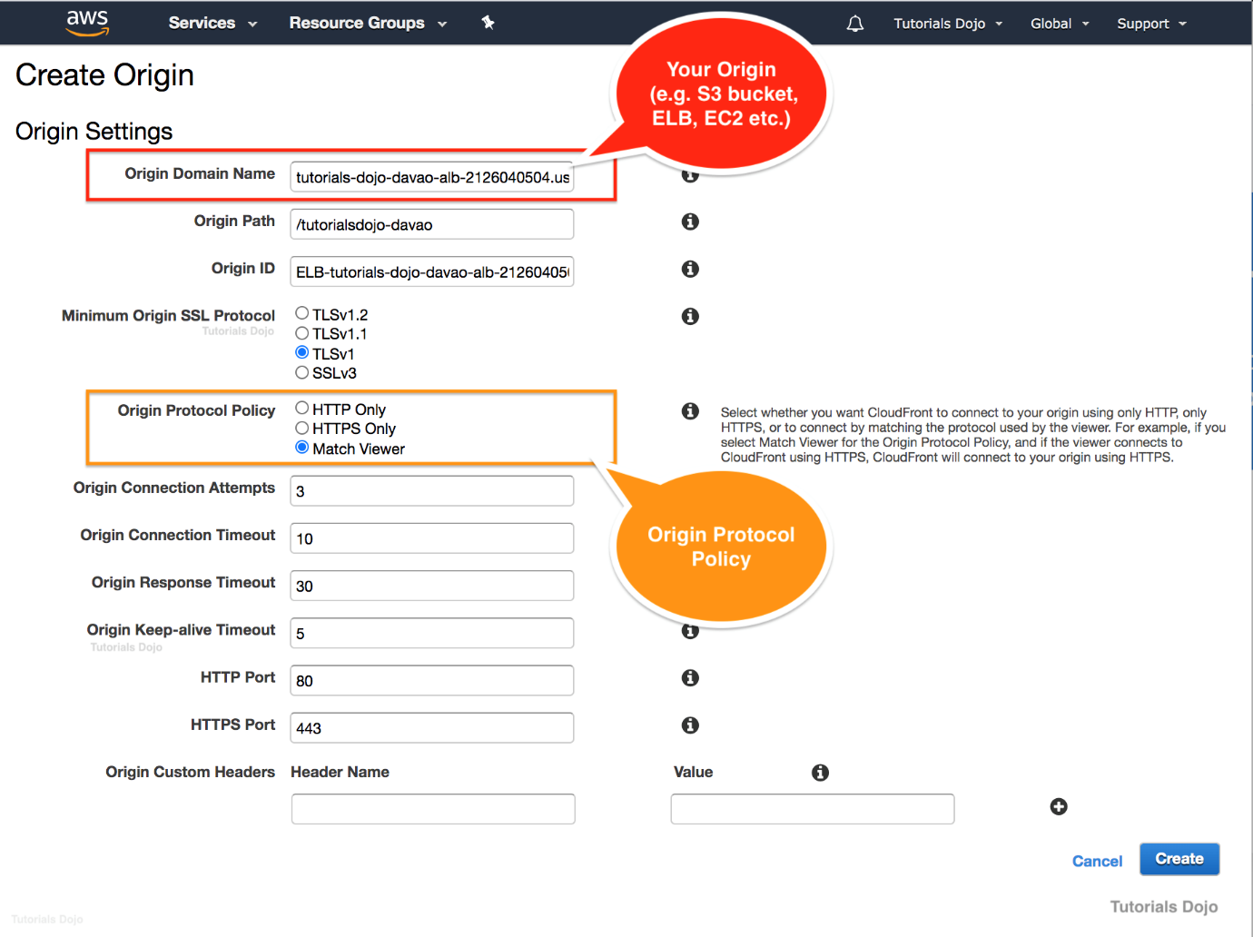
In CloudFront, there are 3 options that you can choose as the value for your Origin Protocol Policy:
- HTTP Only
- HTTPS Only
- Match Viewer.
For HTTP Only, CloudFront solely uses HTTP to access the origin. For HTTPS Only, CloudFront uses only HTTPS to access the origin and for Match Viewer, CloudFront communicates with your origin using HTTP or HTTPS, depending on the protocol of the viewer request. CloudFront caches the object only once even if viewers make requests using both HTTP and HTTPS protocols.
Take note that the term “Viewer” in CloudFront basically means the requestor or the client that sends the request. Therefore, the name: “MatchViewer” basically means that CloudFront is simply matching the protocol being used by the viewer.
Hence, the correct answer is: Set the Origin Protocol policy of the CloudFront distribution to Match Viewer.
The option that says: Set the Origin Protocol policy of the CloudFront distribution to HTTP and HTTPS is incorrect because this is not a valid value for the Origin Protocol policy. The HTTP and HTTPS type is only valid with the Viewer Protocol policy.
The option that says: Set the Viewer Protocol policy of the CloudFront distribution to HTTP and HTTPS is incorrect because you have to use the Origin Protocol policy and not Viewer Protocol.
The option that says: Set the Viewer Protocol policy of the CloudFront distribution to Match Viewer is incorrect because the Match Viewer type is only applicable if you are using an Origin Protocol policy.
References:
http://docs.aws.amazon.com/AmazonCloudFront/latest/DeveloperGuide/distribution-web-values-specify.html
https://docs.aws.amazon.com/AmazonCloudFront/latest/DeveloperGuide/using-https-cloudfront-to-custom-origin.html
Note: This question was extracted from our AWS Certified Advanced Networking Specialty Practice Exams.

Question 2
A company wants to launch its online shopping website to give customers an easy way to purchase the products they need. The proposed setup is to host the application on an AWS Fargate cluster, utilize a Load Balancer to distribute traffic between the Fargate tasks, and use Amazon CloudFront for caching and content delivery. The company wants to ensure that the website complies with industry best practices and should be able to protect customers from common “man-in-the-middle” attacks for e-commerce websites such as DNS spoofing, HTTPS spoofing, or SSL hijacking.
Which of the following configurations will provide the MOST secure access to the website?
- Register the domain name on Route 53 and enable DNSSEC validation for all public hosted zones to ensure that all DNS requests have not been tampered with during transit. Use AWS Certificate Manager (ACM) to generate a valid TLS/SSL certificate for the domain name. Configure the Application Load Balancer with an HTTPS listener to use the ACM TLS/SSL certificate. Use Server Name Identification and HTTP to HTTPS redirection on CloudFront.
- Register the domain name on Route 53. Use a third-party DNS provider that supports the import of the customer-managed keys for DNSSEC. Import a 2048-bit TLS/SSL certificate from a third-party certificate service to AWS Certificate Manager (ACM). Configure the Application Load Balancer with an HTTPS listener to use the imported TLS/SSL certificate. Use Server Name Identification and HTTP to HTTPS redirection on CloudFront.
- Use Route 53 for domain registration. Use a third-party DNS service that supports DNSSEC for DNS requests that use the customer-managed keys. Use AWS Certificate Manager (ACM) to generate a valid 2048-bit TLS/SSL certificate for the domain name and configure the Application Load Balancer HTTPS listener to use this TLS/SSL certificate. Use Server Name Identification and HTTP to HTTPS redirection on CloudFront.
- Register the domain name on Route 53. Since Route 53 only supports DNSSEC for registration, host the company DNS root servers on Amazon EC2 instances running the BIND service. Enable DNSSEC for DNS requests to ensure the replies have not been tampered with. Generate a valid certificate for the website domain name on AWS ACM and configure the Application Load Balancers HTTPS listener to use this TLS/SSL certificate. Use Server Name Identification and HTTP to HTTPS redirection on CloudFront.
Show me the answer!
Correct Answer: 1
Amazon now allows you to enable Domain Name System Security Extensions (DNSSEC) signing for all existing and new public hosted zones, and enable DNSSEC validation for Amazon Route 53 Resolver. Amazon Route 53 DNSSEC provides data origin authentication and data integrity verification for DNS and can help customers meet compliance mandates, such as FedRAMP.
When you enable DNSSEC signing on a hosted zone, Route 53 cryptographically signs each record in that hosted zone. Route 53 manages the zone-signing key, and you can manage the key-signing key in AWS Key Management Service (AWS KMS). Amazon’s domain name registrar, Route 53 Domains, already supports DNSSEC, and customers can now register domains and host their DNS on Route 53 with DNSSEC signing enabled. When you enable DNSSEC validation on the Route 53 Resolver in your VPC, it ensures that DNS responses have not been tampered with in transit. This can prevent DNS Spoofing.
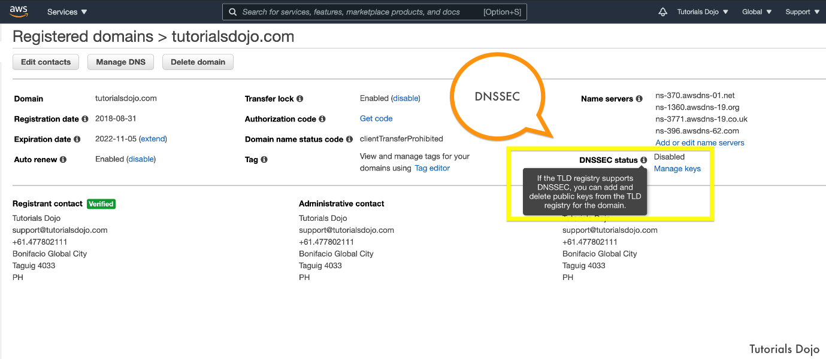
AWS Certificate Manager is a service that lets you easily provision, manage, and deploy public and private Secure Sockets Layer/Transport Layer Security (SSL/TLS) certificates for use with AWS services and your internal connected resources. SSL/TLS certificates are used to secure network communications and establish the identity of websites over the Internet as well as resources on private networks. AWS Certificate Manager removes the time-consuming manual process of purchasing, uploading, and renewing SSL/TLS certificates. Using a valid SSL Certificate for your application load balancer ensures that all requests are encrypted on transit as well as protection against SSL hijacking.
CloudFront supports Server Name Indication (SNI) for custom SSL certificates, along with the ability to take incoming HTTP requests and redirect them to secure HTTPS requests to ensure that clients are always directed to the secure version of your website.
Therefore, the correct answer is: Register the domain name on Route 53 and enable DNSSEC validation for all public hosted zones to ensure that all DNS requests have not been tampered with during transit. Use AWS Certificate Manager (ACM) to generate a valid TLS/SSL certificate for the domain name. Configure the Application Load Balancer with an HTTPS listener to use the ACM TLS/SSL certificate. Use Server Name Identification and HTTP to HTTPS redirection on CloudFront.
The option that says: Register the domain name on Route 53. Use a third-party DNS provider that supports the import of the customer-managed keys for DNSSEC. Import a 2048-bit TLS/SSL certificate from a third-party certificate service to AWS Certificate Manager (ACM). Configure the Application Load Balancer with an HTTPS listener to use the imported TLS/SSL certificate. Use Server Name Identification and HTTP to HTTPS redirection on CloudFront is incorrect. Although this is possible, you don’t have to rely on a third-party DNS provider as Route 53 supports DNSSEC signing. Also, ACM can secure a 2048-bit TLS/SSL Certificate for free so you don’t have to buy certificates from other providers.
The option that says: Use Route 53 for domain registration. Use a third-party DNS service that supports DNSSEC for DNS requests that use the customer-managed keys. Use AWS Certificate Manager (ACM) to generate a valid 2048-bit TLS/SSL certificate for the domain name and configure the Application Load Balancer HTTPS listener to use this TLS/SSL certificate. Use Server Name Identification and HTTP to HTTPS redirection on CloudFront is incorrect. This is also possible, but you don’t have to rely on a third-party DNS provider as Amazon Route 53 already supports DNSSEC signing.
The option that says: Register the domain name on Route 53. Since Route 53 only supports DNSSEC for registration, host the company DNS root servers on Amazon EC2 instances running the BIND service. Enable DNSSEC for DNS requests to ensure the replies have not been tampered with. Generate a valid certificate for the website domain name on AWS ACM and configure the Application Load Balancers HTTPS listener to use this TLS/SSL certificate. Use Server Name Identification and HTTP to HTTPS redirection on CloudFront is incorrect as this solution is no longer recommended. This setup was previously used as a workaround when DNSSEC signing was not supported natively yet in Amazon Route 53.
References:
https://docs.aws.amazon.com/Route53/latest/DeveloperGuide/domain-configure-dnssec.html
https://docs.aws.amazon.com/acm/latest/userguide/acm-services.html
https://aws.amazon.com/about-aws/whats-new/2020/12/announcing-amazon-route-53-support-dnssec/
https://docs.aws.amazon.com/AmazonCloudFront/latest/DeveloperGuide/using-https-viewers-to-cloudfront.html
Note: This question was extracted from our AWS Certified Solutions Architect Professional Practice Exams.
For more AWS practice exam questions with detailed explanations, visit the Tutorials Dojo Portal:
Amazon CloudFront Cheat Sheet References:
https://docs.aws.amazon.com/AmazonCloudFront/latest/DeveloperGuide
https://aws.amazon.com/cloudfront/features/
https://aws.amazon.com/cloudfront/pricing/
https://aws.amazon.com/cloudfront/faqs/
------------------------------ ---------------------------------- ---------------------------------
https://tutorialsdojo.com/amazon-route-53/
Amazon Route 53 Cheat Sheet
- A highly available and scalable Domain Name System (DNS) web service used for domain registration, DNS routing, and health checking.
Key Features
- Resolver
- Traffic flow
- Latency based routing
- Geo DNS
- Private DNS for Amazon VPC
- DNS Failover
- Health Checks and Monitoring
- Domain Registration
- CloudFront and S3 Zone Apex Support
- Amazon ELB Integration
Domain Registration
- Choose a domain name and confirm that it’s available, then register the domain name with Route 53. The service automatically makes itself the DNS service for the domain by doing the following:
  - Creates a hosted zone that has the same name as your domain.
  - Assigns a set of four name servers to the hosted zone. When someone uses a browser to access your website, such as www.example.com, these name servers tell the browser where to find your resources, such as a web server or an S3 bucket.
  - Gets the name servers from the hosted zone and adds them to the domain.
- If you already registered a domain name with another registrar, you can choose to transfer the domain registration to Route 53.

- Enable DNSSEC signing on new or existing public hosted zones. DNSSEC provides data integrity verification and
data origin authentication for DNS.
- You can also configure DNSSEC on domain registration.
Routing Internet Traffic to your Website or Web Application
- Use the Route 53 console to register a domain name and configure Route 53 to route internet traffic to your website or web application.
- After you register your domain name, Route 53 automatically creates a public hosted zone that has the same name as the domain.
- To route traffic to your resources, you create records, also known as resource record sets, in your hosted zone.
- You can create special Route 53 records, called alias records, that route traffic to S3 buckets, CloudFront distributions, and other AWS resources.
- Each record includes information about how you want to route traffic for your domain, such as:
  - Name – name of the record corresponds with the domain name or subdomain name that you want Route 53 to route traffic for.
  - Type – determines the type of resource that you want traffic to be routed to.
  - Value
- How traffic is routed
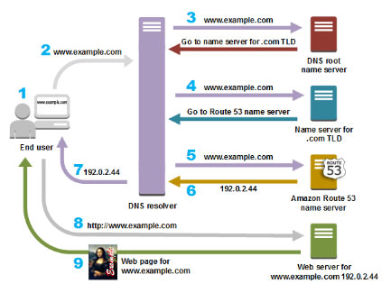
Route 53 Health Checks

  - How it works
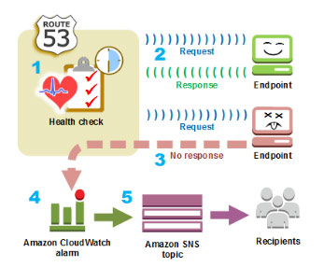

  - Create a health check and specify values that define how you want the health check to work, such as:
    - The IP address or domain name of the endpoint that you want Route 53 to monitor.
    - The protocol that you want Route 53 to use to perform the check: HTTP, HTTPS, or TCP.
    - The request interval you want Route 53 to send a request to the endpoint.
    - How many consecutive times the endpoint must fail to respond to requests before Route 53 considers it unhealthy. This is the failure threshold.
  - You can configure a health check to check the health of one or more other health checks.
  - You can configure a health check to check the status of a CloudWatch alarm so that you can be notified on the basis of a broad range of criteria.
Know the following Concepts
- Domain Registration Concepts – domain name, domain registrar, domain registry, domain reseller, top-level domain
- DNS Concepts
  - Alias record – a type of record that you can create to route traffic to AWS resources.
  - DNS query
  - DNS resolver
  - Domain Name System (DNS)
  - Private DNS
  - Hosted zone – a container for records, which includes information about how to route traffic for a domain and all of its subdomains.
  - Name servers – servers in the DNS that help to translate domain names into the IP addresses that computers use to communicate with one another.
  - Record (DNS record) – an object in a hosted zone that you use to define how you want to route traffic for the domain or a subdomain.
  - Routing policy
  - Subdomain
  - Time to live (TTL)
- Health Checking Concepts
  - DNS failover – a method for routing traffic away from unhealthy resources and to healthy resources.
  - endpoint
  - health check
Routing Policies
- Simple routing policy – route internet traffic to a single resource that performs a given function for your domain. You can’t create multiple records that have the same name and type, but you can specify multiple values in the same record, such as multiple IP addresses.
- Failover routing policy – use when you want to configure active-passive failover.
- Geolocation routing policy – use when you want to route internet traffic to your resources based on the location of your users.
- Geoproximity routing policy – use when you want to route traffic based on the location of your resources and, optionally, shift traffic from resources in one location to resources in another.
  - You can also optionally choose to route more traffic or less to a given resource by specifying a value, known as a bias. A bias expands or shrinks the size of the geographic region from which traffic is routed to a resource.
  - The effect of changing the bias for your resources depends on a number of factors, including the following:
    - The number of resources that you have.
    - How close the resources are to one another.
    - The number of users that you have near the border area between geographic regions.
- Latency routing policy – use when you have resources in multiple locations and you want to route traffic to the resource that provides the best latency.
- IP-based routing policy – use when you want to route traffic based on your users’ locations, and know where the IP address or traffic is coming from.
- Multivalue answer routing policy – use when you want Route 53 to respond to DNS queries with up to eight healthy records selected at random.
- Weighted routing policy – use to route traffic to multiple resources in proportions that you specify.
- When you register a domain or transfer domain registration to Route 53, it configures the domain to renew automatically. The automatic renewal period is typically one year, although the registries for some top-level domains (TLDs) have longer renewal periods.
- When you register a domain with Route 53, it creates a hosted zone that has the same name as the domain, assigns four name servers to the hosted zone, and updates the domain to use those name servers.
Hosted Zones
- Route 53 automatically creates the Name Server (NS) and Start of Authority (SOA) records for the hosted zones.
- Route 53 creates a set of 4 unique name servers (a delegation set) within each hosted zone.
- Public hosted zone – route internet traffic to your resources
- Private hosted zone – route traffic within an Amazon VPC. You create a private hosted zone, and specify the VPCs that you want to associate with the hosted zone.
  - To use private hosted zones, you must set the following VPC settings to true:
    - enableDnsHostnames
    - enableDnsSupport
  - In a private hosted zone, you can associate Route 53 health checks only with failover, multivalue answer, weighted, latency, and, geolocation records.
  - You can use the following routing policies when you create records in a private hosted zone:
    - Simple
    - Failover
    - Multivalue answer
    - Weighted
    - Latency-based
    - Geolocation
Records
- Create records in a hosted zone. Records define where you want to route traffic for each domain name or subdomain name. The name of each record in a hosted zone must end with the name of the hosted zone.
- Alias Records
  - Route 53 alias records provide a Route 53–specific extension to DNS functionality. Alias records let you route traffic to selected AWS resources. They also let you route traffic from one record in a hosted zone to another record.
  - You can create an alias record at the top node of a DNS namespace, also known as the zone apex.
- CNAME Record
  - You cannot create an alias record at the top node of a DNS namespace using a CNAME record.
- Alias records vs CNAME records
CNAME Records | Alias Records
You can’t create a CNAME record at the zone apex. | You can create an alias record at the zone apex. Alias records must have the same type as the record you’re routing traffic to.
Route 53 charges for CNAME queries. | Route 53 doesn’t charge for alias queries to AWS resources.
A CNAME record redirects queries for a domain name regardless of record type. | Route 53 responds to a DNS query only when the name and type of the alias record matches the name and type in the query.
A CNAME record can point to any DNS record that is hosted anywhere. | An alias record can only point to selected AWS resources or to another record in the hosted zone that you’re creating the alias record in.
A CNAME record appears as a CNAME record in response to dig or Name Server (NS) lookup queries. | An alias record appears as the record type that you specified when you created the record, such as A or AAAA.
- You can use IAM policy conditions to grant users fine-grained access to updating resource record sets.
- You can also combine any of the granular permissions to create permissions.
Supported DNS Record Types
- A Record Type – the value for an A record is an IPv4 address in dotted decimal notation.
- AAAA Record Type – the value for an AAAA record is an IPv6 address in colon-separated hexadecimal format.
- CAA Record Type – lets you specify which certificate authorities (CAs) are allowed to issue certificates for a domain or subdomain.
- CNAME Record Type – a CNAME Value element is the same format as a domain name.
- DS Record Type – represents key tag, algorithm, digest type, and digest of the zone key.
- MX Record Type – each value for an MX record actually contains two values, priority and domain name.
- NAPTR Record Type – converts one value to another or replaces one value with another.
- NS Record Type – identifies the name servers for the hosted zone. The value for an NS record is the domain name of a name server.
- PTR Record Type – is the same format as a domain name.
- SOA Record Type – provides information about a domain and the corresponding Amazon Route 53 hosted zone.
- SPF Record Type – a list of all authorized hostnames or IP addresses that are allowed to send an email on behalf of your domain.
- SRV Record Type – represents priority, weight, port, and domain name.
- TXT Record Type – contains text information for sources outside your domain.
DNS Domain Name Format
- Names of domains, hosted zones, and records consist of a series of labels separated by dots, which can be up to 63 bytes long. The total length of a domain name cannot exceed 255 bytes, including the dots.
- You can create hosted zones and records that include * in the name.
Using Traffic Flow to Route DNS Traffic
- You use the visual editor to create a traffic policy. A traffic policy includes information about the routing configuration that you want to create:
  - the routing policies that you want to use
  - resources that you want to route DNS traffic to, such as the IP address of each EC2 instance and the domain name of each ELB load balancer.
- Create a policy record where you specify the hosted zone in which you want to create the configuration that you defined in your traffic policy. It’s also where you specify the DNS name that you want to associate the configuration with.
Route 53 Resolvers
- Resolver answers DNS queries for VPC domain names such as domain names for EC2 instances or ELB load balancers, and performs recursive lookups against public name servers for all other domain names.
- DNS resolvers on your network can forward DNS queries to Resolver in a specified VPC. You can also configure Resolver to forward queries that it receives from EC2 instances in your VPCs to DNS resolvers on your network.
- Resolver is regional.
- An inbound endpoint specifies the VPC that queries pass through on the way from your network to Resolver.
- To forward DNS queries that originate on EC2 instances in one or more VPCs to your network, you create an outbound endpoint and one or more rules.
- Route 53 Resolver DNS Firewall is a managed firewall that lets you block DNS queries made from known malicious domains and allow queries from trusted domains. This is achieved through the use of “blocklists” and “allowlists”.
Route 53 Health Checks and DNS Failover
- Each health check that you create can monitor one of the following:
  - The health of a specified resource, such as a web server
  - The status of other health checks
  - The status of an Amazon CloudWatch alarm
- Each health checker evaluates the health of the endpoint based on two values:
  - Response time
  - Whether the endpoint responds to a number of consecutive health checks that you specify (the failure threshold)
- Types of health checks
  - HTTP and HTTPS health checks – Route 53 must be able to establish a TCP connection with the endpoint within four seconds. In addition, the endpoint must respond with an HTTP status code of 2xx or 3xx within two seconds after connecting.
  - TCP health checks – Route 53 must be able to establish a TCP connection with the endpoint within ten seconds.
  - HTTP and HTTPS health checks with string matching – Route 53 must be able to establish a TCP connection with the endpoint within four seconds, and the endpoint must respond with an HTTP status code of 2xx or 3xx within two seconds after connecting. After a Route 53 health checker receives the HTTP status code, it must receive the response body from the endpoint within the next two seconds.
- Health-checking features to route traffic only to the healthy resources:
  - Check the health of EC2 instances and other resources (non-alias records)
  - Evaluate the health of an AWS resource (alias records)
- Two types of failover configurations
  - Active-Active Failover – all the records that have the same name, the same type, and the same routing policy are active unless Route 53 considers them unhealthy. Use this failover configuration when you want all of your resources to be available the majority of the time.
  - Active-Passive Failover – use this failover configuration when you want a primary resource or group of resources to be available the majority of the time and you want a secondary resource or group of resources to be on standby in case all the primary resources become unavailable. When responding to queries, Route 53 includes only the healthy primary resources.
- To create an active-passive failover configuration with one primary record and one secondary record, you just create the records and specify Failover for the routing policy.
- To configure active-passive failover with multiple resources for the primary or secondary record, create records with the same name, type, and routing policy for your primary resources. If you’re using AWS resources that you can create alias records for, specify Yes for Evaluate Target Health.
- You can also use weighted records for active-passive failover, with caveats.
- You can configure Amazon Route 53 to log information about the queries that Route 53 receives. Query logging is available only for public hosted zones.
Authentication and Access Control
- Authenticate with IAM before allowing to perform any operation on Route 53 resources.
- Every AWS resource is owned by an AWS account, and permissions to create or access a resource are governed by permissions policies. A permissions policy specifies who has access to what.
Amazon Route 53 Monitoring
- The Route 53 dashboard provides detailed information about the status of your domain registrations, including:
  - Status of new domain registrations
  - Status of domain transfers to Route 53
  - List of domains that are approaching the expiration date
- You can use Amazon CloudWatch metrics to see the number of DNS queries served for each of your Route 53 public hosted zones. With these metrics, you can see at a glance the activity level of each hosted zone to monitor changes in traffic.
- You can monitor your resources by creating Route 53 health checks, which use CloudWatch to collect and process raw data into readable, near real-time metrics.
- Log API calls with CloudTrail
Amazon Route 53 Pricing

- A hosted zone is charged at the time it’s created and on the first day of each subsequent month. To allow testing, a hosted zone that is deleted within 12 hours of creation is not charged, however, any queries on that hosted zone will still incur charges.
- Billion queries / month
- Queries to Alias records are provided at no additional cost to current Route 53 customers when the records are mapped to the following AWS resource types:
  - Elastic Load Balancers
  - Amazon CloudFront distributions
  - AWS Elastic Beanstalk environments
  - API Gateways
  - VPC endpoints
  - Amazon S3 buckets that are configured as website endpoints
- Traffic flow policy record / month
- Pricing for domain names varies by Top Level Domain (TLD)
Amazon Route 53 Tutorials on YouTube:
https://www.youtube.com/user/AmazonWebServices/search?query=Route+53
Note: If you are studying for the AWS Certified Advanced Networking Specialty exam, we highly recommend that you take our AWS Certified Advanced Networking – Specialty Practice Exams and read our Advanced Networking Specialty exam study guide.

Validate Your Knowledge
Question 1
A company is building its customer web portal in multiple EC2 instances behind an Application Load Balancer. The portal must be accessible on www.tutorialsdojo.com as well as on its tutorialsdojo.com root domain.
How should the Network Engineer set up Amazon Route 53 to satisfy this requirement?
- Set up an Alias A Record for tutorialsdojo.com with the ALB as the target. For the www.tutorialsdojo.com subdomain, create a CNAME record that points to the ALB.
- Set up a CNAME Record for tutorialsdojo.com with the ALB as the target. For the www.tutorialsdojo.com subdomain, create a CNAME record that points to the ALB.
- Set up a CNAME Record for tutorialsdojo.com with the ALB as the target. For the www.tutorialsdojo.com subdomain, create an Alias A record that points to the ALB.
- Set up a non-alias A Record for tutorialsdojo.com with the ALB as the target. For the www.tutorialsdojo.com subdomain, create a CNAME record that points to the ALB.
Show me the answer!
Correct Answer: 1
Amazon Route 53 alias records provide a Route 53–specific extension to DNS functionality. Alias records let you route traffic to selected AWS resources, such as CloudFront distributions and Amazon S3 bucket. They also let you route traffic from one record in a hosted zone to another record.
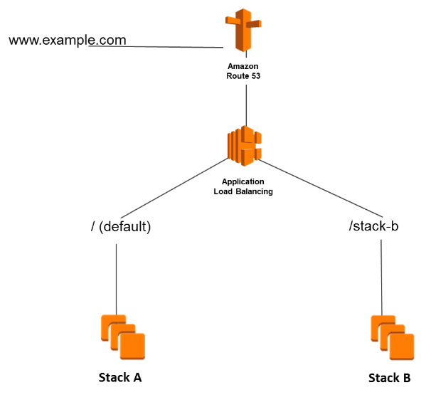
Unlike a CNAME record, you can create an alias record at the top node of a DNS namespace, also known as the zone apex. For example, if you register the DNS name tutorialsdojo.com, the zone apex is tutorialsdojo.com. You can’t create a CNAME record for tutorialsdojo.com, but you can create an alias record for tutorialsdojo.com that routes traffic to www.tutorialsdojo.com.
When Route 53 receives a DNS query for an alias record, Route 53 responds with the applicable value for that resource:
A CloudFront distribution – Route 53 responds with one or more IP addresses for CloudFront edge servers that can serve your content.
An Elastic Beanstalk environment – Route 53 responds with one or more IP addresses for the environment.
An ELB load balancer – Route 53 responds with one or more IP addresses for the load balancer.
An Amazon S3 bucket that is configured as a static website – Route 53 responds with one IP address for the Amazon S3 bucket.
Another Route 53 record in the same hosted zone – Route 53 responds as if the query is for the record that is referenced by the alias record.
Hence, the correct answer is: Set up an Alias A Record for tutorialsdojo.com with the ALB as the target. For the www.tutorialsdojo.com subdomain, create a CNAME record that points to the ALB.
The option that says: Set up a CNAME Record for tutorialsdojo.com with the ALB as the target. For the www.tutorialsdojo.com subdomain, create a CNAME record that points to the ALB is incorrect. Although the configuration for the subdomain is correct, you still can’t create a CNAME record for the root domain or zone apex. You have to set up an Alias A record instead.
The option that says: Set up a CNAME Record for tutorialsdojo.com with the ALB as the target. For the www.tutorialsdojo.com subdomain, create an Alias A record that points to the ALB is incorrect because you can’t create a CNAME record for the root domain or zone apex. The subdomain configuration is technically correct because you can set up an Alias A record for your subdomain in Route 53. The issue here is the use of a CNAME record in the zone apex.
The option that says: Set up a non-alias A Record for tutorialsdojo.com with the ALB as the target. For the www.tutorialsdojo.com subdomain, create a CNAME record that points to the ALB is incorrect because a non-alias A Record can only accept IP addresses and not the DNS name of the ALB.
References:
https://docs.aws.amazon.com/Route53/latest/DeveloperGuide/resource-record-sets-choosing-alias-non-alias.html
https://docs.aws.amazon.com/Route53/latest/DeveloperGuide/routing-to-elb-load-balancer.html
Note: This question was extracted from our AWS Certified Advanced Networking Specialty Practice Exams.
Question 2
A Network Engineer has been tasked to protect the company’s publicly accessible online customer portal and to secure the clients’ sensitive financial information. Hackers must be prevented from intercepting DNS queries and from replacing the actual IP addresses of the website with unauthorized IP addresses in the DNS resolvers. The solution should protect the users from being routed to the IP addresses provided by the attackers in the spoofed response that could potentially direct them to fake or phishing websites.
What should the Engineer do to satisfy this requirement?
- Enable Domain Name System Security Extensions (DNSSEC) in Amazon Route 53.
- Enable Server Name Indication (SNI) in Amazon Route 53.
- Set up a private hosted zone in Amazon Route 53 and launch a BIND DNS Server.
- Set up Perfect Forward Secrecy (PFS) using Diffie-Hellman (DH) group 2 to prevent DNS spoofing.
Show me the answer!
Correct Answer: 1
Attackers sometimes hijack traffic to Internet endpoints such as web servers by intercepting DNS queries and returning their own IP addresses to DNS resolvers in place of the actual IP addresses for those endpoints. Users are then routed to the IP addresses provided by the attackers in the spoofed response, for example, to fake websites.
You can protect your domain from this type of attack, known as DNS spoofing or a man-in-the-middle attack, by configuring Domain Name System Security Extensions (DNSSEC), a protocol for securing DNS traffic.

When you configure DNSSEC for your domain, a DNS resolver establishes a chain of trust for responses from intermediate resolvers. The chain of trust begins with the TLD registry for the domain (your domain’s parent zone) and ends with the authoritative name servers at your DNS service provider. Not all DNS resolvers support DNSSEC. Resolvers that don’t support DNSSEC don’t perform any signature or authenticity validation.
Hence, the correct answer is: Enable Domain Name System Security Extensions (DNSSEC) in Amazon Route 53.
The option that says: Enable Server Name Indication (SNI) in Amazon Route 53 is incorrect because this feature is primarily used to support multiple TLS certificates for your web applications and not for protecting against DNS Spoofing or man-in-the-middle attacks.
The option that says: Set up a private hosted zone in Amazon Route 53 and launch a BIND DNS Server is incorrect because a private hosted zone is just a container that holds information about how you want Amazon Route 53 to respond to DNS queries for a specific domain and its subdomains within one or more VPCs.
The option that says: Set up Perfect Forward Secrecy (PFS) using Diffie-Hellman (DH) group 2 to prevent DNS spoofing is incorrect because this is simply a feature that provides additional safeguards against the eavesdropping of encrypted data through the use of a unique random session key.
References:
https://docs.aws.amazon.com/Route53/latest/DeveloperGuide/domain-configure-dnssec.html
https://aws.amazon.com/route53/faqs/
Note: This question was extracted from our AWS Certified Advanced Networking Specialty Practice Exams.
------------------------------ ---------------------------------- ---------------------------------
https://tutorialsdojo.com/amazon-vpc/
Amazon VPC Cheat Sheet
- Create a virtual network in the cloud dedicated to your AWS account where you can launch AWS resources
- Amazon VPC is the networking layer of Amazon EC2
- A VPC spans all the Availability Zones in the region. After creating a VPC, you can add one or more subnets in each Availability Zone.
Key Concepts
- A virtual private cloud (VPC) allows you to specify an IP address range for the VPC, add subnets, associate security groups, and configure route tables.
- A subnet is a range of IP addresses in your VPC. You can launch AWS resources into a specified subnet. Use a public subnet for resources that must be connected to the internet, and a private subnet for resources that won’t be connected to the internet.
- To protect the AWS resources in each subnet, use security groups and network access control lists (ACLs).
- Expand your VPC by adding secondary IP ranges.
EC2-VPC vs EC2-Classic
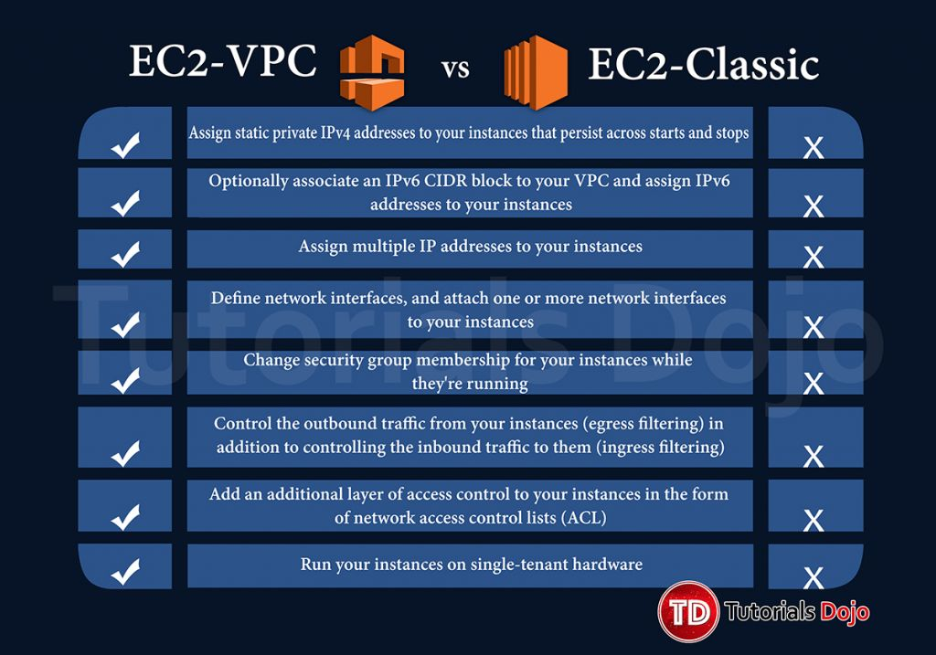
Default vs Non-Default VPC
Default | Non-Default VPC
If your account supports the EC2-VPC platform only, it comes with a default VPC that has a default subnet in each Availability Zone. | You can create your own non-default VPC, and configure it as you need. Subnets that you create in your non-default VPC and additional subnets that you create in your default VPC are called non-default subnets.
Your default VPC includes an internet gateway, which allows your instances to communicate with the internet, and each default subnet is a public subnet. | Instances can communicate with each other, but can’t access the internet. You can enable internet access for an instance launched into a non-default subnet by attaching an Internet Gateway and associating an Elastic IP address with the instance.
Each instance that you launch into a default subnet has a private IPv4 address and a public IPv4 address. | By default, each instance that you launch into a non-default subnet has a private IPv4 address, but no public IPv4 address, unless you specifically assign one at launch, or you modify the subnet’s public IP address attribute.
To allow an instance in your VPC to initiate outbound connections to the internet but prevent unsolicited inbound connections from the internet, you can use a network address translation (NAT) device for IPv4 traffic.
You can optionally associate an Amazon-provided IPv6 CIDR block with your VPC and assign IPv6 addresses to your instances. IPv6 traffic is separate from IPv4 traffic; your route tables must include separate routes for IPv6 traffic.
A diagram of default VPC
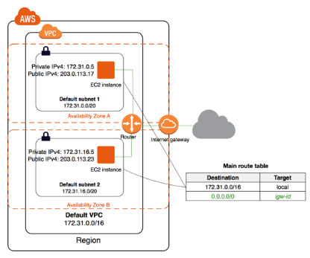
A diagram of non-default VPC
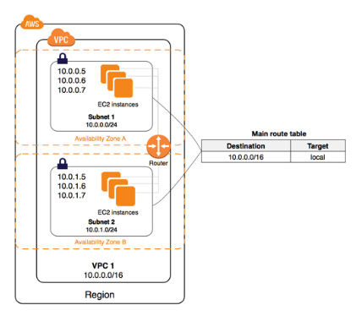
Accessing a Corporate or Home Network

  - You can optionally connect your VPC to your own corporate data center using an IPsec AWS managed VPN connection, making the AWS Cloud an extension of your data center.
  - A VPN connection consists of:
    - a virtual private gateway (which is the VPN concentrator on the Amazon side of the VPN connection) attached to your VPC.
    - a customer gateway (which is a physical device or software appliance on your side of the VPN connection) located in your data center.
    - A diagram of the connection
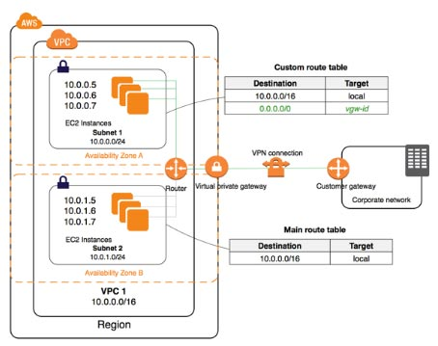

  - AWS Site-to-Site Virtual Private Network (VPN) connections can be moved from a virtual private gateway to an AWS Transit Gateway without having to make any changes on your customer gateway. Transit Gateways enable you to easily scale connectivity across thousands of Amazon VPCs, AWS accounts, and on-premises networks.
  - AWS PrivateLink enables you to privately connect your VPC to supported AWS services, services hosted by other AWS accounts (VPC endpoint services), and supported AWS Marketplace partner services. You do not require an internet gateway, NAT device, public IP address, AWS Direct Connect connection, or VPN connection to communicate with the service. Traffic between your VPC and the service does not leave the Amazon network.
  - AWS PrivateLink-Supported Services:

- Amazon IP Gateway | - Amazon Elastic Container Registry
- Amazon AppStream 2.0 | - Amazon Elastic Container Service
- AWS App Mesh | - AWS Glue
- Application Auto Scaling | - AWS Key Management Service
- Amazon Athena | - Amazon Kinesis Data Firehouse
- AWS Auto Scaling | - Amazon Kinesis Data Streams
- Amazon Cloud Directory | - Amazon Rekognition
- AWS CloudFormation | - Amazon SageMaker and Amazon SageMaker Runtime
- AWS CloudTrail | - Amazon SageMaker Notebook
- Amazon CloudWatch | - AWS Secrets Manager
- Amazon CloudWatch Events | - AWS Security Token Service
- Amazon CloudWatch Logs | - AWS Server Migration Service
- AWS CodeBuild | - AWS Service Catalog
- AWS CodeCommit | - Amazon SNS
- AWS CodePipeline | - Amazon SQS
- AWS Config | - Amazon Systems Manager
- AWS DataSync | - AWS Storage Gateway
- Amazon EC2 API | - AWS Transfer for SFTP
- Amazon EC2 Auto Scaling | - Amazon WorkSpaces
- Amazon Elastic File System | - Endpoint services hosted by other AWS accounts
- Elastic Load Balancing | - Supported AWS Marketplace partner services
- AWS CloudHSM

  - You can create a VPC peering connection between your VPCs, or with a VPC in another AWS account, and enable routing of traffic between the VPCs using private IP addresses. You cannot create a VPC peering connection between VPCs that have overlapping CIDR blocks.
  - Applications in an Amazon VPC can securely access AWS PrivateLink endpoints across VPC peering connections. The support of VPC peering by AWS PrivateLink makes it possible for customers to privately connect to a service even if that service’s endpoint resides in a different Amazon VPC that is connected using VPC peering.
  - AWS PrivateLink endpoints can now be accessed across both intra- and inter-region VPC peering connections.
VPC Use Case Scenarios
- VPC with a Single Public Subnet
- VPC with Public and Private Subnets (NAT)
- VPC with Public and Private Subnets and AWS Managed VPN Access
- VPC with a Private Subnet Only and AWS Managed VPN Access
Subnets
- When you create a VPC, you must specify a range of IPv4 addresses for the VPC in the form of a Classless Inter-Domain Routing (CIDR) block (example: 10.0.0.0/16). This is the primary CIDR block for your VPC.
- You can add one or more subnets in each Availability Zone of your VPC’s region.
- You specify the CIDR block for a subnet, which is a subset of the VPC CIDR block.
- A CIDR block must not overlap with any existing CIDR block that’s associated with the VPC.
- Types of Subnets
  - Public Subnet – has an internet gateway
  - Private Subnet – doesn’t have an internet gateway
  - VPN-only Subnet – has a virtual private gateway instead
- IPv4 CIDR block size should be between a /16 netmask (65,536 IP addresses) and /28 netmask (16 IP addresses).
- The first four IP addresses and the last IP address in each subnet CIDR block are NOT available for you to use, and cannot be assigned to an instance.
- You cannot increase or decrease the size of an existing CIDR block.
- When you associate a CIDR block with your VPC, a route is automatically added to your VPC route tables to enable routing within the VPC (the destination is the CIDR block and the target is local).
- You have a limit on the number of CIDR blocks you can associate with a VPC and the number of routes you can add to a route table.
- The following rules apply when you add IPv4 CIDR blocks to a VPC that’s part of a VPC peering connection:
  - If the VPC peering connection is active, you can add CIDR blocks to a VPC provided they do not overlap with a CIDR block of the peer VPC.
  - If the VPC peering connection is pending-acceptance, the owner of the requester VPC cannot add any CIDR block to the VPC. Either the owner of the accepter VPC must accept the peering connection, or the owner of the requester VPC must delete the VPC peering connection request, add the CIDR block, and then request a new VPC peering connection.
  - If the VPC peering connection is pending-acceptance, the owner of the accepter VPC can add CIDR blocks to the VPC. If a secondary CIDR block overlaps with a CIDR block of the requester VPC, the VPC peering connection request fails and cannot be accepted.
- If you’re using AWS Direct Connect to connect to multiple VPCs through a direct connect gateway, the VPCs that are associated with the direct connect gateway must not have overlapping CIDR blocks.
- The CIDR block is ready for you to use when it’s in the associated state.
- You can disassociate a CIDR block that you’ve associated with your VPC; however, you cannot disassociate the primary CIDR block.
Subnet Routing
- Each subnet must be associated with a route table, which specifies the allowed routes for outbound traffic leaving the subnet.
- Every subnet that you create is automatically associated with the main route table for the VPC.
- You can change the association, and you can change the contents of the main route table.
- You can allow an instance in your VPC to initiate outbound connections to the internet over IPv4 but prevent unsolicited inbound connections from the internet using a NAT gateway or NAT instance.
- To initiate outbound-only communication to the internet over IPv6, you can use an egress-only internet gateway.
Subnet Security
- Security Groups — control inbound and outbound traffic for your instances
  - You can associate one or more (up to five) security groups to an instance in your VPC.
  - If you don’t specify a security group, the instance automatically belongs to the default security group.
  - When you create a security group, it has no inbound rules. By default, it includes an outbound rule that allows all outbound traffic.
  - Security groups are associated with network interfaces.
- Network Access Control Lists — control inbound and outbound traffic for your subnets
  - Each subnet in your VPC must be associated with a network ACL. If none is associated, automatically associated with the default network ACL.
  - You can associate a network ACL with multiple subnets; however, a subnet can be associated with only one network ACL at a time.
  - A network ACL contains a numbered list of rules that is evaluated in order, starting with the lowest numbered rule, to determine whether traffic is allowed in or out of any subnet associated with the network ACL.
  - The default network ACL is configured to allow all traffic to flow in and out of the subnets to which it is associated.
  - For custom ACLs, you need to add a rule for ephemeral ports, usually with the range of 32768-65535. If you have a NAT Gateway, ELB or a Lambda function in a VPC, you need to enable 1024-65535 port range.
- Flow logs — capture information about the IP traffic going to and from network interfaces in your VPC that is published to CloudWatch Logs.
- Flow logs can help you with a number of tasks, such as:
  - Diagnosing overly restrictive security group rules
  - Monitoring the traffic that is reaching your instance
  - Determining the direction of the traffic to and from the network interfaces
- Flow log data is collected outside of the path of your network traffic, and therefore does not affect network throughput or latency. You can create or delete flow logs without any risk of impact to network performance.
- After you’ve created a flow log, it can take several minutes to begin collecting and publishing data to the chosen destinations. Flow logs do not capture real-time log streams for your network interfaces.
- VPC Flow Logs can be sent directly to an Amazon S3 bucket which allows you to retrieve and analyze these logs yourself.
- Amazon security groups and network ACLs don’t filter traffic to or from link-local addresses or AWS-reserved IPv4 addresses. Flow logs do not capture IP traffic to or from these addresses.
Security Group | Network ACL
Operates at the instance level | Operates at the subnet level
Supports ALLOW rules only | Supports ALLOW rules and DENY rules
Is stateful: Return traffic is automatically allowed, regardless of any rules | Is stateless: Return traffic must be explicitly allowed by rules
We evaluate all rules before deciding whether to allow traffic | We process rules in number order when deciding whether to allow traffic
Applies only to EC2 instances and similar services that use EC2 as a backend. | Automatically applies to all
Security group is specified when launching the instances, or is associated with the instance later on | Instances in the subnets it’s associated with
- Diagram of security groups and NACLs in a VPC
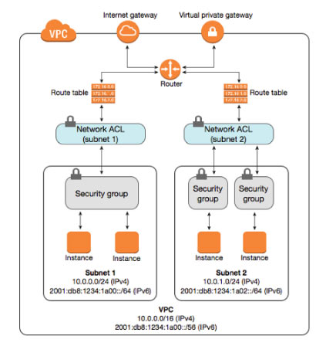
VPC Networking Components
- Network Interfaces
  - a virtual network interface that can include:
    - a primary private IPv4 address
    - one or more secondary private IPv4 addresses
    - one Elastic IP address per private IPv4 address
    - one public IPv4 address, which can be auto-assigned to the network interface for eth0 when you launch an instance
    - one or more IPv6 addresses
    - one or more security groups
    - a MAC address
    - a source/destination check flag
    - a description
  - Network interfaces can be attached and detached from instances, however, you cannot detach a primary network interface.
- Route Tables
  - contains a set of rules, called routes, that are used to determine where network traffic is directed.
  - A subnet can only be associated with one route table at a time, but you can associate multiple subnets with the same route table.
  - You cannot delete the main route table, but you can replace the main route table with a custom table that you’ve created.
  - You must update the route table for any subnet that uses gateways or connections.
  - Uses the most specific route in your route table that matches the traffic to determine how to route the traffic (longest prefix match).
- Internet Gateways
  - Allows communication between instances in your VPC and the internet.
  - Imposes no availability risks or bandwidth constraints on your network traffic.
  - Provides a target in your VPC route tables for internet-routable traffic, and performs network address translation for instances that have been assigned public IPv4 addresses.
  - The following table provides an overview of whether your VPC automatically comes with the components required for internet access over IPv4 or IPv6.
  - To enable access to or from the Internet for instances in a VPC subnet, you must do the following:
    - Attach an Internet Gateway to your VPC
    - Ensure that your subnet’s route table points to the Internet Gateway.
    - Ensure that instances in your subnet have a globally unique IP address (public IPv4 address, Elastic IP address, or IPv6 address).
    - Ensure that your network access control and security group rules allow the relevant traffic to flow to and from your instance
 | Default VPC | Non-default VPC
Internet gateway | Yes | Yes, if you created the VPC using the first or second option in the VPC wizard. Otherwise, you must manually create and attach the internet gateway.
Route table with route to internet gateway for IPv4 traffic (0.0.0.0/0) | Yes | Yes, if you created the VPC using the first or second option in the VPC wizard. Otherwise, you must manually create the route table and add the route.
Route table with route to internet gateway for IPv6 traffic (::/0) | No | Yes, if you created the VPC using the first or second option in the VPC wizard, and if you specified the option to associate an IPv6 CIDR block with the VPC. Otherwise, you must manually create the route table and add the route.
Public IPv4 address automatically assigned to instance launched into subnet | Yes (default subnet) | No (non-default subnet)
IPv6 address automatically assigned to instance launched into subnet | No (default subnet) | No (non-default subnet)
- Egress-Only Internet Gateways
  - VPC component that allows outbound communication over IPv6 from instances in your VPC to the Internet, and prevents the Internet from initiating an IPv6 connection with your instances.
  - An egress-only Internet gateway is stateful.
  - You cannot associate a security group with an egress-only Internet gateway.
  - You can use a network ACL to control the traffic to and from the subnet for which the egress-only Internet gateway routes traffic.
- NAT
  - Enable instances in a private subnet to connect to the internet or other AWS services, but prevent the internet from initiating connections with the instances.
  - NAT Gateways
    - You must specify the public subnet in which the NAT gateway should reside.
    - You must specify an Elastic IP address to associate with the NAT gateway when you create it.
    - Each NAT gateway is created in a specific Availability Zone and implemented with redundancy in that zone.
    - Deleting a NAT gateway disassociates its Elastic IP address, but does not release the address from your account.
    - A NAT gateway supports the following protocols: TCP, UDP, and ICMP.
    - You cannot associate a security group with a NAT gateway.
    - A NAT gateway can support up to 55,000 simultaneous connections to each unique destination.
    - A NAT gateway cannot send traffic over VPC endpoints, VPN connections, AWS Direct Connect, or VPC peering connections.
    - A NAT gateway uses ports 1024-65535. Make sure to enable these in the inbound rules of your network ACL.
  - NAT Instance vs NAT Gateways
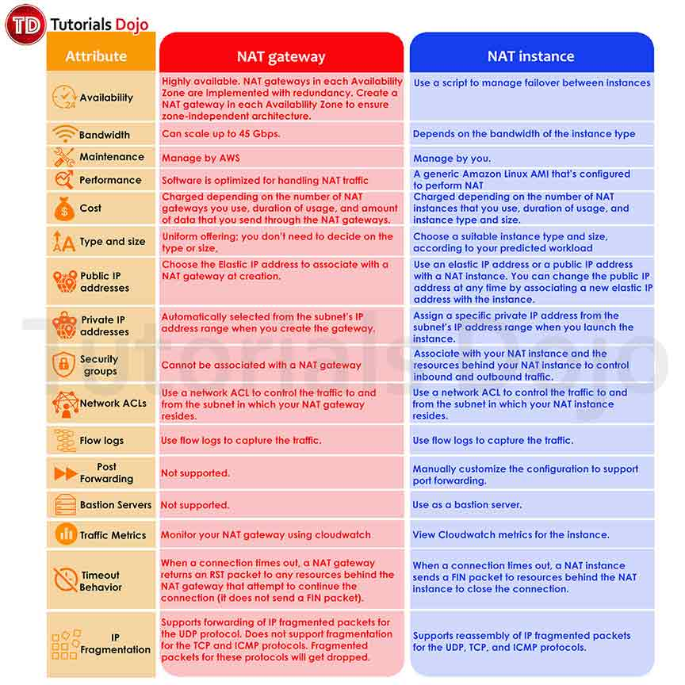
- DHCP Options Sets
  - Dynamic Host Configuration Protocol (DHCP) provides a standard for passing configuration information to hosts on a TCP/IP network.
  - You can assign your own domain name to your instances, and use up to four of your own DNS servers by specifying a special set of DHCP options to use with the VPC.
  - Creating a VPC automatically creates a set of DHCP options, which are domain-name-servers=AmazonProvidedDNS, and domain-name=domain-name-for-your-region, and associates them with the VPC.
  - After you create a set of DHCP options, you can’t modify them. Create a new set and associate a different set of DHCP options with your VPC, or use no DHCP options at all.
- DNS
  - AWS provides instances launched in a default VPC with public and private DNS hostnames that correspond to the public IPv4 and private IPv4 addresses for the instance.
  - AWS provides instances launched in a non-default VPC with private DNS hostname and possibly a public DNS hostname, depending on the DNS attributes you specify for the VPC and if your instance has a public IPv4 address.
  - Set VPC attributes enableDnsHostnames and enableDnsSupport to true so that your instances receive a public DNS hostname and Amazon-provided DNS server can resolve Amazon-provided private DNS hostnames.
    - If you use custom DNS domain names defined in a private hosted zone in Route 53, the enableDnsHostnames and enableDnsSupport attributes must be set to true.
- VPC Peering
  - A networking connection between two VPCs that enables you to route traffic between them privately. Instances in either VPC can communicate with each other as if they are within the same network.
- Elastic IP Addresses
  - A static, public IPv4 address.
  - You can associate an Elastic IP address with any instance or network interface for any VPC in your account.
  - You can mask the failure of an instance by rapidly remapping the address to another instance in your VPC.
  - Your Elastic IP addresses remain associated with your AWS account until you explicitly release them.
  - AWS imposes a small hourly charge when EIPs aren’t associated with a running instance, or when they are associated with a stopped instance or an unattached network interface.
  - You’re limited to five Elastic IP addresses.
- VPC Endpoints
  - Privately connect your VPC to supported AWS services and VPC endpoint services powered by PrivateLink without requiring an internet gateway, NAT device, VPN connection, or AWS Direct Connect connection.
  - Endpoints are virtual devices.
  - Two Types
    - Interface Endpoints
      - An elastic network interface with a private IP address that serves as an entry point for traffic destined to a supported service.
      - Can be accessed through AWS VPN connections or AWS Direct Connect connections, through intra-region VPC peering connections from Nitro instances, and through inter-region VPC peering connections from any type of instance.
      - For each interface endpoint, you can choose only one subnet per Availability Zone. Endpoints are supported within the same region only.
      - You can add endpoint policies to interface endpoints. The Amazon VPC endpoint policy defines which principal can perform which actions on which resources. An endpoint policy does not override or replace IAM user policies or service-specific policies. It is a separate policy for controlling access from the endpoint to the specified service.
      - An interface endpoint supports IPv4 TCP traffic only.

    - Gateway Endpoints
      - A gateway that is a target for a specified route in your route table, used for traffic destined to a supported AWS service.
      - You can create multiple endpoints in a single VPC, for example, to multiple services. You can also create multiple endpoints for a single service, and use different route tables to enforce different access policies from different subnets to the same service.
      - You can modify the endpoint policy that’s attached to your endpoint, and add or remove the route tables that are used by the endpoint.
      - Endpoints are supported within the same region only. You cannot create an endpoint between a VPC and a service in a different region.
      - Endpoints support IPv4 traffic only.
      - You must enable DNS resolution in your VPC, or if you’re using your own DNS server, ensure that DNS requests to the required service (such as S3) are resolved correctly to the IP addresses maintained by AWS.
  - You can create your own application in your VPC and configure it as an AWS PrivateLink-powered service (referred to as an endpoint service). You are the service provider, and the AWS principals that create connections to your service are service consumers.
- ClassicLink
  - Allows you to link an EC2-Classic instance to a VPC in your account, within the same region. This allows you to associate the VPC security groups with the EC2-Classic instance, enabling communication between your EC2-Classic instance and instances in your VPC using private IPv4 addresses.
VPN Connections
VPN connectivity option | Description
AWS managed VPN | You can create an IPsec VPN connection between your VPC and your remote network. On the AWS side of the VPN connection, a virtual private gateway provides two VPN endpoints (tunnels) for automatic failover. You configure your customer gateway on the remote side of the VPN connection.
AWS VPN CloudHub | If you have more than one remote network, you can create multiple AWS-managed VPN connections via your virtual private gateway to enable communication between these networks.
Third-party software VPN appliance | You can create a VPN connection to your remote network by using an Amazon EC2 instance in your VPC that’s running a third-party software VPN appliance. AWS does not provide or maintain third-party software VPN appliances; however, you can choose from a range of products provided by partners and open source communities.
AWS Direct Connect | You can also use AWS Direct Connect to create a dedicated private connection from a remote network to your VPC. You can combine this connection with an AWS-managed VPN connection to create an IPsec-encrypted connection.
- Specify a private Autonomous System Number (ASN) for the virtual private gateway. If you don’t specify an ASN, the virtual private gateway is created with the default ASN (64512). You cannot change the ASN after you’ve created the virtual private gateway.
- When you create a VPN connection, you must:
  - Specify the type of routing that you plan to use (static or dynamic)
  - Update the route table for your subnet
- If your VPN device supports Border Gateway Protocol (BGP), specify dynamic routing when you configure your VPN connection. If your device does not support BGP, specify static routing.
- VPG uses path selection to determine how to route traffic to your remote network. Longest prefix match applies.
- Each VPN connection has two tunnels, with each tunnel using a unique virtual private gateway public IP address. It is important to configure both tunnels for redundancy.
VPC Traffic Mirroring
- Allows you to replicate the network traffic from EC2 instances within your VPC to security and monitoring appliances for content inspection, threat monitoring, troubleshooting, and more.
- Both Nitro and non-Nitro instances are supported.
Amazon VPC Pricing
- Charged for VPN Connection-hour
- Charged for each “NAT Gateway-hour” that your NAT gateway is provisioned and available.
- Data processing charges apply for each Gigabyte processed through the NAT gateway regardless of the traffic’s source or destination.
- You also incur standard AWS data transfer charges for all data transferred via the NAT gateway.
- Charges for unused or inactive Elastic IPs.
Amazon VPC Overview from AWS re:Invent
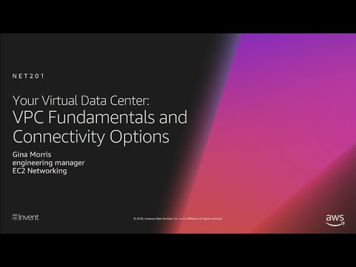
Amazon VPC-related Cheat Sheets:
- VPC Peering

- Longest Prefix Match: Understanding Advanced Concepts in VPC Peering
Note: If you are studying for the AWS Certified Advanced Networking Specialty exam, we highly recommend that you take our AWS Certified Advanced Networking – Specialty Practice Exams and read our Advanced Networking Specialty exam study guide.

Validate Your Knowledge
Question 1
An Amazon Virtual Private Cloud (VPC) has a fleet of EC2 instances hosted in a private subnet that connects to an Amazon S3 bucket via its VPC Gateway Endpoint. The VPC doesn’t have an attached Internet Gateway since the application is only used internally. You were instructed to configure the security group of the instances to only allow traffic to and from the public IP ranges of the S3 endpoint. To get the required IP ranges, you used the information provided by the aws ec2 describe-prefix-lists AWS CLI command. The solution worked but after a few weeks, you noticed that the outgoing requests are timing out and the instances can’t connect to the bucket any longer.
Which of the following is the most suitable solution that you can do to solve this issue with LEAST effort?
- Create a new customer-managed prefix-list that contains the public IP ranges of the S3 endpoint. Modify the outbound VPC security group rule to use the prefix-list in connecting to the Gateway VPC endpoint.
- Set up a CloudFront Function for the Amazon S3 bucket to have a static public IP range that doesn’t change.
- Create a Lambda function that updates the security group. Use the AWS-managed AmazonIpSpaceChanged topic in Amazon SNS as the trigger for the function.
- Configure the outbound VPC security group rule to use the AWS-managed prefix-list in connecting to the Gateway VPC endpoint.
Show me the answer!
Correct Answer: 4
The AWS prefix list ID logically represents the range of public IP addresses used by the service. All instances in subnets associated with the specified route tables automatically use the endpoint to access the service. Subnets that are not associated with the specified route tables do not use the endpoint. This enables you to keep resources in other subnets separate from your endpoint.
To view the current public IP address range for a service, you can use the describe-prefix-lists command:
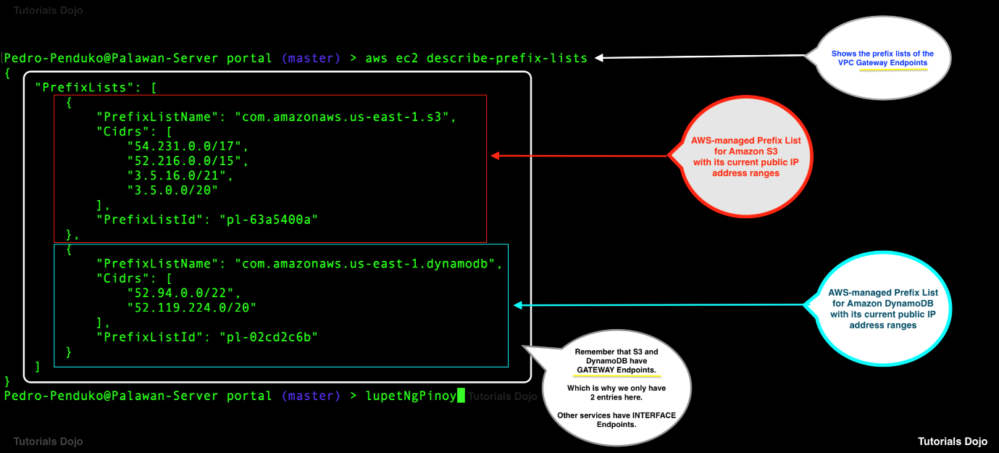
A prefix list is a set of one or more CIDR blocks. There are two types of prefix lists:
-AWS-managed prefix-list — Represents the IP address ranges for an AWS service. You can reference an AWS-managed prefix-list in your VPC security group rules and in subnet route table entries. For example, you can reference an AWS-managed prefix-list in an outbound VPC security group rule when connecting to an AWS service through a gateway VPC endpoint. You cannot create, modify, share, or delete an AWS-managed prefix list.
-Customer-managed prefix-list — A set of IPv4 or IPv6 CIDR blocks that you define and manage. You can reference the prefix-list in your VPC security group rules and in subnet route table entries. This enables you to manage the IP addresses that you frequently use for these resources in a single group, instead of repeatedly referencing the same IP addresses in each resource. You can share your prefix list with other AWS accounts, enabling those accounts to reference the prefix-list in their own resources.
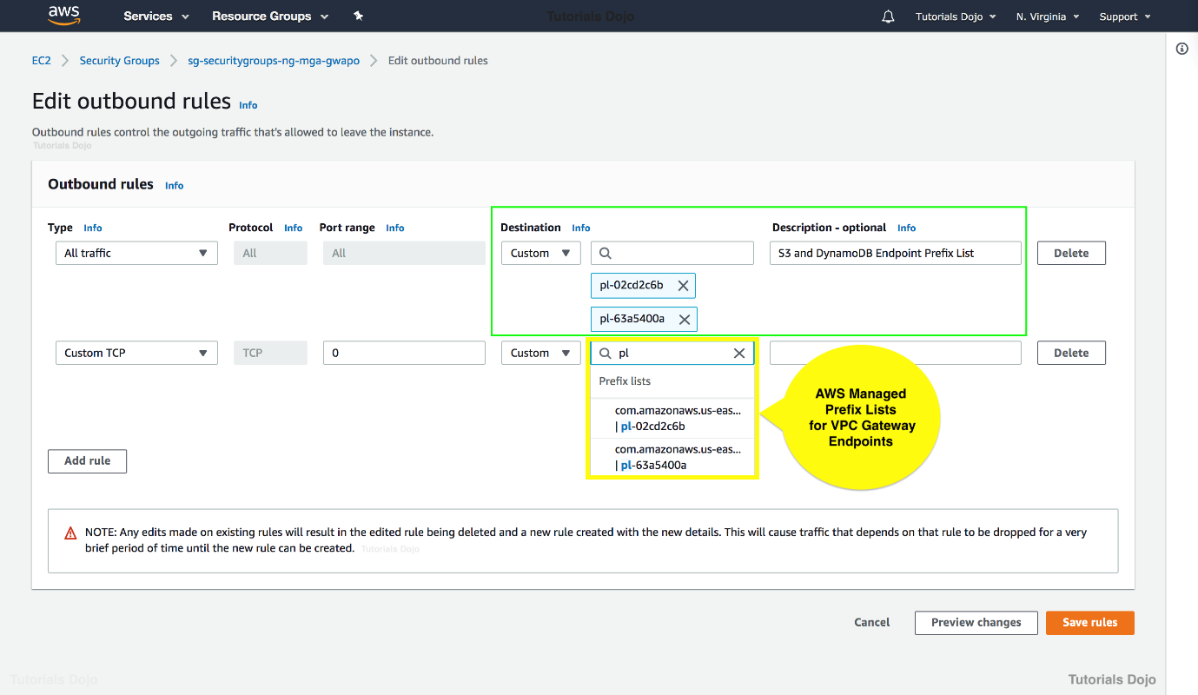
In this scenario, you can use the AWS-managed prefix-lists in your security group to allow access to the VPC Gateway Endpoint of the Amazon S3 bucket. AWS will automatically update the underlying public IP ranges that are associated with these prefix-lists.
Hence, the correct answer is: Configure the outbound VPC security group rule to use the AWS-managed prefix-list in connecting to the Gateway VPC endpoint.
The option that says: Create a new customer-managed prefix-list that contains the public IP ranges of the S3 endpoint. Modify the outbound VPC security group rule to use the prefix-list in connecting to the Gateway VPC endpoint is incorrect. Although this option may work, you still have to manually update the prefix-list whenever the AWS public IP ranges were changed. A more suitable solution here is to use AWS-managed prefix-list.
The option that says: Set up a CloudFront Function for the Amazon S3 bucket to have a static public IP range that doesn’t change is incorrect because a CloudFront Function simply allows you to write lightweight functions in JavaScript for high-scale, latency-sensitive CDN customizations. Using CloudFront Functions in this situation is not applicable.
The option that says: Create a Lambda function that updates the security group. Use the AWS-managed AmazonIpSpaceChanged topic in Amazon SNS as the trigger for the function is incorrect. Although this can technically work, this solution still entails a lot of effort to implement. You can simply use an AWS-managed prefix-list for this scenario.
References:
https://aws.amazon.com/blogs/security/how-to-automatically-update-your-security-groups-for-amazon-cloudfront-and-aws-waf-by-using-aws-lambda/
https://docs.aws.amazon.com/vpc/latest/userguide/vpce-gateway.html
https://docs.aws.amazon.com/vpc/latest/userguide/managed-prefix-lists.html
Note: This question was extracted from our AWS Certified Advanced Networking Specialty Practice Exams.
Question 2
A company has multiple VPCs with IPv6 enabled for its suite of web applications. The Solutions Architect attempted to deploy a new Amazon EC2 instance but encountered an error indicating that there were no available IP addresses on the subnet. The VPC has a combination of IPv4 and IPv6 CIDR blocks, but the IPv4 CIDR blocks are nearing exhaustion. The architect needs a solution that will resolve this issue while allowing future scalability.
How should the Solutions Architect resolve this problem?
- Set up a new IPv4 subnet with a larger CIDR range. Associate the new subnet with the VPC and then launch the instance.
- Ensure that the VPC has IPv6 CIDRs only. Remove any IPv4 CIDRs associated with the VPC.
- Set up a new IPv6-only subnet with a large CIDR range. Associate the new subnet with the VPC then launch the instance.
- Disable the IPv4 support in the VPC and use the available IPv6 addresses.
Show me the answer!
Correct Answers: 1
mazon Virtual Private Cloud (VPC) is a service that lets you launch AWS resources in a logically isolated virtual network that you define. You have complete control over your virtual networking environment, including selection of your own IP address range, creation of subnets, and configuration of route tables and network gateways. You can use both IPv4 and IPv6 for most resources in your virtual private cloud, helping to ensure secure and easy access to resources and applications.
A subnet is a range of IP addresses in your VPC. You can launch AWS resources into a specified subnet. When you create a VPC, you must specify a range of IPv4 addresses for the VPC in the form of a CIDR block. Each subnet must reside entirely within one Availability Zone and cannot span zones. You can also optionally assign an IPv6 CIDR block to your VPC, and assign IPv6 CIDR blocks to your subnets.
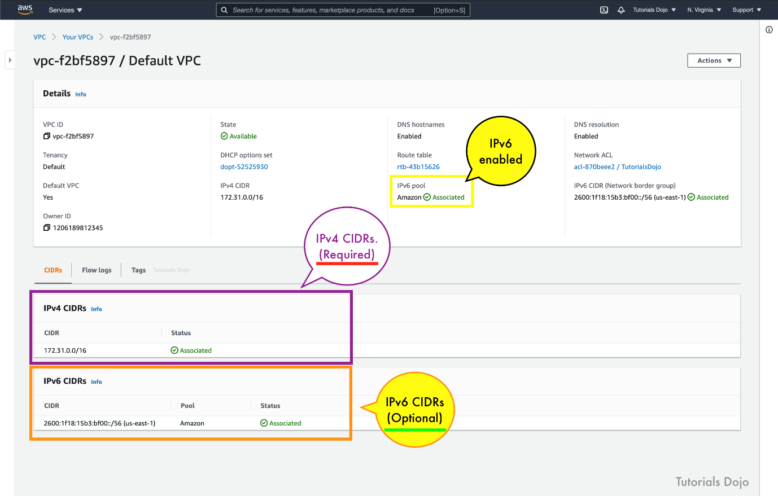
If you have an existing VPC that supports IPv4 only and resources in your subnet that are configured to use IPv4 only, you can enable IPv6 support for your VPC and resources. Your VPC can operate in dual-stack mode — your resources can communicate over IPv4, or IPv6, or both. IPv4 and IPv6 communication are independent of each other. You cannot disable IPv4 support for your VPC and subnets since this is the default IP addressing system for Amazon VPC and Amazon EC2.
By default, a new EC2 instance uses an IPv4 addressing protocol. To fix the problem in the scenario, you need to create a new IPv4 subnet and deploy the EC2 instance in the new subnet.
Hence, the correct answer is: Set up a new IPv4 subnet with a larger CIDR range. Associate the new subnet with the VPC and then launch the instance.
The option that says: Set up a new IPv6-only subnet with a large CIDR range. Associate the new subnet with the VPC then launch the instance is incorrect. While it is possible to create an IPv6-only subnet, this feature is only supported for nitro EC2 instance type. Additionally, the scenario does not specify the instance type. Therefore, this option is not applicable for non-Nitro instances, despite the VPC being IPv6-enabled.
The option that says: Ensure that the VPC has IPv6 CIDRs only. Remove any IPv4 CIDRs associated with the VPC is incorrect because you can’t have a VPC with IPv6 CIDRs only. The default IP addressing system in VPC is IPv4. You can only change your VPC to dual-stack mode where your resources can communicate over IPv4, or IPv6, or both, but not exclusively with IPv6 only.
The option that says: Disable the IPv4 support in the VPC and use the available IPv6 addresses is incorrect because you cannot disable the IPv4 support for your VPC and subnets since this is the default IP addressing system.
References:
https://docs.aws.amazon.com/vpc/latest/userguide/vpc-migrate-ipv6.html
https://docs.aws.amazon.com/vpc/latest/userguide/vpc-ip-addressing.html
https://aws.amazon.com/vpc/faqs/
Note: This question was extracted from our AWS Certified Solutions Architect Associate Practice Exams.
For more AWS practice exam questions with detailed explanations, visit the Tutorials Dojo Portal:

Additional Training Materials: Amazon VPC Video Courses on Udemy
- Amazon VPC Mastery for AWS Certifications
- Amazon Web Services – Understanding the VPC
Amazon VPC Cheat Sheet References:
https://docs.aws.amazon.com/vpc/latest/userguide/what-is-amazon-vpc.html
https://aws.amazon.com/vpc/details/
https://aws.amazon.com/vpc/pricing/
https://aws.amazon.com/vpc/faqs/
------------------------------ ---------------------------------- ---------------------------------
https://tutorialsdojo.com/aws-direct-connect/
AWS Direct Connect Cheat Sheet
- Using Direct Connect, data can now be delivered through a private network connection between AWS and your datacenter or corporate network.
- Direct Connect links your internal network to a Direct Connect location over a standard Ethernet fiber-optic cable. One end of the cable is connected to your router, the other to a Direct Connect router. With this connection, you can create virtual interfaces directly to public AWS services or to Amazon VPC.

- 1 Gbps, 10 Gbps, and 100 Gbps connections are available.
- Supports hosted connection capacities of 1, 2, 5 and 10 Gbps. 1, 2, 5 and 10 Gbps hosted connections will provide customers with higher capacities that were previously only available via dedicated connections.
- Amazon Direct Connect also supports AWS Transit Gateway, aside from configuring Site-to-Site VPN connections. With this feature, customers can connect thousands of Amazon VPCs in multiple AWS Regions to their on-premises networks using 1/2/5/10 Gbps AWS Direct Connect connections.
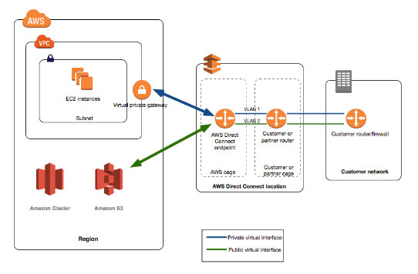
Beneficial Use Cases

  - When transferring large data sets.
  - When developing and using applications that use real-time data feeds.
  - When building hybrid environments that satisfy regulatory requirements requiring the use of private connectivity.

Setting Up Methods
Port speed | Method
1 Gbps or higher | Connect directly to an AWS device from your router at an AWS Direct Connect location.
1 Gbps or higher | Work with a partner in the AWS Partner Network or a network provider to connect a router from your data center, office, or colocation environment to an AWS Direct Connect location. The network provider does not have to be a member of the APN to connect you.
Less than 1 Gbps | Work with a partner in the AWS Partner Network who can create a hosted connection for you. Sign up for AWS and then follow the instructions to accept your hosted connection.
Components

  - Connections – Create a connection in an AWS Direct Connect location to establish a network connection from your premises to an AWS Region. From Direct Connect you can connect to all AZs within the region.
  - Virtual interfaces – Create a virtual interface to enable access to AWS services. A public virtual interface enables access to public services, such as S3. A private virtual interface enables access to your VPC.
- To access public resources in a remote Region, you must set up a public virtual interface and establish a Border Gateway Protocol session.
- You can create a Direct Connect gateway in any public Region. Use it to connect your Direct Connect connection over a private virtual interface to VPCs in your account that are located in different Regions.
- To provide for failover, request and configure two dedicated connections to AWS. These connections can terminate on one or two routers in your network. There are different configuration choices available:
  - Active/Active (BGP multipath) – This is the default configuration, where both connections are active. If one connection becomes unavailable, all traffic is routed through the other connection.
  - Active/Passive (failover) – One connection is handling traffic, and the other is on standby. If the active connection becomes unavailable, all traffic is routed through the passive connection.
- Autonomous System numbers (ASN) are used to identify networks that present a clearly defined external routing policy to the Internet.
Cross Connects

  - After you have downloaded your Letter of Authorization and Connecting Facility Assignment (LOA-CFA), you must complete your cross-network connection, also known as a cross connect.
  - If you already have equipment located in a Direct Connect location, contact the appropriate provider to complete the cross connect.
  - If you do not already have equipment located in a Direct Connect location, you can work with one of the partners in the AWS Partner Network to help you to connect to an AWS Direct Connect location.
Virtual Interfaces

  - You must create a virtual interface to begin using your Direct Connect connection.
  - You can configure multiple virtual interfaces on a single AWS Direct Connect connection.
    - For private virtual interfaces, you need one private virtual interface for each VPC to connect to from the AWS Direct Connect connection, or you can use a AWS Direct Connect gateway.
  - Prerequisites
    - Connection: The Direct Connect connection or link aggregation group for which you are creating the virtual interface.
    - Virtual interface name: A name for the virtual interface.
    - Virtual interface owner
    - (Private virtual interface only) Connection to
    - VLAN: A unique virtual local area network tag that’s not already in use on your connection.
    - Address family: Whether the BGP peering session will be over IPv4 or IPv6.
    - Peer IP addresses: A virtual interface can support a BGP peering session for IPv4, IPv6, or one of each (dual-stack). You cannot create multiple BGP sessions for the same IP addressing family on the same virtual interface
    - BGP information: A public or private Border Gateway Protocol Autonomous System Number for your side of the BGP session, and an MD5 BGP authentication key.
    - (Public virtual interface only) Prefixes you want to advertise: Public IPv4 routes or IPv6 routes to advertise over BGP. You must advertise at least one prefix using BGP.
  - The maximum transmission unit (MTU) of a network connection is the size, in bytes, of the largest permissible packet that can be passed over the connection. The MTU of a virtual private interface can be either 1500 or 9001 (jumbo frames). The MTU of a transit virtual interface for VPC Transit Gateways associated with Direct Connect gateways can be either 1500 or 8500 (jumbo frames). A public virtual interface doesn’t support jumbo frames.
  - Jumbo frames are supported on virtual private interfaces attached to a virtual private gateway or a Direct Connect gateway. Jumbo frames apply only to propagated routes from Direct Connect.
Link Aggregation Groups (LAG)

  - A logical interface that uses the Link Aggregation Control Protocol to aggregate multiple connections at a single Direct Connect endpoint, allowing you to treat them as a single, managed connection.
  - All connections in the LAG must use the same bandwidth.
  - You can have a maximum of four connections in a LAG. Each connection in the LAG counts towards your overall connection limit for the Region.
  - All connections in the LAG must terminate at the same Direct Connect endpoint.
  - Can aggregate up to 4 Direct Connect ports into a single connection using LAG.
  - All connections in a LAG operate in Active/Active mode.
  - It will only be available for dedicated 1G and 10G connections.
Direct Connect Gateways

  - Use a Direct Connect gateway to connect your Direct Connect connection over a private virtual interface to one or more VPCs in your account that are located in the same or different Regions.
  - It is a globally available resource.
  - Direct Connect gateway also enables you to connect between your on-premises networks and Amazon Virtual Private Cloud (Amazon VPC) in any commercial AWS Region except in China regions.
  - Prior to multi-account support, you could only associate Amazon VPCs with a Direct Connect gateway in the same AWS account. With the launch of multi-account support for Direct Connect gateway, you can associate up to 10 Amazon VPCs from multiple accounts with a Direct Connect gateway. The VPCs must be owned by AWS Accounts that belong to the same AWS payer account ID.

AWS Direct Connect SiteLink

  - The SiteLink feature makes it easy to create a private network connection between your on-premises locations to AWS. This is done by connecting your AWS resources to Direct Connect locations (e.g. offices, data centers) around the globe.
  - Using the feature, you can link your on-premises data centers to Direct Connect and send data between them over the shortest path between your AWS Direct Connect locations.

AWS Direct Connect Security

  - Use IAM for controlling access.

AWS Direct Connect Monitoring

  - You can optionally assign tags to your Direct Connect resources to categorize or manage them. A tag consists of a key and an optional value, both of which you define.
  - CloudTrail captures all API calls for AWS Direct Connect as events.
  - Set up CloudWatch alarms to monitor metrics.

AWS Direct Connect Pricing

  - You pay only for the network ports you use and the data you transfer over the connection.
  - Pricing is per port-hour consumed for each port type. Data transfer out over AWS Direct Connect is charged per GB. Data transfer IN is $0.00 per GB in all locations.
AWS Direct Connect Deep Dive:
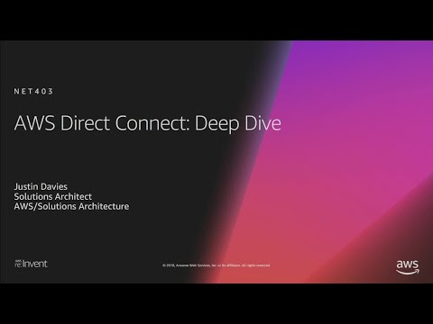
AWS Direct Connect-related Cheat Sheets:
- S3 Transfer Acceleration vs Direct Connect vs VPN vs Snowball vs Snowmobile
Note: If you are studying for the AWS Certified Advanced Networking Specialty exam, we highly recommend that you take our AWS Certified Advanced Networking – Specialty Practice Exams and read our Advanced Networking Specialty exam study guide.

Validate Your Knowledge
Question 1
A leading insurance firm has a VPC in the US East (N. Virginia) region for their head office in New York and another VPC in the US West (N. California) for their regional office in California. There is a requirement to establish a low latency, high-bandwidth connection between their on-premises data center in Chicago and both of their VPCs in AWS.
As the SysOps Administrator of the firm, how could you implement this in a cost-effective manner?
- Establish a Direct Connect connection between the VPC in US East (N. Virginia) region to the on-premises data center in Chicago and then establish another Direct Connect connection between the VPC in US West (N. California) region to the on-premises data center.
- Set up an AWS Direct Connect connection to the on-premises data center. Launch a new AWS Direct Connect Gateway with a virtual private gateway and connect the VPCs from US East and US West regions. Integrate the Direct Connect connection to the Direct Connect Gateway.
- Set up an AWS VPN managed connection between the VPC in US East (N. Virginia) region and the on-premises data center in Chicago.
- Set up two separate VPC peering connections for the two VPCs and for the on-premises data center.
Show me the answer!
Correct Answer: 2
You can use an AWS Direct Connect gateway to connect your AWS Direct Connect connection over a private virtual interface to one or more VPCs in your account that are located in the same or different regions. You associate a Direct Connect gateway with the virtual private gateway for the VPC and then create a private virtual interface for your AWS Direct Connect connection to the Direct Connect gateway. You can attach multiple private virtual interfaces to your Direct Connect gateway. A Direct Connect gateway is a globally available resource. You can create the Direct Connect gateway in any public region and access it from all other public regions.
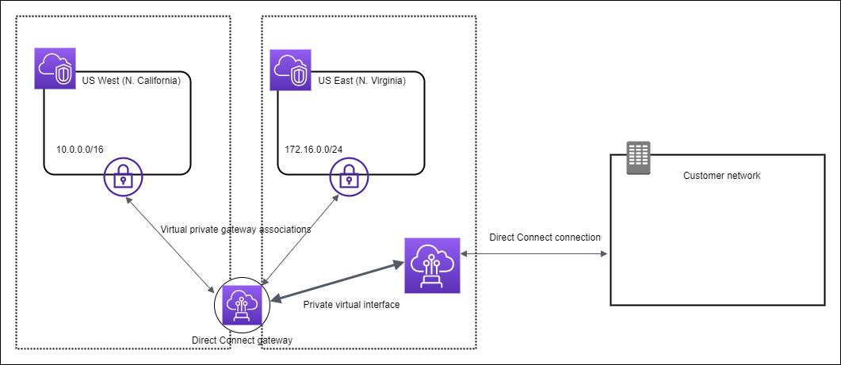
Hence, the correct answer is: Set up an AWS Direct Connect connection to the on-premises data center. Launch a new AWS Direct Connect Gateway with a virtual private gateway and connect the VPCs from US East and US West regions. Integrate the Direct Connect connection to the Direct Connect Gateway.
Establishing a Direct Connect connection between the VPC in US East (N. Virginia) region to the on-premises data center in Chicago and then establishing another Direct Connect connection between the VPC in US West (N. California) region to the on-premises data center is incorrect because establishing two separate Direct Connect connections is expensive and hence, not a cost-effective option. It is better to establish a Direct Connect gateway, which just uses one Direct Connect connection to integrate the 2 VPCs and the on-premises data center.
Setting up an AWS VPN managed connection between the VPC in US East (N. Virginia) region and the on-premises data center in Chicago is incorrect because a VPN Connection is a more suitable solution for low to modest bandwidth requirements and can tolerate the inherent variability in Internet-based connectivity.
Setting up two separate VPC peering connections for the two VPCs and for the on-premises data center is incorrect because VPC Peering is used to connect 2 VPCs together and not to connect your on-premises data center.
References:
https://docs.aws.amazon.com/directconnect/latest/UserGuide/direct-connect-gateways.html
https://docs.aws.amazon.com/directconnect/latest/UserGuide/direct-connect-gateways-intro.html
Note: This question was extracted from our AWS Certified SysOps Administrator Associate Practice Exams.

Question 2
A company has a hybrid cloud infrastructure that consists of its Amazon VPC in the us-east-1 (N. Virginia) Region and its corporate network. A single 10-Gbps AWS Direct Connect connection with multiple private virtual interfaces has been established to allow EC2 instances to send data to the on-premises file storage servers. The Network Administrator has been tasked to ensure high resiliency to common connectivity failures which will support the critical production workloads.
What must the Administrator do to satisfy this requirement?
- Create a second 10-Gbps AWS Direct Connect connection to another AWS Direct Connect location.
- Create a second 10-Gbps AWS Direct Connect connection to the existing AWS Direct Connect location.
- Create a second 10-Gbps AWS Managed VPN connection between the VPC and the on-premises network.
- Launch a Direct Connect Gateway that connects two public virtual interfaces in the us-east-1 (N. Virginia) Region to the on-premises network.
Show me the answer!
Correct Answer: 1
Amazon Web Services (AWS) offers customers the ability to achieve highly resilient network connections between Amazon Virtual Private Cloud (Amazon VPC) and their on-premises infrastructure. This capability extends customer access to AWS resources in a reliable, scalable, and cost-effective way.
You can achieve maximum resiliency for critical workloads by using separate connections that terminate on separate devices in more than one location:
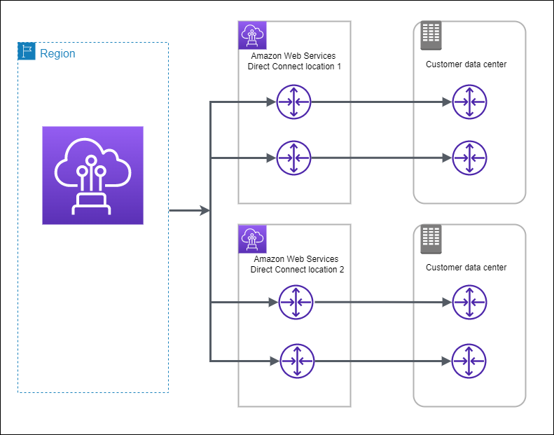
Highly resilient, fault-tolerant network connections are key to a well-architected system. AWS recommends connecting from multiple data centers for physical location redundancy. When designing remote connections, consider using redundant hardware and telecommunications providers. If you are only using a single AWS Direct Connect location, you have to create another Direct Connect connection to another AWS Direct Connect location to improve the connection’s resiliency.
Additionally, it is a best practice to use dynamically routed, active/active connections for automatic load balancing and failover across redundant network connections. Provision sufficient network capacity to ensure that the failure of one network connection does not overwhelm and degrade redundant connections.
Hence, the correct answer is: Create a second 10-Gbps AWS Direct Connect connection to another AWS Direct Connect location.
The option that says: Create a second 10-Gbps AWS Direct Connect connection to the existing AWS Direct Connect location is incorrect because this setup does not provide high resiliency. If the single AWS Direct Connect location goes down, then there would be no way for the on-premises network to connect to the VPC and vice versa.
The option that says: Create a second 10-Gbps AWS Managed VPN connection between the VPC and the on-premises network is incorrect because an AWS Managed VPN connection is not capable of reaching a throughput of 10-Gbps. Multiple VPN connections to the same Virtual Private Gateway are bound by an aggregate throughput limit from AWS to on-premises of up to 1.25 Gbps.
The option that says: Launch a Direct Connect Gateway that connects two public virtual interfaces in the us-east-1 (N. Virginia) Region to the on-premises network is incorrect because a Direct Connect gateway simply enables you to use your existing AWS Direct Connect connection to access VPCs in your account on two or more AWS Regions. Moreover, you have to use private virtual interfaces in Direct Connect Gateway and not public virtual interfaces.
References:
https://docs.aws.amazon.com/directconnect/latest/UserGuide/high_resiliency.html
https://aws.amazon.com/directconnect/resiliency-recommendation/
Note: This question was extracted from our AWS Certified Advanced Networking Specialty Practice Exams.
For more AWS practice exam questions with detailed explanations, visit the Tutorials Dojo Portal:
AWS Direct Connect Cheat Sheet References:
https://docs.aws.amazon.com/directconnect/latest/UserGuide
https://aws.amazon.com/directconnect/features/
https://aws.amazon.com/directconnect/pricing/
https://aws.amazon.com/directconnect/faqs/
------------------------------ ---------------------------------- ---------------------------------
https://tutorialsdojo.com/aws-elastic-load-balancing-elb/
AWS Elastic Load Balancing Cheat Sheet
- Distributes incoming application or network traffic across multiple targets, such as EC2 instances, containers (ECS), Lambda functions, and IP addresses, in multiple Availability Zones.
- When you create a load balancer, you must specify one public subnet from at least two Availability Zones. You can specify only one public subnet per Availability Zone.
General Features
- Accepts incoming traffic from clients and routes requests to its registered targets.
- Monitors the health of its registered targets and routes traffic only to healthy targets.
- Enable deletion protection to prevent your load balancer from being deleted accidentally. Disabled by default.
- Deleting ELB won’t delete the instances registered to it.
- Cross Zone Load Balancing – when enabled, each load balancer node distributes traffic across the registered targets in all enabled AZs.
- Supports SSL Offloading which is a feature that allows the ELB to bypass the SSL termination by removing the SSL-based encryption from the incoming traffic.
Types of Load Balancers
- Application Load Balancer ( ALB )

  - Functions at the application layer, the seventh layer of the Open Systems Interconnection (OSI) model.
  - Allows HTTP and HTTPS.
  - At least 2 subnets must be specified when creating this type of load balancer.
  - Components:
    - A load balancer serves as the single point of contact for clients.
    - A listener checks for connection requests from clients. You must define a default rule for each listener that specifies a target group, condition, and priority.
    - Target group routes requests to one or more registered targets. You can register a target with multiple target groups, and configure health checks on a per target group basis.
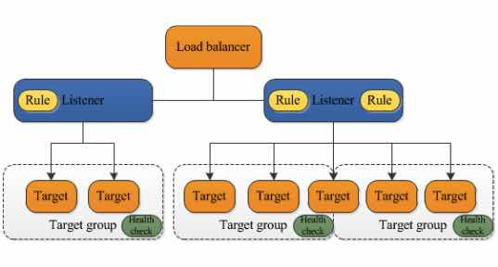

  - Benefits
    - Support for path-based and host-based routing.
    - Support for routing requests to multiple applications on a single EC2 instance.
    - Support for registering targets by IP address, including targets outside the VPC for the load balancer.
    - Support for containerized applications.
    - Support for monitoring the health of each service independently.
    - Support for redirecting requests from one URL to another.
    - Support for returning a custom HTTP response.
    - Support for the load balancer to authenticate users of your applications before routing requests using OIDC-compliant identity providers and/or Amazon Cognito user pools.
    - Support for registering Lambda functions as targets.
    - Supports load balancer-generated cookies for sticky sessions.
    - Supports Application-based cookie stickiness. This ensures that clients connect to the same load balancer target for the duration of their session using application cookies.
    - Supports dual-stack mode. This enables you to create IPv6 target groups and link IPv4 and IPv6 clients to targets in IPv6 or dual-stack subnets.
  - Cross-zone load balancing is always enabled.
  - If you specify targets using an instance ID, traffic is routed to instances using the primary private IP address specified in the primary network interface for the instance. If you specify targets using IP addresses, you can route traffic to an instance using any private IP address from one or more network interfaces.
  - You can also specify Lambda functions are targets to serve HTTP(S) requests.
  - HTTP/2 Support
  - WebSockets Support
  - Monitoring:
    - CloudWatch metrics – retrieve statistics about data points for your load balancers and targets as an ordered set of time-series data, known as metrics.
    - Access logs – capture detailed information about the requests made to your load balancer and store them as log files in S3.
    - Request tracing – track HTTP requests.
    - CloudTrail logs – capture detailed information about the calls made to the Elastic Load Balancing API and store them as log files in S3.
- Network Load Balancer ( NLB )
  - Functions at the fourth layer of the Open Systems Interconnection (OSI) model. Uses TCP and UDP connections.
  - At least 1 subnet must be specified when creating this type of load balancer, but the recommended number is 2.
  - Components:
    - A load balancer serves as the single point of contact for clients.
    - A listener checks for connection requests from clients.
    - A target group routes requests to one or more registered targets. You can register a target with multiple target groups. You can configure health checks on a per target group basis.
  - Benefits
    - Ability to handle volatile workloads and scale to millions of requests per second.
    - Support for static IP addresses for the load balancer, or assign one Elastic IP address per subnet enabled for the load balancer.
    - Support for registering targets by IP address.
    - Support for routing requests to multiple applications on a single EC2 instance (register each instance or IP address with the same target group using multiple ports).
    - Support for containerized applications.
    - Support for monitoring the health of each service independently.
    - Supports forwarding traffic directly from NLB to ALB.
    - Supports load balancing for both IPv4 and IPv6 clients.
  - Cross-zone load balancing is disabled by default.
  - If you specify targets using an instance ID, the source IP addresses of the clients are preserved and provided to your applications. If you specify targets by IP address, the source IP addresses are the private IP addresses of the load balancer nodes.
  - Network Load Balancers support connections from clients over inter-region VPC peering, AWS managed VPN, and third-party VPN solutions.
  - You can deploy services that rely on the UDP protocol, such as Authentication and Authorization, Logging, DNS, and IoT, behind a Network Load Balancer
  - Offers multi-protocol listeners, allowing you to run applications such as DNS that rely on both TCP and UDP protocols on the same port behind a Network Load Balancer.

  - You CANNOT enable or disable Availability Zones for a Network Load Balancer after you create it.
  - Network Load Balancers use Proxy Protocol version 2 to send additional connection information such as the source and destination.
  - Preserves the client-side source IP allowing the back-end to see the IP address of the client. This can then be used by applications for further processing.
  - Automatically provides a static IP per Availability Zone (subnet) that can be used by applications as the front-end IP of the load balancer.
  - Zonal Isolation
  - In the event that your Network load balancer is unresponsive, integration with Route 53 will remove the unavailable load balancer IP address from service and direct traffic to an alternate Network Load Balancer in another region.
  - Supports TLS termination on Network Load Balancers. Additionally, Network Load Balancers preserve the source IP of the clients to the back-end applications, while terminating TLS on the load balancer.
  - Monitoring:
    - CloudWatch metrics – retrieve statistics about data points for your load balancers and targets as an ordered set of time-series data, known as metrics.
    - VPC Flow Logs – capture detailed information about the traffic going to and from your Network Load Balancer.
    - Access Logs – capture detailed information about the requests made to your load balancer and store them as log files in S3.
    - CloudTrail logs – capture detailed information about the calls made to the Elastic Load Balancing API and store them as log files in Amazon S3.
- Gateway Load Balancer ( GWLB )
  - Primarily used for deploying, scaling, and running third-party virtual appliances.
  - The virtual appliances can be your custom firewalls, deep packet inspection systems, or intrusion detection and prevention systems in AWS
  - Uses the Internet Protocol (IP) to pass the OSI Layer 3 traffic to its registered targets.
  - GWLB Target groups support the Generic Networking Virtualization Encapsulation (GENEVE) on port: 6081
  - Runs within one Availability Zone (AZ)
  - You cannot specify publicly routable IP addresses as your target
  - You can provision a Gateway Load Balancer Endpoint that creates a secured, low-latency, connections to and from the virtual appliance
  - Does not support SSL Offloading, Server Name Indication (SNI), Back-end Server Encryption, User Authentication, Custom Security Policy or Application-Layer Protocol Negotiation (ALPN)
  - Monitoring:
    - CloudWatch metrics – retrieve statistics about data points for your Gateway Load Balancers and virtual appliances (targets).
    - VPC Flow Logs – capture the information about the incoming and outgoing traffic to and from your Gateway Load Balancers (GWLB).
    - CloudTrail logs – determine which GWLB API calls were made, the source IP address where the call came from, who made the call and when the call was made.
- Classic Load Balancer ( CLB )
  - Distributes incoming application traffic across multiple EC2 instances in multiple Availability Zones.
  - For use with EC2 classic only. Register instances with the load balancer. AWS recommends using Application or Network load balancers instead.
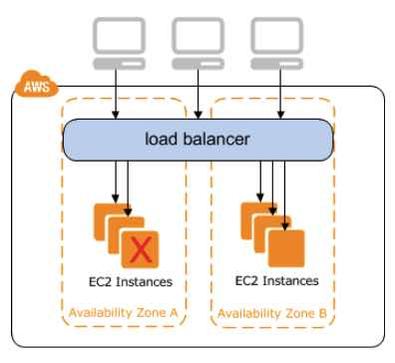

  - To ensure that your registered instances are able to handle the request load in each AZ, keep approximately the same number of instances in each AZ registered with the load balancer.
  - Benefits
    - Support for EC2-Classic
    - Support for TCP and SSL listeners
    - Support for sticky sessions using application-generated cookies
  - An Internet-facing load balancer has a publicly resolvable DNS name, so it can route requests from clients over the Internet to the EC2 instances that are registered with the load balancer. Classic load balancers are always Internet-facing.
  - Monitoring:
    - CloudWatch metrics – retrieve statistics about ELB-published data points as an ordered set of time-series data, known as metrics.
    - Access logs – capture detailed information for requests made to your load balancer and stores them as log files in the S3 bucket that you specify.
    - CloudTrail logs – keep track of the calls made to the Elastic Load Balancing API by or on behalf of your AWS account
- HTTP Headers
  - Application Load Balancers and Classic Load Balancers support X-Forwarded-For, X-Forwarded-Proto, and X-Forwarded-Port headers.
- Choose whether to make an internal load balancer or an Internet-facing load balancer. Classic Load Balancer in EC2-Classic must be an Internet-facing load balancer.
  - The nodes of an Internet-facing load balancer have public IP addresses.
  - The nodes of an internal load balancer have only private IP addresses.
- Public DNS name format for your load balancers
  - EC2-VPC : name-1234567890.region.elb.amazonaws.com (supports IPv4 addresses only)
  - EC2-Classic: (support both IPv4 and IPv6 addresses)
    - name-123456789.region.elb.amazonaws.com
    - ipv6.name-123456789.region.elb.amazonaws.com
    - dualstack.name-123456789.region.elb.amazonaws.com
- Load Balancer States
  - Provisioning – The load balancer is being set up.
  - Active – The load balancer is fully set up and ready to route traffic.
  - Failed – The load balancer could not be set up.
- By default, ELB idle timeout value to 60 seconds. If a target doesn’t send data at least every 60 seconds while the request is in flight, the load balancer can close the front-end connection. For back-end connections, enable the HTTP keep-alive option for your EC2 instances.
- You can register each EC2 instance or IP address with the same target group multiple times using different ports, which enables the load balancer to route requests to microservices.
- Listeners define the port and protocol to listen on.
- Listener rules determine how the load balancer routes requests to the targets in one or more target groups. You can add rules that specify different target groups based on the content of the request. If no rules are found, the default rule will be followed. Parts are:
  - Rule priority
  - Rule action
  - Rule conditions
- Slow Start Mode gives targets time to warm up before the load balancer sends them a full share of requests.
- Sticky sessions route requests to the same target in a target group. You enable sticky sessions at the target group level. You can also set the duration for the stickiness of the load balancer-generated cookie, in seconds. Useful if you have stateful applications.
- Health checks verify the status of your targets. The statuses for a registered target are:
Value | Description
initial | The load balancer is in the process of registering the target or performing the initial health checks on the target.
healthy | The target is healthy.
unhealthy | The target did not respond to a health check or failed the health check.
unused | The target is not registered with a target group, the target group is not used in a listener rule for the load balancer, or the target is in an Availability Zone that is not enabled for the load balancer.
draining | The target is deregistering and connection draining is in process.
Security, Authentication and Access Control
- Use IAM Policies to grant permissions
- Resource-level permissions
- Security groups that control the traffic allowed to and from your load balancer.
Recommended rules for internet-facing load balancer:
Inbound
Source | Port Range
0.0.0.0/0 | listener
Outbound
Destination | Port Range
instance security group | instance listener
instance security group | health check
For internal load balancer:
Inbound
Source | Port Range
VPC CIDR | listener
Outbound
Destination | Port Range
instance security group | instance listener
instance security group | health check
Summary of Features
Feature | Application Load Balancer | Network Load Balancer | Gateway Load Balancer
Protocols | HTTP, HTTPS, gRPC | TCP, UDP, TLS | IP
Platforms | VPC | VPC | VPC
Health checks | HTTP, HTTPS, gRPC | TCP, HTTP, HTTPS | TCP, HTTP, HTTPS
Cloudwatch Metrics | Yes | Yes | Yes
Logging | Yes | Yes | Yes
Zonal Failover | Yes | Yes | Yes
Connection Draining (deregistration delay) | Yes | Yes | Yes
Load Balancing to multiple ports on the same instance | Yes | Yes | Yes
IP addresses as targets | Yes | Yes (TCP, TLS) | Yes
Load Balancer deletion protection | Yes | Yes | Yes
Configuration idle connection timeout | Yes
Cross-zone load balancing | Yes | Yes | Yes
Sticky sessions | Yes | Yes | Yes
Static IP |  | Yes
Elastic IP address |  | Yes
Preserve Source IP address | Yes | Yes | Yes
Resource-based IAM permissions/ Tag-based IAM permissions | Yes | Yes | Yes
Slow start | Yes
Web sockets | Yes | Yes | Yes
PravateLink Support |  | Yes (TCP, TLS) | Yes (GWLBE)
Source IP address CIDR-based routing | Yes
Layer 7
Path-based routing | Yes
Host-based routing | Yes
Native HTTP/2 | Yes
Redirects | Yes
Fixed Response | Yes
Lambda Functions as targets | Yes
HTTP header-based routing | Yes
HTTP method-based routing | Yes
Query parameter-based routing | Yes
Security
SSL offloading | Yes | Yes
Server Name Indication (SNI) | Yes | Yes
Back-end server encryption | Yes | Yes
User authentication | Yes
Session resumption | Yes | Yes
Terminates flow/proxy behavior | Yes | Yes | Yes

AWS Elastic Load Balancing Pricing
- You are charged for each hour or partial hour that an Application Load Balancer is running and the number of Load Balancer Capacity Units (LCU) used per hour.
- You are charged for each hour or partial hour that a Network Load Balancer is running and the number of Load Balancer Capacity Units (LCU) used by Network Load Balancer per hour.
- You are charged for each hour or partial hour that a Gateway Load Balancer is running and the number of Gateway Load Balancer Capacity Units (GLCU) used by Gateway Load Balancer per hour.
- You are charged per VPC endpoint, AZ, and GB of data processed for the Gateway Load Balancer Endpoint.
- You are charged for each hour or partial hour that a Classic Load Balancer is running and for each GB of data transferred through your load balancer.
Best Practices on Elastic Load Balancing:
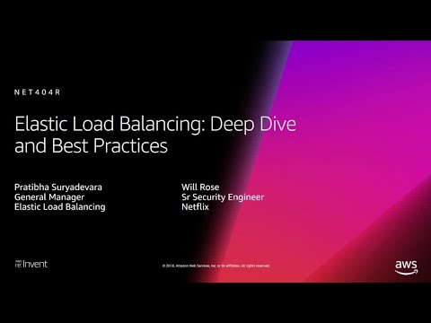
AWS Elastic Load Balancing-related Cheat Sheets:
- Application Load Balancer vs Network Load Balancer vs Classic Load Balancer
Note: If you are studying for the AWS Certified Advanced Networking Specialty exam, we highly recommend that you take our AWS Certified Advanced Networking – Specialty Practice Exams and read our Advanced Networking Specialty exam study guide.

Validate Your Knowledge
Question 1
What is the primary reason why you should be using an elastic load balancer for a website with high activity?
- ELBs help you scale servers easily without manual intervention
- ELBs can distribute traffic equally to your backend targets to handle the incoming traffic load
- ELBs help tighten security through the use of security groups
- ELBs boost your website’s overall performance
Show me the answer!
Correct Answer: 2
Elastic Load Balancing automatically distributes incoming application traffic across multiple targets, such as Amazon EC2 instances, containers, IP addresses, and Lambda functions. It can handle the varying load of your application traffic in a single Availability Zone or across multiple Availability Zones.
Elastic Load Balancing offers three types of load balancers that all feature the high availability, automatic scaling, and robust security necessary to make your applications fault-tolerant. They are Application Load Balancer, Network Load Balancer, and Gateway Load Balancer.
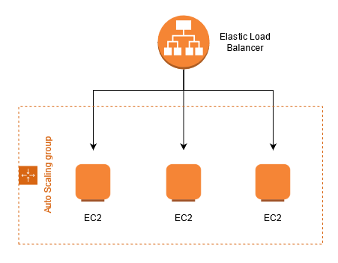
Hence, the correct answer is: ELBs can distribute traffic equally to your backend targets to handle the incoming traffic load.
The option that says: ELBs help you scale easily without manual intervention is incorrect. For automatic scaling of your compute capacity, you need another service called AWS Auto Scaling to go with your load balancers. Auto-scaling handles the scaling of capacity for you so that your instances are not being overwhelmed.
The option that says: ELBs help tighten security through the use of security groups is incorrect. Although ELBs do add security for your instances, it is not solely because of security groups. Security groups can be used directly with EC2 instances, so this statement is not the best answer for the scenario.
The option that says: ELBs boost your website’s overall performance is incorrect because ELBs do not boost website performance. This is usually done by another AWS service known as Amazon CloudFront. ELBs redirect traffic to healthy instances in a controlled manner, providing you the elasticity and fault tolerance that your applications need.
References:
https://docs.aws.amazon.com/elasticloadbalancing/latest/userguide/what-is-load-balancing.html
https://aws.amazon.com/elasticloadbalancing/features/
Check out this AWS Elastic Load Balancing Cheat Sheet:
https://tutorialsdojo.com/aws-elastic-load-balancing-elb/
Application Load Balancer vs Network Load Balancer vs Classic Load Balancer vs Gateway Load Balancer:
https://tutorialsdojo.com/application-load-balancer-vs-network-load-balancer-vs-classic-load-balancer/
AWS Elastic Load Balancing Overview:

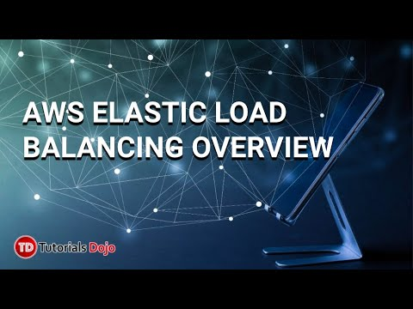
Note: This question was extracted from our AWS Certified Cloud Practitioner Practice Exams.

Question 2
After a year of development, the company’s 100-node high-performance computing (HPC) application is now ready to be deployed to an Amazon Elastic Kubernetes Service (Amazon EKS) cluster with Horizontal Pod Autoscaler (HPA). The application must be capable of receiving millions of UDP traffic per second from the public Internet while maintaining low latency.
Which of the following is the most operationally efficient solution that should be implemented to meet the above requirements?
- Launch a Gateway Load Balancer and integrate an Elastic Fabric Adapter (EFA) to each Kubernetes pod deployed in the Amazon EKS cluster
- Integrate the AWS Load Balancer Controller add-on to the EKS cluster. Launch a Network Load Balancer to load balance network traffic to individual Kubernetes pods.
- Install the AWS Load Balancer Controller add-on to the EKS cluster and launch an Application Load Balancer to distribute the incoming traffic to the Kubernetes pods.
- Set up the kube-proxy Amazon EKS add-on to the cluster and configure the Source Network Address Translation (SNAT) of the Kubernetes pods by setting the AWS_VPC_K8S_CNI_EXTERNALSNAT configuration to true.
Show me the answer!
Correct Answer: 2
Network Load Balancer operates at the connection level (Layer 4), routing connections to targets – Amazon EC2 instances, microservices, and containers – within Amazon Virtual Private Cloud (Amazon VPC) based on IP protocol data. Ideal for load balancing of both TCP and UDP traffic, Network Load Balancer is capable of handling millions of requests per second while maintaining ultra-low latencies. Network Load Balancer is optimized to handle sudden and volatile traffic patterns while using a single static IP address per Availability Zone. It is integrated with other popular AWS services such as Auto Scaling, Amazon EC2 Container Service (ECS), Amazon CloudFormation, and AWS Certificate Manager (ACM).
Network Load Balancer preserves the client-side source IP address, allowing the back-end EC2 instances to see the IP address of the client. This can then be used by applications for further processing.
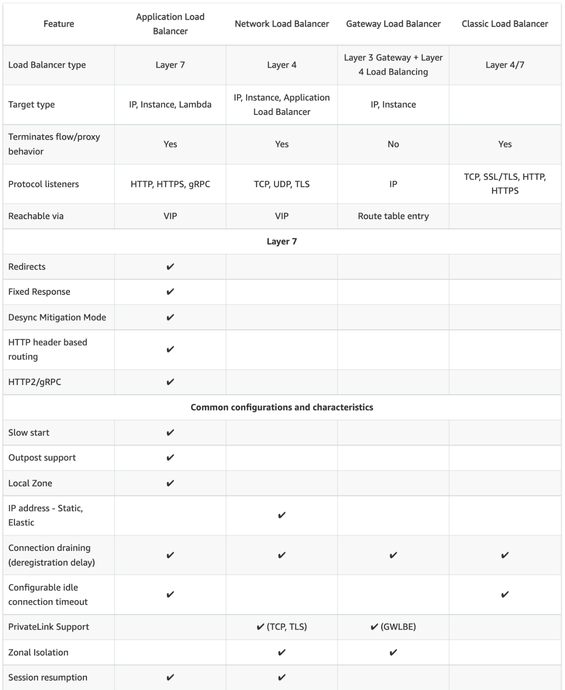
Network traffic is load balanced at L4 of the OSI model. To load balance application traffic at L7, you deploy a Kubernetes ingress, which provisions an AWS Application Load Balancer. An AWS Network Load Balancer can load balance network traffic to pods deployed to Amazon EC2 IP and instance targets or to AWS Fargate IP targets.
The AWS Load Balancer Controller manages AWS Elastic Load Balancers for a Kubernetes cluster. The controller provisions the following resources:
– An AWS Application Load Balancer (ALB) when you create a Kubernetes Ingress.
– An AWS Network Load Balancer (NLB) when you create a Kubernetes service of type LoadBalancer.
In the past, the Kubernetes network load balancer was used for instance targets, but the AWS Load balancer Controller was used for IP targets. With the AWS Load Balancer Controller version 2.3.0 or later, you can create NLBs using either target type. The AWS Load Balancer Controller controller was formerly named the AWS ALB Ingress Controller. It’s an open-source project managed on GitHub.
Hence, the correct answer is Integrate the AWS Load Balancer Controller add-on to the EKS cluster. Launch a Network Load Balancer to load balance network traffic to individual Kubernetes pods.
The option that says: Install the AWS Load Balancer Controller add-on to the EKS cluster and launch an Application Load Balancer to distribute the incoming traffic to the Kubernetes pods is incorrect because an ALB is not capable of handling millions of requests per second while maintaining ultra-low latencies, unlike a Network Load Balancer. Moreover, this type of load balancer doesn’t preserve the client-side source IP address.
The option that says: Launch a Gateway Load Balancer and integrate an Elastic Fabric Adapter (EFA) to each Kubernetes pod deployed in the Amazon EKS cluster is incorrect because a Gateway Load Balancer simply helps you easily deploy, scale, and manage your third-party virtual appliances. This type of load balancer is not capable of receiving millions of requests per second while maintaining low latency.
The option that says: Set up the kube-proxy Amazon EKS add-on to the cluster and configure the Source Network Address Translation (SNAT) of the Kubernetes pods by setting the AWS_VPC_K8S_CNI_EXTERNALSNAT configuration to true is incorrect because kube-proxy just maintains network rules on each Amazon EC2 node of the EKS cluster. In addition, changing the default SNAT configuration is also unwarranted since the scenario didn’t mention any connection between your EKS cluster VPC to another VPC peering, a transit VPC, or a Direct Connect connection. SNAT must only be changed if these aforementioned resources need to initiate communication with your pods using an IPv4 address.
References:
https://docs.aws.amazon.com/eks/latest/userguide/network-load-balancing.html
https://docs.aws.amazon.com/eks/latest/userguide/aws-load-balancer-controller.html
https://docs.aws.amazon.com/eks/latest/userguide/pod-networking.html
Note: This question was extracted from our AWS Certified Advanced Networking Specialty Practice Exams.
For more AWS practice exam questions with detailed explanations, visit the Tutorials Dojo Portal:
Additional Training Materials: AWS Elastic Load Balancing Video Courses on Udemy
- Amazon EC2 Master Class (with Auto Scaling & Load Balancer)
- AWS: Get Started with Load Balancing and Auto-Scaling Groups
AWS ELB Cheat Sheet References:
https://docs.aws.amazon.com/elasticloadbalancing/latest/application/introduction.html
https://docs.aws.amazon.com/elasticloadbalancing/latest/network/introduction.html
https://docs.aws.amazon.com/elasticloadbalancing/latest/classic/introduction.html
https://aws.amazon.com/elasticloadbalancing/features/
https://aws.amazon.com/elasticloadbalancing/pricing/?nc=sn&loc=3
------------------------------ ---------------------------------- ---------------------------------
https://tutorialsdojo.com/aws-global-accelerator/
AWS Global Accelerator Cheat Sheet
- A service that uses the AWS Global Network to improve the availability and performance of your applications to your local and global users.
- It provides static IP addresses that act as a fixed entry point to your application endpoints in a single or multiple AWS Regions, such as your Application Load Balancers, Network Load Balancers or Amazon EC2 instances.
- AWS Global Accelerator continually monitors the health of your application endpoints and will detect an unhealthy endpoint and redirect traffic to healthy endpoints in less than 1 minute.
How It Works
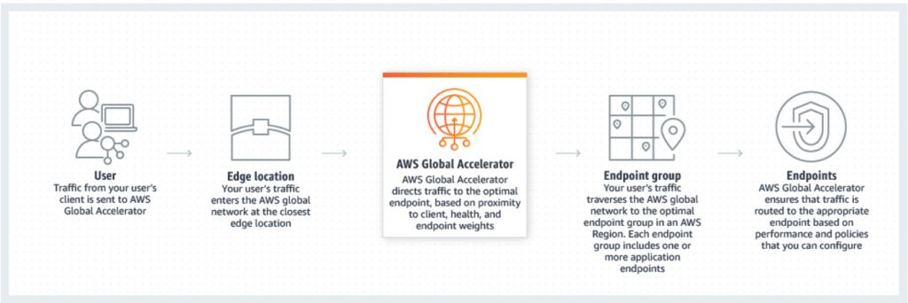
Concepts

  - An accelerator is the resource you create to direct traffic to optimal endpoints over the AWS global network.
  - Network zones are isolated units with their own set of physical infrastructure and service IP addresses from a unique IP subnet.
  - AWS Global Accelerator provides you with a set of two static IP addresses that are anycast from the AWS edge network. It also assigns a default Domain Name System (DNS) name to your accelerator, similar to a1234567890abcdef.awsglobalaccelerator.com, that points to the static IP addresses.
  - A listener processes inbound connections from clients to Global Accelerator, based on the port (or port range) and protocol that you configure. Global Accelerator supports both TCP and UDP protocols.
  - Each endpoint group is associated with a specific AWS Region. Endpoint groups include one or more endpoints in the Region.
  - Endpoints can be Network Load Balancers, Application Load Balancers, EC2 instances, or Elastic IP addresses.

Benefits of AWS Global Accelerator

  - Instant regional failover – AWS Global Accelerator automatically checks the health of your applications and routes user traffic only to healthy application endpoints. If the health status changes or you make configuration updates, AWS Global Accelerator reacts instantaneously to route your users to the next available endpoint. Monitors the health of your application endpoints by using TCP, HTTP, and HTTPS health checks.
  - High availability – AWS Global Accelerator has a fault-isolating design that increases the availability of your application. When you create an accelerator, you are allocated two IPv4 static IP addresses that are serviced by independent network zones.
  - No variability around clients that cache IP addresses – You do not have to rely on the IP address caching settings of client devices. Change propagation of a configuration update only takes a matter of seconds.
  - Improved performance – AWS Global Accelerator ingresses traffic from the edge location that is closest to your end clients through anycast static IP addresses. Then traffic traverses the AWS global network, which optimizes the path to your application that is running in an AWS Region. AWS Global Accelerator chooses the optimal AWS Region based on the geography of end clients, which reduces first-byte latency and improves performance.
  - Easy manageability – The static IP addresses provided by AWS Global Accelerator are fixed and provide a single entry point to your applications. This lets you easily move your endpoints between Availability Zones or between AWS Regions, without having to update your DNS configuration or client-facing applications.
  - Fine-grained control – AWS Global Accelerator lets you set a traffic dial for your regional endpoint groups, to dial traffic up or down for a specific AWS Region when you conduct performance testing or application updates. In addition, if you have stateful applications, you can choose to direct all requests from a user to the same endpoint, regardless of the source port and protocol, to maintain client affinity. These features give you fine-grained control. By default, the traffic dial is set to 100% for all regional endpoint groups.
  - Also supports bring your own IP (BYOIP) so you can use your own IPs on the AWS edge network.
Steps in deploying an accelerator

  - Create an accelerator
  - Configure endpoint groups
  - Register endpoints for endpoint groups
Global Accelerator vs CloudFront
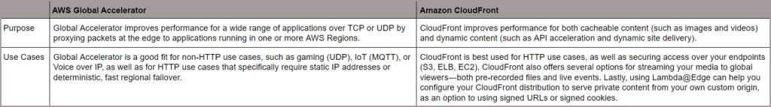
Both services integrate with AWS Shield for DDoS protection.
AWS Global Accelerator Security

  - SOC, PCI, HIPAA, GDPR, and ISO compliant.
  - AWS Global Accelerator Flow Logs provide detailed records about traffic that flows through an accelerator to an endpoint.
  - As a managed service, AWS Global Accelerator is protected by the AWS global network security procedures.
AWS Global Accelerator Pricing

  - You are charged for each accelerator that is provisioned and the amount of traffic in the dominant direction that flows through the accelerator.
  - For every accelerator that is provisioned (both enabled and disabled), you are charged a fixed hourly fee and an incremental charge over your standard Data Transfer rates per GB, also called a Data Transfer-Premium fee.
Note: If you are studying for the AWS Certified Advanced Networking Specialty exam, we highly recommend that you take our AWS Certified Advanced Networking – Specialty Practice Exams and read our Advanced Networking Specialty exam study guide.
AWS Global Accelerator Cheat Sheet Resources:
https://aws.amazon.com/global-accelerator/
https://aws.amazon.com/global-accelerator/faqs/
https://docs.aws.amazon.com/pt_br/global-accelerator/latest/dg/what-is-global-accelerator.html
------------------------------ ---------------------------------- ---------------------------------
https://tutorialsdojo.com/aws-transit-gateway/
AWS Transit Gateway Cheat Sheet
- A networking service that uses a hub and spoke model to enable customers to connect their on-premises data centers and their Amazon Virtual Private Clouds (VPCs) to a single gateway.
- With this service, customers only have to create and manage a single connection from the central gateway into each on-premises data center, remote office, or VPC across your network.
- If a new VPC is created, it is automatically connected to the Transit Gateway and will also be available to every other network that is also connected to the Transit Gateway.
Features
- Inter-region peering
  - Transit Gateway leverages the AWS global network to allow customers to route traffic across AWS Regions.
  - Inter-region peering provides an easy and cost-effective way to replicate data for geographic redundancy or to share resources between AWS Regions.

- Multicast
  - Enables customers to have fine-grain control on who can consume and produce multicast traffic.
  - It allows you to easily create and manage multicast groups in the cloud instead of the time-consuming task of deploying and managing legacy hardware on-premises.
  - This multicast solution is also scalable so the customers can simultaneously distribute a stream of content to multiple subscribers.
- Automated Provisioning
  - Customers can automatically identify the Site-to-Site VPN connections and the on-premises resources with which they are associated using AWS Transit Gateway.
  - Using the Transit Gateway Network Manager, you can also manually define your on-premises network.
Note: If you are studying for the AWS Certified Advanced Networking Specialty exam, we highly recommend that you take our AWS Certified Advanced Networking – Specialty Practice Exams and read our Advanced Networking Specialty exam study guide.

Validate Your Knowledge
Question 1
A multinational bank has two data centers that are 60 miles (96.56 kilometers) from each other. The bank also has a single transit gateway that has multiple VPC and VPN attachments.
The Network team recently established two AWS Direct Connect connections from the company’s on-premises data centers to a Direct Connect location with the help of a local Direct Connect Partner. Afterward, they provisioned an AWS Direct Connect Gateway that connects to the AWS Direct Connect location via a transit virtual interface.
With this setup, what other network connections can be implemented? (Select TWO.)
- Connect multiple VPCs in the same or different AWS account using the Direct Connect connection.
- Associate multiple transit gateways in different AWS Regions to the Direct Connect Gateway and use the same ASNs for each transit gateway. Enable the Appliance mode for all transit gateways.
- Allow on-premises servers to connect to AWS resources that are reachable via public IP addresses such as AWS public endpoints and S3 buckets. Configure the Appliance mode on the existing transit gateway.
- Use equal-cost multi-path routing (ECMP) to get higher VPN bandwidth by aggregating multiple VPN connections in different AWS Regions.
- Associate multiple transit gateways in the same AWS Region.
Show me the answer!

For more AWS practice exam questions with detailed explanations, visit the Tutorials Dojo Portal:
AWS Transit Gateway Cheat Sheet Reference:
https://aws.amazon.com/transit-gateway/
------------------------------ ---------------------------------- ---------------------------------
https://tutorialsdojo.com/vpc-peering/

VPC Peering Cheat Sheet
- A networking connection between two VPCs that enables you to route traffic between them privately using private IPv4 addresses or IPv6 addresses. Instances in either VPC can communicate with each other as if they are within the same network.
- You can create a VPC peering connection between your own VPCs, with a VPC in another AWS account, or with a VPC in a different AWS Region (also called Inter-Region VPC Peering).
- A VPC peering connection is neither a gateway nor a AWS Site-to-Site VPN connection, and does not rely on a separate piece of physical hardware. There is no single point of failure for communication or a bandwidth bottleneck.
- VPC Peering does NOT support edge-to-edge routing. You can create multiple VPC peering connections for each VPC that you own, but transitive peering relationships are not supported.
  - In the following diagram, VPC B is not peered with VPC C.

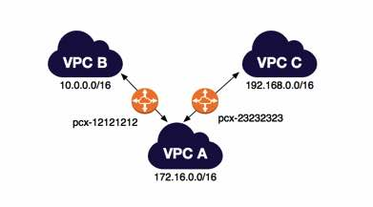
Establishing A Peering Connection

  - The owner of the requester VPC sends a request to the owner of the accepter VPC to create the VPC peering connection. The accepter VPC cannot have a CIDR block that overlaps with the requester VPC’s CIDR block.
  - To enable the flow of traffic between the VPCs using private IP addresses, the owner of each VPC in the VPC peering connection must manually add a route to one or more of their VPC route tables that points to the IP address range of the other VPC (the peer VPC).
  - Update the security group rules that are associated with your instance to ensure that traffic to and from the peer VPC is not restricted.
  - By default, if instances on either side of a VPC peering connection address each other using a public DNS hostname, the hostname resolves to the instance’s public IP address. To change this behavior, enable DNS hostname resolution for your VPC connection. This will allow the DNS hostname to resolve to the instance’s private IP address.
Limitations

  - You cannot create a VPC peering connection between VPCs that have matching or overlapping IPv4 or IPv6 CIDR blocks.
  - You cannot have more than one VPC peering connection between the same two VPCs at the same time.
  - Unicast reverse path forwarding in VPC peering connections is not supported.
  - If the VPCs are in the same region, you can enable the resources on either side of a VPC peering connection to communicate with each other over IPv6.
  - For inter-region peering, you cannot create a security group rule that references a peer VPC security group. Communication over IPv6 is not supported as well.
For those preparing for the AWS Certified Solutions Architect Professional exam, it’s a must to read this article as well: Longest Prefix Match: Understanding Advanced Concepts in VPC Peering
Note: If you are studying for the AWS Certified Advanced Networking Specialty exam, we highly recommend that you take our AWS Certified Advanced Networking – Specialty Practice Exams and read our Advanced Networking Specialty exam study guide.

VPC Peering Cheat Sheet References:
https://docs.aws.amazon.com/vpc/latest/userguide/vpc-peering.html
https://docs.aws.amazon.com/vpc/latest/peering/what-is-vpc-peering.html

