https://tutorialsdojo.com/amazon-cloudwatch/
Amazon CloudWatch Cheat Sheet
- Monitoring tool for your AWS resources and applications.
- Display metrics and create alarms that watch the metrics and send notifications or automatically make changes to the resources you are monitoring when a threshold is breached.
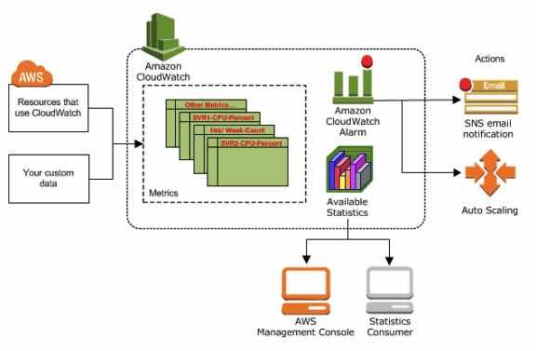
- CloudWatch is basically a metrics repository. An AWS service, such as Amazon EC2, puts metrics into the repository and you retrieve statistics based on those metrics. If you put your own custom metrics into the repository, you can retrieve statistics on these metrics as well.
- CloudWatch does not aggregate data across regions. Therefore, metrics are completely separate between regions.
CloudWatch Concepts

  - Namespaces – a container for CloudWatch metrics.
    - There is no default namespace.
    - The AWS namespaces use the following naming convention: AWS/service.
  - Metrics – represents a time-ordered set of data points that are published to CloudWatch.
    - Exists only in the region in which they are created.
    - Cannot be deleted, but they automatically expire after 15 months if no new data is published to them.
    - As new data points come in, data older than 15 months is dropped.
    - Each metric data point must be marked with a timestamp. The timestamp can be up to two weeks in the past and up to two hours into the future. If you do not provide a timestamp, CloudWatch creates a timestamp for you based on the time the data point was received.
    - By default, several services provide free metrics for resources. You can also enable detailed monitoring, or publish your own application metrics.
    - Metric math enables you to query multiple CloudWatch metrics and use math expressions to create new time series based on these metrics.
    - Important note for EC2 metrics: CloudWatch does not collect memory utilization and disk space usage metrics right from the get go. You need to install CloudWatch Agent in your instances first to retrieve these metrics.
  - Dimensions – a name/value pair that uniquely identifies a metric.
    - You can assign up to 10 dimensions to a metric.
    - Whenever you add a unique dimension to one of your metrics, you are creating a new variation of that metric.
  - Resolution – a custom metric can be classified as standard or high resolution.
    - Standard Resolution
      - Data with a granularity of one minute.
      - Default metrics produced by AWS services.
    - High Resolution
      - Data with a granularity of one second.
      - Provides more insight into your application’s sub-minute activity.
  - Statistics – metric data aggregations over specified periods of time.

    - Each statistic has a unit of measure. Metric data points that specify a unit of measure are aggregated separately.
    - You can specify a unit when you create a custom metric. If you do not specify a unit, CloudWatch uses None as the unit.
    - A period is the length of time associated with a specific CloudWatch statistic. The default value is 60 seconds.
    - CloudWatch aggregates statistics according to the period length that you specify when retrieving statistics.
    - For large datasets, you can insert a pre-aggregated dataset called a statistic set.

Statistic | Description
Minimum | The lowest value observed during the specified period. You can use this value to determine low volumes of activity for your application.
Maximum | The highest value observed during the specified period. You can use this value to determine high volumes of activity for your application.
Sum | All values submitted for the matching metric added together. Useful for determining the total volume of a metric.
Average | The value of Sum / SampleCount during the specified period. By comparing this statistic with the Minimum and Maximum, you can determine the full scope of a metric and how close the average use is to the Minimum and Maximum. This comparison helps you to know when to increase or decrease your resources as needed.
SampleCount | The count (number) of data points used for the statistical calculation.
pNN.NN | The value of the specified percentile. You can specify any percentile, using up to two decimal places (for example, p95.45). Percentile statistics are not available for metrics that include any negative values.
- Percentiles – indicates the relative standing of a value in a dataset. Percentiles help you get a better understanding of the distribution of your metric data.
- Alarms – watches a single metric over a specified time period, and performs one or more specified actions, based on the value of the metric relative to a threshold over time.
  - You can create an alarm for monitoring CPU usage and load balancer latency, for managing instances, and for billing alarms.
  - When an alarm is on a dashboard, it turns red when it is in the ALARM state.
  - Alarms invoke actions for sustained state changes only.
  - Alarm States
    - OK—The metric or expression is within the defined threshold.
    - ALARM—The metric or expression is outside of the defined threshold.
    - INSUFFICIENT_DATA—The alarm has just started, the metric is not available, or not enough data is available for the metric to determine the alarm state.
  - You can also monitor your estimated AWS charges by using Amazon CloudWatch Alarms. However, take note that you can only track the estimated AWS charges in CloudWatch and not the actual utilization of your resources. Remember that you can only set coverage targets for your reserved EC2 instances in AWS Budgets or Cost Explorer, but not in CloudWatch.
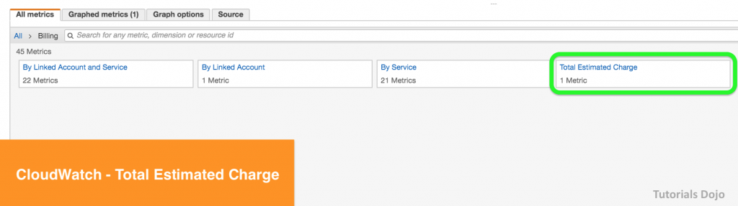

  - When you create an alarm, you specify three settings:
    - Period is the length of time to evaluate the metric or expression to create each individual data point for an alarm. It is expressed in seconds.
    - Evaluation Period is the number of the most recent periods, or data points, to evaluate when determining alarm state.
    - Datapoints to Alarm is the number of data points within the evaluation period that must be breaching to cause the alarm to go to the ALARM state. The breaching data points do not have to be consecutive, they just must all be within the last number of data points equal to Evaluation Period.
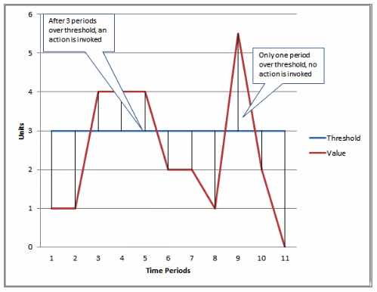

    - For each alarm, you can specify CloudWatch to treat missing data points as any of the following:
      - missing—the alarm does not consider missing data points when evaluating whether to change state (default)
      - notBreaching—missing data points are treated as being within the threshold
      - breaching—missing data points are treated as breaching the threshold
      - ignore—the current alarm state is maintained
  - You can now create tags in CloudWatch alarms that let you define policy controls for your AWS resources. This enables you to create resource level policies for your alarms.
CloudWatch Dashboard

  - Customizable home pages in the CloudWatch console that you can use to monitor your resources in a single view, even those spread across different regions.
  - There is no limit on the number of CloudWatch dashboards you can create.
  - All dashboards are global, not region-specific.
  - You can add, remove, resize, move, edit or rename a graph. You can metrics manually in a graph.
  - You can share your dashboards with users who do not have direct access to your AWS account via three ways:
    - Share a single dashboard and designate specific email addresses and passwords of the people who can view the dashboard.
    - Share a single dashboard publicly, so that anyone who has the link can view the dashboard.
    - Share all the CloudWatch dashboards in your account and specify a third-party SSO provider for dashboard access. All users who are members of this SSO provider’s list can access the dashboards in the account. To enable this, you integrate the SSO provider with Amazon Cognito.
CloudWatch Events (Amazon EventBridge)

  - Deliver near real-time stream of system events that describe changes in AWS resources.
  - Events respond to these operational changes and take corrective action as necessary, by sending messages to respond to the environment, activating functions, making changes, and capturing state information.
  - Concepts
    - Events – indicates a change in your AWS environment.
    - Targets – processes events.
    - Rules – matches incoming events and routes them to targets for processing.
  - Amazon EventBridge is a service that builds upon the CloudWatch Events service API. Both Amazon EventBridge and CloudWatch Events use the same underlying infrastructure. You can still continue managing events through CloudWatch Events but the preferred way is to manage events via Amazon EventBridge.
  - Amazon EventBridge extends the capabilities of CloudWatch Events by enabling customers to connect data from their own apps and third-party SaaS apps, making it easier to connect applications.
CloudWatch Logs

  - Features
    - Query log data
    - Monitor logs from EC2 instances in real-time
    - Monitor CloudTrail logged events
    - By default, logs are kept indefinitely and never expire
    - Archive log data
    - Log Route 53 DNS queries
  - CloudWatch Logs Insights enables you to interactively search and analyze your log data in CloudWatch Logs using queries.
  - CloudWatch Vended logs are logs that are natively published by AWS services on behalf of the customer. VPC Flow logs is the first Vended log type that will benefit from this tiered model.
  - After the CloudWatch Logs agent begins publishing log data to Amazon CloudWatch, you can search and filter the log data by creating one or more metric filters. Metric filters define the terms and patterns to look for in log data as it is sent to CloudWatch Logs.
  - Filters do not retroactively filter data. Filters only publish the metric data points for events that happen after the filter was created. Filtered results return the first 50 lines, which will not be displayed if the timestamp on the filtered results is earlier than the metric creation time.
  - Metric Filter Concepts
    - filter pattern – you use the pattern to specify what to look for in the log file.
    - metric name – the name of the CloudWatch metric to which the monitored log information should be published.
    - metric namespace – the destination namespace of the new CloudWatch metric.
    - metric value – the numerical value to publish to the metric each time a matching log is found.
    - default value – the value reported to the metric filter during a period when no matching logs are found. By setting this to 0, you ensure that data is reported during every period.
    - dimensions – key-value pairs that define a metric.
    - You can create two subscription filters with different filter patterns on a single log group.
  - CloudWatch Contributor Insights enables you to create rules to analyze structured log events.
  - CloudWatch Metric Insights is a flexible query capability that allows you to aggregate and group your metrics in real-time to quickly identify issues
  - You can use CloudWatch Evidently to test new features by serving them to a subset of your users and monitor its performance before fully launching the feature.
  - Real user monitoring allows you to collect and view client-side data about the performance of your web application from actual user sessions in near real time using CloudWatch RUM.
CloudWatch Agent

  - Collect more logs and system-level metrics from EC2 instances and your on-premises servers.
  - Needs to be installed.
  - Default namespace for metrics collected is CWAgent.
  - You can retrieve custom metrics from your applications using StatsD and collectd.
- Cloudwatch Metric Streams
  - Amazon CloudWatch Metric Streams lets you create a continuous, near real-time stream of metrics to a destination of your choice.
  - You can use Metric Streams to send metrics to Datadog, New Relic, Splunk, Dynatrace, Sumo Logic, and S3.
CloudWatch Application Insights
- AWS CloudWatch Application Insights facilitates observability for your applications and underlying AWS resources.
- It helps you set up the best monitors for your application resources to continuously analyze data for signs of problems with your applications.
- Application discovery and configuration: The first time an application is added to CloudWatch Application Insights, it scans the application components to recommend key metrics, logs, and other data sources to monitor for your application.
- Data preprocessing: CloudWatch Application Insights continuously analyzes the data sources being monitored across the application resources to discover metric anomalies and log errors (observations).
- Intelligent problem detection: The CloudWatch Application Insights engine detects problems in your application by correlating observations using classification algorithms and built-in rules.
- Alert and action: When CloudWatch Application Insights detects a problem with your application, it generates CloudWatch Events to notify you of the problem.
- Data Retention
  - CloudWatch Application Insights retains problems for 55 days and observations for 60 days.
- Features
  - It provides automated dashboards that show potential problems with monitored applications, which help you to quickly isolate ongoing issues with your applications and infrastructure.
  - When you add your applications to Amazon CloudWatch Application Insights, it scans the resources in the applications and recommends and configures metrics and logs on CloudWatch for application components.
  - It analyzes metric patterns using historical data to detect anomalies, and continuously detects errors and exceptions from your application, operating system, and infrastructure logs.
  - It correlates these observations using a combination of classification algorithms and built-in rules.
  - It automatically creates dashboards that show the relevant observations and problem severity information to help you prioritize your actions.
  - For common problems in .NET and SQL application stacks, such as application latency, SQL Server failed backups, memory leaks, large HTTP requests, and canceled I/O operations, it provides additional insights that point to a possible root cause and steps for resolution.
  - Built-in integration with AWS SSM OpsCenter allows you to resolve issues by running the relevant Systems Manager Automation document.
CloudWatch Container Insights

  - Data Collection and Aggregation
    - It collects, aggregates, and summarizes metrics and logs from your containerized applications and microservices.
    - It is available for Amazon Elastic Container Service (Amazon ECS), Amazon Elastic Kubernetes Service (Amazon EKS), and Kubernetes platforms on Amazon EC2.
    - It supports collecting metrics from clusters deployed on AWS Fargate for both Amazon ECS and Amazon EKS.
  - Diagnostic Information
    - It provides diagnostic information, such as container restart failures, to help you isolate issues and resolve them quickly.
    - You can set CloudWatch alarms on metrics that Container Insights collects.
  - Metrics and Logs
    - It collects data as performance log events using the embedded metric format.
    - The metrics that Container Insights collects are available in CloudWatch automatic dashboards.
    - It automatically creates a log group for the performance log events.
  - Charges
    - With the original version of Container Insights, the metrics are charged as custom metrics.
    - With Container Insights with enhanced observability for Amazon EKS, Container Insights metrics are charged per observation instead of being charged per metric stored or log ingested.
  - Performance Data Collection
    - In Amazon EKS and Kubernetes, Container Insights uses a containerized version of the CloudWatch agent to discover all of the running containers in a cluster.
    - It then collects performance data at every layer of the performance stack.
  - Encryption
    - Container Insights supports encryption with the AWS KMS key for the logs and metrics that it collects.
    - Only symmetric keys are supported.
Authentication and Access Control

  - Use IAM users or roles for authenticating who can access
  - Use Dashboard Permissions, IAM identity-based policies, and service-linked roles for managing access control.
  - A permissions policy describes who has access to what.
    - Identity-Based Policies
    - Resource-Based Policies
  - There are no CloudWatch Amazon Resource Names (ARNs) for you to use in an IAM policy. Use an * (asterisk) instead as the resource when writing a policy to control access to CloudWatch actions.
Amazon CloudWatch Pricing

  - You are charged for the number of metrics you have per month
  - You are charged per 1000 metrics requested using CloudWatch API calls
  - You are charged per dashboard per month
  - You are charged per alarm metric (Standard Resolution and High Resolution)
  - You are charged per GB of collected, archived and analyzed log data
  - There is no Data Transfer IN charge, only Data Transfer Out.
  - You are charged per million custom events and per million cross-account events
  - You are charged per rule and for log events that matches your rule.
  - Evidently events and analysis are charged per 1 million events.
  - RUM events are charged per 100k events.
  - Logs Insights is priced per query and charges based on the amount of ingested log data scanned by the query.
Collect Metrics and Logs from Amazon EC2 instances with the CloudWatch Agent:
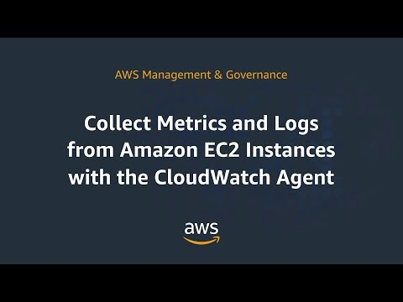
Amazon CloudWatch-related Cheat Sheets:
- CloudWatch Agent vs SSM Agent vs Custom Daemon Scripts
- AWS CloudTrail vs Amazon CloudWatch

Validate Your Knowledge
Question 1
A company needs to ensure the safety of its employees by measuring the temperature of their facility every 5 minutes using smart sensors. They want to send the custom data metrics of their application to CloudWatch to view the data graphs visually.
Which of the below statements is true regarding the scenario above?
- You can use AWS CLI or API to upload the data metrics to CloudWatch.
- Using AWS Snowball, the customer can import the data to CloudWatch.
- You can directly go to the AWS Console and upload the data to CloudWatch.
- A custom data metric from smart sensors is not supported by CloudWatch.
Show me the answer!
Correct Answer: 1
Amazon CloudWatch is a monitoring service for AWS cloud resources and the applications you run on AWS. You can use Amazon CloudWatch to collect and track metrics, collect and monitor log files, and set alarms. Amazon CloudWatch can also be used to gain system-wide visibility into resource utilization, application performance, and operational health. You can use these insights to react and keep your application running smoothly.
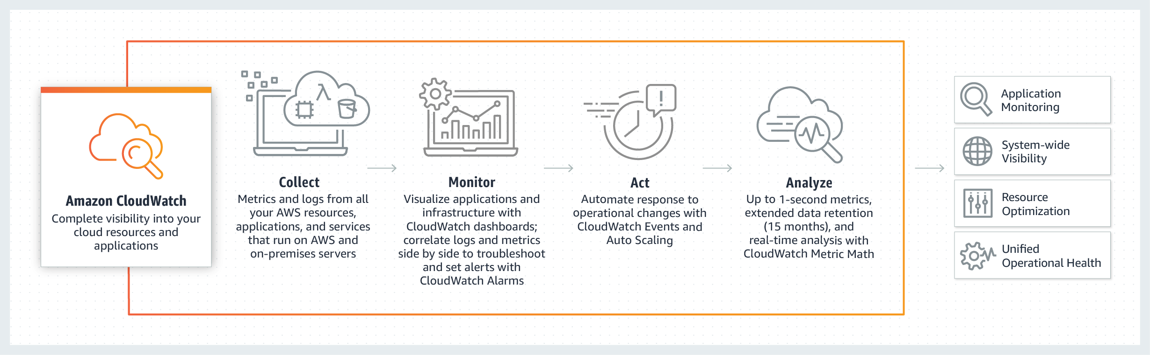
Although there is no option on the AWS console to upload custom metrics, you can do so by using the AWS CLI or the API.
To publish a single data point using CloudWatch for a new or existing metric, use the put-metric-data command with one value and the time stamp.
aws cloudwatch put-metric-data --metric-name PageViewCount --namespace MyService --value 2 --timestamp 2018-10-10-14T08:00:00.000Z
Hence, the correct answer is: You can use AWS CLI or API to upload the data metrics to CloudWatch.
The option that says: Using AWS Snowball, the customer can import the data to CloudWatch is incorrect because you don’t use Snowball to import data to CloudWatch. You can use AWS CLI or API to upload the data metrics to CloudWatch.
The option that says: You can directly go to the AWS Console and upload the data to CloudWatch is incorrect because you cannot upload custom metrics via the AWS Console.
The option that says: A custom data metric from smart sensors are not supported by CloudWatch is incorrect because AWS CloudWatch supports uploading custom metrics.
Reference:
https://docs.aws.amazon.com/AmazonCloudWatch/latest/monitoring/publishingMetrics.html
Note: This question was extracted from our AWS Certified SysOps Administrator Associate Practice Exams.

Question 2
There is a new compliance rule in your company that audits every Windows and Linux EC2 instances each month to view any performance issues. They have more than a hundred EC2 instances running in production, and each must have a logging function that collects various system details regarding that instance. The SysOps team will periodically review these logs and analyze their contents using AWS Analytics tools, and the result will need to be retained in an S3 bucket.
In this scenario, what is the most efficient way to collect and analyze logs from the instances with minimal effort?
- Install the unified CloudWatch Logs agent in each instance which will automatically collect and push data to CloudWatch Logs. Analyze the log data with CloudWatch Logs Insights.
- Install AWS SDK in each instance and create a custom daemon script that would collect and push data to CloudWatch Logs periodically. Enable CloudWatch detailed monitoring and use CloudWatch Logs Insights to analyze the log data of all instances.
- Install the AWS Systems Manager Agent (SSM Agent) in each instance which will automatically collect and push data to CloudWatch Logs. Analyze the log data with CloudWatch Logs Insights.
- Install AWS Inspector Agent in each instance which will collect and push data to CloudWatch Logs periodically. Set up a CloudWatch dashboard to properly analyze the log data of all instances.
Show me the answer!
Correct Answer: 1
To collect logs from your Amazon EC2 instances and on-premises servers into CloudWatch Logs, AWS offers both a new unified CloudWatch agent, and an older CloudWatch Logs agent. It is recommended to use the unified CloudWatch agent which has the following advantages:
– You can collect both logs and advanced metrics with the installation and configuration of just one agent.
– The unified agent enables the collection of logs from servers running Windows Server.
– If you are using the agent to collect CloudWatch metrics, the unified agent also enables the collection of additional system metrics, for in-guest visibility.
– The unified agent provides better performance.
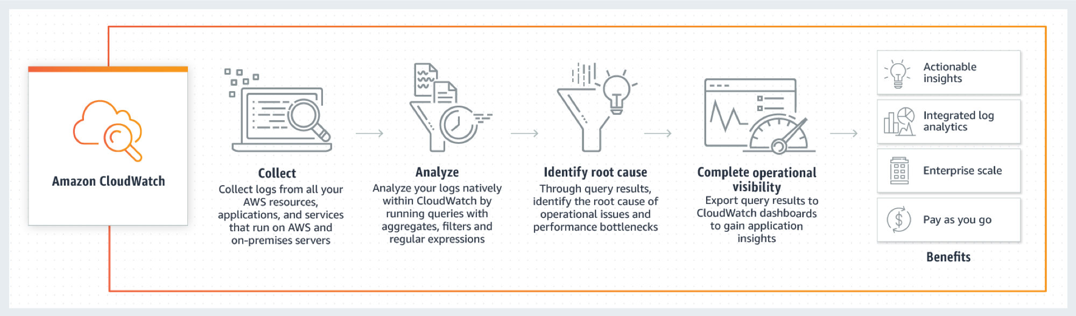
CloudWatch Logs Insights enables you to interactively search and analyze your log data in Amazon CloudWatch Logs. You can perform queries to help you quickly and effectively respond to operational issues. If an issue occurs, you can use CloudWatch Logs Insights to identify potential causes and validate deployed fixes.
CloudWatch Logs Insights includes a purpose-built query language with a few simple but powerful commands. CloudWatch Logs Insights provides sample queries, command descriptions, query autocompletion, and log field discovery to help you get started quickly. Sample queries are included for several types of AWS service logs.
The option that says: Install AWS SDK in each instance and create a custom daemon script that would collect and push data to CloudWatch Logs periodically. Enable CloudWatch detailed monitoring and use CloudWatch Logs Insights to analyze the log data of all instances is incorrect. Although this is a valid solution, this entails a lot of effort to implement as you have to allocate time to install the AWS SDK to each instance and develop a custom monitoring solution. Remember that the question is specifically looking for a solution that can be implemented with minimal effort. In addition, it is unnecessary and not cost-efficient to enable detailed monitoring in CloudWatch in order to meet the requirements of this scenario since this can be done using CloudWatch Logs.
The option that says: Install the AWS Systems Manager Agent (SSM Agent) in each instance which will automatically collect and push data to CloudWatch Logs. Analyze the log data with CloudWatch Logs Insights is incorrect as although this is also a valid solution, it is more efficient to use CloudWatch agent than an SSM agent. Manually connecting to an instance to view log files and troubleshoot an issue with SSM Agent is time-consuming hence, for more efficient instance monitoring, you can use the CloudWatch Agent instead to send the log data to Amazon CloudWatch Logs.
The option that says: Install AWS Inspector Agent in each instance which will collect and push data to CloudWatch Logs periodically. Set up a CloudWatch dashboard to properly analyze the log data of all instances is incorrect because AWS Inspector is simply a security assessments service which only helps you in checking for unintended network accessibility of your EC2 instances and for vulnerabilities on those EC2 instances. Furthermore, setting up an Amazon CloudWatch dashboard is not suitable since its primarily used for scenarios where you have to monitor your resources in a single view, even those resources that are spread across different AWS Regions. It is better to use CloudWatch Logs Insights instead since it enables you to interactively search and analyze your log data.
References:
https://docs.aws.amazon.com/AmazonCloudWatch/latest/logs/WhatIsCloudWatchLogs.html
https://docs.aws.amazon.com/systems-manager/latest/userguide/monitoring-ssm-agent.html
https://docs.aws.amazon.com/AmazonCloudWatch/latest/logs/AnalyzingLogData.html
CloudWatch Agent vs SSM Agent vs Custom Daemon Scripts:
https://tutorialsdojo.com/cloudwatch-agent-vs-ssm-agent-vs-custom-daemon-scripts/
Note: This question was extracted from our AWS Certified Solutions Architect Associate Practice Exams.
For more AWS practice exam questions with detailed explanations, visit the Tutorials Dojo Portal:

Additional Training Materials: Amazon CloudWatch Video Courses on Udemy
- Amazon CloudWatch in 60 Minutes: Monitor your AWS resources
Amazon CloudWatch Cheat Sheet References:
https://docs.aws.amazon.com/AmazonCloudWatch/latest/monitoring
https://aws.amazon.com/cloudwatch/features/
https://aws.amazon.com/cloudwatch/pricing/
https://aws.amazon.com/cloudwatch/faqs/
----------------------------------- -------------------------------- ------------------------------
AWS :Analytics Services https://tutorialsdojo.com/amazon-cloudwatch/
Amazon CloudWatch Cheat Sheet
- Monitoring tool for your AWS resources and applications.
- Display metrics and create alarms that watch the metrics and send notifications or automatically make changes to the resources you are monitoring when a threshold is breached.

- CloudWatch is basically a metrics repository. An AWS service, such as Amazon EC2, puts metrics into the repository and you retrieve statistics based on those metrics. If you put your own custom metrics into the repository, you can retrieve statistics on these metrics as well.
- CloudWatch does not aggregate data across regions. Therefore, metrics are completely separate between regions.
CloudWatch Concepts

  - Namespaces – a container for CloudWatch metrics.
    - There is no default namespace.
    - The AWS namespaces use the following naming convention: AWS/service.
  - Metrics – represents a time-ordered set of data points that are published to CloudWatch.
    - Exists only in the region in which they are created.
    - Cannot be deleted, but they automatically expire after 15 months if no new data is published to them.
    - As new data points come in, data older than 15 months is dropped.
    - Each metric data point must be marked with a timestamp. The timestamp can be up to two weeks in the past and up to two hours into the future. If you do not provide a timestamp, CloudWatch creates a timestamp for you based on the time the data point was received.
    - By default, several services provide free metrics for resources. You can also enable detailed monitoring, or publish your own application metrics.
    - Metric math enables you to query multiple CloudWatch metrics and use math expressions to create new time series based on these metrics.
    - Important note for EC2 metrics: CloudWatch does not collect memory utilization and disk space usage metrics right from the get go. You need to install CloudWatch Agent in your instances first to retrieve these metrics.
  - Dimensions – a name/value pair that uniquely identifies a metric.
    - You can assign up to 10 dimensions to a metric.
    - Whenever you add a unique dimension to one of your metrics, you are creating a new variation of that metric.
  - Resolution – a custom metric can be classified as standard or high resolution.
    - Standard Resolution
      - Data with a granularity of one minute.
      - Default metrics produced by AWS services.
    - High Resolution
      - Data with a granularity of one second.
      - Provides more insight into your application’s sub-minute activity.
  - Statistics – metric data aggregations over specified periods of time.

    - Each statistic has a unit of measure. Metric data points that specify a unit of measure are aggregated separately.
    - You can specify a unit when you create a custom metric. If you do not specify a unit, CloudWatch uses None as the unit.
    - A period is the length of time associated with a specific CloudWatch statistic. The default value is 60 seconds.
    - CloudWatch aggregates statistics according to the period length that you specify when retrieving statistics.
    - For large datasets, you can insert a pre-aggregated dataset called a statistic set.

Statistic | Description
Minimum | The lowest value observed during the specified period. You can use this value to determine low volumes of activity for your application.
Maximum | The highest value observed during the specified period. You can use this value to determine high volumes of activity for your application.
Sum | All values submitted for the matching metric added together. Useful for determining the total volume of a metric.
Average | The value of Sum / SampleCount during the specified period. By comparing this statistic with the Minimum and Maximum, you can determine the full scope of a metric and how close the average use is to the Minimum and Maximum. This comparison helps you to know when to increase or decrease your resources as needed.
SampleCount | The count (number) of data points used for the statistical calculation.
pNN.NN | The value of the specified percentile. You can specify any percentile, using up to two decimal places (for example, p95.45). Percentile statistics are not available for metrics that include any negative values.
- Percentiles – indicates the relative standing of a value in a dataset. Percentiles help you get a better understanding of the distribution of your metric data.
- Alarms – watches a single metric over a specified time period, and performs one or more specified actions, based on the value of the metric relative to a threshold over time.
  - You can create an alarm for monitoring CPU usage and load balancer latency, for managing instances, and for billing alarms.
  - When an alarm is on a dashboard, it turns red when it is in the ALARM state.
  - Alarms invoke actions for sustained state changes only.
  - Alarm States
    - OK—The metric or expression is within the defined threshold.
    - ALARM—The metric or expression is outside of the defined threshold.
    - INSUFFICIENT_DATA—The alarm has just started, the metric is not available, or not enough data is available for the metric to determine the alarm state.
  - You can also monitor your estimated AWS charges by using Amazon CloudWatch Alarms. However, take note that you can only track the estimated AWS charges in CloudWatch and not the actual utilization of your resources. Remember that you can only set coverage targets for your reserved EC2 instances in AWS Budgets or Cost Explorer, but not in CloudWatch.


  - When you create an alarm, you specify three settings:
    - Period is the length of time to evaluate the metric or expression to create each individual data point for an alarm. It is expressed in seconds.
    - Evaluation Period is the number of the most recent periods, or data points, to evaluate when determining alarm state.
    - Datapoints to Alarm is the number of data points within the evaluation period that must be breaching to cause the alarm to go to the ALARM state. The breaching data points do not have to be consecutive, they just must all be within the last number of data points equal to Evaluation Period.


    - For each alarm, you can specify CloudWatch to treat missing data points as any of the following:
      - missing—the alarm does not consider missing data points when evaluating whether to change state (default)
      - notBreaching—missing data points are treated as being within the threshold
      - breaching—missing data points are treated as breaching the threshold
      - ignore—the current alarm state is maintained
  - You can now create tags in CloudWatch alarms that let you define policy controls for your AWS resources. This enables you to create resource level policies for your alarms.
CloudWatch Dashboard

  - Customizable home pages in the CloudWatch console that you can use to monitor your resources in a single view, even those spread across different regions.
  - There is no limit on the number of CloudWatch dashboards you can create.
  - All dashboards are global, not region-specific.
  - You can add, remove, resize, move, edit or rename a graph. You can metrics manually in a graph.
  - You can share your dashboards with users who do not have direct access to your AWS account via three ways:
    - Share a single dashboard and designate specific email addresses and passwords of the people who can view the dashboard.
    - Share a single dashboard publicly, so that anyone who has the link can view the dashboard.
    - Share all the CloudWatch dashboards in your account and specify a third-party SSO provider for dashboard access. All users who are members of this SSO provider’s list can access the dashboards in the account. To enable this, you integrate the SSO provider with Amazon Cognito.
CloudWatch Events (Amazon EventBridge)

  - Deliver near real-time stream of system events that describe changes in AWS resources.
  - Events respond to these operational changes and take corrective action as necessary, by sending messages to respond to the environment, activating functions, making changes, and capturing state information.
  - Concepts
    - Events – indicates a change in your AWS environment.
    - Targets – processes events.
    - Rules – matches incoming events and routes them to targets for processing.
  - Amazon EventBridge is a service that builds upon the CloudWatch Events service API. Both Amazon EventBridge and CloudWatch Events use the same underlying infrastructure. You can still continue managing events through CloudWatch Events but the preferred way is to manage events via Amazon EventBridge.
  - Amazon EventBridge extends the capabilities of CloudWatch Events by enabling customers to connect data from their own apps and third-party SaaS apps, making it easier to connect applications.
CloudWatch Logs

  - Features
    - Query log data
    - Monitor logs from EC2 instances in real-time
    - Monitor CloudTrail logged events
    - By default, logs are kept indefinitely and never expire
    - Archive log data
    - Log Route 53 DNS queries
  - CloudWatch Logs Insights enables you to interactively search and analyze your log data in CloudWatch Logs using queries.
  - CloudWatch Vended logs are logs that are natively published by AWS services on behalf of the customer. VPC Flow logs is the first Vended log type that will benefit from this tiered model.
  - After the CloudWatch Logs agent begins publishing log data to Amazon CloudWatch, you can search and filter the log data by creating one or more metric filters. Metric filters define the terms and patterns to look for in log data as it is sent to CloudWatch Logs.
  - Filters do not retroactively filter data. Filters only publish the metric data points for events that happen after the filter was created. Filtered results return the first 50 lines, which will not be displayed if the timestamp on the filtered results is earlier than the metric creation time.
  - Metric Filter Concepts
    - filter pattern – you use the pattern to specify what to look for in the log file.
    - metric name – the name of the CloudWatch metric to which the monitored log information should be published.
    - metric namespace – the destination namespace of the new CloudWatch metric.
    - metric value – the numerical value to publish to the metric each time a matching log is found.
    - default value – the value reported to the metric filter during a period when no matching logs are found. By setting this to 0, you ensure that data is reported during every period.
    - dimensions – key-value pairs that define a metric.
    - You can create two subscription filters with different filter patterns on a single log group.
  - CloudWatch Contributor Insights enables you to create rules to analyze structured log events.
  - CloudWatch Metric Insights is a flexible query capability that allows you to aggregate and group your metrics in real-time to quickly identify issues
  - You can use CloudWatch Evidently to test new features by serving them to a subset of your users and monitor its performance before fully launching the feature.
  - Real user monitoring allows you to collect and view client-side data about the performance of your web application from actual user sessions in near real time using CloudWatch RUM.
CloudWatch Agent

  - Collect more logs and system-level metrics from EC2 instances and your on-premises servers.
  - Needs to be installed.
  - Default namespace for metrics collected is CWAgent.
  - You can retrieve custom metrics from your applications using StatsD and collectd.
- Cloudwatch Metric Streams
  - Amazon CloudWatch Metric Streams lets you create a continuous, near real-time stream of metrics to a destination of your choice.
  - You can use Metric Streams to send metrics to Datadog, New Relic, Splunk, Dynatrace, Sumo Logic, and S3.
CloudWatch Application Insights
- AWS CloudWatch Application Insights facilitates observability for your applications and underlying AWS resources.
- It helps you set up the best monitors for your application resources to continuously analyze data for signs of problems with your applications.
- Application discovery and configuration: The first time an application is added to CloudWatch Application Insights, it scans the application components to recommend key metrics, logs, and other data sources to monitor for your application.
- Data preprocessing: CloudWatch Application Insights continuously analyzes the data sources being monitored across the application resources to discover metric anomalies and log errors (observations).
- Intelligent problem detection: The CloudWatch Application Insights engine detects problems in your application by correlating observations using classification algorithms and built-in rules.
- Alert and action: When CloudWatch Application Insights detects a problem with your application, it generates CloudWatch Events to notify you of the problem.
- Data Retention
  - CloudWatch Application Insights retains problems for 55 days and observations for 60 days.
- Features
  - It provides automated dashboards that show potential problems with monitored applications, which help you to quickly isolate ongoing issues with your applications and infrastructure.
  - When you add your applications to Amazon CloudWatch Application Insights, it scans the resources in the applications and recommends and configures metrics and logs on CloudWatch for application components.
  - It analyzes metric patterns using historical data to detect anomalies, and continuously detects errors and exceptions from your application, operating system, and infrastructure logs.
  - It correlates these observations using a combination of classification algorithms and built-in rules.
  - It automatically creates dashboards that show the relevant observations and problem severity information to help you prioritize your actions.
  - For common problems in .NET and SQL application stacks, such as application latency, SQL Server failed backups, memory leaks, large HTTP requests, and canceled I/O operations, it provides additional insights that point to a possible root cause and steps for resolution.
  - Built-in integration with AWS SSM OpsCenter allows you to resolve issues by running the relevant Systems Manager Automation document.
CloudWatch Container Insights

  - Data Collection and Aggregation
    - It collects, aggregates, and summarizes metrics and logs from your containerized applications and microservices.
    - It is available for Amazon Elastic Container Service (Amazon ECS), Amazon Elastic Kubernetes Service (Amazon EKS), and Kubernetes platforms on Amazon EC2.
    - It supports collecting metrics from clusters deployed on AWS Fargate for both Amazon ECS and Amazon EKS.
  - Diagnostic Information
    - It provides diagnostic information, such as container restart failures, to help you isolate issues and resolve them quickly.
    - You can set CloudWatch alarms on metrics that Container Insights collects.
  - Metrics and Logs
    - It collects data as performance log events using the embedded metric format.
    - The metrics that Container Insights collects are available in CloudWatch automatic dashboards.
    - It automatically creates a log group for the performance log events.
  - Charges
    - With the original version of Container Insights, the metrics are charged as custom metrics.
    - With Container Insights with enhanced observability for Amazon EKS, Container Insights metrics are charged per observation instead of being charged per metric stored or log ingested.
  - Performance Data Collection
    - In Amazon EKS and Kubernetes, Container Insights uses a containerized version of the CloudWatch agent to discover all of the running containers in a cluster.
    - It then collects performance data at every layer of the performance stack.
  - Encryption
    - Container Insights supports encryption with the AWS KMS key for the logs and metrics that it collects.
    - Only symmetric keys are supported.
Authentication and Access Control

  - Use IAM users or roles for authenticating who can access
  - Use Dashboard Permissions, IAM identity-based policies, and service-linked roles for managing access control.
  - A permissions policy describes who has access to what.
    - Identity-Based Policies
    - Resource-Based Policies
  - There are no CloudWatch Amazon Resource Names (ARNs) for you to use in an IAM policy. Use an * (asterisk) instead as the resource when writing a policy to control access to CloudWatch actions.
Amazon CloudWatch Pricing

  - You are charged for the number of metrics you have per month
  - You are charged per 1000 metrics requested using CloudWatch API calls
  - You are charged per dashboard per month
  - You are charged per alarm metric (Standard Resolution and High Resolution)
  - You are charged per GB of collected, archived and analyzed log data
  - There is no Data Transfer IN charge, only Data Transfer Out.
  - You are charged per million custom events and per million cross-account events
  - You are charged per rule and for log events that matches your rule.
  - Evidently events and analysis are charged per 1 million events.
  - RUM events are charged per 100k events.
  - Logs Insights is priced per query and charges based on the amount of ingested log data scanned by the query.
Collect Metrics and Logs from Amazon EC2 instances with the CloudWatch Agent:

Amazon CloudWatch-related Cheat Sheets:
- CloudWatch Agent vs SSM Agent vs Custom Daemon Scripts
- AWS CloudTrail vs Amazon CloudWatch

Validate Your Knowledge
Question 1
A company needs to ensure the safety of its employees by measuring the temperature of their facility every 5 minutes using smart sensors. They want to send the custom data metrics of their application to CloudWatch to view the data graphs visually.
Which of the below statements is true regarding the scenario above?
- You can use AWS CLI or API to upload the data metrics to CloudWatch.
- Using AWS Snowball, the customer can import the data to CloudWatch.
- You can directly go to the AWS Console and upload the data to CloudWatch.
- A custom data metric from smart sensors is not supported by CloudWatch.
Show me the answer!
Correct Answer: 1
Amazon CloudWatch is a monitoring service for AWS cloud resources and the applications you run on AWS. You can use Amazon CloudWatch to collect and track metrics, collect and monitor log files, and set alarms. Amazon CloudWatch can also be used to gain system-wide visibility into resource utilization, application performance, and operational health. You can use these insights to react and keep your application running smoothly.

Although there is no option on the AWS console to upload custom metrics, you can do so by using the AWS CLI or the API.
To publish a single data point using CloudWatch for a new or existing metric, use the put-metric-data command with one value and the time stamp.
aws cloudwatch put-metric-data --metric-name PageViewCount --namespace MyService --value 2 --timestamp 2018-10-10-14T08:00:00.000Z
Hence, the correct answer is: You can use AWS CLI or API to upload the data metrics to CloudWatch.
The option that says: Using AWS Snowball, the customer can import the data to CloudWatch is incorrect because you don’t use Snowball to import data to CloudWatch. You can use AWS CLI or API to upload the data metrics to CloudWatch.
The option that says: You can directly go to the AWS Console and upload the data to CloudWatch is incorrect because you cannot upload custom metrics via the AWS Console.
The option that says: A custom data metric from smart sensors are not supported by CloudWatch is incorrect because AWS CloudWatch supports uploading custom metrics.
Reference:
https://docs.aws.amazon.com/AmazonCloudWatch/latest/monitoring/publishingMetrics.html
Note: This question was extracted from our AWS Certified SysOps Administrator Associate Practice Exams.

Question 2
There is a new compliance rule in your company that audits every Windows and Linux EC2 instances each month to view any performance issues. They have more than a hundred EC2 instances running in production, and each must have a logging function that collects various system details regarding that instance. The SysOps team will periodically review these logs and analyze their contents using AWS Analytics tools, and the result will need to be retained in an S3 bucket.
In this scenario, what is the most efficient way to collect and analyze logs from the instances with minimal effort?
- Install the unified CloudWatch Logs agent in each instance which will automatically collect and push data to CloudWatch Logs. Analyze the log data with CloudWatch Logs Insights.
- Install AWS SDK in each instance and create a custom daemon script that would collect and push data to CloudWatch Logs periodically. Enable CloudWatch detailed monitoring and use CloudWatch Logs Insights to analyze the log data of all instances.
- Install the AWS Systems Manager Agent (SSM Agent) in each instance which will automatically collect and push data to CloudWatch Logs. Analyze the log data with CloudWatch Logs Insights.
- Install AWS Inspector Agent in each instance which will collect and push data to CloudWatch Logs periodically. Set up a CloudWatch dashboard to properly analyze the log data of all instances.
Show me the answer!
Correct Answer: 1
To collect logs from your Amazon EC2 instances and on-premises servers into CloudWatch Logs, AWS offers both a new unified CloudWatch agent, and an older CloudWatch Logs agent. It is recommended to use the unified CloudWatch agent which has the following advantages:
– You can collect both logs and advanced metrics with the installation and configuration of just one agent.
– The unified agent enables the collection of logs from servers running Windows Server.
– If you are using the agent to collect CloudWatch metrics, the unified agent also enables the collection of additional system metrics, for in-guest visibility.
– The unified agent provides better performance.

CloudWatch Logs Insights enables you to interactively search and analyze your log data in Amazon CloudWatch Logs. You can perform queries to help you quickly and effectively respond to operational issues. If an issue occurs, you can use CloudWatch Logs Insights to identify potential causes and validate deployed fixes.
CloudWatch Logs Insights includes a purpose-built query language with a few simple but powerful commands. CloudWatch Logs Insights provides sample queries, command descriptions, query autocompletion, and log field discovery to help you get started quickly. Sample queries are included for several types of AWS service logs.
The option that says: Install AWS SDK in each instance and create a custom daemon script that would collect and push data to CloudWatch Logs periodically. Enable CloudWatch detailed monitoring and use CloudWatch Logs Insights to analyze the log data of all instances is incorrect. Although this is a valid solution, this entails a lot of effort to implement as you have to allocate time to install the AWS SDK to each instance and develop a custom monitoring solution. Remember that the question is specifically looking for a solution that can be implemented with minimal effort. In addition, it is unnecessary and not cost-efficient to enable detailed monitoring in CloudWatch in order to meet the requirements of this scenario since this can be done using CloudWatch Logs.
The option that says: Install the AWS Systems Manager Agent (SSM Agent) in each instance which will automatically collect and push data to CloudWatch Logs. Analyze the log data with CloudWatch Logs Insights is incorrect as although this is also a valid solution, it is more efficient to use CloudWatch agent than an SSM agent. Manually connecting to an instance to view log files and troubleshoot an issue with SSM Agent is time-consuming hence, for more efficient instance monitoring, you can use the CloudWatch Agent instead to send the log data to Amazon CloudWatch Logs.
The option that says: Install AWS Inspector Agent in each instance which will collect and push data to CloudWatch Logs periodically. Set up a CloudWatch dashboard to properly analyze the log data of all instances is incorrect because AWS Inspector is simply a security assessments service which only helps you in checking for unintended network accessibility of your EC2 instances and for vulnerabilities on those EC2 instances. Furthermore, setting up an Amazon CloudWatch dashboard is not suitable since its primarily used for scenarios where you have to monitor your resources in a single view, even those resources that are spread across different AWS Regions. It is better to use CloudWatch Logs Insights instead since it enables you to interactively search and analyze your log data.
References:
https://docs.aws.amazon.com/AmazonCloudWatch/latest/logs/WhatIsCloudWatchLogs.html
https://docs.aws.amazon.com/systems-manager/latest/userguide/monitoring-ssm-agent.html
https://docs.aws.amazon.com/AmazonCloudWatch/latest/logs/AnalyzingLogData.html
CloudWatch Agent vs SSM Agent vs Custom Daemon Scripts:
https://tutorialsdojo.com/cloudwatch-agent-vs-ssm-agent-vs-custom-daemon-scripts/
Note: This question was extracted from our AWS Certified Solutions Architect Associate Practice Exams.

----------------------------------- -------------------------------- ------------------------------
AWS :Analytics Services https://tutorialsdojo.com/amazon-opensearch-service/

Amazon OpenSearch Service Cheat Sheet
- Amazon OpenSearch lets you search, analyze, and visualize your data in real-time. This service manages the capacity, scaling, patching, and administration of your Elasticsearch clusters for you, while still giving you direct access to the Elasticsearch APIs.
- The service offers open-source Elasticsearch APIs, managed Kibana, and integrations with Logstash and other AWS Services. This combination is often coined as the ELK Stack.
Amazon OpenSearch Concepts
- An Amazon OpenSearch domain is synonymous with an Elasticsearch cluster. Domains are clusters with the settings, instance types, instance counts, and storage resources that you specify.
- You can create multiple Elasticsearch indices within the same domain. Elasticsearch automatically distributes the indices and any associated replicas between the instances allocated to the domain.
- Amazon OpenSearch uses a blue/green deployment process when updating domains. Blue/green typically refers to the practice of running two production environments, one live and one idle, and switching the two as you make software changes.
- When new service software becomes available, you can request an update to your domain and benefit from new features immediately. Some updates are required, and others are optional.
- If you take no action on required updates, AWS updates the service software automatically after a certain timeframe (typically two weeks).
- The alerting feature notifies you when data from one or more Elasticsearch indices meet certain conditions, such as receiving HTTP 503 errors.
- New SQL support enables you to query your domain using the familiar SQL syntax without compromising on Elasticsearch’s full-text search and scoring capabilities. With SQL support, you can query your data using aggregations, group by, and where clauses to investigate your data.
Amazon OpenSearch Storage
- You can choose between local on-instance storage (up to 3 PB) or Amazon EBS volumes to store your Elasticsearch indices.
- You can build data durability for your Amazon Elasticsearch domain through automated and manual snapshots. By default, the service will automatically create daily snapshots of each domain and retain them for 14 days. The automated snapshots are stored free of charge in Amazon S3, while the manual snapshots will incur standard Amazon S3 usage charges.
- Snapshots backup a cluster’s data and state, includes cluster settings, node information, index settings, and shard allocation.
- You cannot use automated snapshots to migrate to new domains. For migrations, you must use manual snapshots stored in your S3 bucket.

Data Ingestion
- Easily ingest structured and unstructured data into your Amazon Elasticsearch domain with Logstash, an open-source data pipeline that helps you process logs and other event data.
- You can also ingest data into your Amazon Elasticsearch domain using Amazon Kinesis Firehose, AWS IoT, or Amazon CloudWatch Logs.
- You can get faster and better insights into your data using Kibana, an open-source analytics and visualization platform. Kibana is automatically deployed with your Amazon Elasticsearch Service domain.
- You can load streaming data from the following sources using AWS Lambda event handlers:
  - Amazon S3
  - Amazon Kinesis Data Streams and Data Firehose
  - Amazon DynamoDB
  - Amazon CloudWatch
  - AWS IoT
- Amazon OpenSearch exposes three Elasticsearch logs through CloudWatch Logs:
  - error logs
  - search slow logs – These logs help fine tune the performance of any kind of search operation on Elasticsearch.
  - index slow logs – These logs provide insights into the indexing process and can be used to fine-tune the index setup.

  - Indexing
    - Before you can search data, you must index it. Indexing is the method by which search engines organize data for fast retrieval.
    - In Elasticsearch, the basic unit of data is a JSON document.
    - Within an index, Elasticsearch organizes documents into types (arbitrary data categories that you define) and identifies them using a unique ID.
Kibana and Logstash
- Kibana is a popular open source visualization tool designed to work with Elasticsearch.
- The URL is elasticsearch-domain-endpoint/_plugin/kibana/.
- You can configure your own Kibana instance aside from using the default provided Kibana.
- Amazon OpenSearch uses Amazon Cognito to offer username and password protection for Kibana. (Optional feature)
- Logstash provides a convenient way to use the bulk API to upload data into your Amazon OpenSearch domain with the S3 plugin. The service also supports all other standard Logstash input plugins that are provided by Elasticsearch.
- Amazon OpenSearch also supports two Logstash output plugins:
  - standard Elasticsearch plugin
  - logstash-output-amazon-es plugin, which signs and exports Logstash events to Amazon OpenSearch.
Amazon OpenSearch Security
- Amazon OpenSearch is HIPAA eligible and compliant with PCI DSS, NOC, and ISO standards.
- You can securely connect your applications to your managed Elasticsearch environment from your VPC or via the public Internet, configuring network access using VPC security groups or IP-based access policies.
- Securely authenticate your users and control access using Amazon Cognito and AWS IAM.
- Has built-in encryption of data-at-rest and in-transit to protect your data both when it is stored in your domain or in automated snapshots, and when it is transferred between nodes in your domain.
- You can create three types of policies to control access to domains:
  - Resource-based Policies – attached to domains. These policies specify which actions a principal can perform on the domain’s subresources, which include Elasticsearch indices and APIs.
  - Identity-based policies – attached to IAM users or roles.
  - IP-based Policies – restrict access to a domain to one or more IP addresses or CIDR blocks.
- Placing an Amazon OpenSearch domain within a VPC enables secure communication between Amazon OpenSearch and other services within the VPC without the need for an internet gateway, NAT device, or VPN connection. All traffic remains securely within the AWS Cloud.
Availability
- You can deploy your Amazon OpenSearch instances across multiple AZs (up to three). If you enable replicas for your indexes, the shards will automatically be distributed such that you have cross-zone replication.
- If one or more instances in an AZ are unreachable or not functional, Amazon OpenSearch automatically tries to bring up new instances in the same AZ to replace the affected instances.
- When enabling Multi-AZ, you should create at least one replica for each index in your cluster. Without replicas, Amazon OpenSearch can’t distribute copies of your data to other Availability Zones.
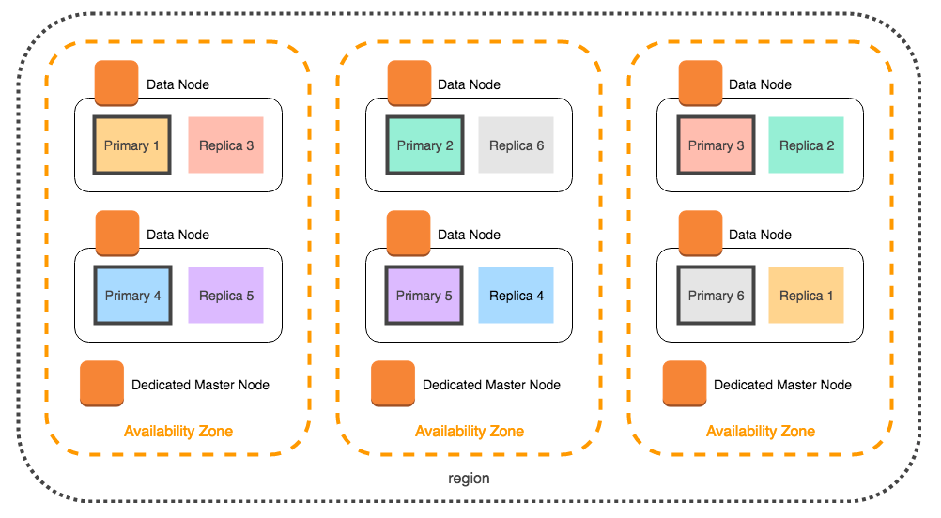
- Even if you select two Availability Zones when configuring your domain, Amazon OpenSearch automatically distributes dedicated master nodes across three Availability Zones. This distribution helps prevent cluster downtime if a zone experiences a service disruption. It also assists in electing a new master node through a quorum between the two remaining nodes.
- Amazon Elasticsearch Service has increased its snapshot frequency from daily to hourly and is retained for 14 days at no extra charge.
Amazon OpenSearch Limitations
- You can either launch your domain within a VPC or use a public endpoint, but not in both.
- You cannot switch your domain from a VPC to a public endpoint and vice versa.
- You can’t launch your domain within a VPC that uses dedicated tenancy.
- You cannot move your domain to a different VPC that where it was initially launched in.
- To access the default installation of Kibana for a domain that resides within a VPC, users must have access to the VPC.
Amazon OpenSearch Pricing

- You pay for each hour of use of an EC2 instance and for the cumulative size of any EBS storage volumes attached to your instances.
- You can use Reserved Instances to reduce long term cost on your EC2 instances.
Amazon OpenSearch Use Cases
- Log Analytics
- Real-Time Application Monitoring
- Security Analytics
- Full Text Search
- Clickstream Analytics
Note: If you are studying for the AWS Certified Data Analytics Specialty exam, we highly recommend that you take our AWS Certified Data Analytics – Specialty Practice Exams and read our Data Analytics Specialty exam study guide.

Amazon OpenSearch Service Cheat Sheet References:
https://aws.amazon.com/elasticsearch-service/features/?nc=sn&loc=2
https://docs.aws.amazon.com/elasticsearch-service/latest/developerguide/what-is-amazon-elasticsearch-service.html

----------------------------------- -------------------------------- ------------------------------
AWS :Analytics Services https://tutorialsdojo.com/amazon-emr/
Amazon EMR Cheat Sheet
- A managed cluster platform that simplifies running big data frameworks, such as Apache Hadoop and Apache Spark, on AWS to process and analyze vast amounts of data.
- You can process data for analytics purposes and business intelligence workloads using EMR together with Apache Hive and Apache Pig.
- You can use EMR to transform and move large amounts of data into and out of other AWS data stores and databases.

Features
- EMR Notebooks provide a managed environment, based on Jupyter Notebooks, to help users prepare and visualize data, collaborate with peers, build applications, and perform interactive analysis using EMR clusters.
- EMR enables you to quickly and easily provision as much capacity as you need, and automatically or manually add and remove capacity.
- You can leverage multiple data stores, including S3, the Hadoop Distributed File System (HDFS), and DynamoDB.
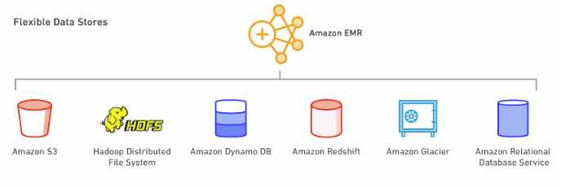
- EMR supports powerful and proven Hadoop tools such as Hive, Pig, HBase, and Impala. Additionally, it can run distributed computing frameworks besides Hadoop MapReduce such as Spark or Presto using bootstrap actions. You can also use Hue and Zeppelin as GUIs for interacting with applications on your cluster.
Components
- Clusters – A collection of EC2 instances. You can create two types of clusters:
  - a transient cluster that auto-terminates after steps complete.
  - a long-running cluster that continues to run until you terminate it deliberately.
- Nodes – Each EC2 instance in a cluster is called a node.
- Node Type – Each node has a role within the cluster, referred to as the node type. The node types are:
  - Master node: A node that manages the cluster by running software components to coordinate the distribution of data and tasks among other nodes for processing. The master node tracks the status of tasks and monitors the health of the cluster. Every cluster has a master node, and it’s possible to create a single-node cluster with only the master node. Does not support automatic failover.
  - Core node: A node with software components that run tasks and store data in the Hadoop Distributed File System (HDFS) on your cluster. Multi-node clusters have at least one core node. EMR is fault tolerant for slave failures and continues job execution if a slave node goes down.
  - Task node: A node with software components that only runs tasks and does not store data in HDFS. Task nodes are optional.
EMR Architecture
- Storage – This layer includes the different file systems that are used with your cluster.
  - Hadoop Distributed File System (HDFS) – a distributed, scalable file system for Hadoop.
    - HDFS distributes the data it stores across instances in the cluster, storing multiple copies of data on different instances to ensure that no data is lost if an individual instance fails.
    - HDFS is ephemeral storage.
    - HDFS is useful for caching intermediate results during MapReduce processing or for workloads that have significant random I/O.
  - EMR File System (EMRFS) – With EMRFS, EMR extends Hadoop to directly be able to access data stored in S3 as if it were a file system.
  - Local File System – refers to a locally connected disk.
    - Each EC2 node in your cluster comes with a pre-configured instance store, which persists only for the lifetime of the EC2 instance.
- Cluster Resource Management – this layer is responsible for managing cluster resources and scheduling the jobs for processing data.
  - By default, Amazon EMR uses YARN, which is a component introduced in Apache Hadoop 2.0 to centrally manage cluster resources for multiple data-processing frameworks.
  - EMR has an agent on each node that administers YARN components, keeps the cluster healthy, and communicates with EMR.
- Data Processing Frameworks – this layer is the engine used to process and analyze data.
  - Hadoop MapReduce – an open-source programming model for distributed computing.
  - Apache Spark – a cluster framework and programming model for processing big data workloads.
Data Processing
- Ways to process data in your EMR cluster:
  - Submitting Jobs Directly to Applications – Submit jobs and interact directly with the software that is installed in your EMR cluster. To do this, you connect to the master node over a secure connection and access the interfaces and tools that are available for the software that runs directly on your cluster.
  - Running Steps to Process Data – Submit one or more ordered steps to an EMR cluster. Each step is a unit of work that contains instructions to manipulate data for processing by software installed on the cluster.
Scaling
- There are two main options for adding or removing capacity:
  - Deploy multiple clusters: If you need more capacity, you can easily launch a new cluster and terminate it when you no longer need it. There is no limit to how many clusters you can have.
  - Resize a running cluster: You may want to scale out a cluster to temporarily add more processing power to the cluster, or scale in your cluster to save on costs when you have idle capacity. When adding instances to your cluster, EMR can now start utilizing provisioned capacity as soon it becomes available. When scaling in, EMR will proactively choose idle nodes to reduce the impact on running jobs.
Deployment
- Choose the instance size and type that best suits the processing needs for your cluster
  - Batch processing
  - Low-latency queries
  - Streaming data
  - Large data storage
- In addition to the standard software and applications that are available for installation on your cluster, you can use bootstrap actions to install custom software.
EMR Notebooks
- A serverless Jupyter notebook.
- An EMR cluster is required to execute the code and queries within an EMR notebook, but the notebook is not locked to the cluster.
- Runs Apache Spark.
Managing Clusters
- A cluster step is a user-defined unit of processing, mapping roughly to one algorithm that manipulates the data.
- When creating a cluster, typically you should select the Region where your data is located.
- You can connect to the master node only while the cluster is running. When the cluster terminates, the EC2 instance acting as the master node is terminated and is no longer available.
- By default, the ElasticMapReduce-master security group does not permit inbound SSH access.
- You can set termination protection on a cluster.
- You can adjust the number of EC2 instances available to an EMR cluster automatically or manually in response to workloads that have varying demands.
- The EMR File System (EMRFS) is an implementation of HDFS that all EMR clusters use for reading and writing regular files from EMR directly to S3. It provides the convenience of storing persistent data in S3 for use with Hadoop while also providing features like consistent view and data encryption.
- You can add tags to your clusters.
- You can launch an EMR cluster with three master nodes to enable high availability for EMR applications. Amazon EMR automatically fails over to a standby master node if the primary master node fails or if critical processes.
High Availability
- You can launch an EMR cluster with three master nodes and support high availability for HBase clusters on EMR. Amazon EMR automatically fails over to a standby master node if the primary master node fails or if critical processes such as Resource Manager or Name Node crash.
- In the event of a failover, Amazon EMR automatically replaces the failed master node with a new master node with the same configuration and boot-strap actions.
Monitoring
- EMR integrates with CloudTrail to log information about requests made by or on behalf of your AWS account.

- You can monitor and interact with your cluster by forming a secure connection between your remote computer and the master node by using SSH.
- EMR provides the ability to archive log files in S3 so you can store logs and troubleshoot issues even after your cluster terminates.
- EMR also provides an optional debugging tool.
- EMR integrates with CloudWatch to track performance metrics for the cluster and jobs within the cluster.
Amazon EMR Security
- EMR integrates with IAM to manage permissions. You define permissions using IAM policies, which you attach to IAM users or IAM groups. The permissions that you define in the policy determine the actions that those users or members of the group can perform and the resources that they can access.
- EMR uses IAM roles for the EMR service itself and the EC2 instance profile for the instances. These roles grant permissions for the service and instances to access other AWS services on your behalf. There is a default role for the EMR service and a default role for the EC2 instance profile.
- EMR uses security groups to control inbound and outbound traffic to your EC2 instances. When you launch your cluster, EMR uses a security group for your master instance and a security group to be shared by your core/task instances.
- EMR supports optional S3 server-side and client-side encryption with EMRFS to help protect the data that you store in S3.
- EMR supports launching clusters in a VPC.
- EMR release version 5.10.0 and later supports Kerberos, which is a network authentication protocol
Amazon EMR Pricing
- You pay a per-second rate for every second for each node you use, with a one-minute minimum.
- The EMR price is in addition to the EC2 price (the price for the underlying servers) and EBS price (if attaching EBS volumes).
Note: If you are studying for the AWS Certified Data Engineer Associate exam, we highly recommend that you take our AWS Certified Data Engineer Associate Practice Exams and read our Data Engineer Associate exam study guide.
Amazon EMR Cheat Sheet References:
https://docs.aws.amazon.com/emr/latest/ManagementGuide
https://aws.amazon.com/emr/features
https://aws.amazon.com/emr/pricing
https://aws.amazon.com/emr/faqs

----------------------------------- -------------------------------- ------------------------------
AWS :Analytics Services https://tutorialsdojo.com/amazon-kinesis/
Amazon Kinesis Cheat Sheet
- Makes it easy to collect, process, and analyze real-time, streaming data.
- Kinesis can ingest real-time data such as video, audio, application logs, website clickstreams, and IoT telemetry data for machine learning, analytics, and other applications.
Kinesis Video Streams
- A fully managed AWS service that you can use to stream live video from devices to the AWS Cloud, or build applications for real-time video processing or batch-oriented video analytics.
- How it works
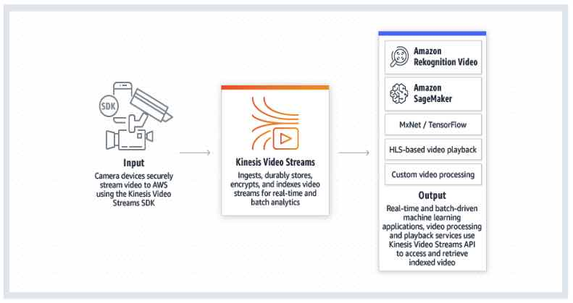
- Benefits
  - You can connect and stream from millions of devices.
  - You can configure your Kinesis video stream to durably store media data for custom retention periods. Kinesis Video Streams also generates an index over the stored data based on producer-generated or service-side timestamps.
  - Kinesis Video Streams is serverless, so there is no infrastructure to set up or manage.
  - You can build real-time and batch applications on data streams.
  - Kinesis Video Streams enforces Transport Layer Security (TLS)-based encryption on data streaming from devices, and encrypts all data at rest using AWS KMS.
- Components
  - Producer – Any source that puts data into a Kinesis video stream.
  - Kinesis video stream – A resource that enables you to transport live video data, optionally store it, and make the data available for consumption both in real time and on a batch or ad hoc basis.
    - Time-encoded data is any data in which the records are in a time series, and each record is related to its previous and next records.
    - A fragment is a self-contained sequence of frames. The frames belonging to a fragment should have no dependency on any frames from other fragments.
    - Upon receiving the data from a producer, Kinesis Video Streams stores incoming media data as chunks. Each chunk consists of the actual media fragment, a copy of media metadata sent by the producer, and the Kinesis Video Streams-specific metadata such as the fragment number, and server-side and producer-side timestamps.
  - Consumer – Gets data, such as fragments and frames, from a Kinesis video stream to view, process, or analyze it. Generally, these consumers are called Kinesis Video Streams applications.
- Kinesis Video Streams provides
  - APIs for you to create and manage streams and read or write media data to and from a stream.
  - A console that supports live and video-on-demand playback.
  - A set of producer libraries that you can use in your application code to extract data from your media sources and upload it to your Kinesis video stream.
- Video Playbacks
  - You can view a Kinesis video stream using either
    - HTTP Live Streaming (HLS) – You can use HLS for live playback.
    - GetMedia API – You use the GetMedia API to build your own applications to process Kinesis video streams. GetMedia is a real-time API with low latency.
- Metadata
  - Metadata is a mutable key-value pair. You can use it to describe the content of the fragment, embed associated sensor readings that need to be transferred along with the actual fragment, or meet other custom needs.
  - There are two modes in which the metadata can be embedded with fragments in a stream:
    - Nonpersistent: You can affix metadata on an ad hoc basis to fragments in a stream, based on business-specific criteria that have occurred.
    - Persistent: You can affix metadata to successive, consecutive fragments in a stream based on a continuing need.
- Pricing
  - You pay only for the volume of data you ingest, store, and consume through the service.

Kinesis Data Stream
- A massively scalable, highly durable data ingestion and processing service optimized for streaming data. You can configure hundreds of thousands of data producers to continuously put data into a Kinesis data stream.
- How it works

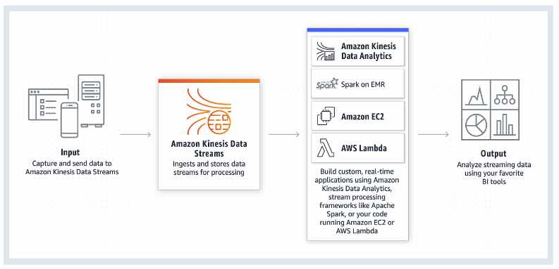
Concepts

  - Data Producer – An application that typically emits data records as they are generated to a Kinesis data stream. Data producers assign partition keys to records. Partition keys ultimately determine which shard ingests the data record for a data stream.
  - Data Consumer – A distributed Kinesis application or AWS service retrieving data from all shards in a stream as it is generated. Most data consumers are retrieving the most recent data in a shard, enabling real-time analytics or handling of data.
  - Data Stream – A logical grouping of shards. There are no bounds on the number of shards within a data stream. A data stream will retain data for 24 hours, or up to 7 days when extended retention is enabled.
  - Shard – The base throughput unit of a Kinesis data stream.
    - A shard is an append-only log and a unit of streaming capability. A shard contains an ordered sequence of records ordered by arrival time.
    - Add or remove shards from your stream dynamically as your data throughput changes.
    - One shard can ingest up to 1000 data records per second, or 1MB/sec. Add more shards to increase your ingestion capability.
    - When consumers use enhanced fan-out, one shard provides 1MB/sec data input and 2MB/sec data output for each data consumer registered to use enhanced fan-out.
    - When consumers do not use enhanced fan-out, a shard provides 1MB/sec of input and 2MB/sec of data output, and this output is shared with any consumer not using enhanced fan-out.
    - You will specify the number of shards needed when you create a stream and can change the quantity at any time.
  - Data Record
    - A record is the unit of data stored in a Kinesis stream. A record is composed of a sequence number, partition key, and data blob.
    - A data blob is the data of interest your data producer adds to a stream. The maximum size of a data blob is 1 MB.
  - Partition Key
    - A partition key is typically a meaningful identifier, such as a user ID or timestamp. It is specified by your data producer while putting data into a Kinesis data stream, and useful for consumers as they can use the partition key to replay or build a history associated with the partition key.
    - The partition key is also used to segregate and route data records to different shards of a stream.
  - Sequence Number
    - A sequence number is a unique identifier for each data record. A sequence number is assigned by Kinesis Data Streams when a data producer calls PutRecord or PutRecords API to add data to a Kinesis data stream.
- Amazon Kinesis Agent is a pre-built Java application that offers an easy way to collect and send data to your Amazon Kinesis data stream.
- Monitoring
  - You can monitor shard-level metrics in Kinesis Data Streams.
  - You can monitor your data streams in Amazon Kinesis Data Streams using CloudWatch, Kinesis Agent, Kinesis libraries.
  - Log API calls with CloudTrail.
- Security
  - Kinesis Data Streams can automatically encrypt sensitive data as a producer enters it into a stream. Kinesis Data Streams uses AWS KMS master keys for encryption.
  - Use IAM for managing access controls.
  - You can use an interface VPC endpoint to keep traffic between your Amazon VPC and Kinesis Data Streams from leaving the Amazon network.
- Pricing
  - You are charged for each shard at an hourly rate.
  - PUT Payload Unit is charged with a per million PUT Payload Units rate.
  - When consumers use enhanced fan-out, they incur hourly charges per consumer-shard hour and per GB of data retrieved.
  - You are charged an additional rate on each shard hour incurred by your data stream once you enable extended data retention.
- Limits

    - There is no upper limit on the number of shards you can have in a stream or account.
    - There is no upper limit on the number of streams you can have in an account.
    - A single shard can ingest up to 1 MiB of data per second (including partition keys) or 1,000 records per second for writes.
    - The default shard limit is 500 shards for the following AWS Regions: US East (N. Virginia), US West (Oregon), and EU (Ireland). For all other Regions, the default shard limit is 200 shards.
    - Each shard can support up to five read transactions per second.

Data Firehose
- The easiest way to load streaming data into data stores and analytics tools.
- It is a fully managed service that automatically scales to match the throughput of your data.
- It can also batch, compress, and encrypt the data before loading it.
- How it works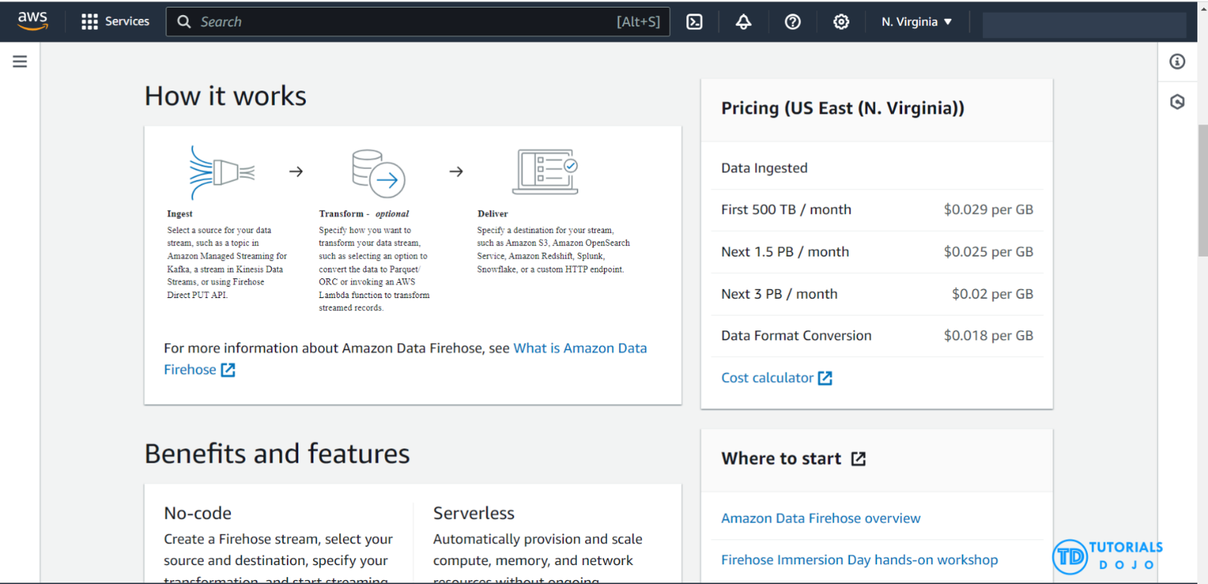

- Features
  - It can capture, transform, and load streaming data into S3, Redshift, Elasticsearch Service, generic HTTP endpoints, and service providers like Datadog, New Relic, MongoDB, and Splunk, enabling near real-time analytics with existing business intelligence tools and dashboards being used today.
  - You can specify a batch size or batch interval to control how quickly data is uploaded to destinations. Additionally, you can specify if data should be compressed.
  - Once launched, your delivery streams automatically scale up and down to handle gigabytes per second or more of input data rate, and maintain data latency at levels you specify for the stream.
  - Data Firehose can convert the format of incoming data from JSON to Parquet or ORC formats before storing the data in S3.
  - You can configure Data Firehose to prepare your streaming data before it is loaded to data stores. Data Firehose provides pre-built Lambda blueprints for converting common data sources such as Apache logs and system logs to JSON and CSV formats. You can use these pre-built blueprints without any change, customize them further, or write your own custom functions.
- Concepts
  - Firehose stream – The underlying entity of Amazon Data Firehose is a Firehose stream, which allows you to send data to it.
  - Record – The data of interest that your data producer sends to a Firehose stream. A record can be as large as 1,000 KB.
  - Data Producer – Producers send records to Firehose streams.
  - Buffer Size and Buffer Interval – Data Firehose buffers incoming streaming data to a certain size or for a certain period of time before delivering it to destinations. Buffer Size is in MBs and Buffer Interval is in seconds.
- Stream Sources
  - You can send data to your Firehose stream using different types of sources:
    - Kinesis Data Streams
    - Amazon MSK
    - Kinesis Agent
    - AWS SDK
    - CloudWatch Logs
    - CloudWatch Events
    - AWS IoT
  - Some AWS services can only send messages and events to a Firehose stream that is in the same Region.
- Data Delivery and Transformation
  - Data Firehose can invoke your Lambda function to transform incoming source data and deliver the transformed data to destinations.
  - Data Firehose buffers incoming data up to 3 MB by default.
  - If your Lambda function invocation fails because of a network timeout or because you’ve reached the Lambda invocation limit, Data Firehose retries the invocation three times by default.
  - Data Firehose can convert the format of your input data from JSON to Apache Parquet or Apache ORC before storing the data in S3. Parquet and ORC are columnar data formats that save space and enable faster queries compared to row-oriented formats like JSON.
  - Data delivery format:
    - For data delivery to S3, Data Firehose concatenates multiple incoming records based on the buffering configuration of your delivery stream. It then delivers the records to S3 as an S3 object.
    - For data delivery to Redshift, Data Firehose first delivers incoming data to your S3 bucket in the format described earlier. Data Firehose then issues a Redshift COPY command to load the data from your S3 bucket to your Redshift cluster.
    - For data delivery to ElasticSearch, Data Firehose buffers incoming records based on the buffering configuration of your delivery stream. It then generates an Elasticsearch bulk request to index multiple records to your Elasticsearch cluster.
    - For data delivery to Splunk, Data Firehose concatenates the bytes that you send.
  - Data delivery frequency
    - The frequency of data delivery to S3 is determined by the S3 Buffer size and Buffer interval value that you configured for your delivery stream.
    - The frequency of data COPY operations from S3 to Redshift is determined by how fast your Redshift cluster can finish the COPY command.
    - The frequency of data delivery to ElasticSearch is determined by the Elasticsearch Buffer size and Buffer interval values that you configured for your delivery stream.
    - Data Firehose buffers incoming data before delivering it to Splunk. The buffer size is 5 MB, and the buffer interval is 60 seconds.
- Monitoring
  - Data Firehose exposes several metrics through the console, as well as CloudWatch for monitoring.
  - Kinesis Agent publishes custom CloudWatch metrics and helps assess whether the agent is healthy, submitting data into Data Firehose as specified, and consuming the appropriate amount of CPU and memory resources on the data producer.
  - Log API calls with CloudTrail.
- Security
  - Data Firehose provides you the option to have your data automatically encrypted after it is uploaded to the destination.
  - Manage resource access with IAM.
- Pricing
  - You pay only for the volume of data you transmit through the service. You are billed for the volume of data ingested into Data Firehose, and if applicable, for data format conversion to Apache Parquet or ORC.
- Limits
  - By default, each account can have up to 50 Data Firehose delivery streams per Region.
  - The maximum size of a record sent to Data Firehose, before base64-encoding, is 1,000 KiB.

Kinesis Data Analytics
- Analyze streaming data, gain actionable insights, and respond to your business and customer needs in real time. You can quickly build SQL queries and Java applications using built-in templates and operators for common processing functions to organize, transform, aggregate, and analyze data at any scale.
- How it works
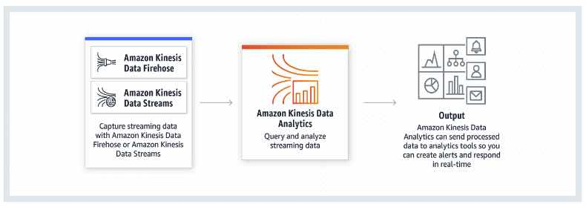
- General Features
  - Kinesis Data Analytics is serverless and takes care of everything required to continuously run your application.
  - Kinesis Data Analytics elastically scales applications to keep up with any volume of data in the incoming data stream.
  - Kinesis Data Analytics delivers sub-second processing latencies so you can generate real-time alerts, dashboards, and actionable insights.
- SQL Features
  - Kinesis Data Analytics supports standard ANSI SQL.
  - Kinesis Data Analytics integrates with Kinesis Data Streams and Data Firehose so that you can readily ingest streaming data.
  - SQL applications in Kinesis Data Analytics support two types of inputs:
    - A streaming data source is continuously generated data that is read into your application for processing.
    - A reference data source is static data that your application uses to enrich data coming in from streaming sources.
  - Kinesis Data Analytics provides an easy-to-use schema editor to discover and edit the structure of the input data. The wizard automatically recognizes standard data formats such as JSON and CSV.
  - Kinesis Data Analytics offers functions optimized for stream processing so that you can easily perform advanced analytics such as anomaly detection and top-K analysis on your streaming data.
- Java Features
  - Kinesis Data Analytics includes open source libraries based on Apache Flink. Apache Flink is an open source framework and engine for building highly available and accurate streaming applications.
  - Kinesis Data Analytics for Apache Flink supports streaming applications built using Apache Beam Java SDK.
  - You can use the Kinesis Data Analytics Java libraries to integrate with multiple AWS services.
  - You can create and delete durable application backups through a simple API call. You can immediately restore your applications from the latest backup after a disruption, or you can restore your application to an earlier version.
  - Java applications in Kinesis Data Analytics enable you to build applications whose processed records affect the results exactly once, referred to as exactly once processing.
  - The service stores previous and in-progress computations, or state, in running application storage. State is always encrypted and incrementally saved in running application storage.
- An application is the primary resource in Kinesis Data Analytics. Kinesis data analytics applications continuously read and process streaming data in real-time.
  - You write application code using SQL to process the incoming streaming data and produce output. Then, Kinesis Data Analytics writes the output to a configured destination.
  - You can also process and analyze streaming data using Java.
- Components
  - Input is the streaming source for your application. In the input configuration, you map the streaming source to an in-application data stream(s).
  - Application code is a series of SQL statements that process input and produce output.
  - You can create one or more in-application streams to store the output. You can then optionally configure an application output to persist data from specific in-application streams to an external destination.
- An in-application data stream is an entity that continuously stores data in your application for you to perform processing.
- Kinesis Data Analytics provisions capacity in the form of Kinesis Processing Units (KPU). A single KPU provides you with memory (4 GB) and corresponding computing and networking.
- For Java applications using Apache Flink, you build your application locally and then make your application code available to the service by uploading it to an S3 bucket.
- Kinesis Data Analytics for Java applications provides your application with 50 GB of running application storage per Kinesis Processing Unit. Kinesis Data Analytics scales storage with your application.
- Running application storage is used for saving application state using checkpoints. It is also accessible to your application code to use as a temporary disk for caching data or any other purpose.
- Pricing
  - You are charged an hourly rate based on the average number of Kinesis Processing Units (or KPUs) used to run your stream processing application.
  - For Java applications, you are charged a single additional KPU per application for application orchestration. Java applications are also charged for running application storage and durable application backups.
High Performance Data Streaming with Amazon Kinesis: Best Practices and Common Pitfalls
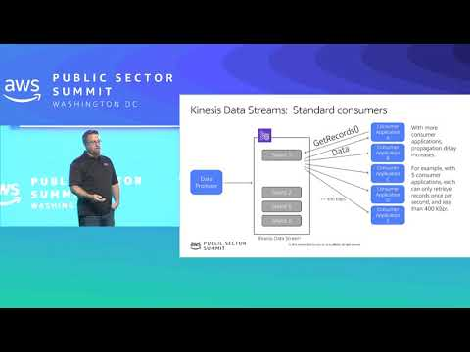
Amazon Kinesis-related Cheat Sheets:
- Kinesis Scaling, Resharding and Parallel Processing

Note: If you are studying for the AWS Certified Data Engineer exam, we highly recommend that you take our AWS Certified Data Engineer Practice Exams and read our Data Engineer exam study guide.


Validate Your Knowledge
Question 1
A financial company has several AWS accounts that fetch market data from several cryptocurrency exchanges. The company is planning to launch a centralized logging ingestion system that automatically converts the incoming application log files to Apache Parquet format and stores the logs in an Amazon S3 bucket for easier processing.
The data engineer has been tasked to ensure that the log files must be delivered in near real-time to provide accurate crypto market statistics.
Which of the following options can meet this requirement LEAST operational overhead?
- Use the Amazon Managed Workflows for Apache Airflow (Amazon MWAA) to forward the log files to an Amazon S3 bucket which will automatically transform the logs into Apache Parquet format.
- Set up the solution to send the cryptocurrency log files to Amazon Data Firehose. Set up the Data Firehose to trigger a Lambda function that converts the log files to Apache Parquet format and delivers the files to the centralized S3 bucket.
- Modify the solution to forward the cryptocurrency log files to Amazon Kinesis Data Streams and install the Kinesis Client Library on an Auto Scaling group of Amazon EC2 instances. Configure the EC2 instances to fetch the stream records and automatically convert the log files to Apache Parquet. Store the processed log files in Amazon S3.
- Refactor the solution to send the cryptocurrency log files to Apache Hive on an Amazon EMR cluster. Launch a table from the log files by using a custom regular expression (regex). Set up an external table on Amazon S3 in Hive with the file format set to Apache Parquet and schedule a HiveQL UNLOAD query to persist the log files to the external Amazon S3 table.
Show me the answer!
Correct Answer: 2
Amazon Data Firehose can convert the format of your input data from JSON to Apache Parquet or Apache ORC before storing the data in Amazon S3. Parquet and ORC are columnar data formats that save space and enable faster queries compared to row-oriented formats like JSON. If you want to convert an input format other than JSON, such as comma-separated values (CSV) or structured text, you can use AWS Lambda to transform it to JSON first.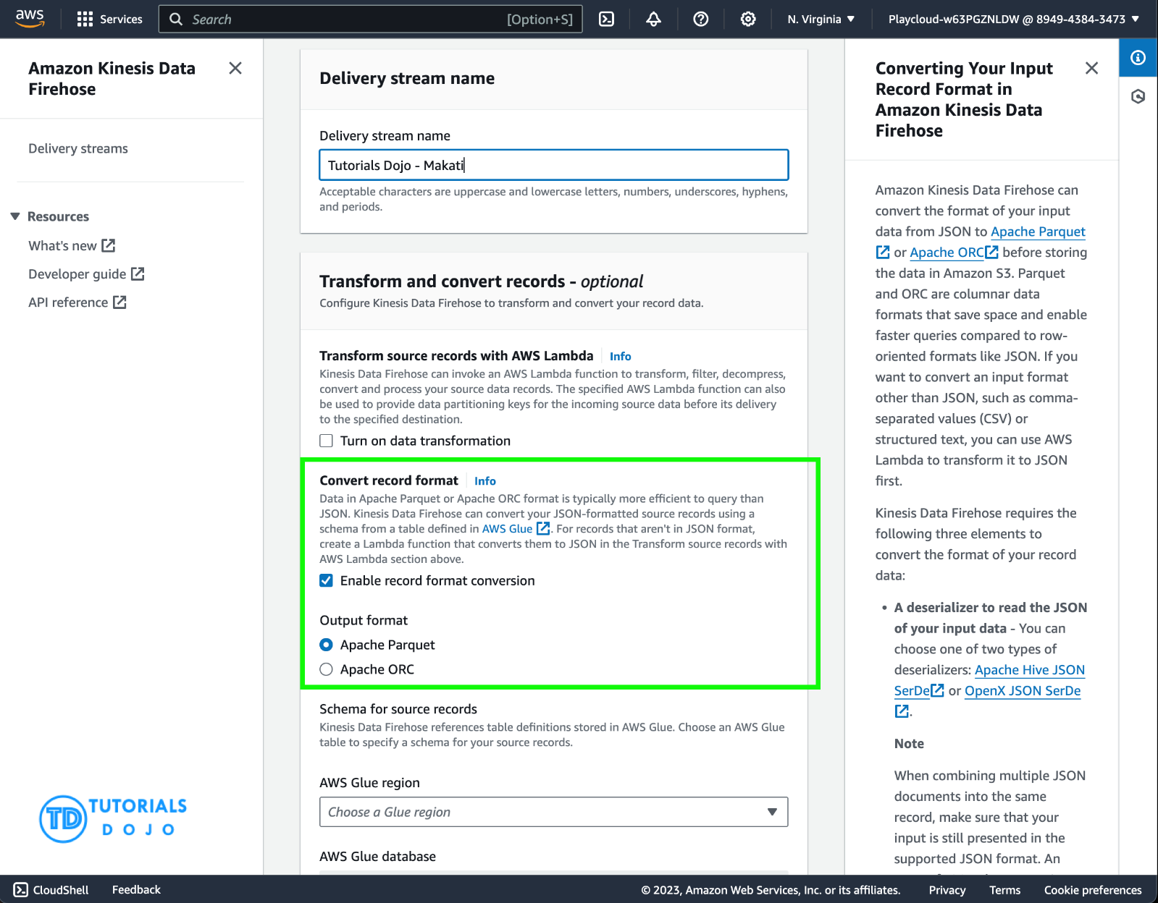

Amazon Data Firehose is a fully managed service for delivering real-time streaming data to destinations such as Amazon Simple Storage Service (Amazon S3), Amazon Redshift, Amazon OpenSearch Service, Amazon OpenSearch Serverless, Splunk, and any custom HTTP endpoint or HTTP endpoints owned by supported third-party service providers, including Datadog, Dynatrace, LogicMonitor, MongoDB, New Relic, Coralogix, and Elastic.
Hence, the correct answer is: Set up the solution to send the cryptocurrency log files to Amazon Data Firehose. Set up the Data Firehose to trigger a Lambda function that converts the log files to Apache Parquet format and delivers the files to the centralized S3 bucket.
The option that says: Use the Amazon Managed Workflows for Apache Airflow (Amazon MWAA) to forward the log files to an Amazon S3 bucket which will automatically transform the logs into Apache Parquet format is incorrect because Amazon Managed Workflows for Apache Airflow is primarily used as a managed orchestration service for Apache Airflow and not for converting log files into Apache Parquet format.
The option that says: Modify the solution to forward the cryptocurrency log files to Amazon Kinesis Data Streams and install the Kinesis Client Library on an Auto Scaling group of Amazon EC2 instances. Configure the EC2 instances to fetch the stream records and automatically convert the log files to Apache Parquet. Store the processed log files in Amazon S3 is incorrect. Take note that the scenario explicitly mentioned that the solution should have the least operational overhead in terms of managing the AWS resources. Having an Auto Scaling group of Amazon EC2 instances entails a lot of management and upkeep which do not conform to the aforementioned requirement.
The option that says: Refactor the solution to send the cryptocurrency log files to Apache Hive on an Amazon EMR cluster. Launch a table from the log files by using a custom regular expression (regex). Set up an external table on Amazon S3 in Hive with the file format set to Apache Parquet and schedule a HiveQL UNLOAD query to persist the log files to the external Amazon S3 table is incorrect. Just like the previous option, using an EC2-based Amazon EMR cluster requires maintenance and certain operational tasks. Using Amazon EMR could be a possible solution if the option mentioned that it uses the Amazon EMR Serverless type.

References:
https://docs.aws.amazon.com/firehose/latest/dev/record-format-conversion.html
https://docs.aws.amazon.com/firehose/latest/dev/data-transformation.html
https://docs.aws.amazon.com/firehose/latest/dev/what-is-this-service.html
Note: This question was extracted from our AWS Certified Data Engineer Practice Exams.

Question 2
The developer has built a real-time IoT device monitoring application that leverages Amazon Kinesis Data Stream to ingest data. The application uses several EC2 instances for processing. Recently, the developer has observed a steady increase in the rate of data flowing into the stream, indicating that the stream’s capacity must be scaled up to sustain optimal performance.
What should the developer do to increase the capacity of the stream?
- Split every shard in the stream.
- Upgrade the instance type of the EC2 instances.
- Merge every shard in the stream.
- Integrate Amazon Data Firehose with the Amazon Kinesis Data Stream to increase the capacity of the stream.
Show me the answer!
Correct Answer: 1
Amazon Kinesis Data Streams is a massively scalable, highly durable data ingestion and processing service optimized for streaming data. You can configure hundreds of thousands of data producers to continuously put data into a Kinesis data stream. Data will be available within milliseconds to your Amazon Kinesis applications, and those applications will receive data records in the order they were generated.
The purpose of resharding in Amazon Kinesis Data Streams is to enable your stream to adapt to changes in the rate of data flow. You split shards to increase the capacity (and cost) of your stream. You merge shards to reduce the cost (and capacity) of your stream.
One approach to resharding could be to split every shard in the stream—which would double the stream’s capacity. However, this might provide more additional capacity than you actually need and therefore create unnecessary costs.
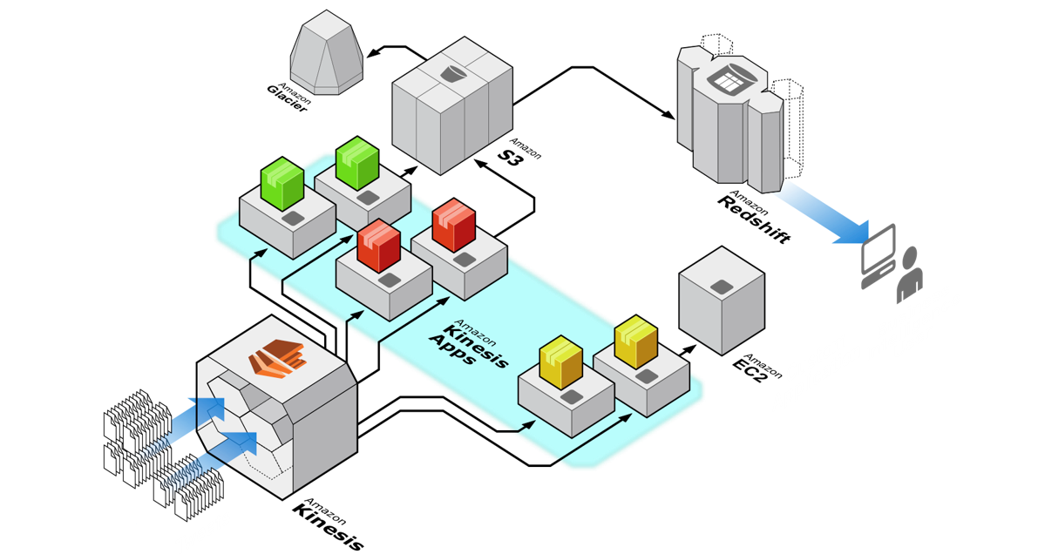
You can also use metrics to determine which are your “hot” or “cold” shards, that is, shards that are receiving much more data, or much less data, than expected. You could then selectively split the hot shards to increase capacity for the hash keys that target those shards. Similarly, you could merge cold shards to make better use of their unused capacity.
You can obtain some performance data for your stream from the Amazon CloudWatch metrics that Kinesis Data Streams publishes. However, you can also collect some of your own metrics for your streams. One approach would be to log the hash key values generated by the partition keys for your data records. Recall that you specify the partition key at the time that you add the record to the stream.
Hence, the correct answer is to split every shard in the stream to increase the capacity of the data stream.
Upgrading the instance type of the EC2 instances is incorrect. Although it will improve the processing time of the data in the stream, it will not increase the capacity of the stream itself. You have to reshard the stream in order to increase or decrease its capacity, and not just upgrade the EC2 instances which process the data in the stream.
Merging every shard in the stream is incorrect because merging shards will actually decrease the capacity of the stream rather than increase it. This is only useful if you want to save costs or if the data stream is underutilized, which are both not indicated in the scenario.
Integrating Amazon Data Firehose with the Amazon Kinesis Data Stream to increase the capacity of the stream is incorrect because Kineses Data Firehose just provides a way to reliably transform and load streaming data into data stores and analytics tools. This method will not increase the capacity of the stream as it doesn’t mention anything about resharding.
References:
https://docs.aws.amazon.com/streams/latest/dev/kinesis-using-sdk-java-resharding-strategies.html
https://docs.aws.amazon.com/streams/latest/dev/kinesis-using-sdk-java-resharding.html
Kinesis Scaling, Resharding and Parallel Processing:
https://tutorialsdojo.com/kinesis-scaling-resharding-and-parallel-processing/
Note: This question was extracted from our AWS Certified Developer Associate Practice Exams.

