1. Question
A company launched a website that accepts high-quality photos and turns the photos into a downloadable video montage. The website offers both a free and a premium account, with the premium account guaranteeing faster processing. All requests by both free and premium members go through a single Amazon SQS queue and are then processed by a group of Amazon EC2 instances that generate the videos. The company needs to ensure that premium users, who paid for the service, have higher priority than free members.
How should the company re-design its architecture to address this requirement?
- For the requests made by premium members, set a higher priority in the SQS queue so it will be processed first compared to the requests made by free members.
- Create an SQS queue for free members and another one for premium members. Configure your EC2 instances to consume messages from the premium queue first and if it is empty, poll from the free members' SQS queue.
- Use Amazon Kinesis to process the photos and generate the video montage in real-time.
- Use Amazon S3 to store and process the photos and then generate the video montage afterward.
Here is a breakdown of the problem, requirements, and the best solution.
Key Requirements
- Prioritization: Premium users' requests must be processed with higher priority than free users' requests.
- Current Architecture: A single Amazon SQS queue with Amazon EC2 instances as workers.
- Goal: Re-design the architecture to meet the prioritization requirement.

Solution Explanation
The company should implement a priority queue pattern using two separate Amazon SQS queues.
- Create an SQS queue for free members and another one for premium members. Configure your EC2 instances to consume messages from the premium queue first and if it is empty, poll from the free members' SQS queue. This solution uses a common and effective design pattern for implementing prioritization with SQS. By using two queues, one for each priority level, the application separates the workloads. The EC2 worker instances are configured to poll the premium queue first. This ensures that any available message from a paying customer is processed immediately. Only when the premium queue is empty will the workers then poll the free members' queue. This guarantees the highest priority for premium requests. This approach is highly scalable and leverages standard SQS functionality.

Comparative Assessment
- For the requests made by premium members, set a higher priority in the SQS queue so it will be processed first compared to the requests made by free members. This is not a native feature of Amazon SQS. SQS is a FIFO (First-In, First-Out) service, and there is no built-in mechanism to prioritize individual messages within a single queue based on content or attributes.
- Use Amazon Kinesis to process the photos and generate the video montage in real-time. Amazon Kinesis is designed for real-time data streaming and analytics, not for a job-queueing priority system. While it could handle the data, it lacks a simple native way to prioritize records, making it an overly complex solution for this specific problem.
- Use Amazon S3 to store and process the photos and then generate the video montage afterward. Amazon S3 is an object storage service. It can store the photos but has NO built-in processing or queuing capabilities. It CANNOT, on its own, handle the logic of prioritizing tasks or generating videos. This option misses the essential compute and queuing components needed for the application.
-----------------------------------------------------------------
Question 2. A company is running a multi-tier web application farm in a virtual private cloud (VPC) that is not connected to their corporate network. They are connecting to the VPC over the Internet to manage the fleet of Amazon EC2 instances running in both the public and private subnets. The Solutions Architect has added a bastion host with Microsoft Remote Desktop Protocol (RDP) access to the application instance security groups, but the company wants to further limit administrative access to all of the instances in the VPC.
Which of the following bastion host deployment options will meet this requirement?
- Deploy a Windows Bastion host on the corporate network that has RDP access to all EC2 instances in the VPC.
- Deploy a Windows Bastion host with an Elastic IP address in the private subnet, and restrict RDP access to the bastion from only the corporate public IP addresses.
- Deploy a Windows Bastion host with an Elastic IP address in the public subnet and allow SSH access to the bastion from anywhere.
- Deploy a Windows Bastion host with an Elastic IP address in the public subnet and allow RDP access to bastion only from the corporate IP addresses.
Key Requirements
- VPC Connectivity: The VPC is not connected to the corporate network. All administrative traffic must traverse the internet.
- Security: The company wants to strictly limit administrative access to all EC2 instances.
- Access Method: Management is performed using Microsoft Remote Desktop Protocol (RDP).
- Architecture: The solution must be based on a bastion host model.

Solution Explanation
The most secure and architecturally sound approach is to deploy a bastion host in the public subnet and restrict its access to a known source.
- Deploy a Windows Bastion host with an Elastic IP address in the public subnet and allow RDP access to bastion only from the corporate IP addresses. This option provides a single, secure point of entry into the VPC. The bastion host is placed in the public subnet, making it reachable from the internet. It has an Elastic IP address to ensure its public IP remains static. The key security feature is the restriction of inbound RDP traffic to only the corporate public IP addresses. This prevents unauthorized access from the broader internet. From the bastion host, an administrator can then establish a secure connection to the application instances in the private subnets.

Comparative Assessment
- Deploy a Windows Bastion host on the corporate network that has RDP access to all EC2 instances in the VPC. This is not a viable solution because the problem statement specifies that the VPC is not connected to the corporate network. Direct connectivity from an on-premises host to the VPC's private instances is NOT possible without a VPN or AWS Direct Connect.
- Deploy a Windows Bastion host with an Elastic IP address in the private subnet, and restrict RDP access to the bastion from only the corporate public IP addresses. This is technically impossible. A host in a private subnet CANNOT be reached directly from the internet, even with an Elastic IP address. Elastic IPs must be associated with instances in a public subnet to be publicly accessible.
- Deploy a Windows Bastion host with an Elastic IP address in the public subnet and allow SSH access to the bastion from anywhere. This option fails on two key requirements. First, it uses SSH, while the requirement specifies RDP for Windows instances. Second, allowing access from "anywhere" (0.0.0.0/0) is a security risk and directly contradicts the goal of "further limit[ing] administrative access."
----------------------------------------------------------------------------
3. Question
A company is building an automation tool for generating custom reports on its AWS usage. The company must be able to programmatically access and forecast usage costs on specific services.
Which of the following would meet the requirements with the LEAST amount of operational overhead?
- Utilize the downloadable AWS Cost Explorer report .csv files to access the cost-related data. Predict usage costs using AWS Budgets.
- Generate AWS Budgets reports for usage cost data and deliver them via Amazon Simple Queue Service (SQS).
- Configure AWS Budgets to send usage cost data to the company via Amazon SNS.
- Use the AWS Cost Explorer API with pagination to programmatically retrieve the usage cost-related data.
4. Question
A company plans to use Route 53 instead of an ELB to load balance the incoming request to the web application. The system is deployed to two EC2 instances to which the traffic needs to be distributed. You want to set a specific percentage of traffic to go to each instance.
Which routing policy would you use?
- Geolocation
- Weighted
- Latency
- Failover
Key Requirements
- Load Balancing: Use Route 53 to distribute incoming web traffic.
- Traffic Distribution: Route a specific percentage of traffic to each of two EC2 instances.
- Architecture: Two EC2 instances as the targets for the web application.

Solution Explanation
To send a specific percentage of traffic to each EC2 instance, you should use the Weighted routing policy.
- Weighted: A weighted routing policy lets you assign a weight to each record set. Route 53 then distributes traffic to the resources based on these weights. For example, you could assign a weight of "80" to one EC2 instance and "20" to the other to send 80% of the traffic to the first instance and 20% to the second. This method provides fine-grained control over how traffic is distributed among your resources.

Comparative Assessment of Other Options
- Geolocation: This policy routes traffic to resources based on the geographic location of the user. It is used when you want to serve content from a specific location to users in that location, not for distributing a percentage of traffic.
- Latency: This policy routes traffic to the resource that provides the lowest latency for the user. It's an excellent choice for improving performance but does not allow you to set specific traffic percentages.
- Failover: This policy routes traffic to a primary resource and, if the primary becomes unhealthy, automatically routes traffic to a secondary resource. It's used for high availability and disaster recovery, not for load balancing based on percentages.
-----------------------------------------------------------------------------
5. Question
An online stock trading application stores financial data in an Amazon S3 bucket, with a lifecycle policy that moves older data to Glacier every month. A strict compliance requirement mandates that a surprise audit can occur at any time, and the required data must be retrievable in under 15 minutes under all circumstances. The manager has instructed that retrieval capacity be available when needed and should support up to 150 MB/s of retrieval throughput.
Which of the following will meet the given requirement? (Select TWO.)
- Purchase provisioned retrieval capacity.
- Use Standard Retrieval for accessing the financial data.
- Use Bulk Retrieval to access the financial data.
- Specify a range, or portion, of the financial data archive to retrieve.
- Use Expedited Retrieval to access the financial data.
Key Requirements
- Data Storage: Amazon S3 with a lifecycle policy moving old data to Glacier.
- Compliance: Data must be retrievable in under 15 minutes for a surprise audit.
- Performance: Retrieval throughput must support up to 150 MB/s.
- Action: Select two actions to meet these requirements.

Solution Explanation
To meet the strict retrieval time and throughput requirements from Amazon S3 Glacier, the company must use a combination of a specific retrieval tier and guaranteed capacity.
- Purchase provisioned retrieval capacity. This is a critical step for meeting the throughput requirement. By purchasing provisioned capacity, the company ensures that its retrieval requests are always prioritized and the required throughput of up to 150 MB/s is guaranteed, even during busy periods when retrieval capacity might be limited for others. This is essential for a "surprise audit" scenario.
- Use Expedited Retrieval to access the financial data. This retrieval tier is designed for urgent, on-demand data access. It allows you to retrieve data in 1 to 5 minutes, which easily satisfies the "under 15 minutes" compliance requirement. When used in conjunction with provisioned capacity, it guarantees both the retrieval time and the necessary throughput.

Comparative Assessment
- Use Standard Retrieval for accessing the financial data. Standard Retrieval takes 3 to 5 hours to complete, which does not meet the "under 15 minutes" requirement.
- Use Bulk Retrieval to access the financial data. Bulk Retrieval is the slowest and cheapest option, taking 5 to 12 hours. It is completely unsuitable for the 15-minute time constraint.
- Specify a range, or portion, of the financial data archive to retrieve. While retrieving a portion of data is possible, it is not a solution on its own. It might reduce the total transfer time, but it does not guarantee the retrieval time or the necessary throughput, which are the core requirements of this problem.
----------------------------------------------------------------------------
6. Question A medical records company is planning to store sensitive clinical trial data in an Amazon S3 repository with the object-level versioning feature enabled. The Solutions Architect is tasked with ensuring that no object can be overwritten or deleted by any user in a period of one year only. To meet the strict compliance requirements, the root user of the company’s AWS account must also be restricted from making any changes to an object in the S3 bucket.
Which of the following is the most secure way of storing the data in S3?
- Enable S3 Object Lock in governance mode with a legal hold of one year.
- Enable S3 Object Lock in compliance mode with a legal hold of one year.
- Enable S3 Object Lock in compliance mode with a retention period of one year.
- Enable S3 Object Lock in governance mode with a retention period of one year.
7. Question
A company plans to launch an application that tracks the GPS coordinates of delivery trucks in the country. The coordinates are transmitted from each delivery truck every five seconds. The must be able to process coordinates from multiple consumers in real-time. The aggregated data will be analyzed in a separate reporting application.
Which AWS service should you use for this scenario?
- Amazon Kinesis
- Amazon Elastic MapReduce (EMR)
- Amazon AppStream
- Amazon Simple Queue Service

8. Question A company is building an internal application that serves as a repository for images uploaded by a couple of users. Whenever a user uploads an image, it would be sent to Kinesis Data Streams for processing before it is stored in an S3 bucket. If the upload was successful, the application will return a prompt informing the user that the operation was successful. The entire processing typically takes about 5 minutes to finish.
Which of the following options will allow you to asynchronously process the request to the application from upload request to Kinesis, S3, and return a reply in the most cost-effective manner?
- Replace the Kinesis Data Streams with an Amazon SQS queue. Create a Lambda function that will asynchronously process the requests.
- Use a combination of SQS to queue the requests and then asynchronously process them using On-Demand EC2 Instances.
- Use a combination of Lambda and Step Functions to orchestrate service components and asynchronously process the requests.
- Use a combination of SNS to buffer the requests and then asynchronously process them using On-Demand EC2 Instances.
Key Requirements
- Asynchronous Processing: The application must return a success prompt to the user immediately, while the image processing continues in the background.
- Cost-Effectiveness: The solution must be the most cost-effective option available.
- Workflow: The processing involves sending data to Kinesis Data Streams and storing the image in an S3 bucket.
- Processing Time: The entire backend process takes approximately 5 minutes.

Solution Explanation
The most cost-effective and efficient way to handle this asynchronous workflow is to replace the Kinesis Data Streams component with a serverless queueing and processing model.
- Replace the Kinesis Data Streams with an Amazon SQS queue. Create a Lambda function that will asynchronously process the requests. This is the ideal solution. A queueing service like Amazon SQS is a perfect fit for decoupling application components and managing asynchronous tasks. When a user uploads an image, the application can immediately send a message to the SQS queue with the image's information and return a success message to the user. An AWS Lambda function, acting as a consumer, can then be configured to be triggered by messages in the SQS queue. This function can then handle the image processing and storage in S3. Since Lambda is a serverless, pay-per-use service, you only incur costs for the time your function is actively running, making it extremely cost-effective for a task that runs for 5 minutes. The maximum execution time for a Lambda function is 15 minutes, which easily accommodates this workload.

Comparative Assessment
- Use a combination of SQS to queue the requests and then asynchronously process them using On-Demand EC2 Instances. While a valid asynchronous architecture, this option is generally more expensive than a serverless solution. With On-Demand EC2 instances, you pay for the instances 24/7, even during periods of low activity, whereas Lambda's pricing model only bills for the compute time used.
- Use a combination of Lambda and Step Functions to orchestrate service components and asynchronously process the requests. AWS Step Functions is a powerful orchestration service, but it's typically used for complex, multi-step workflows. For a straightforward, single-task process that fits within the Lambda execution time limit, using Step Functions adds unnecessary cost and complexity.
- Use a combination of SNS to buffer the requests and then asynchronously process them using On-Demand EC2 Instances. Amazon SNS is a publish/subscribe messaging service, not a queueing service. It's designed to send notifications to many subscribers, not to reliably store messages for a single consumer to poll. Therefore, it is not a suitable service to act as a message buffer in this type of asynchronous worker pattern.
------------------------------------------------------------------------------
9. Question A merchandising company is planning to enhance its storage capabilities for Amazon EC2 instances by using Amazon FSx for Windows File Server. The company’s EC2 instance in the us-east-2 region has a Server Message Block (SMB) file share mounted as a volume. The company has set a Recovery Time Objective (RTO) of 10 minutes to mitigate the risks associated with disruptions.
Moreover, the company aims to have a backup copy of this file system in the us-west-1 region and must ensure that users cannot delete or alter the data for 5 years to meet compliance and governance standards.
Which of the solutions will fulfill these requirements? (Select TWO.)
- Set up AWS Backup Vault Lock in governance mode for a target vault in us-east-2 and configure the minimum retention duration of 5 years.
- Configure an AWS FSx for Windows File Server file system in us-east-2 with a Multi-AZ deployment type. Utilize AWS Backup to establish a daily backup plan with a rule replicating the backup to us-west-1.
- Enable Vault Lock in compliance mode for a designated vault in the us-east-2 region on AWS Backup. Configure the data retention period to be a minimum of 5 years.
- Launch an AWS FSx for Windows File Server file system in us-east-2 with a Single-AZ 2 deployment type. Use AWS Backup to establish a daily backup plan, including a backup rule to copy the backup to us-west-1.
- Establish an AWS FSx for Windows File Server file system in us-east-2, and opt for a Multi-AZ deployment type. Configure a Lambda function that sets a daily backup and includes a rule to replicate the backup to us-west-1.
Key Requirements
- Service: Amazon FSx for Windows File Server.
- Location: File system in us-east-2 with a backup copy in us-west-1.
- High Availability: Recovery Time Objective (RTO) of 10 minutes.
- Compliance: Data must be non-deletable and non-alterable for 5 years.
- Action: Select two solutions that meet these requirements.

Solution Explanation
To meet the high availability, backup, and strict compliance requirements, the company must use a combination of an FSx Multi-AZ deployment and a specific backup vault configuration.
- Configure an AWS FSx for Windows File Server file system in us-east-2 with a Multi-AZ deployment type. Utilize AWS Backup to establish a daily backup plan with a rule replicating the backup to us-west-1. This solution correctly addresses the RTO and backup requirements. A Multi-AZ deployment provides a fast, automatic failover to a standby file server in another Availability Zone, which easily meets the 10-minute RTO. AWS Backup is the ideal, purpose-built service for creating automated daily backups, and it includes a native feature to replicate those backups to a different region like us-west-1.
- Enable Vault Lock in compliance mode for a designated vault in the us-east-2 region on AWS Backup. Configure the data retention period to be a minimum of 5 years. This is the definitive solution for the compliance requirement. AWS Backup Vault Lock in compliance mode makes backups immutable. Once enabled, no one, including the root user, can delete or alter the backups for the specified retention period of 5 years. This directly fulfils the mandate that users "cannot delete or alter the data." This solution is a crucial second component to the first one, ensuring the backups are secure and compliant.

Comparative Assessment of Other Options
- Set up AWS Backup Vault Lock in governance mode for a target vault... Governance mode allows privileged users to delete or modify backups, which violates the strict compliance rule of making the data undeletable.
- Launch an AWS FSx for Windows File Server file system in us-east-2 with a Single-AZ 2 deployment type... A Single-AZ 2 deployment does not provide the fast failover needed to meet a 10-minute RTO. A failure would require a manual restoration process from a backup, which would take much longer.
- Establish an AWS FSx for Windows File Server file system in us-east-2, and opt for a Multi-AZ deployment type. Configure a Lambda function that sets a daily backup... While a Multi-AZ deployment is correct, using a custom Lambda function for backups is an inefficient and complex approach. AWS Backup is a managed service designed for this exact task, making it the superior and more reliable choice.
--------------------------------------------------------------------------
10. Question
A company has moved its suite of internal tools to AWS. For audit compliance, several CloudTrail trails are made to record all API calls. Each log file is also protected with server-side encryption with AWS KMS keys (SSE-KMS). Despite this, the company wants to ensure it can identify whether a log file has been tampered with.
Which security measure should the solutions architect employ?
- Enable CloudTrail Insights events.
- Enable the CloudTrail Log File Validation feature on all trails.
- Use the CloudTrail Processing Library when doing audit compliance.
- Configure CloudWatch Logs to monitor all trails and use Amazon SNS to send notifications when a log file has been tampered with.
11. Question
A manufacturing company has EC2 instances running in AWS. The EC2 instances are configured with Auto Scaling. There are a lot of requests being lost because of too much load on the servers. The Auto Scaling is launching new EC2 instances to take the load accordingly yet, there are still some requests that are being lost.
Which of the following is the MOST suitable solution that you should implement to avoid losing recently submitted requests?
- Set up Amazon Aurora Serverless for on-demand, auto-scaling configuration of your EC2 Instances and also enable Amazon Aurora Parallel Query feature for faster analytical queries over your current data.
- Use larger instances for your application with an attached Elastic Fabric Adapter (EFA).
- Replace the Auto Scaling group with a cluster placement group to achieve a low-latency network performance necessary for tightly-coupled node-to-node communication.
- Use an Amazon SQS queue to decouple the application components and scale-out the EC2 instances based upon the ApproximateNumberOfMessages metric in Amazon CloudWatch.
12. Question
A company is deploying a Microsoft SharePoint Server environment on AWS using CloudFormation. The Solutions Architect needs to install and configure the architecture that is composed of Microsoft Active Directory (AD) domain controllers, Microsoft SQL Server 2012, multiple Amazon EC2 instances to host the Microsoft SharePoint Server and many other dependencies. The Architect needs to ensure that the required components are properly running before the stack creation proceeds.
Which of the following should the Architect do to meet this requirement?
- Configure the UpdateReplacePolicy attribute in the CloudFormation template. Send a success signal after the applications are installed and configured using the cfn-signal helper script.
- Configure the DependsOn attribute in the CloudFormation template. Send a success signal after the applications are installed and configured using the cfn-init helper script.
- Configure a CreationPolicy attribute to the instance in the CloudFormation template. Send a success signal after the applications are installed and configured using the cfn-signal helper script.
- Configure a UpdatePolicy attribute to the instance in the CloudFormation template. Send a success signal after the applications are installed and configured using the cfn-signal helper script.
12. Question
A company is deploying a Microsoft SharePoint Server environment on AWS using CloudFormation. The Solutions Architect needs to install and configure the architecture that is composed of Microsoft Active Directory (AD) domain controllers, Microsoft SQL Server 2012, multiple Amazon EC2 instances to host the Microsoft SharePoint Server and many other dependencies. The Architect needs to ensure that the required components are properly running before the stack creation proceeds.
Which of the following should the Architect do to meet this requirement?
- Configure the UpdateReplacePolicy attribute in the CloudFormation template. Send a success signal after the applications are installed and configured using the cfn-signal helper script.
- Configure the DependsOn attribute in the CloudFormation template. Send a success signal after the applications are installed and configured using the cfn-init helper script.
- Configure a CreationPolicy attribute to the instance in the CloudFormation template. Send a success signal after the applications are installed and configured using the cfn-signal helper script.
- Configure a UpdatePolicy attribute to the instance in the CloudFormation template. Send a success signal after the applications are installed and configured using the cfn-signal helper script.
14. Question
A Solutions Architect is working for a large global media company with multiple office locations all around the world. The Architect is instructed to build a system to distribute training videos to all employees.
Using Amazon CloudFront, what method would be used to serve content that is stored in Amazon S3 but not publicly accessible from S3 directly?
- Create a web ACL in AWS WAF to block any public S3 access and attach it to the CloudFront distribution.
- Create an S3 bucket policy that lists the CloudFront distribution ID as the principal and the target bucket as the Amazon Resource Name (ARN).
- Create an Identity and Access Management (IAM) user for CloudFront and grant access to the objects in your S3 bucket to that IAM user.
- Create an Origin Access Control (OAC) for CloudFront and grant access to the objects in your S3 bucket to that OAC.
15. Question
A company hosts its web application on a set of Amazon EC2 instances in an Auto Scaling group behind an Application Load Balancer (ALB). The application has an embedded NoSQL database. As the application receives more traffic, the application becomes overloaded mainly due to database requests. The management wants to ensure that the database is eventually consistent and highly available.
Which of the following options can meet the company requirements with the least operational overhead?
- Change the ALB with a Network Load Balancer (NLB) to handle more traffic and integrate AWS Global Accelerator to ensure high availability. Configure replication of the NoSQL database on the set of Amazon EC2 instances to spread the database load.
- Configure the Auto Scaling group to spread the Amazon EC2 instances across three Availability Zones. Use the AWS Database Migration Service (DMS) with a replication server and an ongoing replication task to migrate the embedded NoSQL database to Amazon DynamoDB
- Configure the Auto Scaling group to spread the Amazon EC2 instances across three Availability Zones. Configure replication of the NoSQL database on the set of Amazon EC2 instances to spread the database load.
- Change the ALB with a Network Load Balancer (NLB) to handle more traffic. Use the AWS Migration Service (DMS) to migrate the embedded NoSQL database to Amazon DynamoDB.
Key Requirements
- Problem: Application performance degradation due to a database bottleneck. The database is an embedded NoSQL database on the EC2 instances.
- Goal: A new database solution that is eventually consistent and highly available.
- Constraint: The solution must have the least operational overhead.

Solution Explanation
The most effective solution is to offload the database management to a fully managed, serverless service like Amazon DynamoDB.
- Configure the Auto Scaling group to spread the Amazon EC2 instances across three Availability Zones. Use the AWS Database Migration Service (DMS) with a replication server and an ongoing replication task to migrate the embedded NoSQL database to Amazon DynamoDB. This is the best solution for several reasons:
  - Least Operational Overhead: Amazon DynamoDB is a fully managed NoSQL database service. This means AWS handles all the operational tasks, including provisioning, patching, scaling, and backups. This drastically reduces the administrative burden on the company.
  - High Availability: DynamoDB is a highly available service, as it automatically replicates data across multiple Availability Zones within a region.
  - Eventual Consistency: By default, DynamoDB provides an eventually consistent read model, which directly meets this requirement.
  - Seamless Migration: The AWS Database Migration Service (DMS) is the correct tool to perform a live migration from the existing database to DynamoDB with minimal downtime, ensuring a smooth transition.
  - Application Availability: Spreading the EC2 instances across three Availability Zones is a separate but important best practice for ensuring the web application itself remains highly available.

Comparative Assessment of Other Options
- Change the ALB with a Network Load Balancer (NLB) to handle more traffic and integrate AWS Global Accelerator to ensure high availability. Configure replication of the NoSQL database on the set of Amazon EC2 instances to spread the database load. This solution does not address the core problem effectively. The bottleneck is the database, not the Application Load Balancer. Manually configuring and managing database replication on EC2 instances would result in high operational overhead, which contradicts the main requirement.
- Configure the Auto Scaling group to spread the Amazon EC2 instances across three Availability Zones. Configure replication of the NoSQL database on the set of Amazon EC2 instances to spread the database load. This option fails to meet the "least operational overhead" requirement. The company would still be responsible for all aspects of database management, including scaling, failover, and maintenance, which is a significant administrative burden.
- Change the ALB with a Network Load Balancer (NLB) to handle more traffic. Use the AWS Migration Service (DMS) to migrate the embedded NoSQL database to Amazon DynamoDB. While the migration to DynamoDB is correct, switching from an ALB (Layer 7) to an NLB (Layer 4) is an unnecessary and likely inappropriate change for a standard web application, which would benefit from the advanced routing and security features of an ALB. The database is the bottleneck, not the load balancer.
-----------------------------------------------------------------------
1 6. Question
A food company bought 50 licenses of Windows Server to be used by the developers when launching Amazon EC2 instances to deploy and test applications. The developers are free to provision EC2 instances as long as there is a license available. The licenses are tied to the total CPU count of each virtual machine. The company wants to ensure that developers won’t be able to launch new instances once the licenses are exhausted. The company wants to receive notifications when all licenses are in use.
Which of the following options is the recommended solution to meet the company’s requirements?
- Define licensing rules on AWS License Manager to track and control license usage. Enable the option to “Enforce license limit” to prevent going over the number of allocated licenses. Add an Amazon SNS topic to send notifications and alerts.
- Configure AWS Resource Access Manager (AWS RAM) to track and control the licenses used by AWS resources. Configure AWS RAM to provide available licenses for Amazon EC2 instances. Set up an Amazon SNS to send notifications and alerts once all licenses are used.
- Define license configuration rules on AWS Certificate Manager to track and control license usage. Enable the option to “Enforce certificate limit” to prevent going over the number of allocated licenses. Add an Amazon SQS queue with ChangeVisibility Timeout configured to send notifications and alerts.
- Upload the licenses on AWS Systems Manager Fleet Manager to be encrypted and distributed to Amazon EC2 instances. Attach an IAM role on the EC2 instances to request a license from the Fleet Manager. Set up an Amazon SNS to send notifications and alerts once all licenses are used
17. Question
A company has a requirement to move an 80 TB data warehouse to the cloud. It would take 2 months to transfer the data based on the current bandwidth allocation.
Which option is the most cost-effective for quick data upload to AWS?
- AWS DataSync
- AWS Snowball Edge
- AWS Direct Connect
- Amazon S3 Multipart Upload
18. Question
A company has a web-based ticketing service that utilizes Amazon SQS and a fleet of EC2 instances. The EC2 instances that consume messages from the SQS queue are configured to poll the queue as often as possible to keep end-to-end throughput as high as possible. The Solutions Architect noticed that polling the queue in tight loops is using unnecessary CPU cycles, resulting in increased operational costs due to empty responses.
In this scenario, what should the Solutions Architect do to make the system more cost-effective?
- Configure Amazon SQS to use long polling by setting the ReceiveMessageWaitTimeSeconds to zero.
- Configure Amazon SQS to use long polling by setting the ReceiveMessageWaitTimeSeconds to a number greater than zero.
- Configure Amazon SQS to use short polling by setting the ReceiveMessageWaitTimeSeconds to a number greater than zero.
- Configure Amazon SQS to use short polling by setting the ReceiveMessageWaitTimeSeconds to zero.
Key Requirements
- Problem: Unnecessary costs and CPU cycles due to frequent polling of an SQS queue with empty responses.
- Goal: Make the system more cost-effective by optimizing the message polling.
- Current State: EC2 instances are polling the queue as often as possible (short polling).

Solution Explanation
To make the system more cost-effective and reduce wasted resources, the company should switch from short polling to long polling. This can be achieved by setting the ReceiveMessageWaitTimeSeconds parameter.
- Configure Amazon SQS to use long polling by setting the ReceiveMessageWaitTimeSeconds to a number greater than zero. This is the correct action to take. When this parameter is set to a value between 1 and 20 seconds, the consumer (the EC2 instance) makes a request and waits for that amount of time for a message to arrive. If a message arrives within the specified time, the request returns immediately. This reduces the number of empty responses, minimizes the number of API calls, and lowers overall operational costs. It is the best practice for most applications where high-throughput is desired without the overhead of constant empty polling.

Comparative Assessment of Other Options
- Configure Amazon SQS to use long polling by setting the ReceiveMessageWaitTimeSeconds to zero. Setting this parameter to zero is the definition of short polling, not long polling. This option is contradictory and would not solve the problem.
- Configure Amazon SQS to use short polling by setting the ReceiveMessageWaitTimeSeconds to a number greater than zero. This statement is incorrect. Setting ReceiveMessageWaitTimeSeconds to a number greater than zero enables long polling, NOT short polling. Short polling is the default behavior and is what is causing the issue.
- Configure Amazon SQS to use short polling by setting the ReceiveMessageWaitTimeSeconds to zero. This is the default behavior of SQS and the source of the problem. It would not resolve the issue of unnecessary API calls and operational costs.
-------------------------------------- ----------------------------------------
19. Question
A government entity is conducting a population and housing census in the city. Each household information uploaded on their online portal is stored in encrypted files in Amazon S3. The government assigned its Solutions Architect to set compliance policies that verify data containing personally identifiable information (PII) in a manner that meets their compliance standards. They should also be alerted if there are potential policy violations with the privacy of their S3 buckets.
Which of the following should the Architect implement to satisfy this requirement?
- Set up and configure Amazon Fraud Detector to send out alert notifications whenever a security violation is detected on their Amazon S3 data.
- Set up and configure Amazon Polly to scan for usage patterns on Amazon S3 data
- Set up and configure Amazon Macie to monitor their Amazon S3 data.
- Set up and configure Amazon Kendra to monitor malicious activity on their Amazon S3 data
Key Requirements
- Data Type: Encrypted files with Personally Identifiable Information (PII) stored in Amazon S3.
- Compliance: Verify that the data meets compliance standards.
- Monitoring: Be alerted for potential policy violations related to S3 bucket privacy.

Solution Explanation
To meet these requirements, the Solutions Architect should implement Amazon Macie, a purpose-built service for data security and privacy.
- Set up and configure Amazon Macie to monitor their Amazon S3 data. Amazon Macie is a fully managed data security and privacy service that uses machine learning to discover and protect sensitive data in AWS, including Amazon S3. It can automatically identify PII such as names, addresses, and other personal information in your stored files. Beyond just identifying sensitive data, it also continuously evaluates S3 buckets for security and access controls, and generates alerts (known as findings) for potential policy violations, such as a publicly accessible bucket or one that is unencrypted. This dual functionality directly addresses both of the government entity's requirements.

Comparative Assessment of Other Options
- Set up and configure Amazon Fraud Detector to send out alert notifications whenever a security violation is detected on their Amazon S3 data. Amazon Fraud Detector is designed to identify fraudulent online activities, like fraudulent transactions or fake accounts. It is NOT used for discovering and verifying sensitive data like PII in S3 buckets.
- Set up and configure Amazon Kendra to monitor malicious activity on their Amazon S3 data. Amazon Kendra is an intelligent search service that uses machine learning to provide highly accurate search results. It is NOT designed to monitor for security or privacy policy violations.
- Set up and configure Amazon Polly to scan for usage patterns on Amazon S3 data. Amazon Polly is a text-to-speech service. It has NO functionality related to scanning data, monitoring S3, or detecting security or usage patterns.
This video on What is Amazon Macie? provides a visual overview of how the service works and its key features. https://www.youtube.com/watch?v=CenD1dq3xj8
----------------------------------- --------------------------------------
20. Question
A manufacturing company is building an IoT-based system to detect faults in its production process in real-time. The system will feed sensor data to an Amazon API Gateway REST API, where the data will be analyzed for any anomalies or faults.
The result of the data processing will then determine the necessary remedial action to be taken. It’s critical that the data is processed in the sequence in which it was sent.
Which of the following is the most operationally efficient solution?
- Store incoming data in Amazon S3 and trigger an AWS Lambda function to process the data via S3 Event Notification
- Store incoming data in a standard Amazon SQS queue and configure an AWS Lambda function to process the data as it arrives in the queue.
- Implement an API Gateway authorizer to ensure that the data stream is processed in real-time and in order of arrival.
- Utilize an API Gateway integration to send incoming data to an Amazon Kinesis Data Stream. Attach an AWS Lambda function to the Kinesis stream to process the data.
- In this scenario, three services are required to implement this solution. First, an API Gateway integration is needed to send incoming data to an Amazon Kinesis Data Stream. This data stream serves as a durable and scalable storage solution for streaming data, preserving its exact sequence of arrival. An AWS Lambda function is used to read and process data from the Kinesis data stream.
- Hence, the correct answer in this scenario is: Utilize an API Gateway integration to send incoming data to an Amazon Kinesis Data Stream. Attach an AWS Lambda function to the Kinesis stream to process the data.
- The option that says: Implement an API Gateway authorizer to ensure that the data stream is processed in real-time and in order of arrival is incorrect because an API Gateway authorizer is NOT designed to ensure that data is processed in real-time nor in a specific order. Its primary function is to control access to an API by validating incoming requests.
- The option that says: Store incoming data in Amazon S3 and trigger an AWS Lambda function to process the data via S3 Event Notification is incorrect because the order of data stored in Amazon S3 is NOT guaranteed. This can lead to inconsistent processing of data, which can negatively impact the manufacturing process. In addition, the use of Amazon S3 event notification is NOT a real-time solution. You have to use the Amazon Kinesis data stream instead for this particular scenario.
- The option that says: Store incoming data in a standard Amazon SQS queue and configure an AWS Lambda function to process the data as it arrives in the queue is incorrect because a standard SQS queue will not guarantee the order in which the data is processed. Additionally, the use of an SQS queue may introduce delays in processing incoming data, which could be problematic for a real-time monitoring system.

- References:
- https://docs.aws.amazon.com/apigateway/latest/developerguide/integrating-api-with-aws-services-kinesis.html#api-gateway-create-api-as-kinesis-proxy
- https://docs.aws.amazon.com/lambda/latest/dg/with-kinesis.html#services-kinesis-configure
- Check out this Amazon API Gateway Cheat Sheet:
- https://tutorialsdojo.com/amazon-api-gateway/
---------------------------------- ----------------------------------
21. Question A company receives semi-structured and structured data from different sources, which are eventually stored in their Amazon S3 data lake. The Solutions Architect plans to use big data processing frameworks to analyze these data and access it using various business intelligence tools and standard SQL queries.
Which of the following provides the MOST high-performing solution that fulfills this requirement?
- Use Amazon Managed Service for Apache Flink Studio and store the processed data in Amazon DynamoDB.
- Create an Amazon EMR cluster and store the processed data in Amazon Redshift.
- Use AWS Glue and store the processed data in Amazon S3.
- Create an Amazon EC2 instance and store the processed data in Amazon EBS.
Key Requirements
- Data Type: Semi-structured and structured data.
- Storage: An Amazon S3 data lake.
- Processing: Big data processing frameworks.
- Analysis: Access via business intelligence (BI) tools and standard SQL queries.
- Performance: The solution must be the MOST high-performing.

Solution Explanation
To achieve the highest performance for analyzing big data from an S3 data lake, the company should use a combination of a big data processing service and a purpose-built data warehouse.
- Create an Amazon EMR cluster and store the processed data in Amazon Redshift. This is the most high-performing solution. An Amazon EMR cluster provides a managed environment for using big data frameworks like Apache Spark or Hadoop to process the raw data in the S3 data lake. Once the data is processed, it is then loaded into Amazon Redshift, a cloud-native, petabyte-scale data warehouse. Redshift is specifically optimized for high-performance analytical queries using standard SQL and is natively integrated with a wide variety of BI tools. This separation of concerns—processing the data with EMR and then analyzing it in a high-performance data warehouse with Redshift—is a classic, highly effective big data architectural pattern.

Comparative Assessment of Other Options
- Create an Amazon EC2 instance and store the processed data in Amazon EBS. This approach is NOT designed for big data. A single EC2 instance and its attached EBS volume would NOT provide the necessary scale or performance FOR processing and analyzing large datasets from a data lake.
- Use AWS Glue and store the processed data in Amazon S3. While a valid solution, it is generally NOT the MOST high-performing. Although AWS Glue can process data and store it back in S3, querying large datasets directly from S3 using services like Amazon Athena, while convenient, is typically slower for complex queries than a dedicated, columnar data warehouse like Amazon Redshift.
- Use Amazon Managed Service for Apache Flink Studio and store the processed data in Amazon DynamoDB. This is the wrong architectural approach. Amazon Managed Service for Apache Flink is a real-time stream processing service, NOT a batch processing solution for a data lake. Additionally, Amazon DynamoDB is a NoSQL database optimized for key-value lookups, NOT for running complex analytical SQL queries.
-------------------------------- -----------------------------------
22. Question A company operates a data lake on Amazon S3, integrating data in Apache Parquet format from various sources. To enhance the data for analysis, the company employs multiple transformation steps. These include filtering anomalies, standardizing date and time formats, and generating analytical aggregates. The transformed data is stored in S3 buckets for access by data analysts.
The company seeks a pre-built, non-coding solution for these data transformations. This solution must include data lineage and profiling features. Additionally, the data transformation steps must be transparent and shareable across the entire organization.
What is the most suitable AWS solution to fulfil these specific needs?
- Set up Amazon EMR to manage data transformation. Document and share the transformation steps with employees through EMR Studio notebooks.
- Query data using Amazon Athena to execute the data transformation using SQL queries. Facilitate the sharing of these Athena SQL queries among employees.
- Utilize AWS Glue DataBrew for the data transformation tasks. Make the transformation steps available to employees through the use of DataBrew recipes.
- Leverage AWS Glue Studio's visual interface for data transformation. Distribute the transformation process across the organization by utilizing AWS Glue jobs.
Key Requirements
- Data Source: Apache Parquet data in an Amazon S3 data lake.
- Transformation: Filtering, standardizing formats, and creating aggregates.
- Method: A pre-built, non-coding solution.
- Features: Must include data lineage and profiling.
- Collaboration: Transformation steps must be transparent and shareable across the organization.

Solution Explanation
Based on the requirements, the most suitable AWS solution is a visual data preparation tool that provides built-in data profiling and a shareable transformation framework.
- Utilize AWS Glue DataBrew for the data transformation tasks. Make the transformation steps available to employees through the use of DataBrew recipes. This is the ideal solution. AWS Glue DataBrew is a visual data preparation tool that allows users to clean and normalize data WITHOUT writing any code. It meets the "pre-built, non-coding" requirement by providing a point-and-click interface with over 250 built-in transformations. DataBrew has native data profiling capabilities that provide statistics and quality reports to help you understand your data. The transformation steps are saved as a DataBrew recipe, which is a transparent, shareable, and versioned list of steps that can be applied to new data. This feature directly addresses the requirements for data lineage and sharing of transformation logic.

Comparative Assessment of Other Options
- Set up Amazon EMR to manage data transformation. Document and share the transformation steps with employees through EMR Studio notebooks. EMR is a powerful framework for big data processing, but it requires writing code (e.g., Python, Scala) for transformations. This violates the "non-coding" requirement.
- Query data using Amazon Athena to execute the data transformation using SQL queries. Facilitate the sharing of these Athena SQL queries among employees. While Athena is excellent for querying data in S3, using SQL for transformations is a form of coding. More importantly, Athena does NOT have built-in, native data profiling and lineage features, which are critical requirements.
- Leverage AWS Glue Studio's visual interface for data transformation. Distribute the transformation process across the organization by utilizing AWS Glue jobs. AWS Glue Studio provides a visual ETL interface, but AWS Glue DataBrew is a more specialized tool for interactive data preparation. DataBrew's "recipe" model is more tailored for the transparency and shareability required for a data analyst audience, whereas Glue Studio is more for data engineers building complex ETL pipelines.
For more on the differences, you can check out this AWS Glue Studio vs. Glue DataBrew video.
--------------------------------- -------------------------------
23. Question A company runs a messaging application in the ap-northeast-1 and ap-southeast-2 region. A Solutions Architect needs to create a routing policy wherein a larger portion of traffic from the Philippines and North India will be routed to the resource in the ap-northeast-1 region.
Which Route 53 routing policy should the Solutions Architect use?
- Weighted Routing
- Latency Routing
- Geolocation Routing
- Geoproximity Routing
24. Question A Solutions Architect is designing a highly available relational database solution to mitigate the risk of a multi-region failure. The database must meet a Recovery Point Objective (RPO) of 1 second and a Recovery Time Objective (RTO) of less than 1 minute. The architect needs a disaster recovery plan that enables automatic cross-region replication with minimal data loss and rapid recovery in the event of a failure.
Which AWS feature best fulfills this requirement?
- Amazon DynamoDB Global table
- Amazon RDS for PostgreSQL with cross-region read replicas
- Amazon Timestream for Analytics
- Amazon Aurora Global Database
- Amazon Aurora Global Database is designed for globally distributed applications, allowing a single Amazon Aurora database to span multiple AWS regions. It replicates your data with no impact on database performance, enables fast local reads with low latency in each region, and provides disaster recovery from region-wide outages.
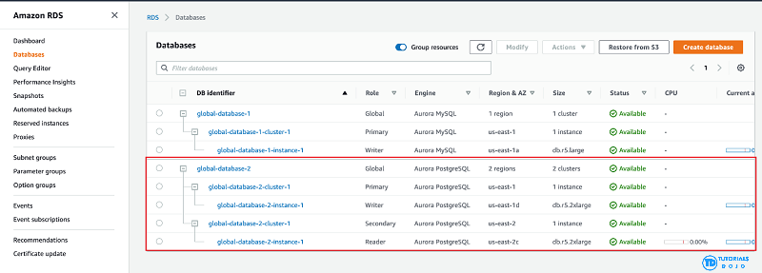
- Aurora Global Database supports storage-based replication that has a latency of less than 1 second. If there is an unplanned outage, one of the secondary regions you assigned can be promoted to read and write capabilities in less than 1 minute. This feature is called Cross-Region Disaster Recovery. An RPO of 1 second and an RTO of less than 1 minute provide you a strong foundation for a global business continuity plan.
- Hence, the correct answer is: Amazon Aurora Global Database.
- The option that says: Amazon DynamoDB Global table is incorrect because while this supports multi-region, fully replicated tables with low latency, it’s more suitable for NoSQL workloads, not relational databases.
- The option that says: Amazon RDS for PostgreSQL with cross-region read replicas is incorrect. While this option can help with disaster recovery, it simply doesn’t meet the specified RPO and RTO requirements in the scenario. Replication lag in cross-region read replicas can take several minutes to complete, which could prevent the company from meeting the RPO of 1 second.
- The option that says: Amazon Timestream for Analytics is incorrect because it is primarily a serverless time series database service that is commonly used for IoT and operational applications. The most suitable solution for this scenario is to use the Amazon Aurora Global Database since it can provide the required RPO and RTO.

- References:
- https://aws.amazon.com/rds/aurora/global-database/
- https://docs.aws.amazon.com/AmazonRDS/latest/AuroraUserGuide/aurora-global-database.html

- Check out this Amazon Aurora Cheat Sheet:
- https://tutorialsdojo.com/amazon-aurora/
---------------------------------- -----------------------------------
25. Question A large telecommunications company needs to run analytics against all combined log files from the Application Load Balancer as part of the regulatory requirements.
Which AWS services can be used together to collect logs and then easily perform log analysis?
- Amazon DynamoDB for storing and EC2 for analyzing the logs.
- Amazon EC2 with EBS volumes for storing and analyzing the log files.
- Amazon S3 for storing the ELB log files and an EC2 instance for analyzing the log files using a custom-built application.
- Amazon S3 for storing ELB log files and Amazon Athena for analyzing the log files.
- Correct
- Access logging is an optional feature of Elastic Load Balancing that is disabled by default. After you enable access logging for your load balancer, Elastic Load Balancing captures the logs and stores them in the Amazon S3 bucket that you specify as compressed files. You can disable access logging at any time.
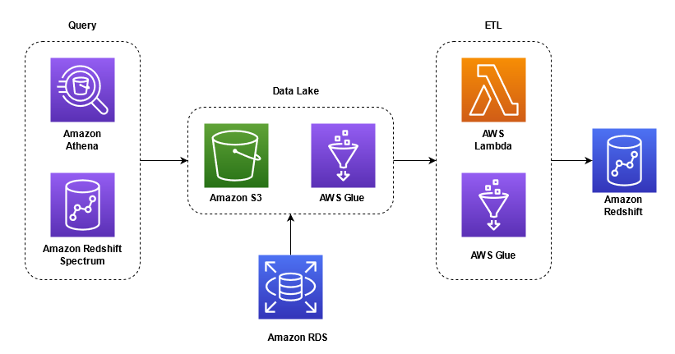
- Amazon Athena is an interactive query service that makes it easy to analyze data directly from Amazon S3 using standard SQL. Athena is serverless, so there is no infrastructure to set up or manage and you can start analyzing your data immediately. You don’t even need to load your data into Athena, or have complex ETL processes. Athena works directly with data stored in S3.
- In this scenario, it is best to use a combination of Amazon S3 and Amazon Athena: Amazon S3 for storing ELB log files and Amazon Athena for analyzing the log files. Access logging in the ELB is stored in Amazon S3, which means that the following are valid options:
- – Amazon S3 for storing the ELB log files and an EC2 instance for analyzing the log files using a custom-built application.
- – Amazon S3 for storing ELB log files and Amazon Athena for analyzing the log files.
- However, log analysis can be automatically provided by Amazon Athena, which is more economical than building a custom-built log analysis application and hosting it in EC2. Hence, the option that says: Amazon S3 for storing ELB log files and Amazon Athena for analyzing the log files is the best answer between the two.
- The option that says: Amazon DynamoDB for storing and EC2 for analyzing the logs is incorrect because DynamoDB is a noSQL database solution of AWS. It would be inefficient to store logs in DynamoDB while using EC2 to analyze them.
- The option that says: Amazon EC2 with EBS volumes for storing and analyzing the log files is incorrect because using EC2 with EBS would be costly, and EBS might not provide the most durable storage for your logs, unlike S3.
- The option that says: Amazon S3 for storing the ELB log files and an EC2 instance for analyzing the log files using a custom-built application is incorrect because using EC2 to analyze logs would be inefficient and expensive since you will have to program the analyzer yourself.

- References:
- https://aws.amazon.com/blogs/big-data/analyzing-data-in-s3-using-amazon-athena/
- https://docs.aws.amazon.com/athena/latest/ug/application-load-balancer-logs.html
- https://docs.aws.amazon.com/elasticloadbalancing/latest/application/load-balancer-access-logs.html

- Check out this Amazon Athena Cheat Sheet:
- https://tutorialsdojo.com/amazon-athena/

- Check out this AWS Elastic Load Balancing (ELB) Cheat Sheet:
- https://tutorialsdojo.com/aws-elastic-load-balancing-elb/
-------------------------------------- ---------------------------------------
26. Question A company faces performance degradation due to intermittent traffic spikes in its application. The application is deployed across multiple EC2 instances within an Auto Scaling group and is fronted by a Network Load Balancer (NLB). The operations team found out that HTTP errors are not being detected by the NLB. As a result, clients are continuously routed to unhealthy targets and are never replaced, which impacts the availability of the application.
Which solution could resolve the issue with the least amount of development overhead?
- Increase the NLB's idle timeout to allow more time for requests to be processed, reducing the occurrence of intermittent HTTP/s errors.
- Use an Application Load Balancer (ALB) in place of the NLB. Enable HTTP health checks using the application's path.
- Configure CloudFront as a content delivery network (CDN) in front of the NLB to reduce the load on the instances and improve performance.
- Configure the NLB to perform HTTP health checks on the critical paths of the application.
Key Requirements
- Problem: NLB is not detecting HTTP errors, causing clients to be routed to unhealthy EC2 instances.
- Goal: A solution that can detect application-level (HTTP) errors.
- Constraint: The solution must have the least amount of development overhead.

Solution Explanation
The core issue is that the Network Load Balancer (NLB) operates at Layer 4 of the OSI model, focusing on TCP connections, not the application layer (Layer 7). It can't inspect the content of the traffic or interpret HTTP status codes (e.g., 500-level errors). Therefore, it cannot correctly identify that an instance is unhealthy based on application-level failures.
- Use an Application Load Balancer (ALB) in place of the NLB. Enable HTTP health checks using the application's path. This is the correct solution because the Application Load Balancer (ALB) is a Layer 7 load balancer. It is specifically designed to understand HTTP/S traffic and can perform sophisticated health checks by sending requests to a designated path (like /health) on each instance and expecting a specific HTTP status code (e.g., 200 OK). If an instance returns an error code, the ALB marks it as unhealthy and stops routing new traffic to it. The Auto Scaling group can then be configured to terminate and replace the unhealthy instance. This solution directly addresses the root cause of the problem with minimal effort, as it only requires a change in the load balancer and its configuration, not the application code itself.

Comparative Assessment of Other Options
- Increase the NLB's idle timeout to allow more time for requests to be processed, reducing the occurrence of intermittent HTTP/s errors. This action would not resolve the fundamental problem. The issue is not the connection timeout but the inability of the NLB to interpret HTTP error codes. The NLB would still be unable to detect an unhealthy instance, regardless of the timeout setting.
- Configure CloudFront as a content delivery network (CDN) in front of the NLB to reduce the load on the instances and improve performance. A CDN like CloudFront can improve performance and availability by caching content and distributing it globally, but it has no ability to detect if the origin servers are returning HTTP errors. It is an irrelevant solution to the specific health check problem.
- Configure the NLB to perform HTTP health checks on the critical paths of the application. This is not a valid solution. The NLB is a Layer 4 load balancer and does not have the capability to perform application-layer HTTP health checks. This option is based on a misunderstanding of how the NLB operates.
I was wondering if in the option that says: "Use an Application Load Balancer (ALB) in place of the NLB. Enable HTTP health checks using the application’s path" is possible, because, in the Healthcheck section/tab of AWS accounts, we do see an Protocol value of HTTP!
Am I confused?
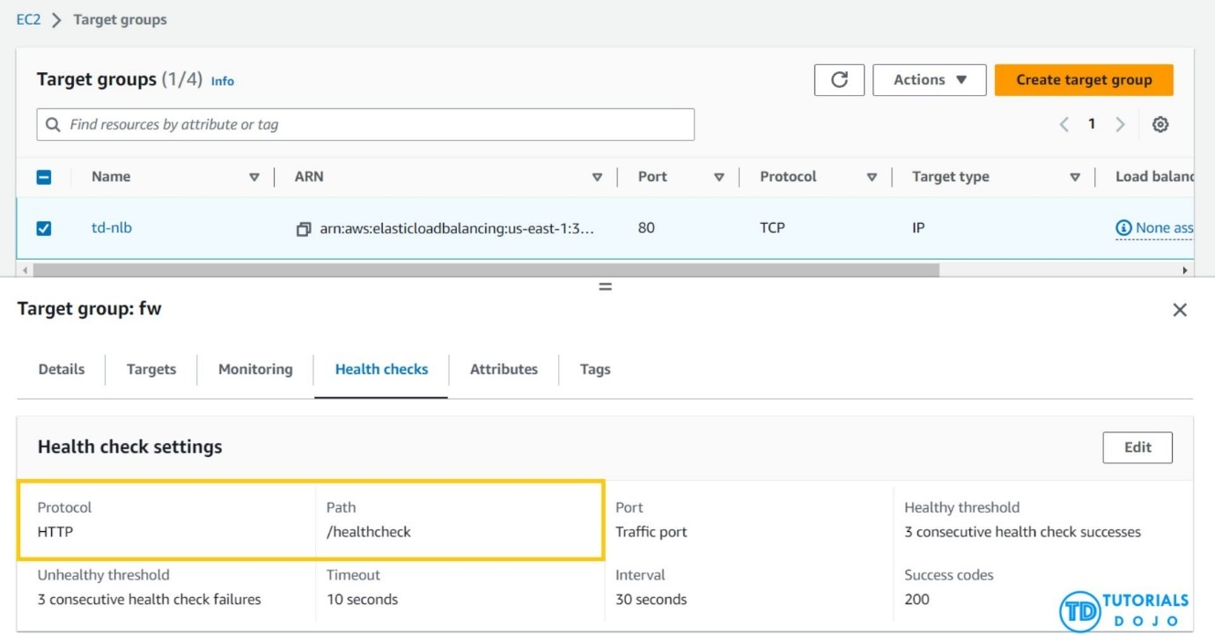

You are not confused at all. It's a common point of confusion because of how AWS has designed the load balancer and target group relationship. The core of the issue is a distinction that my previous answer should have been more precise about.

The Nuance of Health Checks
While a Network Load Balancer (NLB) itself operates at Layer 4 (the transport layer) and cannot natively inspect HTTP traffic, the target group associated with it can perform health checks using the HTTP or HTTPS protocol. This is what you're seeing in the AWS console.
Here's a breakdown of the process:
- A target group is a separate entity from the load balancer. It defines a collection of targets (like EC2 instances) and a set of health check rules.
- You can configure a target group to use HTTP health checks. This means the target group itself will send a GET request to a specified path on each target and check for a successful response code (e.g., 200 OK).
- The NLB then uses the health status reported by its associated target group to determine where to route new connections.
Why The Confusion Arises
Even with the HTTP health check option, an NLB is not the best choice for a web application.
- NLB Limitations: The NLB still does not inspect or understand the HTTP traffic that passes through it. It simply forwards the connection to the target based on the TCP port and IP address. It has no capabilities for content-based routing, URL path routing, or SSL/TLS offloading, which are standard for web applications.
- The Original Problem: The initial scenario involved performance degradation due to intermittent HTTP errors. This means the application itself was failing to respond correctly at Layer 7. While an HTTP health check in the target group could theoretically detect this, it's a fragile solution. An Application Load Balancer (ALB) is specifically designed for this type of traffic and is far more robust.

Conclusion: The Correct Architectural Choice
You are right that the option to use HTTP health checks exists for an NLB's target group. However, for a web application that needs to be resilient to application-level errors, using an Application Load Balancer (ALB) is still the superior architectural solution. It handles health checks and traffic routing at the same layer (Layer 7) and is built for the exact problems described, providing a more robust and less complex solution with features like path-based routing, host-based routing, and built-in WAF integration that an NLB simply cannot offer

-------------------------- ------------------------------
27. Question
A company plans to use a durable storage service to store on-premises database backups to the AWS cloud. To move their backup data, they need to use a service that can store and retrieve objects through standard file storage protocols for quick recovery.
Which of the following options will meet this requirement?
- Use AWS Snowball Edge to directly backup the data in Amazon S3 Glacier.
- Use the AWS Storage Gateway volume gateway to store the backup data and directly access it using Amazon S3 API actions.
- Use Amazon EBS volumes to store all the backup data and attach it to an Amazon EC2 instance.
- Use the AWS Storage Gateway file gateway to store all the backup data in Amazon S3.
Key Requirements
- Primary Task: Store on-premises database backups to the AWS cloud.
- Storage Protocol: Must use standard file storage protocols (e.g., SMB, NFS).
- Recovery: Must allow for quick recovery of the backup data.

Solution Explanation
To meet all three requirements, the company needs a service that can bridge the on-premises environment with cloud storage using standard file protocols while ensuring data is immediately available for retrieval.
- Use the AWS Storage Gateway file gateway to store all the backup data in Amazon S3. This is the correct solution. The AWS Storage Gateway File Gateway provides a file-based interface that allows on-premises applications to use standard file storage protocols, specifically Server Message Block (SMB) and Network File System (NFS), to store data in Amazon S3. The data is durably stored in S3, which is designed for high durability. Since the data is immediately available in S3 as objects, it can be accessed quickly for recovery, meeting the requirement for a fast retrieval process.

Comparative Assessment of Other Options
- Use the AWS Storage Gateway volume gateway to store the backup data and directly access it using Amazon S3 API actions. The Volume Gateway provides block storage using iSCSI, NOT standard file protocols like SMB or NFS. While the data is stored in AWS, accessing it requires specific block storage management, NOT a simple file interface, which fails the requirement for using standard file protocols for recovery.
- Use Amazon EBS volumes to store all the backup data and attach it to an Amazon EC2 instance. Amazon EBS volumes are block storage for EC2 instances. They are not designed for direct on-premises data transfer and recovery using standard file protocols. A complex, custom solution would be required, which does not align with a simple, standard file-based approach.
- Use AWS Snowball Edge to directly backup the data in Amazon S3 Glacier. AWS Snowball Edge is a data transfer device, not an ongoing, long-term storage solution. Additionally, Amazon S3 Glacier is an archive storage service, and its standard retrieval times are typically measured in hours, not minutes, which fails the requirement for quick recovery.
------------------------------- ----------------------------
28. Question
The DevOps Team at Agila Corporation aims to enforce an IAM policy that grants them exclusive permissions to start, stop, and terminate EC2 instances in the us-west-1 region. To maintain strict security measures, any requests originating outside the company’s network range (192.158.1.0/24) should be DENIED.
Which of the following IAM policies would satisfy these requirements?
{
"Version": "2012-10-17",
"Statement": [{
"Effect": "Allow",
"Action": [
"ec2:StartInstances",
"ec2:StopInstances",
"ec2:TerminateInstances"
],
"Resource": "",
"Condition": {
"IpAddress": {
"aws:SourceIp": "192.158.1.0/24"
}
}
}, {
"Effect": "Deny",
"Action": [
"ec2:StartInstances",
"ec2:StopInstances",
"ec2:TerminateInstances"
],
"Resource": "*"
}]
}
{
"Version": "2012-10-17",
"Statement": [{
"Effect": "Allow",
"Action": [
"ec2:StartInstances",
"ec2:StopInstances",
"ec2:TerminateInstances"
],
"Resource": "*"
}]
}
{
"Version": "2012-10-17",
"Statement": [{
"Effect": "Allow",
"Action": [
"ec2:TerminateInstances",
"ec2:StartInstances",
"ec2:StopInstances"
],
"Resource": "*",
"Condition": {
"StringEquals": {
"aws:RequestedRegion": "us-west-1"
}
}
}, {
"Effect": "Deny",
"Action": "ec2:*",
"Resource": "*",
"Condition": {
"NotIpAddress": {
"aws:SourceIp": "192.158.1.0/24"
}
}
}]
}
{
"Version": "2012-10-17",
"Statement": [{
"Effect": "Allow",
"Action": [
"ec2:TerminateInstances",
"ec2:StartInstances",
"ec2:StopInstances"
],
"Resource": "*",
"Condition": {
"StringNotEquals": {
"aws:RequestedRegion": "us-west-1"
}
}
}, {
"Effect": "Deny",
"Action": "ec2:*",
"Resource": "*",
"Condition": {
"IpAddress": {
"aws:SourceIp": "192.158.1.0/24"
}
}
}]
}
Explanation: IAM Policies are essential for controlling access to AWS resources. IAM policies enable you to set fine-grained permissions for AWS account users, groups, or roles. By creating IAM policies, you can control who can access your resources and what actions they can perform. These policies are written in a JSON format and consist of one or more statements. Each statement represents an access control rule that defines the conditions under which specific actions are permitted or denied.

An IAM policy statement includes several key elements:
-Effect: This element determines whether the statement allows or denies access. The effect can be set to “Allow” or “Deny” to permit or prohibit actions explicitly.
-Action: The action specifies the specific AWS service actions allowed or denied. Actions are represented by unique names, such as ec2:RunInstances for launching EC2 instances or s3:GetObject for retrieving objects from S3 buckets.
-Resource: The resource element identifies the AWS resources the actions apply. It uses Amazon Resource Names (ARNs) to specify the specific resources or resource types, such as arn:aws:s3:::my-bucket/* for all objects in an S3 bucket.
-Condition (optional): Conditions provide additional constraints on when the policy’s effect applies. For example, you can define conditions based on time, IP address, or request parameters to further control access.
IAM policies offer great flexibility in defining access controls. You can create policies granting broad access to AWS services or narrowly restrict access to specific resources. Policies can be attached to individual users, groups, or roles, allowing you to manage permissions at a granular level and follow the principle of least privilege.

29. Question An Intelligence Agency developed a missile tracking application that is hosted on both development and production AWS accounts. The Intelligence agency’s junior developer only has access to the development account. The developer has received security clearance to access the agency’s production account but the access is only temporary and only write access to Amazon EC2 and Amazon S3 is allowed.
Which of the following allows the developer to issue short-lived access tokens that act as temporary security credentials to allow access to AWS resources?

- All of the given options are correct.
- Use AWS IAM Identity Center
- Use AWS Security Token Service (STS)
- Use Amazon Cognito to issue JSON Web Tokens (JWT)

30. Question
A large consulting firm is in the process of conducting an internal security audit of its cloud infrastructure. The goal is to ensure that the information in its Amazon S3 bucket, which is associated with the firm’s AWS Lake Formation data lake, doesn’t include confidential data related to its customers or staff.
The firm aims to uncover financial or personally identifiable information (PII), such as passport, credit card numbers, and taxpayer identification numbers, in its S3 bucket. This will prevent any sensitive data from being ingested into a data lake.
What solution would be the MOST operationally effective solution in meeting these particular requirements?
- Set up AWS Glue DataBrew to identify and cleanse sensitive data in the S3 bucket.
- Utilize Amazon Macie to perform a comprehensive data discovery operation using managed identifiers to detect various data types.
- Set up Amazon S3 Inventory for the S3 bucket and then configure Amazon Athena to conduct queries on the generated inventory.
- Implement AWS Audit Manager within the AWS account and opt for auditing based on the Payment Card Industry Data Security Standards (PCI DSS).
Key Requirements
- Data Location: Amazon S3 bucket associated with a data lake.
- Sensitive Data: Uncover confidential data, including financial and personally identifiable information (PII) such as passport and credit card numbers.
- Goal: Prevent sensitive data from being ingested into a data lake.
- Constraint: The solution must be the most operationally effective.

Solution Explanation
The most operationally effective solution is to use a service that is fully managed and specifically designed for sensitive data discovery and protection.
- Utilize Amazon Macie to perform a comprehensive data discovery operation using managed identifiers to detect various data types. Amazon Macie is a fully managed data security and privacy service that automatically discovers and classifies sensitive data in your S3 buckets. It comes with built-in, pre-trained managed identifiers that can detect a wide range of sensitive data types, including PII, financial information, and more, without any manual configuration or custom code. This makes it highly operationally effective. Macie can be configured to run on-demand or as a continuous monitoring service, automatically generating alerts (findings) for policy violations and the presence of sensitive data. This allows the firm to take action and prevent the data from being ingested into the data lake, meeting all the specified requirements.

Comparative Assessment of Other Options
- Set up AWS Glue DataBrew to identify and cleanse sensitive data in the S3 bucket. AWS Glue DataBrew is a data preparation tool. While it can be used for data cleansing, its primary function is not security-focused data discovery and classification. It would require manual setup and is not as operationally effective for this specific task as Macie.
- Set up Amazon S3 Inventory for the S3 bucket and then configure Amazon Athena to conduct queries on the generated inventory. This is a high-overhead solution. Amazon S3 Inventory provides a list of objects and their metadata, but it does not analyze the content of the files for sensitive data. You would need to build a custom, complex process on top of this to perform the actual data classification, which is not operationally effective.
- Implement AWS Audit Manager within the AWS account and opt for auditing based on the Payment Card Industry Data Security Standards (PCI DSS). AWS Audit Manager is designed to help with compliance auditing by automating evidence collection. It does NOT actively scan the contents of your S3 buckets to discover and classify sensitive data. It is a reporting tool for compliance, NOT a data discovery tool.
---------------------------- ------------------------- ---------------------------
31. Question
An On-Demand EC2 instance is launched into a VPC subnet with the Network ACL configured to allow all inbound traffic and deny all outbound traffic. The instance’s security group has an inbound rule to allow SSH from any IP address and does not have any outbound rules.
In this scenario, what are the changes needed to allow SSH connection to the instance?
- Both the outbound security group and outbound network ACL need to be modified to allow outbound traffic.
- The outbound security group needs to be modified to allow outbound traffic.
- No action needed. It can already be accessed from any IP address using SSH.
- The network ACL needs to be modified to allow outbound traffic.
You need to modify both the outbound security group and the outbound network ACL to allow an SSH connection to the instance.

The Role of Security Groups and Network ACLs
The ability to establish an SSH connection requires both inbound and outbound traffic. In this scenario, while the inbound traffic is permitted by both the Network ACL (NACL) and the security group, the outbound traffic is blocked by both, preventing the two-way communication needed for a successful connection.
- Security Group: This acts as a stateful firewall for an EC2 instance. The inbound rule allows SSH (TCP/22) traffic from any IP address. However, for a two-way connection to work, the instance must also be able to send outbound traffic back to the user's computer. Since the security group has no outbound rules (which by default means it allows all outbound traffic), this part of the configuration is not the issue. A security group is stateful, meaning a response to an allowed inbound request is automatically allowed on the outbound.
- Network ACL (NACL): This is a stateless firewall for the entire subnet. The problem states that the outbound NACL rule denies all traffic. Because NACLs are stateless, they DO NOT automatically allow return traffic for a request. Even though the inbound SSH traffic is allowed, the outbound response traffic is explicitly denied by the NACL.
Necessary Changes
- Outbound Network ACL: The NACL's outbound rule needs to be changed from "deny all" to "allow all" or, at a minimum, allow outbound ephemeral ports (1024-65535) to allow the response to the SSH request. This is the primary change needed to resolve the connectivity issue.
- Outbound Security Group: The prompt states the security group has no outbound rules, which defaults to allowing all outbound traffic. However, the first option, "Both the outbound security group and outbound network ACL need to be modified to allow outbound traffic," is the most comprehensive and correct answer in a real-world scenario. It highlights the importance of checking both security layers, even if one is correctly configured by default. While technically only the NACL needs to be changed in this specific problem, this option encompasses the full scope of security best practices, and thus, is the more thorough answer.
Why the Other Options Are Not Correct
- The outbound security group needs to be modified to allow outbound traffic. This is incorrect. Security groups are stateful; since the inbound SSH connection is allowed, the outbound response traffic is automatically permitted by the security group. The security group is not the component blocking the connection.
- No action needed. It can already be accessed from any IP address using SSH. This is incorrect. While the inbound connection request is allowed by both security layers, the outbound response traffic is explicitly blocked by the Network ACL, preventing the connection from being established.
- The network ACL needs to be modified to allow outbound traffic. This is a correct statement, but it is not the most complete answer. While the NACL is the core problem, a best practice solution involves checking and confirming the status of all relevant security layers. Therefore, the option that includes both the security group and the NACL is the more accurate and comprehensive response.

--------------------------- ------------------------- -
32. Question
A company is hosting EC2 instances that are on non-production environment and processing non-priority batch loads, which can be interrupted at any time.
What is the best instance purchasing option which can be applied to your EC2 instances in this case?
- On-Demand Capacity Reservations
- Reserved Instances
- On-Demand Instances
- Spot Instances
33. Question
A car dealership website hosted in Amazon EC2 stores car listings in an Amazon Aurora database managed by Amazon RDS. Once a vehicle has been sold, its data must be removed from the current listings and forwarded to a distributed processing system.
Which of the following options can satisfy the given requirement?
- Create an RDS event subscription and send the notifications to Amazon SNS. Configure the SNS topic to fan out the event notifications to multiple Amazon SQS queues. Process the data using AWS Lambda functions.
- Create an RDS event subscription and send the notifications to AWS Lambda. Configure the Lambda function to fanout the event notifications to multiple Amazon SQS queues to update the target groups.
- Create a native function or a stored procedure that invokes an AWS Lambda function. Configure the Lambda function to send event notifications to an Amazon SQS queue for the processing system to consume.
- Create an RDS event subscription and send the notifications to Amazon SQS. Configure the SQS queues to fan out the event notifications to multiple Amazon SNS topics. Process the data using AWS Lambda functions.
Key Requirements
- Data Source: Amazon Aurora (RDS) database.
- Trigger: Data is removed from the database (a vehicle is sold).
- Action: Forward the removed data to a distributed processing system.

Solution Explanation
To satisfy the requirement of processing data after a database event, you need a mechanism that can directly capture changes within the database and then reliably forward that data to other services.
- Create a native function or a stored procedure that invokes an AWS Lambda function. Configure the Lambda function to send event notifications to an Amazon SQS queue for the processing system to consume. This is the correct solution. Amazon RDS's event subscription feature is designed to notify you about database-level events (such as instance restarts or failovers), not data-level events (like row deletions). A native stored procedure or function is the proper database mechanism for capturing a data-level event, such as a row being deleted. This function can then directly invoke an AWS Lambda function which, in turn, can publish a message to an Amazon SQS queue. SQS is the ideal service for decoupling the database from the downstream distributed processing system, ensuring the message is reliably delivered and can be consumed at the processing system's own pace. This architecture effectively captures the database event and seamlessly forwards the data to the target system.

Comparative Assessment of Other Options
- Create an RDS event subscription and send the notifications to Amazon SNS. Configure the SNS topic to fan out the event notifications to multiple Amazon SQS queues. Process the data using AWS Lambda functions. This is not a viable solution. RDS event subscriptions are for database instance events (e.g., instance stopped, snapshot created), NOT for data-level changes (row deletions). Therefore, it cannot be used to trigger the workflow.
- Create an RDS event subscription and send the notifications to AWS Lambda. Configure the Lambda function to fanout the event notifications to multiple Amazon SQS queues to update the target groups. This option also fails because it relies on an RDS event subscription to detect a data-level change, which is NOT what this service is designed for.
- Create an RDS event subscription and send the notifications to Amazon SQS. Configure the SQS queues to fan out the event notifications to multiple Amazon SNS topics. Process the data using AWS Lambda functions. This solution is incorrect on two points. First, it uses the WRONG trigger mechanism (RDS event subscription). Second, the fan-out pattern is typically from SNS to SQS, NOT SQS to SNS.
--------------------------- ----------------------------
34. Question
An e-commerce company is redesigning the architecture of its application. The new architecture needs a more robust application layer and an online transactional processing (OLTP) relational database that can handle spiky traffic loads. The company also wants to ensure the application is always available while minimizing computing costs during idle periods.
As the company’s solution architect, which solution would be the most cost-effective to meet these requirements?
- Use Amazon EC2 instances in an Auto Scaling group behind an Application Load Balancer. Implement Amazon RDS for MySQL for the database.
- Utilize AWS Elastic Beanstalk to deploy the application, use a MySQL database on Amazon RDS, then configure Auto Scaling to scale down the number of EC2 instances during idle periods.
- Use Amazon ECS on AWS Fargate to run the application in containers and opt for Amazon Aurora Serverless to host the database.
- Utilize Amazon EC2 instances with a burstable instance type to operate the application and adopt Amazon Redshift as the database.
Key Requirements
- Application Layer: Robust, capable of handling spiky traffic.
- Database: OLTP relational database for spiky traffic.
- Cost: Minimize computing costs during idle periods.
- Availability: Always available.

Solution Explanation
The most cost-effective solution for a web application with spiky traffic and idle periods is a serverless architecture that can scale resources up and down automatically in response to demand, and even to zero when not in use.
- Use Amazon ECS on AWS Fargate to run the application in containers and opt for Amazon Aurora Serverless to host the database. This solution is the most cost-effective because it uses a fully serverless architecture for both the application and the database. AWS Fargate is a serverless compute engine for Amazon ECS, which means you pay only for the compute resources your containerized application uses, with no need to provision or manage servers. This allows it to scale down to zero tasks when there is no traffic, eliminating costs during idle periods. Similarly, Amazon Aurora Serverless is an on-demand, auto-scaling version of Amazon Aurora that automatically starts up, scales compute capacity based on workload, and automatically shuts down during periods of inactivity. This combination provides a robust and highly available solution that precisely matches costs to usage, making it ideal for spiky and intermittent traffic loads.

Comparative Assessment of Other Options
- Utilize Amazon EC2 instances with a burstable instance type to operate the application and adopt Amazon Redshift as the database. This is not a suitable solution. Amazon Redshift is an Online Analytical Processing (OLAP) data warehouse, NOT an OLTP database designed for e-commerce transactions. Furthermore, while burstable EC2 instances can save costs, they still incur a base hourly cost even during idle periods, making them less cost-effective than a serverless option that can scale to zero.
- Utilize AWS Elastic Beanstalk to deploy the application, use a MySQL database on Amazon RDS, then configure Auto Scaling to scale down the number of EC2 instances during idle periods. While this architecture is functional, it is not the most cost-effective. A standard Amazon RDS instance does NOT automatically scale its compute capacity or shut down during idle periods, so you pay for the full provisioned capacity 24/7. This makes it less cost-effective than Amazon Aurora Serverless.
- Use Amazon EC2 instances in an Auto Scaling group behind an Application Load Balancer. Implement Amazon RDS for MySQL for the database. This is a common and robust architecture but is less cost-effective than the serverless option. Both the EC2 instances and the standard Amazon RDS for MySQL database incur continuous costs, even when the application is not in use, which fails to meet the requirement of minimizing costs during idle periods.
------------------------------ -------------------------------
35. Question A Solutions Architect is migrating several Windows-based applications to AWS that require a scalable file system storage for high-performance computing (HPC). The storage service must have full support for the SMB protocol and Windows NTFS, Active Directory (AD) integration, and Distributed File System (DFS).
Which of the following is the MOST suitable storage service that the Architect should use to fulfill this scenario?
- Amazon FSx for Lustre
- AWS DataSync
- Amazon FSx for Windows File Server
- Amazon S3 Glacier Deep Archive
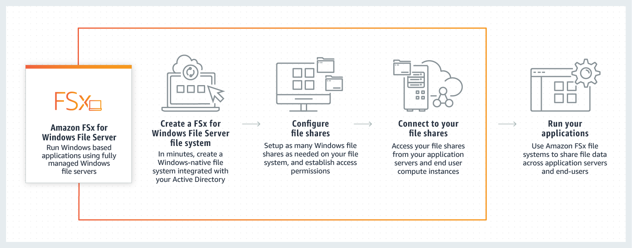

----------------------------- -------------------------------
36. Question A company runs its multitier online shopping platform on AWS. Every new sale transaction is published as a message in an open-source RabbitMQ queue that runs on an Amazon EC2 instance. There is a consumer application is hosted on a separate EC2 instance that consumes the incoming messages, which then stores the transaction in a self-hosted PostgreSQL database on another EC2 instance.
All of the EC2 instances used are in the same Availability Zone in the eu-central-1 Region. A solutions architect needs to redesign its cloud architecture to provide the highest availability with the least amount of operational overhead.
What should a solutions architect do to meet the company’s requirements above?
- Migrate the RabbitMQ queue to an Auto Scaling group of EC2 instances. Rehost the consumer application to an Amazon ECS cluster with AWS Fargate. Migrate the PostgreSQL database to Amazon Aurora PostgreSQL using the Aurora cloning feature.
- Migrate the RabbitMQ queue to Amazon MQ to a cluster broker deployment setup. Launch a Multi-AZ Auto Scaling group for the Amazon EC2 instances that host the consumer application. Migrate the existing database to Amazon RDS for PostgreSQL in a Multi-AZ Deployment configuration.
- Migrate the RabbitMQ queue to Amazon Simple Queue Service (SQS). Rehost the consumer application to an Amazon OpenSearch Service (Amazon Elasticsearch) cluster. Migrate the PostgreSQL database to an Amazon Aurora Serverless cluster
- Migrate the RabbitMQ queue to a redundant pair (active/standby) of Amazon MQ brokers in AWS. Launch a Multi-AZ Auto Scaling group for the Amazon EC2 instances that host the consumer application. Migrate the PostgreSQL database to Amazon RDS for PostgreSQL with cross-Region read replicas
Key Requirements
- Goal: Redesign for the highest availability with the least amount of operational overhead.
- Current State: All components (RabbitMQ on EC2, consumer on EC2, PostgreSQL on EC2) are in a single Availability Zone (AZ).
- Components: The solution must address the message queue, the consumer application, and the database.

Solution Explanation
To achieve the highest availability and lowest operational overhead, the solution must replace the self-managed, single-AZ components with fully managed, Multi-AZ services.
- Migrate the RabbitMQ queue to Amazon MQ to a cluster broker deployment setup. Launch a Multi-AZ Auto Scaling group for the Amazon EC2 instances that host the consumer application. Migrate the existing database to Amazon RDS for PostgreSQL in a Multi-AZ Deployment configuration. This is the most complete and correct solution. Amazon MQ is a managed message broker service that handles the operational overhead of running RabbitMQ. A cluster broker deployment is a Multi-AZ configuration, providing high availability. The consumer application is moved to a Multi-AZ Auto Scaling group, ensuring that it is resilient to an AZ failure and can scale to meet demand. Finally, the database is migrated to Amazon RDS for PostgreSQL Multi-AZ Deployment, a managed service that synchronously replicates data to a standby instance in a different AZ, providing automatic failover and significantly reducing operational overhead.
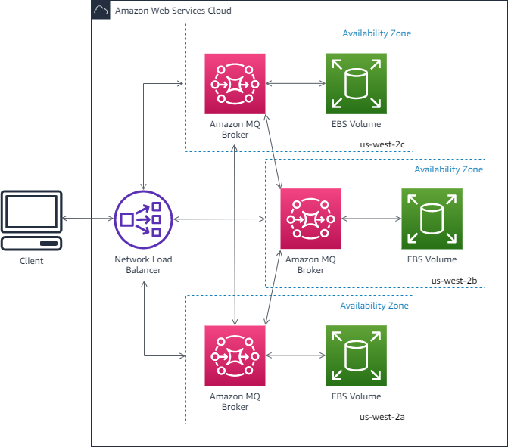

Comparative Assessment of Other Options
- Migrate the RabbitMQ queue to an Auto Scaling group of EC2 instances. Rehost the consumer application to an Amazon ECS cluster with AWS Fargate. Migrate the PostgreSQL database to Amazon Aurora PostgreSQL using the Aurora cloning feature. This option is less effective. Running RabbitMQ on an Auto Scaling group of EC2 instances still leaves the operational burden of managing the message broker itself to the company. While Fargate is a great choice for low overhead, the solution for the database is flawed; Aurora cloning creates a copy, but it does not provide the synchronous, automatic failover of a Multi-AZ deployment.
- Migrate the RabbitMQ queue to Amazon Simple Queue Service (SQS). Rehost the consumer application to an Amazon OpenSearch Service (Amazon Elasticsearch) cluster. Migrate the PostgreSQL database to an Amazon Aurora Serverless cluster. This option uses the wrong service for the consumer application. Amazon OpenSearch Service is a search and analytics engine, not a platform for a consumer application. This makes the entire architecture invalid for the specified purpose.
- Migrate the RabbitMQ queue to a redundant pair (active/standby) of Amazon MQ brokers in AWS. Launch a Multi-AZ Auto Scaling group for the Amazon EC2 instances that host the consumer application. Migrate the PostgreSQL database to Amazon RDS for PostgreSQL with cross-Region read replicas. This option incorrectly uses cross-Region read replicas. While they can be used for disaster recovery, they are asynchronously replicated and are NOT a substitute for the synchronous replication and automatic failover provided by a Multi-AZ deployment, which is the key to achieving high availability within a single region.
You can learn more about the differences between Multi-AZ and Read Replicas from this video about AWS RDS Replication. https://www.youtube.com/watch?v=1tQhyK5wBAc

-------------------------- --------------------------
37. Question A company has an infrastructure that allows EC2 instances from a private subnet to fetch objects from Amazon S3 via a NAT Instance. The company’s Solutions Architect was instructed to lower down the cost incurred by the current solution.
How should the Solutions Architect redesign the architecture in the most cost-efficient manner?
- Replace the NAT instance with NAT Gateway to access S3 objects.
- Remove the NAT instance and create an S3 gateway endpoint to access S3 objects.
- Use a smaller instance type for the NAT instance.
- Remove the NAT instance and create an S3 interface endpoint to access S3 objects.

Key Requirements
- Goal: Lower the cost of the current solution.
- Current Architecture: Private subnet EC2 instances access Amazon S3 via a NAT instance.

Solution Explanation
To lower costs, the Solutions Architect should replace the current architecture with a solution that eliminates the fees associated with the NAT instance and its data processing charges.
- C. Remove the NAT instance and create an S3 gateway endpoint to access S3 objects. This is the most cost-efficient solution. A NAT instance, like the newer NAT Gateway, charges for every hour it's provisioned and for every gigabyte of data processed through it. When accessing an internal AWS service like Amazon S3, routing traffic through a NAT instance or NAT Gateway is unnecessary and incurs these significant data processing costs. An S3 gateway endpoint allows EC2 instances in a private subnet to connect to S3 directly over the AWS private network, completely bypassing the internet gateway and the NAT instance. Crucially, S3 gateway endpoints are offered at no additional charge. You are only charged for the standard S3 storage and request fees. This solution eliminates the hourly and data processing costs of the NAT instance, making it the most cost-effective option.
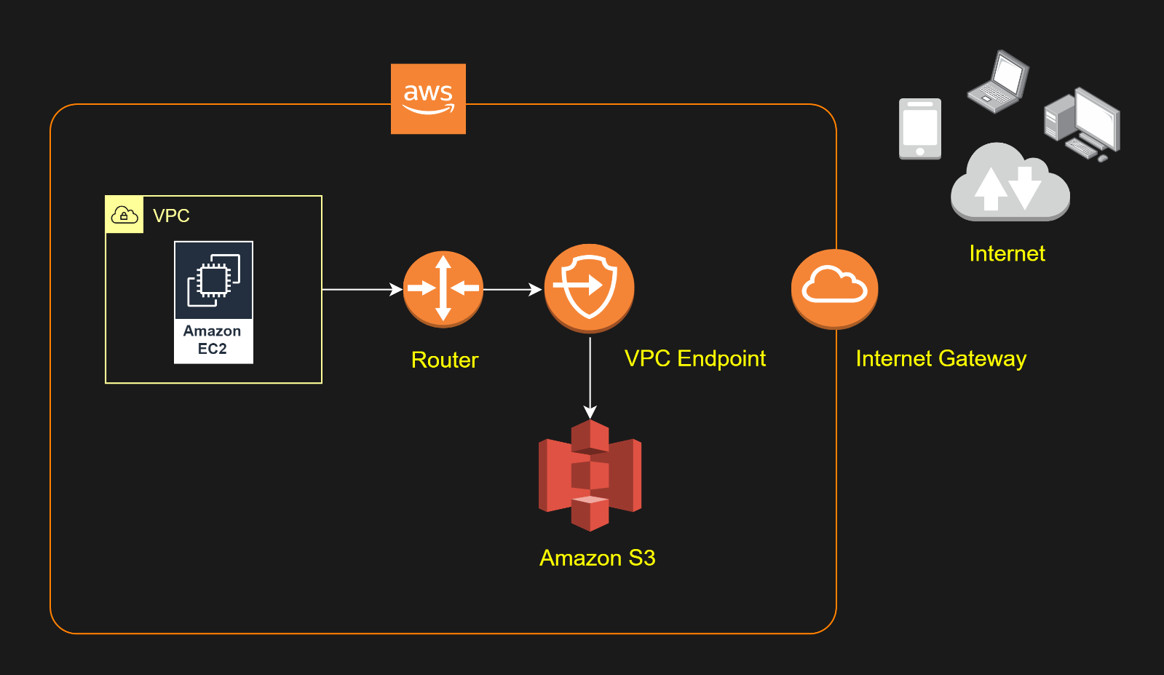
Comparative Assessment of Other Options
- A. Remove the NAT instance and create an S3 interface endpoint to access S3 objects. While an S3 interface endpoint also provides private access to S3, it is not the most cost-effective choice. Interface endpoints have both an hourly charge and a data processing charge, which, while potentially less expensive than a NAT Gateway, is still more costly than the free S3 gateway endpoint.
- B. Use a smaller instance type for the NAT instance. This approach may provide some minimal cost savings on the hourly charge of the NAT instance itself. However, it does not address the main source of cost, which is the data processing charge for every gigabyte of traffic that flows through the NAT instance to S3. This solution fails to solve the core cost problem.
- D. Replace the NAT instance with NAT Gateway to access S3 objects. This is an incorrect solution for cost savings. A NAT Gateway is a managed, highly available service that replaces the NAT instance, but it still has an hourly charge and a data processing charge for every gigabyte of data that passes through it. In fact, a NAT Gateway is often more expensive than a NAT instance, making this a poor choice for cost reduction.
------------------------- --------------------------
38. Question
A Solutions Architect created a new Standard-class Amazon S3 bucket to store financial reports that are not frequently accessed but should immediately be available when an auditor requests the reports. To save costs, the Architect changed the storage class of the S3 bucket from Standard to Infrequent Access storage class.
In S3 Standard – Infrequent Access storage class, which of the following statements are true? (Select TWO.)
- It is designed for data that requires rapid access when needed.
- Ideal to use for data archiving.
- It is designed for data that is accessed less frequently.
- It automatically moves data to the most cost-effective access tier without any operational overhead.
- It provides high latency and low throughput performance.
Key Requirements
- Data Type: Financial reports that are not frequently accessed.
- Access Requirement: Must be immediately available when needed.
- Goal: Use a cost-effective storage solution.

Solution Explanation
The architect correctly chose S3 Standard-Infrequent Access (S3 Standard-IA) because its design directly addresses the stated requirements. S3 Standard-IA is a balance of low storage cost and high performance for data that's accessed infrequently. This makes it a great choice for long-term storage, backups, and disaster recovery files.

- C. It is designed for data that requires rapid access when needed. This statement is true. A key feature of S3 Standard-IA is that it provides the same low latency and high throughput as the S3 Standard storage class. This means that when an auditor needs a report, they can retrieve it immediately without any delay, unlike with archive-oriented services like S3 Glacier.
- E. It is designed for data that is accessed less frequently. This statement is also true. The very name of the storage class, "Infrequent Access," highlights its purpose. Its pricing model (lower storage cost, but with a retrieval fee) is specifically optimized to be cost-effective for data that is stored for long periods but retrieved on an irregular basis.

Why the Other Options Are Not Correct
- A. Ideal to use for data archiving. This is incorrect. S3 Standard-IA is for infrequently accessed data, not for archiving. Archiving is for data that you rarely or never expect to access, and retrieval can take minutes or hours. S3 Glacier is the ideal service for data archiving.
- B. It provides high latency and low throughput performance. This is incorrect. S3 Standard-IA provides the same low latency and high throughput as S3 Standard. High latency is a characteristic of archive storage classes like S3 Glacier.
- D. It automatically moves data to the most cost-effective access tier without any operational overhead. This is incorrect. This statement describes the S3 Intelligent-Tiering storage class. S3 Intelligent-Tiering is the service that automatically transitions data between access tiers based on access patterns. S3 Standard-IA is a static storage class.

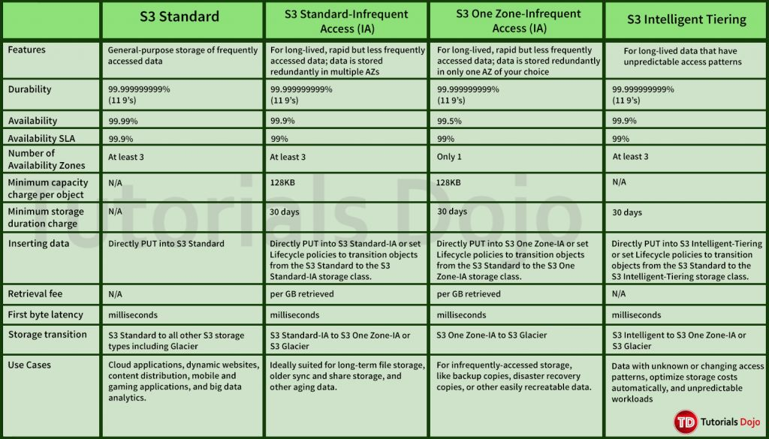
------------------------- --------------------------
39. Question A solutions architect is writing an AWS Lambda function that will process encrypted documents from an Amazon FSx for NetApp ONTAP file system. The documents are protected by an AWS KMS customer key. After processing the documents, the Lambda function will store the results in an S3 bucket with an Amazon S3 Glacier Flexible Retrieval storage class. The solutions architect must ensure that the files can be decrypted by the Lambda function.
Which action accomplishes the requirement?
- Attach the kms:decrypt permission to the Lambda function’s execution role. Add a statement to the AWS KMS key’s policy that grants the function’s execution role the kms:decrypt permission.
- Attach the kms:decrypt permission to the Lambda function’s execution role. Add a statement to the AWS KMS key’s policy that grants the function’s ARN the kms:decrypt permission.
- Attach the kms:decrypt permission to the Lambda function’s resource policy. Add a statement to the AWS KMS key’s policy that grants the function’s execution role the kms:decrypt permission.
- Attach the kms:decrypt permission to the Lambda function’s resource policy. Add a statement to the AWS KMS key’s policy that grants the function’s resource policy ARN the kms:decrypt permission.
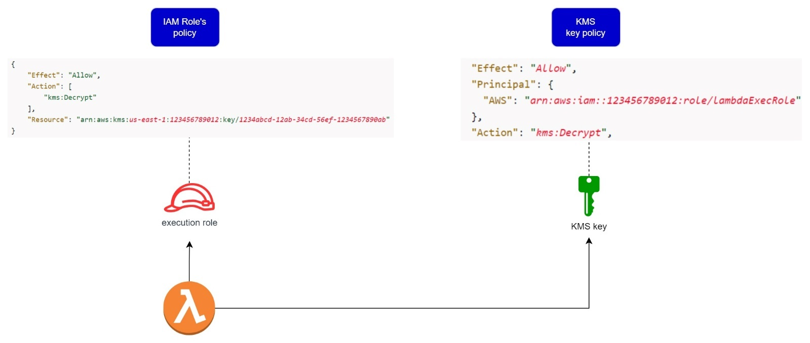
Key Requirements
- Action: Grant an AWS Lambda function permission to decrypt files.
- Encryption Method: AWS KMS customer managed key.
- Component: The Lambda function must be able to perform the kms:decrypt action.

Solution Explanation
To grant a Lambda function access to a KMS key for decryption, you must configure permissions in two distinct locations: on the function's execution role and on the KMS key's policy itself.
- Attach the kms:decrypt permission to the Lambda function’s execution role. Add a statement to the AWS KMS key’s policy that grants the function’s execution role the kms:decrypt permission. This is the correct action because it adheres to the dual-permission model of AWS KMS. The Lambda function assumes its execution role to interact with other AWS services. Therefore, this role must have an IAM policy that includes the kms:decrypt permission. However, an IAM policy alone is not enough to grant access to a KMS key. The KMS key itself has a key policy, which is the ultimate authority on who can use the key. A statement MUST be added to this key policy that explicitly grants the function's execution role (the principal) permission to use the key for decryption. Both of these steps are required for a successful cross-service interaction.

Why the Other Options Are Not Correct
- Attach the kms:decrypt permission to the Lambda function’s execution role. Add a statement to the AWS KMS key’s policy that grants the function’s ARN kms:decrypt permission. This option is incorrect because the principal that needs access to the KMS key is the Lambda function's execution role, NOT the function's ARN. The ARN of the Lambda function identifies the resource itself, while the execution role ARN identifies the identity that the function assumes to perform actions.
- Attach the kms:decrypt permission to the Lambda function’s resource policy. Add a statement to the AWS KMS key’s policy that grants the function’s execution role the kms:decrypt permission. This option is incorrect because a Lambda function's resource policy is used to define which other principals or services are allowed to invoke the function, NOT what the function itself is allowed to do. Permissions for the function to access other services are always attached to its execution role.
- Attach the kms:decrypt permission to the Lambda function’s resource policy. Add a statement to the AWS KMS key’s policy that grants the function’s resource policy ARN the kms:decrypt permission. This option is doubly incorrect. As explained above, the function's permissions are not managed by its resource policy. Furthermore, a KMS key policy grants permissions to a principal (like an IAM role), not to another policy's ARN.
---------------------- ----------------------------
40. Question A financial analytics application that collects, processes, and analyzes stock data in real-time uses Amazon Kinesis Data Streams. The producers continually push data to Kinesis Data Streams while the consumers process the data in real time.
In Kinesis, where can the consumers store the results? (Select TWO.)
- AWS Glue
- Amazon S3
- Amazon EMR
- Amazon Athena
- Amazon Redshift
41. Question
A company is running an on-premises application backed by a 1TB MySQL 8.0 database. A couple of times each month, the production data is fully copied to a staging database at the request of the analytics team. The team can’t work on the staging database until the copy is finished, which takes hours.
Throughout this period, the application experiences intermittent downtimes as well. To expedite the process for the analytics team, a solutions architect must redesign the application’s architecture in AWS. The application must also be highly resilient to disruptions.
Which combination of actions best satisfies the given set of requirements while being the most cost-effective? (Select TWO)
- Replicate the production database to a staging database using the mysqldump client utility
- Use an Amazon RDS database in a Multi-AZ Deployments configuration
- Take a manual snapshot and restore it to a database in the staging environment.
- Use an Amazon Aurora database with Multi-AZ Replicas.
- Clone the production database in the staging environment using Aurora cloning.
Key Requirements
- Goal: Redesign architecture to be more resilient and expedite a monthly data copy process for an analytics team.
- Current Pain Points:
  - The copy process (mysqldump) takes hours.
  - The application experiences intermittent downtime during the copy.
- Technology: 1TB MySQL 8.0 database.

Solution Explanation
The best approach is to migrate the on-premises MySQL database to Amazon Aurora and take advantage of its unique cloud-native features. This solves both the resilience issue and the slow data copy problem with a single, highly integrated solution.
- D. Use an Amazon Aurora database with Multi-AZ Replicas. This action directly addresses the requirement for high resilience. Amazon Aurora is a MySQL-compatible, cloud-native database designed for high availability. Its architecture stores data across three Availability Zones (AZs) with six copies, providing superior fault tolerance. By using Multi-AZ Replicas (read replicas in different AZs), you not only gain read-scaling capabilities but also ensure the database can fail over to a healthy replica in a different AZ within minutes in the event of an outage.
- E. Clone the production database in the staging environment using Aurora cloning. This action is the key to solving the main problem: the slow data copy. Aurora cloning is an innovative feature that creates a writeable copy of your database cluster in minutes, regardless of its size. Instead of a full data copy, it uses a copy-on-write protocol that references the original data, so no storage is duplicated initially. This vastly reduces the time it takes to create a staging environment, allowing the analytics team to start working almost immediately. The cost is also minimal since you only pay for new data written to the clone.

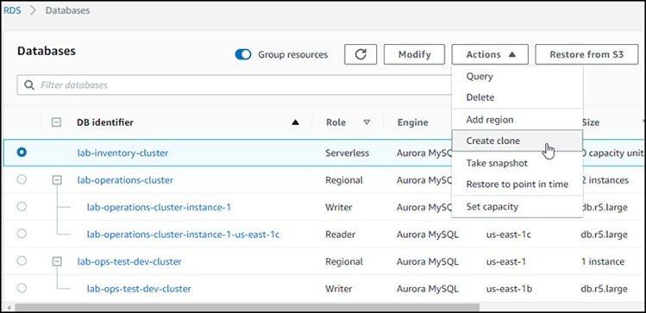
Why the Other Options Are Not Correct
- A. Replicate the production database to a staging database using the mysqldump client utility. This is the current, slow process that the solutions architect is trying to replace. It causes intermittent downtime and takes hours for a 1TB database, so it does not meet the requirements.
- B. Use an Amazon RDS database in a Multi-AZ Deployments configuration. While this option correctly addresses the need for high availability and resilience, it does not offer the fast-cloning capability of Aurora. Restoring a 1TB database from an RDS snapshot would still take a considerable amount of time, failing to meet the requirement to "expedite the process."
- C. Take a manual snapshot and restore it to a database in the staging environment. This is a valid method for creating a copy, but it is not the most efficient. Restoring a large database from a snapshot, even an RDS one, can still take a long time and is slower than an Aurora clone.
This video on Fast Database Cloning in Amazon Aurora provides an excellent overview of how Aurora's cloning feature works and why it's so much faster than traditional methods. https://www.youtube.com/watch?v=gdhSG25gSZA

---------------------------------- ----------------------------------
42. Question A company plans to host a web application in an Auto Scaling group of Amazon EC2 instances. The application will be used globally by users to upload and store several types of files. Based on user trends, files that are older than 2 years must be stored in a different storage class. The Solutions Architect of the company needs to create a cost-effective and scalable solution to store the old files yet still provide durability and high availability.
Which of the following approach can be used to fulfil this requirement? (Select TWO.)
- Use a RAID 0 storage configuration that stripes multiple Amazon EBS volumes together to store the files. Configure the Amazon Data Lifecycle Manager (DLM) to schedule snapshots of the volumes after 2 years.
- Use Amazon EBS volumes to store the files. Configure the Amazon Data Lifecycle Manager (DLM) to schedule snapshots of the volumes after 2 years.
- Use Amazon S3 and create a lifecycle policy that will move the objects to S3 Standard-IA after 2 years.
- Use Amazon EFS and create a lifecycle policy that will move the objects to EFS-IA after 2 years.
- Use Amazon S3 and create a lifecycle policy that will move the objects to S3 Glacier after 2 years.
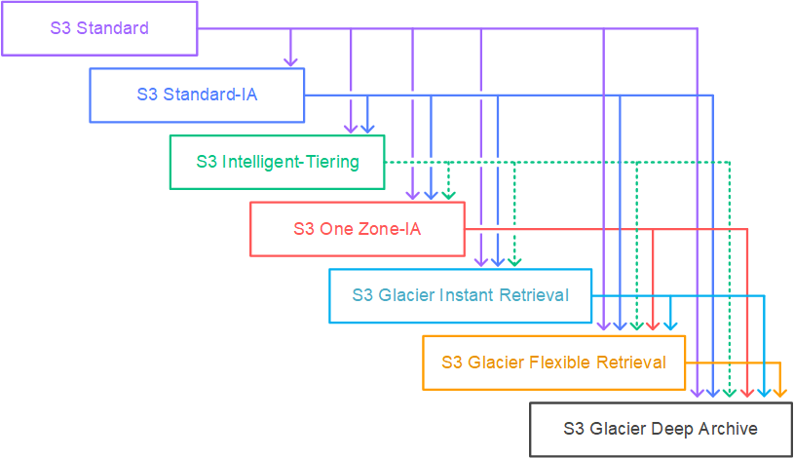
The solutions architect must use a solution that is both scalable and cost-effective, and that can automatically move files to a different storage class after two years. The files must remain highly durable and available.

Solution Approach
The most suitable approach for this use case is to leverage the features of Amazon S3, which is designed for this exact scenario. S3 provides a highly scalable, durable, and available object storage service with built-in features for lifecycle management.
- C. Use Amazon S3 and create a lifecycle policy that will move the objects to S3 Standard-IA after 2 years. This is a correct approach. Amazon S3 is the industry standard for storing unstructured data like the global user-uploaded files. It offers extreme durability and scalability. By creating a lifecycle policy, the solutions architect can automate the transition of objects from the default S3 Standard storage class to S3 Standard-Infrequent Access (S3 Standard-IA). S3 Standard-IA is designed for data that is accessed less frequently but needs to be immediately available when required, which aligns perfectly with the problem statement. This provides a significant cost saving on storage without sacrificing the high availability and durability of the data.
- E. Use Amazon S3 and create a lifecycle policy that will move the objects to S3 Glacier after 2 years. This is also a correct and highly cost-effective approach. S3 Glacier is an archival storage class designed for long-term data retention at a very low cost. While its retrieval times are slower than S3 Standard-IA, a solutions architect could choose this option if the retrieval time for older files is not critical. A lifecycle policy can automatically transition objects to S3 Glacier after the 2-year mark, providing a substantial cost reduction for files that are not expected to be accessed. This solution meets the requirements for a cost-effective, durable, and scalable solution for old files.

Why the Other Options are Not Correct
- A. Use a RAID 0 storage configuration that stripes multiple Amazon EBS volumes together to store the files. Configure the Amazon Data Lifecycle Manager (DLM) to schedule snapshots of the volumes after 2 years. This is a poor choice. RAID 0 provides no redundancy and actually increases the risk of data loss. Furthermore, Amazon EBS is a block storage service meant for EC2 instances and is not a cost-effective solution for storing a large number of independent files with a long-term storage requirement. It also lacks the native lifecycle management capabilities of S3 for transitioning individual files based on age.
- B. Use Amazon EBS volumes to store the files. Configure the Amazon Data Lifecycle Manager (DLM) to schedule snapshots of the volumes after 2 years. While Amazon EBS is a durable and reliable storage service for EC2 instances, it is not optimized for a web application where users are directly uploading files. More importantly, it is not a cost-effective solution for long-term file storage compared to S3. DLM automates snapshots of volumes, not the migration of files to a different storage class. The company would still be paying for the full cost of the EBS volume even for old files.
- D. Use Amazon EFS and create a lifecycle policy that will move the objects to EFS-IA after 2 years. This is not a suitable approach. While Amazon EFS provides a file system that can be shared among EC2 instances and has a lifecycle management feature to transition files to EFS-IA, its primary use case is for shared file systems, not for a global web application's user-uploaded content. Compared to Amazon S3, EFS is generally more expensive and is not designed to scale to the massive number of objects that a global file upload application would produce.
This video about how to set up S3 Lifecycle Rules will help you understand the concept better. How to set up S3 Lifecycle Rules https://m.youtube.com/watch?v=WiIow2AECho&pp=0gcJCccJAYcqIYzv
----------------------------- --------------------------------------------
43. Question
A company launched a cryptocurrency mining server on a Reserved EC2 instance in the us-east-1 region’s private subnet that uses IPv6. Due to the financial data that the server contains, the system should be secured to prevent any unauthorized access and to meet regulatory compliance requirements.
In this scenario, which VPC feature will allow the EC2 instance to communicate to the Internet but prevents inbound IPv6 traffic?
- Egress-only Internet gateway
- NAT Gateway
- NAT instances
- Internet Gateway
44. Question
A GraphQL API hosted is hosted in an Amazon EKS cluster with AWS Fargate launch type and deployed using AWS SAM. The API is connected to an Amazon DynamoDB table with DynamoDB Accelerator (DAX) as its data store. Both resources are hosted in the us-east-1 region.
The AWS IAM authenticator for Kubernetes is integrated into the EKS cluster for role-based access control (RBAC) and cluster authentication. A solutions architect must improve network security by preventing database calls from traversing the public internet. An automated cross-account backup for the DynamoDB table is also required for long-term retention.
Which of the following should the solutions architect implement to meet the requirement?
- Create a DynamoDB interface endpoint. Associate the endpoint to the appropriate route table. Enable Point-in-Time Recovery (PITR) to restore the DynamoDB table to a particular point in time on the same \or a different AWS account.
- Create a DynamoDB interface endpoint. Set up a stateless rule using AWS Network Firewall to control all outbound traffic to only use the dynamodb.us-east-1.amazonaws.com endpoint. Integrate the DynamoDB table with Amazon Timestream to allow point-in-time recovery from a different AWS account.
- Create a DynamoDB gateway endpoint. Associate the endpoint to the appropriate route table. Use AWS Backup to automatically copy the on-demand DynamoDB backups to another AWS account for disaster recovery.
- Create a DynamoDB gateway endpoint. Set up a Network Access Control List (NACL) rule that allows outbound traffic to the dynamodb.us-east-1.amazonaws.com gateway endpoint. Use the built-in on-demand DynamoDB backups for cross-account backup and recovery.
45. Question
A solutions architect is instructed to host a website that consists of HTML, CSS, and some Javascript files. The web pages will display several high-resolution images. The website should have optimal loading times and be able to respond to high request rates.
Which of the following architectures can provide the most cost-effective and fastest loading experience?
- Host the website in an AWS Elastic Beanstalk environment. Upload the images in an S3 bucket. Use CloudFront as a CDN to deliver the images closer to your end-users.
- Launch an Auto Scaling Group using an AMI that has a pre-configured Apache web server, then configure the scaling policy accordingly. Store the images in an Elastic Block Store. Then, point your instance’s endpoint to AWS Global Accelerator.
- Host the website using an Nginx server in an EC2 instance. Upload the images in an S3 bucket. Use CloudFront as a CDN to deliver the images closer to end-users.
- Upload the HTML, CSS, Javascript, and the images in a single bucket. Then enable website hosting. Create a CloudFront distribution and point the domain on the S3 website endpoint.
46. Question
A Solutions Architect is working for an online hotel booking firm with terabytes of customer data coming from the websites and applications. There is an annual corporate meeting where the Architect needs to present the booking behavior and acquire new insights from the customers’ data. The Architect is looking for a service to perform super-fast analytics on massive data sets in near real-time.
Which of the following services gives the Architect the ability to store huge amounts of data and perform quick and flexible queries on it?
- Amazon ElastiCache
- Amazon DynamoDB
- Amazon RDS
- Amazon Redshift
47. Question
A company plans to migrate all of their applications to AWS. The Solutions Architect suggested to store all the data to EBS volumes. The Chief Technical Officer is worried that EBS volumes are not appropriate for the existing workloads due to compliance requirements, downtime scenarios, and IOPS performance.
Which of the following are valid points in proving that EBS is the best service to use for migration? (Select TWO.)
- EBS volumes support live configuration changes while in production which means that you can modify the volume type, volume size, and IOPS capacity without service interruptions.
- EBS volumes can be attached to any EC2 Instance in any Availability Zone.
- When you create an EBS volume in an Availability Zone, it is automatically replicated on a separate AWS region to prevent data loss due to a failure of any single hardware component.
- An EBS volume is off-instance storage that can persist independently from the life of an instance.
- Amazon EBS provides the ability to create snapshots (backups) of any EBS volume and write a copy of the data in the volume to Amazon RDS, where it is stored redundantly in multiple Availability Zones
48. Question
A company has a High Performance Computing (HPC) cluster that is composed of EC2 Instances with Provisioned IOPS (io1) volume to process transaction-intensive, low-latency workloads. The Solutions Architect must maintain high IOPS while keeping the latency down by setting the optimal queue length for the volume. The size of each volume is 10 GiB.
Which of the following is the MOST suitable configuration that the Architect should set up?
- Set the IOPS to 600 then maintain a high queue length.
- Set the IOPS to 500 then maintain a low queue length.
- Set the IOPS to 400 then maintain a low queue length.
- Set the IOPS to 800 then maintain a low queue length.
49. Question
A company has an application hosted in an Amazon ECS Cluster behind an Application Load Balancer. The Solutions Architect is building a sophisticated web filtering solution that allows or blocks web requests based on the country that the requests originate from. However, the solution should still allow specific IP addresses from that country.
Which combination of steps should the Architect implement to satisfy this requirement? (Select TWO.)
- In the Application Load Balancer, create a listener rule that explicitly allows requests from approved IP addresses.
- Using AWS WAF, create a web ACL with a rule that explicitly allows requests from approved IP addresses declared in an IP Set.
- Add another rule in the AWS WAF web ACL with a geo match condition that blocks requests that originate from a specific country.
- Place a Transit Gateway in front of the VPC where the application is hosted and set up Network ACLs that block requests that originate from a specific country.
- Set up a geo match condition in the Application Load Balancer that blocks requests from a specific country.
50. Question
A company needs to use Amazon Aurora as the Amazon RDS database engine of their web application. The Solutions Architect has been instructed to implement a 90-day backup retention policy.
Which of the following options can satisfy the given requirement?
- Configure RDS to export the automated snapshot automatically to Amazon S3 and create a lifecycle policy to delete the object after 90 days.
- Create an AWS Backup plan to take daily snapshots with a retention period of 90 days.
- Create a daily scheduled event using CloudWatch Events and AWS Lambda to directly download the RDS automated snapshot to an S3 bucket. Archive snapshots older than 90 days to Glacier.
- Configure an automated backup and set the backup retention period to 90 days.
51. Question
A company is experiencing repeated outages in the Availability Zone where its Amazon RDS database instance is deployed, resulting in a complete loss of access to the database during each incident.
Which solution should be implemented to prevent losing database access if this occurs again?
- Make a snapshot of the database
- Increase the database instance size
- Create a read replica
- Enable Multi-AZ failover
52. Question
A large multinational investment bank has a web application that requires a minimum of 4 EC2 instances to run to ensure that it can cater to its users across the globe. You are instructed to ensure fault tolerance of this system.
Which of the following is the best option?
- Deploy an Auto Scaling group with 2 instances in each of 2 Availability Zones behind an Application Load Balancer.
- Deploy an Auto Scaling group with 2 instances in each of 3 Availability Zones behind an Application Load Balancer.
- Deploy an Auto Scaling group with 1 instance in each of 4 Availability Zones behind an Application Load Balancer.
- Deploy an Auto Scaling group with 4 instances in one Availability Zone behind an Application Load Balancer.
53. Question
A company has several microservices that send messages to an Amazon SQS queue and a backend application that poll the queue to process the messages. The company also has a Service Level Agreement (SLA) which defines the acceptable amount of time that can elapse from the point when the messages are received until a response is sent. The backend operations are I/O-intensive as the number of messages is constantly growing, causing the company to miss its SLA. The Solutions Architect must implement a new architecture that improves the application’s processing time and load management.
Which of the following is the MOST effective solution that can satisfy the given requirement?
- Create an AMI of the backend application's EC2 instance and launch it to a cluster placement group.
- Create an AMI of the backend application’s EC2 instance. Use the image to set up an Auto Scaling group and configure a target tracking scaling policy based on the CPUUtilization metric with a target value of 80%.
- Create an AMI of the backend application’s EC2 instance. Use the image to set up an Auto Scaling group and configure a target tracking scaling policy based on the ApproximateAgeOfOldestMessage metric.
- Create an AMI of the backend application's EC2 instance and replace it with a larger instance size.
54. Question
A company has a cryptocurrency exchange portal that is hosted in an Auto Scaling group of EC2 instances behind an Application Load Balancer and is deployed across multiple AWS regions. The users can be found all around the globe, but the majority are from Japan and Sweden. Because of the compliance requirements in these two locations, you want the Japanese users to connect to the servers in the ap-northeast-1 Asia Pacific (Tokyo) region, while the Swedish users should be connected to the servers in the eu-west-1 EU (Ireland) region.
Which of the following services would allow you to easily fulfill this requirement?
- Set up a new CloudFront web distribution with the geo-restriction feature enabled.
- Use Route 53 Weighted Routing policy.
- Use Route 53 Geolocation Routing policy.
- Set up an Application Load Balancers that will automatically route the traffic to the proper AWS region.
55. Question
A company has two On-Demand EC2 instances inside the Virtual Private Cloud in the same Availability Zone but are deployed to different subnets. One EC2 instance is running a database and the other EC2 instance a web application that connects with the database. You need to ensure that these two instances can communicate with each other for the system to work properly.
What are the things you have to check so that these EC2 instances can communicate inside the VPC? (Select TWO.)
- Check the Network ACL if it allows communication between the two subnets.
- Check if both instances are the same instance class.
- Check if the default route is set to a NAT instance or Internet Gateway (IGW) for them to communicate.
- Check if all security groups are set to allow the application host to communicate to the database on the right port and protocol.
- Ensure that the EC2 instances are in the same Placement Group.
56. Question
A company is using an Amazon RDS for MySQL 5.6 with Multi-AZ deployment enabled and several web servers across two AWS Regions. The database is currently experiencing highly dynamic reads due to the growth of the company’s website. The Solutions Architect tried to test the read performance from the secondary AWS Region and noticed a notable slowdown on the SQL queries.
Which of the following options would provide a read replication latency of less than 1 second?
- Migrate the existing database to Amazon Aurora and create a cross-region read replica.
- Upgrade the MySQL database engine.
- Use Amazon ElastiCache to improve database performance.
- Create an Amazon RDS for MySQL read replica in the secondary AWS Region.
57. Question
A company has established a dedicated network connection from its on-premises data center to AWS Cloud using AWS Direct Connect (DX). The core network services, such as the Domain Name System (DNS) service and Active Directory services, are all hosted on-premises. The company has new AWS accounts that will also require consistent and dedicated access to these network services.
Which of the following can satisfy this requirement with the LEAST amount of operational overhead and in a cost-effective manner?
- Create a new AWS VPN CloudHub. Set up a Virtual Private Network (VPN) connection for additional AWS accounts.
- Set up a new Direct Connect gateway and integrate it with the existing Direct Connect connection. Configure a VPC peering connection between AWS accounts and associate it with Direct Connect gateway.
- Create a new Direct Connect gateway and integrate it with the existing Direct Connect connection. Set up a Transit Gateway between AWS accounts and associate it with the Direct Connect gateway.
- Set up another Direct Connect connection for each and every new AWS account that will be added.
58. Question
In Amazon EC2, you can manage your instances from the moment you launch them up to their termination. You can flexibly control your computing costs by changing the EC2 instance state.
Which of the following statements is true regarding EC2 billing? (Select TWO.)
- You will be billed when your Reserved instance is in terminated state.
- You will be billed when your On-Demand instance is preparing to hibernate with a stopping state.
- You will be billed when your Spot instance is preparing to stop with a stopping state.
- You will not be billed for any instance usage while an instance is not in the running state.
- You will be billed when your On-Demand instance is in pending state.
59. Question
A company has a top priority requirement to monitor certain database metrics and send email notifications to the Operations team if any issues occur.
Which combination of AWS services can accomplish this requirement? (Select TWO.)
- Amazon CloudWatch
- Amazon Simple Email Service
- Amazon Simple Notification Service (SNS)
- Amazon Simple Queue Service (SQS)
- Amazon EC2 Instance with a running Berkeley Internet Name Domain (BIND) Server.

