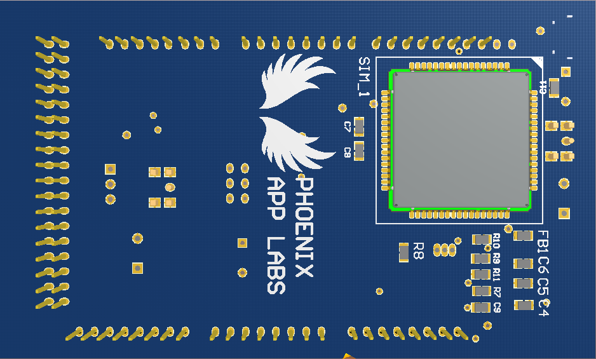

Stackable Headers

SIM900 Module

Fig 2:- Bottom side view of Shield

**USB_1**:- This is a micro USB port which gives power to GPS and GSM module. Please note that it does not give power to MEGA board as the MEGA board can be supplied as usual with USB port or from DC female jack on the MEGA board itself. The reason why separate power supply is required is because SIM900 itself can take up to 2A current while sending burst and L-80 can take up to max of 30mA of current while getting FIX. To supply enough current and prevent any kind of damage to the boards, external supply is provided.

**GSM_ANT:-** It is a SMA connector to connect GSM/GPRS antenna. It is of 50 ohm, 2dbi, 5cm long rubber deck antenna. Please be careful while connecting antennas, as separate connectors and antenna with different configuration has been provided.

**GSM_SW:-** This switch is used to by SIM900 to connect to network. Please press the switch for at least 1 sec. Every time you turn on the module this switch needs to be pressed to make the module to connect it to internet. Once the module has been registered to network then the LED D2 will be blinking once in ever 2sec. If the module is registered then it will blink once every second.

*NOTE: - Pressing switch SW_1 second time will make the module to go into the power down mode.*

**SIM_CARD:-** This is a Nano-SIM-Card holder. Directions for inserting the sim card has been given on the slot. Please see the image below and put your card in the same way.

**GPS_ANT:-** This is one more SMA connector for GPS module. GPS may not get a FIX when inside the building. This antenna can increase the chances of getting proper signal inside such area. Connect the antenna and place the antenna near any window. Connecting antenna does not guarantee the FIX for GPS, it is very much dependent on the location where you are, but it surely increases the signal strength.

**LED D2:-** This LED is used to indicate if GSM/GPRS module got connected to the network. If it blinking once per second then it is not connected to the network. If it is blinking once in every two seconds, it indicates the module has been registered with the network. To make it to connect it to network the press the switch SW_1 as mentioned above.

**LED D1:-** This is use to indicate if GPS got the fix. Getting fix is nothing but if the module is able to detect the exact latitude and longitude. If GPS got the FIX then it will blink once per second, or else it will not blink at all.

**RESET: -** It is similar to reset button present on MEGA board. Pressing this switch will make the MEGA BOARD to reset. Please note that this switch will not reset the GPS or GSM module. Both the modules will be function as usual. This will make the MEGA board to reset and run the code from beginning.

**POWER PORT: -** It is located just below the GPS antenna connector. It given extra point to power the module. The shield can be powered with any external power source of 5V through these pins. All the grounds named “GND” are connected even the GNDs of board are connected with the GNDs of the shield. Vcc of power port and USB are connected but they are not connected with 5V of MEGA board.

**PLUG-N-PLAY**

After knowing all the important components of the shield let’s plug and it start working on this. This shield directly fits on the Arduino Board and exposes all the pins. Please note that *SERIAL1* and *SERIAL2* can’t be used to connect any other devices as they are already occupied by GPS and GSM/GPRS modules. To make the shield working only 3 connections need to be done.

1. Connect the USB port to USB_1 port
2. Mount GSM antenna on GSM_ANT SMA connector
3. Mount GPS antenna on GPS_ANT SMA Connector and try to place it near a window for better signal reception.

Below are the interface diagram of how GSM and GPS modules will be connected with Arduino Mega Board.

**Interface with FTDI (USB to Serial converter)**

There would be need when you want to connect the modules to external FTDI or USB to Serial converter. Please note that TX port of GPS and GSM modules are connected with RX of the shield so that when it will be placed on the board it works properly.

But if you want to see the output of any module with your USB to Serial converter then you have to connect it properly or else the communication may not happen. Refer to the diagram below:-

**SHIELD**

GPS Module

GSM/GPRS MODULE

TX RX

TX RX

RX1 TX1 RX2 TX2

FTDI (USB to Serial Converter)

FTDI (USB to Serial Converter)

RX TX

RX TX

This may look confusing but it is very simple to understand. As we see TX of both the GSM and GPS module are connected with RX1 and RX2 of shield so that it can be connected with RX1 and RX2 with Arduino MEGA. But when you want to connect the shield with FTDI or any external USB to Serial converter you have to connect the RX1/RX2 with RX of FTDI and TX1/TX2 with TX of FTDI. In this way the connection will be fine.