**UNO_SHEILD_GPS_GSM**

1. **INTRODUCTION**

This shield is designed is such a way that it adds the functionality of GSM and GPS retaining its previous functionality. It directly sits on ARDUINO UNO board and exposes all its pins. The board uses one *Software Serial* for communication with GPS and GSM modules. To provide GPS functionality “*Quectel Module L-80”* has been used, to add GSM functionality “*SIMCOM Module SIM800”* has been used.

1. **BLOCK DIAGRAM**

PIN MAPPED

ARDUINO UNO

RX

LOGIC CIRCUITRY

TX

GPS GSM Shield

TX

RX

TX

RX

L-80 GPS

SIM800

1. **SPECIFICTIONS**

USB PORT

GSM ANTENNA

NANO SIM CARD HOLDER

GSM SWITCH

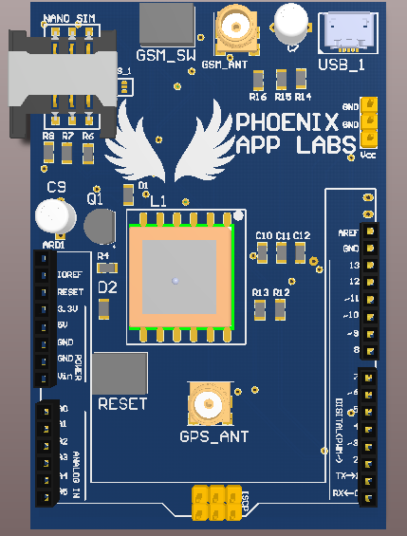

POWER PORT

GPS ANTENNA

RESET

**USB_1**:- This is a micro USB port which gives power to GPS and GSM module. Please note that it does not give power to UNO board as the UNO board can be supplied as usual with USB port or from DC female jack on the UNO board itself. The reason why separate power supply is required is because SIM800 itself can take up to 2A current while sending burst and L-80 can take up to max of 30mA of current while getting FIX. To supply enough current and prevent any kind of damage to the boards, external supply is provided.

**GSM_ANT:-** It is a SMA connector to connect GSM/GPRS antenna. It is of 50 ohm, 2dbi, 5cm long rubber deck antenna. Please be careful while connecting antennas, as separate connectors and antenna with different configuration has been provided.

**GSM_SW:-** This switch is used to by SIM900 to connect to network. Please press the switch for at least 1 sec. Every time you turn on the module this switch needs to be pressed to make the module to connect it to network. Once the module has been registered to network then the LED D2 will be blinking once in ever 3sec. If the module is registered then it will blink once every second.

*NOTE: - Pressing switch SW_1 second time will make the module to go into the power down mode.*

**SIM_CARD:-** This is a Nano-SIM-Card holder. Directions for inserting the sim card has been given on the slot. Please see the image below and put your card in the same way.

**GPS_ANT:-** This is one more SMA connector for GPS module. GPS may not get a FIX when inside the building. This antenna can increase the chances of getting proper signal inside such area. Connect the antenna and place the antenna near any window. Connecting antenna does not guarantee the FIX for GPS, it is very much dependent on the location where you are, but it surely increases the signal strength.

**LED D2:-**This LED is used to indicate if GSM/GPRS module got connected to the network. If it blinking once per second then it is not connected to the network. If it is blinking once in every two seconds, it indicates the module has been registered with the network. To make it to connect it to network the press the switch SW_1 as mentioned above.

**LED D1:-** This is use to indicate if GPS got the fix. Getting fix is nothing but if the module is able to detect the exact latitude and longitude. If GPS got the FIX then it will blink once per second, or else it will not blink at all.

**RESET: -**It is similar to reset button present on UNO board. Pressing this switch will make the UNO BOARD to reset. Please note that this switch will not reset the GPS or GSM module. Both the modules will be function as usual. This will make the UNO board to reset and run the code from beginning.

**POWER PORT: -** It is located at the right corner below UCB port. It given extra point to power the module. The shield can be powered with any external power source of 5V through these pins. All the grounds named “GND” are connected even the GNDs of board are connected with the GNDs of the shield. Vcc of power port and USB are connected but they are not connected with 5V of UNO board.

1. **ACCESSING GPS and GSM**

This shield has two modules GPS and GSM and both uses UART communication to talk with Arduino UNO. One logic circuits of MUX-DEMUX has been implemented so that both the module can talk to UNO one at a time.

Status of ***PIN 13*** will decide which module is currently talking to UNO. If the ***PIN 13*** is in ***HIGH*** state the UNO is connected to GPS module. It means if you are sending or receiving any data on *softwareserial.shield()*  then it means the data is either going/coming to/from GPS module. Similarly if the status of the ***PIN13*** is ***LOW*** then it is communicating with GSM/GPRS module.

1. **PLUG-N-PLAY**

After knowing all the important components of the shield let’s plug and start working on this. This shield directly fits on the Arduino Board and exposes all the pins. We are using Software Serial at pin 7(RX) and 8(TX).To make the shield working only 4steps need to be done.

1. Connect the USB port to USB_1 port
2. Mount GSM antenna on GSM_ANT SMA connector
3. Mount GPS antenna on GPS_ANT SMA Connector and try to place it near a window for better signal reception.
4. Download the **.ino** file from our github repository: [https://github.com/neerajneo0305/ MEGA_SHEILD](https://github.com/neerajneo0305/%20MEGA_SHEILD)and start writing your code. Please reading the cod

This is how it looks after mounting the shield on the UNO board:-

1. **INTERFACE WITH FTDI (USB TO SERIAL CONVERTER)**

There would be need when you want to connect the modules to external FTDI or USB to Serial converter. Please note that TX port of GPS and GSM modules are connected with RX of the shield so that when it will be placed on the board it works properly.

But if you want to see the output of any module with your USB to Serial converter then you have to connect it properly or else the communication may not happen. Refer to the diagram below:-

**SHIELD**

GSM/GPRS MODULE

GPS Module

TX RX

TX RX

RX1 TX1 RX2 TX2

FTDI (USB to Serial Converter)

FTDI (USB to Serial Converter)

RX TX

RX TX

This may look confusing but it is very simple to understand. As we see TX of both the GSM and GPS module are connected with RX1 and RX2 of shield so that it can be connected with RX1 and RX2 with Arduino UNO. But when you want to connect the shield with FTDI or any external USB to Serial converter you have to connect the RX1/RX2 with RX of FTDI and TX1/TX2 with TX of FTDI. Connect pin no 13 to Vcc if you want to access GPS module or connect it with GND to access GSM/GPRS module. In this way the connection will be fine.

1. **LINKS:-**

* **Quectel L-80 GPS Module**

<http://www.quectel.com/uploadimage/downlad/l80_hardware_design_v1.1.pdf>

<http://docs-europe.electrocomponents.com/webdocs/147d/0900766b8147dbed.pdf>

* **SIMCOM800 Module**

<http://simcom.ee/documents/SIM800/SIM800_Hardware%20Design_V1.08.pdf>

<https://www.elecrow.com/download/SIM800%20Series_AT%20Command%20Manual_V1.09.pdf>

* **GITHUB Links**

<https://github.com/neerajneo0305/MEGA_SHEILD>