Ollama & Local LLM Troubleshooting Guide
Commands to diagnose and fix Ollama and installed models (Qwen, Llama) on macOS
This guide covers two common problems: (1) Ollama is down and not working, and (2) installed models like Qwen and Llama are not working. Each section lists the commands to run, where to run them (the macOS Terminal app), and an illustrative screenshot of the expected output.

Case 1: Ollama is Down and Not Working
Ollama runs as a local server on port 11434. If it is not running, any request to Qwen or Llama will fail with a connection error. Follow these steps in the macOS Terminal app (Applications → Utilities → Terminal, or Spotlight + type “Terminal”).

Step 1 — Check if Ollama is running
Run these commands to see if the Ollama process and its port are active:
# 1. Check if the Ollama process is running (no output = not running)
ps aux | grep -i ollama | grep -v grep
# 2. Check if port 11434 is listening (no output = not listening)
lsof -iTCP:11434 -sTCP:LISTEN
# 3. Test the API (error = Ollama is DOWN)
curl -s --max-time 3 http://localhost:11434/api/tags
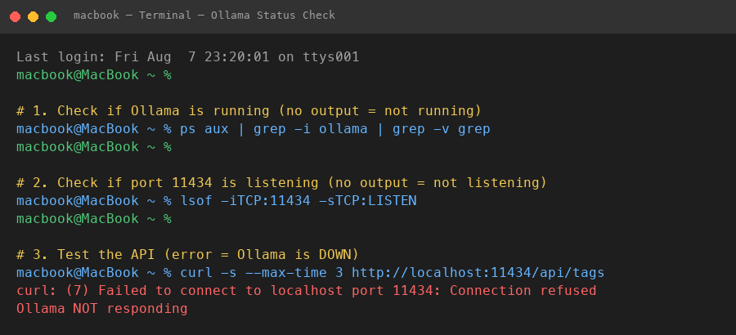
Where to run: macOS Terminal — checking Ollama status (no output means it is down)

Step 2 — Start Ollama as a background service
If the checks above show Ollama is down, start it as a background service. This registers it to auto-start at login and keep running:
# Start Ollama as a background service (auto-starts at login)
brew services start ollama
# Verify the service is registered
brew services list | grep ollama
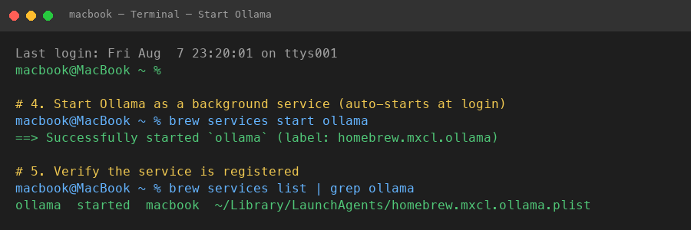
Where to run: macOS Terminal — starting Ollama with brew services

Step 3 — Verify Ollama is up
Confirm the API responds and lists your installed models:
# Confirm the API responds with the model list
curl -s http://localhost:11434/api/tags | jq '.models[].name'
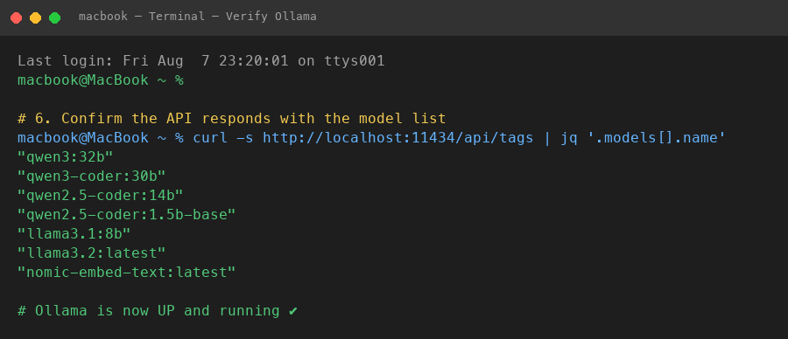
Where to run: macOS Terminal — verifying Ollama is up and models are listed
If you see the model names listed, Ollama is now UP and running. You can now use Qwen and Llama models.

Case 2: Installed Models (Qwen, Llama) Not Working
If Ollama is running but a specific model fails, the model may not be installed, may be corrupted, or may be too large for your system memory. Follow these steps in the macOS Terminal app.

Step 1 — List installed models
Check which models are actually installed:
# List all installed models
ollama list
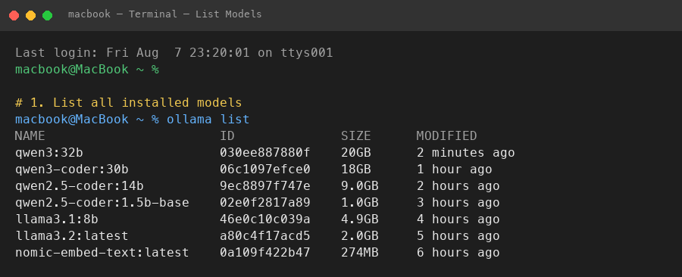
Where to run: macOS Terminal — listing installed models

Step 2 — Test a model with a simple prompt
Run a quick prompt to test each model:
# Test a model with a simple prompt
ollama run qwen2.5-coder:14b "Say hello"
# Test another model (Qwen 3)
ollama run qwen3:32b "What is 2+2?"
# Test Llama
ollama run llama3.1:8b "Say hi"
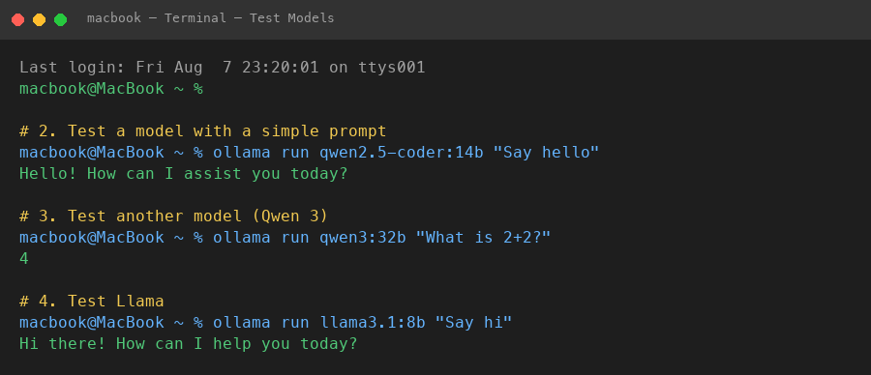
Where to run: macOS Terminal — testing models with ollama run

Step 3 — Test via the API (curl)
You can also test models programmatically via the HTTP API:
# Test via the API (curl) - non-streaming
curl -s http://localhost:11434/api/generate \
-d '{"model":"qwen2.5-coder:14b","prompt":"Say hello","stream":false}' \
| jq -r '.response'
# Check which model is currently loaded in memory
curl -s http://localhost:11434/api/ps | jq '.models[].name'
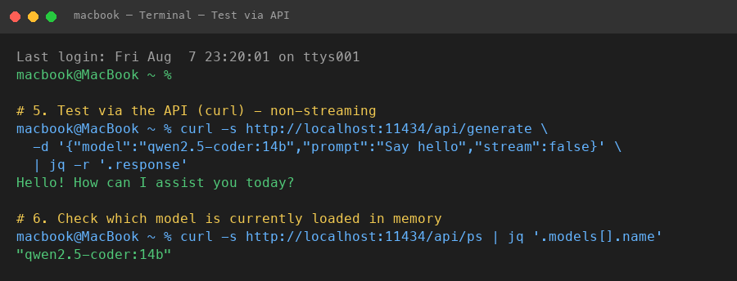
Where to run: macOS Terminal — testing models via the API

Troubleshooting tips
- If a model is not listed by `ollama list`, it is not installed. Install it with `ollama pull <model>` (e.g. `ollama pull qwen3:32b`).
- If a model fails to load, it may be too large for your RAM. Check your memory with `sysctl -n hw.memsize` (bytes) and use a smaller model if needed.
- If Ollama is running but slow, check memory pressure with `memory_pressure`.
- To stop a model that is hogging memory, run `ollama stop <model>`.
- To see the Ollama server log, run `tail -f /opt/homebrew/var/log/ollama.log`.

