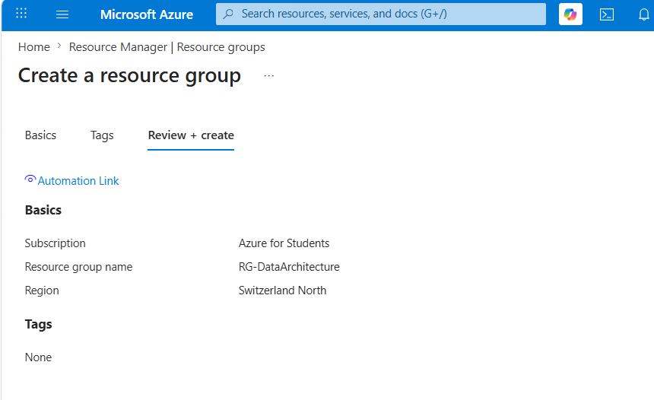
Figure 1: creation of resource group named RG-DataArchitecture
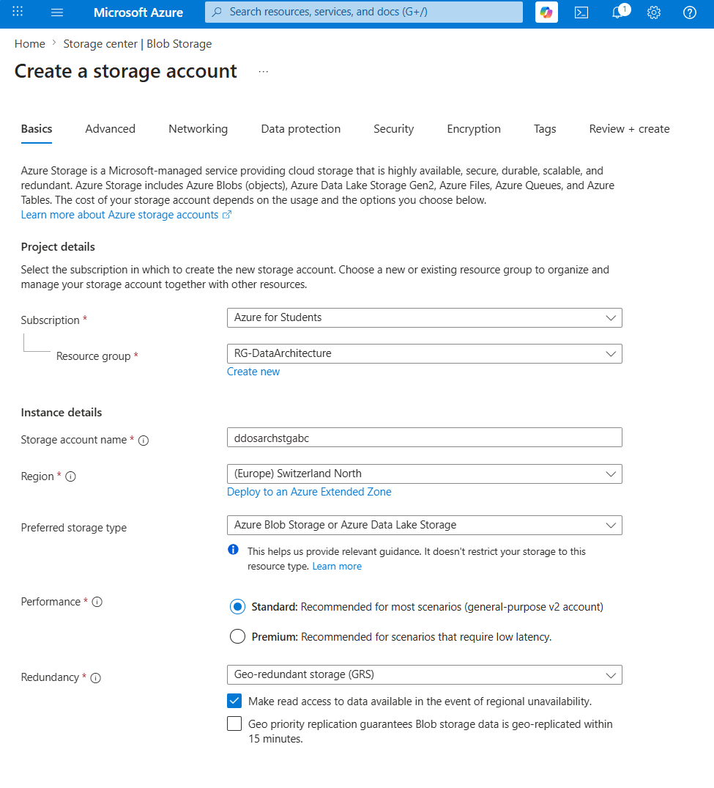
Figure 2: creation of storage account named ddosarchstgabc
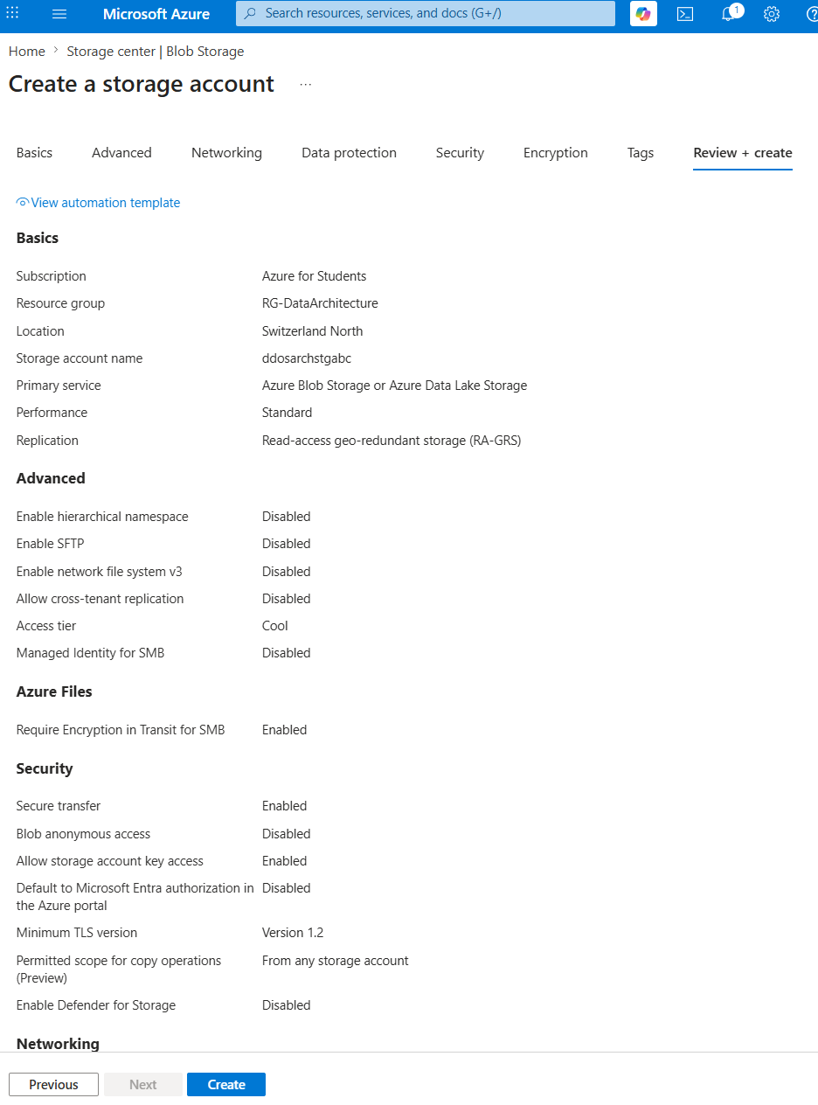
Figure 3: review of created storage account named ddosarchstgabc

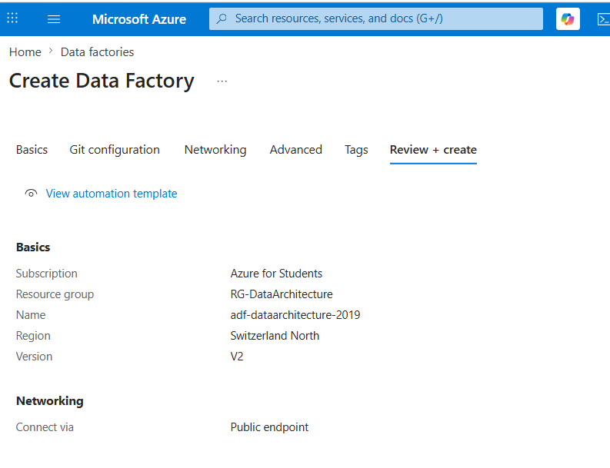
Figure 4: creation of data factory named adf-dataarchitecture-2019
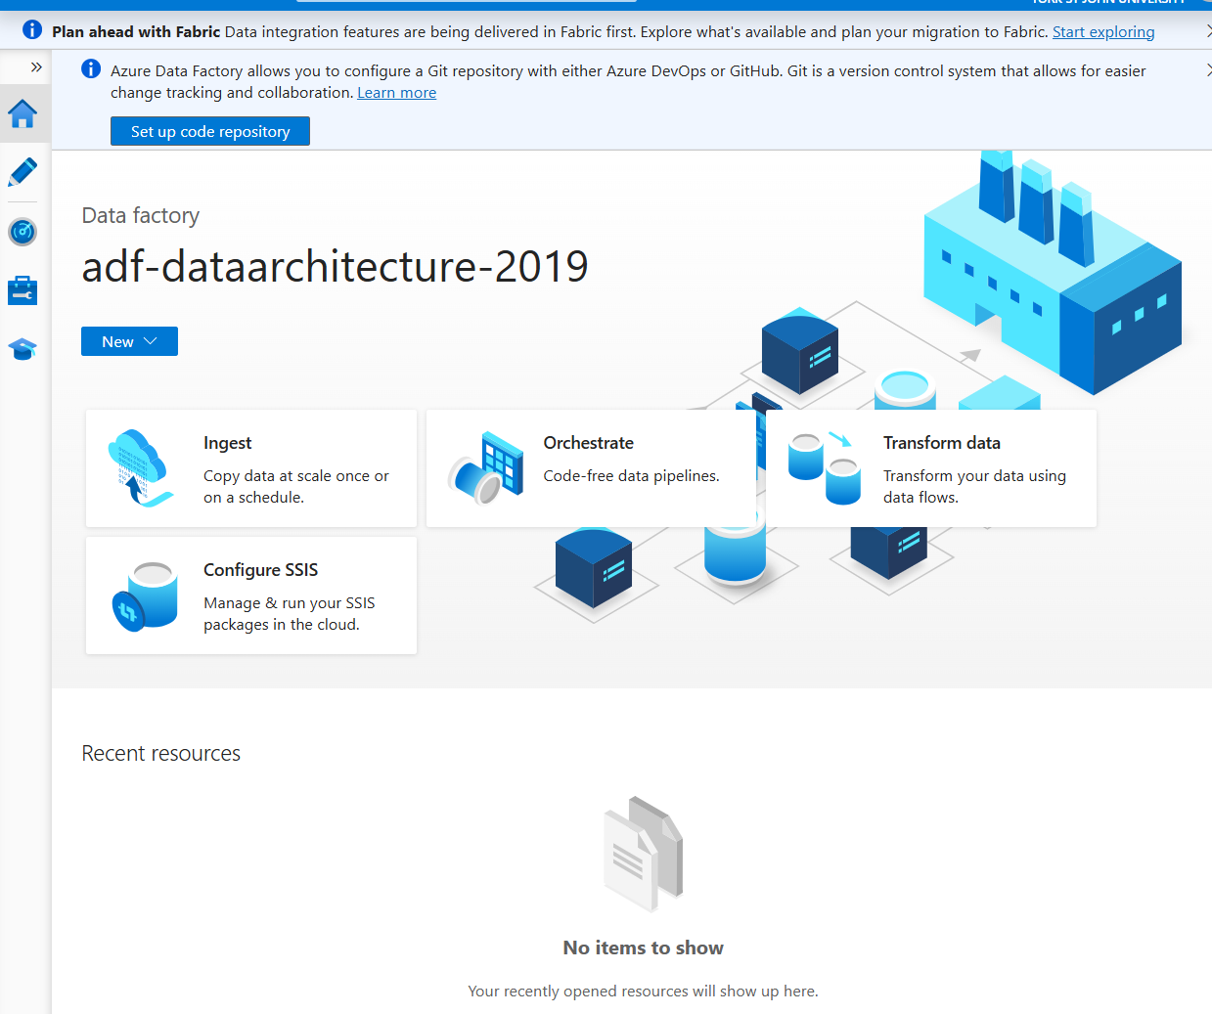
Figure 5: successful creation of adf-dataarchitecture-2019 data factory

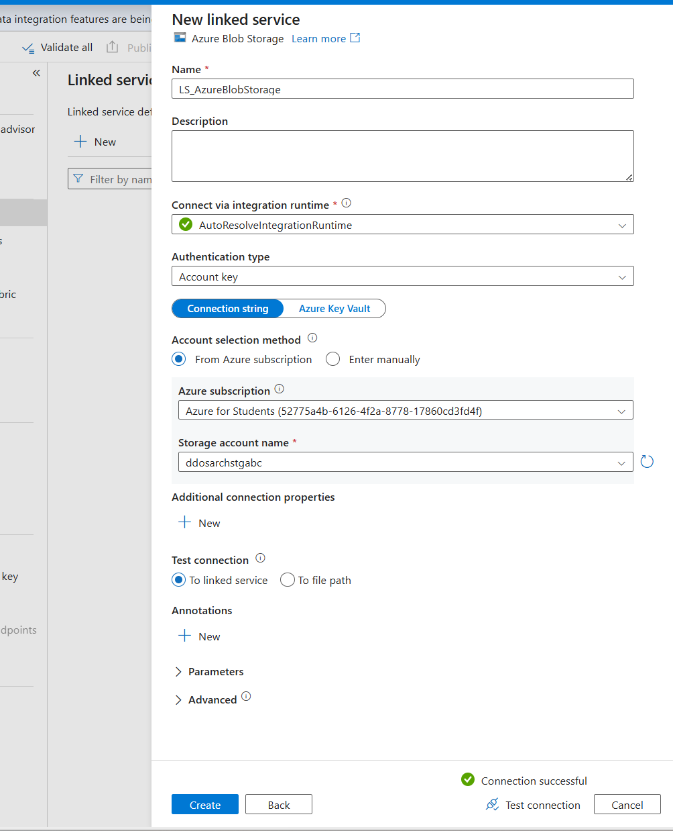
Figure 6: creation of new linked service named LS_AzureStorage in adf-dataarchitecture-2019 data factory
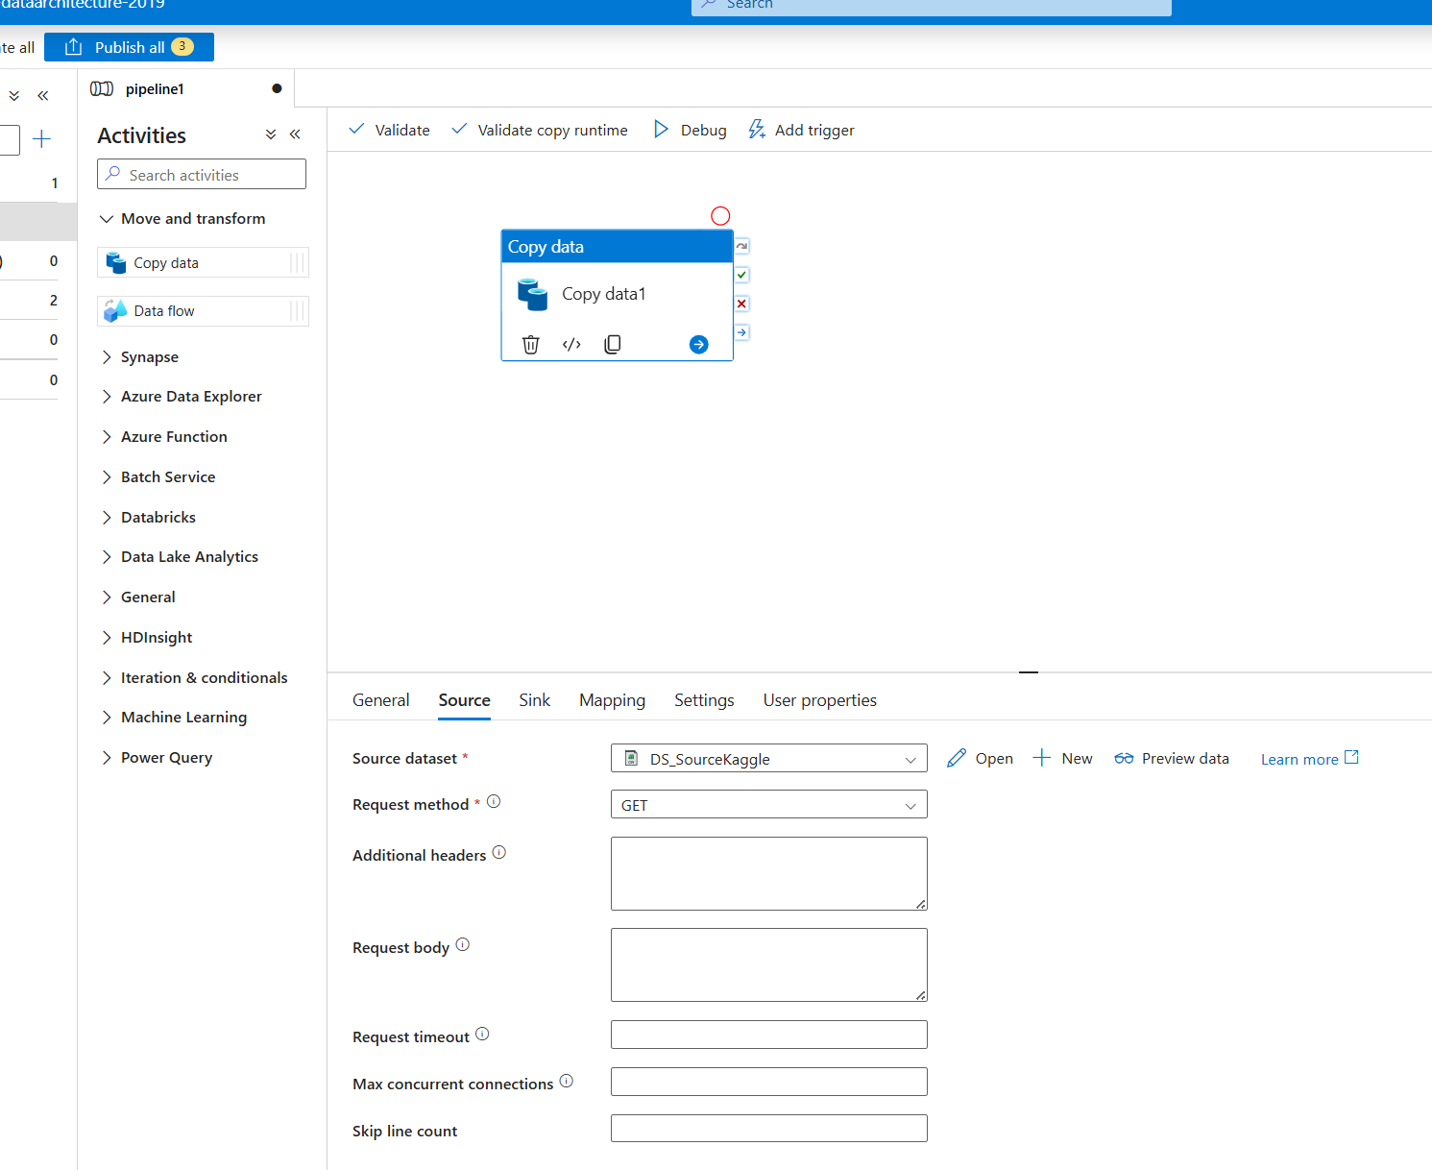
Figure 7: creation of pipeline from where configured Kaggle directly as source
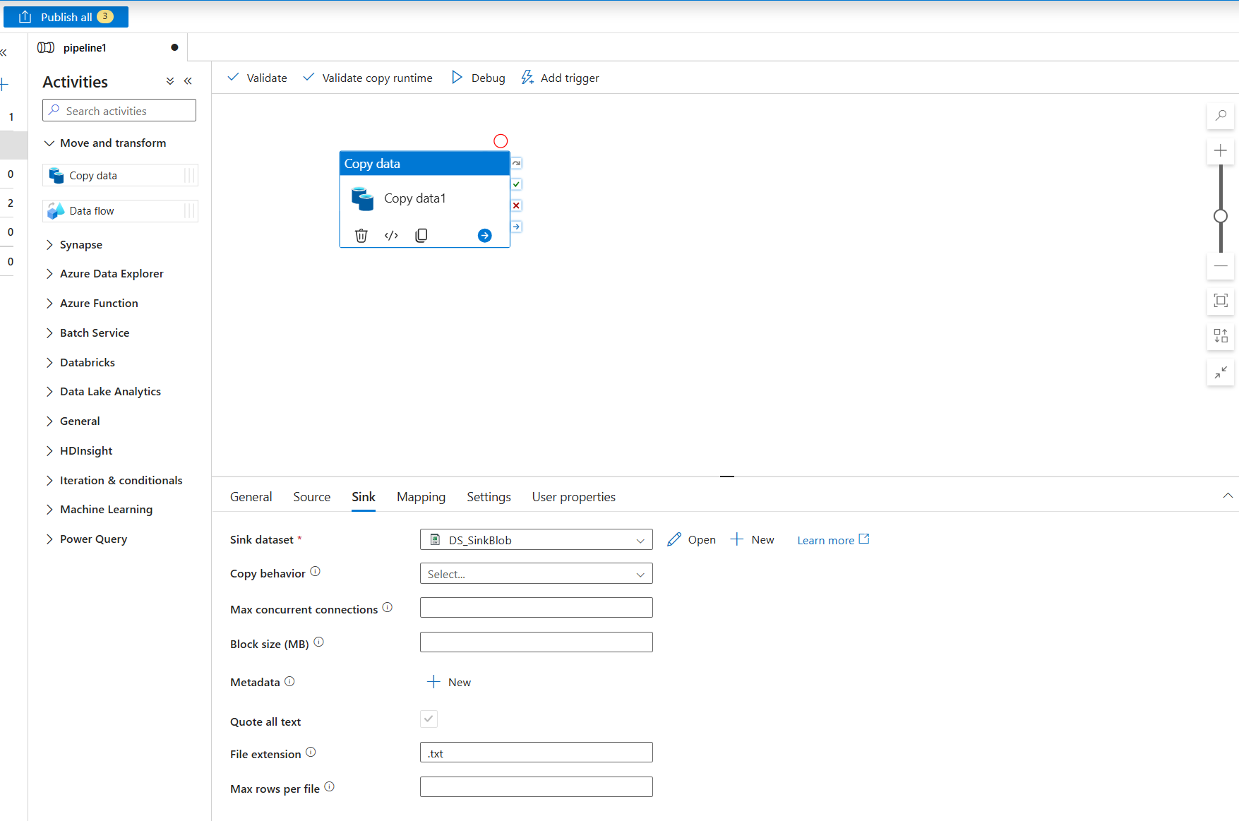
Figure 8: configured sink to previous created azure storage account
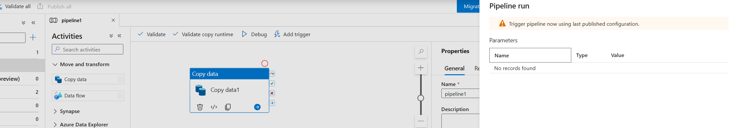
Figure 9: after publishing triggered the pipeline to start the transfer of data

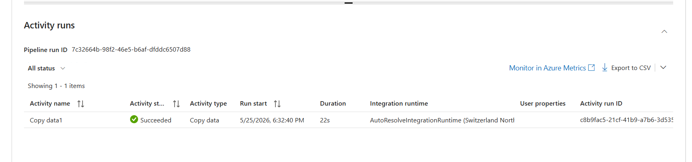
Figure 10: Successful execution of the Azure Data Factory data ingestion pipeline, copying the Kaggle Syn.csv dataset to Azure Blob Storage in 22 seconds.

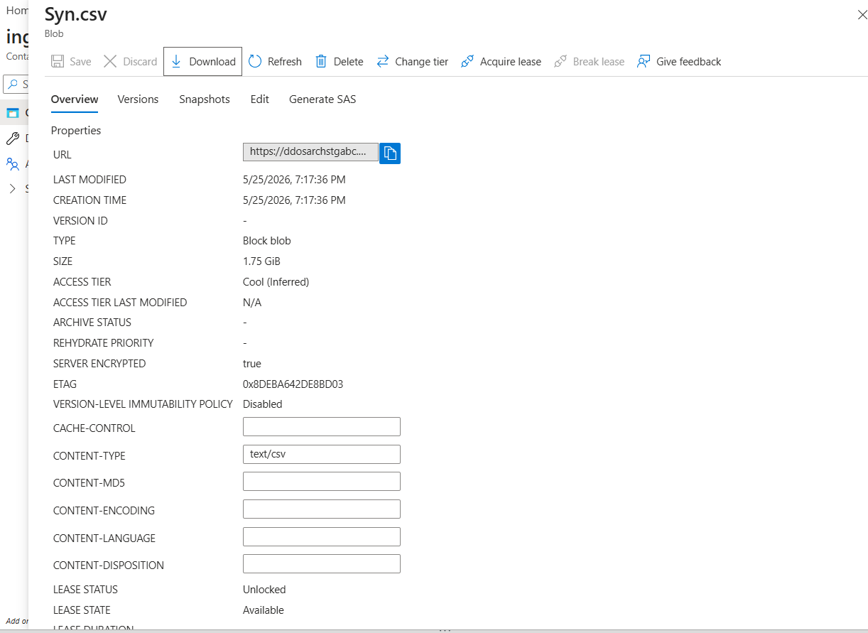
Figure 11: Ingesting Syn.csv via Azure Blob Storage for downstream ETL automation
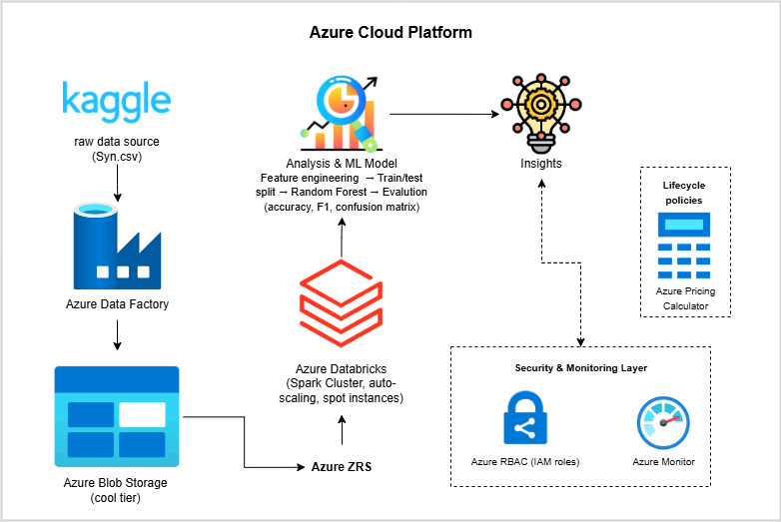
Figure 12: Proposed cloud architecture for cost-efficient and secure big data processing and machine learning implementation using the CIC DDoS2019 dataset on Azure

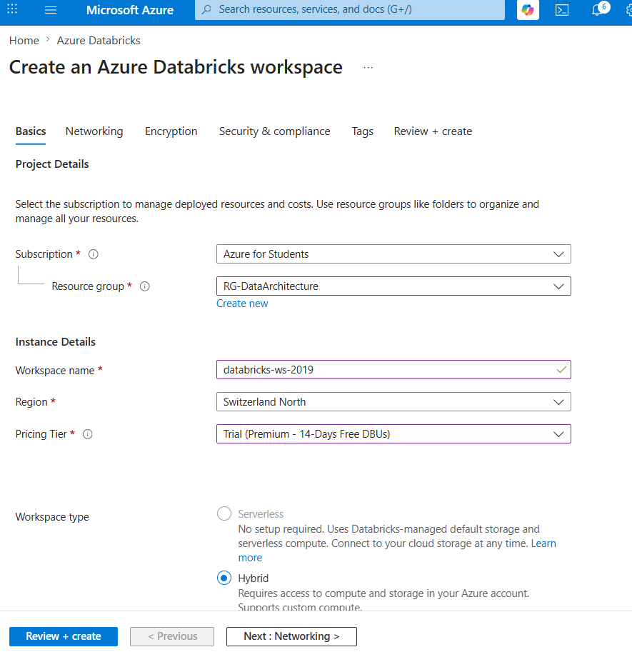
Figure 13: creation of azure databricks workspace

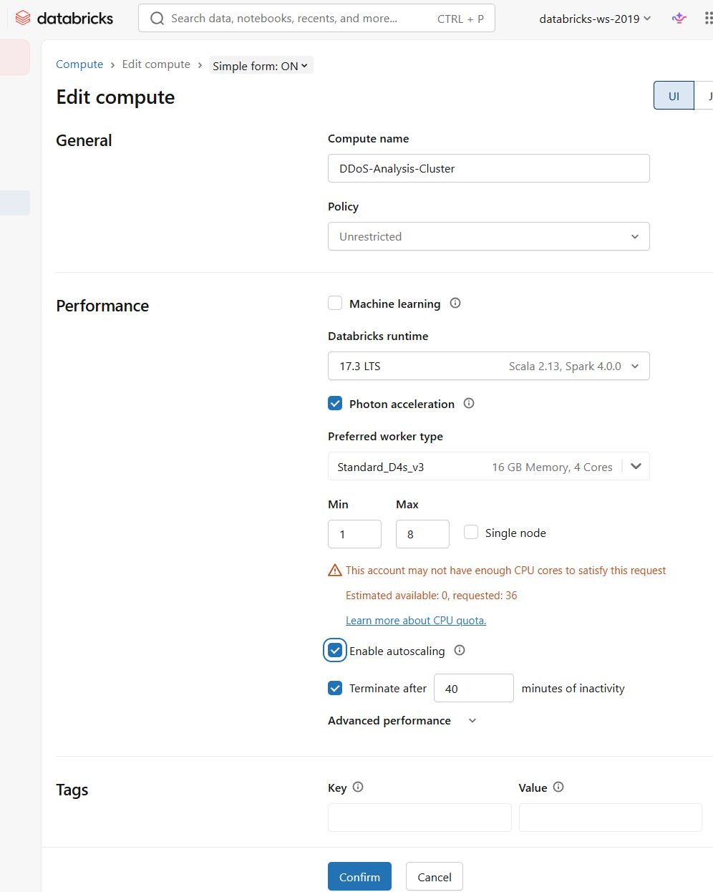
Figure 14: creation of new compute resource in databricks with autoscaling (min:1 and max:8 workers)
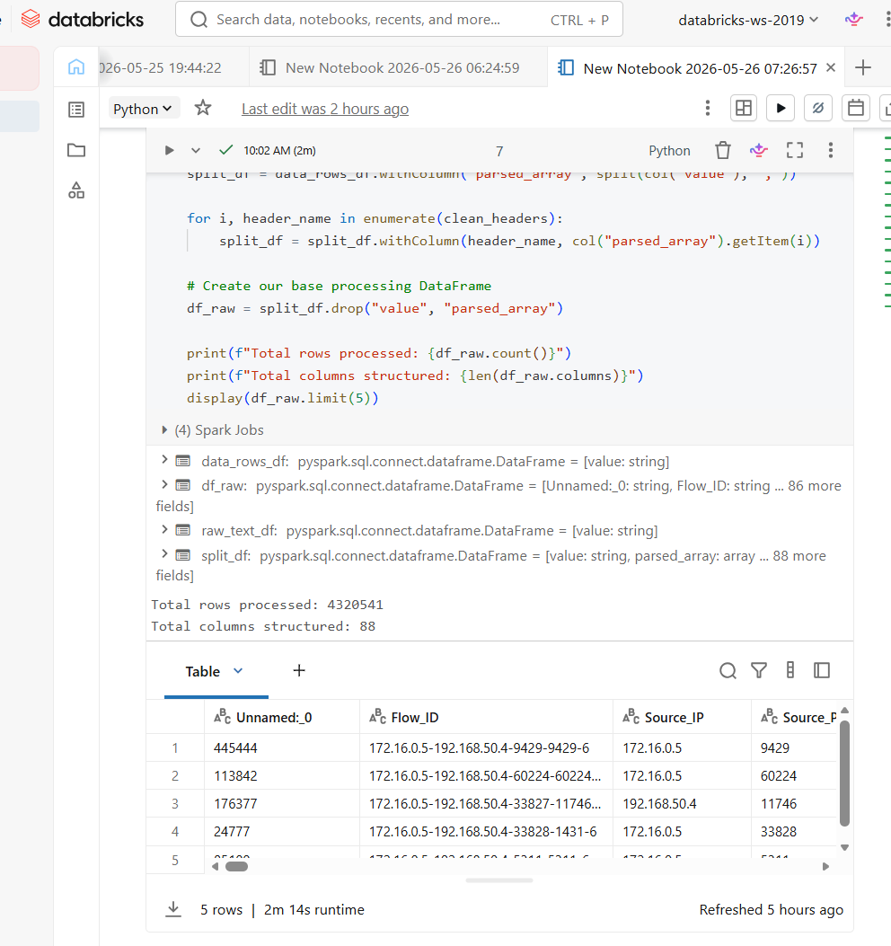
Figure 15: raw data records and feature size
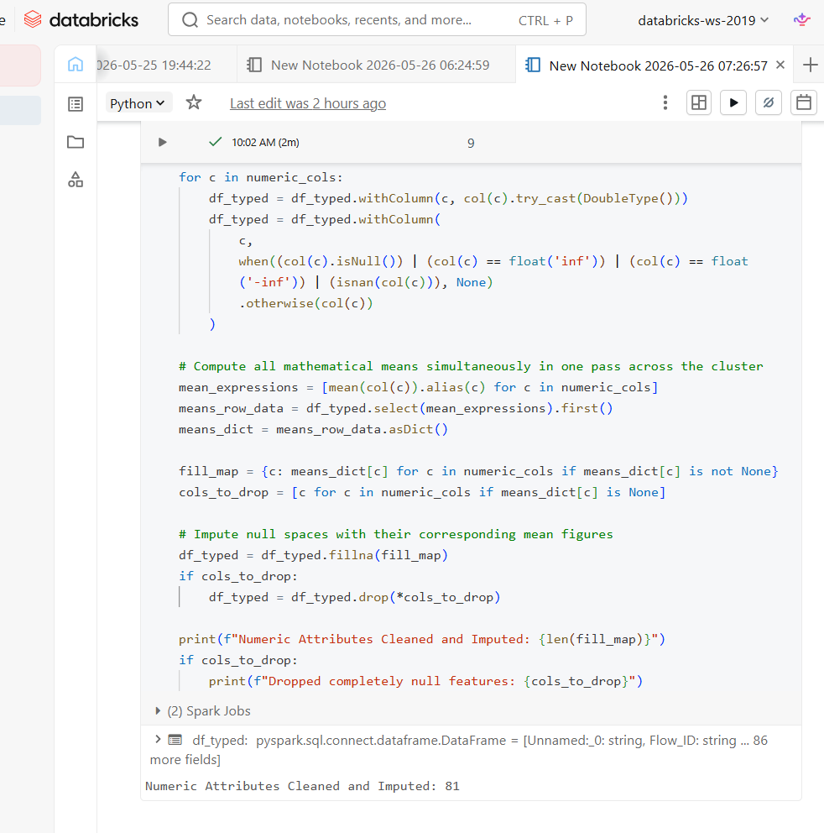
Figure 16: Handle Infinite Values and Missing Data
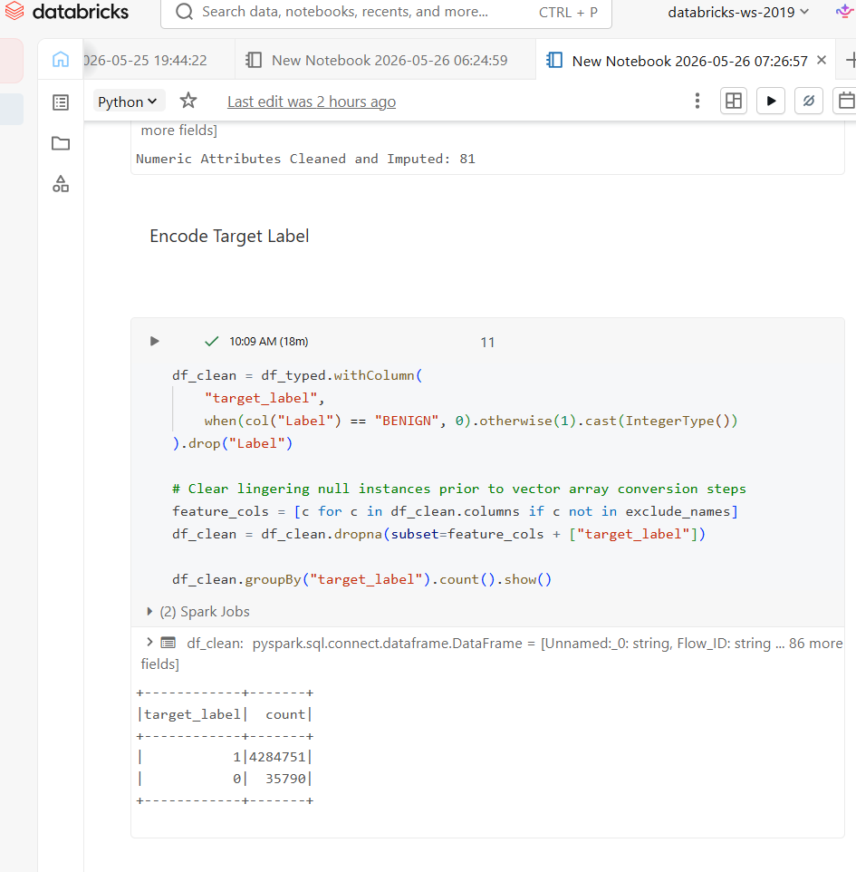
Figure 17: Encoded Target Label
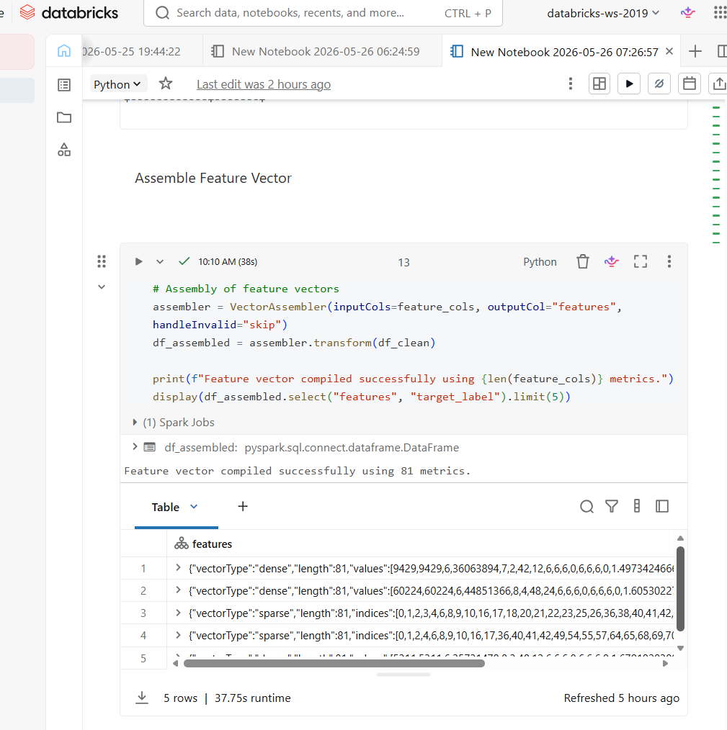
Figure 18: Assembled Feature Vector
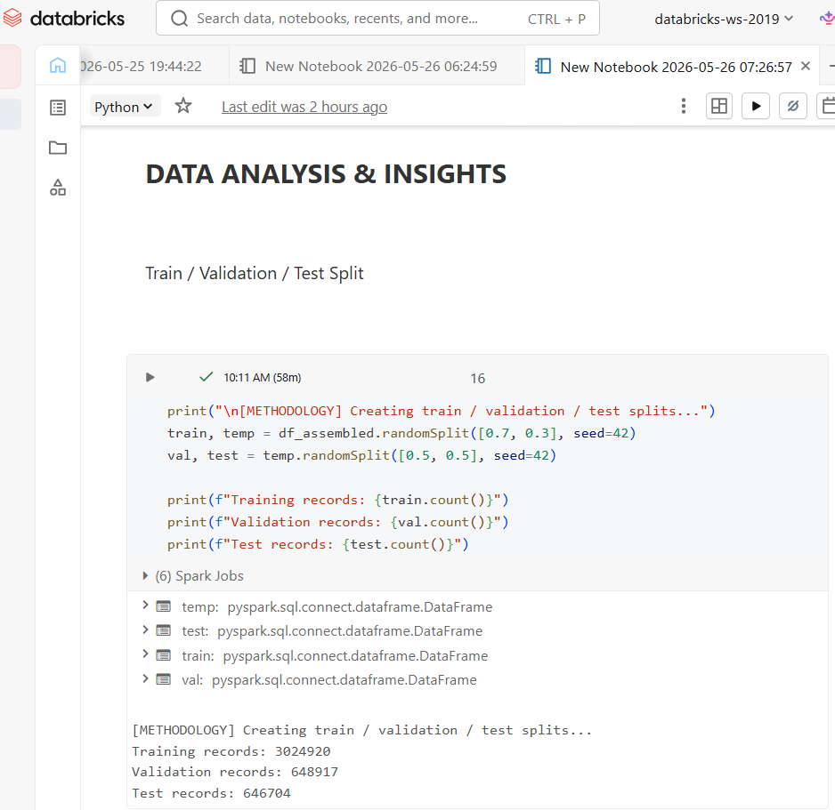
Figure 19: Trian, validation, test split
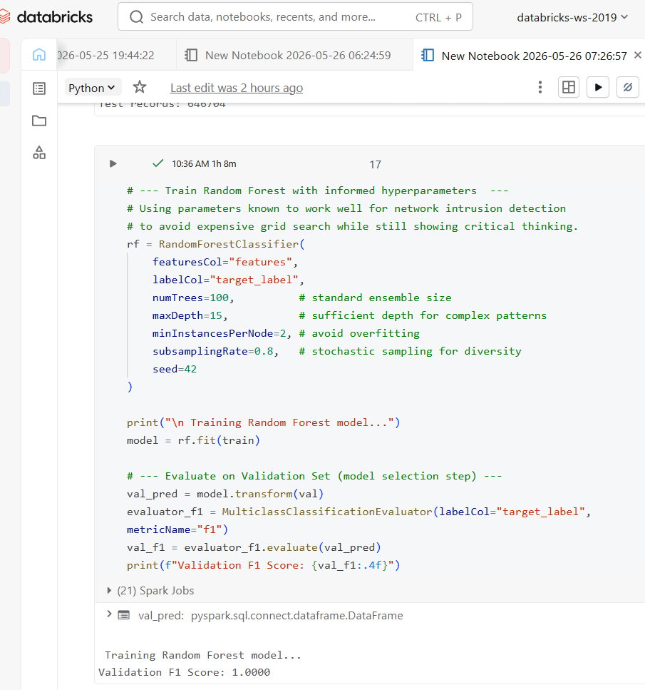
Figure 20: random forest model with hyperparameters validations
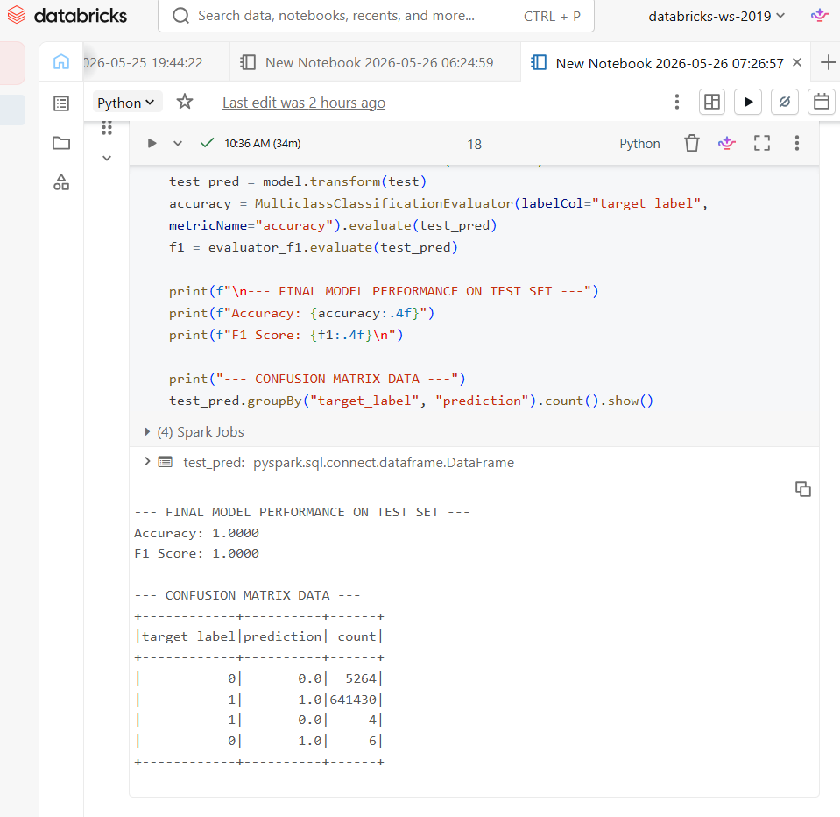
Figure 21: final model evaluation and performance
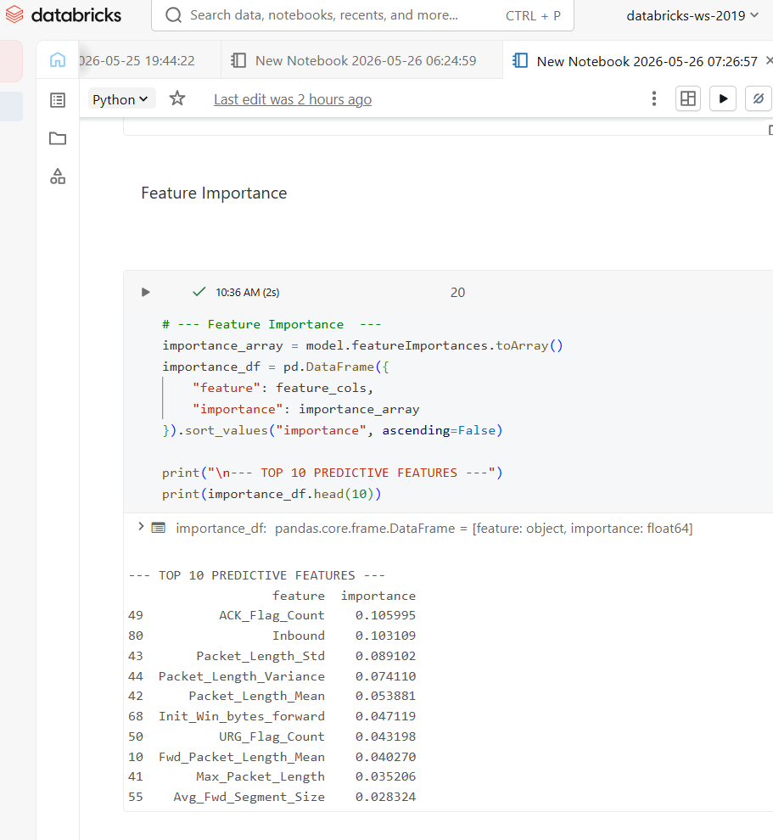
Figure 22: top 10 predictive features
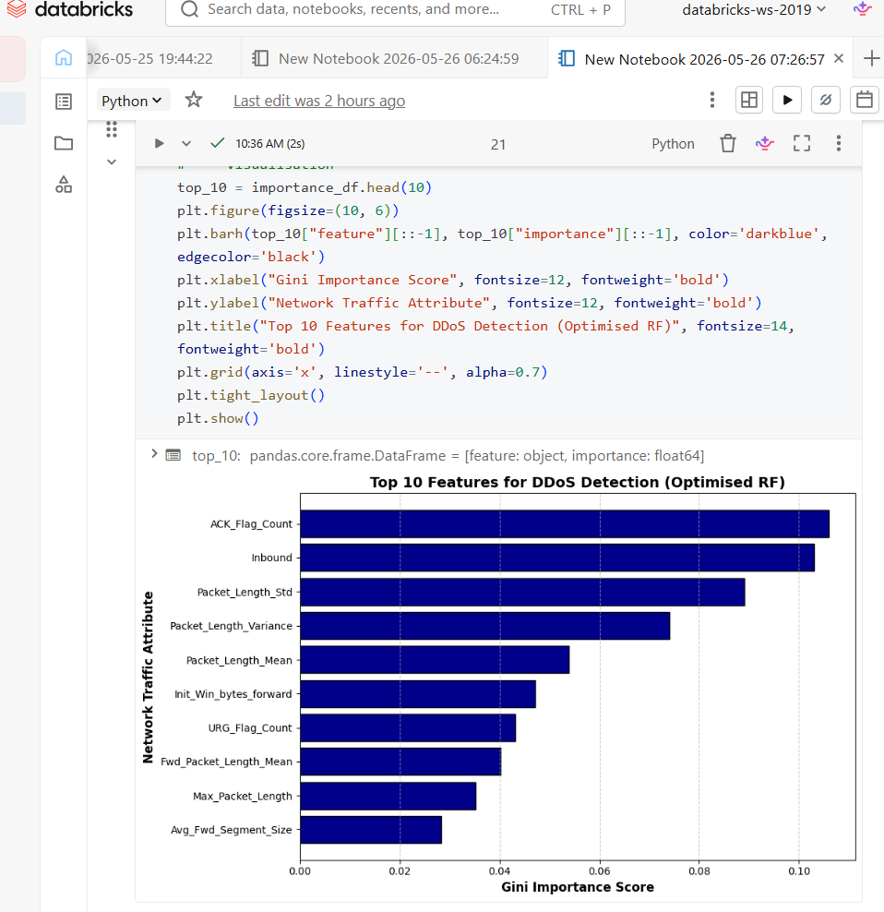
Figure 23: top 10 features for DDoS Detection
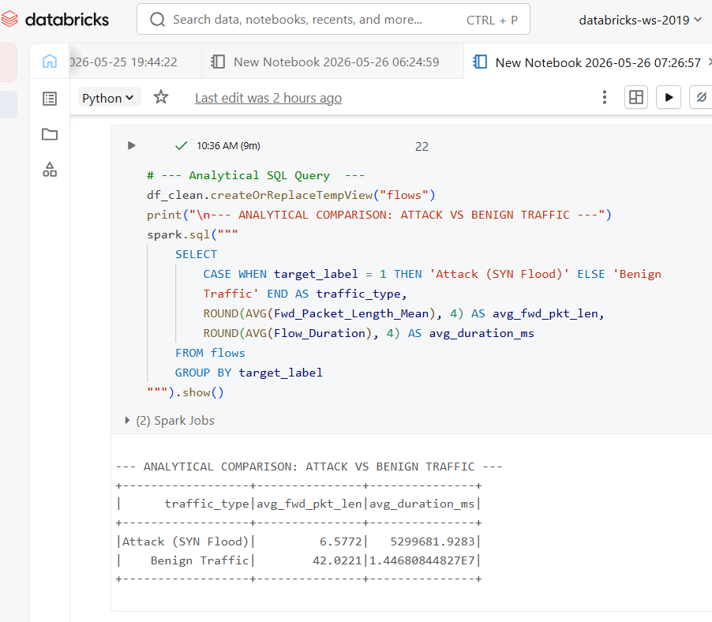
Figure 24: SQL query for analytical comparison: attack vs benign traffic
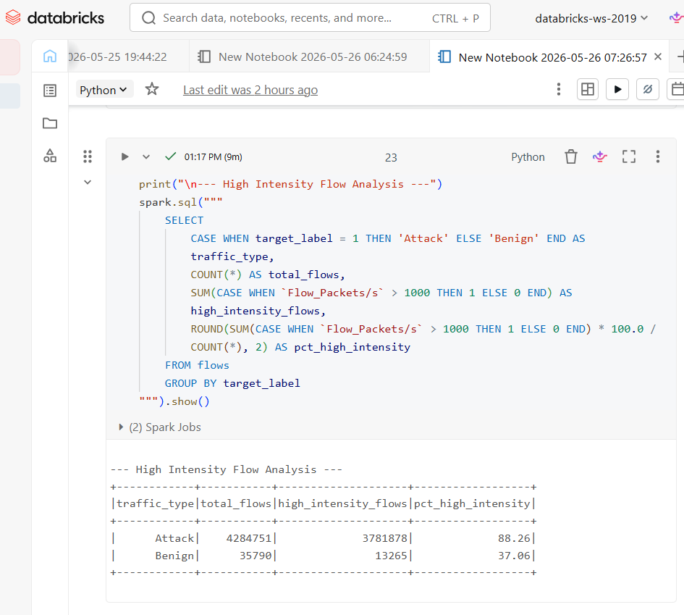
Figure 25: query for high intensity flow analysis
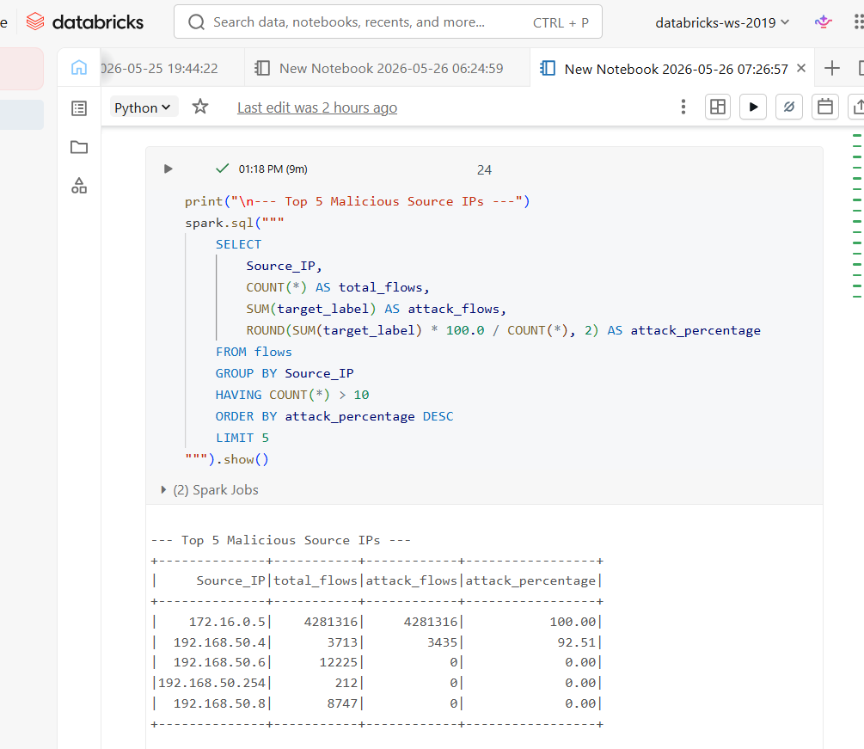
Figure 26: query on top 5 malicious source Ips
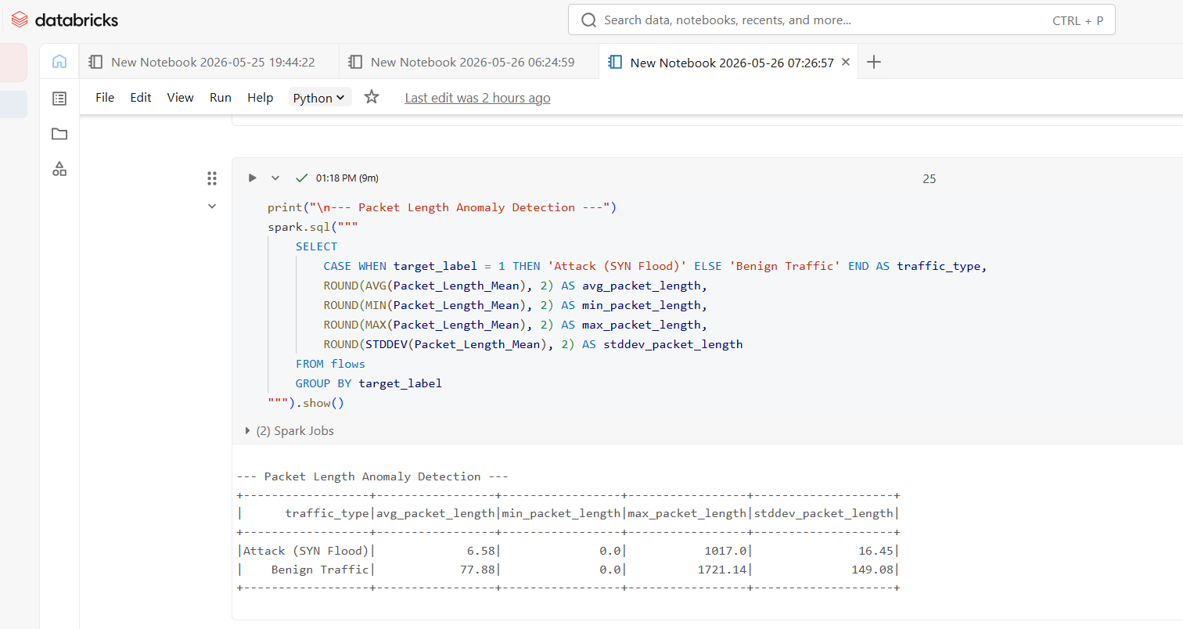
Figure 27: query for packet length anomaly detection
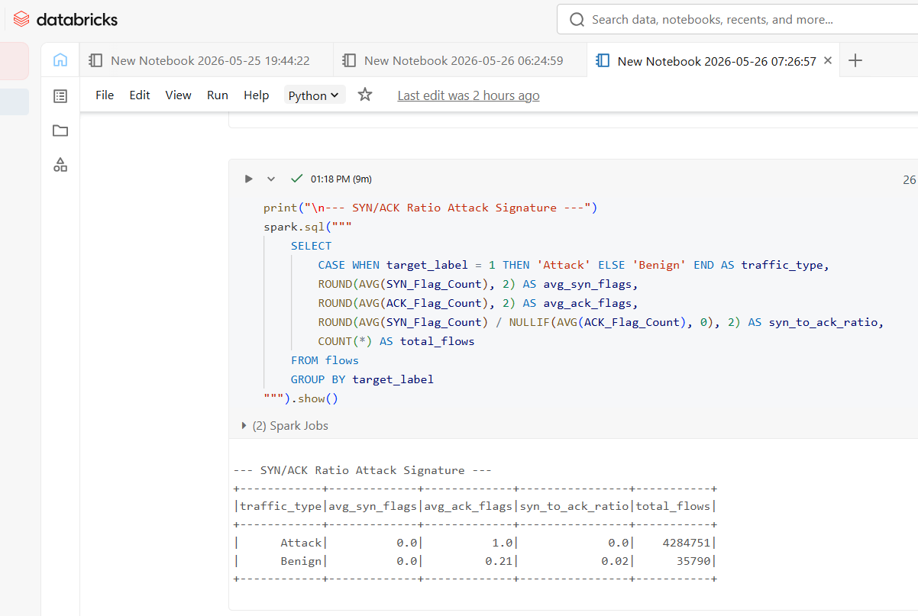
Figure 28: query for SYN/ACK Ratio Attack Signature
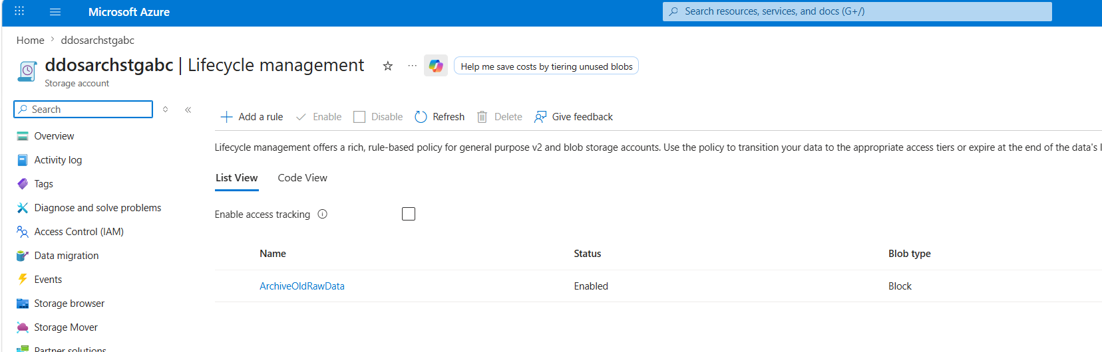
Figure 29: creation of new rule lifecycle management under storage account named ddosarchstgabc
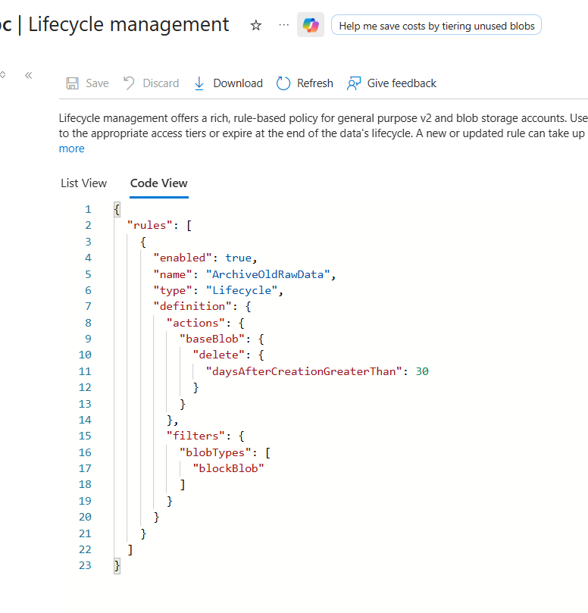
Figure 30: code view of created rule

Component | Optimised Cost | Non-Optimised Cost
Azure Data Factory | $0.50 (intermittent) | $0.50
Storage Account (30 GB) | $2.27 (Cool + LRS) | $2.92 (Hot + LRS)
Azure Databricks (DS3_v2) | $1.80 (auto-scaling, 3 hours) | $438.00 (always-on, 730 hours)
Total | $4.58/month | $441.42/month
Table 1: estimated price for the service that are used and calculated with azure price calculator
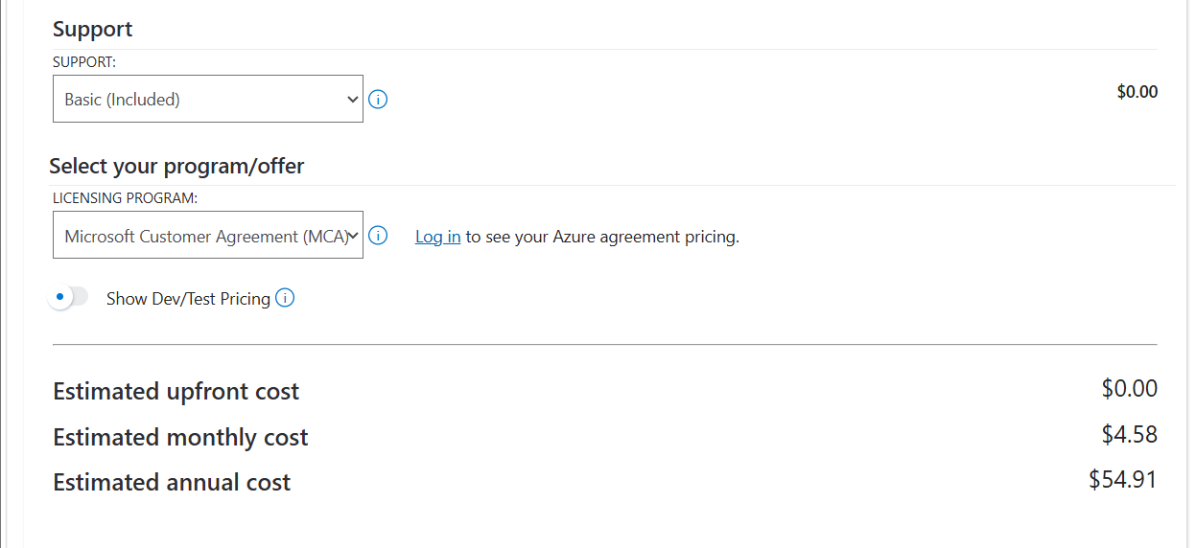
Figure 31: estimated price for the service from azure price calculator portal

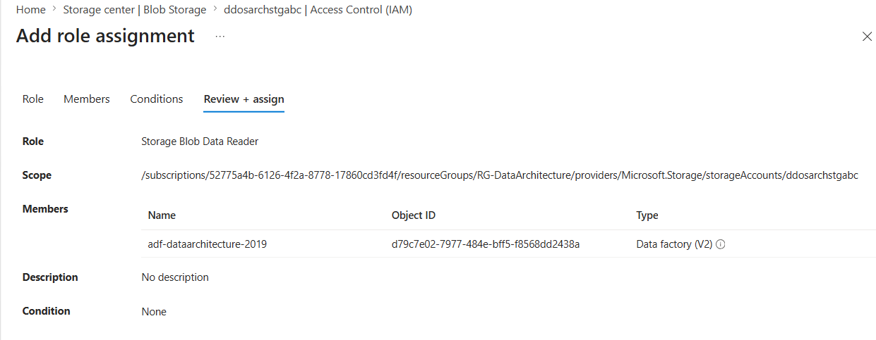
Figure 32: Implemented Access Control via Azure Role-Based Access Control (RBAC)
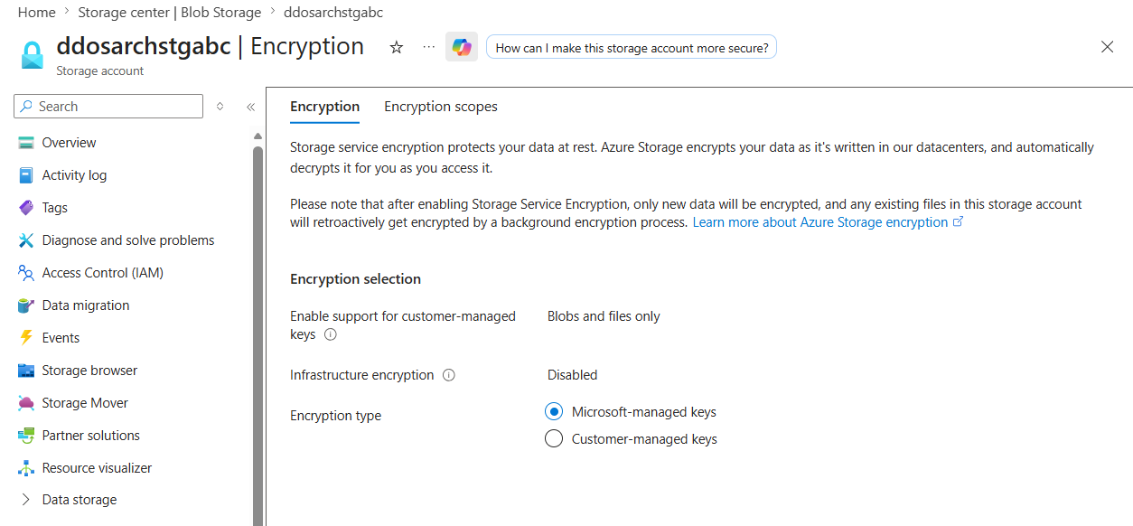
Figure 33: Azure Storage Encryption blade displaying active Microsoft-managed key protection for data at rest
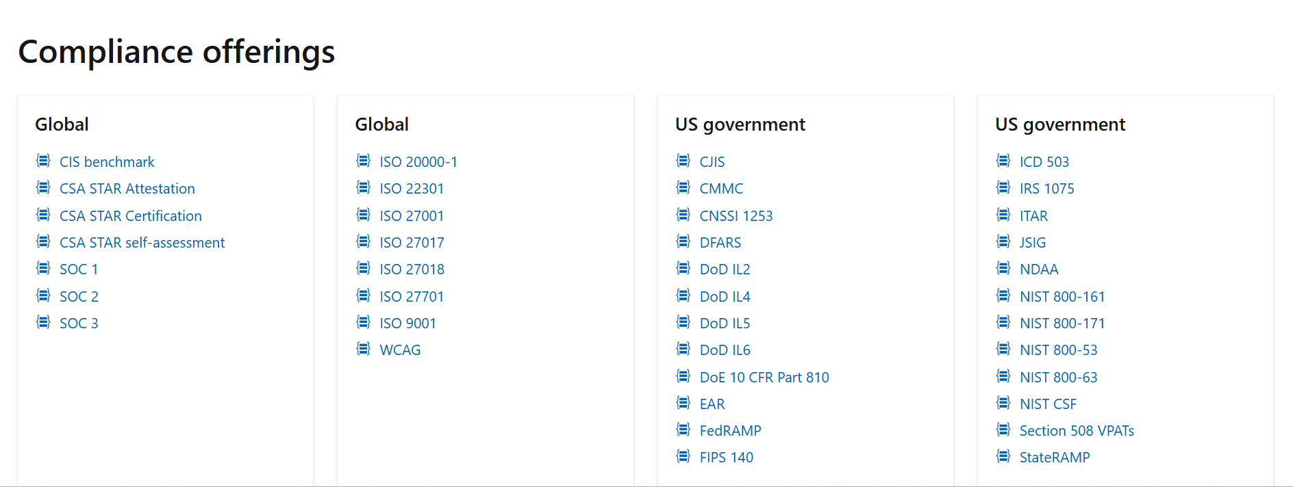
Figure 34: Azure corporate compliance matrix showcasing active global and government security certifications
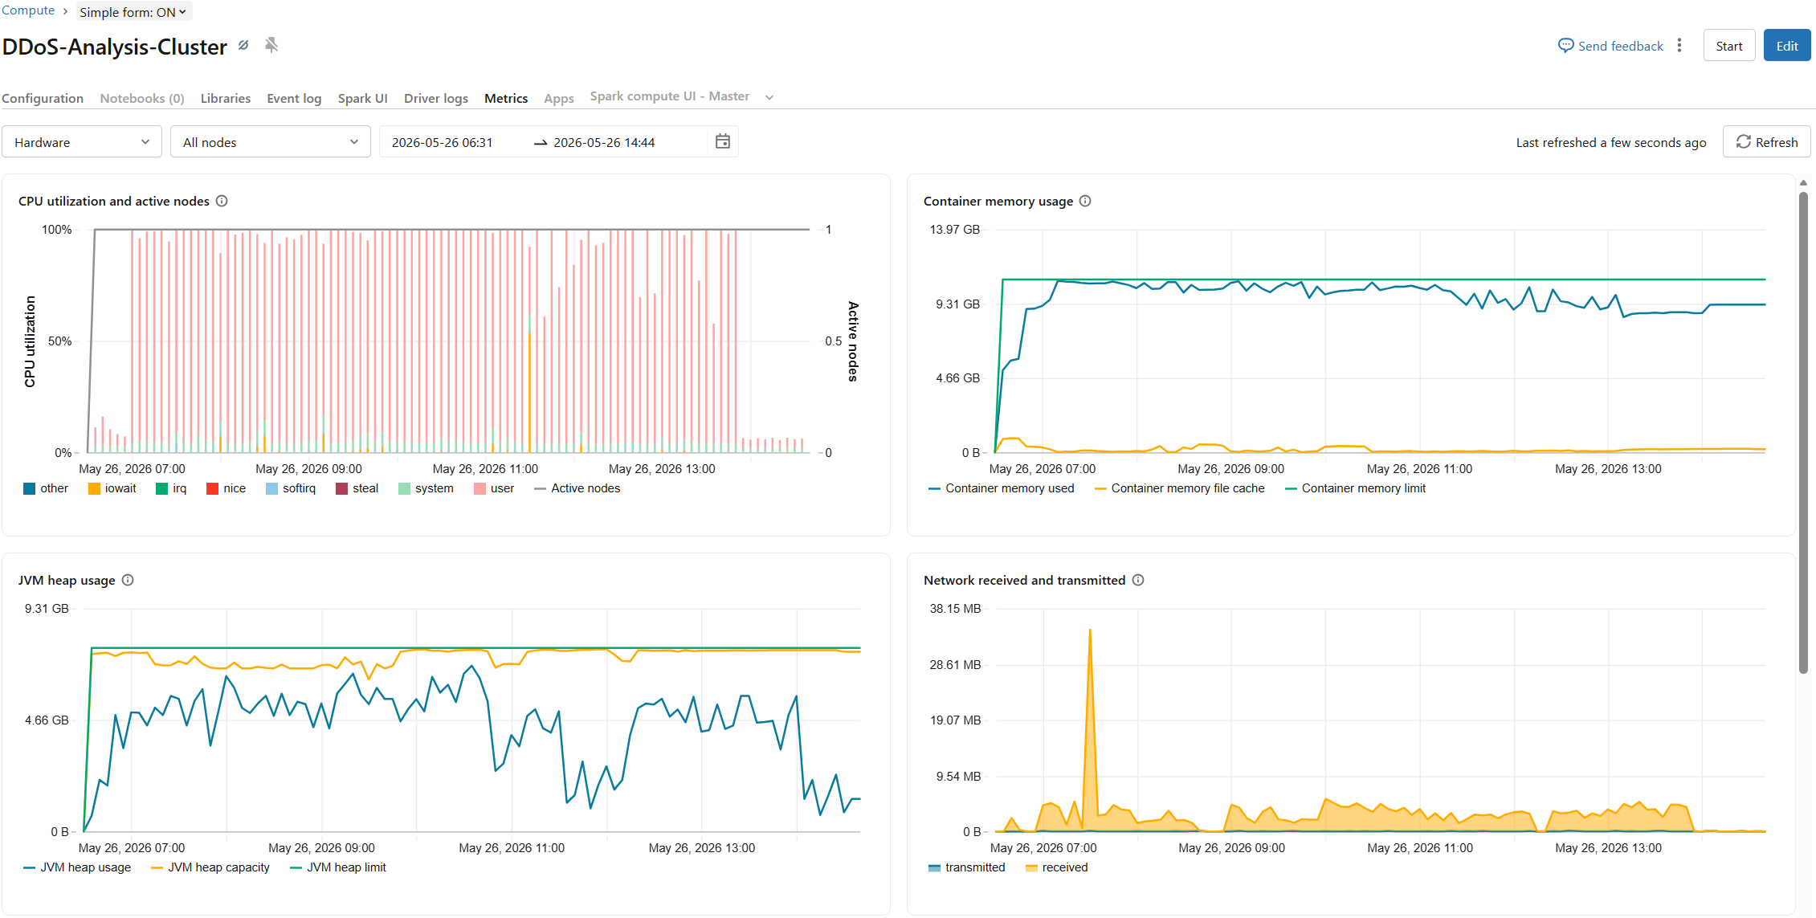
Figure 35: Azure Databricks native compute metrics dashboard illustrating real-time and historical telemetry for CPU, memory capacity, and network I/O during workload execution.
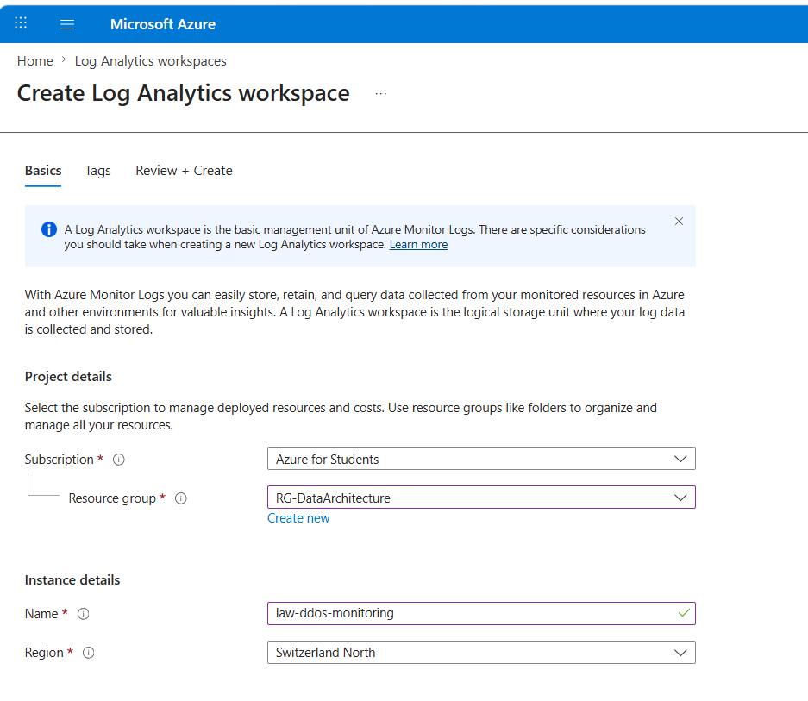
Figure 36: creation of log analytic workspace
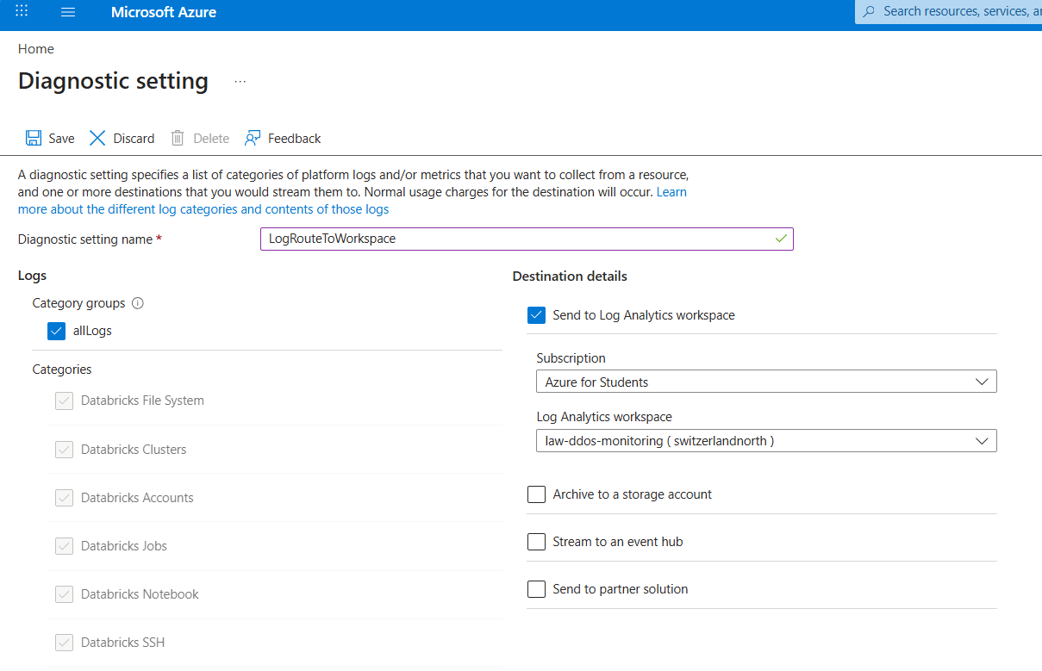
Figure 37: Configuring enterprise platform logging with Azure Monitor to enforce strict system monitoring policies on compute resources

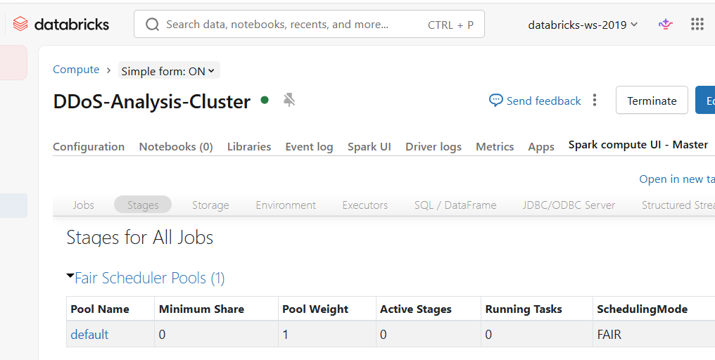
Figure 38: Apache Spark UI Stages view tracking active job execution pools and task schedules to identify runtime data skew and partition bottlenecks

