**[Generating a GPG key](https://docs.github.com/en/authentication/managing-commit-signature-verification/generating-a-new-gpg-key" \l "generating-a-gpg-key)**

**1. gpg --full-generate-key**

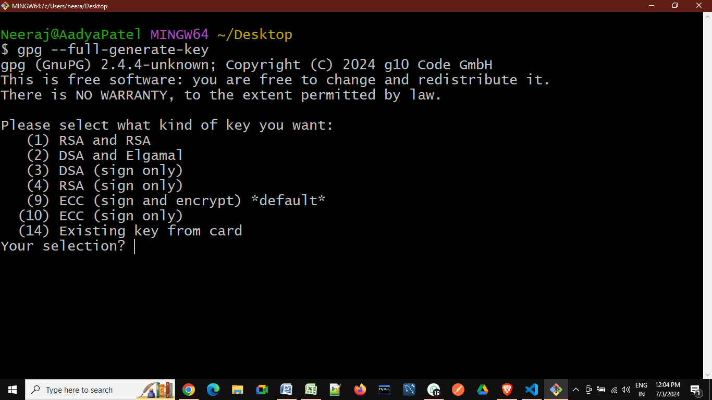

**I. Press 1 for choosing RSR and RSH**

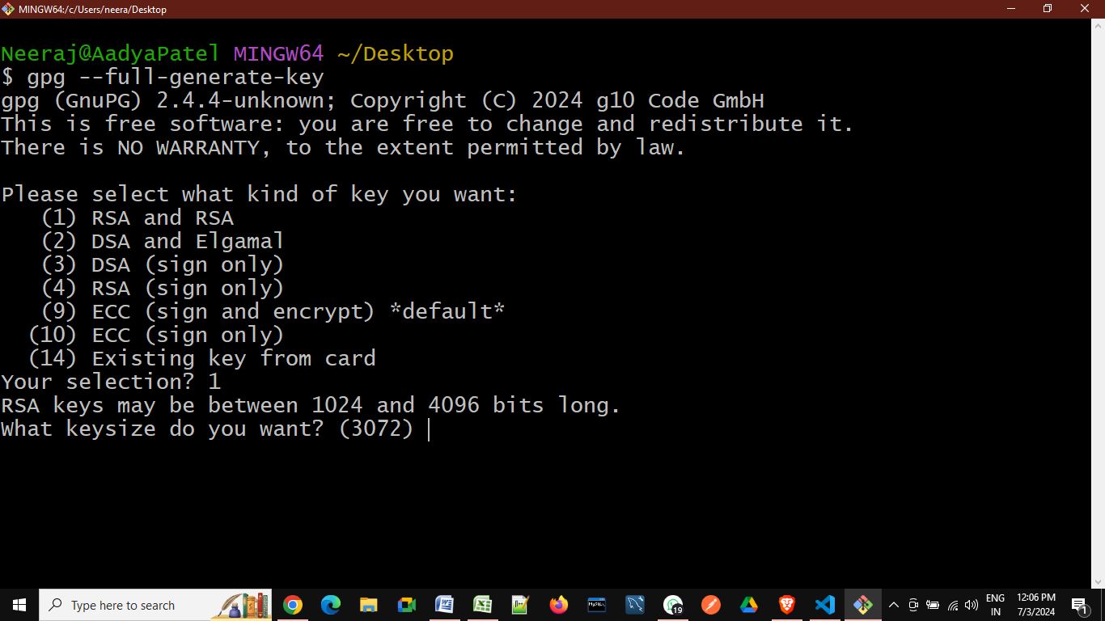

**II. Enter size of RSA key in between 1024 to 4096**

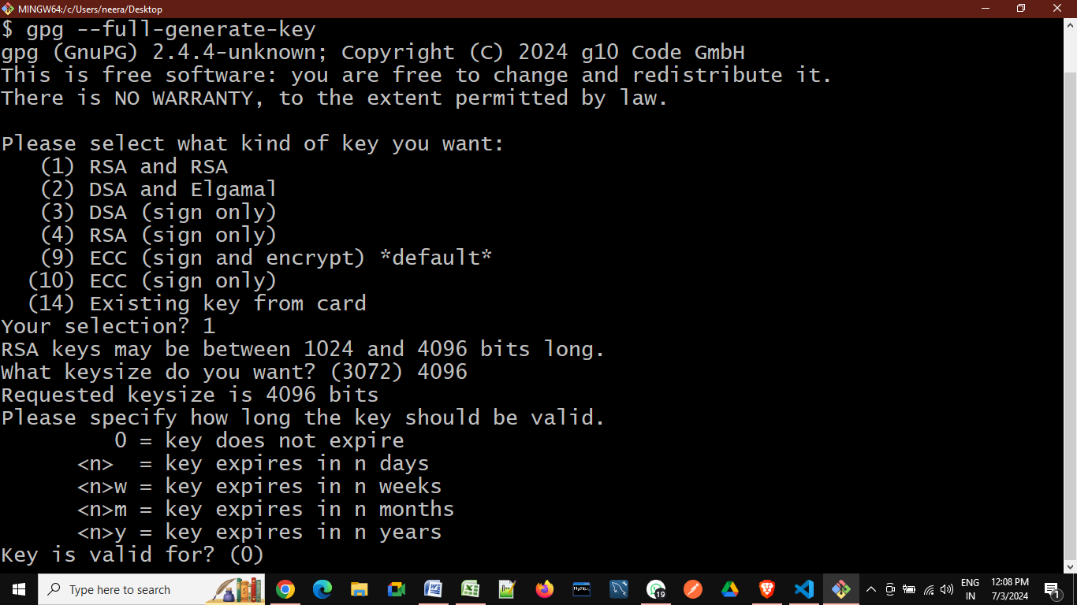

**III. set GPG-key valid up-to time in mention format**

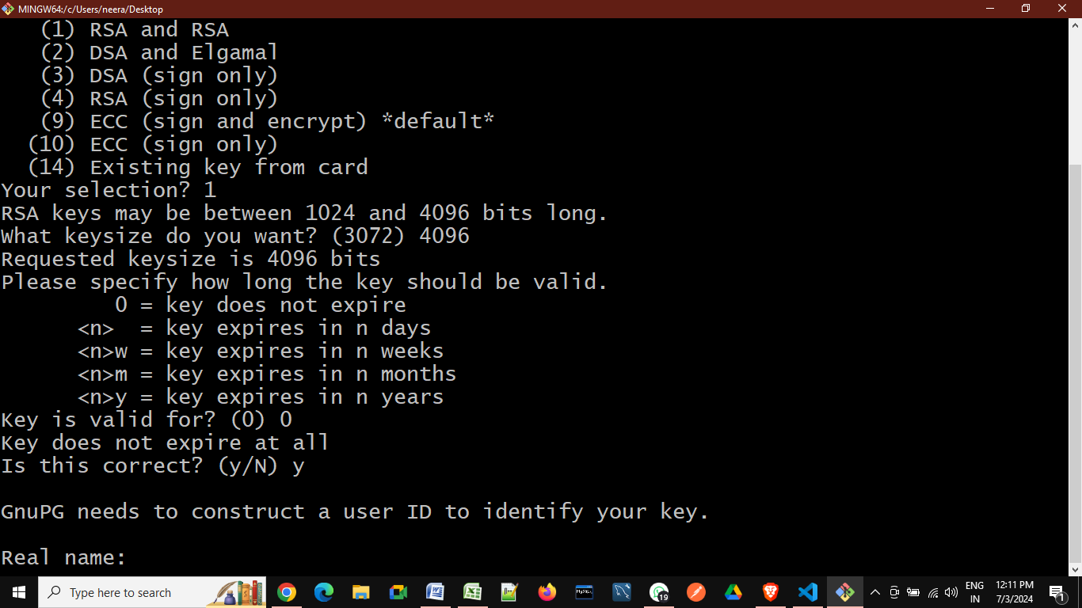

**IV. Provide your identity to GPG-Key(through user name & email)**

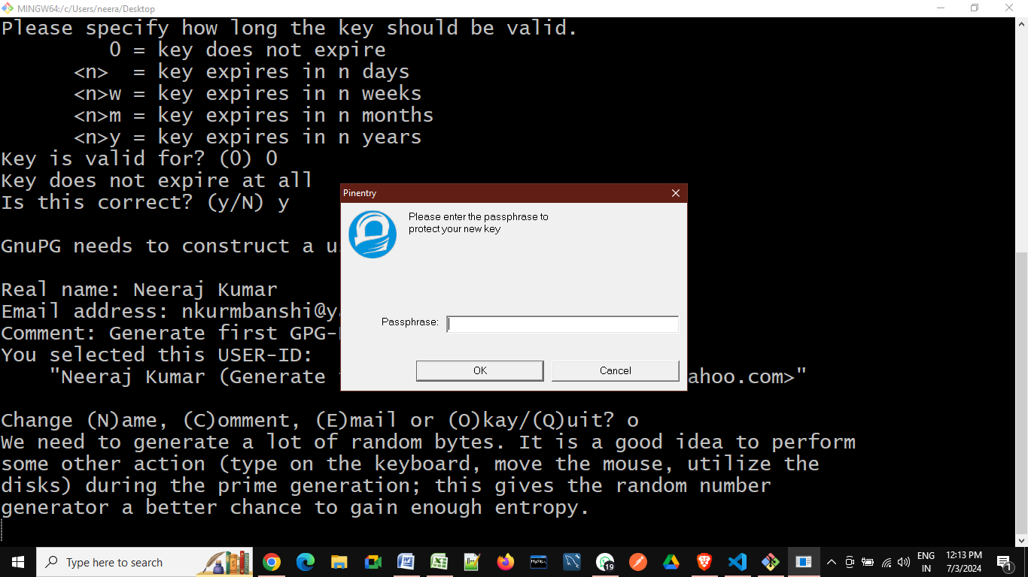

**V. It’s generate new GPG-Key:**

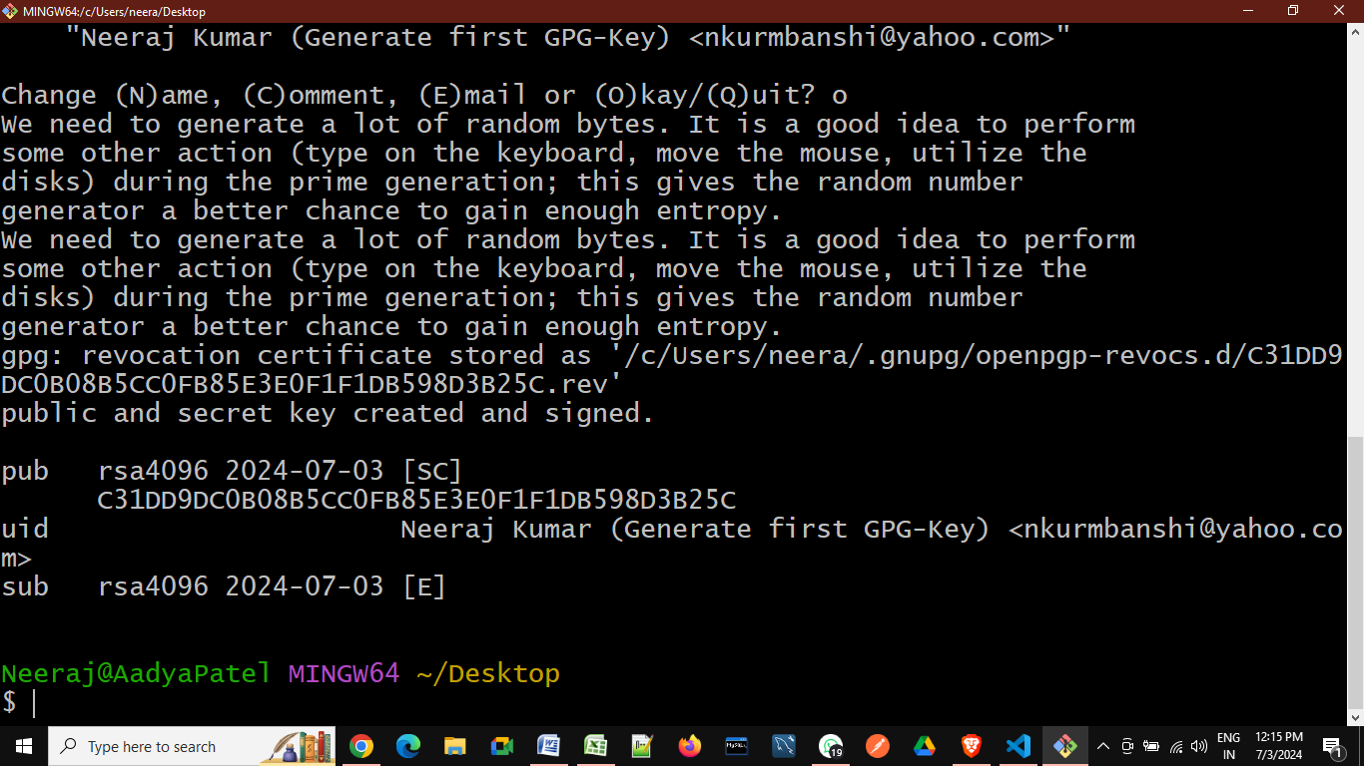

**2.** gpg --list-secret-keys --keyid-format=long

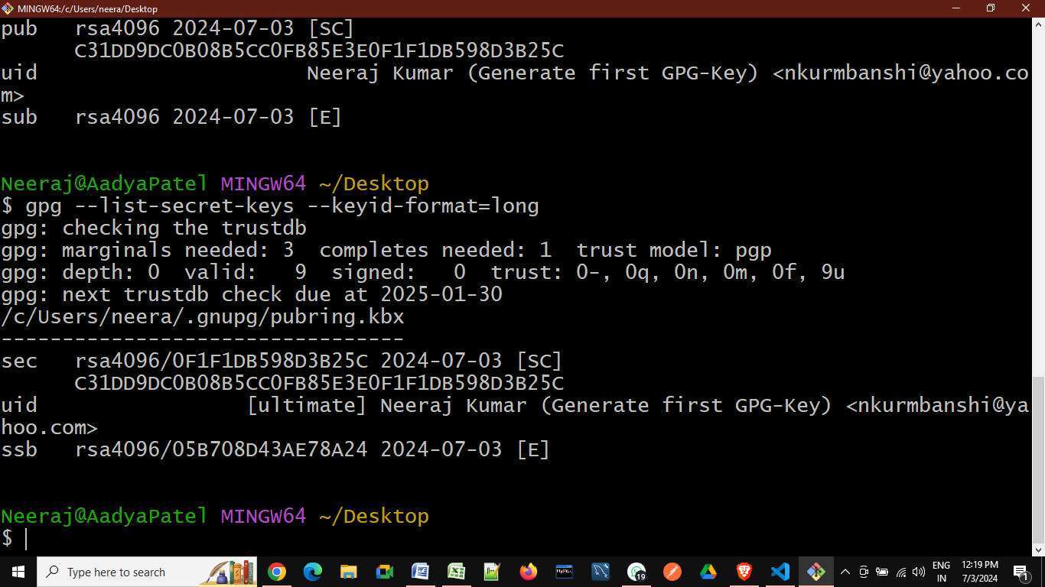

**3.** gpg --armor --export 0F1F1DB598D3B25C

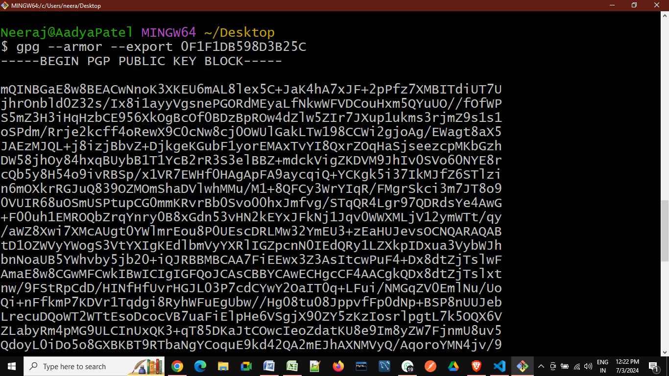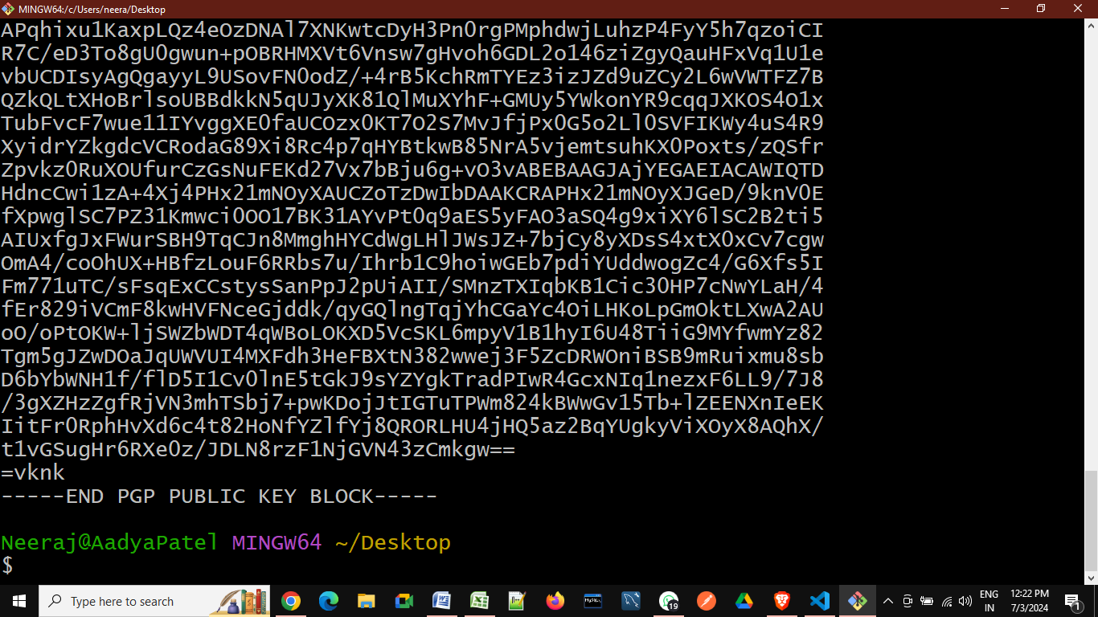

**4. Copy code from bash and past into our github🡪setting🡪SSH and GPG🡪Newgpgkey section :---**

-----BEGIN PGP PUBLIC KEY BLOCK-----

**------------------------------------------**

**------------------------------------------**

**------------------------------------------**

-----END PGP PUBLIC KEY BLOCK-----

**5. Telling Git about your signing key:-**

a. gpg --list-secret-keys --keyid-format=long

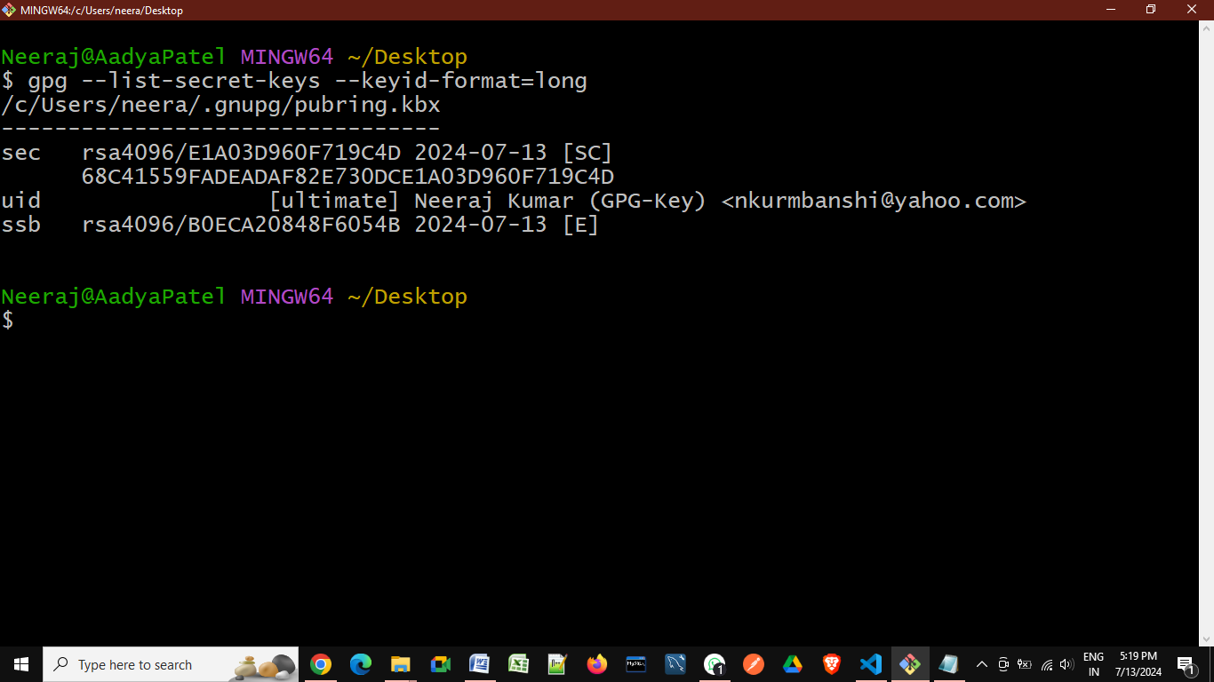

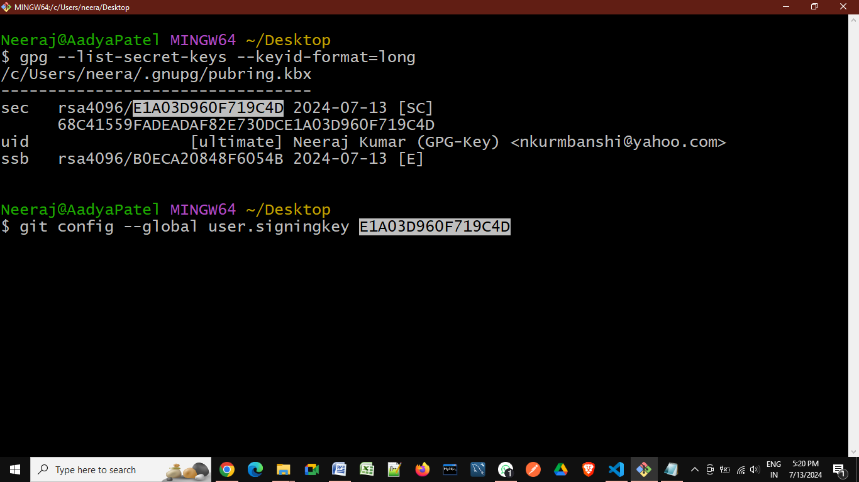

b. git config --global commit.gpgsign true

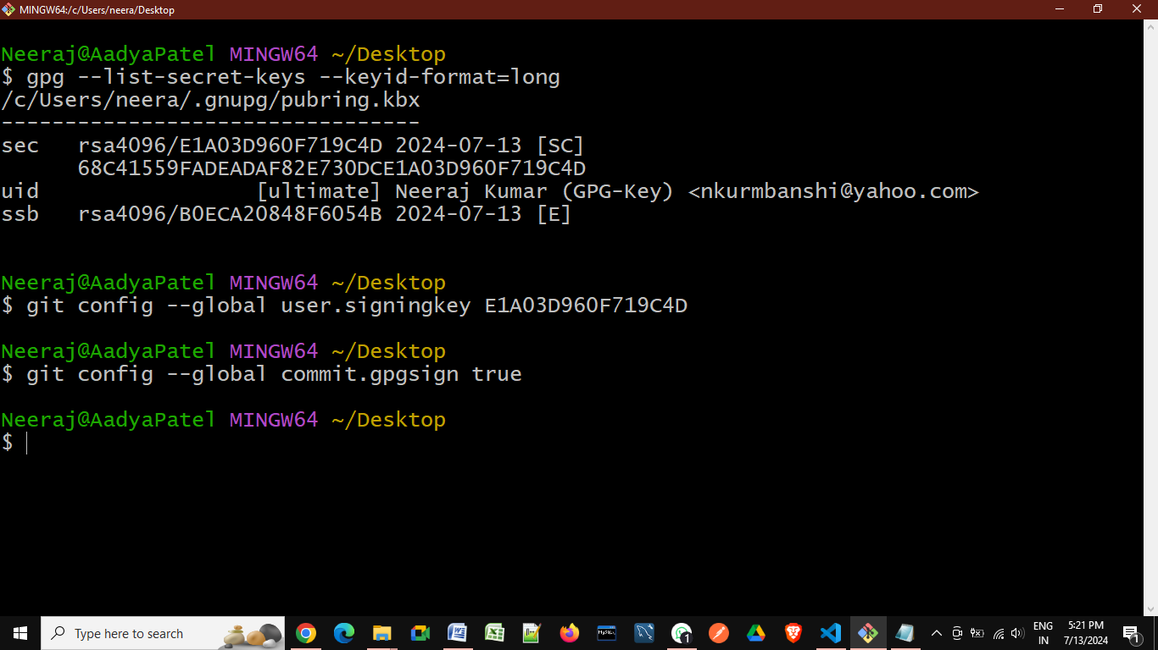

**Check all existing GPG-Key:**

gpg --list-secret-keys --keyid-format=long

**Delete existing global data:**

git config --global --unset user.name Neeraj

**Delete existing GPG-Key:**

gpg --delete-secret-keys C058E82EC960A861 DBE4362B0ECFD5F2 70A58E1CD7D9686C

[

sec rsa4096/**C058E82EC960A861** 2024-02-04 [SC] [expires: 2025-02-03]

EABFF42FDBFABBED3C8EE26FC058E82EC960A861

uid [ultimate] Neeraj Kumar (GPG-Key) <nkurmbanshi@yahoo.com>

ssb rsa4096/919281DB8D5DD069 2024-02-04 [E] [expires: 2025-02-03]

sec rsa4096/**DBE4362B0ECFD5F2** 2024-02-05 [SC] [expires: 2025-02-04]

DE3AEEEF254EA030F0CE5733DBE4362B0ECFD5F2

uid [ultimate] Neeraj Kumar (GPG-Key) <nkurmbanshi@yahoo.com>

ssb rsa4096/91607846CF4BC333 2024-02-05 [E] [expires: 2025-02-04]

sec rsa4096/**70A58E1CD7D9686C** 2024-06-21 [SC]

66C38D63335676274D7784F870A58E1CD7D9686C

uid [ultimate] Neeraj Kumar (Generate_GPGKey) <nkurmbanshi@yahoo.com>

ssb rsa4096/CD0D1D93BD283F11 2024-06-21 [E]

]