CS3235 Course Project — Requirements Document
Helping Eyes · Working with Large Language Models (LLMs) · Version 0.3 · 28 October 2026

1. Project overview
Field | Details
Project title | Helping Eyes — Camera-Based Reading Assistant for Visually Impaired Users
Team ID | [Team ID]
Team members (name, roll no., role) | [Name — Roll no. — Role, one line per member]
Faculty mentor | [Faculty mentor name]
Primary course module | 3 · Multimodal (camera images, text and speech), with tool use from Module 2 (Agents) for the consent-based web lookup
Version / date | v0.3, 28-10-2026

Problem statement (3–5 sentences): Visually impaired people depend on printed text every day — medicine packs, food labels, letters, bills and books — but cannot read it independently. Commercial reading aids are expensive and need dedicated hardware, and phone OCR apps usually read every word aloud, so the user must listen to an entire label to find one detail such as a dosage or an expiry date. Classical OCR pipelines also struggle with the conditions of hand-held use: blur, tilted or curved pages, two-page book spreads and running headers that are read in the middle of the text.
Why an LLM? Users ask open-ended, spoken questions about arbitrary text ("How many can a ten-year-old take?", "Read only the warning", "Can I use it on a burn?"). Answering requires understanding the question, locating and quoting the relevant part of noisy OCR text, and phrasing a short spoken answer — which rule-based keyword matching cannot do across the variety of labels and documents. Tasks that do have exact answers are deliberately kept out of the LLM: full read-out is spoken directly from the OCR text, page-number questions are answered in code, and expiry dates are compared with today's date in code, because small models get date comparisons wrong (measured: Qwen 2.5 3B alone gave the right verdict for 5 of 22 dates; with the code's verdict, 22 of 22).
One-line solution summary: A camera-based reading assistant, used from a web page on a laptop or phone, that helps visually impaired people to get exactly the information they need from labels, documents and books by using on-device text recognition (Apple Vision), a language model (Gemini Flash-Lite online, or Qwen 2.5 3B Instruct running locally) and speech.

2. Scope and users
In scope — what the finished system will do:
- Live text detection with spoken positioning guidance ("Move closer", "Move left", glare hints) and automatic capture, from the laptop webcam or a phone camera in the browser; a shutter button and photo upload as alternatives.
- Spoken and typed requests about the captured text: full read-out, selective read-out ("read only the dosage") and question answering with a language model chosen on the page (Gemini online or Qwen 3B on the Mac), spoken sentence by sentence.
- Deterministic expiry-date checking, and a web lookup that is offered only when the text does not contain the answer and performed only with the user's consent.
- Book reading mode: page-turn detection, two-page spread splitting, recognition of the printed page number and running title on any page, reading order across columns and paragraphs, continuation after the view moves, and an on-screen highlight of the word being read.
- Voice, keyboard and typed controls to stop, repeat, re-capture and switch modes.
- A public https address for the same web app (the Mac is the server, reached through a free ngrok or Cloudflare tunnel), so a phone or another person can use it with the same answering rules (see Section 11 for why it is not on a cloud host).
Out of scope — what you are deliberately not building this semester:
- Native mobile apps (phones use the web page). The server runs on macOS only, because it uses Apple Vision.
- Handwriting recognition and general scene description (objects, people, obstacles).
- Training or fine-tuning models.
- On-device speech recognition: spoken requests are recognised by the browser's Web Speech API (Chrome and Edge use an online service; see OQ-3).
- User accounts and storage of captured images or text.
Target users
User type | What they need from the system | How they will interact (chat, API, CLI, web UI)
Blind or visually impaired adult | Hear only the information needed from labels, letters and books, without seeing a screen | Voice (microphone and speakers) with spoken guidance; single-key keyboard shortcuts (can be switched off); a screen-reader mode that hands all speech to the user's own screen reader or braille display
Low-vision user | Follow the text on screen while it is read aloud | Web page with the line and word being read highlighted, large buttons, light and dark themes with 7:1 text contrast, 200 % zoom; voice or keyboard
Caregiver, tester or evaluator | Set the system up, choose the model, type questions, check the server's health and logs | run.py in a terminal (server log), the .env settings file and /api/health
Any user without a Mac | Try the system from any device | Phone or computer browser at the shared https address: camera, voice or typed questions, spoken answers

Example user scenario: (1) The user opens the page and allows the camera and microphone; they press Listen once for hands-free listening. (2) They hold a paracetamol strip in front of the camera; Apple Vision checks the view several times a second and the page says "Move closer". (3) When the text is readable and held still, the label is captured and the page says "Got it. What would you like to know?" (4) The user asks "When does it expire?"; the browser's speech recognition returns the text. (5) The request router sends the question, the captured text and the expiry check computed in code ("Exp. 04/2028: has not expired") to the model chosen in the Answers from menu (Gemini Flash-Lite by default, or Qwen 2.5 3B in Ollama). (6) The first sentence of the answer, "No, it has not expired; it is good until the end of April 2028", is spoken by the local Kokoro voice. (7) The user asks "What is paracetamol used for?"; the text does not say, so the page offers "Should I look it up online?", and on "yes" answers from DuckDuckGo results, starting with "According to the web" and ending with a reminder to confirm with a pharmacist.

3. Functional requirements
Each requirement is a single testable statement. Priority uses MoSCoW: Must, Should, Could.
ID | Requirement ("The system shall…") | Priority | How it will be verified
FR-1 | The system shall detect text in the live camera view and give spoken positioning guidance until the text is readable and in view. | Must | Demo + 20 trials on real items
FR-2 | The system shall capture all text in view with on-device OCR once the text has been held still, without reading it aloud. | Must | Character error rate on real item photos (148 pharmacy photos + other categories)
FR-3 | The system shall read the full captured text aloud, exactly as recognised, when the user asks to read everything. | Must | Demo + 10 test requests
FR-4 | The system shall answer spoken or typed questions about the captured text using only that text, speaking the answer sentence by sentence. | Must | Factual questions on the real photos, scored by fixed rules; free-text answers judged on a blind sample
FR-5 | The system shall read only the requested part of the text, word for word, when the user asks for a specific part (e.g. dosage, directions). | Must | 15 selective read-out test requests
FR-6 | The system shall state when the captured text does not contain the answer and offer a web lookup, performing it only after the user agrees. | Should | Questions whose answer is not on the photo
FR-7 | The system shall determine whether a printed expiry date has passed by computing it in code, not by the language model. | Must | 22 expiry dates in the formats seen on real packs, plus 2 relative wordings
FR-8 | The system shall support stop, repeat, new capture, read everything and mode switching by voice, keyboard and typed commands. | Must | Scripted command checklist
FR-9 | In book mode, the system shall detect page turns, split two-page spreads and read the text in reading order, starting from the first body line. | Should | Synthetic layouts + real book photos + a real page-turn video
FR-10 | In book mode, the system shall announce the printed page number(s) and running title of any page, including a randomly opened page. | Should | Page-number accuracy on synthetic layouts + real book photos
FR-11 | In book mode, the system shall continue from the word it had reached when the camera or book moves, instead of restarting the page. | Could | Scripted camera-shift scenarios
FR-12 | In book mode, the system shall highlight the line and word being spoken on screen. | Could | Word-to-box mapping check + demo
FR-13 | The system shall be reachable at a public https address, from which a user captures a photo in the browser, asks a spoken or typed question and hears the answer, with the same grounding and safety rules. | Must | Demo on the public address (phone) + the speed test

4. LLM design requirements
This section shows which course concepts the project applies; techniques that are not used are marked with the reason.
Aspect | Your choice | Justification
Base model(s) | Gemini 3.1 Flash-Lite (default, through Google's OpenAI-compatible API, free tier). Qwen 2.5 3B Instruct (qwen2.5:3b-instruct, 4-bit, 1.9 GB) running on the Mac in Ollama, chosen in the page's Answers from menu. Qwen 2.5 7B was used in the earlier desktop version and removed. | Flash-Lite is fast and free within a daily limit and needs no GPU; Qwen 3B is the offline option with no data leaving the Mac. Both are compared on the same photos and questions in Section 7. The 7B model was dropped because the 3B model is fast enough on the Mac and leaves memory for the OCR and the voice.
Access method | One OpenAI-style chat client for both: Gemini at generativelanguage.googleapis.com/v1beta/openai (API key in the git-ignored .env), Qwen at Ollama 0.23.2's localhost:11434/v1. Both stream responses | One code path for both providers; any OpenAI-compatible provider can be set in .env (LLM_BASE_URL, LLM_MODEL). Failures (busy, quota, no key, model missing, Ollama not running) are spoken as plain messages.
Prompting strategy | Zero-shot system prompt with explicit rules, plus few-shot examples for the not-in-text case; control outputs READ_ALL and [NOT_IN_TEXT]; facts computed in code (today's date, expiry checks, page facts) injected into the prompt; temperature 0.2 | Rules keep answers short, spoken-friendly and grounded in the captured text; the control outputs let the application react deterministically (read the OCR text itself, offer a web lookup); injecting computed facts avoids the date-arithmetic errors measured in the 3B model.
Retrieval (RAG) | No vector retrieval. The captured text (one item or one page spread) is placed directly in the prompt (context window 8,192 tokens). Optional web retrieval: top-5 DuckDuckGo results used as context after user consent | A single captured item fits in the context window, so indexing adds no value; web retrieval covers questions the item itself cannot answer.
Fine-tuning | None | Prompting with rules and examples met the behaviour targets during development; there is no labelled training data, and fine-tuning is not needed for reading and answering from a given text.
Agents and tools | Single assistant with a rule-based request router (commands, read-all fast path, question answering) and one tool: web search (DuckDuckGo via ddgs), with a model-written search query; no agent framework | The router handles predictable requests without the model (fast and reliable); the web tool is gated by explicit user consent and never offered for item-specific facts (expiry, batch, price).
Protocols | Not used | No external agents or MCP servers are needed; all components run in one process.
Multimodal input | Image: camera frames from the browser → Apple Vision text recognition (fast mode for live guidance, accurate mode with per-word boxes for captures) and a custom OpenCV pipeline (quality check, flattening, deskew, dewarp, shadow fix, book layout). Audio in: the browser's Web Speech API. Audio out: Kokoro (local neural voice on the Mac), Microsoft Edge voice as backup, the browser's voice last. The LLM itself is text-only | Measured on 148 real photos, Apple Vision read the key lines with 89.7 % character accuracy in 0.17 s per photo (RapidOCR 87.7 % in 0.60 s, Tesseract 57.6 %); a vision-language model (Qwen 2.5-VL 7B) needed about 12 s on a test label. On-device OCR plus a text LLM gives far lower latency.
Alignment and safety | System prompt rules (use only the captured text, never invent details, be precise with medicine, dates and prices, say when the answer is absent); expiry verdicts computed in code; web answers must start with "According to the web" and health answers end with "Please confirm with a pharmacist or doctor"; web lookups require consent and are blocked for expiry, batch and price | Risks addressed: hallucinated or wrong medical details, confusing web information with what is printed on the item, and unnecessary data leaving the device.

If you fine-tune with LoRA, show the trainable-parameter calculation for one adapted weight matrix of size d × k with rank r:
Trainable parameters = r × (d + k)
Not applicable — no fine-tuning is used (see the Fine-tuning row).
LLM pipeline: User request (speech → text by the browser, or typed) → request router: application commands (stop, repeat, next, book mode) are handled directly; "read everything" requests are answered by speaking the OCR text itself; page-number questions are answered from the page layout; other requests go to the LLM → prompt = rules + today's date + expiry checks computed in code + page facts + captured OCR text + the last six exchanges → Gemini Flash-Lite or Qwen 2.5 3B (streaming, temperature 0.2) → post-processing: control outputs (READ_ALL, [NOT_IN_TEXT]) are interpreted, the stream is split into sentences, each sentence is voiced as soon as it is complete → if the text did not contain the answer, the user is offered a web lookup (search query written by the model → DuckDuckGo top-5 → answer from results), never for expiry, batch or price.

5. Data requirements
List every dataset, document collection or API the project depends on, including test data you will build yourselves.
Dataset / source | Purpose | Size | Format | Licence / permission | Link
Gemini 3.1 Flash-Lite (Google AI Studio, free tier) | Language model (inference only, default) | Hosted; free daily request limit | OpenAI-compatible chat API | Google Gemini API terms | https://ai.google.dev/gemini-api/docs
Apple Vision text recognition | On-device OCR (inference only) | Built into macOS | System framework | macOS licence | https://developer.apple.com/documentation/vision/recognizing-text-in-images
Real-world photo set (collected by the team) | Evaluation: OCR, answers, image checks, book mode | 148 pharmacy photos (strips, cartons, personal care) + food labels, book pages, documents and signs; 1 page-turn video | JPEG + JSON reference (Claude's reading of each photo) | Own photos of own items | eval/data/private/ (git-ignored); only scores are committed
Questions and expiry texts (written by the team) | Evaluation: answers, not-in-text detection, expiry | 21 questions per pharmacy photo, 5–9 written per other photo; 22 + 2 expiry label texts | JSON | Own | eval/run_photo_eval.py, eval/run_expiry.py
Synthetic book pages (generated with OpenCV) | Book-mode development and regression tests | 6 page layouts; page-turn sequences with 10 noise seeds | Generated image frames | Own | Project repository (tests)
DuckDuckGo web search (ddgs) | Runtime web lookup after consent | Top 5 results per query | JSON (title, snippet, URL) | DuckDuckGo terms; unofficial library | https://pypi.org/project/ddgs/
Kokoro-82M voice (kokoro-onnx), af_sarah | Spoken output on the Mac (Edge voice as backup) | About 350 MB, downloaded once (run.py --get-voice) | ONNX model + voice file | Apache 2.0 | https://github.com/thewh1teagle/kokoro-onnx
Qwen 2.5 3B Instruct weights (local option) | Language model (inference only) | 3.1 B parameters, about 1.9 GB (4-bit) | GGUF via Ollama | Qwen Research License (non-commercial) | https://huggingface.co/Qwen/Qwen2.5-3B-Instruct
RapidOCR and Tesseract 5.5.1 (baselines) | OCR baselines in the evaluation only (RapidOCR was the app's earlier reader) | PP-OCR ONNX models; Tesseract LSTM English | ONNX / system program | Apache 2.0 | https://github.com/RapidAI/RapidOCR · https://github.com/tesseract-ocr/tesseract

- Preprocessing: Photos are downscaled so the longer side is at most 1600 px. A quality check (sharpness, glare, light, contrast) decides which corrections are tried: flattening of a tilted item, shadow removal and contrast correction, binarisation; the version Apple Vision reads with the highest confidence is kept. Book pages are also deskewed and dewarped. OCR output is cleaned in code: header and footer rows (page numbers, running titles) are separated from the body, words hyphenated across lines are rejoined, and lines are ordered by recursive XY-cut. No chunking is needed because one captured item fits in the context.
- Train / test separation: No model is trained. The few-shot examples in the system prompt ("Is it waterproof?", "What is zinc oxide?") are not part of the test set; prompts were frozen before the evaluation runs, and every result file records the git commit and whether the code had uncommitted changes.
- Personal or sensitive data: Camera frames and photos are processed in memory and never saved by the app. Captured text and the conversation are kept only in the server's memory for the session (30 minutes). The captured text (never the picture) goes to Google when Gemini is chosen; with Qwen it stays on the Mac. Spoken requests are recognised by the browser's speech service (Chrome uses Google). Web lookups send only the question and the product name to DuckDuckGo, and only with consent. Test photos contain only the team's own items, with no names, addresses or faces; they stay in a git-ignored folder.

6. Non-functional requirements
Each requirement has a measurable target.
ID | Category | Requirement | Target
NFR-1 | Latency | Time from the request text being available to the start of the spoken answer; capture and live-detection speed | ≤ 2.0 s to the first spoken sentence for 90 % of questions; capture ≤ 0.5 s; live detection ≥ 10 checks per second (all on the Mac, measured over localhost)
NFR-2 | Cost | API or compute spend for the whole project | ₹0 — free Gemini tier, local Qwen, Apple Vision, local Kokoro voice, free search, free tunnel; no paid resources
NFR-3 | Hardware | Hardware needed to run the system | Server: a Mac with Apple Silicon (development: M3 Pro, 18 GB, macOS 27). Users: any device with Chrome or Edge (camera and microphone need the https address)
NFR-4 | Reliability | Behaviour when the model, camera or an online service fails | Spoken message, no crash: model busy or quota used up, no key, Qwen not running → plain spoken messages; server voice fails → the browser's voice takes over; camera blocked → explained on the page; web search fails → spoken apology
NFR-5 | Hallucination control | How unsupported claims are limited | ≤ 5% of answers contain claims not supported by the captured text; ≥ 90% of unanswerable questions correctly reported as not in the text
NFR-6 | Safety | Harmful or misleading output handling | 100% of web answers labelled "According to the web"; 0 web lookups offered for expiry, batch or price; 100% correct expiry verdicts; health answers end with the pharmacist reminder
NFR-7 | Privacy | What user data is logged, stored or sent to third parties | No images or text stored on disk; the captured text goes to the chosen model's provider (Google for Gemini, none for Qwen); speech recognition by the browser's service; only the question and product name go to DuckDuckGo, after consent; logs contain timings and errors, not user text
NFR-8 | Usability | Who can use it without training | A first-time user following only the spoken prompts captures an item and hears its expiry date in < 2 min without looking at the screen

7. Evaluation plan and success metrics
The project succeeds if it meets the targets below on a held-out test set. Every Must requirement needs at least one metric.
Metric | What it measures | Method | Baseline | Target | Linked req.
Character error rate (CER) | OCR accuracy of the capture | Real photos vs a reference reading of each photo (key lines) | Qwen 2.5-VL 7B as OCR (earlier prototype) | ≤ 0.05 | FR-2
Answer accuracy | Correct answers and selective read-outs | Factual questions on the real photos, fixed scoring rules; free-text answers judged blind on a sample | Same model without the rules and examples | ≥ 90% correct | FR-4, FR-5
Not-in-text recall | Absent information reported, lookup offered | Questions whose answer is not on the photo | Prompt without tag and examples | ≥ 90% | FR-6, NFR-5
Unsupported-claim rate | Hallucination | Numbers not in the text (every answer) + blind judgement of a free-text sample | — | ≤ 5% | NFR-5
Expiry verdict accuracy | Expired / not expired | 22 dates in the formats of real packs + 2 relative wordings | LLM-only date reasoning (failed on "03/2026") | 100% | FR-7, NFR-6
Time to first spoken sentence | Responsiveness | The speed test: 20 questions per model on the real server | — | p90 ≤ 2.0 s | NFR-1
Page-number and reading-order accuracy | Book-mode page structure | 6 synthetic layouts (6/6 achieved) + real book photos | Page counter and pixel-projection layout (earlier version) | ≥ 90% on real spreads | FR-9, FR-10
Page-turn detection | New page read once, no false re-reads | 10 synthetic sequences (10/10 achieved) + a real page-turn video | — | ≥ 95% | FR-9, FR-11
User rating | Perceived usefulness, 1–5 scale | 5+ users, including visually impaired participants where possible | — | ≥ 4.0 average | NFR-8
Gemini vs Qwen 3B | Which model answers better and faster | The same photos and questions, both models, paired | Qwen 2.5 3B (local) | Reported with paired 95 % confidence intervals (no target) | FR-4, FR-6, NFR-1

- Test set: 148 phone photos of pharmacy items (79 cartons, 43 blister strips, 26 personal-care items; good light, glare, tilted and curved), plus photos of food labels, book pages, documents and signs, and a page-turn video. The reference for each photo is a careful reading of the photo itself (key printed lines and fields), written before any engine's output was seen; there is no second labeller, so this is stated as a limit. Scoring rules were checked by hand on random samples. Results: markdown/eval_results.md, generated by eval/make_results.py.
- Standard benchmark (if any): None planned: no standard benchmark covers spoken question answering over camera-captured product labels. A small subset of a scene-text OCR benchmark (e.g. ICDAR 2015 incidental scene text) may be used as an OCR sanity check if time allows.
- Ablation: (1) Expiry verdict computed in code vs by the LLM alone; (2) Apple Vision vs RapidOCR vs Tesseract, and with vs without the app's image corrections; (3) Gemini Flash-Lite vs Qwen 2.5 3B; (4) book-mode reading order by layout alone vs with the model's paragraphs.

8. Frontend — UI/UX specifications
Item | Your specification
Framework | A single HTML/JavaScript page (helping_eyes/web/) served by the FastAPI backend; voice-first
Styling / component library | Plain CSS: large buttons (48 px), light and dark themes with measured contrast (text 7:1), reduced-motion, more-contrast and forced-colours support; overlays drawn on a canvas over the camera picture
Target devices | Laptop browsers (fits the window without scrolling from 1000 × 560) and phones (Chrome or Edge), minimum width 360 px
Response display | Answers streamed sentence by sentence and spoken; the answer text shows the word being spoken; "You said: …" shows what was heard
Error and empty states | Spoken messages: "I haven't captured any text yet", "I can't see any text", "The language model is busy right now, or today's free limit is used up", "I can't reach the Qwen model on this computer", "Sorry, I couldn't search online right now", glare and light hints
Accessibility | Voice-first: every state and result is spoken; single-key shortcuts that can be switched off (WCAG 2.1.4); a screen-reader mode with one ARIA live region; text contrast 7:1 and controls 3:1 in both themes; visible focus ring; 200 % zoom; line and word highlight for low-vision users
Design tool / wireframes link | Screenshots of the running application (no separate design tool)

Screens
Screen | Purpose | Key UI elements | Linked req.
Capture (normal mode) | Find, guide, capture; then ask | Camera picture with guide box and text-line outlines, round shutter button, spoken hints, Capture now (C), New item (R), Listen (M), Answers from menu | FR-1–FR-8
Book mode | Read a book page by page | Spine line, headers and page numbers outlined, numbered paragraphs, line and word highlight, status bar with page numbers | FR-9–FR-12
Settings and upload | Screen-reader mode, shortcuts on or off, reading a photo instead of the camera | Settings panel (top right), Upload photo, two-page spread tick box, Back to camera | FR-3, FR-8
Phone at the shared address | The same page on a phone | Phone camera, the same buttons in one column, hands-free listening in Chrome on Android | FR-13

User flow: Open the page → allow the camera and microphone → press Listen → hold the item in front of the camera and follow the spoken hints → capture and "Got it. What would you like to know?" → spoken or typed question → spoken answer, the word being spoken highlighted → optional web lookup offer and consent → next item with New item or "next". Book mode: press B or say "book mode" → open the book → "Pages 146 and 147" and reading from the first line, with the spoken word highlighted → turn the page. The web lookup is announced ("Let me look that up") and its answer is labelled "According to the web".
Wireframes: Figures 1 and 2 are screenshots of the running web page (headless Chrome, with a photo from the test set or a book page played as the camera).
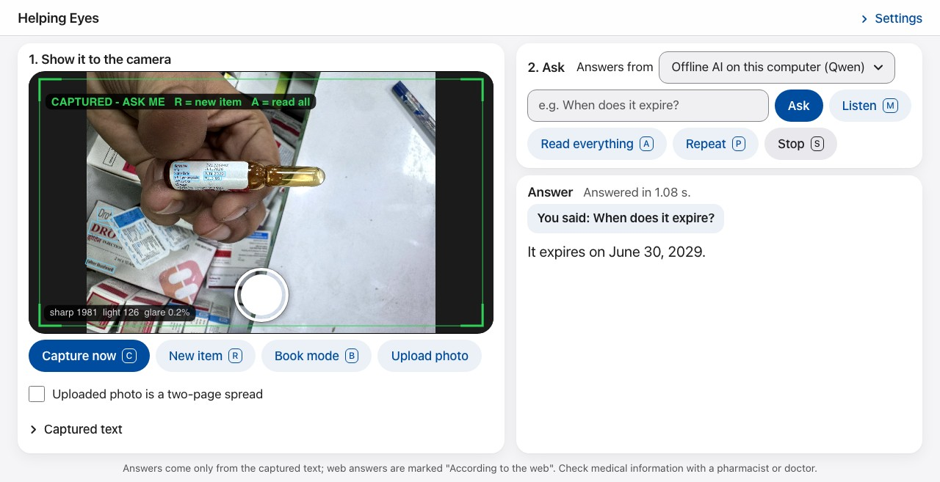
Figure 1. Capture (normal mode): a medicine label has been captured, the user asked "When does it expire?" and Qwen 3B answered from the captured text (an illustration of the interface, not a measure of accuracy).
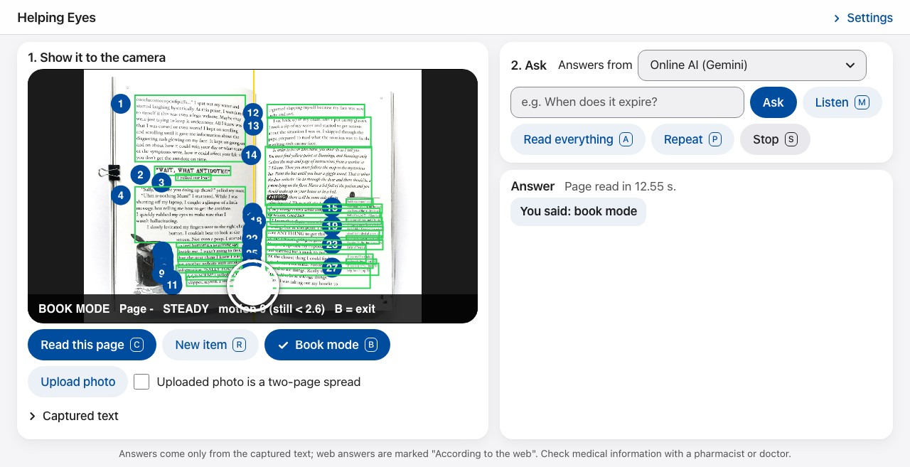
Figure 2. Book mode: the spine (yellow) and the paragraphs (green) numbered in reading order on a two-page spread; the line and word being spoken are highlighted while it reads.

9. Backend specifications
Item | Your specification | Version
Language | Python: one FastAPI process (server.py) with a thread pool; one OCR job at a time | Python 3.13 (CI: 3.11)
Web framework | FastAPI with Uvicorn; WebSocket for the live frames, streamed NDJSON for answers | fastapi 0.141.1, uvicorn 0.54.0
LLM orchestration | Direct HTTP calls to an OpenAI-compatible chat API (streaming) with a custom request router; no framework | requests 2.34.2
Model serving | Gemini (hosted) or Ollama on the Mac with qwen2.5:3b-instruct; OCR by Apple Vision (pyobjc); voice by Kokoro (kokoro-onnx) | Ollama 0.23.2; pyobjc ≥ 12; kokoro-onnx 0.6.1
Relational / document DB | None — per-session state in the server's memory, keyed by a random session id from the page, discarded after 30 minutes | —
Vector DB | None — no retrieval index (captured text fits in the context window) | —
Cache / queue | In-process: one OCR lock, a thread pool for OCR, background warm-up of the OCR and the voice | Python standard library
File / object storage | None — frames and text are not saved | —
Authentication | None — the shared address has no login; requests are rate-limited per client (30 a minute, 60 voice requests a minute, 2 live streams) | —
Secrets management | One local .env file (helping_eyes/.env, git-ignored, python-dotenv): the Gemini key, optional model, voice and ngrok settings; nothing committed to Git | —

API endpoints: the first six are served by server.py (also /api/quality for an uploaded photo's sharpness, light and glare); the last two are external services.
Method | Endpoint | Purpose | Request → Response | Auth
POST | /api/capture | Read all text in a photo (or a two-page spread) and keep it | multipart {image, sid, book} → {ok, text, label, running_title, message} | No (rate-limited)
POST | /api/ask | Commands, questions and the web lookup (after "yes") | {sid, question, provider} → NDJSON events: sentence, command, offer_search, done | No (rate-limited)
POST | /api/book/page | Book mode: read a steady page, or resume where reading stopped | multipart {image, sid, event, read_pos} → {action, text, from_pos, label, layout} | No (rate-limited)
GET | /api/health | Health check for the deployment | — → {status, model, llm_configured, ocr, memory_mb, tts_engine} | No
WS | /ws/live | Live frames: guidance and capture trigger, or page turns in book mode | JPEG frames → {type: guide | book, hint, state, …} | No (2 streams per client)
POST | /api/tts | One sentence to speech | {text} → MP3 audio (Kokoro, Edge voice as backup) | No (rate-limited)
POST | …/chat/completions (Gemini, or Ollama at localhost:11434/v1) | Generate a streamed answer | {model, messages, stream: true, temperature} → server-sent chunks | Gemini: API key; Ollama: none (local)
GET | DuckDuckGo search (ddgs) | Web lookup after consent | query → top 5 {title, body, href} | No

Database schema: Not applicable — no database. In-memory state per session: captured text with page facts, the last six question–answer pairs, the chosen model, a pending web lookup, the current page layout (line and word boxes with character offsets) and the reading position; discarded after 30 minutes.

10. Architecture diagram
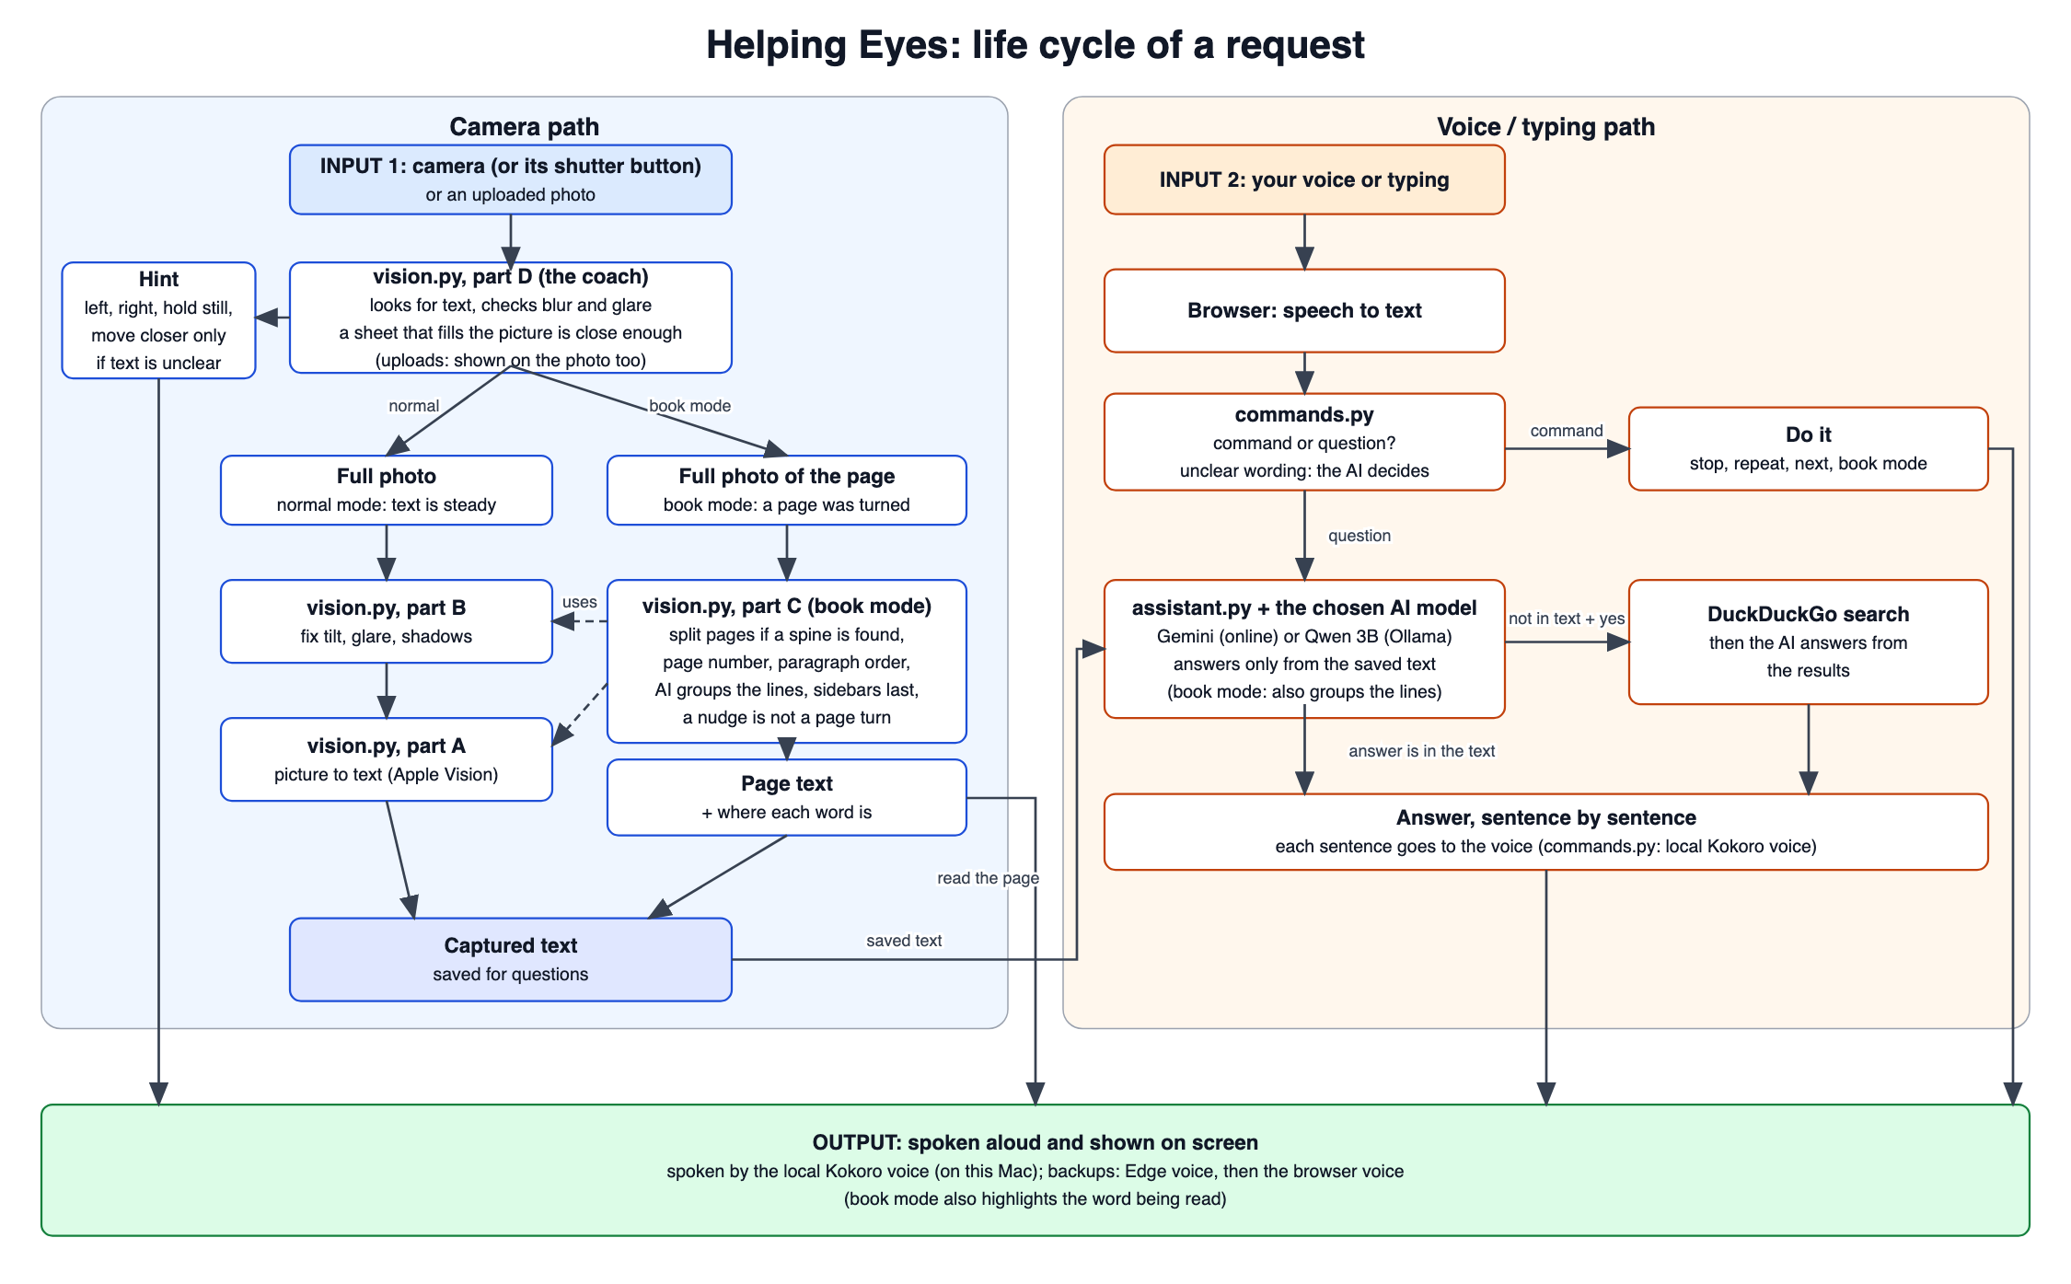
Figure 3. System architecture: the life cycle of a request, from the camera and the microphone in the browser, through the server on the Mac (vision.py, commands.py, assistant.py), to speech and the on-screen answer.

Component description:
Browser page (web/index.html, app.js): camera and microphone, sends live frames and photos, plays the server's audio, draws the overlays and highlights; speech recognition by the browser.
vision.py: Apple Vision text detection and recognition with per-word boxes; quality check and photo corrections; live guidance (LiveGuide).
vision.py, book mode: page-turn detection by frame differencing (BookWatcher), spine detection, header/footer and page-number recognition, deskew and dewarp, XY-cut reading order, the model's paragraphs, continuation after movement (BookReader).
server.py (FastAPI): sessions, rate limits, the endpoints in Section 9; run.py starts it, opens Chrome, starts Ollama if needed and opens the tunnel with --share.
assistant.py: grounded question answering with streamed output, expiry checks and page facts in code, the not-in-text tag and the consent-based web lookup; Gemini or Qwen 3B.
commands.py: the request router (commands, read everything, questions) and the voice: Kokoro on the Mac first, Edge voice as backup, the browser's voice last.
Ollama + Qwen 2.5 3B Instruct: the offline answer option on the Mac.
DuckDuckGo (ddgs): optional web lookup after consent; no account or key needed.
.env (git-ignored): the Gemini key and optional settings; no secrets in the repository.
Google Gemini 3.1 Flash-Lite: the default answer model, through its OpenAI-compatible API.
ngrok or Cloudflare tunnel (run.py --share): gives the server on the Mac a public https address for phones and other users.

11. Cloud hosting and deployment (mandatory)
Every project must be deployed on a public cloud and reachable by a public URL for the final demo. A laptop-only or Colab-only demo does not meet this requirement. Helping Eyes, changed in v0.3: In v0.3 the app is hosted on the team's Mac and reached at a public https address through a free tunnel instead, because its text reader, Apple Vision, runs only on macOS: no free cloud host offers macOS. A Linux cloud version would have to use RapidOCR, which read the key lines of the 148 test photos less accurately (87.7 % against 89.7 %) and more slowly (0.60 s against 0.17 s per photo, on the Mac; slower on a free cloud CPU). The Hugging Face Space planned in v0.2 was therefore dropped. The change is listed in the change log for the faculty mentor's approval.
Item | Your specification
Cloud provider | None: the team's Mac is the server; a free ngrok account (fixed address) or a Cloudflare Quick Tunnel (no account) makes it public over https
Free tier / credits used | Free tier only — free Gemini API tier, free ngrok domain; no credit card; total cost ₹0
Frontend hosting | Served by the same FastAPI app on the Mac (static HTML, JavaScript and CSS); the browser provides the camera (getUserMedia) and speech recognition (Web Speech API)
Backend hosting | FastAPI application (server.py) run by Uvicorn on the Mac, started by run.py; run.py --share opens the tunnel and keeps the Mac awake (caffeinate)
LLM hosting | Gemini Flash-Lite through Google's API (hosted by Google); Qwen 2.5 3B in Ollama on the Mac
Managed databases | None required (no database; per-session state in memory)
Containerisation | None (Apple Vision needs macOS; the earlier Dockerfile for a Linux host was removed)
CI/CD | GitHub Actions on a macOS runner compiles the code and runs every test (157) on each push; nothing is deployed automatically
Environment config & secrets | helping_eyes/.env on the Mac (git-ignored): LLM_API_KEY, optional LLM_MODEL, NGROK_DOMAIN, voice settings
Domain and HTTPS | The tunnel's https address: a fixed https://<name>.ngrok-free.app with a free ngrok domain, otherwise a new https://….trycloudflare.com address each run
Monitoring and logging (LLMOps) | The server log (run.py): OCR time, version kept, time to the first answer sentence, voice timing and errors per request; /api/health shows the OCR, model, voice and memory state; the ngrok request log at localhost:4040
Estimated monthly cost | ₹0 per month. The address works only while the Mac is awake and run.py --share is running
Public demo URL | https://<name>.ngrok-free.app (printed by run.py --share; fixed when NGROK_DOMAIN is set)

Deployment steps: 1. Get a free Gemini key at Google AI Studio and put it in helping_eyes/.env as LLM_API_KEY. 2. pip install -r requirements.txt in the virtual environment; python run.py --get-voice once for the Kokoro voice. 3. Optional: brew install ollama and ollama pull qwen2.5:3b-instruct for the offline model. 4. brew install ngrok, ngrok config add-authtoken <token>, and NGROK_DOMAIN=<free domain> in .env (or brew install cloudflared). 5. Plug in the charger and run python run.py --share; wait for "Ready" and open the printed https address on a phone. 6. Check <address>/api/health. Full steps: markdown/hosting.md.
Shutdown plan: No paid resources are used, so no charges can arise. Ctrl+C stops the server and the address; the Gemini key can be deleted in Google AI Studio after the evaluation.

12. Risks and mitigation
Risk | Likelihood (L/M/H) | Impact (L/M/H) | Mitigation / fallback
Gemini is busy or the free daily limit is used up during the demo | M | M | Spoken "busy" message with retry; switch the Answers from menu to Qwen 3B on the Mac; read everything and page numbers never need a model
The Mac sleeps, loses the network or the tunnel address changes before the demo | M | M | run.py --share keeps the Mac awake; a fixed ngrok domain; start a few minutes before the demo; keep the backup recording
Hosting on one Mac instead of a cloud host does not meet the course's cloud requirement | M | H | Reason documented in Section 11 (Apple Vision is macOS-only; measured accuracy and speed); ask the faculty mentor for approval (OQ-1); public https address works from any device
OCR errors on curved, glossy or blurred print lead to wrong answers | M | H | Hold-still capture, spoken guidance, answers only from captured text; user can ask to read everything to check
Wrong or invented medical details from the language model | M | H | Grounding rules, not-in-text tag, expiry computed in code, pharmacist reminder
No internet: speech recognition, Gemini, the web lookup and the shared address unavailable | M | M | On the Mac: Qwen 3B and the Kokoro voice work offline; typed requests and keys still work
DuckDuckGo rate limits or library changes | M | L | Spoken error message; switch to another free search source if needed
Several visitors at once slow the live guidance (one OCR job at a time on the Mac) | L | M | Per-client rate limits and at most 2 live streams per client; share the address only with the demo audience
The microphone hears the app's own voice | L | M | The microphone is paused while the app speaks and turns itself on again when it is quiet; pressing Listen while it talks stops the talking

13. Timeline and milestones
Week | Milestone | Deliverable | Owner
1–2 | Requirements approved | This document, signed off | [Name]
3–4 | Test set collected, baseline running | Baseline results: OCR, answers, book mode | [Name]
5–7 | Core pipeline complete; web app on the Mac with a public address (run.py --share); Docker / Hugging Face plan dropped (Section 11) | Working prototype on a public https address | [Name]
8–9 | Evaluation and improvement | Metrics table filled (markdown/eval_results.md) | [Name]
10 | Final submission | Live demo at the public address, report, code, slides | All

14. Final deliverables
- Source code in a public or instructor-shared GitHub repo with a README and setup steps
- Working demo at the public https address (5–7 minutes), plus a backup recording
- Final report with evaluation results mapped to FR/NFR IDs
- Presentation slides
- Individual contribution statement from each member

15. Open questions
- OQ-1 (changed 28-10-2026) Hosting: the app runs on the team's Mac with a public https address through a free tunnel, not on a cloud host, because Apple Vision is macOS-only (Section 11). Remaining: confirm with the faculty mentor that this meets the deployment requirement. Owner: [Name]; by [DD-MM-YYYY].
- OQ-2 (done 28-10-2026) Real-world test set: 148 pharmacy photos with a reference reading of each, plus food labels, book pages, documents, signs, a page-turn video and 24 expiry texts; results in markdown/eval_results.md.
- OQ-3 On-device speech recognition (e.g. Whisper on the Mac) to remove the internet dependency for spoken requests; today the browser's online speech service is used. Owner: [Name]; by [DD-MM-YYYY].
- OQ-4 (closed) The optional Gemini reader became the default answer model; Qwen 3B is the offline option, chosen on the page.
- OQ-5 (done) The synthetic book-mode tests are in the repository (helping_eyes/tests/test_vision_book.py) and run on every push.

16. Change log
Date | Version | Change | Reason
26-09-2026 | v0.1 | Initial requirements document | First submission for sign-off
26-09-2026 | v0.2 | Cloud deployment decided: free Hugging Face Space (Section 11); web version added (FR-13, new user type and screen); LLM, data, NFR, evaluation, backend, endpoints, architecture, risks, timeline and OQ-1 updated | Cloud deployment is mandatory; all components must be free
28-10-2026 | v0.3 | Updated to the system as built: web app served from the Mac with a public https address through a free tunnel instead of a Hugging Face Space (Section 11, OQ-1); Gemini Flash-Lite as default model and Qwen 2.5 3B as the offline option (Qwen 7B removed); Kokoro voice; browser speech recognition; accessibility settings; real-world evaluation methods and data (Sections 5, 7); endpoints, backend, architecture, risks and open questions updated | The cloud plan could not keep Apple Vision (macOS only), which read the test photos best; the document must describe the delivered system. Needs the faculty mentor's approval

17. Sign-off
Role | Name | Signature | Date
Team lead | [Name]
Faculty mentor | [Name]

