1)
Change the tab setting to have 4 spaces instead of a tab.
http://stackoverflow.com/questions/407929/how-do-i-change-eclipse-to-use-spaces-instead-of-tabs

2)
Create project from git directory (Some screenshots maybe be on next page so scroll down and check before making final selection):
File → New → Java Project

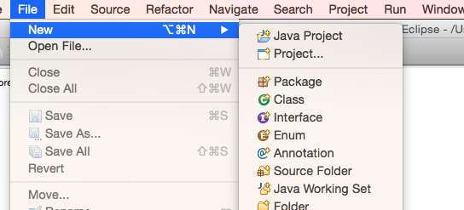

a) Enter project name as “BillingSystem”
b) Uncheck the checkbox for “Use default location”
c) Click “Browse” button to select the directory where the source for system exists select uptill the folder name “Canyou” (where the git code exists)
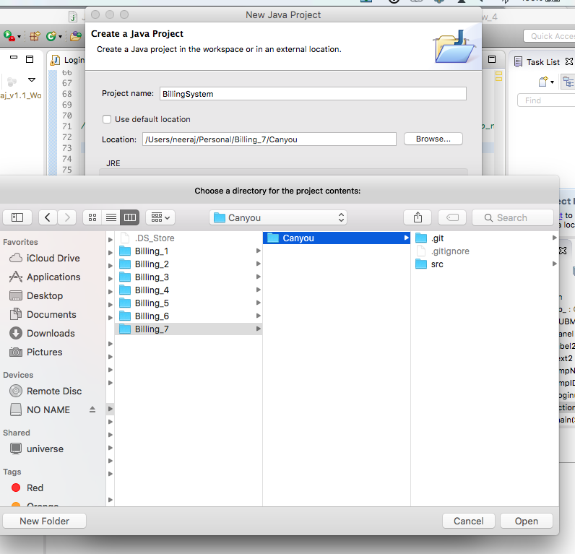
d) Hit “Open”
e) Then click “Finish” (on the project creation screen)

File → Import

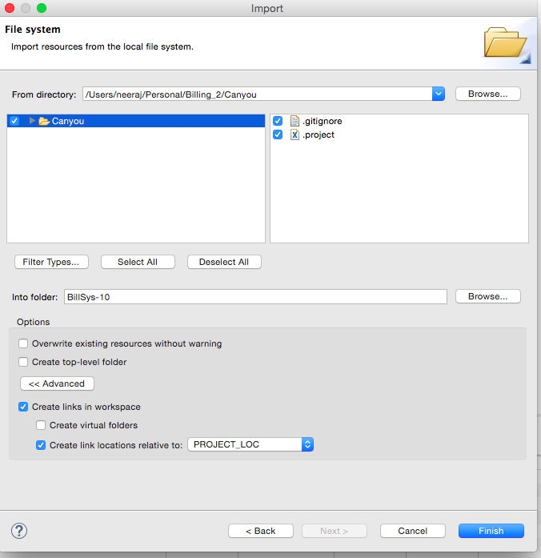

3) Adding database mysql-connector jar to project else your code would either not compile or you would get below exception:

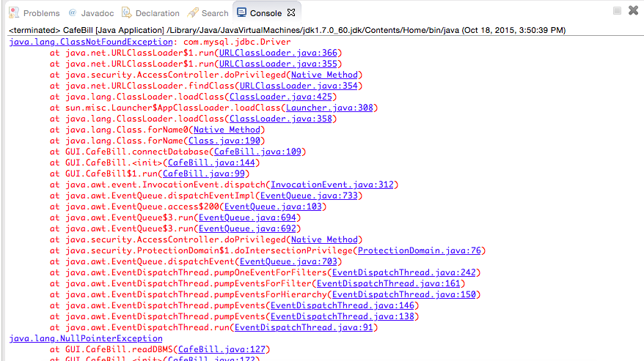

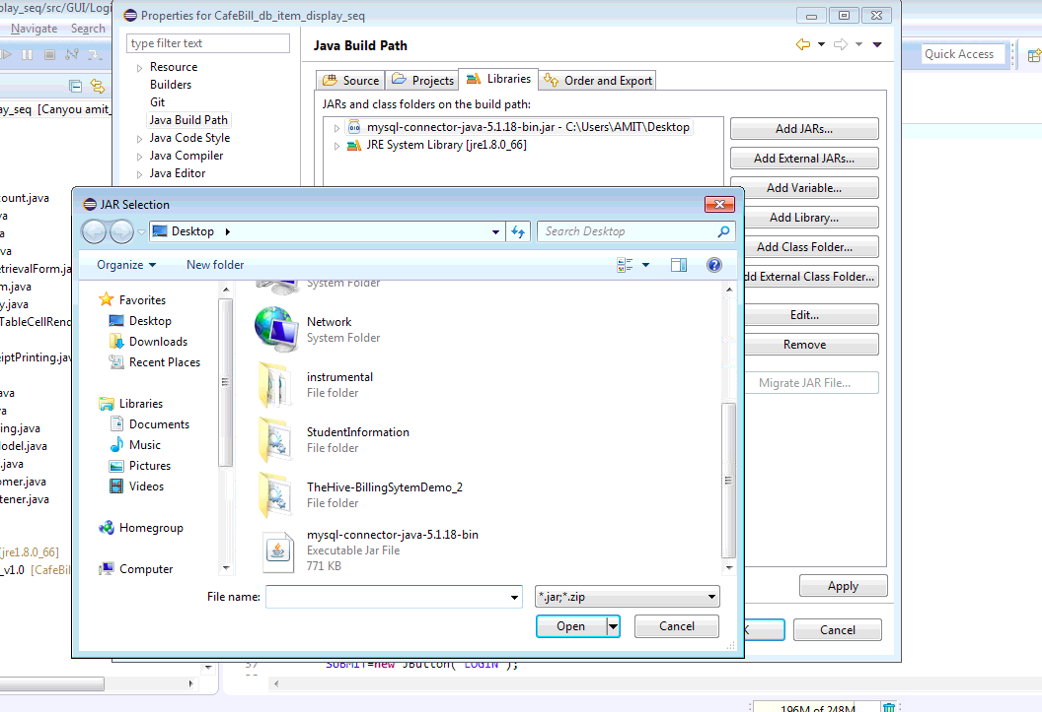
Select the file ”mysql-connector” from our project folder the file is user Canyou->src->lib

