**Audience Persona**

**Mary Bjornsdottir**

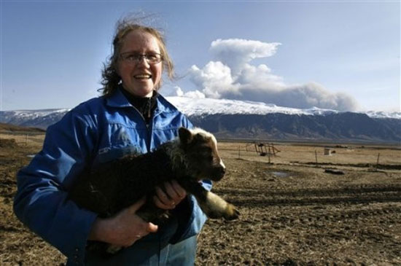

**Age**: 50

**Culture & Nationality**

Icelandic

**Occupation**

Potato Farmer

**Relationship Status and Family**

Married three times with 11 kids

Mary Bjornsdottir is a potato farmer who lives in South Iceland, close to Eyafjallajokull volcano. She likes country music, hiking, gardening, and rock collecting and her favorite foods are salmon and lamb. She is part of the Pirate Party which supports open information and access.

As a farmer, Mary is an early riser and works hard to mend her crop. She wakes up at 6 am to check the weather and eat breakfast. Afterwards she goes to the farm to check on the potatoes. She eats her daily sack lunch then begins to harvest the potatoes. Closer to the afternoon, she puts away the farming equipment and potatoes into storage. Every Friday of the week, a truck comes by to pick up the potatoes. She then eats an early dinner and goes to bed soon after. Her career goals include farming more potatoes than her rival neighbors. Currently, she is a local farmer but dreams to expand her business beyond Iceland.

**Skills**

Her skills include time management, craftsmanship, harvesting, and interpersonal skills

**Knowledge:**

As an Icelander, Mary is aware and has been aware of volcanic activity and earthquakes in Iceland. She is not fearful of volcanic activity and she is aware of the emergency evacuation plans.

**User Needs**

Mary needs to know when a volcano erupts because the ash that falls ruins her crops. Furthermore, she has poor and limited access to the internet so she is unable to monitor announcements from the Icelandic Met Office.

Word Count: 269