**PBJ Documentation**

**Ingredients Required:**

* Natural Peanut Butter (avoid using processed peanut butter since it may make the sandwich greasy and bitter in taste)
* Jam (Preferably a whole fruit jam since it will add the fruity flavor and tanginess that you need to balance out the PBJ sandwich)
* Fresh Bread (preferably white bread, but you may choose to use brown bread)

**Procedure:**

1. Take two slices of bread (white or brown, as per your preference).

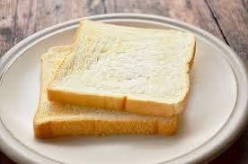

1. Mix the contents of the jar of peanut butter thoroughly with a spoon or butter knife.

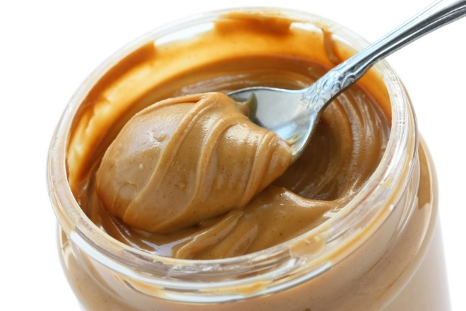

1. Apply sufficient quantity of peanut butter evenly on one of the slices of bread.

*Note: Too much peanut butter will overwhelm the sandwich with the flavor.*

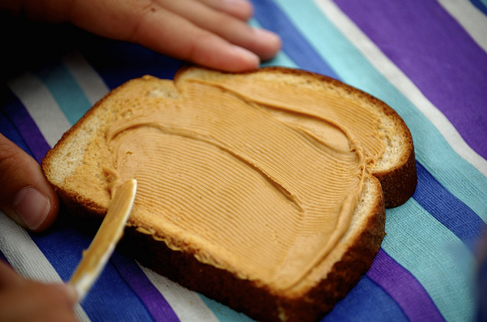

1. Apply sufficient quantity of jam on the other slice of bread.

*Note: Too much jam will just make the sandwich thus compromising the balance of flavors.*

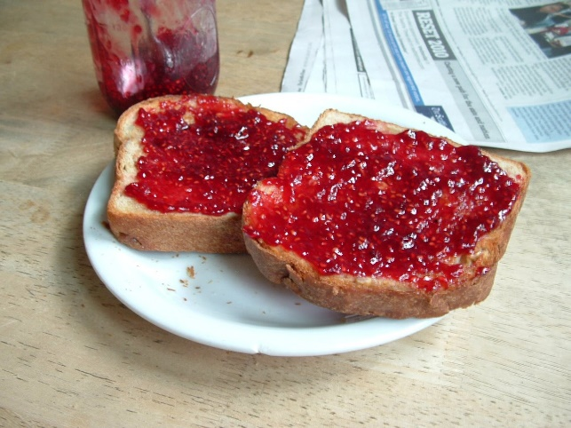

1. Put the two slices together such that the peanut butter and the jam touch each other.

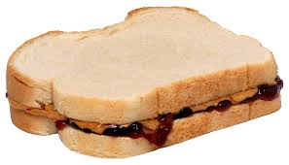

1. Apply butter on either side of the sandwich and toast it on a pan on low heat till you see a crispy golden crust on the outside which adds texture to your PBJ.

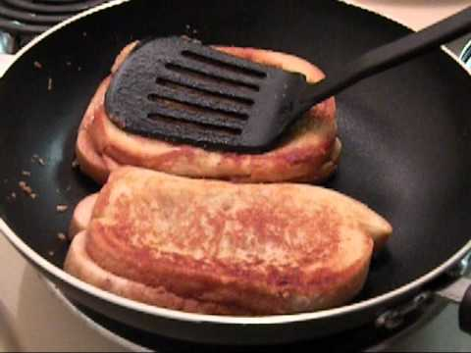

If you like grilling your sandwiches on the grill, you may do so too.

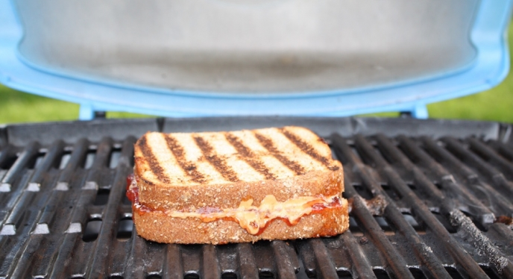

*Note: Toasting or grilling will also make the flavors inside the sandwich infuse together thus improving the quality of the PBJ.*

1. *Optional Step:* Place the toasted (or grilled) sandwich on the serving plate and cut in two halves.

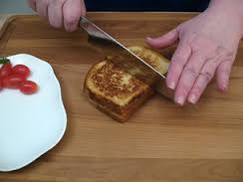

**Result:**

Your PBJ sandwich is ready!

