Selenium WebDriver Hierarchy
Understanding Selenium hierarchy is VERY important for:
- framework design
- interview questions
- advanced automation
- Selenium internals

1. Complete Selenium Driver Hierarchy
SearchContext
↑
WebDriver
↑
RemoteWebDriver
↑
--------------------------------
↑ ↑ ↑
ChromiumDriver FirefoxDriver SafariDriver
↑
--------------------------------
↑ ↑
ChromeDriver EdgeDriver

2. SearchContext (Top Level)
This is the root interface.
Provides:
- element searching capability
Methods:
find_element()
find_elements()

Example
element = driver.find_element(By.ID, "username")
Both:
- WebDriver
- WebElement
inherit from:
- SearchContext

Hierarchy
SearchContext
↑
WebDriver
↑
WebElement
That is why BOTH can search elements.

3. WebDriver Interface
Main Selenium interface.
Defines browser-level operations.
Common methods:
Method | Purpose
get() | Open URL
back() | Browser back
forward() | Browser forward
refresh() | Refresh page
close() | Close tab
quit() | Close browser
title | Get page title
current_url | Get URL

WebDriver Role
Defines WHAT browser should do.
Not HOW.

4. RemoteWebDriver
This is the actual core implementation.
Implements:
- WebDriver
- JavascriptExecutor
- TakesScreenshot
- Interactive
- HasCapabilities

Major Role of RemoteWebDriver
Handles:
- HTTP communication
- W3C protocol
- Selenium commands
- Session management
- Remote execution

Architecture
Test Script
↓
RemoteWebDriver
↓
HTTP Commands
↓
Browser Driver
↓
Browser

Important Point
Almost EVERYTHING in Selenium finally works through:
- RemoteWebDriver

5. ChromiumDriver
Intermediate class for Chromium browsers.
Parent of:
- ChromeDriver
- EdgeDriver
Provides Chromium-specific implementation.

Hierarchy
RemoteWebDriver
↑
ChromiumDriver
↑
ChromeDriver

Chromium Browsers
Browser | Uses ChromiumDriver?
Chrome | Yes
Edge | Yes
Brave | Yes
Opera | Yes

6. ChromeDriver
Actual Chrome implementation.
Used in:
driver = webdriver.Chrome()
Internally:
ChromeDriver
↓
ChromiumDriver
↓
RemoteWebDriver
↓
WebDriver

ChromeDriver Responsibilities
- Starts chromedriver.exe
- Creates session
- Launches Chrome
- Translates Selenium commands

7. FirefoxDriver
Separate implementation for Firefox.
RemoteWebDriver
↑
FirefoxDriver
Uses:
- geckodriver

8. EdgeDriver
Edge also Chromium-based.
RemoteWebDriver
↑
ChromiumDriver
↑
EdgeDriver
Uses:
- msedgedriver

9. Browser Driver Role
Browser drivers act as translators.
Selenium Command | Driver Translation
click() | Browser native action
send_keys() | Keyboard events
get() | Navigation command

Example Flow
driver.find_element(By.ID, "btn").click()
Internal flow:
Python Selenium
↓
RemoteWebDriver
↓
HTTP Request
↓
ChromeDriver
↓
Chrome DevTools Protocol
↓
Chrome Browser

10. Browser Itself
Actual UI application:
- Chrome.exe
- firefox.exe
- msedge.exe
Selenium never directly controls browser.
It controls:
- browser driver
Driver controls:
- browser

11. Important Selenium Interfaces

A. JavascriptExecutor
Used for JavaScript execution.
driver.execute_script()
Implemented by:
- RemoteWebDriver

B. TakesScreenshot
driver.save_screenshot()
Implemented by:
- RemoteWebDriver

C. HasCapabilities
driver.capabilities
Provides:
- browser version
- platform
- capabilities

13. Most Important Interview Concept
Question:
Why is RemoteWebDriver important?
Answer:
RemoteWebDriver is the core Selenium implementation responsible for HTTP communication, session management, command execution, and browser interaction. All browser-specific drivers like ChromeDriver and FirefoxDriver ultimately inherit from it.
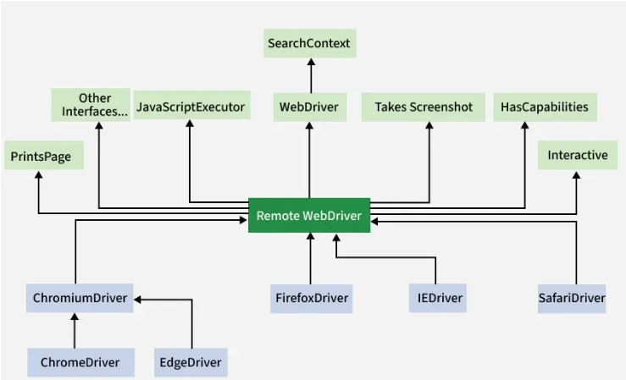
14. Super Important Hidden Concept
Even local execution is actually remote architecture internally.
When you run:
webdriver.Chrome()
internally:
Python Script
↓
RemoteWebDriver
↓ HTTP
ChromeDriver Server
↓
Chrome Browser
ChromeDriver itself is a small HTTP server.

15. Real-Time Enterprise Architecture
Pytest Framework
↓
Page Objects
↓
WebDriver Factory
↓
RemoteWebDriver
↓
Grid / Driver Server
↓
Browser
This is how enterprise frameworks work.

