# **Team details:**

**NANDANA MANOJ PES2UG20CS215**

**NEERAJ SUDHEER PES2UG20CS221**

**PRATHAM MANJA PES2UG20CS253**

**PREETHIKA AJAY KUMAR PES2UG20CS256**

# **Project Plan Document**

**1: Identify the lifecycle to be followed for the execution of your project and justify why you have chosen the model.**

MODEL USED : Agile-Waterfall Hybrid Model

Agile method on an enterprise level while using the Waterfall method for requirements, design, and implementation.The Agile-Waterfall hybrid incorporates the best of both methods. We have a fixed requirement for this project , and every deliverable has been already finalized. Only the implementation requires the team to use the agile philosophy where everything is flexible including the deadlines. The reason the two methodologies can work harmoniously is that Agile is more a mindset and approach than a methodology, so it’s possible to use the Agile philosophy with the more rigid Waterfall methodology.

**2: Identify the tools which u want to use throughout the lifecycle like planning tool, design tool, version control, development tool, bug tracking, testing tool.**

Tools used in this project are as follows:

Planning Tool : Jira

Design Tool : Not Applicable

Version Control Tool : Git/GitHub

Development Tool : Collaboratory

Bug Tracking Tool : ClickUp

Testing Tool : Selenium

**3: Determine all the deliverables and categorize them as reuse/build components and justify the same.**

Documents:

* Software Requirements Specification
* Architecture
* Test Plan
* Test Results

Executables:

* Keyboard Interface component - This can be reused by adapting to different input devices.
* Speed Test algorithm
* Components can be dockerized and can be deployed in the public cloud

**4: Create a WBS for the entire functionalities in detail.**

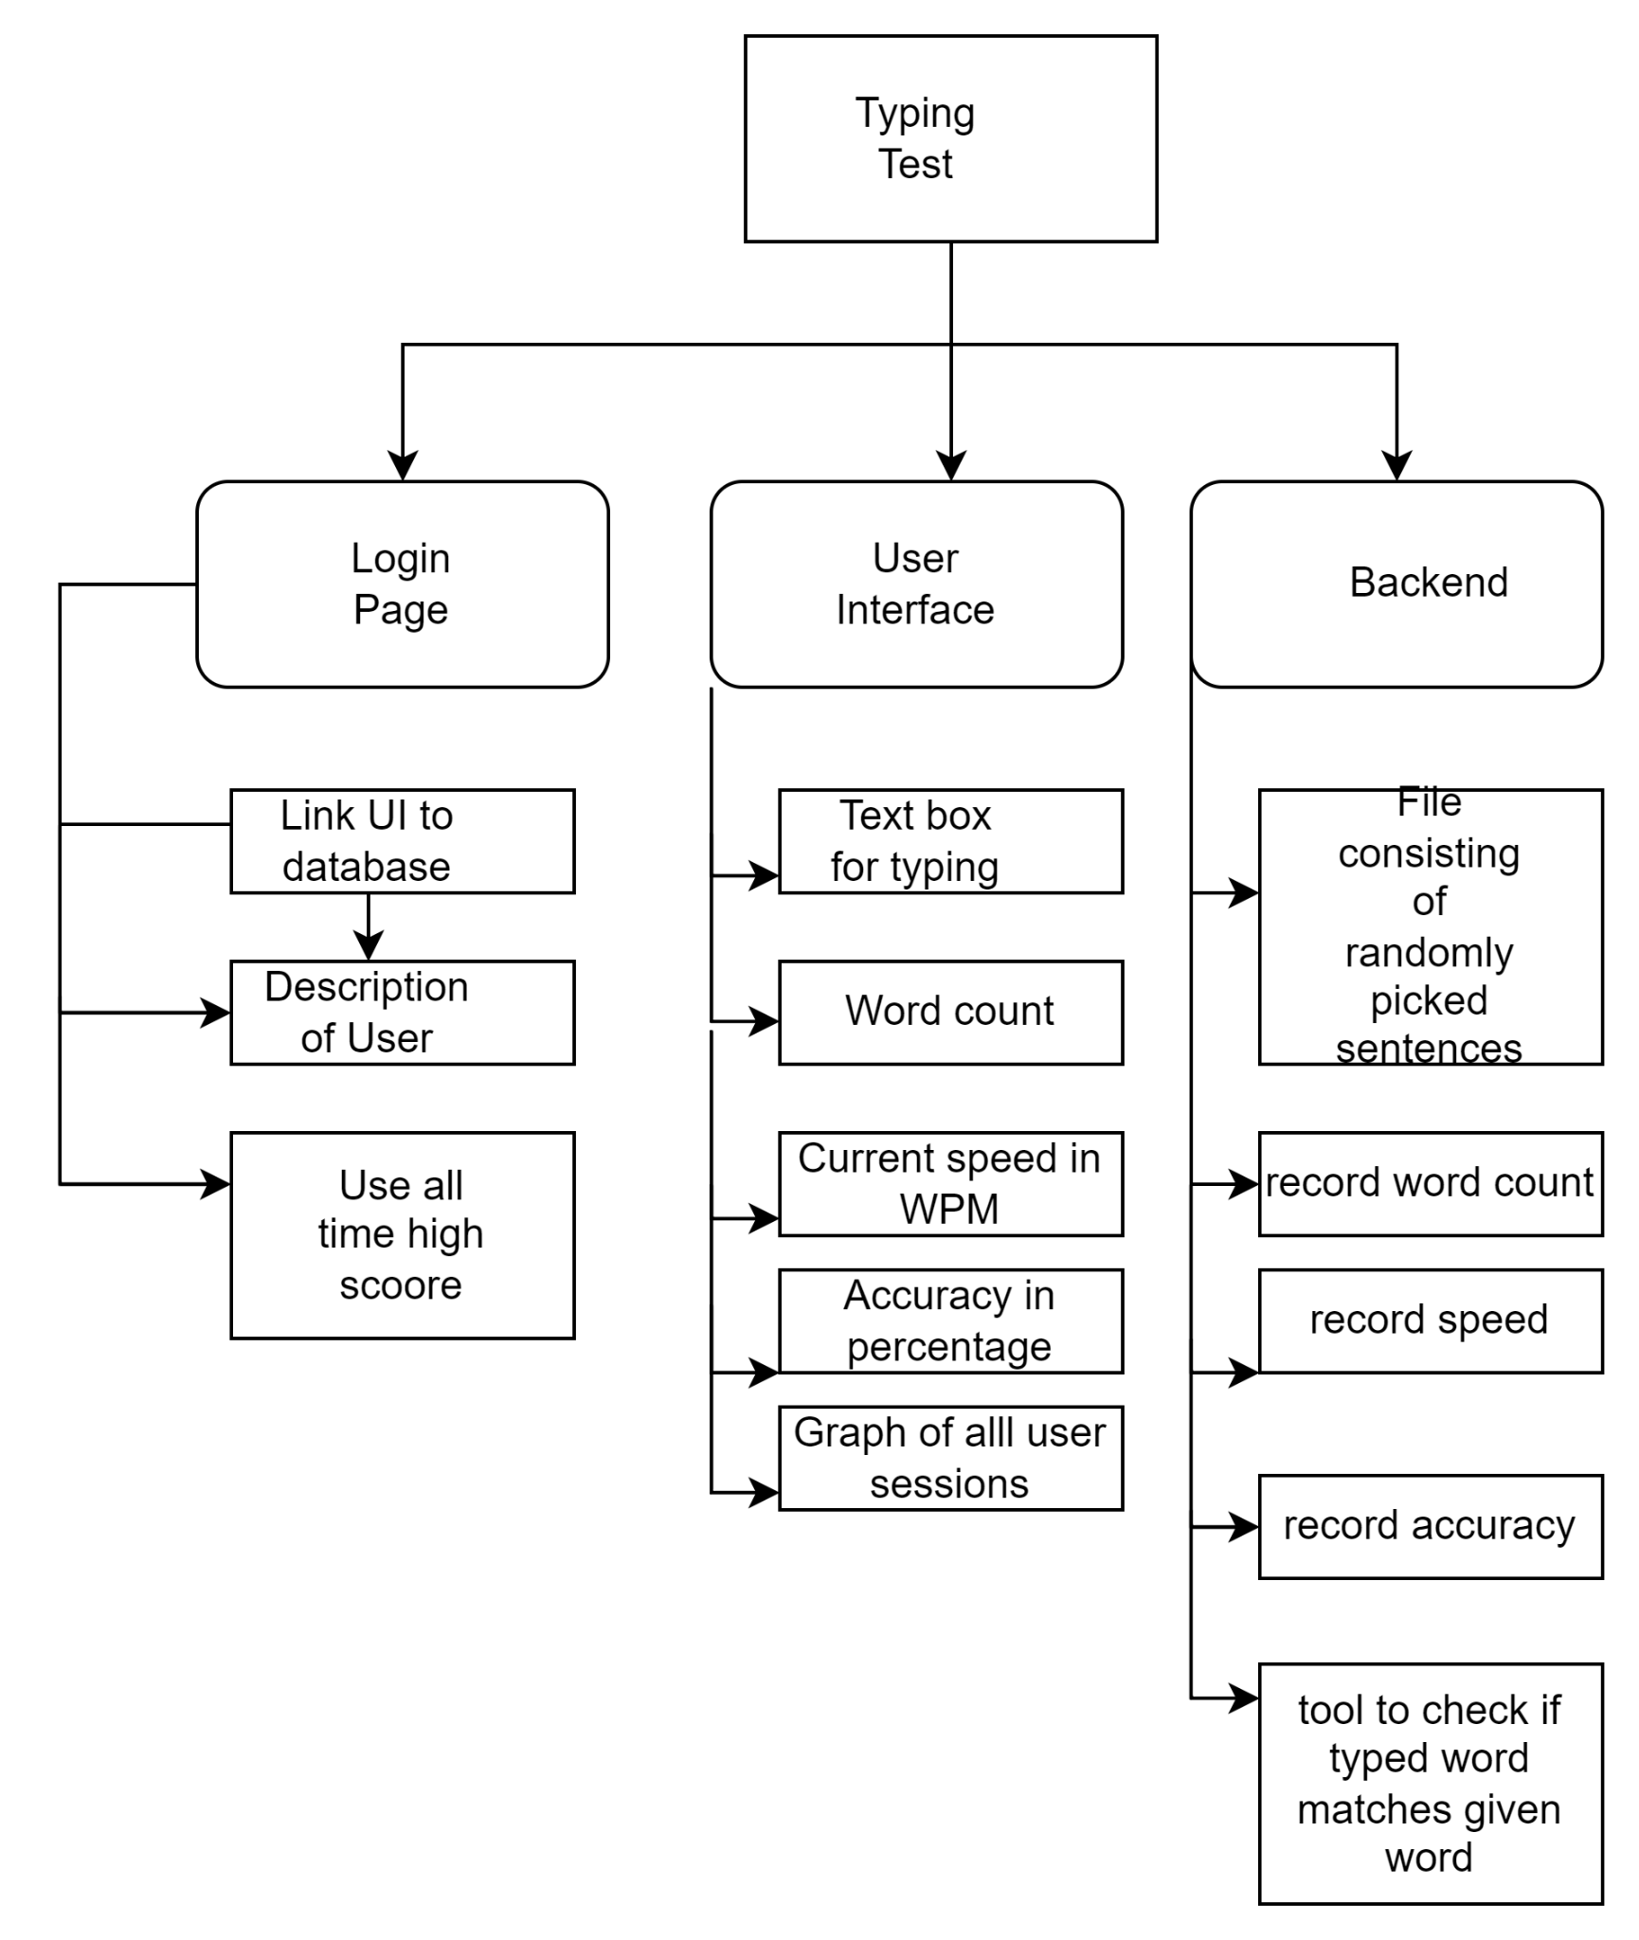

**5: Do a rough estimate of effort required to accomplish each task in terms of months.**

Our project is a short term project so we can consider it organic. Therefore, we can assume to have atleast 500 lines of code

Now,we can estimate effort using cocomo model

E= 2.4*(500*10^-3)^1.05

=1.159 PM

**6: Create the Gantt Chart for scheduling using any tool.`**

Project split into Sprints:

We have 6 sprints which are mentioned below:

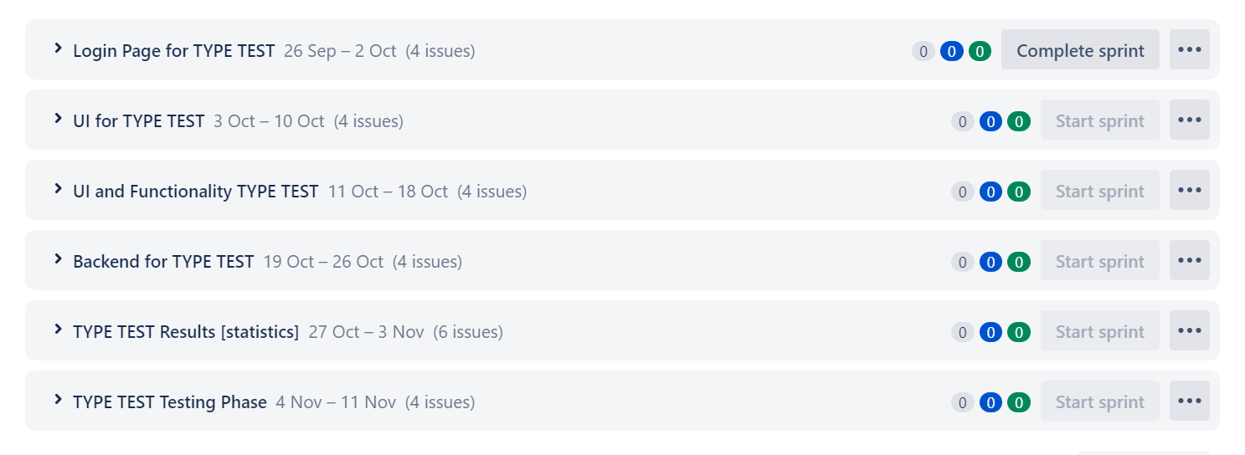

Under sprint 1 we have following issues

| **[SPEED-1]** [**Task for creating credentials for a new user**](https://pratham72.atlassian.net/browse/SPEED-1)Created: 13/Sep/22 Updated: 24/Sep/22 | |
| --- | --- |
| **Status:** | To Do |
| **Project:** | [Typing Speed test Software](https://pratham72.atlassian.net/secure/BrowseProject.jspa?id=10000) |
| **Components:** | None |
| **Affects versions:** | None |
| **Fix versions:** | None |

| **Type:** | Story | **Priority:** | Medium |
| --- | --- | --- | --- |
| **Reporter:** | [Pratham Manja](https://pratham72.atlassian.net/secure/ViewProfile.jspa?accountId=63203afed1b3f6489b92f563) | **Assignee:** | [Nandana Manoj](https://pratham72.atlassian.net/secure/ViewProfile.jspa?accountId=63203bf555a96b85c3118e43) |
| **Resolution:** | Unresolved | **Votes:** | 0 |
| **Labels:** | None | | |
| **Remaining Estimate:** | Not Specified | | |
| **Time Spent:** | Not Specified | | |
| **Original estimate:** | Not Specified | | |

| **Rank:** | 0|hzzzzz: |
| --- | --- |
| **Sprint:** | Login Page for TYPE TEST |

Generated at Mon Sep 26 12:24:27 UTC 2022 by Pratham Manja using Jira 1001.0.0-SNAPSHOT#100207-sha1:1c92a42278ca3d773804961d926813b1c02585cb.

| **[SPEED-3]** [**Task for creating a password authentication system**](https://pratham72.atlassian.net/browse/SPEED-3)Created: 24/Sep/22 Updated: 24/Sep/22 | |
| --- | --- |
| **Status:** | To Do |
| **Project:** | [Typing Speed test Software](https://pratham72.atlassian.net/secure/BrowseProject.jspa?id=10000) |
| **Components:** | None |
| **Affects versions:** | None |
| **Fix versions:** | None |

| **Type:** | Story | **Priority:** | Medium |
| --- | --- | --- | --- |
| **Reporter:** | [Pratham Manja](https://pratham72.atlassian.net/secure/ViewProfile.jspa?accountId=63203afed1b3f6489b92f563) | **Assignee:** | [Pratham Manja](https://pratham72.atlassian.net/secure/ViewProfile.jspa?accountId=63203afed1b3f6489b92f563) |
| **Resolution:** | Unresolved | **Votes:** | 0 |
| **Labels:** | None | | |
| **Remaining Estimate:** | Not Specified | | |
| **Time Spent:** | Not Specified | | |
| **Original estimate:** | Not Specified | | |

| **Rank:** | 0|i0000f: |
| --- | --- |
| **Sprint:** | Login Page for TYPE TEST |

Generated at Mon Sep 26 12:24:59 UTC 2022 by Pratham Manja using Jira 1001.0.0-SNAPSHOT#100207-sha1:1c92a42278ca3d773804961d926813b1c02585cb.

