Software Requirements Specification

for Typing Speed Test Software

**Version 1.0 approved**

**Prepared by:**

**Nandana Manoj - PES2UG20CS215  
Neeraj Sudheer - PES2UG20CS221  
Pratham Manja - PES2UG20CS253  
Preethika Ajay Kumar - PES2UG20CS256**

**PES University  
15.09.2022**

**Table of Contents**

**Table of Contents ii**

**Revision History ii**

**1. Introduction 1**

1.1 Purpose 1

1.2 Intended Audience and Reading Suggestions 1

1.3 Product Scope 1

1.4 References 1

**2. Overall Description 2**

2.1 Product Perspective 2

2.2 Product Functions 2

2.3 User Classes and Characteristics 2

2.4 Operating Environment 2

2.5 Design and Implementation Constraints 2

2.6 Assumptions and Dependencies 3

**3. External Interface Requirements 3**

3.1 User Interfaces 3

3.2 Software Interfaces 3

3.3 Communications Interfaces 3

**4. Analysis Models**

**5. System Features 4**

5.1 System Feature 1 4

5.2 System Feature 2 (and so on) 4

**6. Other Nonfunctional Requirements 4**

6.1 Performance Requirements 4

6.2 Safety Requirements 5

6.3 Security Requirements 5

6.4 Software Quality Attributes 5

6.5 Business Rules 5

**7. Other Requirements 5**

**Revision History**

| **Name** | **Date** | **Reason For Changes** | **Version** |
| --- | --- | --- | --- |
|  |  |  |  |
|  |  |  |  |

# Introduction

## Purpose

The product whose software requirements are specified in this document is a Typing Tutor. This product is aimed to help users increase their typing speed. This product can be used by anyone who is looking to improve their typing speed and accuracy. The various writing statistics computed can help the users better themselves every time.

## Intended Audience

The potential audiences for this document are the design and development team to specify software designs. The test team can define the test scenarios according to the requirements specified. Project Manager, Quality Manager and Stakeholders will use this SRS document for reviewing.

## Product Scope

This project aims to create a Typing Test that can help users assess attributes like their speed and accuracy. This software will be immensely helpful to those trying to better the way the type. An interactive GUI will be used to provide the users with an interface to type. The project is implemented like a game and makes it fun to use.

# Overall Description

## Product Perspective

*The software that we are developing is a follow on member of a product family with some improvements.Our system includes a python module which works to provide best user interface*

## Product Functions

*Our product Functions include:*

* *A user interface to practise typing*
* *A backed file system to store all the list of words to be displayed*
* *A statistics page which displays all the calculated informations like*
* *accuracy*
* *words per minute*
* *word count*

## User Classes and Characteristics

*Our Product is basically made for the learners who actually want to increase their expertise in typing.Mostly its focusing on students and tech experts who want to increase their typing speed and accuracy*

## Operating Environment

*the software requires following operating environment:*

* *python version 3.0 and above*
* *windows 8 and above*

## Design and Implementation Constraints

*The client must have the following Hardware Configurations:*

* *RAM 8GB*
* *Python library*
* *Pygame library installed*

*Apart from these client must also provide system access these programs*

## 2.6 Assumptions and Dependencies

*Assumptions are*

* *The Operating system is windows 8 and above*
* *The version of the python library in client’s system*

# External Interface Requirements

## User Interfaces

* *The game opens with a welcome page*
* *The typing page automatically appears after sometime*
* *A sentence appears on the screen( for the typist to reciprocate in the text box)*
* *A text box is present for the typist to type the displayed sentence*
* *On pressing enter, the results are displayed( time taken to finish typing, accuracy, words per minute)*

## Software Interfaces

* *A text file containing a list of sentences(randomly shuffled and displayed in UI)*
* *Tools used:*
  + *Python*
* *Libraries in python:*
  + *pygame*
  + *sys*
  + *time*
  + *random*
  + *tkinter*
  + *timeit*
* *Operating System Support:*
  + *Windows 10/11*
  + *Ubuntu 22.02*

# Analysis Models

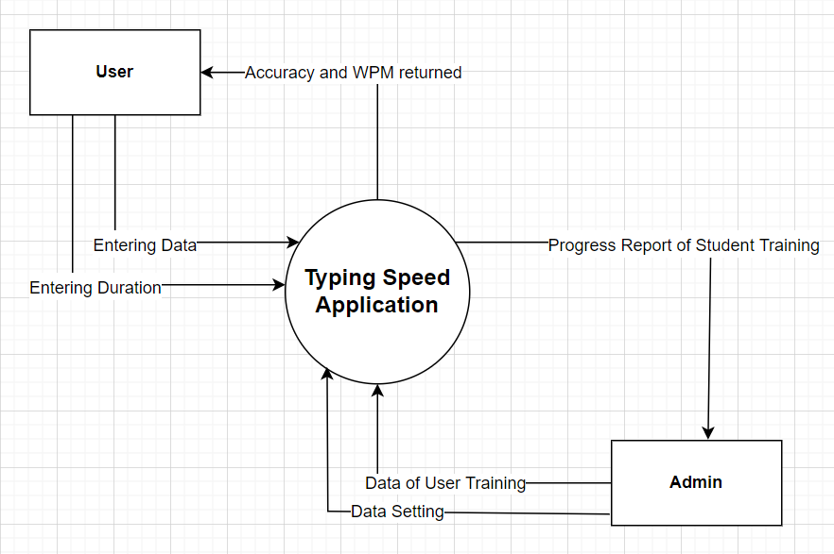

This is the use case diagram for the Application , here the user enters the time duration of the test and then starts the test. After it is submitted , the information is processed and using the already provided formulas and modules as specified by the Admin , the results and the associated graphs and formulated and then returned to the user.

# System Features

## Set Time Module

5.1.1 Description and Priority

*This is a module of very high priority. The user selection of the time decides the size of the text and the complexity of the test he/she will be provided. It basically helps a person select the duration of the test and suitable text is provided considering the selected time. We have a time limit of 30 seconds, 60 seconds and 90 seconds. The user can pick any of the available time limits to take the test. The user will not be able to enter custom time as we have text suitable only for the provided time limits.*

5.1.2 Stimulus/Response Sequences

*When a time interval is chosen by the user,he/she is greeted with a paragraph of text suitable for that time limit.*

5.1.3 Functional Requirements

*The functional requirements are not completely gathered . TBD*

REQ-1: TBD

REQ-2: TBD

## Display Result and Associated Statistics Module

5.2.1 Description and Priority

*This is a module of very high priority.This will be initiated just after the time limit has exhausted or when the user has stopped his/her session. When it is initiated it takes all the data entered by the user as well as the time as the input and compares it with the correct text to test for accuracy. It also calculated the WPM (words per minute) and generates a graph for the same*

5.2.2 Stimulus/Response Sequences

*When a user completes his/her session either by stopping or when the counter stops , the data is processed and relevant information is displayed.*

5.2.3 Functional Requirements

*The functional requirements are not completely gathered . TBD*

REQ-1: TBD

REQ-2: TBD

## 

# Other Nonfunctional Requirements

## Performance Requirements

* *Characters typed by user should be displayed on GUI without lag.*
* *Immediate display of user statistics.*
* *Interactive and engaging user interface.*

|  |  |  |  |  |
| --- | --- | --- | --- | --- |
|  |  |  |  |  |
|  |  |  | |  |
|  |  |  |  |  |
|  |  |  |  |  |
|  |  |  |  |  |
|  |  |  |  |  |
|  |  |  |  |  |
|  |  |  |  |  |