32
Mechanical harvesting in crop plants
32.1 Introduction
Mechanical harvesting is the process of using agricultural machinery to mechanize the work of harvesting in agricultural crops, greatly increasing farm worker productivity. In modern times, powered machinery has replaced many farm jobs formerly carried out by manual labour or by working animals such as oxen, horses and mules. The entire history of agriculture contains many examples of the use of tools, such as the hoe and the plough. But the ongoing integration of machines since the Industrial Revolution has allowed farming to become much less labour-intensive. Current mechanized agriculture includes the use of tractors, trucks, combine harvesters, countless types of farm implements, airplanes and helicopters (for aerial application), and other vehicles. Precision agriculture even uses computers in conjunction with satellite imagery and satellite navigation (GPS guidance) to increase yields. Mechanization was one of the large factors responsible for urbanization and industrial economies. Besides improving production efficiency, mechanization encourages large scale production and sometimes can improve the quality of farm produce. On the other hand, it can displace unskilled farm labour and can cause environmental degradation (such as pollution, deforestation, and soil erosion), especially if it is applied shortsightedly rather than holistically.
Harvesting is the last field operation and one of the most demanding. It is carried out within a limited period, and delay leads to field losses and to loss of quality. Mechanical harvesting is therefore attractive when it meets the following objectives:
- Timeliness: harvesting at the right stage of maturity, before weather damage or shattering reduces yield and quality.
- Capacity and cost: a high work rate per machine and per operator, and a lower cost per unit of produce.
- Reduced drudgery and labour: less hard manual work, and less dependence on seasonal labour that is increasingly scarce or costly.
- Quality and losses: lower field losses and, in the best cases, a cleaner and more uniform product.

32.1.1 Types of Harvesting Machines
Harvesting machines differ according to the crop and the part of the plant that is harvested. Combine harvesters cut, thresh and clean cereals, pulses and oilseeds in one pass. Cotton pickers and strippers remove the seed cotton from the plant. Sugarcane harvesters cut the stalks at the base, remove the tops and trash, and either leave whole stalks or cut them into billets. Fruit harvesters either shake the plant so that the ripe fruit falls onto catching surfaces, as in raspberries, or identify and pick individual fruits, as in the strawberry-picking robots now under development. The sections that follow describe the history of the subject and four examples: cotton, sugarcane, raspberry and strawberry.
32.2 History of Mechanization of Agriculture
32.2.1 Early Implements and the Rise of Powered Machinery
Jethro Tull’s seed drill (ca. 1701) was a mechanical seed spacing and depth-placing device that increased crop yields and saved seed. It was an important factor in the British Agricultural Revolution.
Since the beginning of agriculture threshing was done by hand with a flail, requiring a great deal of labour. The threshing machine, which was invented in 1794 but not widely used for several more decades, simplified the operation and allowed the use of animal power. Before the invention of the grain cradle (ca. 1790) an able bodied labourer could reap about one quarter acre of wheat in a day using a sickle. It was estimated that for each of Cyrus McCormick’s horse-pulled reapers (ca. 1830s) freed up five men for military service in the US Civil War. Later innovations included raking and binding machines. By 1890 two men and two horses could cut, rake and bind 20 acres of wheat per day. In the 1880s the reaper and threshing machine were combined into the combine harvester. These machines required large teams of horses or mules to pull. Steam power was applied to threshing machines in the late 19th century. There were steam engines that moved around on wheels under their own power for supplying temporary power to stationary threshing machines. These were called road engines, and Henry Ford seeing one as a boy was inspired to build an automobile. With internal combustion came the first modern tractors in the early 1900s, becoming more popular after the Fordson tractor (ca. 1917). At first reapers and combine harvesters were pulled by tractors, but in the 1930s self powered combines were developed.
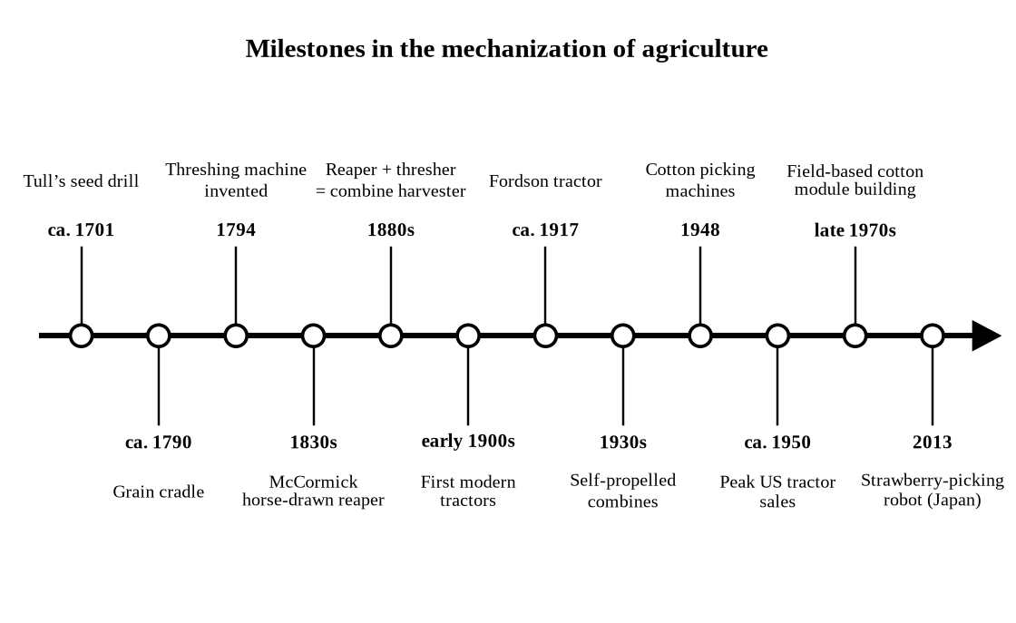
Fig. 32.1. Milestones in the mechanization of agriculture.
32.2.2 Mechanization, Labour and the Harvesting of Produce
Advertising for motorized equipment in farm journals during this era did its best to compete against horse-drawn methods with economic arguments, extolling common themes such as that a tractor "eats only when it works", that one tractor could replace many horses, and that mechanization could allow one man to get more work done per day than he ever had before. The horse population in the US began to decline in the 1920s after the conversion of agriculture and transportation to internal combustion. Peak tractor sales in the US were around 1950. In addition to saving labour, this freed up much land previously used for supporting draft animals. The greatest period of growth in agricultural productivity in the US was from the 1940s to the 1970s, during which time agriculture was benefiting from internal combustion powered tractors and combine harvesters, chemical fertilizers and the green revolution. Although farmers of corn, wheat, soy, and other commodity crops had replaced most of their workers with harvesting machines and combines enabling them to efficiently cut and gather grains, growers of produce continued to rely on human pickers to avoid the bruising of the product in order to maintain the blemish-free appearance demanded of consumers. The continuous supply of illegal workers from Latin America that was willing to harvest the crops for low wages further suppressed the need for mechanization. As the number of illegal workers has continued to decline since reaching its peak in 2007 due to increased border patrols and an improving Mexican economy, the industry is increasing the use of mechanization. Proponents argue that mechanization will boost productivity and help to maintain low food prices while farm worker advocates assert that it will eliminate jobs and will give an advantage to large growers who are able to afford the required equipment.
32.3 Efforts Towards Mechanical Harvesting in Cotton
In cotton (Gossypium hirsutum L.) cropping, similar trends have been observed owing to recent developments in harvesting technology. Despite the latest cotton pickers being fitted with dual tires on the front axle, subsoil stresses are comparable to commercially available combine harvesters. Consequently, the drive towards adoption of more efficient machines to reduce costs and increase work rates has brought about concern due to the potentially negative effects of increased soil compaction and the associated need for tillage repair.
32.3.1 Principles of Cotton Harvesting Machines
Two kinds of machine are used to harvest cotton. The spindle picker has drums carrying many rotating, barbed and moistened spindles. As the machine moves along the row the spindles enter the plant, the lint of the open bolls winds round them, and doffer pads then strip it off. An air stream carries the seed cotton through ducts to a basket or, in the newest machines, to an on-board module builder (Fig. 32.2). Because only open bolls are picked, the field is usually harvested more than once. The stripper uses rolls or brushes that pull the whole boll, open or unopened, together with burs and some leaf and stem material, off the plant in one pass. Table 32.1 compares the two machines.
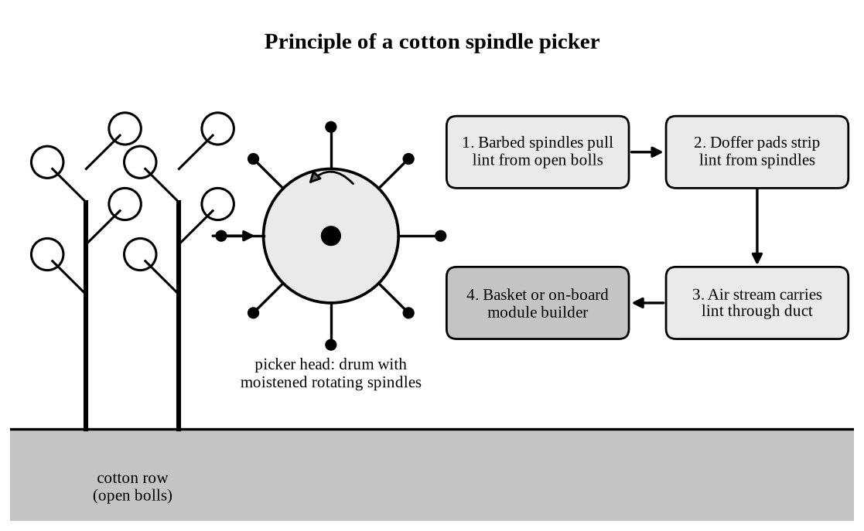
Fig. 32.2. Principle of a cotton spindle picker.
Table 32.1. Comparison of the cotton picker and the cotton stripper.
Feature | Spindle picker | Stripper
Action | Barbed spindles remove the lint from open bolls | Rolls or brushes strip whole bolls, burs and some leaves and stems
Passes | Selective; usually more than one pass as the bolls open | Once-over harvest after most bolls have opened
Quality of harvest | Comparatively clean seed cotton | More trash in the lint, so more cleaning is needed at the gin
Harvest rate | Lower | Higher
Cost and use | Higher machine cost; suited to higher-yielding regions | Lower cost; suited to lower-yielding areas such as Texas

Defoliants and boll-opening chemicals are normally applied before harvest, so that most bolls are open and the amount of leaf trash is reduced; this is especially important when the crop is stripped.
32.3.2 Advances in Cotton Picking Techniques and Technology Uptake
Since the inception of machine based cotton pickers having on-board module building, the time required to pick a bale of cotton (weight range: 2-2.5 Mg) has decreased from approximately 50 to 70 man-hours (hand-picking) down to eight minutes. Adoption of spindle-type pickers in the United States (U.S.) occurred progressively from the west to the east of the cotton belt, which responded to the absence of an effective and well established manual labor harvesting system that was originally in place in the southeast. In the western cotton belt, where yields were relatively higher, the potential to grow cotton was limited by availability of labor. Hence, the industry was smaller and less developed compared with the east. However, the introduction of cotton picking machines in 1948 enabled this limitation to be overcome and resulted in rapid adoption of cotton pickers (approximately 10% and 75% by 1951 and 1959, respectively), which drove the industry forward.
Conversely, the picker did not offer the same range of benefits in the south where labor was needed for three seasonal peaks, namely, planting, weeding, and harvest, and therefore adoption was relatively slower (approximately 10% by 1960). These peaks required that ordinary farm workers were given a share of the profit in a share-farming setup to entice them to stay all year round. Because mechanical or chemical weed control techniques had not been developed, machine-picking would have negatively impacted the system almost to failure. In the west, the risk of crop failure due to incidence of weeds was lower because they could be controlled, with some degree of efficacy, by means of timely irrigations in the drier environment.
The cotton stripper, as opposed to the cotton picker, was initially adopted in Texas because lower yields in that part of the cotton belt did not warrant the relatively higher cost of pickers. The stripper provided higher harvest rates compared with the picker, but increased contamination of lint with cotton trash to a greater extent than the picker.
32.3.3 Cultivars for Mechanical Harvesting
Cultivars that were amenable to mechanical harvest progressively replaced those that were hand-picked. These cultivars had improved performance in narrower rows, stronger fiber-to-boll attachment, shorter requirements for growing season, shorter limbs, and closer boll set. To a limited extent, some of these crop characteristics facilitated mechanical picking and therefore sped-up adoption of pickers. However, this process also led to increased pressure on gins due to faster delivery rate from the field. Subsequently, the development of field-based module building systems in the late 1970s reduced gin downtime and removed this pressure, but reduced safety in the work environment.
Cotton breeders have therefore had to consider machine harvestability as a breeding objective, alongside yield and fibre quality.
32.3.4 Machine Design and Field Constraints
Innovation and automation in cotton picking technology are often regarded as key drivers for a successful and competitive industry. However, mechanization of cotton harvesting brought about contrasting effects; for example, increased picking rates, ability to manage greater land areas, and lower labor requirements, but also resulted in gin downtime and safety issues.
In mechanized agriculture, higher capacity machines have contributed to reduce risk associated with climate uncertainty (timeliness), improve harvest rates and overall system efficiency but, often, at the expense of increased weight of farm equipment.
Cotton production systems are no exception; cotton pickers feature more design constraints than other systems because of the picking action of the spindle. Maximizing picking efficiency, that is the percent of cotton picked from the crop, requires plants to pass through the spindle mechanism. Consequently, the direction of travel must be the same for that of planting.
Because the majority of Australian cotton growers (approximately 80%) utilize furrow irrigation, picking must be conducted in the same direction as the furrows in any location in the field. Other crops such as winter cereals do not have this limitation because the plants can be cut at any position relative to the front of the machine by harvesting first. Hence, the direction of harvest can change from the planting direction, allowing for increases of turning space. Conversely, furrow-irrigated cotton fields in Australia are characterized by “dead space” at the head ditch reserved for turning machinery, which cannot be increased by harvesting first. Therefore, the turning circle has to be small to minimize turning time, which is enabled by maintaining a short wheel-base and a relatively narrow, rear track-gauge width (Deutsch et al., 2001).
32.3.5 Round Balers and Soil Compaction
The latest cotton pickers manufactured by John Deere (e.g., JD7760 and CP690), commonly referred to as round balers (RB), utilize on-board module building (OBMB), as opposed to the conventional boll basket picker (BP), which requires external module building and additional in-field equipment support to operate. The weight of the RB is approximately 36 Mg fully loaded, with a rear axle load reaching 16.5 Mg; this represents a weight increase of about 50% compared with the BP. This has several engineering design implications for the RB, including: (1) increased dimensions of rear tires, (2) repositioning of engine, and (3) raised chassis.
The increase in the overall weight of the machine has resulted in increased risk of soil damage due to compaction, which is recognized in several studies to be one of the main causes of soil degradation in cotton-based systems in Australia. Estimates for Australia indicate that the cost of soil compaction, determined as equivalent agricultural production loss, is approximately AUD 850 million per year. The incidence of soil compaction has brought about increased questioning on the maximum acceptable axle load for agricultural machinery with large physical footprints.
Despite this, the Australian cotton industry has seen a rapid adoption of RB, with approximately 80% of the cotton area harvested in the 2012-2013 season picked by RB pickers. Further, 36% of RB owners have more than one RB picker. The RB picker has been labeled as a revolution in cotton picking; however, improved understanding of its potential impacts on the cotton production system is required.
32.4 Mechanization in Sugar Cultivation
Sugarcane is the most important agro-industrial crop next to cotton, which is being cultivated in around 4.50 million hectares area in India. The country has produced more than 355 million tonnes of cane at a national average of 70 tonnes per hectare. In the present context of globalization, ways and means have to be further evolved to produce more sugar per unit area, time and input in order to keep pace with the population growth while preserving the soil and water resources. The challenges in the millennium can be met effectively by adopting the appropriate mechanical alternatives not only for increasing the productivity but inculcating cost efficiency in sugarcane production system. The farm mechanization in the context of sugarcane cultivation aims at introducing timeliness of operation, reducing human drudgery and improving overall production efficiency.
32.4.1 Mechanization of Sugarcane Harvesting
Gradually, timely harvesting of sugarcane at affordable cost is becoming a problem particularly in tropical region. Managing a big fleet of labourers to give timely supply of cane to the mill is not easy any more. Under these circumstances, sugar industry is looking for alternate mechanical means for harvesting sugarcane crop at a reasonable wage rate.
In subtropical India, normally, sugarcane harvesting is free of cost in exchange for green tops and as such in near future, the problem does not appear to be of a major concern. Efforts may be made to develop efficient hand tools for harvesting sugarcane crop so as to improve the quality of cutting and output/man/day with reduced energy input. Partial mechanization seems to be a suitable answer for the time being particularly in subtropical belt.
The available sugarcane harvesting systems can be grouped into the following:
- whole stalk linear windrowing;
- whole stalk transverse windrowing;
- whole stalk bundling machine;
- hand controlled self propelled harvester;
- chopper type cane harvesters;
- whole stalk harvesting; and
- manual cutting.

32.4.2 Manual Cutting
Proper manual cutting results in minimum loss of cane and the highest quality of the product. The productivity of manual cutters can be improved by giving them proper training, the use of correct cane knife, balance diet, etc.
32.4.3 Mechanical Cutting
Cane cutting attachments for agricultural tractors have been developed. This harvesting system still requires an appreciable amount of labour as cane stalk have to be detrashed, detopped and bundled and subsequently loaded into the wagons. Heavy recumbent cane is difficult to be handled with these aids and dry leaves are removed only partially. More advance machines are now available (CAMECO Harvester), which cut the cane stalk at the base and detop. The cut canes are placed in a single windrow from 4 to 6 rows. Subsequently depending upon the availability of the labour, mechanical loaders/manual loaders can be employed for loading purposes. 8–10% of the trash remains in the harvested cane. At a later stage, use of separate detrashers can be explored for minimizing the level of trash in the cane to be supplied to the mills.
32.4.4 Chopper Type Harvester
With the increasing labour problem, pace of mechanized harvesting may be accelerated and imported models of chopper harvesters may be tried and introduced with the modifications suiting to local needs. Efforts have been initiated in parts of Tamil Nadu and Maharashtra where imported models of chopper harvesters have been tried on a limited scale. There is no doubt that handling of even a heavy tonnage recumbent crop can easily be handled and output of 25–30 tonnes/field hour can be achieved but trash percentage in the billets (7–8%), small size of the fields, high initial cost of the machine, wider row spacing required (1.5 m) and sophisticated systems are the major constraints in successful adoption of these imported machines under Indian conditions. Delays from harvest to crush further aggravate the problem. Efforts are being made to develop an indigenous model of sugarcane harvester suiting to Indian conditions. A modern combine sugarcane chopper harvester (Austoft 7000) was imported from Australia and field tested in Sakthi Sugars Ltd, Sakthinagar, Tamilnadu.
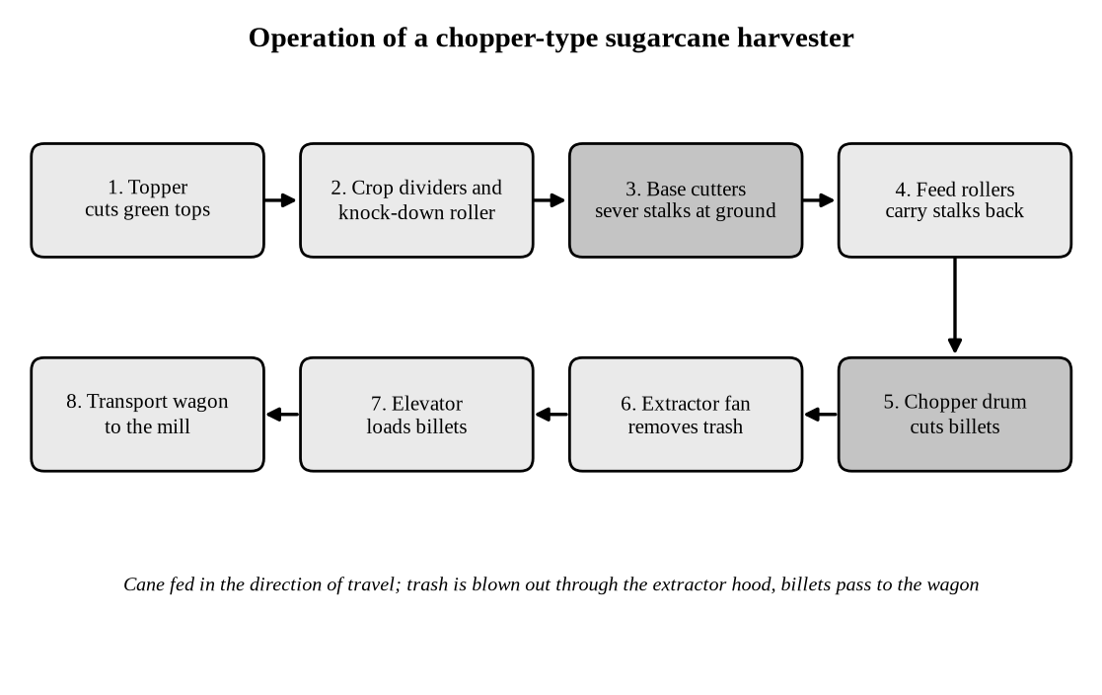
Fig. 32.3. Operation of a chopper-type sugarcane harvester.
Table 32.2 summarizes the performance figures quoted above for the three main approaches.
Table 32.2. Sugarcane harvesting methods.
Method | Performance | Advantages | Constraints
Manual cutting | Depends on training, a correct cane knife and a balanced diet | Minimum loss of cane; highest quality of product | Scarcity and cost of labour; timeliness of supply to the mill
Tractor-mounted cutter / CAMECO harvester | Cuts at the base and detops; 4–6 rows placed in a single windrow | Much less cutting labour | Loading still needs labour; 8–10% trash remains; difficult in heavy recumbent cane
Chopper type harvester | 25–30 tonnes per field hour | Handles heavy recumbent cane; billets ready for loading | 7–8% trash in billets; small fields; high initial cost; row spacing of 1.5 m needed; delay from harvest to crush

32.5 Mechanical Harvesting for Strawberries and Raspberries
32.5.1 Strawberries
The strawberry is a herbaceous plant of the rose family and one of the most widely cultivated berry crops. Strawberries are a high cost-high value crop with the economics supporting mechanization. However, the delicate nature of fruit makes it an unlikely candidate for mechanization in the near future. A strawberry harvester developed by Shibuya Seiki and unveiled in Japan in 2013 is able to pick a strawberry every eight seconds. The robot identifies which strawberries are ready to pick by using three separate cameras and then once identified as ready, a mechanized arm snips the fruit free and gently places it in a basket. The robot moves on rails between the rows of strawberries which are generally contained within elevated greenhouses. A new strawberry harvester made by Agrobot that will harvest strawberries on raised, hydroponic beds using 60 robotic arms is expected to be released in 2016.
The main difficulties in picking strawberries by machine are to recognize which fruits are ripe, to reach fruit that is hidden by leaves, and to detach the berry without bruising it at an acceptable speed and cost (Fig. 32.4).
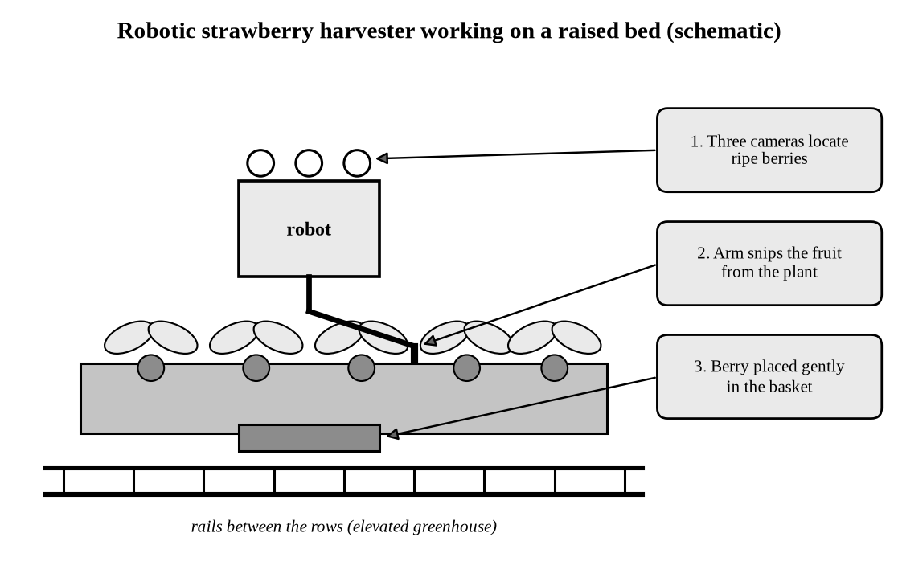
Fig. 32.4. Robotic strawberry harvester working on a raised bed (schematic).
32.5.2 Raspberries
Raspberries are perennial, woody and bushy plants of the family Rosaceae, cultivated mainly in Russia, Poland, Serbia and Mexico, among other countries. There are three types of raspberries: black, red and blue. In the USA and Canada, 99% of raspberries is harvested by mechanical methods. Several mechanical harvesters are now available, such as the OXBO 9000 built by Oxbo International Corporation (2017).
Most raspberry harvesters straddle the row. Oscillating beater bars or rods on both sides of the plants shake the ripe fruit loose, and it falls onto catch plates and a conveyor, where a fan removes leaves and light debris before the fruit is collected (Fig. 32.5). Fruit that is picked in this way is used mainly for processing rather than for the fresh market.
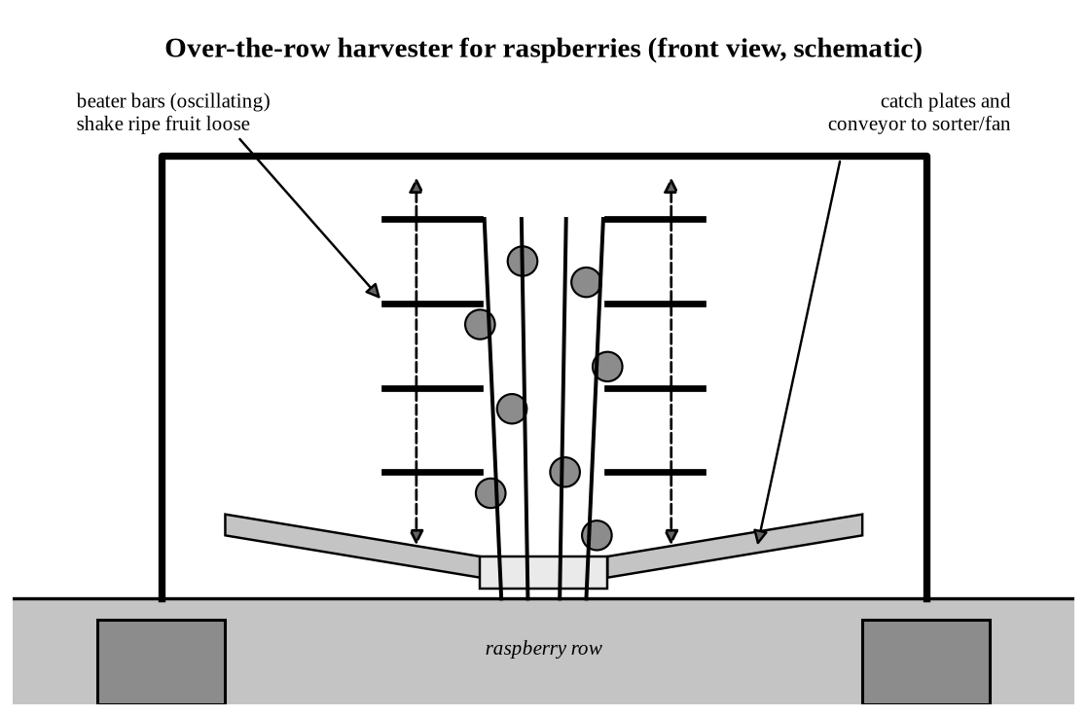
Fig. 32.5. Over-the-row harvester for raspberries (schematic).
32.6 Advantages, Limitations and Prospects
32.6.1 Advantages and Limitations
Mechanical harvesting brings timeliness, higher work rates, a lower cost per unit of produce and less hard manual work. Its limitations, illustrated by the examples in this chapter, are the following:
- High capital cost: modern machines are expensive and favour large growers; small fields and small holdings, as in much of India, limit their use.
- Soil compaction: heavier machines, such as the round-baler cotton pickers, compact the soil, and the loss of production has been estimated at about AUD 850 million per year for Australia.
- Trash and quality: stripper cotton and chopper-harvested cane contain more trash than hand-harvested produce.
- Damage to fruit: delicate fruit such as strawberries bruise easily, so most fresh-market produce is still picked by hand.
- Social and environmental effects: mechanization can displace unskilled farm workers and may cause environmental degradation if applied without regard to the whole system.

32.6.2 Breeding for Mechanical Harvesting
The performance of a harvesting machine depends as much on the crop as on the machine. Cotton cultivars that were suited to machine picking replaced hand-picked cultivars, and the same is true for the other crops discussed here. Table 32.3 lists characters that are generally considered desirable.
Table 32.3. Plant characters that favour mechanical harvesting.
Crop | Desirable characters
Cotton | Adaptation to narrow rows; strong fibre-to-boll attachment; short growing season; short limbs; close boll set; uniform opening of bolls
Sugarcane | Erect, non-lodging stalks; uniform height and thickness; low trash and easy detrashing; suitability for the row spacing of the machine (about 1.5 m for chopper harvesters)
Raspberry | Berries that ripen together and detach cleanly when ripe; firm fruit that withstands shaking; erect canes
Strawberry | Firm, bruise-resistant fruit; fruit carried clear of the foliage; concentrated ripening

32.6.3 Future Prospects
Precision agriculture, with satellite navigation (GPS guidance) and on-board computers, is increasing the efficiency of harvesting machines. Machine vision and robotic arms, as in the strawberry harvesters mentioned above, are extending mechanical harvesting to high-value crops that so far have been picked by hand. The adoption of these technologies will depend on their cost, on the availability of labour, and on the availability of cultivars and field layouts designed for the machine.
Summary
- Mechanical harvesting replaces manual labour with machines, giving timeliness, higher productivity and lower cost, but at a high capital cost and with possible environmental effects.
- Mechanization developed from the seed drill, grain cradle, threshing machine and reaper through the combine harvester and tractor, with produce crops being mechanized last.
- Cotton is harvested by spindle pickers or strippers; round-baler pickers with on-board module building raised work rates but also soil compaction.
- Sugarcane is harvested manually, by cutters that windrow whole stalks, or by chopper harvesters, whose adoption in India is limited by trash, field size, cost and row spacing.
- Raspberries are mostly harvested by shake-and-catch machines, whereas strawberry harvesting is moving towards robots using cameras and robotic arms.
- Crop characters that suit the machine are an important breeding objective.

Problems
- What are the advantages and disadvantages of mechanical harvesting? Discuss with examples.
- Trace the history of the mechanization of agriculture from the seed drill to the self-propelled combine harvester.
- Describe the working of a cotton spindle picker. How does it differ from a cotton stripper?
- Discuss the effect of round-baler cotton pickers on soil compaction and the cotton production system.
- Describe the systems available for harvesting sugarcane. What are the constraints in the adoption of chopper harvesters in India?
- How are raspberries and strawberries harvested mechanically? Why is it more difficult to mechanize strawberry harvesting?
- List the plant characters that favour mechanical harvesting in cotton and sugarcane.
- Write short notes on: (i) module building in cotton, (ii) CAMECO harvester, (iii) OXBO 9000, (iv) precision agriculture.

