33
Tree Breeding
33.1 Introduction
Man has occupied and lived in and near forested lands for thousands of years, and in so doing has had substantial effects on the genetic structure of forests throughout the world. These changes, through harvesting, land clearing, reforestation and afforestation, have, with few exceptions, been undirected in terms of purposeful genetic management objectives. This is quite different to the effects man has had on crops and domesticated animals: there was usually a cognizant awareness to actively manage the genetic resources of his food supply, through selection of seed and breeding stock, and through improving agricultural, horticultural and husbandry techniques. Forests, in most areas of the world, were viewed in a different manner, as largely self-perpetuating and adequate in their ability to provide wood and other services, so little management was necessary. In rare situations planting of seedlings or trees from local areas was done. Sometimes exotic species were tried, were found to be more desirable than the local species, and were planted in large estates, but little was known about genetic differences among seed sources, and only species differences were viewed as important.
It is clear to most national and international forestry agencies that those days are now over. Almost no forested ecosystems can be considered untouched by man’s influence. The idea that man can let forests “evolve” on their own, as they have since they first formed and have re-formed themselves over time, after all types of disturbances, is no longer something that should be considered acceptable to responsible governments, forest managers, conservationists and environmentalists anywhere on the planet. In this regard, great needs and opportunities exist for the development and management of populations of forest trees, as they have been shown to be amongst the most genetically variable organisms on earth. Relative to genetic improvement in agricultural species, forest tree genetic improvement programs are relatively new endeavors. As the science of genetics developed over the last century, plant breeders took advantage of new discoveries from both theoretical and empirical research. Similarly, many developments in forest genetics and tree improvement were directly applicable, however, many refinements were necessary in order to accommodate the unique biological features of forest trees. For instance, issues such as reproductive biology, geographic patterns of genetic variation in species, maintaining adaptive genetic variation over very long periods of time, and the maintenance of wild forest reserves are issues that are somewhat unique to forest tree genetic resource management.
33.1.1 Features of Forest Trees as Breeding Material
The following features distinguish forest trees from most crop plants and influence the design of every breeding programme.
- Long generation time: many species take years or decades to flower, and the rotation age of a plantation may be 10 to 60 years or more, so that a breeding cycle is very long and a programme must plan for the needs of decades ahead.
- Outcrossing and heterozygosity: most forest trees are outcrossing and highly heterozygous, and inbreeding often causes serious loss of vigour.
- Large genetic variation: natural populations hold large genetic variation within and among populations, and are adapted to local climate and site.
- Large size: big trees need large experimental sites, and the trial environment is usually variable and patchy.

33.1.2 Breeding Objectives and Stages of a Programme
The main objectives of tree improvement are growth and yield of wood, stem straightness and form, wood properties such as density and fibre characteristics, resistance to insects and diseases, tolerance of drought and cold, and, for some species, products such as oleoresin or rubber. A typical programme passes through the following stages: (i) definition of the objectives and choice of species and seed sources (provenances); (ii) selection of superior (“plus”) trees to form the base population; (iii) progeny testing of the selected trees in replicated field trials; (iv) establishment of seed orchards or clonal propagation for the supply of improved material; and (v) repeated cycles of selection, breeding and testing (recurrent selection). The sections that follow describe each of these stages.
33.2 Genetic Surveys of Natural Populations
33.2.1 Provenance Testing
As far back as the early and mid-1900s emphasis was placed on wide-range genetic surveys (i.e., provenance testing) using “common garden” experimental principles. The early common garden experiments by ecologists in the 1940s (and earlier) served as the initial models for these investigations in forestry and ecology research. The process was relatively simple in concept. Samples are collected from natural populations of interest (i.e., provenances) then planted in several test environments (usually within the range of the provenance collections) to test performance of the local provenance versus others. These early studies showed that most tree species had large amounts of genetic variation both within and among populations, but local populations were not always the best. However, forest trees, in general, do show that patterns of adaptation are reasonably well associated with the climate from which they originated. More importantly, there are differences among and within species in the general level of adaptation. Species have also been categorised as generalists, intermediates or specialists in their level of adaptation to climatic and environmental gradients. For instance, species such as western white pine (Pinus monticola) are considered generalists, i.e., adaptations are not well correlated to climatic or geographic variables, yet others, such as Douglas-fir, are much more tightly adapted, and movement of seed in this species needs to be restricted.
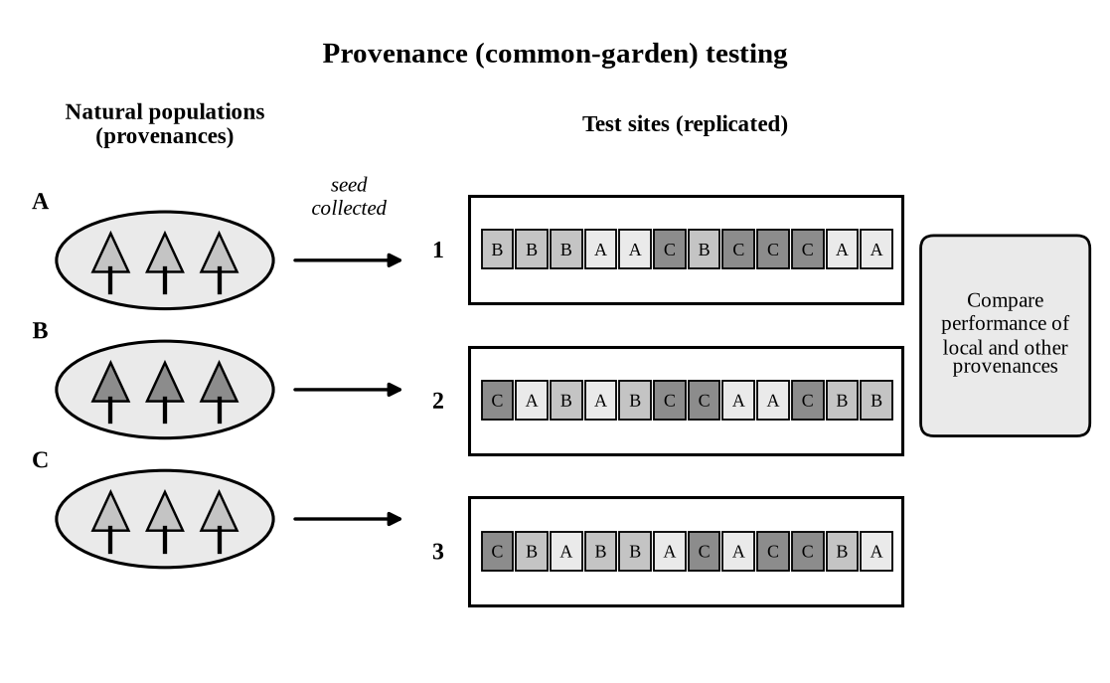
Fig. 33.1. Provenance (common-garden) testing.
33.2.2 Genetic Surveys with Molecular Markers
In the early 1970s genetic surveys of forest trees, with the use of molecular genetic markers, further confirmed large amounts of genetic variation were present, as they had shown in fruit flies, and other organisms. However, these molecular marker studies largely sample neutral genes i.e., genes that vary in the population, but do not have noticeable “phenotypic” effects on individuals. (The term “phenotype” refers to the entire “observed” organism, which is a combination of both the genotype of the organism, environmental effects it has encountered, and the interaction of the two. For instance, genetic variation measured by molecular markers, called isoenzymes (protein variants called allozymes), have been useful for investigating gene flow, mating dynamics within and among stands, heterozygosity (genetic diversity), and various other measures of genetic variation (e.g., effective population size, number of alleles per locus, variation levels among populations and species, and the frequency of rare alleles).
33.2.3 Neutral and Adaptive Variation
It is now clear that both neutral (“random” molecular genetic markers) and non-neutral (adaptive, quantitative genetic variation from common garden studies) were important to study.
The continued development of more complex DNA markers (e.g., Random Amplified Polymorphic DNA (RAPD)), or Simple Sequence Repeat (SSR's or microsatellite markers) are now providing better information on variation at neutral or quasi-neutral gene loci. On the other hand, common garden experiments allow for the complete assessment of the organism (i.e., the phenotype) and this is ultimately what tree breeders must rely on. There are very few ways for breeders to make the progress that is required, without the use of well-designed and executed field experimentation. Observations of the performance of the whole tree, the performance of related groups of trees, and developing an intimate familiarity with all the biological aspects of the species they wish to improve is critical to the success of any kind of genetic improvement in a species.
33.2.4 Base Populations
Whether or not a particular species has had the benefit of some pre-breeding activities i.e., population or provenance studies, it is apparent that geographic genetic variation should be factored into the design of a genetic improvement program. However, many programs have had to start without the benefits of such information. In these situations it is still important to design sampling strategies so that as many populations as possible can be sampled, with several trees per population, to capture and increase the probabilities of having good “provenance effects” in the base population.
In the case of exotics, a well developed “land race”, if present, may also be an effective base population. These landrace introductions are typically species, which have previously been used for purposes other than timber or pulpwood production, such as windbreaks, shelterbelts or ornamentals. They may have been shown to have some growth and quality advantages over local native species and can therefore be desirable species in “adapted” populations from which to select a base population of trees. Several large industries have been established from such introductions of materials, such as radiata or Monterey pine, rubber and coffee, and may have originated from a relatively small collection from wild populations. The point here is that many sources of material may serve as an excellent population with which to make further advances.
33.3 Improvements Through the Use of Superior Tree Selection in the Wild
33.3.1 Heritability
Plants or animals with desirable characteristics have served as breeding stock for hundreds if not thousands of years, without sophisticated genetic theory, or statistical genetic analysis to support selections made by farmers. Genetic testing techniques developed by man over the last several decades have made it possible for much more rapid genetic improvement. However, the underlying reason for genetic gains made throughout the history of agriculture is the same: most traits have genetic variation, and these differences can be transferred to offspring or progeny (i.e., they are heritable, or in a statistical sense, they have a “heritability” (h2) greater than zero). Higher heritability traits (e.g., eye color in humans) tend to be those controlled by a few genes with large effect, or several genes not greatly affected by the environmental conditions with which they interact. They usually respond quickly even to mild selection. Low heritability traits (e.g., growth potential in plants and animals) are typically affected by many genes each with a small effect, and can be affected by the environmental conditions to a greater degree. They require more intense selection methods to attain similar levels of gain, compared to higher heritability traits. Heritability is measured as the ratio of genetic variation (Vg) over that of the total or phenotypic variation (i.e., genetic + environmental variation = phenotypic variation, Vp), observed in the population i.e., h2 = Vg/Vp. It is intuitive that if environmental variation is minimised our ability to discriminate among better candidate trees is easier.
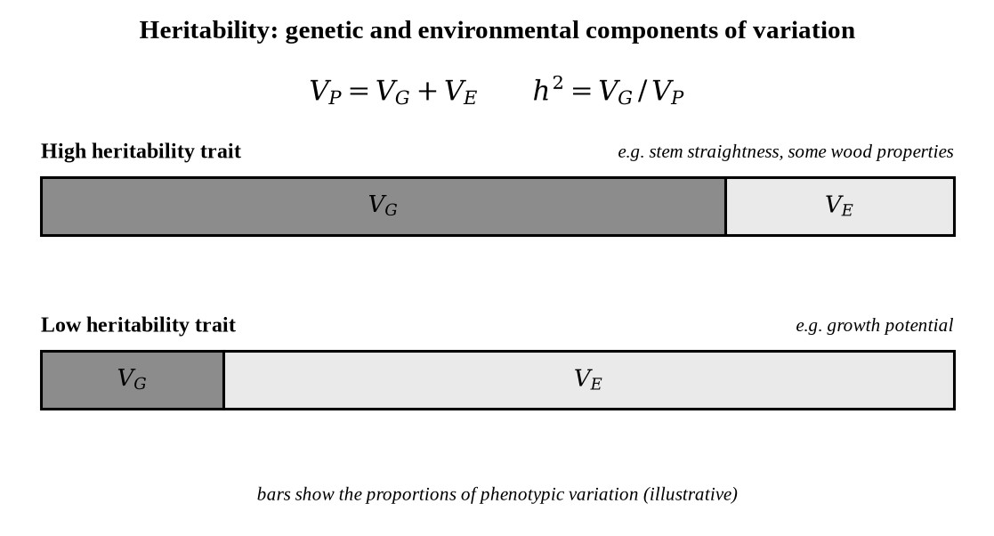
Fig. 33.2. Heritability: genetic and environmental components of variation.
33.3.2 Selection “in the Woods”
This is the basic idea behind the use of progeny testing techniques i.e., to obtain statistical estimates of Vg and Vp (described below). However, this logic is also relevant to our understanding of why “in the woods” heritabilities are typically low: namely that Vp is very large in wild uneven-aged forests. For example, if the original selections are made from an unimproved plantation which is nearing harvesting age, this can be one of the most efficient selection approaches from a non-pedigree population. Gains are certainly lower than they would be with genetic testing, but the costs per unit gain or time may be reasonable. Efficiency of selection in plantations versus wild forests tend to be higher as environmental differences among trees in the plantations (e.g., similar ages, similar cultural treatments to all seedlings) are lower. The least favorable situation tends to be when selection would occur in old-growth forests, where there are typically more variable environmental histories that may have generated uneven regeneration, age class differences, etc. Overall, most tree improvement programs have focused on improving growth potential, so visual selection or even comparison-tree selection techniques have not been very effective because growth is typically a low heritability trait.
However, there are a few other traits that have been successfully improved by phenotypic selection, such as straightness, form characteristics, some disease resistance traits, and wood properties. Again, this is primarily due to the fact that they can have higher heritabilities. So while “in the woods” selections have generally been regarded as not being an efficient means of improvement for some traits, they can be very cost effective if resources are limited and if the trait tends to have a high heritability.
After screening the chosen source, or individuals, the breeder is now in the situation of needing to efficiently establish a program of “recurrent” selection by genetic testing, selection and breeding. Recurrent refers to this continual process of selection, breeding to create a population of new genetic combinations in the offspring, and testing with a new round of selections.
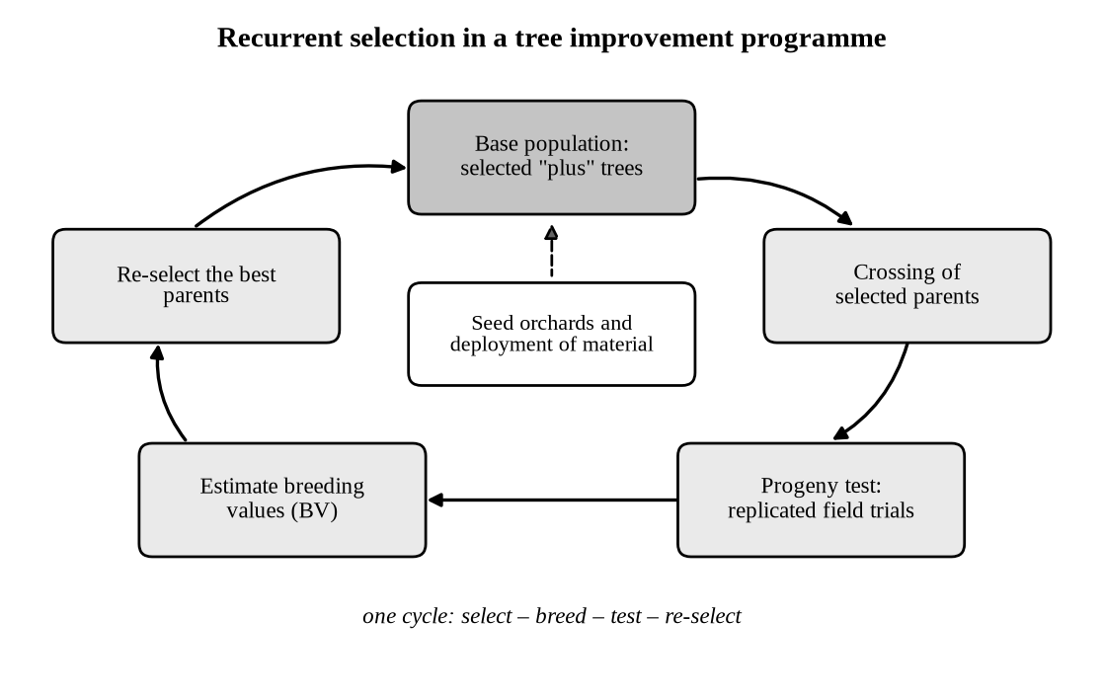
Fig. 33.3. Recurrent selection in a tree improvement programme.
33.4 Testing Procedures for Genetic Advancement
The first step described above is generally referred to as phenotypic or mass selection (i.e., selection without the use of pedigreed genetic information). However, in forest trees, it is now generally accepted that because the main traits of interest are related to growth potential (and usually of low heritability), and because forest trees have long generations times, selection with the use of genetic information from progeny testing is usually necessary. Once the breeder has assembled a large enough population from selections in the wild, usually a few to several hundred, decisions are required with respect to the type of progeny testing needed. The first decision is to determine if the testing is for the purpose of further screening of selected trees from the reference (wild) population, or whether it will serve for both purposes of screening and for re-selection for continued breeding and improvement. Second, does the biology of the species allow for vegetative reproduction (i.e., cloning), or is cross-breeding a realistic option and the best means of production of trees for testing and re-selection? This has some influence on the types of testing that should be undertaken, but it is critical to establish the objectives of the program at the outset of the testing scheme.
33.4.1 Improvements Through the Use of Progeny Testing
As in animal breeding, the past 30 years have seen tree breeders increasingly use techniques that more accurately identify and predict the genetic value or worth selected parent trees. Evaluation of a mother tree's true genetic worth can be accomplished by evaluating how its offspring perform relative to offspring from other trees. The use of a tree's offspring, whether they are cuttings (clones) or seedling offspring, is a powerful technique for examining the genetic value of any parent tree. This occurs because offspring share a portion of the mother and father genes, and when planted in sufficient numbers in a proper field experiment, will tend to sample all the micro-environments across the test site. With many offspring trees per parent, planted across the test site(s), some trees will sample better than average sites (i.e., microenvironments), and some worse, but on average the statistical average or mean of the family will reflect the true genetic mean of the family. To carry this point to the extreme, family averages (i.e., the arithmetic mean for a trait measured on all progeny from a parent) from one million offspring would predict the genetic worth or breeding value almost perfectly. This is generally not possible, viable or even necessary and it is common practise to use about 20-30 offspring per family per site, as including more observations per family tends to be inefficient with respect to our interest in being able to compare more families. If multiple test sites are used in the progeny test, it may be desirable to slightly decrease the number of test trees per family per site, but generally it is not desirable to go much less than 20-30 on each site. In more complex test designs, with fewer than a dozen or so offspring per parent on each test site, little loss of experimental trees can be tolerated.
The biology of the species to be tested plays an important part in the actual design and analysis. For instance, in most temperate conifers, the use of open-pollinated seed for testing is an efficient means for screening potential parent trees from the wild populations. However, if such seed is not available, or if insect-pollinated seed are not reliable for insuring that enough individuals from the population are cross fertilizing with the parent tree of interest, controlled pollination can be done with pollen from a few dozen “average” or random trees. This is necessary in order to have the progeny represent the average genetic effect of the population, so that all female (mother) trees are fairly compared. For instance, some of the controlled crossing systems (described below in more detail), such as the factorial-mating scheme, only use a half dozen or so male trees (for pollen). The use of such a small number of male “tester” parents, however, restricts the inferences that a breeder can make about the levels of genetic variation among the female parents being tested. Once again, if ranking the parents is the only criteria or purpose of the test, then a small number of tester pollen parents is adequate. This is typically referred to as polymix testing, especially if one dozen or more random pollen (but unrelated) parents are used in the controlled crossing.
The approach mentioned above has been described as family selection (or sire selection in animal breeding), and has become quite efficient with statistically sophisticated techniques that have been developed over the last two decades. Family selection based on the use of family averages, in well designed progeny tests (see discussion later on test designs) served as the primary technique for most of the genetic advancement in the 1960s and 1970s.
33.4.2 Breeding Value
The breeder is also usually interested in determining a genetic worth or score, or more technically correct, a breeding value (BV), for each parent tree. The BV is a measure, or a numerical score, of the additive genetic worth (average genetic effect) of the genes each female tree contains in relation to the whole population. In the case of an open pollinated test, the breeder can estimate the BV of each parent by multiplying the family deviations (i.e., family averages minus the grand mean for the test, sometimes referred to as the general combining ability, or GCA) by the family-mean heritability and then multiplying by 2. The family-mean heritability is required to “regress” the environmental noise and lack of precision from the deviations. The multiplier of 2 is required to account for the fact that the average effect of the open-pollinated contribution from the wild is assumed to have a BV of 0. Essentially, then, the family mean deviations, or GCA's are one-half of what they would be if the parent was crossed with itself, but of course this isn't possible in most cases because of inbreeding depression. Improved statistical theory and computational capabilities using techniques such as Best Linear Prediction (BLP) and Best Linear Unbiased Prediction (BLUP) have now become the standard statistical approaches for predicting BV's. In forestry, with adequate family sizes mentioned earlier, techniques such as BLP are generally not necessary but should be used if possible as they have been shown to be the optimal method. The reason they are so effective is that they utilise more of the genetic information available to the breeder. This information can be in the form of the performance of relatives (father, grandfather, etc), performance across many environments, and across experiments with age differences. New statistical techniques are being developed, almost yearly, to make prediction of genetic worth more accurate and precise, but these are becoming very specific to the type of breeding problem a breeder is facing and cannot be elaborated upon here.
BV = 2 × h²_{family mean} × (family mean – grand mean)

Table 33.1. Methods of selecting trees for breeding.
Method | Basis of selection | Advantages | Limitations
Mass (phenotypic) selection | Appearance of the tree itself, without pedigree information | Quick and inexpensive; effective for traits of high heritability such as stem form | Inefficient for low-heritability traits such as growth
Family selection (progeny test) | Mean of the offspring of each parent, with breeding value (BV) estimated from the family deviation | More accurate for growth traits; allows ranking of parents | Needs replicated field trials and years of waiting
Polymix and factorial testing (controlled crosses) | Offspring from controlled pollination with a dozen or more (polymix) or about half a dozen (factorial) pollen parents | Does not depend on open pollination in the wild; polymix gives a fair ranking of females | Few tester males restrict inferences about genetic variation among females
Clonal selection | Performance of cuttings or grafts of each tree | Replicates the same genotype; can be multiplied directly | Possible only in species that can be propagated vegetatively

33.4.3 Progeny Test Designs
Progeny test designs: As mentioned above, the objective of progeny testing is to allow the breeder to be more accurate in the ability to evaluate the genetic potential of selected parent trees. The basic principle is again one of reducing or limiting environmental effects. Proper replication and randomization accomplishes this and underpins all experimental layouts, but several factors need to be considered. In forest tree genetic testing, early designs tended to follow those in crop breeding but these have been shown not to be the best for forest trees. Historically, large plots containing greater than a dozen trees, with only 2-3 replications per site were used. The thinking behind this was that any genetic differences among genetic entries in the test would be visually striking with large multi-tree plots. Yields could then also be extrapolated to yield an entire plot mean, rather than one based on individual trees. However, these designs tended to bias family means, due to inadequate replication across variable forest environments, i.e., family mean averages or deviations (i.e., GCA's) could be confounded with environmental variations across the test site. Without the use of correct analytical procedures (e.g., BV's or BLP's), and as the estimates become confounded with environmental variations, the results may not be largely different than random numbers. In summary, forest tree field testing environments can be large and quite variable and therefore good field test designs are required.
33.4.4 Field Designs
Field designs: The types of designs briefly discussed above, i.e., all genetic entries in the study are replicated in each replication or block, with multiple blocks, are referred to as Randomized Complete Block designs (RCB's). In the field, blocks or replications are laid out with the hope of “blocking” out patches of similar micro-sites, but the weakness with the design has typically been that the blocks are too large and still sample across environmental patches. With fewer numbers of trees per family in each block, and therefore more blocks on the test site, the efficiency of the design becomes greater. Carried to the obvious extreme, the use of single tree plots (i.e., only one individual per genetic entry randomly located in each block) is known to be the most efficient RCB designs and are commonly used now in forest tree genetic testing. Row plot designs of 3-5 trees are still sometimes useful tests that may combine other objectives or needs, but their accuracy is somewhat reduced. For example, in comparing two of these designs, a typical and relatively robust single-tree plot experiment would be one with 25-30 progeny per genetic entry (which means 25-30 blocks or replications). In an experiment with, let's say, four-tree row plots, and 28 trees per genetic entry, the breeder would have to identify seven blocks in the field test. Biases can occur if the seven blocks do not do a good job in stratifying the site into seven homogeneous blocks. It is important to note that if there are not environmental patches or gradients on a test site and then no experimental design is necessary! However, this is usually never the case and in fact forest tree test sites are normally quite patchy, with large gradients, even if it is not visible at the time of establishing the test sites. Recently, many breeding programs are considering new designs, such as incomplete block designs (ICB). If the number of treatments to be compared is large, then we need large number of blocks to accommodate all the treatments. This requires more experimental material and so the cost of experimentation becomes high which may be in terms of money, labor, time etc. The completely randomized design and randomized block design may not be suitable in such situations because they will require large number of experimental units to accommodate all the treatments. In such situations when sufficient numbers of homogeneous experimental units are not available to accommodate all the treatments in a block, then incomplete block designs can be used. In incomplete block designs, each block receives only some of the selected treatments and not all the treatments, so that the size of each block can be kept small and homogeneous.
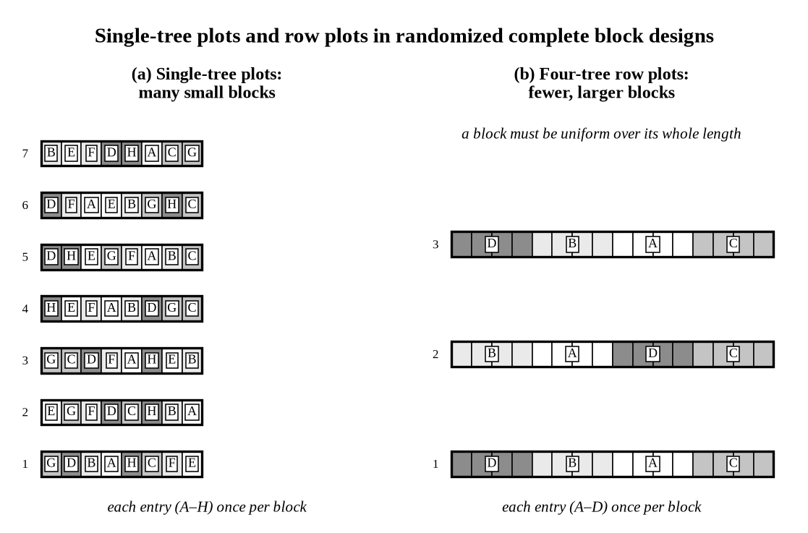
Fig. 33.4. Single-tree plots and row plots in randomized complete block designs.
33.5 Vegetative Propagation
33.5.1 Uses of Vegetative Propagation
The technique of vegetative propagation has a direct application in forest tree improvement programs, because it allows genetically superior trees to be multiplied, 1,000 or even 10,000 times, without altering their genotype. When trees are reproduced vegetatively, they are multiplied without fusion of the male and female reproductive cells. This asexual reproduction produces plants (propagules) true to form without any different or new traits from a second parent, unless mutations occur. Thus, vegetative propagation is an essential tool in multiplying and preserving valuable germ plasm, and in estimating the genotype in clonal tests. If a superior tree is easily rooted, it can be increased many-fold without delay. Some of the hardwoods, such as willow, poplar, or locust, are good examples of this. With most species, however, and especially the conifers where vegetative propagation on a large scale is economically impossible, multiplication has to be by seed. For this purpose seed orchards are being established with grafted stock or rooted cuttings from superior trees, and these orchards are then managed solely for the production of high quality seed.
33.5.2 Rooting of Cuttings and Air-Layering
Although of great silvicultural importance, determined attempts to propagate vegetatively forest trees that do not normally root or sprout were only started some 20 to 30 years ago. Considerable research is being conducted on finding methods to root cuttings of species refractory to rooting. Tests have been made with numerous types of media, varied temperature and light regimes, different treatments with hormones, nutrients, fungicides and insecticides, and throughout the different seasons of the year from trees of various ages (Mergen, 1955). Despite these concentrated efforts, there are still many species where it is extremely difficult to obtain cuttings with adequate root systems. With the advent of thin plastic sheets it has been possible to induce rooting by air-layering branches on trees that do not root well from cuttings. The air-layering technique, although over 2,000 years old, has only recently been used to propagate forest trees for use in improvement work. Rooting individual needle fascicles can now also propagate certain conifers.
33.5.3 Advantages and Limitations of Clones
In agriculture, various plants have been propagated vegetatively through many centuries without much apparent loss in vigor, and so far there is no likelihood of a reduction in vigor in trees propagated vegetatively.
There is, however, danger that because all the members of a clone are genetically identical, a disease infection or insect attack will spread rapidly once it is established. There is evidence of this disadvantage in some of the hybrid poplar clones that have been propagated by cuttings, especially where an entire stand consists of one single clone. Depending on the species there is no or little difference in the growth pattern of cuttings taken from different parts of the same tree, and once they become established the rooted branches appear similar to trees that grew from seed. There is strong evidence (however) that in some species cuttings from lateral branches will always have a plagiotropic growth. Araucaria provides a good example of this type of behavior.
33.5.4 Grafting and Other Applications
Perhaps the greatest use of vegetative propagation lies not in its use as a direct means of multiplying superior trees for commercial use, but as a tool in facilitating studies. As mentioned above, selected trees are mostly scattered over the range of a species which makes it difficult to control-pollinate a large number of trees within a season. Scions (branches) from these trees are therefore grafted on stock planted close to the laboratories to facilitate the breeding work. By this method germ plasm of the selected trees is also preserved should the parent trees die, and scions from one selected tree can be established in many locations throughout the world. There are, for instance, Douglas firs growing in Denmark that have the identical genotype as trees in the natural range in the U.S.A. (Larsen, 1956).
In addition to these considerations, vegetative propagation permits one to transplant a scion onto a root stock that can survive under particular conditions; change a dioecious tree into a monoecious tree; propagate bud mutants; induce flower formation; and study virus transmittal and resistance mechanisms. Inter-generic and inter-specific grafts (heteroplastic) are also possible, and these afford a great opportunity to study the translocation of solutes (Fig. 33.5). Not all graft combinations within the same genus, however, are completely compatible, but this incompatibility is being used to good advantage with several fruit trees to induce earlier flowering.
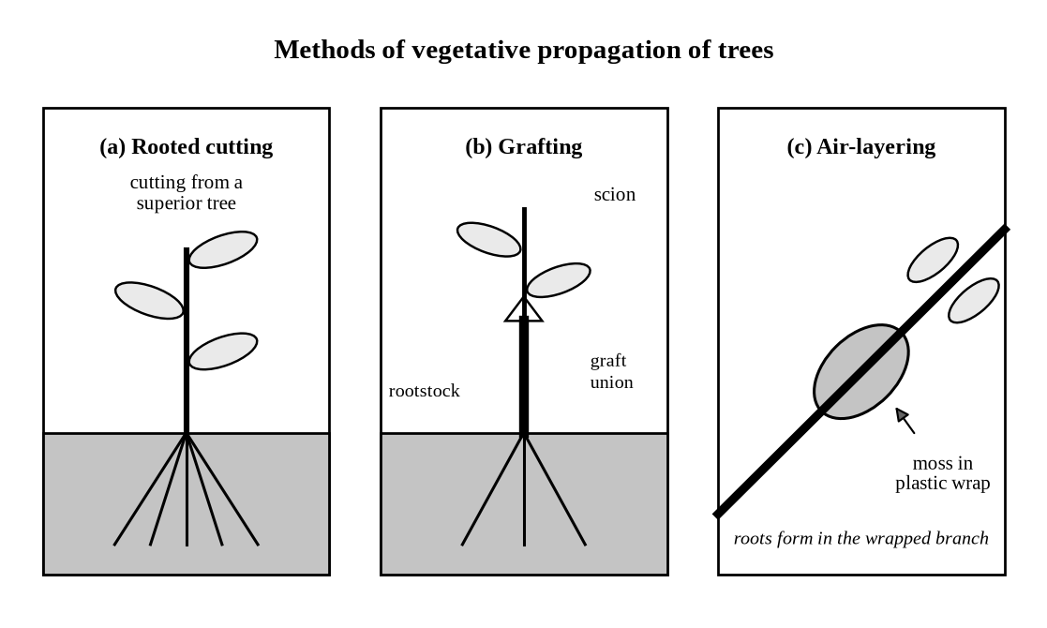
Fig. 33.5. Methods of vegetative propagation of trees.
Great advances have been made in the general field of vegetative propagation of forest trees, but intensive studies on the physiology of root formation are needed to solve the problem of those trees that root with great difficulty. The method of vegetative propagation has proved its usefulness in various phases of forest tree improvement work, and, with the expansion of basic research with forest trees, its usefulness in other branches of forest biology will be recognized.
33.6 Tree Selection
33.6.1 Seed Production Areas and Seed Orchards
To alleviate the seed-supply problem, and to assure seed from trees of known quality and origin, seed orchards and seed production areas are being established. In these forest stands, selected trees are favored and propagated for the purpose of producing high-quality seed. Trees in the seed orchards are selected for a variety of different desirable traits, such as high degree of resistance to a particular disease, rapid growth, good stem form, good natural pruning, wood of high density, or high yield of oleoresin.
For seed production areas the best natural or planted stands are cleared of the inferior trees, and the desirable trees are maintained for seed production. These potential seed trees are selected purely on the basis of general outward appearance (phenotype), and the true genetic makeup (genotype) of these selected seed trees cannot be determined until the planting originating from these trees are old enough for evaluation. Tree selection for seed production areas is fairly simple and consists of leaving the best 10 to 50 trees per acre evenly distributed through the stand, so that each selected tree can attain maximum crown development and fruitfulness. As mentioned, selection is purely visual, but if carried out in even-aged and well-stocked stands, the selected trees will normally be those that have survived competition and were best fitted for that particular site. This type of selection will probably not upgrade the resulting plantations much above their parents, but will maintain a genetic status quo in the resulting plantations, and will assure seed of known origin from good phenotypes at a cost competitive with that from commercial sources. Above all, it will tend to counterbalance the dysgenic practices of collecting cones from isolated, deformed trees; for the characteristics that make a tree attractive to the commercial collector (extreme limbiness and a large crown, along with poor natural pruning) make the tree an undesirable seed source from a forest manager’s point of view.
Seed orchards are of two main kinds. In a clonal seed orchard, grafts or rooted cuttings of selected plus trees are planted in a layout that keeps the members of the same clone apart, so that cross-pollination between different clones is favoured. In a seedling seed orchard, the progeny of tested families are planted, and the poorer families and individuals are removed (rogued) when the test results are known, so that the same planting serves both for testing and for seed production. Orchards are managed for flowering and seed yield, by wide spacing, fertilization and isolation from pollen of poor trees. Table 33.2 compares the main sources of seed.
Table 33.2. Sources of forest tree seed.
Seed source | Selection | Genetic quality | Remarks
Unselected stands (commercial collection) | None; cones are often collected from isolated, deformed trees | Unknown; may be dysgenic | Cheap, but the origin of the seed is uncertain
Seed production area | Best stand thinned to the best 10 to 50 trees per acre, by appearance only | Maintains the status quo; seed of known origin | Cost is competitive with commercial seed
Seed orchard | Selected plus trees propagated by grafts or cuttings; traits such as growth, form, wood density and resistance | Improved, and improvable with test results | Needs the establishment and management of the orchard

33.6.2 Selection of Plus Trees
Within the general field of individual tree selection, however, the greatest efforts have been spent not on selecting the best trees within a given stand, but within a particular locality or within its entire range. Emphasis is placed on the selection of individual trees for use in seed orchards. This type of selection is the basis or foundation for the majority of tree-breeding programs that have as a goal the mass production of trees that are outstanding in a particular characteristic. These selected “plus” or “superior” trees supply seed and pollen for progeny tests, and cuttings for vegetative propagation. They also will serve another useful purpose, namely that of preserving outstanding germ plasm for future generations. Through the forests all over the world, foresters are looking for pines with resistance to insects or disease, spruces with exceptional growth characteristics, maple trees with a sweeter sap, chestnut trees with ability to withstand the chestnut blight, or birches with curly grain, to name just a few from a large list of objectives.
Although selection of outstanding forest trees has been under way for some time, there is as yet little precise statistical information available on which to base general predictions. The outcome or benefits of a particular type of selection need to be evaluated for each case. In one instance, selection of outstanding trees along with their subsequent mass propagation might be a fruitful line of approach while, in other instances, where the desirable traits are under loose genetic control or where legitimate selection and evaluation cannot be made, this approach will yield no beneficial results at all. The total amount of improvement in a particular quality, and the rate at which the improvement will become available by selection will depend on various factors, such as the intensity of the selection procedure, the amount of genetic variation present in a particular species, the degree of heritability of the character under selection, and on the method of propagation.
33.6.3 Factors Determining the Response to Selection
Intensity of selection refers to the standards set up before one starts to look for plus trees. Selection can be on the basis of percentage of superiority, e.g., 100 percent faster growth rate than the average tree of the same stand; the best tree in a group of 100, 1,000, or 10,000 trees; or the tree that deviates by 4 standard deviations from the mean. In selection for disease or insect resistance, a choice is made of trees not affected or trees affected, which were able to throw off the attack.
Selection is effective only within the range of genetic variation that is present in a species. Because in the process of selection and intraspecific controlled pollinations, no new genes are introduced into the gene pool of the species, we must have the required genetic variability to begin with, lest selection yield no beneficial results (Fig. 33.6).
The response to selection, R, is the difference between the mean of the offspring of the selected trees and the mean of the original population. It is equal to the product of the heritability and the selection differential, S, which is the difference between the mean of the selected trees and the mean of the population (Fig. 33.6). The gain per year is obtained by dividing by the time that one generation takes:
R = h² S ΔG per year = i h² σ_{P} / L
where i is the intensity of selection (S expressed in standard deviations, σ_{P}) and L is the generation interval. The long generation interval of trees is therefore the main reason for slow progress, and it explains the interest in propagation by cuttings and in early selection.
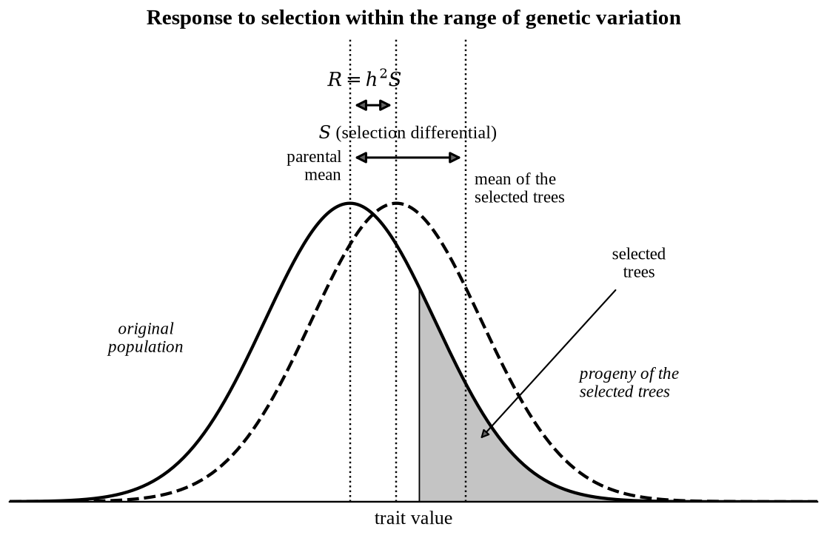
Fig. 33.6. Response to selection within the range of genetic variation.
Heritability is an index of the transmissibility of the selected characteristic, and expressed in statistical terms it is the effect of the genes in relation to the total amount of variability. Therefore, the greater the genetic effect, the larger the index of transmissibility. Because heritability consists of two components - genetic and environmental - it can be modified by changing the environment.
The method of propagation plays a very important part in determining the rate at which improvement can be achieved. If the desirable traits are under rigid control, and the tree lends itself to economical multiplication by the rooting of cuttings, superior planting stock can be made available immediately on a limited scale. If, at the other extreme, the selected tree has to be reproduced sexually when mature and the rate of genetic improvement per generation is slow, a hundred or more years might elapse before practical benefits are obtained.
33.6.4 Standards for the Selection of Superior Trees
Rigid standards for selecting superior trees, based on the progeny data on hand, should be developed without further delay for all the commercial species so that their genetic potentials can be fully utilized. The standards and methods for selection should be worked out by joint co-operation between forest managers, wood users and forest geneticists. These standards will need to be modified as the results from replicated progeny tests become available. In these specifications individual traits should be stressed, such as high yield of extractives, rapid growth, or resistance to insects or disease. Some foresters also place emphasis on a combination of desirable traits, e.g., exceptional height and diameter growth along with straight grain, dense wood, and high alpha-cellulose content. If trees are selected for only one desirable trait, selection is most effective; the degree of difficulty and chances of failure increase in a geometric progression with the number of traits used, unless there is genetic linkage between these traits. Under most conditions, selection will be effective only if practiced on one or possibly two characters at a time.
Field selection can be facilitated by providing foresters and woodsmen with illustrated guides for the various species so that they may be on the look-out for exceptional trees. The theoretical “plus” trees can also be described in statistical terms as a basis or guide for their recognition.
33.6.5 Selection in Nursery Beds
For some traits, selection must be at rotation age, while for traits that “mature” in seedlings or young saplings, the “plus” trees can be selected in nursery beds or young plantations. For example, longleaf pine with a short (one- to two-year) grass stage, or trees with exceptional cold hardiness, have been selected in the nursery beds. Selection in nursery beds, however, is only of value if the characteristics for which the seedlings were selected in the juvenile stage maintain their attributes through to maturity. If selection in the nursery is feasible, advantage should be taken of this method, for it allows selection amongst millions of even-aged seedlings growing under uniform conditions. Nursery bed selection is more effective when the seed is graded by size before sowing, for this eliminates part of the variation in initial height growth and vigor.
33.6.6 Value and Limits of Phenotypic Selection
Selection of superior trees definitely has a place in forest tree improvement programs, as has been shown by the results of F₁ progeny tests from parents selected for oleoresin yield, fibre characteristics, production of rubber, resistance to drought, resistance to disease and over-all pattern of growth.
However, for most traits, as long as selection is based strictly on phenotypic or outward appearance, the ratio of “plus” genotypes to selected “plus” phenotypes will be low. Accurate diagnostic methods of selection are needed that will aid selection on the basis of morphology. From the progeny tests, methods will be evolved that use biochemical and refined physical tests of those characteristics that are the underlying causes of the desirable traits. Examples of some tests that might be used are: the tannin content of bark in chestnut as an indication of resistance to the chestnut blight, viscosity of oleoresin as an index of gum yielding ability, or resin on pine branches as an indication of resistance to the resin midge. The development of these tests should not be considered as an end in itself, but they should help to speed progeny tests for they will allow one to use very young plants.
33.6.7 Catalogued Plus Trees
In general, the intensity of selection should depend on what the tree is to be used for, and on how much time and effort (money) one contemplates spending on it. If the tree is to be used for extensive vegetative propagation along with controlled pollinations and subsequent progeny testing, considerable time and effort need to be invested in the selection phase. It is advisable to mark, describe and catalogue each individual tree so that this information may be exchanged between the various tree breeders, and also to protect the trees from the axe.
The number of catalogued “plus” trees that have been selected throughout the world is quite impressive. In Sweden alone, there are about 3,000 catalogued trees that were selected for their outstanding height and diameter growth, and exceptional growth and good form. These trees form the core of the Swedish tree improvement program (Streyffert, 1958). In Finland, by 1953, approximately 500 pines, 200 spruces, 100 birches along with some 200 trees of other species had been selected, measured in detail, and rendered identifiable in the field. Some of these selected trees are located in forest stands north of the Arctic Circle (Anonymous, 1953).
When specifications for superior trees are prepared, one should keep in mind that the results of a program of controlled breeding will not be available on a commercial basis until after some 30 to 60 years have passed. With our rapid changes in utilization standards and conversion practices, some of the specific tree requirements will have been taken care of by technological advances by the time the “improved” trees are available. Therefore, one should select for traits that can still be expected to be of importance some 30 to 50 years hence.
33.7 Biotechnology and Genomic Approaches in Tree Breeding
The long generation time of trees makes methods that shorten or improve selection particularly valuable. The principal approaches are the following.
- Molecular markers: microsatellites (SSRs) and single nucleotide polymorphisms (SNPs) are used to fingerprint clones and orchard parents, to check pedigrees and pollen contamination in seed orchards, and to measure genetic diversity.
- QTL and association mapping: markers linked to genes for wood properties, disease resistance or adaptation can be found by QTL mapping in pedigrees and by association studies in natural populations. In many cases the effects found are small and specific to a family, which limits their use for direct marker-assisted selection.
- Genomic selection: breeding values are predicted from dense genome-wide markers by a model that has been calibrated on a population that has been measured for the trait. Young seedlings can be selected before field testing, which can shorten the generation interval. Studies in loblolly pine, eucalypts and spruces have shown prediction accuracies that were useful, but accuracy depends on the size of the training population and its relationship to the selection candidates.
- Tissue culture and clonal forestry: micropropagation, and somatic embryogenesis in conifers, allow large numbers of plants of an elite genotype to be produced, and the embryogenic cultures can be stored in liquid nitrogen while field tests of the clones are completed.
- Genetic engineering: genes for herbicide tolerance, insect resistance or altered lignin have been introduced into poplars and other trees; planting of such trees is restricted in many countries, in part because of the possible spread of transgenes by pollen and seed over long distances.

33.7.1 Conservation of Forest Genetic Resources
Selection narrows genetic variation, so a breeding programme has to be accompanied by the conservation of the variation of the species. In situ conservation uses reserves and genetic conservation areas in which natural processes continue, whereas ex situ conservation uses seed banks, clone banks, provenance trials and arboreta. In the multiple-population breeding strategy the breeding population is divided into several sublines, which limits inbreeding and retains diversity while each subline is improved. Provenance information is also used to match seed sources to expected changes in climate.
Summary
- Forest trees are genetically variable, long-lived and outcrossing, and tree improvement programmes are still young compared with those of crops.
- Provenance tests in common gardens show the pattern of adaptation of species, and both marker (neutral) variation and quantitative (adaptive) variation have to be studied.
- Heritability, h² = V_{G} / V_{P}, is low for growth traits, so progeny testing in well designed replicated trials, with single-tree plots where possible, is usually needed to estimate breeding values.
- Vegetative propagation multiplies superior genotypes, supplies grafts for seed orchards and helps to preserve germplasm, but clones carry the risk of epidemics.
- The response to selection is R = h²S; it depends on the intensity of selection, the genetic variation, the heritability and the method of propagation.
- Markers, genomic selection, tissue culture and conservation strategies support the classical methods of selection and testing.

Problems
- How do the genetic improvement of forest trees and that of agricultural crops differ?
- What is provenance testing? How do molecular marker studies and common-garden experiments complement each other?
- Define heritability. Why is it low for growth traits in forest trees, and what are the consequences for selection in the wild?
- Explain the terms breeding value, general combining ability, open-pollinated family and polymix.
- Compare single-tree plots and row plots in a randomized complete block design. Why are single-tree plots considered efficient?
- Discuss the uses and limitations of vegetative propagation in forest tree improvement.
- Distinguish between a seed production area and a seed orchard. What are the two kinds of seed orchard?
- What factors determine the rate of improvement achieved by selection of plus trees?
- How can genomic selection speed up tree breeding?
- Write short notes on: (i) recurrent selection, (ii) polymix testing, (iii) air-layering, (iv) nursery bed selection.
Suggested Further Reading
Falconer, D.S. and Mackay, T.F.C. (1996). Introduction to Quantitative Genetics, 4th ed. Longman, Harlow.
Grattapaglia, D. and Resende, M.D.V. (2011). Genomic selection in forest tree breeding. Tree Genetics & Genomes 7: 241–255.
Namkoong, G., Kang, H.C. and Brouard, J.S. (1988). Tree Breeding: Principles and Strategies. Springer-Verlag, New York.
White, T.L., Adams, W.T. and Neale, D.B. (2007). Forest Genetics. CABI Publishing, Wallingford.
Zobel, B. and Talbert, J. (1984). Applied Forest Tree Improvement. John Wiley & Sons, New York.

