Web Application for COVID-19 Detection Using Convolutional Neural Network

**Authors Name**: Nilesh Yadav

Roll number: *2K18/EC/111*

Delhi Technological University New Delhi, India  
nileshyadav_2k18ec111@dtu.ac.in

**Authors Name**: Neeraj Yadav

Roll number: *2K18/EC/109*

Delhi Technological University New Delhi, India  
neerajyadav_2k18ec109@dtu.ac.in

*Abstract*— The 2019 novel Corona virus (COVID-19), with a starting point in China, has unfold quickly among the folks living in other countries, and is approaching approximately 37.8 million cases worldwide in step with the statistics of European Centre for Disease Prevention and Control. There square measure a restricted variety of COVID-19 check kits offered in hospitals because of the increasing cases daily. Therefore, it is necessary to implement associate automatic detection system as a fast different diagnosis choice to curtail COVID-19 spreading among folks. With Convolution neural network trained on X-ray pictures, CT-Scan of chest collected from totally different sources to embrace COVID-19 patients and healthy persons.

Keywords—Covid-19, Web Application, HTML, Flask, Python, Convolution neutral network, Image Processing, X-ray, CT-Scan, Deep Learning, CSS.

# Introduction

The sharp spike in of patients with COVID-19 , a new virus, has put unprecedented load over healthcare social infrastructure systems across the world. In several countries, the hospitals have already been overpowered. There are restricted kits for tests, restricted hospital beds for admission of such patients, restricted personal protective equipment (PPE) for healthcare personnel and restricted ventilators. here we propose the employment of chest X-Ray, CT-Scan, Ultrasound to observe COVID-19 infection within the patients exhibiting symptoms. The most contribution of this work is in proposing a unique deep neural network based model for slight high accuracy in detection of COVID-19 infection from the chest X-Ray, CT-Scan pictures of the patients. We would like to emphasize that we don't seem to be proposing the employment of the planned model as best option to the traditional diagnostic tests for COVID-19 infection, however it as a sorting tool to guide educationally for those within the forefront of this analysis. Deep Learning (DL) is a subset of Machine Learning (ML) that enables computers for automatic training or learning of sensible features from the raw data sets. In medical imaging, most of the deep learning breakthrough has happened with the introduction of the convolutional neural network. CNN considers the input in the form of 2D or 3D images and can better utilize spatial and configurational information. Infection on lungs is one of the major signs of COVID-19 which can be seen while examining the X-Ray and CT- Scan images of lungs and could provide a breakthrough during diagnosing COVID-19. Therefore, we have considered the application of deep learning classifiers and proposed a novel algorithm for extracting the features from various radiology images to detect the presence of infection. The proposed algorithm ensures the use of deep transfer learning on X-Ray and CT-Scan images of lungs and assesses the report of suspected COVID-19 patients. In this paper, we have considered the advantage of deep learning classifiers for extracting the features from the taken radiology images of COVID-19 X-Ray and CT Scan and trained them against a combination of Pneumonia, other pulmonary diseases and normal cases. Thus, our model can be used both independently and alongside a radiologist. The model also focuses on the False Positives (FP) due to the patients with Pneumonia which can create a chaotic scenario. Considering a patient having Pneumonia who is detected falsely by our model as COVID-19 positive will be asked to be admitted in a suspected COVID-19 section of the hospital. Through our experiments it has been suggested to consider the Pneumonia cases in suspected category in order to prevent the further spread of COVID-19.

.

## Existing Work

* Respiratory illness detection in Chest X-Rays:- Numerous deep learning based approaches are been developed to different lungs diseases, including pneumonia. The model is trained to classify X-Ray pictures categories, together with respiratory illness. Given the visual similarity of the input samples, we tend to found this to be the similar pre-trained backbone to develop a model for distinguishing COVID-19 Patients.
* COVID-19 detection with Chest X-Rays:- Since the recent sharp surge of COVID-19 infections across the globe, many different screening approaches are developed to spotcases of COVID-19. The main objective is to detect COVID-19 patients. It takes as input a chest X-Ray picture and outputs a prediction among 3 classes: No illness, Pneumonia and COVID-19.

## Drawback of existing work

COVID have an effect on several elements of lungs that can’t be pictured solely with X-Rays. Thus with CT Images of chest can offer our Deep Learning(CNN) model to extract additional Features that it uses to train and do the predictions. Also the existing work uses pre-trained models which require very high computational power. The model trained in this project is built from scratch and can run on medium computational Power as well.

## Our Contribution

CT scan of chest can also be used to Identify COVID, we will use these along side X-Rays to give more accurate results. Our Convolution Neural Network Model will be trained on X-Rays, CT-Scans to predict COVID which is able to provide additional correct results as compared to the prevailing work. Further a web application is built using the Deep Learning Models to provide a better interface to use. The web application made is built in Flask, HTML and CSS. The main contributions of the paper are listed here:

• We have proposed a Convolutional Neural Network Architecture made from scratch and tested it on two different radiology datasets for faster detection of COVID-19.

• With the usage of deep learning and its advantage, it is assumed that proposed model is faster than the traditionally used testing kit.

• We also make the usage of false positive cases e.g., Pneumonia and consider them in COVID-19 suspected category.

• Efficiency of proposed model is more accurate on X-Ray compared to CT-Scan images, the final efficiency is based on the average of both.

• We used the concept of ‘dropout’ in our proposed model in order to overcome the overfitting issue and perform better in real-time.

• We then created a webpage, which provides the options of uploading X-Ray image and CT-Scan image. The images uploaded are then connected to the Model trained. The model then make predictions which are then shown on the webpage.

Large numbers of X-Ray, CT and Ultrasound picture are available from several public databases. COVID-19 chest X-Rays were obtained from the publicly accessible COVID-19 Image information Data Collection. This collection has been sourced from websites like GitHub and Kaggle. Unsurprisingly, the pictures from this are of variable size and quality. CT scans for COVID-19 and nonCOVID-19 were obtained from the publicly accessible COVID-CT Dataset []. Moreover, the process of CT scanning is dynamic, with a full scan consisting of many separate slices taken in a helical pattern along the chest cavity. These images have been sampled from video sourced from numerous online sources. A large corpus of research exists relating to the use of machine learning to improve the efficiency and accuracy of lung cancer diagnosis is largely driven by extensive CT based lung cancer screening programs in many parts of the world. Several researches have achieved incredibly accurate results using CNNs with transfer learning to detect lung nodules. Recently a deep learning system built by Google achieved state-of-the-art performance using patients' current and prior CT volumes to predict the risk of lung cancer. This system outperformed human radiologists where prior CT scans were not available, and equated human radiologist performance where historical CT scans were available. Although X-Ray is the current reference diagnosis for pneumonia, some studies point out that CT generally outperforms X-Ray as a diagnostic tool for pneumonia, albeit at higher cost and convenience.

# BLOCK DIAGRAM

Starting with the Machine Learning part, we first trained our Model on X-Rays and CT-Scans. Below is the Model Diagram of the Project which was trained on X-Rays and CT-Scans collected from Different Sources. The Final Result is based on the average of predictions made by individual Models.

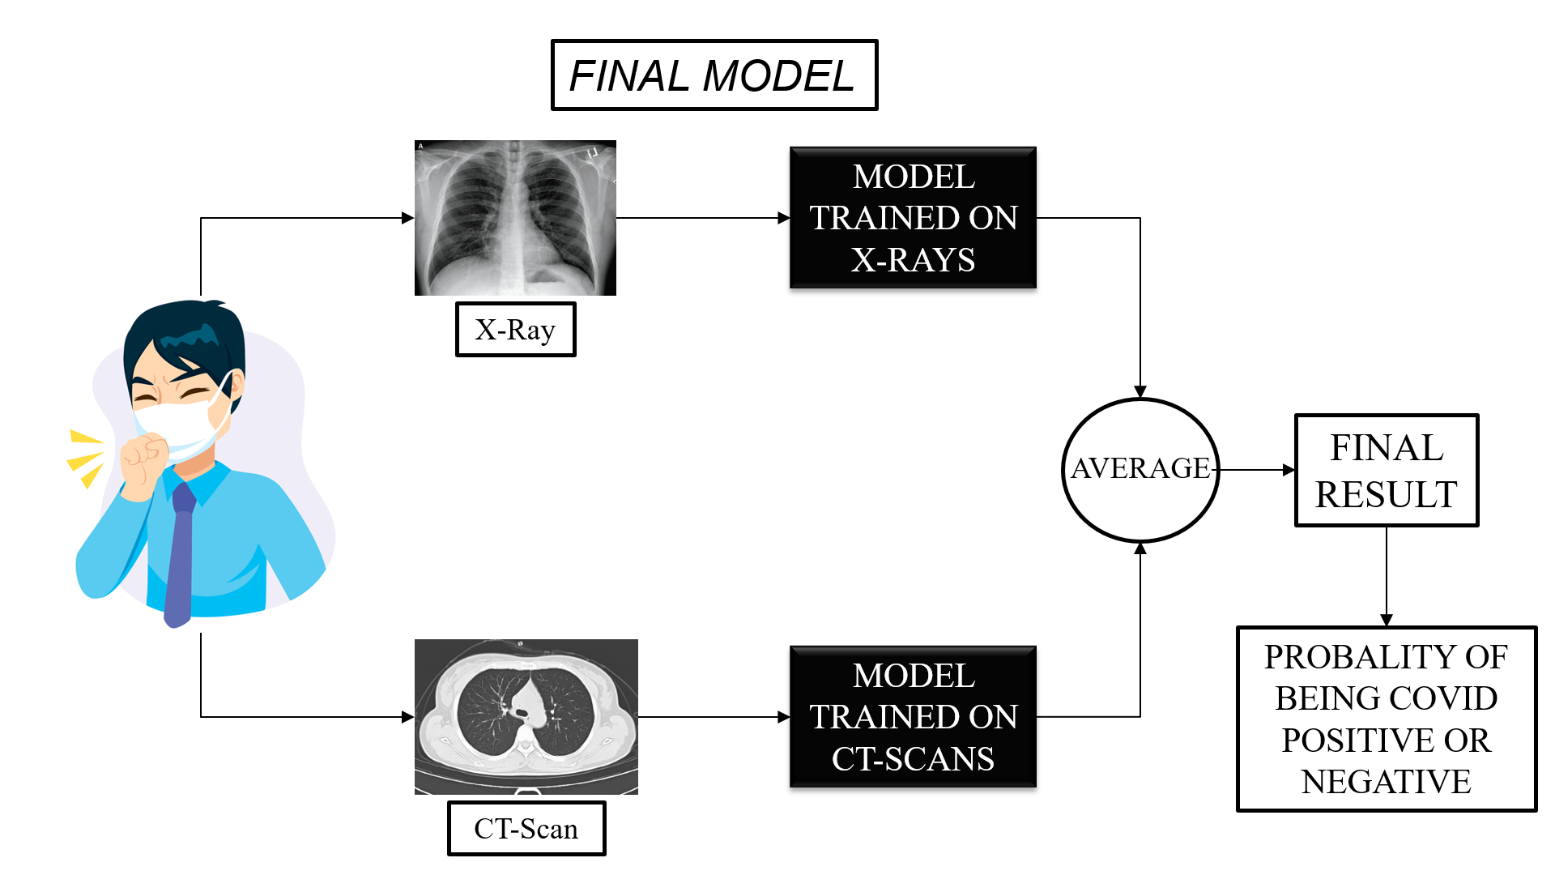

Fig 1: WORKING MODEL DIAGRAM

Computational methods such as AI, Data Science, Machine Learning, and data mining are being used actively to obtain the effective solution of COVID-19 pandemic. These methods are mainly dependent on the datasets for making an effective detection. Since COVID-19 is a new disease therefore the limited amount of dataset is available for the execution of experiments. However, to apply deep learning on radiology imaging, few public datasets are available. In this work, we have considered the following datasets for the execution of the project.

X-Ray :- For COVID Patients, the X-Ray images were Collected from GITHUB repository. For Normal patients Images were collected from KAGGLE.

CT-SCANS: For COVID and Normal Patients, the CT images were collected from COVID-CT Master Dataset available on GITHUB.

# PROPOSED WORK

The proposed deep learning Model mainly focuses on binary classification of images in order to classify the various X-Ray and CT-Scan images for fast and accurate detection of COVID- 19. The proposed algorithm considers two different Convolutional Neural Network trained on X-Ray and CT-Scans images to extract simple features and then learn the pattern of COVID-19 cases obtained from the patients’ X-Ray and CT-Scan images. The main feature of the proposed technique is that it is trained from scratch, no pre-trained Models are used. Similar to other algorithms it also considers the input dataset. Here, X-Ray and CT- Scan images which includes the cases of COVID-19, NON-COVID- 19 and Normal, have been considered. The main steps of the proposed algorithm are as follows:

• **Step1: Generate the train, validate, and test dataset-** generates the required sub-datasets from the input dataset. Here, the first sub-dataset is a training dataset in which the sample of data is used to fit the model for learning purposes. In the second sub-dataset of testing, a set of samples is considered to tune the various hyper-parameters for an unbiased evaluation of the classifier while selecting the number of hidden units in a neural network. Finally, holdout test sub-dataset which is a random set of samples used to assess the performance of a fully-specified model. The split ratio of training, validation, and testing sub-dataset are considered 70, 15, and 15 in case of X-Ray Model and 70, 20 and 10 in case of CT-Scan Model respectively.

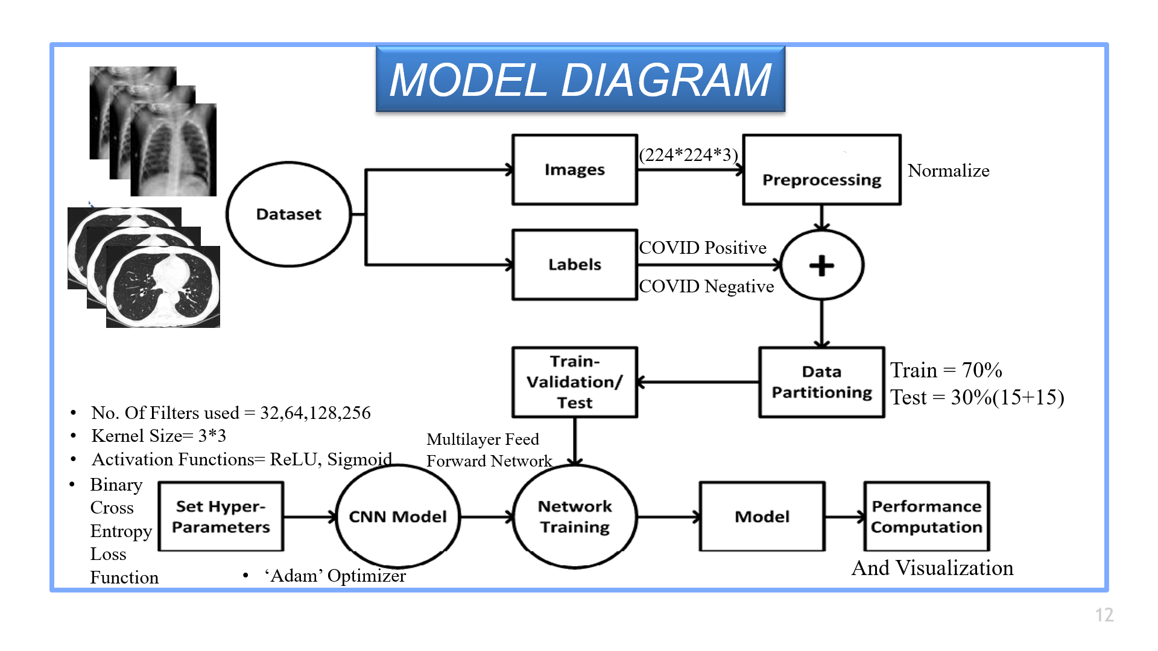

Fig 2: ML MODEL DIAGRAM

• **Step2: Prepare the CNN architecture-** In this step, we have made two different Model Architecture for classification which is further trained on X-Ray and CT-Scans separately. The proposed model has been trained for adapting and learning the basic features (e.g., edges and boundaries) of computer vision which ensures that the models needs not to learn every time from scratch while training on X-Ray and CT-Scan image datasets. After certain attempts we have explored the most suitable CNN Architecture using which the best accuracy for the proposed model has been obtained.

## Convolutional Neural Network (CNN)

Computers scan pictures as pixels and it's expressed as a matrix (NxNx3) — (height by dimension by depth). pictures build use of 3 channels (RGB), so is why we've a depth of three. The Convolutional Layer makes use of a group of learnable filters. A filter is employed to observe the presence of specific options or patterns gift within the original image (input). it's typically expressed as a matrix (MxMx3), with a smaller dimension however an equivalent depth because the input data. This filter is convolved (slided) across the dimension and height of the input data, associated a real is computed to convey an activation map. completely different filters that observe different options square measure convolved on the input data and a group of activation maps is outputted that is passed to subsequent layer within the CNN.

Convolutional Architecture used for Training on X-Rays is Given below.

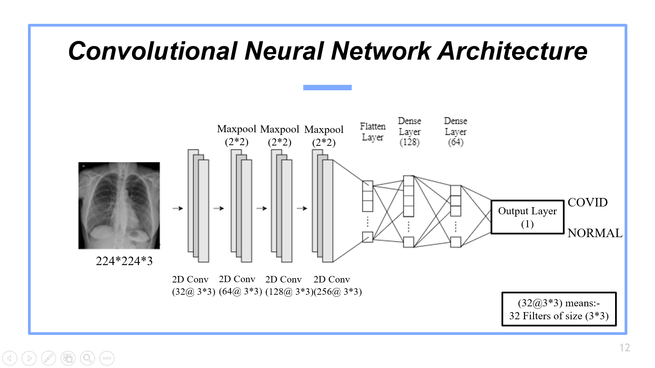

Fig 3: CNN Architecture for X-Rays

Convolutional Architecture used for Training on CT-Scans is Given below.

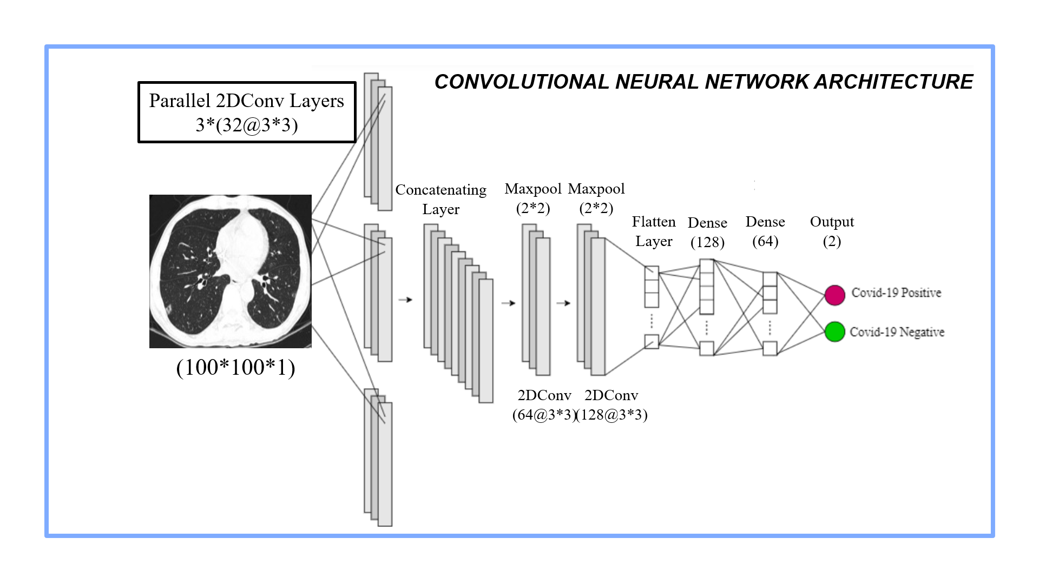

Fig 4: CNN Architecture for CT-Scans

• **Step3: Creating the Web Application-** In this step, we created a web application. The front end of our web application will be developed using HTML. It will basically contain three windows to upload X-Ray, CT-Scan and Ultrasound Images and the result will be shown below. The backend of our Web Application will be developed using Flask which is a web framework module based on Python. The backend will basically connect the uploaded images with the CNN model trained before. The Web Application is created for providing an interface to the person and the Model trained. Separate window for uploading X-Ray and CT-scan is provided. After clicking on the predict button, the final result along with the probability is shown. The Created Web Page is Shown Below.

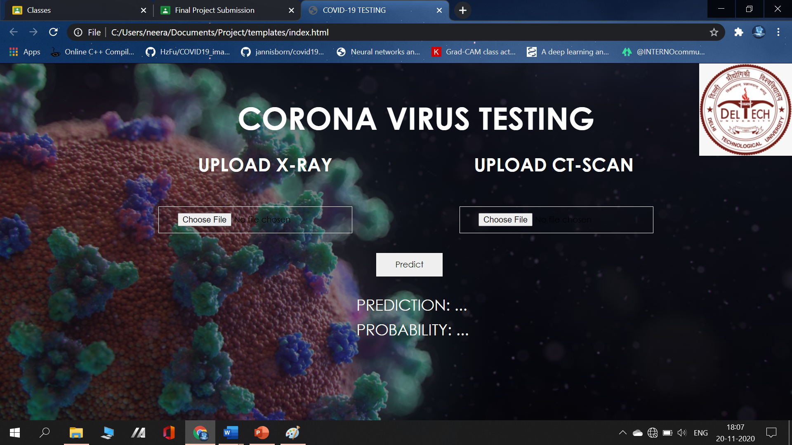

Fig 5: Web Page Created

# EXPERIMENTATION

* Machine Learning (Convolutional Neural Network):

Language Used: Python

Platform Used: Jupyter Notebook

Table below shows the Datasets Used for training the Machine Learning Model.

**TABLE 1.** Summary of Data Source Used.

|  |  |  |  |
| --- | --- | --- | --- |
| **Collection** | **Number of Images** | **Characteristics** | **Notes** |
| COVID-19 Image Data Collection | 196: Covid-19(PA) | Variable size, quality, contrast and brightness. | Only source of publicly accessible Covid-19 PA X-Ray images and used in this Project. |
| NIH chest X-Ray | 1500: Pneumonia  : No finding | Intra-dataset uniformity similar to covid-19 dataset. All images are 1024 x1024 in size. | Objectively similar in quality to covid-19 Image Data collection Used in this Project. |
| Covid-CT MASTER | 349: Covid-19  397: Non-Covid | Variable size, contrast and brightness. | Only source of publicly accessible covid-19 CT images and used in this Project. |

**TABLE 2.** Sampled dataset for experiments

|  |  |  |  |
| --- | --- | --- | --- |
| **Image Mode** | **Condition** | **Source images** | **Curated images** |
| X-Ray | Covid-19  Normal | 930  1500 | 196  200 |
| CT | Covid-19  Normal | 349  397 | 349  350 |

* Web Application:

Front end Using: HTML and CSS

Back end Using: Flask based on Python

# RESULTS AND DISCUSSION

In this work, we have performed two different experiments on two different datasets of radiology imaging and then Combined the results of both individual experiments. These experiments can be broadly classified into (1) Binary Image Classification on X-Ray of COVID-19 positive patients vs. X-Ray of Normal Patients (2) CT Scan of COVID-19 positive patient’s vs. CT Scan of NON-COVID-19 patients.

* BASED ON X-RAY:

In this experiment, we have applied the proposed deep learning Algorithm to classify COVID-19 infected cases from the Normal cases. For this purpose, we have used 196 X-Ray images of COVID- 19 infected patients from the COVID-chest X-ray-dataset and 200 CXR images of Normal patients from the Chest X-Ray Images (Pneumonia) dataset. The count of the cases are highlighted in table above. The primary dataset is divided into three sub-datasets i.e. training, testing, and holdout sets. In train and test split, we have used 70% of images for training, and the remaining 30% for testing purposes. However, for validation purpose we have used 15% of images from the 30% of testing images. COVID-19 positive cases dataset distribution is 136,30, and 30 for training, validation, and testing respectively. Whereas, for the Normal Patients the dataset distribution is 140, 30, and 30 for training and testing purposes respectively. Once the dataset has been classified, we applied the proposed deep learning model using Algorithm on the distributed dataset. The training accuracy, validation accuracy, training loss, and validation loss graphs are shown below. As represented by a red dot on curve line of training accuracy and validation accuracy, we have obtained the best results for the proposed model on the specific epoch. The significance of the proposed model is that it automatically avoids overfitting issue through dropout method. The performance of the proposed model has been calculated by using the confusion matrix as shown below. Based on this, we have calculated the sensitivity and specificity of the proposed model. The sensitivity and specificity of the proposed model is 96.67%, and 90.62% respectively. From these results, we can infer that any patient who visits the hospital and is COVID-19 Negative (i.e., True Negatives) can be detected as Normal with very high accuracy during the tests by using the Chest X-Ray images.

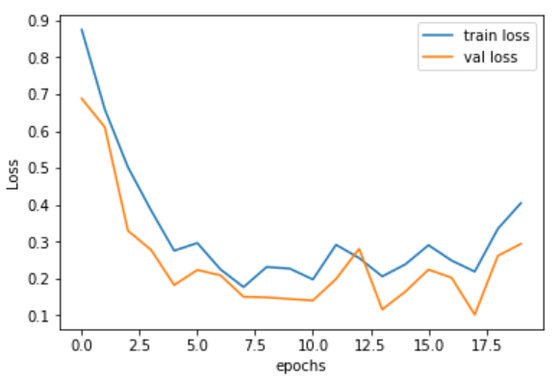

The Lowest Loss obtained on Training data is 0.17 and on validation data is 0.15. The best model is saved.

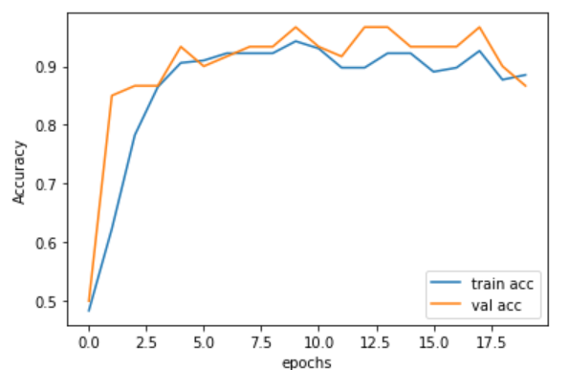

The Highest Accuracy obtained on Training data is 94% and on Validation Data is 96%. The model is then tested on the Holdout testing Data and Confusion Matrix is being Plotted and shown Below:

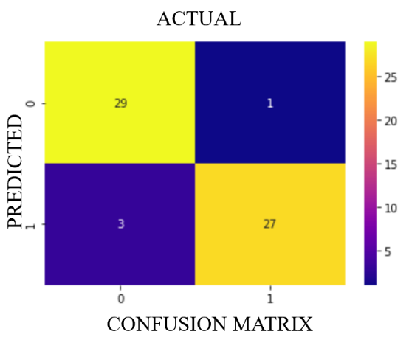

* BASED ON CT-SCAN:

In this experiment, at first trained the model on CT-Scans and evaluated the Performance measures and then the results were compared as obtained by X-Ray and CT-Scan images for COVID-19 vs. Non-COVID-19 cases. For this, CT-scan dataset of CT-MASTER Dataset is trained on the model for both COVID-19 and NON-COVID-19 cases. Both the cases have equal number of images i.e., 349 and 350 as given in table above. Through the confusion matrix presented in Table below, sensitivity, and specificity values have been calculated, which are 87.14% and 98.38% respectively. From these results, we can claim that a COVID- 19 patient can be tested accurately along with 92.85% accuracy. We have also observed that CT Scans are relatively more reliable to use in training our model as the CT Scans images provide a better and detailed description to the radiologist. These obtained results are shown in Fig. below. Once, the proposed model is trained on CT-Scan images, the same can detect the COVID-19 patients successfully on random CXR images. CT-Master Dataset is one of the most current dataset that has maximum number of COVID-19 and NON-COVID-19 radiology images.

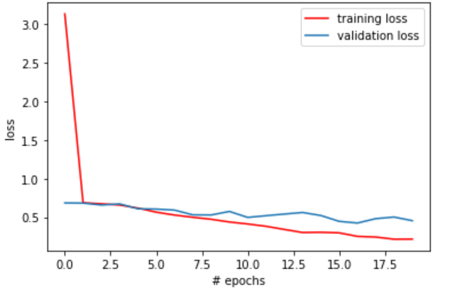

The minimum Loss obtained is 0.21 on training data and 0.41 on validation data. The best model was saved.

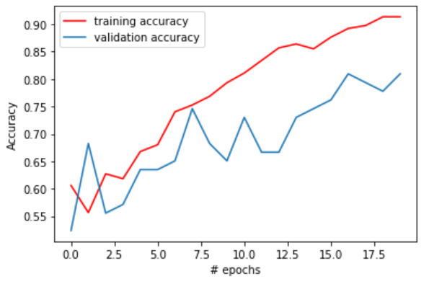

Maximum Accuracy Obtained is 92% on training data and 89 % on validation data. The model is then tested on the Holdout testing Data and Confusion Matrix is being Plotted and shown Below:

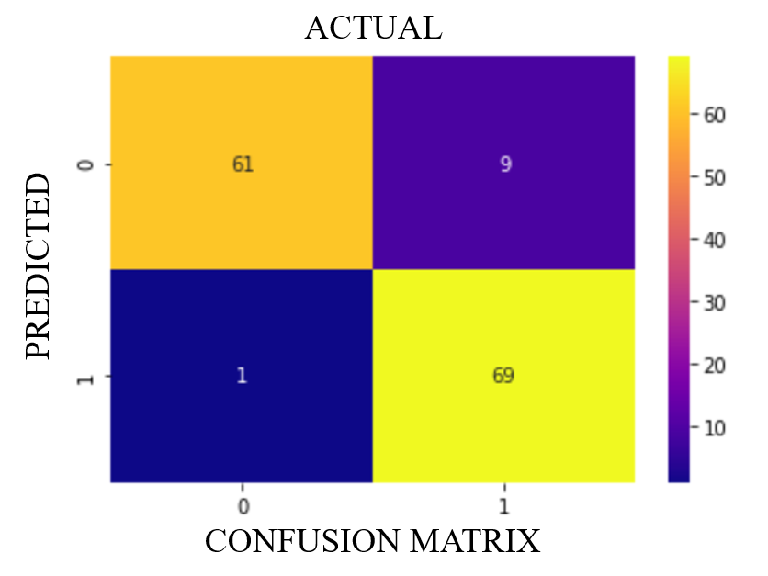

The Performance Measures calculated for both the models are given below:

**TABLE 3.** Performance Measures Calculated.

|  |  |  |
| --- | --- | --- |
| **Performance**  **Measure** | **X-Ray Model** | **CT-Scan Model** |
| Accuracy | 93.33 % | 92.85 % |
| Precision | 96.67 % | 87.14 % |
| Recall | 90.62 % | 98.38 % |

The Final Proposed Model is based on the best two saved models which were trained on X-Ray and CT-Scans. So if there is person who is having symptoms of CORONAVIRUS can prove his or her X-Ray and CT-Scans to our Model, which will the Make the predictions on the individual Image by the individual Model. The Final result will show whether or not the person is COVID POSITIVE with a Probability which is calculated on the basis of average of the individual Model prediction Probabilities. The results are shown through the webpage created.

# CONCLUSION

In this work, we have performed experiments on binary image classification for the detection of COVID-19 and Non-COVID- 19 positive patients. Further, from the analysis, it is revealed that non-COVID-19 positive patients may have Pneumonia or other pulmonary diseases. In various experiments for detecting the COVID- 19 cases, we have considered the X-Ray and CT-Scan images of the chest. The proposed model provides an accuracy of 93% while detecting the COVID-19 cases which is much faster than the traditional RT-PCR testing approach. The weights obtained from the training of the proposed model during the processing of CT Scan images also provide a significant response to X-Ray images. The obtained results reveal that the patient diagnosed with Pneumonia has more chances to get tested as a False Positive by the proposed algorithm. Therefore, to detect the COVID-19 cases accurately with higher recall, it is suggested to train the model on radiology images of patients with Pneumonia symptoms as well. This will help us to detect pneumonia patients as True Negative which were previously detected as false positive. This results in an unbiased detection of COVID-19 cases in a real-time scenario.

# Acknowledgment

We extend our sincere thanks to Assistant Prof. Sanjay Patidar

# REFERENCES

1. Bennett, J.M.: Smart ct scan based covid19 virus detector. https://github.com/JordanMicahBennett/SMART-CT-SCANBASED-COVID19VIRUS DETECTOR (2020)
2. M. Polsinelli, L. Cinque, and G. Placidi, ``A light CNN for detecting COVID-19 from CT scans of the chest,'' 2020, *arXiv:2004.12837*.[Online]. Available:<http://arxiv.org/abs/2004.12837>
3. Huang, G., Liu, Z., van der Maaten, L., Weinberger, K.Q.: Densely connected convolutional networks. In: Proceedings of the IEEE Conference on Computer Vision and Pattern Recognition (2017).
4. R. Yamashita, M. Nishio, R. K. G. Do, and K. Togashi, ``Convolutional neural networks: An overview and application in radiology,'' *Insights into Image*, vol. 9, no. 4, pp. 611_629, Aug. 2018, doi: 10.1007/s13244-018- 0639-9.
5. C. Szegedy, S. Ioffe, V. Vanhoucke, and A. Alemi, ``Inceptionv4, inception-resnet and the impact of residual connections on learning,'' in *Proc. AAAI Conf. Artif. Intell.*, San Francisco, CA, USA: AAAI Press, 2017, pp. 4278_4284, doi: 10.5555/3298023.3298188.
6. T. Ai, Z. Yang, H. Hou, C. Zhan, C. Chen, W. Lv, Q. Tao, Z. Sun, and L. Xia, ``Correlation of chest CT and RT-PCR testing for coronavirus disease 2019 (COVID-19) in China: A report of 1014 cases,'' *Radiology*, vol. 296, no. 2, pp. E32_E40, Aug. 2020, doi: 10.1148/radiol.2020200642.
7. C. Szegedy, V. Vanhoucke, S. Ioffe, J. Shlens, and Z.Wojna, ``Rethinking the inception architecture for computer vision,'' in *Proc. IEEE Conf. Comput. Vis. Pattern Recognit. (CVPR)*, Las Vegas, NV, USA, Jun. 2016, pp. 2818_2826, doi: 10.1109/CVPR.2016.308.
8. (2020). *Who COVID-19 Situation Reports*. [Online]. Available: <https://www.who.int/emergencies/diseases/novel-coronavirus-2019/> situation-reports.
9. H. Ravishankar, P. Sudhakar, R. Venkataramani, S. Thiruvenkadam, P. Annangi, N. Babu, and V. Vaidya, ``Understanding the mechanisms of deep transfer learning for medical images,'' in *Deep Learning and Data Labeling for Medical Applications* (Lecture Notes in Computer Science), vol. 10008, G. Carneiro, Ed. Cham, Switzerland: Springer, 2016, pp. 188_196, doi: 10.1007/978-3-319-46976-820.
10. J. Y. Wu, A. Tuomi, M. D. Beland, J. Konrad, D. Glidden, D. Grand, and D. Merck, ``Quantitative analysis of ultrasound images for computeraided diagnosis,'' *J. Med. Imag.*, vol. 3, no. 1, Jan. 2016, Art. no. 014501, doi: 10.1117/1.jmi.3.1.014501