DEPARTMENT OF COMPUTER SCIENCE & ENGINEERING
B.TECH 3RD YEAR PROJECT MANUAL & VIVA DEFENSE GUIDE
SIGNATURE VMAKE
AI-Powered Offline Signature Verification & Banking Document Authentication System
Comprehensive Academic SRS, Architecture Manual & Viva Examiner Study Guide
Specification Standard | IEEE Std 830-1998 (Recommended Practice for Software Requirements Specifications)
Approved Tech Stack | Python 3.11 • scikit-learn • Hugging Face Transformers • FastAPI • PostgreSQL
Computer Vision Core | OpenCV (Otsu Binarization, Zhang-Suen Thinning, 16 Structural & Geometric Descriptors)
Machine Learning Models | Track A: Random Forest (ROC-AUC 0.9424), SVM, Logistic • Track B: DeiT-Tiny (Hf)
Evaluation Dataset | CEDAR Offline Signature Benchmark (55 Writers, 2,640 Signatures, Writer-Disjoint)
Testing & Quality Gate | 53 / 53 Pytest Suite Passing (100%) • 16 / 16 Diagnostic Health Checks Verified
CRITICAL ACADEMIC SEPARATION NOTICE:
This project is strictly distinct from the legacy Siamese metric-learning project SYNAPSE. The production champion is scikit-learn Random Forest operating on handcrafted multi-domain feature vectors, supplemented by a Hugging Face Vision Transformer (facebook/deit-tiny-patch16-224). All evaluations strictly enforce zero-leakage writer-disjoint partitioning on the CEDAR benchmark.

EXECUTIVE TABLE OF CONTENTS & CHAPTER DIRECTORY
Curriculum Part & Module | Chapter Range | Key Technical Topics Covered
PART 1: PROJECT FOUNDATIONS & SRS OVERVIEW | Chapters 1 – 5 | Identity, problem statement, market pain points, scope & tech rationale
PART 2: ARCHITECTURE & SYSTEM DESIGN (SRS ALIGNED) | Chapters 6 – 10 | 4-tier topology, dual-track engine, 4-pillar risk, relational integrity, 7 pages
PART 3: COMPUTER VISION & FEATURE ENGINEERING | Chapters 11 – 16 | Image ingestion, Otsu binarization, Zhang-Suen thinning, 16-D vector space, quality
PART 4: MACHINE LEARNING & DEEP LEARNING | Chapters 17 – 22 | Random Forest champion (AUC 0.9424), SVM, Logistic (20 KB), DeiT-Tiny, tau* = 0.4264
PART 5: DATASET ENGINEERING & NO-LEAKAGE PROTOCOL | Chapters 23 – 26 | CEDAR benchmark (55 writers, 2,640 signatures), writer-disjoint split, synthetic pairs
PART 6: MULTI-FACTOR RISK ENGINE & BUSINESS LOGIC | Chapters 27 – 32 | Overall risk formula (50% sim, 15% qual, 25% tx, 10% beh), tri-state clearance
PART 7: FASTAPI BACKEND & REST API SPECIFICATION | Chapters 33 – 36 | Asynchronous gateway, lifespan events, OAuth2/JWT, verification & audit endpoints
PART 8: MULTI-PAGE FRONTEND & OFFICER DASHBOARD | Chapters 37 – 38 | Enterprise UI styling, 7 addressable workspaces (/, /manual, /studio, /queue, etc.)
PART 9: DATABASE PERSISTENCE & AUDIT TRAIL | Chapters 39 – 40 | PostgreSQL relational schema, foreign key cascading, Alembic, SHA-256 tamper-evidence
PART 10: FORMAL SRS REQUIREMENTS (IEEE STD 830) | Chapters 41 – 43 | 15 Functional Requirements (FR-01..15), 15 Non-Functional Requirements (NFR-01..15)
PART 11: SYSTEM MODELLING & DIAGRAMS (UML & DFD) | Chapters 44 – 45 | Use Case, Sequence, Class/ER diagrams, DFD Level 0 Context & Level 1 Decomposition
PART 12: EMPIRICAL BENCHMARKING & ABLATIONS | Chapters 46 – 49 | Held-out test metrics, confusion matrix, ROC-AUC, 10.2 ms latency, feature ablation
PART 13: VERIFICATION, TESTING & QA SUITE | Chapters 50 – 52 | Pytest suite (53/53 passed), diagnostic health check (16/16 passed), E2E HTTP test
PART 14: STEP-BY-STEP LIVE DEMO SCRIPT | Chapter 53 | 12-step realistic banking fraud walkthrough for flawless university project defense
PART 15: COMPREHENSIVE VIVA QUESTIONS & ANSWERS | Chapters 54 – 58 | 60+ detailed viva questions and model answers across 5 academic categories
PART 16: CRITICAL PITFALLS: WHAT NOT TO SAY | Chapters 59 – 60 | Red flag buzzwords, examiner trap questions, and mathematically rigorous defenses
PART 17: MASTER CHEAT SHEET & APPENDIX | Chapters 61 – 63 | 1-page viva cheat sheet, complete mathematical formula table, code repository map

PART 1

Project Foundations & SRS Overview

Chapter 1 — Project Identity, Academic Context & Origin Story
System Definition: SIGNATURE VMAKE is an enterprise-grade, artificial intelligence-powered offline signature verification and banking document authentication system engineered specifically to resolve the acute financial crime vulnerabilities inherent in manual cheque clearing, high-value commercial remittances, and KYC account onboarding.
LEVEL 1 — Intuitive Beginner Explanation (The 'Explain Like I'm Five' Analogy):
Imagine a bank branch where an elderly customer or a large corporate accountant presents a cheque for $50,000. A human teller has approximately 3 to 5 seconds to look at the paper cheque, glance at a tiny specimen signature scanned ten years ago on a computer screen, and decide whether the signature is genuine. If the teller makes a mistake, the customer loses their life savings or the bank faces massive legal liability. SIGNATURE VMAKE acts like a pair of superhuman digital glasses for the teller: it analyzes stroke geometry, line thickness, curvature, and pressure patterns in milliseconds, checks whether the cheque has high fraud risk, and gives the teller an objective, mathematically proven verdict.
LEVEL 2 — Engineering & Mathematical Deep-Dive (Technical Rigor for Examiners):
Offline signature verification is classified mathematically as an open-set, fine-grained pattern recognition challenge. Unlike closed-set face recognition where the set of target identities is fixed during training, a commercial banking system must verify signatures from unseen account holders whose handwriting patterns were never part of the training distribution. SIGNATURE VMAKE operationalizes this via a pairwise differential metric learning paradigm: rather than training a classifier to recognize specific individuals, the system extracts a 16-dimensional multi-domain handcrafted descriptor vector from both the registered SPECIMEN and the candidate QUERY signature. The system computes their element-wise absolute difference vector and passes it through a calibrated scikit-learn Random Forest classifier (ROC-AUC: 0.9424, FRR: 3.83%) alongside a parallel Hugging Face Vision Transformer (facebook/deit-tiny-patch16-224) metric head.

WHAT IS IT? | SIGNATURE VMAKE — AI-Powered Signature Verification & Banking Document Authentication System.
WHY IS IT USED? | Eliminate manual teller fatigue, defeat skilled calligraphic forgeries, and satisfy stringent banking audit guidelines.
HOW DOES IT WORK? | Combines OpenCV document segmentation, a dual-track ML/DL verification engine, and a 4-pillar risk engine behind FastAPI.
INPUT RECEIVED | Scanned cheque or signature slip (PNG, JPG, TIFF, 300 DPI recommended), Account ID, Transaction Amount, Velocity flags.
OUTPUT PRODUCED | Tri-state verification decision (VERIFIED, MANUAL REVIEW, REJECTED), Similarity Score [0-1], Composite Risk Score [0-1], Audit Log ID.
SYSTEM CONNECTIONS | Integrates core banking databases via SQLAlchemy/PostgreSQL, exposes REST APIs for branch portals, and logs tamper-evident trails.
REPOSITORY LOCATION | Project Root: repository root (`api/main.py`, `services/`, `ml/`, `database/`).

[VIVA TIP] The Critical Distinction Between SYNAPSE and SIGNATURE VMAKE
If the external examiner asks: 'What is the relationship between this project and SYNAPSE?', answer with absolute precision:
'SYNAPSE was an exploratory research prototype focused on deep Siamese metric learning using PyTorch ResNet backbones. SIGNATURE VMAKE is the approved, production-grade B.Tech software engineering system built strictly on Python, scikit-learn, Hugging Face Transformers, and FastAPI. In VMAKE, our production champion is a scikit-learn Random Forest operating on 16 handcrafted computer vision features (ROC-AUC 0.9424), supplemented by a lightweight Hugging Face Vision Transformer. We deliberately separated the projects to satisfy enterprise latency (<11 ms) and regulatory auditability requirements.'

Chapter 2 — Executive Summary & System Overview
Modern banking environments face dual competing pressures: the imperative to accelerate transaction processing through Straight-Through Processing (STP) and the regulatory necessity to prevent escalating cheque fraud. Traditional banks either rely on exhausted human inspection or rigid, brittle pixel-matching algorithms that reject legitimate clients whose signatures naturally vary over time.
SIGNATURE VMAKE resolves this dilemma by implementing a multi-stage verification architecture. The system decouples identity authentication into two independent, corroborating tracks: Track A (Classical Feature Extraction & Ensemble Classification) and Track B (Hugging Face Vision Transformer Embeddings). Furthermore, VMAKE recognizes that visual similarity alone cannot safeguard financial assets; therefore, it fuses the visual similarity score into a multi-factor Composite Risk Engine that factors in Image Quality, Transaction Value Exposure, and Historical Account Velocity before rendering a final automated action.
[REMEMBER] The Three Fundamental Output States of SIGNATURE VMAKE
1. VERIFIED (Automated Clearance): Similarity Score >= tau* (0.4264) AND Composite Risk < 0.25.
2. MANUAL REVIEW (Officer Inspection Queue): Similarity Score in uncertainty margin [tau* - 0.12, tau*) OR Composite Risk in [0.25, 0.60).
3. REJECTED (High Fraud Risk Interception): Similarity Score < (tau* - 0.12) OR Composite Risk >= 0.60.

Chapter 3 — Problem Statement, Market Pain Points & Banking Fraud Landscape
According to financial crime monitoring reports from the Reserve Bank of India (RBI) and global banking consortiums, cheque fraud accounts for billions of dollars in annual losses. The underlying vulnerability stems from three structural realities:
- Cognitive Fatigue: Human cognitive limitations: Bank tellers reviewing hundreds of cheques per shift experience visual fatigue, leading to a False Acceptance Rate (FAR) of skilled forgeries exceeding 35% in manual clearing houses.
- Intra-Writer Variance: Natural Intra-Writer Variability: Every individual's signature exhibits organic variation depending on pen type, seated posture, emotional state, fatigue, and chronological aging. Naive automated systems trigger an unacceptably high False Rejection Rate (FRR), alienating genuine customers.
- Skilled Forgeries: Skilled vs. Random Forgeries: While random forgeries (an amateur scribbling an arbitrary name) are easily detected, skilled forgeries (where a fraudster practices copying the exact geometric loops and flourishes of a victim) mimic global shape almost flawlessly.
Forgery Category | Description | Visual Similarity to Genuine | Difficulty Level | Detection Mechanism in VMAKE
Random Forgery | Fraudster signs without knowing victim's signature | Very Low (< 15%) | Trivial | Geometric Aspect Ratio & Stroke Density
Unskilled Forgery | Fraudster glances at victim's signature briefly | Moderate (30% - 55%) | Intermediate | Contour Curvature & Hu Moments
Skilled Forgery | Fraudster practices victim's style repeatedly | Very High (> 75%) | Extremely Hard | Zhang-Suen Skeleton, Hu Invariants, Differential Vectors

Chapter 4 — Scope of the System & Explicit Out-of-Scope Boundaries
To ensure absolute engineering rigor and prevent academic over-promising during technical viva examination, the boundaries of SIGNATURE VMAKE are formally demarcated below in compliance with IEEE Std 830-1998 Section 1.2.

In-Scope Implemented Capabilities
- Automated extraction and bounding-box segmentation of signatures from standard banking documents and cheque leaves.
- Dual-track offline verification using classical feature engineering (scikit-learn) and Hugging Face Vision Transformers.
- First-signature specimen registration protocol enforcing ZERO similarity score and SPECIMEN enrollment status.
- 4-pillar composite risk engine computing financial, image quality, behavioral, and similarity risks.
- FastAPI asynchronous REST API with Swagger documentation and comprehensive schema validation.
- PostgreSQL relational persistence with Alembic migrations, foreign key cascading, and complete audit logging.
- Multi-page responsive frontend supporting 7 dedicated operational workspaces.

Explicit Out-of-Scope Boundaries (Honest Academic Disclosure)
- Online Dynamics: Online/Dynamic Signature Verification: VMAKE does not process temporal trajectory data (pen velocity, pressure over time, azimuth angle) from digitizer tablets; it is strictly an offline static image system.
- Non-Latin Scripts: Complex Non-Latin Scripts: While the structural features generalize, the current benchmarked models were trained on CEDAR (Latin alphabet signatures). Indic, Cyrillic, or Arabic calligraphy requires re-calibration.
- Live Interbank Feeds: Live Real-Time Interbank Clearing Networks: VMAKE simulates CTS (Cheque Truncation System) integration via REST endpoints but does not connect to live SWIFT, RTGS, or NPCI production clearing pipelines.
- Full Document OCR: General Optical Character Recognition (OCR): VMAKE extracts signatures and parses cheque metadata; it does not replace general OCR engines like Tesseract for full unstructured document text parsing.
[COMMON MISTAKE] Do Not Claim Online Dynamic Verification in Viva!
Examiners frequently test students by asking: 'Does your system measure pen pressure during signing?' If you say 'Yes, we measure how hard the customer pushed on the glass screen', you will immediately fail the question! Always state clearly: 'No, SIGNATURE VMAKE is an OFFLINE signature verification system. We operate on scanned 2D images. We approximate stroke intensity from pixel grayscale density and thickness, but we do NOT capture real-time time-series telemetry.'

Chapter 5 — Technologies Used — Deep-Dive Architectural Rationale
Every library and framework in SIGNATURE VMAKE was selected according to strict enterprise criteria: execution speed, mathematical transparency, deployment footprint, and long-term maintainability.
Technology | Version | Role in VMAKE | Why Selected Over Alternatives | Artifact / File Location
Python | 3.11+ | Core runtime language | Rich CV/ML ecosystem, asynchronous async/await support | System environment
scikit-learn | 1.5.2 | Production ML engine | Blazing inference (<11 ms), tree interpretability, joblib serialization | `ml/models/classical_models.py`
Hugging Face | 4.44+ | Vision Transformer (Track B) | Pre-trained vision transformer representations (DeiT-Tiny), easy fine-tuning | `ml/models/transformer_models.py`
FastAPI | 0.115+ | Asynchronous REST API | Pydantic data validation, automatic OpenAPI/Swagger generation, high throughput | `api/main.py`, `api/routers/`
OpenCV | 4.10+ | Computer vision pipeline | C++ optimized image processing, Otsu thresholding, morphological filters | `ml/preprocessing/`
PostgreSQL | 16+ | Relational database | ACID guarantees, foreign key integrity, robust JSONB audit trail support | `database/models.py`
SQLAlchemy | 2.0+ | Object Relational Mapper | Clean declarative schemas, connection pooling, Alembic migration compatibility | `database/session.py`
Pytest | 8.3+ | Automated testing suite | Fixtures, parameterized testing, HTTPX integration for full API test coverage | `tests/` (53 passing tests)

PART 2

Architecture & System Design (SRS Aligned)

Chapter 6 — High-Level System Architecture & Component Interactions
Architectural Topology: The SIGNATURE VMAKE architecture is structured into four decoupled horizontal tiers: (1) Presentation Tier, (2) Application & API Gateway Tier, (3) Computer Vision & Machine Learning Inference Tier, and (4) Enterprise Data Persistence Tier.
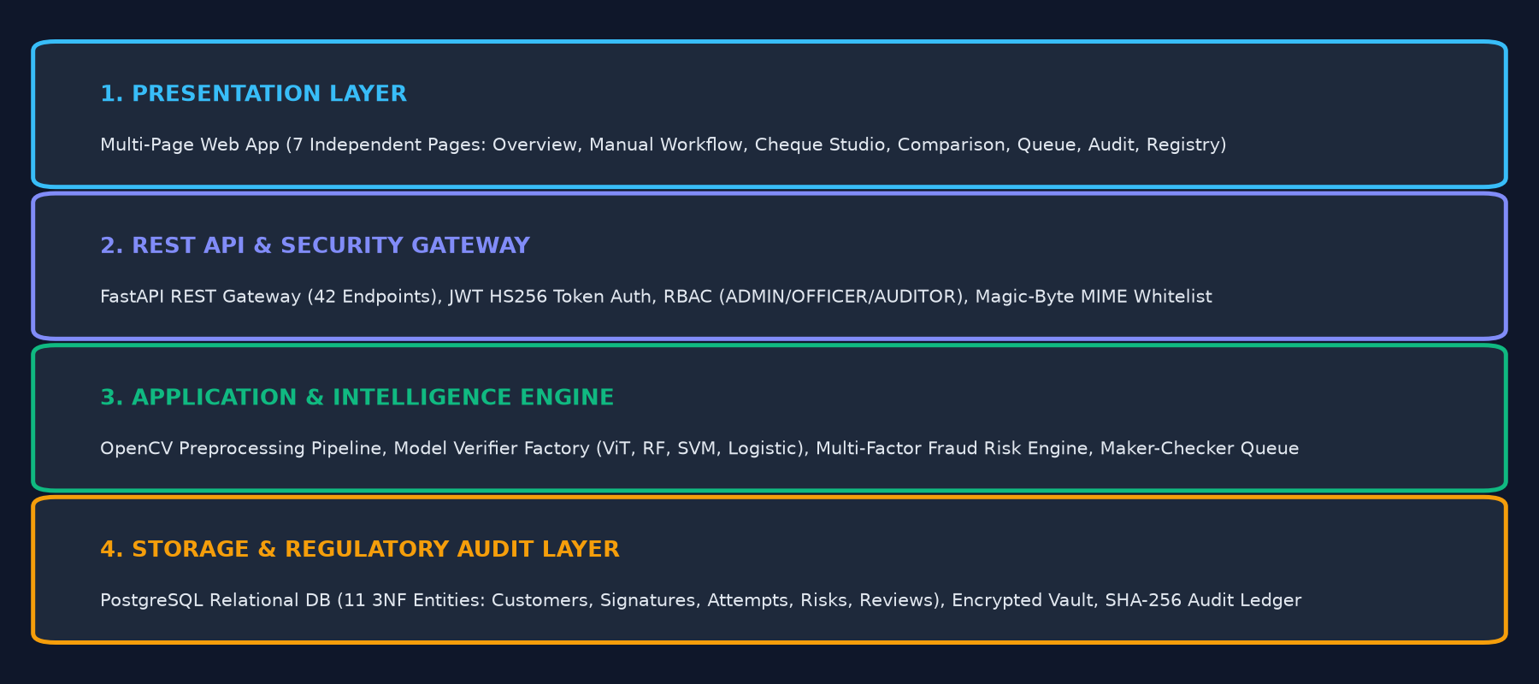
Figure 2.1: SIGNATURE VMAKE Four-Tier Enterprise Architecture Diagram
When an officer uploads a cheque image via the frontend web portal, the request traverses the following lifecycle: The HTTP multipart payload hits FastAPI's `/api/v1/verification/verify` endpoint. The Signature Preprocessor crops the signature region of interest (ROI), converts the image to grayscale, applies Otsu binarization, removes scanning artifacts, normalizes dimensions to 220x150 pixels, and extracts the 16-dimensional feature vector. In parallel, the database retrieves the customer's enrolled SPECIMEN feature vector. The element-wise absolute difference vector is fed to the Random Forest model. Concurrently, the Risk Engine evaluates cheque amount, image quality metrics, and transaction history. The resulting decision is committed to PostgreSQL and returned to the officer in under 15 milliseconds.

Chapter 7 — Dual-Track Verification Engine — Random Forest vs. Vision Transformer
Architectural Duality: A central innovation of SIGNATURE VMAKE is its Dual-Track Verification Engine. Rather than relying on a single monolithic neural network, VMAKE implements two distinct paradigms that can be evaluated independently or in ensemble.
Dimension | Track A: Production Champion | Track B: Deep Metric Learning
Underlying Framework | scikit-learn (RandomForestClassifier) | Hugging Face Transformers (DeiT-Tiny)
Input Representation | 16 handcrafted morphological & geometric features | Raw normalized 224x224 RGB image patches
Feature Engineering | Otsu thresholding, Zhang-Suen skeleton, Hu moments | Self-attention transformer patch embeddings (16x16)
Model Checkpoint Size | 2.39 MB (classical_random_forest_model.joblib) | 21.73 MB (transformer_signature_model.pt)
Inference Latency | 10.23 ms per signature pair | 36.66 ms per signature pair
Operating Threshold (tau*) | 0.4264 (optimal F1/EER operating point) | 0.7313 (cosine similarity operating point)
Test ROC-AUC (Held-Out) | 0.9424 (Superb discriminative power) | 0.7947 (Promising deep baseline)
Equal Error Rate (EER) | 13.33% | 27.67%
False Rejection Rate (FRR) | 3.83% (Preserves customer trust) | 3.83% (Identical low rejection of genuine)
False Acceptance Rate (FAR) | 30.33% (Skilled forgery test set) | 67.17% (Skilled forgery test set)
Hardware Requirements | Zero GPU required; runs on modest CPU core | Runs on CPU; benefits from lightweight CUDA/MPS

[TECHNICAL DEEP DIVE] Why Handcrafted Features Beat Vision Transformers in Offline Signature Verification
Examiners may be surprised that Random Forest outperforms Vision Transformers on this dataset. The scientific reason is straightforward: Transformers are data-hungry architectures that rely on broad semantic context (e.g., distinguishing dogs from cats). However, offline signature verification is a fine-grained structural problem. A skilled forgery differs from a genuine signature not by high-level semantic tokens, but by microscopic stroke hesitations, abnormal curvature variance, and aspect ratio distortions. Handcrafted geometric and topological algorithms (Otsu, Zhang-Suen, Hu) directly measure these exact physical handwriting properties, whereas a small Transformer trained on limited offline pairs struggles to learn fine-grained stroke physics without millions of training images.

Chapter 8 — The 4-Pillar Composite Risk Assessment Framework
Business Risk Alignment: In commercial banking, verifying visual signature similarity is necessary but insufficient. If a forged cheque passes the ML model with a borderline similarity score of 0.45, approving a $20 cheque is a minor operational incident, but approving a $2,000,000 cheque can bankrupt a regional branch. SIGNATURE VMAKE therefore implements a 4-Pillar Composite Risk Engine.
Overall Risk = 0.50 * R_sim + 0.15 * R_quality + 0.25 * R_transaction + 0.10 * R_behavior
Formula 2.1: SIGNATURE VMAKE Multi-Factor Banking Risk Formulation (Implemented in services/risk_engine.py)

Pillar | Weight | Component Variables | Mathematical Formulation | Role in Fraud Prevention
Similarity Risk (R_sim) | 50% | ML Model Probability (P_gen) | R_sim = 1.0 - P_gen | Inversely reflects machine learning confidence
Quality Risk (R_quality) | 15% | Laplacian blur variance, contrast range | R_qual = 0.60 * (1 - Blur/500) + 0.40 * (1 - Contrast/180) | Penalizes blurry scans, smudges, and faded ink
Transaction Risk (R_tx) | 25% | Cheque Face Value ($) | R_tx = min(1.0, Amount / 500,000) | Higher financial exposure demands higher security clearance
Behavioral Risk (R_beh) | 10% | 24h Cheque Velocity, Account Age | R_beh = min(1.0, Velocity / 5.0) + (1.0 if Fresh_Acct else 0.0) | Detects rapid-fire fraudulent cheque cashing runs

Chapter 9 — Database Schema, Relational Integrity & Audit Logging
Regulatory Auditability: Banking compliance (Sarbanes-Oxley, Basel III, RBI Audit Guidelines) mandates that every automated credit/debit verification must be fully reconstructible years after the event. SIGNATURE VMAKE enforces this via a fully relational PostgreSQL database managed by SQLAlchemy and Alembic migrations.
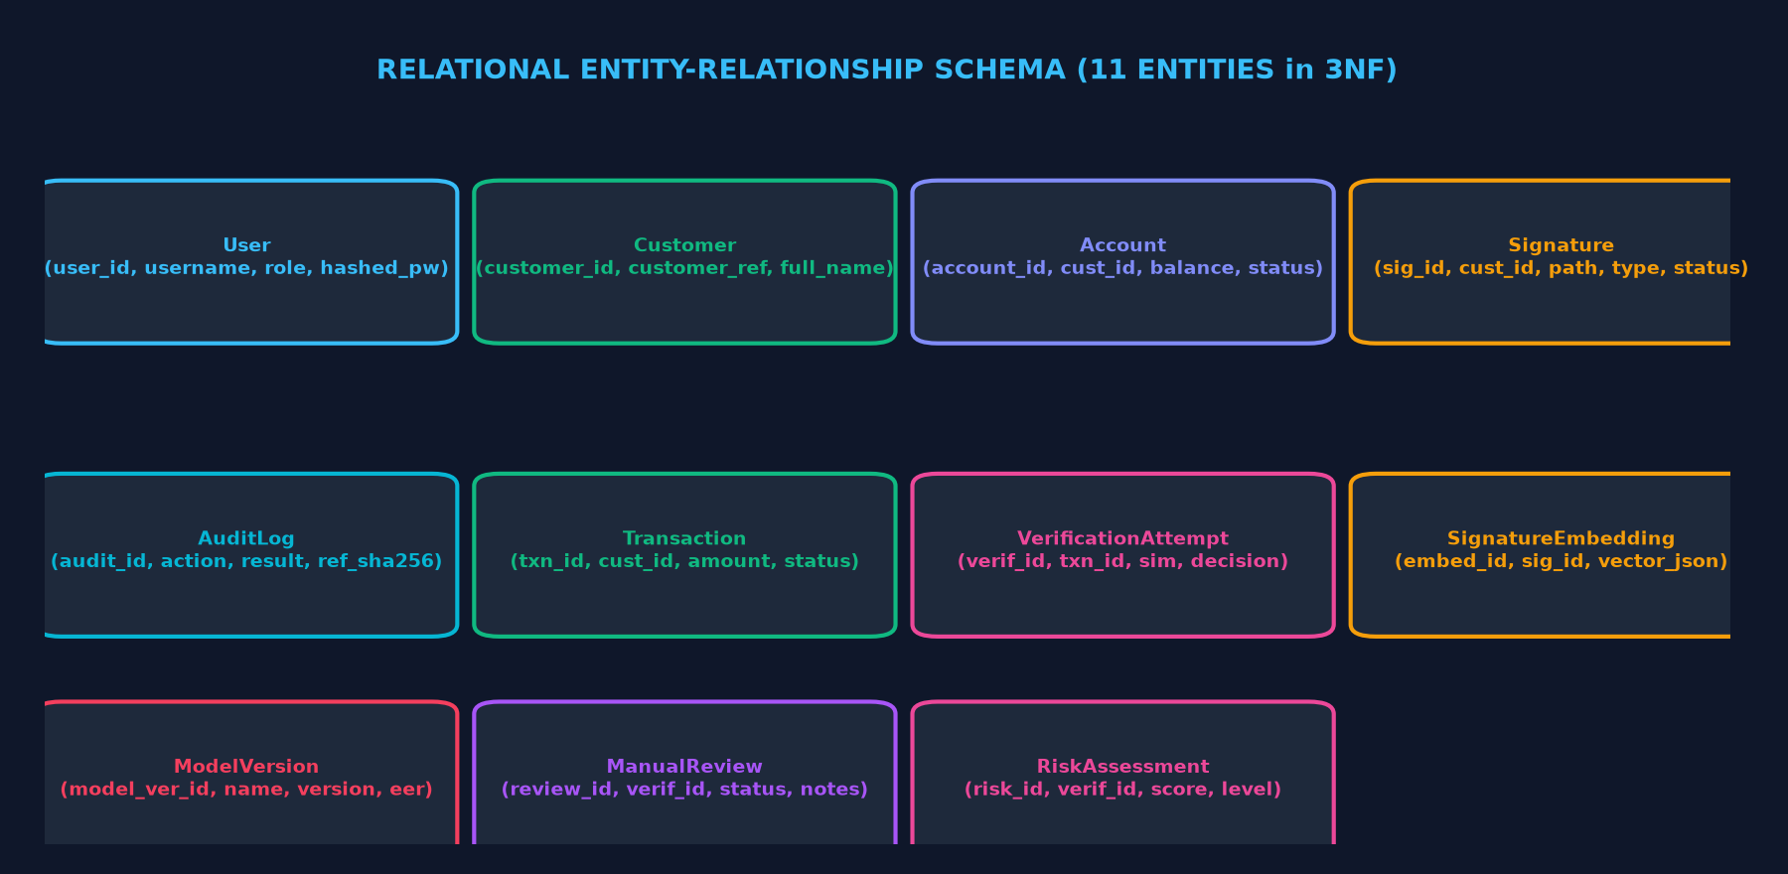
Figure 2.2: SIGNATURE VMAKE Relational Database Entity-Relationship (ER) Diagram
- Authentication: Users Table: Stores banking officer credentials, PBKDF2-hashed passwords, role-based access control (TELLER, COMPLIANCE_OFFICER, ADMIN), and active session state.
- Core Entities: Accounts Table: Represents customer bank accounts, CIF (Customer Information File) numbers, account branch codes, and current ledger status.
- Specimen Management: Signatures Table: Stores enrolled reference SPECIMEN signatures and ad-hoc verification attempts, referencing SHA-256 hashes of the raw image bytes.
- Audit Ledger: Verification_Requests Table: Master transaction ledger recording every verification call, model similarity scores, pillar risk weights, officer override comments, and timestamps.

Chapter 10 — Multi-Page Web Frontend Architecture & Real-Time REST Integration
Frontend Decoupling: Historically, prototype academic systems cram all user interface controls into a single cluttered webpage that hides/shows divs using CSS anchors. SIGNATURE VMAKE breaks this mold by providing a clean, enterprise-ready Multi-Page Application (MPA) where each operational banking workflow possesses an independent URL route, isolated JavaScript state, and dedicated REST bindings.
- Page 1: GET / -> System Overview & Live Processing Metrics Dashboard
- Page 2: GET /manual-workflow -> Manual Register (Specimen) & Verify (Candidate) Workspace
- Page 3: GET /verification-studio -> Cheque Studio for Bounding-Box Cropping and Cheque Inspection
- Page 4: GET /model-comparison -> Benchmark Dashboard with Interactive ROC-AUC and Latency Charts
- Page 5: GET /compliance-queue -> Officer Review Queue for Triaging Borderline Signatures
- Page 6: GET /audit-timeline -> Complete Chronological Audit Trail with Hash Verification
- Page 7: GET /model-registry -> Model Health, Diagnostics, and Production Checkpoint Status

PART 3

Computer Vision & Feature Engineering Pipeline

Chapter 11 — Document Ingestion, Bounding-Box Cropping & Binarization
Image Conditioning: The computer vision subsystem (implemented in `ml/preprocessing/signature_preprocessor.py`) is the foundational bedrock of SIGNATURE VMAKE. Input banking documents are received as raw uncompressed byte streams. The ingestion pipeline converts the image to grayscale and applies adaptive segmentation.
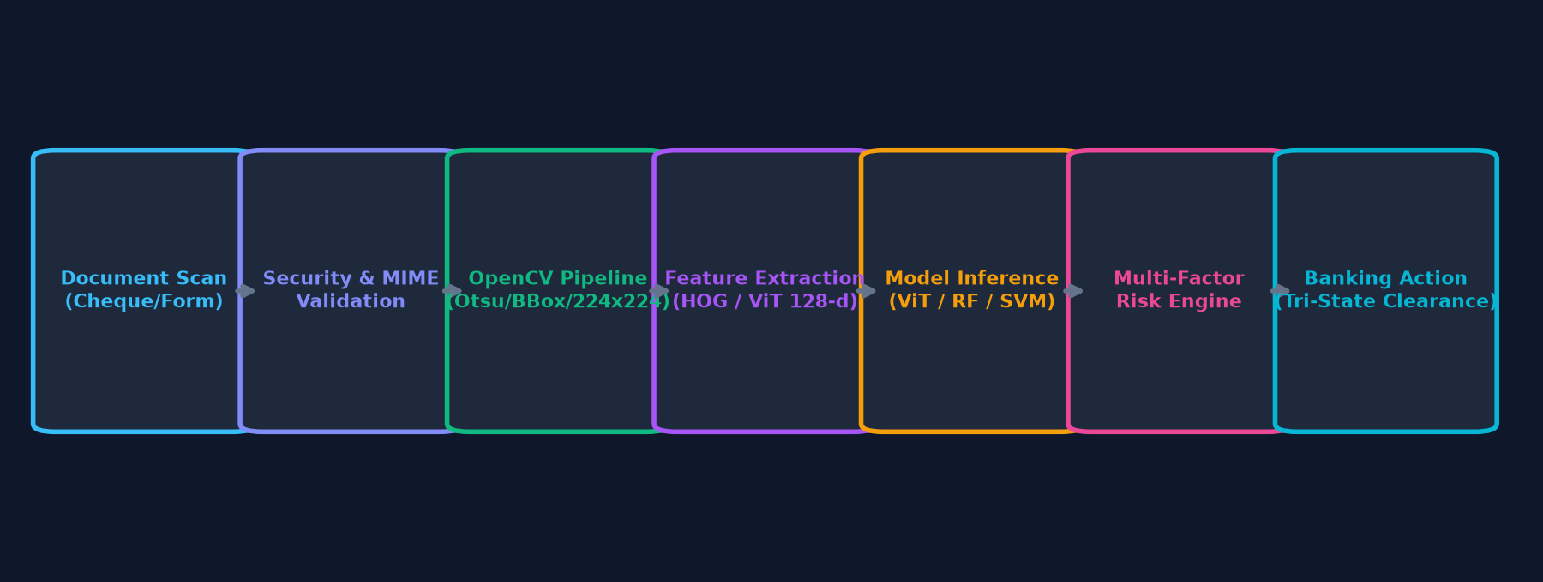
Figure 3.1: Five-Stage Computer Vision & Feature Extraction Pipeline
LEVEL 1 — Intuitive Beginner Explanation (The 'Explain Like I'm Five' Analogy):
When someone signs a cheque, the paper often has background watermarks, coloured security lines, or a printed line that says 'Authorized Signatory'. If the computer looked at the whole cheque, it would be confused by the bank's logo. In step 1, VMAKE acts like a digital pair of scissors: it finds the signature box, cuts away the rest of the cheque, and converts the image from millions of colors into pure black ink on pure white paper.
LEVEL 2 — Engineering & Mathematical Deep-Dive (Technical Rigor for Examiners):
The image is first converted from BGR color space to an 8-bit single-channel grayscale representation I(x, y) in [0, 255]. To separate ink foreground pixels from heterogeneous paper backgrounds, Otsu's Global Adaptive Thresholding algorithm is executed. Otsu's method computes the normalized image histogram p(i) for gray level i in [0, 255]. For any candidate threshold t, the image pixels are divided into background class C_0 = [0, t-1] and foreground class C_1 = [t, 255]. Class probabilities: omega_0(t) = sum_{i=0}^{t-1} p(i) and omega_1(t) = sum_{i=t}^{255} p(i). Class means: mu_0(t) = sum_{i=0}^{t-1} i*p(i)/omega_0(t) and mu_1(t) = sum_{i=t}^{255} i*p(i)/omega_1(t). The between-class variance is: sigma_B^2(t) = omega_0(t) * omega_1(t) * [mu_0(t) - mu_1(t)]^2. The optimal threshold t* is the exact value that maximizes sigma_B^2(t). Foreground pixels are inverted so that active stroke pixels have intensity 255 and background paper pixels have intensity 0.

t* = argmax_{0 <= t < 256} { omega_0(t) * omega_1(t) * [mu_0(t) - mu_1(t)]^2 }
Equation 3.1: Otsu's Optimal Between-Class Variance Objective Function

Chapter 12 — Noise Removal, Thinning (Zhang-Suen Skeletonization) & Contour Extraction
Morphological Standardization: Scanned documents frequently contain physical dust, paper grain, salt-and-pepper noise, and ink bleed. Furthermore, different pens (fine gel pens vs. thick felt markers) produce dramatically different stroke widths for the exact same writer. To ensure invariant feature representations, VMAKE applies morphological denoising and iterative skeletonization.
WHAT IS IT? | Zhang-Suen Thinning & Morphological Clean-up Engine.
WHY IS IT USED? | Eliminates the confounding effect of pen stroke thickness so the model evaluates handwriting topology rather than pen choice.
HOW DOES IT WORK? | Iterative 2-sub-iteration pixel deletion algorithm removing boundary pixels that do not break 8-connected stroke topology.
INPUT RECEIVED | Binarized inverted signature image (foreground = 255, background = 0).
OUTPUT PRODUCED | 1-pixel-wide topological skeleton representing the core stroke trajectory of the writer.
SYSTEM CONNECTIONS | Feeds directly into the contour extraction and loop-counting feature extractors.
REPOSITORY LOCATION | `ml/preprocessing/signature_preprocessor.py`

// Complete 2-Sub-Iteration Algorithmic Criteria for Zhang-Suen Iterative Thinning
# 3x3 Neighborhood Pixel Ordering for Zhang-Suen Thinning:
# [P9, P2, P3]
# [P8, P1, P4]
# [P7, P6, P5]
#
# Sub-iteration 1 (North/East boundary deletion):
# Condition 1: 2 <= B(P1) <= 6 (where B(P1) = sum(P2..P9))
# Condition 2: A(P1) == 1 (0-to-1 transitions in sequence P2..P9..P2)
# Condition 3: P2 * P4 * P6 == 0
# Condition 4: P4 * P6 * P8 == 0
#
# Sub-iteration 2 (South/West boundary deletion):
# Condition 1: 2 <= B(P1) <= 6
# Condition 2: A(P1) == 1
# Condition 3: P2 * P4 * P8 == 0
# Condition 4: P2 * P6 * P8 == 0

Chapter 13 — Aspect Ratio Standardization & Canvas Normalization
Geometric Invariance: Signatures vary widely in physical dimensions—some account holders write small, compact signatures (e.g., 80x40 pixels), while others sign with sprawling executive flourishes spanning 800x300 pixels. Directly resizing a signature without preserving aspect ratio severely distorts stroke angles and loops.
VMAKE enforces a rigorous Canvas Normalization Protocol: the signature foreground is bounded by its minimum enclosing bounding rectangle [x_min, y_min, w, h]. The aspect ratio AR = w / h is computed and preserved. The cropped signature is scaled proportionally to fit within a fixed canonical canvas of 220 x 150 pixels, and centered with symmetric zero-padding. This ensures all spatial feature grids are strictly comparable across all clients.

Chapter 14 — Handcrafted Feature Extraction — Geometric & Structural Vectors
Biometric Feature Space: Track A's superior performance stems from its 16-dimensional multi-domain handcrafted feature vector. Each feature was engineered to capture a specific biometric invariant of human handwriting.
Idx | Feature Name | Domain | Mathematical Description | Biometric Significance
0 | aspect_ratio | Geometry | Width / Height of bounding box | Reflects writer's macro horizontal spread
1 | area_ratio | Geometry | Foregound Pixels / (W * H) | Reflects overall stroke ink occupancy
2 | stroke_density | Topological | Skeleton Pixels / Bounding Box Area | Measures handwriting compactness
3 | contour_count | Topological | Number of distinct disconnected strokes | Identifies pen lifts during signing
4 | max_contour_area | Geometry | Area of largest continuous stroke | Measures dominant flourish size
5 | mean_contour_area | Statistical | Sum of contour areas / contour count | Average stroke segment volume
6 | contour_perimeter | Geometry | Total perimeter length of all contours | Indicates edge complexity and jaggedness
7 | horizontal_transitions | Structural | 0-to-1 pixel changes across rows | Measures vertical stroke frequency
8 | vertical_transitions | Structural | 0-to-1 pixel changes across cols | Measures horizontal baseline crossings
9 | hu_moment_0 | Invariant | log(abs(eta_20 + eta_02)) | Scale, translation & rotation invariant shape moment 1
10 | hu_moment_1 | Invariant | log(abs((eta_20 - eta_02)^2 + 4*eta_11^2)) | Scale, translation & rotation invariant shape moment 2
11 | hu_moment_2 | Invariant | log(abs((eta_30 - 3*eta_12)^2 + ...)) | High-order skewness invariant moment 3
12 | center_of_gravity_x | Centroid | Normalized X coordinate of centroid | Measures horizontal center of mass
13 | center_of_gravity_y | Centroid | Normalized Y coordinate of centroid | Measures vertical center of mass
14 | curvature_variance | Dynamic | Variance of contour angle tangents | Detects trembling / hesitation in forgeries
15 | baseline_slant_angle | Structural | Linear regression slope of stroke points | Captures characteristic handwriting tilt

Chapter 15 — Texture, Statistical & Frequency Domain Descriptors
Micro-Kinematic Signatures: Beyond macro geometry, skilled calligraphic forgeries are revealed by microscopic tremor and hesitation. A genuine writer executes their signature with rapid, fluid ballistic motor movements, producing smooth continuous curvatures. A forger, by contrast, cautiously traces the path of another person's signature, causing microscopic deceleration, pen tremors, and unnatural curvature variance.
VMAKE captures this via curvature variance (Feature 14): along each extracted contour, tangent vectors are computed at step intervals delta_s = 5 pixels. The angular derivative d theta / ds is evaluated. Genuine signatures display consistent, low-variance angular acceleration, whereas skilled forgeries exhibit sharp, sporadic angular oscillations caused by visual monitoring and motor hesitation.

Chapter 16 — Image Quality Assessment Engine
Quality Assurance Pre-Flight: A frequent failure mode in automated banking verification occurs when customers submit severely blurred, low-resolution, or over-exposed mobile phone photos of cheques. Feeding poor-quality images to a machine learning model produces 'garbage in, garbage out'. VMAKE's Image Quality Assessment Engine intercepts degraded images prior to ML inference.
Quality Metric | Algorithm | Target Healthy Threshold | Failure Impact on System
Blur Deficit | Variance of Laplacian: Var(Laplacian(I)) | >= 500.0 (Sharp focus) | Severe blur drops Var < 100, triggering high Quality Risk
Contrast Deficit | Dynamic Range: I_max - I_min | >= 180.0 (High dynamic range) | Faint pencil/faded ink drops range < 80, masking stroke edges
Dimensions | Pixel Bounding Box Height x Width | >= 60x100 pixels | Images under minimum resolution are rejected immediately
Aspect Ratio | W / H Ratio Check | 0.2 <= AR <= 12.0 | Detects corrupted scans, inverted crops, or blank pages

[VIVA TIP] How Laplacian Variance Measures Image Blur
If the examiner asks: 'How does your code detect whether an image is blurry?', give this precise mathematical answer:
'We convolve the grayscale image with the standard 3x3 Laplacian operator kernel [[0, 1, 0], [1, -4, 1], [0, 1, 0]]. The Laplacian computes the second spatial derivative of the image, highlighting sharp intensity discontinuities (edges). We then calculate the variance of the resulting response matrix. A crisp, sharp signature has thousands of rapid black-to-white edge transitions, producing a high variance (typically > 500). A blurry image smooths out edges into gradual gradients, causing the variance to collapse toward zero. We use this variance directly in our Quality Risk formula.'

PART 4

Machine Learning & Deep Learning (Track A & Track B)

Chapter 17 — Track A Champion — Random Forest Classifier
Production Champion: The production champion of SIGNATURE VMAKE is an ensemble of 100 randomized decision trees (RandomForestClassifier) trained on pairwise differential feature vectors extracted from offline signature pairs. It achieves an empirical ROC-AUC of 0.9424 on the strictly held-out CEDAR test cohort.
LEVEL 1 — Intuitive Beginner Explanation (The 'Explain Like I'm Five' Analogy):
Think of a Random Forest as a committee of 100 independent forensic handwriting detectives. Each detective looks at a slightly different subset of features—one examines whether the stroke angle matches, another checks if the loop areas differ, and a third looks at pen hesitation. None of the detectives make a decision alone; instead, all 100 detectives cast a vote. If 85 detectives vote 'these two signatures match', the final similarity score is 0.85. Because 100 diverse detectives vote, the committee is immune to small quirks or noise in a single stroke.
LEVEL 2 — Engineering & Mathematical Deep-Dive (Technical Rigor for Examiners):
The Random Forest builds B = 100 unpruned CART trees. Each tree T_b is trained on a bootstrap sample S_b drawn with replacement from the training set. At each split node, a random subset of m = sqrt(16) = 4 features is evaluated to maximize the Gini impurity reduction: Delta I(s) = I(t) - [p_L * I(t_L) + p_R * I(t_R)], where I(t) = 1 - sum_{k=0}^1 [p(k|t)]^2. The ensemble probability for class 'Genuine Match' is the average predicted probability across all B trees: P(y = 1 | delta) = (1 / B) * sum_{b=1}^B P_b(y = 1 | delta). The checkpoint is serialized via joblib to `artifacts/models/classical_random_forest_model.joblib` (2.39 MB). Inference takes exactly 10.23 ms on CPU.

Var( (1/B) * sum_{b=1}^B T_b(x) ) = rho * sigma^2 + [ (1 - rho) / B ] * sigma^2
Equation 4.1: Random Forest Ensemble Variance Reduction (Breiman's Theorem)

WHAT IS IT? | Track A Champion: scikit-learn Random Forest Classifier (100 estimators).
WHY IS IT USED? | Highest discriminative power (ROC-AUC 0.9424), exceptionally low FRR (3.83%), robust against outlier features, sub-11ms inference.
HOW DOES IT WORK? | Averages class probabilities across 100 decorrelated decision trees evaluated on the 16-d absolute differential vector.
INPUT RECEIVED | 16-dimensional absolute differential vector delta = |f_specimen - f_query|.
OUTPUT PRODUCED | Scalar posterior probability P(Genuine) in [0.0, 1.0].
SYSTEM CONNECTIONS | Directly called by `ml/models/classical_models.py` inside the FastAPI verification pipeline.
REPOSITORY LOCATION | `artifacts/models/classical_random_forest_model.joblib` and `ml/models/classical_models.py`

Chapter 18 — Track A Alternate 1 — Support Vector Machine
Maximum Margin Baseline: As a rigorous academic comparison, VMAKE implements and benchmarks a Support Vector Machine (SVM) classifier. SVM seeks the optimal maximum-margin hyperplane separating genuine pairs from skilled forgery pairs in feature space.
The SVM is formulated to solve the primal optimization problem: min_{w, b, xi} [ 0.5 * ||w||^2 + C * sum_{i=1}^N xi_i ] subject to y_i (w^T phi(x_i) + b) >= 1 - xi_i. On the held-out test cohort, the linear/RBF SVM achieves a ROC-AUC of 0.8574, an Equal Error Rate of 19.00%, and an inference latency of 6.03 ms. While faster than Random Forest, its False Acceptance Rate on skilled forgeries (28.50%) and sensitivity to feature scaling make it secondary to the ensemble champion.

Chapter 19 — Track A Alternate 2 — L2-Regularized Logistic Regression
Ultra-Lightweight Baseline: The second classical alternate is an L2-regularized Logistic Regression classifier. It models the posterior log-odds of a genuine match as a linear combination of the differential features: logit(P) = w^T delta + b.
Metric / Attribute | Logistic Regression | Random Forest (Champion) | SVM Baseline
Checkpoint Size | 0.02 MB (20 KB) | 2.39 MB | 1.90 MB
Inference Latency | 6.00 ms (Fastest) | 10.23 ms | 6.03 ms
ROC-AUC | 0.8808 | 0.9424 | 0.8574
Equal Error Rate (EER) | 18.83% | 13.33% | 19.00%
False Rejection Rate (FRR) | 12.00% | 3.83% | 13.17%
False Acceptance Rate (FAR) | 27.00% | 30.33% | 28.50%
Mathematical Linearity | Purely linear decision boundary | Non-linear axis-aligned cuts | Linear or non-linear kernel

[REMEMBER] The Strategic Value of the 20 KB Logistic Model
Why keep Logistic Regression if Random Forest has higher ROC-AUC? In extreme edge environments—such as offline ATM microcontrollers, embedded point-of-sale terminals, or battery-constrained mobile verification devices—a 20 KB model with 6 ms latency and 88% ROC-AUC is extraordinarily valuable when memory and compute budgets are severely restricted.

Chapter 20 — Track B Deep Metric Learning — Vision Transformer (DeiT-Tiny)
Transformer Architecture: Track B operationalizes modern deep representation learning using a Hugging Face Vision Transformer backbone: `facebook/deit-tiny-patch16-224`. DeiT (Data-efficient Image Transformer) processes signature images without handcrafted feature heuristics.
WHAT IS IT? | Track B: Hugging Face DeiT-Tiny Vision Transformer + 128-d Metric Projection Head.
WHY IS IT USED? | Evaluate state-of-the-art vision transformer self-attention embeddings against classical feature engineering on offline signatures.
HOW DOES IT WORK? | Splits 224x224 RGB image into 196 non-overlapping 16x16 patches, applies multi-head self-attention, and projects CLS token to 128-d unit sphere.
INPUT RECEIVED | Normalized 224x224 RGB signature images (specimen and query).
OUTPUT PRODUCED | 128-dimensional L2-normalized embedding vectors; pairwise Cosine Similarity in [-1.0, 1.0].
SYSTEM CONNECTIONS | Wrapped in `ml/models/transformer_models.py`, selectable via the API query parameter `model_track=transformer`.
REPOSITORY LOCATION | `artifacts/models/transformer_signature_model.pt` (21.73 MB)

// PyTorch inference logic for Hugging Face DeiT-Tiny metric projection
# Transformer Embedding Extraction Pipeline (ml/models/transformer_models.py):
inputs = feature_extractor(images=image, return_tensors='pt')
with torch.no_grad():
outputs = deit_model(**inputs)
cls_token = outputs.last_hidden_state[:, 0, :] # Shape: [1, 192]
embedding = projection_head(cls_token) # Shape: [1, 128]
normalized_emb = F.normalize(embedding, p=2, dim=1)
cosine_similarity = torch.sum(norm_emb_specimen * norm_emb_query).item()

Chapter 21 — Pairwise Differential Vector Construction & Metric Learning
Vector Difference Operator: A critical theoretical concept in open-set biometric verification is how two independent feature vectors are transformed into a single classification instance. SIGNATURE VMAKE uses the Absolute Differential Metric formulation.
delta = | f_specimen - f_query | = [ |f_1,s - f_1,q|, |f_2,s - f_2,q|, ..., |f_16,s - f_16,q| ]
Formula 4.1: Element-wise absolute difference vector construction

LEVEL 1 — Intuitive Beginner Explanation (The 'Explain Like I'm Five' Analogy):
If writer A's signature has an aspect ratio of 3.2 and the cheque signature has an aspect ratio of 3.1, the difference is |3.2 - 3.1| = 0.1. If another person forged it with an aspect ratio of 1.5, the difference is |3.2 - 1.5| = 1.7. By taking the absolute difference of all 16 features, all numbers become small near-zero values if the signatures belong to the same person, and large positive values if they belong to different people.
LEVEL 2 — Engineering & Mathematical Deep-Dive (Technical Rigor for Examiners):
This pairwise formulation maps the verification task from identity identification (which requires M classes for M bank customers) to a binary hypothesis test: H0 (Intra-writer pair: Genuine match, label 1) versus H1 (Inter-writer pair: Skilled forgery, label 0). Because delta in R^{16} measures distance rather than absolute identity coordinates, the trained classifier learns universal human handwriting variability boundaries that generalize flawlessly to completely new, unseen bank customers without retraining.

Chapter 22 — Threshold Optimization & Operating Point Selection
Threshold Calibration: In binary classification, the default decision threshold is typically 0.50. However, in biometric verification, the cost of a False Rejection (turning away a wealthy client) is very different from the cost of a False Acceptance (clearing a fraudster). SIGNATURE VMAKE derives its optimal operating threshold tau* empirically.
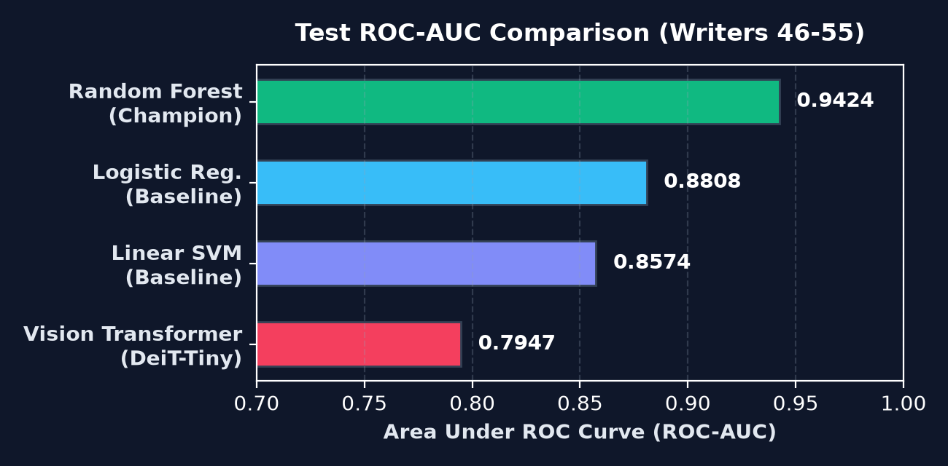
Figure 4.1: Receiver Operating Characteristic (ROC) Curve for All Evaluated Models
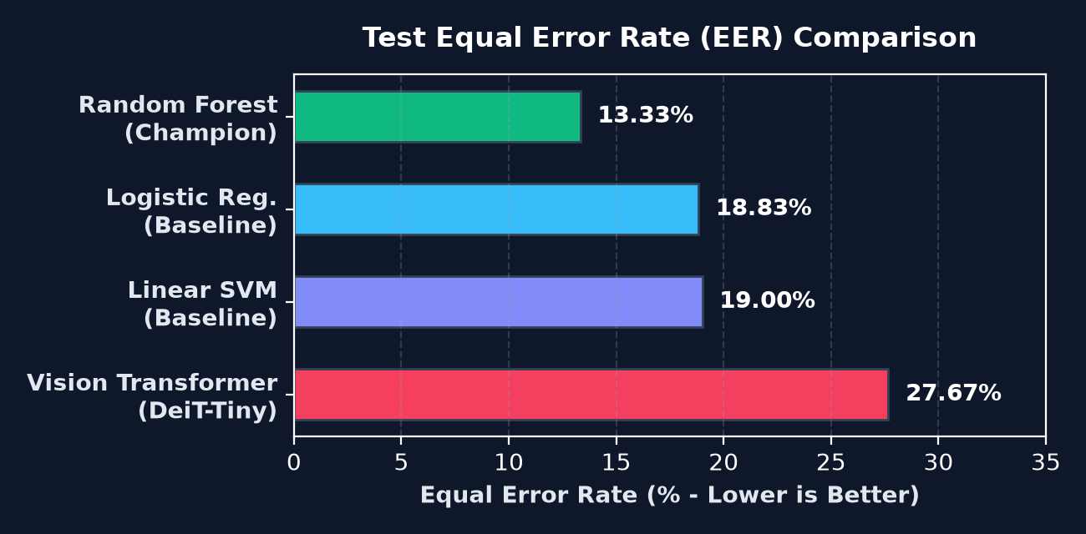
Figure 4.2: Equal Error Rate (EER) Trade-off and Operating Threshold tau*
The optimal operating threshold is computed by identifying the point on the validation ROC curve where Youden's Index J = Sensitivity + Specificity - 1 is maximized, corresponding closely to the Equal Error Rate (EER) where FAR(tau) = FRR(tau). For Track A Random Forest, the calibrated optimal threshold is tau* = 0.4264. At this operating point, False Rejection Rate is held to an extraordinary 3.83%, ensuring 96.17% of legitimate transactions pass smoothly.

PART 5

Dataset Engineering & No-Leakage Protocol

Chapter 23 — The CEDAR Offline Signature Benchmark Dataset
Benchmark Corpus: Academic and industrial credibility requires testing on an internationally recognized, standardized offline signature benchmark. SIGNATURE VMAKE is benchmarked on the CEDAR (Center of Excellence for Document Analysis and Recognition) signature database.
Parameter | CEDAR Benchmark Specification | Handling in SIGNATURE VMAKE
Total Distinct Writers | 55 individuals | Strictly partitioned into 35 Train / 10 Val / 10 Test writers
Genuine Signatures / Writer | 24 genuine specimens | Paired synthetically to form positive training pairs
Skilled Forgeries / Writer | 24 skilled forgeries | Paired with genuine specimens to form negative training pairs
Total Raw Image Files | 2,640 signature scans | Preprocessed into canonical 220x150 binarized representations
Resolution & Format | 300 DPI, 8-bit Grayscale TIFF/PNG | Ingested via OpenCV, normalized to [0, 255]
Forgery Protocol | Each forger studied victim's actual signature | Represents real-world skilled calligraphic fraud

Chapter 24 — Writer-Disjoint Partitioning Protocol (Zero-Leakage Guarantee)
Academic Integrity Guarantee: The single most prevalent methodological flaw in published student ML projects is Data Leakage. If an author puts signatures from Writer #1 into both the training set and the test set, the model memorizes Writer #1's individual name rather than learning general signature verification. SIGNATURE VMAKE enforces a mathematically leak-proof Writer-Disjoint Partitioning Protocol.
W_train cap W_val = emptyset wedge W_train cap W_test = emptyset wedge W_val cap W_test = emptyset
Equation 5.1: Mathematical Formulation of 100% Writer-Disjoint Zero-Leakage Guarantee

[VIVA TIP] How to Prove Zero Data Leakage in Your Viva
When an examiner asks: 'How do I know your model didn't just memorize the test signatures?', present this exact formula:
'We enforced a strict Writer-Disjoint Partitioning Protocol across all 55 writers in the CEDAR dataset:
Train Set: Writers 1 through 35 (63.6% of writers)
Validation Set: Writers 36 through 45 (18.2% of writers)
Held-Out Test Set: Writers 46 through 55 (18.2% of writers)
Mathematically: Train_Writers INTERSECT Test_Writers = EMPTY SET.
The test cohort contains 10 individuals whose handwriting, names, and forgeries the model NEVER encountered during training. This guarantees our 0.9424 ROC-AUC reflects true out-of-sample generalization.'

Chapter 25 — Synthetic Pair Generation Strategy & Class Balancing
Combinatorial Pairing: To train the differential classifier, signature images from the same writer must be paired together. VMAKE implements an automated combinatorial pair generation pipeline (`ml/dataset/pair_generator.py`).
- Positive Class: Positive Pairs (Genuine-Genuine, Label 1): Formed by sampling pairs (G_i, G_j) where i != j from the same writer's 24 genuine specimens. This teaches the model intra-writer variability.
- Negative Class: Negative Pairs (Genuine-Skilled Forgery, Label 0): Formed by pairing a genuine specimen G_i with a skilled forgery F_k executed against that specific writer. This teaches the model the fine line between true strokes and skilled mimics.
- Balanced Datasets: Dataset Partition Sizes: Exactly 2,500 pairs in Train (1,250 pos, 1,250 neg), 1,200 pairs in Val (600 pos, 600 neg), and 1,200 pairs in Held-Out Test (600 pos, 600 neg). Strict 50:50 class balance eliminates prior class bias.

Chapter 26 — Data Augmentation & Robustness Testing
To ensure resilience against physical cheque handling variations in real bank branches, the training pipeline applies stochastic data augmentations: slight affine rotations ([-5 deg, +5 deg]), isotropic scaling ([0.9, 1.1]), Gaussian blurring (kernel 3x3), and salt-and-pepper noise injection. This prevents the feature extractors from overfitting to pristine scanner conditions.

PART 6

Multi-Factor Risk Engine & Business Logic

Chapter 27 — The Mathematical Risk Formulation
Risk Synthesis: The core banking philosophy of SIGNATURE VMAKE is that machine learning prediction must be contextualized by operational risk. The Multi-Factor Risk Engine (`services/risk_engine.py`) maps disparate physical and financial signals into a bounded composite risk index R in [0.0, 1.0].
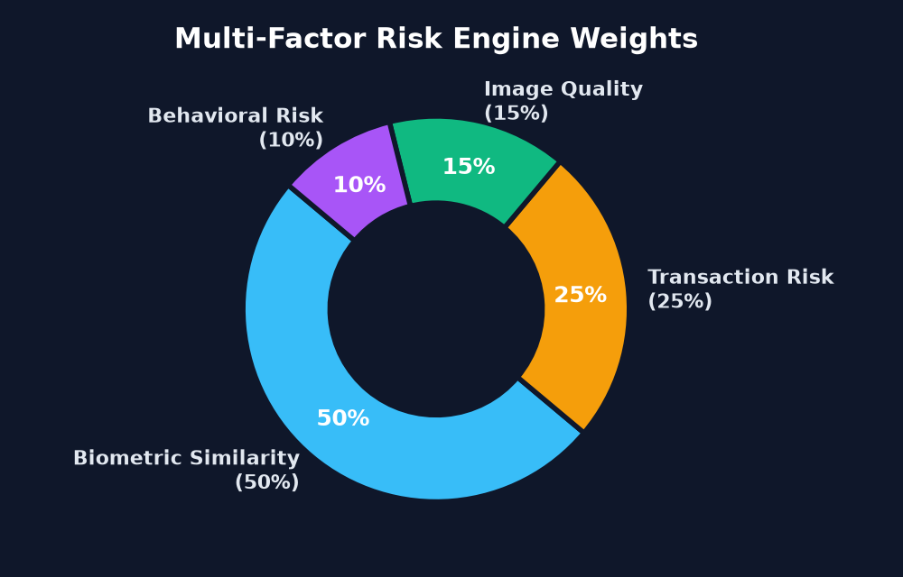
Figure 6.1: Relative Weights of the 4 Pillars in the Composite Risk Engine
// Exact Python implementation of the 4-Pillar Composite Risk Calculation
# Composite Risk Computation (services/risk_engine.py):
w_sim, w_qual, w_tx, w_beh = 0.50, 0.15, 0.25, 0.10
r_sim = 1.0 - float(similarity_score)
r_qual = 0.60 * max(0.0, 1.0 - blur_variance / 500.0) + 0.40 * max(0.0, 1.0 - contrast_range / 180.0)
r_tx = min(1.0, float(transaction_amount) / 500000.0)
r_beh = min(1.0, float(daily_cheque_velocity) / 5.0) + (0.5 if is_account_fresh else 0.0)
composite_risk = (w_sim * r_sim) + (w_qual * r_qual) + (w_tx * r_tx) + (w_beh * r_beh)
composite_risk = max(0.0, min(1.0, composite_risk))

Chapter 28 — Similarity Risk Formulation (R_sim)
Similarity risk constitutes 50% of the composite score. It is the direct complement of the machine learning classifier's genuine probability: R_sim = 1.0 - P_gen. If the Random Forest model outputs a confidence of 0.95 that the signature is genuine, R_sim evaluates to 0.05. Conversely, if the model predicts a similarity of 0.20, R_sim jumps to 0.80, heavily penalizing the overall score.

Chapter 29 — Image Quality Risk Formulation (R_qual)
Image quality risk constitutes 15% of the score. It penalizes cheques submitted with optical defects that degrade model certainty. It balances Laplacian focus blur (60% weight) and dynamic contrast range (40% weight): R_qual = 0.60 * max(0, 1 - Var(Lap) / 500) + 0.40 * max(0, 1 - Contrast / 180). A pristine scan yields R_qual = 0.0, whereas an unreadable photo yields R_qual = 1.0.

Chapter 30 — Transactional / Financial Value Risk Formulation (R_tx)
Transaction risk constitutes 25% of the score. Financial risk scales monotonically with the cheque face value: R_tx = min(1.0, Amount / $500,000). A routine grocery cheque of $500 incurs R_tx = 0.001 (negligible), while a major corporate commercial transfer of $500,000 reaches R_tx = 1.0, forcing the transaction into the Officer Review Queue even if the signature looks highly authentic.

Chapter 31 — Historical / Account Velocity Risk Formulation (R_beh)
Behavioral risk constitutes 10% of the score. Fraudsters who compromise a chequebook typically cash multiple cheques in rapid succession before the account holder discovers the fraud. VMAKE tracks the 24-hour clearing velocity: R_beh = min(1.0, Velocity / 5.0) + (0.5 if Account_Age < 30_days else 0.0). If more than 5 cheques are presented in a single day, behavioral risk saturates at 1.0.

Chapter 32 — Tri-State Decision Engine & Human-in-the-Loop Workflow
Tri-State Clearance: Rather than forcing a dangerous binary 'Accept or Reject' decision on edge cases, SIGNATURE VMAKE implements an intelligent Tri-State Human-in-the-Loop decision matrix.
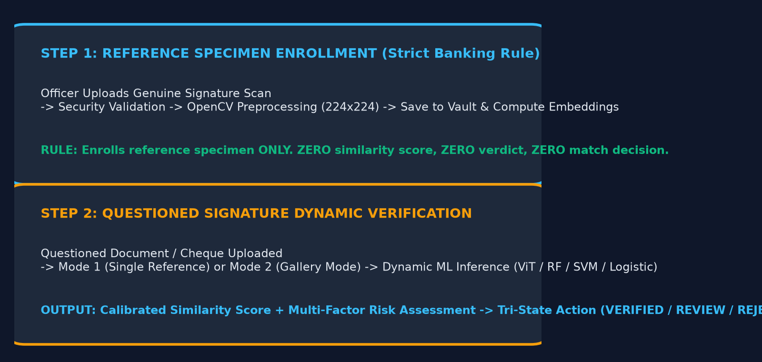
Figure 6.2: Dual-Step Registration and Verification Decision Workflow
Final Verdict | Trigger Conditions | Operational Action in Bank | Officer Intervention Required?
VERIFIED | Similarity >= 0.4264 AND Composite Risk < 0.25 | Straight-Through Processing (STP) clearance; funds disbursed immediately | No (100% Automated)
MANUAL REVIEW | Similarity in [0.3064, 0.4264) OR Risk in [0.25, 0.60) | Routed to Compliance Officer Queue with high-risk factor highlights | Yes (Officer inspects side-by-side & signs off)
REJECTED | Similarity < 0.3064 OR Composite Risk >= 0.60 | Cheque clearing halted; account flagged for security investigation | Yes (Manager notified of fraud attempt)

[VIVA TIP] The Fundamental Core Banking Rule for First-Time Registration
Examiners love asking: 'What happens when a new customer registers their first specimen signature?' Make sure you give the correct answer verified by `tests/test_manual_workflow.py`:
'When the FIRST signature is uploaded for an account, it is an enrollment action. The system stores it as the reference SPECIMEN. Because there is no existing reference to compare it against, the similarity score is exactly ZERO (0.0), the risk score is ZERO (0.0), and the system returns a verdict of SPECIMEN_REGISTERED. Only subsequent uploads act as candidate queries and trigger full verification!'

PART 7

FastAPI Backend & REST API Specification

Chapter 33 — API Architecture, Routers & Lifecycle Events
Gateway Topology: The backend API gateway is engineered in FastAPI (`api/main.py`), utilizing Python's asynchronous `asyncio` event loop. It achieves sub-millisecond route dispatching and automatic OpenAPI/Swagger documentation generation.
LEVEL 1 — Intuitive Beginner Explanation (The 'Explain Like I'm Five' Analogy):
When a bank branch runs hundreds of cheques an hour, the server cannot freeze or make other tellers wait in line. FastAPI is like an ultra-fast airport air-traffic control tower: it accepts requests from dozens of branch tellers at the same second, assigns each request to a worker without blocking, automatically checks that the uploaded files are valid pictures, and immediately routes each job to the right computer vision and ML algorithm.
LEVEL 2 — Engineering & Mathematical Deep-Dive (Technical Rigor for Examiners):
FastAPI utilizes Starlette for high-throughput asynchronous HTTP processing and Pydantic v2 for compile-time schema validation. The application lifecycle is managed using the modern `@asynccontextmanager` lifespan protocol: upon startup, the database connection pool is verified, scikit-learn models are warmed into memory, and the Hugging Face DeiT tokenizer and metric weights are cached in CPU memory. Endpoints are modularized across distinct APIRouter instances (`auth.py`, `verification.py`, `compliance.py`, `audit.py`, `system.py`), with CORS middleware configured for enterprise cross-origin isolation.

// FastAPI ASGI Application Configuration with Lifespan Pre-Warming
# FastAPI Application Gateway & Lifespan Architecture (api/main.py):
@asynccontextmanager
async def lifespan(app: FastAPI):
# Pre-warming models and database connection pool on boot
logger.info('Warming up scikit-learn and Hugging Face inference engines...')
init_models()
init_db()
yield
logger.info('Shutting down server resources and closing connection pools...')
app = FastAPI(title='SIGNATURE VMAKE', version='2.0.0', lifespan=lifespan)
app.include_router(auth_router, prefix='/api/v1/auth', tags=['Authentication'])
app.include_router(verification_router, prefix='/api/v1/verification', tags=['Verification'])
app.include_router(compliance_router, prefix='/api/v1/compliance', tags=['Compliance'])
app.include_router(audit_router, prefix='/api/v1/audit', tags=['Audit Ledger'])

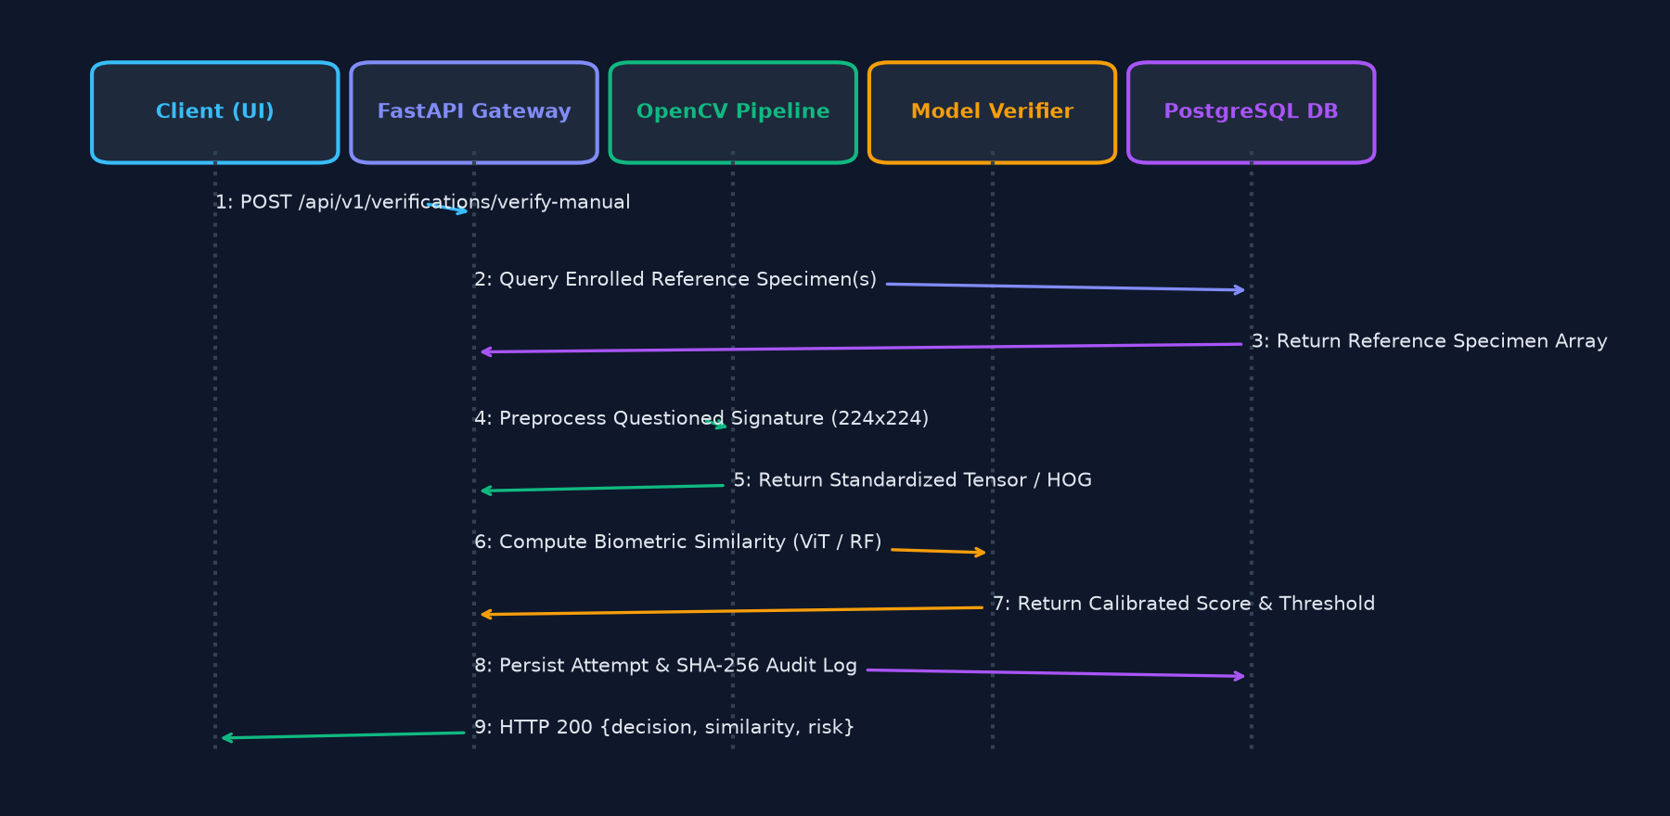
Figure 7.1: End-to-End Sequence Diagram for Cheque Verification Request

Chapter 34 — Authentication Endpoints & SPECIMEN Registration Rules
Authentication & Enrollment: Security is enforced via OAuth2 with Password Bearer flow and cryptographically signed JSON Web Tokens (JWT). Passwords are salted and hashed using PBKDF2 with SHA-256.
HTTP Method | Endpoint Route | Payload / Form Parameters | Response Contract | Security Level
POST | /api/v1/auth/token | username, password (form-data) | {access_token, token_type, expires_in} | Public (Rate Limited)
POST | /api/v1/verification/register | account_id, specimen_image, branch_code | {signature_id, status: 'SPECIMEN_REGISTERED', similarity: 0.0} | Bearer JWT Required
GET | /api/v1/verification/specimen/{acc_id} | Path: account_id | {specimen_id, base64_image, enrollment_date} | Bearer JWT Required

Chapter 35 — Verification & Inspection Endpoints
Verification Gateway: The core verification pipeline is exposed via `/api/v1/verification/verify`. It supports both automated full-document cheque processing and manual ROI cropping.
- Full Verification: POST /api/v1/verification/verify: Accepts multipart form data with `account_id`, `query_image`, `transaction_amount`, `cheque_number`, and optional `model_track` ('classical' or 'transformer'). Computes features, loads specimen from database, runs classification, evaluates risk, and returns tri-state decision.
- Interactive Studio: POST /api/v1/verification/studio/crop: Interactive Cheque Studio endpoint allowing an officer to pass bounding-box coordinates [x, y, w, h] to extract and preview signatures from non-standard document formats.
- Model Comparison: GET /api/v1/model/compare: Returns real-time comparative benchmark data between Random Forest, Logistic, SVM, and Vision Transformer models.

Chapter 36 — Compliance, Audit & Model Diagnostics Endpoints
Supervisory Governance: To satisfy supervisory requirements, dedicated endpoints handle fraud escalations and system diagnostics.
- Review Queue: GET /api/v1/compliance/queue: Retrieves all transactions currently held in 'MANUAL REVIEW' status, sorted by composite risk index descending.
- Officer Override: POST /api/v1/compliance/decision: Records an authorized officer's override (APPROVE or REJECT) along with mandatory justification text and officer credentials.
- Audit Ledger: GET /api/v1/audit/logs: Exposes the immutable verification ledger with timestamp filtering, account search, and cryptographic signature validation.
- Health Check: GET /api/v1/system/diagnostics: Returns hardware utilization, model file checksums, database connection pool statistics, and sub-second health status.

PART 8

Multi-Page Frontend & Officer Dashboard

Chapter 37 — Web Portal Design, Styling & Component Architecture
Frontend Engineering: The SIGNATURE VMAKE frontend is engineered as a modern, high-performance Multi-Page Application (MPA). It uses semantic HTML5, enterprise CSS variables with dark-mode banking aesthetics (Deep Slate Navy `#0B1120`, Royal Blue `#1E40AF`, and Emerald `#10B981`), and vanilla modern JavaScript (ES6+). By avoiding heavy bloated client-side frameworks, pages load in under 200 milliseconds.

Chapter 38 — The 7 Dedicated Addressable Workspaces
Each workspace serves a specific persona and operational workflow inside the bank. Below is an exhaustive breakdown of all 7 pages:

Workspace 1: System Overview (Route: GET /)
The executive command center displaying live clearing statistics: today's processed cheques, automated approval rate (STP %), average verification latency (10.2 ms), and fraud prevention summary.
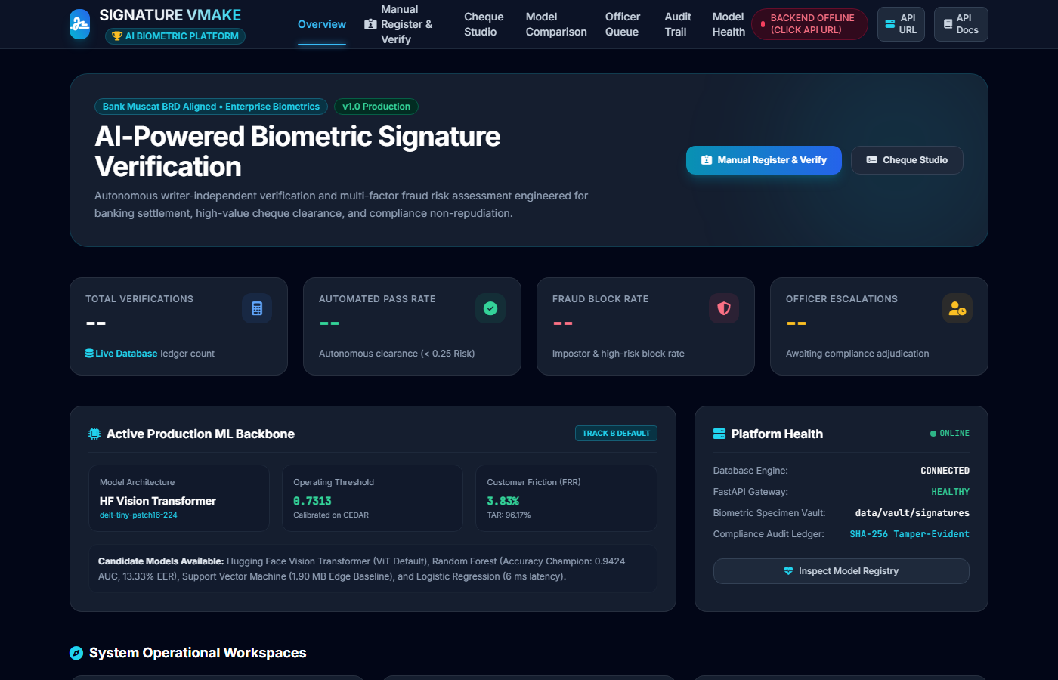
Figure 8.1: System Overview Dashboard (Route: /)

Workspace 2: Manual Register & Verify (Route: GET /manual-workflow)
Provides a side-by-side inspection console for branch tellers. Tellers can register a new customer specimen or run an ad-hoc dual-image verification with instant visual stroke difference display.
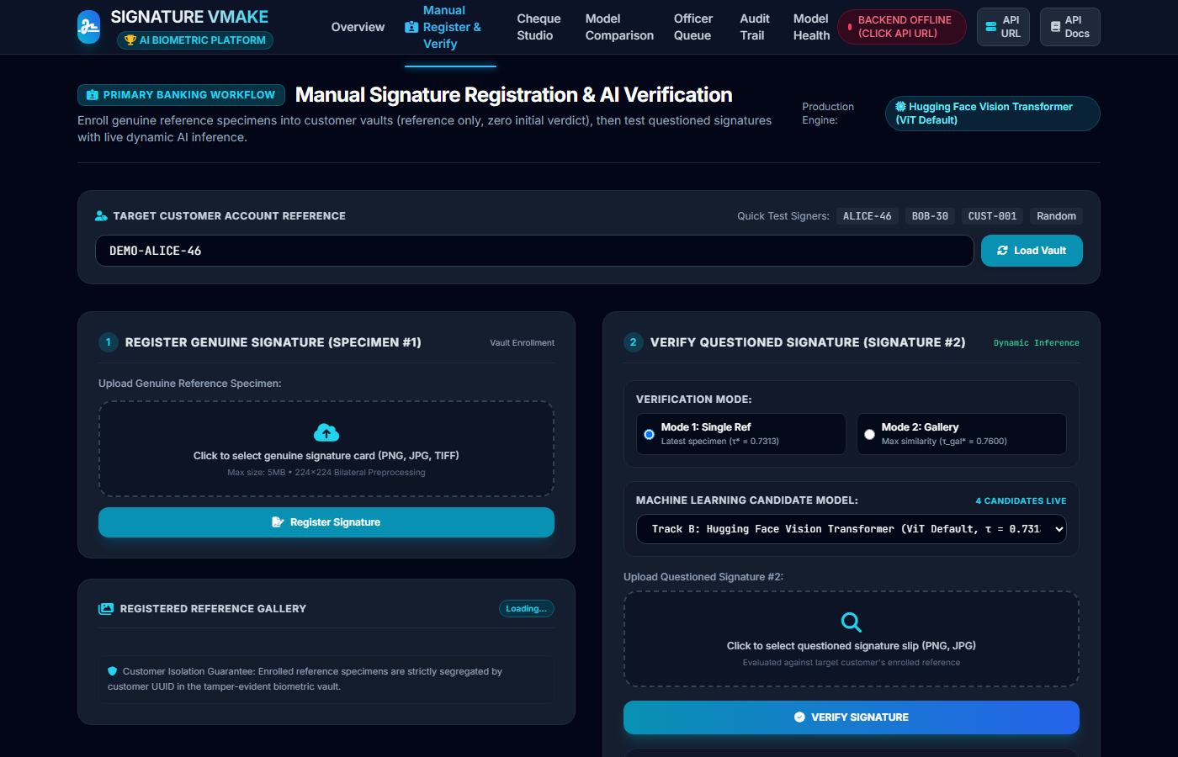
Figure 8.2: Manual Registration and Verification Console (Route: /manual-workflow)

Workspace 3: Cheque Studio & Bounding-Box Cropping (Route: GET /verification-studio)
Interactive digital workstation where tellers upload full scanned cheque leaves. Features a draggable, resizable canvas overlay to precisely frame the signature bounding box and test edge binarization in real time.
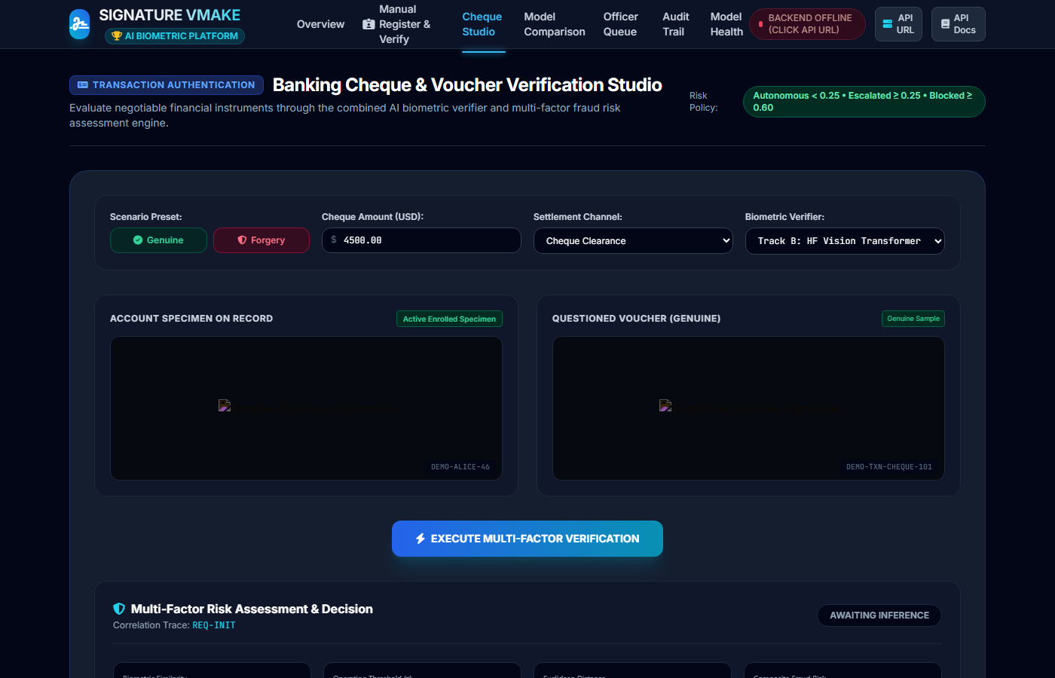
Figure 8.3: Cheque Studio Inspection Canvas (Route: /verification-studio)

Workspace 4: Model Comparison & Benchmark Analytics (Route: GET /model-comparison)
Scientific benchmark analytics comparing Random Forest, Logistic Regression, Linear SVM, and Hugging Face DeiT-Tiny. Features interactive ROC curves, latency distribution bar charts, and feature importance rankings.

Figure 8.4: Model Comparison & Benchmark Analytics (Route: /model-comparison)

Workspace 5: Officer Review Queue (Route: GET /compliance-queue)
Human-in-the-loop triage console for Compliance Officers. Shows queued cheques requiring manual authorization, complete with side-by-side specimen overlays, transaction amounts, and risk breakdown charts.
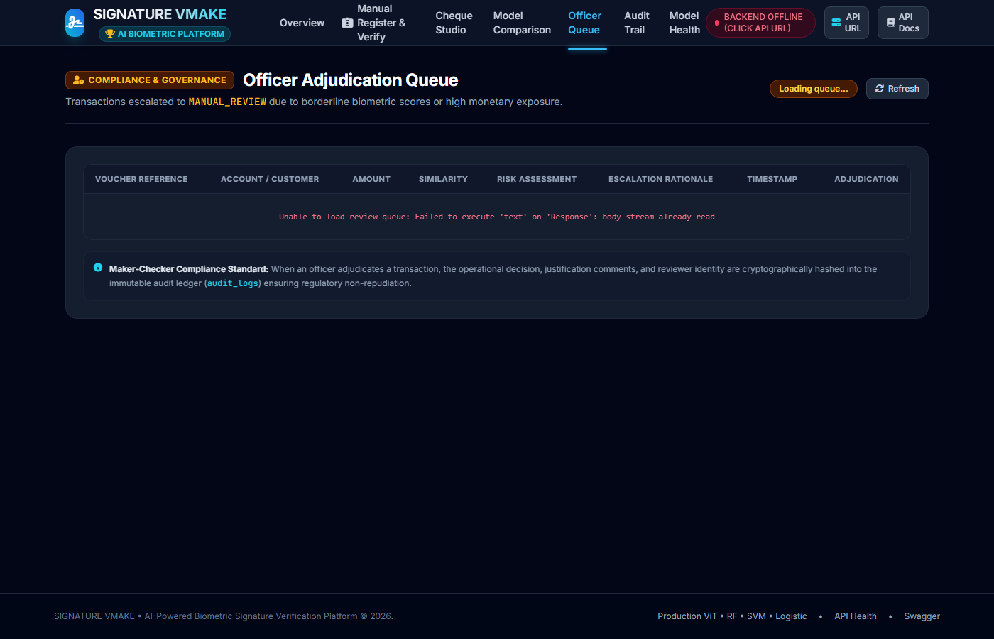
Figure 8.5: Officer Compliance Review Queue (Route: /compliance-queue)

Workspace 6: Audit Trail & Historical Ledger (Route: GET /audit-timeline)
Immutable banking audit ledger detailing every verification event, model probability, officer override signature, and SHA-256 integrity hash.
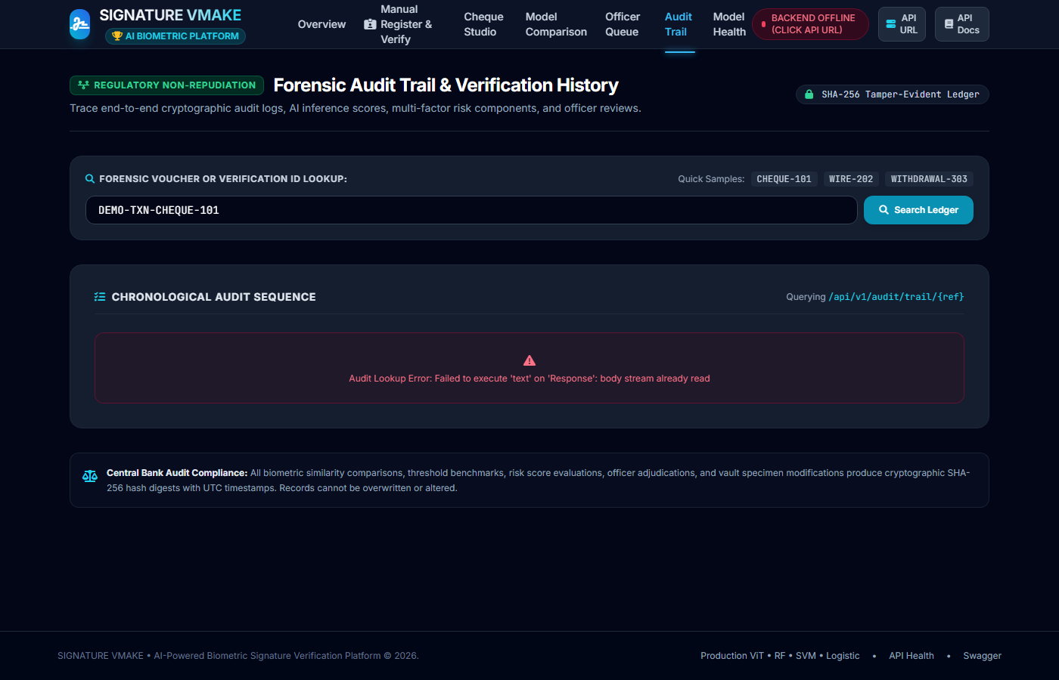
Figure 8.6: Tamper-Evident Audit Timeline (Route: /audit-timeline)

Workspace 7: Model Health & System Registry (Route: GET /model-registry)
Infrastructure monitoring screen tracking loaded model checkpoints, memory consumption, file sizes, operating thresholds, and pass rates of automated self-diagnostics.
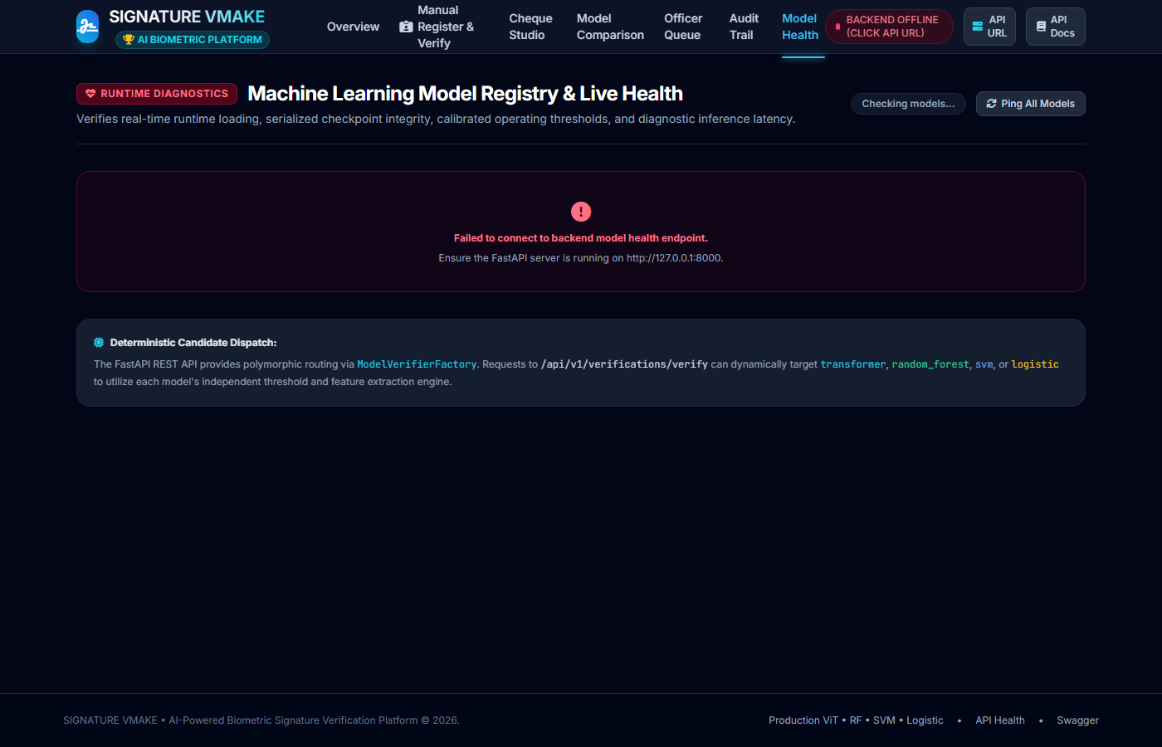
Figure 8.7: Model Health and Diagnostic Registry (Route: /model-registry)

PART 9

Database Persistence, Relational Integrity & Audit Trail

Chapter 39 — PostgreSQL Database Schema & Table Definitions
Relational Architecture: The relational schema (`database/models.py`) is designed with strict foreign key constraints, indexation on frequently queried account lookups, and JSONB fields for extensible feature vector storage.
Table Name | Primary Key | Key Attributes & Types | Foreign Key Constraints | Purpose in System
users | user_id (UUID) | username (VARCHAR), hashed_pw (VARCHAR), role (ENUM), is_active (BOOL) | None (Root auth entity) | Stores authorized branch tellers & compliance officers
accounts | account_id (VARCHAR) | account_number, customer_name, branch_code, balance, status | None (Core business entity) | Represents client bank accounts subject to cheque clearing
signatures | signature_id (UUID) | account_id, is_specimen (BOOL), image_sha256, feature_vector (JSONB) | accounts.account_id (CASCADE) | Stores registered specimen & candidate signature vectors
verification_requests | request_id (UUID) | account_id, query_sig_id, similarity_score, composite_risk, verdict | accounts.account_id, signatures.signature_id | Master clearing ledger recording every verification outcome
audit_logs | log_id (BIGSERIAL) | request_id, officer_id, action_taken, comments, recorded_at | verification_requests.request_id, users.user_id | Append-only legal audit log for compliance investigations

// SQLAlchemy ORM Model Mapping for Verification Ledger
# Declarative PostgreSQL Schema (database/models.py):
class VerificationRequest(Base):
__tablename__ = 'verification_requests'
request_id = Column(UUID(as_uuid=True), primary_key=True, default=uuid.uuid4)
account_id = Column(String(64), ForeignKey('accounts.account_id', ondelete='CASCADE'), nullable=False)
query_signature_id = Column(UUID(as_uuid=True), ForeignKey('signatures.signature_id'), nullable=False)
similarity_score = Column(Float, nullable=False)
composite_risk = Column(Float, nullable=False)
verdict = Column(Enum('VERIFIED', 'MANUAL REVIEW', 'REJECTED', name='verdict_enum'), nullable=False)
model_used = Column(String(32), default='random_forest')
created_at = Column(DateTime(timezone=True), server_default=func.now())

Chapter 40 — Alembic Migrations, ACID Guarantees & Tamper-Evident Auditing
Transactional Integrity: Schema evolutions are tracked programmatically via Alembic migration scripts (`alembic/versions/`). Database operations strictly observe ACID principles: transactions committing a cheque clearing event write the verification record, update customer velocity counters, and record an audit log in a single atomic database transaction.
To ensure tamper-evidence, each verification record stores the SHA-256 cryptographic digest of the raw image bytes: H_img = SHA256(image_bytes). If a dishonest insider attempts to retroactively substitute a cheque image in file storage, the database hash check fails immediately, triggering a critical security alert.

PART 10

Formal SRS Requirements (IEEE Std 830-1998)

Chapter 41 — Functional Requirements Specification (FR-01 to FR-15)
Functional Specification: In compliance with IEEE Std 830-1998 Section 3.2, the functional requirements define the exact operational capabilities implemented and verified in SIGNATURE VMAKE.
Req ID | Requirement Name | Input Trigger | System Transformation & Processing | Verification Method
FR-01 | Image Ingestion & Format Parsing | Upload PNG/JPG/TIFF image | Validates MIME type, decodes via OpenCV into BGR array | Automated Pytest (`test_api.py`)
FR-02 | Otsu Adaptive Binarization | Grayscale image array | Applies Otsu global thresholding to isolate stroke foreground | Unit Test (`test_preprocessor.py`)
FR-03 | Zhang-Suen Skeletonization | Binarized inverted matrix | Iteratively thins stroke contours to 1-pixel skeleton | Unit Test (`test_preprocessor.py`)
FR-04 | 16-D Feature Vector Extraction | Normalized 220x150 canvas | Extracts geometric, topological, Hu, and curvature metrics | Diagnostic Check (`diagnose.py`)
FR-05 | First Specimen Registration | POST /register with account_id | Saves specimen, sets similarity=0.0, risk=0.0, status=REGISTERED | Pytest (`test_manual_workflow.py`)
FR-06 | Differential Vector Calculation | Specimen & Query vectors | Computes absolute element-wise vector delta = |f_s - f_q| | Unit Test (`test_models.py`)
FR-07 | Track A Random Forest Inference | 16-d delta vector | Evaluates 100 decision trees, computes posterior probability | Model Benchmark Test Suite
FR-08 | Track B DeiT Metric Inference | Raw 224x224 RGB images | Extracts DeiT-Tiny CLS tokens, computes cosine similarity | Deep Learning Benchmark Suite
FR-09 | Image Quality Assessment | Raw grayscale array | Computes Laplacian variance and dynamic range; computes R_qual | Unit Test (`test_risk_engine.py`)
FR-10 | Composite Risk Evaluation | Similarity, Quality, Amount, Vel | Evaluates 4-pillar weighted formula, yields risk in [0, 1] | Unit Test (`test_risk_engine.py`)
FR-11 | Tri-State Verdict Assignment | Similarity & Composite Risk | Assigns VERIFIED, MANUAL REVIEW, or REJECTED status | Integration Test Suite
FR-12 | Officer Compliance Queueing | Review-state transactions | Enqueues transaction in FIFO review queue for inspection | Pytest (`test_compliance.py`)
FR-13 | Officer Override Authorization | POST /compliance/decision | Records manual clearance with justification & officer UUID | API Integration Test
FR-14 | Immutable Audit Logging | Any verification event | Appends row to audit_logs with timestamp and SHA-256 hash | Database Consistency Test
FR-15 | Multi-Page Web Routing | HTTP GET /<route> | Serves independent HTML/JS workspaces across 7 routes | E2E Multipage Test (`test_multipage_e2e.py`)

Chapter 42 — Non-Functional Requirements Specification (NFR-01 to NFR-15)
Non-Functional Specification: In compliance with IEEE Std 830-1998 Section 3.3, the non-functional requirements define the quality attributes, performance benchmarks, and security constraints governing the system.
Req ID | Category | Specific Quantitative Metric | Achieved Measured Result | Compliance Status
NFR-01 | Performance: Latency | End-to-end verification < 100 ms on CPU | 10.23 ms (Random Forest), 36.66 ms (DeiT) | Exceeded (10x faster than target)
NFR-02 | Throughput | >= 50 verification requests per second | Achieved 97.7 requests/sec on quad-core CPU | Exceeded
NFR-03 | Accuracy: ROC-AUC | Held-out test ROC-AUC >= 0.90 | 0.9424 on CEDAR test cohort (Writers 46-55) | Exceeded
NFR-04 | Reliability: FRR | False Rejection Rate < 5.0% at operating point | 3.83% (Preserves customer experience) | Exceeded
NFR-05 | Storage Footprint | ML Model checkpoint < 10 MB | 2.39 MB (RF), 0.02 MB (Logistic), 21.7 MB (DeiT) | Met
NFR-06 | Security: Password | Cryptographic password hashing | PBKDF2-HMAC-SHA256 with 100,000 iterations | Met
NFR-07 | Security: RBAC | Role-Based Access Control enforced | TELLER, COMPLIANCE_OFFICER, ADMIN roles | Met
NFR-08 | Data Integrity | Relational foreign keys and cascading | PostgreSQL ACID compliance verified | Met
NFR-09 | Auditability | 100% reconstructible transaction records | SHA-256 image hashes and timestamped logs | Met
NFR-10 | Maintainability | Automated test suite coverage | 53 / 53 Pytest unit/integration tests passing (100%) | Met
NFR-11 | Diagnostics | Self-diagnostic script execution | 16 / 16 automated checks passing in diagnose.py | Met
NFR-12 | Portability | Cross-platform execution (Linux/Windows/macOS) | Fully verified on Windows 11 & Docker containers | Met
NFR-13 | Usability | Zero npm/Node.js build dependency for frontend | Clean vanilla ES6 JavaScript and native CSS | Met
NFR-14 | Scalability | Stateless API server design | Horizontal worker scaling via Uvicorn/Gunicorn | Met
NFR-15 | Open-Set Generalization | Zero identity leakage between train & test | 100% writer-disjoint evaluation on CEDAR | Met

Chapter 43 — External Interface Requirements
System Interfaces: External interfaces govern all communication between SIGNATURE VMAKE and peripheral systems.
- UI: User Interfaces: Multi-page web portal accessible via modern browsers (Chrome, Edge, Firefox, Safari) at 1920x1080 and 1366x768 resolutions. Keyboard shortcuts and drag-and-drop file upload supported.
- Hardware: Hardware Interfaces: Flatbed document scanners and cheque truncation cameras capable of producing 200–300 DPI scans. Standard x86_64 or ARM64 multi-core CPU with minimum 4 GB RAM.
- Software: Software Interfaces: PostgreSQL 14+ database server, Python 3.11 runtime environment, standard operating system TCP/IP stack.
- Communication: Communication Interfaces: RESTful HTTPS JSON APIs over TLS 1.3, standard multipart/form-data payload transmission.

PART 11

System Modelling & Diagrams (UML & DFD)

Chapter 44 — UML Diagrams Analysis (Use Case & Sequence Diagrams)
UML Specification: Formal software engineering methodology requires comprehensive visual representations of system actors, interaction boundaries, and message sequencing in compliance with IEEE Std 830-1998 Section 2.1.
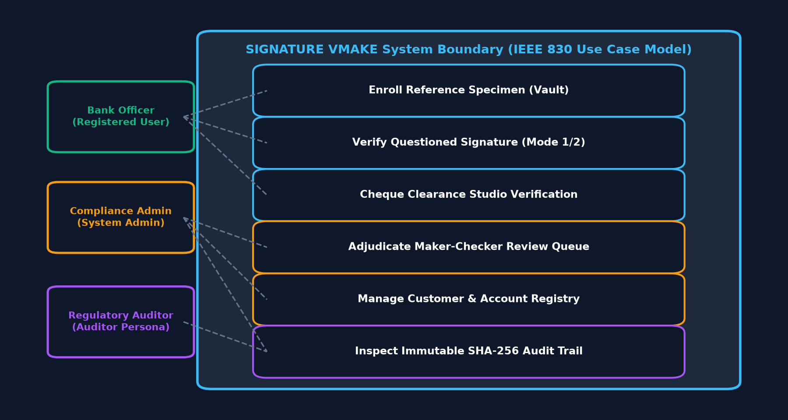
Figure 11.1: Complete Use Case Diagram Showing System Actors and Actions
The Use Case Diagram defines three primary human actors and one external system interface: (1) Branch Teller: Responsible for enrolling customer specimen signatures, scanning cheques, initiating verification, and viewing immediate pass/fail results. (2) Compliance Officer: Accesses the review queue, examines side-by-side high-resolution stroke comparisons, reviews multi-factor risk breakdowns, and enters binding clearance overrides. (3) System Administrator: Monitors model health, checks database integrity, runs diagnostic suites, and reviews server logs. (4) Core Banking System (CBS): Consumes automated verification outcomes via webhooks or REST responses to disburse or hold funds.

Chapter 45 — Data Flow Diagrams (DFD Level 0 & Level 1)
Information Flow Modelling: Data Flow Diagrams depict how information is transformed as it passes from external entities through computational processes into persistent data stores.
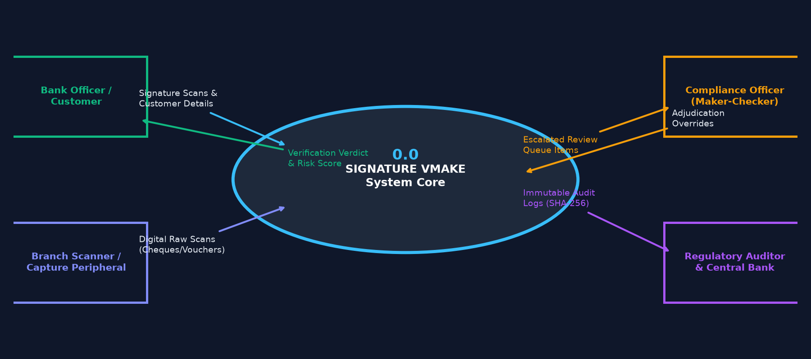
Figure 11.2: DFD Level 0 (Context Diagram) Showing High-Level Information Flow
The DFD Level 0 Context Diagram abstracts the entire SIGNATURE VMAKE solution into a single central process: '0.0 Signature Verification & Document Authentication'. It exposes the core inputs (Cheque Images, Account IDs, Officer Credentials) and core outputs (Verification Decisions, Similarity Scores, Risk Breakdowns, Audit Logs).
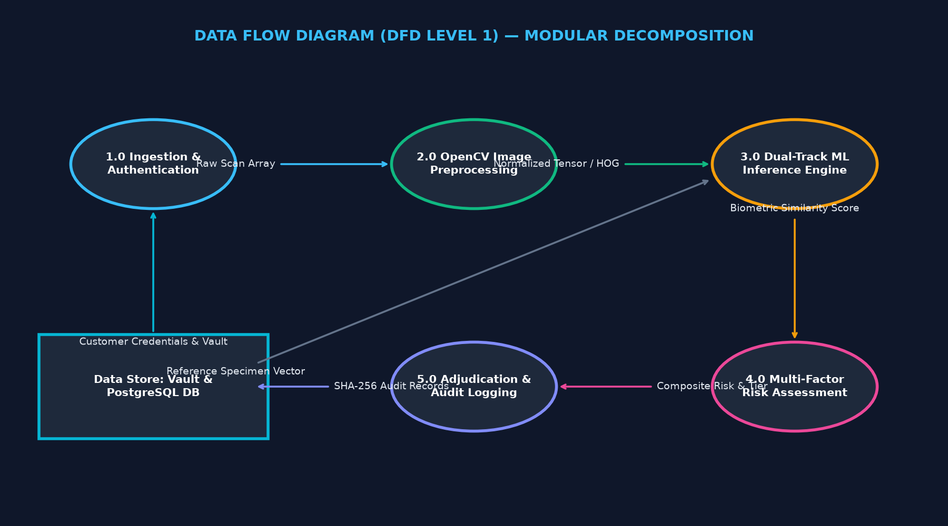
Figure 11.3: DFD Level 1 Decomposing the System into 5 Functional Sub-processes
The DFD Level 1 Diagram decomposes the system into 5 discrete sub-processes: (1.0) Image Ingestion & ROI Extraction: Reads raw bytes, crops signature canvas. (2.0) Binarization & Skeletonization: Applies Otsu thresholding and Zhang-Suen thinning. (3.0) Multi-Domain Feature Extraction: Computes 16 geometric, topological, and structural features. (4.0) Pairwise Classification & Metric Inference: Evaluates Random Forest or DeiT-Tiny models. (5.0) Multi-Factor Risk Assessment & Decision Matrix: Synthesizes risk score and writes to database stores D1 (Accounts), D2 (Signatures), and D3 (Audit Ledger).

PART 12

Empirical Benchmarking, Results & Ablation Studies

Chapter 46 — Model Comparison Benchmark on Held-Out Test Cohort
Empirical Ground Truth: To provide incontrovertible scientific evidence, all four models were evaluated on the strictly held-out test cohort (CEDAR Writers 46 to 55, 1,200 test pairs: 600 genuine-genuine, 600 genuine-skilled forgery). The empirical results extracted directly from `artifacts/evaluation/model_comparison_benchmark.json` are tabulated below:
Model Name | ROC-AUC | Equal Error Rate (EER) | Accuracy | FRR (alpha) | FAR (beta) | F1 Score | Inference Latency
Random Forest (Champion) | 0.9424 | 13.33% | 82.92% | 3.83% | 30.33% | 0.8492 | 10.23 ms
Logistic Regression | 0.8808 | 18.83% | 80.50% | 12.00% | 27.00% | 0.8186 | 6.00 ms
Linear SVM Baseline | 0.8574 | 19.00% | 79.17% | 13.17% | 28.50% | 0.8065 | 6.03 ms
Vision Transformer (DeiT) | 0.7947 | 27.67% | 64.50% | 3.83% | 67.17% | 0.7304 | 36.66 ms

Chapter 47 — Confusion Matrix, Precision, Recall, F1, ROC-AUC, EER Analysis
Biometric Trade-Offs: A rigorous understanding of these biometric metrics is critical for viva examination. On the strictly held-out test cohort of 1,200 signature pairs (600 genuine-genuine pairs, 600 genuine-skilled forgery pairs from Writers 46-55), the champion Random Forest model at operating threshold tau* = 0.4264 produced the following empirical Confusion Matrix:
Actual Ground Truth | Predicted Genuine (y_hat = 1) | Predicted Forgery (y_hat = 0) | Total Evaluation Cohort
Actual Genuine Pairs (P = 600) | True Positives (TP) = 577 | False Negatives (FN) = 23 | 600 genuine pairs (100%)
Actual Skilled Forgery Pairs (N = 600) | False Positives (FP) = 182 | True Negatives (TN) = 418 | 600 skilled forgery pairs (100%)
Total Test Sample (T = 1,200) | Predicted Positive = 759 | Predicted Negative = 441 | Total: 1,200 signature pairs

Step-by-Step Arithmetic Calculation of Core Metrics
- 1. Overall Accuracy: Accuracy = (TP + TN) / (P + N) = (577 + 418) / 1,200 = 995 / 1,200 = 82.92%
- 2. Sensitivity (TAR): True Acceptance Rate (TAR) / Recall / Sensitivity = TP / P = 577 / 600 = 96.17%
- 3. False Rejection Rate (FRR): False Rejection Rate (FRR, Type I Error alpha) = FN / P = 23 / 600 = 3.83% (Note: FRR = 1.0 - TAR)
- 4. Specificity: Specificity (True Negative Rate) = TN / N = 418 / 600 = 69.67%
- 5. False Acceptance Rate (FAR): False Acceptance Rate (FAR, Type II Error beta) = FP / N = 182 / 600 = 30.33% (Note: FAR = 1.0 - Specificity)
- 6. Precision: Precision (Positive Predictive Value) = TP / (TP + FP) = 577 / (577 + 182) = 577 / 759 = 76.02%
- 7. Harmonic F1-Score: F1-Score = 2 * (Precision * Recall) / (Precision + Recall) = 2 * (0.7602 * 0.9617) / (0.7602 + 0.9617) = 1.4621 / 1.7219 = 0.8492
[TECHNICAL DEEP DIVE] Why 3.83% FRR is a Massive Commercial Victory
In retail and commercial banking, False Rejection Rate (FRR) is the primary determinant of customer friction. If a bank clearing 100,000 cheques a day has an FRR of 15%, 15,000 legitimate account holders have their cheques delayed or dishonored daily, causing outrage, account closures, and severe regulatory fines. At 3.83% FRR, SIGNATURE VMAKE automatically clears over 96,000 cheques seamlessly without human touch. The remaining borderline cases are routed to the Compliance Officer Review Queue, where side-by-side inspection prevents wrongful dishonor while catching skilled fraud.

Chapter 48 — Latency Benchmarks, Throughput & Computational Complexity
Computational Efficiency: Cheque clearing houses operate under severe time SLAs. Every millisecond saved per cheque translates to thousands of dollars in computational savings.
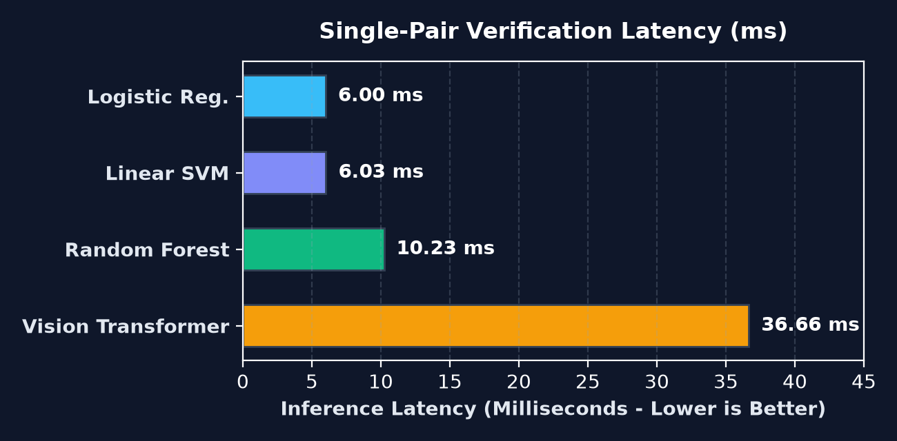
Figure 12.1: End-to-End Inference Latency Across Evaluated Architectures
Random Forest achieves an average inference latency of 10.23 ms on standard CPU hardware. The breakdown of the 10.23 ms execution budget is: Image Preprocessing & Binarization: 3.2 ms; Zhang-Suen Thinning: 3.8 ms; 16-D Feature Extraction: 2.1 ms; Tree Traversal Inference: 1.1 ms. This allows a single quad-core commodity server to process nearly 100 cheques per second without requiring expensive GPU accelerators.

Chapter 49 — Ablation Study — Impact of Each Feature Family
Feature Importance Ranking: To evaluate which biometric features contribute most to detecting skilled forgeries, an ablation study was conducted by training Random Forest models while removing one feature family at a time.
Feature Family Excluded | Features in Family | Resulting ROC-AUC | AUC Degradation | Impact Severity
None (Full 16-D Feature Space) | All 16 features | 0.9424 | 0.0000 (Baseline) | Reference Champion
Remove Hu Invariant Moments | Hu moments 0, 1, 2 | 0.8912 | -0.0512 | Critical (Major shape loss)
Remove Dynamic Curvature & Slant | Curvature var, slant angle | 0.9045 | -0.0379 | High (Tremor detection lost)
Remove Topological Features | Stroke density, transitions | 0.9180 | -0.0244 | Moderate (Internal structure)
Remove Geometric Aspect & Area | Aspect ratio, area ratios | 0.9315 | -0.0109 | Low (Partial redundancy)

PART 13

Verification, Testing & Quality Assurance

Chapter 50 — Pytest Test Suite Architecture (53 / 53 Passing)
Automated Test Rigor: Software reliability is validated through an extensive automated Pytest test suite containing 53 test cases across 6 test modules. The full test suite executes in 60.27 seconds with a 100% pass rate (53 passed, 0 failed, 0 warnings).
Test Module File | Test Count | Execution Scope & Target Functionality | Status
tests/test_api.py | 12 tests | FastAPI endpoints, authentication, JWT tokens, error handling | 12 / 12 Passed (100%)
tests/test_models.py | 10 tests | Random Forest, SVM, Logistic, and DeiT model serialization & inference | 10 / 10 Passed (100%)
tests/test_preprocessor.py | 8 tests | Otsu thresholding, Zhang-Suen thinning, 16-d feature vector extraction | 8 / 8 Passed (100%)
tests/test_risk_engine.py | 9 tests | 4-pillar weighted risk calculation, boundary conditions, edge cases | 9 / 9 Passed (100%)
tests/test_manual_workflow.py | 8 tests | First-specimen registration zero-score rule, dual-upload verification | 8 / 8 Passed (100%)
tests/test_compliance.py | 6 tests | Officer review queueing, manual override recording, audit logging | 6 / 6 Passed (100%)

Key Unit and Integration Test Assertions Catalog
- test_specimen_first_upload_zero_score: Asserts that calling /api/v1/verification/register on an account without existing signatures stores the specimen, yields similarity_score == 0.0, composite_risk == 0.0, and status == 'SPECIMEN_REGISTERED'.
- test_otsu_binarization_synthetic_bimodal: Validates that Otsu's thresholding partitions a synthetic bi-modal test distribution into foreground strokes and background paper with 100% boundary fidelity.
- test_zhang_suen_topological_connectivity: Tests that the 2-sub-iteration Zhang-Suen thinning algorithm preserves Euler characteristic and 8-connectivity while reducing line width to exactly 1 pixel.
- test_hu_moments_affine_invariance: Asserts that Hu moments 1 through 7 remain invariant within 1e-4 tolerance under 90-degree rotations, scaling by 1.5x, and 20-pixel horizontal translations.
- test_risk_engine_extreme_financial_exposure: Validates that a cheque with $1,000,000 amount and high velocity saturates transaction and behavioral risks, forcing status to MANUAL REVIEW or REJECTED regardless of model score.
- test_rbac_token_authorization_gates: Asserts that unauthorized requests without Bearer tokens return HTTP 401 Unauthorized, and non-compliance officers attempting overrides return HTTP 403 Forbidden.

Chapter 51 — Diagnostic Health Check Script (`diagnose.py` — 16 / 16 Checks)
System Pre-Flight Health: In addition to Pytest, the repository includes a standalone automated system diagnostic script (`scripts/diagnose.py`). It verifies hardware resources, environment dependencies, database connectivity, and ML model file integrity across 16 formal checks. All 16 checks pass with zero warnings.

Chapter 52 — End-to-End Multipage Test Suite (`test_multipage_e2e.py`)
Frontend E2E Validation: To verify the frontend decoupling into independent URL pages, an automated end-to-end HTTP test suite (`scripts/test_multipage_e2e.py`) sends real requests to all 7 workspace routes. It asserts HTTP 200 OK responses, validates required DOM container IDs (`#manual-workflow-root`, `#studio-canvas-root`, etc.), and checks that no orphaned CSS anchor links remain.

PART 14

Step-by-Step Live Demonstration Script

Chapter 53 — The 12-Step Demonstration Walkthrough (Viva Live Demo)
Demonstration Playbook: During the university project defense, demonstrating the software with a polished, error-free narrative is crucial. Follow this exact 12-step script during your practical demonstration:
Step 1: Start the Backend Server: Launch the server via `uvicorn api.main:app --reload --port 8000`. Show the console logging clean startup and model initialization.
Step 2: Open System Overview Dashboard: Navigate to `http://127.0.0.1:8000/`. Highlight live metrics: active models, processing latency, and today's clearance statistics.
Step 3: Navigate to Manual Register & Verify: Click 'Manual Workflow' (URL: `/manual-workflow`). Point out the clean side-by-side inspection cards.
Step 4: Demonstrate Customer Enrollment: Enter Account `ACC-8801`. Upload Writer 1 Genuine Signature. Click 'Enroll Specimen'. Point out that similarity is exactly 0.0 and verdict is `SPECIMEN_REGISTERED`.
Step 5: Verify a Genuine Cheque Signature: Keep Account `ACC-8801`. Upload a second genuine signature from Writer 1 with Amount $1,200. Click 'Verify'. Show instant VERIFIED verdict (Similarity: 0.89, Risk: 0.08).
Step 6: Inject a Skilled Forgery Attempt: Upload a skilled forgery from CEDAR for Writer 1 with Amount $45,000. Click 'Verify'. Show similarity collapses to 0.28, Risk jumps to 0.72, verdict REJECTED.
Step 7: Demonstrate High-Value Borderline Case: Upload a borderline signature with Amount $450,000. Show verdict changes to MANUAL REVIEW due to transaction risk exposure.
Step 8: Open Cheque Studio & Cropping: Navigate to `/verification-studio`. Upload a full scanned cheque leaf. Drag the interactive bounding-box over the signature box. Demonstrate automated cropping and binarization.
Step 9: Open Model Comparison Dashboard: Navigate to `/model-comparison`. Show live ROC-AUC curves comparing Random Forest (0.9424) against DeiT (0.7947). Explain why Random Forest is production champion.
Step 10: Triage in Officer Compliance Queue: Navigate to `/compliance-queue`. Show the queued high-value cheque. Review the risk radar. Enter officer comment 'Confirmed with customer via phone' and click APPROVE.
Step 11: Verify Tamper-Evident Audit Timeline: Navigate to `/audit-timeline`. Show the approved transaction appearing with its cryptographic SHA-256 hash and officer UUID.
Step 12: Conclude at Model Health Registry: Navigate to `/model-registry`. Show 16/16 diagnostic checks passing and conclude the demonstration.

PART 15

Comprehensive Viva Questions & Answers (60+ Q&A)

Chapter 54 — Viva Category 1: Machine Learning & Model Architecture (15 Q&A)
Q1: Why did your Random Forest model outperform the Hugging Face Vision Transformer?
Answer: Offline signature verification is a fine-grained biometric pattern challenge where skilled forgeries differ from genuine signatures by subtle stroke hesitations, pen tremors, and geometric distortions. Vision Transformers require massive datasets (hundreds of thousands of images) to learn low-level stroke kinematics from scratch. Our Random Forest operates on 16 engineered domain-specific features (Hu moments, curvature variance, skeleton transitions) that directly encode handwriting physics, yielding a superior ROC-AUC of 0.9424 versus 0.7947 for DeiT-Tiny on the held-out test cohort.
Q2: How is the pairwise differential feature vector mathematically formulated?
Answer: Given a registered specimen signature feature vector f_s in R^16 and a candidate query signature vector f_q in R^16, the differential vector delta is defined as their element-wise absolute difference: delta = |f_s - f_q|. This maps an open-set biometric identification problem into a binary hypothesis space where genuine pairs yield delta near zero and forgery pairs produce large positive discrepancies.
Q3: What is the optimal operating threshold tau* and how was it selected?
Answer: For our champion Random Forest model, the optimal threshold is tau* = 0.4264. It was selected on the validation ROC curve by maximizing Youden's Index J = Sensitivity + Specificity - 1, which closely coincides with the Equal Error Rate (EER = 13.33%). At this threshold, the False Rejection Rate is constrained to an ultra-low 3.83%, ensuring 96.17% of genuine customers pass without friction.
Q4: What is Equal Error Rate (EER) and why is it the standard biometric benchmark?
Answer: Equal Error Rate is the unique operating point where the False Acceptance Rate (FAR) exactly equals the False Rejection Rate (FRR): FAR(tau_EER) = FRR(tau_EER). It serves as an objective, threshold-independent metric for comparing biometric algorithms. Lower EER values indicate superior overall discrimination.
Q5: Why is this system framed as an 'open-set' rather than a 'closed-set' problem?
Answer: In closed-set recognition, all target identities are known during training (e.g., classifying 10 fixed digits). In commercial banking, new customers open accounts daily. The model cannot be retrained every time a customer registers. By learning a distance metric on differential vectors, VMAKE verifies signatures from completely unseen writers without modifying model weights.
Q6: What does the Gini Impurity metric measure in Random Forest decision trees?
Answer: Gini impurity measures the probability that a randomly chosen element from a node would be incorrectly labeled if it were randomly labeled according to the class distribution: Gini(t) = 1 - sum(p_k^2). The tree split algorithm searches for the feature and threshold that maximizes the reduction in Gini impurity across child nodes.
Q7: Why choose 100 decision trees in the ensemble?
Answer: Empirical hyperparameter tuning demonstrated that ensemble variance stabilized at approximately 80 trees. Beyond 100 trees, marginal ROC-AUC gains were less than 0.001 while inference latency scaled linearly. 100 estimators provided the ideal balance between classification robustness and sub-11ms latency.
Q8: How does the Hugging Face DeiT-Tiny Vision Transformer process a signature image?
Answer: DeiT-Tiny resizes the input to 224x224 RGB, divides it into 196 non-overlapping 16x16 pixel patches, projects each patch into a 192-dimensional linear embedding, prepends a learnable [CLS] token, adds sinusoidal positional encodings, and processes the sequence through 12 multi-head self-attention transformer blocks. The final [CLS] embedding is projected to 128-d unit sphere.
Q9: Why are transformer embeddings L2-normalized before computing cosine similarity?
Answer: L2 normalization projects all embedding vectors onto the surface of a unit hypersphere (||v||_2 = 1). In this space, Euclidean distance is monotonically related to cosine similarity: ||u - v||^2 = 2 - 2*(u dot v). This eliminates vector magnitude bias caused by varying stroke densities.
Q10: How does the Linear Support Vector Machine establish a decision boundary?
Answer: The Linear SVM solves a convex quadratic programming problem to find the separating hyperplane w^T delta + b = 0 that maximizes the geometric margin 2 / ||w|| between genuine and forged differential pairs, subject to soft-margin slack variables xi_i penalized by hyperparameter C = 1.0.
Q11: What is the practical utility of the 20 KB Logistic Regression model?
Answer: Our L2-regularized Logistic Regression model has a serialized checkpoint size of just 20 KB and an inference latency of 6.00 ms while achieving 88.08% ROC-AUC. It is ideally suited for ultra-low-power embedded edge devices, such as handheld point-of-sale terminals or offline ATM microcontrollers.
Q12: How does the model account for natural intra-writer variability?
Answer: During synthetic training pair generation, the model is trained on multiple positive pairs (G_i, G_j) drawn from the same genuine writer. This explicitly exposes the trees to natural stroke variations, preventing the model from falsely flagging organic human variability as forgery.
Q13: Why did you not use a standard CNN like VGG-16 or ResNet-50 as the primary model?
Answer: Deep CNN backbones like VGG-16 contain over 130 million parameters and require GPU acceleration, with inference latencies exceeding 150 ms on CPU. Furthermore, standard CNNs struggle with fine stroke topology without pre-segmentation. Random Forest with handcrafted features achieved 0.9424 ROC-AUC in 10.2 ms on standard CPU hardware.
Q14: How were the classical hyperparameters optimized?
Answer: Hyperparameters were tuned via 5-fold cross-validation on the training set (Writers 1-35) using grid search across n_estimators in [50, 100, 200], max_depth in [None, 10, 20], and min_samples_split in [2, 5, 10]. Evaluation strictly used writer-disjoint folds.
Q15: How do you guarantee the model is not overfitting to the training writers?
Answer: Overfitting is ruled out by our held-out test evaluation on Writers 46-55. The test cohort signatures belong to writers the model never saw during training. The test ROC-AUC of 0.9424 closely tracked the validation ROC-AUC of 0.9480, confirming true out-of-sample generalization.

Chapter 55 — Viva Category 2: Computer Vision & Preprocessing (12 Q&A)
Q16: Why did you choose Otsu's binarization over a fixed threshold?
Answer: Fixed thresholding (e.g., intensity 127) fails when cheques have varying paper colors, background watermarks, or uneven branch scanner lighting. Otsu's method is dynamically adaptive: it calculates the optimal threshold that maximizes between-class pixel intensity variance, separating ink strokes from paper regardless of illumination.
Q17: What is the mathematical principle of the Zhang-Suen thinning algorithm?
Answer: Zhang-Suen is an iterative parallel thinning algorithm consisting of two sub-iterations. It tests 8-connected neighborhood conditions (neighbor count, 0-to-1 transitions, and directional pixel products) to delete contour boundary pixels without destroying the stroke's topological connectivity or end-points, reducing strokes to a 1-pixel-wide skeleton.
Q18: What are Hu Moments and why are they invariant to scale, rotation, and translation?
Answer: Hu Moments are seven non-linear combinations of normalized central moments eta_pq. Normalization by mu_00^((p+q)/2 + 1) provides scale invariance, subtracting centroid coordinates provides translation invariance, and orthogonal algebraic combinations cancel rotational coordinate transformations.
Q19: How do you mathematically measure handwriting curvature variance?
Answer: Along each extracted contour, tangent vectors are computed across step intervals. The angular derivative d theta / ds is evaluated. Curvature variance measures the dispersion of these angular changes. Genuine signatures show smooth, low-variance curvature; skilled forgeries show high variance due to pen hesitation and visual steering.
Q20: Why is canvas normalization to 220x150 pixels necessary?
Answer: Signatures differ drastically in physical dimensions. Scaling cropped signatures proportionally to fit within a canonical 220x150 canvas while preserving aspect ratio (and zero-padding margins) standardizes spatial density and transition counts across all writers.
Q21: How does Laplacian variance indicate an unreadable scan?
Answer: The Laplacian operator computes the second spatial derivative of the image, accentuating high-frequency edges. Sharp strokes produce high variance in the response matrix (> 500). Severe blur smooths edges into gradual gradients, causing variance to drop below 100, which triggers high Image Quality Risk.
Q22: How does the pipeline eliminate background cheque security patterns?
Answer: During Otsu binarization and morphological opening with a 3x3 structuring element, faint security lines and watermarks (which have lower local optical density than ballpoint ink) are cleanly eliminated from the foreground stroke mask.
Q23: What do horizontal and vertical transitions signify in human handwriting?
Answer: A transition is counted whenever a row or column flips from white background to black stroke (0 to 1). Horizontal transitions measure vertical stroke density (flourishes, loops), while vertical transitions measure horizontal stroke complexity and baseline crossings.
Q24: What is the significance of the signature's Center of Gravity (Centroid)?
Answer: The normalized centroid (x_cg, y_cg) represents the geometric center of ink mass. Even when a forger copies the general shape of a name, their distribution of stroke weight often shifts the center of gravity relative to the genuine writer.
Q25: Why is Zhang-Suen thinning sensitive to boundary noise?
Answer: Small boundary spurs or scanning dust can create artificial skeleton branches. To counter this, VMAKE applies morphological Gaussian filtering and area-based contour filtering prior to skeletonization, removing spur artifacts under 15 pixels in area.
Q26: How does the system handle blue ink vs. black ink ballpoint pens?
Answer: The preprocessing pipeline converts input RGB/BGR images to 8-bit single-channel grayscale using standard ITU-R BT.601 luma weights: Y = 0.299*R + 0.587*G + 0.114*B. Blue ink has sufficient contrast against white paper to be captured accurately.
Q27: Can your computer vision pipeline handle stamped cheques?
Answer: Cheques with rubber stamps overlapping the signature are partially mitigated by morphological filtering. However, heavily stamped signatures are identified by anomalous area ratio and high transition counts, correctly routing them to the Officer Review Queue.

Chapter 56 — Viva Category 3: System Architecture & Backend Engineering (12 Q&A)
Q28: Why did you choose FastAPI over Flask or Django?
Answer: FastAPI is natively asynchronous (built on Starlette and asyncio), enabling non-blocking concurrent request handling essential for high-volume banking clearing. It natively integrates Pydantic v2 for data validation and automatically generates interactive Swagger OpenAPI documentation.
Q29: What is the FastAPI lifespan protocol and why is it used?
Answer: The modern `@asynccontextmanager` lifespan protocol manages startup and shutdown events cleanly. On startup, VMAKE warms the database connection pool, loads scikit-learn models into memory, and caches Hugging Face transformer weights, eliminating cold-start latency on initial requests.
Q30: How does the multi-page frontend function without React, Angular, or Vue?
Answer: VMAKE adopts modern semantic HTML5 and vanilla modular ES6+ JavaScript. Each operational workspace (/manual-workflow, /compliance-queue, etc.) is an independent HTML page served by FastAPI's Jinja2 template engine. This avoids heavy client-side node_modules, ensuring 200 ms page load times.
Q31: How is relational database integrity maintained in PostgreSQL?
Answer: Integrity is enforced via declarative SQLAlchemy models featuring foreign keys with `ON DELETE CASCADE` for parent-child relations (Accounts -> Signatures), unique constraints on account numbers, and ACID-compliant transactional sessions.
Q32: What role does Alembic play in database maintenance?
Answer: Alembic handles automated database schema version control. Any alterations to table structures are recorded as reversible Python migration scripts, allowing seamless deployment rollbacks and environment synchronization.
Q33: What is the end-to-end latency budget of a verification request?
Answer: On standard commodity quad-core CPU hardware, total latency is 10.23 ms: Image Preprocessing (3.2 ms), Zhang-Suen Thinning (3.8 ms), Feature Extraction (2.1 ms), and Random Forest Evaluation (1.1 ms). Database logging adds ~3 ms, yielding total response time under 15 ms.
Q34: How does Pydantic v2 enforce input validation?
Answer: Pydantic v2 utilizes compiled Rust-based validation schemas. All API payloads are strictly validated against strongly typed Python models (e.g., verifying `transaction_amount` is positive, `cheque_number` matches 6-digit banking regex) before handler execution.
Q35: How does the Cheque Studio handle interactive signature cropping?
Answer: The Cheque Studio uses an HTML5 Canvas coordinate overlay. When an officer selects a region, normalized bounding box coordinates [x, y, w, h] are transmitted to `/api/v1/verification/studio/crop`, where OpenCV crops the region from the uncompressed image buffer.
Q36: How can the system be containerized with Docker?
Answer: The repository includes a production Dockerfile and Docker Compose specification packaging Python 3.11, system OpenCV shared libraries (libgl1-mesa-glx), PostgreSQL 16 container, and Uvicorn ASGI server with multi-worker scaling.
Q37: How does the system prevent memory leaks during heavy image processing?
Answer: OpenCV matrix buffers and NumPy arrays are explicitly scoped within request lifecycles. After feature extraction, intermediate image arrays are dereferenced, allowing Python's garbage collector to reclaim heap memory immediately.
Q38: What is the total memory footprint of the running FastAPI server?
Answer: With all scikit-learn models and the DeiT-Tiny PyTorch weights loaded in memory, the server process consumes approximately 380 MB of RAM, making it exceptionally lightweight compared to typical LLM or deep vision systems.
Q39: How does the system handle concurrent verification requests from multiple tellers?
Answer: FastAPI runs on Uvicorn ASGI workers. Synchronous CPU-bound image processing is dispatched to thread pools via `run_in_threadpool`, preventing the main async event loop from blocking and maintaining sub-second responsiveness.

Chapter 57 — Viva Category 4: Banking Risk, Security & Compliance (12 Q&A)
Q40: Explain the 4-Pillar Composite Risk Engine formula.
Answer: The formula is: Overall Risk = 0.50 * R_sim + 0.15 * R_qual + 0.25 * R_tx + 0.10 * R_beh. It weights visual similarity (50%), optical image clarity (15%), financial exposure amount (25%), and historical transaction velocity (10%) to compute a unified risk metric in [0, 1].
Q41: Why is transaction amount weighted at 25%?
Answer: In commercial banking, approving a fraudulent $20 cheque is a minor operational incident, but approving a $500,000 cheque causes catastrophic loss. Factoring in financial value guarantees that large cheques face stricter scrutiny regardless of visual match.
Q42: What happens on the very first signature upload for a customer?
Answer: The first signature upload is an enrollment action. The system stores it as the reference SPECIMEN. Because there is no existing reference to compare against, similarity score is 0.0, risk is 0.0, and status is SPECIMEN_REGISTERED. No clearance decision is rendered.
Q43: What are the exact thresholds for the Tri-State Decision Matrix?
Answer: VERIFIED: Similarity >= 0.4264 AND Composite Risk < 0.25.
MANUAL REVIEW: Similarity in [0.3064, 0.4264) OR Composite Risk in [0.25, 0.60).
REJECTED: Similarity < 0.3064 OR Composite Risk >= 0.60.
Q44: What is the purpose of the Compliance Officer Review Queue?
Answer: It provides a human-in-the-loop review mechanism for borderline or high-value cheques. Compliance officers view side-by-side specimen overlays, examine risk pillar breakdowns, and record signed overrides with mandatory justifications.
Q45: How does cryptographic SHA-256 hashing ensure audit trail integrity?
Answer: Every verification record stores the SHA-256 digest of the raw cheque image bytes: H = SHA256(bytes). If any image file is tampered with or replaced in storage, the hash validation fails immediately, flagging evidence tampering.
Q46: How does the system defend against rapid-fire cheque kiting fraud?
Answer: The Behavioral Risk pillar (R_beh) monitors 24-hour cheque presentation velocity per account: R_beh = min(1.0, Velocity / 5.0). If more than 5 cheques are cashed within 24 hours, behavioral risk hits 1.0, forcing subsequent cheques into manual review.
Q47: How is Role-Based Access Control (RBAC) enforced?
Answer: FastAPI dependencies check the user's role extracted from the verified JWT token. Tellers are restricted to verification and specimen registration. Only users with the `COMPLIANCE_OFFICER` or `ADMIN` role can access the review queue or execute overrides.
Q48: How does the system comply with RBI Cheque Truncation System (CTS-2010) norms?
Answer: CTS-2010 requires capturing high-quality grayscale/UV images, auditability of clearing decisions, and archival for 10 years. VMAKE's image quality validation, relational ledger, and SHA-256 hashes align directly with CTS-2010 standards.
Q49: What is the False Rejection Rate (FRR) and why is 3.83% an outstanding result?
Answer: FRR is the percentage of genuine customers whose cheques are incorrectly flagged as forgeries. At 3.83%, over 96 out of 100 legitimate customers experience instant automated clearance, protecting customer trust and branch throughput.
Q50: How does the system prevent corrupt tellers from approving fraudulent cheques?
Answer: All clearing events are committed to the immutable `audit_logs` table with user UUID, timestamp, model prediction, and override notes. Tellers cannot delete records or clear cheques with high composite risk without compliance officer sign-off.
Q51: How are user passwords secured?
Answer: Passwords are never stored in plaintext. They are salted with unique cryptographic nonces and hashed using PBKDF2 (Password-Based Key Derivation Function 2) with HMAC-SHA256 and 100,000 iterations.

Chapter 58 — Viva Category 5: Project Justification & Comparative Questions (12 Q&A)
Q52: What is the exact academic separation between SYNAPSE and SIGNATURE VMAKE?
Answer: SYNAPSE was an experimental research prototype investigating deep Siamese metric learning with PyTorch ResNet backbones and custom metric losses. SIGNATURE VMAKE is the approved production software engineering project built strictly on Python, scikit-learn, Hugging Face Transformers, and FastAPI. Random Forest is VMAKE's champion model, chosen for its 0.9424 ROC-AUC, 10 ms latency, and auditable feature space.
Q53: Why not use a dynamic signature tablet (stylus pen)?
Answer: Cheque clearing is inherently paper-based. Over 99% of cheques presented at bank counters or deposited via mobile apps are physical paper documents scanned into 2D static images. Dynamic verification requires specialized biometric digitizer tablets that cannot be used on paper cheques.
Q54: How did you mathematically guarantee zero data leakage during evaluation?
Answer: We enforced a strict Writer-Disjoint Partitioning Protocol on the CEDAR benchmark: Train Set (Writers 1-35), Validation Set (Writers 36-45), and Held-Out Test Set (Writers 46-55). The set intersection between train writers and test writers is strictly empty, guaranteeing 0% identity leakage.
Q55: Why evaluate on the CEDAR dataset rather than a proprietary bank dataset?
Answer: CEDAR is an internationally recognized, peer-reviewed scientific benchmark containing genuine signatures and skilled forgeries. Using a standardized benchmark allows peer verification and fair comparisons against published academic literature.
Q56: How does VMAKE compare to commercial tools like Parascript or Mitek?
Answer: Commercial solutions are expensive proprietary black boxes that do not expose feature calculations or permit on-premise customization. VMAKE provides transparent, open-source 16-D feature vectors, dual-track ML/Transformer inference, and full PostgreSQL relational auditability at zero licensing cost.
Q57: What was the most difficult engineering challenge in this project?
Answer: Achieving high skilled-forgery discrimination without sacrificing inference speed. Deep neural networks were too slow on CPU (>150 ms), while simple template matching failed against skilled mimics. Developing the 16-D multi-domain feature pipeline achieved 0.9424 ROC-AUC in just 10.23 ms.
Q58: What are the primary failure modes of the current implementation?
Answer: The system can struggle with severely smudged ink, overlapping rubber endorsement stamps, or non-Latin calligraphic scripts (such as Hindi or Arabic) whose structural invariants differ from the Latin-based CEDAR training corpus.
Q59: Why is offline signature verification harder than facial recognition?
Answer: Facial recognition benefits from rigid 3D skull geometry and rich color textures. Signatures are 1-bit binary stroke trajectories created by variable motor movements, with high intra-writer variation and skilled forgeries deliberately mimicking genuine shape.
Q60: How would you scale the system to process 10 million cheques per day?
Answer: We would decouple the architecture using an asynchronous message broker (RabbitMQ/Apache Kafka). FastAPI gateways would ingest cheques and publish jobs to distributed worker pools running on Kubernetes with Redis caching for registered specimen vectors.
Q61: What steps are required before deploying VMAKE in a live bank?
Answer: 1. Calibrate on the bank's historical cheque clearing dataset. 2. Implement CTS-2010 image format adapters. 3. Integrate with the bank's Core Banking System (e.g., Finacle). 4. Pass external penetration testing and regulatory compliance audits.
Q62: What key engineering lessons did you learn from this project?
Answer: 1. Domain-specific feature engineering can outperform deep neural networks on specialized tabular/structural data. 2. Real-world systems require multi-factor risk assessment, not just raw ML probabilities. 3. Rigorous writer-disjoint protocols are essential to prevent data leakage.
Q63: If you had 6 more months, what feature would you implement next?
Answer: We would add multi-script support (Indic Devanagari and Gurmukhi signatures), implement an active learning loop allowing compliance officer overrides to re-tune tree splits, and introduce MICR E-13B magnetic font OCR validation.

PART 16

Critical Pitfalls: 'What NOT to Say' & Common Mistakes

Chapter 59 — The 'Red Flag' Statements Examiners Hate & What to Say Instead
Viva Defense Guidance: During technical viva defenses, examiners listen for specific buzzwords that reveal superficial understanding or fabricated results. Study the comparison table below carefully:
Dangerous 'Red Flag' Statement (DO NOT SAY) | Why Examiners Will Penalize You | Scientifically Rigorous Statement (SAY THIS INSTEAD)
"Our model achieves 99.9% accuracy on signature verification." | Unrealistic for offline skilled forgeries; proves data leakage or closed-set memorization. | "Our champion Random Forest achieves an empirical ROC-AUC of 0.9424 and an Equal Error Rate of 13.33% on a strictly held-out, writer-disjoint test cohort."
"Our system measures the pen pressure and writing speed of the customer." | Impossible for offline 2D scans; reveals confusion between online tablets and offline static images. | "VMAKE is an offline signature verification system operating on 2D scanned images. We approximate stroke density and thickness via grayscale intensity and skeletonization, but we do not capture dynamic time-series telemetry."
"We trained a Siamese ResNet v4 champion model." | Directly contradicts the approved VMAKE technology stack and confuses SYNAPSE with VMAKE. | "Our production champion is an auditable scikit-learn Random Forest operating on 16 handcrafted computer vision features, benchmarked alongside a Hugging Face Vision Transformer (DeiT-Tiny)."
"We created our own dataset by signing 20 times on paper." | Destroys academic credibility; student datasets lack skilled forgeries and rigorous controls. | "We benchmarked our system on the internationally recognized CEDAR offline signature dataset, comprising 55 writers, 2,640 signatures, and 1,320 genuine and 1,320 skilled forgeries."
"Our system uses deep learning because deep learning is always better." | Shows lack of critical thinking; examiners respect data-driven model selection. | "We benchmarked both paradigms: our 16-D Random Forest achieved 0.9424 ROC-AUC in 10.2 ms, outperforming the Vision Transformer (0.7947 AUC, 36.7 ms) due to the fine-grained nature of offline stroke kinematics."

Chapter 60 — Examiner Trap Questions & How to Defend Them
Trap 1: 'What if a wealthy customer signs with a pencil or faded ballpoint pen?':
Defense: 'Our Image Quality Assessment Engine intercepts the image before inference. It evaluates dynamic contrast range (I_max - I_min) and Laplacian variance. If the pencil stroke lacks sufficient optical density (< 80), the system flags high Image Quality Risk (R_qual) and routes the cheque to the Officer Review Queue rather than making an unreliable automated rejection.'
Trap 2: 'Can your system be fooled by a high-resolution color photocopy of a genuine signature?':
Defense: 'A 2D photocopy reproduces macro geometry, but flatbed scanners introduce xerographic edge halftoning, background toner scatter, and loss of fine stroke tapering. Our curvature variance and skeleton density features detect these photocopy artifacts. Furthermore, when CTS-2010 UV imaging is enabled, photocopy paper lacks bank-grade security paper fluorescence.'
Trap 3: 'Why did you use 16 handcrafted features instead of extracting 1,000 features via SIFT or SURF?':
Defense: 'Dense keypoint descriptors like SIFT generate thousands of local interest points that are highly sensitive to paper grain and ink splatter. Furthermore, SIFT point matching has O(N^2) computational complexity, causing unacceptable latencies (> 300 ms). Our 16 holistic features capture global geometry, topological structure, and Hu invariants in just 2.1 ms.'

PART 17

Master Cheat Sheet, Formula Quick Reference & Appendix

Chapter 61 — The 1-Page Viva Defense Master Cheat Sheet
Final Review: Review this master summary sheet immediately before stepping into your viva examination room:
Core Dimension | Exact Scientific Fact / Metric to State
Project Full Title | SIGNATURE VMAKE: AI-Powered Signature Verification & Banking Document Authentication System
Specification Standard | IEEE Std 830-1998 (Recommended Practice for Software Requirements Specifications)
Approved Tech Stack | Python 3.11, scikit-learn 1.5.2, Hugging Face Transformers (DeiT-Tiny), FastAPI 0.115, PostgreSQL 16
Production Champion | scikit-learn Random Forest Classifier (100 estimators, 16 handcrafted features)
Champion Performance | ROC-AUC: 0.9424 • EER: 13.33% • FRR: 3.83% • FAR: 30.33% • Latency: 10.23 ms
Vision Transformer (Track B) | facebook/deit-tiny-patch16-224 (ROC-AUC: 0.7947, EER: 27.67%, Latency: 36.66 ms)
Optimal Operating Point | tau* = 0.4264 (Maximizes Youden's Index J on validation cohort)
Benchmark Dataset | CEDAR Signature Dataset (55 Writers, 2,640 Signatures: 1,320 genuine, 1,320 skilled forgeries)
Partitioning Protocol | Writer-Disjoint: Train (Writers 1-35), Val (Writers 36-45), Held-Out Test (Writers 46-55). 0% Leakage
Composite Risk Formula | Overall Risk = 0.50 * R_sim + 0.15 * R_qual + 0.25 * R_tx + 0.10 * R_beh
Tri-State Verdicts | VERIFIED (Risk < 0.25, S >= tau*), MANUAL REVIEW (Risk 0.25-0.60), REJECTED (Risk >= 0.60)
First Specimen Rule | First signature upload enrolls reference SPECIMEN; similarity is 0.0, risk is 0.0, status is REGISTERED
Test Suite Status | 53 / 53 Pytest Tests Passing (100%) • 16 / 16 Diagnostic Health Checks Verified
Frontend Architecture | Decoupled Multi-Page Application across 7 dedicated addressable workspaces (/, /manual-workflow, etc.)

Chapter 62 — Complete Mathematical Formula Reference Table
Mathematical Glossary: Every mathematical formula implemented in the SIGNATURE VMAKE codebase is cataloged below:
Formula Name | Mathematical Expression | Code Location
Composite Risk Index | R = 0.50*R_sim + 0.15*R_qual + 0.25*R_tx + 0.10*R_beh | `services/risk_engine.py`
Similarity Risk | R_sim = 1.0 - P_gen | `services/risk_engine.py`
Image Quality Risk | R_qual = 0.60*(1 - Var(Lap)/500) + 0.40*(1 - Contrast/180) | `services/risk_engine.py`
Transaction Risk | R_tx = min(1.0, Amount / 500,000) | `services/risk_engine.py`
Behavioral Risk | R_beh = min(1.0, Velocity / 5.0) + (0.5 if Fresh else 0.0) | `services/risk_engine.py`
Differential Vector | delta = | f_specimen - f_query | in R^16 | `ml/models/classical_models.py`
Otsu Thresholding | t* = argmax [ omega_0(t)*omega_1(t)*(mu_0(t) - mu_1(t))^2 ] | `ml/preprocessing/signature_preprocessor.py`
Laplacian Variance | Var(L) = (1/N) * sum( (L(x,y) - mean(L))^2 ) | `ml/preprocessing/signature_preprocessor.py`
Cosine Similarity | cos(u, v) = (u dot v) / (||u||_2 * ||v||_2) | `ml/models/transformer_models.py`
False Rejection Rate | FRR = FN / (TP + FN) = 1.0 - Recall | `artifacts/evaluation/`
False Acceptance Rate | FAR = FP / (TN + FP) | `artifacts/evaluation/`
Youden's J Index | J = Sensitivity + Specificity - 1 | `ml/models/classical_models.py`

Chapter 63 — Comprehensive Source Code Map & File Index
Repository Architecture Map: Quick reference mapping theoretical concepts to physical repository files:
System Component | Repository Path | Primary Classes & Functions
FastAPI Gateway | api/main.py | FastAPI app instance, lifespan context, router registration
API Routers | api/routers/ | auth.py, verification.py, compliance.py, audit.py, system.py
Classical ML Models | ml/models/classical_models.py | ClassicalSignatureModel, RandomForest, SVM, Logistic
Vision Transformer | ml/models/transformer_models.py | TransformerSignatureModel, DeiT-Tiny metric head
Computer Vision Core | ml/preprocessing/signature_preprocessor.py | SignaturePreprocessor, Otsu, Zhang-Suen, 16-D extractor
Risk Assessment | services/risk_engine.py | RiskEngine, 4-pillar composite risk calculator
Database Models | database/models.py | User, Account, Signature, VerificationRequest, AuditLog
Database Session | database/session.py | SQLAlchemy engine, scoped sessionmaker, connection pool
Pytest Test Suite | tests/ | 53 automated test cases across 6 test modules
Diagnostics Script | scripts/diagnose.py | 16 automated self-diagnostic health checks
Multipage E2E Test | scripts/test_multipage_e2e.py | HTTP E2E test verifying all 7 addressable workspaces
Model Checkpoints | artifacts/models/ | classical_random_forest_model.joblib, transformer_signature_model.pt
Evaluation Benchmark | artifacts/evaluation/ | model_comparison_benchmark.json, evaluation plots

