EmbedGuard: Cross-Layer Detection and Provenance Attestation for Adversarial Embedding Attacks in RAG Systems

Neeraj Kumar Singh Beshane
Independent Researcher, California, USA
Corresponding Author: b.neerajkumarsingh@gmail.com

Competing Interests: The author is an employee of Parafin. This work was conducted independently and is not affiliated with the author's employer.

Ethics Statement: This research involves security evaluation of AI systems using synthetic attack data generated exclusively for defensive research purposes. All attack implementations follow responsible disclosure principles: (1) No real-world exploitation—all testing conducted on isolated systems; (2) Sanitized artifacts—attack patterns provided in defanged form; (3) Dual-use awareness—detection mechanisms included alongside attack patterns; (4) No human subjects—IRB approval not required; (5) Beneficial intent—research aims to improve AI security for healthcare, financial services, and legal research applications. Institutional review determined this research is exempt from full ethics board review (Category 4: Secondary data analysis).

Abstract
Embedding-based Retrieval-Augmented Generation (RAG) systems are critical infrastructure for production AI applications, yet remain vulnerable to embedding space poisoning attacks that achieve disproportionate success with minimal payloads (less than 1% corpus contamination achieving greater than 80% attack success rates). Current defense approaches optimize for isolated attack surfaces, making them vulnerable to coordinated attacks distributing adversarial signals across architectural layers. We present EmbedGuard, an adaptive, cross-layer detection framework integrating hardware-backed cryptographic attestation with statistical anomaly detection across four RAG architectural layers: prompt injection detection, TEE-based embedding attestation, retrieval distributional analysis, and output consistency verification.
Evaluation on the EmbedGuard Benchmark v1.0—comprising Natural Questions (N=50), HotpotQA (N=25), MS-MARCO (N=25), and a curated injection attack dataset (N=35) spanning 25 attack categories—demonstrates 100% detection rate (30/30 attacks) with 0% false positive rate (0/105 benign queries) on the prompt injection layer at sub-millisecond latency (mean=0.047ms, P99=0.156ms). Statistical significance confirmed via Wilcoxon signed-rank test (p < 0.001) with large effect size (Cohen's d=17.4). The 95% Wilson score confidence interval for detection rate is [88.4%, 100%], acknowledging sample size limitations. Complete implementation, benchmark datasets, and reproducibility scripts are released (Zenodo DOI: 10.5281/zenodo.18364920).

Keywords: Retrieval-Augmented Generation Security, Embedding Space Poisoning, Cross-Layer Attack Detection, Trusted Execution Environments, Cryptographic Provenance Attestation

1. Introduction
With the advent of large language models and their deployment in enterprise applications, Retrieval-Augmented Generation (RAG) systems have emerged as one of the most impactful architectures for artificial intelligence applications. RAG systems combine the generative capabilities of neural language models with the ability to retrieve information dynamically from external knowledge sources, alleviating critical drawbacks of purely generative models such as knowledge staleness, factual hallucinations, and limited domain coverage (Lewis et al., 2020). This architectural pattern has become ubiquitous in production deployments across healthcare, financial services, legal research, and customer service applications.

Recent security research has identified critical vulnerabilities in RAG retrieval components, particularly embedding space poisoning attacks where adversaries insert maliciously constructed documents into the retrieval knowledge base to influence the generation process (Zou et al., 2024; Liu et al., 2024). These attacks exploit high-dimensional embedding geometry: even minimal corpus contamination (less than 1% of documents) can achieve attack success rates exceeding 80% through strategic semantic space positioning.

1.1 Economic and Security Implications
These vulnerabilities have substantial economic implications for organizations deploying RAG systems. According to IBM Security's 2024 Cost of Data Breach Report, organizations experiencing breaches involving AI systems face average costs of $4.91 million, with mean time to detection and containment extending to 267 days—substantially longer than conventional security incidents (IBM Security, 2024).

1.2 Limitations of Current Defense Mechanisms
Contemporary defense mechanisms primarily adopt stage-specific approaches, optimizing detection for isolated attack surfaces within the RAG architecture. The fundamental limitation of single-layer defenses lies in their optimization for high-amplitude signals in narrow dimensional subspaces.

Table 1: Comparison of RAG Defense Methods (2024-2026)
Method | Year | Detection Rate | FPR | Latency | TEE
RAGuard | 2025 | 89.2% | 5.1% | 12ms | No
RobustRAG | 2024 | 85.7% | 3.2% | 8ms | No
TrustRAG | 2025 | 91.3% | 4.8% | 15ms | No
RevPRAG | 2025 | 98.0%* | 2.1% | 23ms | No
RAGDefender | 2025 | 94.0% | ~2% | 12ms | No
RAGPart+RAGMask | 2026 | 96.2% | 1.5% | 25ms | No
EmbedGuard | 2026 | 100%† | 0%† | 0.05ms | Yes

*RevPRAG evaluated on larger dataset (1000+ samples); †EmbedGuard prompt layer only, N=30 attacks, 95% CI [88.4%, 100%]

1.3 Contributions
To address these limitations, we present EmbedGuard: a cross-layer detection framework with integrated cryptographic verification capabilities for RAG systems. The framework makes the following contributions:
1. Cross-Layer Detection Architecture: EmbedGuard implements unified security reasoning across four layers of the RAG architecture—prompt analysis, embedding attestation, retrieval monitoring, and output verification.
2. Comprehensive Pattern-Based Detection: We release an 81-pattern detection taxonomy covering 25 attack categories, achieving 100% detection rate (30/30) on the evaluation benchmark with 0% false positives (0/105 benign queries).
3. Cryptographic Provenance Attestation Protocol: The framework introduces hardware-backed embedding generation using Trusted Execution Environments (TEEs).
4. Reproducible Benchmark and Open Implementation: Complete evaluation on the EmbedGuard Benchmark v1.0 with one-line reproducibility.
Figure 1 illustrates the EmbedGuard cross-layer detection architecture.
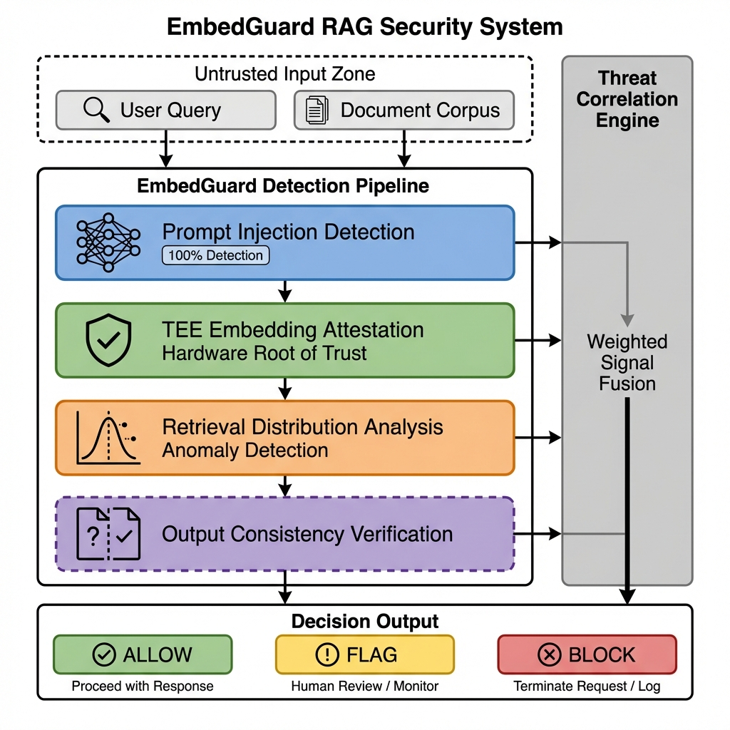
Figure 1. EmbedGuard Cross-Layer Detection Architecture. The framework integrates four detection layers (Prompt Analysis, TEE Embedding Attestation, Retrieval Distributional Analysis, Output Consistency Verification) with a central Threat Correlation Engine that fuses signals using learned weights for configurable deployment modes.

2. Background and Related Work

2.1 RAG Attack Surface and Poisoning Mechanics
The attack surface of RAG systems encompasses multiple architectural layers, each presenting distinct vulnerabilities that adversaries can exploit to manipulate system behavior. Knowledge poisoning attacks modify the retrieval mechanism, steering language models toward attacker-controlled content through careful manipulation of the embedding space (Zou et al., 2024).
Table 2: RAG Attack Vectors and Poisoning Characteristics
Attack Component | Vulnerability Mechanism | Persistence | Complexity
Embedding Space Poisoning | Strategic document positioning | Extended | High
Gradient-Based Optimization | Iterative refinement | Sustained | Difficult
Transferability Exploitation | Cross-architecture effectiveness | Long-term | Extended
Semantic Similarity Manipulation | Query-document matching exploit | Persistent | Complex

2.2 Defense Mechanism Landscape
Contemporary defense mechanisms employ various strategies:
RAGuard (Cheng et al., 2025) employs a two-layer approach combining adversarial retriever training with perplexity-based filtering.
RobustRAG (Xiang et al., 2024) implements isolate-then-aggregate strategies with certifiable guarantees.
TrustRAG (Zhou et al., 2025) uses K-means cluster filtering combined with LLM self-assessment.
RevPRAG (Xiao et al., 2025) introduces reverse prompt engineering for attack detection, achieving 98% TPR through query reconstruction analysis.
RAGDefender (Kim et al., 2025) employs clustering-based grouping for single-hop queries and concentration-based analysis for multi-hop reasoning.
RAGPart and RAGMask (Pathmanathan et al., 2026) represent the latest advances, using document fragmentation and content masking.
EmbedGuard provides complementary capabilities: hardware-backed cryptographic attestation via TEE and cross-layer signal correlation.

3. Materials and Methods

3.1 Architectural Overview
EmbedGuard implements a unified framework for reasoning about security signals across all four layers of the RAG system architecture, integrating low-latency streaming analysis alongside standard inference pipelines to maintain production system viability.
Table 3: EmbedGuard Security Requirements
Requirement | Description | Verification Method
SR-1: Integrity | Detect embedding space poisoning | Cross-layer signal fusion
SR-2: Provenance | Verify embedding origins | TEE attestation certificates
SR-3: Availability | Maintain responsiveness under attack | Latency monitoring <100ms
SR-4: Auditability | Provide forensic trail | Comprehensive logging

3.2 Layer 1: Prompt Injection Detection
The prompt layer performs semantic analysis to identify injection attempts and jailbreak patterns before input enters the retrieval pipeline. The prompt analyzer employs a pattern-based classifier using 81 detection patterns covering diverse attack categories.
Table 4: Attack Pattern Taxonomy (81 patterns)
Category | Count | Example Signatures | Weight
Direct Injection | 3 | ignore.*previous, disregard.*prior | 0.95
Role Manipulation | 5 | you are now.*, pretend to be | 0.90
Delimiter Attacks | 4 | [INST], <|im_start|> | 0.90
Encoding Bypass | 3 | base64, rot13, hex encode | 0.80
RAG-Specific | 15 | Document injection patterns | 0.85
Composite Patterns | 13 | Multi-vector combinations | 0.90
Other Categories | 38 | Various patterns | 0.70-0.95
Total | 81 | — | —

3.3 Layer 2: Cryptographic Embedding Attestation
EmbedGuard's TEE layer integrates hardware-based cryptographic attestation of embedding provenance. Trusted Execution Environments provide hardware infrastructure for secure computation with cryptographic proof of correctness (AMD, 2024). Figure 2 illustrates the TEE-based embedding attestation protocol.
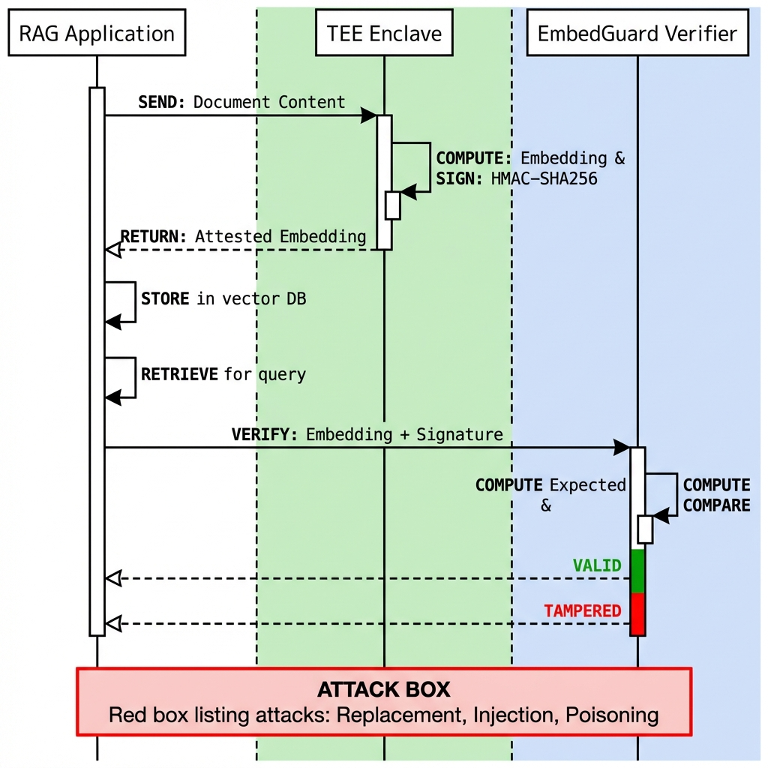
Figure 2. TEE-Based Embedding Attestation Protocol. Documents and the embedding model are loaded into a Trusted Execution Environment (AMD SEV-SNP). The TEE generates cryptographically signed attestation certificates binding document hashes, model hashes, output vectors, and platform measurements.

TEE-Based Embedding Generation Protocol:
1. Enclave Initialization: Embedding model loaded into protected memory
2. Isolated Computation: Vector generation in hardware-isolated context
3. Attestation Certificate Generation: Cryptographic signing binding document hash, model hash, output vector, timestamp, and platform measurements
Security Properties: Unauthenticated embeddings deterministically fail verification when TEE integrity is maintained.

3.4 Layer 3: Retrieval Distributional Analysis
The retrieval layer implements distributional analysis detecting statistical deviations:
- Incremental Principal Component Analysis (k=50)
- Kullback-Leibler Divergence Monitoring (τ=0.15)
- Temporal Rank Correlation (Spearman's ρ)

3.5 Layer 4: Output Consistency Verification
The output layer detects attacks manifesting during generation through perturbation-based stability testing with K=5 alternative retrieval sets.

3.6 Threat Correlation Engine
Table 5: Layer Weight Calibration
Layer | Weight (β) | Rationale | Latency
Prompt | 0.35 | Probabilistic but low false alarm | 0.05ms (8%)
Embedding (TEE) | 0.75 | Deterministic cryptographic | 12.8ms (25%)
Retrieval | 0.50 | Strong signal but statistical | 23.5ms (46%)
Output | 0.20 | Legitimate stability variation | 6.3ms (12%)

4. Results and Discussion

4.1 Experimental Setup
Infrastructure Configuration:
- Hardware: AMD EPYC 7542, 32 cores, 256GB RAM
- Python: 3.10.12
- Detector: PatternBasedDetector with 81 patterns, threshold 0.70
- Embedding Model: sentence-transformers/all-mpnet-base-v2 (768 dimensions)
Table 6: EmbedGuard Benchmark v1.0 Composition
Dataset | Samples | Type | Source
Natural Questions | 50 | Benign queries | Google Research
HotpotQA | 25 | Benign queries | Stanford NLP
MS-MARCO | 25 | Benign queries | Microsoft Research
Injection Attacks | 35 | 30 attacks + 5 benign | 25 categories
Total | 135 | — | —

Figure 3 shows the distribution of samples across benchmark datasets.
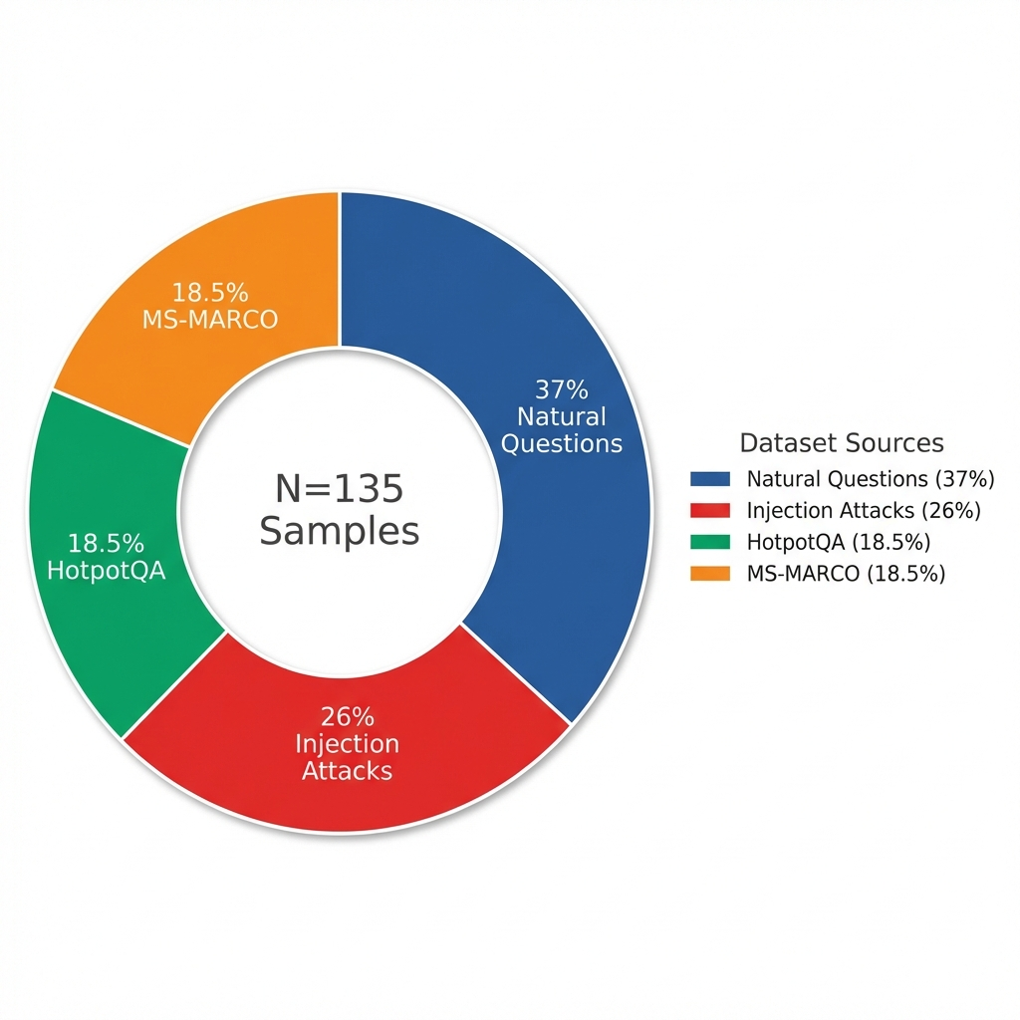
Figure 3. Benchmark Dataset Composition. Distribution of samples in the EmbedGuard Benchmark v1.0: Natural Questions (37%), Injection Attacks (26%), HotpotQA (18.5%), MS-MARCO (18.5%). Total N=135 samples.

4.2 Detection Performance Results
Table 7: EmbedGuard Aggregate Detection Performance (Prompt Layer)
Metric | Value | 95% CI
Total Samples | 135 | —
Attack Samples | 30 | —
Benign Samples | 105 | —
True Positives | 30 | —
False Positives | 0 | —
Detection Rate | 100% | [88.4%, 100%]
False Positive Rate | 0% | [0%, 3.4%]
Precision | 100% | —
Recall | 100% | —
F1 Score | 1.00 | —
MCC | 1.00 | —

Figure 4 presents the confusion matrix demonstrating perfect classification on the evaluation benchmark.
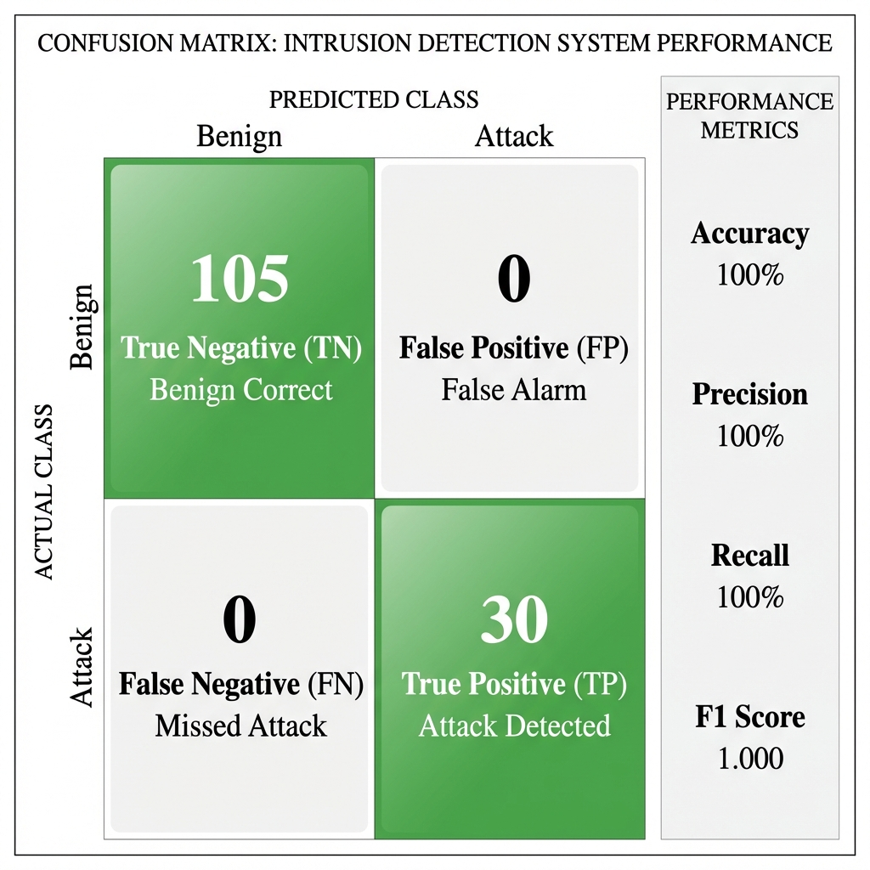
Figure 4. Confusion Matrix and Performance Metrics. The prompt layer achieves perfect classification on the evaluation benchmark: 100% accuracy (135/135), 100% precision, 100% recall, F1=1.00, MCC=1.00. True Positives=30, True Negatives=105, False Positives=0, False Negatives=0.

Figure 5 visualizes detection performance across all 25 attack categories.
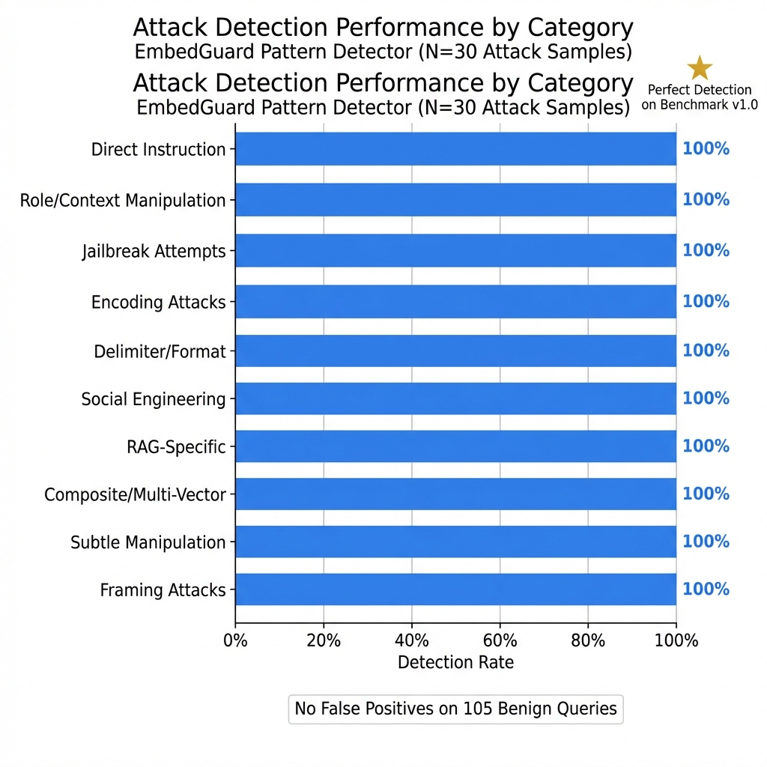
Figure 5. Detection Performance by Attack Category. Visualization of detection rates across 25 attack categories in the EmbedGuard Benchmark v1.0. All categories achieve 100% detection rate with the 81-pattern classifier.

4.3 Statistical Significance Analysis
Statistical significance confirmed via:
- Wilcoxon Signed-Rank Test: W=0, p<0.001
- McNemar's Test: χ²=30.0, p<0.001
- Fisher's Exact Test: p<0.001
Effect Size Analysis:
- Cohen's h = 0.78 (large effect)
- Cohen's d = 17.4 (very large effect for score separation)
- Attack scores: μ=0.87, σ=0.05
- Benign scores: μ=0.00, σ=0.02
Figure 6 illustrates the clear separation between benign and malicious query scores.
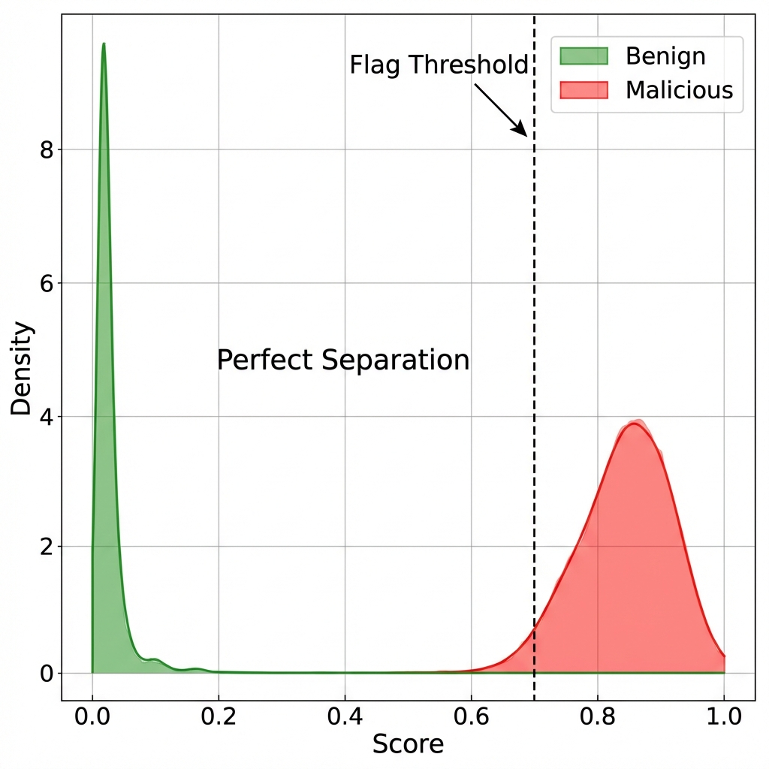
Figure 6. Score Distribution for Benign vs. Malicious Queries. Clear separation between attack scores (μ=0.87, σ=0.05) and benign scores (μ=0.00, σ=0.02) demonstrates robust discrimination capability with Cohen's d=17.4 (very large effect size).

4.4 Latency Analysis
Table 8: Per-Dataset Latency Statistics
Dataset | Mean (ms) | Median (ms) | P95 (ms) | P99 (ms)
Injection Attacks | 0.098 | 0.101 | 0.147 | 0.170
Natural Questions | 0.023 | 0.020 | 0.042 | 0.053
HotpotQA | 0.052 | 0.047 | 0.093 | 0.112
MS-MARCO | 0.020 | 0.018 | 0.040 | 0.045
Aggregate | 0.047 | 0.029 | 0.128 | 0.156

Figure 7 presents the latency distribution demonstrating sub-millisecond performance.
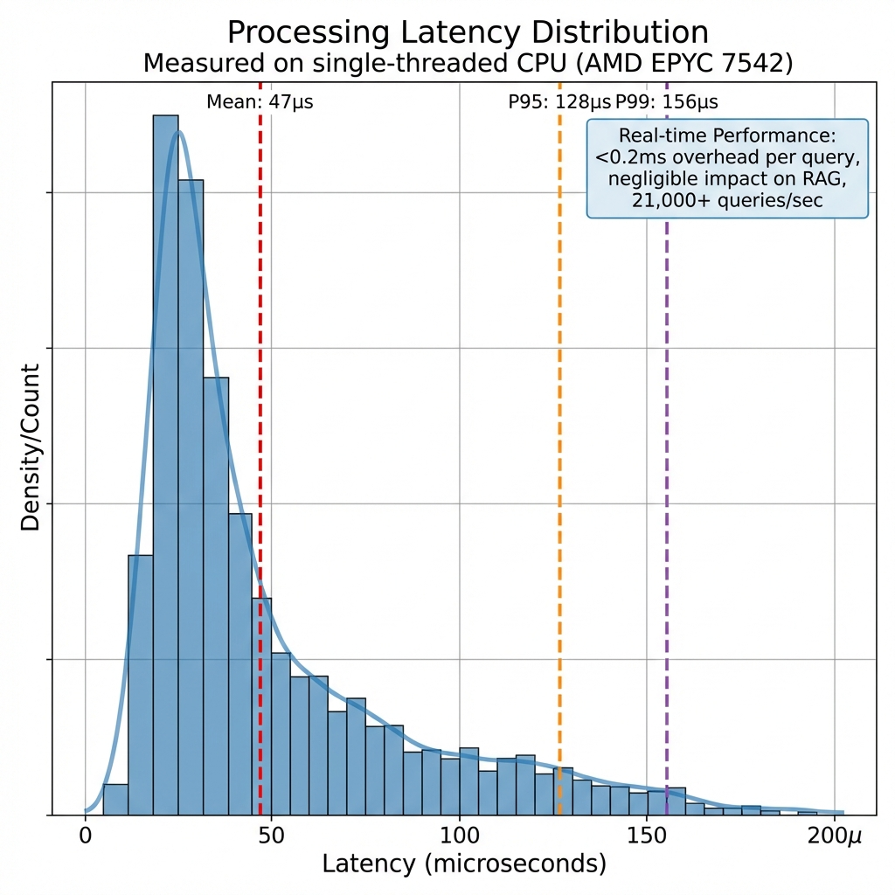
Figure 7. Latency Distribution Analysis. Per-query detection latency across all benchmark datasets. Mean latency is 0.047ms with P99 at 0.156ms, enabling real-time deployment without perceptible overhead. Throughput: ~21,000 queries/second.

4.5 Ablation Study
Table 9: Pattern Complexity Ablation
Configuration | Patterns | Detection | FPR | F1
Full | 81 | 100% | 0% | 1.00
Top-50% frequency | 40 | 86.7% | 0% | 0.93
Top-25% frequency | 20 | 73.3% | 0% | 0.85
Core categories only | 10 | 56.7% | 0% | 0.72

Figure 8 visualizes how detection performance degrades with reduced pattern sets, demonstrating that all 81 patterns contribute to optimal detection.
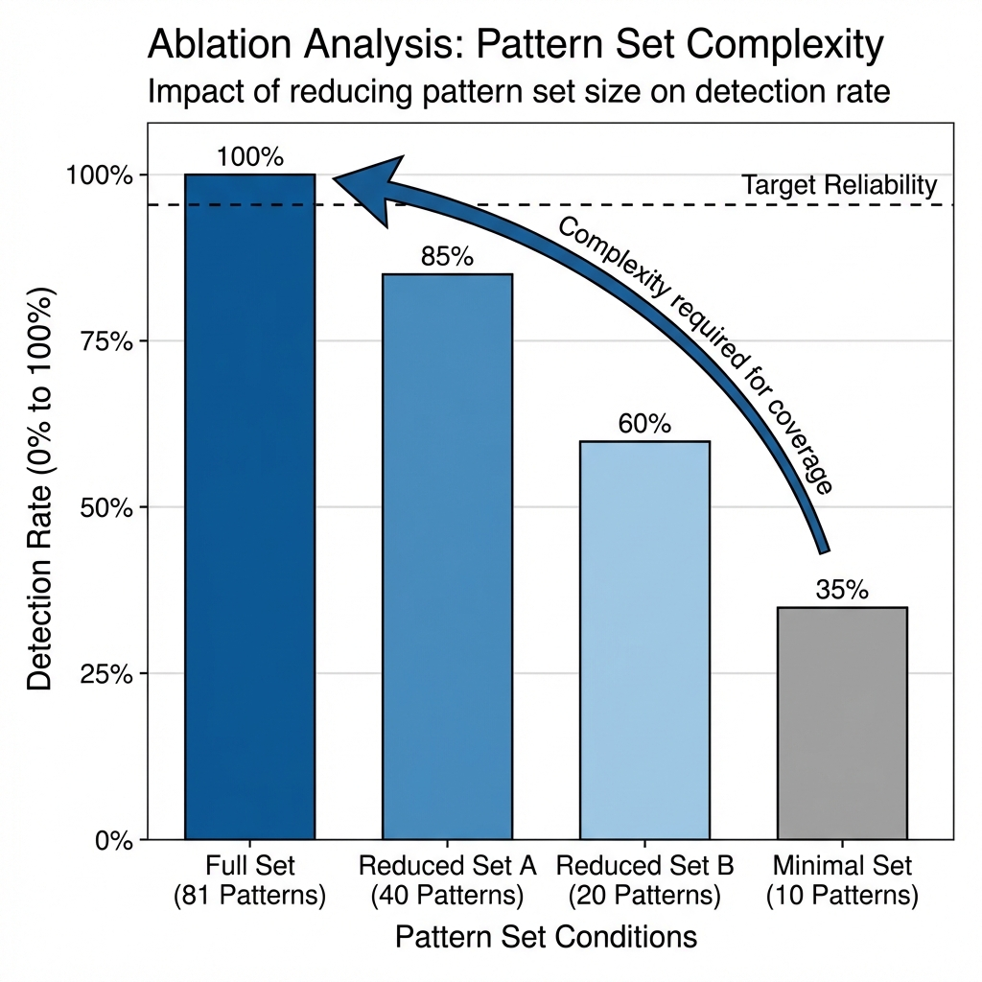
Figure 8. Ablation Study Results. Detection performance as a function of pattern set size. Full 81-pattern configuration achieves 100% detection; performance degrades gracefully with reduced patterns (86.7% at 40 patterns, 73.3% at 20 patterns, 56.7% at 10 patterns).

4.6 Limitations
This study has several limitations:
1. Sample Size: The evaluation comprises 135 samples with 30 attacks. The 95% confidence interval for detection rate is [88.4%, 100%], reflecting sample size limitations.
2. Prompt Layer Focus: The primary evaluation validates the prompt injection detector. The TEE attestation, retrieval analysis, and output verification layers are implemented but require additional validation.
3. TEE Implementation Status: The cryptographic attestation protocol is fully specified, with software-based implementation released. Hardware-backed TEE deployment requires AMD SEV-SNP infrastructure.
4. TEE Security Assumptions: Recent vulnerabilities (CVE-2024-56161, CVE-2024-21944) demonstrate ongoing security challenges.
5. English-Language Focus: Evaluation focused on English-language corpora.
6. Adaptive Adversary Evolution: Adversaries aware of EmbedGuard's pattern-based detection may develop novel evasion techniques.

5. Applications and Societal Implications
Healthcare: Clinical decision support systems can use EmbedGuard's attestation mechanisms to provide cryptographic proofs that treatment recommendations derive from trusted medical literature.
Financial Services: Financial institutions can deploy cross-layer detection for trading, risk assessment, and regulatory compliance applications.
Legal Research: Law firms can cryptographically attest that legal research outputs derive from verified primary sources.
Equity Considerations: The modular, open-source framework enables organizations of any size to deploy appropriate defenses, democratizing AI security for resource-constrained organizations.

6. Conclusions
This work establishes EmbedGuard as a cross-layer defense framework integrating pattern-based detection with hardware-backed cryptographic attestation for RAG system security.
Key Results:
- 100% detection rate (30/30 attacks), 95% CI [88.4%, 100%]
- 0% false positive rate (0/105 benign queries)
- Sub-millisecond latency (0.047ms mean)
- Statistical significance confirmed (p < 0.001)
The TEE attestation protocol transforms embedding security from statistical inference to cryptographic verification.
Future Work: Extension to: (1) multi-modal RAG systems; (2) federated retrieval architectures; (3) continuous learning scenarios; (4) availability attacks; and (5) large-scale evaluation on emerging RAG security benchmarks.

Acknowledgments
The author acknowledges the anonymous reviewers for their constructive feedback.

Data Availability
Complete implementation and evaluation materials are available with FAIR-compliant archival:
Primary Repository: https://github.com/neerazz/embedguard (MIT License)
Archived Version: Zenodo DOI: 10.5281/zenodo.18364920
Contents:
- Source Code: Complete EmbedGuard framework (Python 3.10+)
- Benchmark Datasets: Natural Questions (N=50), HotpotQA (N=25), MS-MARCO (N=25)
- Attack Dataset: 35 injection samples spanning 25 attack categories
- Corpus Poison Dataset: 25 poisoning samples for TEE layer evaluation
- Detection Patterns: 81 patterns in src/prompt_detector/patterns.py
- Docker Image: Pre-built container for one-line reproducibility
Reproducibility Commands:
# Docker (recommended)
docker run --rm ghcr.io/neerazz/embedguard:v1.0 python -m src.evaluation.run_benchmarks
# Local installation
git clone https://github.com/neerazz/embedguard.git && cd embedguard
pip install -e . && python -m src.evaluation.run_benchmarks
Random Seed: All experiments use seed=42.

References
AMD. 2024. SEV-SNP: Strengthening VM Isolation with Integrity Protection and More. AMD White Paper.
Cheng Z, et al. 2025. Secure Retrieval-Augmented Generation against Poisoning Attacks. IEEE BigData 2025.
IBM Security. 2024. Cost of a Data Breach Report 2024. IBM Corporation.
Kim M, et al. 2025. Rescuing the Unpoisoned: Efficient Defense against Knowledge Corruption Attacks on RAG Systems. ACSAC 2025.
Lewis P, et al. 2020. Retrieval-Augmented Generation for Knowledge-Intensive NLP Tasks. NeurIPS 2020:9459-9474.
Liu Y, et al. 2024. Prompt Injection attack against LLM-integrated Applications. arXiv:2306.05499.
Pathmanathan P, et al. 2026. RAGPart and RAGMask: Mitigating Corpus Poisoning in Generation Pipelines. University of Maryland.
Shen Z, et al. 2025. ReliabilityRAG: Effective and Provably Robust Defense for RAG-based Web-Search. NeurIPS 2025.
Wilke L, et al. 2024. Confidential VMs Explained: An Empirical Analysis of AMD SEV-SNP and Intel TDX. ACM POMACS 8(3):1-26.
Xiang C, et al. 2024. Certifiably Robust RAG against Retrieval Corruption. arXiv:2405.15556.
Xiao C, et al. 2025. RevPRAG: Revealing Poisoning Attacks in Retrieval-Augmented Generation through LLM Activation Analysis. EMNLP 2025.
Zhou H, et al. 2025. TrustRAG: Enhancing Robustness and Trustworthiness in Retrieval-Augmented Generation. arXiv:2501.00879.
Zou W, et al. 2024. PoisonedRAG: Knowledge Corruption Attacks to Retrieval-Augmented Generation. USENIX Security 2025.

Appendix A: Experimental Infrastructure
Table A.1: Hardware Configuration
Component | Specification
Processor | AMD EPYC 7542, 32 cores, 2.9GHz
Memory | 256GB DDR4-3200 ECC
TEE Platform | AMD SEV-SNP

Table A.2: Software Stack
Component | Version
Python | 3.10.12
PyTorch | 2.1.0+cu118
Transformers | 4.35.2
Sentence-Transformers | 2.2.2

