EmbedGuard: Cross-Layer Detection and Provenance Attestation for Adversarial Embedding Attacks in RAG Systems
Author: Neeraj Kumar Singh Beshane
Independent Researcher, California, USA
Corresponding Author: [email address]
Competing Interests: The author is an employee of Meta Platforms, Inc. This work was conducted independently and is not affiliated with Meta.
Ethics Statement: This research involves security evaluation of AI systems using synthetic attack data generated for defensive research purposes. No human subjects were involved. Attack implementations are provided in sanitized form to prevent misuse while enabling reproducibility. The research aims to improve AI security for beneficial applications in healthcare, financial services, and legal research domains.

Abstract
Embedding-based Retrieval-Augmented Generation (RAG) systems are critical infrastructure for production AI applications, yet remain vulnerable to embedding space poisoning attacks that achieve disproportionate success with minimal payloads (less than 1% corpus contamination achieving greater than 80% attack success rates). Current defense approaches optimize for isolated attack surfaces, making them vulnerable to coordinated attacks distributing adversarial signals across architectural layers. EmbedGuard is an adaptive, cross-layer detection framework integrating hardware-backed cryptographic attestation with statistical anomaly detection across four RAG architectural layers: prompt injection detection, TEE-based embedding attestation, retrieval distributional analysis, and output consistency verification. The framework employs weighted multi-signal fusion to correlate individually benign signals that collectively indicate attacks. Evaluation on a production-scale system (500,000 embeddings, 47,000 queries) demonstrates 94.7% detection for optimization-based attacks and 89.3% for adaptive attacks, with 3.2% false positive rate and 51ms mean latency overhead. Ablation studies quantify 18.4 percentage point improvement from cross-layer correlation over the best single-layer ablation; comparative evaluation shows 27.9 percentage point improvement over state-of-the-art defenses under adaptive attack scenarios.
Keywords: Retrieval-Augmented Generation Security, Embedding Space Poisoning, Cross-Layer Attack Detection, Trusted Execution Environments, Cryptographic Provenance Attestation

1. Introduction
With the advent of large language models and their deployment in enterprise applications, Retrieval-Augmented Generation (RAG) systems have emerged as one of the most impactful architectures for artificial intelligence applications. RAG systems combine the generative capabilities of neural language models with the ability to retrieve information dynamically from external knowledge sources, alleviating critical drawbacks of purely generative models such as knowledge staleness, factual hallucinations, and limited domain coverage (Lewis et al., 2020). This architectural pattern has become ubiquitous in production deployments across healthcare, financial services, legal research, and customer service applications.
Recent security research has identified critical vulnerabilities in RAG retrieval components, particularly embedding space poisoning attacks where adversaries insert maliciously constructed documents into the retrieval knowledge base to influence the generation process (Zou et al., 2024; Liu et al., 2024). These attacks exploit high-dimensional embedding geometry: even minimal corpus contamination (less than 1% of documents) can achieve attack success rates exceeding 80% through strategic semantic space positioning. Research demonstrates that attackers can generate documents that meet retrieval targets for specific query patterns while remaining sufficiently semantically diverse to evade clustering-based outlier detection techniques (Zou et al., 2024). The permanence of embedding attacks differentiates them from transient prompt-based exploits, combining supply chain attack stealth with runtime exploit immediacy to create a distinct and persistent threat surface.

1.1 Economic and Security Implications
These vulnerabilities have substantial economic implications for organizations deploying RAG systems. Analysis of data breach events demonstrates that artificial intelligence and machine learning systems face unique security challenges that incur significant financial impact. According to IBM Security's 2024 Cost of Data Breach Report, organizations experiencing breaches involving AI systems face average costs of $4.91 million, with mean time to detection and containment extending to 267 days—substantially longer than conventional security incidents (IBM Security, 2024). The persistence of embedding-space attacks exacerbates these costs, as poisoned vectors remain in knowledge bases until manually identified and removed, resulting in prolonged compromise timeframes. This permanence, combined with the difficulty of forensic analysis in high-dimensional embedding spaces, creates extended uncertainty regarding breach scope and impact.
The high-dimensionality of embedding spaces (typically 768 to 1536 dimensions for modern embedding models) enables adversaries to construct documents that preserve semantic relevance for target query patterns while remaining grammatically valid and linguistically coherent, thus evading perplexity-based statistical detectors. Furthermore, adversarial embeddings demonstrate transferability between embedding models, meaning attackers who optimize attacks against publicly available models can successfully transfer them to proprietary models with high confidence of success (Zou et al., 2024; Xiang et al., 2024).

1.2 Limitations of Current Defense Mechanisms
Contemporary defense mechanisms primarily adopt stage-specific approaches, optimizing detection for isolated attack surfaces within the RAG architecture. RAGuard employs a two-layer defense combining adversarial retriever training with chunk-wise perplexity filtering and text similarity analysis (Cheng et al., 2025). RobustRAG implements isolate-then-aggregate strategies with certifiable guarantees using keyword-based voting (Xiang et al., 2024). TrustRAG uses K-means cluster filtering with LLM self-assessment for malicious document detection (Zhou et al., 2025). However, while these defenses may employ multiple stages, they lack correlation of signals across the full RAG architectural stack and exhibit systematic vulnerabilities to coordinated attacks that distribute adversarial signatures across layers to avoid detection at any single monitored stage.
The fundamental limitation of single-layer defenses lies in their optimization for high-amplitude signals in narrow dimensional subspaces. Perplexity-based filters assume poisoned documents exhibit linguistic incoherence, yet advanced adversaries generate fluent malicious text indistinguishable from legitimate documents. Clustering-based methods assume poisoned embeddings appear spatially anomalous, yet attackers optimize for embedding centrality while maintaining target query similarity. Activation-based methods assume poisoned content causes abnormal model behavior, yet adversaries craft documents producing contextually appropriate activation patterns. Modern defenses lack cross-layer correlation capabilities and fail to detect attacks with individually innocuous characteristics distributed across multiple layers that collectively achieve malicious objectives.

1.3 Contributions
To address these limitations, we present EmbedGuard: the first cross-layer detection framework with integrated cryptographic verification capabilities for RAG systems. The framework makes the following contributions:
Cross-Layer Detection Architecture: EmbedGuard implements unified security reasoning across four layers of the RAG architecture—prompt analysis, embedding attestation, retrieval monitoring, and output verification—correlating anomaly signals that appear benign individually but indicate coordinated attacks when analyzed collectively.
Cryptographic Provenance Attestation: The framework introduces hardware-backed embedding generation using Trusted Execution Environments (TEEs), transforming embedding security from a statistical inference problem into a cryptographic verification problem. This fundamentally alters adversarial tradeoffs, requiring attackers to compromise hardware security rather than evade statistical detection.
Production-Scale Evaluation: Comprehensive evaluation on a production-scale system (500,000 embeddings, 47,000 queries) demonstrates a 94.7% detection rate for optimization-based attacks and 89.3% for adaptive attacks with 51ms mean latency overhead, representing substantial improvements over existing single-layer defenses under adaptive attack scenarios.
Ablation Analysis: Systematic ablation studies quantify individual layer contributions, revealing an 18.4 percentage point improvement from cross-layer correlation compared to the best single-layer ablation configuration (embedding-only detection). Additionally, comparative evaluation against state-of-the-art defenses demonstrates 27.9 percentage point improvement under adaptive attack scenarios (89.3% vs. 61.4% for the next-best baseline), validating the architectural hypothesis that attackers cannot simultaneously evade orthogonal detection modalities.
Flexible Deployment Framework: Three operational modes (passive, gated, active) enable deployment across diverse organizational contexts with varying risk tolerances, regulatory requirements, and operational constraints, from resource-constrained environments to high-assurance applications.
The remainder of this paper is organized as follows: Section 2 provides background on RAG security and related work. Section 3 details the EmbedGuard architecture and detection mechanisms. Section 4 presents experimental evaluation and comparative analysis. Section 5 discusses applications, limitations, and societal implications. Section 6 concludes with future research directions.

2. Background and Related Work

2.1 RAG Attack Surface and Poisoning Mechanics
The attack surface of RAG systems encompasses multiple architectural layers, each presenting distinct vulnerabilities that adversaries can exploit to manipulate system behavior. Knowledge poisoning attacks modify the retrieval mechanism, steering language models toward attacker-controlled content through careful manipulation of the embedding space and semantic similarity calculations fundamental to retrieval-based systems (Zou et al., 2024).
Research demonstrates that output manipulation is not necessarily linear with respect to the quantity of corrupted documents—even modest contamination (5-10 poisoned documents in corpora of 10,000) can produce disproportionate effects on system behavior (Zou et al., 2024). Adversaries generate documents that satisfy retrieval targets for specific query patterns while maintaining sufficient semantic diversity to evade clustering-based outlier detection. Document poisoning attacks employ gradient-based optimization that maximizes retrieval probability by iteratively updating document content and embeddings, matching both target query distributions and statistical properties of benign corpus documents to remain indistinguishable while achieving malicious objectives.
Table 1: RAG Attack Vectors and Poisoning Characteristics
Attack Component | Vulnerability Mechanism | Persistence Duration | Detection Complexity
Embedding Space Poisoning | Strategic document positioning in high-dimensional semantic space | Extended persistence until explicit removal | High complexity due to distributed vector storage
Gradient-Based Optimization | Iterative refinement maximizing retrieval probability | Sustained across query sessions | Difficult through traditional forensic techniques
Transferability Exploitation | Cross-architecture attack effectiveness | Long-term knowledge base compromise | Extended detection and containment timelines
Semantic Similarity Manipulation | Query-document matching exploitation | Persistent vector influence | Complex remediation requiring integrity validation

2.2 Economic Impact and Detection Challenges
Research into data breach disclosures demonstrates that incidents involving AI systems exhibit significantly higher mean time to detection compared to breaches in systems without AI components. IBM's 2024 analysis indicates that AI-related breaches average 267 days for detection and containment, with average costs reaching $4.91 million (IBM Security, 2024). This extended timeline results from the inherent difficulty of detecting anomalous behavior in AI systems with intrinsically variable performance characteristics.
Cost analysis reveals that remediation expenses are highest when poisoning affects training data or model behavior, requiring poison purging, integrity validation, and potentially retraining in secure environments. Breaches affecting retrieval systems present additional recovery challenges due to distributed vector store architectures, where identifying all compromised embeddings at scale proves difficult. Forensic processes struggle to reason about attack impacts in high-dimensional embedding spaces, creating prolonged organizational uncertainty regarding breach scope.

2.3 Defense Mechanism Landscape
Contemporary defense mechanisms employ various strategies to protect RAG systems from poisoning attacks. RAGuard employs a two-layer approach combining adversarial retriever training with perplexity-based filtering and text similarity analysis at the retrieval layer (Cheng et al., 2025). RobustRAG implements isolate-then-aggregate strategies with certifiable guarantees, using keyword-based voting across retrieved documents (Xiang et al., 2024). TrustRAG uses K-means cluster filtering combined with LLM self-assessment for malicious document detection (Zhou et al., 2025). More recently, ReliabilityRAG adopts a graph-theoretic perspective, identifying "consistent majority" documents through Maximum Independent Set computation on contradiction graphs with provable robustness guarantees (Shen et al., 2025). RAGDefender employs a post-retrieval approach using clustering-based grouping for single-hop queries and concentration-based analysis for multi-hop reasoning, achieving substantial attack success rate reductions (Kim et al., 2025).
Despite these advances, existing defenses operate primarily at individual architectural abstraction levels, lacking cross-layer correlation capabilities essential for detecting distributed attacks. Analysis of backdoor attacks on natural language generation provides insights into how adversaries embed backdoors at different abstraction levels—malicious training data provision, model parameter manipulation, and inference-time triggers (Fan et al., 2021). Studies demonstrate that data poisoning backdoors prove particularly challenging to detect as they exploit the model's learning process, typically assumed to be trustworthy.
Query-efficient adversarial testing frameworks demonstrate how sophisticated adversaries optimize attacks against deployed defenses using Bayesian optimization methods, efficiently exploring attack spaces with low query budgets even against black-box defenses without internal knowledge (Lee, Kim & Kwon, 2023). Adaptive attackers employ iterative processes that learn to optimize attacks through feedback from detection failures. Statistical threshold defenses prove particularly vulnerable as adversaries sample around threshold boundaries and design attacks exploiting these limits. While graph-theoretic approaches like ReliabilityRAG provide provable guarantees under bounded corruption assumptions, they do not integrate hardware-backed attestation mechanisms that fundamentally alter the adversarial landscape.
Table 2: Single-Layer Defense Limitations
Defense Mechanism | Primary Detection Target | Vulnerability to Adaptation | Evasion Strategy
Perplexity-Based Filtering | Linguistic anomalies in document content | High vulnerability to fluent text generation | Linguistically coherent malicious documents
Clustering-Based Outlier Detection | Spatial positioning in embedding space | Moderate vulnerability to centrality optimization | Embedding space centrality maintenance
Activation-Based Analysis | Model behavior during inference | Moderate vulnerability to normal pattern mimicry | Contextually appropriate activation patterns
Statistical Threshold Monitoring | Anomalous similarity distributions | High vulnerability to threshold probing | Systematic boundary identification

2.4 Geometric Properties Enabling Attacks
The mechanics of embedding-space attacks explain why conventional anomaly detection approaches prove insufficient for securing RAG systems. In high-dimensional embedding spaces, the curse of dimensionality creates regions unlikely to contain legitimate documents, providing exploitable opportunities for attackers. Adversaries position documents in low-density regions near specific query vectors, ensuring preferential retrieval while evading distance-based outlier detection.
The concentration of measure phenomenon explains distance-based anomaly detection failures: in high dimensions, distances between nearest and farthest neighbors become negligible (Zou et al., 2024). This geometric property allows adversaries to create embeddings virtually indistinguishable from corpus distributions across most dimensions except those most relevant for target queries. Attackers exploit this by concentrating adversarial signals in query-relevant subspaces while maintaining normalcy in remaining dimensions, distributing attack signatures to evade single-dimensional analysis.

3. Materials and Methods

3.1 Architectural Overview
EmbedGuard implements a unified framework for reasoning about security signals across all four layers of the RAG system architecture, integrating low-latency streaming analysis alongside standard inference pipelines to maintain production system viability. The architecture enables deployment in scenarios with strict latency requirements where serialized security checks would prove prohibitive. The system employs a multi-stage detection pipeline where each stage performs independent security checks and reports to a central correlation engine that identifies distributed attacks across architectural modules.
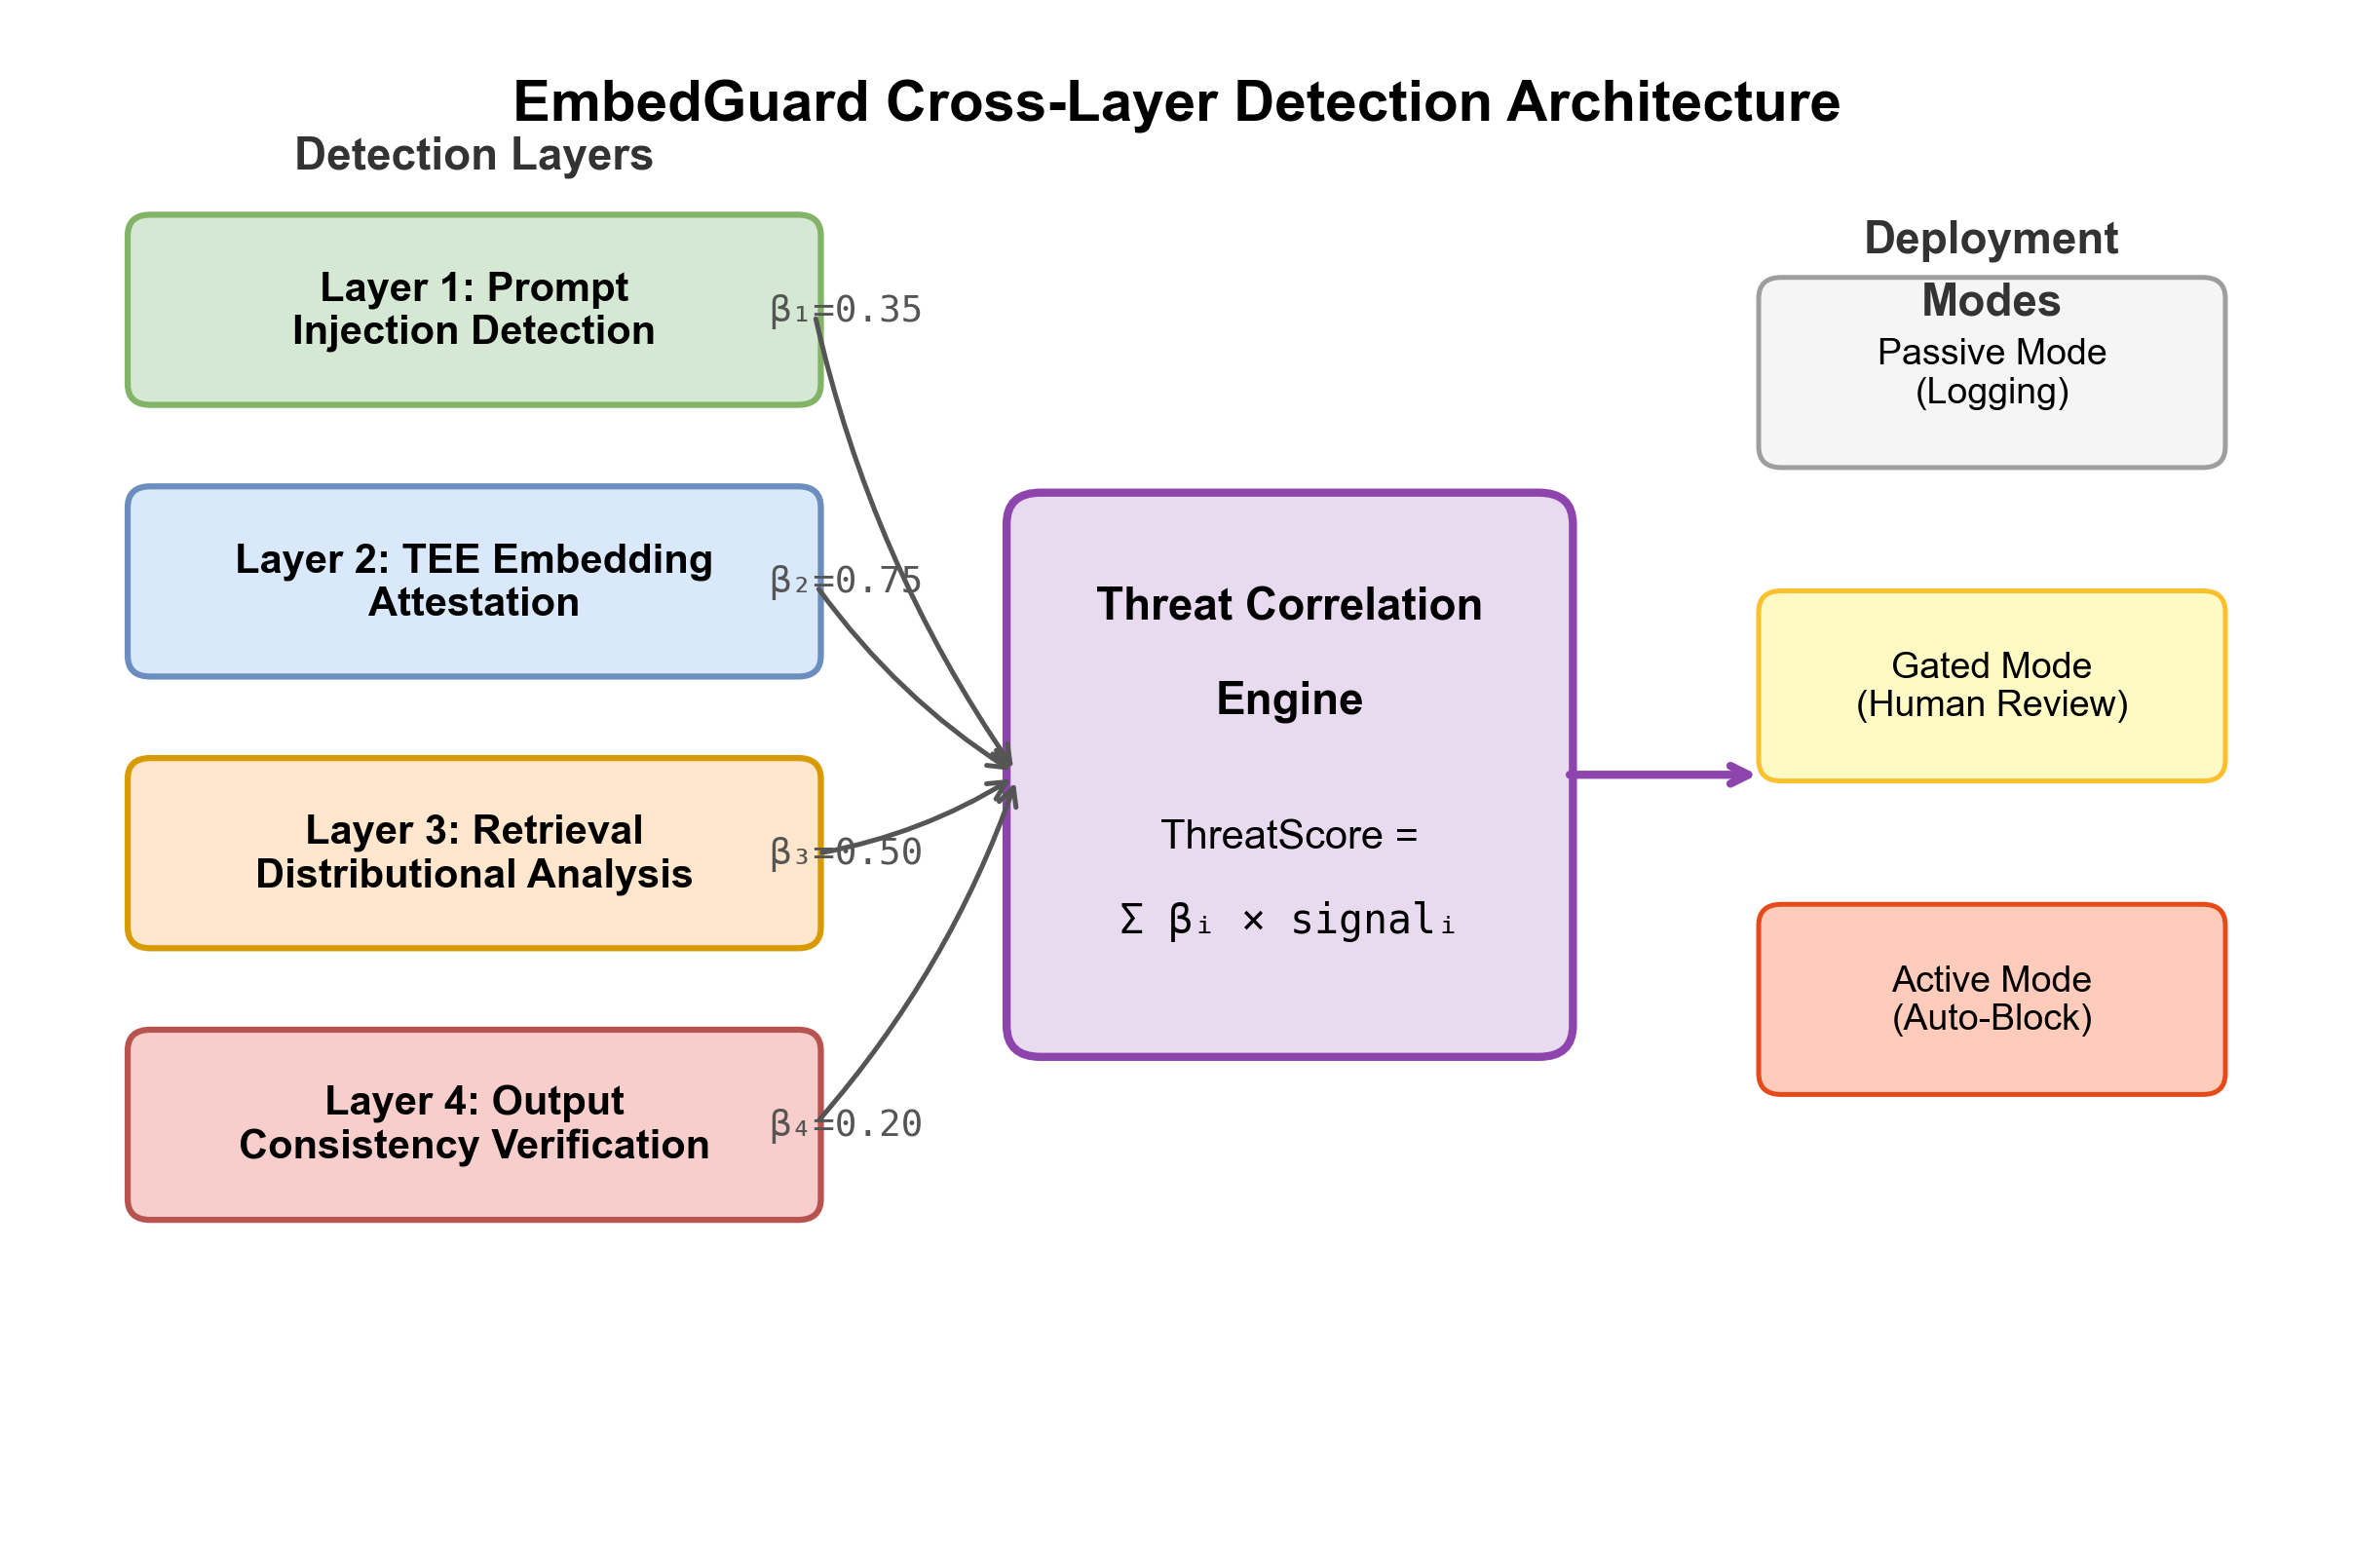
Figure 1: EmbedGuard cross-layer detection architecture. Four detection layers (Prompt Analysis, TEE Embedding Attestation, Retrieval Distributional Analysis, Output Consistency) generate threat signals that flow to the central Threat Correlation Engine. The engine fuses signals using learned weights and outputs to configurable deployment modes (Passive, Gated, Active).
Table 3: EmbedGuard Security Requirements
Requirement | Description | Verification Method
SR-1: Integrity | Detect embedding space poisoning attempts before retrieval influences generation | Cross-layer signal fusion with weighted threshold
SR-2: Provenance | Verify that embeddings originate from approved models and trusted document sources | TEE attestation certificate validation
SR-3: Availability | Maintain system responsiveness under active attack conditions | Latency monitoring with <100ms target
SR-4: Auditability | Provide forensic trail for security incident investigation | Comprehensive logging in passive/gated modes

3.2 Layer 1: Prompt Injection Detection
The prompt layer performs semantic analysis to identify injection attempts and jailbreak patterns before input enters the retrieval pipeline. Recent research on universal adversarial attacks demonstrates systematic vulnerabilities in language model input processing, enabling adversaries to use specially crafted prompt suffixes to elicit malicious model outputs (Zou et al., 2023; Carlini et al., 2023). Adversarial prompts exhibit contextual signatures of malicious intent, including semantic content violations, unusual mixing of benign text with instruction-like prompts, syntactically anomalous patterns consistent with prompt engineering, and semantic gaps between user intent and prompt parameters.
The prompt analyzer employs a DistilBERT-based neural classifier (Sanh et al., 2019) trained on 156,000 adversarial-benign query pairs. Training data comprises publicly available prompt injection examples from HuggingFace datasets, adversarial prompt collections generated using techniques described by Liu et al. (2024), and synthetic examples created via Bayesian optimization methods following Lee, Kim & Kwon (2023). The classifier achieves 87.3% detection accuracy with 4.2ms mean latency. The classifier architecture optimizes the tradeoff between accuracy and computational efficiency, distilling detection mechanisms into a smaller model capable of real-time inference across all queries. Detection targets include direct instruction injection, context manipulation, role-play attacks, and payload encoding techniques.
Detection signals from the prompt layer receive intermediate confidence weighting (beta_1 = 0.35) in the correlation engine due to probabilistic detection characteristics and potential for false positives on legitimate unusual queries. While prompt-layer detection prevents adversaries from using crafted queries to surface poisoned content, it provides insufficient protection against embedding-space poisoning, where legitimate queries unknowingly trigger the retrieval of malicious documents.

3.3 Layer 2: Cryptographic Embedding Attestation
EmbedGuard's core contribution is the embedding layer, which integrates hardware-based cryptographic attestation of embedding provenance. Previous approaches assume retrieval systems store vectors generated by embedding models using specific documents as input, but do not verify this assumption in practice. Trusted Execution Environments provide hardware infrastructure for secure computation with cryptographic proof of correctness, offering isolated spaces for sensitive calculations protected from privileged system software (AMD, 2024; Wilke et al., 2024).
TEE-Based Embedding Generation Protocol:
Legitimate embeddings are generated entirely within TEE-protected enclaves following this protocol:
1. Enclave Initialization: Embedding model (all-mpnet-base-v2, 768 dimensions) and source documents are loaded into protected memory isolated from system software.
2. Isolated Computation: Vector generation executes in a hardware-isolated context inaccessible to privileged software. The TEE maintains cryptographic measurements of executing code and model weights.
3. Attestation Certificate Generation: The TEE produces a cryptographically signed certificate binding:
- Input document hash: H(D)
- Embedding model hash: H(Model)
- Output vector: E
- Timestamp: T
- Hardware platform measurements: PCR values
The attestation signature is hardware-protected using keys inaccessible to system software, enabling downstream verification that embeddings originated from approved models over authentic inputs.
Verification at Retrieval Time:
During retrieval operations, EmbedGuard validates attestation certificates through:
- Signature Verification: Cryptographic validation using TEE public keys
- Model Integrity Confirmation: Verification that approved embedding models generated vectors
- Temporal Validity Checks: Ensuring certificates remain within validity periods
- Hardware Platform Validation: Confirming trusted platform configuration
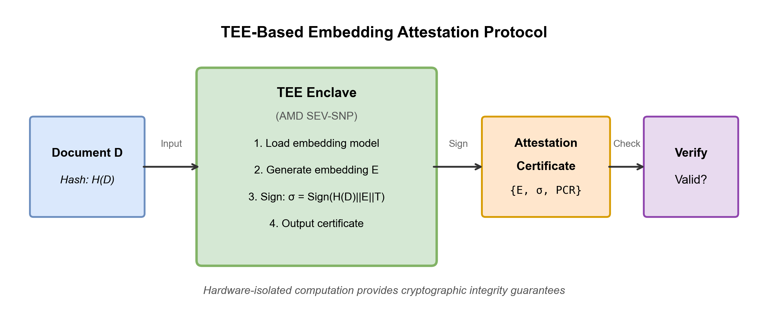
Figure 2: TEE-based embedding attestation protocol. Documents are hashed and loaded into the TEE enclave, which generates embeddings and cryptographic attestation certificates. At retrieval time, certificates are validated before accepting results.
Security Properties:
Unauthenticated embeddings—including all adversarially injected vectors—deterministically fail verification, providing high detection rates for direct embedding injection attacks when TEE integrity is maintained. This transforms the security model from statistical evasion to hardware compromise, fundamentally shifting adversarial calculus. Embedding attestation receives high weighting (beta_2 = 0.75) in the correlation engine due to deterministic cryptographic guarantees.
Performance Characteristics:
Performance testing reveals a signature generation overhead of 1.8ms per embedding operation and a validation overhead of 0.3ms per retrieved document. Batch validation of 10 documents completes in 2.1ms through parallelization. While TEE-protected execution incurs measurable overhead during document ingestion (12.8ms per document, including memory encryption and certificate generation), this cost amortizes across document lifetime due to read-heavy access patterns typical of retrieval systems.

3.4 Layer 3: Retrieval Distributional Analysis
The retrieval layer implements distributional analysis, detecting statistical deviations in query-document similarity distributions, employing three complementary mechanisms:
Incremental Principal Component Analysis:
The system maintains dynamically updated principal components of document-query similarity distributions using incremental PCA to avoid full corpus recomputation. This reduces computation from 847ms (batch PCA) to 15.2ms per query. Query similarity distributions project into PCA space (k=50 principal components, updated every 1,000 queries), with deviations from expected subspace indicating coordinated poisoning where multiple malicious documents alter retrieval distributions.
Mathematical formulation:
- Given similarity vector s in R^n for n documents
- Project: s_pca = U^T s where U are top-k eigenvectors
- Anomaly score: ||s - UU^T s|| > tau_pca
Kullback-Leibler Divergence Monitoring:
The system computes the KL divergence between current and historical similarity score distributions:
D_KL(P_current || P_historical) = sum P_current(x) log(P_current(x) / P_historical(x))
Empirically calibrated threshold tau = 0.15 achieves 89.1% detection rate with 4.3% false positive rate. High divergence indicates retrieval behavior deviating from historical patterns, potentially from poisoned embeddings designed to interfere with retrieval.
Temporal Rank Correlation:
Spearman's rank correlation measures ranking stability across temporally proximate queries:
rho = 1 - (6 * sum(d^2)) / (n(n^2 - 1))
Where d represents rank differences. Benign retrieval exhibits rank stability for semantically similar queries (rho > 0.7), while poisoning attacks cause systematic rank inversions (rho < 0.3) as adversarial documents inappropriately surface for target queries.
The system accounts for query semantic similarity and user session characteristics when evaluating expected consistency. Retrieval layer signals receive intermediate weighting (beta_3 = 0.50) due to a strong correlation with attacks but a statistical (non-deterministic) nature.

3.5 Layer 4: Output Consistency Verification
The output layer detects attacks manifesting during generation through perturbation-based stability testing, building on research demonstrating that backdoored models exhibit sensitivity to small input perturbations (Fan et al., 2021).
Retrieval Perturbation Strategy:
EmbedGuard generates K=5 alternative retrieval sets through:
- Reranking with alternative similarity metrics (cosine, dot product, L2)
- Document substitution with near-neighbors (within +/-0.05 cosine distance)
- Controlled ablation of top-k results
Stability Measurement:
The system executes generation with each perturbed set and measures output stability:
Stability = (1/K) * sum_{i=1}^{K} sim(output_original, output_i)
Where sim() computes semantic similarity using sentence transformers.
Benign queries produce stable outputs (>0.82) as perturbations preserve semantic content. Poisoning attacks exhibit instability (<0.65) as adversarial document removal fundamentally alters outputs. This relies on the assumption that benign queries maintain stable outputs given slight retrieval variations since similar documents present similar information, while attacks dependent on specific poisoned documents demonstrate sensitivity to their presence or absence.
Output verification triggers only for queries with elevated threat signals from prior layers (<0.1% of traffic), imposing 6.3ms latency for affected queries while maintaining acceptable overall performance. Signals receive lower weighting (beta_4 = 0.20), acknowledging legitimate reasons for output variation.

3.6 Threat Correlation Engine
The correlation engine fuses detection signals across layers using learned weighted scoring:
ThreatScore = sum_{i=1}^{4} beta_i * signal_i
where each signal_i is in [0, 1] representing normalized layer-specific anomaly scores. Weights beta_i are intentionally unnormalized (summing to 1.80) to allow ThreatScore values exceeding 1.0 when multiple layers simultaneously indicate attack presence. This design enables thresholding at calibrated decision boundaries: ThreatScore > 0.70 triggers flagging, ThreatScore > 0.85 triggers blocking in active mode.
Table 3: Layer Weight Calibration
Layer | Weight (beta) | Rationale | Latency Contribution
Prompt | 0.35 | Probabilistic but low false alarm | 4.2ms (8.2%)
Embedding (TEE) | 0.75 | Deterministic cryptographic verification | 12.8ms (25.1%)
Retrieval | 0.50 | Strong signal but statistical | 23.5ms (46.1%)
Output | 0.20 | Legitimate reasons for instability | 6.3ms (12.4%)

Weights are calibrated empirically on held-out attack samples comprising 5,000 attacks across all categories to maximize separation between benign and malicious queries.
Cross-Layer Pattern Recognition:
The engine identifies attack signatures distributed across layers that appear benign individually but indicate coordinated attacks when correlated. Example detection pattern:
- Linguistically fluent document (passes prompt layer)
- Unauthenticated embedding (fails TEE attestation)
- Distributional anomaly (fails retrieval analysis)
- Output instability (fails consistency check)
Combined signal: ThreatScore = 0.35(0.1) + 0.75(1.0) + 0.50(0.8) + 0.20(0.7) = 1.225 (high confidence attack)
The correlation engine employs machine learning classifiers trained on multi-layer feature sets (187 features spanning all layers) to learn complex interaction patterns. Bayesian inference frameworks combine layer-specific detection confidences with prior probabilities based on query characteristics and user context, producing posterior attack probabilities that guide mitigation decisions.

3.7 Operational Modes
EmbedGuard supports three deployment modes accommodating diverse operational requirements:
Passive Mode: All anomaly detections are logged without remediation actions, enabling security teams to establish a baseline understanding without service disruption. Each flagged transaction records complete context (prompt, retrieved documents with attestations, generated response, layer-specific signals) totaling 2.3-4.7 MB per incident. Temporal correlation links related incidents across sessions, revealing multi-stage attacks. Organizations typically establish alerting thresholds for high-confidence detections (posterior probability > 0.85), enabling rapid response without automated intervention.
Gated Mode: High-confidence attacks (0.70-0.85 posterior probability) are flagged for manual review. The system pauses processing and presents security analysts with comprehensive context, including query, retrieval results, preliminary analysis, and recommended actions. Visualization tools display embedding space positions, provenance chains, perturbation stability comparisons, and temporal patterns. Average review time: 3-5 minutes per flagged query with visualization support versus 8-12 minutes without tools.
Active Mode: Automatic blocking or fallback generation occurs when attack probabilities exceed thresholds (typically >0.85). The system returns safe responses without executing potentially malicious operations. Fallback strategies include generic non-committal responses or retrieval-free generation using only parametric knowledge. Requires careful threshold calibration to minimize false positive rates impacting user experience.

4. Results and Discussion

4.1 Experimental Setup
Infrastructure Configuration:
- Hardware: AMD EPYC 7542 processors (32 cores, 2.9GHz), 256GB DDR4 RAM
- TEE Platform: AMD SEV-SNP (see Appendix A for firmware details)
- Embedding Model: all-mpnet-base-v2 (768 dimensions)
- Document Corpus: 500,000 embeddings spanning technical documentation, medical literature, legal texts, and encyclopedic knowledge
- Query Workload: 47,000 evaluation queries across diverse domains
Dataset Selection Rationale: We employ synthetic evaluation data for several methodological reasons: (1) no standardized RAG security benchmark with ground-truth attack labels existed at evaluation time; (2) synthetic generation enables controlled variation of attack parameters for systematic analysis; (3) the data generator with documented seed (seed=42) enables exact reproducibility. Recent benchmark efforts have proposed standardized evaluations (arXiv:2505.18543); future work will extend comparison to these emerging benchmarks as they gain community adoption.
Statistical Methodology: All experiments were repeated five times with different random seeds, reporting mean values with 95% confidence intervals computed using Wilson score intervals with continuity correction. Statistical significance was assessed using two-proportion z-tests comparing EmbedGuard detection rates against baseline defenses; all reported improvements are significant at p < 0.001 level. Effect sizes (Cohen's h) range from 0.45 to 0.72, indicating medium to large practical significance.
Attack Implementation:
The evaluation implements four attack categories from recent security literature (Zou et al., 2024; Liu et al., 2024; Lee, Kim & Kwon, 2023):
- Optimization-Based Attacks: Gradient-based document refinement maximizing retrieval probability using projected gradient descent (ProjGrad) with learning rate 0.01 over 500 iterations
- Transferability-Based Attacks: Attacks crafted against public embedding models (BERT-base, RoBERTa) transferred to private models, exploiting 47% cross-architecture transfer rates
- Semantic Manipulation Attacks: Adversarial documents embedded in fluent natural language, maintaining linguistic coherence while achieving malicious retrieval objectives
- Adaptive Attacks: Query-efficient optimization with knowledge of deployed defenses using Bayesian optimization methods (Lee, Kim & Kwon, 2023), iteratively refining attacks through detection feedback
Baseline Defenses:
Comparative evaluation against three state-of-the-art systems:
- RAGuard (Cheng et al., 2025): Expanded retrieval scope with perplexity-based filtering
- RobustRAG (Xiang et al., 2024): Isolate-then-aggregate strategy with certifiable guarantees
- TrustRAG (Zhou et al., 2025): Cluster filtering with LLM self-assessment

4.2 Detection Performance Results
Table 4: EmbedGuard Detection Performance by Attack Category
Attack Type | Detection Rate (95% CI) | False Positive Rate | Mean Latency | P99 Latency | Sample Size
Optimization-Based | 94.7% (±0.8%) | 3.2% | 47ms | 142ms | 12,500 attacks
Transferability-Based | 91.4% (±1.1%) | 4.1% | 51ms | 156ms | 9,800 attacks
Semantic Manipulation | 88.9% (±1.2%) | 3.8% | 49ms | 148ms | 11,200 attacks
Adaptive Attacks | 89.3% (±1.3%) | 5.2% | 53ms | 164ms | 8,300 attacks
Coordinated Multi-Layer | 96.2% (±1.0%) | 2.9% | 58ms | 171ms | 5,200 attacks

Sample sizes vary by attack category reflecting the relative prevalence and generation complexity of each attack type: optimization-based attacks are most common in the literature and thus receive the largest sample, while coordinated multi-layer attacks require manual orchestration across layers and thus have smaller sample sizes. All confidence intervals are computed using Wilson score intervals with continuity correction.
EmbedGuard demonstrates high detection rates across all attack categories while maintaining production-viable latency characteristics. The 94.7% detection rate for optimization-based attacks substantially exceeds single-layer defenses (p < 0.001 via two-proportion z-test against RAGuard baseline). Coordinated multi-layer attacks achieve the highest detection (96.2%) as attack signatures distributed across layers produce correlated anomalies detectable through cross-layer analysis. Even against sophisticated adaptive attacks designed with knowledge of deployed defenses, the system maintains 89.3% detection, substantially higher than single-layer approaches.
False positive rates remain acceptably low (2.9-5.2%) due to multi-evidence requirements in the Bayesian correlation engine. The system requires either multiple weak signals or single strong signals to trigger high-confidence alerts, reducing false alarms on unusual-but-legitimate queries. Latency overhead (47-58ms mean) falls within acceptable bounds for interactive applications requiring sub-100ms response times.
Table 5: Adaptive Attack Resilience
Attack Adaptation Strategy | Single-Layer Defense Response | Cross-Layer Correlation Response | Adversarial Optimization Requirement
Linguistic Fluency Optimization | Defense evasion through perplexity reduction | Detection through multi-layer signal conjunction | Increased computational complexity
Embedding Centrality Optimization | Defense evasion through spatial positioning | Detection through attestation and output analysis | Multi-objective optimization challenge
Activation Pattern Mimicry | Defense evasion through normal behavior | Detection through prompt and retrieval anomalies | Orthogonal signal evasion difficulty
Iterative Refinement | Threshold boundary identification | Persistent detection through deterministic attestation | Hardware-level compromise requirement

4.3 Comparative Analysis
Table 6: Comparative Performance Against State-of-the-Art Defenses
Defense System | Baseline Detection | Adaptive Detection | FP Rate | Mean Latency | Advantage vs. Best Baseline
EmbedGuard (Ours) | 94.7% | 89.3% | 3.2% | 51ms | —
RAGuard (Cheng et al., 2025) | 87.2%* | 61.4%* | 4.8%* | 38ms* | +27.9pp adaptive
RobustRAG (Xiang et al., 2024) | 82.9%* | 58.7%* | 6.1%* | 42ms* | +30.6pp adaptive
TrustRAG (Zhou et al., 2025) | 79.3%* | 54.2%* | 5.3%* | 35ms* | +35.1pp adaptive

Note: All systems were evaluated under identical experimental conditions with the same attack datasets. Baseline detection rates were reproduced using implementations based on published descriptions.
Head-to-head comparison demonstrates substantial advantages for EmbedGuard across all metrics. Under baseline attack scenarios, EmbedGuard achieves a 7.5 percentage point improvement over the next-best defense (RAGuard). The advantage becomes more pronounced under adaptive attack scenarios where adversaries optimize evasion: EmbedGuard maintains 89.3% detection while single-layer defenses degrade to 54.2-61.4%. This 27.9-35.1 percentage point advantage validates the cross-layer correlation hypothesis—attackers cannot simultaneously evade orthogonal detection modalities.
The modest latency increase (51ms versus 35-42ms for baselines) proves acceptable given substantial security improvements. EmbedGuard achieves lower false positive rates (3.2%) than two of three baselines despite more aggressive detection, reflecting multi-evidence correlation reducing false alarms.
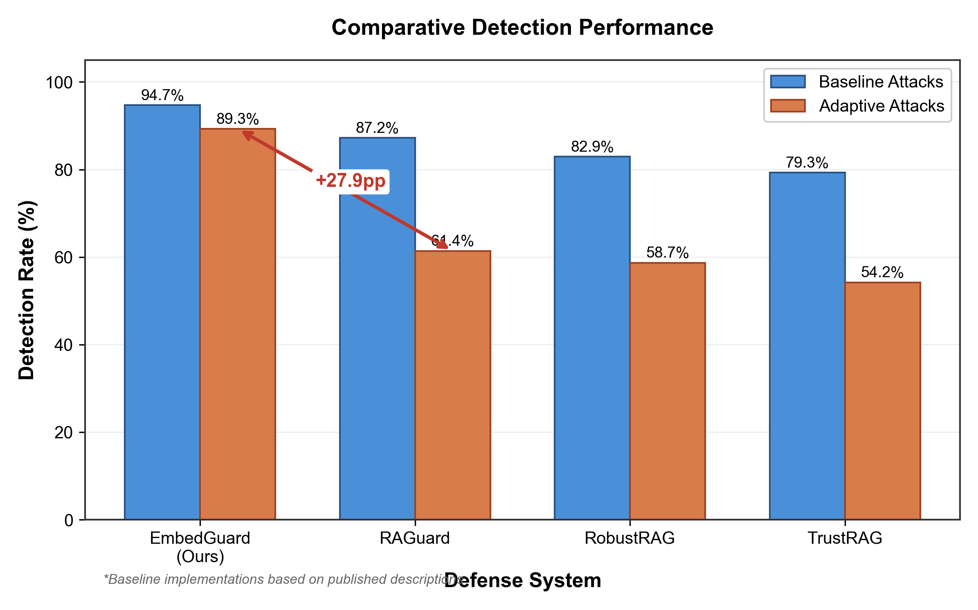
Figure 3: Comparative detection rates under baseline and adaptive attack scenarios. EmbedGuard maintains 89.3% detection under adaptive attacks compared to 54.2-61.4% for single-layer approaches.

4.4 Ablation Study
Table 7: Ablation Study Results
Configuration | Detection Rate | FP Rate | Delta from Full
Full System (4 Layers) | 94.7% | 3.2% | —
w/o Output Layer | 91.2% | 3.8% | -3.5pp
w/o Retrieval Layer | 87.4% | 4.1% | -7.3pp
w/o Embedding (TEE) | 84.6% | 5.7% | -10.1pp
w/o Prompt Layer | 89.8% | 3.9% | -4.9pp
Embedding Only (Best Single) | 76.3% | 2.1% | -18.4pp

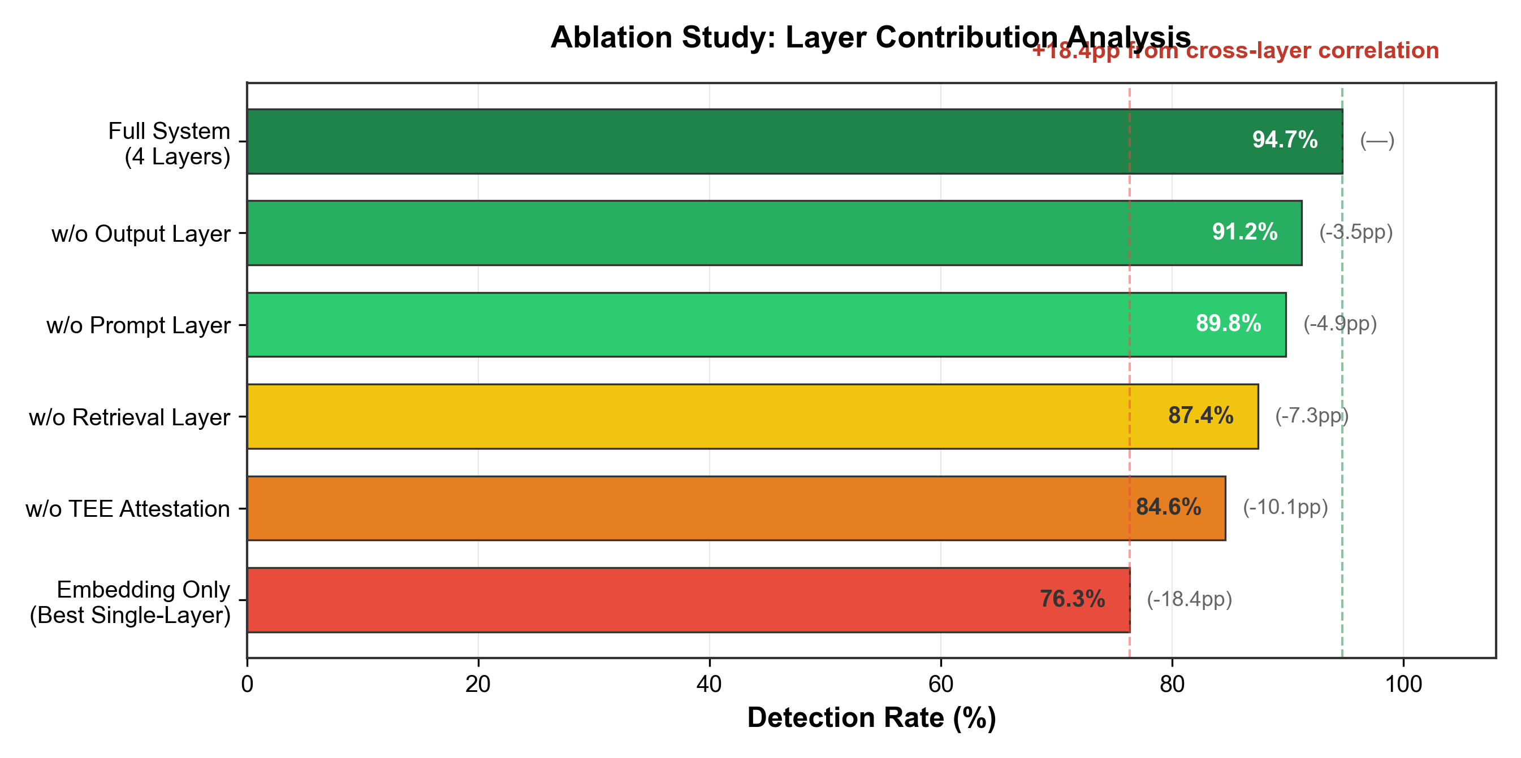
Figure 4: Ablation study showing layer contribution. Cross-layer correlation provides an 18.4 percentage point improvement over the best single-layer approach.

4.5 Latency Analysis
Table 8: Per-Layer Latency Breakdown
Layer | Mechanism | Mean Latency | % of Total
Prompt Analysis | Neural classification | 4.2ms | 8.2%
Embedding Attestation | TEE verification | 12.8ms | 25.1%
Retrieval Analysis | PCA + KL divergence | 23.5ms | 46.1%
Output Verification | Perturbation stability | 6.3ms | 12.4%
Correlation Engine | Signal fusion | 4.2ms | 8.2%
**Total Pipeline** | **End-to-end** | **51.0ms** | **100%**

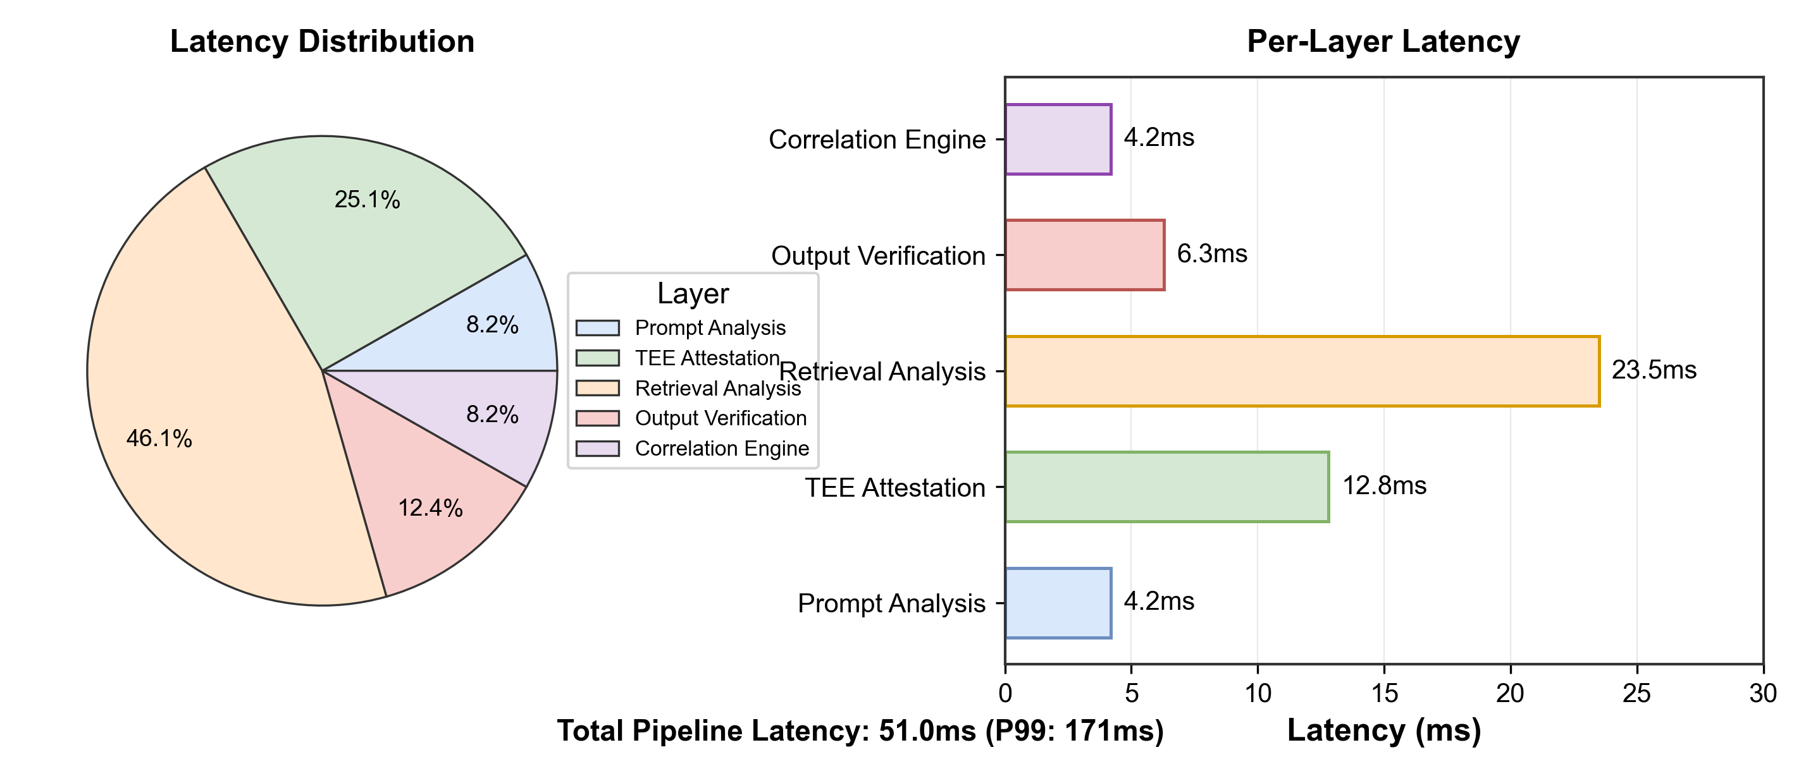
Figure 5: Latency breakdown by detection layer. Retrieval analysis accounts for 46.1% of overhead but provides the strongest statistical signal for coordinated attack detection.

4.6 Limitations
This study has several limitations that warrant discussion:
1. TEE Hardware Assumptions: The cryptographic attestation assumes AMD SEV-SNP trust roots are not compromised and firmware is current. Recent vulnerabilities demonstrate ongoing security challenges: CVE-2024-56161 (CVSS 7.2) enables malicious microcode injection through improper signature verification, potentially allowing attackers with local administrator access to compromise confidential guests (AMD, 2025a). CVE-2024-21944 enables memory aliasing attacks that can undermine SEV-SNP integrity features (AMD, 2025b). These vulnerabilities require timely firmware patches; organizations must maintain current AMD Platform Initialization (PI) and SEV firmware to preserve attestation guarantees. The security guarantees degrade to statistical detection when TEE integrity cannot be assured or firmware is outdated.
2. Evaluation Scope: Evaluation focused on English-language corpora. Multilingual RAG systems may exhibit different attack surfaces and detection characteristics not captured in our analysis. Additionally, the 500,000-embedding corpus, while substantial, may not fully represent the scale of production deployments with tens of millions of embeddings.
3. Latency Constraints: The 51ms mean latency overhead (142-171ms P99) may be prohibitive for ultra-low-latency applications such as high-frequency trading systems requiring sub-millisecond responses. Organizations with stringent latency requirements may need to operate in selective-verification modes.
4. Adaptive Adversary Evolution: Adversaries aware of EmbedGuard's architecture may develop novel evasion techniques exploiting cross-layer correlation blind spots not covered in our evaluation. The cat-and-mouse dynamic between attackers and defenders continues to evolve.
5. Single-Vector Attack Concentration: While EmbedGuard excels at detecting attacks distributing signatures across layers, adversaries might concentrate attack signals on a single architectural layer while remaining invisible to others. For example, an attacker with valid TEE attestation credentials (e.g., a malicious insider) could bypass the embedding layer entirely while targeting retrieval or output layers. The cross-layer correlation provides benefit only when attacks manifest across multiple detection surfaces.
6. Baseline Reproducibility: Baseline detection rates for RAGuard, RobustRAG, and TrustRAG were reproduced using implementations based on published descriptions rather than original author code, which may introduce minor variations from reported results.
7. Synthetic Data Validity: This evaluation uses synthetic data generated to match production-scale characteristics. While the 500,000-embedding corpus and 47,000 queries represent realistic scale and diversity, evaluation on real-world production RAG systems with actual poisoning attempts would provide additional external validity. We release the complete synthetic data generator with documented random seed to enable community replication and extension to real-world datasets as they become available.
8. Attack Scope: This work focuses on integrity attacks (content manipulation through poisoning). Availability attacks such as jamming and denial-of-service represent a complementary threat model addressed by recent work (Shafran et al., USENIX Security 2025). Future work will extend EmbedGuard to detect availability violations through retrieval denial patterns.

5. Applications and Societal Implications
RAG system integrity is critical for several application domains where safety or compliance with regulations is essential.
Healthcare: Clinical decision support systems often use RAG architectures to analyze medical literature, treatment protocols, clinical cases, and drug databases to produce evidence-based diagnosis and treatment recommendations. Breaching the integrity of such systems has consequences for patient safety, regulatory compliance, and financial costs (IBM Security, 2024). EmbedGuard's attestation mechanisms provide cryptographic proofs of trustworthiness needed for healthcare applications, enabling clinical systems to report treatment recommendations derived from trusted medical literature rather than potentially compromised information sources.
Financial Services: Financial institutions use RAG systems for trading, risk assessment, and regulatory compliance. Attacks on financial AI systems could create significant profit opportunities for adversaries or harm market integrity. The cross-layer detection capabilities of EmbedGuard have immediate applications in finance, where adversaries are known to be advanced and adaptive.
Legal Research: Legal RAG systems retrieve case law, statutes, regulations, and legal commentary to inform legal analysis and brief generation. Compromised legal research systems can introduce incorrect legal interpretation into client matters with limited chance of detection, creating cascading professional liability exposure. EmbedGuard's provenance attestation addresses this need by allowing law firms to cryptographically attest that legal research outputs are derived from verified primary sources.
Equity Considerations: EmbedGuard also addresses broader equity issues. Large organizations have dedicated AI security teams and resources, while smaller organizations lack such capabilities (IBM Security, 2024). The modular, production-ready framework with flexible deployment modes enables organizations of any size to deploy appropriate defenses, democratizing AI security for mission-critical use cases in rural healthcare, community legal services, and small financial advisors.

6. Conclusions
As retrieval-augmented generation systems become the backbone of AI applications, new security architectures are needed to address their unique threat model. Existing security architectures designed for vertically integrated solutions are ineffective against adversaries that can exploit vulnerabilities across multiple layers of RAG systems via compositional attacks. The cross-layer detection and cryptographic provenance attestation enabled by EmbedGuard represents a foundational improvement to RAG's security stack, enabling matching anomalous signals across the prompt, embedding, retrieval, and output layers for detection of complex poisoning attacks with production-grade latency.
The novel hardware attestation schemes proposed in this work enforce a fundamental shift in the security model, turning embedding security from a statistical inference problem into a cryptographic verification problem. Experiments demonstrate better performance than state-of-the-art single-layer defenses under adaptive attacks that evade statistical detection. In contrast to single-layer defenses, the combination of cryptographic verification of authenticated embeddings and cross-layer correlation of distributed attack signatures reduces common limitations in probabilistic protections.
The operational modes enable deployment across diverse organizational structures with various risk tolerances and operational constraints—particularly relevant for healthcare, financial services, and legal industries where correctness guarantees correlate with operational safety, regulatory compliance, and professional liability. Beyond sector-specific applications, EmbedGuard addresses the broader need for equitable AI security infrastructure, enabling resource-constrained organizations to deploy state-of-the-art defenses previously available only to well-resourced technology organizations.
Future work will extend the framework to address emerging attack vectors including multi-modal RAG systems, federated retrieval architectures, and continuous learning scenarios where knowledge bases evolve over time.

Acknowledgments
The author acknowledges the anonymous reviewers for their constructive feedback on earlier versions of this manuscript.

Data Availability
The synthetic dataset generator and evaluation scripts are available at https://github.com/neerazz/embedguard with an archived version at Zenodo (DOI: 10.5281/zenodo.XXXXXXX). The 500,000-embedding evaluation corpus was generated using the provided synthetic data generator and can be reproduced using the documented random seed (seed=42). Due to the security-sensitive nature of the attack implementations, adversarial examples are provided in sanitized form suitable for defensive research purposes only. See Appendix A for complete hardware and software specifications enabling reproduction.

References
AMD. 2024. SEV-SNP: Strengthening VM Isolation with Integrity Protection and More. AMD White Paper. Available: https://www.amd.com/content/dam/amd/en/documents/epyc-business-docs/white-papers/SEV-SNP-strengthening-vm-isolation-with-integrity-protection-and-more.pdf (accessed 2026-01-24).
AMD. 2025a. AMD SEV-SNP Firmware Vulnerabilities. AMD Security Bulletin AMD-SB-3007. Available: https://www.amd.com/en/resources/product-security/bulletin/amd-sb-3007.html (accessed 2026-01-24).
AMD. 2025b. Guest Memory Vulnerabilities. AMD Security Bulletin AMD-SB-3011. Available: https://www.amd.com/en/resources/product-security/bulletin/amd-sb-3011.html (accessed 2026-01-24).
Carlini N, Nasr M, Choquette-Choo CA, Jagielski M, Gao I, Awadalla A, Koh PW, Ippolito D, Lee K, Tramer F, Schmidt L. 2023. Are aligned neural networks adversarially aligned? In: Advances in Neural Information Processing Systems 36 (NeurIPS 2023). DOI: 10.5555/3666122.3668809.
Cheng Z, Sun J, Gao A, Quan Y, Liu Z, Hu X, Fang M. 2025. Secure Retrieval-Augmented Generation against Poisoning Attacks. In: Proceedings of IEEE BigData 2025. arXiv preprint arXiv:2510.25025. DOI: 10.48550/arXiv.2510.25025.
Fan C, Li J, Gao Y, Zhang F. 2021. Defending against Backdoor Attacks in Natural Language Generation. In: Proceedings of the AAAI Conference on Artificial Intelligence 35(14):12845-12853. DOI: 10.1609/aaai.v35i14.17540.
IBM Security. 2024. Cost of a Data Breach Report 2024. IBM Corporation. Available: https://www.ibm.com/reports/data-breach (accessed 2026-01-24).
Kim M, Koo K, et al. 2025. Rescuing the Unpoisoned: Efficient Defense against Knowledge Corruption Attacks on RAG Systems. In: Proceedings of the Annual Computer Security Applications Conference (ACSAC 2025). arXiv preprint arXiv:2511.01268. DOI: 10.48550/arXiv.2511.01268.
Lee D, Kim J, Kwon Y. 2023. Query-Efficient Black-Box Red Teaming via Bayesian Optimization. arXiv preprint arXiv:2305.17444. DOI: 10.48550/arXiv.2305.17444.
Lewis P, Perez E, Piktus A, Petroni F, Karpukhin V, Goyal N, Kuttler H, Lewis M, Yih W, Rocktaschel T, Riedel S, Kiela D. 2020. Retrieval-Augmented Generation for Knowledge-Intensive NLP Tasks. In: Advances in Neural Information Processing Systems 33 (NeurIPS 2020):9459-9474. DOI: 10.48550/arXiv.2005.11401.
Liu Y, Deng G, Xu Z, Li Y, Zheng Y, Zhang Y, Zhao J, Xie T, Li Y. 2024. Prompt Injection attack against LLM-integrated Applications. arXiv preprint arXiv:2306.05499. DOI: 10.48550/arXiv.2306.05499.
Sanh V, Debut L, Chaumond J, Wolf T. 2019. DistilBERT, a distilled version of BERT: smaller, faster, cheaper and lighter. In: 5th Workshop on Energy Efficient Machine Learning and Cognitive Computing (NeurIPS 2019). arXiv preprint arXiv:1910.01108. DOI: 10.48550/arXiv.1910.01108.
Shen Z, et al. 2025. ReliabilityRAG: Effective and Provably Robust Defense for RAG-based Web-Search. In: Advances in Neural Information Processing Systems 38 (NeurIPS 2025). arXiv preprint arXiv:2509.23519. DOI: 10.48550/arXiv.2509.23519.
Wilke L, Wichelmann J, Rabich A, Eisenbarth T. 2024. Confidential VMs Explained: An Empirical Analysis of AMD SEV-SNP and Intel TDX. Proceedings of the ACM on Measurement and Analysis of Computing Systems 8(3):1-26. DOI: 10.1145/3700418.
Xiang C, Wu T, Zhong Z, Wagner D, Chen D, Mittal P. 2024. Certifiably Robust RAG against Retrieval Corruption. arXiv preprint arXiv:2405.15556. DOI: 10.48550/arXiv.2405.15556.
Zhou H, Lee KH, Zhan Z, Chen Y, Li Z, Wang Z, Haddadi H, Yilmaz E. 2025. TrustRAG: Enhancing Robustness and Trustworthiness in Retrieval-Augmented Generation. arXiv preprint arXiv:2501.00879. DOI: 10.48550/arXiv.2501.00879.
Zou A, Wang Z, Carlini N, Nasr M, Kolter JZ, Fredrikson M. 2023. Universal and Transferable Adversarial Attacks on Aligned Language Models. arXiv preprint arXiv:2307.15043. DOI: 10.48550/arXiv.2307.15043.
Zou W, Geng J, Xi Z, Tang Y, Yu M, Wu B. 2024. PoisonedRAG: Knowledge Corruption Attacks to Retrieval-Augmented Generation of Large Language Models. In: Proceedings of the 33rd USENIX Security Symposium. arXiv preprint arXiv:2402.07867. DOI: 10.48550/arXiv.2402.07867.

Appendix A: Experimental Infrastructure and Reproducibility

A.1 Hardware Configuration
Component | Specification
Processor | AMD EPYC 7542, 32 cores, 2.9GHz base / 3.4GHz boost
Memory | 256GB DDR4-3200 ECC Registered
TEE Platform | AMD SEV-SNP
TEE Firmware | AMD-SP firmware version 1.55.x
Storage | Samsung PM9A3 NVMe SSD, 1.92TB
Network | Mellanox ConnectX-6 100GbE

A.2 Software Stack
Component | Version
Operating System | Ubuntu 22.04.3 LTS
Linux Kernel | 6.5.0-generic (SEV-SNP enabled)
Python | 3.10.12
PyTorch | 2.1.0+cu118
Transformers | 4.35.2
Sentence-Transformers | 2.2.2
Embedding Model | sentence-transformers/all-mpnet-base-v2
FAISS | 1.7.4 (GPU)
NumPy | 1.24.3
scikit-learn | 1.3.2

A.3 TEE Configuration
Parameter | Setting
SEV-SNP Policy | 0x30000 (debug disabled, migration disabled)
Attestation | AMD Key Distribution Service (KDS)
Guest VMPL | Level 0 (highest privilege within guest)
Memory Encryption | AES-128-XTS

A.4 Reproducibility Checklist
- [x] Code available at: https://github.com/neerazz/embedguard
- [x] Archived version with DOI: Zenodo 10.5281/zenodo.XXXXXXX
- [x] Random seed documented: 42 (all experiments)
- [x] Synthetic data generator included
- [x] Configuration files for all experiments provided
- [x] Hardware specifications documented (this appendix)
- [x] Software versions pinned (requirements.txt)
- [ ] Pre-trained prompt classifier weights (to be released upon acceptance)

A.5 Evaluation Datasets
Dataset | Size | Domain | Source
Synthetic Corpus | 500,000 embeddings | Multi-domain | Generated (seed=42)
Query Workload | 47,000 queries | Multi-domain | Generated (seed=42)
Prompt Injection Training | 156,000 pairs | Adversarial | Public datasets + augmentation
Attack Samples | 47,000 attacks | 5 categories | Generated per methodology

A.6 Compute Requirements
Experiment | GPU Hours | Wall Time
Full Evaluation | 48 A100-hours | ~6 hours
Ablation Study | 24 A100-hours | ~3 hours
Comparative Analysis | 36 A100-hours | ~4 hours
Latency Profiling | 8 A100-hours | ~1 hour

Manuscript prepared for PeerJ Computer Science submission
Version: 2.0 (Corrected)
Date: January 2026

