**Table Of Content**

**Page No.**

* **Certificate II**
* **Acknowledgement III**
* **Table of figures IV**
* **Table of contents 01**
* **Table of contents 02**
* **Abstract 03**

**Chapter1:Introduction**

* 1. Purpose of this document 04
  2. Existing system 05
  3. Future extension 05

**Chapter2:Background Research**

2.1 Background of the system 06

2.2 Advantages of the system 07

2.3 Applications 08

**Chapter3:Project Design**

3.1 Theory 09

3.2 Hardware Required 09

3.2.1 Sensor Technology 09

3.2.2 Soil Moisture Sensor 14

3.2.3 Arduino UNO 17

3.2.4 Specifications Of Arduino Uno 18

3.2.5 Soil Moisture Sensor YL-69 20

3.2.6 DC Motor 23

3.3 Software Design 24

3.4 Real Time Applications Of Arduino 31

**Chapter4:Project Construction&Testing**

4.1 Construction&Block Diagram 34

4.2 Testing 36

4.3 Result 37

**Chapter5:Safety&Conclusion**

5.1 Safety 38

5.2 Conclusion 38

* **References**

**ABSTRACT**

In daily operation related to watering the plants are the most important cultural practice and the most labor-intensive task. No matter whatever the weather it is, either too hot and cold or too dry and wet, it is very crucial to control the amount of water reaching the plants. So, it will be effective to use an idea of automatic plant watering system, which waters the plants when they need it. An important aspect of this project is that: “when and how much to water”. To reduce manual activities for the human to watering plant, an idea of automatic plant watering system is adopted.

There have a various types of automatic watering systems; those are by using sprinkler system, drip watering system, nozzles and other. To make the gardener works easily and Knowing when and how much to water, the automatic plant watering system is created. Normally, the plants need to be watered twice daily, morning and evening. People enjoy plants, their benefits and the feeling related to nurturing them. However for most people it becomes challenging to keep them healthy and alive. To accommodate this challenge we have developed a prototype, which makes a plant more self-sufficient and watering it. This project can be grouped into subsystems such as; power supply, Adriano Uno, Soil moisture sensor and motor.

This project uses Arduino board, which consists of ATmega328 Microcontroller. It is programmed in such a way that it will sense the moisture level of the soil (plants) and supply the water if required. This type of system is often used for general plant care, as a part of caring for small and large gardens. Use of wired systems in remote areas is usually unfeasible due to high costs, wireless is the best solution.

Overall, this Arduino based automatic plant watering system is beneficial in terms of encouraging planting without the need of human effort. We hope that, through this prototype people will enjoy having plants without the challenges related to absent or forgetfulness.

**CHAPTER 1**

**1.0 INTRODUCTON**

Since nowadays, in the age of advanced technology and electronics, the life style of the human should be smart, simpler, easier and much more convenient. So, therefore; there is a need for many automated systems in human’s daily life routine to reduce their daily activities and jobs. Here an idea of one such system named as automatic plant watering system is very useful. As many people are facing a lot of problem watering the plants in the garden, especially when they away from the home. This model uses sensor technologies with microcontroller/arduino in order to make a smart switching device to help millions of people.

In its most basic form, system is programmed in such a way that soil moisture sensor which senses the moisture level from the plant at particular instance of time, if moisture level of the sensor is less than the specified value of threshold which is predefined according to the particular plant then the desired amount of water is supplied to plant till it’s moisture level reaches to the predefined threshold value. System involves humidity and temperature sensor which keep tracks the current atmosphere of the system and has an influence when watering happens. Motor will control the water flow in the system, when Arduino reads value from moisture sensor it triggers the solenoid valve according to the desired condition. In addition, system reports its current status and sends the reminder message about watering plants and gets SMS fromthe recipient. All this notification can be done by using Arduino GSM(Global System For Mobile Communication) shield only,which we have not used in this project.

**1.1 PURPOSE OF THIS DOCUMENT**

In this 21st century ,Climate change and depletion of resources have become major issue to deal with.With the ever growing population and increased demand for natural resources we find ourselves in the middle of crisis,a crisis which calls for immediate action.Sustainable development must be adopted by each one of us,both on personal level and socio-industrial level.

Among the teeming natural resources which make life possible on earth ,perhaps the the most important is water.Water shortage has become a crucial issue in most parts of the world.Recently ,the state maharastra in our country is facing severe drought which has already claimed many lives.Hence,we see that water conservation is of utmost importance.This led us to take up the project related to conservation of water.

**1.2 EXISTING SYSTEM**

The existing system which we are using now-a-days have the following drawbacks,

1. Data not received accurately
2. No protocol architecture
3. No communication device.

Due to this large amounts of water is getting wasted sometimes,which indirectly leads to shortage of water for our usage.

**1.3 FUTURE EXTENSION**

Many people forget to water their plant on a busy schedule of day and due to that many plants gets suffered and ultimately die. Apart from that another big problem in the modern society is, the shortage of water and the unplanned use of water inadvertently results in wastage of water. It is a big task to utilize water resources in a proper way thus, a system is required to handle this task automatically.In automatic plant watering system, the most momentousadvantage isthat water is onlysupplied when preset threshold value of the soil moisture sensor goes below.This saves lots of water even in the bigger irrigation systems.

**CHAPTER 2**

**2.0 BACKGROUND RESEARCH**

**2.1. BACKGROUND OF THE SYSTEM**

It has been studied in the school from the science’s books that the plants are very imperative for all the humanity in many aspects. As they keep the environmental clean by producing fresh oxygen time to time. Automatic plant watering system have been seen becoming much more with the rise in the everyday objects being connected to the advanced technologies, these systems are implemented at a growing rate. Places like homes as well as on industrial levels. The main use of these systems is efficiency and easy to use.

Plant watering system provides the ability to plant lovers to take of their home plant while they are away – through the use of efficient and reliable components such as different types of sensor technologies.

There are several different/uncomplicated types of indoor plant watering system, depending on the level of automation needed.

**Plant** **Watering** **Globes** **and** **Spikes** – It is one of the successful indoor system. The basic premise of the plant watering spike is the fact that it is a reservoir that basically waters the plant through capillary action. And the spike is made of unglazed ceramic. A small plastic tube goes from the spike to the nearby reservoir, and when soil moisture of the soil goes low it automatically draws water through the device into the soil. This basic system can be shown below in *figure* *1,*

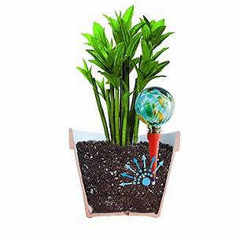

Figure 01:Plant watering using globes&spikes

**Indoor** **Drip** **Watering** **System** – This system can take the guesswork out of watering the plant. As it is not necessary to remember when was the reservoir refilled last time on self-contained pots. Instead it is possible to run a drip system to those same pots and run a timer.

However, for minimal maintenance watering this can be ideal. But one strategy to keep in mind when using those watering system is that there is no way for the dirt in the pot itself to regulate the water flow, as it does with most self-watering pots. Timer will turn on, and drips water for certain amount, then turns off. One disadvantage of this is that if plant do not require much water, there is a chance of over watering them.

A typical drip wateing system using timer is shown in the figure 2,

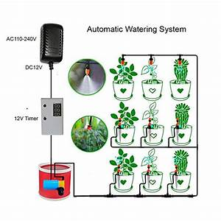

Figure 02:Drip Watering System

However,there aremoredifferenttypes ofplantwatering system including self-watering pots and container, self-watering hanging baskets, outdoor drip irrigation system and so on. As It can be seenfrom allthose systemwhichis described aboveis not veryideal. So,itisnecessary to use sensor technologies here. The sensor provides real-time data that is used to run the overall system efficiently. Which keeps track the real-time values and update the system frequently. In addition, the key technologies behind the smart automated plant watering system will be discussed through the extensive research on them. These technologies include the frequentlyupdateofsystem according to the sensing technologyusedto allowthe system to real time events such as soil moisture level of a plants goes below the threshold value and so on.

**2.2 ADVANTAGES OF AUTOMATED PLANT WATERING SYSTEM**

**1. Conserves water and time**

Hand watering with a hose or watering can takes substantial time and early morning and evening watering rituals take away from family and work. Both drip,sprinkler and arduino irrigation systems have timers that can be preset for daily or weekly watering so you do not need to monitor

the watering because the timer shuts the water off when it has finished. Your water bill should be lower if the irrigation system is effective.

**2. Preserves soil structure&nutrients**

Watering with a wide open garden hose may allow too much water to seep into the soil. As a result, nutrients leach out with the water runoff, leaving the plants with fewer nutrients available. The soil may also become compacted when you water with a hose. Plants may show signs of withering or root disease with suffocating, compacted soil. Using either drip or sprinkler irrigation produces smaller droplets, helping to preserve nutrients and reducing soil compaction.

3. **Gardening flexibility**

If you have a busy schedule, you'll appreciate being able to work in the garden at the same time as the plants are being watered. While one garden section is being watered, you can plant and prune in another area.

**4.Improved safety&less power consumption**

As we are using soil moisture sensor here,the motor pumps water whenever the moisture in the soil crosses a predefined value and the motor runs for sometime,hence saving of power.

**2.3 APPLICATIONS**

1.It can be used in agricultural fields.

2.It can be used for cultivation purposes.

3.It can be used to provide water in nursery&houses.

4.Useful in gardens&parks.

**CHAPTER 3**

**3.0 PROJECT DESIGN**

**3.1 THEORY**

This section of the report talks about why different components were chosen and how they interfaced with a microcontroller. The idea was to build a fully functioning automated plant watering system. To do this, electronic components must be chosen very carefully and to ensure that all the chosen components interfaced correctly with the microcontroller.

**3.2 HARDWARE REQUIRED**

1.Arduino Uno.

2.Soil Moisture Sensor.

3.LM-393 IC.

4.DC/Servo Motor.

5.USB TYPE-B Cable.

6.Personal Computer

**3.2.1 SENSOR TECHNOLOGY**

*“Sensor* *is* *a* *device* *which* *provides* *a* *usable* *output* *in* *respond* *to* *a* *specified* *measurement”* (Engineering.nyu.edu, n.d.)

Sensor is a device that perceives and reacts to some sort of contribution from the physical environment. The specific data could be light, heat, motion, moisture, pressure or any of an incredible number of other natural marvels. The yield is general a banner that is changed over to understandable show at the sensor location or transmitted electronically completed a framework for examining or further taking care of.

Sensors obtains a physical amount and changes over it onto a flag reasonable for handling. These days sensor change over estimation of physical wonders into electrical flag. Sensors are inescapable. They are implanted in our bodies, automobiles, plans, cell phones, radios, chemical plants, mechanical plants and incalculable different applications..

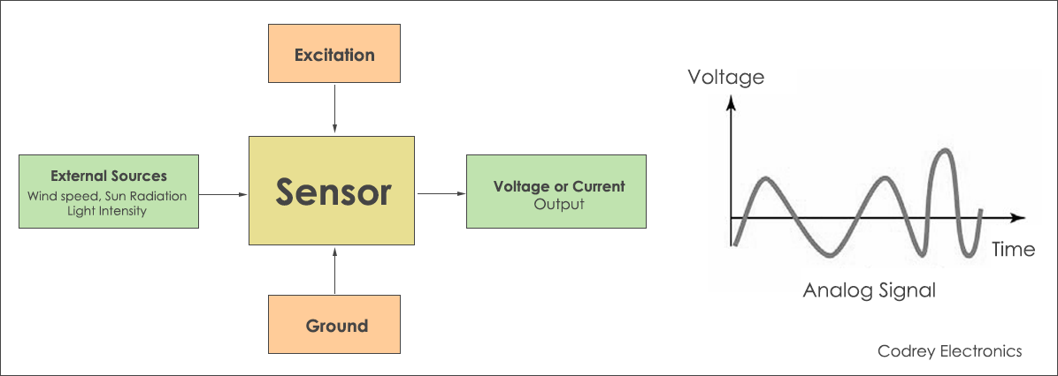

Figure3:Sensor Block Diagram

There are several classifications of sensors made by different authors and experts. Some are very simple and some are very complex. The following classification of sensors may already be used by an expert in the subject but this is a very simple classification of sensors.

In the first classification of the sensors, they are divided in to Active and Passive. Active Sensors are those which require an external excitation signal or a power signal.

Passive Sensors, on the other hand, do not require any external power signal and directly generates output response.

The other type of classification is based on the means of detection used in the sensor. Some of the means of detection are Electric, Biological, Chemical, Radioactive etc.

The next classification is based on conversion phenomenon i.e. the input and the output. Some of the common conversion phenomena are Photoelectric, Thermoelectric, Electrochemical, Electromagnetic, Thermooptic, etc.

The final classification of the sensors are Analog and Digital Sensors. Analog Sensors produce an analog output i.e. a continuous output signal with respect to the quantity being measured.

Digital Sensors, in contrast to Analog Sensors, work with discrete or digital data. The data in digital sensors, which is used for conversion and transmission, is digital in nature.

**DIFFERENT TYPE OF SENSORS**

The following is a list of different types of sensors that are commonly used in various applications. All these sensors are used for measuring one of the physical properties like Temperature, Resistance, Capacitance, Conduction, Heat Transfer etc.

* Temperature Sensor
* Proximity Sensor
* Accelerometer
* IR Sensor (Infrared Sensor)
* Pressure Sensor
* Light Sensor
* Ultrasonic Sensor
* Smoke, Gas and Alcohol Sensor
* Touch Sensor
* Color Sensor
* Humidity Sensor
* Tilt Sensor
* Flow and Level Sensor

We will see about few of the above mentioned sensors in brief. More information about the sensors will be added subsequently. A list of projects using the above sensors is given at the end of the page.

Temperature Sensor

One of the most common and most popular sensor is the Temperature Sensor. A Temperature Sensor, as the name suggests, senses the temperature i.e. it measures the changes in the temperature.

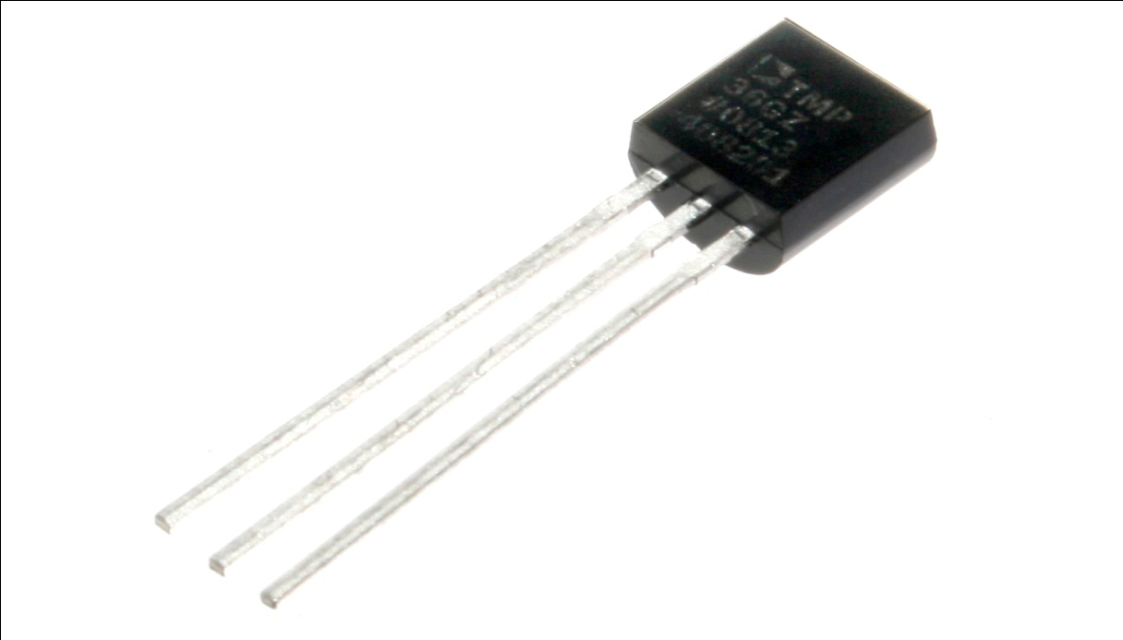

Figure 4:Temperature Sensor

In a Temperature Sensor, the changes in the Temperature correspond to change in its physical property like resistance or voltage.

There are different types of Temperature Sensors like Temperature Sensor ICs (like LM35), Thermistors, Thermocouples, RTD (Resistive Temperature Devices), etc.

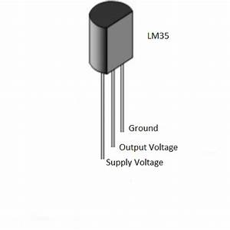

Figure 5:LM35 Sensor

Temperature Sensors are used everywhere like computers, mobile phones, automobiles, air conditioning systems, industries etc.

Proximity Sensor.

A Proximity Sensor is a non-contact type sensor that detects the presence of an object. Proximity Sensors can be implemented using different techniques like Optical (like Infrared or Laser), Ultrasonic, Hall Effect, Capacitive, etc. 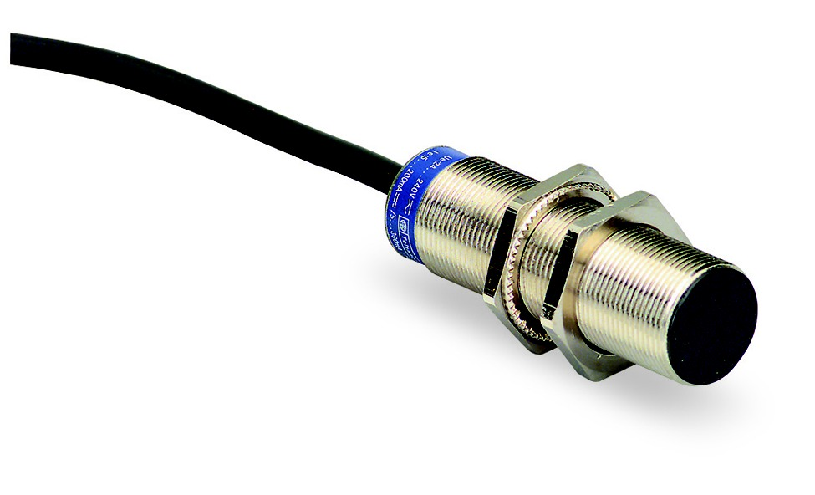

Figure 6;Proximity Sensor

Some of the applications of Proximity Sensors are Mobile Phones, Cars (Parking Sensors), industries (object alignment), Ground Proximity in Aircrafts, etc.

Infrared Sensors

IR Sensors or Infrared Sensor are light based sensor that are used in various applications like Proximity and Object Detection. IR Sensors are used as proximity sensors in almost all mobile phones.

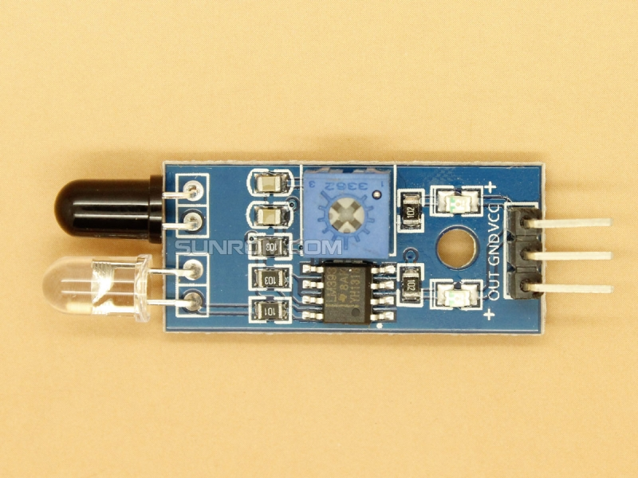

Figure 7:Infrared Sensor

There are two types of Infrared or IR Sensors: Transmissive Type and Reflective Type. In Transmissive Type IR Sensor, the IR Transmitter (usually an IR LED) and the IR Detector (usually a Photo Diode) are positioned facing each other so that when an object passes between them, the sensor detects the object.

The other type of IR Sensor is a Reflective Type IR Sensor. In this, the transmitter and the detector are positioned adjacent to each other facing the object. When an object comes in front of the sensor, the sensor detects the object.

Different applications where IR Sensor is implemented are Mobile Phones, Robots, Industrial assembly, automobiles etc.

Ultrasonic Sensors

An Ultrasonic Sensor is a non-contact type device that can be used to measure distance as well as velocity of an object. An Ultrasonic Sensor works based on the properties of the sound waves with frequency greater than that of the human audible range.

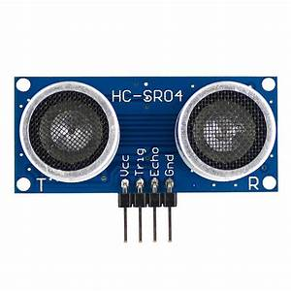

Figure 8:Ultrasoniic Sensor

Using the time of flight of the sound wave, an Ultrasonic Sensor can measure the distance of the object (similar to SONAR). The Doppler Shift property of the sound wave is used to measure the velocity of an object.

**3.2.2 SOIL MOISTURE SENSOR**

The soil moisture sensor uses capacitance to quantify the water substance of soil (by estimating the dielectric permittivity of the soil, which is an element of the water content). Simply insert the sensor into the soil to be tested, and the volumetric water content of the soil is reported in percent. These sensors consisting of two electrodes and probes for estimating the soil resistance are frequently utilized for residential purposes. Time Domain Reflectometry (TDR) and Time Domain Transmission (TDT) are also used for measuringthe soilmoisture content. Ahigher average dielectric constantfor the soilis caused by a higher water concentration. These sensors give real-time information and enhance the irrigation efficiency. The sensors are easy to install and require very less maintenance.

During dry condition, when no moisture or water the probes are dry. Circuit is open,no currentflowsinto the base of the transistor, so theLED is OFF. During wet condition, when there is moisture or water, the probes gets short circuit when in contact with moisture/water. Circuit is closed, current will flow into the base of the transistor, LED turns ON.

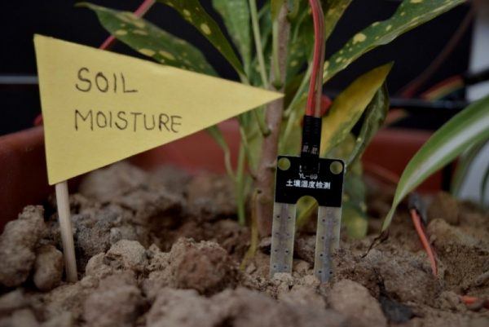

Figure 9:Use Of Soil Moisture Sensor

**Grove** **Soil** **Moisture** **Sensor:** This sensor is used to detect the moisture in the soil and give the readings back to the microcontroller. It is consisting of two probes which are used to measure the volumetric content of water around it. Thesetwo probes enablethe currentto go through the soil and afterward it gets the resistance reading to measure the moisture value. Normally, this sensor is consisting of three pins. Power 5V, Ground and analogue output pin which give the reading back to the microcontroller. The advantage of this sensor is during an interface with the Arduino extra hardware is not required that’s why it is easy to use. It can also work with different architecture like raspberry pi etc.

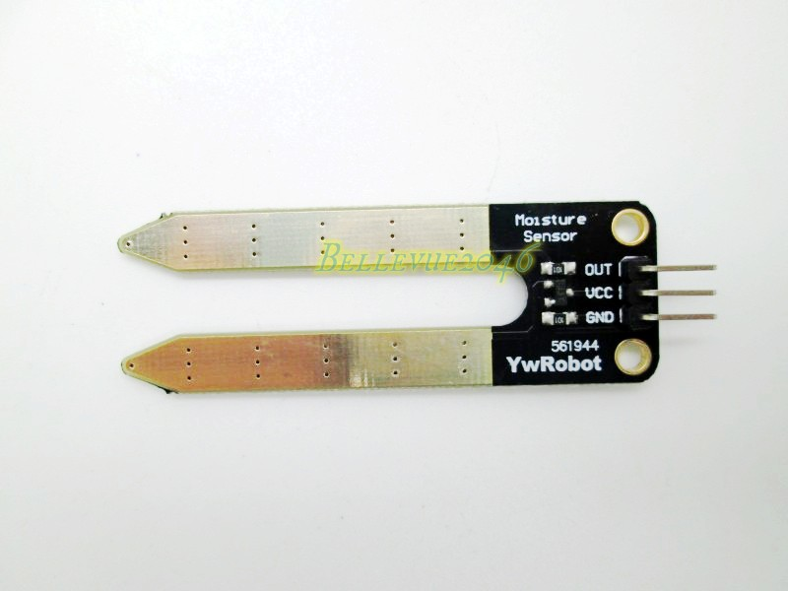

Figure 10:Grove Soil Moisture Sensor

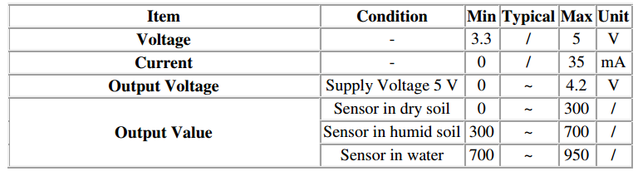

Figure 11:Specifications Of Grove Sensor

**Transistor:** A transistor is a device that controls current and voltage stream and works as a switch for electronic signals. It is consisting of three layers of a semiconductor material, each fit for conveying a current. They are fundamental components in IC, which comprise of a substantial number of transistor interconnected with circuitry and baked into a single silicon microchip. One of the most common uses of the transistor in an electrical circuit is that they act as a simple switch.In short,a transistor conducts current across the collector-emitter path only when a voltage is applied to the base. When there is no base voltage, transistor seems to be in switch off mode. When there is base voltage present, transistor switch is on.

**3.2.3 ARDUINO UNO**

Arduino Uno contains Atmega328p chip which acts as a main microcontroller of the system. As Arduino Uno has a number of facilities for communicating with a personal computer, another Arduino, or other microcontrollers. The atmega328p chip on Arduino provides UART TTL 5V serial communication, which is available on digital pins 0 RX and digital pin 1 TX. It also supports I2C and SPI communication. The biggest advantage of using an Arduino Uno Is its prepared to utilize structure. As Arduino arrives in an entire bundle shape which incorporates the 5V regulator, a burner, an oscillator, a microcontroller, serial communication interface and headers for connections. Another advantage of using an Arduino is its automatic unit conversion capability. Also, it very easy to interface different sensors and get them working with the Arduino. By default, it uses 16MHz clock speed which means microcontroller can execute 16 million instructions per second. It also possesses ADC, UART, and Timers.

Figure 12:Parts of Arduino Uno 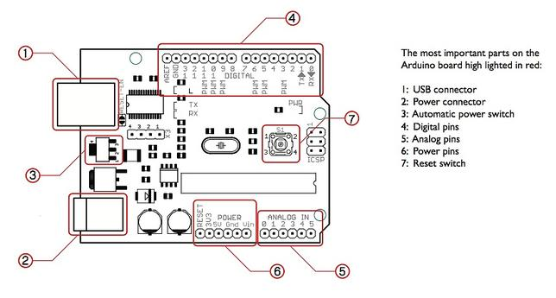

Arduino’s processor basically uses the Harvard architecture where the program code and program data have separate memory. It consists of two memories- Program memory and the data memory.The code is stored in the flash program memory, whereas the data is stored in the data memory. The Atmega328 has 32 KB of flash memory for storing code (of which 0.5 KB is used for the bootloader), 2 KB of SRAM and 1 KB of EEPROM and operates with a clock speed of 16MHz.

There are various types of Arduino boards in which many of them were third-party compatible versions. The most official versions available are the Arduino Uno R3 and the Arduino Nano V3. Both of these run a 16MHz Atmel ATmega328P 8-bit microcontroller with 32KB of flash RAM 14 digital I/O and six analogue I/O and the 32KB will not sound like as if running Windows. Arduino projects can be stand-alone or they can communicate with software on running on a computer. For e.g. Flash, Processing, Max/MSP). The board is clocked by a 16 MHz ceramic resonator and has a USB connection for power and communication. You can easily add micro SD/SD card storage for bigger tasks.

**3.2.4 SPECIFICATIONS OF ARDUINO UNO**

* It is an easy USB interface. This allows interface with USB as this is like a serial device.
* The chip on the board plugs straight into your USB port and supports on your computer as a virtual serial port. The benefit of this setup is that serial communication is an extremely easy protocol which is time-tested and USB makes connection with modern computers and makes it comfortable.
* It is [easy-to-find the microcontroller](https://www.elprocus.com/microcontrollers-types-and-applications/) brain which is the ATmega328 chip. It has more number of hardware features like timers, external and internal interrupts, PWM pins and multiple sleep modes.
* It is an open source design and there is an advantage of being open source is that it has a large community of people using and troubleshooting it. This makes it easy to help in debugging projects.
* It is a 16 MHz clock which is fast enough for most applications and does not speeds up the microcontroller.
* It is very convenient to manage power inside it and it had a feature of built-in voltage regulation. This can also be powered directly off a USB port without any external power. You can connect an external power source of upto 12v and this regulates it to both 5v and 3.3v.
* 13 digital pins and 6 analog pins. This sort of pins allows you to connect hardware to your Arduino Uno board externally. These pins are used as a key for extending the computing capability of the Arduino Uno into the real world. Simply plug your electronic devices and [sensors](https://www.watelectrical.com/6-different-types-of-temperature-sensors-with-their-specifications/) into the sockets that correspond to each of these pins and you are good to go.
* This has an ICSP connector for bypassing the USB port and interfacing the Arduino directly as a serial device. This port is necessary to re-bootload your chip if it corrupts and can no longer used to your computer.
* It has a 32 KB of flash memory for storing your code.
* An on-board LED is attached to digital pin 13 to make fast the debugging of code and to make the debug process easy.
* Finally, it has a button to reset the program on the chip.

Arduino was created in the year 2005 by two Italian engineers David Cuartielles and Massimo Banzi with the goal of keeping in mind about students to make them learn how to program the Arduino uno microcontroller and improve their skills about electronics and use it in the real world.

Arduino uno microcontroller can sense the environment by receiving input from a variety of sensors and can affect its surroundings by controlling lights, motors, and other actuators. The microcontroller is programmed using the Arduino programming language (based on Wiring) and the Arduino development environment (based on Processing).

**Pin Description**

Arduino Uno consists of 14 digital input/output pins (of which 6 can be used as PWM outputs), 6 analog inputs, a 16 MHz crystal oscillator, a USB connection, a power jack, an ICSP header, and a reset button.

**Power Jack**:  Arduino can be power either from the pc through a USB or through external source like adaptor or a battery. It can operate on a external supply of 7 to 12V. Power can be applied externally through the pin Vin or by giving voltage reference through the IORef pin.

**Digital Inputs**: It consists of 14 digital inputs/output pins, each of which provide or take up 40mA current. Some of them have special functions like pins 0 and 1, which act as Rx and Tx respectively , for serial communication, pins 2 and 3-which are external interrupts, pins 3,5,6,9,11 which provides pwm output and pin 13 where LED is connected.

**Analog inputs**: It has 6 analog input/output pins, each providing a resolution of 10 bits.

**ARef**: It provides reference to the analog inputs

**Reset**: It resets the microcontroller when low.

The most important advantage with Arduino is the programs can be directly loaded to the device without requiring any hardware programmer to burn the program. This is done because of the presence of the 0.5KB of Bootloader which allows the program to be burned into the circuit. All we have to do is to download the Arduino software and writing the code.

**3.2.5 SOIL MOISTURE SENSOR YL-69**

The soil moisture sensor or the hygrometer is usually used to detect the humidity of the soil. So, it is perfect to build an automatic watering system or to monitor the soil moisture of your plants.

The sensor is set up by two pieces: the electronic board (at the right), and the probe with two pads, that detects the water content (at the left).

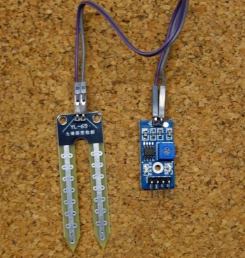

Figure 13:YL-69 Soil Moisture Sensor

The sensor has a built-in potentiometer for sensitivity adjustment of the digital output (D0), a power LED and a digital output LED, as you can see in the following figure 14.

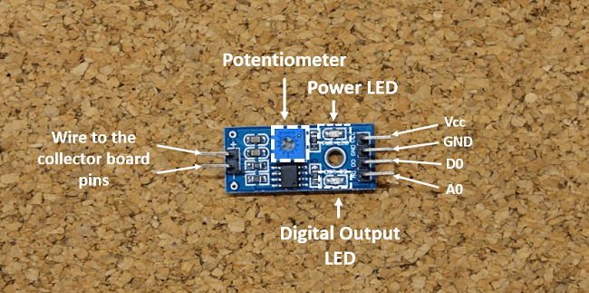

Figure 14:Electronic Board

The voltage that the sensor outputs changes accordingly to the water content in the soil.

When the soil is:

* **Wet:**the output voltage decreases
* **Dry:**the output voltage increases.

The output can be a digital signal (D0) LOW or HIGH, depending on the water content. If the soil humidity exceeds a certain predefined threshold value, the modules outputs LOW, otherwise it outputs HIGH. The threshold value for the digital signal can be adjusted using the potentiometer.

The output can be a analog signal and so you’ll get a value between 0 and 1023.

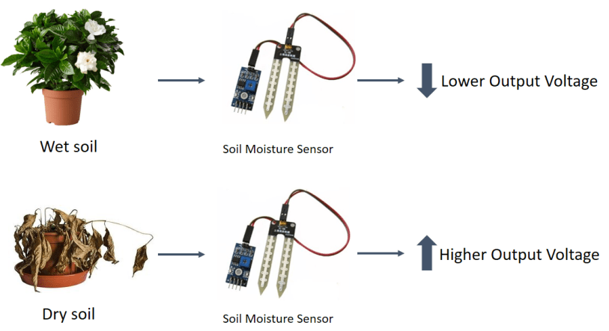

Figure 15:Modes Of Operation

PIN WIRING IS SHOWN IN THE BELOW TABLE

|  |  |
| --- | --- |
| Pin | Wiring to Arduino Uno |
| A0 | Analog Pins |
| D0 | Digital Pins |
| GND | GND |
| VCC | 5V |

**3.2.6 DC MOTOR**

A **DC motor** is any of a class of rotary electrical machines that converts direct current electrical energy into mechanical energy. The most common types rely on the forces produced by magnetic fields. Nearly all types of DC motors have some internal mechanism, either electromechanical or electronic, to periodically change the direction of current flow in part of the motor.

DC motors were the first form of motor widely used, as they could be powered from existing direct-current lighting power distribution systems. A DC motor's speed can be controlled over a wide range, using either a variable supply voltage or by changing the strength of current in its field windings. Small DC motors are used in tools, toys, and appliances.

The [universal motor](https://en.wikipedia.org/wiki/Universal_motor) can operate on direct current but is a light weight [brushed](https://en.wikipedia.org/wiki/Brush_(electric)) motor used for portable power tools and appliances. Larger DC motors are currently used in propulsion of electric vehicles, elevator and hoists, and in drives for steel rolling mills. The advent of power electronics has made replacement of DC motors with [AC motors](https://en.wikipedia.org/wiki/AC_motors) possible in many applications.

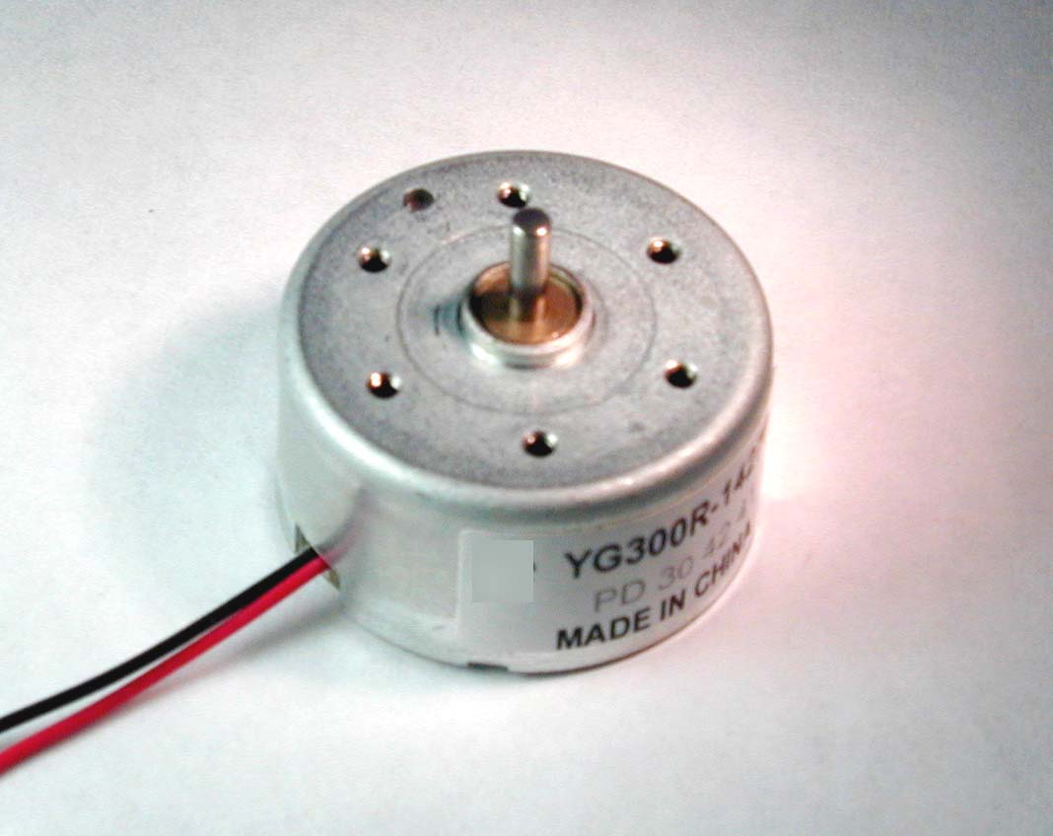

Figure 16:Small DC Motor(0.5-6Volts)

**3.3 SOFTWARE DESIGN**

After getting the hardware done, it’s time to test the hardware with the software. In this section, the implementation of the software design will be described in detail for each of the different automation/ technologies used within the system. This includes the Arduino code written and uploaded to the Arduino

Arduino IDE was used to get the upload the software on the Arduino. For the basic Circuit shown,it is designed to turn On the water pump when the moisture level of soil crosses a predefined value . A small program was written and uploaded to the Arduino which gets the readings from the different sensor and prints them on the screen. Finally, once all the software design was done it’s time to merge all the software design together and build a final working software for the system.

The Arduino tool window consists of the toolbar with the buttons like verify, upload, new, open, save, serial monitor. It also consists of a text editor to write the code, a message area which displays the feedback like showing the errors, the text console which displays the output and a series of menus like the File, Edit, Tools menu.

**STEPS TO PROGRAM AN ARDUINO**

* Programs written in Arduino are known as sketches. A basic sketch consists of 3 parts

1. Declaration of Variables  
2. Initialization: It is written in the setup () function.  
3. Control code: It is written in the loop () function.

* The sketch is saved with .ino extension. Any operations like verifying, opening a sketch, saving a sketch can be done using the buttons on the toolbar or using the tool menu.
* The sketch should be stored in the sketchbook directory.
* Chose the proper board from the tools menu and the serial port numbers.
* Click on the upload button or chose upload from the tools menu. Thus the code is uploaded by the bootloader onto the microcontroller.

PROGRAMMING

* The Arduino integrated development environment (IDE) is a cross-platform application written in Java, and is derived from the IDE for the Processing programming language and the Wiring projects
* The Arduino Uno board can be programmed with the Arduino software.
* Select “Arduino Uno from the Tools > Board menu (according to the microcontroller on your board).
* The ATmega328 on the Arduino Uno comes preburned with a bootloader that allows you to upload new code to it without the use of an external hardware programmer. It communicates using the original STK500 protocol.
* You can also bypass the bootloader and program the microcontroller through the ICSP (In-Circuit Serial Programming) header.
* The ATmega16U2 (or 8U2 in the rev1 and rev2 boards) firmware source code is available .

**FEW BASIC ARDUINO FUNCTIONS ARE,**

* **void setup**():

### **Description**

The setup() function is called when a sketch starts. Use it to initialize variables, pin modes, start using libraries, etc. The setup() function will only run once, after each powerup or reset of the Arduino board.

* **void loop**():

### **Description**

After creating a setup() function, which initializes and sets the initial values, the loop() function does precisely what its name suggests, and loops consecutively, allowing your program to change and respond. Use it to actively control the Arduino board.

* **digitalRead**(pin):

### **Description**

Reads the value from a specified digital pin, either HIGH or LOW.

### **Syntax**

digitalRead(pin)

### **Parameters**

**pin**: the Arduino pin number you want to read

### **Returns**

HIGH or LOW

* **digitalWrite**(pin, value):

### **Description**

Write a HIGH or a LOW value to a digital pin.

If the pin has been configured as an OUTPUT with pinMode(), its voltage will be set to the corresponding value: 5V (or 3.3V on 3.3V boards) for HIGH, 0V (ground) for LOW.

If the pin is configured as an INPUT, digitalWrite() will enable (HIGH) or disable (LOW) the internal pullup on the input pin. It is recommended to set the pinMode() to INPUT_PULLUP to enable the internal pull-up resistor.

If you do not set the pinMode() to OUTPUT, and connect an LED to a pin, when calling digitalWrite(HIGH), the LED may appear dim. Without explicitly setting pinMode(), digitalWrite() will have enabled the internal pull-up resistor, which acts like a large current-limiting resistor.

### **Syntax**

digitalWrite(pin, value)

### **Parameters**

**pin**: the Arduino pin number.  
value: HIGH or LOW.

### **Returns**

Nothing

* **pinMode**(pin, mode):

### **Description**

Configures the specified pin to behave either as an input or an output.

### **Syntax**

pinMode(pin, mode)

### **Parameters**

**pin**: the Arduino pin number to set the mode of.  
**mode**: INPUT, OUTPUT, or INPUT_PULLUP.

### **Returns**

Nothing

* **analogRead**(pin):

#### **Description**

Reads the value from the specified analog pin. The Arduino board contains a 6 channel (8 channels on the Mini and Nano, 16 on the Mega), 10-bit analog to digital converter. This means that it will map input voltages between 0 and 5 volts into integer values between 0 and 1023. This yields a resolution between readings of: 5 volts / 1024 units or, .0049 volts (4.9 mV) per unit. The input range and resolution can be changed using analogReference().

It takes about 100 microseconds (0.0001 s) to read an analog input, so the maximum reading rate is about 10,000 times a second.

#### **Syntax**

analogRead(pin)

#### **Parameters**

**pin**: the number of the analog input pin to read from (0 to 5 on most boards, 0 to 7 on the Mini and Nano, 0 to 15 on the Mega)

#### **Returns**

int (0 to 1023)

* **analogWrite**(pin, value)

### **Description**

Writes an analog value (PWM wave) to a pin. Can be used to light a LED at varying brightnesses or drive a motor at various speeds. After a call to analogWrite(), the pin will generate a steady rectangular wave of the specified duty cycle until the next call to analogWrite() (or a call to digitalRead() or digitalWrite()) on the same pin.

### **Syntax**

analogWrite(pin, value)

### **Parameters**

pin: the Arduino pin to write to. Allowed data types: int.  
value: the duty cycle: between 0 (always off) and 255 (always on). Allowed data types: int.

### **Returns**

Nothing

* **serial.begin**(baud rate)

### **Description**

Sets the data rate in bits per second (baud) for serial data transmission. For communicating with Serial Monitor, make sure to use one of the baud rates listed in the menu at the bottom right corner of its screen. You can, however, specify other rates - for example, to communicate over pins 0 and 1 with a component that requires a particular baud rate.

An optional second argument configures the data, parity, and stop bits. The default is 8 data bits, no parity, one stop bit.

### **Syntax**

Serial.begin(speed)  
Serial.begin(speed, config)

### **Parameters**

Serial: serial port object. See the list of available serial ports for each board on the Serial main page.  
speed: in bits per second (baud). Allowed data types: long.

### **Returns**

Nothing

**PROGRAM CODE:-**

**int motor =2;**

**int redled=7;**

**const int VAL_PROBE=A0;**

**const int MOISTURE_LEVEL=500;**

**void setup() {**

**Serial.begin(9600);**

**pinMode(2,OUTPUT);**

**} pinMode(2,OUTPUT);**

**void loop() {**

**int moisture= analogRead(VAL_PROBE);**

**Serial.println(moisture);**

**if(moisture>MOISTURE_LEVEL)**

**{**

**digitalWrite(2,HIGH);**

**digitalWrite(7,LOW);**

**Serial.println("motor is on");**

**delay(1000);**

**}**

**else**

**{**

**digitalWrite(2,LOW);**

**digitalWrite(7,HIGH);**

**Serial.println("motor is off");**

**delay(1000);**

**}**

**}**

**REASONS WHY ARDUINO IS BEING PREFERRED IN THESE DAYS**

1. It is inexpensive
2. It comes with an open source hardware feature which enables users to develop their own kit using already available one as a reference source.
3. The Arduino software is compatible with all types of operating systems like Windows, Linux, and Macintosh etc.
4. It also comes with open source software feature which enables experienced software developers to use the Arduino code to merge with the existing programming language libraries and can be extended and modified.
5. It is easy to use for beginners.
6. We can develop an Arduino based project which can be completely stand alone or projects which involve direct communication with the software loaded in the computer.
7. It comes with an easy provision of connecting with the CPU of the computer using serial communication over USB as it contains built in power and reset circuitry.

Applications. For instance in applications involving controlling some actuators like motors, generators, based on the input from sensors.

#### **3.4 REAL TIME APPLICATIONS OF ARDUINO**

1.ARDUINO BASED HOME AUTOMATION SYSTEM

The project is designed by using Arduino uno board for the development of home [automation system](http://www.edgefx.in/applications-of-short-range-technologies-using-zigbee-technology/) with Bluetooth which is remotely [controlled and operated by an Android OS smart phone](http://www.edgefxkits.com/android-based-smart-phone-used-for-induction-motor-control). Houses are becoming smarter and well developed by using such kind of advanced technologies. Modern houses are gradually increasing the way of design by shifting to centralized control system with [remote controlled switches](http://www.edgefx.in/types-of-remote-light-switches-and-thier-working-principles/)instead of conventional switches.

a[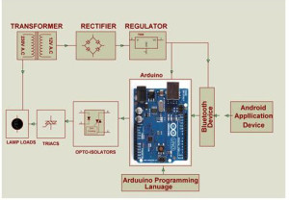](http://www.edgefx.in/wp-content/uploads/2014/07/arduino-board-home-automation.jpg)

**Fig 17:Arduino Based Home Automation**

In order to achieve this, a Bluetooth module is interfaced to the Arduino Uno board at the receiver end while on the transmitter end, a Graphical User Interface application on the cell phone sends ON/OFF commands to the receiver where loads are connected. By touching the identified location on the Graphical User Interface, lamps are used as loads in this project can be turned ON/OFF remotely by using this technology. The loads are operated by using Arduino Uno board through thyristors using triacs and OPTO-Isolators.

2.ARDUINO BASED AUTO INTENSITY CONTROL OF LIGHT

As the intensity is cannot be controlled by using High Intensity Discharge (HID) lamps power saving is not possible in [street lights](http://www.edgefx.in/requirements-for-solar-led-street-light-system-and-its-applications/) with these lamps as the density on roads is decreasing from peak hours of nights to early morning.

[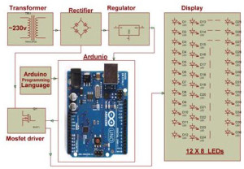](http://www.edgefx.in/wp-content/uploads/2014/07/arduino-based-auto-intensity-control.jpg)

**Fig 18:Arduino Based Auto Intensity Control**

Thus, this system overcomes this problem by [controlling the intensity of LED lights](http://www.edgefx.in/solar-based-solar-power-generation-projects-for-engineering-students/) on street by gradually reducing intensity by controlling the voltage applied to these lamps. This system uses arduino board to [produce PWM pulses](https://www.elprocus.com/pulse-width-modulation-pwm/) and it is programmed in such a way that it decreases the voltage applied to these lamps gradually till late nights and completely shutdowns at morning.

Thus, Arduino development board can sense the environment by receiving input from [different sensors](https://www.elprocus.com/sensors-types-applications/) and affects its surroundings by controlling motors, lights and other actuators. The microcontroller on the board is programmed using the Arduino programming language.

**CHAPTER 4**

**4.0 PROJECT CONSTRUCTION AND TESTING**

After getting all the hardware and software design done successfully it’s time for the project construction and testing. In this section of the report, details will be given on how the different hardware design gets implemented and tested. This section also talks about if there was any hidden problem within the software code that was important to troubleshoot and evacuate and to build the project successfully.

**4.1 CONSTRUCTION AND BLOCK DIAGRAM**

When the hardware design for all the schematics has been completed. It’s time to build the design on the Veroboard itself . The first thing done was to solder all the components on the Veroboard.It has to be done with great care, if the soldering goes wrong it’s hard to de-solder the components because de-soldering could damage the component and the copper tracks of the Veroboard. When soldering it has to be in mind that copper tracks on the Veroboard work horizontally, so this means all the components have to be soldered vertically on the board and if mistakenly two lines connect with each other then it is necessary to break the joint otherwise same voltage could flow on each line which ends up with a short circuit or the components will be damaged. An aluminium sheet was taken from the room and marked out according to the desired base calculations. Once the aluminium sheet marked out with all the necessary components on it. It’s time to drill the holes in it. 3mm drill was used to mount the Veroboard circuits on the aluminium base, 10 mm drill was used for power and ground headers and 11mm drill was used for circuit wires which goes through them under the aluminium sheet and then connect with Arduino.

The Arduino, motor and latch circuit(soil moisture sensor circuit) was mounted on the veroboard, on the top left of the sheet soil moisture sensor is mounted along with YL-69 sensor . On the top right, there was sensor circuit was placed which takes moisture and temp/humidity readings. reason for placing sensor circuit on the left because the sensor can take readings from plants/soil easily,On the right motor is connected which controls the flow of water. And then finally, the Laptop is connected externally to the arduino using USB type B(version 2.0) cable.

**BLOCK DIAGRAM**

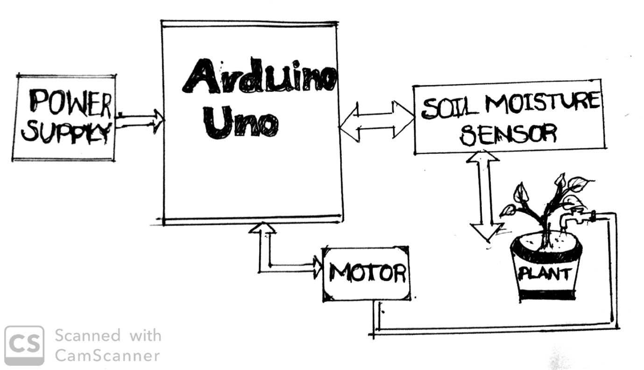

Figure 19:Block Diagram

For the project which is prepared by us,we have not provided any power supply to the arduino uno externally,the supply for arduino is taken from the personal computer using a connecting cable.

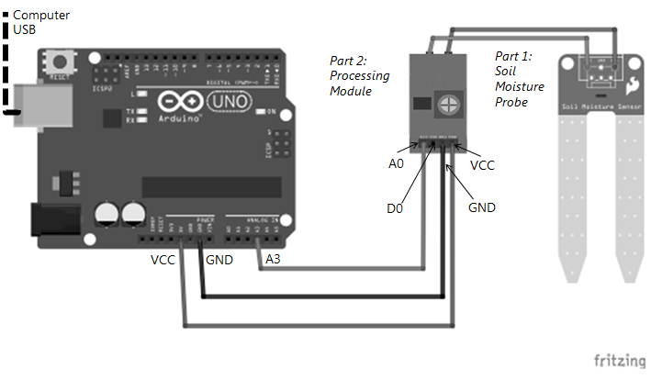

Figue 20:Connection Diagram

**4.2 TESTING**

Testing procedure acquires an important section of the project report because it plays a vital role in the development of the project. Testing of the hardware and software is important because it founds any issues which can be present in the hardware or in software and can damage the important components of the system. Once all the Veroboard design was built with care it’s time to test each individual Veroboard circuit.

The second test conducted was with the sensor circuit. In this test, samplecode was uploaded on the Arduino which prints the reading on the serial computer screen. This test included making sure that all the sensor on board is working properly and taking correct readings what they supposed to get. In order to test the readings from the sensor, another temperature and humidity sensor was introduced just to compare the measurements taken by both the sensors. readings from the sensor were close enough to say that the sensor was working properly. For the moisture sensor, it was clearly seen that all the sensor was working properly because they are taking the readings from the same pot and the readings taken by the sensor was close to each other.

**Software Testing:**

Software testing phase is also an important aspect of the project development. Software testing is a procedure of executing a program or application with the goal of finding the software bugs. It can likewise be expressed as the process of validating and verifying that a software program or application meet its technical requirement, works as accepted and can be executed with a similar trademark

**WORKING:**

Working of this **Automatic Plant Irrigation System** is quite simple. First of all, it is a **Completely Automated System**and there is no need of manpower to control the system. Arduino is used for controlling the whole process and GSM module is used for sending alert messages to user on his Cellphone if required.

  If moisture is present in soil then there is conduction between the two probes of Soil Moisture sensor and due to this conduction, transistor remains in triggered/on state and Arduino Pin D7 remains Low. When Arduino reads LOW signal at D7, Motor turned OFF” and water pump remains in Off state.

Now if there is no Moisture in soil then Transistor becomes Off and Pin D7 becomes High. Then Arduino reads the Pin D7 and turns On the water motor and Motor will automatically turn off when there is sufficient moisture in the soil. Further check the **Demonstration** for better understanding the project working process.

**4.3 RESULT**

As all the testing done with satisfactory result. Since there is no as such particular result that has to be documented. As the system works with moisture and sensor which takes reading according to the current room temperature and humidity. Readings from the moisture sensor in the circuit also depend on what the current moisture level is for the plant. Otherwise, overall result coming out from the circuit in terms of functionality was good for motivation.

**CHAPTER 5**

**5.0 SAFETY AND CONCLUSION**

**5.1 SAFETY**

Safety and ethical consideration are one of the important aspects of the project. Because engineers must keep this in mind that accidents can happen anywhere and with anyone. So, there is always a danger while doing this kind of project which includes heavy machinery. So, it is important for every engineer to keep this safety and ethical consideration in mind while working in the workshop or surrounded by heavy machinery which can cause severe damage. This chapter will go into the details about these safety considerations.

While doing such project safety is one of the important thing in terms of construction of the project. For instance, when drilling, safety glasses must be put on and safety guard must be used.Thisis because drillercanproduce a dustparticle whichcan gointhe eyes forthis reason safety glasses is important for drilling. When drilling always start from the small drills because using bigger drills straightaway can damage the thing which needs to be drill and can also cause lots of noise, the worst-case scenario is that drill can stick into the board and start spinning it along with itself which can cause severe injury to the person who is drilling. The last thing which needs to be taken care of is to make sure that the vacuum is always on during drilling if possible which can absorb the dust particle and prevents them to get stuck in the eyes.

Another most important safety consideration is extreme caution must be taken while soldering because soldering iron gets hot and can easily burn ones’ hand. When soldering makes sure the vacuum is on which absorbs all the harmful gasses from soldering. If possible, safety gloves must be always on when soldering. Make sure solder iron must be held from the top which prevents hands from burning and provides excellent quality soldering on the board.

When wire stripping makes sure it must be done gently and not to harm others by throwing the remains. When testing the LED and PCB boards, make sure the area is clean from striped wires that could cause short circuits.

**5.2 CONCLUSION**

In this section, all the problems which were occurred during the project and the problem which still exist in the system will also be reported. Starting from the initial problems which were caused early in the project was choosing right components for the system, the most important choice was to choose a microcontroller which can perform several tasks at once and keeps the entire system on track. For this reason, Arduino Uno was selected which basically works on *Harvard* *Architecture* which means that it has separate buses for data transfer and instruction fetches, therefore there is no delay for fetching and executing within the Arduino. It has an Atmega328p onboard chip which has 32kb of flash memory, 2 kb of SRAM, 1kb of EPROM and operates on 16Mhz clock speed. As Arduino fulfils all the requirements needed for the project. For this reason, Arduino was selected for this project.

**GSM (Global System for Mobile Communications, originally Group Spécial Mobile) module** is used for sending SMS to the user.So that the user gets message/remainder everytime on his/her mobile phone when the motor is turned ON/OFF.

**REFERENCES**

1. <http://www.discoversensors.ie/sensors/sensors_in_everyday_life>.

2.http://www.farnell.com/datasheets/2258678.pdf?_ga=2.131393803.544744636.15233007141174929237.1523300714&_gac=1.61922782.1523301015.Cj0KCQjwnqzWBRC_ARIsABSMVTOVbk.

3. <https://www.elprocus.com/arduino-basics-and-design/>.

4. <https://www.elprocus.com/wp-content/uploads/2013/08/Programming-Arduino.jpg>.

5. <http://www.circuitstoday.com/arduino-irrigation-plant-watering-using-soil-moisture-sensor>.

6. <https://randomnerdtutorials.com/guide-for-soil-moisture-sensor-yl-69-or-hl-69-with-the-arduino/>.

7. <https://www.edgefx.in/arduino-uno-board-tutorial-and-its-applications/>.

8. <https://www.elprocus.com/temperature-sensors-types-working-operation/>.

9. <https://www.efxkits.us/lm35-temperature-sensor-circuit-working/>.

10. <https://www.rapidonline.com/pdf/73-4443.pdf>.

11. <https://eeeproject.com/touch-sensor/touch-sensor-working/>.

11. <https://www.scribd.com/doc/69745445/Automatic-Plant-Irrigation-System>.

12. <https://www.rotronic.com/en/humidity_measurement-feuchtemessung-mesure_de_l_humidite/capacitive-sensors-technical-notes-mr>.