Credit Card Approval
Risk Prediction
Project Report: data analysis, modelling and evaluation
Dataset: Credit Card Approval Prediction (Kaggle, rikdifos)
Tools: Python, pandas, NumPy, scikit-learn, matplotlib

Contents
1. Executive Summary
2. Introduction
3. Data Description
4. Exploratory Data Analysis
5. Data Preparation
6. Feature Engineering and Preprocessing
7. Modelling
8. Evaluation and Results
9. Discussion
10. Limitations
11. Recommendations and Future Work
12. Conclusion
Appendix A. Notebook Workflow Summary

1. Executive Summary
This project builds and compares machine-learning classifiers that predict whether a credit card applicant is likely to become a credit risk, using only information supplied at the time of application. The applicant data (438,557 rows) is joined with monthly repayment records (1,048,575 rows) to create a labelled dataset of 36,457 applicants.
Target: an applicant is labelled a credit risk if they were 30 or more days overdue in any recorded month. About 11.6% of applicants meet this definition (5,350 of 45,985 in the credit record).
Method: 17 features (8 numerical, 9 categorical) are prepared with a shared scikit-learn preprocessing pipeline. Five models (Logistic Regression, KNN, Decision Tree, Random Forest, linear SVM) are trained on 80% of the data and evaluated on the remaining 20%, followed by 5-fold stratified cross-validation.
Main findings:
- Random Forest is the best overall model: test F1 of 0.425 and mean cross-validated F1 of about 0.398, with recall of 0.626 on the risk class.
- Decision Tree is a close second (F1 0.414) with the highest recall (0.649).
- KNN reaches the highest accuracy (0.878) but detects only 22.8% of risky applicants, so accuracy is a misleading metric for this problem.
- Logistic Regression and linear SVM perform poorly (F1 near 0.20), indicating non-linear relationships in the data.
- Overall predictive strength is modest. The results are a solid baseline, not a production-ready credit-scoring model.

2. Introduction

2.1 Background
Banks and card issuers must decide quickly whether to approve a credit card application. Approving an applicant who later falls behind on payments creates losses; rejecting a reliable applicant loses revenue. Data-driven risk scoring helps to make this decision consistently.

2.2 Problem Statement
Given demographic, financial and employment attributes of an applicant, predict whether the applicant will be a credit risk (a delinquent payer).

2.3 Objectives
- Explore and clean the application and credit-record datasets.
- Define a binary credit-risk target from repayment history.
- Engineer meaningful features and build a reusable preprocessing pipeline.
- Train and compare five classification algorithms.
- Evaluate the models using metrics suited to an imbalanced problem and identify the best one.

2.4 Scope
The project covers exploratory analysis, feature engineering, baseline modelling and evaluation in a single Jupyter notebook. Hyperparameter tuning, threshold optimisation, explainability and deployment are outside the current scope and are listed as future work.

3. Data Description

3.1 Source
The data comes from the Kaggle dataset "Credit Card Approval Prediction" (rikdifos), downloaded programmatically with the kagglehub library. It consists of two CSV files linked by the applicant identifier ID.
File | Rows | Columns | Content
application_record.csv | 438,557 | 18 | Applicant demographics, income, employment, housing and contact flags
credit_record.csv | 1,048,575 | 3 | Monthly repayment status per applicant (ID, MONTHS_BALANCE, STATUS)

3.2 Application Record Fields
Field | Description
ID | Unique applicant identifier (join key)
CODE_GENDER | Gender (M/F)
FLAG_OWN_CAR / FLAG_OWN_REALTY | Owns a car / real estate (Y/N)
CNT_CHILDREN, CNT_FAM_MEMBERS | Number of children and family members
AMT_INCOME_TOTAL | Annual income
NAME_INCOME_TYPE | Working, Commercial associate, Pensioner, State servant, Student
NAME_EDUCATION_TYPE | Five education levels, from Lower secondary to Academic degree
NAME_FAMILY_STATUS | Married, Single / not married, Civil marriage, Separated, Widow
NAME_HOUSING_TYPE | House / apartment, With parents, Municipal, Rented, Office, Co-op apartment
DAYS_BIRTH | Days before the application date (negative number)
DAYS_EMPLOYED | Days employed (negative); 365243 marks no current employment
FLAG_MOBIL, FLAG_WORK_PHONE, FLAG_PHONE, FLAG_EMAIL | Contact availability flags (0/1)
OCCUPATION_TYPE | Occupation category (18 types, many missing)

3.3 Credit Record Fields
Field | Description
ID | Applicant identifier
MONTHS_BALANCE | Month of the record relative to extraction month (0 = current, -1 = previous, down to -60)
STATUS | C paid off; X no loan; 0 = 1-29 days past due; 1 = 30-59; 2 = 60-89; 3 = 90-119; 4 = 90-119 (severe); 5 = 120+ days past due

4. Exploratory Data Analysis

4.1 Data Quality
- Both files were checked with shape, info, describe, null counts and duplicate counts.
- Application data: no exact duplicate rows; the only column with missing values is OCCUPATION_TYPE (134,203 missing, about 30.6%).
- Credit record: no missing values and no duplicate rows; 45,985 unique applicants.
- FLAG_MOBIL equals 1 for all 438,557 applicants, so it carries no information.

4.2 Applicant Profile
After deriving age and years of employment, the average applicant is about 43 years old (range 20 to 69) with about 5.5 years of employment (median 4). Median annual income is about 160,781 and the mean about 187,524, indicating a right-skewed income distribution with a maximum of 6,750,000.
Attribute | Most common category | Count
Income type | Working | 226,104
Education | Secondary / secondary special | 301,821
Family status | Married | 299,828
Housing | House / apartment | 393,831
Children | 0 children | 304,071
Employment status | employed (329,600) vs unemployed (108,957) | -

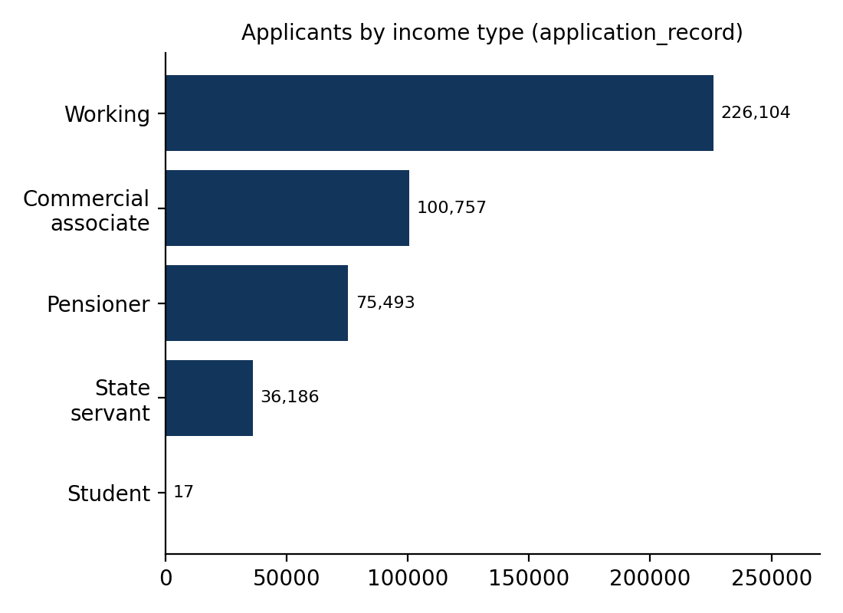
Figure 1. Applicants by income type (application_record)
Contact flags show that most applicants have no work phone (348,156 of 438,557), no email (391,102) and about 71% have no phone number recorded; these flags therefore have limited coverage.

4.3 Repayment History
Across all 1,048,575 monthly records, the most frequent statuses are C (442,031), 0 (383,120) and X (209,230). Serious delinquencies are rare: status 1 appears 11,090 times and statuses 2 to 5 together only 3,104 times.
STATUS | Meaning | Monthly records
C | Paid off | 442,031
0 | 1-29 days past due | 383,120
X | No loan that month | 209,230
1 | 30-59 days past due | 11,090
5 | 120+ days past due | 1,693
2 | 60-89 days past due | 868
3 | 90-119 days past due | 320
4 | 90-119 days past due (severe) | 223

5. Data Preparation

5.1 Cleaning Steps
- Age: AGE = -DAYS_BIRTH / 365, converted to integer years.
- Years employed: YEARS_EMPLOYED = |DAYS_EMPLOYED| / 365. The value 365243 is an encoded placeholder for people without a current job and was replaced with 0.
- Employment status: EMPLOYMENT_STATUS = 'employed' when YEARS_EMPLOYED is above 0, otherwise 'unemployed'.
- Occupation: missing OCCUPATION_TYPE values were filled with the category 'Unknown', preserving the information that occupation was not reported.

5.2 Building the Target Variable
The credit record has many rows per applicant, so it was aggregated to one row per ID. A month is flagged risky when STATUS is 1, 2, 3, 4 or 5 (30 or more days overdue). An applicant is labelled CREDIT_RISK = 1 if at least one month is flagged.
CREDIT_RISK | Applicants | Share
0 (no risk) | 40,635 | 88.4%
1 (risk) | 5,350 | 11.6%
Total | 45,985 | 100%

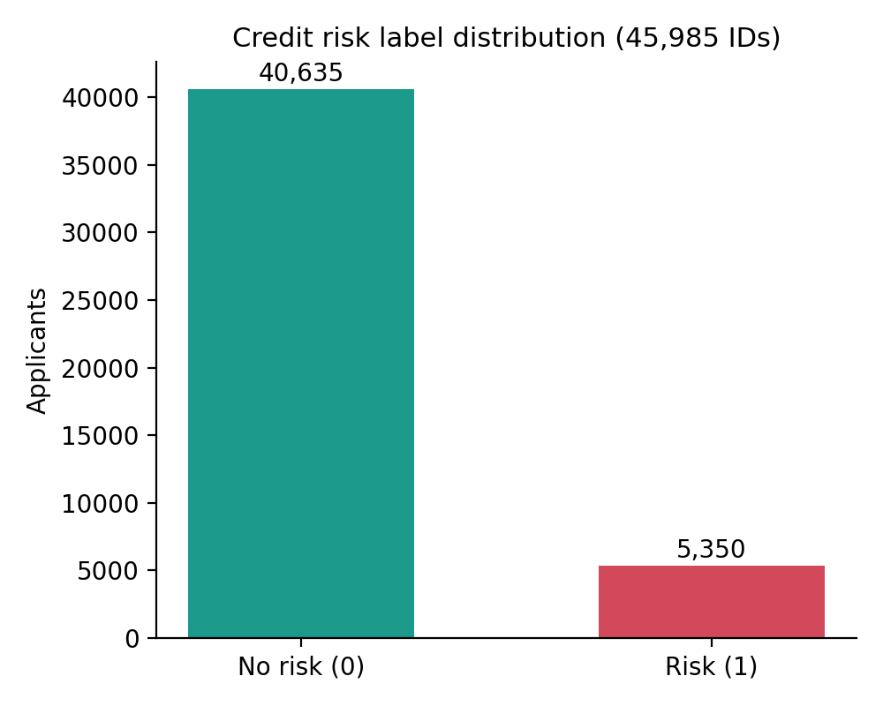
Figure 2. Distribution of the credit-risk label

5.3 Merging the Datasets
The application data was inner-joined to the risk labels on ID. Only 36,457 of the 438,557 applicants have a credit history, so the modelling dataset has 36,457 rows with no duplicate IDs.

5.4 Columns Removed
ID (identifier only), DAYS_BIRTH and DAYS_EMPLOYED (replaced by AGE and YEARS_EMPLOYED) and FLAG_MOBIL (constant) were dropped, leaving 17 predictors plus the target.

6. Feature Engineering and Preprocessing

6.1 Final Feature Set
Type | Features
Numerical (8) | CNT_CHILDREN, AMT_INCOME_TOTAL, FLAG_WORK_PHONE, FLAG_PHONE, FLAG_EMAIL, CNT_FAM_MEMBERS, AGE, YEARS_EMPLOYED
Categorical (9) | CODE_GENDER, FLAG_OWN_CAR, FLAG_OWN_REALTY, NAME_INCOME_TYPE, NAME_EDUCATION_TYPE, NAME_FAMILY_STATUS, NAME_HOUSING_TYPE, OCCUPATION_TYPE, EMPLOYMENT_STATUS

6.2 Train/Test Split
The data was split 80/20 using train_test_split with random_state=42 and stratify on the target, so both parts keep the same proportion of risky applicants.
Split | Rows | Risk cases (test)
Training | 29,165 | -
Test | 7,292 | 858 (11.8%)
Total | 36,457 | -

6.3 Preprocessing Pipeline
A ColumnTransformer scales the numerical columns with StandardScaler and encodes the categorical columns with OneHotEncoder (handle_unknown='ignore', dense output). Each model is wrapped together with this transformer in a scikit-learn Pipeline, so the scaler and encoder learn their parameters from training data only, which prevents data leakage into the test set.

7. Modelling
Five classifiers were trained on identical features and the same split. The risk class is far smaller than the no-risk class, so class_weight='balanced' was used wherever the algorithm supports it (KNN does not).
Model | Settings | Rationale
Logistic Regression | max_iter=1000, balanced weights | Simple, interpretable linear baseline
K-Nearest Neighbors | n_neighbors=5 | Distance-based, non-parametric comparison
Decision Tree | random_state=42, balanced weights | Captures non-linear rules and interactions
Random Forest | 200 trees, balanced weights, random_state=42 | Ensemble of trees; reduces variance
SVM | linear kernel, balanced weights | Maximum-margin linear classifier

8. Evaluation and Results

8.1 Evaluation Metrics
Because only about 12% of applicants are risky, plain accuracy is not sufficient: a model that always predicts 'no risk' would score about 88%. Precision, recall and F1 are therefore reported with Risk as the positive class.
- Precision: of applicants flagged as risky, the share that truly are.
- Recall: of truly risky applicants, the share the model catches.
- F1: harmonic mean of precision and recall; used to rank models.

8.2 Test-Set Performance
Model | Accuracy | Precision | Recall | F1
Logistic Regression | 0.574 | 0.135 | 0.486 | 0.212
KNN | 0.878 | 0.462 | 0.228 | 0.306
Decision Tree | 0.783 | 0.303 | 0.649 | 0.414
Random Forest | 0.800 | 0.321 | 0.626 | 0.425
SVM | 0.614 | 0.132 | 0.411 | 0.200

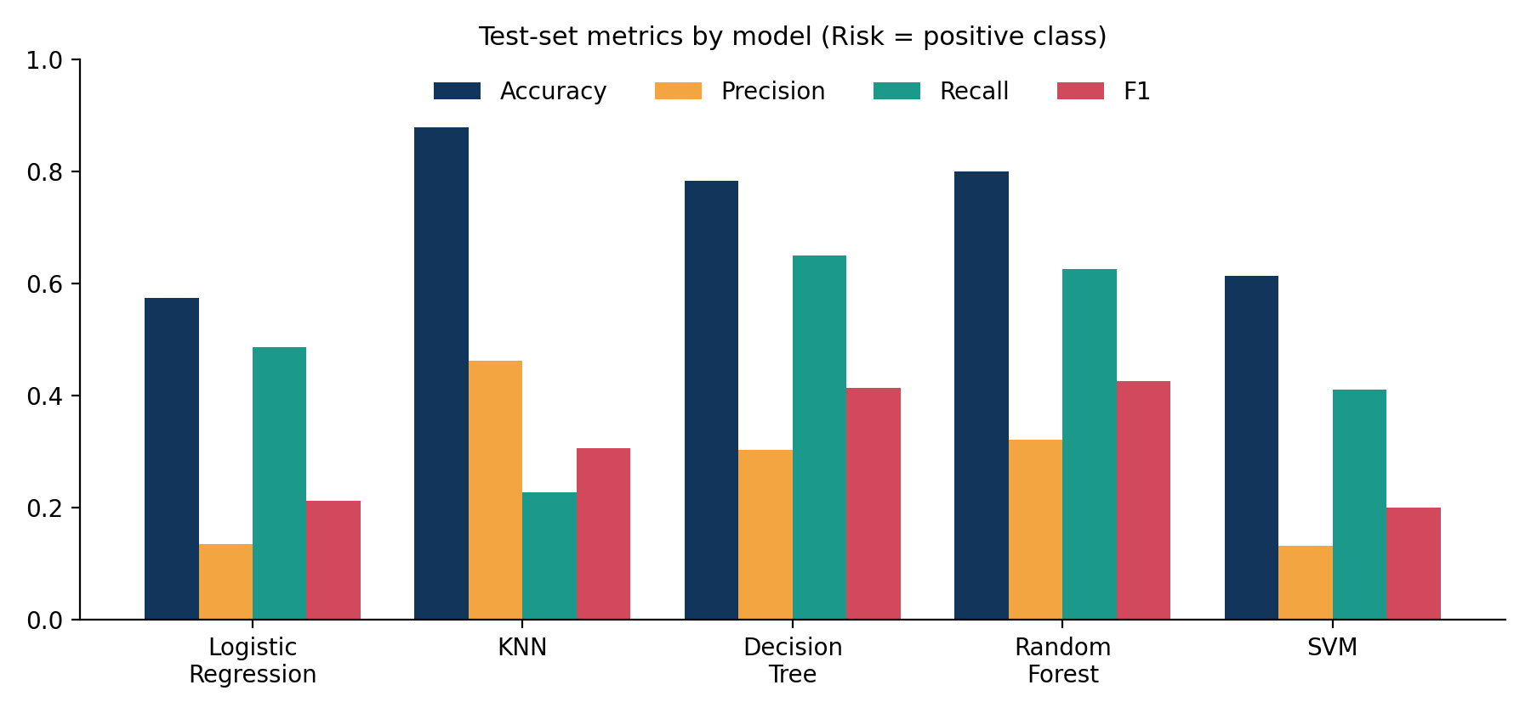
Figure 3. Test-set metrics by model

8.3 Confusion Matrices
The matrices below show actual classes in rows and predicted classes in columns for the 7,292 test applicants.
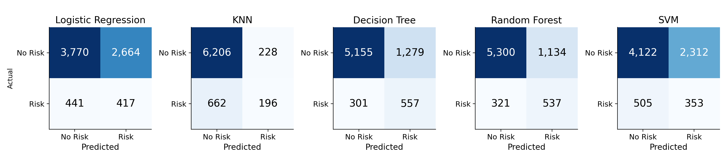
Figure 4. Confusion matrices for all five models
Model | True neg. | False pos. | False neg. | True pos.
Logistic Regression | 3,770 | 2,664 | 441 | 417
KNN | 6,206 | 228 | 662 | 196
Decision Tree | 5,155 | 1,279 | 301 | 557
Random Forest | 5,300 | 1,134 | 321 | 537
SVM | 4,122 | 2,312 | 505 | 353

Note: the notebook printed a confusion matrix for Logistic Regression and KNN using a stale prediction variable. The correct KNN matrix is the one shown above; the Logistic Regression matrix was reconstructed from its reported precision, recall and accuracy, which it reproduces exactly (accuracy 0.574).

8.4 Cross-Validation
To check stability, each pipeline was evaluated with 5-fold stratified cross-validation (shuffle, random_state=42) on the training data, scoring F1.
Model | Fold 1 | Fold 2 | Fold 3 | Fold 4 | Fold 5 | Mean
Logistic Regression | 0.194 | 0.221 | 0.212 | 0.205 | 0.207 | 0.208
KNN | 0.242 | 0.266 | 0.244 | 0.220 | 0.247 | 0.244
Decision Tree | 0.391 | 0.375 | 0.399 | 0.388 | 0.392 | 0.389
Random Forest | 0.406 | 0.385 | 0.407 | 0.397 | 0.401 | 0.398
SVM | 0.190 | 0.209 | 0.212 | 0.196 | 0.191 | 0.200

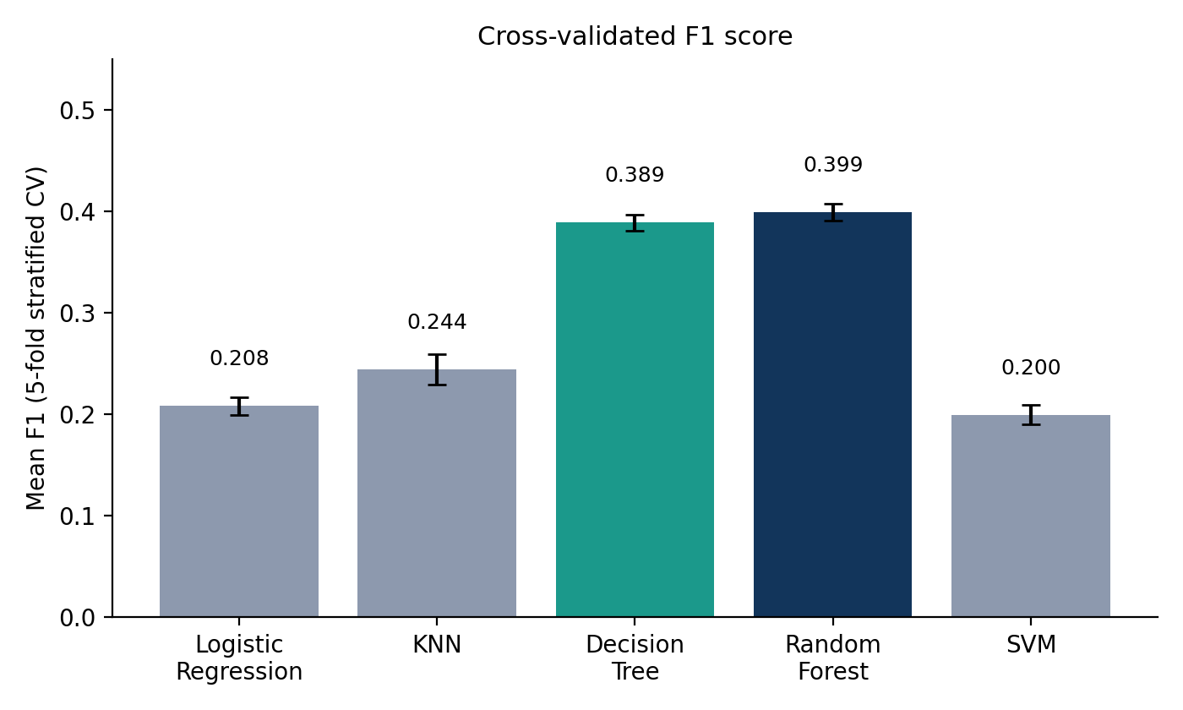
Figure 5. Mean cross-validated F1 with standard deviation

9. Discussion
- Best model: Random Forest ranks first on test F1 (0.425) and cross-validated F1 (0.398), and its fold scores vary only between 0.385 and 0.407, so the ranking is stable.
- Recall versus precision: tree-based models catch roughly 63-65% of risky applicants but with precision near 0.30-0.32, meaning about two of three alerts are false alarms. The right balance depends on the relative cost of a default versus a lost customer.
- KNN's accuracy: its 0.878 accuracy comes from rarely predicting risk (196 true positives, 228 false positives). It also lacks class weighting.
- Linear models: Logistic Regression and linear SVM reach only about 0.20 F1, suggesting risk depends on non-linear combinations of features.
- Limited signal: even the best model has moderate performance, which suggests application-time demographics explain only part of later repayment behaviour.

10. Limitations
- Label definition is strict and simple: any single 30+ day delay marks the applicant as risky, regardless of severity, timing or later repayment.
- Only 36,457 of 438,557 applicants have credit history, so the model is trained on a subset that may not represent all applicants.
- Class imbalance (about 12% positives); predictions use default decision thresholds and probabilities are not calibrated.
- No hyperparameter tuning was performed; models use near-default settings.
- The 365243 employment placeholder is mapped to 0 years and 'unemployed', which also covers pensioners.
- Gender and age are used as predictors; fairness and regulatory requirements must be reviewed before any real-world use.
- Notebook hygiene: hard-coded local file paths, stale variable in two confusion-matrix cells, trailing empty cells and no visualisations inside the notebook.

11. Recommendations and Future Work
- Tune Random Forest hyperparameters with GridSearchCV or RandomizedSearchCV and test gradient boosting (XGBoost, LightGBM).
- Address imbalance further with SMOTE or by selecting a decision threshold from business costs; report precision-recall curves and PR-AUC.
- Engineer richer features from the credit record: number of delinquent months, worst status, months on book, recency of delinquency.
- Add feature-importance and SHAP analysis to explain individual decisions.
- Perform a fairness audit on gender and age, and consider removing sensitive attributes.
- Save the trained pipeline with joblib and expose it via an API or Streamlit app; parameterise the data paths.

12. Conclusion
The project shows an end-to-end workflow from raw Kaggle data to a compared set of credit-risk classifiers. A Random Forest trained on 17 application features detects about 63% of risky applicants at 0.32 precision (F1 0.425), the best trade-off among the five models tested. Accuracy alone would have wrongly favoured KNN. The results form a sound baseline; improved labels, tuning, threshold selection and a fairness review are the recommended steps toward a deployable scoring model.

Appendix A. Notebook Workflow Summary
Step | Stage | What the notebook does
1 | Setup | Imports pandas, NumPy, matplotlib; downloads data with kagglehub
2 | Inspect application data | shape, columns, info, null counts, describe, duplicates
3 | Feature creation | AGE, YEARS_EMPLOYED, EMPLOYMENT_STATUS; fill OCCUPATION_TYPE
4 | Category profiling | value_counts for occupation, income, education, family, housing, flags, children
5 | Inspect credit record | shape, info, nulls, describe, duplicates, STATUS counts, unique IDs
6 | Target creation | RISK flag per month, max per ID gives CREDIT_RISK
7 | Merge and clean | Inner join on ID; drop ID, DAYS_BIRTH, DAYS_EMPLOYED, FLAG_MOBIL
8 | Split | Stratified 80/20 split
9 | Preprocessing | ColumnTransformer with StandardScaler and OneHotEncoder
10 | Modelling | Logistic Regression, KNN, Decision Tree, Random Forest, SVM pipelines
11 | Evaluation | Classification reports, confusion matrices, summary metrics table
12 | Cross-validation | 5-fold stratified CV with F1 scoring for all models

