RONDO Fluted Trays are packaging devices consisting of a fluted tray with compartments, which hold and cushion inserted articles by a spring clip action. A wide range of products can be separated and held firmly in place with this unique process.  The inserted object is secured by the restricted, though flexible, opening of the flute. The spaces between and beneath the flutes act as protective features. | 
TRAY BENEFITS:
- No tooling charges.
- Multivariable partitioning - made to hold a product of any size or a combination of (3) three different sizes within one tray.
- Any Styrofoam, plastic or thermoform tray can be replaced with our paperboard trays
- Sufficient Strength – Retains items safely during shipping
- Bio-degradable – Will not contaminate the environment
- Tamper-proof designs
- Re-collapsible
- Trays made to display your product
- Multi-color printing available for inner and outer panels
- Insertion of products in house
- Prompt delivery
- Over 55 styles available
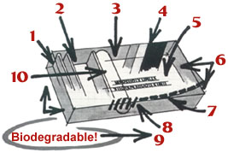 | 1. Printed on all outer surfaces if required. Adds information exposure.  2. Multivariable Partitioning! Mr. Smith wants to pack square items too.  3. Product Insertion from Above! Gravity works better.  4. Outer Cover Printed Multicolor! Appearance sells the package and products in it!  5. Information Printed on Inside Cover! Leaflets can be misplaced.  6. Numerous Sizes - Without Additional Tooling Costs! Tooling costs are the standard for most competitor's packs.  7. Tamper Proof Closure! Correct contents are assured.  8. Reclosable! Not every item is used at once.
9. Automatic Manufacturing without Scrap! Insertion of products inhouse offering cost savings.
10. Sufficient Strengh! Retains items safely during shipping. Products arrive intact.

Of crucial importance in the overall context of the RONDO concept is the fact that the approach to packaging is readily adaptable to the full range of automation – from semi-automatic to complete, automated operations. While this capability does not rule out the use of RONDO packaging materials in manual packing situations, the value of this technique progressively increases with the level of automation.  The inherent capabilities of RONDO packaging systems are fully realized in the close, working relationship between the company’s technical team and customer personnel. This collaboration is made considerably more effective and valuable by the fact that the machines used to achieve packaging automation are designed and built in RONDO’s own factory. | 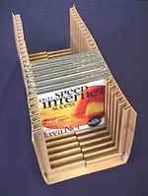

TUBES
CCL is the only North American manufacturer of a full range of metal, and laminate tubes along with a host of complimentary closures including tamper-evident designs. Accordingly, CCL can provide you with the tube and closure that works best for your precise product requirements. Our advanced tube making facilities are complimented by in-house cap making and auxiliary process capabilities. CCL can offer you the complete package of tubes, caps, hot stamping and other processes. CCL Container, long known as the industry's service leader, today offers you expanded marketing dimensions through innovation and leading edge technology.

