
INTERNSHIP REPORT
Distributor Survey, Retailer Onboarding & Multi-Brand Analysis
A Study of North Delhi Retail & Distribution Networks
Submitted by: Neeru
Project Track: Distributor Survey / Retailer Onboarding
Duration: 8 Weeks (08-Jun-2026 to 02-Aug-2026)
Areas Covered: Mukherjee Nagar, GTB Nagar, Gandhi Vihar, Indra Vihar
Submitted to: NextG Apex India Pvt. Ltd., Navi Mumbai
Reporting Cadence: Weekly status update

Certificate
This is to certify that Neeru has completed an 8-week internship on the project "Distributor Survey, Retailer Onboarding & Multi-Brand Analysis" during the period 08-June-2026 to 02-August-2026.
During this period, the intern demonstrated sincerity, discipline, and a strong willingness to learn and completed all assigned deliverables, including field surveys, data analysis, and Power BI dashboard development to the satisfaction of the organization.

[Organization Letterhead / Seal]

Signatory | Name | Signature | Date
Mentor / Reporting Manager
Project Sponsor
Academic Supervisor / University Coordinator

Acknowledgement
I would like to express my sincere gratitude to my mentor and reporting manager for their continuous guidance and support throughout this 8-week internship. Their feedback during weekly status updates helped me refine the survey design, correct gaps in the data-collection process, and improve the structure of the Power BI dashboards.
I am also thankful to the distributors and retailers across Mukherjee Nagar, GTB Nagar, Gandhi Vihar, and Indra Vihar who took the time to respond to the survey despite their busy schedules. Their willingness to share operational details, even while withholding sensitive financial information, made this study possible.
I would like to thank the university for providing this internship opportunity as part of the academic curriculum, and my peers who supported the field data-collection effort during the survey rollout phase.
This internship has been a valuable learning experience, giving me practical exposure to FMCG distribution structures, retail data collection, and business intelligence tools that I would not have gained through classroom learning alone.

Executive Summary
This report presents the work carried out during an 8-week internship on distributor survey, retailer onboarding, and multi-brand analysis, conducted in four localities of North Delhi: Mukherjee Nagar, GTB Nagar, Gandhi Vihar, and Indra Vihar. The project was designed to help the sponsoring organization understand the structure of local retail and distribution networks, and to build a repeatable process for onboarding new retailers and evaluating multi-brand expansion opportunities.
The internship combined primary field research with dashboard-based analysis. Structured questionnaires were designed and piloted for two respondent groups: retailers and distributors, covering store type, location, brand and product availability, retail potential, customer footfall on the retailer side, and staffing, delivery capacity, area coverage, cold storage, demand patterns, and expansion potential on the distributor side. Data was collected through in-person visits across the four target localities and subsequently cleaned, structured, and loaded into two Power BI dashboards.
The Retailer Onboarding Dashboard consists of four pages: Executive Dashboard, Product & Brand Analysis, Retailer Analysis & Market Coverage, and Key Insights & Recommendations, and gives a locality-wise view of retailer density, store type mix, brand and product-category availability, and retail potential. The Distributor Survey Dashboard consists of three pages: Distributor Overview, Market Intelligence & Business Insights, and Operational Analysis, and captures distributor scale (retailers served, employees, delivery vehicles, area covered), demand patterns by category, brand strength, onboarding challenges, and expansion potential.
One limitation is flagged upfront: distributors were unwilling to disclose financial information such as revenue, margins, investment, or ROI, treating these as confidential. In line with the scope agreed with the organization, no financial figures have been estimated or inferred anywhere in this report; wherever such data would ordinarily appear, this is explicitly noted as unavailable.
Based on the survey findings and dashboard analysis, the report proposes a retailer onboarding framework and a set of multi-brand expansion recommendations, along with a discussion of the study’s limitations, learnings, and scope for future work. Detailed figures referenced throughout the report (dashboard screenshots, chart values) are marked with placeholders where the actual visual needs to be inserted from the live Power BI files submitted alongside this report.

Table of Contents
Certificate 3
Acknowledgement 4
Executive Summary 5
Table of Contents 6
1. Company Profile 9
2. Industry Overview 10
3. Project Background 11
4. Problem Statement 12
5. Need for Study 13
6. Objectives 14
7. Scope of Work 15
8. Research Methodology 16
8.1 Survey Design 16
8.2 Sampling 16
8.3 Data Collection Process 16
9. Retailer Survey Analysis 18
9.1 Store Type Distribution 18
9.2 Locality-wise Retailer Coverage 18
9.3 Retail Potential and Customer Footfall 18
9.4 Brand and Product Availability at Retailer Level 18
10. Distributor Survey Analysis 20
10.1 Distributor Scale and Operational Capacity 20
10.2 Cold Storage Availability 20
10.3 Category-level Demand and Growth 20
10.4 Brand Strength and Expansion Potential 20
10.5 Onboarding Challenges and Retailer Visit Frequency 21
11. Power BI Dashboard Development 22
11.1 Dashboard Design Approach 22
11.2 Retailer Onboarding Dashboard 22
11.3 Distributor Survey Dashboard 23
12. Business Insights 25
12.1 Retail Landscape 25
12.2 Product and Brand Landscape 25
12.3 Retailer Opportunities 25
12.4 Distributor-side Insights 25
13. Key Findings 26
13.1 Market Insights 26
13.2 Product & Brand Insights 26
13.3 Retailer Opportunities 26
13.4 Distributor-side Findings 26
14. Recommendations 28
15. Retailer Onboarding Framework 29
15.1 Stage 1 – Locality and Store Screening 29
15.2 Stage 2 – Retailer Evaluation 29
15.3 Stage 3 – Distributor Matching 29
15.4 Stage 4 – Onboarding and Review 29
16. Multi-brand Expansion Strategy 31
17. Limitations 32
18. Future Scope 33
19. Learning Outcomes 34
20. Conclusion 35
21. References 36
22. Annexure 37
22.1 Retailer Questionnaire 37
22.2 Distributor Questionnaire 37
22.3 Dashboard Screenshots 38

1. Company Profile
NextG Apex India Pvt. Ltd., Navi Mumbai, is engaged in the FMCG sector, working with a network of distributors and retailers to reach end consumers across urban markets. The organization sponsored this internship to gain a ground-level understanding of how its products and competing brands move through local distribution and retail channels in North Delhi.
As specific organizational details (year of establishment, product portfolio, turnover, employee strength, and head office location) were not shared as part of the internship brief, these are left as placeholders below rather than assumed:
Particular | Detail
Company Name | NextG Apex India Pvt. Ltd., Navi Mumbai
Nature of Business | FMCG – Distribution & Retail
Year of Establishment | Not available
Head Office
  Navi Mumbai, Maharashtra
Product Categories
  Breakfast Cereals, Peanut Butter, Rice, Pulses, Beverages and FMCG Products
Market Presence | Maharashtra and Other Distribution Markets

For the purpose of this internship, the organization’s primary interest was in the North Delhi micro-market, where it wished to evaluate the existing distributor network, assess retailer readiness for onboarding, and identify opportunities for expanding brand presence across categories.

2. Industry Overview
The Indian FMCG sector operates through a layered distribution structure in which brands typically reach consumers via super-stockists or distributors, who in turn service a base of retail outlets ranging from small Kirana (neighborhood) stores to organized mini-supermarkets. In dense urban markets such as North Delhi, this structure is particularly fragmented: a single locality can be served by multiple distributors, and retail outlets vary widely in size, product range, and customer footfall.
Kirana stores continue to account for a large share of FMCG retail in India because of their proximity to consumers, flexible credit arrangements with local distributors, and ability to stock fast-moving items in small quantities. Small supermarkets, while fewer in number, tend to carry a wider assortment and more organized shelf space, making them attractive for brands seeking visibility across multiple product categories.
From a distributor’s perspective, profitability in this environment depends on factors such as the number of retailers served, delivery reach (vehicles and area covered), category mix, and the strength of relationships with retailers. Distributors are also the primary gatekeepers for onboarding new retailers and introducing new brands into a territory, which is why this study places distributor-side data collection at the center of the retailer onboarding and multi-brand expansion exercise.
This internship’s field observations are limited to four localities in North Delhi – Mukherjee Nagar, GTB Nagar, Gandhi Vihar, and Indra Vihar – and should be read as a micro-market study rather than a representation of the broader FMCG industry.

3. Project Background
The project was assigned as an 8-week internship track titled "Distributor Survey / Retailer Onboarding & Multi-Brand Analysis," running from 08-June-2026 to 02-August-2026, with weekly status updates as the agreed reporting cadence. The internship plan laid out a week-by-week execution schedule covering objective definition, questionnaire design, a pilot survey, full field rollout, data analysis, dashboard development, framework design, and final reporting.
The underlying business need was to build a structured, repeatable way to understand local retail and distribution networks before committing resources to onboarding new retailers or pushing additional brands into a territory. Rather than relying on informal, anecdotal knowledge of a market, the organization wanted a survey-backed, dashboard-supported view of outlet categories, distributor capacity, and category-level demand and growth patterns.
North Delhi was chosen as the pilot geography, with Mukherjee Nagar, GTB Nagar, Gandhi Vihar, and Indra Vihar selected as the four target localities for field coverage. These areas offered a mix of dense Kirana clusters and a smaller number of organized outlets, making them a reasonable testbed for the retailer onboarding and multi-brand expansion questions this project set out to answer.

4. Problem Statement
Before this project, the organization lacked a structured, up-to-date view of the retailers and distributors operating in Mukherjee Nagar, GTB Nagar, Gandhi Vihar, and Indra Vihar. Without this, decisions on which retailers to go onboard, which localities to prioritize, and which brands or categories to push in each area were difficult to make on an objective basis.
Specifically, the organization lacked answers to questions such as which store types and localities have the greatest concentration of retail outlets; which brands and product categories already have strong shelf presence versus which are under-represented; which distributors have the scale (in terms of retailers served, staff, and delivery capacity) to support new retailer onboarding or additional brand lines; and what operational challenges distributors face when onboarding new retailers.
This project sets out to close that gap by running a structured survey of both retailers and distributors, and by converting the resulting data into two interactive Power BI dashboards that the organization can use to guide onboarding and expansion decisions going forward.

5. Need for Study
- Local FMCG retail and distribution networks change frequently: new outlets open, existing ones change store type or brand mix, and distributor capacity shifts, so a one-time or outdated view of the market is not reliable for onboarding decisions.
- Retailer onboarding without a clear framework can lead to inconsistent selection criteria, with some high-potential outlets overlooked and others onboarded without sufficient brand or product fit.
- Multi-brand expansion decisions made without category-level demand data risk pushing brands into categories that are already saturated, or missing categories with genuine unmet demand.
- Distributors are the primary channel partners for onboarding and expansion, so understanding their operational capacity (retailers served, delivery reach, cold storage, staffing) is a prerequisite for realistic planning.
- A dashboard-based approach allows the organization to revisit and filter the data by locality, store type, or category as needed, rather than relying on a static, one-time report.

6. Objectives
- To design and pilot a structured survey instrument for both retailers and distributors in the target localities.
- To collect field data on outlet categories, store type, brand and product availability, retail potential, and customer footfall from retailers.
- To collect field data on distributor scale, operational capacity, category-level demand and growth patterns, brand strength, onboarding challenges, and expansion potential from distributors.
- To clean, structure, and analyze the collected data to identify patterns across localities, store types, and product categories.
- To build two Power BI dashboards: a Retailer Onboarding Dashboard and a Distributor Survey Dashboard that present these findings in an interactive, filterable format.
- To translate the survey and dashboard findings into a practical retailer onboarding framework and a set of multi-brand expansion recommendations.

7. Scope of Work
The scope of this internship, as agreed at the outset, covered the following areas:
- Collection of distributor and retailer information through structured, in-person surveys across Mukherjee Nagar, GTB Nagar, Gandhi Vihar, and Indra Vihar.
- Mapping of outlet categories, store type, brand and product availability, and competitor presence at the retailer level.
- Mapping of distributor scale, delivery capacity, category-level demand, and market intelligence at the distributor level.
- Design of a retailer onboarding workflow based on survey findings.
- Recommendation of multi-brand expansion opportunities based on category-level demand and brand-presence data.
- Development of two Power BI dashboards to present retailer- and distributor-side findings.
Explicitly out of scope: any collection, estimation, or calculation of distributor financial data such as revenue, margins, investment, or ROI. As detailed in Chapter 19 (Limitations), distributors treated this information as confidential and declined to share it, and no attempt has been made anywhere in this report to infer or approximate these figures.

8. Research Methodology

8.1 Survey Design
Two separate structured questionnaires were designed, one for retailers and one for distributors based on the information needs identified in the Problem Statement and Objectives. The retailer questionnaire focused on outlet-level attributes: store type, location (area/locality), brand availability, product availability by category, an assessed retail potential rating, and observed customer footfall. The distributor questionnaire focused on operational and market-intelligence attributes: number of retailers served, number of employees, number of delivery vehicles, geographical area covered, availability of cold storage, category with the highest current demand, category growing fastest, brands with the strongest market presence, visit frequency to retailers, categories with the highest expansion potential, and the main challenges faced in onboarding new retailers.
Both questionnaires used a mix of closed-ended (categorical and numeric) questions to allow consistent aggregation across respondents, and a small number of open-ended prompts to capture qualitative context such as business challenges. The full question sets are reproduced in the Annexure.

8.2 Sampling
A purposive, area-based sampling approach was used rather than random sampling, given the field nature of the exercise. Respondents were selected by physically visiting retail outlets and distributor offices/warehouses across the four target localities, aiming for reasonable coverage of different store types (Kirana stores and small supermarkets) and, on the distributor side, different scales of operation. The exact sample size achieved (number of retailers and number of distributors surveyed) should be reported here from the final cleaned dataset: 27 retailers and 6 distributors.
As this was a localized, non-probability sample confined to four specific localities, findings should be read as indicative of these micro-markets rather than as statistically representative of North Delhi or the broader city.

8.3 Data Collection Process
Data collection followed the phased approach set out in the 8-week execution plan: the questionnaire and a mobile data-collection form were designed in Week 2, piloted in one area in Week 3 to identify and correct ambiguous questions, and then rolled out across all four target localities in Week 4. Field visits were conducted in person, with responses recorded directly on the mobile form to reduce transcription errors and speed up downstream cleaning.
Following the pilot, minor refinements were made to question wording and response categories (for example, standardizing store-type and product-category labels) to ensure that responses could be aggregated consistently once the full dataset was compiled.

9. Retailer Survey Analysis
The retailer survey captured the following fields for each outlet visited: store type, area/locality, brand availability, product availability by category, an assessed retail potential rating, and customer footfall. These fields feed directly into the Retailer Onboarding Dashboard described in Chapter 11.

9.1 Store Type Distribution
Retail outlets across the four localities were classified into store types, primarily Kirana stores and small supermarkets, consistent with the general market structure described in Chapter 2. The relative share of each store type by count is shown in the "Store Type Distribution" donut chart on the Executive Dashboard page.
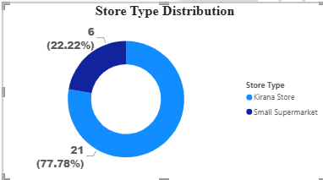

9.2 Locality-wise Retailer Coverage
The number of retailers surveyed in each locality is charted in "Retailers by Area" on the Executive Dashboard and again in "Retailer Coverage by Area" on the Retailer Analysis & Market Coverage page. This gives a direct read on where retailer density and therefore onboarding opportunity is concentrated among Mukherjee Nagar, GTB Nagar, Gandhi Vihar, and Indra Vihar.
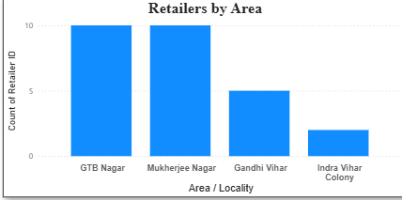

9.3 Retail Potential and Customer Footfall
Each outlet was assigned a retail potential rating at the time of the survey, and a "High Potential Stores" count is tracked as a headline card on the Executive Dashboard. Customer footfall was recorded qualitatively per outlet and is available as a filter (slicer) alongside store type and locality, so the organization can narrow the view to, for example, high-footfall Kirana stores in a specific locality.
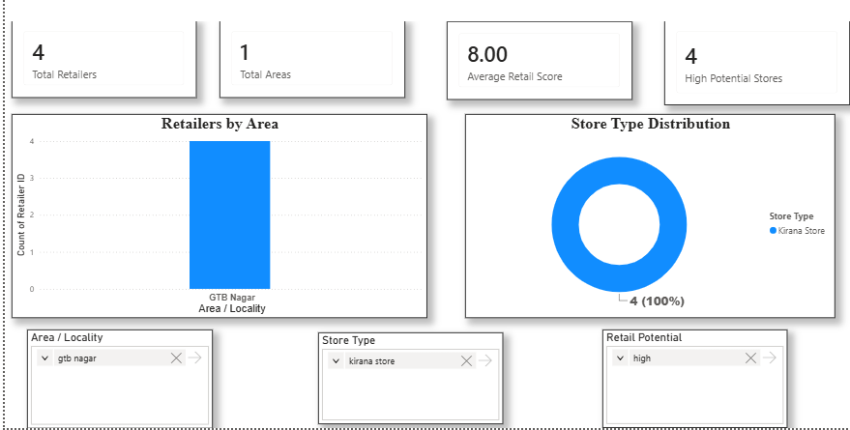

9.4 Brand and Product Availability at Retailer Level
For each retailer, the survey recorded which brands were stocked and which product categories were available. This was aggregated in the "Brand Availability Across Retailers" and "Stores Stocking Each Product Category" charts on the Product & Brand Analysis page, and further broken down per retailer in the "Retailer-wise Brand Portfolio" table on the Retailer Analysis & Market Coverage page.
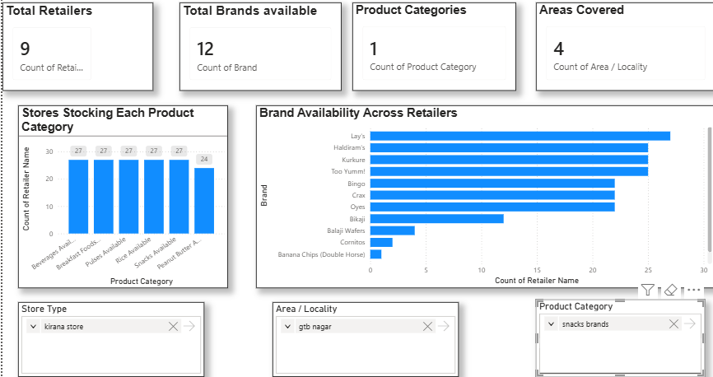
A summary of the retailer-side data fields collected is given below for reference.
Field | Description
Store Type | Category of outlet (e.g., Kirana store, small supermarket)
Location | Area / locality of the outlet
Brand Availability | Brands stocked at the outlet
Product Availability | Product categories stocked at the outlet
Retail Potential | Assessed potential rating of the outlet
Customer Footfall | Observed footfall level at the outlet

10. Distributor Survey Analysis
The distributor survey captured operational and market-intelligence data for each distributor covered: retailers served, number of employees, number of delivery vehicles, geographical area covered, cold storage availability, highest-demand product category, fastest-growing product category, strongest brands, visit frequency to retailers, categories with the highest expansion potential, and the main challenges faced in onboarding new retailers.

10.1 Distributor Scale and Operational Capacity
Distributor scale was assessed using four headline metrics on the Distributor Overview page: total distributors covered, total retailers served (summed across distributors), average number of employees, and average number of delivery vehicles. These are supported by the "Retailers Served by Distributor" bar chart and "Geographical Area Covered" column chart, which together indicate which distributors have the reach to support additional retailer onboarding or brand lines.
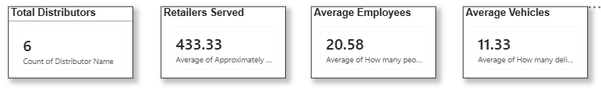

10.2 Cold Storage Availability
Cold storage availability was recorded as a yes/no field and visualized in the "Cold Storage Availability" donut chart, and cross-referenced against area covered in the "Cold Storage vs Area Covered" chart on the Operational Analysis page. This is relevant to any future expansion into temperature-sensitive product categories, since distributors without cold storage would need additional investment before they could support such categories.
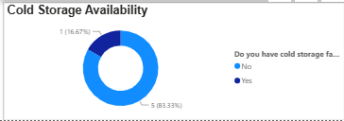

10.3 Category-level Demand and Growth
Distributors were asked which product category currently has the highest demand in their area, and which category is growing the fastest. These are shown side by side in "Highest Demand Product Categories" and "Fastest Growing Product Categories" on the Market Intelligence & Business Insights page. Reading these two charts together highlights categories that are both currently strong and gaining momentum - the most attractive candidates for continued or expanded distribution - as well as categories that are growing quickly but not yet dominant, which may represent early-stage expansion opportunities.
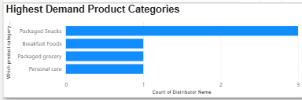
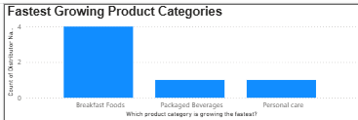

10.4 Brand Strength and Expansion Potential
Distributors were also asked which brands have the strongest presence in their market, shown in "Most Frequently Mentioned Brands," and which product categories they see as having the highest expansion potential, shown in "Preferred Expansion Categories." These distributor-side perceptions are a useful cross-check against the retailer-side brand and product availability data discussed in Chapter 9, since a gap between what distributors see as high-potential and what is actually available on retail shelves points directly to a multi-brand expansion opportunity (see Chapter 16).
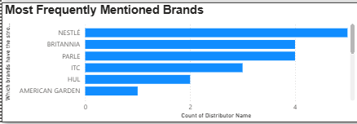

10.5 Onboarding Challenges and Retailer Visit Frequency
The "Top Distribution Challenges" chart summarizes the main difficulties distributors reported when onboarding new retailers, and the "Retail Visit Frequency" chart on the Operational Analysis page shows how often distributors typically visit their retailers. Both feed directly into the retailer onboarding framework proposed in Chapter 16, since onboarding challenges reported by existing distributors are a realistic starting point for anticipating friction with new retailers.
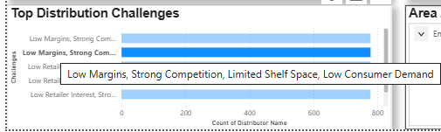
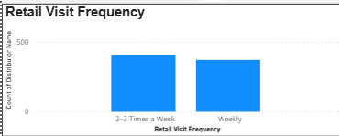
A summary of the distributor-side data fields collected is given below for reference.
Field | Description
Retailers Served | Approximate number of retailers currently served
Employees | Number of people working in the distribution business
Delivery Vehicles | Number of delivery vehicles operated
Area Covered | Approximate geographical area covered (sq. km)
Cold Storage | Whether cold storage facilities are available
Highest Demand Category | Product category with the highest current demand
Fastest Growing Category | Product category growing fastest
Strongest Brands | Brands with the strongest market presence
Market Penetration / Visit Frequency | How frequently retailers are typically visited
Business Challenges | Major challenges in onboarding new retailers
Expansion Potential | Product categories seen as having the highest expansion potential

11. Power BI Dashboard Development
Once the survey data had been cleaned and structured, it was loaded into Microsoft Power BI and built out into two separate dashboards: the Retailer Onboarding Dashboard and the Distributor Survey Dashboard, reflecting the two respondent groups covered by the field survey. Both dashboards were designed to be filterable by locality, store type/distributor, and, where applicable, product category, so that the organization can drill into a specific area or segment rather than only viewing aggregate totals.

11.1 Dashboard Design Approach
The design approach for both dashboards followed a consistent structure: a headline metrics row (card visuals) at the top of the landing page, followed by category and locality-level breakdowns using bar, column, and donut charts, and slicers placed consistently across pages to allow cross-filtering by area, store type, or distributor. This structure was chosen so that a user opening either dashboard for the first time can immediately see overall scale (via the cards) before drilling into specific patterns (via the charts and slicers).
Both dashboards use a common visual theme (fonts, color palette, and layout grid) so that they can be presented together as a single body of work, even though they draw on two separate underlying datasets (retailer-side data and distributor-side data).

11.2 Retailer Onboarding Dashboard
The Retailer Onboarding Dashboard is built across four pages:
Page | Purpose
Executive Dashboard | Headline metrics (total retailers, total areas, average retail score, high-potential stores) plus locality-wise retailer counts and store-type mix.
Product & Brand Analysis | Category-wise product availability and brand availability across all surveyed retailers.
Retailer Analysis & Market Coverage | Retailer-wise brand portfolio table, average brand portfolio by store type, and area-wise retailer coverage.
Key Insights & Recommendations | Narrative summary of market insights, product & brand insights, retailer opportunities, recommendations, and an overall conclusion.

The Executive Dashboard page opens with four cards : Total Retailers, Total Areas, Average Retail Score, and High Potential Stores , giving an at-a-glance summary of the retailer-side survey before the user filters into any specific locality or store type. Below these, "Retailers by Area" (a clustered column chart) shows retailer counts across Mukherjee Nagar, GTB Nagar, Gandhi Vihar, and Indra Vihar, while "Store Type Distribution" (a donut chart) shows the overall split between Kirana stores and small supermarkets. Slicers for area/locality, store type, and retail potential sit alongside these visuals so the numbers can be filtered on the fly.
The Product & Brand Analysis page carries this forward with "Stores Stocking Each Product Category" (a clustered column chart showing how many retailers stock each category) and "Brand Availability Across Retailers" (a clustered bar chart showing how many retailers stock each brand), backed by four supporting cards for total retailers, total brands, product categories, and areas covered.
The Retailer Analysis & Market Coverage page provides more granular detail: a "Retailer-wise Brand Portfolio" table listing, for every retailer, its area, store type, and the brands and product categories it stocks; an "Average Brands per Retailer" card and matching "Average Brand Portfolio by Store Type" column chart; and a "Retailer Coverage by Area" bar chart.
The final page, Key Insights & Recommendations, is a narrative summary written directly on top of the dashboard (rather than a chart page) and is reproduced in full in Chapter 15 (Key Findings) since it captures the intern’s own read of the retailer-side data.
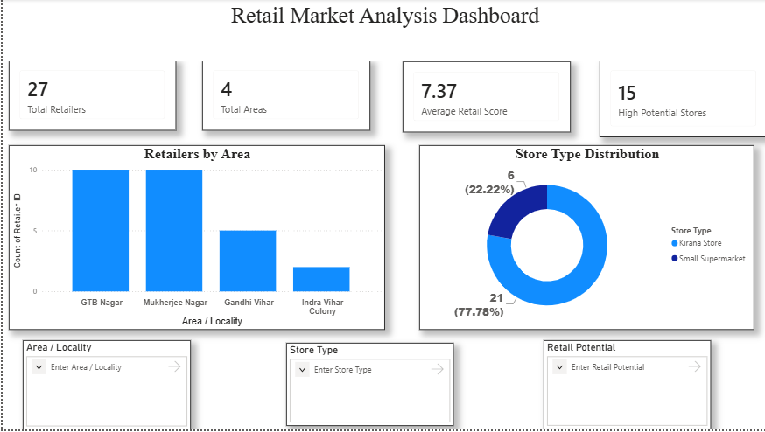
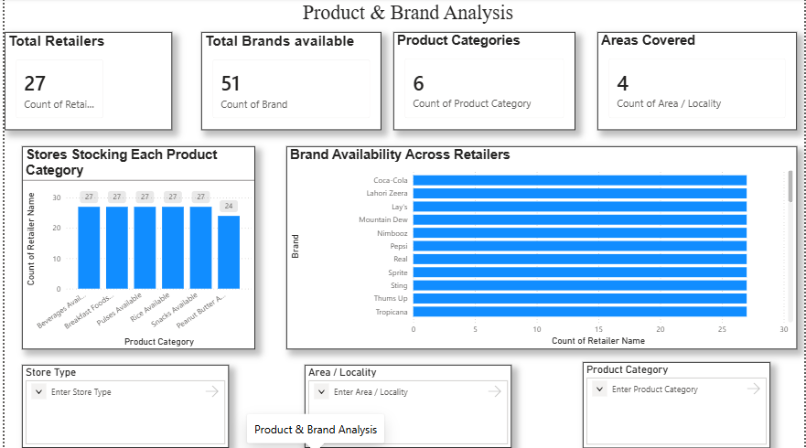
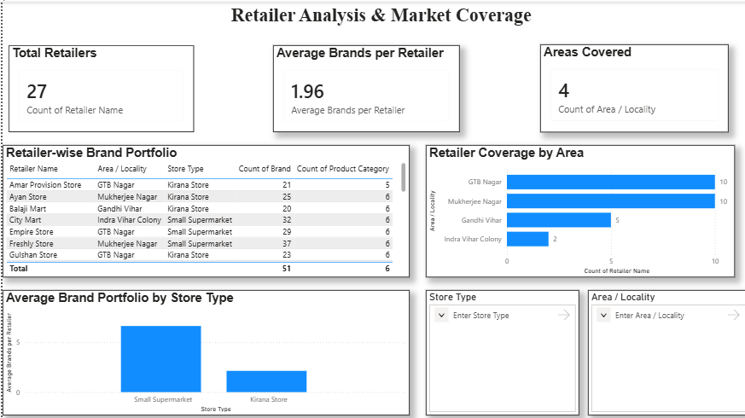

11.3 Distributor Survey Dashboard
The Distributor Survey Dashboard is built across three pages:
Page | Purpose
Distributor Overview | Headline metrics (total distributors, retailers served, average employees, average vehicles) plus retailers served by distributor, area covered, and cold storage availability.
Market Intelligence & Business Insights | Category-level demand and growth patterns, brand strength, expansion potential, and onboarding challenges.
Operational Analysis | Retail visit frequency, distributor penetration by area, cold storage vs. area covered, and retailers served vs. employees.

The Distributor Overview page opens with four cards : Total Distributors, Retailers Served, Average Employees, and Average Vehicles – followed by "Retailers Served by Distributor" (a bar chart), "Geographical Area Covered" (a column chart), and "Cold Storage Availability" (a donut chart). Area/locality and distributor-name slicers allow the same page to be filtered down to a single territory or distributor.
The Market Intelligence & Business Insights page brings together five charts: "Highest Demand Product Categories" and "Fastest Growing Product Categories" (both showing distributor counts by category), "Most Frequently Mentioned Brands," "Preferred Expansion Categories," and "Top Distribution Challenges." Together, these give a market-intelligence view of where category-level demand and brand strength currently sit, and where distributors themselves see room for growth.
The Operational Analysis page repeats the four headline cards (adding an "Average Area Covered" card) and adds four further visuals: "Retail Visit Frequency" (how often distributors visit their retailers), "Distributor Penetration" (distributor count by area/territory), "Cold Storage vs Area Covered," and a "Retailers Served vs Employees" scatter chart that lets the organization spot distributors that serve a large retailer base relative to their staff size - a useful indicator of operational efficiency, and conversely, distributors that may be under-staffed relative to their retailer load.
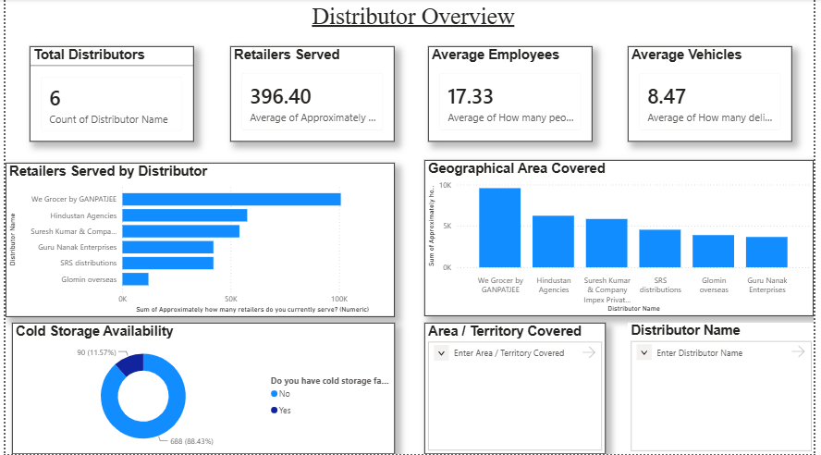
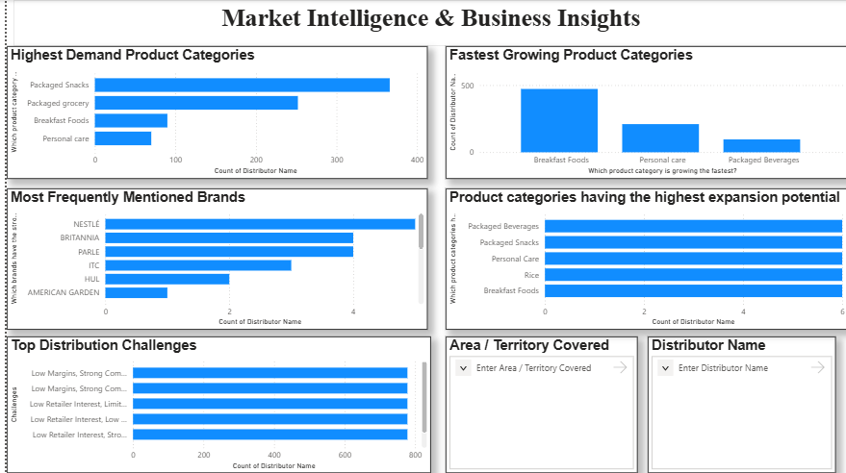
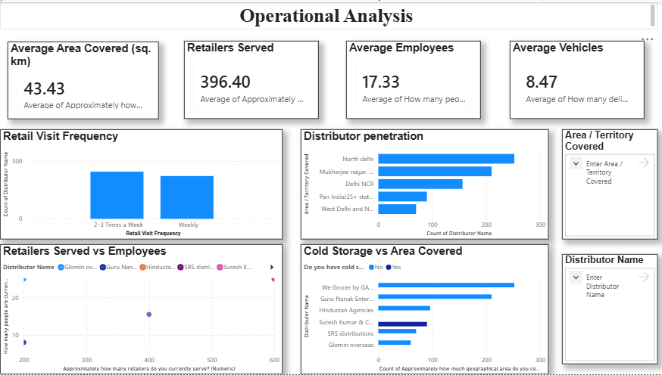

12. Business Insights
This chapter draws together the reading of both dashboards into a single business-level view, before Chapter 13 lists the specific key findings and Chapters 14-16 turn them into recommendations.

12.1 Retail Landscape
The survey covered retail outlets across North Delhi, including Kirana stores and small supermarkets, with retail presence observed across all four target localities, helping identify which areas carry a higher concentration of retailers. Kirana stores showed a strong overall market presence, consistent with their wide availability of fast-moving consumer products and their role as the primary point of sale in these localities.

12.2 Product and Brand Landscape
Multiple national and regional brands were identified across the surveyed retail outlets, with categories such as peanut butter, beverages, rice, pulses, and breakfast products showing differing levels of availability from one retailer to the next. Brands with comparatively limited retailer presence stand out as candidates for expanded distribution, since their low current availability rather than low demand may be the binding constraint on their market share in these localities.

12.3 Retailer Opportunities
Retailers carrying a wider brand portfolio are natural priorities for onboarding, since they have already demonstrated a willingness and capacity to stock multiple brands. Small supermarkets present an additional opportunity because of their broader product assortment and more organized shelf space, while high-footfall Kirana stores offer a route to improving product reach and market penetration even where individual shelf space is more limited.

12.4 Distributor’s Insights
On the distributor side, the operational metrics captured- retailers served, staffing, delivery vehicles, area covered, and cold storage- point to meaningful variation in scale and capacity across the distributors surveyed
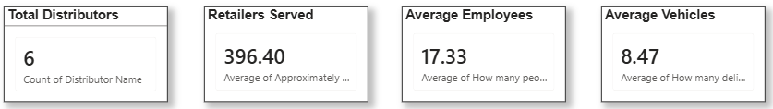
Category-level demand and growth data, together with distributor-reported onboarding challenges, provide a realistic, ground-level check against which any expansion or onboarding plan should be tested before it is rolled out.

13. Key Findings

The findings presented below represent the intern's own summary, as documented on the Key Insights & Recommendations page of the Retailer Onboarding Dashboard. They are reproduced here to provide a complete record of the dashboard outputs and recommendations.

13.1 Market Insights
- The survey covered retail outlets across North Delhi, including Kirana stores and small supermarkets.
- Retail presence was observed across multiple localities, helping identify areas with higher retailer concentration.
- Kirana stores showed strong market presence due to their wide availability of fast-moving consumer products.

13.2 Product & Brand Insights
- Multiple national and regional brands were identified across surveyed retail outlets.
- Categories such as peanut butter, beverages, rice, pulses, and breakfast products showed different levels of availability.
- Brands with limited retailer presence represent potential opportunities for market expansion.

13.3 Retailer Opportunities
- Retailers with a wider brand portfolio can be prioritized for potential onboarding.
- Small supermarkets provide opportunities due to their broader product assortment and organized shelf space.
- High-footfall Kirana stores can help improve product reach and increase market penetration.

13.4 Distributor’s Findings
- Distributor scale (retailers served, employees, delivery vehicles, area covered) varies meaningfully across the distributors surveyed (see the Distributor Overview page for the exact split).
- Category-level demand and growth are not always aligned: the category with the highest current demand is not necessarily the fastest growing one, which has direct implications for expansion sequencing (Chapter 16).
- Onboarding challenges reported by distributors are a practical early-warning list for anything new-retailer onboarding is likely to run into.
Overall conclusion (as recorded on the dashboard): the retailer survey provides insights into brand presence, product availability, and retailer potential in the North Delhi market, and the findings can support better retailer onboarding decisions, category expansion strategies, and improved market coverage.

14. Recommendations
The following recommendations follow directly from the Key Findings in Chapter 13 and are also recorded on the dashboard’s Key Insights & Recommendations page.
- Expand the retailer network in areas with higher customer and retailer activity, prioritizing the localities shown to have the greatest retailer density and footfall on the Executive Dashboard.
- Prioritize onboarding of retailers with strong brand availability and product variety, since these outlets have already shown a willingness and operational capacity to stock a broad range.
- Improve availability of under-represented product categories identified in the Product & Brand Analysis page, rather than adding further depth to categories that are already well stocked.
- Use the distributor-side onboarding-challenge data (Chapter 10.5) to prepare for common friction points: - such as
before beginning a new onboarding drive.
- Revisit these recommendations periodically as new survey rounds are run, since retail and distributor conditions in these localities are likely to shift over time.

15. Retailer Onboarding Framework
Based on the survey and dashboard findings, the following four-stage framework is proposed for onboarding new retailers in the target localities. It is designed to be repeatable, so that each new locality or retailer batch can be run through the same stages using the same dashboard structure built during this internship.

15.1 Stage 1: Locality and Store Screening
Use the Executive Dashboard’s locality and store-type filters to shortlist areas and store types with the highest retailer density and retail-potential ratings, rather than approaching outlets on an ad hoc basis.

15.2 Stage 2: Retailer Evaluation
Within a shortlisted locality, evaluate individual retailers against the same criteria used in the field survey: store type, existing brand portfolio, product-category range, and observed customer footfall. Retailers already carrying a wide brand portfolio (see the "Average Brands per Retailer" and "Retailer-wise Brand Portfolio" views) should be prioritized, consistent with Chapter 13.3.

15.3 Stage 3: Distributor Matching
Match shortlisted retailers to a distributor with adequate operational capacity in that area using the Distributor Overview and Operational Analysis pages to check retailers-already-served, delivery-vehicle count, and area coverage, so that onboarding does not overload a distributor beyond its demonstrated capacity.

15.4 Stage 4 – Onboarding and Review
Following retailer onboarding, the same survey should be administered after a predefined review period (e.g., three months). The updated responses should be compared with the baseline assessment to evaluate improvements in brand availability, product assortment, and overall retail potential. The new data should then be incorporated into the Power BI dashboards, enabling continuous monitoring and ensuring that the onboarding framework remains data-driven and performance-oriented over time.
Stage | Key Question | Dashboard Support
1. Locality & Store Screening | Where is retailer density and potential highest? | Executive Dashboard – area/store-type slicers, retail potential card
2. Retailer Evaluation | Which retailers already show strong brand/product range and footfall? | Retailer Analysis & Market Coverage – brand portfolio table
3. Distributor Matching | Which distributor has spare capacity in this area? | Distributor Overview / Operational Analysis – retailers served, vehicles, area covered
4. Onboarding & Review | Is the onboarded retailer performing as expected? | Re-run survey; compare updated dashboard figures against baseline

16. Multi-brand Expansion Strategy
The multi-brand expansion strategy proposed here rests on cross-referencing three views already built into the dashboards: retailer-side product/brand availability (Chapter 9.4), distributor-side category demand and growth (Chapter 10.3), and distributor-side perceived expansion potential (Chapter 10.4).
- Prioritize categories that distributors flag as both high current demand and high expansion potential, but which show comparatively low retailer-level availability on the Product & Brand Analysis page , this combination indicates unmet demand rather than a saturated category.
- Treat categories that are growing fastest (Chapter 10.3) but not yet the highest in current demand as early-stage opportunities, worth a smaller, test-scale rollout before a full expansion commitment.
- For brands already identified as having the strongest market presence (Chapter 10.4), focus expansion on retailers and localities where that brand is currently under-represented, rather than further increasing its presence where it is already well stocked.
- Sequence expansion through retailers with a wider existing brand portfolio first (Chapter 13.3), since these outlets have already shown operational readiness to add new lines.
Because distributor financial data (margins, ROI) could not be collected (Chapter 17), this strategy is deliberately built on demand, growth, and availability signals rather than profitability projections. Any financial viability assessment of the categories or brands recommended above would need to be carried out separately by the organization using its own internal cost and margin data.

17. Limitations
- Financial data gap: distributors treated revenue, profit margins, investment levels, and ROI as confidential and were unwilling to share this information. In line with the agreed scope, no attempt has been made to calculate, estimate, or infer any of these figures anywhere in this report or in the accompanying dashboards; all financial-related sections are explicitly marked as unavailable rather than approximated.
- Sample coverage: the survey was confined to four localities in North Delhi (Mukherjee Nagar, GTB Nagar, Gandhi Vihar, and Indra Vihar) and a purposive rather than random sample of retailers and distributors, so findings should be read as indicative of these micro-markets rather than statistically representative of the wider city or region.
- Self-reported data: several distributor-side fields (e.g., retailers served, area covered, category demand and growth) were self-reported by distributors rather than independently verified, and are subject to the normal limitations of survey-based data collection.
- Time constraints: the 8-week duration of the internship limited the survey to a single round of data collection; the findings represent a snapshot rather than a trend observed over multiple periods.
- Qualitative categorization: fields such as "retail potential" and "customer footfall" were assessed using structured but ultimately judgment-based ratings rather than objective, independently measured metrics.

18. Future Scope
- Extend the survey to additional localities beyond Mukherjee Nagar, GTB Nagar, Gandhi Vihar, and Indra Vihar to build a wider North Delhi (and eventually city-level) view.
- Introduce periodic re-surveys (e.g., quarterly) of the same retailers and distributors to convert this snapshot into a trend view, and to measure the impact of onboarding and expansion decisions over time.
- Where the organization is able to obtain distributor financial data directly (with distributor consent), extend the dashboards to include margin and ROI analysis alongside the existing operational and market-intelligence views.
- Automate parts of the data-collection and cleaning pipeline (for example, through a standard mobile form template) to reduce the manual effort required for future survey rounds.
- Add a formal scoring model on top of the existing dashboards to rank retailers and localities for onboarding priority, building on the framework proposed in Chapter 15.

19. Learning Outcomes
This internship provided practical, first-hand exposure to several aspects of FMCG distribution and retail analytics that are difficult to learn outside a field setting:
- Practical experience in designing a structured survey instrument, including the value of piloting a questionnaire before full rollout to catch ambiguous or poorly-scoped questions.
- Direct exposure to how local FMCG distribution and retail networks are structured on the ground, including the operational differences between Kirana stores and small supermarkets.
- Hands-on experience cleaning and structuring field-collected survey data for analysis, including standardizing categorical responses (store types, product categories) for consistent aggregation.
- Development of Power BI dashboarding skills, including designing multi-page reports, using card, bar, column, donut, and scatter visuals appropriately, and building cross-filtering slicers for area, store type, and distributor.
- An understanding of how to work within real-world data limitations, distributor unwillingness to share financial data, and the importance of clearly flagging such gaps rather than working around them with assumptions.
- Experience translating raw survey and dashboard findings into an actionable business framework (Chapter 15) and strategy (Chapter 16) that a non-technical stakeholder can act on.

20. Conclusion
Over the course of this 8-week internship, a structured distributor and retailer survey was designed, piloted, and rolled out across four localities of North Delhi, and the resulting data was cleaned and built into two Power BI dashboards covering retailer onboarding and distributor operations respectively. Together, these give the sponsoring organization a filterable, evidence-based view of retail and distribution conditions in Mukherjee Nagar, GTB Nagar, Gandhi Vihar, and Indra Vihar, something that was not previously available in a structured form.
The retailer survey provides insights into brand presence, product availability, and retailer potential in the North Delhi market, and the findings can support better retailer onboarding decisions, category expansion strategies, and improved market coverage. On the distributor side, the survey highlights meaningful variation in operational scale and capacity, along with category-level demand, growth, and onboarding-challenge data that together inform the retailer onboarding framework (Chapter 15) and multi-brand expansion strategy (Chapter 16) proposed in this report.
The one significant gap in the study is financial data; distributors were unwilling to share revenue, margin, investment, or ROI figures, and, per the agreed scope, no such figures have been estimated in this report. Subject to this limitation, the survey, dashboards, and frameworks developed during this internship provide a practical, repeatable starting point for the organization’s retailer onboarding and multi-brand expansion efforts in this market and can be extended to additional localities or survey rounds as outlined in Chapter 18.

21. References
This report is based primarily on primary data collected through the field survey described in Chapter 8, and on internal project documentation (the 8-Week Internship Plan) provided at the start of the internship. No external secondary sources were used in compiling the survey findings or dashboard analysis presented in this report.
Serial no. | Source | Type | Use in Report
1 | 8-Week Internship Plan – Distributor Survey / Retailer Onboarding & Multi-Brand Analysis (Neeru) | Internal project document | Project background, scope, and execution timeline (Chapters 3, 7, 8)
2 | Retailer Survey – primary field data (Mukherjee Nagar, GTB Nagar, Gandhi Vihar, Indra Vihar) | Primary data | Retailer Onboarding Dashboard; Chapters 9, 12–16
3 | Distributor Survey – primary field data (Mukherjee Nagar, GTB Nagar, Gandhi Vihar, Indra Vihar) | Primary data | Distributor Survey Dashboard; Chapters 10, 12–16

22. Annexure

22.1 Retailer Questionnaire
The following fields were captured for each retailer surveyed. Exact question wording used in the field form should be inserted here from the original mobile survey form.
- Retailer name/outlet name
- Area/locality
- Store type (e.g., Kirana store, small supermarket)
- Brand availability: which brands are stocked at this outlet?
- Product availability: which product categories are stocked at this outlet?
- Retail potential: assessed rating of the outlet’s potential
- Customer footfall: observed footfall level at the outlet
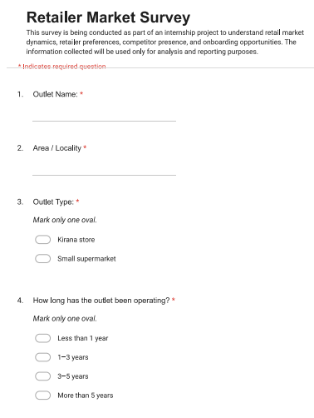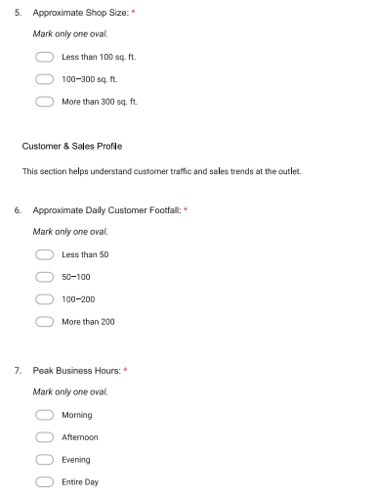
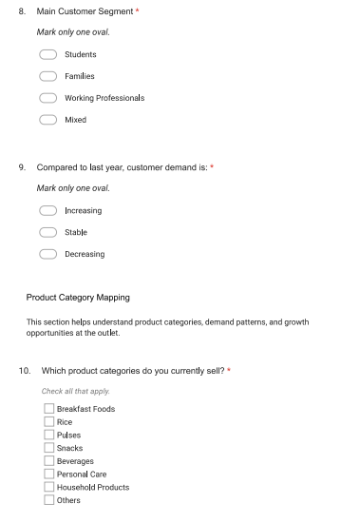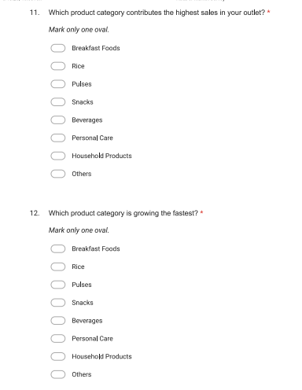
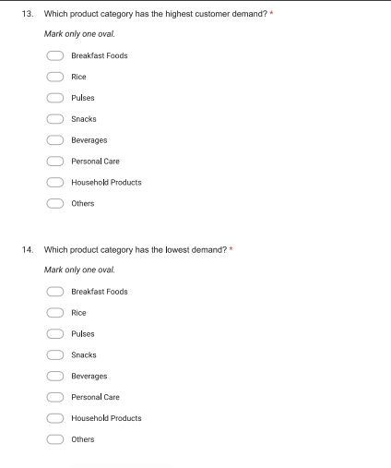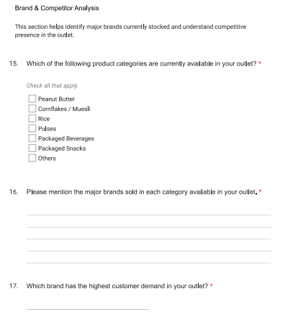
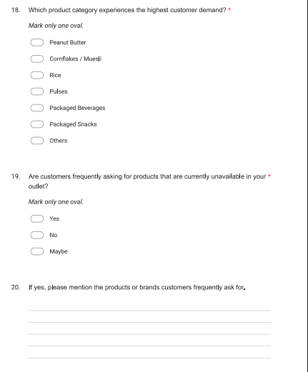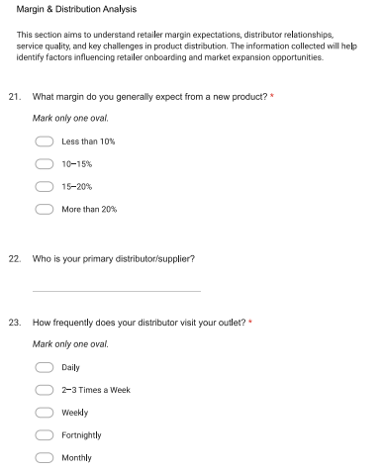
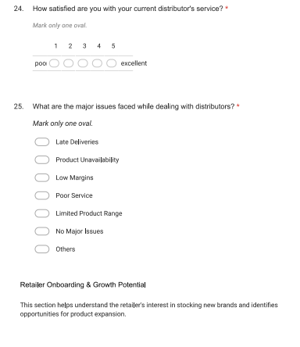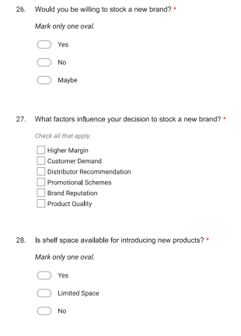
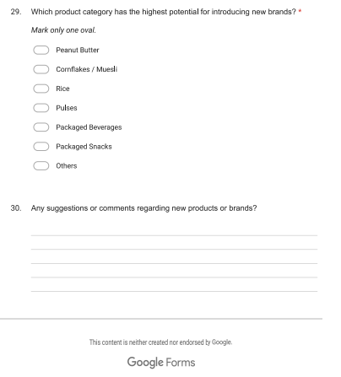

22.2 Distributor Questionnaire
The following fields were captured for each distributor surveyed. Exact question wording used in the field form should be inserted here from the original mobile survey form.
- Distributor name
- Area/territory covered
- Approximately how many retailers do you currently serve? (Numeric)
- How many people are currently working in your distribution business? (Numeric)
- How many delivery vehicles do you currently operate? (Numeric)
- Approximately how much geographical area do you cover? (Numeric, sq. km)
- Do you have cold storage facilities? (Yes/No)
- Which product category has the highest demand in your area?
- Which product category is growing the fastest?
- Which brands have the strongest presence in your market?
- How frequently do you typically visit retailers?
- Which product categories have the highest expansion potential?
- What are the major challenges in onboarding new retailers?
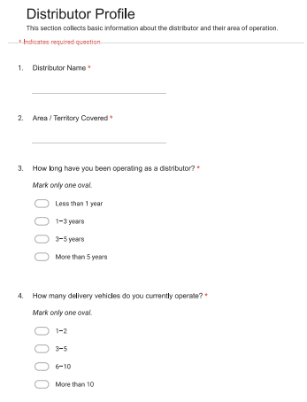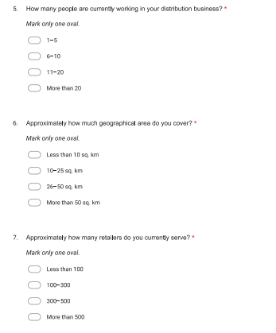
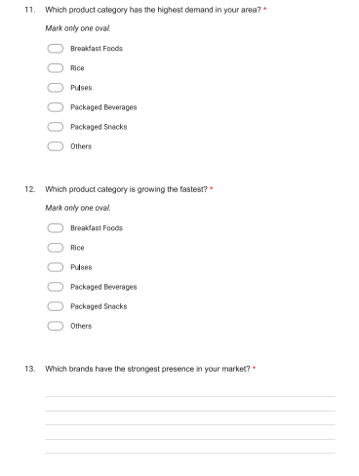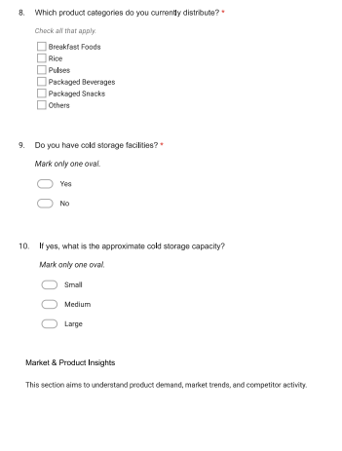
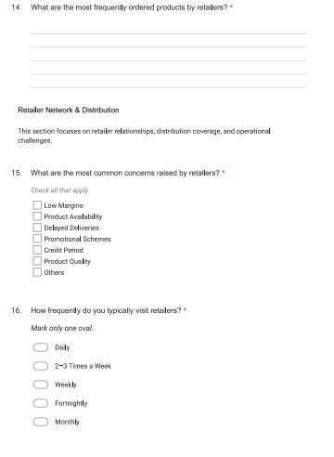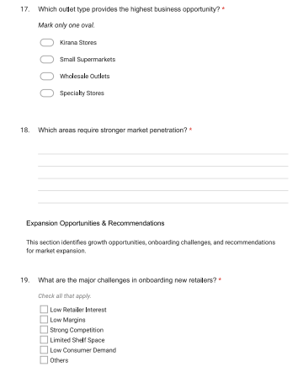
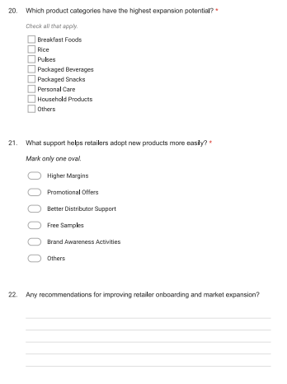

22.3 Dashboard Screenshots

Retailer Dashboard:
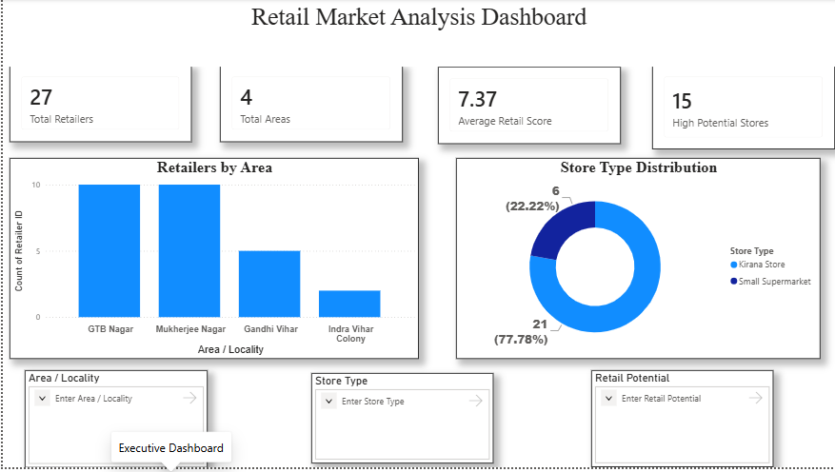
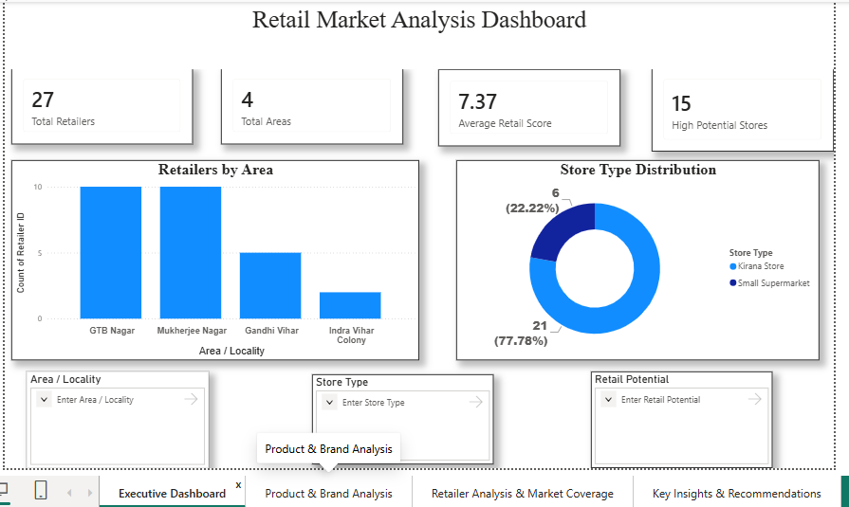
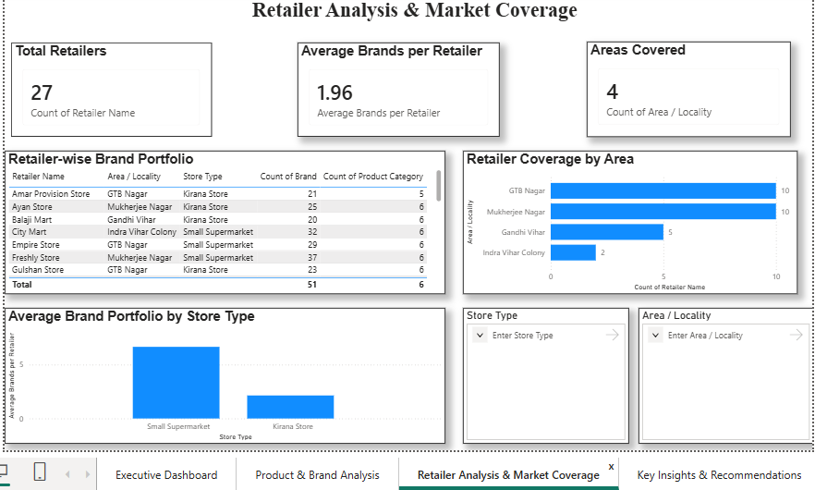
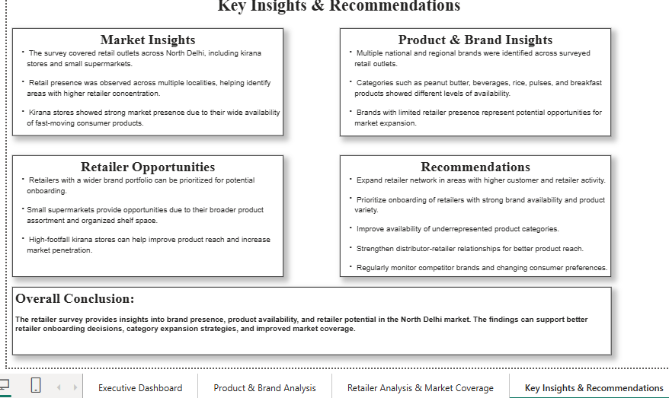

- Distributor Dashboard:
