**CURRENT TOPIC HUMAN COMPUTER INTERACTION**

**CS-630-740**

**SMART HEALTH TRACKING SYSTEM**

**(TRACKING EMOTIONS)**

**PROJECT PHASE 1**

**By,**

**NEERAJA KARETI**

**(S01995530)**

**SNO CONTENTS PAGE NO**

1 Usability and user experience goals 3

2 Design questions 4

3 User need’s, user requirement and list main task 5

4 Scenarios and use case 6

5 Requirements using Volere shell 10

6 Conceptual model 13

7 Mental model 13

8 Analyze and enhanced conceptual model  13

9 Interface design issues 14

10 Initial designs 14

11 Evaluate the designs 15

12 Conclusion 15

1. **Compile a list of usability and user experience goals using design goals (ch1)**

*Usability and user experience goals:*

* Safety

The website used by user should not explore to any virus.

* Utility

It is most important one because the website should provide the functionality which is expected by user.

* Efficiency

It should check whether the website allows to complete the task such as controlling the flow of screen when it’s clicked on button.

* Learnability

It is most important one because it will show how easy a website is to learn to use.

* Effectiveness

It is more general goal which will helpful in website to analyze how it is working and it’s working as it supposed to do.

UX:

* Satisfying

All users should get satisfied with user experience.

* Helpful

Creative design with online help facility will make the user more helpful.

* Enjoyable

When user using website for first time, the user will be enjoying it while using the device.

* Motivating

User who is not aware of using the website, the help feature existing in website will motivate the user to learn how to use the website.

* Exciting

The way website will be designed will make the user more excitement to look for all the features that is being designed in that website.

1. **Transfer them to questions using design goals (ch1)**

*Usability questions:*

1. Will it be possible to measure the response time that is when the user clicks on any button or menu in the website?
2. Obtain the feedback from users after a specific period of use.
3. Does the website allow user to perform their actions effectively?
4. When user enters unwanted webpage it will allow user to redirect to the home papa?

*UX questions:*

1. How to secure the website while using by the user.
2. Will the user be able to work on more than one task simultaneously? If so, how it will happen and what will be happened in background.
3. The designed supports in all the platforms like iOS or android.
4. The speed of website response is good.
5. **Identify users' needs and identify user requirements and then list main tasks (ch10).**

*User’s needs:*

* User should be able to view a scheduled activity.
* User should be able to add the activity.
* User should view the history.
* User should be able to come back or else cancel the operation when user enters unwanted website.
* User must be able to register for the activity.
* User should be able to enter the data without any error.

*User’s requirements:*

|  |  |
| --- | --- |
| List of users’ | Requirements |
| User 1 | Must be able to login to the smart health tracking system without any problem while validating the login credentials. |
| User 2 | The designed website should support the multiple options when the forgot password button is clicked. |
| User 3 | Designed system should allow the user to perform their activities as per their need. |
| User 4 | System should ask the new member to register before they login to the smart health tracking system |
| User 5 | System should display an add an activity, list the scheduled active activities and view history of the user. |
| User 6 | In add an activity, the website should have the assignment type, course name, course number, grade worth, emotion of user for specific activity. |
| User 7 | In list of scheduled activity, it should display the course name, course number, grade worth and must capture the emotions of the user for that specific activity. |
| User 8 | When user clicks on archive the activity, it should not display that activity anymore |
| User 9 | System should display the history of the user with course name, course number, grades worth etc. |

1. **Come up with scenarios and use cases (ch10).**

*Scenario 1:*

User want to launch the website. If new user, the user must register in the website. For existing user, they can login into the smart health tracking system.

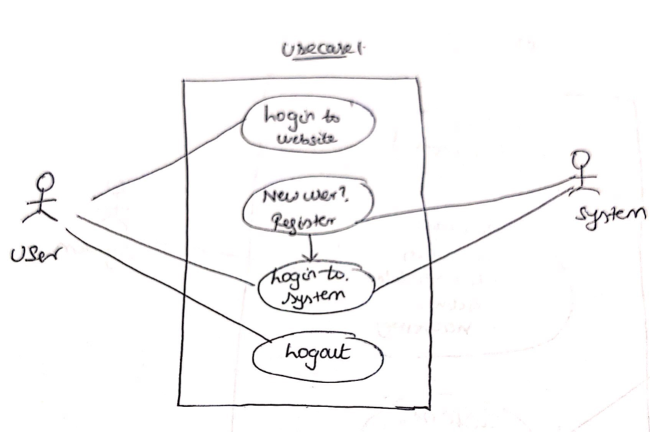

*Scenario 2:*

Once user login to website, it will display add a list the scheduled active activities and view history of the user.

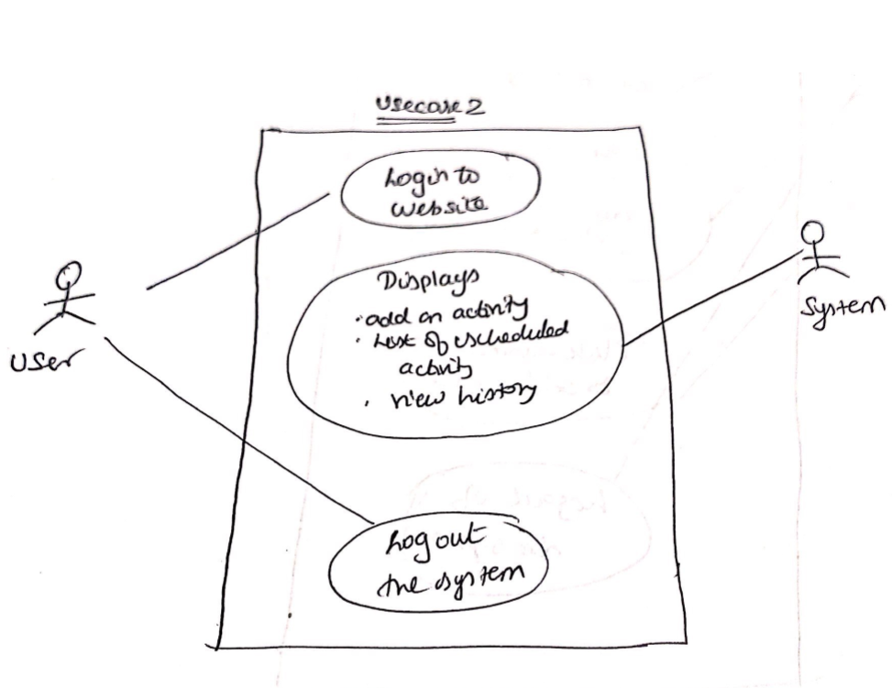

*Scenario 3:*

When add an activity is selected by user, the website shows the options like assignment type, course name, course number, grade worth, emotion of user for specific activity.

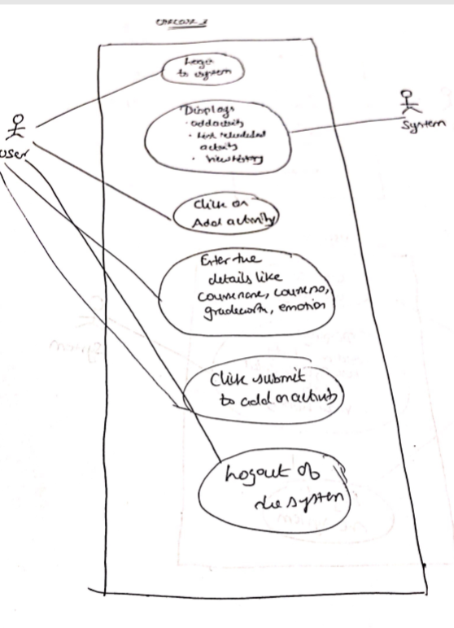

*Scenario 4:*

When list a scheduled active activity is selected by user, the website displays the course name, course number, grade worth and will capture the emotions of the user for that specific activity.

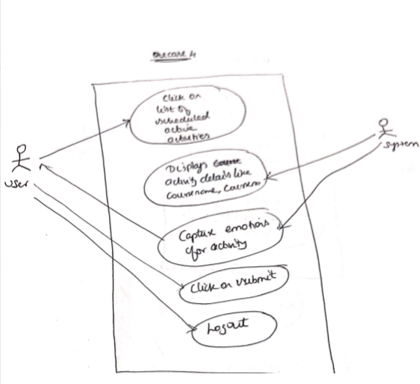

*Scenario 5:*

When view an history is selected by user, the system displays the history of the user with course name, course number, grades worth etc.

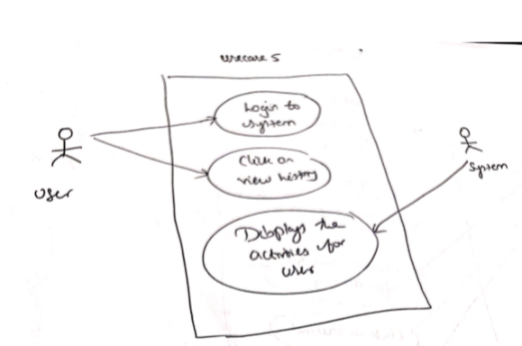

1. **Come up with requirements and write them using Volere shell (ch10).**

*Requirement #*: 1                  *Requirement Type:* 4 *Event/use case#:* 1

*Description:* The website will ask the new user to register in the system before they login to smart health tracking system.

*Rationale:* The person who will be registering in the system should be enrolled in the specific course or must undertake an activity.

*Source*: User 4

*Fit Criterion:* The website will provide the clear information to the user how to register in the system.

*Customer Satisfaction:* 5                  *Customer Dissatisfaction:* 4

*Dependencies:* Seats must be updated constantly with the left seats for a specific activity.

*Conflicts:* When seats are not updated correctly.

*Supporting Materials:*  None

*History*: Similar systems used for online activities at the various university

*Requirement #:* 2                *Requirement Type:* 5 *Event/use case#:* 2

*Description:* The website will display add an activity, list the scheduled active activities and view history of the user.

*Rationale:* The website should display add an activity, list the scheduled active activities and view history of the user for a specific user.

*Source*: Users 5

*Fit Criterion:* The website will provide the clear information on the user activity.

*Customer Satisfaction*: 6                       *Customer Dissatisfaction*: 3

*Dependencies:* It will be depending on the database how securely the information is retrieved for specific user.

*Conflicts:* The possible conflicts will be when the data is not stored correctly on the database.

*Supporting Materials:* None

*History:* Similar systems used for online activities at the various university.

*Requirement #:* 2                *Requirement Type:* 6 *Event/use case#:* 3

*Description:* When add an activity is selected by user, the website will display the options like assignment type, course name, course number, grade worth, emotion of user for specific activity.

*Rationale:* It should display the add an activity options for specific user.

*Source*: Users 6

*Fit Criterion:* The website will provide the clear information on how to add the user activity.

*Customer Satisfaction*: 7                     *Customer Dissatisfaction*: 2

*Dependencies:* It will be depending on the database how securely the information is stored for specific user.

*Conflicts:* The possible conflicts will be when the data is not stored correctly on the database.

*Supporting Materials:* None

*History:* Similar systems used for online activities at the various university.

*Requirement #:* 4                *Requirement Type:* 7 & 8 *Event/use case#:* 4

*Description:* When list a scheduled active activity is selected by user, the website will display the course name, course number, grade worth and will capture the emotions of the user for that specific activity. When activity is archived, it should no longer available in the system

*Rationale:* It should display the list of scheduled active activity for specific user.

*Source*: Users 7 & 8

*Fit Criterion:* The website will provide the clear information on how to view the list of scheduled user activity.

*Customer Satisfaction*: 4                     *Customer Dissatisfaction*: 5

*Dependencies:* It will be depending on the database how securely the information is stored and retrieved for specific user.

*Conflicts:* The possible conflicts will be when the data is not stored correctly on the database.

*Supporting Materials:* None

*History:* Similar systems used for online activities at the various university.

*Requirement #:* 5                *Requirement Type:* 9 *Event/use case#:* 5

*Description:* When view an history is selected by user, the system displays the history of the user with course name, course number, grades worth etc.

*Rationale:* It should display the history of an activity for specific user.

*Source*: Users 9

*Fit Criterion:* The website will provide the clear information on how view the history of user activity.

*Customer Satisfaction*: 6                   *Customer Dissatisfaction*: 3

*Dependencies:* It will be depending on the database how securely the information is retrieved for specific user.

*Conflicts:* The possible conflicts will be when the data is not stored correctly on the database.

*Supporting Materials:* None

*History:* Similar systems used for online activities at the various university.

1. **Come up with a conceptual model (ch2).**

* The conceptual model for smart health tracking system will be a concept and metaphor of a physical website which allows the user to maintain their stress relief activity and will track the emotions for each activity.
* This model will provide the user to track their activity involved in the course for stress relief.
* The system allows the member to add an activity, to list the scheduled active activity and to view the history of activity.
* When activity deadline is over, when the user selects archived activity it will no longer be available.

1. **Elect a mental model from people (ch3).**

* When new member login to system, provide the member details while registering into system.
* Member should be able to add a multiple activity at a time.
* When user selects the list of scheduled active activities, member should be able to retrieve the both completed and pending activity. Member should be able to capture their emotions for that activity.
* Member should have an option to archive the activity when deadline is ended.
* Member should view the history of activity.

1. **Analyze findings and come up with an enhanced conceptual model (ch3).**

There is no need of designing an enhanced conceptual model for allowing users to develop a better mental model of smart health tracking system. Instead of that, provide the training to non-users of the designed system or users who has contradict view on those designed system. There should be a training module associated with the designed system it will help the user to how to use the system or else providing the support for the website.

1. **Consider interface design issues (ch6).**

*Interface design issues*

* There are chances of occurring the error while retrieving the activity details for user when clicked on view history. This might be due to backend connection error.
* While designing the interface for the user to track their emotions. There might be chance of having the coding issue for capturing the user emotions.
* Availability of activity for that course should be periodically updated otherwise there might be chance of having the problems while registering for the activity.
* The code used for designing the interface should not be complex one. So that it will not take more time to respond when user performs any action on the interface.
* Form, name types and structure are the main research issues.
* The most important design principle will be consistency.
* In windows system, it has invented computer display, enables more information to be viewed and task to be performed. It has scroll bars within windows to access more information.
* Design of icons are easier to remember than the commands. Design will be compact and can be variably placed on the screen

1. **Sketch some initial designs (including the interface) (ch9).**

*Design 1*

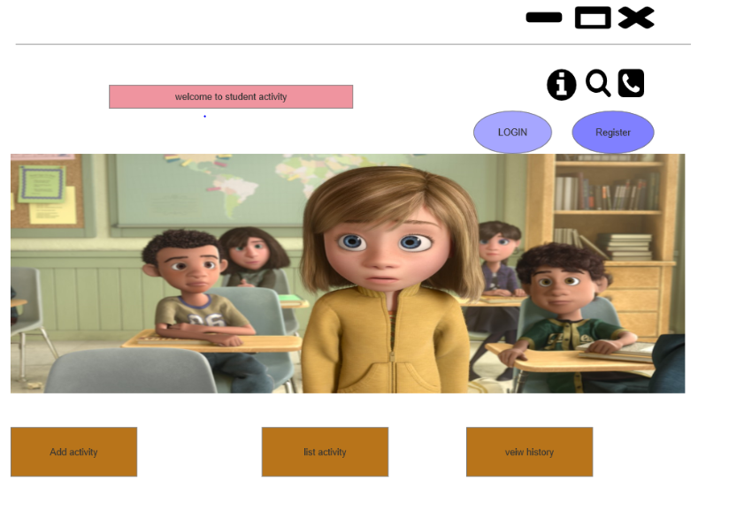

*Design 2*

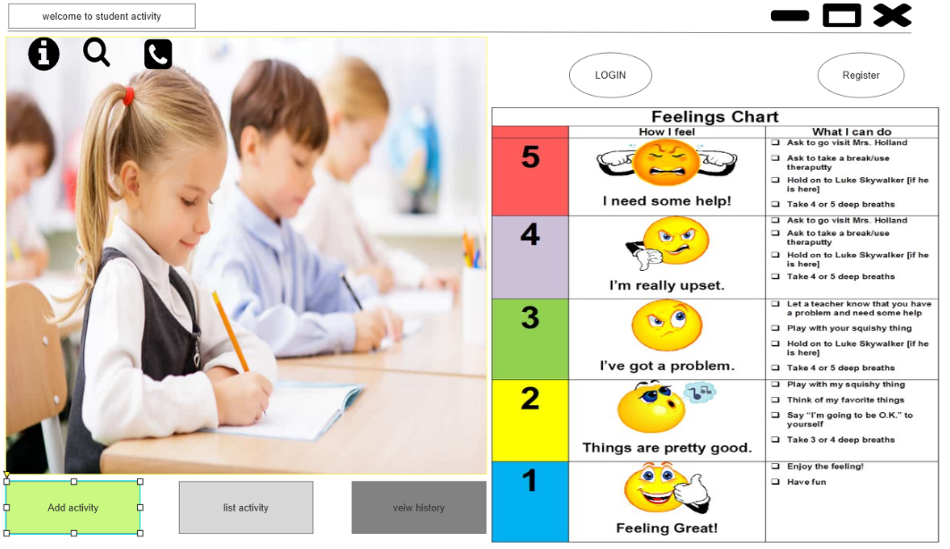

1. **Evaluate the two designs and then select one to implement in next phase(ch9)**

* In design 1, the interface is not more attractive and it’s very simple looking. But in design 2, it’s more attractive and its way of interface looking is good.
* Design 2 will help the member to understand the website by looking into it. In other words, it provides the helpful information to the members. But in design 2, it does not have that much helpful information in the website for the user.
* Design 1 does not represent the scale of emotions for the activity in home page while as design 2 shows the scale of emotions in the home page.

I am going to implement my design 2 in the next phase.

1. **Conclusion**

I am going to implement the design 2 interface for the next phase and I will include all the requirements in my interface design which I mentioned in this report.